TUBECTOMY OF PET ANIMALS



A Clinical report submitted as per approved style and content

Signature of Author  (Mst. Ayesha Khatun)  Roll : 2005/20  Reg. No : 211  Intern ID : C-19  Session : 2004-2005 | Signature of Supervisor  (Dr. Azizunnesa)  Asistant Professor  Dept. of Medicine And Surgery  Faculty of Veterinary Medicine  Chittagong Veterinary & Animal  Sciences University.

TUBECTOMY OF PET ANIMALS

A Clinical report presented in partial fulfillment of the requirement for the degree of DVM (Doctor of Veterinary Medicine)

A Clinical report
Submitted by
Roll : 2005/20
Reg. No : 211
Intern ID : C-19
Session : 2004-2005

Faculty of Veterinary Medicine
Chittagong Veterinary & Animal Sciences University.
Khulshi, Chittagong -4202.
February, 2011

INDEX

ACKNOWLEDGEMENT i

CHAPTER | CONTENTS | PAGE NO
 | ABSTARCT | 1
1 | Introduction | 2-3
2 | Review of Literature | 4-13
3 | Materials and Methods | 14-20
4 | Results and Discussion | 21
5 | Conclusion | 22
6 | Limitations of the Study | 23
 | References | 24-25

ACKNOWLEDMENT

At the inspection, I wish to acknowledge the immeasurable grace and profound kindness of the “GOD” the supreme ruler of universe, without whose desire I could not conclude this report .

The author would like to express her deep sense of gratitude and thanks to Professor Dr. A. S. Mahfuzul Bari , Vice Chancellor of Chittagong Veterinary and Animal Sciences University.

The author would like to express her deep sense of gratitude and heartfelt appreciation to Professor Dr. M. A. Matin Prodhan , Dean, Faculty of Veterinary Medicine, Chittagong Veterinary And Animal Sciences University.

The author extends her gratefulness to her Supervisor Dr Azizunnesa, Asistant Professor, Department of Medicine and Surgery, Faculty Of Veterinary Medicine, Chittagong Veterinary And Animal Sciences University for her scholastic guidance and supervision of the report work and write up of the dissertation.

The author highly express her sincere gratitude and gratefulness to the internship coordinator Md. Ashraf Ali Biswas, Associate Professor, Department of Animal Science & Animal Nutrition, Chittagong Veterinary And Animal Sciences University for his constant inspiration, cordial co-operation.

Finally the author express her good wishes and warmest sense of gratitude to all her wishes to families and friends .

The Author

Tubectomy in pet animals

ABSTRACT

The study was conducted at Central Veterinary Hospital, Dhaka during the period from 27th june to 28th august 2010.The study population was dog (3) and cat(2). The breed of dog was German Shepherd and local and the cats were local (deshi). Midline approach method was applied to tubectomy in pet animals to observe the procedure of tubectomy, pre and post operative anesthetic procedure and management, any complications of tubectomy in our country. General anesthesia was provided to animal before operation. All the animals were in under general management provided by owner. Post operative monitoring has done for 7 days. Antibiotic Ceftriaxon (Inj. Ceftron® 250mg vial,General Company) was injected @ 42mg/kg bw i/m daily for 7 days to prevent the secondary bacterial infection, antihistaminic drugs Chlorpheniramine maleate (Inj. Astavet® 10ml vial, Acme Company) was injected @ 2mg/kg bw i/m daily for 7 days to prevent anaphylaxis, allergic and gastric acid secretion, Vitamin B complex ( Inj. Beconex 10ml vial, Renata Company) was also injected @ 1ml i/m daily for 7 days. No anesthetic hazards were found during monitoring period. Operated wound was fully recovered within 7 days . There was no complication encountered except one case(cat). The cat was suffered with abscess on incision site at 15 days of operation.

Chapter 1

INTRODUCTION
Pet rearing like dogs and cats is now worldwide popular. In most of the developed country every citizen have a pet of their own. But rearing dog and cat is a great hazard if they are not tubectomized or vasectomized. Because bitches are monoestrous animal but they give birth about 15-16 pups at a time and their maturity comes in 6 to 9 month of ages. Cats are polyestrous animal and they give birth in every 3 to 4 months and their maturity also comes in 6 to 9 months.(Slatter, D.,1993) So maintain such a large big family is certainly hazardous. Here the surgeons appeared as reliable friend to solve the problem of pet beloved owners by doing spaying or tubectomy or vasectomy. In Bangladesh the picture is somewhat different because Bangladesh is a developing country. The economy of the country based on agriculture. About 80 % people of the country lived in the village. They mainly rare livestock animals like cattle, goat, sheep and poultry. Few of them rear dogs as a guard and cats as a pet. In urban areas now-a-days it is a common practice to rear a pet animal like dog,cat, parrot, moyna etc. They rear dogs and cats as a companion. The relationship between owner and pet is very complicated, they love their pets as a family member and they are very much concern about their pets. Pets provide a focus for the owner to care for, touch & watch.(Fogle, 1992)
Pets also decrease loneliness, make the owner feel safe, keep the owner busy, provide a stimulus for exercise.

However, pets carry many infectious and non-infectious diseases such as vomition. Chronic renal failure, rabies, pruritus, skin diseases, pyometra, metritis etc. that have the importance in public health. In present days as the owner`s are very conscious about their pets they don’t want unexpected over population from their pets. They want to avoid the unwanted breeding, any diseases of uterus and sexually transmitted diseases. For these reasons hysterectomy is commonly performed in dog and cat. It also prevent pyometra, metritis, mammary tumors or congenital anomalies, some endocrine abnormalities (i.e., diabetes, epilepsy) and dermatoes (e.g. generalized Demodex) and also prevent the estrus and unwanted offspring.

Tubectomy has also advantages in some cases like it eliminates risk of testicular cancer (most are benign in behaviour), reduces risk of mammary cancer (if performed before 2.5 years of age), reduces risk of pyometra (uterine infection),eliminates risk of uterine tumours (given uterus is removed) , eliminates risk of ovarian cancer, reduces risk of prostatic hyperplasia and inflammation reduces risk of benign perianal tumours in dogs, reduces urine marking, mounting & it may reduce roaming.

In Bangladesh hysterectomy is a common practice in pet animals to avoid some reproductive problems and specially to reduce over population or unwanted pregnancy. In some cases tubectomy also preferred to avoid unwanted pregnancy or over population but there is very few literature is available on the tubectomy in dog and cat in our country. The practice of this is also very recent concern. In concern of growing its importance, the study was under taken with following objectives:
- To know the procedure of tubectomy practiced in our country.
- To observed the pre and post operative management technique.
- To observed the pre and post anesthetic hazards of pets.
- To get idea about the depth of different reflexes during GA n dog and cat.
- To identify any complications during post operative management of tubectomy.
Chapter 2

REVIEW OF LITERATURE

2.1 Definition:
Tubal ligation is a medical procedure in which the fallopian tubes are cut and surgically tied so that ova cannot become fertilized or reach the uterus.(Wiley & Sons,2010)

Tubal ligation is a method of female sterilization in which the fallopian tubes are surgically tied.( Houghton,2010)

Tubal Sterilization is a permanent method of contraception where the fallopian tubes are blocked so that the ova or eggs are prevented from traveling to the uterus from the ovary.Tubectomy also referred to, as Tubal Sterilization is a surgical procedure done on female as a permanent method of contraception. (Anitah, 2011)

Surgical removal of one or both fallopian tubes. Common causes for the removal include an infection in the fallopian tube, an ectopic pregnancy or for treatment of certain reproductive system cancers that would be used in conjunction with the removal of the ovaries and uterus. (http://www.pregnology.com/AZ/T/5)

Snipping and tying of fallopian tubes as a sterilization measure can be performed on female cats and dogs. Risk of unwanted pregnancies is insignificantly small. Only a few veterinarians will perform the procedure. ( Blackshaw, J.K. 1991)

Tubal sterilization is intended to be a permanent method of birth control. This single procedure can provide highly effective protection against pregnancy for the remainder of a woman’s reproductive years. Temporary methods have an increased chance of failure and some may have bothersome side effects.

Tubal ligation is considered a permanent form of birth control. It is not recommended as a temporary or reversible procedure.

2.2 Types of Tubectomy:
Anitah (2011) states that blocking the fallopian tubes for Tubal sterilization can be done in several ways. The tubes can be closed by placing implants, by applying clips, clamps or rings and by cutting and tying the ends.There are different surgical approaches for the tubal sterilization operations are:
1. Laparoscopy
2. Microlaparoscopy
3. Laparotomy (concurrent with cesarean delivery)
4. Minilaparotomy
5. Hysteroscopy
6. Vaginal approaches.
The most popular is using a laparoscope; where the patient has just a couple of small scars and is discharged home the same day.
2.3 Indications of tubectomy:
Slatter (1993) reported that the ovariohysterectomy is performed for the following indications:
- The most common reason to perform ovariohysterectomy is to prevent estrus and wanted offspring.
- Prevention of mammary tumors or congenital anomaklies.
- Prevention and treatment of pyometra, metritis, neoplasia(i.e. ovaries,uterine or vaginal), cysts, trauma, uterine torsion, uterine prolaps, subinvolution of placental sites, vaginal prolapsed, vaginal hyperplasia.

Fossum et.al. (1997) also stated that the ovariohysterectomy is performed for the control of some endocrine abnormalities (i.e. diabetes, epilepsy) and dermatoes(e.g generalized Demodex).

Burrrow et. al.,(2006) reported that the ovariohysteretomy is performed for the control of over population of cats.

2.4 Pre-operative Preparations :
Anitah (2011) states that pre-operative preparations include counseling and measures to improve the outcome of surgery, such as:
1. Informed consent-written consent is obtained from the patient`s owner prior to performing the surgery
2. In Preoperative counseling the patient`s owner needs to be informed that the procedure of Tubal sterilization is permanent and irreversible and that a small chance of failure exists. The relative likelihood of an ectopic pregnancy is increased when sterilization failure occurs
3. It can be done as day-surgery or may require an overnight stay in the hospital
4. It is recommended that the patient take nothing by mouth (food, water, etc.) for at least 6 hours before the scheduled operation or after midnight if the operation is planned in the morning.
5. Painkillers and antibiotics may be prescribed before the procedure.
6. A sedative may be useful to relieve the anxiety of surgery
7. The Abdomen and genital area may be shaved and prepared for the surgery
8. Before surgery or during the previous night a bath maybe advisable. During the bath thorough cleaning of the abdomen and genital area with soap and water a few times can help in lowering the bacterial count and lessen the chances of any infection from surgery
9. An enema maybe administered to the patient prior to performing the surgery. Sometimes a laxative maybe given to clear the bowels prior to the surgery

2.5 Surgical anatomy for tubectomy:
Each ovary lies caudal to a kidney, thus the right ovary is more cranial and more difficult to exteriorize. The suspensory ligament attaches the ovary to body wall and courses craniodorsally from the ovary. The proper ligament of the ovary attaches to the uterus. The ovarian artery and vein are delicate and easily torn. They may me obscured by fat in older animals. They course almost straight dorsally from the exteriorized ovary. The broad ligament attaches the uterus to the dorsolateral body wall and the around ligaments runs within the broad ligament. Caudal the round ligaments must be distinguished from the uterus. The uterine artery and vein lie lateral to the uterine body within the broad ligament. The ovarian pedicle includes the ovarian vassels and the fatty part of the broad ligament associated with the ovary.(Hosgood et. al.,1998)
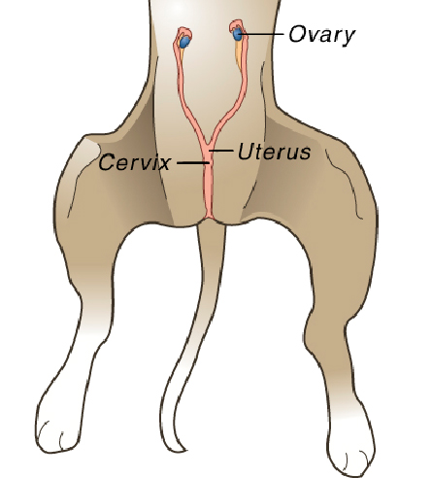
Anatomy of the bitch

2.6 positioning of pet for tubectomy:
Smith et.al., (1993) said that the animal is positioned for ovariohysterectomy in dorsal recumbency and the abdomen is approached by caudoventral midline celiotomy. Coe et. al.,(2006) also stated that in performing ovariohysterectomy , the animal is placed in right lateral recumbency and its legs were extended caudally with ties during flank approach. During midline approach , the animal is placed in dorsal recumbency for ovariohysterectomy

2.7 Site of incision for ovariohysterectomy:
Venogopalan (2004) stated that a point one inch behind the umbilicus backwards along the midline for a distance of about three to five inches but length of incision may be extended depending on need. The length of midline incision is based on the size of the animal. The distance between the umbilicus and the pubis is divided into thirds. In a cat, the incision is made in the middle third because the uterine body is more difficult to exteriorize than the ovaries (Slatter, 1993). A ventral midline skin incision is made beginning at the umbilicus scar cranially and extending to the level of the pectin ossis pubis caudally (Smith et.al.1993). Coe. et.al. 2006 reported that a midline or slightly paramedian incision was made through the linea alba or rectus abdominis muscle and parietal peritoneum to enter the peritoneal cavity. The position for the incision was indentified by visualizing an equilateral triangle with vertices at the greater trochanter, the wing of the ilium and the center point of the incision(Flank approach). Berge.et.al.(1996) reported that better healing is obtained with bilateral flank incision than with an incision in the midline.

2.8 Surgical Procedures for Tubectomy :
There are some different procedures to complete the operation:

2.8.1 Midline approach:
Smith et. al.,(1993) stated that the midline approach is best method for ovariohysterectomy. In this method, the patient is positioned in dorsal recumbency, and the abdomen is approached by caudoventral midline celiotomy. The skin incision is shorten for selective ovariohysterectomy. In the normal animal, the right or left uterine horn is located by means of an ovariohysterectomy hook or an index finger. The uterine horn is followed cranially to the ovary, which is located just caudal to the kidney. The canine ovary is located within the ovarian bursa and is obscured by fat. The proper ligament of the ovary is located between the uterine horn and the ovarian bursa. A clamp is placed on this structure to facilitate placing traction on the ovary. The suspensory ligament extends between the ventral ovary and the twelfth or thirteenth rib and is stretched or torn prior to ligation of the ovarian vascular pedicle. The ovarian artery arises from the aorta and extends through the mesovarium to the ovary. The broad ligament (mesometrium) is torn or severed to assist in exteriorization of the uterine horns and body. If the broad ligament is vascular, it should be ligated prior to cut. The uterine arteries and veins supply the caudal uterus and are ligated just cranial to cervix by mass ligation with the uterus. Alternatively, uterine vasculature may be individually ligated.

Ovariohysterectomy of the diseased uterus is similar to that performed on the normal uterus, but the skin incision is larger. If the patient is pregnant or the uterus is diseased, the uterine horns are distended and may fill the abnormal cavity, necessary care on the abdominal entry to avoid injury to the uterus or to other abdominal viscera. Moistened laparotomy pads are used to pack off the pregnant or diseased uterus. The uterus is closed with a simple continuous patter with synthetic absorbent suture in an interrupted Lambert pattern.

2.8.2 Flank approach:
Coe et.al.,(2006) reported the flank approach for ovariohysterectomy.in this method the animal was placed in right lateral recumbency and its legs were extended caudally with ties. The position for the incision was identified by visualizing an equilateral triangle with vertices at the greater trochanter, the wing of the ilium and the center point of the incision: a sterile wire template 2.5 cm was used to standardize the length of the incision. The skin,subcutaneous fat, external aponeurosis, internal and transverse abdominal obliques and peritonium were incisied in a dorsal to ventral direction to enter the peritonoal cavity.in some cases owing to difficult in identifying or exteriorizing the genital tract , it was necessary to extend the skin incision. The uterus was identified and exteriorized. A window was made in the broad ligament/ mesovarium proximal to the ovary and the ovarian pedicle was double clamped with Halstead ‘mosquito’ haemostats. The pedicle was ligated immediately below the hemostats with 2 metric braided lactometer (polysorb; US Surgical). The pedicle was sectioned between the clamps and the stump was grasped with rat-toothed forceps for inspection after the removal of the haemosta; after establishing that was no haemorrhage the pedicle was released. The procedure was repeated for the other pedicle. The uterine body was exteriorized and an encircling ligature 2 metric braided lactometer was placed cranial to the cervix without clamping. After the placement of this ligature the uterine body was triple clamped and a further ligature was tied into the crush of the lowest clamp. This uterine body was sectioned between the second and third clamps and the cervical stump was inspected for haemorrhage (3 times). The internal and external muscle layers were closed together with 2 metric braided lactometer in a simple continuous pattern. The subcutaneous fat was closed 2 metric braided lactometer in a simple continuous pattern. A further subcuticular/ interdermal continuous suture of 2 metric poliglecprone (Monocryl; Ethicon)was used to appose the skin edges, and no skin suture were inserted.

2.9 Other Surgical Procedures:
1. Laparotomy (concurrent with cesarean delivery) :
Laparotomy is an incision made in the abdominal wall to allow a physician to look at the organs. Bilateral tube ligation may be performed after closure of the uterine incision during cesarean delivery.

2. Mini-laparotomy:
Periumbilical minilaparotomy is the most common procedure immediately after childbirth.
Postpartum tubal ligation is technically simple because the uterine fundus is at the level of the umbilicus, making the fallopian tubes readily accessible through a small periumbilical abdominal incision.
Minilaparotomy following delivery in the early puerperium is convenient, simple, and cost effective. However, if maternal or infant complications exist, sterilization should be delayed.

3. Hysteroscopy:
The principle of this procedure is to place an implant in the fallopian tubes with the help of a Hysteroscope, which is a small telescope-like instrument, which is inserted into the uterine cavity.

The device works by inducing scar tissue to form over the implant, blocking the fallopian tube and preventing fertilization of the egg by the sperm. The small metallic implant is called the Essure System and hence the procedure is known as the Essure procedure.
1. Under local anesthesia a 5-mm operative hysteroscope is inserted under direct vision through the cervical canal, and the uterine cavity is entered.
2. The uterine cavity is distended with normal saline.
3. A special catheter that is inserted through the vagina into the uterus and then into the fallopian tube.
4. The catheter is retracted after placing the metal implant.

This process takes approximately 3 months to form complete occlusion, which is then documented by a hysterosalpingogram, where a dye is injected into the fallopian tubes and X-Rays are taken to document the block. The patient must be counseled to use alternate forms of contraception for 3 months until a hysterosalpingogram can be obtained to confirm bilateral Tubal occlusion. This procedure cannot be reversed.
Unlike other currently available Tubal sterilization procedures for women, placement of an implant device does not require an incision or general anesthesia.

4. Vaginal approaches are rarely used because they are associated with a higher incidence of infection and are no longer recommended.

2.10 Complications:
It is important to be aware of the potential risks of tubal ligation. Complications can range from nausea and vomiting to paralysis or even loss of life. Minor risks, such as bruising, are usually temporary. Depending on the individual situation, a major complication may lead to a longer stay, a blood transfusion, or a repeat surgery. (Schoenstadt, 2009)
Anitah (2011) states that complications due to anesthesia and surgery can occur during tubal sterilization. Complications due to anesthesia are rare and include reactions to anesthetic medications,breathing difficulties. Complications of surgery are rare, however these include bleeding,Infection ,damage to the bladder, puncture (perforation) of the uterus, laceration (tear) of the cervix, perforation of the fallopian tube, perforation of major vessels - laparoscopy ,cardiac arrhythmias – due to CO2 – laparoscopy, if pregnancy occurs after the procedure, there is an increased risk for an ectopic pregnancy in which the pregnancy develops in the fallopian tubes.
2.11 Post-operative Care:
Anitah(2011) states that post-operative care involves the precautions that needs to be followed by the patient after the surgery.
The follow-up visit for open or laparoscopic approaches is 1-2 weeks postoperatively.
Notify the health care provider if you develop fever (38°C or 100.4°F), increasing or persistent abdominal pain, or bleeding or purulent discharge from the incision.
Medications should be taken as per the doctor’s prescription.
Ensure to complete the whole course of the antibiotic.
Refrain from sexual intercourse for about a week after surgery.

Burrow et. al.,(2006) stated that the pain injection is advantageous in tubectomized pet because it will remain clam and allow the healing process to start immediately. By the following morning the grogginess will have worn off. At first get do not be in a big rush to feed. After 1 hour at home offer a small amount of food and water. If the appetite is good,offer more several can make nauseous. Keep contact with children and other pets to a minimum in the first night, and restrict activity fir several days to allow the incision to heal. Do not let pet go outside until healing is complete.
Chapter 3
Materials and method
3.1 Study area:
The study was conducted at Central Veterinary Hospital (CVH), Dhaka .
3.2 Duration : 2 months, 27th June, 2010 to 28th August, 2010.
3.3 Population:
The pet animal which were brought for tubectomy in CVH,Dhaka. In total 5 cases were found of which 3 were dog and 2 were cat. The breed of dog was German shepherd (one) and two were local (deshi). The cats were local (deshi).
3.4 Case history:
Total operative case were 5 among them 3 were dog and 2 were cat.
The age of dogs ranges from 2-2.5 years and 1-1.5 years in cats. Physical parameters were taken before the operation started and parameters like temperature, pulse, respiration all were normal. The surgery of tubectomy was done on preset date and the owners were advised to starvate their pets for 18 hours before operation. Starvation was advised to control vomiting, aspiration pneumonia, urination and defecation during operation that will help the aseptic operation.
  - Instruments used in the surgery:
Before operation all necessary instruments and applinces were sterilized. Sterilization was done by Autoclaving.( Autoclaving was done by 121 C temperature, 15 lb pressure/inch for 15 minutes). The following instruments and appliances were used for tubectomy:
- Instruments for aseptic surgery:
- Scalpel handles with blades
- Scissors
- Needle holder
- Needle
- Allis tissue forceps
- Rat tooth forceps
- Artery forceps
b) Appliances for aseptic surgery:
- Towel
- cotton and gauge
- suture materials (Nylon, Catgut etc)
- Tincture benzoin, Cotton pad

  - Procedure of operation or tubectomy:
3.6.1 Pre operative monitoring of pets:
A thorough checkup was done prior to tubectomy .The clinical parameters like temperature,heart rate and respiration rate were recorded. All the parameters were found normal. They were normal in response to stimuli & other clinical findings like posture, gait were also normal. There was no abnormal discharge from eye, vagina and nose.
3.6.2 Premedication of pet animal:
Before anesthesia, premedication is important to the pets. For premedication Atropine Sulphate and Xylazine were used. Atropine Sulphate (Atropine Sulphate- 1ml vial; American Reagent Laboratories) used for the prevention of bradycardia, shock, salivation and intestinal motility.10 minutes after administration of Atropine sulphate, Zylazine HCl( Zylazine-10ml vial, Indian Immunological Ltd.) was administered. The rate and route of administration of preanesthetics were given below:

Species | Preanesthetic agent | Dose | Route
Dog | Atropine sulphate | 0.02mg/kg bw | Intramuscularly
Dog | Zylazine HCl | 1.1mg/kg bw | Intramuscularly
Cat | Atropine sulphate | 0.01mg/kg bw | Intramuscularly
Cat | Zylazine HCl | 2mg/kg bw | Intramuscularly

3.6.3 Anesthesia of pet:
After premedication, anesthesia was done by Ketamine HCl ( Inj. Catypsol -10ml vial ,Gedeon Richer Ltd. Budapest , Hungery). After 10 minutes of the Ketamine administration, the pet was unconscious and then continuous monitoring was done for identifying the anesthetic hazards. After this the pet was ready for operation. The dose and route of administration of anesthetic agents were given below:

Species | Anesthetic agent | Dose | Route
Dog | Ketamine HCl | 5.5mg/kg bw | Intramuscularly
Cat | Ketamine HCl | 20mg/kg bw | Intramuscularly

3.6.4 Preparation of the patient:
The preparation was done by clipping, shaving in the operative area, from xiphoid to the pubis. Finally aseptic wash was done to the operative area by detol.

3.6.5 Preparation of the surgeon:
At first arms and hands were washed with soap and water and then with detergent. The excess fluid should be allowed to drip from the elbows. Then the sterile gloves were put on.

3.6.6 Operative technique:
Before starting the operation all sterilized instruments were setting in the tray & the surgeon was ready for operation. The pet was placed in dorsal position on the operation table. The operative site was sterilized by tincture iodine. The surgeon was made a slightly paramedian incision through the linea alba.
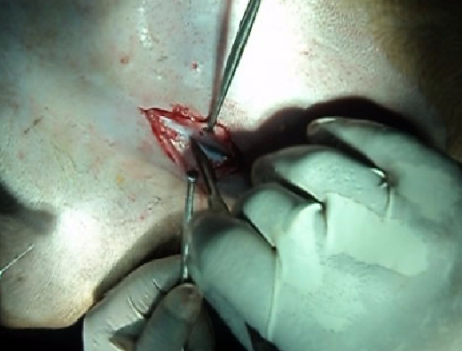
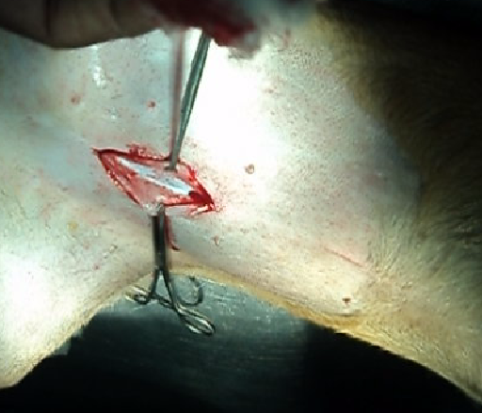

Fig 1 : Paramedian incision for tubectomy

At first the skin and subcutaneous fat was incised in the paramidline midway between the umbilicus and the pubis. It is important to go through the abdominal muscle in the proper location. This location is called the linea alba and the area where the abdominal muscles meet. Making the incision here will yield almost no bleeding and gives the surgeon a strong anchor to the muscles back together. Then the external aponeurosis, internal and transverse abdominal oblique and peritonium were incised in a dorsal to ventral direction to enter the peritoneal cavity. We start the muscle incision with a scalpel and complete it with the scalpel or a scissors taking special care not cut any internal organs.
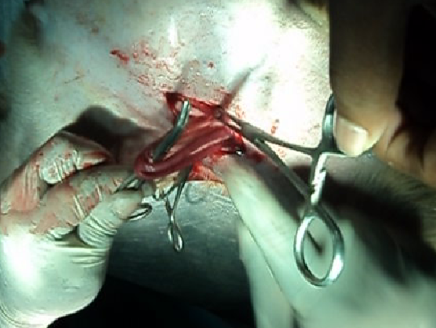
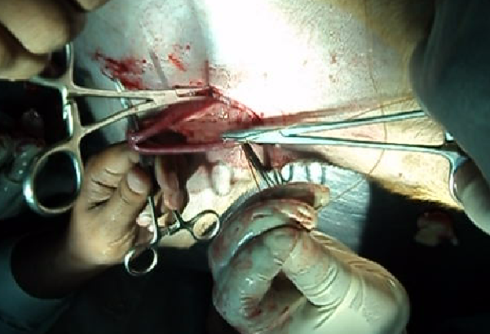

Fig2: Exteriorizing uterine horn by forceps and suturing in uterine horn

Then the entire body was exteriorized until the bifurcation and the cervix was visualized. Then both uterine horns were ligated with catgut (no.2) in the ovarian side and cutting of the uterine horn after ligature was done.
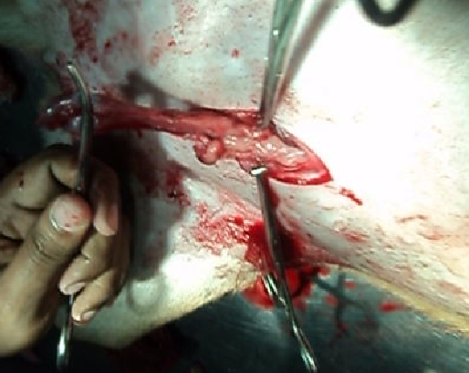
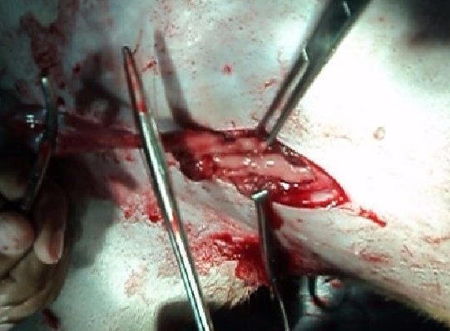

Fig 3 : Excision of uterine horn & suturing in the uterine body

Then another ligation was made immediately proximal to the cervix by using catgut(no.2). the uterine body was grasped with forceps and cut between the suture and the forceps.
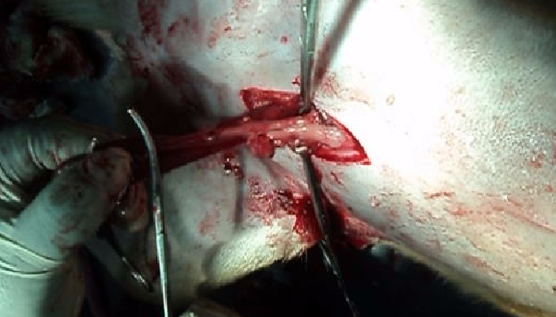
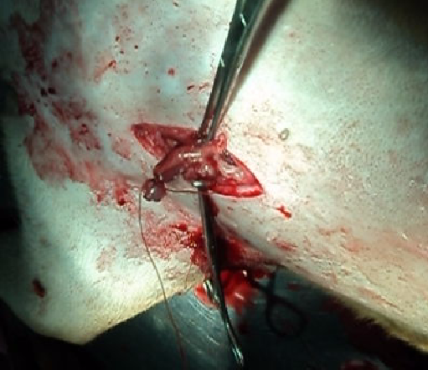

Fig 4 : Excision of uterine body

A small amount of procain penicillin, benzyl penicilin and streptomycin powder (Inj. Streptopen 0.5gm vial , Renata Animal Health) were used before closing the incision for check the contamination. Then the muscle was sutured by simple continuous suture by using catgut(No. 6). The skin was sutured by simple interrupted suture by utilizing nylon thread. A bandage was placed over the incision site.
3.6.7 Post operative monitoring of the patient:
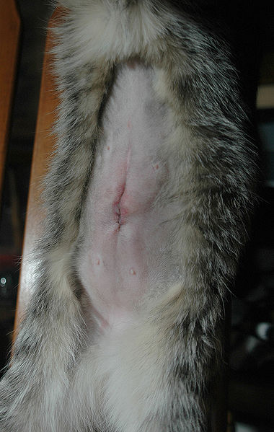
After performing tubectomy the pet was checked thoroughly like temperature, heart rate and respiration rate etc and also the different reflexes like palpebral, pedal, tongue and jaw reflex time to time. This monitoring was continued up to the patient left the hospital. The anesthetic effects were completely recovered after 5-6 hours. The wound was complete healed after 7-8 days.

Fig5 : Complete healing of incision site
3.6.8 Post operative treatment:
Post operative antibiotic Ceftriaxon was injected (Inj. Ceftron® 250mg vial,General Company) @ 42mg/kg bw i/m daily for 7 days to prevent the secondary bacterial infection.Antihistaminic drugs Chlorpheniramine maleate (Inj. Astavet® 10ml vial, Acme Company) was injected @ 2mg/kg bw i/m daily for 7 days to prevent anaphylaxis,allergic and gastric acid secretion. Vitamin B complex ( Inj. Beconex 10ml vial, Renata Company) @ 1ml i/m daily for 7 days.

Chapter 4

RESULT & DISCUSSION

In this study period 5 cases of tubectomy has done in dog(3) and cat(2) in central Veterinary Hospital, Dhaka. Tubectomy in dogs and cats was done by the midline approach procedure in every cases. Atropine sulphate and Zylazine HCl used as pre anesthetic agent, Ketamine HCl used as anesthetic agent to anesthetized the animal and antibiotic Ceftriaxon (Inj. Ceftron® 250mg vial,General Company) @ 42mg/kg bw i/m daily for 7 days to prevent the secondary bacterial infection,Antihistaminic drugs Chlorpheniramine maleate (Inj. Astavet® 10ml vial, Acme Company) @ 2mg/kg bw i/m daily for 7 days to prevent anaphylaxis, allergic and gastric acid secration, Vitamin B complex ( Inj. Beconex 10ml vial, Renata Company) @ 1ml i/m daily for 7 days was applied after surgery. The dog and cat were bright , alert, good in body condition, all physical parameters were taken like temperature, pulse, respiration and all parameters were absolutely normal. All the tubectomized animals during post operative period were appears normal, good in body condition and there was no complication in the operative area and in the body. But after 15 days later a tubectomized cat was suffering from complication in the operative area. There was a large abscess beside the incision site. The cat was treated again removing the pus and then injected antibiotic Tab. Ciprocin(250mg×6), Tab Alatrol(3) for 3 days. The treated cat was fully recovered within 3 days. Smith et. al. (1993) used the midline approach of tubectomy and it was successfully done . In this study the same midline procedure is applied and the operation was successfully done and there was no complications after operation except one case. So it is revealed that midline approach is appropriate for tubectomy in dog and cat.
Chapter 5

CONCLUSION

The study revealed that the operation was done successfully, there was no pre and post anesthetic hazard, no pre and post operative complications in the incision site except one case and it may be concluded from the study that tubectomy could be a safe and easy method to prevent unwanted pregnancy in pet animals or birth control as well as avoid some reproductive disorders. The study was done with the conclusions like to know the procedure of tubectomy practiced in our country, observed the pre and post operative management technique, also observed the pre and post anesthetic hazards of pets, get idea about the depth of different reflexes during GA in dog and cat and identify any complications during post operative management of tubectomy.

Chapter 6

LIMITATIONS OF THE STUDY

In our country tubectomy is not common practice yet. Some concern owner do only tubectomy to their pets. In this study only 5 cases of tubectomy were found in Central Veterinary Hospital, Dhaka during for my internship placement. The post operative care of all cases was not observed because the owners are not interested to leave their pets in the hospital and the facilities of post operative care in that hospital was also limit.

REFERENCES

- Burrow, R., E. Wawra., G. Pinchbeck., M. Senior, and A. Dugdale,(2006). Prospective evaluation of postoperative pain in cats undergoing ovariohysterectomy by a midline or flank approach. The Veterinary Record,158:657-661.

- Berge,E. and M. Westhues,(1966). Veterinary Operative Surgery. Medical Book Company. 7 Aaboulevard. Copenhegen. Denmark. Pp. 315-316.

- Blackshaw, J.K. (1991). "An overview of types of aggressive behavior in dogs and methods of treatment". Appl. Anim. Behav. Sci. 30: 351–361.

- Coe, R. J., N. J. Grint ., M .S. Trivers., A.H. Moore and P.E. Holt, (2006). Comparison of flank and midline approaches to the ovariohysterectomy of cats. The Veterinay Record, 159:309-313

- Fogle, B R(1992). Animal US. Waltham International Focus. 2:2-8

- Fossum, T. W., C.S. Hedlum.,D.A. Hulse., D.A. Johnson. B.S .Hoeard,(1997) . Small Animal Surgery. Mosby. St. Louis. Philadelphia. London. Toronto. Sydney. Pp. 523-524.

- Hosgood G., J. D. Hoskins., J. R. Davidson., & J. A Smith.,(1998). Small animal Paediatric Medicine and Surgery. 1st Edition . Reed Educational and professional publishing Ltd. Pp .165:21-35.

- Paddleford, R.R.(1999). Manual of Small Animal Anesthesia . 2nd Edition. W.B. Saunders company. Philadelphia. London. Toronto. Montreal Sydney, Tokyo. Pp.1-30.

- Slatter, D.(1993). Textbook of Small Animal Surgery. 2nd Edition. W.B. Suanders company. Philadelphia. London. Toronto. Monreal Sydney. Pp 1303-1307.

- Smith , M .M. and R. D.Waldron (1993). Atlas of Approaches for General Surgery of the Dog and Cat. W.B. Saunders company. Philadelphia. London. Toronto. Montreal Sydney. Pp. 172,244-247.

- Venugopalan, A. (2004). Essential of veterinary Surgery. Oxford and IBH Publishing Company privet Ltd. 8th Edition. New Delhi. Pp. 566-567.

1.http://www.emedicinehealth.com/
tubal_sterilization/article_em.htm
2. http://familydoctor.org/792.xml
3. http://www.fwhc.org/birth-control/
tubalig.htm
4. http://en.wikipedia.org/wiki/Tubal_ligation
5. http://www.gynob.emory.edu/
familyplanning/tuballigation.cfm
6. http://www.emedicine.com/med/
topic3313.htm
7. http://www.who.int/reproductive-health/
publications

