Study on Prevalence of PPR Relation with Gastrointestinal Parasitic Infestation in Goat at District Veterinary Hospital in Faridpur.

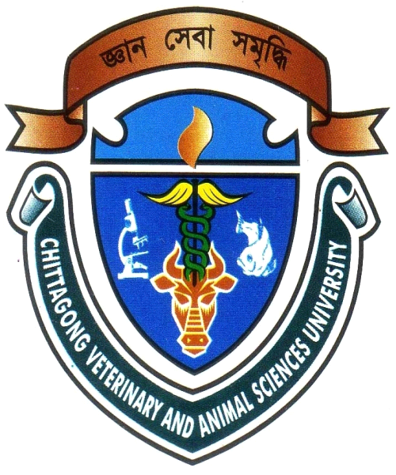

A CLINICAL REPORT SUBMITTED BY
MANOBANDRO MAJUMDER
ROLL NO: 2005/15
REG NO: 207
INTERN ID: B-15

Report presented in partial fulfillment of the requirement for the degree of
Doctor of Veterinary Medicine.

Chittagong Veterinary and Animal Sciences University
Khulshi, Chittagong -4202
February, 2011
Study on Prevalence of PPR Relation with Gastrointestinal Parasitic Infestation in Goat at District Veterinary Hospital in Faridpur.

A clinical report submitted as per as approved style and content.

Signature of supervisor
DR. MD. ABUL QUASEM Ph. D
Professor
Department of Anatomy and Histology
Chittagong Veterinary and Animal Sciences University

Signature of Author
MANOBANDRO MAJUMDER
Roll No: 2005/15
Reg, No: 207
Intern ID: B-15

Faculty of Veterinary Medicine
Chittagong Veterinary and Animal Sciences University
Khulshi, Chittagong -4202

February, 2011

