Study on Prevalence of PPR relation with gastrointestinal parasitic infestation in goat at District Veterinary Hospital in Faridpur.

ABSTRACT
The study was undertaken to know the prevalence of PPR and to determine relation between PPR and parasitic infestation in three breeds of goat Black Bengal, jamunapari and crosses of Black Bengal with jamunapari at district veterinary hospital in Faridpur. The duration of this study was two month. The study was designed on clinical findings. About 118 goats were hospitalized during this time among them 86 goats were found affected with PPR. The disease was diagnosis by clinical findings. It was about 73.78% goat affected with PPR. It was prevailed high at the age 5-12 months. In this study there found high prevalence of PPR in female in Black Bengal, Jamunapari and cross were 82.97%, 77.78% and 58.33% respectively. In case of clinical findings as temperature, heart rate, respiration rate and dehydration were assessed. In Black Bengal goat the highest temperature, heart rate, respiration and dehydration were recorded 63.83% (104ºc to 105.9ºc), 36.17% (70-90/minute and 91-110/minute), 51% (30-50/minute) and 55.32% slight dehydration respectively. In jamunapari goat the highest temperature, heart rate, respiration and dehydration were recorded 40.74% (102ºc to 103.9ºc), 40.74% (70-90/minute), 55.55% (30-50/minute) and 62.96% slight dehydration respectively. In cross goat the highest temperature, heart rate, respiration and dehydration were recorded 58.33% (104ºc to 105.9ºc), 41.67% (91-110/minute and 110-130/minute), 58.33% (30-50/minute) and 66.63% slight dehydration respectively. Percentages of GI parasite affected goat which were showing PPR simultaneously in Black Bengal, Jamunapari and cross were 74.47%, 88.88% and 75% respectively. Among the parasites the egg of Hemoncus spp ,Tricostrongylus spp as nematode Monezia spp as cestode and fasiola gigantica as trematode found. It was found nematode highest in Black Bengal, Jamunapari and cross were 68.57%, 66.67% and 55.56% respectively. In these combined infected goat the severe form of PPR found in this three breed (Black Bengal, Jamunapari and cross) were 57.14%, 62.50% 77.77% respectively.

Key word: PPR, GI parasites, Black Bengal, Jammunapari, relation between GI parasites with PPR.
CHAPTER -I

INTRODUCTION

Agriculture is the economical base of our country. Livestock is one of the most powerful components in the agricultural economy of Bangladesh. The contribution of livestock sub-sector to the agricultural production and annual growth rate of the livestock sub sector are 12.9 and 7.6% respectively (BBS, 1998).The contribution of livestock subsector in GDP in the year of 1995-96, 2000-2001, 2005-2006 were 3.36,2.95 and 2.93 respectively.(BBS, 2007). Among livestock the goat rearing is very popular. Goat is considered as the poor man’s cattle. In Bangladesh, there are about 34.5 millions of goats (FAO, 2003). About 97.90% of goats are distributed in rural areas and 2.10% in urban areas (BBS, 1986). In addition to its production of high quality of meat, Black Bengal goat provides world famous skin. There are several diseases in goat which cause higher mortality. In present conditions goats are affected with serious exotic killer disease Peste des petits ruminants (Debnath, 1995).

Antelope and other small wild ruminant species can also be severely affected (Abu Elzein et al., 2004). PPRV antigen has been detected in an outbreak of respiratory disease in camel and sick domestic buffaloes (Taylor et al., 1990; Scott, 2000 and Abraham et al., 2005). In addition, PPRV is considered as a serious predisposing factor for respiratory disease complex in sheep and particularly in goats, (Taylor et al., 1990).

The etiological agent of PPR is Peste des petits ruminants virus (PPRV) has been classified under family Paramyxoviridae, Order Mononegavirales and Genus Morbillivirus (Tober et al., 1998). Similar to other morbilliviruses, PPRV is fragile and it can’t survive for long time outside the host. Its half life has been estimated to be 2.2 minutes at 56ºC and 3.3 hours at 37ºC (Rossiter and Taylor, 1994). Like other members of the family Paramyxoviridae, PPR virus is an enveloped pleomorphic particle. The genome of PPRV is single stranded RNA, approximately 16kb long with negative polarity (Haas et al., 1995). PPR virus, like other morbilliviruses, is lymphotropic and epitheliotropic (Scott, 1981).

It induces the most severe lesions in organ systems rich in lymphoid and epithelial tissues. The incubation period is about four days. The disease is particularly in young animals. The disease is characterized by mainly three symptoms like discharge (nasal, ocular and oral) diarrhea and death., hence it is called 3D disease. The other symptoms are high fever, eroded stomatitis, pneumonia and gastroenteritis (Radostits et al., 2000). Erosions on the mucous membrane of the buccal cavity are accompanied by marked salivation. Ulcers develop in the mucosae of the alimentary, respiratory and urinary tracts. Conjuctivitis with ocular discharge is a feature of the disease. A profuse diarhhoea, which results in dehydration , develops within days of infection. Signs of tracheitis and pneumonia are common. There is asevere leucopenia which facilitates secondary bacterial infection.Pulmonary infections caused by Pasteurella species are common in the later stages of the disease.Pregnant animals may abort. Mortality rates in severe outbreaks often exceed 70 % and actually affected goats may die within ten days of exposure to the virus. (Quinn et al., 2005; Forsyth and Barret, 1995).

Pestides des petits ruminants virus might lead to high economic losses where mortality in goats could reach 95% and in sheep only slightly less (Murphy et al., 1999). PPR occurs in most African countries, the Middle East and the Indian subcontinent (Abraham et al. 2005., EI-Hag and Tylor, 1984; Lefevre, 1982; Lefevre et al., 1991 and Tylor, 1984). PPR was first described in Ivory Coast (Gargadennec and Lalanne, 1942) and then after, it has been recognized in many of the sub-Saharans countries that lie between the Atlantic Ocean and the Red Sea (Lefevre and Diallo, 1990).

In Bangladesh, the PPR virus was identified during a severe outbreak in 1993 (Shil et al., 1995) which was further confirmed by World Reference Laboratory and found that the virus has a close relation with Indian isolates (West Bengal) of PPR virus at a cluster with Asian group (Barrett et al., 1997).

PPR in goat has been recorded in 1993 from the border belt areas of south western districts of Bangladesh and then spreads like epidemics fashion throughout the country. It has been reported that the Black Bengal goats were more susceptible (67.24%) to PPR than Jamunapari breed (32.76%). Morbidity varies from 40-95% and mortality as high as 80-85% (Samad, 2000). In Bangladesh, outbreak of Rinderpest like disease, later confirmed by a reference laboratory to be PPR during 1993 in border belts area of South Western districts (Sathkhira, Jessore and Barguna) of Bangladesh by Dr Taylor PPR was not clearly recognizable up to 1972. It still causes serious economic losses (Diallo, 2003).

PPRV is transmitted by direct contact with secretions and excretions of infected animals. It is highly contagious and all discharges can carry virus. Substantial quantities of virus are found in ocular nasal or oral secretions of sick goats and in the feces late in disease (Abegunde and Abu, 1977).

The outbreak of this disease causes a heavy economic loss in Bangladesh. Currently Bangladesh government has taken a national scheme of poverty alleviation through goat rearing. The total program will be null and void if the said disease will not control in Bangladesh. PPR is immunologically similar to rinderpest and produce solid immunity so prevention of the disease by vaccination is easier than any other method (Shil, 2000).

Other hand gastrointestinal parasitic infections in small ruminants are also considerable economic importance because small ruminants' rearing has been a major source of income especially to the marginal farmers (Bandyopadhyay, 1999). Parasitism is an important limiting factor especially in Bangladesh as because the climatic condition of the country favors the development and survival of various parasites. In fact, goats of Bangladesh are affected by various intestinal helminths (Qadir, 1967; Haq and Shaikh, 1968). These parasites reduce appetite with concomitant reduction of food intake, an increased passage of food through the digestive tract, indirectly may be the cause of decreased food utilization and eventually decrease the synthesis of protein in the skeletal muscle (Soulsby, 1965). They also cause retarded growth (Ashraf, 1985 and Kochapakdeeet et al., 1995), lowered productivity (Perry and Randolph, 1999), mortality (FAO, 1974) and high economic losses (Irfan, 1984 and Iqbal et al., 1993). . The most important parasites include coccidia (protozoa), nematodes (roundworms), cestodes (tapeworms), and trematodes (flukes) (GORSKI et al., 2004). Goats suffer more frequently haemonchosis (Maqsood et al., 1996., Nwosu et al., 2007and Tariq et al., 2008). The parasites reduce immunity by causing malnutrition in animal because some gastrointestinal parasites serious blood suckers (Githigia et al., 2001).

There may be a close relation with PPR and GI parasites .The main aim of this study was finding the relation between PPR with parasitic infestation in goat. Though the parasites cause serious malnutrition, it may predispose the PPR virus causing acute and severe infection.

Considering all aspect described, the present study, therefore, undertaken with the following objectives-

OBJECTIVES

- To study the occurrence of PPR in terms of breed, age and sex.
- Study on clinical sign and symptoms of PPR infected goat in field level.
- To determine the relation between PPR and parasitic infection in goat.

CHAPTER-II
REVIEW OF LITERATURE

PPR and GI parasites are the most prevailed diseases in goat. Both of them cause huge economic loss to farmer. To know details about their nature, mode of transmission, clinical feature and control and prevention lot of research was performed. Among them some important works has been re-mentioned blow

2.1 PPR infection in goat

2.1.1 History:
Gargadennec and Lalanne (1942) were reported the disease was first described in Ivory Coast of West Africa in 1940.

Lefevre and Diallo (1990) were mentioned it has been recognized in many of the sub-saharian countries that lie between the Atlantic Ocean and the Red Sea.

Shil (2000) was said the PPR virus was first isolated by Gilbert and Monnier in 1962 in Senegal.

Furley et al., (1987); Lefevre et al., (1991); Perl et al., (1994); Taylor et al. (1990), Ozkul et al. (2002) were reported PPR is present in nearly all Middle Eastern countries up to Turkey.

Shaila et al. (1989) was Said that It is also widespread in India and southwest Asia Presently, PPR occurs in most African countries situated in a wide belt between the Sahara and equator, the middle east (Arabian peninsula, Israel, Syria and Jordon) and the Indian subcontinent.

Abdollahpour et al, (2006) was Mentioned outbreaks of PPR are now known to be common in India, Nepal, Bangladesh, Pakistan and Afghanistan.

Shil, (1995) and Debnath, (1995) was reported later it spread in Bangladesh at 1993.

2.1.2 Geographical Distribution:
Gilbert and Monnier (1962). Was mentioned that The PPR virus was first recorded and isolated by in Senegal, although clinical description was reported from Ivory Coast during 1942. PPR virus circulates in belt lying across Africa and Saudi Arabia in 1981 and spread North wards from Saudi Arabia into Jordan, Syria, Iraq, Iran and Pakistan. PPR has also reported from Southern states of India in 1987 and later it spread in to other Indian States. A serious outbreak of PPR in goats has been recorded in 1993 from the border belt areas of Southwestern districts of Bangladesh and then spreads like epidemic throughout and the country.
2.1.3 Agent and Morphology:
Tober et al., (1998) was mentioned the etiological agent , Peste des petits ruminants virus (PPRV) virus has been classified under family Paramyxoviridae, Order Mononegavirales and Genus Morbillivirus.

Haas et al., (1995) was said that genome of PPRV is single stranded RNA, approximately 16kb long with negative polarity. PPR virions, as other morbilliviruses, are enveloped, pleomorphic particles containing single strand RNA as the genome.

Barrett et al., (1993) was said it is closely related to rinderpest virus, canine distemper virus, and human measles virus.
Rossiter and Taylor, (1994) was reported Similar to other morbilliviruses, PPRV is fragile and it cannot survive for long time outside the host. Its half life has been estimated to be 2.2 minutes at 56 ºC and 3.3 hours at 37ºc.

Shil, 2000 and Barrett et al., (1998). was reported it is composed of 15, 948 nucleotides,which is encoded with six structural protein, e.g. Necleocapside (N), Matrix (M), Fusion (F), Haemagglutinin (H), Polymerase (P), The PPR virus identified in Bangladesh is under the lineage 4 of PPR phylogenetic tree based on the N gene analysis .

2.1.4 Hosts:
Saliki, (1998);EMPRES, (1999); Ozkul,( 2002);Lefevre and Diallo, (1990) was mentionmed Cattle, buffaloes, camels, and pigs are also susceptible to infection but do not exhibit clinical signs and are unable to transmit the disease to other animals.
Shaila et al., (1989) was mentioned that natural disease affects mainly goats and sheep, but it is usually more severe in goats where it causes heavy losses and is only occasionally severe in sheep Black Bengal goats are more susceptible (67.24 %) to PPR than Jamunapari breed (32.76 %).
Blood et al., (1995) was reported, susceptibility to infection rises with age. However, the disease is rapidly fatal in the young animals (60.87 %) especially at 7-12 months of age.
Venkataramanan et al., (2005) said that PPR is a major constrain in the development of goat industry due to high morbidity (50-90%) and case fatality (50- 85%) rates. Kids over 4 months and under 1 year of age are at highest risk and cause huge economic loss per year.

2.1.5 Pathogenecity:
Gibbs et al., (1979) .Mentioned that PPR virus is not pathogenic for cattle but rinderpest can also affect goat along with PPR.

Sil et al., (2000-2001). The high morbidity (100%) and mortality (50-90%) rates in goats caused by PPR have been described in Bangladesh, followed by evaluation of ELISA as field diagnostic method and inactivated vaccine to control this disease.

Opasina et al., (1985). Found Case fatality rate is higher in goats (55-85%) compared to sheep (45-75%).

Taylor, (1984); Lefebvre and Diallo, (1990) was mentioned that when a susceptible population builds up, periodic epizootics (outbreak) occurs, some of which might lead to almost 100% mortality among affected goat and sheep at risk.

2.1.6 Transmission
Abegunde and Abu, (1977) was found PPRV is transmitted by direct contact with secretions and excretions of infected animals. It is highly contagious and all discharges can carry virus. Substantial quantities of virus are found in ocular nasal or oral secretions of sick goats and in the faeces late in disease.

Shanthi kumar et al., (1994) was reported that the virus is present in eye, nose, and mouth discharges as well as feces. Faeces is the main spreading agent and through it, disease may occur in epidemic proportion.

Radostits et al., (1994), Fraser, (1986) was mentioned that newly purchased animal from market and wild animal have been suspected to play a role for spreading a disease.

2.1.7 Pathology:
Rowland et al., (1971) was mentioned PPR virus causes epithelial necrosis of the mucosa of the alimentary and respiratory tracts marked by the presence of eosinophilic intracytoplasmic and intranuclear inclusion bodies. In the spleen, tonsil and lymph nodes, the virus causes necrosis of lymphocytes evidenced by pyknotic nuclei and karyorrhexis.

Scott, (1981) was said that PPR virus, like other morbilliviruses, is lymphotropic and epitheliotropic.

Brown et al., (1991) was found multinucleated giant cells (syncytia) can be observed in all affected epithelia as well as in the lymph nodes

Rahman et al., (2001) was found that Lungs were highly consolidated in apical lobe, echymotic and brush paint haemorrage were found in epicardium.

Sil, (2000) was found that Zebra stripes are formed by haemorrage in the fold of rectum. Lymphocytes percentage declines (up to 21 %) with onset of duration of diseases increases at the same time neutrophilia (up to 72 %) occur.
Kulkarni et al., (1996) was proved that Pneumonia was not always a consistent feature of PPR in goat.

2.1.8 Clinical Features
Barrett, (1994) was found incubation period of PPR disease is 2-10 days, commonly 4-5 days.

Defra, (2001) and Sil, (2000). Was reported that after incubation period patients develop sudden high fever (40°C-41°C), remaining high for 5-8 days., will return to normal before recovery or drop below normal before death.

Lefevre and Diallo,( 1990);Rowland et al., (1969) was found after infection, the clinical signs are as Serous nasal discharge, becoming mucopurulent., can crust over and occlude nostrils. Purulent ocular discharge with congested conjunctiva and bronchopneumonia generally found.

Ikede and Uzoukwu, (1983); Bundza et al.,( 1968); Brown et al., (1991). Was reported that Necrosis and ulceration of mucous membrane, Non haemorrhagic diarrhea, respiratory distress, including dyspnea and sneezing. Excessive salivation and anorexia. Severe dehydration and emaciation followed by hypothermia. Death usually occurs after 5-10 days

Prognosis:
Saliki, (1998) was mentioned that young animals (7 to 12 months of age) often suffer more severe disease.

Dhar, (2002) was found that the prognosis of acute PPR is usually poor., especially when lesions do not resolve within 2 to 3 days or when extensive necrosis and bacterial infection hive the animal's breath an unpleasant, fetid odor.

2.1.9 Outbreak Control:
Saliki, (1998) was mentioned that methods applied for rinderpest eradication may be appropriate for PPR.
Nanda et al., (1996) was found these include the quarantine, slaughter, proper disposal of carcasses and avoiding contact fomites, decontamination of facilities and equipment, restrictions on importation of sheep and goats from infected areas.

2.1.10 Treatment and vaccination
Sil et al., (2000-2001) was said PPR being an exotic disease in Bangladesh, there is a very little knowledge about its epidemic nature, diagnostic techniques and control strategy.A control programme using locally produced tissue culture live attenuated rinderpest vaccine, as well as imported rinderpest vaccine were adapted against PPR in this country, but failed.
Sil and Scott, (2000) was found that the efficacy of the thermo stable PPR vaccine incubated at room temperature for 14 days. Hyper immune serum can be used successfully along with long acting antibiotic (Antibiotic combined hyper immune serum therapy) to limit the the spread of virus and recover those animals which are under incubation and in early stage of infection. Good nursing, symptomatic treatment with broad spectrum antibiotic/sulphur drugs can safe life of sick animal and also can improve the immunosuppressive condition of the affected goat.

Diallo, (2002) was reported that a homologous PPR live vaccine was developed, but the main disadvantage of this vaccine, like other Morbillivirus vaccine, is its poor thermal stability.

Chowdhury et al. (2004) was said that to solve this problem, a thermo stable PPR vaccine has been developed experimentally by scientists of BLRI and DLS.
2.2 Parasitic infestation in goat
Soulsby, (1965) was said parasites reduce appetite with concomitant reduction of food intake, an increased passage of food through the digestive tract, indirectly may be the cause of decreased food utilization and eventually decrease the synthesis of protein in the skeletal muscle.
Qadir, (1967); Haq and Shaikh, (1968) found that goats of Bangladesh are affected by various intestinal helminths ferquenly.
Irfan, (1984) and Iqbalet al., (1993) was reporteted that due to the GI parasites found huge economical loss
Ashraf, 1985 and Kochapakdeeet al., (1995) was mentioned parasites cause retarded growth.
Al-Quaisy et al., (1987) was mentioned Production potential of livestock development programs is plagued in tropical and subtropical areas due to prevalence of helminthes which causes high mortality and great economic losses.
Perry and Randolph, (1999) was mentioned that the GI parasite infection cause low productivity in goat.
Bandyopadhyay, (1999) gastrointestinal parasitic infections in small ruminant’s considerable economic importance in small ruminants' rearing has been a major source of income especially to the marginal farmers.
Maqsood et al., (1996); Nwosu et al., (2007) and Tariq et al., (2008) was observed that Goats suffer more frequently haemonchosis.
Githigia et al., (2001) reported that parasites reduce immunity by causing malnutrition in animal because some gastrointestinal parasites serious blood suckers.
Gorski et al., (2004) was said most important parasites in goats include coccidia (protozoa), nematodes (roundworms), cestodes (tapeworms), and trematodes (flukes).
Pathak and Pal, (2008) were reported that Systemic studies on the prevalence of gastrointestinal parasites in goats revealed that the percentage of overall prevalence of infection was 85.22%. Seasonal prevalence was highest in monsoon (94.60%), moderate in summer (87.50%) and lowest in winter (63.15%)

Saiful Islam and Taimur ,(2008) were mentioned that prevalence of internal parasitic infections was higher in goats (74.55%) than in sheep (55.88%). Liver fluke (F. gigantica) was more prevalent in goat (14.28 %) than in sheep (8.82%) whereas tapeworm infection was more frequent in sheep (24.26%) in comparison to goat (16.52%).
2.3 Relation between PPR and GI parasites
Al-Quaisy et al ., (1985) said parasite because Malnutrition so any viral disease may cause severity.
S.S.Rautmare, (2010) was mentioned Poor nutritional status, stress of movement, and concurrent parasitic and bacterial infections enhance the severity of clinical signs of PPR diseases.

CHAPTER- III
MATRIALS AND METHODS

3.1 Study area
The study was conducted district veterinary hospital (DVH) in Faridpur district. The study period was two months from 27 June to 28 August, 2010.
3.2 Collection of data
The study was conducted on PPR infected sheep and goats of various age, sex and breed that were brought to the hospital over the study period. All clinical data was recorded in a case sheet.
3.3 Study population
About 150 cases were handled in hospital. Among them 103 was goat of different breed (Black Bangal, jamunapari and Black Bangal and jamunapari cross). 73 of them were affected with PPR. Among them 65 was affect with parasites. The total samples were divided into several groups such as species, age, and sex.
3.4 Diagnosis procedure of PPR
Diagnosis was performed by collecting information on history from owner, observing clinical signs and physical examinations of the goats thoroughly. In this study, population groups were divided in two groups, depending upon the early stage and later stage of clinical signs and symptoms according to breeds .According to BLRI 1999, PPR consists of 5 phase of infection cycle as incubation period, prodermal phage, erosive phage, pneumonic phage, diarrhea and death.
Here, prodermal and erosive phage was considered as early stage and pneumonic phage and diarrhea as later stage of infection.
Infected animal of early stage showed sharp rise temperature (104˚-106˚F), impaired appetite, depression, erected hair, serous nasal discharge, and sneezing, congested oral mucosa and later may found erosion in the lip, buccal mucosa, gum, dental pad, plate, tongue and nasal passage.
In later stage, the animal showed mucopurulent to purulent nasal discharge which may encrusted and mated over the mouth. Pneumonia, severe dyspnoea, diarrhea with dark brown colored fluid feces and necrotic debris streaked with or without blood. Temperate regresses with advancing dehydration and emaciation and increased heart and respiration rate. In severe case recumbence found.

3.4.1 Anamnesis
History of the cases were taken from the owner and carefully recorded in each case individually.

3.4.2Clinical examination:
The flowing clinical examinations were done carefully and the findings were recorded.
3.4.3 Distance inspection
It was performed by observing the animal from distance. It’s posture and gait mainly observed.

3.4.4 Close inspection
Close inspection were performed properly in order to observe the presenting signs such as a sharp rise of temperature of 104⁰F – 106⁰F, occulonasal discharge, diarrhea, respiratory distress and off feed.
3.4.5 Temperature
Per rectal temperature were recorded with the thermometer in every case by digital thermometer, model: MC-240 manufacturer: OMRON Healthcare company Ltd, Japan.
3.4.6 Indirect auscultation
Respiratory distress was identified with the help of stethoscope and observed the lung and tracheal sound and recorded. Heart rate also measured by stethoscope.

3.4.7 Dehydration test:
Dehydration was measured by skin fold test. Three category of dehydration found
- Severe dehydrated
- Moderate dehydrated
- Slight dehydrated.

3.5 Diagnosis of GI parasite
The egg of GI parasite was Diagnosis by direct smear method. The freshly collected feces sample was homogenized properly. Then a drop of sample was taken on slide. Then observation under microscope (manufactured by Olympus) in low magnification.
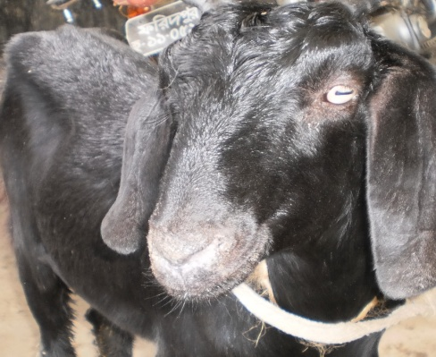
3.6 Clinical sign and symptom of PPR
- Markedly depressed and dull appearance.
- Rough hair coat.
- Thick serous or purulent discharge from the eyes and nose.
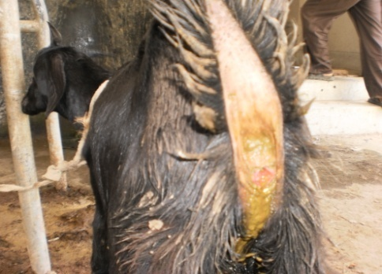
- Sudden high fever (104⁰ – 106⁰ F), remaining high for 5-8 days, will return to normal before recovery or drop below normal before death.
- Anorexia, severe dehydration and emaciation followed by hypothermia.
- The mucous membrane of the mouth and eyes become much reddened and small pinpoint grayish areas appeared on the gum, dental pad, palate, lips and upper surface of the tongue and characteristic foul smell came out from mouth.
- Faces were semisolid and liquid green brown, yellow and black colored, watery foul smelling and contain blood streaks and pieces of dead gut tissue.
- In severe cases, difficulty in breathing marked by extension of head and neck, dilation of nostrils, protrusion of the tongue and soft painful coughs.

3.7 Clinical sign and symptom of worm infestation
- Rerated growth.
- Loss of body weight.
- Fetid diarrhea.

3.8 Analysis of data
Data were compiled with Microsoft exel 2007 and statical calculations were done by statistical calculator ‘Statpac’ version 3.00 by 1997-2005 Statpac, Inc.
A descriptive analysis was carried out to express the result in frequency (F) and percentage (%) and risk ratio,$χ^{2}−$value, p-value, significant interpretation was analyzed.

CHAPTER-IV
Result and discussion

Following table 4.1 was showing that highest in Black Bengal and cross. About 75% affected in Black Bengal and Crosses. 64.28% affected in Jamunapari.

Table 4.1: PPR prevalence in breeds of goat

Breed | No. of Samples | No of non affected | No. of Affected | Percentage of affected | Percentage of non affected | $χ^{2}−$value | p-value | Interpretation
Black Bengal | 60 | 15 | 47 | 75% | 25% | 1.62 | 0.45 | insignificant
jamunapari | 42 | 10 | 27 | 64.28% | 35.72% | 1.62 | 0.45 | insignificant
Cross | 16 | 4 | 12 | 75% | 25% | 1.62 | 0.45 | insignificant
Total | 118 | 27 | 86 | 72.88% | 27.22%

According to Shaila et al., (1989) Black Bengal goats are more susceptible (67.24 %) to PPR than Jamunapari breed (32.76%). But the study was showing little difference. The study was not fully agreed with them. But Black Bengal was showing more diseases susceptibility than jamunapari goat. In this aspect the study was supporting their Observation.

Table4. 2: Prevalence of Diseases in different age group
breed | 0-6 Months | 7-12 Months | >12 Months | Total | $χ^{2}−$value | p-value | Interpretation
Black Bangal | 30  63.63% | 11  23.40% | 6  14.89% | 47 | 13.52 | 0.228 | insignificant
Jamunapari | 4  14.81% | 14  51.85% | 9  33.34% | 27 | 13.52 | 0.228 | insignificant
Cross | 5  41.67% | 5  41.67% | 2  16.67% | 12 | 13.52 | 0.228 | insignificant

Susceptibility of PPR disease in age group is presented in Table. Data shows that, 0-6 month’s age group In Black Bengal, over 12 months in Jamunapari and 0-6months, 7-12months were more susceptible. In case of BB the 63.63 % affected goats were in between 0-6 months range. But in jamunapari it is 50% in over 12 month’s age. But in cross it was 41.67% in both 0-6 months and 7-12 months. It was found more prevalence of PPR in goat under 1 year of age specialy 4- 12 months of age (Venkataramanan et al., 2005) and 7-12 months of age (Blood et al, 1995). The current study fully agrees with them.

Table 4.3: Prevalence of PPR according to sex
breed | Female | Male | Total | $χ^{2}−$value | p-value | Interpretation
Black Bengal | 39  82.97% | 8  17.03% | 47 | 3.37 | 0.19 | insignificant
Jamunapari | 21  77.78% | 6  22.22% | 27 | 3.37 | 0.19 | insignificant
Cross | 7  58.33% | 5  41.67% | 12 | 3.37 | 0.19 | insignificant

In Black Bengal 82% animal were female which was afeected with PPR.In jamunapari about 77.78% but in cross was female 58.33% which were lower than other breeds. It may due to the females were normally immunological status suppressed due to pregnancy or milking status (Chakrabarti, 2004).Samad,(2001)was found around 55% female goat affected with PPR. But this study shows higher value than Samad’s observation.

Table 4.4: Temperature recorded in PPR affected goats
Breed | 102.0-103.9ºc | 104-105.9ºc | 106ºc and over | Total | $χ^{2}−$value | p-value | Interpretation
Black Bengal | 17  36.17% | 30  63.83% | 0  0% | 47 | 24.755 | 0.0001 | insignificant
Jamunapari | 11  40.74% | 7  25.92% | 9  33.33% | 27 | 24.755 | 0.0001 | insignificant
Cross | 5  41.67% | 7  58.33% | 0  0% | 12 | 24.755 | 0.0001 | insignificant

In study maximum temperature was found in black Bengal (63.83%) at the range of 104-105.9 ͦ c, in jamunapari highest value ( 40.74%) at 102.0 to 103.9ºc and 25.92% was found at the range of 104-105.9 ͦ c and over 106ºc ( 33.33% ) found. In cross highest 58.33% was found at 104º-105.9ºc. That indicating that high fever was comparatively higher in jamunapari than Black Bengal and cross. A wide range of variation in fever was found in PPR according to severity. In Severe condition high temperature were recorded. Comparatively in Jamunapari acute sever form of PPR was found in higher degree.
According to Radostitis et al., (2000) in PPR there found 104ºc - 105ºc and over in initial stage. This study also agrees with them. Maximum patient in this study was shown fever in this range.

Table 4.5: Heart rate recorded in PPR affected goats
Breed | 70-90/minute | 91-110/minute | 111-130/minute | Total | $χ^{2}−$value | p-value | Interpretation
Black Bangal | 17  36.17% | 17  36.17% | 13  27.66% | 47 | 8.095 | 0.0881 | insignificant
Jamunapari | 14  40.74% | 3  25.92% | 10  33.33% | 27 | 8.095 | 0.0881 | insignificant
Cross | 2  16.66% | 5  41.67% | 5  41.67% | 12 | 8.095 | 0.0881 | insignificant

Table4.5, showing that in case of Black Bengal the maximum heart rate were 36.17% recorded at both 70-90/minute and 91-110/minute range groups. That means over one third of the study sample’s heart rate were at range of 70-110/minute. In case of jamunapari highest values recorded 40.74% at the range of 70-90/minute and in cross 41.67% were recorded both in 91-110/minute and 111-130/minute. That indicating in cross about 83.44% was at the range of 91-130/minute. It was indicating clearly that in case of cross heart rate was higher in compression to others. It may be due to the age of the animals, severity of dehydration and nutritional status. In young age, severe dehydration and anemic condition cause higher degree of heart rate. In cross above 80% were below 1 year.

Table 4.6: Respiration rate recorded in PPR affected goats
Breed | 30-50/minute | 51-70/minute | 71-90/minute | Total | $χ^{2}−$value | p-value | Interpretation
Black Bengal | 24  51.06% | 20  42.55% | 3  6.38% | 47 | 2.939 | 0.5681 | insignificant
Jamunapari | 15  55.55% | 11  40.74% | 1  3.70% | 27 | 2.939 | 0.5681 | insignificant
Cross | 7  58.33% | 3  25% | 2  16.67% | 12 | 2.939 | 0.5681 | insignificant

In case of respiration rate highest values were found in all breeds at the range of 30-50/minute. In Black Bengal, Jamuapari and cross it were respectively 51.06%, 55.55% and 58.33% respectively. That means over half of the study population were in normal range of respiration rate. Mainly respiration rate increases in PPR in chronic pneumonic condition. But maximum goats were brought to hospital at initial stage, when pneumonic conditions of goats were not so severe. The respiration found higher in case of PPR (Rodestitis, 2000). The study agrees with the observation. It found higher respiration rate in disease condition.

Table4.7: Dehydration recorded in PPR affected goats
Species | Slight | Moderate | Severe | Total | $χ^{2}−$value | p-value | Interpretation
Black Bengal | 26  55.32% | 8  17.02% | 13  27.66% | 47 | 1.08 | 0.90 | insignificant
Jamunapari | 17  62.96% | 3  11.11% | 7  25.92% | 27 | 1.08 | 0.90 | insignificant
Cross | 8  66.67% | 1  8.33% | 3  25% | 12 | 1.08 | 0.90 | insignificant

The table 4.7 was showing that the slight dehydration was found in case all breeds in maximum value. The values were 55.32%, 62.96% and 66.67% in Black Bengal, Jamunapari and cross respectively. It was indicating that the maximum patients were brought to hospital just 1 or 2 days after showing clinical sign. It also found that severe dehydration was higher than moderate dehydration.
According to (Rodestitis et al., 2000) just after showing the clinical sign the dehydration is not remarkably. After few days of diarrhea the animal become severely dehydrate which lead to animal die. The study also support this statement the maximum study patient was hospitalized just after the showing the clinical sign.

Table 4.8: Percentages of parasite affected goat which showing PPR in different breed
Breed | No of examined | Presence of parasites egg in feces | Absences of parasites egg in feces
Black Bengal | 47 | 35(74.47%) | 12 (25.53%)
Jamunapari | 27 | 24(88.88%) | 3 (11.11%)
Cross | 12 | 9 (75%) | 3 (25%)

Study was showing that about 75% animals which affected with PPR also affected with different types of GI parasites in Black Bengal And cross. In Jamunapari it rises up to 88.88%. The jamunapari was more prone to GI parasitic infection. Black Bengal was more Resistance to GI parasites than other breed (Maqsood et al, 1996). Study also agrees with him. It found more resssistance in Black Bengal against GI parasites than other breed.

Table 4.9: Different type of parasite infestation in PPR affected goat
Breed | Nematode | Cestode | Trematode | Total | $χ^{2}−$value | p-value | Interpretation
Black Bengal | 24  68.57% | 9  25.71% | 2  5.71% | 35 | 1.57 | 0.813 | insignificant
Jamunapari | 16  66.67% | 7  29.16% | 1  4.17% | 24 | 1.57 | 0.813 | insignificant
Cross | 5  55.56% | 4  44.44% | 0  0% | 9 | 1.57 | 0.813 | insignificant

Above observation showing that nematodes (Hemonchus spp, Trichostrongylus spp) infection was highest in every breed. It founds 68.57% in Black Bengal which is highest among all breeds. Mainly in goat Hemonchus spp is very dangerous gastrointestinal parasite (Maqsood et al., 1996. Nwosu et al., 2007., Tariq et al., 2008). It is serious blood sucker cause serious malnutrition and predisposes other diseases (Githigia et al., 2001). Cestode like Monizia spp was found in highest 44.44% in cross.

Table 4.10: Effect of parasites on severity in PPR affected Goat
Species | Mild | Moderate | Severe | Total | $χ^{2}−$value | p-value | Interpretation
Black Bengal | 4  11.42% | 11  31.42% | 20  57.14% | 35 | 1.66 | 0.80 | insignificant
Jamunapari | 3  12.5% | 6  25% | 15  62.5% | 24 | 1.66 | 0.80 | insignificant
Cross | 1  11.12% | 1  11.11% | 7  77.77% | 9 | 1.66 | 0.80 | insignificant

Table 4.10 was showing that the goat which suffering from both PPR and parasitic infection combined, showing severity high. In cross about 77.77% animals was showing severe form of PPR. The Black Bengal and Jamunapari the severe form of PPR prevalence was 57.14% and 62.5% respectively. That indicating that the parasitic infection may assist PPR virus for developing severe form of PPR. Severity was asses based on the recorded clinical sign showing the study population during study. High fever (105ºc and over) watery diarrhea and high respiration rate with mucoplurent discharged (Rodestitis, 2000) take as severe form of PPR. Fever around 104ºc, Semisolid feces with serous discharge take as moderate and fever around 103 c and initial lesion of pneumonia termed as mild form of PPR. It clears that Parasitic infected goats showing severe form of this diseases high. It may due to malnutrition which causes immune suppression.

Graphically representation of study result

Figure 4. 1: Prevalence of PPR in different age group in different breed of goat.
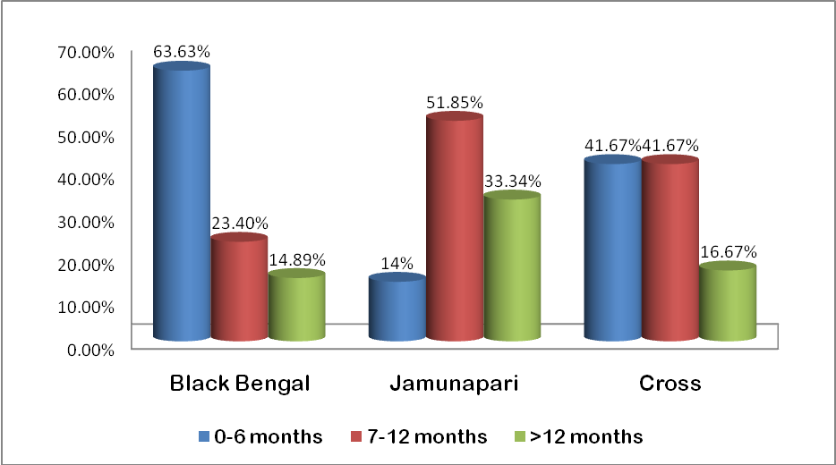
Figure4. 2: Prevalence of PPR in goat according to sex in different breed.
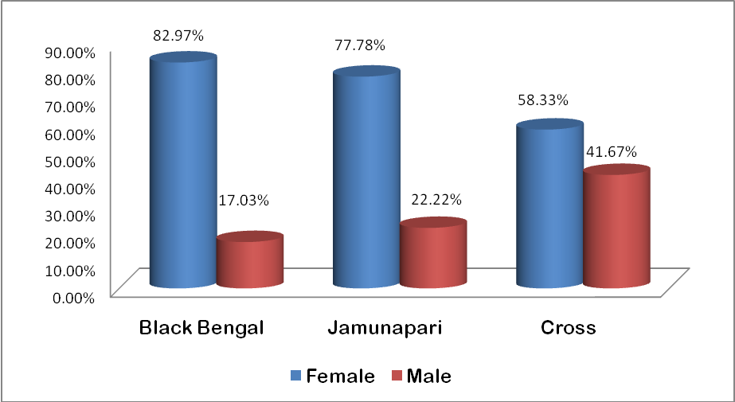

Figure 4.3: Temperatures recorded in PPR affected goat in different breed
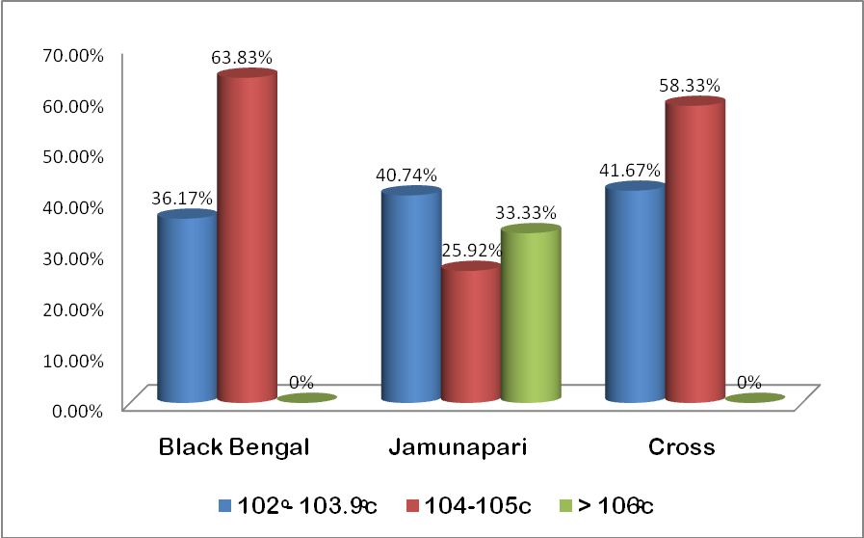

Figure 4.4: Heart rate recorded in PPR affected goat in different breed

Figure 4.5: Respiration rate recorded in PPR affected goat in different breed.
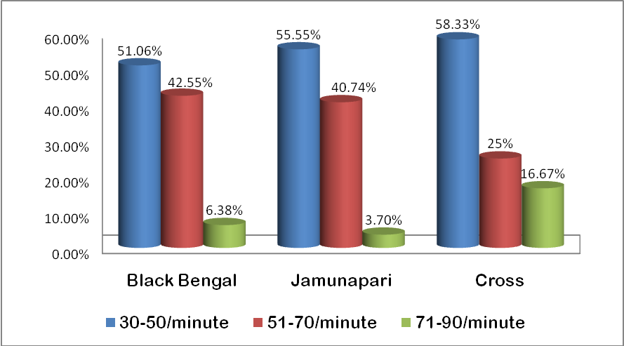

Figure 4.6: Degree of dehydration recorded in PPR affected goat in different breed.
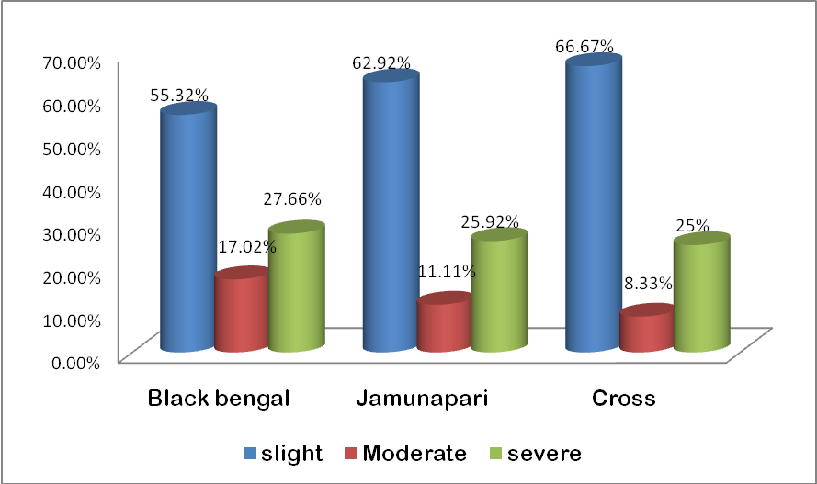

Figure 4.7: Prevalence of parasites in PPR affected goat in different breed
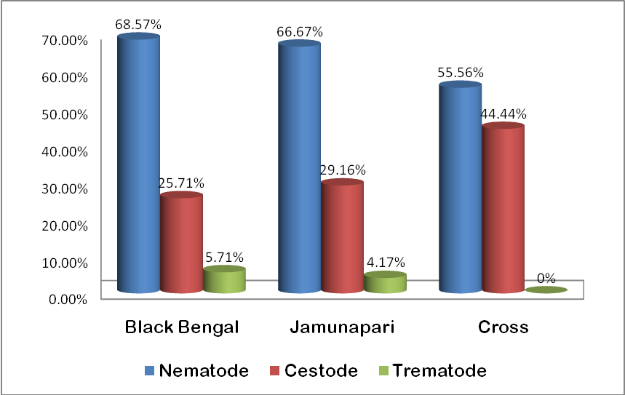

Figure 4.8: Effects of parasites in severity of diseases (PPR) in different breed.
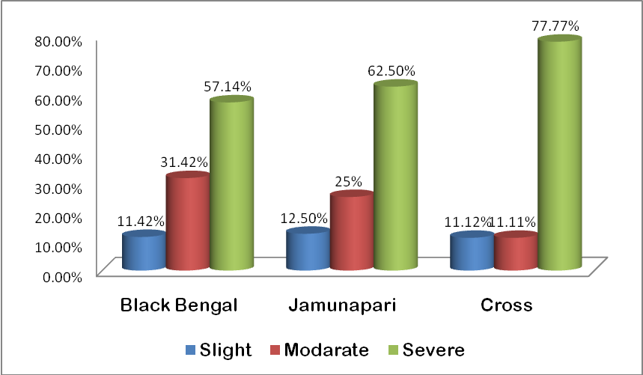

CHAPTER -V
CONCLUSION
According to the results and discussions, it may draw a conclusion on this study as the female of all three breeds (Black Bengal, Jamunapari and cross) are mostly susceptible to PPR and GI parasites and age of 5-12 months were most dangerous period. It was found increased temperature (104º-106ºc and over) in acute form PPR. In case of severe pneumonia the respiration was found higher than normal. It varies animal to animal according to stage of pneumonia. Increased heart rate also featured findings in maximum cases. Dehydration rate was varies according to frequency of diarrhea. In maximum PPR affected goats were affected with GI parasites simultaneously. In case of duel infected goat the severity of PPR found Maximum. From this study, it may concluded that the GI parasites have a relation with PPR infection in goat due to animals were suffering from malnutrition which facilities to show acute form of PPR.

RECOMMENDATION
To avoid the economical loss of goat owners due to PPR and GI parasites flowing steps should be taken immediately
- Medicating with anthelmentices in each goat regularly as the prescription of a registered veterinary doctor in appropriate dose and frequency.
- Regular vaccination with PPR vaccine in every goat in regular intervals. Though it causes solid immunity so vaccination program will be very much effective to control the disease (Sil, 2000)
- Special nutritional care for Young and female goats.

ACKNOWLEDGEMENT
All praises are due to the Almighty Supreme Lord. The creator and supreme authority of the universe, Who made the author enable to complete this assignment. I am grateful to my honorable teacher and supervisor Dr. Md. Abul Quasem Ph. D, Professor, Dept. of Anatomy and Histology and to Dr. A.S.M Golam Kibria, Lecturer, Dept. of Anatomy and Histology, Chittagong Veterinary and Animal Sciences University for Their valuable suggestion and guidance.

I am also grateful to honorable Professor Dr. A.S Mahfuzul Bari, Vice Chancellor, and Professor Dr. Abdul Motin Prodhan, Dean, Faculty of Veterinary Medicine of Chittagong Veterinary and Animal Sciences University for arranging this type of work as a compulsory part of the internship program.

I wish to express my gratitude to Sharojendro Nath Shaha, District Livestock Officer, Faridpur and all the stuffs of the district veterinary Hospital, Faridpur.

Finally, by no means least, I am really very much grateful to my parents, teachers and my friends who have inspired me in various ways.

The Author
February, 2011

REFERENCES

Al-Quaisy, H.H.K., Al-Zubaidy,A.J., Altaf, K.I and Makkawi, T.A. (1987): The
pathogenecity of haemonchosis in sheep and goat in Iraq. Clinical, parasitological and
haematological findings. Vet. Parasitol. 24:221-228.
Abraham, G. (2005). Antibody seroprevalences against peste des petits ruminants
Virus in camels, cattle, goats and sheep in Ethiopia. Prev. Vet. Medicine. 70:51-57.

Abraham, G., Sintayehu, G. A., Albina, E and Roger, F. (2005). Antibody seroprevavence
aginst Peste des petits ruminants (PPR) virus in came, cattle, goat and sheep in
Ethiopia Prev. Vet. Med., 70: 51-7.

Abdollahpour, G., Roofi, A., Najafi, J., Sasani, F and Sakhaie, E. (2006). Clinical and
para-clinical findings of a recent outbreak of Peste des petits ruminants in Iran. J.
Vet. Med. B, 53: 14-16.
BLRI, Research achievements & activities. (1999)., P.27-28.
Barrett, T. (1993). The molecular biology of rinderpest and peste des petits
ruminants. Ann. Med. Vet. 137 (2): 77-85.

Barrete, E. (1994). Rinderpest and distemper viruses. In: R.G Webster and A.
Granoff(eds). Encvci. Virol, 3: 1260-1268.
Blood, D.C.; Radostits & Hunderson, J.A. (1995). Veterinary medicine, 6th ed. London:
Bailliere Tindall.
Barrete, T., Pronab.D., Sreenivasa, B.P and Corteyn, M. (1997). Recent
Epidemiology of peste des petits ruminants virus (PPRV). Vet. Microbiology. 88:
125-130.
Bandyopadhyay, B. (1999): Journal of Parasitol. 13(2): 79-80.
Chakrabarti A. ( 2003). A Textbook of Preventive Veterinary Medicine. 3rd edn., Kalyani
Publishers, New Delhi, India.

Chakrabarti, A. (2004). A Text Book of Preventive Veterinary Medicine.p., 72-76.
DLS, (2007). Livestock population in Bangladesh
Debnath, N. C. (1995). Peste des petits ruminants (PPR). An overview, Proceeding of
the BSVER Symposium of Eradication of Rinderpest and Related disease. Second
BSVER Annual Scientific Conference held on 2nd December, 1995, Dhaka. Pp.9-
13.

Diallo, A. (2003). Peste des petits ruminants. Featured article published in the website: http://
www.indiveterinarycommunity.com (Accessed 12th August, 2004).

Diallo, A. (2002). Control of PPR. Classical and new generation vaccines. Vaccines for
OIE List-A and emerging animal diseases. Proceeding of a symposium. Ames,
owa, USA. September 16-18, 2002

Diallo, A. (2006). Control of Peste des petits ruminants and poverty alleviation. J. Vet.
Med., 53: 11-13

Diap, M., Sarr, J and Libeea,U. ( 2005). Evaluation of novel diagnostic tools for Peste des
petits ruminants virus in naturally infected goat herds. Epidemiol. Infect., 133: 711-
717.

El hag,A. B and Taylor W.P. (1984). Isolation of PPR virus from the Sudan. Res. vet. Sci.,
36: 1-4.

FAO (2003). FAO Production Yearbook, Food and Agricultural Organization of the

United Nations, Rome, Italy. Vol. 57, p. 147.

Fraser, C.M, (1986). Peste des petits ruminants(PPR). The Merck Veterinary Manual.
6th edition, Merck and co.Inc.U.S.A..,402-403.
Githigia, S.M., Thamsborg, S.M., Munyua, W.K and Maingi, N. (2001): Impact of gastro-
intestinal helminthes on production in goats in Kenya. Small Rum. Res. 42: 21-29
GORSKI .P, NIZNIKOWSKI.R , STRZELEC .E, POPIELARCZYK .D, GAJEWSKA .A and WEDRYCHOWICZ.H (2004) : Prevalence of protozoan and helminth internal parasite

Infections in goat and sheep flocks in Poland, Arch. Tierz., Dummerstorf 47, Special Issue,
43-49.

Haq .S and Shaikh .H (1968). A Survey of Helminthes Parasiting the Gastro-intestinal
Tracts of Goats and Sheep in East Pakistan. East Pakistan Journal of Veterinary
Hass, S.S., Horst, P. and Islam, A.B.M.M. (1995). Effects of different factors on pre-weaning
survivality of Black Bengal Kids. Small Ruminant Research 18: 1-5.
Science 2: 54-62.
Iqbal, Z. M., Akhtar, M., Khan, N and Riaz, M. (1993) Prevalence and
economic significance of haemonchosis in sheep and goats slaughtered at
Faisalabad abattoir. significance of haemonchosis in sheep and goats slaughtered at
Faisalabad abattoir. Pakistan J. Agric. Sci., 30: 51-3

Islam, M.R.,Shamsuddin, M., Das, P.M and Dewan, M.L. (2001). An outbreak of
Peste des petits ruminants in Black Bengal goats in Mymensingh, Bangladesh. The
Bangladesh Veterinarian. 18(1): 14-19.

Kulkarni , D.D., Bhikane, A.U., Shaila, M.S., Varalakshmi, P., Apte, M.P and Narladkar, B.W. (1996). Peste des petits ruminants in goats in India. Vet. Rec. 138 (8): 187-188.

Lefevre, P.C and Diallo, A. (1990). Peste des petits ruminants virus. Rev. Sci. Tech. Off.
Int. Epiz. 9: 951-965.

Lefevre, P. J. and Diallo, (1990). Peste des petits ruminants. Rev. Sci. Technol. (OIE), 9:

951-965.

Maqsood, M., Iqbal, Z and Chaudhary A.H. (1996): Prevalence and intensity of
Haemonchosis with reference to breed, sex and age of sheep and goats. Pak. Vet. J.,
16(1): 41-43

Murphy, F.A., Gibbs, E. P. J., horzinek M. C and Studdert, M. J. (1999). Veterinary
Virology. 3rd edn., Academic Press, San Diego, California, USA.
Nwosu C.O.,Madu, P.P and Richards ,W.S. (2007): Prevalence and seasonal changes in the
population of gastrointestinal nematodes of small ruminants in the semi-arid zone of
north-eastern Nigeria. Vet. Parasitol., 144:118–124.
Opsina, B.A. (1985): Tropical Animal Health Production. 17:217.
Ozkul, A.,Akea, Y and Alkan, F. (2002). Prevalence, distribution, and host range of peste
des petits ruminants virus, Turkey. Emerg Infect Dis. Jul., 8(7): 708-712.
Ozkul, A. (2002). Prevalence, distribution, and host range of Peste des petits
ruminants virus, Turkey. Emerging Infec. Dis. 8 (7): 708-712.

Qadir, ANMA (1967). Investigation on the incidence of
gastrointestinal parasites of goats in the East Pakistan Agricultural .,
University Campus. Bangladesh Veterinary Journal 15: 58-61.

Pathak ,A.K and Pal, S. (2008). Seasonal Prevalence of Gastrointestinal Parasites in Goats from
Durg District of Chhattisgarh, Veterinary World, Vol.1(5):136-137.

Rautmare, S.S. (2010). Emerging diseases of sheep and goat with special reference to peste-des-
petits and blue tongue in small ruminant. Virology & FMD Lab. Disease Investigation
Section, Pune – 411 007

Radostits, O. M., Gay .C.C.,Doughlas .C.,Blood., Hinchclifl.K.W. (2000). Vet, Medicine 9th
edition. Page 1077-1079.
Roeder, P. L., Abraham, G., Kenfe ,G and Barrett, T. (1994). Pestedes petits ruminants
in Ethiopian goats. Trop. Anim. Health prod., 26: 69-73.

Soulsby E.J.L (1965) Textbook of Veterinary Clinical Parasitology. Vol. I- Helminths.
Blackwell Scientific Publications Ltd., Oxford, UK pp.1120.
Shaila, M.S.., Shamaki, D.., Forsyth, M.A.., Diallo, A.., Goatley, L.., Kitching, R.P. and Barrett, T. (1996). Geographic distribution and epidemiology of peste des petits
ruminants virus. Virus Res. 43 (2):149-53.

Shaila, M. S., Purushothaman, V.., Bhavasar, D., Venugopal ,K and R. A. Venkatesan, (1989).
Peste des petits ruminants of sheep in India. Vet. Rec., 125: 602.

Sil BK, Rahman MM, Taimur MJFA and Sarker AJ (1995). Observation of outbreaks
of PPR in organized goat farms and its control strategy. Presented at the Annual
Conference of the Bangladesh Society for Veterinary Education and Research.
December 3, 2005, BARC, Dhaka.

Scott, G. R. (2000). Peste des petits ruminants and rinderpest. In: Martin W. B., and I. Aitken
(ed), Diseases of Sheep, 3rd edn, p. 398. Blackwell Publishing, Oxford, UK.

Samad, M. A. (2001). Poshu palan o chikitsa vidya LEP publication BAU Mymensingh, P-693.

Sil ,B.K and Taimur M.J.F.A (2001). Final report of the: Contract research project on
production of peste des petits (PPR) vaccine and its field application. BARC funded project,
BLRI, Savar, Dhaka, June 2001.

Sil ,B.K., Rahman ,M.M., Taimur M.J.F.A and Sarker A.J (1995). Observation of outbreaks
of PPR in organized goat farms and its control strategy. Presented at the Annual
Conference of the Bangladesh Society for Veterinary Education and Research.
December 3, 2005, BARC, Dhaka.

Sil B.K., Taimur M.J.F.A.,Hossain K.M., Giasuddin M.,Haque M.E., Chowdhury E.R., Alam M.R and Sarker A.J (2000- 2001). Preliminary study towards the development of inactivated PPR vaccine. Bangladesh Journal of Livestock Research 7- 8: 1-6.

Saiful Islam, K. B. M. Taimur, M. J. F. A. (2008). Helmentihic and protozoan internal
Parasitic infection in free ranging small ruminants in Bangladesh, Slov Vet Res 2008., 45
(2): 67-72.

Taylor W.P.,Abegunde, A. (1979). The isolation of peste des petits ruminants virus from
Nigerian sheep and goats, Res. vets. Sci., 26: 94-96.

Tober, and Taylor, W.P. (1998). The epidemiology of peste des petits ruminants in the Sultanate
of Oman. Vet. Microbiol. 22 (4): 341-352.

Tariq K.A.,Chishti, M.Z. ., Ahmad, F. ., Shawl, A.S. (2008): Epidemiology of gastro-intestinal
nematodes of sheep managed under traditional husbandry system in Kashmir valley
Vet. Parasitol., 158: 138–143.

Venkataramanan, R., Bandyopadhyay, S. K. and Oberoi, M. S. (2005). Present status
and strategies for the control of transboundary and other economically important
Animal diseases in India: A review. Indian J. Animal Sci. 75(4): 456-464.

