ACKNOWLEDGEMENT

All the praises go to the Almighty Allah, the creator and supreme ruler of the Universe, who enabled the author to complete the work successfully.

The author expresses his sincere gratitude, humble respect and immense indebtedness to his supervisor, Professor Dr. Mohammad Lutfur Rahman, Head, Department of Anatomy and Histology, Chittagong Veterinary & Animal Sciences University for his guidance, kind co-operation, sincere help, valuable suggestions, constructive criticism and for his active involvement with this study from its inception.

The author also expresses his gratitude and deep sense of respect to all of his friends and well wishers for their support and inspiration throughout the study period and for preparing this report.

Last but not least, the author extended his appreciation to all of his teachers and his parents for their unforgettable support, suggestions, criticisms and cordial help from its inception to the last of this study.

The Author

ABBREVIATIONS

ASP | Aspergillosis
BAC | Bacterial disease
COC | Coccidiosis
EC | E. coli
FC | Fowl cholera
GUM | Gumboro disease
MYC | Mycoplasmosis
ND | New Castle disease
NE | Necrotic enteritis
PRO | Protozoal disease
SAL | Salmonellosis
VIR | Viral disease

Abstract

Disease profile investigation of 60 dead broilers were carried out in Community Based Animal Health Care Survices (CBAHCS), Sitakunda, Chittagong. Birds are brought from different broiler farms of Sitakunda Upazila, Chittagong. Total 6 weeks long study was carried out during the poultry placement to know the incidence of various diseases of broiler. Necessary informations were collected from structured questionnaire and post mortem examination was done for diagnosis of disease. Among the diseases the New castle disease (18%) and the colibacillosis (22%) were diagnosed to be the highest in percentage in <3 wks and >3 wks aged of birds, respectively. Moreover, bacterial diseases were very much prominent in percentage in both cases of age (i.e 35.29% & 53.84% in <3 wks & >3 wks aged birds, respectively). Hubbard Classic bird was affected mostly by bacterial diseases (47.36%) whereas in Cobb-500/100 the frequency of bacterial diseases was 36.36%.

Key words: Broiler, Disease, Poultry

CHAPTER-I

INTRODUCTION

The concept of poultry farming as an industry in Bangladesh was started during early eighties. Poultry industry has been expanding in Bangladesh & considered as a sub-sector of agriculture. There are more than 1 lac poultry farms & total poultry production is 120 millions. (DLS, 2002). Though poultry farming has dramatically been increased, but the diseases are the most important constrain towards its development. The most common poultry diseases are salmonellosis, colibacillosis, infectious bursal disease (IBD), new castle disease (ND), chronic respiratory disease (CRD) etc.

Salmonellosis refers to the infections with bacteria of the genus Salmonella are responsible for a variety of acute & chronic disease in poultry. Infected poultry moreover comprise one of the most important reservoirs of salmonellae that can be transmitted through the food chain to humans (Gast,1997).

Pullorum disease (PD) is caused by Salmonella pullorum. It is a common fatal malady of avian species a G- coccobacillary bacterium. Mortality from pullorum disease in chickens is usually confined to the first 2-3 wks of age (Gordon et al,1982).

The term colibacillosis refers to any localized or systemic infections caused entirely or partly by E.coli, including colisepticemia, coligranuloma (Hjarre’ s disease) air sac disease (CRD), Avian cellulites(inflammatory process), swollen head syndrome, peritonitis, salpingitis, osteomyelitis, synovitis, panophthalmitis & omphalitis/yolk sac infection. Colibacillosis is a typically secondary localized or systemic disease, occurring when host defence have been implied or overwhelmed. Collectively infections caused by E.coli are responsible for significant losses to poultry industry. It was reported that 43% broiler carcasses condemned for disease at processing had lesions consistent with colisepticemia (Barnes and Gross,1997).

Objectives:
On this background, the present study was aimed to diagnose various broiler diseases on the basis of postmortem examination in Sitakunda upazila, Chittagong.

CHAPTER-II

REVIEW OF LITERATURE

In this part of the report available literatures about poultry diseases are reviewed.

Sastry et al., (1968) described that diagnosis is an art of determination of the nature of disease, its causes, lesions, symptoms etc.

Prasad et al., (1992) reported that a clear concept of anatomy, physiology & the normal behaviour is essential for boiler disease diagnosis. Both quantitative and qualitative changes occur during disease conditions, which are appreciated in terms of signs and symptoms.

Chauhan (1995) reported six types of diagnosis on the basis of mode. These are Snap diagnosis, Tentative diagnosis, Symptomatic diagnosis, Confirmatory diagnosis, Differential diagnosis and Test therapy diagnosis.

Poultry disease diagnosis by post mortem examination is more effective than any other method. Moreover, combination of clinical findings with postmortem examination give more strength in diagnosis. Though diagnosis of poultry disease only by observing pathological changed occur in postmortem may not be correct all times, because many diseases can cause same type of pathological changes in same organ. But combinations of clinical findings and postmortem examination have some advantages over other methods (Samad, 1998).

Newcastle disease:
Rima et al., (1995) reported that Newcastle disease is caused by Avian Paramyxoviridae virus, serotype-1(APMV-1) viruses that have been placed in genus Rubela virus. The virus particle consists of an assembly of material composed of single-stranded ribonucleic acid enclosed in a protein coat. This assembly is surrounded by an envelope, which is derived from the membranes of the host cell. Projecting from the envelope is a fringe of glycoprotein spikes, these are the haemagglutinin neuroaminidase (HN) & fusion (F) glycoproteins. The envelope itself contains 2 glycoproteins & 7 polypeptides that initiate the virus to neutralize the antibodies in the host.

Beard and Hanson (1984) stated that strains of ND virus have been distinguished on the basis of clinical signs produced in the infected chickens.

Hoque et al., (1999) reported that in Bangladesh about 90% of the rural household rear poultry and this contributes over 85% of the total poultry production.

Chowdhury et al., (1982) reported that in Bangladesh, ND claimed up to 40-60% of the total mortality in rural scavenging chickens in late seventies.

Sinha et al., (1954) reported that ND virus containing excretions from infected birds, including aerosols can contaminate feed, water, footwear, clothing, tools, equipments & the environment. Exposure of susceptible birds to any these sources of virus can result in transmission. Also infected poultry may spread the virus if their tissues are used without proper processing in rendered products. Approximately 2 days after exposure & a full day before showing clinical signs, the infected birds begin to liberate virus in the air that leaves its respiratory tract & continues to do so for several days.

Rott and Klenk (1988) reported that the ability of an isolate of NDV to form plaques in cell culture without the addition of additives, especially trypsin, to the overlay is a strong indication that the isolate is virulent for chickens.

Alexander (2000) reported that sample from dead bodies should consist of oro-nasal swabs, as well as samples collected from lungs, air sac, intestine (including contents), spleen, brain, liver and heart tissues.

The diagnostic tests for detection of NCDV in a poultry flock are as follows:

- Hemaglutination inhibition test
- Fluorescent antibody test
- Enzyme-linked immunosorbent assay
- Virus neutralization test (Beard,1980)
- Immunodiffusion test (Chu et al,1982)
- Compliment fixation test (Wilcox & Consigli,1972; Allan & Gough,1976)
- Nucleotide sequencing (Alexander,2000)
- Use of monoclonal antibodies (Alexander,1992)

Avian colibacillosis:

Synonym: Colisepticemia, Hjarre’sdisease, Coligranuloma, peritonitis, salpingitis, synovitis, omphalitis, air sacculitis, Mushy chick disease.

Chakrabarti (1993) stated that colibacillosis is a very important wide spread bacterial disease causing great roll on poultry economy. It affects the birds of various age group.

Sharon (1997) reported that Coliform infections are often caused by strains of Escherichia coli organism. there is a marked variation in severity. The disease occurred as acute infections with sudden & high mortality to mild infections of a chronic nature with low morbidity & mortality.

Barns (1990) reported that materials should be streaked on eosine methylene blue, McConkey or tergitol agar. Care must be taken to avoid fecal contamination of samples. A presumptive diagnosis of E. coli can be made if most of the colonies are characteristically dark with a metallic sheen on EMB agar, bright pink with precipitate in medium on Mcconkey agar & yellow on tergitol agar.

Salmonellosis:

Shivaprasad(1997) reported that the organisms are gram negative, nonsporogenic, nonmotile and facultatively anaerobic. They are slender rods, 1.0-2.5 micrometer in length & 0.3-1.5 micrometer in width. The bacilli mostly occur singly, but occasionally two or more can be found united.

Gust (1990) Avian salmonellosis is caused by a group of the genus. Salmonella causing acute or chronic manifestation & death. This causes food poisoning in man & thus has public health significance. It is estimated that approximately 33 million causes of human illness & 9 million deaths occur annually due to food infected with Salmonella & other organisms.

Shivaprasad (1997) A definitive diagnosis of Pullorum Disease (PD) requires isolation & identification of salmonella pullorum or salmonella gallinarum, respectively. A tentative diagnosis, however can be made on flock history, clinical signs, mortality & lesions. Positive serological findings can also be of major value in detecting infection, however positive results should not be considered adequate for a definite diagnosis because of the delay of 3-10 or more days in appearance of agglutinating antibodies following infection & also because of cross reactions with other salmonella species.

Gast (1997) reported that the genus Salmonella (of the family Enterobacteriaceae) named for the eminent United States Department of Agriculture (USDA) Veterinarian & Bacteriologists Daniel E Salmon, consists of more than 2300 serologically distinguishable variants. These serotypes are usually named for the place of initial isolation. Although recent taxonomic refinement have indicated that all Salmonella can be grouped into only five subgenera, the distinctions between serotypes are often epidemiologically relevant. Accordingly, Salmonella isolates are still often described primarily in terms of their serotype nomenclature.

Bacillary white diarrhea (BWD) was a term used to designate Pullorum Disease (PD) before 1929 but the teem PD has since gained universal acceptance. There have been no reported outbreaks of Fowl Typhoid (FT) in commercial poultry in the United State since 1980. PD was once enzootic in many areas of the world. The incidence of PD in the United States is so rare that it was once thought that the disease has been eradicated from the commercial poultry population (Shivaprasad, 1997).

Wyatt and Hamilton (1975) reported that the number of clinically infected birds were higher than the mortality. The mortality of S. pullorum was found to be increased significantly (P<0.05) than only S. pullorum infected group which were not observed in only aflatoxin treated birds & negative control groups.

Shivaprasad, (1997) also found in salmonellosis there was enlargement & congestion of spleen frequently observed. Fibrinous exudates in the pericardium & on the liver capsules were also evident in some birds. A variable amount of caseous mass was also found in the lumen of oviduct.

Pullorum disease is seen primarily in chicks under 3 weeks of age & the first indication is usually excessive numbers of dead in shell chicks & deaths shortly after hatching. Affected birds show variable & non specific signs, including depression with tendency to huddle, respiratory distress, adherence of chalky white material with pasted down appearance around the vent.

Hutt et al., (1960) reported that diagnosis in young birds is made by isolating the causative organism in the laboratory. In older birds, blood testing may indicate an infection but a positive diagnosis depends upon isolation & identification of organism by laboratory procedures.

Sharon (1997) reported that fowl typhoid is an infectious contagious bacterial disease that is usually acute but sometimes chronic. It affects most domestic & wild fowl including chickens, turkeys, ducks, pigeons, pheasants & other game birds. The disease is caused by Salmonella gallinarum.

Gross (1959) reported that the signs include sudden death or sporadic mortality, listlessness, green or yellow diarrhea (accompanied with pasting of vent feathers),loss of appetite, increased thirst & a pale anaemic appearance of comb & wattles.

Fowl cholera:
Synonyms: Avian cholera, avian hemorrhagic septicemia.

Chakrabarti (1993) stated that it is an acute or contagious disease affecting domestic as well as wide range birds causing septicemic condition with high mortality in acute form. On the contrary, chronic form shows localized symptomatic infection. The chronic form is also known as Wattle Cholera.

Coccidiosis:

Coccidiosis is the term applied to the diseased condition caused by infection with one or more of the many species of coccidia, a subdivision of great protozoan class sporozoa & is characterized by varying degrees of enteritis that causes decreased production & performance including mortality.

Coccidia are often present in the intestine of birds of 3-6 weeks old in most flocks. The findings of bloody intestinal content & a few oocyst by microscopic examination of smear from the intestine indicate clinical coccidiosis (Barns, 1990).

Incidences of coccidiosis are also decreasing in Bangladesh because of routine use of coccidiostats and use of vaccines in some selected organized farms. But it will take time to reach coccidial vaccines to the smallholder farms. Necrotic enteritis was though not very common but it should be regarded as an important disease since it has been found associated with coccidiosis causing severe production losses in broiler industry (Vissiennon, 1996).

Avian influenza:

Mutinelli (2002) reported that from the end of March to the beginning of December 1999, an epidemic of low-pathogenicity avian influenza (LPAI), caused by a H7N1 type A influenza virus, affected the intensively reared poultry population of Northeastern Italy. A total of 199 flocks were diagnosed with influenza infection. The highest number affected flocks were in meat turkeys (164), with only a limited number of turkey breeder, chicken (breeders, broilers, and table egg layers), and guinea fowl flocks infected. Following the circulation of the LPAI virus in a susceptible population for several months, a high-pathogenicity avian influenza (HPAI) virus emerged. Over 13 million birds on 413 different premises were affected by the HPAI virus, including turkey, chicken, guinea fowl, pheasant, Japanese quail, ostrich, and waterfowl flocks. In the present paper we report on the clinical, gross, histopathological, and immunohistochemical investigations performed on different avian species naturally infected by the LPAI virus and the HPAI virus.

Necrotic enteritis:
The records of three poultry diagnostic laboratories in Ontario were examined for the years 1969, 1970 and 1971. During this period 855 (7.7%) of 11,076 consignments of broiler chickens examined were diagnosed as necrotic enteritis. The condition was most common in broilers at three weeks of age, with 66% of all cases occurring in chickens between two and four and one half weeks. The disease occurred throughout the year but it was most common during July, August, September and October. Necrotic enteritis often occurred more than once per year on a farm.

Mycoplasmosis:
Mycoplasmosis caused by Mycoplasma gallisepticum infection, is popularly known as chronic respiratory disease (CRD) of chickens & infectious sinusitis of turkeys. Clinically the disease is very difficult to differentiate with other respiratory diseases. Morbidity is very high, usually almost all birds in a flock may be infected with variable severity & duration. but mortality is very low, usually depends on virulence of concomitant pathogens like E. coli, infectious bronchitis virus, Newcastle disease virus etc.

Biswas et al., (1992) and Amin et al., (1992) reported that avian mycoplasmosis is an emerging disease of poultry in Bangladesh.

Jordan and Amin (1980) reported that it is an economically important poultry disease distributed all over the world. Almost all of the domestic & wild birds are susceptible to mycoplasmosis.

Prodhan (2002) reported that the disease is commonly designated as chronic respiratory disease.

Nunaya et al.,(1995) reported that respiratory rales, sometimes coughing, ocular & nasal discharges characterize the disease, but may often be confused with other diseases. Air saculitis, sinusitis & synovitis may be also be seen in some cases.

Prodhan (2002) reported that post mortem lesions are prominent in complicated mycoplasmosis.

Gross (1961) reported that caseous or purulent mass in the thoracic air sac, some degree of pneumonia in association with fibrinopurulent pericarditis & perihepatitis are frequently observed in complicated cases..

Prodhan (2002) reported that different diagnostic techniques were used for detection of mycoplasmosis. Of them culture, serology & polymerase chain reaction (PCR) techniques are commonly used for diagnosis of mycoplasmosis. Antibody to mycoplasma present in the blood sera or egg yolk can be measured by different serological tests.

Higgins and Whithear (1986) reported that confirmatory test for screening infection are Hemagglutination Inhibition (HI) test & Enzyme Linked Immunosorbent Assay (ELISA).

Aspergillosis:
Aspergillosis has been observed in many birds and mammals. Frequent reference is made to the relationship of the disease in man to occupation, particularly in the so-called gaveurs des pigeons (pigeon feeders).

The fungus grows quite readily on ordinary laboratory culture media at room temperature, at 37⁰C, and higher. Czapek's solution agar or Sabouraud's agar may be used. The colonies are green to bluish green at first and darken with age so as to appear almost black. The colonies vary from velvety to floccose. The conidiophores are short, up to 300µ long by 2-8µ in diameter, the vesicles are apical flask-shaped up to 20-30µ in diameter, the sterigmata are 6-8 by 2-3µ in diameter, in chains forming solid columns up to 400 by 50µ (Thom and Church, 1926).

Vigorous healthy birds apparently can withstand considerable exposure to Aspergillus spores occurring under natural conditions. Inhalation of a considerable number of spores, as may occur when the litter or feed are heavily contaminated, may result in infection. The occasional bird which becomes infected in a flock which is otherwise healthy may do so because of lowered resistance or severe individual exposure. Aspergillosis can readily be produced experimentally by intrathoracic injection in chickens and pigeons. Schutz (1884), Bollinger (cited by Van Heelsbergen, 1929), and others observed that infection of the lungs was established following inhalation of spores. Walker (1915) reported that 5-7 days old ostriches succumbed in 2-8 days to aspergillosis in the lungs and air sacs if spores were blown into the trachea. Intravenous inoculation resulted in pulmonary and hepatic aspergillosis. Young ostriches also developed the disease when kept on straw which had been artificially contaminated. Durant and Tucker (1935) produced the disease in a poulty by feeding mash from which A. fumigatus was isolated.
The lesions depend considerably on the site of infection. Either localisation or generalisation may be observed. Individual lesions may be observed, for example, in the syrinx or in a single air sac. The lungs are most frequently involved. Pulmonary lesions vary from miliary nodules up to larger nodules. In some cases there may be localised hepatization, and in others grossly visible mycelial masses may be present in the air passages and bronchi. There may be generalised involvement of the air sacs. Occasionally a circular disc-shaped necrotic mass with a concave surface, loosely attached to which there is a circular more or less flat or convex plaque, may be observed. Various manifestations of the disease have been described. Lange (1914) recorded nodules in the lungs and the thoracic and abdominal cavities of chickens, ducks, geese, and pigeons. These nodules varied from pinhead or millet seed size up to the size of a pea. They were yellow in colour, of an elastically soft cartilaginous consistency, and homogeneously caseous. Individual nodules were noted on the intestinal serosa and in the parenchyma of the liver in a goose.
The nodules in the lungs of a turkey observed by Schlegel (1915) were pinhead to lentil size and were surrounded by an infiltrated or hemorrhagic corona with considerable hepatization. There were also grayish yellow, fibrinopurulent disc- or plate-shaped masses of exudate 2-5mm thick on the pleura. Inflammation and detrital masses were present in the bronchi. The anterior thoracic, axillary, and cervical air sacs contained yellow caseous flat discs and masses consisting of inflammatory exudate and mycelia. The left lower thoracic, upper posterior thoracic and left abdominal air sacs were greatly distended. The walls of these air sacs were thickened and covered with a furlike growth of mold. Adjacent to the air sacs there were lentil-sized, knob-shaped, concentrically layered, turbid yellow, solid nodules composed of fibrin and mycelia. There were about 200cc of reddish turbid fluid in the abdominal cavity.
There were no circumscribed yellowish foci in the outbreak in chicks reported by Savage and Isa (1933). There was a diffuse grayish yellow infiltration in the lungs, with about one-third of each lung involved. Mortality was 90% in this outbreak.
In pneumomycosis in a flamingo described by Mohler and Buckley (1904), the lungs were filled with nodules, and the mucosa of the bronchi was covered with membranous.
The fungus can be demonstrated by cultural methods if not in fresh microscopic preparations. Occasionally masses of the fungus are visible to the naked eye in the air passages of the lungs in the air sacs or in the abdominal cavity. The typical fruiting heads may be readily demonstrated in such lesions. Demonstration of the fungus by direct examination may be impossible in the small caseous nodules seen particularly in the lungs.

CHAPTER-III

MATERIALS AND METHODS

Study population:

A total of 60 commercial broiler birds were postmortemed for lesions that were brought into community based animal health care survices (CBAHCS), Sitakunda. This study was undertaken during Poultry placement in Sitakunda Upazila, Chittagong.

Tools required for postmortem examination:

1. Postmortem tray
2. Scissorsa
3. Simple forceps
4. Glass slide
5. Gloves
6. Masks

Measures taken before postmortem examination:

- At first general inspection was done on dead birds for detecting any defects or abnormalities that were present externally.

- After that a close inspection was done regarding the state of eye, presence or absence of litter materials in the beak.

- Then the birds were sprinkled with water for preventing any dust.
- Then the abdominal cavity was opened & inspection of visceral organs was done. Then the inspection of proventriculus, gizzard, liver, intestine was done both internally & externally for detecting any sorts of lesions.

- The cecal tonsil & bursa also inspected.
- Lungs & air sacs were inspected for edema & caseous exudates, respectively.
- Overall the internal organs were viewed at a glance.
- The oesophagus, trachea were also inspected for detecting lesions.

Measures taken after postmortem examination:

1. The birds were properly disposed by burial.
2. The lesions on different organs that were found were noted down in the questionnaire.
3. Then the tentative diagnosis was done in relation to lesions.

The tentative diagnosis was done according to following table:

Name of the disease | Post mortem findings
Newcastle disease (ND) | - Inflammation of trachea & air sac  - Cheese like lining in trachea  - Cloudy air sac  - Hemorrhage in tip of the gland of proventriculus  - Formation of plug in intestine or caecal tonsil.
Chronic respiratory disease (CRD) | - Mucous with some blood in trachea.  - Heart thickened.  - Fibrinous & yellow film on surface of liver.  - Air sac thickened, opaque & sometimes contain slimy or cheesy exudates.
Infectious bursal disease (IBD) | - Hemorrhage in thigh & pectoral muscles & at the junction of proventriculus & gizzard.  - Swollen, urate deposits, double size, severely edematous.  - Reddened & also sometimes hemorrhage in bursa.  - Increase mucous in intestine, white appearance of kidney to some cases spleenomegaly.
Fowl cholera (FC) | - Film on surface of liver.  - White or yellow spots in the liver or pin-point necrotic foci.  - Broken egg yolks in ovary.  - In laying hen free yolk in body cavity.  - Heart thickened, fibrinous & yellow.  - Hemorrhage in heart.
Necrotic enteritis (NE) | - Inflammatory condition in intestine  - Hemorrhagic intestine.
Colibacillosis | - Air sac foamy, purulent & thickened.  - Heart became thickened, fibrinous & yellow.  - Film on surface of liver.  - Salpingitis, peritonitis, synovitis.
Salmonellosis | - An abnormal ovary with hemorrhage, atrophic follicle.  - The caeca contain a caseous core, sometimes tinted with blood.

CHAPTER-IV

RESULTS AND DISCUSSION

In this study I have postmortemed about 60 broilers of which 34 birds having age below 3 wks were affected by various diseases whereas 12 birds had bacterial, 10 had viral, 6 had protozoal, 2 had mycoplasmal & 4 had fungal disease. On the other hand 26 birds having age above 3 wks were affected by various diseases whereas 14 birds had bacterial, 6 had viral, 2 had protozoal, 2 had mycoplasmal & 2 had fungal disease.

Name of the variable | Number | Type of disease
Name of the variable | Number | BAC | VIR | PRO | MYC | FUN
Age<3wks | 34 | 12(35.29%) | 10(29.41%) | 6(17.64%) | 2(5.88%) | 4(11.76%)
Age>3wks | 26 | 14(53.84%) | 6(23.07%) | 2(7.69%) | 2(7.69%) | 2(7.69%)

Table-1: Type of disease found in two different age group of birds.

From Table-1 & Graph-1 it has been found that the bacterial diseases were very much prominent (35.29%) in < 3 wks of aged birds which is also found high (53.84%) in > 3 wks of aged birds.

Graph-1: Type of diseases in two different age group of birds.
Here 34 birds having age below 3 wks & 26 were found having age above 3 wks. There were found coccidiosis & new castle disease in 6 cases, aspergillosis & IBD in 4 cases, E.coli in 8 cases, Necrotic enteritis, fowl cholera, mycoplasmosis in 2 cases of below 3 weeks aged birds whereas new castle disease & necrotic enteritis in 4 cases, E.coli in 6 cases, salmonellosis, aspergillosis, fowl cholera, mycoplasmosis, coccidiosis and IBD in single case in above 3 wks of aged birds.

Name of the variable | Number | Name of the disease & statistical parameter
Name of the variable | Number | ASP | EC | NEC | SAL | FC | COC | MYC | ND | IBD
Age<3wks | 34 | 4 | 8 | 2 | 0 | 2 | 6 | 2 | 6 | 4
Age>3wks | 26 | 2 | 6 | 4 | 2 | 2 | 2 | 2 | 4 | 2

Table-2: Diagnosis of diseases according to age.

From Table-2 & Graph 2 & 3 it revealed that the birds < 3 wks of age were very much sensitive to diseases the frequency of diseases were more than the older age. About 18% & 15% birds were found affected by New Castle disease in < 3 wks & > 3wks of aged birds respectively.

Graph-2: Disease diagnosed in < 3 wks aged birds

Graph-3: Diseases diagnosed in > 3 wks aged birds.

From the total of 60 birds Hubbard Classic was 38 numbers & Cobb-500/100 was 22 numbers. Among them total18 birds had bacterial, 12 had viral, 4 had protozoal, 2 had mycoplasmal & 2 had fungal disease in Hubbard Classic birds. On the other hand, total 22 Cobb-500/100 were affected by various diseases whereas 8 birds had bacterial, 4 had viral, 4 had protozoal, 2 had mycoplasmal & 4 had fungal disease.

Name of the variable (strain) | Number | Type of disease
Name of the variable (strain) | Number | BAC | VIR | PRO | MYC | FUN
Hubbard Classic | 38 | 18(47.36%) | 12(31.57%) | 4(10.52%) | 2(5.26%) | 2(5.26%)
Cobb-500/100 | 22 | 8(36.36%) | 4(18.18%) | 4(18.18%) | 2(9.09%) | 4(18.18%)
Table-3: Type of diseases according to broiler strains.

From Table-3 it was also revealed that Hubbard Classics were very much prone (47.6%) to various bacterial diseases whereas the frequency of affection of diseases were low in Cobb-500/100 in comparison to Hubbard Classic. But in Cobb-500/100 bacterial diseases were frequently (36.36%) occurred.

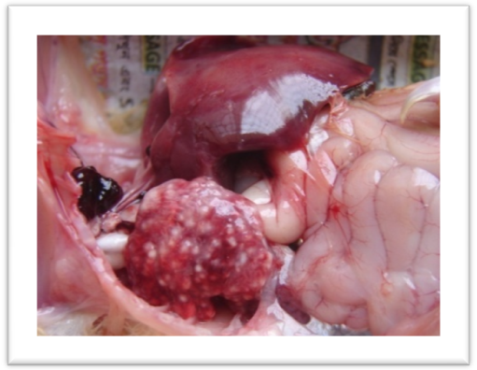

Caseous nodule in lung

Fig: Lesions of aspergillosis

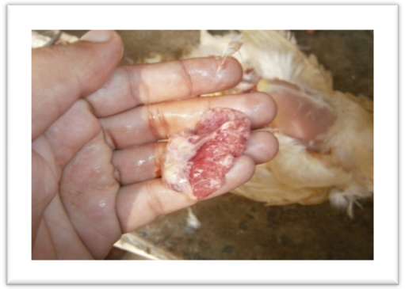

Congestion in lung

Fig: Lesions of mycoplasmosis

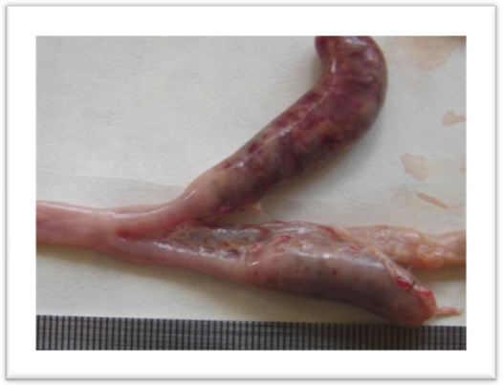

Cheesy cecal core

Fig: Lesions of coccidiosis

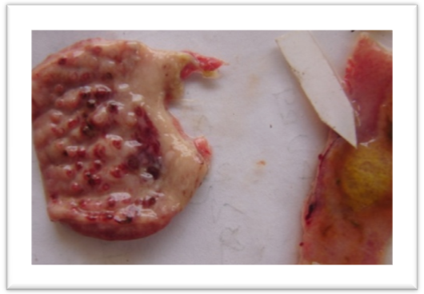
Hemorrhage in tips of proventriculus

Plug in intestine

Hemorrhage in bursa

Fig: Lesions of ND

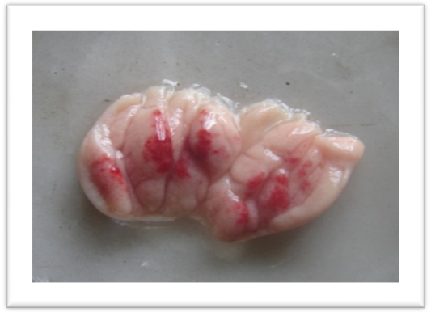

Fig: Lesions of IBD

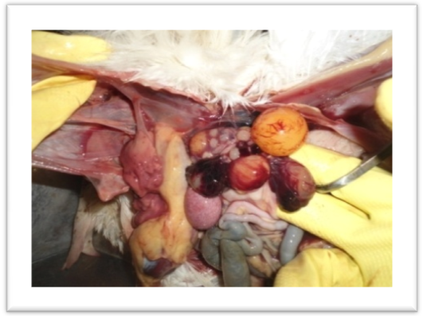

Cyst in the ovary

Fig: Lesions of salmonellosis

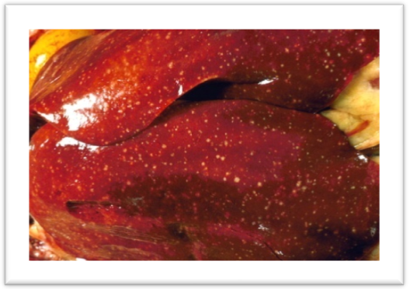

Pin-point necrotic foci in liver

Fig: Lesions of fowl cholera

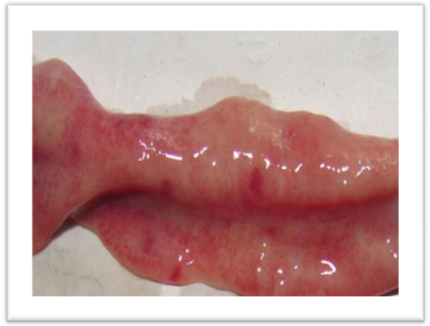

Inflammatory condition in intestine

Fig: Lesions of necrotic enteritis

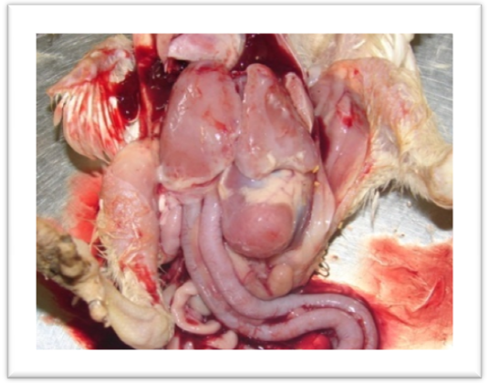

perihepatitis

Fig: Lesions of colibacillosis

pericarditis

LIMITATIONS

- Frequency of the diseases was not representative because all cases of the area were not brought to the hospital during the study period.

- Diseases associated with managemental & environmental factors could not be correlated.

- Although postmortem was used to diagnose the diseases, but sensitive test (serological tests) is required for accurate diagnosis.

- Time was not sufficient for this kind of study.

- Follow up of the cases was not possible for each & every cases.

CHAPTER-V

CONCLUSION

The poultry production in Bangladesh is characterized predominantly by the backyard type small-scale operation for a long time. They rear traditionally their native birds as scavenging system with very small profit. Almost all-rural household has some poultry and women are the raisers of these chickens. Poultry keeping are one of the most appropriate incomes generating activities for rural women. During the last few years commercial broiler farming become one of the profitable industries in Bangladesh. Many farmers change their traditional rearing system and become a modern commercial broiler rearer. A small-scale broiler rearing has become a beneficial occupation for the women and young generation of the country. Government of Bangladesh is trying to increase commercial broiler production for alleviation of poverty and creation of employment opportunity to improve national health status. But mortality of chicken due to various fatal infectious and non-infectious diseases are one of the major constrains for the profitable broiler rearing. In Bangladesh, farmers face a wide range of broiler diseases, which reduce the optimal production of the flock. In this study we also found that broiler are affected by various bacterial, viral, protozoal diseases. Among various diseases, bacterial diseases were found in maximum cases revealed by post-mortem examination. Broiler sector is very much important for the national economy of Bangladesh. So, proper biosecurity measurement as well as therapeutic management should be ensured for raising this industry.

REFERENCES

Alexander, D.J. (1998) Use of monoclonal antibodies in the diagnosis of Newcastle disease & characterization of the virus. In Proc. Comission of the European Communities on avuan paramyxo viruses.27-29 July.pp:145-146.

Alexander, D.J. (2000) Newcastle disease & other avian paramyxo viruses. Office International des Epizooties, Science & Technical review,19(2): 443-462.

Allan, W.H. and Gough, R.E. (1976) Res. Vet.Sci:20:101-103.

Amin, M. M. and Rahman, M. M. (1992) Investigation on chronic respiratory disease in chickens: part-II BAU Research Progress 6:262-266.

Barns, H.J. and Gross, W. B. (1990) Disease of Poultry, 1 0th edition,pp:131-141.

Beard, C.W. and Hanson, R. P. (1984) Disease of poultry.3rd edition.pp:129-135.

Biswas, H. R. and Haque, M. M. (1992) Chicken Mycoplasma in Bangladesh. Asian Australian Journal of Animal Science 6:249-251.

Chakrabarti, A. (1993) A textbook of preventive Veterinary Medicine, 7th edition,pp:709-798.

Chauhan, R.S. (1995) Veterinary clinical & laboratory diagnosis, 23rd edition.pp:13-15.

Chowdhury, T. I. M. and Amin, M. M. (1982) Study on Newcastle disease in Bangladesh. A research report, Department of Microbiology & Hygiene, Bangladesh Agricultural University, Mymensingh, Bangladesh.

Chu, H.P. and Schild, G.C. (1982) Avian Pathology.5th Edition.pp:227-234.

Durant, A. J. and Tucker, C. M. (1935) Aspergillosis of wild turkeys reared in captivity Journal of American Veterinary Medical Association 1935; 86: 781-84.

Gordon, R. F. and J. tucker (1955) The treatment of chronic carriers of Salmonella pullorum with furazolidone.Vet.Rec.67:116-118.

Gross, W. B. (1961) The development of air sac disease. Avian diseases 5:413-439.

Gust, R. K. and Beard, C.W. (1990) Serological detection of experimental salmonella enteritidis infection in laying hens.pp:721-728.

Higgins, P.A. and Whithear, K. G.(1986) Detection & differentiation of Mycoplasma gallisepticum & M. synoviae antibodies in chicken serum using Enzyme Linked Immuno-sorbent Assay.Avian Disease 30:160-180.

Houque, Q. M., Chowdhury, S. A. and Sil, B. K. (1999) Poultry Research in Bangladesh Present status & its implementation.pp:151-164.

Hutt, W. E., Rath, N.C. and Donoghue, A. M. (2004) Individual & combined efficacy Of Bacteriophage & Baytril(Enrofloxacin) to treat a severe Escherichia coli respiratory infection in broiler chicken.International Poultry Science.83:1780-1781.

Jordan, F. T.W. and Amin, M. M. (1980) A survey of Mycoplasma infections in domestic poultry. Research in veterinary science 29:96-100.

Jordan, F. T.W. and Pattison, M. (1997) Poultry diseases, 4th edition.pp:9-15.
Lange, W. (1898) Schimmelpilzerkankungen beim Gefluegel. Deut Tieraerztl Wochschr 1898; 22: 642-43.
Long, J. R. (1973) Necrotic Enteritis in Broiler Chickens I. A Review of the Literature and the Prevalence of the Disease in Ontario. July; 37(3): 302–308.

Mohler, J. R. and Buckley, J. S. (1904) Pulmonary mycosis of birds with report of a case in a flamingo. ESDA BAI Circ. 1904; 58: 122-36

Mutinelli, F., Capua, I., Terregino, C., and Cattoli, G. (2002) Clinical, Gross, and Microscopic Findings in Different Avian Species Naturally Infected During the H7N1 Low- and High-Pathogenicity Avian Influenza Epidemics in Italy During 1999 and 2000 National Reference Laboratory for Newcastle Disease and Avian Influenza, Istituto Zooprofilattico Sperimentale delle Venezie, Via Romea 14/A, 35020 Legnaro, Italy Avian Diseases: Vol. 47, No. s3, pp. 844–848.
Nunoya, T. T. and Nagasawa, Y. (1995) Occurance of keratoconjuctivitis apparently caused by Mycoplasma gallisepticum in layer chickens.Veterinary Pathology 32: 11-18.

Prasad, B. (1992) Veterinary clinical diagnostic technology.pp:1.

Prodhan, M. A. A.(2002) Study on avian mycoplasmosis: Prevalance, Isolation, Characterization & Antigenic properties. A Ph.D. thesis, offered from Department of microbiology & Hygiene. Bangladesh Agricultural University, Mymensingh, pp:1-178.

Richard K. Gast (1997) Disease of Poultry,10th Edition,81-84.

Rima, B., Billeter, M. A. and Meulen, V. (1995) Paramyxoviridae. In: Virus taxonomy,6th report of the International Committee on Taxonomy of Viruses. Springer-Verlag, Vienna & Newyork.pp:617-621
.
Rott, R. and Klenk, H.D. (1988) Molecular basis of infectivity & pathogenicity of Newcastle disease virus.pp:98-112.

Roy-Parimal, Dhillon, A. S. and Johnson, S. (2001) Pathogenecity of different Serogroups of Avian Salmonella in specific pathogen free pathogens.Avian Disease: 45:922-937.

Samad, M. A. (1988) Poultry palon O chikitsha biddya (Poultry Husbandry & Medicine), 3rd edition.pp:73-75.

Sastry, G.A. and Rao, P. (1968) Veterinary Pathology,7th edition.pp:1-3.
Savage, A., Isa J. M.(1933) A note on mycotic pneumonia of chickens. Sci Agr 1933; 13: 341.
Schutz. (1884) Eindringen von pilsporen in die atmungswege uind die dadurch bedingten Erkrankungen der Lungen und ueber den Pilz des Huehnergrindes. Mitt Kaiserl Gesundheitsamt 1884; 2: 208.
Schlegel, M. (1915) Schimmelpilzerkrankung (Aspergillose) in den Lungen bei Tieren. Berlin Muench Tieraerztl Wochschr 1915; 31: 25.
Sharone (1997) Bacterial disease of poultry & their management.Australian Veterinary Journal, 57:139-141.Shivaprasad,H.L.(2000):Fowl typhoid & pullorum disease. Revue-Scientific-et-Technique-OIE,19:405-406.

Shivaprasad, H.L. and Baker, R. C. (1990) Pathogenesis of salmonella enteritidis infection in laying chickens.pp:547-550.

Sinha, S. K., Hanson, R.P. and Brandly, C. A. (1954) Veterinary Journal.11:287-292.

Thom C, Church MB. The Aspergilli . Williams and Wilkins Co, Baltimore (1926) A report on Aspergillosis.Vol-3.pp-123-125.

Van Heelsbergen (1929) T. Handbuch der Gefluegelkrankheiten und der Gefluegelzucht. Ferdinand Enke, Stuttgart 1929; pp. 312-22.

Vissiennon, T. (1996) Effect of performance enhancers and ionophore coccidiostats on the incidence of Clostridium perfringens enterotoxaemia in chickens. Research report to Elanco Animal Health, Gieben.
Walker J. (1915) Aspergillosis in the ostrich chick. Union S Africa Dept Agr., Ann Rept 1915; 3-4: 535-74.
Wilcox, G.E. & Consigli, R. A.(1972) Avian diseases.16:1019-1028.

Wyatt, R.D. and Hamilton, P.B.(1975) Interaction of aflatoxicosis with heat stress. International Poultry Science.54:1065-1070.

APPENDIX

QESTONNAIRE

Diseases diagnosed in broiler chickens by postmortem examination

Date: Sample No.:

- Name of the owner & address:……………………………………….
- Total no. of birds:…………………………………………………….
- Total death to date:…………………………………………………...
- Age of the birds:……………………………………………………...
- Type of feed: a) mash b) pellet
- Strain:………………………………………………………………...
- When the bird was died:……………………………………………...
- Clinical signs described by the owners:

- Postmortem findings:
Head | Spleen
Trachea | Proventriculus
Lung | Gizard
Liver | Air sac
Intestine | Caecal tonsil
Bursa | Yolk sac
Others

- Vaccination history:

- Tentative diagnosis based on post mortem examinations:

- Treatment given:

Signature of the interviewer

