DAIRY FARMING AT GAFFARGAON THANA,
IN MYMENSING DISTRICT:
ROLE OF WOMEN

A production report submitted by

Roll No: 2006\104

Reg. NO: 281

Internship ID: F-58
Session: 2005-2006

A production report represent for the Partial Fulfillment of the Degree of Doctor of Veterinary Medicine (DVM).

Chittagong Veterinary and Animal Sciences University
khulshi,chittagong-4202.

February, 2013
DAIRY FARMING AT GAFFARGAON THANA,
IN MYMENSING DISTRICT:
ROLE OF WOMEN

A production report submitted

as per approved style and content

Signature of the Supervisor
Name: Tasneem Imam
Designation: Lecturer in Statistics
Department: Agricultural Economics and Social Sciences
Chittagong Veterinary & Animal
Sciences University.

Signature of the Author
Moshammat Naifa Begum
Roll No: 2006/104
Reg. No.: 281
Intern ID: F-56
Session : 2005-2006

February, 2013

DEdicated
to
my Beloved Parents

“All things that are good and remarkable in the world, the half is done by man and the half is done by women.”
Kazi Nazrul Islam

"Just as a bird couldn't fly with its one wing only,
a nation could not march forward if the women are left behind."

Swami Vivekananda

CONTENTS

Chapter | Title | Page
 | Acknowledgment | I
 | Abstract | II
Chapter-I | Introduction | 01-02
 | 1.1 Objectives of the study | 02
Chapter-II | Review of Literature | 03-04
Chapter-III | Materials and Methods | 05-06
 | 3.1 Selection of the study area | 05
 | 3.2 Selection of the samples/ Respondents | 05
 | 3.3 Preparation of the survey schedule | 06
 | 3.4 Method of Data collection | 06
 | 3.5 Period of data collection | 06
Chapter-IV | Results and Discussions | 07-17
 | 4.1 Demographic & socio-economic status of the respondent | 07-08
 | 4.2 Involvement of farm women in Decision making in feeding | 10
 | 4.3 Involvement of farm women in Decision making in health care | 11
 | 4.4 Involvement of farm women in Decision making in breeding management | 12
 | 4.5 Involvement of farm women in Decision making in management practices | 13-14
 | 4.6 Involvement of farm women in Decision making in hygiene, watering, milking, manure disposal & vacination | 15-16
 | 4.7 Women comments regarding Dairying | 17
Chapter-V | Summery and conclusion | 18-19
 | References | 20
 | APPENDIX-A (Interview schedules) | 21-25
 | APPENDIX-B (picture gallery) | -

List of Tables

table | Title | Page
Table 4.1 | Distribution of respondents according to their demographic & socio economic charactfristics age and family position | 09
Table 4.2 | Distribution of farm women in decision making – Feeding | 10
Table 4.3 | Distribution of farm women in decision making – Health Care | 11
Table 4.4 | Distribution of farm women in decision making– Breeding | 12
Table 4.5 | Distribution of farm women in decision making– Management. | 13
Table 4.6 | Distribution of respondents in terms of hygiene maintaining, Watering ,milking, selling, manure disposal & vaccination | 15
Table 4.7 | Women comments regarding dairy farming | 17

Acknowledgment

All praise goes to Omnipotent, Omnibenificient and Almighty Allah, the creator and supreme authority of the universe, who empowers the author to complete the research work successfully enable to complete this report.

It is impossible to acknowledge a debt of this nature individually, but it is a great pleasure to express the author’s deep sense of gratitude and indebtedness to her Supervisor Tasneem Imam, Lecturer in Statistics, Department of Agricultural Economics & Social Sciences, Chittagong Veterinary & Animal Sciences University, Chittagong, for her keen interest, inspiring guidance, thoughtful advice and constant encouragement during the course of the study and preparation of this report.

The author whishes to express his gratitude to the Dr. Bibek Chandra Suttradhar, Associate professor and Director External Affairs, Chittagong Veterinary and Animal Sciences University, for his supervision and kind co-operation during the period of internship

Indeed, the author extend her deepest appreciation to the owner who help me to fulfill this report by giving necessary information.

The author is also very grateful to her classmates for their valuable suggestions and to her Parents, her friends for their heartiest help.

If this report will help to evaluate the great contribution of women in rural economy, the author will be gratified.

The Author
January, 2013.

I
ABSTRACT

In Bangladesh rural women play a significant rule in animal husbandry and allied fields. There are some studies conducted on women participation in dairying in different areas of Bangladesh. But so far no study has been conducted to know the percentage of rural women engaged in dairying in this study area. Therefore, the present study was undertaken to know the extend of involvement of farm women and other family members in the decision making in relation to feeding, management, health care.

For the study, a multistage sampling is considered and by which 30 farm women were taken having some conditions fulfilled. Questionnaires were prepared for easy collection of necessary information.

From the information obtained, it was observed that mostly housewives (76.7%) contribute in dairyng but most of them (73.3%) are belongs to 20-40age. Their predominant religion is Islam (64%). Most of them were primarily educated (30%), having <1 acre land (30%), lived in mixed type of houses (40%) with a family having family member less than 5 (63.33%).

From the collected data it was found that the overall contributions of women is greater than men in dairying on the study area. It was also observed that in decision making, regarding health care (39.16%) and feeding (33.32%) women had highest participation, while in breeding and management practices their participation were 25.55% & 32.72% respectively. Besides, in case of hygiene maintaining, watering, milking, milk selling, manure disposal and vaccination women had their participation of about 46.66%, 23.33%, 36.66%, 16.66%, 16.66% and 30% respectively.

Key words: rural women, dairying, house wives, participation.

II
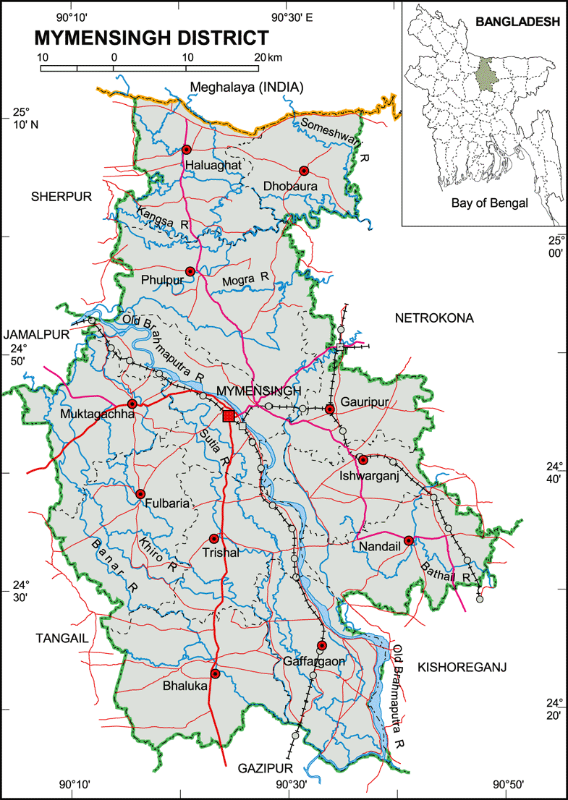

APPENDIX – B
PICTURE GALLERY

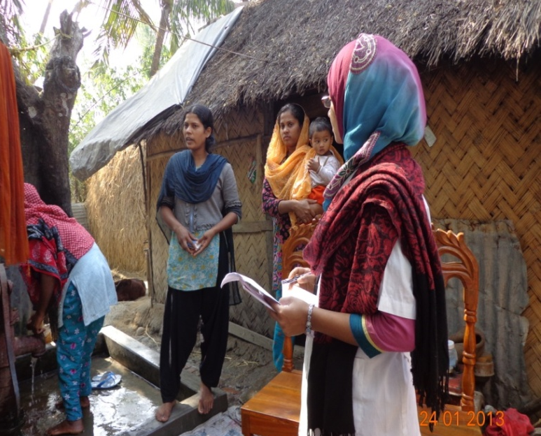
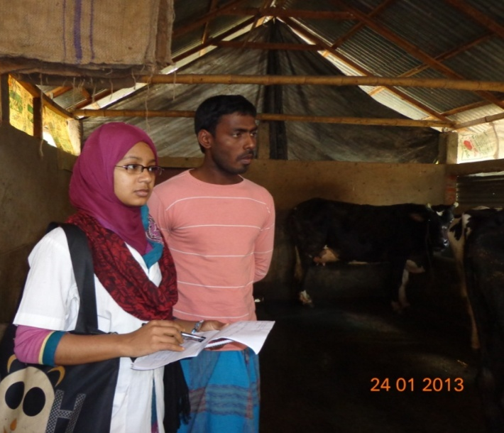

Picture: Collection of data

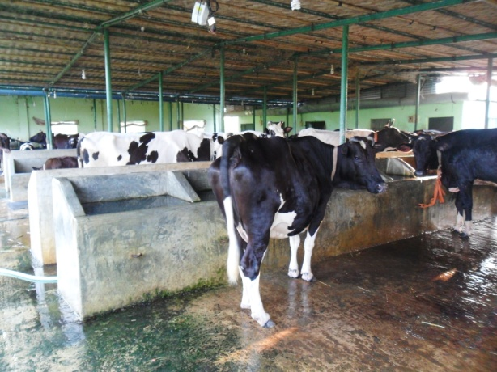
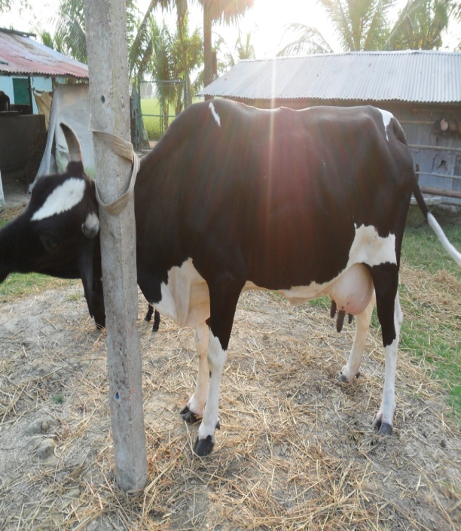

Picture: Farm visiting.

