**CHAPTER–1**

**INTRODUCTION**

Broiler farming plays an important role in improving livelihood, food security and poverty alleviation in rural and semi-urban communities in developing countries including Bangladesh. Broiler production has become a specialized and speedy business at present time for the people of the country. Short life cycle of the broiler and requirement of relatively less amount of capital attributed to its popularity to the farmers. A large number of energetic men and women are coming forward to undertake broiler farming as a means of self employment. Broiler farming has also been playing an important role in improving livelihood of the farmers. There are some examples where the broiler raisers have changed their socio-economic conditions to a considerable extent. A study report on the impacpt on Smallholder Livestock Development Project (SLDP) in rural community at different rural areas of Bangladesh revealed that the overall socio-economic condition of the beneficiaries , their egg and meat consumption capability, empowerment of rural women in decision making issues and employment opportunities were significantly increased after the intervention made by SLDP (Alam, 1997). Another study showed that commercial broiler farming provided employment opportunities for unemployed family members, improved socio-economic conditions and increased women empowerment among rural people of Bangladesh (Rahman *et al*., 2006).

Broiler farming has encouraged the people of different sections such as small farmers, landless labourers and educated unemployed as well as for industrialists to establish broiler farms on small & large scale. The better growth performance of broiler bird might simply be a function of higher feed intake. Feed consumption followed similar trend to that of weight gain. These non significant differences in growth performances support the finding of Oliveira et al (1974), Shanmugasundaran *et al.* (1976), Haque and Chowdhury (1994), Anisuzzaman & Chowdhury (1996), Hussain *et al* (1996), Haque and Chowdhury (1994), Anisuzzaman & Chowdhury (1996), Hussain *et al* (1996) & Sarica *et al* (1998) Findings of the study clearly indicate that all broiler farms made good profit & the large farms , however, carried little higher profit (Bang, vt. 2001 vol. 18 , Nos. 153-159.)

Broiler meat contains high quality protein and micro-nutrients which has had a tremendous impact on health and nutrition for the poor people in rural areas (Neumann et al., 2002; Barroetoa, 2007). Again, another study reported that it can be the main source of family earning or can provide sufficient income and gainful employment opportunity to rural farmers throughout the year (Bhende, 2006). For this reason, broiler farming has been playing a key role in providing meat to overcome the malnutrition and serve as a tool for employment generation and poverty alleviation (Raha, 2007). All these evidences suggested that commercial broiler farming deserve wider scale expansion throughout the country as a poverty reduction activity. Despite its high potential the broiler farming is not based on sound footings. Studies revealed that most of the broiler farm owners suffered from adequate amount of credit to run their farms and provision of credit for poultry farming is not yet very regular and well established practice among all the financial institutions - banks and NGOs in Bangladesh (Jabbar *et al.*, 2005). So, broiler farm owners face various problems like shortage, high price and poor quality of DOC (Day-old chick); high price, poor quality and unavailability of feeds; high cost and low quality of medicine, vaccine and veterinary services shortage of capital; inadequate marketing facilities; and poor transportation and communication (Raha, 2007);

Though broiler farming faces various problems, a huge scope exists for development of broiler industry in Bangladesh. It is interesting to note that broiler farming is solely in the private sector particularly in the hands of small farmers who are running their enterprise through self-finance. So it is very much necessary to assess whether broiler farming is contributing positively for the socio-economic development of the broiler farmers or not. The overall objective of the present study is, however, to estimate and assess the extent of improving livelihood of small scale commercial broiler farmers. It also identifies and analyzes the problems faced by the farm holders. Thus to meet the nutritional requirement & in the context of income generation & employment for rural household poultry husbandry is one of the most important source. Poultry rearing is an important source of nutrition, food & income & it's therefore a means of alleviation of rural poverty. Most of the rural households keep poultry for their family income   
& consumption. Poultry husbandry especially broiler rearing becomes a very encouraging enterprise for small farmers,landless laboures and educated unemployed as well as big enterprise.

**OBJECTIVES**

**The specific objectives of my study were as follows:**

1) To analyze the situation of poultry rearing in rural area.

2) To study the management pattern of broiler Farming.   
3) To study the weight gain and feed conversion ratio

4) To estimate the cost and return from broiler fanning**.**

5) To determine the socio economic development by broiler farming

6) To know the problems faced by the farm owners both in production and marketing

**CHAPTER-II**

**REVIEW OF LITERATURE**

To understand a research study thoroughly it is very important to highlight its background knowledge and other related marks.It provides additional information and reduces the chances of repeating previous mistakes.Therefore a brief review of literature is given below of the study.

**Islam et al.,(2007**) evaluated the broiler farm units in NWFP and found that the education standard of a large size farmer(3000-4000 birds)was better than medium (1500-3000 birds) and small farmers(below 1500 birds).The recurring expenditure on day old chicks were Rs.284812, Rs.158400 and Rs.87542,feed Rs.401920,Rs.233960 and Rs.124840,medicine and vaccines Rs.14000,Rs.16998 and Rs.12730,labor Rs.27600,Rs.11196,marketing Rs.8374,Rs.6170 and Rs.5598,mortality Rs.21240,Rs.26790 and Rs.11730,for large,medium and small farms respectively.The economic analysis demonstrated that large and small farms received greater cost benefit ratio(1:1.22),while lowest ratio was observed in medium farms(1:1.17).

**Mack et al.,(2005**)found that with the rapidly growing demand for animal products,including poultry meat and eggs,there is a need for increased investment in livestock production.Investment from private,public and international sources however needs to be guided by policies and institutions that promote equitable,sustainable,and environmentally friendly long-term outcomes.Poverty however remains at unacceptably high levels, particularly in sub-Saharan Africa and Asia,and it is important to recognize the contribution of livestock to the income and Welfare of the rural poor.Backyard poultry make an important contribution to poverty alleviation and should be considered in any strategy aimed at improving rural livelihoods. With the right policies and investment,there is ample evidence that will designed and participative development programme can overcome the constraints faced by the small holder poultry producers with significant economic and social benefits.

**Gondwe *et al* (2003)** found that rural poultry is raised and utilized by about 80 percent of the human population, primarily situated in rural areas and occupied by subsistence agriculture. Different poultry species are raised, mostly.

**Jensen and Dolberg (2002)** advocated for using poultry as a tool in poverty alleviation. An enabling environment must be established by providing access to feed, vaccine, vaccinations services, micro-finance, marketing and other inputs and services.

**Del Ninno *et al.,* (2001)** described in their paper that rural poultry production will not protect poor people in Bangladesh against the natural disasters that hit the country from time to time, but it can help them build up their asset base.

**Jensen (2000)** observed that about 70 % of the rural landless women are directly or indirectly involved in poultry rearing activities. He found that homestead poultry rearing is economically viable. The poultry sector could be one of the most productive sectors if these women are properly trained, supported with credit and other necessary inputs and made to operate under supervision of extension workers. Poultry rearing is suitable for widespread implementation as it is of low cost, required little skills, is highly.productive.There are some geographical hot spots where industrial poultry production and small holder village poultry systems have both massively grown in close geographical proximity, notably in Thailand, Indonesia, and China.

. **Todd, (1999) and Dolberg, (2001)** opined that poultry activity is to be considered as a learning process for the beneficiaries, but it has to be realised that one activity alone is not sufficient to lift a family out of poverty. The opportunities called as the enabling environment must be available for the beneficiaries to establish a small poultry enterprise, to minimize the risks and to take up other income generating activities.

**Huq and Mallik (1998)** found that rural women in Bangladesh use poultry as a tool in poverty alleviation and concluded that poultry development has potential for capturing the inequitable distribution of income and employment in rural areas. Women could operate and manage broiler, layer and duck farms efficiently with a high return on the investment. Poultry production on a smaller scale like in the are useful to improve the native backyard poultry under scavenging and semi-intensive systems, where women traditionally play the most important role.

**Yasmin et. al. (1989)** studied the characteristics of backyard poultry farmers in Bangladesh. Findings of the indicated that 17% had low knowledge, while 13% had considerable knowledge. Statistical tests revealed that education, family size, occupation, number of birds and extension contact of the farmers had a positive and significant relationship with their knowledge on poultry production

**CHAPTER - III**

**METHODOLOGY**

**i. Location:**

In Birampur upazilla most of the farms are situated near the house. Some of the farms are separated from the house. For improved faming system, transport facilities and other facilities are considered during site selection for farming.

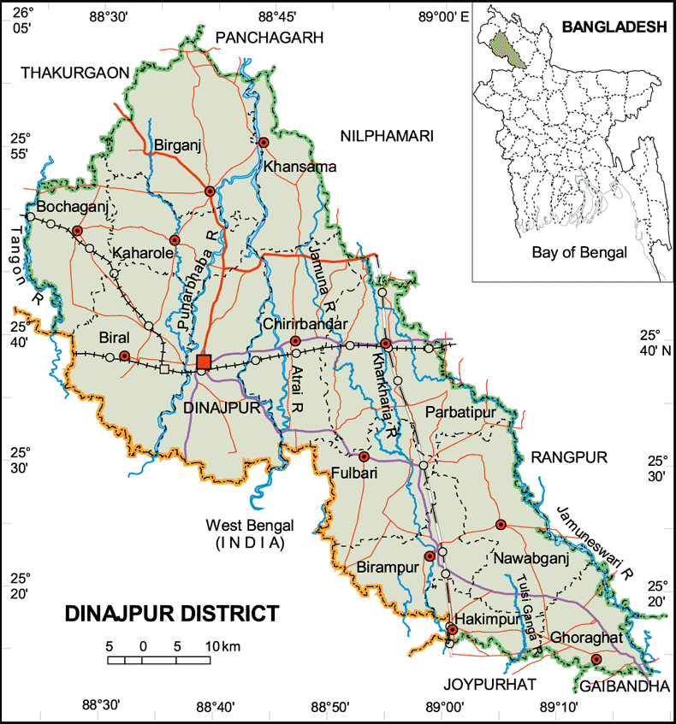 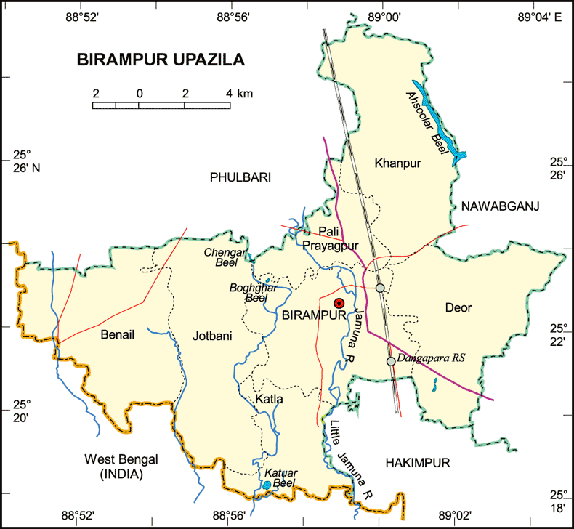

Fig:Location of the study area

**ii. Selection of study area:**

The area was selected according to my Internship placement.

**iii. Preparation of the survey schedule:**

The survey schedule was developed in accordance with the objective of study. Survey schedule was prepared to get the desired information from the broiler farm owner.

**iv. Period of data collection:**

The necessary information of the study was carried out when I was staying at Birampur upazilla Veterinary Hospital, under Dinajpur district from 16.07.12 to 06.09.12. During this period I visited some farms & collected data on prospects and problems of Broiler farming at Birampur upazilla by using an interview schedule through face to face interviewing.

**V. Collection of data:**

During the study period I visited 10 broiler farms in different unions in Birampur upazilla. Data were collected by taking interview.

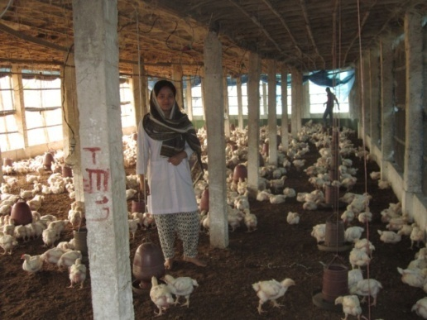

Fig:Visiting the broiler farm

**vi. Data analytical Techniques:**

The collected data were analyzed after coding, decoding, summarized when staying in CVASU campus with correspondence of supervisor. Simple statistical methods such as mean, percentage, standard deviations etc. were applied for analyzing the collected data to meet up the study goals and objectives.

**vii.** **Limitations of the study:**

The required information of the study was collected by a single visit to each farm at the end of one batch of broiler marketing due to shortage of time and fund during the internship placement period at Birampur upazilla Veterinary Hospital.

**CHAPTER- IV**

**FARM INFORMATION**

**A. Socioeconomic status of the farmers**:

Broiler farming was a income generating enterprise for almost all the farmers. People from all strata of the society, irrespective of religion, education, occupation & economic background were involved. About one third of the fanners were literate, the other were illiterate. The majority (70%) were not engaged in other form of occupation and by this occupation their economic condition was sound enough to maintain their families. All had gained their knowledge and experience of broiler farming from their farm consultant.

**B. Strains that are used by farms:**

The broiler were non descript types widely differing phenotypes. The so- called Hab chicks, Starbro, ISa-I 757 are common.

**C.** **Husbandry practices:**

The most practical program for broiler rearing has been the use of all-in, all-out system in which   
only one age of broilers is on the farm at the same day and later sold on the same day,  
after which there is a period when no birds are on the premises. This lack of birds breaks   
any cycle of an infectious disease: the next group of birds has clean start with no possibility   
of contracting a disease from older flocks on the farm. The downtimes maintain the  
farmer ranges from 14 to16 days.

**i)** **Flock Size**

The majority (85%) of flocks comprised 1000-1500 birds within the overall range between 1000-3000.

**Poultry population in each farm:-**

|  |  |
| --- | --- |
| **Name of the farm** | **Flock size** |
| Haque poultry farm | 3000 |
| Rabbi poultry farm | 3000 |
| Ujjal poultry farm | 1700 |
| Amin poultry farm | 1500 |
| Sohel poultry farm | 1200 |
| Aziz poultry farm | 1000 |
| Muhin poultry farm | 1000 |
| Dulal poultry farm | 500 |
| Mondol poultry farm | 500 |
| Sahin poultry farm | 300 |

**Source: Field Survey, 2013**

**ii) Housing:**

There are of course many different styles and designs of houses such as shed   
hype, combination hype, Gable type etc. during my study I found that   
most or the farmers constructed gable Type house for their bird which is made by bamboo & tin and suing the wire net around the houses, almost all of the houses are south facing  
& keep the house in well ventilated.

**iii) Floor, Feeder and water space followed by tile farmers are as follows:**

|  |  |  |  |
| --- | --- | --- | --- |
| **Age** | **Floor space** | **Water space** | **Feeder space** |
| First week | 0.5sqft/bird | 0.5 inch/bird | 1 inch/bird |
| Second week | 0.5sqft/bird | 0.57 inch/bird | 1.5 inch/bird |
| Third week | 1 sqft/bird | 0.75 inch/bird | 1.5 inch/bird |
| Fourth week | 1 sqft/bird | 1 inch/bird | 2 inch/bird |
| Fifth week | 1 sqft/bird | 1 inch/bird | 2 inch/bird |

**iv) Chick transportation**:

Farmers are start their rearing program from day old to market age. They start their  
program by collecting the chick from hatchery or other selling enterpriser. After collection   
most of the fanner transports their chick by taxi or tempo. It is noted that chick is  
packed in paper box: which is supplied by selling enterpriser or hatchery.

**v) Disinfection of the farm:**

The floor of the house is usually disinfected by iosan, phenol bleaching powder or limewater before placing the litter materials. But among the disinfectants the farmer most commonly use iosan & bleaching powder.

Most of the farmers fumigate the house before 10 days of arrival of chicks and they follow the following formula for fumigation.

Potassium permanganate (ppm): Formalin (400/0 formaldehyde) -1:2

i.e. 60 gm Potassium permanganate + 120 ml formalin for 100 cubic ft areas.

- Then applied litter materials. Rice husk and saw dust were widely used by the farmers with a depth of 1 -2 inch. The other litter materials are wood savings, straw or leaves etc. Surrounding the brooding area by the use of plastic sheet. Brooder was run 3 hours before arrival of chicks with a Temperature of 90° to 95°.

**(vi) Treatment of the chick in the house:**

After arrival of the chick in the house farmers firstly gave the chick water with the   
mixer of Glucose, Vitamin and minerals. Then feed is given in a paper sheet for the first   
3 hours, after that feed was given in feeder. Number of waterer & feeder used by  
the farmer is shown in following table:

**Number of Feeder:**

|  |  |  |
| --- | --- | --- |
|  | **0-2 Weeks** | **3-5 Weeks** |
| Chicks feeder | 2 ft long feeder/ 50 chicks | - |
| Tube Feeder | - | 4 in number/100 birds |

**Number of waterer:**

|  |  |  |
| --- | --- | --- |
| Waterer | **0-2 weeks** | **3-5 weeks** |
| 1 plastic drinker/50 birds | - |
| - | 1 Plastic drinker/50 birds |

**vii) Brooding:**

Artificial heat was use in brooding chick. It was seen that 5-10 brooder /500 bird & electric   
bulb were used by the fanners as a heat source for the first 2 weeks of age Number.   
of electric bulb were used by farmers for heat source is shown in following  
table:

|  |  |  |
| --- | --- | --- |
| **Number of chicks** | **No. of electric bulb** | |
| **Summer** | **Winter** |
| 500 | 100 watt 2 in number and 60 watt 1 in number | 200 watt 2 in number and 100 watt 2 in number |

After 2 weeks brooder guard had been withdrawn and the brooder house ere used as grower house.

**viii) Temperature schedule:**

|  |  |
| --- | --- |
| **Age(weeks)** | **Temperature of Brooding** |
| 0-1 | 90ºF |
| 1-2 | 85ºF |
| 2-3 | 80ºF |
| 3-4 | 75ºF |
| 4-5 | 75ºF |

* It was seen that most of the farmer used thermometer for measuring temperature.

**ix) Litter management:**

|  |  |  |
| --- | --- | --- |
| **Litter material** | **Depth** | |
| **Winter** | **Summer** |
| Rice husk | 1.5-2 inch | 1 inch |

**x) Feeding:**

Feeding is main function in rearing broiler chicks. More feed consumption, more weight gain. The chicks should be given small quantity of feed frequently for the 1st week. The farmer use the following way for feeding the broiler

**Feeding Practices of Broiler Farming**

|  |  |
| --- | --- |
| **Age** | **Nature of feed** |
| 1st week | Crumble |
| 2nd week | Crumble |
| 3rd week | Pellet |
| 4th week | Pellet |
| 5th week to finishing | Pellet |
| 6th week to finishing | Pellet |

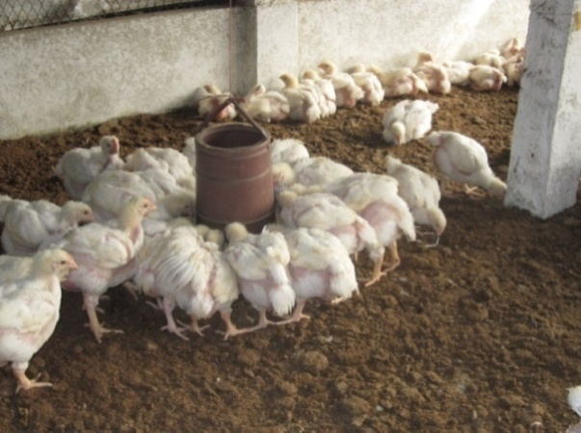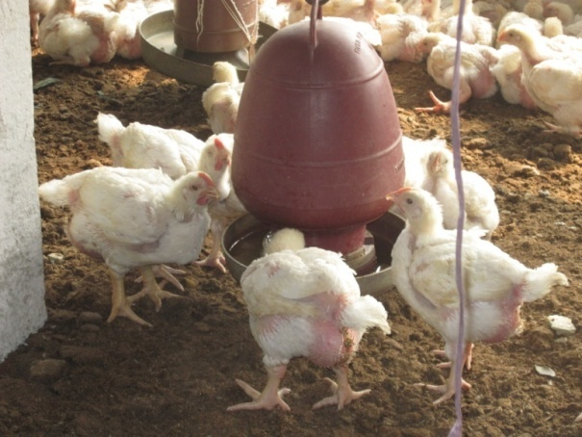

Fig:Feeding and watering practices in broiler farm

**xi)Weight gain:**

After proper feeding weight gain which is recorded by the farm owner are given bellow:



Fig: Graphical Representation of weight gain

Fig: Graphical representation of weight gain.

**xii) Incidence of diseases and health maintenance program:**

**-** Incidence of diseaseand health status was recorded. Mortality was estimated by farms.  
**Health maintenance program:**

A health program is fundamental for successful broiler production. Under health program  
farmers only done vaccination & used foot bath (1% ppm) in front of the shed.

**Vaccination schedule:**

|  |  |  |
| --- | --- | --- |
| **Age** | **Vaccine(Trade)** | **Route** |
| 3rd day | BCRDV | Eye drop |
| 7th day | Gumboro (228E) | Eye drop |
| 14th day | Gumboro (228E) | Eye drop |
| 21st day | BCRDV | Eye drop |

**xiii) Marketing information of Broilers:**

Broilers in this region were raised & sold when age at 5 weeks either at the local market or at the farmer doorstep to individual and local traders.

|  |  |  |  |
| --- | --- | --- | --- |
| **Parameters** | **Purchase cost/chick** | **Feed cost/Kg** | **Price of meat/Kg** |
| Farm-1 | 29 | 35 | 135 |
| Farm-2 | 30 | 35 | 135 |
| Farm-3 | 30 | 32 | 137 |
| Farm-4 | 29 | 34 | 134 |
| Farm-5 | 30 | 35 | 133 |
| Farm-6 | 29 | 34 | 137 |
| Farm-7 | 31 | 35 | 130 |
| Farm-8 | 30 | 35 | 133 |
| Farm-9 | 31 | 35 | 130 |
| Farm-10 | 29 | 33 | 137 |

**Source: Field Survey, 2013**

**CHAPTER-V**

**RESULT AND DISCUSSION**

**Performance of commercial broiler at different farms in Birampur upazilla:**

|  |  |  |  |  |  |  |  |  |  |  |
| --- | --- | --- | --- | --- | --- | --- | --- | --- | --- | --- |
| **Parameters** | **Farm-1** | **Farm-2** | **Farm-3** | **Farm-4** | **Farm-5** | **Farm-6** | **Farm-7** | **Farm-8** | **Farm-9** | **Farm-10** |
| Body.wt(kg) | 1.6 | 1.5 | 1.5 | 1.6 | 1.7 | 1.4 | 1.8 | 1.6 | 1.8 | 1.45 |
| Feed intake (Kg)/bird | 3.1 | 2.9 | 3 | 3.1 | 3.2 | 2.8 | 3.3 | 3 | 3.2 | 3 |
| FCR | 1.9:1 | 1.9:1 | 2:1 | 1.9:1 | 1.8:1 | 2:1 | 1.8:1 | 1.8:1 | 1.7:1 | 2.06:1 |
| Mortality rate | 3% | 2.5% | 3% | 2.9% | 3.1% | 2.5% | 3% | 2.1% | 3.5% | 2.4% |
|  | **\***Cost involve/bird | 148 | 142 | 142 | 145 | 152 | 135 | 157 | 145 | 153 | 138 |
| Return/bird | 216 | 203 | 206 | 215 | 226 | 192 | 234 | 213 | 234 | 199 |
| Benefit/bird | 68 | 61 | 64 | 70 | 72 | 57 | 77 | 68 | 81 | 61 |
| Cost Benefit ratio | 1:.45 | 1:.42 | 1:.45 | 1:48 | 1:.47 | 1:.42 | 1:.49 | 1:.46 | 1:.52 | 1:.44 |

Fig:Graphical representation of body weight and feed intake

Fig: Graphical representation of benefit(%) of respective farms

**Total Cost**

\***(Cost involve /bird=**

**Total no of birds**

Cost involve per bird including housing, vaccination ,medication, electricity, feed and chick cost.**)**

The above table shows that body Weight was height in farm-**7,9(1.8)** followed by farm-5(1.7),farm-1,4,8(1.6),farm-2,3(1.5),farm-10(1.45),and farm-6(1.4)

respectively.

FCR was found best in farm -**9(1.7)** followed by farm-5,7,8(1.8), farm-1,2,4(1.9), farm -3,6(2.0) and farm-10(2.06) respectively.

Return /bird varied from farm to farm due to high market price. The farm **-7,9** got highest market price **(234**) then farm-5(226), farm-1(216), farm-4(215), farm-8 (213),farm-3(206),farm-2(203),farm-10(199) and farm-6(192).

Benefit was estimated highest in Farm**-9(81)** followed by farm-7(77), farm -5(72), farm -4(70),farm-1,8(68),farm-3(64),farm-2,10(61) and farm-6(57) respectively.

And cost benefit ratio was determined best in farm**-9(1:0.52)** followed by farm-7(1:0.49), farm-4(1:0.48),farm-5(1:0.47),farm-8(1:0.46),farm-1,3(1:0.45),farm-10(1:0.44)andfarm-2,6(1:0.42) respectively.

In the study, we notice that production performance long stand depend on chick's quality i.e. different hatchery.Production variation was also dependent on different strains (Zaman, 2008). It is also observable that some hatchery supply often different quality maintaining chicks. It is depend on demand and supply of chicks. In the study the chicks of KAZI farm (1.7:1) have shown better performance than others. The farmers who will rear the chicks of KAZI and fed their flock C.P's feed, will get more profit. On the other hand the chicks of BRAC (2.06:1) show lower performance due to low quality chicks. Their chick’s weight, feed conversion ration, are low but disease prevalence and mortality is higher than other. Overall the whole study shows that the average weight gain, feed convertion ratio of broiler at Birampur Upazilla is almost satisfactory.

**Development of socio-economic condition of broiler farmers in the study area:**

**Employment opportunity**

Small scale commercial broiler farming provided an annual employment opportunity to the family members of broiler farmers. It was also observed that similar type of employment opportunities created for rural poor, landless labourers, small and marginal farmers and unemployed or under employed laborers. Thus, adopting of small scale broiler farming made a positive impact on the employment opportunities to the unemployed family labors in the study area.

**Monthly household income and expenditure**

The overall monthly income of the farmers increased day by day. Thus positive changes in household income occurred due to the adoption of small scale commercial broiler farming in Birampur upazilla. The increased income of the farmers influenced them to make more investment in broiler farming and spend more money in different aspects of household.

**Current savings and investment**

The percentage of exchange of cash in hand and savings with banks were increased by adoption of broiler farming. These changes were bearing a direct financial impact on investment in broiler business.

**Conditions of school-going children**

School-going boys and girls of broiler farmers increased sucessively. Most of the respondents expressed that the education expenses of their children increased which was affordable with their increased income from broiler farming

**Changes in possession of household assets**

The increased income of the respondents through participation of broiler farming also reflected in the possession of household assets. Family assets like television, sewing machine, dining table, electric fans and mobile phone increased after adopting broiler farming.

**Sources of drinking water and latrine condition**

The sources of drinking water from own tube-well increased and shared tube-well decreased than before after the involvement with broiler farming. Thus, broiler farming created a positive impact on the sources of drinking water of the broiler farmers. After broiler farming, ownership of *katcha* latrines decreased but ownership of sanitary latrines increased. It indicates that broiler farming has made an encouraging intervention on sanitation of broiler farmers

**Health status of respondents**

The broiler farmers reported that their family health status had improved. They further opined that the occurrences of diseases had reduced and annual cost for treatment was supported after conducting broiler farming.

**Changes in socio-economic condition**

Seventy two per cent broiler farmers informed that their socio-economic condition had improved due to the adoption of broiler farming. On the other hand 28 % respondents implied that their socio-economic condition remained unchanged.

Fig: Graphical representation socio-economic condition of broiler farmers

**PROBLEMS OF BROILER FARMING IN BIRAMPUR UPAZILLA**

**l. Shortage of feed & proper nutrition:**

Bangladesh is a highly populated country. There is no enough land for feed cultivation. As a result, the farm owner faces the crisis of feed. The feed which are found in the market have less nutritive value. The broiler does not gain proper weight by consuming those feed.

**2. Lack of transport facilities:**

A transport facility of Birampur upazilla is not so good. It is difficult for the farmers to transport the necessities from one place to another. So people do not find interest to establish farm

**3. Low quality feed: -**

The feed which are found in the market are of low quality. The feed suppliers do not maintain proper nutritive composition and hygienic condition.

**4. Low quality chick:**

The hatchery owner supply low quality chicks. As a result the farm owners are deprived from having good and healthy chicks. Many chicks die in their early stage of life. It is very harmful for a farm and farmers lose interest to do farm.

**5. High mortality rate of chicks:**

When the farms become affected by any contagious disease, the mortality rate of the birds is very high. The farm owner do not take proper care and treatment in due time. As a result the farm owners face to huge loss.

**6. Lack of knowledge:**

Most of the farm owners are illiterate and they have lack of knowledge about farm management, as a result the broilers do not grow rapidly.

**7. Lack of well established diagnostic lab:**

There are no any opportunities for diagnosis of disease in village level because lack of well established diagnostic laboratory in the village.

**8. Lack of post mortem facilities:**

There is lack of post mortem facilities of dead bird for the diagnosis of disease. As a result they can not know the accurate cause of the diseases and not take proper preventive measure.

**9. Lack of proper vaccination:**

Proper vaccination is also barrier for the establishment of broiler farm in rural areas. The farm owner do not vaccinate their birds in due time because of lack of vaccine supplied by the Govt.

**10. Lack of bio-security knowledge:**

The farm owners do not maintain bio-security strictly. Local people, cattle, goat, dog, cat, other birds are always threatened for a farm. Many farmers do not use foot bath at the entrance of the farm.

**11. Unavailability of expert consultants:**

People of remote area do not get good & expert poultry consultants. So many birds die without any treatment.

**12. Unavailability of drugs:**

Good and varieties quality of drugs are not found in the village. It is a major cause of death of poultry and a barrier of establishment of farms.

**13. High cost of drug:**

The cost of poultry drug is very high. The poor farm owners are not able to buy drug of high cost for the treatment of their birds.

**14. Absence of proper disease control model:**

There is no any disease control model in the rural level on which the farmer can prevent diseases occurred in the farm.

**15. Acute shortage of veterinary support staff:**

There is lack of veterinary doctor and other staff for the suggestion of farm owner for the development of broiler farm in the village level.

**16. Influence of Drugs Company:**

Representatives of drug companies communicate with the farm owner and influence them for using their low quality drug. As a result the birds do not get sufficient active ingredients used in drug and die of disease unexpectedly. It acts as a barrier for the development of broiler farm in rural area.

**17. Influence by feed supplying company:**

Many feed companies communicate with farm owner and influence them for using their low quality feed. It also acts as a barrier for development of broiler farm is rural area.

**18. Lack of Govt. influence:**

The Govt. does not take care of the remote area like ours. People do not get the help of the Govt. on broiler farming in this area. So this area is lag behind in this sector.

**19. Condition of the people**:

The overall condition of the people is not so good. Most of the people are illiterate, poor and unconscious. The illiterate people do not know how to establish a farm, poor people can not invest money and the unconscious people do not realize the value of protein for the formation of our body. They also do not know that this demand of protein for the body can be achieved by broiler meat in comparison to other meat.

**CHAPTER-VI**

**CONCLUSION**

From the above discussion it can be concluded that Birampur upazilla under Dinajpur district is a very suitable and prospectious zone for broiler farming and broiler production. But first it is crying need to solve the above mentioned problems and other constraints. Then it would be possible to establish broiler farms to meet the protein demand of the people and to remove the poverty of people creating employment opportunities for the unemployment people. Government is to take proper steps and play an important role for establishment of a poultry zone in this area by solving the all problems and giving more opportunities to the existing farm owners. The government can take a mega plan to establish a farm in each upazilla of Bangladesh using which as a model, local people would create their own farm. Finally, it can be said that small scale broiler farming contributed positively to the socio-economic development of the broiler farmers as well as the improvement of rural livelihood,in the study area.

**Recommendations**

The following recommendations may be put forward:

* Government should monitor the reasonable price of poultry feed and day old chicks.
* Facilities of the institutional loan to the owners of poultry farms should be made so that they can get the credit on easy terms.
* Hatcheries should increase the supply of day old chicks.
* For proper housing, nutrition, disease control, marketing and management-DLS should provide short term training for the owners of the poultry farms.
* The regular supply of electricity should be ensured.
* Government support should be provided to medicine and vaccine producing Institutions to ensure the availability of the medicine and vaccine in the area.
* Price stabilization of the market should be monitored by the government to ensure the reasonable profitability of the farmers.

**CHAPTER-VII**

**REFERENCES**

L. Mozumdar, K. S. Farid, J. U. Ahmed1 and M. W. Rahman-2009, Broiler farming: An approach to improve rural livelihood, J. Bangladesh Agril. Univ. 7(2): 395–402

Mack,S.D. Hoffmann and J.Otte.,(2005),The contribution of poultry of Rural Development,World`s Poultry Science Journal. Vol.61

Agarwal et al(1986). Broiler feeding and nutrition. Pakistan journal of Nutrition2(2);60-67

Del Ninno et al (2001). Commercial Broiler production. North Carolina state University

Rahman, M (2003 ) Growth of Poultry Industry in Bangladesh. Poverty Alleviation and Employment Opportunity7  3rd  International Poultry Show and Seminar, Dhaka, Bangladesh.

Karlon 2001.Broiler production,Taxas Agricultural Extension Services bulletin. Texes A&M

University, Texas. 16-17 Feb. 15-24.

Anisuzzaman and Chowdhury 1996, An Economic Study On Poultry Farms In Bangladesh, Journal of Livestock Research,1-5:161-174

Haque and Chowdhury, 1994, Current Ststus of Poultry and Marketing System of Bangladesh, Agricultural Research Project – 2.

Bangladesh Bureau of Statistic, statistical year book of Bangladesh1996, Dhaka p-46.

Islam,F.,A.Raziq,M.R.Khan,M.I.Khan and A.Ahmad.(2007).An Analytical evolution of broiler farm units in Malakand agency.International Journal of Life Sciences.1(4):377-384

**APPENDIX Study on Commercial Broiler farming in Birampur upazila**

**Questionnaire**

1.

A. Name of the farm.................................................

B. Name of the owner/Farmer/Employee.................

C. Address: Village.........Union................P.O.................Thana.............District……….

2.Husbandry practice:

A. Housing:

a. Brooder house b. Grower cum finisher house

B. Feeding:

* Collection of feed...........................................
* Storage of feed …..........................................
* Types of feed...................................................
* How many times feed supplied daily.............

C. Watering:

* Source of water
* Frequency of water supply

D. Litter materials................................................................

E. Ventilation

a. Sufficient .b. Insufficient

F.Lighting schedule…………………………………………

G. Bio-security.............................................................

H. Foot bath: …………………………………………

3. Number of sheds.......................................................

4. Incidence of diseases……………………………….

5. Management of disease condition:

a. Self management

b. Quack

c. Veterinary doctor

6 .Health programme:

a. Vaccination. b.Anthelmintic

7.Marketing system:……………………………………

8. Cost & return:………………………………………..

9 The farm is profitable or not......................................

Name of the interviewee............... Name of the interviewer...........

Date.......... Date: ……………

Signature............. Signature

**.......................................................THE END.............................................................**