Chapter I
INTRODUCTION

The domestic cat (Felis catus or Felis silvestris cat is a small, usually furry, domesticated, carnivorous mammal. It is often called the housecat when kept as an indoor pet, or simply the cat when there is no need to distinguish it from other felids and felines. Cats are valued by humans for companionship and their ability to hunt vermin and household pests. The English word cat (Old English catt) is in origin a loanword, introduced to many languages of Europe from Latin cattus and Byzantine Greek κάττα, including Portuguese and Spanish gato, French chat, German Katze, Lithuanian katė and Old Church Slavonic kotka, among others. The ultimate source of the word is Afroasiatic, presumably from Late Egyptian čaute,]the feminine of čaus "wildcat". The word was introduced, together with the domestic animal itself, to the Roman Republic by the 1st century BCE. An alternative word with cognates in many languages is English puss (pussycat). A group of cats is referred to as a "clowder" or a "glaring", a male cat is called a "tom" or "tomcat" (or a "gib", if neutered), a female is called a "molly” or (especially among breeders) a "queen", and a pre-pubescent juvenile is referred to as a "kitten". The male progenitor of a cat, especially a pedigreed cat, is its "sire", and its female progenitor is its "dam".
Classification based on human interaction
Population | Food source | Shelter | Socialized
Pedigree | Fed by owner | Human homes | Yes
Pet | Fed by owner | Human homes | Yes
Semi-feral | General feeding | Buildings | Yes
Feral | General feeding/foraging | Buildings | No
Free-ranging cats are active both day and night, although they tend to be slightly more active at night. The timing of cats' activity is quite flexible and varied, which means that house cats may be more active in the morning and evening (crepuscular behavior), as a response to greater human activity at these times. Although they spend the majority of their time in the vicinity of their home, housecats can range many hundreds of meters from this central point, and are known to establish territories that vary considerably in size, in one study ranging from 7 to 28 hectares (17 to 69 acres). Cats conserve energy by sleeping more than most animals, especially as they grow older. The daily duration of sleep varies, usually 12–16 hours, with 13–14 being the average. Some cats can sleep as much as 20 hours in a 24-hour period. The term "cat nap" for a short rest refers to the cat's tendency to fall asleep (lightly) for a brief period. While asleep, cats experience short periods of rapid eye movement sleep often accompanied by muscle twitches, which suggests that they are dreaming. These territories are marked by urine spraying, by rubbing objects at head height with secretions from facial glands, and by defecation. Between these territories are neutral areas where cats watch and greet one another without territorial conflicts. Outside these neutral areas, territory holders usually chase away stranger cats, at first by staring, hissing, and growling, and if that does not work, by short but noisy and violent attacks. Despite some cats cohabiting in colonies, cats do not have a social survival strategy, or a pack mentality and always hunt alone.
Domestic cats use many vocalizations for communication, including purring, trilling, hissing, growling/snarling, grunting, and several different forms of meowing. By contrast, feral cats are generally silent. Their types of body language, including position of ears and tail, relaxation of whole body, and kneading of paws, are all indicators of mood. The tail and ears are particularly important social signal mechanisms in cats, e.g. with a raised tail acting as a friendly greeting, and flattened ears indicating hostility. Tail-raising also indicates the cat's position in the group's social hierarchy, with dominant individuals raising their tails less often than subordinate animals. Nose-to-nose touching is also a common greeting and may be followed by social grooming, which is solicited by one of the cats raising and tilting its head. Among domestic cats, males are more likely to fight than females. Among feral cats, the most common reason for cat fighting is competition between two males to mate with a female. In such cases, most fights will be won by the heavier male. Another common reason for fighting in domestic cats is the difficulty of establishing territories within a small home. Female cats will also fight over territory or to defend their kittens. Spaying females and neutering males will decrease or eliminate this behavior in many cases, suggesting that the behavior is linked to sex hormones.

When fighting, cats make themselves appear more impressive and threatening by raising their fur, arching their backs, and turning sideways, thus increasing their apparent size. Often, the ears are pointed down and back to avoid damage to the inner ear and potentially listen for any changes behind them while focused forward. They may also vocalize loudly and bare their teeth in an effort to further intimidate their opponent. Fights usually comprise of grappling and delivering powerful slaps to the face and body with the forepaws as well as bites. Cats will also throw themselves to the ground in a defensive posture to rake their opponent's belly with their powerful hind legs. Serious damage is rare as the fights are usually short in duration, with the loser running away with little more than a few scratches to the face and ears. However, fights for mating rights are typically more severe and injuries may include deep puncture wounds and lacerations. Normally, serious injuries from fighting will be limited to infections of scratches and bites, though these can occasionally kill cats if untreated. In addition, bites are probably the main route of transmission of feline immunodeficiency virus (FIV). Sexually active males will usually be involved in many fights during their lives, and often have decidedly battered faces with obvious scars and cuts to the ears and nose. When cats mate, the tomcat (male) bites the scruff of the female's neck as she assumes a position conducive to mating known as lordosis behavior.

Domesticated cat
Scientific classification
Kingdom: | Animalia
Phylum: | Chordata
Class: | Mammalia
Order: | Carnivora
Family: | Felidae
Genus: | Felis
Species: | F. catus

Objectives
- To know the different varieties of indigenous cat.
- To know the health status of pet cats.
- To know the behavioral characteristics.
- To know the reproduction characteristics.

Chapter II
REVIEW OF LITERATURE

The cat expresses its visual signals mainly by the positions of the ears and tail, and by the body posture. The ears can be moved either backwards while still erect, downwards towards the chin, or positioned partly backwards and partly downwards. Wild cats like the tiger or the lynx have dark markings on the back of the ear. In the back-ward ear position, these markings are seen from in front of the cat and make the ears more conspicuous. This ear position is thought to signal offensive aggression, i.e. the cat trying to manipulate the opponent to withdraw. By flattening the ears towards the chin, the ears and their offensive signals are hidden. This is used by defensive cats signaling acceptance of a subordinate status. Such cats can however, defend themselves if the dominant cat attacks. This is frequently signaled simultaneously by an open mouth, perhaps also accompanied by hissing. The arousal of this cat is also is also evidenced by large pupils. If the cat experiences a conflict between offensive and defensive motivations, the ear signal may be intermediate providing the cat with a fine-tuned mechanism for experiencing a conflict between offensive and defensive motivations, the ear signal may be intermediate, providing the cat with a fine tuned mechanism for expressing various relative strengths of these motivations. As staring eyes may signals offensive threat, cats frequently avoid looking at each other in the early stages of agonistic encounters. ( Bjarne O. Brastad and Morten Bakken)

Female cats are seasonally polyestrous, which means they may have many periods of heat over the course of a year, the season beginning in spring and ending in late autumn. Heat periods occur about every two weeks and last about 4 to 7 days. Multiple males will be attracted to a female in heat. The males will fight over her, and the victor wins the right to mate. At first, the female will reject the male, but eventually the female will allow the male to mate. The female will utter a loud yowl as the male pulls out of her. This is because a male cat's penis has a band of about 120–150 backwards-pointing penile spines, which are about one millimeter long; upon withdrawal of the penis, the spines rake the walls of the female's vagina, which is a trigger for ovulation. This act also occurs to clear the vagina of other sperm in the context of a second (or more) mating, thus giving the later males a larger chance of conception. After mating, the female will wash her vulva thoroughly. If a male attempts to mate with her at this point, the female will attack him. After about 20 to 30 minutes, once the female is finished grooming, the cycle will repeat. Because ovulation is not always triggered by a single mating, females may not be impregnated by the first male with which they mate. Furthermore, cats are superfecund; that is, a female may mate with more than one male when she is in heat, with the result that different kittens in a litter may have different fathers. The gestation period for cats is between 64–67 days, with an average length of 66 days. The size of a litter averages three to five kittens, with the first litter usually smaller than subsequent litters. Kittens are weaned at between six and seven weeks, and cats normally reach sexual maturity at 5–10 months (females) and to 5–7 months (males), although this can vary depending on breed. Females can have two to three litters per year, so may produce up to 150 kittens in their breeding span of around ten years. Cats are ready to go to new homes at about 12 weeks old, or when they are ready to leave their mother. Cats can be surgically sterilized (spayed or castrated) as early as 7 weeks to limit unwanted reproduction. This surgery also prevents undesirable sex-related behavior, such as aggression, territory marking (spraying urine) in males and yowling (calling) in females. Traditionally, this surgery was performed at around six to nine months of age, but it is increasingly being performed prior to puberty, at about three to six months. In the USA approximately 80% of household cats are neutered.

Census
Estimated domestic cats in top cat-owning countries and regions (millions, rounded to the nearest hundred thousand):
Country | Domestic | Feral
USA | 93.6 | 60.0–100.0
Europe | 60.0
China | 58.0
Australia | 2.7 | 18.0+
Russia | 17.8
Brazil | 11.0
United Kingdom | 9.0 | 1.0+
France | 10.0
Japan | 10.0
Germany | 8.0
Canada | 7.9–8.5
Italy | 7.5–9.4
Ukraine | 7.4
Poland | 6.0
India | 3.9
Netherlands | 3.0
Spain | 2.8
Belgium | 1.7
Mexico | 13.5
New Zealand | 2.0
South Africa | 2.0 | 7.0

Although wildcats are solitary, the social behavior of domestic cats is much more variable and ranges from widely dispersed individuals to feral cat colonies that form around a food source, based on groups of co-operating females. Within such groups one cat is usually dominant over the others. Each cat in a colony holds a distinct territory, with sexually active males having the largest territories, which are about ten times larger than those of female cats and may overlap with several females' territories. To date, there are few scientific data available to assess the impact of cat predation on prey populations. Even well-fed domestic cats may hunt and kill, mainly catching small mammals, but also birds, amphibians, reptiles, fish and invertebrates. Hunting by domestic cats may be contributing to the decline in the numbers of birds in urban areas, although the importance of this effect remains controversial. In the wild, the introduction of feral cats during human settlement an threaten native species with extinction.] In many cases controlling or eliminating the populations of non-native cats can produce a rapid recovery in native animals. However, the ecological role of introduced cats can be more complicated: for example, cats can control the numbers of rats, which also prey on birds' eggs and young, so in some cases eliminating a cat population can actually accelerate the decline of an endangered bird species in the presence of a mesopredator, controlled by cats.

In the Southern Hemisphere, cats are a particular problem in landmasses such as Australasia, where cat species have never been native and there were few equivalent native medium-sized mammalian predators. Native species such as the New Zealand Kakapo and the Australian Bettong, for example, tend to be more ecologically vulnerable and behaviorally "naive" to redaction by feral cats. Feral cats have had a major impact on these native species and have played a leading role in the endangerment and extinction of many animals. Cat numbers in the UK are growing and their abundance is far above the "natural" carrying capacity, because their population sizes are independent of their prey's dynamics: i.e. cats are "recreational" hunters, with other food sources. Population densities can be as high as 2,000 individuals per km and the trend is an increase of 0.5 million cats annually. (Wikipedia, the free encyclopedia)

A cat parasite has the ability to manipulate entire human cultures, according to a 2006 study. The microbe Toxoplasma gondii is a mind-control master. It infects rats and makes them act reckless, hanging out in places where they're likely to get caught by cats. This works out well for the parasite, which can only reproduce in the feline stomach. But Toxoplasma gondii's mind control also extends to humans: People living in countries with high T. gondii infection rates were more likely to be neurotic than people living in areas were infection rates were low, the 2006 study found. Neuroticism is a personality trait characterized by anxiety and insecurity. If enough people are infected (likely from contact with cats), the study researchers said, it's possible that T. gondii could shift the behaviors of entire cultures.
( http://www.livescience.com/13884-kitty-kitty-10-facts-cat-lovers.html)

Density of free ranging domestic cats appears directly dependent on food resources. Most domestic cats are solitary hunters. Prey species include those considered by men to be vermin, which may explain why cats have been allowed to coexist with people in the absence of much artificial selection for specific behaviors. Kittens will learn to prefer and to best hunt the prey species that their mother preferentially hunted. Pet cats learn to prefer a certain texture of food. (Susan E. Aiello et. al)
Data from other studies indicate that the role of marking (feces, urine or both) can be important in the maintenance of complex social hierarchies. Unless such subtle communicatory signals are noticed, one could assert that the social system is maintained by far simpler mechanism such as linear dominance. Wolski (1982) & Mcdonald and colleagues noted that the edges of ranges are after marked with urine. Usually, if a new male enters and his scent is not one of the scents, that is common for the group, without inhibiting a defensive posture, however the avoidance of conflict was correlated with urine marks and ability to induce withdrawal of intruders. (Karen L. Overal)

Cat frequently eats grass. This is observed in free ranging, prey killing cats as well as in those eating canned or dry diets. It is not surprising, therefore, that cats may eat houseplants. Plant eating can have serious consequences to this cat. Because so many house plants are poisonous. But regardless of whether the plant or the cat at the risk, the behavior is undesirable. If owners observe their cat eating a plant they can punish the cat on frighten it a way but the cat is like the destructive dog, most cat misbehave in the owner’s absence. The best solution is to provide the green plants that the cat apparently needs and certainly desires. (Katherine A. Houpt)

Cats generally have pregnancies lasting from 58 to 65 days. They can become pregnant at as early as six months of age and go into heat twice a year, in the spring and the fall. Cats are induced ovulators, which mean that they need stimulation by a male in order to release eggs from their ovaries. Until this happens, a cat can remain quite uncomfortable throughout the heat period, which can last up to three weeks. Anyone who has a female cat knows that the sound a cat makes during heat is one of extreme distress. I often find cat owners camped out on my office doorstep waiting for my arrival so that I can spay their cat immediately, as they and their cat were up half the night due to the cat's suffering.
If you are planning to mate your cat, it's a good idea to line up a male well in advance. Most successful litters are from females who are between three and six years old mated with an experienced male. Be aware that the act of mating can be pretty intense because the male will grab the queen (the mother cat) by the neck with his teeth, often resulting in some hair loss and scarring. Your vet can confirm the pregnancy after about four weeks by either palpation (feeling the abdomen with a gentle squeeze), ultrasound or a bit later on by radiograph. During the pregnancy the queen's caloric intake and weight will increase, so be sure to provide additional food. Toward the end of the pregnancy the queen's mammary glands will swell, and she may start nesting in a specific area. (answers.yahoo.com › All Categories › Pets › Cats)

Chapter III
MATERIALS AND METHODS

- Preliminary survey for the cats.
- Browsing internet and websites.
- Photography for phenotypic and behavioral characteristics of cat.
- Interviewing people by set interview schedule.
- Direct observation on cats.
- Studying secondary data.

Chapter IV
RESULTS AND DISCUSSIONS

4.1 Breeds

Breeds are commonly found in Bangladesh are non descriptive. The available breeds of cat available in the world are given below.
Breed | Country | Year discovered | Characteristics | Extra info | Image
American Bobtail | United States | 1960 | playful, friendly, energetic and extremely intelligent, | Is the result of a cat body type genetic mutation affecting the tail development | 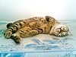
American Curl | United States | 1983 | Uncommon breed | Have almost straight ears, but showcats must have ears that curl in an arc between 90 and 180 degrees. | 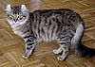
American Longhair (Maine Coon) | United States |  | adaptable, friendly, and undemanding nature | Polycystic kidney disease also present in the breed. Weight gain is sometimes a problem, so regular physical activity
American Shorthair | United States | 1900´s was imported | Are known for their gentle expression | Male American Shorthairs can weigh up to 15 pounds, while females can get up to 12 pounds at maturity. They are known for having long life spans, and can live to be 20 years old with good care.
Abyssinian | Ethiopia | 1882 | Is believed to have originated from one Egyptian female kitten named Zula | The Abyssinian has alert, relatively large pointed ears
Aegean cat | Greece | Natural/Standard | Semi-long | Bi- or tri-colored
Australian Mist | Australia | Crossbreed | Moderate | Short | 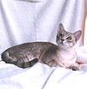
American Polydactyl | United States | Not-Mutation | Moderate | Short/Long
American Wirehair | United States | Mutation |  | Rex
Arabian Mau | Arabian Peninsula | Natural |  | Short
Asian (cat) | Developed in the United Kingdom-Britain |  |  | Short
Asian Semi-longhair | Great Britain | Crossbreed |  | Semi-long
Balinese | United States | Crossbreed | Oriental | Long | 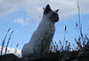
Bambino | United States | Crossbreed |  | Hairless/Furry down
Bengal | United States | Hybrid |  | Short
Birman | Burma | Natural |  | Long
Bombay | United States | Crossbred | Moderate | Short
Brazilian Shorthair | Brazil | Natural |  | Short
British Shorthair | United Kingdom | Natural | Cobby | Short
British Longhair | United Kingdom |  | Cobby | Long
Burmese | Burma and Thailand | Natural |  | Short | 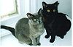
Burmilla | United Kingdom | Crossbreed |  | Short/Long
California Spangled Cat | United States | Crossbreed |  | Short | 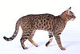
Chantilly/Tiffany | United States
Chartreux | France | Natural | Cobby | Short
Chausie | France | Hybrid |  | Short
Cheetoh | United States | Hybrid Crossbreed |  | Short
Colorpoint Shorthair |  |  |  | Short
Cornish Rex | United Kingdom | Mutation |  | Rex | 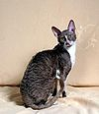
Cymric | Isle of Man | Natural/Mutation |  | Long | 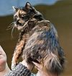
Cyprus Aphrodite | Cyprus | Natural | Lean and muscular | All
Devon Rex | England | Mutation | Oriental | Rex | 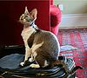
Domestic shorthair cat |  |  |  | Short
Donskoy or Don Sphynx | Russia |  |  | Hairless
Dragon Li | China | Natural |  | Short | 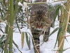
Dwelf |  | Crossbreed
Egyptian Mau | Egypt | Natural |  | Short | 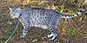
European Shorthair | Sweden-Italy | Natural |  | Short
Exotic Shorthair | United States | Crossbreed | Cobby | Short
German Rex | East Germany | Mutation |  | Rex | 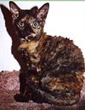
Havana Brown | United Kingdom |  |  | Short | 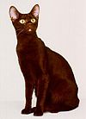
Highlander (cat) | America | Crossbreed | Moderate | Short
Himalayan/Colorpoint Persian | United Kingdom | Crossbreed | Cobby | Long
Japanese Bobtail | Japan | Natural | Moderate | Short/Long
Javanese | Indonesia | Crossbreed | Oriental | Long/Short | 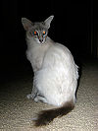
Korat | Thailand | Natural |  | Short
Kurilian Bobtail | Russia | Natural | Semi-Cobby | Short/Long | 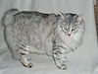
LaPerm | United States | Mutation | Moderate | Rex | 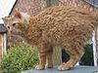
Maine Coon | United States | Natural |  | Long
Manx | Isle of Man | Natural/Mutation |  | Short/Long
Mekong bobtail | Russia | Natural/Mutation |  | Short | 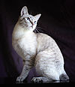
Minskin | United States | Crossbreed | Semi-Cobby | Short/Hairless
Munchkin | United States | Mutation
Nebelung | United States |  |  | Semi-long
Napoleon |  |  |  | Long/short
Norwegian Forest Cat | Norway | Natural |  | Long | 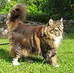
Ocicat | United States | Crossbreed |  | Short | 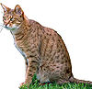
Ojos Azules | United States
Oregon Rex | United States | Mutation |  | Rex
Oriental Bicolor |  |  | Oriental | Bicolor | 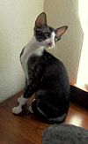
Oriental Shorthair |  |  | Oriental | Short

Oriental Longhair |  |  | Oriental | Semi-long
Persian | Greater Iran |  | Cobby | Long
Peterbald | Russia | Crossbreed | Stocky | Hairless | 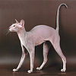
Pixie-bob | United States | Natural |  | Short | 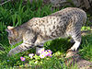
Ragamuffin | United States | Crossbreed | Cobby | Long
Ragdoll | United States | Crossbreed | Cobby | Long
Russian Blue | Russia | Natural |  | Short
Russian Black, White or Tabby | Australia | Crossbreed |  | Short
Savannah | United States | Hybrid |  | Short | 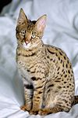
Scottish Fold | Scotland | Natural/Mutation | Cobby | Short/Long
Selkirk Rex | United States | Mutation/Cross |  | Rex (Short/Long)
Serengeti cat | United States | Hybrid Crossbreed |  | Short
Siamese | Thailand | Natural | Oriental | Short | 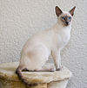
Siberian | Russia | Natural | Semi-Cobby | Semi-long
Singapura | Indonesia | Natural |  | Short
Snowshoe | United States | Crossbreed |  | Short
Sokoke | Kenya | Natural |  | Short
Somali | United States | Mutation |  | Long
Sphynx | Canada/USA | Mutation | Stocky | Hairless
Thai | Thailand | Natural |  | Short
Tonkinese | Canada | Crossbreed |  | Short
Toyger | United States | Crossbreed | Moderate | Short
Turkish Angora | Turkey | Natural |  | Semi-long
Turkish Van | Turkey | Natural |  | Semi-long | 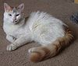
Ukrainian Levkoy | Ukraine |  |  | Hairless | 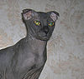
Ussuri | Russia | Natural Hybrid |  | Short
York Chocolate Cat | United States
(http://en.wikipedia.org/wiki/List_of_cat_breed)
4.2 Social status:
Generally cats are not commonly pet. Cats are seldom found as pet. The stray cats collect food from their own. Cats are not generally loved by common people compared to dog in the study area.

4.3 Common foods:
They generally prey cockroaches and rats. They usually like to eat milk, rice, fish. But they are greatly fond of spine of dried fish & dried fish. One thing more was found that sometimes they eat plants when they face enteric disturbances and disorders.

According to Susan E. Aiello et. al , most domestic cats are solitary hunters. Prey species include those considered by men to be vermin. It has been found that, they prey cockroaches and rats.

According to Katherine A. Houpt , cat frequently eats grass. It was found that sometimes they eat plants. A local practitioner said that it was due to helminthic infection. This condition improves if pyrental pamoate (Delentin syrup) is given to the cat.

4.4 Common/ behavioral characteristics:
Cats are likely to disappear from house for 3-4 days. One interesting observation was found
that the cats have strong attraction for opposite sex. They disappear with their partners. If someone prevent them to do this kind of activity, they even withdraw food. Usually they are obedient to owners. But, they do not cooperate even with the owner in mating season. They have intentions to leave home.

According to Wikipedia, the free encyclopedia, sexually active domestic cats have large territories where they are dominant. One interesting observation was found that the cats have strong attraction for opposite sex. They disappear with their partners.

According to Karen L. overal, the edges of ranges are after marked with urine in cats. Cats avoid other territories for avoiding conflicts. It has been found that, Cat in a colony has a definite territory and they usually avoid other colony territories. So, this is mostly similar to my study.

Phenotypic characteristics through photography:
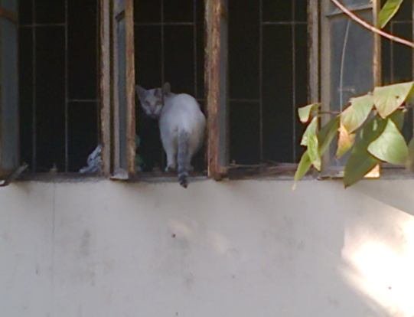
Fig : Cat in kitchen . Fig. : Resting cat.
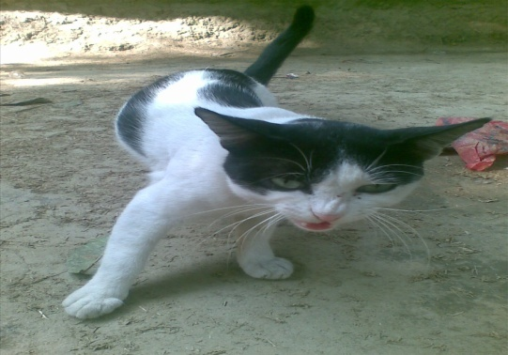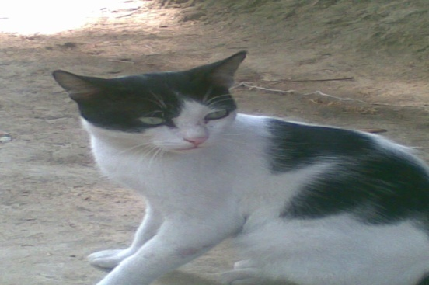
Fig : Angry cat. Fig. : Tensed cat.
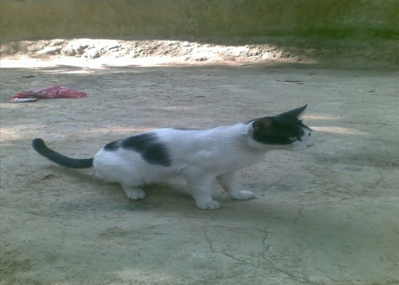
Fig. : Jolly cat. Fig. : Passers by cat.

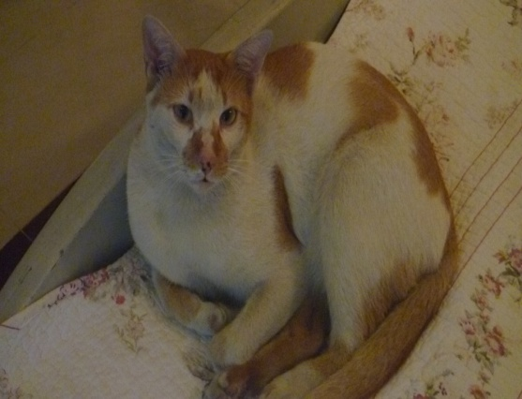
Fig. : Thinkful walking. Fig. : Lazy cat
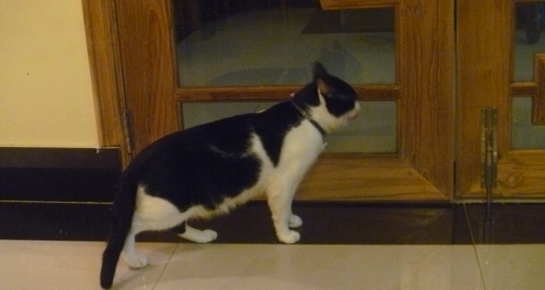
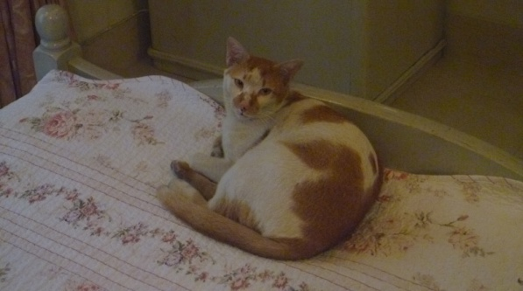
Fig. : Affectionate cat. Fig. : Careful cat.
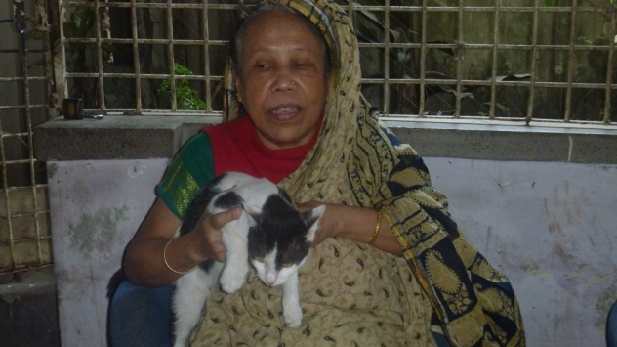
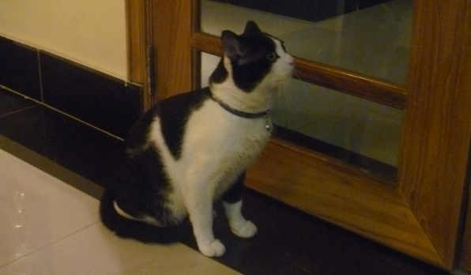
Fig.: Cat in dog sitting posture. Fig. : Cat owner with cat.

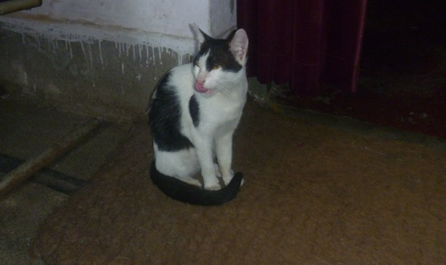
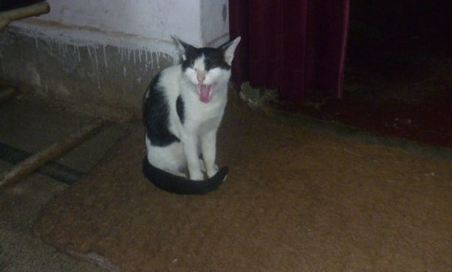
Fig : Agile act. Fig.: Observing cat.
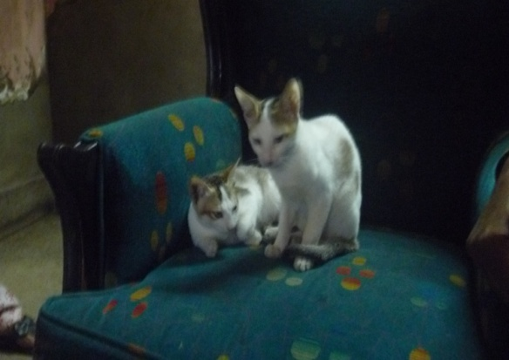
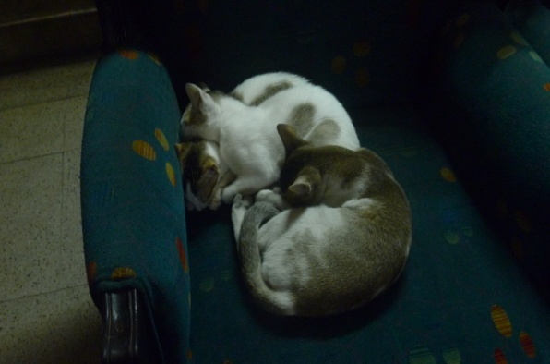
Fig.:Sleepy cats. Fig.: Playing cat.
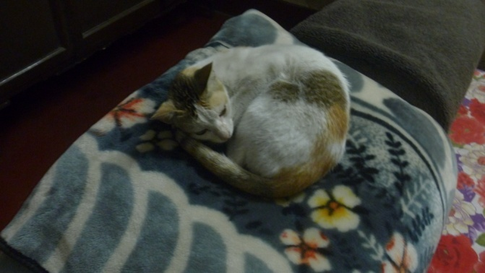
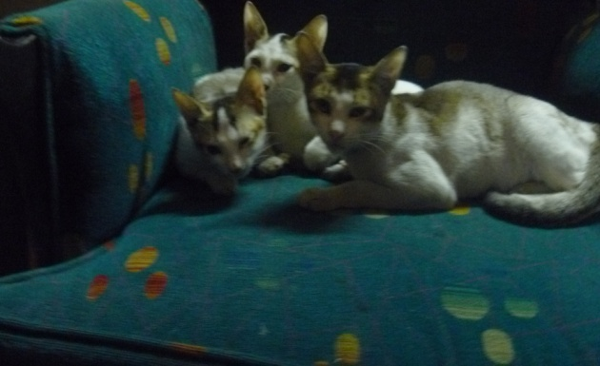
Fig. : Interested cats. Fig. : Cat in deep sleep.
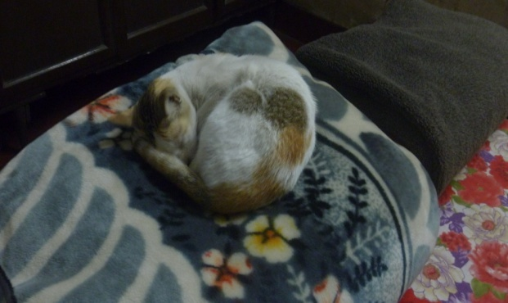
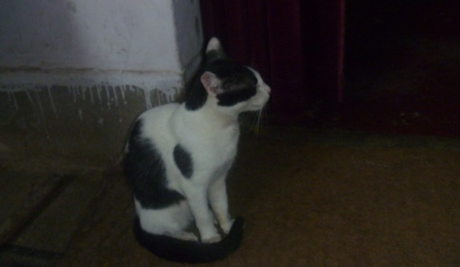
Fig : Sharp cat. Fig. : Drousy cat
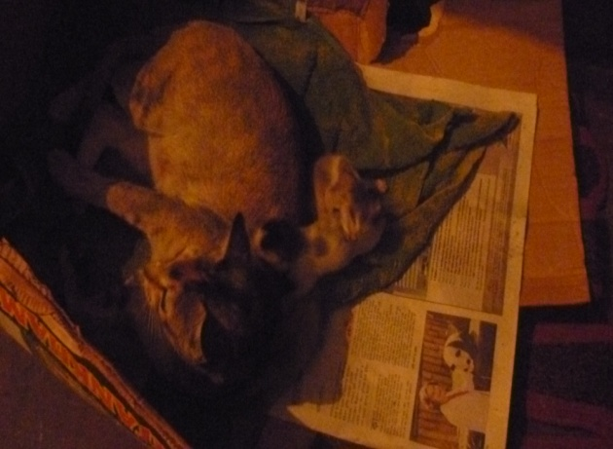
Fig. : kitten beside cat. Fig. : Seeking mother love.
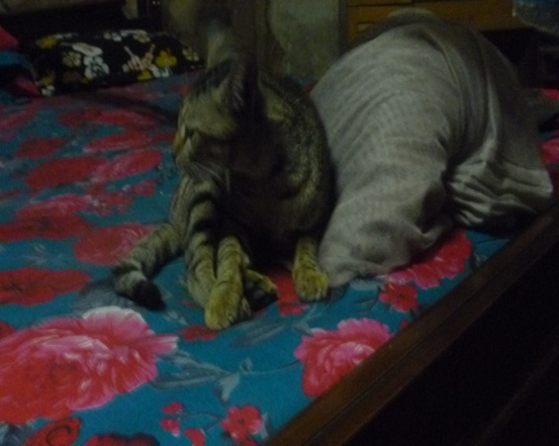
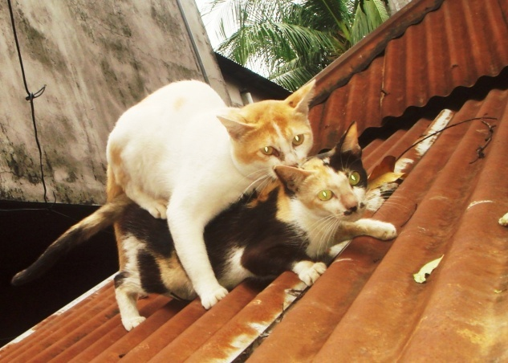
Fig. : Mating posture. Fig. : Subconscious mind cat.

4.5 Common physiological characteristics:
Domestic cats, especially young kittens, are known for their love of play. This behavior mimics hunting and is important in helping kittens learn to stalk, capture, and kill prey. Cats will also engage in play fighting, with each other and with humans. This behavior may be a way for cats to practice the skills needed for real combat, and might also reduce any fear they associate with launching attacks on other animals.
Owing to the close similarity between play and hunting, cats prefer to play with objects that resemble prey, such as small furry toys that move rapidly, but rapidly lose interest (they become habituated) in a toy they have played with before. Cats also tend to play with toys more when they are hungry. String is often used as a toy, but if it is eaten it can become caught at the base of the cat's tongue and then move into the intestines, a medical emergency which can cause serious illness, even death. Owing to the risks posed by cats eating string. Stray cats defecate in loose feces and cover the feces with something.

Body temperature of felines normal ranges between 100.5 - 102.5 °F(38 - 39.2°c). Respiratory Rate is 16 - 40 breaths per minute. Heart Rate is 120-140 beats per minute. Kittens have 26 teeth. Adult cats have 30 teeth. They usually lose their deciduous (baby) teeth by 6 months of age, which are replaced by the adult teeth. Generally, Kitten don’t have permanent teeth at birth; but complete eruption is occurred by 60 days of age. The dental formula is
I - 3/3 C - 1/1 P - 3/2 M - 0/0 = 13 x 2 = 26,
Which is for adult at about 4 months of age,
I - 3/3 C - 1/1 P - 3/2 M - 1/1 = 15 x 2 = 30.

4.6 Reproductive characteristics :
Female cats are seasonally polyestrous, which means they may have many periods of heat over the course of a year, the season beginning in spring and ending in late autumn. Heat periods occur about every two weeks and last about 4 to 7 days. Multiple males are attracted to a female in heat. The males fight over her, and the victor wins the right to mate. At first, the female will reject the male, but eventually the female will allow the male to mate. The female will utter a loud yowl as the male pulls out of her. This is because a male cat's penis has a band of about 120–150 backwards-pointing penile spines, which are about one millimeter long; upon withdrawal of the penis, the spines rake the walls of the female's vagina, which is a trigger for ovulation. This act also occurs to clear the vagina of other sperm in the context of a second (or more) mating, thus giving the later males a larger chance of conception.
After mating, the female wash her vulva thoroughly. If a male attempts to mate with her at this point, the female will attack him. After about 20 to 30 minutes, once the female is finished grooming, the cycle repeats.

Because ovulation is not always triggered by a single mating, females may not be impregnated by the first male with which they mate. Furthermore, cats are superfecund; that is, a female may mate with more than one male when she is in heat, with the result that different kittens in a litter may have different fathers.

Gestation period for cats is between 64–67 days, with an average length of 66 days. The size of a litter averages three to five kittens, with the first litter usually smaller than subsequent litters. Kittens are weaned at between six and seven weeks, and cats normally reach sexual maturity at 5–10 months (females) and to 5–7 months (males), although this can vary depending on breed. Females can have two to three litters per year, so may reproduce up to 150 kittens in their breeding span of around ten years.
According to Bjarne O. Brastad and Morten Bakken, cats can however, defend themselves if the dominant cat attacks. This is frequently signaled simultaneously by an open mouth, perhaps also accompanied by hissing. The arousal of this cat is also is also evidenced by large pupils. It has been found that in fear and aggression, cats open mouth, do hissing sound and erect ear. So, this is similar to my study Queen cats produce sound at the time of mating with tom cats. Male cats can kill the kittens of other cats.

4.7 Husbandry practices in cases of pets:
Domestic pets are kept with owners. They reside in the drawing room, kitchen, sofas or any other soft places of house. They are provided foods and medicines and vaccination by owners in due time. The kittens is nurtured well by owners. The best dried foods are better for cats than the best wet foods. Wet foods differ mainly in their water content, and dried foods provide cats with important chewing exercise for their gums and teeth.

4.8 Merits and demerits of cats as pet :
Cats have a nature of putting mouth in curry. Besides it is a source of diphtheria and rabies in human. Sometimes it shows non obedient nature. But, it kills rats, prey cockroaches and other vermin. It helps to protect our surroundings from problematic creatures.

4.9 Cats diseases and remedial care: A number of diseases affect health of cats. Some important diseases are listed below:

The cat bacterial diseases are tetanus,tuberculosis, salmonellosis, leptospirosis, feline bordetellosis, tularemia, metritis, nocardiosios, actinomycoses, pyoderma.
The cat viral diseases are Feline rabies, Feline immunodeficiency virus, Feline parvo virus or Feline panleukepenia, Feline infectious peritonitis virus, Feline rota virus infection, Feline viral upper respiratory infection, Feline calicivirus infection.

Fungal diseases of the cat are Fungal Disease (Sporotrichosis) of the Skin, Fungal Infection (Aspergillosis), Fungal Infection (Coccidioidomycosis , Fungal Infection (Histoplasmosis), Fungal Infection (Malassezia pachydermatis) of the Skin, Fungal Infection (Pneumocystosis) of the Lung, Fungal Infection (Yeast), Fungal Infection of Lower Urinary Tract, Fungal Toxicosis related to Fusarium Fungus.

The cat parasitic diseases are Toxocara cati infection,Dipylidium caninum infection, Gnathostoma spinigerum infection(stomach worm), Ancylostoma tubaeforme and A. brazilense infection infection(Hook worms of cat), Trichinella spiralis infection, Feline dirofilariasis (feline heartworm disease), Feline babesiosis, Isospora felis or Isospora rivolta infection, Entamoeba histolytica infection.

Others diseases of cats are diabetes mellitus, otitis interna, arthritis, rickets/osteomalacia, food hypersensitivity.abscess, drug toxicity, arthritis in cats, aspiration pneumonia, ring worm infection.
The disease that were handled by SAQTVH, CVASU since January 2012 to present vomiting, anorexia, diarrhea, dermatitis, dermatophytoses, fungal infection, flea infestation , ear mite infestation, round worm infection, renal failure, coughing & sneezing, feline infectious enteritis, fracture of limbs, constipation, vaccination in cat.
Drugs commonly use in SAQTVH, CVASU in treatment of cats:
Trade name | Compositon
Ring guard ointment | Miconazole Nitrate IP, Neomycin Sulphate IP, chlorocresol IP. Uses: Used to relief from Ringworm & Athlete's.
Inj.Metro IV | Metronidazole.
Orbidex C eyedrop | Chloramphenicol.
Inj.KCND | Kenamycin, Collistin, Neomycin, Dexamethasone. It works well in arthritis.
Inj. Vita ADE | Vitamin A, Vitamin D, Vitamin E
Inj. Ringer’s lactate | Saline.
Syp. Avolac | Lactulose(Purgative).
Syp. Delentin | Pyrentel pamoate.(Anthelmintic drug)
Syp. Xinc B | Zinc
Liq. Calvit P | Ca, Mg, P.
Syp. Ficlox | Cloxacillin.
Syp.Fimoxyl | Amoxicillin.
Inj. Vermic/Ivertin | Ivermectin
Inj. Strepto P | Streptomycin and Penicillin
Vaccine Quadricat | Protection against Rabies, Feline calici virus, Feline leukepenia virus, Feline Herpes virus. 1ml s/c ly.
Syp. Cef 3 | Ceftriaxone
Inj. Eracef vet 1gm | Ceftriaxone
Syp. Biconex | Vitamin
Tab. Omidon | Ondasterone (anti vomiting agent)

Paracetamol can’t be given to cat, because :
Paracetamol (also known as acetaminophen) is a common anti-inflammatory drug found in most supermarkets and household medicine cabinets. It's often use to treat headaches and muscular pain in humans, but it should never be given to an animal, especially cats.
Cats are easily poisoned by paracetamol because they have different liver metabolisms compared to humans. In humans and most other animals, the paracetamol is combined with glucuronide producing a safe product. Cats have very low levels of glucuronide, and consequently more of the paracetamol is processed via the cytochrome P450 pathway, producing the toxic product NAPBQ. NAPBQ damages the red blood cells and liver of cats. Other species, including humans, can also suffer paracetamol poisoning by using a high dose of the drug, or for a long period of time as this will use up the reserved of glucuronide in the liver.
The toxic dose for a cat is 50-100mg of paracetamol per kg of body weight. A large cat may barely survive one tablet without permanent damage. Unfortunately, many unknowing owners who give their cat paracetamol to make it feel better find that after the tablet there is no improvement, and give the cat another. This second tablet guarantees that there is enough paracetamol to cause liver failure and kill the cat.
A cat poisoned by paracetamol may seem nauseous or vomit. They will usually show a Heinz body anaemia and the typical symptoms associated with that: blue or brown gums, lethargy and depression. Cats usually show swollen faces and paws, and may be crying. In severe cases the cat will already be jaundiced and show signs of hepatotoxicity.
Paracetamol poisoning can be treated with timely medical attention, before the liver becomes so badly damaged that it can no longer function.

Chapter V
CONCLUSION

Cats are very amazing creature. They are very good as companion animals. Many people are fond of cats. As a companion, we must know about their behaviors, feeding, breeding, psychology, likes and dislikes. To improve relationship with cats and make sound mental and physical health we must provide facilities to them. Skills of veterinarians should have to be improved in handling diseases and management of cats. In a nutshell, it can be said that cat also be pet as companion animal though it can not be compared with dog.

Limitation of study:
The study covers only a limited area Khulshi, Chittagong during the study period (1st December to 30th December). Due to limitation of time duration whole area was not possible to include in the study. This is simply an introduction to study on cats, so far known, in Bangladesh.

Chapter VI
ACKNOWLEDGEMENT

All praise is due to almighty Allah, who enable the author to complete the study successfully.

The author would like to express his deep sense of gratitude & thanks to Professor Dr. A. S. M. Bari, vice-chancellor, Chittagong Veterinary & Animal Sciences University.

The author would like to express his deep sense of gratitude & heartfelt appreciation to Prof. Dr. Gouranga Ch. Chanda, MSc, Ph.D, MBA, Head of Department of Dairy & Poultry Sciences, Chittagong Veterinary & Animal Sciences University for his scholastic guidance & cordial cooperation in all phases of this study.

The author finally, is ever indebted to his family members, friends & well wishers.

Author.

Chapter VII
REFERENCES

Aiello. Susan E. (1998): Social behavior. The Merck Veterinary Manual. 8th edn. Merck and co. Inc U.S.A:1183.

Houpt, Katherine A (2011): Plant eating. Domesticated Animal Behavior For Veterinarians And Animal Scientists. 8th edn. Wiley-Blackwell. U.S.A.: 253.

Overall, Karen L (1997): The role of scent. Clinical behavioral medicine for small animal.1st edn. Mosby yearbook, Inc.St. Louis Missouri: 73-74.

Rahman, Siddikur Md. (2006) : Canine and Feline Medicine volume 2. 1st edn. Prithul & Priya publication. Bangladesh : 1-281.

http://voices.yahoo.com/paracetamol-poisoning-cats-765357.html
en.wikipedia.org/wiki/List_of_cat_breeds
en.wikipedia.org/wiki/Cat
www.livescience.com/13884-kitty-kitty-10-facts-cat-lovers.htm
www.petmd.com/cat/conditions

