HUSBANDRY PRACTICES OF DAIRY FARMING AT CHITTAGONG SUBURBAN AREA
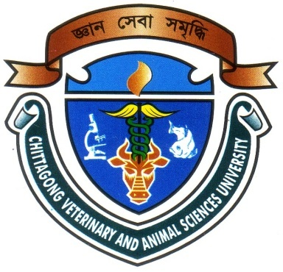

A Production Report Presented in Partial Fulfillment of the Requirement for the Degree of Doctor of Veterinary Medicine

A Report submitted by

Roll No: 07/03

Reg. No: 287

Intern ID: A-02

Session: 2006-2007

Faculty of Veterinary Medicine

Chittagong Veterinary and Animal Sciences University

Khulshi, Chittagong-4202

HUSBANDRY PRACTICES OF DAIRY FARMING AT CHITTAGONG SUBURBAN AREA

A Production Report Submitted as per approved style and content

--------------------------  (Signature of Author)  Md. Shohel Al Faruk  Roll No: 07/03  Reg. No: 287  Intern ID: A-02  Session: 2006-2007 | -------------------------------  (Signature of Supervisor)  Dr. Gouranga Ch. Chanda  Professor & Head  Dept. of Dairy & Poultry Science,  Faculty of Veterinary Medicine

Chittagong Veterinary and Animal Sciences University

Khulshi, Chittagong-4202
February, 2013.
ACKNOWLEDGEMENT

All praises are due to Almighty “Allah”. Who enabled the author to complete this study successfully Guidance, cooperation and help received from persons during the study period. The author is immensely grateful to all of them. The author doses not have adequate words to express his heartfelt sense of gratification and sincere appreciation to his benevolent teacher and report supervisor.

The author express his deep sense of gratitude, heartfelt respect and immense indebtness to his supervisor Dr. Gouranga Ch. Chanda, Professor & Head, Department of Dairy & Poultry Science, Chittagong Veterinary and Animal sciences University for his valuable advice, scholastic guidance, suggestions, inspiration and who was involved with this study through its inception.

The author expresses his heartful respect to Dr. Md Abul Quasem, Professor, Department of Anatomy & Histology for his valuable advice and co-operation. Finally I want to give special thank to DR. S. K. Shill, Lecturer. Dept. of Anatomy & Histology and DR. Saiful Bari, Lecturer. Dept. of Dairy & Poultry Science, Chittagong Veterinary and Animal sciences University for his valuable advice about scientific report writing. I would like to expressing my deep sense of gratitude and thanks to Dr. Masuduzzaman, Dean. Faculty of Veterinary Medicine & Vice Chancellor, Dr. A. S. Mahfuzul Bari Chittagong Veterinary and Animal Sciences University.

I also express thanks to my friends Supervisors’ help and co-operation have been received from many person during the tenure of this place of report. The author is immensely grateful to all of them, although it is not possible to mention every one by name.

The Author

February, 2013.

PLAGIARISM CERTIFICATE
It is given assurance that this report is not a facsimile of any other study report. Various information collected from different books and journals that are cited in reference list which seem to be essential in preparing this report. So it’s claimed to be original.

-----------------------------
Sign of the author.

