**ABSTRACT**

The study was conducted on the management including housing, feeding, productive and reproductive performance of pigeons in an intensive pigeon farm at Chittagong, Bangladesh. Data were collected for a period of one month from 11 November to 10 December on all age and sex group of ten varieties. The pigeons were reared in modified poultry cages. For the movements of pigeons, a small paved area of 13 x 12 ft was provided in the farm. Available feed supplied to the pigeon were rice, wheat, cowpea, mustard oil cake, germinating gram and lentil as grain mix and oyster shell, grit, dicalcium phosphate and salt as mineral mix. The supplied diet contained ME (2993.8 kcal/Kg) and CP (15. %). The body weight was significantly (P<0.001) different among all the varieties of pigeons. But there was no significant (P=0.67) difference of body weights between male and female pigeons. It was observed that the age of maturity, incubation period and productive life were ranging from 6-7 months, 18-21 days and 6-9 years respectively. The production of squabs was ranging from 5-12 pair per year. Mostly prevailing diseases were New Castle disease, Pigeon Pox, Coryza and Parasitic infestation accordingly. From the study, it was observed that the owner of that farm reared pigeons as his hobby and the production level was also satisfactory. As there is an increased demand of pigeon as food or ornamental birds in this area. So, he can take the chance to earn money. In the future, further extensive studies on pigeon of larger population and of different areas should be done to know the management practice of individual varieties.

Keywords: Pigeon, Pigeon farming.

**CHAPTER-1**

**INTRODUCTION**

The word Pigeon has been derived from French word “Pijon” which means young bird and as well as the Latin word “Pipion” which means Columba(dove). Domestic Pigeons are descendents of Wild pigeons (*Columba livia*) distributed in Rocky Ravines throughout the Asia and Europe. Evidence of its domestication dates back to 4500 BC. They are generally kept for ornamental purposes. Pigeon rearing has a global distribution. It is well accepted pursuit in Middle East, North Africa and several parts of North America and Europe. Pigeon raising is a popular hobby in China **(Jalal *et al.,* 2011).**

Bangladesh is a land of agriculture. Most of the village people of his country are engaged in agriculture, livestock, and poultry rearing. More than 80 percent of the rural households rear poultry (**Haque, 1987 and Ahmed, 1988**). Production of young meat Pigeon (Squab Raising) provides alternative income to small farmers. Squabs are being reared as a side line in Villages, towns and on farms. Squab raising can be made profitable source of income with good management and market squabs require little land since all breeders are kept in small pens and houses. A pigeon is a tradition part of Middle Eastern diet. In China Pigeon meat is a popular restaurant dishes and there is good demand from Jewish community clubs all over the world.

Bangladesh has a long historical record of raising poultry under backyard system. The weather and vast areas of crop field along with housing premises of Bangladesh are suitable for pigeon farming. The contributions of pigeon have not yet been considered in relation to the contribution of livestock sub-sector and whole poultry production though the pigeons provide alternative source of animal protein. Comparatively low investment, care less, less feed and housing cost involved, easy and economic husbandry practices, short reproduction cycle and less disease occurrence are observed for pigeon farming. Pigeons are used in natural beautification and ornamental birds as source of recreation, source of palatable, delicious and easily digestible animal protein, sources of bio-fertilizer especially for family gardening and used as the laboratory animal in case of genetic and hormonal studies. Hence profitable pigeon farming may be an easy and reliable source of employment opportunity, way of family labour utilization and cash income. Sustainable and increasing rate of pigeon farming may enhance the rate of reducing the gap of animal protein consumption/deficiency; increase the rate of poverty reduction and it may improve the socio-economic status of the rural poor community (**Asaduzzaman *et al*., 2007**). There is a little information on the diseases affecting pigeons in Bangladesh. Proper disease data and information are valuable to formulate any control strategy. Further pigeon could be potential reservoir for public health significant pathogens such as Salmonella, Colibacillosis, Trichomoniasis, Mite infestation and for commercial chickens such as Newcastle disease (**Cruickshank and Smith, 1949 and Muller, 1965**) .The current study was conducted to observe the total management practices of a pigeon farm and to formulate some suggestions about pigeon farming in Chittagong, Bangladesh.

**The main objectives of the study were**

- to find out the housing and feeding practices

- to evaluate management practices of the pigeons

- to know the overall behavior of pigeon.

**CHAPTER-2**

**REVIEW OF LITERATURE**

**2.1. Characteristics**

The domestic pigeon (*Columba livia*) (also called the rock dove or city pigeon) was originally found in Europe, Northern Africa, and India. Pigeons originally lived in high places—cliffs, ledges, and caves near the sea—that provided them with safety. Over time they have adapted to roosting and nesting on windowsills, roofs, eaves, steeples, and other man-made structures. Pigeons typically have a gray body with iridescent feathers around their neck, a broad black band on their tail, and salmon-colored feet. Breeders have created color variations, so the body color may also be white, tan, black, or a combination of several colors. Pigeons have a strutting walk and their call is a long, drawn-out *coo* that can be heard quite easily. When they take off, their wing-tips touch, making a characteristic clicking sound (**Link, 2005)**.

## 2.2. Breeds and [Varieties of Pigeons](http://pigeon.tamilnadufarms.com/varieties-of-pigeons/)

**Mellot and Hilliker (2008)** reported that there are about 200 different breeds and varieties of domestic pigeons. The body shape and size determines the breed, while the feather color or pattern determines the variety. Pigeons may be grouped into three classes.

**Utility Breeds**- Used primarily for squab production. The largest pigeon breeds include the White Kings, Red Carneau, French Mondain, Gaint Homers and Runt.

**Fancy Breeds**- Usually kept for their beauty of form and color. Primarily for exhibition, these birds include such breed as Fantails, Jacobin, Owls, Pouters and Modenas.

**Flying or Homing Breeds**-Used for racing, endurance flying and homing. Major breeds are Racing Homers and Rollers.

The following is a description of a few of the more common or numerous breeds reported by.

Rollers- Small and trim. Good flyers .Most will perform intricate maneuvers(roll or spin) in the air.

Homers- Possess an uncanny sense of direction. Powerful flyers that will rapidly return to their home over distances of as far as 600 miles.

Kings – Large with a square build. Full, well-rounded breasts. Often used for squab production.

Carneau- Large, medium length. Very prolific, good parents. Often used for squab production.

Mondains- Large, gentle disposition. Good parents. May be used for squab production.

Fantails- Small size with a greater than average number of tail feathers which are carried spread like a saucer. Heads are carried over the back and may tremble or pulsate.

Pouters- Come in many sizes and shapes; some have feathered legs and feet.All have the ability to inflate their crops with air.

Frils- Medium sized. Very short beaks. Bib or ruffle or curled feathers on their breasts and short feathers on their shanks. Many delicately laced color patterns.

Jacobins- Long and rather slender. Rosette of feathers on either side of the neck so as to almost hide the head. Unusual and attractive in appearance.

Modenas- Compact, rather square build and medium size. More than 25 color variations.

**2.3. Housing**

**Bolla (2007)** reported thatPigeon houses are called as lofts. For maximum production and minimum disease risk, house pigeons in comfortable dry quarters, preferably facing north-east. Good ventilation and plenty of sunlight will keep the house dry. Breeders can be housed either in a building with a flight area, or under fully intensive conditions. If wire floors are used, mesh should be not less than 18 gauge and 25 mm × 50 mm, or its equivalent. A breeding pair of pigeons needs a total floor area of about 0.6 m2, including 0.4 m2 nest area. Each pen should house 25–30 pairs of breeders. A skillion-roofed shed (see photo below) is probably the most economical type of building. A comfortable shed height would be 2 m at the back and 2.25 m at the front. A 10 cm covering of wood shavings on the floor helps keep the shed dry. Build concrete or wooden floors where sheds are on poorly drained land. Provide perches in both the house and the flight area at several levels.

Wire poultry cages 30 x 46 x 41 cm (12 x 18 x 16 in.) high, in three batteries of 10 cages each, may be suspended on a custom made rack over standard, slightly forward sloping, rat-rack dropping trays. The fronts of the cage batteries are modified to suspend feed and water troughs or individual cups. Temporary dividers can easily be inserted between the individual cages if desired, although signs of insecurity, or of fighting between birds in adjacent cages, have not been a problem. Birds have thrived in these cages over a period of 12 years with no indication of maladjustment, and have been used consistently in behavioral studies. On release, at any time, they are able to fly immediately. The majority of pigeons for research are housed singly, often for long periods (several years), in commercially obtained, standard pigeon cages. These average about 24 cm (9 1/2 in.) wide, provide approximately 775 cm2 (120 sq. in.) of floor space, with up to 33 cm (13 in.) head room. Commercial cages have a more or less solid back and sides, a wire mesh top and door, with outside water and feed containers. While pigeons have been maintained in even smaller cages, for several months in "apparent good health," they lose muscle tone and strength in their wings, are unable to fly properly on release and, in attempting to do so, may sustain injury (sprains) to their wing joints. Breeding pairs must be provided with two nests, as they will often start a new clutch before the previous pair of squabs has left the nest (**Clarkson *et al.*, 1963**).

**Important Points to Be Considered In Housing of Pigeons**

Appropriate stocking density; Cage should provide healthy environment; Protect from extreme weather & predators; Sufficient number of feeders and waters and sufficient nesting sites; If there are a number of aviaries, they should not shear a common surface drain; Floor of wire mesh & tray underneath or floor covered with bedding material must be present; Roosting sites are to be provided; Some bathing sites or sprinklers must also be provided. But the pipes may be coated with zinc to prevent rusting. Birds may eat the flakes of zinc and get poisoned, so, it is important to wash them periodically with vinegar **(Jalal *et al*., 2011).**

**2.4. Nutrition**

Members of the family Columbidae are all seed eaters, though most species will also eat insects. Domestic pigeons and doves are almost entirely granivorous. Non-breeding birds may be maintained on a fairly low protein diet consisting of peas, wheat, corn, and similar cereal grains. Under large group housing conditions, it has proven advantageous to offer these grains "cafeteria style," along with oyster shell, a granite grit mix and mineral supplement containing iodized salt. Pigeons, if they are to breed optimally, need a supplement of Vitamin D and probably Vitamin A and B. The diet for breeders should contain at least 15% protein, and it is good practice to use a commercial, combined vitamin-mineral premix added to either the feed or water. Food consumption is about one-tenth of the pigeon's body weight and will range from 20-100 g daily, depending on the strain (**Hollander, 1954; Clarkson *et al.,* 1963; Sturtevant and Hollander, 1978**).

**Abd El-Azeem *et al*. (2007) reported that** the highest energy level of pigeons (3200 Kcal ME/kg) was the best as compared with other energy levels (2600, 2800 and 3000 Kcal ME/kg).

The parents feed their squabs on ‘pigeon milk’, a fluid they secrete in their crops. Pigeon milk looks like thick custard and is very high in protein. Improved weights can be obtained by hand feeding squabs from when they are 10 days old. Hand feed them three times a day on a pigeon grain ration that has been soaked in water for 4 hours. Pigeons need water for bathing to remove external parasites, and for drinking. A dish can be used for both quite satisfactorily. Clean it at least daily and refill it with clean water. Otherwise provide water in concrete or galvanized troughs about 1 m long, 60 cm wide and 10 cm deep. Provide each breeding pair of birds with 2.5 cm of watering space. Shade the watering facilities. Each pair of breeders will consume approximately 180 L of water a year (**Bolla, 2007**).

With large numbers of pigeons and pens it may prove advantageous to install an automatic watering cup system, as pigeons readily adapt to these. Either a float system or individual receptacle with weight controlled flow may be used (**Clarkson *et al.,* 1963**).

**2.5. Breeding**

Under the appropriate conditions of light, warmth, and nutrition, pigeons will breed and lay year round. Young pigeons reach sexual maturity by six to seven months. They breed well for at least five to six years and will continue to reproduce, but less regularly, into an old age of 10 or more years. Pigeons are monogamous; however, established pairs can be manipulated if required and new mates will be accepted. It is advisable not to allow previous mates access to each other, however, as, having long memories, they may return to their original monogamous relationship. Pairing among the grouped birds starts with a courting ritual in which the male pigeon struts before the hen. Acceptance is signaled by the female following the male to a nesting place that he will have chosen, though the nest will not be started for two or three days. The cock brings the nesting material (straw, twigs, etc.) and the hen builds. About a week later, the first egg is laid, a second one follows in about 45 hours. Pigeons will lay successive clutches of two eggs at five week intervals and will raise from 10-22 young per annum, with 15 to 16 considered a good commercial production average (**Levi, 1969; Hollander, 1954; Sturtevant and Hollander, 1978**).

Selection of pigeon can be done on the basis of good laying capacity, which produced good squab weight, livability and market quality. The first cross of two breed selected and the breed for squab production usually produces a very good market squab. Sexual maturity is attained at about 6 to 7 months of age when the pigeons begin to mate. Breeding season is usually long and may continue all the year round. In the prime life (3-6 years) pigeons produce about 5-8 squabs per year. Breeders need to be replaced after 4-5 years. Pigeons are usually reared in any water proof house that is easy to clean. The traditional pigeon shelters (dovecotes) consist of columns of pigeon. Tower of mud, brick, stones or wood, which provides protection form predators are also popular for keeping these birds. Pigeons do not prefer communal roosts instead independent shelves should be provided (two breeding pair). These nests may be constructed in batteries of any convenient number arranged in tiers one above the other along side of walls. This system allows free range flights and requires minimal human intervention **(Jalal *et al.*, 2011).**

**2.5.1. Eggs**

The pigeon hen lays an egg, generally skips a day and in each clutch they lay 2 eggs **(Jalal *et al.*, 2011).**

**Table 1: Different parameters of eggs.**

|  |  |  |  |  |  |
| --- | --- | --- | --- | --- | --- |
| Incubation period (Days) | Eggs/year (Number) | Fertility (%) | Hatchability of fertile eggs (%) | Age of Sexual maturity(months) | Egg weight(gm) |
| 18 | 12-15 | 90 | 85 | 6 | 17 |

**2.5.2. Incubation and Hatching**

Both partners share in the incubation and either one will sit if the eggs are seen to be unattended, though the male most often sits from 10:00 a.m. to 4:00 p.m. (**Hollander, 1954**).

The duration of incubation is 18 days from laying of the first egg in pigeons (**Silver, 1978**). Hatching takes about 24 hours from first pipping of the shell. Pigeon eggs can be incubated artificially using modified poultry incubator trays, with similar temperature, humidity, and rotational regimens as for chickens.

**2.5.3. Brooding and Rearing**

Both the parents care for the young. They feed them regurgitating a thick, creamy mixture called as the pigeon milk into the open mouth of the young. Pigeons are the most rapid growing of all poultry. Squabs exceed the normal adult weight at the time they are ready to leave the nest-at about 30 days of age **(Jalal *et al*., 2011).**

**2.6. Health Management**

**Indicators of Good Health are:-**

Appearance of the dropping in terms of quality as well as quantity; Amount of feed and water consumed; Behavior; Posture; Body weight; Rate and depth of respiration **( Jalal *et al*., 2011)**.

**Signs of Disease:-**

Discharge from nostrils, eyes or beak; Excess loss of feathers or misshapen or ruffled feathers; Soiled vents; Dull or closed eye;. Lameness, wound or swollen feet; Over grown beak and nails; Stains or scabs on un-feathered parts **( Jalal *et al*., 2011)**.

**Management of the Diseased Bird:-**

Separate the sick bird; Discourage pecking of the bird by removing it from the flock; this will prevent the spread of infection from the flock; Treat the diseased cases separately; Give euthanasia if treatment fails. This will help in reducing the spread of infection in the flock and will in turn help in reducing the mortality. Before introducing the new bird in the flock, the bird must be kept separately for a period of 30 days as a mark of quarantine measure **(Jalal *et al*., 2011).**

**2.6.1. Common diseases in pigeon**

**Salmonellosis-** Among the bacterial diseases, salmonellosis (paratyphoid) has been reported to be the principal enzootic disease encountered in laboratory pigeons in the USA although the infection is usually only expressed by mild enteric signs and does not constitute a major problem (**Clarkson *et al.,* 1963**). Although several *Salmonella* biotypes are a serious zoonotic hazard to humans, pigeon strains of *Salmonella* *typhimurium* do not play a significant role in human salmonellosis (**Oye and Borghijs, 1979**). However, feral pigeons are important carriers in the spread of this disease to other species (**Williams, 1978**).

**Avian Tuberculosis-** *Mycobacterium avium*, the causative organism of avian TB, occurs among feral pigeons and has been reported in commercially acquired White Carneaux pigeons of a research colony. The risk of infection from this ubiquitous organism increases with age and duration of exposure. Wood pigeons and starlings are reservoirs of infection for the spread of this microorganism to other animals. Signs of the infection include lameness, "wry neck," skin lesions, and loss of appetite. The disease might be confused with salmonellosis, some forms of which show similar signs (**Pond and Rush, 1981 and Thoen and Karlson, 1978**).

**Mycoplasmosis (catarrh)-** The causative organism of this infection is probably present in a latent state in most pigeons, which when stressed may come down with a clinical upper respiratory infection (**Schrag, 1974 and Sinclair, 1980**). The signs of catarrh may be confused with ornithosis (psittacosis). Diagnosis should be confirmed by culture and the making of a mycoplasma antigen for serological testing.Some of the virus diseases that occur occasionally and spontaneously in pigeons are due to herpes virus, Newcastle disease virus, paramyxo virus, adeno virus and avian pox virus ,among others (**Schrag, 1974 and Hofstad, 1978**).

**Parasitic Infestations**

Parasites may be responsible for a number of serious health problems among pigeons, either directly or indirectly as vectors in the transmission of pathogens.

a. **Ectoparasites-** Ectoparasites should not be a problem in the laboratory pigeon colony; however, incoming birds should be checked during quarantine for lice and mites. Treatment with a synthetic pyrethroid is effective and safe, although other external parasiticides recommended for poultry may also be used.

b. **Protozoan Diseases-** The hypoboscid fly (louse fly) is the vector for the protozoan *Hemoproteus* responsible for "pigeon malaria," a severe anemia of particular concern inthe racing homer breed. Treatment lies in control of the vector bypyrethroids or other insecticides. Canker (Trichomoniasis): Infection with the protozoan parasite *Trichomonas gallinae* is the potentially most serious protozoan disease ofcolumbids. Its distribution is worldwide and it occurs with some frequencyamong wild pigeons and those raced by fanciers. However, it should notbe a problem in laboratory pigeons (**Kocan and Banko, 1974**).

c. **Helminths-** Domestication and intensive confinement rearing of pigeons has increased awareness of clinical disease and mortality from heavy infestations with internal parasites such as *Ascaridia* (round worm), *Capillaria* (crop worm and hair worms), *Syngamus tracheae* (grape worms) and *Tetrameres* *fissipina*, which affect the proventriculus (**Schock and Cooper, 1978**).

**2.7. Manure and Carcass**

Pigeon manure is an organic waste, whose nature is little-known due to the lack of scientific literature regarding its production and characteristics. In general, pigeon manure could be an organic fertilizer resource according to its nutrient content, with higher fertilizer value than poultry manure. In several farming systems, especially in Mediterranean areas, co-composting with sheep or rabbit manure are traditionally developed due to its satisfactory C/N ratio for the starting mix (**Yilmaz *et al*., 2007**).

**CHAPTER-3**

**MATERIALS AND METHODS**

**3.1. Study Period**

The study was carried out from 11 November, 2012 to 10 December, 2012. Regular observations were made during the period to collect necessary data from the selected farm.

**3.2. Study Location**

The Pigeon farm was located at Meor Goli, Number Two Gate, Chittagong where the study was carried out. The owner of the farm is Alhaz Mohammad Monsur. The area and the farm were selected purposefully and randomly. Keeping in view the objectives of the study, the farm was also chosen on information that owner of this farm have been rearing pigeons of different varieties since long time.

**3.3. Study Population**

There were 10 varieties of pigeon in that pigeon farm. These were King, Peswari, Sirazee, Homer, Strasser, Giribaz, Lark, Fantail, Pouter and Jacobin. The study was carried out on the management system of pigeon. Total 96 pigeon were present at the time of study.

**3.4. Collection of Data**

Data were collected by using a questioner which have been attached in the Annex 1. Interview schedule was carefully designed towards the farm owner and attendant keeping the objectives in view. Most easy, simple and direct questions were asked to obtain information.

Varieties of the pigeons were identified by observing their body characteristics and behavior. The parameters such as feeds, feeding pattern and management system were recorded by interviewing with the owner and the attendant. Some information was also taken by me such as the measurement of house; height and nest place and weight of the pigeons on the farm. The reproductive parameters like age of sexual maturity, incubation period, productive life of male and female pigeons and number of squab production were collected from the record book of the farm. Disease prevalence on the farm was observed physically and data regarding this were collected from the farm record book. For the investigation of parasitic infestation, feces of pigeons were collected and then brought to the laboratory of Pathology and Parasitology Department at Chittagong Veterinary and Animal Sciences University, Chittagong and performed coproscopy.

Qualitative data were converted into quantitative forms by means of suitable score whenever needed and the local units were converted into standard unit scales.

**3.5. Study Procedures**

During the study period, the farm was visited in every alternative day. Most of the management practices were observed physically and required data were collected from the record books of the farm with the coordination of the owner in addition to current data.

**3.6. Analytical Techniques**

Collected data were complied, tabulated and analyzed. Simple descriptive statistical techniques were used to explain the data. Minimum, maximum, median and percentage were used mainly to illustrate the results. ANOVA and T-test was also done to describe some results.

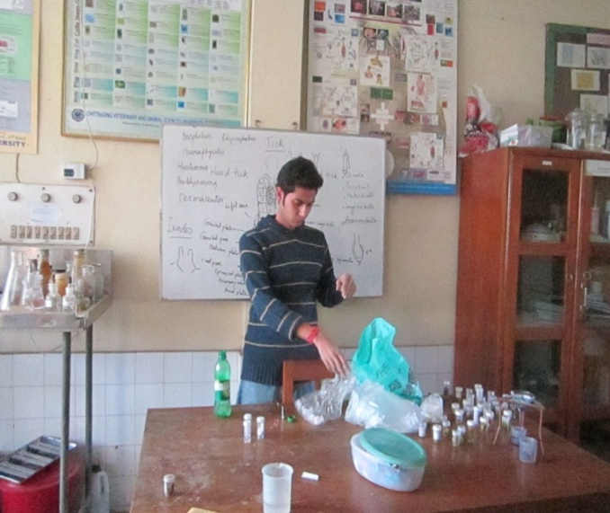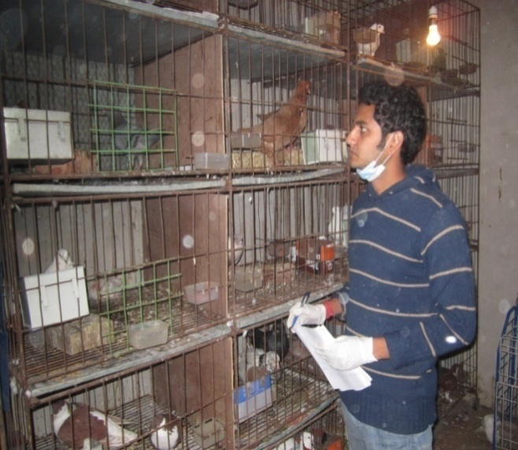

Image 1: Data collection

Image 2: Laboratory works

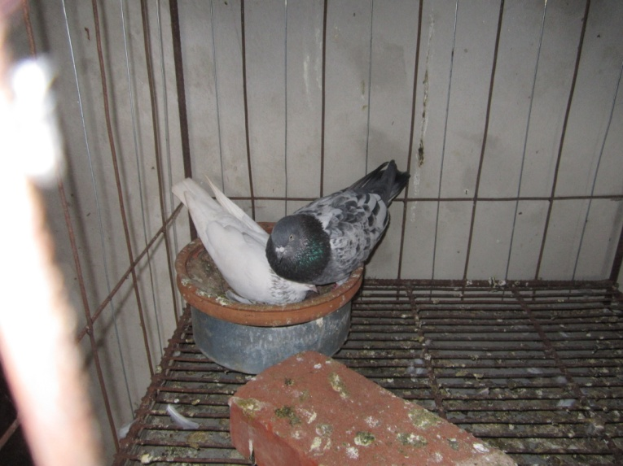

Image 3: Nesting behavior of pigeon

**CHAPTER-4**

**RESULTS AND DISCUSSIONS**

**4.1. Varieties of Pigeon**

There were 96 pigeons of 10 varieties in the farm. Among all of them, Giribaz was the largest proportion of 22 in number and lark was in smallest of 2 in number. Second largest proportion was Sirazee which 20 in number. The King and Peswari were in equal proportion. The other varieties were Pouter, Strasser, Fantail, Homer and Jacobin. Whereas **Asaduzzaman *et al*. (2007)** reported that most of the pigeon farmers of Bangladesh had no idea about the breeds or varieties of pigeon. They also reported that usually pigeons reared as pairs. So, male female ratio should be 1.0. Among all the pigeons half were male and half were female in the current observation which correlates with that given ratio. The images of different varieties of pigeon have been attached in the Annex 2. The frequency of different varieties which were studied given in the figure 1.

**Figure 1: Frequency (percent) of different varieties of pigeon in the farm.**

**4.1. Housing of Pigeon**

The house, in which pigeons reared, was a one storied building. The size of the house was about 15x12 ft(excluding wall) with 8ft height. There was an open paved area in front of this house which was about 13 ft in length and 12ft in width and enclosed by wire net. It was used for the movement of pigeons at day time. An exhausting fan was used for assessing ventilation. The house face was southern direction whereas **Bolla (2007)** reported that for maximum production and minimum disease risk the pigeon house should be preferably facing north-east.

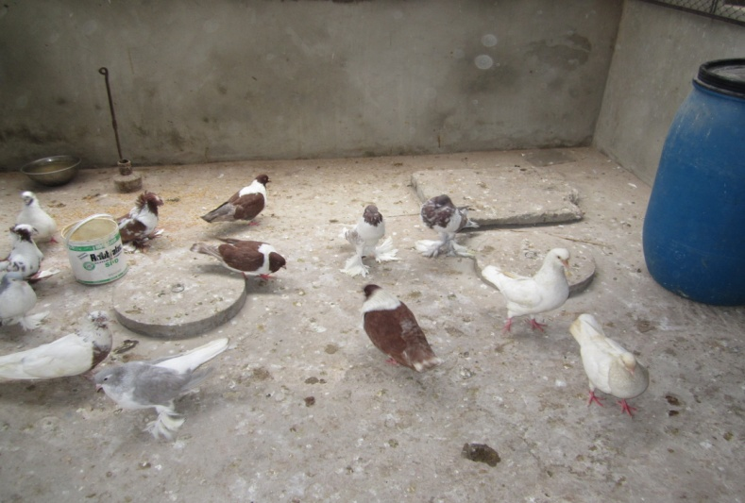

Image 4: Open paved area

**4.1.1. Cages**

All pigeons were reared in cages. Modified poultry cage system was used in this farm. All cages were iron made. There was tray under every pen for the collection of droppings. One pair of pigeon was kept in each pen.

**Table 2: Measurements of pens specified for different varieties.**

|  |  |  |  |
| --- | --- | --- | --- |
| Varieties | Length (cm) | Width (cm) | Height (cm) |
| Existing | Existing | Existing |
| King | 92 | 51 | 61 |
| Peswari | 59 | 51 | 51 |
| Sirazee | 59 | 51 | 51 |
| Homer | 59 | 51 | 51 |
| Strasser | 59 | 51 | 51 |
| Giribaz | 59 | 51 | 51 |
| Lark | 59 | 51 | 51 |
| Fantail | 59 | 51 | 51 |
| Pouter | 92 | 51 | 61 |
| Jacobin | 59 | 51 | 51 |

From above table it was observed that the provided space measurement to pigeon is 59x 51 x 51 cm (in case of king & potter it is about 92 x 51 x 51 cm).These result disagreed with **Lewis *et al.* (2003).** Theyreported that the length, width and height of the cages should be 27 inches or 69 cm, 32 inches or 81 cm, 24 inches or 61 cm for two hens. The size of the cages in the current study was less than the above data because the body size of pigeon is lower than chicken.

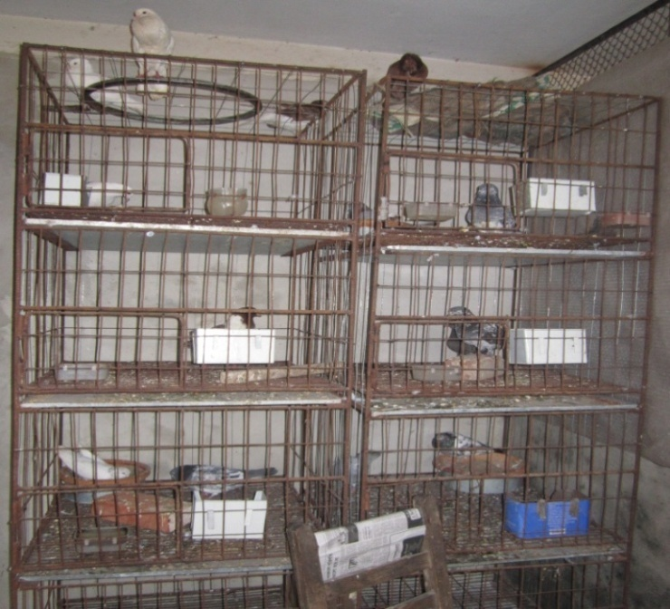

Image 5: Modified poultry cage

**4.1.2. Feeders and waterers**

Each of the pen contained one feeder and one waterer. Waterers were washed daily with a sanitizing agent, which is supported by the findings of  **Mellot and Hilliker (2008).**

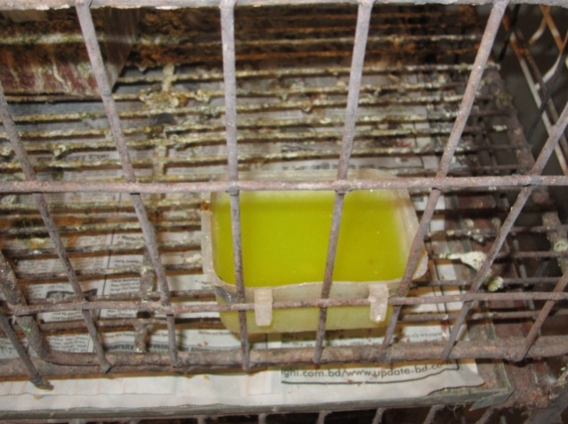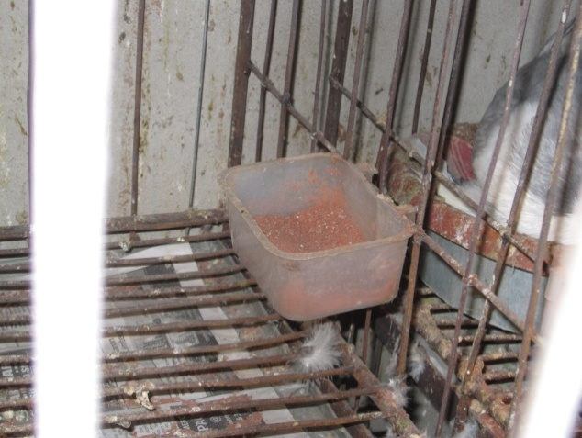

Image 6: Feeder

Image 7: Waterer

**4.2. Feeding of Pigeon**

In this study it was observed that, grain mix and mineral mix were supplied to the pigeon. Grain mix was given 45 gm per bird daily and the mineral mix was given 6.5 gm per bird daily. The total amount of feed was 51.5 gm which partially agrees with **Strand Magazine (1901) and Bretton (1914)**. They reported that the feed intake per pigeon per day was 47.35g which was somewhat lower than the present observation. The price of 1 kg grain mix was 40 taka, so the cost of grain mix for per bird was 1.8 taka daily whereas **Asaduzzaman *et al*. (2007)** reported that pigeon feed cost was 28 taka per kg. So the current study shows that the feed cost was somewhat higher. Owner said that, mineral mix was given for the improvement of thickness of eggshell said by the owner.

**Table 3: Grain mix ration in the farm.**

|  |  |  |  |
| --- | --- | --- | --- |
| Ingredients | Quantity (kg) | ME (kcal/100kg) | CP (%) |
| Rice | 10 | 293.7 | 1.19 |
| Wheat | 70 | 2131.5 | 9.1 |
| Cowpea | 5 | 150.2 | 1.42 |
| Mustard Oil Cake | 5 | 118 | 1.75 |
| Germinating Gram | 5 | 138.3 | 1.04 |
| Lentil | 5 | 117.1 | 0.625 |
| Total | 100 | 2993.8 | 15.125 |

**Table 4: Mineral mix ration in the farm.**

|  |  |  |  |
| --- | --- | --- | --- |
| Ingredients | Quantity (kg) | Ca (%) | P (%) |
| Oyster shell | 22.7 | 8.467 | 0.002 |
| Grit | 11.3 | 4.045 | 0.002 |
| Dicalcium phosphate | 9.1 | 2.21 | 1.656 |
| Salt | 2.3 | - | - |
| Total | 100 | 14.72 | 1.66 |

In the study, the ingredients were rice, wheat, cowpea, mustard oil cake, germinating gram and lentil for grain mix. Among these wheat was 70% in case of grain mix. These results disagree with **Jalal *et al.* (2011).** Theyobserved that yellow corn, grain sorghum, cowpeas or field peas, wheat, oat groat and hempseed were used as grain mix and the quantity of wheat was 15% .These variation may be caused due to availability of ingredients or environmental factors. The ingredients for mineral mix and its quantity of current observation are supported by the findings of **Jalal *et al.* (2011).**

In the current observation, the supplied diet contained ME (2993.8 kcal/kg) and CP (15.125%) which agrees with **Khasaba and Ibrahem (2007)** who reported thatdiet containing 2800 kcal/kg with 16 or 14% CP level was suitable requirement and satisfactory for production and reproduction of pigeons during the spring, autumn and winter seasons.

The grain mix and mineral mix were provided separately in the farm which agrees with **Mellot and Hilliker (2008).** They indicated that most pigeons performed well if they were provided with adequate grain mix and mineral mix in separate feeders.

**4.3. Vitamin-mineral and Water Supplement**

Fast AD3E® (Vitamin A, D & E preparation) - 0.25ml

DB vitamin® (Vitamin and Mineral preparation) - 0.25ml

Digestivio® (Acidifier) - 0.025ml

Normal saline - 100ml/bird (4% saline solution)

Here Fast AD3E® and DB® vitamin were supplied as vitamin mineral source, for 5 days consecutively and then made an interval of 10 days and again continued. Normal saline was given in summer season to reduce stress & to prevent diarrhea, if any birds delayed in egg laying, then 4 drops of Fast AD3E® mixing with 0.5 liter water was given to that bird for egg laying within 7 day, said by the owner of farm.

In pigeon farm, it was observed that water was supplied once daily and more or less 110 ml water per day for per bird which disagrees with the findings of **Bolla (2007)** who indicated that the average water requirement for a bird was 245ml per day. The different types of variety may be responsible for variation in water consumption.

**4.4. Productive and Reproductive Performance**

**4.4.1. Body Weight**

From figure-2 Homer and King were on the highest position whereas Peswari in the lowest position. The weight of Giribaz was ranges from 350 to 400 gm whereas lark also had the similar body weight of 400 gm. Sirazee was ranges from 580 to 610 gm where Fantail was ranges from 490 to 520 gm which is lower than Sirazee. Peswari and Strasser almost same in 700 gm. Pouter was also similar with Peswari. The highest body weight of Jacobin was 750 gm which was the median body weight of King. **Jalal *et al.* (2011)** reported that the weight of adult pigeons were ranges from 640 to 850gm. The current study showed that the weight ranges from 270 to 810 gm. And from ANOVA, the p-value was <0.001 which indicate that the body weight among different varieties were truly different. The variation may be due to difference in variety and weather.



**Figure 2: Box-plot of body weight showing minimum, maximum, median, 25th and 75th percentile values stratified by different varieties of pigeons in the farm.**

**Table 5: ANOVA of mean body weight among different varieties of pigeon.**

|  |  |  |  |
| --- | --- | --- | --- |
| Variety | Mean | Standard Deviation | Frequency |
| Fantail | 503.33333 | 10.33 | 6 |
| Giribaz | 375.90909 | 15.93 | 22 |
| Homer | 795 | 12.91 | 4 |
| Jacobin | 720 | 24.49 | 4 |
| King | 750.8333 | 33.15 | 12 |
| Lark | 400 | 0 | 2 |
| Peswari | 600 | 153.80 | 12 |
| Pouter | 690 | 13.09 | 8 |
| Sirazee | 600.5 | 8.26 | 20 |
| Strasser | 646.67 | 42.27 | 6 |
| Total | 581.56 | 147.94 | 96 |

**Table 6: Analysis of variance.**

|  |  |  |  |  |  |
| --- | --- | --- | --- | --- | --- |
| Source | SS | df | MS | F | P-value |
| Between group | 1787180.47 | 9 | 198575.61 | 58.51 | <o.oo1 |
| Within group | 291885.15 | 86 | 3394.01 |  |

From figure 3, the body weight of male pigeons were 280-810 gm which was somewhat higher than the body weight of female pigeons ranges from 270-800 gm. The median body weight of female pigeons was 600 gm which was slightly lower than the median body weight of male pigeons 610 gm. By using t-test, estimated p-value was not statistically significant (p-value=0.67). That means, there was no difference between body weight of male and female. These findings contradicted with **Kigir *et al.* (2010)**.They observed that male pigeon had more body weight than female pigeons.



**Figure 3: Median, maximum, minimum, 25th and 75th percentiles of body weight (gram) in male and female pigeons in the farm.**

**Table 7: T-test of mean body weights between male and female pigeons.**

|  |  |  |  |  |  |  |
| --- | --- | --- | --- | --- | --- | --- |
| Variable | Observation | Mean | Standard deviation | 95% Conf. Interval | | P-value |
| Female  Male | 48  48 | 574.79  588.33 | 146.82  150.28 | 532.1583  544.6963 | 617.43  631.97 | 0.67 |
| Combined | 96 | 581.56 | 147.93 | 551.588 | 611.54 |
| Difference |  | -13.54 |  | -73.75316 | 46.67 |

**4.4.2. Different Reproductive traits**

**Figure 4: Mean values of age at maturity, productive life, number of egg per laying, incubation period and production of squabs of different varieties of pigeon in the farm.**

The age when the pigeon being sexually mature was 7 month in case of Homer, Lark, Fantail and king and 6 month in case of Giribaz, Jacobin, Peswari, Pouter, Sirazee and Strasser. So, the age of sexual maturity in the current study was ranging from 6-7 months which is supported by the findings of **Sturtevant and Hollander (1978).**

Strasser, Pouter, King and Lark produced 5 pairs of pigeon per year whereas Giribaz and Homer produced 12 and 10 pairs respectively. In addition Sirazee and Fantail produced 8 pairs and Jacobin and Peswari produced 7 pairs per year. So, production of squabs by a pair of breeder pigeons was ranging 5-12 pair per year which agrees with the findings of **Levi (1969).** Hereported that a pair of breeder pigeon could produce 18-20 squabs per year.

**Jalal *et al.* (2011)** reported that the incubation period of pigeon was 18 days which agree with the current study. However, 21 days of incubation period was observed in case of Homer, Jacobin, King and Sirazee in this study. On the other hand, 18 days of incubation period was observed in Giribaz.

Moreover, the productive life was 5 years for male and 7-8 years for female which are nearly in consistent with the findings of **Bolla (2007).** Hereported that the productive life for male was 5 years and for female 10 years.

In case of Pouter and King, it was observed that, plastic eggs were kept on their dovecotes during the incubation period and their eggs were transferred into the dovecotes of Sirazee or Giribaz for hatching. As because, King and Pouter were used to waste their eggs during incubation.

It was also observed that the eggs of first two clutches for all the varieties were unable to hatch any squabs. **Miller (1972)** also reported that the eggs of first clutches were 50% infertile.

**4.5. Health Management**

**4.5.1. Diseases of Pigeon**

The common diseases of the farm were New Castle disease, Pigeon Pox, Coryza and Parasitic infestation. The New Castle disease was mostly prevalent in the farm which agrees with the observation of **Hofstad (1978).** In case of new castle disease and pigeon pox, Tetracycline® (antibiotic) therapy was applied in addition with vitamin and mineral supplement. Doxicab® was administered in the treatment of Coryza.

In the study we found that many of the pigeons affected with ecto-parasites such as such as lice, mites and endo-parasities like *Ascaridia* (round worm), *Capillaria* (crop worm and hair worms), *Syngamus tracheae* (grape worms); which is supported by the findings of **Schock and Cooper (1978).** Parasitic infestation was reduced through administering Vermic® (anti-parasiting agent) orally and applying antiseptic spray.

**4.5.2. Mortality of Pigeon**

After observing the data of previous 6 months, we found, mortality of pigeon was 14.58%.The mortality rate was not same in all varieties. The mortality rate of different varieties presented in Figure 4.

Percentage of Mortality rate

**Figure 4: Mortality rate of pigeons in the farm.**

The above table shows that the mortality rate was more in case of heavy breeds, whereas it was much lower in case of light breeds. In this study the overall mortality rate was 14% which is more or less similar with the findings of **Asaduzzaman *et al*. ( 2007)** who reported the mortality rate of pigeons were 5-15 %. Most of the mortality occurs from the attack of predators and disease. Transportation mortality was negligible in case of pigeon and squab. This may be an advantage over chicken.

**4.5.3. Regular sanitation in the farm**

Timson®, Kerosene and Fitkari® (Potash Alum) were used for cleaning the floors and the cages. Timson®, Fitkari® (Potash Alum) and Kerosene were mixed with 4 liter of water and then sprayed regularly with a 2 days interval. In rainy season it was used daily.

**4.5.4. Disposal of the waste and Carcass**

The waste materials from the pigeons were collected regularly and then disposed into a pit. The death birds are buried into the soils. But **Yilmaz *et al.* (2007)** indicated that pigeon manure could be an organic fertilizer resource.

**CHAPTER-5**

**CONCLUSION**

From this study it can be said that, the owner reared 96 pigeons of 10 varieties. Some were local while most of them were exotic variety. It is amazing that, there did exist a low mortality rate in this farm. As the owner reared pigeons as his hobby so he took care of them in close contact. The management system of his farm was almost near about scientific standard level. As a consequence, the production level was also satisfactory. By improving feeding, breeding system management and other environmental support the production level can be improved more. On the other hand, it may be a great source of income as well. As there is an increased demand of pigeon as food or ornamental birds in this area, owner can take a chance to earn money by marketing squabs, eggs, productive or unproductive adult pigeons. This farming can be popularized through extension activities. In the future, further extensive studies on pigeon of larger population and of different areas should be done to know the management practice of individual varieties.

**BIBLIOGRAPHY**

**Abd El-Azeem FA, El-shafei T and Abdullah EA, (2007).** Studies on the effect of different dietary metabolizable energy levels on some performance of local baladi pigeons. Egypt Poult. Sci., Vol (27) (III): (595-611).

## Abou Khashaba HA and Ibrahem MA, (2007). Nutritional and management studies on the pigeon: effect of protein, metabolizable energy level and/or season on productive performance of pigeons, Egypt. Poult. Sci., Vol (29) (IV): (923-945).

**Ahmed S, (1988).** Role of farming system research in identification of problems of poultry production. Proceeding of the workshop on Livestock Component of Farming System Research in Bangladesh, 21st December 1988, Bangladesh Agricultural Research Council, Dhaka, Bangladesh.

## Anonymous, (1901). The only pigeon ranch in the world. The Strand Magazine. April, pp. 534–535.

**Asaduzzaman M, Mahiuddin M, Howlider MAR, Hossain MMand Yeasmin T, ( 2009)**. Pigeon farming in gouripur upazila of mymensingh district. Bang. J. Anim. Sci., 38(1&2) : 142 – 150.

**Bolla G, (2007).** Squab Rising, Primefact 601, Replaces Agfact A5.0.4 (sixth edition).

## Bretton P, (1914). Pigeons for profit. London: C. Arthur Pearson Ltd.

**Clarkson TB, Prichard RW, Lofland HB and Goodman HO, (1963).** The pigeon as a laboratory animal. Lab. Anim. Care, 13: 767.

**Cruickshank JC and Smith WH, (1949).** Isolation of Salmonella from Dogs, cats and pigeons. British Med. J., Dec-3: 1256-1258.

**Haque QME, (1987).** Characteristics of two villages for farming system research. Farming System Research Programs, Bangladesh Livestock Research Institute, Savar, Dhaka, Bangladesh.

**Hofstad MS, (1978)**. Diseases of poultry (7th ed.). Iowa State University Press, Ames IA.

**Hollander WF, (1954)**. Pigeons in research. Proc. Animal Care Panel; 5: 71.

## Jalal H, Bihaqi SM, Bihaqi SJ and Iqbal A, (2011). A guide to commercial pigeon farming, Indian Pet J. - Online Issue., February, Volume 10.

**Kigir ES, Sivachelvan SN, Kwari HD, Sonfada MN, Yahaya A, Thilza IB and Wiam IM, (2010).** Gross and microscopic changes in the gonads of male and female Domestic Pigeon (*Columbia Livia*). New York Sci. J,3(10).

**Kocan RM and Banko W, (1974).** Trichomoniasis in the Hawaiian barred dove. J. Wildl. Dis.; 10: 359.

**Levi WM, (1969).** The pigeon. Levi Publishing, Sumter SC.

**Lewis EC, Charles JW, Edward TM and Elton IJ, (2003)**. Homemade comfort cages for small poultry flocks. Maryland Cooperative Extension, Factsheet 429.

**Link R, (2005).** Living with wildlife in the Pacific Northwest. Washington Dept. of Fish and Wildlife.

**Mellot JL and Hilliker A, (2008).** 4-H Pigeon and Dove project**,** Oregon State University,4-H 154.

**Miller WJ, (1972)**. Reproductive success in pigeon. Iowa State University, Ames, Iowa.

**Oye E and Borghijs VJ,** **(1979).** Speilen Fauben bei humanen Ifektionen durch *Salmonella typhimurium* var Copenhagen eine Rolle: Deutsche Tierarztlische Wochenschrift; 86: 306.

**Pond CL and Rush HG, (1981).** Infection of White Carneaux pigeons (*Columba livia*) with *Mycobacterium avium*. Lab. Anim. Sci., 31: 196.

**Schock RC and Cooper R, (1978).** Internal parasitisms in captive birds. Mod. Vet. Pract.; 59(6): 439.

**Schrag L, (1974).** Healthy pigeons recognition, prevention and treatment of the major pigeon diseases. Verlag Ludwig Schober, Hengersberg FRG. Sci. and Genetics Newsletter 8 (suppl.): 7.

**Silver R, (1978).** The parental behavior of ring doves. Am. Sci.; 66: 209.

**Sinclair DV, (1980).** Respiratory disease in pigeons Vet. Rec; 106: 466.

**Sturtevent J and Hollander WF, (1978).** Breeding pigeons at the lab., Pigeon.

**Thoen GO and Karlson AG, (1978).** Tuberculosis. In: Diseases of Poultry (7th ed.) (M.S. Hofstads, ed.). Iowa State University Press, Ames IA; 209-224.

**Williams JE, (1978).** Paratyphoid infections. In: Diseases of Poultry (7th ed.) (M.S. Hofstad, ed.). Iowa State University Press, Ames IA, 1978: 117-167.

**Yilmaz F, Baysal E, Toker H, Colak M, Yigitbasi ON and Simsek H, (2007)**. An investigation on pin head formation time of Agaricus bisporus on wheat straw and waste tea leaves based composts using some locally available peat materials and secondary casing materials. African J. of Biotech.: 15 (6), 1655-1664.

**ANNEX-1**

**Questioner for Data Collection**

|  |  |
| --- | --- |
| **Serial No** |  |
|
| **Breed/Variety** |  |
| **Sex** | Male  Female |
| **Age (year)** |  |
| **Body weight (gm**) |  |
| **Age at sexual maturity (months)** |  |
| **Incubation period (days)** |  |
| **Productive life (years)** |  |
| **No. of squab production per year** |  |
| **No. of eggs per laying** |  |
| **Daily feed intake (gm)** |  |
| **Disease** |  |
| **Others** |  |

**ANNEX -2**

**Images of Different Varieties of Pigeon**

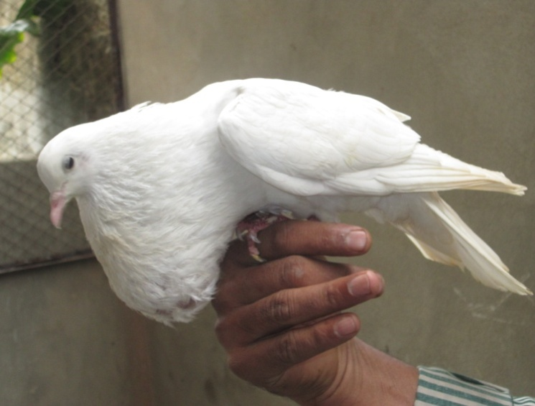

**Image A: Pouter**

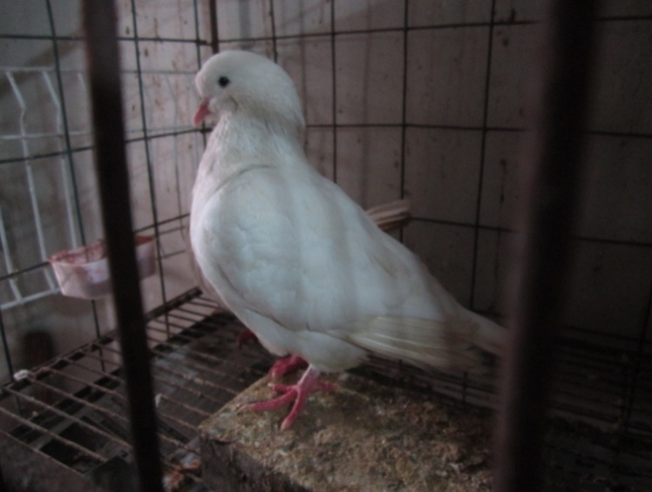

**Image B: King**

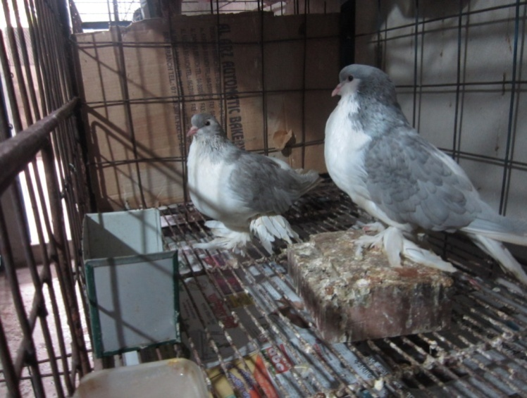

**Image C: Sirazee**

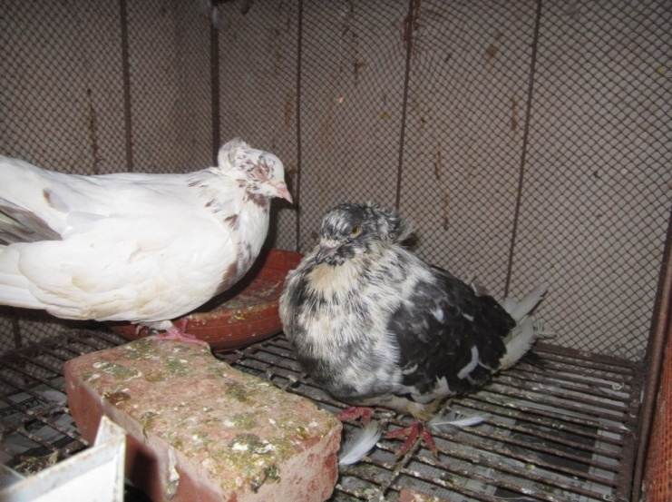

**Image D: Jacobin**

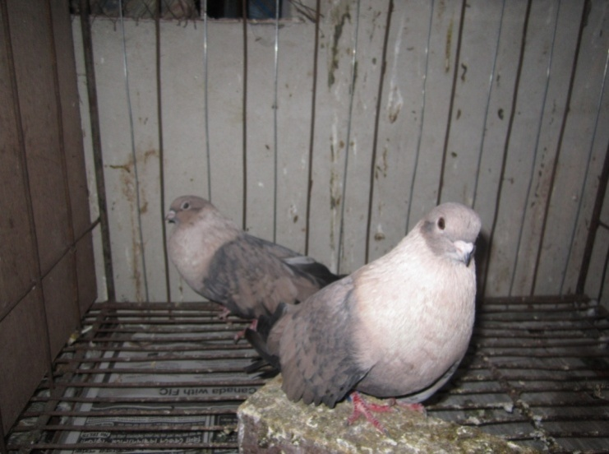

**Image E: Lark**

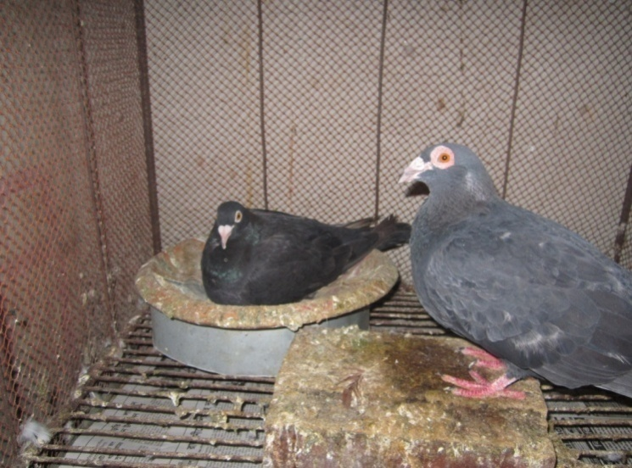

**Image F: Homer**

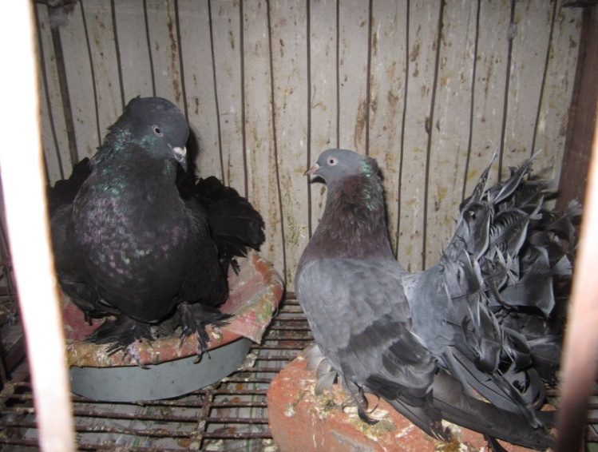

**Image G: Fantail**

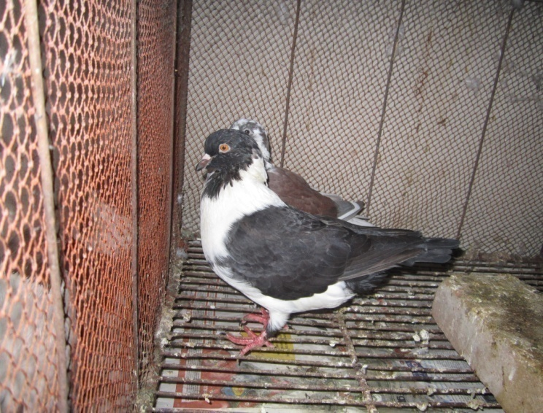

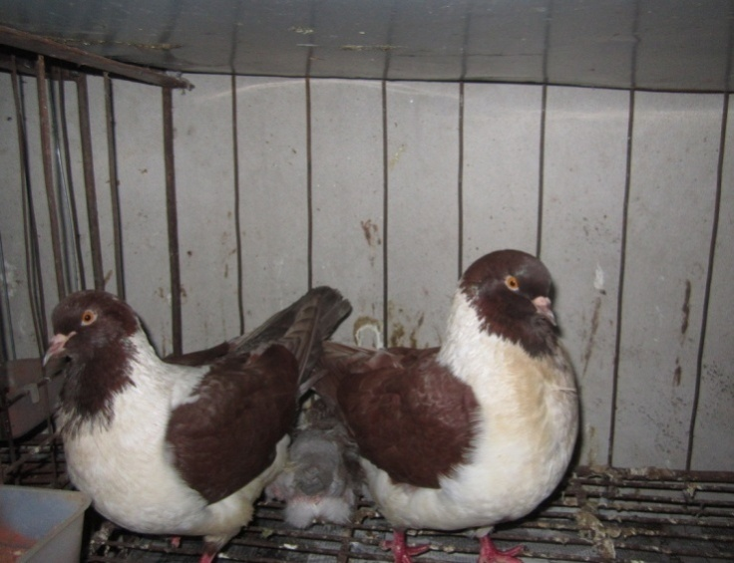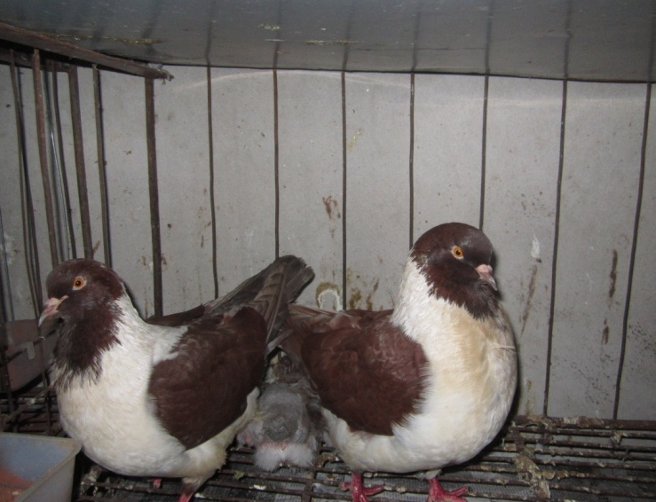

**Image I: Strasser**

**Image H: Peswari**

**Image 9: Strasser**

**Image 8: Peswari**