Chapter 1

INTRODUCTION

The poultry farming has now turned into one of the most important division of agriculture throughout the world. It is expanding rapidly as a dynamic industry in South Asian countries. The tremendous role of commercial broilers is to meet the increasing demand of the population for protein by the meats and eggs. Poultry is basically a source of economical, palatable and healthy food protein (Mahesar et al. 2010). .poultry industry is playing a vital role in the economy of the country and providing employment for the people.

Poultry feeds are known as a complete feeds, since it is prepared in such a way to contain all the vitamins, minerals, energy, protein, and other nutrients essential for proper health of the birds, egg production and growth. it is generally agreed that feed represents the major cost of the poultry production. According to McNab(1999) this cost lies between 65 and 75%. So, any improvement in the performance of broilers and layers due to their diet can inevitably have a profound effect on profitability. Seasonal availability of locally produced feed ingredients together with variations in quality of some ingredients have made the feed situation in Bangladesh unsatisfactory from the quality standpoint. Inadequate feed analytical services as well as lack of statutory control over feed quality have further aggravated the situation. The number of feed mills is increasing rapidly throughout the country to meet the high demand It was reported in 1999 that there were 40 feed mills with 900 dealers within the private sector that were producing and distributing poultry feed all over the country (Latif 1999).Few of the feed mills are serious in maintaining the quality of products. On the other hand, farmers do not have access to adequate facilities to analyze and monitor the quality of the commercial feeds. In view of the limited availability and varying sources of different feed ingredients, the level of nutrients in the prepared feeds may differ from what is actually required. In view of the above situation, the present study was undertaken to ascertain the variations in the nutrient status of compound broiler feeds collected from two different feed mills located in Bangladesh and to compare the quality of the feeds. Different feeds give different results in terms of growth and egg production. To attain the exact quantities of nutrients, it is important to balance the ratio of diet.

Chapter 2

REVIEW OF THE LITERATURE

It is generally agreed that feed represents the major cost of the poultry production. Hence, an attempt is made here to put together some of the closely related findings about the broiler feed in general from other sources and has been reviewed in this chapter with special reference .

Dick et al.,(2002) suggested that harmonization of feed qualities can only be possible when a given standard adopted nationwide.ogunwolere and onwukaet al.,(1997) reported that a part from highest crud fiber contain in most commercial feed, the recomanded and noticeable low crud protien observed in some commercial feed and these feeds are areadulterated with sawdust, sand and maize barn. .

Wiebe et al.,(2002) stated that the recomanded level in Nigeria.the poultry industry has continued to decline as a result of low quality of feed and high feeding cost which accounted about 75% of total cost of production.

According to McNab (1999) poultry feed cost lies between 65 and 75%. So, any improvement in the performance of broilers and layers due to their diet can inevitably have a profound effect on profitability.

Onwudike and Temim et al., who reported that feed efficiency was improved with increasing dietary CP levels for broiler chicks.

Leeson et al., who reported improved feed efficiency with 22 and 24% CP and 3000Kcal ME/kg as compared with diets with 20% CP and 2600Kcal ME/kg.

Ferguson et al.,reported an increase in FCR when CP was reduced from 21.5 to 19.6% in a six-week broiler growth trial.

Nawaz et al. reported that low-ME and high-CP diets promised optimum performance for broiler chicks at both starter and finisher
(Falk, 1985).A general definition of the pelleting process is “the agglomeration of small particles into larger particles by the means of a mechanical process in combination with moisture, heat, and pressure”

(Fairfield, 1994) pelleting improves feed handling characteristics (i.e. dustiness and flowability) and reduces the incidence of pathogenic organisms

(Acar et al., 1991;Scheideler, 1995; Moritz et al., 2001).The most commonly touted advantages to pelleting is the growth and feed efficiency improvements realized

(Behnke, 1996). it was thought that via steam conditioning and extrusion of the feed
through the pellet die, the integrity of the starch granules and proteins were disrupted in a manner that improved diet digestibility

(Husser and Roblble 1962; Bolton, 1960; Sibbald, 1977).The majority of evidence does not support any pelleting effects on protein or energy digestion

It was work reported by Jensen (1962) that brought forth the notion that pelleting enhances bird performance by reducing energy expenditure for prehension thereby yielding more energy available for tissue accretion.

The proportion of intact pellets presented to the bird further depends on feed delivery systems
on the trucks and within the broiler house (Scheideler, 1995).

(Behnke, 1996) In the feed mill,diet formulation, particle size of the mash, conditioning time and temperature, pellet die thickness, and cooling and drying time, contribute to pellet quality numerous nonnutritive factors, such as those related to feed processing and general husbandry that modify broiler behavior (Skinner-Noble, 2005)

(Cobb Vantress, 2003) The majority of poultry rations utilized today undergo some type of post-mixing processing, and production manuals contain many managerial-husbandry recommendations that impact BW and FCR

Chapter 3

MATERIALS AND METHODS

Location and objectives

The experiment was conducted at “Chittagong veterinary and animal sciences University”khulshi, Chittagong. The objective was to evaluate the compound broiler feeds based on, proximate analyses.
Out of different feed mills engaged in production and marketing of poultry feed in Bangladesh, two were selected randomly (Table: 1), and considered as the experimental treatments.

Table: 1 Location of randomly selected feed mills
NF | Nourish Feed Limited, Gusinga, Sreepur, Gazipur
AF | Aftab Feed Limited, Koliachar, Bazitpur, Kishoregong

3.1. Collection of feed samples
Broiler Feed samples (starter, grower, finisher) were collected from the sales and display centers of the feed mills and also from different broiler farm in Chittagong district.

3.2. Preparation of samples
At first the samples were collected from different sales, displaycenters and also from different broiler farm. Then the samples were grinded separately and stored in air tight plastic bags until required for analysis (Mahesar et al. 2008).

3.3. Analysis of Nutrient composition of poultry feed of different companies
The feed samples were analysed for proximate composition viz., Drymatter(DM), moisture, crude protein(CP), crude fat(EE), crude fibre(CF) and total mineral matter (ash) and expressed in percentage. Proximate analysis of these feeds was done according to the procedures described by AOAC (1990).

3.3.1 Moisture
Five grams of powdered feed sample was weighed into a previously weighed
moisture cup and dried in an oven at 60°C till a constant weight was attained (Anon., 1990 )

Initial weight (g) – Final weight (g)
Moisture % = ------------------------------------------ × 100
Sample weight

3.3. 2 Crude protein
The nitrogen content of flour was estimated by Microkjeldahl method in Parnas and Wagner apparatus (Anon., 1990). The crude protein content was calculated by multiplying with factor 6.25 and expressed on per cent basis.
(Titre—Blank ) × Normality of HCL × 14.007 × 6.25
Protein % = ------------------------------------------------------------- × 100
Sample weight (g)

3.3.3 Crude fat(EE)
Moisture free sample was weighed in moisture free thimbles and crude fat was extracted by refluxing in soxhlet apparatus using petroleum ether as solvent. Per cent crude fat was calculated by difference (Anon., 1990).
Initial weight (g) – Weight after extraction (g)
Crude fat % = --------------------------------------------------------- × 100
Sample weight (g)

3.3.4 Crude fibre
Fat free seed flour sample was hydrolyzed with dilute sulphuric acid (0.255 N) and dilute alkali (0.313 N) to estimate crude fibre by employing the methods of Mayanard (1970).

Weight residue with crucible (g) – Weight of ash with crucible
Crude fibre % = -------------------------------------------------------------------- ×100
Weight of fat free sample (g)

3.3.5 Total mineral matter
Total mineral matter ( ash ) was determined by igniting samples in muffle furnace at 600°c for 3 - 4 hours ( Anon., 1990). The total mineral matter was expressed as per cent.

Weight of crucible with ash (g)
Total mineral matter %(ASH) = -------------------------------------------- × 100
Weight of crucible with sample (g)

3.3.6 Metabolizable energy
The metabolizable energy content was calculated by using the following formula (Lodhi et al, 1976).
ME=32.95(% CP + % EE * 2.25 +% NFE) -29.20

3.3.7 Calculation of NFE:
The NFE content was calculated by deducting the sum of the values for moisture, crude protein, crude fat, crude fiber and total mineral matter in 100 ( Raghuramulu et al., 1983 )

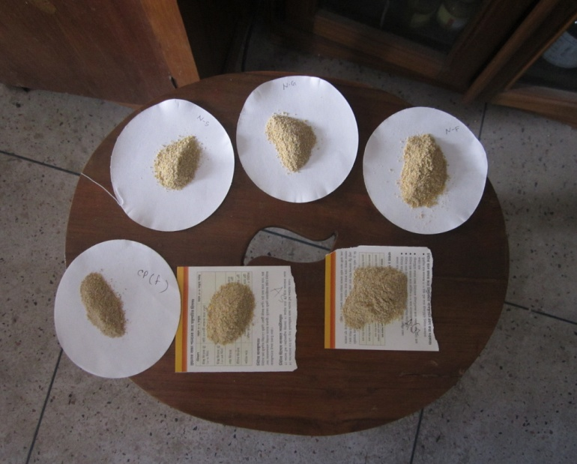
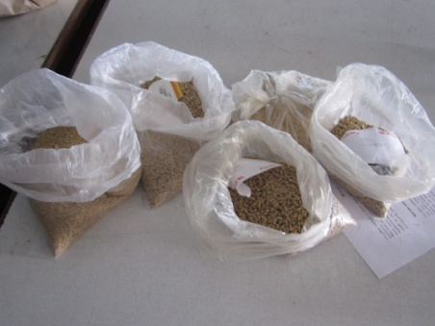

Fig 2: grinded samples
Fig 1: Feed samples

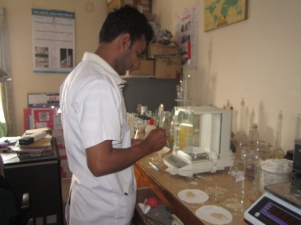
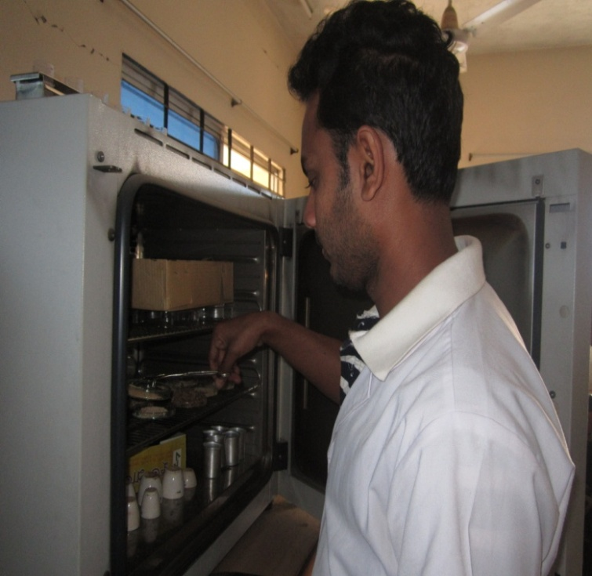

Fig 3: Estimation of DM
Fig 4: Weighing of samples

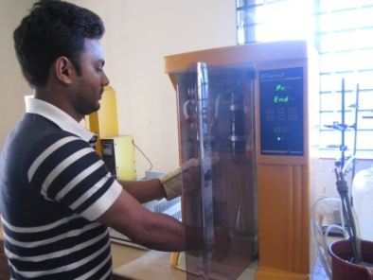

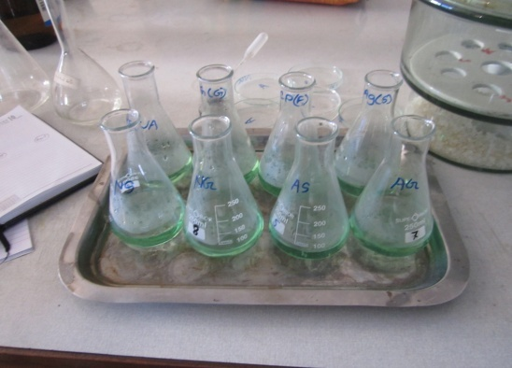
Fig 5: Estimation of CP
Fig 5: Estimation of CP

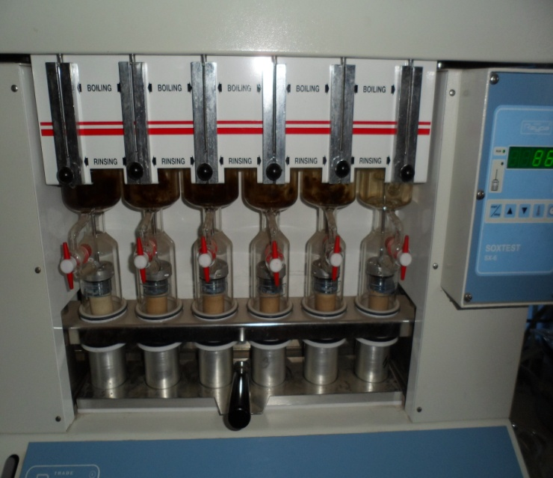
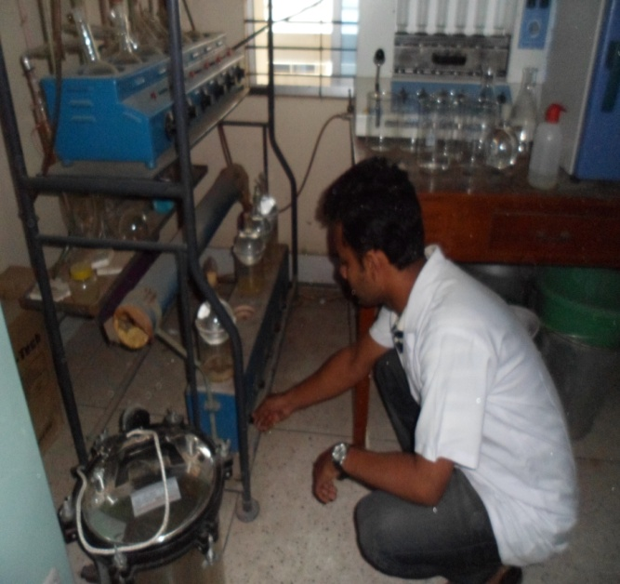

Fig 7: Estimation of CF
Fig 6: Estimation of EE

Chapter 4

RESULTS

Table (4.1): Proximate component of two companies feed with company standard (starter feed)
Variables | Aftab Feed Limited  (AF), |  | Nourish Feed Limited,  (NF)
 | Company value | Observed value | Company value | Observed value
MOISTURE% | 11 | 10.1 | 12 | 9.2
DM% | 89 | 89.8 | 88 | 90.8
ME[kcal/kg] | 3000 | 2866 | 2950 | 2849
CP% | 22 | 19.77 | 21 | 20.12
CF% | 4.8 | 3.8 | 5 | 2.99
NFE% | 51.5 | 54.83 | 61.5 | 56.89
EE% | 6.5 | 5.9 | 5.5 | 4.6
ASH% | 8.7 | 5.6 | 6.5 | 6.2

Table (4.2): Proximate component of two companies feed with company standard (grower feed)
Variables | Aftab Feed Limited  (AF), |  | Nourish Feed Limited,  (NF)
 | Company value | Observed value | Company value | Observed value
MOISTURE% | 11 | 10.2 | 12 | 9.6
DM% | 89 | 89.8 | 88 | 90.4
ME[kcal/kg] | 3050 | 2825 | 3000 | 2873
CP% | 19.5 | 18.38 | 20 | 19.77
CF% | 5 | 4.8 | 5 | 4.6
NFE% | 52.2 | 54.52 | 55.5 | 53.03
EE% | 7 | 6.1 | 7.5 | 6.8
ASH% | 6.5 | 6 | 6.3 | 6.2

Table (4.3): Proximate component of two companies feed with company standard (finisher feeds)
Variables | Aftab Feed Limited  (AF), |  | Nourish Feed Limited,  (NF)
 | Company value | Observed value | Company value | Observed value
MOISTURE% | 11 | 10.4 | 12 | 10
DM% | 89 | 89.6 | 88 | 90
ME[kcal/kg] | 3100 | 2856 | 3050 | 2877
CP% | 18.5 | 17.3 | 19 | 18.34
CF% | 5 | 4.9 | 5 | 4.3
NFE% | 55 | 54.3 | 60.5 | 53.46
EE% | 7.5 | 7.1 | 7.40 | 7.3
ASH% | 6 | 6 | 6.3 | 6.6

Chapter 5

DISCUSSIONS

From the above observation (table 4.1, 4.2, 4.3) it can be said that, moisture,CP,ME, CF,EE, ASH content of aftab starter feed were 10.1, 19.77, 2866, 3.8, 5.9, 5.6 respectively. which were slightly lower than the company value 11, 22, 3000, 4.8, 6.5, 8.7 and these value disagree with B C Roy et al.,(2004).they observed moisture ,CP,ME, CF,EE ,ASH content of aftab starter feed were 10.3, 23.9, 3093, 4.7, 6.7, 8.7 respectively.DM content was 89.8 which was almost similar to the company DM value 89 this value agrees with B C Roy et al.,(2004). they observed DM value of aftab starter feed was 89.7 but the NFE content was 54.83 which was slightly higher than the company NFE value 51.5 this value disagrees with B C Roy et al.,(2004 they observed NFE value of aftab starter feed was 55.8
.

Moisture, CP, ME, CF, EE, content of aftab Grower feed were 10.2, 18.38, 2825, 4.8, 6.1, respectively. which were slightly lower than the company value11, 19.5 ,3050, 5, 7, these value disagree wth B C Roy et al.,(2004).they observed moisture ,CP,ME, CF,EE content of aftab grower feed were 10.6, 21, 3188, 5.20, 7.8, respectively.DM,& ASH content were 89.8, 6 respectively which were almost similar to the company DM & ASH value 89, 6.5 these value agree with B C Roy et al.,(2004). they observed DM & ASH value of aftab grower feed was 89.4, 6.8 but the NFE content was 54.52 which was slightly higher than the company NFE value 52.2 this value disagrees with B C Roy et al.,(2004 they observed NFE value of aftab grower feed was 59.1 .

Moisture ,CP,ME, CF,EE,NFE content of aftab Finisher feed were 10.4, 17.3, 2856,4.9,7.1 ,54.3 respectively. Which were slightly lower than the company value 11, 18.5, 3100, 5, 7.5 ,54.3 these value disagree with B C Roy et al.,(2004).they observed moisture ,CP,ME, CF,EE,NFE content of aftab starter feed were 10.6, 20.2, 3080, 4.8, 8, 60.6 respectively DM,& ASH content were 89.6, 6 respectively which were almost similar to the company DM& ASH value 89, 6 these value agree with B C Roy et al.,(2004). They observed DM& ASH value of aftab finisher feed was 89.4, 6.

Moisture ,CP,ME, CF,NFE ,EE content of Nourish starter feed were 9.2, 20.12, 2849,2.99, 56.89,4.6, respectively. which were slightly lower than the company value 12, 21, 2950, 5, 61.5, 5.5 these value disagree with B C Roy et al.,(2004).they observed moisture ,CP,ME, CF,NFE content of nourish starter feed were 10,22.9, 3148, 3.5, 61.4, 5.5 respectively ASH content was 6. 2 which was almost similar to the company ash value 6.5 this value agree with B C Roy et al.,(2004). They observed ASH value 6.5. DM observed value of nourish starter feed was 90.8 which were slightly higher than the company value 88. This value disagree with B C Roy et al.,(2004 they observed DM value of nourish starter feed was 90.

Moisture, CP,ME, CF,NFE ,EE content of Nourish grower feed were 9.6, 19.77,2873,4.6, 53.03, 6.8 respectively. which were slightly lower than the company value 12, 20, 3000, 5, 55.5, 7.5 these value disagree with B C Roy et al.,(2004).they observed moisture ,CP,ME, CF,NFE ,EE content of nourish grower feed were 10.6, 22.6, 3177, 5.3, 58.3,7.30 respectively. ASH content was 6.2 which was almost similar to the company ash value 6.3 this value agree with B C Roy et al.,(2004). They observed ASH content of nourish grower feed was 6.3. DM value of nourish grower feed was 90.4 which were slightly higher than the company DM value 88 .This value disagree with B C Roy et al.,(2004) they observed DM value of nourish grower feed was 90.4.

Moisture, CP, ME, CF,NFE content of Nourish finisher feed were 10,18.34, 2877, 4.3, 53.46, respectively. which were slightly lower than the company value 12,19, 3050, 5, 60.5 these value disagree with B C Roy et al.,(2004).they observed moisture ,CP,ME, CF,NFE content of nourish finisher feed were 9.6, 20.6, 3208, 4.5, 61.00 respectively ASH& EE content were 6.6, 7.3 which was almost similar to the company ASH &EE value 6.3, 7.40 this value agree with B C Roy et al.,(2004). They observed ASH& EE value of nourish starter feed were 6.3, 7.4 but the DM content was 90 which was slightly higher than the company DM value 88 this value disagree with B C Roy et al.,(2004 they observed DM value of nourish starter feed was 90.4.

ME, CP, value of both aftab & nourish feed also disagree with NRC(19994) standard whereas they reported that starter should contain ME%3000,CP%22 .Grower should contain ME%3100,CP%21.finisher should contain ME%3200,CP%20.

These variation of nutrient content of aftab & nourish feed occurred due to environmental or experimental variation.

Chapter 6

CONCLUSION

The data included in the study represented the variations among the quality of the poultry feeds broiler (starter, grower, finisher) from selected manufactures which was somewhat slightly differed from NRC (1994) recommendations and also from their company standard. Each manufactures has its own formulation which doesn’t remain constant throughout the whole year but changes according to the feasibility of the constituents of the poultry feed. The existing information about the composition and nutritive value of the poultry feed permits the poultry farmers to select the better choice of feed and it’s ration for the better growth and health of the poultry on the basis of cost, palatability and energy. All company should supply proper nutrient during feed formulation to fulfill nutrient requirement of poultry.
.

Chapter 7

References

AOAC.( 1990) Methods of Analysis of the Association of Official Analytical Chemists, 14th Ed., Association of Official Analytical Chemists, Washington, DC.

Acar, N., E. T. Moran, Jr., W. H. Revingtion, and S.F. Bilgili. (1991) Effect of improved pellet quality from using a calcium lignosulfonate binder on performance and carcass yield of broilers reared under different marketing schemes. Poult. Sci. 70:1339-1344.mance. J. Appl. Poult. Res. 10:347-353.

Behnke, K. C. (1996) Feed manufacturing technology: current issues and challenges. Anim. Feed Sci. Tech. 62:49-57

B C Roy, H Ranvig*, S D Chowdhury**, M M Rashid and A Chwalibog*(2004) Evaluation of compound broiler feeds manufactured in Bangladesh

Behnke, K. C. (1996) Feed manufacturing technology: current issues and challenges. Anim. Feed Sci. Tech. 62:49-57

Cobb Vantress, Inc. (2003) Cobb Broiler Nutrition Guide. Cobb-Vantress, Inc. Siloam Springs, AR.

Dick Z.,(2002) safe the codex Alimentations.feed tech6:19.

FairField, D. (1994) Pelleting cost center. In: Feed Manufacturing Technology IV. Ed. R. R. McEllhiney. American Feed Industry Association. Arlington, VA.

Ferguson NS, Gates RS, Taraba JL, et al. The effect of dietary crude protein on growth, ammonia concentration,

Falk, D. (1985) Pelleting cost center. In: Feed Manufacturing Technology III. Ed. R. R. McEllhiney. American Feed Industry Association. Arlington, VA.

Hussar, H., and A. R. Robblee. (1962) Effects of pelleting on the utilization of feed by the growing chicken. Poult. Sci. 41:1489-1493.

Jensen, L. S., L. H. Merrill, C. V. Reddy, and J. Mc.Ginnis. (1962) Observations on eating patterns and rate of food passage of birds fed pelleted and unpelleted diets. Poult. Sci. 41:1414-1419.

Latif M A (1999) History of Poultry Industry in Bangladesh. Proceeding of the seminar of International Poultry Show, (1999). WPSA. Bangladesh branch. Pp. 11-1

Lodhi, G.M., Singh, D. and Ichponani, J.S., (1976) Variation in nutrient content of feeding stuff rich in protein and reassessment of the chemical methods of metabolizable energy estimation. Journal of agricultural science 86,(293-303).

McNab J (1999) Advance in poultry nutrition in the world. Proceeding of the seminar and international poultry show (1999). WPSA Bangladesh branch p. 52.

Maynard, A.J.,( 1970) Methods in Food Analysis. Academic Press, New York, p. 176.

Modified AOAC official method 962.09, AOAC Official Methods of Analysis.

Modified official method 984.13, AOAC 16th edition.

Moritz, J. S., R. S. Beyer, K. J. Wilson, K. R. Cramer, L. J. McKinney, and F. J. Fairchild. (2001) Effect of moisture addition at the mixer to a corn-soybean based diet on broiler performance.

NRC (1994) Nutrient requirement of poultry, National Research Council 8th revision ed. National Academy Press. Washington, DC
Nawaz H, Mushtaq T, Yaqoob M. (2006) Effect of varying levels of energy and protein on live performance and carcass characteristics of broiler chicks. The Journal of Poultry Science.;43:388–393.

Onwudike OC. Energy and protein requirements of broiler chicks in humid tropics. Tropical Animal Production. 1983;8:39–44.

Ogunwolere Y.O and CFI.onwuka,(1997) Assesment of some qualities commercial livestock feeds.nigerian J.Amal production,24; 137-142

Raghuramulu, N., Nair, M.K. and Kalyansundaram, S.,(1983) In : A Manual of Laboratory Techniques, NIN, ICMR, Hyderabad, India.

Scheideler, S. E. (1995) Is pelleting cost effective? Feed Mangement. Vol 46, No. 1. p 21-26

S.A. Mahesar, S.T.H. Sherazi, Abdul Niaz, M.I. Bhanger, Sirajuddin, Abdul Rauf. (2010) Simultaneous assessment of zinc, cadmium, lead and copper in poultry feeds by differential pulse anodic striping voltammetry. Food and Chemical Toxicolo doi: 10.1016/j.fct.2010.05.071

Skinner-Noble, D. O., L. J. McKinney, and R. G. Teeter.(2005) Predicting effective caloric value of nonnutritive factors: III. Feed form affects broiler performance by modifying behavior patterns. Poult. Sci. 84:403 – 411

Temim S, Chagneau AM, Guillaumin S, Michel J, Peresson R, Tesseraud S. (2000) Excess dietary protein improve growth performance and carcass characteristics in heat-exposed chickens? Poultry Science. ;79(3):312–317.and litter composition in broilers. Poultry Science.77(10):1481–1487.

Wiebe,VS;(2002) Your health world poultry,18:714.

