**CHAPTER-3**

**METHODOLOGY**

**3.1 Case history**

A four months-old male Doberman dog was brought to the Pet Centre, on october 3, 2012 in Tamilnadu Veterinary and Animal Sciences University (TANUVAS), Namakkal, India, with a history of ingestion of pesticide powder (Methyl Bromathion) with vomiting and tenesmus for last two days. There was no defecation,fresh blood was discharging through rectum and the dog was taking only a few sips of water from the last two days. Cephradine (Vericef, Indus Pharma, Tamilnadu, India) (50 mg/kg) and 5% dextrose saline were given since the clinical signs were manifested.

**3.2 Case presentation**

On presentation, the dog was depressed but responsive and was assessed as 5% dehydrated. He was mildly hyperthermic (103°F [39.4°C]), tachycardic (140 bpm), and panting. His

heart sounds were muffled and lung sounds were clear on thoracic auscultation.

**3.3 Clinical examination**

The animal was dehydrated and exhibited mild discomfort on abdominal palpation at the time of clinical examination. Physical examination revealed a firm and painful mass in the mid-caudal abdomen. A series of concentric hyperechoic and hypoechoic rings appeared on ultrasound examination in the transverse plane (Figure:7). A sausage-shaped mass with folded layers of intestinal wall appeared on longitudinal scan (Figure:8). The ultrasound examination confirmed an intestinal intussusception of about 4 inches in length and 2 inches in diameter.

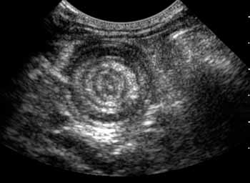

Figure 7:  Ultrasound views of  an intussusception. The figure shows a transverse view. Alternating hyperechoic and hypoechoic concentric rings are present within the lumen of a distended loop of bowel, giving the typical "target" sign.

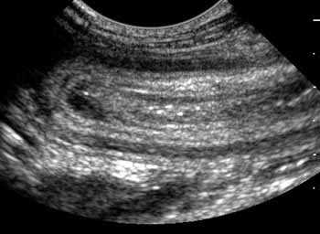

Figure 8: shows a longitudinal view of the intussusception.  Notice that multiple layers of bowel wall are within the lumen of the intussuscipiens.

Abdominal radiographs in dog was taken and revealed gas-distended bowels, consistent with mechanical intestinal obstruction. A soft-tissue opacity mass was being identified on survey radiographs.

   

A B

Figure 9: Lateral (**A**) and ventrodorsal (**B**) views of an Ileocolic intussusception following a barium enema. A large “coiled-spring”–appearing filling defect is present within the transverse and descending colon. Barium is present within the lumen of the colon surrounding the intussusceptum.

The history, clinical, ultrasonographic and radiographic findings were suggestive of ileocolic intussusception.

**3.4 Diagnostics**

Blood gas analysis revealed alkalosis (Pco2; 27.5 mmHg) with compensatory metabolic acidosis and hyperlactemia; Abnormalities on the complete blood count included a mildly decreased platelets count and leukocytosis characterized by a mature neutrophilia and monocytosis. Blood chemistry abnormalities included hypoproteinemia, hypernatremia, and hypocalcemia .The urine specific gravity was 1.057 (Reference range:1.030-1.050). But urinalysis revealed no other abnormalities.The blood picture showed leucocytosis, lymphopenia, mild anaemia and decreased levels of total proteins (Table 1).

**Table 1: Comparison of the haematological parameters of a four-months-old male doberman dog with normal value.**

|  |  |  |  |  |
| --- | --- | --- | --- | --- |
| **Test** | **Value** | **Normal value** | **Remarks** | |
| pH | 7.30 | 7.33-7.45 | Low | |
| Pco2 | 27.7mmHg | 29-42mmHg | Low | |
| HCO3 | 19.6MEq/L | 17-24MEq/L | High | |
| Lactate | 3.3mmol/L | 0-2.5mmol/L | High | |
| Red blood cells | 5.06*103/ μL | 5.50-8.50*103/ μL | Low | |
| Leukocytes | 28.2*103/μL | 13*103/μL | High | |
| Neutrophils | 23.68*103/μL | 12.9*103/μL | High | |
| Monocytes | 2.538*103/μL | 0.1*103/μL | High | |
| Lymphocytes | 0.81*103/μL | 1-4.80*103/μL | Low | |
| Platelates | 206*103/μL | 211*103/μL | Low | |
| Haemoglobin | 10.5g/dl | 12-18g/dl | Low | |
| Hematocrit | 35.5% | 36%-59% | Low | |
| Total protein | 5.1g/dl | 5.2-7.3g/dl | Low |  |
| Sodium | 158mmol/L | 146-154mmol/L | High |  |
| Calcium | 8.5 mg/dl | 9-11mg/dl | Low | |  |
| Total bilirubin | 0.40mg/dl | 0-0.2mg/dl | High | |
| Thrombin time | 6.7sec | 3.7-10sec | High | |
| Thyroxine | 2.0 | 0.73-2.9 | High | |
| Cortisol (baseline) | 1.4 | 0.5-3.0 | High |  |

Source:Merck’s Veterinary Manual, 9th Edition (1998).

**3.5 Preparation of dog for surgery**

A four-months old Doberman dog was considered for the study.The feed intake of the dog’s was reduced for two days and completely stopped for 24hours before surgery. Clipping and shaving were performed on ventral midline for celiotomy following the standard procedure (Fossum *et al*., 2002). The surgical intervention for the dog was conducted on october 6, 2012 in Tamilnadu Veterinary and Animal Sciences University (TANUVAS), Namakkal, India.

**3.6 Anaesthetic protocol**

Xylazine hydrochloride (0.5mg/kg; Xylaz, Farvet Pharamaceuticals, Paris, France) and atropine sulphate (0.3mg/kg; Atrosin, Abbott, Laboratories, India), were injected intramuscularly as a preanesthetic. Atropine helps to stabilize the bradycadia of the patient caused by Xylazine. Moreover, xylazine causes hypersalivation which is also controlled by atropine sulfate.

**3.7 Surgical rectification**

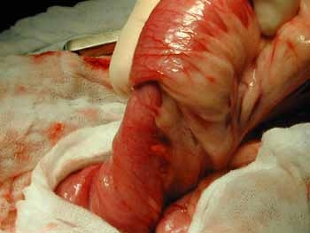Surgical procedure was adopted to correct the Ileocolic intussusceptions of a doberman dog. The dog was positioned in dorsal recumbancy for ventral midline celiotomy and was prepared for aseptic surgery by scrubbing with povidone-iodine (0.75% w/v) surgical scrub. Thiopental sodium (10mg/kg as 5% solution; Pentothal sodium, Abbott Laboratories, India) was injected intravenously for general anesthesia. Intravenous line of 5% dextrose was maintained during the whole operation. The peritoneal cavity was opened by giving an incision on skin, subcutaneous tissue, at linea alba and the peritoneum. The intussusception was found to be ileocolic, on exploration (Figure 10).

Figure 10: An intra-operative view of an intussusception Notice that one section of the small intestine (ileum) has telescoped into the adjoining section (colon).

A gentle traction was applied to reduce the intussusception since the tissues were devitalized in the adjoining section of the small intestine(ileum) has telescoped into the adjoining section(colon).The affected parts were resected and end-to-end anastomosis of remaining intestinal components was carried out. Atraumatic clamps were applied on the proximal and

distal ends of the affected parts, before resection. The resected part of intestine was about 6 inches long. The atraumatic clamps were brought closer to each other with both ends of intestinal parts. The end to end anastomosis was performed by applying crushing suturing pattern using a polyglactin 910 (Vicryl-Johnson and Johnson, New Brunswick, U.S.A.) (Erkert *et al*., 2003). The intestine was reduced back into the abdomen. The abdomen was closed in three layers i.e., linea alba, subcutaneous tissue and the skin. The linea alba was closed with Vicryl (Johnson and Johnson, New Brunswick,U.S.A) using simple interrupted suturing pattern, (Bazan and Hontanilla, 1999), while subcutaneous layer was closed by simple continuous suturing pattern with the help of chromic catgut No. 1 (Tan *et al*., 2008). On the skin simple interrupted sutures were applied by using a non-absorbable suture material, Braided Silk No. 2/0 (Mersilk, Johnson & Johnson, New Brunswick, U.S.A.).

**3.8 Follow up of the patient**:

After surgery and necessary treatment of patient was provided under close observation in hospital by active participation and mobile phoning during on October month, 2012.