A STUDY ON
ANALYSIS OF PHYSIOLOGICAL PARAMETERS OF RUMEN FLUID IN NORMAL AND DIGESTIVE DISORDERED CATTLE


Report Presented in Partial Fulfillment of the Requirement for the Degree of Doctor of Veterinary Medicine

A Report Submitted by Roll no. -05/27
Intern ID No- D-25
Reg. No- 218
Session:2004-2005

Faculty of Veterinary Medicine
Chittagong Veterinary and Animal Sciences University
Khulshi, Chittagong-4202

A STUDY ON
ANALYSIS OF PHYSIOLOGICAL PARAMETERS OF RUMEN FLUID IN NORMAL AND DIGESTIVE DISORDERED CATTLE

A Production Report Submitted as per approved style and content

….........................................  Author  Shah Md. Imran Hossain  Roll No. 05/27  Intern ID: D-25  Reg. No. 218  Session: 2004-2005 | ….......................................  Supervisor  Dr. Md. Belayet Hossain  Associate Professor  Dept. of Physiology, Biochemistry and Pharmacology  Chittagong Veterinary and Animal  Sciences University  Khulshi, Chittagong - 4202

CONTENTS

CHAPTER | NAME OF CONTENTS | PAGE NO.
 | ACKNOWLEDGEMENT | i
 | ABSTRACT | ii
I | INTRODUCTION | 1-2
II | REVIEW OF LITERATURE | 3-6
III | MATERIALS AND METHODS | 7-8
IV | RESULTS AND DISCUSSION | 9-13
V | CONCLUSION | 14
VI | LIMITATION | 15
VII | REFERENCE | 16-17

LIST OF TABLES
NO | NAME OF TABLE | PAGE NO
4.1 | Color of rumen fluid | 9
4.2 | Odor of rumen fluid | 10
4.3 | Consistency of rumen fluid | 11
4.4 | P^{H} of rumen fluid | 11
4.5 | Motility and number of rumen protozoa | 13

LIST OF GRAPHS
NO | NAME OF GRAPH | PAGE NO
4.1 | Pie chart showing different color | 9
4.2 | Pie chart showing different odor | 10
4.3 | Pie chart showing different consistency | 11
4.4 | Pie chart showing different range of P^{H} of rumen fluid | 12
4.5 | Pie chart showing motility of rumen protozoa | 13
ACKNOWLEDGEMENT

First praise to acknowledge the immeasurable grow and profound kindness of my creator the Almighty Allah, the supreme ruler of universe.

I am very grateful to Professor Dr. A. S. Mahfuzul Bari, honorable Vice Chancellor, Chittagong Veterinary and Animal Sciences University, Khulshi, Chittagong to give the facilities to complete the study by using the computer facilities at CVASU computer laboratory.

I am also very grateful to my supervisor Dr. Md. Belayet Hossain, Associate Professor, Dept. of Physiology, Biochemistry and Pharmacology, Faculty of Veterinary Medicine, Chittagong Veterinary and Animal Sciences University, for his scholastic guidance, simultaneous inspiration, constructive criticism and invaluable suggestions during the entire period of the study and also for the preparation of this report.

Special thanks to Dr. Md. Abul Kalam, Veterinary Surgeon, Upzilla Veterinary Hospital, Companiganj, Noakhali, for his kind co-operation.

The Author
February, 2011

i
Study on analysis of physiological parameters of rumen fluid in normal and digestive disordered Cattle

ABSTRACT
The study was carried out with a view to analyze various physiological parameters of rumen fluid. For this sample of rumen fluid was collected from Cattle in Upazilla Veterinary Hospital, Companiganj, Noakhali and in Teaching Veterinary Hospital, CVASU. After collection of rumen fluid from both diseased and healthy animal different physiological parameters of rumen fluid (e.g. Color, Odor, Consistency, P^{H}) and motility of protozoa was observed and studied in relation with different digestive disorder of Cattle. So, This study revealed four (4) colors of rumen fluid such as- greenish, greenish brown, milky grey and dark brown or grayish brown and their percentage were 30%, 37.5%, 17.5%, 15% respectively which indicate the normal, simple indigested, acidosis & chronic bloat or alkalosis respectively. Odor like- putrid (27.5%) aromatic (47.5%), sour (10%), pungent (15%) indicating the sub-acute indigestion, normal condition, acid indigestion & alkalosis respectively. Consistency was found as watery, gruel like and foamy which were 47.5%, 37.5%, 15% respectively. P^{H} rumen fluid ranged 4.0 to 4.5, 5.0 to 5.5, 5.5 to 6.5, 6.5 to 7.0 & 7.0 to 7.5 were found 27.5%, 10%, 17.5%, 30% and 15% of cases which indicate acidic, mild acidic, simple indigested, normal and alkaline pH of rumen fluid respectively. Rumen protozoal motility showed that vigorous (30%), moderate (32.5%), mild (10%) and absent (27.5%) for normal, simple indigested or alkalosis, mild acidosis and acidosis condition respectively. This study helps to interpret that body temperature, ruminal motility; rumination and feeding regimen have a relation with physiological parameter of rumen fluid and ruminal protozoal numbers and their motility.

Key words: Rumen fluid, Rumen protozoa, Ruminal acidosis, Alkalosis, Chronic bloat, indigestion.

ii

CHAPTER-I

INTRODUCTION
Cattle and other ruminants are markedly different from monogastric animals, such as man, in that they have an additional organ, the rumen.The rumen, also known as a paunch, forms the larger part of the reticulorumen, which is the first chamber in the alimentary canal of ruminant animals. It serves as the primary site for microbial fermentation of ingested feed.This ruminal environment consists of mainly ruminal fluid and rumen micro-flora. So the different physiological and bio-chemical parameters of the rumen fluid e.g. color, odor, consistency, pH, motility and number of rumen micro flora are closely related with ruminal environment, digestion and proper metabolism of ruminant. In a word, digestion in rumen is solely dependent upon microbial activity and physiochemical parameters of ruminal fluid. The rumen microbial population is very dense, containing 10¹⁰ bacteria/ml, 10⁶ protozoa/ml, and 10³ fungi/ml. Because protozoa are so much larger than bacteria, the protozoa can make up close to half of the total microbial biomass. (Hungate, R. E., 1961)
Digestive disorder or anorexic condition of the large and small ruminants is the most common and considerable problem in our country which hamper the proper growth and production of animals. It also causes great economic losses of Bangladeshi farmer. A good ruminal environment and microbial activity are most necessary and essential factors for good digestion and metabolism and ultimately for better growth and production of the animal. (Kurar et al., 1988)
The inhabitants of the rumen microbial eco- system, a complex consortium of different microbial groups living in symbiotic relationship with the host, act synergistically for the bio-conversion of lignocellulosic feeds into volatile fatty acids which serve as a source of energy for the animals. (Sahu and Karma, 2005)
The rumen is buffered over a range of 5.7 to 7.3 by phosphate and bicarbonate from saliva and bicarbonate from rumen fermentation.While the rumen is very well buffered around P^{H} 6.8, the buffering capacity is poor below P^{H} 6.0. A major consequence when ruminal P^{H} falls below 6 is that fibre digestion declines dramatically. There are two reasons for this. Firstly, the enzymes necessary for fibre breakdown do not function effectively at P^{H} <6.0 and secondly, the growth rate of fibrolytic activity declines markedly at low P^{H}. Not only are these bacteria not able to obtain the sugars necessary for growth, the low P^{H} impedes growth itself. Fibrolytic bacteria are unable to maintain the P^{H} inside their cells when ruminal P^{H} is low. This incapacitates the cell machinery making growth impossible (Basak and Chakrabarty, 1993).
For optimum ruminal fermentation and fibre digestion, ruminal P^{H} should lie between 6.0 and 6.4, although, even in healthy cows, ruminal P^{H} will fluctuate below this level for short periods during the day. This drop in ruminal P^{H} is a result of the breakdown of dietary carbohydrates (e.g. starch), particularly from cereal grains such as corn and barley. (Chodhury P.C., 1980)
Any alteration of these parameters causes digestive disorder, ruminal dysfunction, anorexia, loss of appetite and other abnormal conditions of the rumen. So examination of these parameters such as P^{H}, color, odor, consistency of rumen fluid and motility and number of ruminal protozoa are the important indicators of the anorexia, reduced feed intake and other digestive disorder of animal.In ruminal dysfunction, the microbial activity and biochemical process get upset. Resultant outcome is the formation of abnormal toxic products of metabolism. The physical, microbial and biochemical alterations in the rumen can therefore be considered as important diagnostic tools for any abnormal or disorder of rumen (Dir Ksen G., 1970).
The main objectives of this study were-

To analyze various physiological parameters of rumen fluid of cattle in healthy and diseased condition.

- To study the motility of protozoa in rumen fluid in relation with indigestion.

- To make a comparison between healthy and anorexic animal in relation to these parameters of the rumen fluid and ruminal microflora.

- To make relationship between the ruminal P^{H} and motility of protozoa in rumen fluid.

CHAPTER-II
REVIEW OF LITERATURE

Blood D.C. et al., (1989) suggested that Simple indigestion is clinically characterized by aoerexia, lack of ruminal movement and changes of pH of rumen contents and finally rumination ceases.

Chakrabarty A., (1994) reported that due to enormous intake of protein there will be excessive accumulation of ruminal ammonia, nitrogen and decrease in V. F. A. leading to an alkaline pH of ruminal fluid. Excessive alkaline pH will inhibit the contraction power of rumen and causes digestive disorder. The range of pH remains between 7.5 to 9.5. When pH exeeds 7.5 there is decreases in the number of rumen flora and rumen fluid appears watery and dark brown in color. They may become slimy and putrid smelling. The paresis and high pH bring about inappetance and interfere cellulose digestion.

Hungate R.E., (1961) reported that the digestive process of ruminants differs from that of other animals because rumen microbial digestion occurs prior to other animal normal digestive process. The short – chain fatty acid (acetic, propionic and butyric acids) are the primary end products of rumen fermentation and are the chief sources of energy available to ruminants from the diet

Dunlop R.H., (1972) reported that the ingestion of large amounts of highly fermentable carbohydrate rich feeds causes an acute digestive disorder due to excessive production of lactic acid in rumen which is clinically characterized by severe toxemia, dehydration ruminal stasis, weakness and recumbency.

Moir and Somers, (1951) found that the population of bacteria inhabiting the rumen may be as dense as 10⁹ cells per gram when they are counted directly under microscope in suitably diluted samples.

Abou et al., (1969) reported that the largest viable counts, however, are less than direct microscopic counts. A thriving Population of ciliated protozoa is also present, and flagellated organisms can usually be found but are insignificant in number.

Cristine and Pugh (1998) reported that in rumen fluid analysis, anorexia may cause the fluid to appear darker, the pH to increase and the number and the motility of protozoa to decrease. A gray color, low pH, and dead or no protozoa are seen in ruminal acidosis from grain overload.

Chakrabarty A. (1994) found that normally rumen fluid color is variable between yellowish brown to greenish. It may be changed with nature of feeds and different abnormal condition of the rumen. Such as:-
Condition/diets | Color
Green fodder / grass | Pure green to greenish olive color
Straw | yellowish brown color
Acid Indigestion | Milky grey in color
Alkaline indigestion | Dark brown
Impaction | Greenish Black
Bloat | Greyish green
Odor of the rumen fluid depends on the condition of rumen. Different abnormal conditions offer different odor. Such as:-

Conditions | Odor
Healthy animal | Aromatic, vinegar like
Acid indigestion | Pungent and sour
Sub Acute indigestion or Protein over feeding | Putrid and fishy
Alkaline indigestion | Ammonical smell
Inactive gastric juice | Stale
Vagus indigestion | Musty

Gnanaprakasan et al., (2005) found that normal consistency of the rumen fluid is watery or slightly viscous and in different condition it is varied. As for example:-

Conditions | Consistency
Normal | watery or Slightly viscous
Acidosis | Porridge or gruel like
Impaction | Hard caked , Scanty
Frothy-bloat | Foaming.
Alkalosis | Variable/ Sometimes watery
Vagus indigestion | Semi-liquid

Randhawa et al., (1990) investigated the possible effects of pH on numbers and growth of rumen protozoa. Feeding of high concentrate diets with a corresponding marked decrease in rumen pH is commonly thought to essentially eliminate the protozoa.

Hungate R. E., (1961) found that there is a great correlation between, pH of rumen fluid and motility and number of ruminal protozoa. Change of pH, due to any abnormal condition of rumen causes the great changes of protozoal motility and total count. The different value of pH in different disordered condition of rumen which causes anorexia are given below by

Condition | pH
Normal | 6.3 to 7.0
Simple indigestion | 5.6 to 7.2
Acid indigestion | 4.0 to 5.8
Alkaline indigestion | 7.3 to 8.5

Dehority and Scott (1996) studied the effect of prolonged high-concentrate feeding on the concentration of rumen protozoa. In general, feeding high-concentrate diets results in a lowering of rumen pH below 6.0 with a marked decrease in protozoal concentration.

Hobbson, P.N. (1989) in tropical countries of the world, the ruminants are fed on lignocellulosic agricultural by-products like cereal straws, stovers, sugarcane bagasse, tree foliages and cakes of oil seeds like groundnut, cotton, mohua, neem and mustard. The efficiency of ruminants to utilize such a wide variety of feeds is due to highly diversified rumen microbial eco-system consisting of bacteria (10¹⁰-10¹¹ cells/ml, representing more than 50 genera), ciliate protozoa (10⁴-10⁶/ml, from 25 genera), anaerobic fungi (10³-10⁵ zoospores/ml, representing five genera) and bacteriophages (10⁸-10⁹/ml). The eco-system is dynamic as the microbial population changes considerably on change of diet so as to adapt it to the new feed ingredients.

CHAPTER-III
MATERIALS AND METHODS

3.1 Study Area
The study was carried out in UVH, Companiganj, Noakhali during my UVH placement in Companiganj, Noakhali and TVH of CVASU.
3.2 Duration of study
The study was carried out from 26th June to 28th July, 2010 and 18th December, 2010 to 25th January, 2011 during internship placement.
3.3 Study population
This study was conducted by collecting rumen fluid from 50 cattle which were in normal, anorexic, simple indigested, acid indigestion and bloat condition.
3.4 Collection of sample
In this study, the rumen fluid was collected with using stomach tube through the oral route and examined within 1 hour of collection in UVH and TVH, CVASU.
3.5 Physical Examination Procedure
3.5.1 Color: Color of the collected rumen fluid was observed by naked eyes and compared with rumen fluid of healthy animal and digestive disordered animal.

3.5.2 Odor: Odor of the collected rumen fluid was observed by organoleptic test and was recorded. Odor of the rumen fluid depends on the condition of rumen.

3.5.3 Consistency: Immediately after collection of rumen fluid sample, their consistencies were observed and recorded.

3.5.4 P^{H}: The ruminal pH is an important factor for good digestion and microbial activity. It was determined by wide range of pH indicator paper and electrical digital pH meter in the laboratory. The pH of rumen fluid changes due to different causes such as ruminal acidosis, alkaline indigestion which ceases the microbial activity of the rumen.
3.5.5 Examination of protozoal activity and motility: A drop of fresh ruminal fluid was taken in a clear glass slide and a cover slip was placed over it and examined under microscope. The motility was graded arbitrarily as -, +, ++, +++, i.e.-none, mild, moderate and vigorous respectively. The grading of motility is expressed symbolically below:-
Density | Symbol | Grade
None | - | 1
Mild / Few | + | 2
Moderate | ++ | 3
Vigorous | +++ | 4

CHAPTER-IV
RESULT AND DISCUSSION
4.1 Color of rumen fluid:
In this study, we got 4 different color of rumen fluid of Cattle. These were greenish, greenish brown, milky grey and dark brown or grayish brown and their percentage are 30%, 37.5%, 17.5%, 15% respectively. These colors depend on the diet and abnormal condition of the rumen. Previous study shows that due to acid indigestion, color of pH become milky grey and due to alkaline indigestion, color of rumen liquor become dark brown or greenish brown color and due to chronic bloat it become grayish green (Chakrabarty A., 1994). So, this study significantly supports that previous study.
Table-4.1: Color of rumen fluid in various conditions of Cattle
Condition | Color | Percentage
Normal animal | Greenish | 30%
Simple indigestion | Greenish brown | 37.5%
Acidosis | Milky Grey | 17.5%
Bloat | Dark Brown | 15%

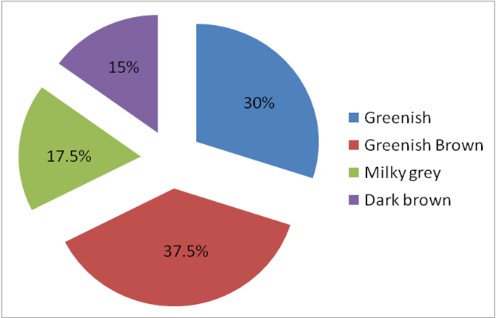

Graph 4.1: Pie chart showing different colors of rumen fluid.

4.2 Odor: Various types of odor were found in this study. Such as putrid (27.5%) aromatic (47.5%), sour (10%), pungent (15%) In earlier study, Gnanaprakasan et al., 2005 reported that putrid, aromatic, sour and stale indicates respectively the protein over feeding or sub acute indigestion, normal condition, acid indigestion and chronic bloat or inactive gastric juice. So this study coincide with the previous study to a great extend.
Table-4.2: Odor of rumen fluid in various conditions of cattle
Condition | Odor | Percentage
Sub-acute indigestion | Putrid | 27.5%
Normal | Aromatic | 47.5%
Acidosis | Sour | 10%
Bloat | Pungent | 15%

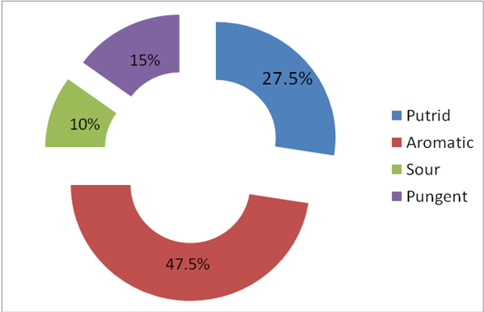
Graph 4.2 Pie diagram showing different odor of rumen fluid.

4.3. Consistency: Three types of consistency were found in different samples. These were watery, gruel like and foamy which are 47.5%, 37.5%, 15% respectively which indicates different abnormal condition of rumen in Cattle. Data from previous study (Dehority and Scott, 1996) shows that during ruminal acidosis, the rumen fluid consistency become gruel like or Porridged during chronic bloat it become foamy.

Table-4.3: Consistency of rumen fluid in various conditions of cattle
Condition | Consistency | Percentage
Normal | Watery | 47.5%
Acidosis | Gruel like | 37.5%
Bloat | Foamy | 15%

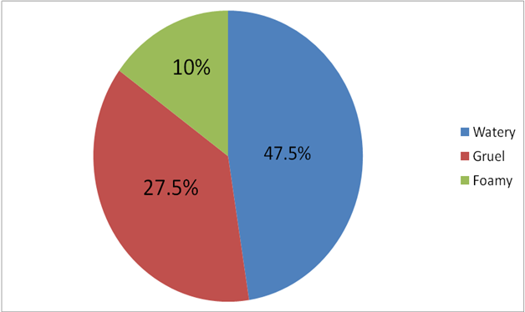
Graph-4.3 Pie chart showing different consistency of rumen fluid.

4.4 P^{H}: There is a great correlation between, pH of rumen fluid and motility and number of ruminal protozoa. In this study pH ranged from 4.0 to 4.5, 5.0 to 5.5, 5.5 to 6.5, 6.5 to 7.0 & 7.0 to 7.5 were found respectively 27.5%, 10%, 17.5%, 30% and 15% which indicate acidic, mild acidic, simple indigested, normal and alkaline pH of rumen fluid respectively. Generally, during acid indigestion, pH ranged from 4.0 to 5.5, during Alkalosis 7 to 8.5 (Gnanaprakasan et al., 2005)
Table-4.4: P^{H} of rumen fluid in various conditions
Conditions | P^{H} | Percentage
Acidosis | 4-4.5 | 27.5%
Mild acidosis | 5-5.5 | 10%
Simple indigestion | 5.5-6.5 | 17.5%
Normal | 6.5-7 | 30%
Bloat | 7-7.5 | 15%

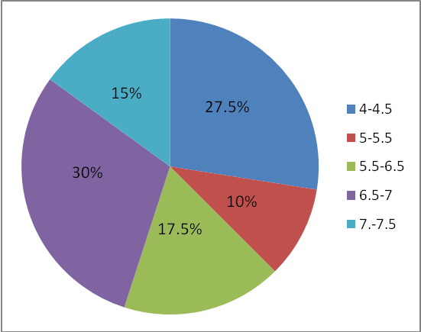
Graph: 4.4 Pie diagram showing different range of P^{H} rumen fluid.

4.5 Motility and number of ruminal protozoa: Due to abnormal condition of rumen, change of pH causes the great changes of protozoal motility and total count. This study shows that motility were found in vigorous (30%), moderate (32.5%), mild (10%) and absent (27.5%). Per focus study of rumen fluid under microscope shown that 10 to 15, 7 to 8, 5 to 6, 1 to 2 and zero (0) no of protozoa in P^{H} of 6.5 to 7, 5.5 to 6.5, 5.0 to 5.5 and 4 to 5 respectively. In this study, we got a relationship among pH of rumen fluid and motility and number of ruminal protozoa. Because when ruminal pH was lower, then motility and number of ruminal protozoa was either lower or absent. According to Dehority and Scott, 1996 showed that excessive high carbohydrate rich green grass or hay (e.g. - Alfa alfa, Orchadgrass, Bromegrass) causes acid indigestion of Cattle and lower pH of ruminal fluid, ultimately, motility and no. of ruminal protozoa decreases.

Table-4.5: Motility and number of rumen protozoa
Condition | Motility | Percentage | No of protozoa per focus
Normal | Vigorous | 30% | 10-15
Simple indigested or Bloat | Moderate | 32.5% | 7-8
Mild acidosis or alkalosis | Mild | 10% | 2-5
Acidosis | Absent | 27.5% | 0

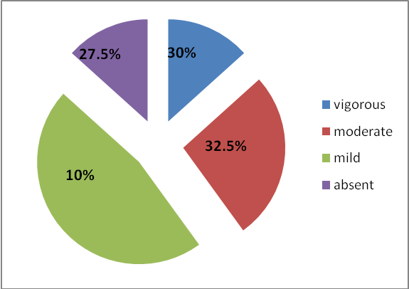
Graph: 4.5. Pie chart showing motility of rumen protozoa.

In this study, we got a relation between the pH of rumen fluid, motility and count of protozoa with the frequency of rumen motility. Those animals whose rumen fluid was 4.5 to 5.5 their rumen motility was less than normal and their protozoal motility and count are also less or absent Blood D.C. et al., (1989) found that during acute acidosis, abdomen becomes distended and rumen motility become ceases sweet sour smelling, ruminal pH 5 or less and no protozoa will be observed. During sub acute acidosis moderate distension of abdomen, weak ruminal contraction, pH become 5.5 to 6, some protozoa remain alive.

CHAPTER-V
CONCLUSION
In this study, the main objective was to know the changes of physiological parameters that occurred in digestive disordered cattle. We can conclude those animals which were suffering from anorexia, chronic acidosis or chronic bloat or indigestion there were a marked change of color, odor, consistency, pH of rumen fluid and change of motility and number of ruminal protozoa. Ruminal microflora which are the fundamental part of digestion generally affected during digestive abnormality. So metabolism of rumen becomes decrease and the animal gradually loss its body condition. Besides that body temperature, respiration rate, heart rate, rumen motility and rumination were also related with the change of the physiological parameters of rumen fluid and motility. There were less number of rumen protozoa per focus in anorexic or digestive disordered cattle. So rumen fluid has a great diagnostic value in different abnormal condition of rumen and helps in treatment of animal accurately according to condition of rumen.

CHAPTER-VI
LIMITATION
Although, I tried my best to perform this study perfectly, however, there were some limitations of this study, such as-

- It is difficult to count rumen protozoa under microscope from fresh fluid for its continuous motility. If possible total protozoa count must be done for proper diagnosis.
- Digital P^{H} meter is not available in Upazilla Veterinary Hospital. So accurate P^{H} of rumen fluid was not being able to take.
- Besides, Anorexic or digestive disordered case was also less in amount.
- Owner did not allow collecting the rumen fluid from the animal all time. It is difficult to manage the owner due to their illiteracy and less practice of veterinarians in our country.

CHAPTER-VII
REFERENCES
Abou, A.R., Bartley E.E. and Fina L.R. (1969) Ciliate protozoa in the rumen of the lactating cow. Journal of Dairy Science, 52, 1088-1091.
Basak, D.N., Pan, S. and Chakrabarti, A. (1993) Physico-chemical and microbial changes in rumen liquor of experimentally induced lactic acidosis in goats. Indian. J. Anim Sci, 63, 263.
Blood, D. C and Radostits, O.M. (1989) Veterinary Medicine; 7th ed. The English language book society.
Chakrabarty A. (1994) Mechanism of Rumen Digestion. 4th edition. P:322.
Choudhury, P. C. (1980) Primary rumen dysfunctions in bovines with special reference to acid and alkli indigestion and their effect on production. Lecture note on summer Inst. Prod. Dis. with special references to rumen dysfunctions in bovines. P. A. U. Ludhiana.
Cristine B. Navarre and Pugh G.H. (1998) Sheep and Goat Medicine, Chapter-4 Disease of Gastrointestinal system. P:69
Dehority, B. A. and Scott, H. W. (1996) Extent of cellulose and hemi-cellulose digestion in various forages by pure cultures of rumen bacteria. J. Dairy sci., 1967, 50, 1136-1141.
Dir Ksen, G. (1970) Acidosis. Proc. 3rd int. Symp. Phys. Dig. Metab. Ruminant, ed. A. T. Phillipson, PP: 612-625. Newcastle : Oriel Press.
Dunlop, R. H. (1972) Pathogenesis of ruminant lactic acidosis. Adv. Vet. Sci. Comp. Med ; 16, 259.
Gnanaprakasan , V., Prathaban, S and Srinivasan, S. R. (2005) A key role view on ruminant medicine . Dept. of Clinical Medicine, Madras.
Hobbson, P.N., (1989) The Rumen Microbial Eco-system, Elsevier Aplied Science, London
Hungate , R. E. (1961) Rumen and its microbes, Academic Press, Washington DC.
Kurar C.K., Gupta B.N. and Mohini S. J. (1988) Protozoal status in Strained rumen Liquor of Cattle and Buffaloes. Indian J. Ani. Sci. 58, 112-115
Moir, R.J. and Somers M. (1951), A factor influencing the protozoal population in Cattle. Nature, 178.
Randhawa, S. S., Ahuja, A. K. and Rathore, S. S. (1990). Effect of lactic acidosis on microbial, protozoal and biochemical changes in rumen liquor of buffalo calves. Indian J. Vet. Med. 9:1.
Sahu, N. P. and Karma, D.N., (2005) Microbial eco-system of the gastro-intestinal tract of wild herbivorous animals .J. Appl. Anim, Res., 21, 207-230.

