Chapter I

INTRODUCTION

A biological ornament is a structure of an animal that appears to serve a decorative function rather than an ostensible, utilitarian function. Ornaments are used in displays to attract mates. An animal may shake, lengthen, or spread out its ornament in order to get the attention of the opposite sex, which will in turn choose the most attractive one. In case of ornamental birds due to their natural beauty, intelligence and attractiveness they attract human also to raise up as a pet.

In past, most "ornamental" species are raised by hobby aviculturists which do not have "profits" as a motive. These dedicated men and women usually do not even make enough "profit" to pay for the feed each year much less the cost of the pens, equipment, and labor. They are glad to donate their time and other costs of raising their favorite species. It can safely be said that few, if any, hobby aviculturists make any profit. But now a days thought has been changed day by day. Because of a huge population which is 15,25,18,015 and out of total population male is 7,63,50,518 (50%) and female 7,61,67,497 (49.9%) (BBS, 2012). A major portion (35%) of the population of Bangladesh lives below upper poverty line (BBS, 2012). To gain a profit is a real accomplishment during these days of economic uncertainty. Unemployed youth(7.2%) (BBS, 2012). and house wives can play a vital role in this regard.

Our hats must go off in a salute to the management of a ornamental bird farm that is a success as there are many hazards which must be overcome to reach success. Because in many ways commercial ornamental bird farming is not identical to raise the poultry birds. There is a difference in housing, management techniques, and even differences in the birds themselves contribute to some confusion as to what "commercial" as opposed to "ornamental" bird breeding really is. However, at the root of the difference is the motivation of the ornamental bird breeder.

There are some considerations which should be taken seriously by the prospective commercial ornamental bird breeders. The money investment that is required for commercial production of ornamental birds and their products is probably the first consideration one should make. In a commercial ornamental bird project there will be considerable investment required. There must be the cost of land. If one goes out and buys land for the enterprise the costs could be as high for an acre of suitable land.

The land should be in an area where it is legal to raise birds. Besides land, there is the investment of pens and equipment which will be high at first, but can be spread over several years. Finally, an up-front investment will be for the birds whether one starts with hatching eggs, started chicks, or breeders. It has been suggested by those with experience that to be assured of an income the person starting off in the ornamental bird business should not have enough money.

The local climate will determine somewhat the species of birds the beginning ornamental bird farmer raises. Most of the commercial species of ornamental birds are tough enough that they can handle most any climate. These species are tough or they would not be candidates for mass production. Generally, in Bangladesh parrot, mayna, lovebird, pigeon, dove, purple swamp hen(kalim), finzes, cockatiels are suitable.

The available market should be considered very carefully. Who will buy the product? Will the sale price be enough to make a decent profit? Should eggs, chicks, young birds, or breeders be produced for the market? This should be carefully thought through and analyzed by the prospective ornamental bird breeder. The market will determine to a great extent the type of birds that are raised.

Checking the law is very first thing for a prospective commercial ornamental bird producer. Most states have laws governing the keeping of native (and some foreign) ornamental birds in captivity. The regulations vary with each state so be sure and check before ordering eggs, chicks, or stock. All aviculturists should operate within the law. For the sake of the whole fancy, we should not only obey the law ourselves, but encourage others to do the same. When only a few violations occur then broad regulations are imposed on us.

Objectives

The specific objectives of the study are as follows:

- To know the overall husbandry practices of ornamental bird farming
practices.
- To estimate and assess the average farm profitability of ornamental bird farming.
- To identify the problems faced by the farm owners both in production and marketing.
- To identify the prospect of ornamental farming in Bangladesh.

Chapter II

REVIEW OF THE LITERATURE

Jeggo (1982) reported that the immature birds were first managed as a group. These parrots become mature at the age of four or more. Being a monogamous species they will then form pairs for life. In Jersey the pairs have been formed on the basis of compatibility and genealogy.

Susan Clubb (2009) reported that, peach faced love birds are one of the most common pet birds worldwide. They are highly domesticated, have been breed over100 years. They are easily available worldwide and usually modestly priced. Lovebird was provided balanced diet and kept in pairs in cages which is 24 inches square. They preferred grooming facilities. They bred at one year old. The hen lays 4-8 eggs 1-2 days apart in single clutch all year around proved that they can live up to 18 to 20 years with good nutrition and care.

4-h members (2008) showed possibilities of raising pigeons and doves. Doves can adapt to nearly all conditions. They acquire very little span be raised in rural, suburban or urban areas, they seldom are restricted by zoning. They are easy to raise, basically inexpensive to maintain and require very little space. They are fairly quiet. By providing loft 4×8×7 feet high and perch 184 inch boards and two separate nest boxes 12×12×18 inch compartment for each mated pair of doves the production can be achieved 8 pairs of young squabs per year.

Elise V. Pearlstine and Juan Sebastian Ortiz (2009) reported about habits,habitat,food,nesting and reproduction,potential ecological impacts of purple swamphen.In their native range they are found in a variety of wetlands and wetland associated habitats.purple swamphen construct nest in shallow water(30-120)cm deep.breeding females typically lay a clutch of 2-7 eggs and purple swamphens may compete with native species for desirable habitat in agricultural areas and wetlands.

Nadja Ziegler (2000) studied about conservation status, captive management by housing, temperature and lighting, bedding, nutritional requirement in captivity, breeding essentials, gestation and parturition, incubation details and neonatal development of parrots. The first captive breed St. Lucia was bred in 1982 and since then a total of 19 young have fledged to 1995.Recently, Paradise Park in Hayle (UK) joined the captive breeding programme for the
species, too. All specimens remain the property of the Government of St. Lucia.

James E. Miller (2004) reported that, managing for doves can provide landowners enjoyment and an alternative source of income.

Chapter III

MATERIALS AND METHODS

i. Location:
The present study was conducted in the village Charigram under Savar upazilla of Dhaka district.
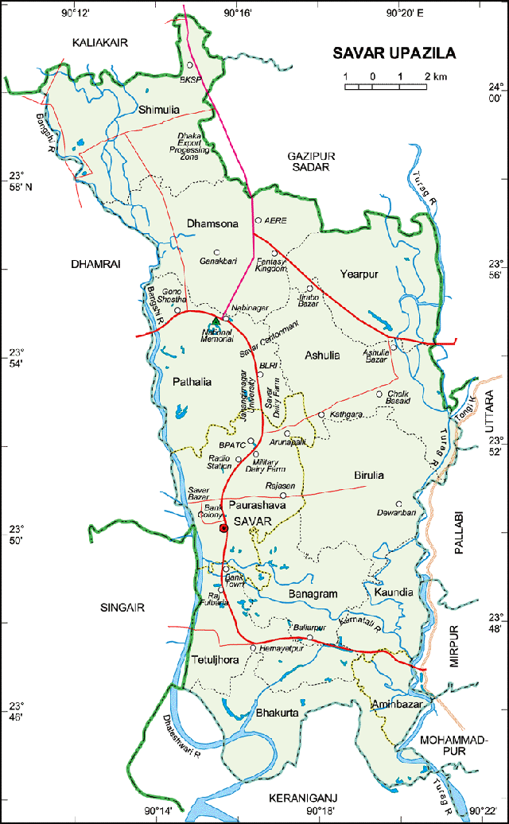
Figure 1: Location of the Study Area

ii. Selection of farm:
The Farmvilla farm was selected for study purpose considering the easy communication, interest of the farmer for giving excess to the farm, research scope and infrastructure of the farm.
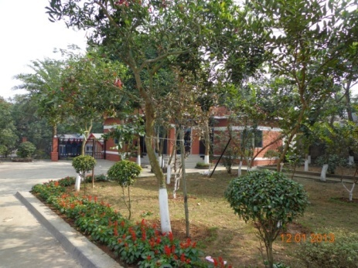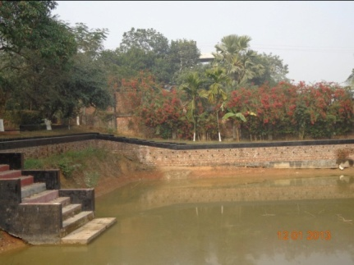
Figure 02 and 03: Overview of Farmvilla farm

iii. Preparation of the questionnaire:
The questionnaire was developed in accordance with the objective of study. It was prepared to get the desired information from the ornamental farm owner and caretaker.

iv. Period of data collection:
The necessary information of the study was collected from 16/07/12 to 07/09/12.

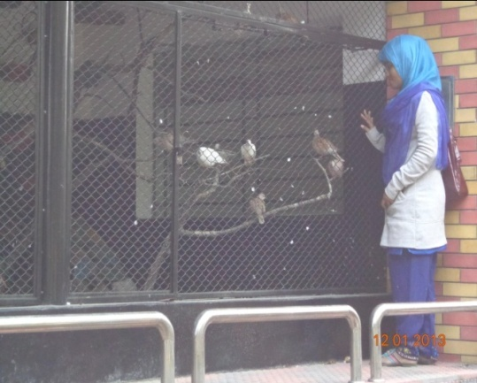
Figure 04: Visit of the farm Figure 05: Observation of Dove bird cage

V. Method of data Collection:
Information related to the study was collected by using an interview schedule through face to face interviewing the farmer/caretaker and physical observation of farm. Before interviewing, the aims and objectives of the study were explained to the owner and caretaker of the farm. They were convinced that the study was purely an academic one and was not likely to have any adverse effect on their business. Thus the primary data were collected. The secondary data were collected from different records kept by the farmer.
The primary data were collected about planning of ornamental bird farm, longevity, housing pattern, cost of housing, nesting pattern and costs, feeding behavior, cost of feed, bird collection, flock size, purchase cost, their production, mortality, disease prevalence, selling price of birds, daily activities in farm.

vi. Data analytical Techniques:
The collected data were kept in Microsoft Office,2007 and analyzed after coding, decoding and summarized when stayed in CVASU.

MANAGEMENT PRACTICES OF THE FARM

A. Collection of birds:
Collection of birds is an important factor for ornamental bird farming. The farm owner collects the birds of different species from zoos, different shops of katabon, Dhaka. The purchase cost per bird is given below:

Table 01: Species wise cost of collecting bird by the farmer
Species | Price per bird | No. of bird | Cost
Love bird | 150 | 20 | 3000/-
Parrot | 100 | 20 | 2000/-
Purple swamp hen | 500 | 10 | 5000/-
Dove | 300 | 20 | 6000/-
Total cost 43,000/-

B. Flock size:
During my internship period I visited 3 ornamental bird farms. Different flock size are observed in different unions. The average flock sizes were found in Farmvilla farm which is given below :

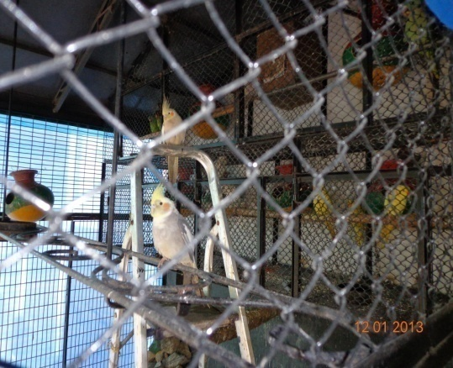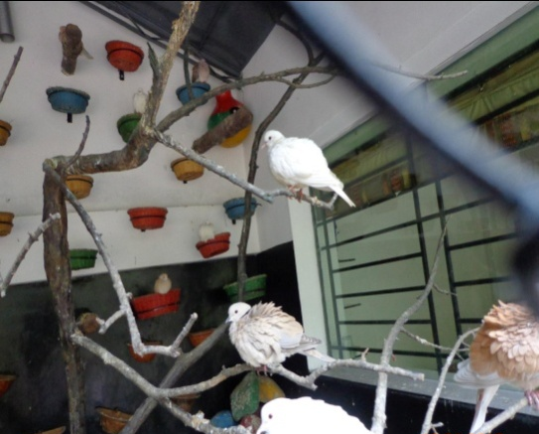
Figure 06:Lovebird flock Figure 07:Dove bird flock

Table no:02 Flock Size of birds:
Species | Flock size | No. of Female | No. of Male
Love bird | 20 | 15 | 5
Parrot | 20 | 15 | 5
Purple swamp hen | 10 | 5 | 5
Dove | 20 | 10 | 10
Total | 70 | 45 | 25

C. Housing
A suitable house is the prime need for the rearing of ornamental birds in the intensive method. In Farmvilla farm owner built houses with bricks, nets with colored potteries for beautification and birds sitting & adequate nesting spaces also provided for breeding purpose of the farm. In winter, farmer use rubber sheet around the nets for protection of birds.
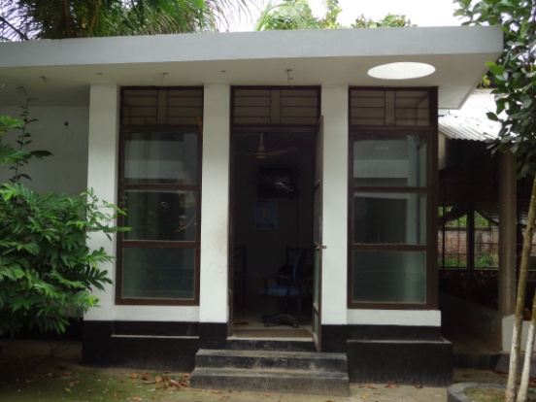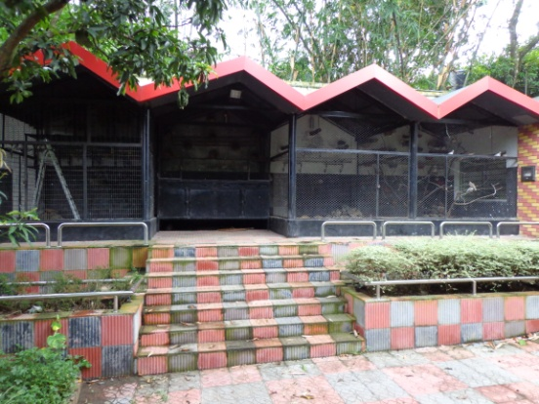
Figure 08: Office room of the farm Figure 09: Architectural view
of bird house

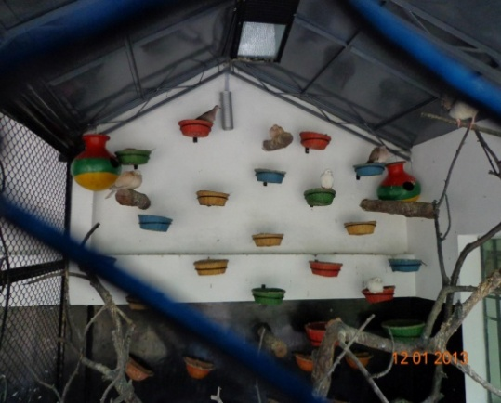 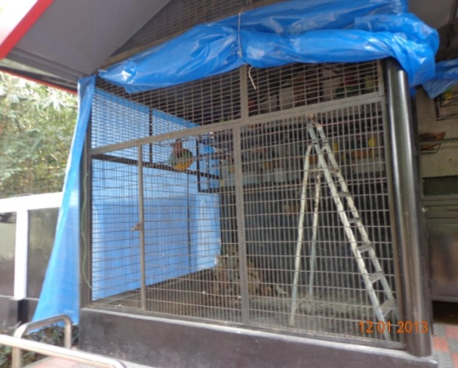 Fig. 10: Dove bird cage Fig.11: Polythene protection in winter

D. Floor, feeder and waterer spaces
The average floor, feeder and waterer spaces provided in the farm are mentioned below.

a.Floor space:
Table 03. Average available floor space for different species of birds
Species | Floor space / bird
Love bird  Week | 0.5 sq. ft.
Parrot | 0.5 sq. ft.
Purple swamp hen | 1.0 sq. ft.
Dove | 1.0 sq. ft.

b. Feeder space:
Table no: 04. Average feeder space provided for different species of Ornamental bird
Species | space/bird
Love bird | 1 inch
Parrot | 1 inch
Purple swamp hen | 2 inch
Dove | 1.5 inch

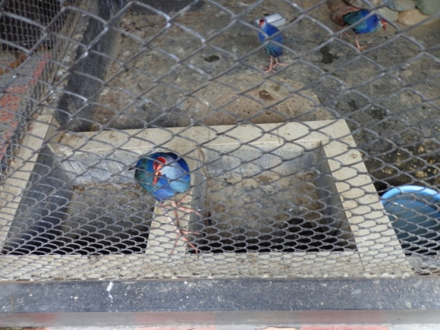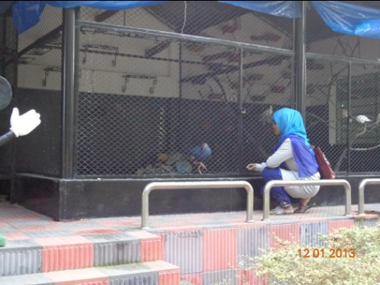
Figure: 12 and 13 Feeder and waterer space in Purple swamphen cage

c. Waterer space:
Table 05: Average waterer space provided for different species of bird
Species | space / bird
Love bird | 0.5 inch
Parrot | 0.5 inch
Purple swamphen | 1.0 inch
Dove | 1.0 inch

E. Nesting space:

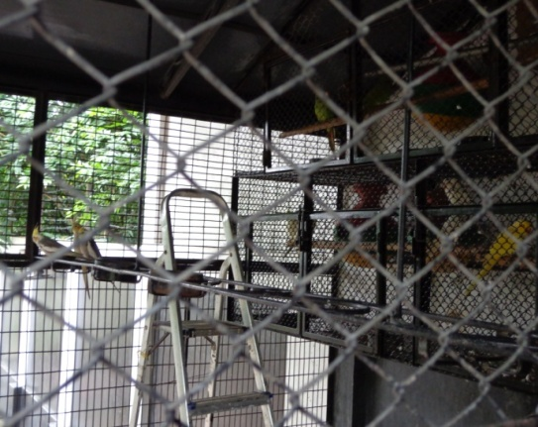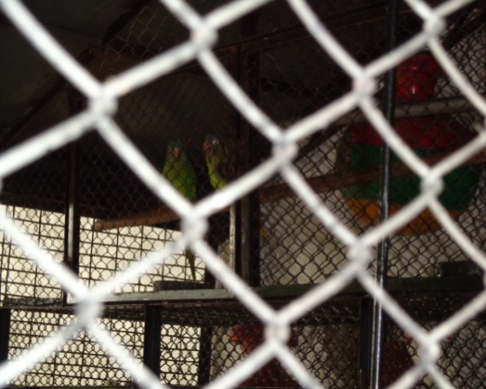
Figure 14 and 15: Nest provided in the house.

Table 06:Average available nesting space for different species of ornamental birds.

Species | Length(inches) | Width(inches) | Height(inches)
Love bird | 12 | 12 | 12
Parrot | 12 | 12 | 12
Purples swamphen | 12 | 6-8 | 8-12
Dove | 12 | 18 | 12

G. Feeding practices:
Feeding is the main function for rearing ornamental bird. “More feed consumption, more body weight gain” is the main concept of the experimental farm. The birds are given small quantity of feed frequently in the 1st week of age.
Feeds are given two times (morning and afternoon) daily. In breeding season they are given proteinaceous feed such as boiled egg, calcium and vitamins such as cod liver oil, brewer yeast. Besides, readymade feeds leafy vegetables, apples, bananas, leeches, berries, peanut, butter, sunflower seeds are also given.

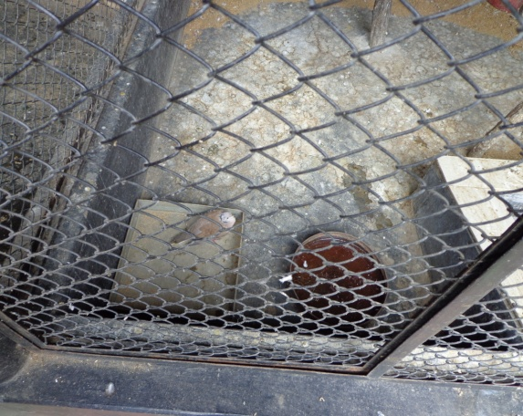
Figure 16: Feeding of seeds

Table no: 07. Feeding practices in the farm

Species | Requirement/bird/day(gm) | Daily requirement for the farm (gm) | Yearly requirement(kg)
Love bird | 20 | 400 | 146.0
Parrot | 20 | 400 | 146.0
Purple swamphen | 35 | 350 | 127.7
Dove | 20 | 400 | 146.0
Total 565.7

H. Disease prevalence:
Disease prevalence which is recorded by the farm owner are given bellow:
Table no:08. Occurrence of diseases in ornamental bird farming
Species | Diseases
Love bird | Psittacosis, liver disease, budgie fledging disease, psittacine beak & feather disease, yeast infections.
Parrot | Psittacine black & feather disease, feather flucking disease, avian salmonella, avian T.B.
Purple swamp hen | Yeast infection, avian salmonella, avian T.B.
Dove | Fowl cholera, coryza, ornithosis, paratyphoid.

I. Table 09: Daily activities schedule followed by Farmvilla farm:
Time schedule | Activities
7.00 a.m. | Cleaning of whole farm premises, cages
8.00 a.m. | Cleaning of waterer, feeder
8.30 a.m. | Collection of broken eggs and dead birds
9.00 a.m. | Giving feed and water
10.00a.m. | Collection of bird for sell
11.00a.m. | Filling of water tank
12.00a.m. | Feed collection from market
5.00p.m. | Cleaning of whole premises, cages.
6.00p.m. | Changing water in waterer,
6.30p.m. | Giving feed
7.00p.m. | Switching on lights

CHAPTER - V

RESULTS AND DISCUSSIONS

Profitability of ornamental bird farming:

Net Profitability: π= TR- TC
Where, TR = Selling of total produced bird per year
TC = Cost for all factors

Table 10:Different collected data
Species | Clutches per year per bird | Number of eggs per clutches per bird | Total Number of eggs per year per bird | Incubation period(days) | Mortality of birds per year | Number of bird sold per year
Love bird | 5 | 3-7 | 32-36 | 23 | 5 | 475
Parrot | 7 | 3 | 21 | 21-30 | 7 | 308
Purple swamp hen | 5 | 2 | 10 | 23-27 | 2 | 48
Dove | 15 | 2 | 30 | 17 | 3 | 297

Table 10 represents that,clutches per bird per year are higher in case of Dove which is 15 in number.In second highest position Parrot which give seven clutches per bird per year.then in 3rd position both Purple Swamphen and Love bird which gives five clutches per bird per year.Where a single clutch was raised by most pairs per breeding cycle.(LOUIS S..WARBURTON,et al)

In case of egg production, love bird has highest egg production which is 32-36 yearly/bird. According to the study of Susan et al, 2009 peach faced love birds produced 4-8 eggs per clutches which is nearly similar to the performance of Farmvilla farm which indicates that farm maintaining good nutrition and husbandry practices. Average 30 eggs were produced per year per dove which is similar with 4-H pigeon & dove project, 2008. The purple swamp hen produced 10 eggs per year per bird which is very lower, naturally 35 eggs per year per birds are recorded by Elise & Juan et al., 2012. Egg production is lower because purple swamp hen prefers to nesting in swallow water and they may also build floating nests (Elise & Juan et al., 2012) but there is no scope of this type of nesting in Farmvilla farm.
Table 10 and figure16 also shows that the mortality rate of parrot was highest followed by lovebird, dove, purple swamp hen.

Fig16: Graphical representation of clutches, total no. of eggs, mortality per year per bird in Farmvilla farm.

Table 11: Investment in operating the farm
Fixed costs | Housing (20 year longevity) | 24,00,000
 | Nesting, cage, wire(20 year longevity) | 5,00,000
Recurring costs | Land rent/year | 2,00,000
 | Housing (@5% depreciation) | 1,20,000
 | Nesting (@ 10% depreciation) | 50,000
Other costs | Veterinary care +Sanitation | 1,50,000
 | Labour: 2(@ 6,000 per month) | 1,44,000
 | Electricity | 24,000
 | Water supply | 3,600
 | Transportation cost | 15,000
 | Miscellaneous cost | 25,000
Bird purchase cost |  | 43,000
Feed cost  Readymade feeds@50 taka per kg for 565.75 kg feeds+ Other feeds |  | 28,287.50+25000=  53287.50
Total recurring expenditure/year 8,27,887.50

In farmvilla farm besides readymade feeds birds are also given other feeds such as leafy vegetables, cutup apples, bananas, leeches, berries, peanut, butter, sunflower seeds. Generally ornamental birds are offered proteinaceous feed such as boiled egg, calcium and vitamins such as cod liver oils, brewer yeast during breeding season (Alyson Kalhagen, About.com Guide). Doves also like vegetables, cooked rice, leafy vegetables, peanut butter, grated cheese, and mashed hard boiled eggs (American Dove Association, 2010). Peach faced lovebirds should also be offered small amounts of fresh dark green leafy vegetables, tiny slices of apple, grapes, melons, sprouts, or other fresh foods (Susanclubb, 2009)
Table12: Yearly income from selling birds
Species | No. of birds | Average selling price per bird (in taka) | Income(in taka)
Love bird | 470 | 400-5000 | 2,32,000
Parrot | 301 | 500-700 | 1,80,000
Purple swamp hen | 46 | 1000 | 48,000
Dove | 295 | 1500-2500 | 8,10,000
Total | 1111 |  | 12,70,000

Fig: Graphical representation of income from different species.

The data shows that, profitability is more in case of dove because their number, price per bird and market demand.
Total income from selling birds = 12,70,000 taka.
Net profit per year = 12,70,000 – 8,27,887.50
= 442112.50 taka
Profit per month = 36842.70 taka.

The profit per month of Farmvilla farm is 36,842.70 taka indicates that it is a profitable business.
B. PROBLEMS OF ORNAMENTAL BIRD FARMING IN SAVAR UPAZILLA
l. Lack of knowledge:
In Bangladesh very few people knows about ornamental birds, their varieties, nutrition, breeding, demand in market. So, most of the entrepreneurs can’t take an initiative to establish ornamental bird farming.

2. Lack of nutritious feed:
In case of ornamental bird, besides readymade feed they also take other type of feeds, such as lovebird takes sunflower seeds, hemp seeds, kushumful, tishi etc. which needs to be cultivated. There is no enough land for feed cultivation. As a result, the farm owner faces the crisis of feed.

3. Lack of electricity:
Electricity is the prerequisite for ornamental bird farming because without electricity birds got frightened in captive condition. But in Savar Upazilla there is a huge problem of load shedding of electricity.

4. Lack of expert opinion:
People of remote area do not get good & expert consultants. So many bird die because of mismanagement.

5. Low quality chick:
The suppliers supply low quality chicks. As a result the farm owners are deprived from
having good and healthy chicks. Many chicks die in their early stage of life. It is very harmful for a farm and loosing farmer interest regarding expanding the farm.

6. High mortality rate of chicks: When the farms become affected by any contagious disease, the mortality rate of the birds is very high. The farm owner cannot take proper care and treatment in due time.

7. Lack of well established diagnostic lab:
There is no opportunity for diagnosis of disease in village level because of lack of diagnostic laboratory near by the village.
8. Lack of post mortem facilities:
There is lack of post mortem facilities of dead bird for the diagnosis of disease. As a result they can not know the actual cause of the diseases and not take proper preventive measure.

9. Lack of bio-security knowledge: The farm owners do not maintain bio-security strictly. Local people, cattle, goat, dog, cat, other birds are always threatened for a farm. Many farmers do not use foot bath at the entrance of the farm.

10. Unavailability of drugs:
Good and varieties quality of drugs are not found in the village. It is a major cause of death of birds and a barrier of establishment of farms.

11. High cost of drug:
The cost of birds drug is very high. The poor farm owners are not able to buy drug of high cost for the treatment of their birds.

12. Absence of proper disease control model:
There is no any disease control model in the rural level on which the farmer can prevent diseases occurred in the farm.

13. Acute shortage of veterinary support staff:
There is lack of veterinary doctor and other staff for the suggestion of farm owner for the development of ornamental bird farm in the village level.

14. Influence by feed supplying company
Many feed companies communicate with farm owner and influence them for using their low quality feed. It also acts as a barrier for development of broiler farm is rural area.

Feasibility of ornamental bird farming in Savar upazilla
The geographical location, environmental condition, number of people, cordiality of people, unemployed people favor the establishment of ornamental bird farm on a large scale in this area. Other factors which can also influence ornamental bird farming in Savar upazilla are given below:

l. Availability of bird:
Since Savar is situated close to Dhaka cityt so, there is a huge market of ornamental bird which is situated in Katabon, Dhaka. So, farmers can get varieties of bird from there and sell their birds.

2. Developed transportation facilities:
The transportation facility of Savar Upazilla is good. It is easier for the farmers to transport the necessities from one place to another. So people of this area may find interest to establish farm.

3. Quality of bird:
Good quality bird can be supplied from Dhaka zoo and kataban market.
4. Peoples demand:
Now a day people’s demand is increasing in this field. Pet animals and birds keeping has become their hobby. These birds are so attractive and friendly so, they may be reared for removing the loneliness of people. So, people have interest to buy them.

5. Utilization of birds and birds product:

Table13: Utilization pattern of ornamental birds
Species | Utilization pattern
Love bird | Pet trade, ornamental cage pet trade, aviculture
Parrot | Circus, travelling zoo.
Purple swamp hen | Meat trade, zoo
Dove | Pet trade, ornamental cage pet trade, aviculture, meat trade.
CONCLUSION

Ornamental bird farming is a new concept in Bangladesh among all the business related to birds and animals. If disease prevalence, mortality rate can be checked it would be a successful business in this country. In this study considering clutches per year per bird, total number of produced egg, total number of sold bird, market demand, price, mortality rate, disease prevalence profitability is more in dove rearing compare to lovebird, parrot, purple swamp hen. Despite of above factors utilization of birds and their products is also a great factor for ranking. Dove can be used for pet trade, ornamental cage pet trade, aviculture and meat trade. Specific species are studied in this study. So, details study is needed in this field.

REFERENCES

LOUISE S. WARBURTON, Black-cheeked lovebirds in Zambia, PsittaScene Volume 16, No 1, University of Natal,( Accessed February 2004), South Africa.

4-h members,4-H pigeon and dove project , Oregon university(Accessed October,2008)

John wragg ,Breeding behavior of parrot ,Parrots,( Accessed 2010)

Susan clubb,Peach faced Love birds, (accessed 2009)

V. Pearlstine and Juan Sebastian Ortiz2,A natural history on Purple swamphen, Elise (Accessed December,2009),Florida university.

Dunn, Jon L. and Jonathan Alderfer ,Field Guide to the Birds of Eastern North America. National Geographic, Washington, D.C.,(Accessed 2008) USA.

Pacheco, Carlos and Peter K. McGregor,Conservation of the purple gallinule (Porphyrio porphyrio L.) in Portugal: causes of decline, recovery and expansion. Biological Conservation 119: 115-120. (Accessed 2004).

Pranty, Bill, Kim Schnitzius, Kevin Schnitzius, and Helen W. Lovell ,Discovery, distribution, and origin of the Purple Swamphen (Porphyrio porphyrio) in Florida. Florida Field Naturalist 28: 1-11 ,. (Accessed 2000),Florida.

Neither,carl,(The book of the pigeon and foreign doves,American pigeon journal co, Accessed 2000),warrenton.

Ornamental Bird Rearing Empowers Rural Women in 24 Parganas, West Bengal, NAIP Sub-Project on Mass Media Mobilization, DKMA with inputs from Zonal Project Director, Zone- II, ICAR, Kolkata)

Dawn M. Trainor-Scalise, Specialized Care for Avian & Exotic Pets , (accessed 2012) , New York, USA

Some websites:
www.berkscountrybirdclub.com,love bird

Priceless Parrots.com,African grey parrots,(Accessed February 4,2012)

About.com ,Love bird breeding basics,Alyson kalhagen,(

www.birdsnways.com/wisdom/ww14eiv…

en.wikipedia.org/wiki/List_of_birds_of_Bangladesh

bikroy.com

APPENDIX

Questionnaire for data collection

1. a. Name of the farm..................................................
b. Name of the owner/Farmer/Employee....................
c. Father’s name...........................................................
d. Address: Village..........Road no...........House no………
Union......................P.O..........................Thana....................District............................Phone no/Mobile no..........................
2.Husbandry practice:
A. Housing:
B. Feeding:
- Collection of feed...........................................
- Storage of feed …..........................................
- Types of feed...................................................
- How many times feed supplied daily.............
C. Watering:
- Source of water
a. Deep tube well b. Pond
- System of water storage
a. Water tank b. Water house
- Frequency of water supply
a. Adlibitum b. Insufficient

D. Litter materials................................................................
E. Litter change....................................................................
F. Ventilation
a. Sufficient .b. Insufficient
G. Natural light...................................................................
H. Artificial light.................................................................
I. Bio-security....................................................................
J. Foot bath:
a. Yes b. No
K. System:
a. all in all out b. Not
3. Number of sheds.........
4. Drainage facility:
a. Sufficient b. Insufficient.
5. Have electric fan?
a. Yes b .No
6. Most common diseases prevalence in the farm................
7. Management of disease condition:
a. Self management
b. Quack
c. Veterinary doctor
8. Feature of Veterinary doctor calling:
a. Actively b. occasional c. In critical situation d. Not at all.
9. The farm is profitable or not......................................................

Name of the interviewee............... Name of the interviewer...........
Date.......... Date: ……………
Signature............. Signature …………………

………………………………..THE END……………………………………..

