ACKNOWLEDGEMENT

All the praises go to the Almighty God, the creator and supreme ruler of the Universe, who enabled the author to complete the work successfully.

The author expresses his sincere gratitude, humble respect and immense indebtedness to his supervisor, Professor Ashraf Ali Biswas, Professor, Dept. of Animal Science and Animal Nutrition, Chittagong Veterinary & Animal Sciences University for his guidance, kind cooperation, sincere help, valuable suggestions, inspiration, constructive criticism and who was involved with this study from its inception.

The author took the opportunities to express his deepest sense of respect and heartfelt appreciations to Prof. Dr. A. S. Mahfuzul Bari, DVM , Phd Vice Chancellor; Prof. Dr. Md. masuduzzaman, Dean, Faculty of Veterinary Medicine, Chittagong Veterinary and Animal Sciences University, Khulshi, Chittagong.

The author also expresses his gratitude and deep sense of respect to all of his friends and well wishers for their support, encouragement, help and inspiration throughout the study period and for preparing this report.

Last but not least, the author extended his appreciation to all of his teachers and his parents for their unforgettable support, suggestions, criticisms, cordial help and inspiration regarding my study from its inception to the last.

The Author

ABSTRACT
--------------------------------------------------------------------------------------------
Since its discovery in 1907, a complex of technological developments has created a potential $500 million market for phytase as an animal feed additive. During last 30 years, research has led to increased use of soybean meal and other plant material as protein sources in animal feed. One problem that had to be overcome was the presence of antinutritional factors, including phytate, in plant. Phytate phosphorus is not digested by monogastric animals (e.g., hogs and poultry), and in order to supply enough of this nutrient, additional phosphate was required in the feed ration. However, this additional phosphorus creates a massive environmental problem when the land's ability to bind it is exceeded. Over the last decade, numerous feed studies have established the efficacy of a fungal phytase to hydrolyze phytate phosphorus in an animal's digestive tract, which benefits the animal while reducing total phosphorus levels in manures.
A technique developed to produce crude microbial phytase (CMPhy) enzyme form fungus, with the objective to enhance phosphorus availability in corn and soybean meal based broiler diets.

Key words: poultry, phytate, aspergillus niger, phytase enzyme

CHAPTER- I
INTRODUCTION
The concepts of poultry farming as an industry in Bangladesh which was started during early eighties. Poultry industry has been expanding in Bangladesh & considered as a sub-sector of agriculture. There are more than 1 lac poultry farms & total poultry production is 120 millions.(DLS,2002). Abut 50% of the people suffer from under nourishment. The economy of Bangladesh mostly depends on agriculture recourses. Poultry industry is an important part of agriculture in our country. Poultry meat can contributes around 37% of the total animal protein supply of Bangladesh (Ahmed -2008) Poultry meat is a quality food for human diet. It provides cash income and creates employment opportunity. Commercial poultry sector has created employment opportunities for about 5 million people. Poultry keeping is a source of pleasure as well as income from selling of eggs and meats. Poultry farming has become increasingly popular both in urban and rural areas.
Poultry production in an efficient way can bridge up this nutritional gap further rate than other animal source. The share poultry in the animal protein of human diet is estimated to be 30%. As the indigenous chicken is not capable of to produce more meat and eggs to meet up the increased demand of our increasing population, the farmers are now raising imported hybrids.
According to WHO, 55 gm animal protein is require per person per day but we are getting only 7.6 gm. To reduce the gap between demand and supply of animal protein poultry can play an important role.
Poultry production has been constantly increasing over the past decades and a very recent survey made by FAO shows that the whole poultry in the World reaches about 14 billion, among those 75% are in the developing countries. According to the Bangladesh Bureau of Statistics (BBS, 1998) about 89% of the rural household rear poultry and the average number of per household are 6.8. Now a day’s broiler farming is very rapidly growing poultry industry, has already got commercial excellence and is also becoming a income generating enterprise in rural and Urban areas of Bangladesh. According to the directorate of livestock services there were 47168 chickens and 26944 duck farms of 50 to 1 lac. birds capacities in 1996 (Rahman et Al.1998). Agriculture generated 39% of the GDP and the share of the livestock sector is 2.8%. The number of poultry is increasing at an annual rate of 5.9% (Haque et. al 2001).
Enzymes are among the most important product obtained for poultry needs through microbial sources. It is play a diversified role in many aspects of everyday life including aiding in digestion, the production of food and several industrial applications. A large number of process in the areas of environment and food biotechnology utilize enzymes at some stage or the other . Current development of biotechnology are yielding new application for enzymes. A large number of microorganisms , plants, roots, tubers , including bacteria, yeast,and fungi produce different types of enzymes. One such enzyme known to play a major role in poultry sector is phytase.
Phytic acid can bound the free P and forms the compound phytate that reduces the availability of phosphorus (P) for monogastric animals. From two-thirds of the P in cereal grains and oil seed meals poultry can utilise only one-third of the P because they lack the phytase enzyme necessary to hydrolyse pP. Due to this reason protein, phosphorus and other minerals bound to phytic acid are excreted as such in the faeces of the birds. The excess of P and nitrogen excretion will not sonly causes a great threat to our environment but also results in an increase in feed cost due to supplementation of feeds with inorganic phosphorus salts. Phytase as an enzyme is capable of breaking down phytates in feeds to release inorganic phosphorus and inositol as well as protein, amino acids, trace minerals and other nutrients chelated with phytates. Thus, phytase can reduce or eliminate the supplementation of inorganic phosphorus in feeds for monogastric animals and improve the utilization efficiency of these nutrients contained in feedstuff. As much as 90 % of the total phosphorus in cereals and oilseeds can be locked up in the form of phytate, which is a virtually indigestible form of phosphorus in plants used in animal feeds.The dire need to find an economical source of P for poultry rations prompted researchers to make available pP in the body of birds.
This study was thus conducted with the objectives to produce phytase enzyme from a fungal species.

CHAPTER-II
REVIEW OF LITERATURE

The term enzyme was used in 1878 by Friedrich Wilhelm Kulne to designate these ‘Biological catalyst’ that has previously been called ‘fermants’. The enzyme, as simple or combined proteins acting as specific catalyst.(Jain, 2001.)
Enzymes may be defined as the organic compounds protein in nature, colloidal in physical state, produced by the living beings having specific catalytic activity. (Pant M. C.1993.)
Enzymes are proteins with highly specialized catalytic functions produced by all living organisms. Enzymes are responsible for many essential biochemical reactions in microorganisms, plants, animals, and human beings. Enzymes are essential for all metabolic processes, but are not alive. Although like all other proteins, enzymes are composed of amino acids, they differ in function in that they have the unique ability to facilitate biochemical reactions without undergoing change themselves. This catalytic capability is what makes enzymes unique. (Katchalsi,et al.1968).
Enzymes are natural protein molecules that act as highly efficient catalysts in biochemical reactions, that is, they help a chemical reaction take place quickly and efficiently. Enzymes not only work efficiently and rapidly, they are also biodegradable. Enzymes are highly efficient in increasing the reaction rate of biochemical processes that otherwise proceed very slowly, or in some cases, not at all. (www. enzymedia.com)
Enzyme is complex protein remain in the live cells and act as a catalyst in the bio-chemical reaction. (Vadra. S. K. 2007)
Enzymes are substances made and used by the body to trigger specific chemical reaction. (Jain, J.L.2001)
Enzymes are responsible for digesting, absorbing, transporting, metabolizing, and eliminating the waste of the nutrients. To emphasize again, every organ, every tissue, and all the 100 trillion cells in human -body depend upon the reaction of metabolic enzymes and their energy factor. (www.enzymedia.com)
Enzymes are proteins composed of up to 20 amino acids. The components of enzymes consist of the biologically active proteins. These proteins have highly complex structures and may be conjugated with metals, carbohydrates and / or lipids.
Enzymes are categorized according to the compounds they act upon. Some of the most common include; proteases which break down proteins, cellulases which break down cellulose, Iipases which split tats (lipids) into glycerol and fatty acids, and amylases which break down starch into simple sugars.(Dubey, R.C.-2005)
Aoyagi and Baker, (1995) have shown that phytase may have increased the zinc bioavailabilty in soybean meal which can increase productive performance of poultry.
Production of enzymes increases with the concentration of culture medium. High concentration of culture medium can produce high amount of enzyme.
Bisset j, (1972) discover an automatic multichamber soil washing apparatus for removing fungal spores from soil those have power to produce enzyme.
Capability of birds by use of cellulolytic enzymes is increased for using high fibre ration, reducing feed cost along with 5-12% improvement in production and feed efficiency. ( Remus.J.-2005)
Enzymes are derived from natural resources, such as fungi and bacteria, and then are genetically engineered or “molecularly evolved” in the laboratory to impart specific new properties. The new genetic material is inserted into the nucleus of a recombinant host, such as the fungus Aspergillus or the bacteria Bacillus.(www.enzymedia.com)
Fan et al. (1987) and Kumakura (1997) reported that enzyme help alleviate shortages of food and animal feeds, solve modern waste disposal problem.
Enzymes are protein chemicals, which carry a vital energy factor needed for every chemical action, and reaction that occurs in our body. There are approximately 1300 different enzymes found in the human cell. These enzymes can combine with coenzymes to form nearly 100,000 various chemicals that enable us to see, hear, feel, move;, digest food, and think. Every organ, every tissue, and all the 100 trillion cells in our body depend upon the reactions of metabolic enzymes and their energy factor. Nutrition cannot be explained without describing the part that enzymes play. (ww.w.enzymedia.com)
Enzyme is a biocatalyst which accelerates biological reactions. (.Jaddav, N.V. 2007)

1 Phytic acid
Phytic acid is the major storage form of phosphorus in cereals, legumes and oilseeds. It serves several physiological functions and also significantly influences the functional and nutritional properties of cereals, legumes and oilseed (and food and feed derived thereof) byforming complexes with proteins and minerals. The correct chemical description of phyticacid is myo-inositol 1,2,3,4,5,6-hexakis dihydrogen phosphate (IUPAC-IUB, 1977). The saltsof phytic acid are described as phytates. More accurately, phytate is a mixed potassium-,magnesium- and calcium salt of phytic acid that is present as a chelate in cereals, legumes and oilseed.

1.1 Chemical Structure of Phytic acid
The conformational structures for phytic acid have been derived from X-ray analysis (Blank et al., 1971) and 31P-NMR (Johnson and Tate, 1969). Johnson and Tate suggested that the phosphate at 2-position is in axial position, the other phosphates being in an equatorial position.In contrast, Blank et al. (1971) concluded that the phosphate groups at the 1-, 3-, 4-, 5-, and 6-positions are axial, that at the 2-position being equatorial. Data of Costello et al. (1976) supportsthe conformation suggested by Johnson and Tate (1969). Costello and co-workers also determined pKa values for dissociating groups of phytic acid using 31P-NMR and pH titration methods. They concluded that six groups were in the strong acid range (pKa 1.1 to 2.1), one in the weak acid range (pKa 5.70), two with pKa 6.80 to 7.60, and three in the very weak acid range (pKa 10.0 to 12.0). This suggests that phytic acid has a strong potential for complexing multivalent cations and positively charged proteins, since it exists as a strongly negatively charged molecule over a wide pH range.s

1.2 Physiological Functions of Phytic acid
Several physiological roles have been suggested for phytic acid in seeds and grains. These include functioning (i) as a phosphorus store, (ii) as an energy store, (iii) as a source of cations, (iv) as a source of myo-inositol (a cell wall precursor), and (v) initiation of dormancy. Inaddition phytic acid probably serves several other unknown functions in seeds (Reddy et al.1989). The role of phytic acid as a natural antioxidant in seeds during dormancy was suggested by Graf et al. (1987). The antioxidant property of phytic acid is based on the assumption that phytic acid effectively blocks iron-driven hydroxyl radical formation. Phytic acid has been shown to exert an antineoplastic effect in animal models of both colon and breast carcinomas.The presence of undigested phytic acid in the colon may protect against the development of colonic carcinoma (Dvorakova, 1998). Studies in the late 1980s and early 1990s have established the role of inositol phosphate intermediates in the transport of materials into the cell. Their role, especially that of inositol triphosphates, in signal transduction and regulation of cell functions in plant and animal cells is a very active area of research (Wodzinski and Ullah, 1996). An antagonist-stimulated increase in inositol (1,4,5)-triphosphate (and inositol (1,3,4,5)-tetraphosphate) is often associated with an increase in cytosolic free Ca2+, which subsequently triggers a variety of physiological events. For reviews on inositol phosphates see Billington (1993) and Ashcroft (1997).

1.3 Occurrence, Distribution and Content of Phytic acid
Phytic acid occurs primarily as salts of mono- and divalent cations (e.g. potassiummagnesium
salt in rice and calcium-magnesium-potassium salt in soybeans) in discrete regions of cereal grains and legumes. It accumulates in seeds and grains during ripening, accompanied by other storage substances such as starch and lipids. In cereals and legumes phytic acid accumulates in the aleurone particles and globoid crystals, respectively (Reddy et al., 1989).
The endosperm of wheat and rice kernels is almost devoid of phytate, as it concentrates in the
germ and aleurone layers of the cells of the kernel. Ferguson and Bollard (1976) found that 99% of the phytate in dry peas was in the cotyledons and 1% in the embryo taxis. The highest amount of phytate among cereals is found in maize (0.83 - 2.22%) and among legumes in dolique beans (5.92 - 9.15%) (Reddy et al., 1989).

1.4 Antinutritive Effects of Phytic acid
Phytic acid has been shown to have a strong antinutritive effect (Pallauf and Rimbach, 1996). This effect is based on the unusual molecular structure of phytic acid. At complete dissociation, the six phoshate groups of phytic acid carry a total of twelve negative charges. Therefore, phytic acid effectively binds different mono-, di-, and trivalent cations and their mixtures, forming insoluble complexes (Reddy et al., 1989). The formation of insoluble phytatemineral
complexes in the intestinal tract prevents mineral absorption. This reduces the bioavailability of essential minerals (Davies, 1982). Zinc appears to be the trace element of which the bioavailability is most influenced by phytic acid. Rimbach and Pallauf (1992) showed that graduated phytic acid supplementations had a negative influence on apparent Zn2+ absorption and lifeweight gain of growing rats. Phytic acid interacts with proteins over a wide pH range, forming phytate-protein complexes.
At a low acidic pH, phytic acid has a strong negative charge due to total dissociation of phosphate groups. Under these conditions a negative influence of phytic acid on the solubility of proteins can be expected because of the ionic binding between the basic phosphate groups of phytic acid and protonized amino acid (lysyl, histidyl and arginyl) residues (De Rham and Jost, 1979; Fretzdorff et al., 1995). Under acidic conditions phytic acid is likely to bind tightly to plant
proteins, since the isoelectric point of plant proteins is generally around pH 4.0 - 5.0. In the intermediate pH range (6.0 to 8.0) both phytic acid and plant proteins have a net negative charge. However, under these conditions complex formation occurs between phytic acid and
proteins. Possible mechanisms include direct binding of phytic acid to protonated ↑-NH2 terminal groups and -NH2 groups of lysine residues, and a multivalent cation-mediated interaction (Cheryan, 1980). By binding to plant proteins, phytic acid decreases their solubility and digestability, therefore also reducing their nutritive value.
In addition to complexing with minerals and proteins, phytic acid interacts with enzymes such as trypsin, pepsin, ↑-amylase and ↓-galactosidase, resulting in a decrease in the activity of these important digestive enzymes (Deshpande and Cheryan, 1984; Singh and Krikorian, 1982; Inagawa et al., 1987).

2 Phytase
Phytase (myo-inositol hexakisphosphate phosphohydrolase) catalyzes the hydrolysis of myo-inositol hexakisphosphate (phytic acid) to inorganic monophosphate and lower myoinositol phosphates, and in some cases to free myo-inositol. The Enzyme Nomenclature Committee of the International Union of Biochemistry distinguishes two types of phytase: 3- phytase (EC 3.1.3.8) and 6-phytase (EC 3.1.3.26). This classification is based on the first phosphate group attacked by the enzyme (see numbering in Fig. 1). 3-Phytase is typical for microorganisms and 6-phytase for plants. Phytase is widespread in nature. Phytase activity has been reported in plant and animal tissues and in a variety of microorganisms.

2.1 Microbial Sources
Microbial phytase activity is most frequently detected in fungi, particularly in Aspergillus species. Shieh and Ware (1968) screened over 2000 microorganisms isolated from soil for phytase production. Most of the positive isolates produced only intracellular phytase. Extracellular phytase activity was observed only in 30 isolates. All extracellular phytase producers were filamentous fungi. Twenty-eight belonged to the genus Aspergillus, one to Penicillum and one to Mucor. Of the 28 phytase-producing Aspergillus isolates 21 belonged to the A. niger group. Other studies (Howson and Davis, 1983; Volfova et al., 1994) confirmed A. niger strains to be the best producers of extracellular phytase.
Phytase has also been detected in various bacteria, e.g. Aerobacter aerogenes (Greaves et al., 1967), Pseudomonas sp. (Irving and Cosgrove, 1971), Bacillus subtilis (Powar and Jagannathan, 1982), Klebsiella sp. (Shah and Parekh, 1990), B. subtilis (natto) (Shimizu, 1992), Escherichia coli (Greiner et al., 1993), Enterobacter sp. 4 (Yoon et al., 1996) and Bacillus sp. DS 11 (later designated as B. amyloliquefaciens) (Kim et al. 1998a). The only bacteria producing extracellular phytase are those of the genera Bacillus and Enterobacter. E. coli phytase is a periplasmic enzyme. Some yeasts, such as Saccharomyces cerevisiae, Candida tropicalis, Torulopsis candida,
Debaryoyces castelii, Debaryomyces occidentalis, Kluyveromyces fragilis and Schwanniomyces castelii, have also been shown to produce phytase (Nayini and Markakis, 1984; Lambrechts et al., 1992; Mochizuki and Takahashi, 1999).

2.2 Plant Sources
Phytase occurs widely in the plant kingdom. Phytase has been isolated and characterized from cereals such as triticale, wheat, maize, barley and rice and from beans such as navy beans, mung beans, dwarf beans and California small white beans. Phytase activity has also been detected in white mustard, potato, radish, lettuce, spinach, grass and lily pollen (Dvorakova, 1998). Laboure et al. (1993) purified and characterized phytase from germinating maize seedlings (Zea mays), and the cDNA coding for this phytase was cloned (Maugenest et al., 1997). This cDNA was used to screen a maize genomic library and two distinct genes were isolated and sequenced.

2.3 Animal Sources
Phytase has been found to exist in monogastric animals (Bitar and Reinhold, 1972; Copper and Gowing, 1983; Yang et al., 1991a; Chi et al., 1999).Generally, however, intestinal phytase does not play a significant role in food-derived phytate digestion in monogastrics (Williams and Taylor, 1985). Craxton et al. (1997) cloned and expressed a rat hepatic multiple inositol polyphosphate phosphatase (MIPP) having phytase activity. The MIPP mRNA was present in all rat tissues examined, but was most highly expressed in kidney and liver. A phytase-like enzyme was also decribed in the protozoan Paramecium (Freund et al., 1992).
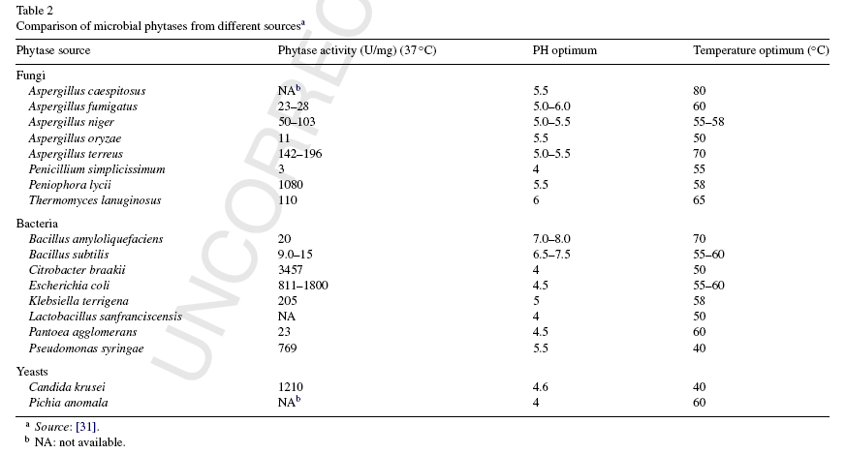

2.4 Sequence Homology of Phytases
The primary sequences of several fungal phytases have been determined in recent years. A phytase cloned from A. niger var. awamori had over 97% identity to A. niger NRRL 3135 phytase (phyA). Less homologous to the A. niger NRRL 3135 phytase are the phytases from A. fumigatus (65%), A. terrus (62%), E. nidulans (62%), T. thermophilus (61%) and M. thermophila (46%). The PhyB from A. niger NRRL 3135 shows 99% identity to the corresponding protein from A. niger var. awamori. Surprisingly, two phytases (PhyA and PhyB) from A. niger NRRL 3135 are only 25% homologous. Bacterial phytase from Escherichia coli and a mammalian phytase (rat hepatic MIPP) do not exhibit apparent sequence similarity to A. niger NRRL 3135 phytase. However, they share a highly conserved sequence motif - RHG - that is found at the active sites of acid phosphatases (Ullah et al., 1991; van Etten et al., 1991). Furthermore, they contain a remote C-terminal motif with histidine and aspartic acid residues that probably take part in the catalysis. Therefore, these phytases are said to form the phytase subfamily of histidine acid phosphatases (Mitchell et al., 1997).
The two plant phytases from Zea mays (PHYT I and PHYT II) are practically identical, but do not show any homology to other phytases or to any phosphatases. However, a region of 33 amino acids was detected that showed similarity to A. niger NRRL 3135 phytase. This region is probably the acceptor site for phosphate (Maugenest et al., 1997).
The phytase from B. amyloliquefaciens (Kim et al., 1998b) shows 72% identity to an open reading frame revealed in the genomic sequencing of the Bacillus subtilis (Kunst et al., 1997), but is not homologous to any phytases or to any phosphatases. Similarly, the phytase from Enterobacter sp. 4 is not homologous to any phytases or histidine acid phosphatases. However, it is 30-38% homologous to low molecular weight acid phosphatases from Chryseobacterium meningosepticum and Streptococcus equisimilis. Especially certain lysine and tryptophan residues appears to be conserved.

2.5 Induction of Phytases
Shieh et al. (1969) observed that the production of extracellular fungal phytase was induced by a limiting concentration of inorganic phosphate in the growth medium. In contrast to fungal phytases, B. subtilis phytase is induced by phytate in the cultivation medium (Powar and Jagannathan, 1982). The enzyme is also induced by wheat bran extract, which is known to contain phytate. Yoon et al. (1996) isolated and identified a phytase-producing bacterium using a synthetic medium containing phytate as the sole source of phosphate. Kim et al. (1998a) also used phytate as the sole source of phosphate to isolate a phytase-producing Bacillus sp. strain DS 11. They produced phytase in a medium containing wheat bran, casein hydrolysate and mineral salts, and reached the maximum phytase activity after 24 hours of cultivation. On the basis of these results it is difficult to say whether the production of these two enzymes is induced by phytate itself or by phosphate starvation. Klebsiella phytase production is induced by phytate (Shah and Parekh, 1990; Tambe et al., 1994; Greiner et al., 1997). This situation is different from the production of phytate-degrading enzymes in E. coli, the synthesis of which has been shown to be stimulated by phosphate starvation or anaerobiosis (Greiner et al., 1997;
Greiner et al., 1993). Various investigators have reported that in plants, during seed germination, phytate is rapidly degraded and that the levels of phytase increase by several orders of magnitude. It is not clear whether the increase in phytase activity is a result of expression of phytase genes or simple activation of existing enzyme. Nayini and Markakis (1986) concluded that seeds contains both constitutive and germination-inducible phytases. Northern blot analysis and in situ hybridization showed a high accumulation of phytase mRNA during the early steps of germination in coleorhiza, radical cortex and coleoptile parenchyma Maugenest et al. (1999). This indicates germination-induced synthesis of maize phytase.

3 Enzymatic Properties of Phytases
3.1 Biophysical Characteristics
Published molecular size and the calculated theoretical molecular size of the mature protein, and the number of subunits of phytases from various sources are shown in Table 2. Most phytases hitherto characterized are monomeric enzymes. This is the case with fungal phytases (Wyss et al., 1999a, Ullah and Gibson, 1987; Dvorakova et al., 1997), with E. coli and K. terrigena phytases (Greiner et al., 1993; Greiner et al., 1997), and with B. subtilis (natto) phytase (Shimizu, 1992). However, some plant and animal phytases appear to be built up of multiple subunits. A phytase accumulating in maize seedlings during germination is a dimeric enzyme built up from two 38 kDa subunits (Laboure et al., 1993). Purified rat intestinal phytase
exhibited two protein bands in SDS-PAGE with estimated molecular masses of 70 and 90 kDa (Yang et al., 1991b). However, since only the 90 kDa subunit is induced by phytic acid, it is likely that these protein bands represent two different enzymes (alkaline phosphatase and phytase, respectively). An inositol hexakisphosphate dephosphorylating enzyme from the protozoan Paramecium has been proposed to have a hexameric structure (Freund et al., 1992). Two different forms of Klebsiella aerogenes phytase have been reported. One, possibly the native enzyme, has an exceptionally large size (700 kDa). The other is probably a fraction of the native enzyme, with a full complement of activity and an exceedingly low molecular weight between 10 and 13 kDa (Tambe et al., 1994). Bacterial phytases are generally smaller than their fungal counterparts. The predicted size of fungal phytases is around 50 kDa and the experimental size is between 65 and 70 kDa, indicating heavy glycosylation. A. niger NRRL 3135 native phytase is 27% glycosylated. It contains a substantial proportion of N-linked mannose chains and galactose (Ullah, 1988a). Wyss et al. (1999b) reported that glycosylation of recombinant phytases was highly variable. Whereas glycosylation was moderate in A. niger, it was excessive and highly variable in Hansenula polymorpha and Saccharomyces cerevisiae. Surprisingly, glycosylation differed not only between the different expression systems used but also between different batches of a phytase produced in the same expression system. Analysis of the glycosylation pattern of A. niger phytase showed that the heterogeneity was due to incomplete glycosylation of two out of ten potential N-glycosylation sites.
In general, glycosylation may have several effects on the properties of an enzyme. Firstly, it may influence the catalytic properties or have an impact on the stability of the enzyme. Secondly, it may influence the pI of the protein. Thirdly, by consuming metabolic energy it may lower the level of expression of the protein. Surprisingly, different extents of glycosylation had no effect on the catalytic properties, thermostability or refolding properties of A. niger phytase (Wyss et al., 1999a). The importance of glycosylation for the structure and function of phytase is further brought into question by the fact that only two potential N-glycolysation sites are conserved in fungal phytases (Pasamontes et al., 1997). Han and Lei (1999) studied the role of glycosylation in the functional expression of A. niger phytase (phyA) in Pichia pastoris. Their results indicated an identical capacity of phytic acid hydrolysis and slightly improved thermostability in glycosylated enzyme produced in P. pastoris compared to the same enzyme overexpressed in A. niger. Deglycosylation of the phytase resulted in 34% reduction in thermostability. Suppression of glycosylation by tunicamycin during expression resulted in significant reduction of phytase production, indicating that glycosylation is vital for the biosynthesis of recombinant PhyA in P. pastoris. However, tunicamycin might also impair the production by other means. Because there was no accumulation of intracellular phytase protein, the impairment did not appear to occur at the level of translocation of phytase
On the other hand, studies by Wyss et al. (1999a) suggest that glycosylation has no or only a minor effect on the pI of the fungal phytases tested. The only exceptions were the phytases expressed in H. polymorpha, in which a pronounced shift to acidic pI values was observed. All the fungal, bacterial, and plant phytases hitherto investigated have acidic pI values, with the exception of A. fumigatus phytase, which has a basic pI. Bacterial phytases seem to be less acidic than fungal phytases: their pI is generally above 6, whereas fungal enzymes have pI values below 5.5. A. fumigatus, Emericella. nidulans, A. terrus, and Myceliophthora thermophila phytases have a tendency to undergo proteolytic degradation when expressed in A. niger and stored as concentrated culture supernatants at 4oC (Wyss et al., 1999a). The activity of phytase from B. subtilis is unaffected by proteases such as trypsin, papain and elastase (Powar and Jagannathan, 1982), indicating a stronger protease resistance than that of fungal phytases.

CHAPTER-III

MATERIALS AND METHODS

The Laboratory experiment was conducted at the Animal Nutrition laboratory and poultry research and training centre (PRTC), Chittagong veterinary and animal sciences university, Chittagong. during December, 2012 to January 2013.

The enzyme phytase was produced from a fungus Aspergillus niger. Which was obtained from poultry research and training centre (PRTC), Chittagong veterinary and animal sciences university, Chittagong.

CULTIVATION OF THE FUNGY:
Sabouraud Dextrose Agar(SDA) was used for the cultivation of fungi, at first the agar was prepared then the inoculation was done. After inoculation the media was allow to grow fungus at room temperature(25c).

COMPOSITION OF SDA AGAR:
Enzymatic Digest of Casein ...................................................... 5 g
Enzymatic Digest of Animal Tissue........................................... 5 g
Dextrose .................................................................................. 40 g
Agar ........................................................................................ 15 g
Final pH: 5.6 ± 0.2 at 25°C
Formula may be adjusted and/or supplemented as required to meet performance specifications

The phytase enzyme was produced through 10 days fermentation at 28°C on corn starch based medium.

COMPOSITION OF THE CORN STARCH BASED MEDIUM:
corn starch: : 91(g/l)
glucose: : 1H₂O 38(g/l)
KNO3 : 12.0(g/l)
FeSO₄.7H₂O : 0.20(g/l)
KCl : 0.60(g/l)
MgSO₄ :7H₂O 0.60(g/l)
The pH was maintained at 4.5 by using 1N H₂SO₄, or 1N NaOH

After 10 days fermentation, the broth was subjected to a series of filtration by using cotton cloth and finally filter paper, until a clear filtrate was obtained. This filtrate in liquid form was then used as the crude phytase enzyme.

CHAPTER –V

RESULTS & DISCUSSIONS

Firstly this fungi was studied in cultural condition in SDA agar media. Then the production of crude phytase enzyme was done on corn starch based medium . The growth rate was observed frequently. In both media it grew very well.

Culture of the fungus:
This fungi was able to grow in the media . After 03 days color changes was found in media . Then microscopic characteristics was observed.

Fermentation of fungus:
After 10 days fermentation, the broth was subjected to a series of filtration by using cotton cloth and finally filter paper, until a clear filtrate was obtained. This filtrate in liquid form was then used as the crude phytase enzyme. Further works of this report is going on that has not been finished yet due to chemical shortage, time shortage and so on.

PHOTOGRAPHIC IMPRESSIONS

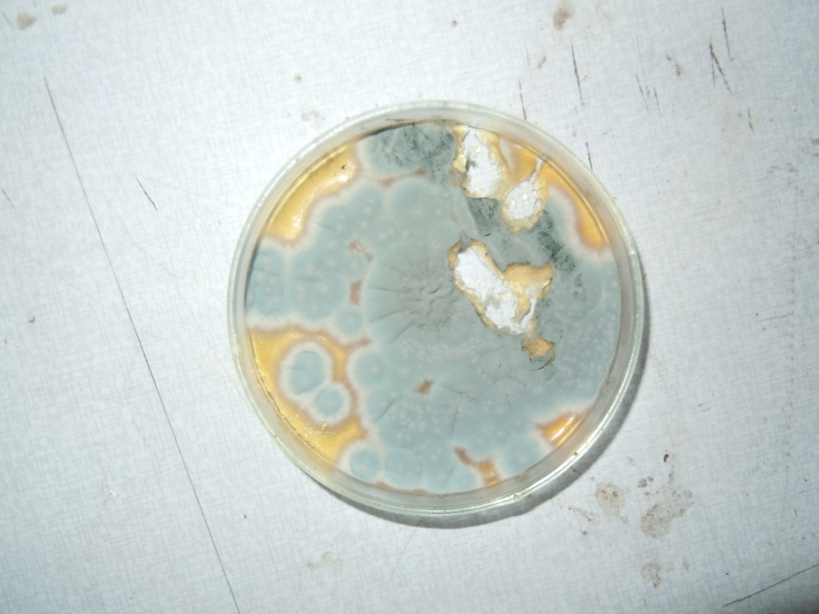
Fig: culture of fungus

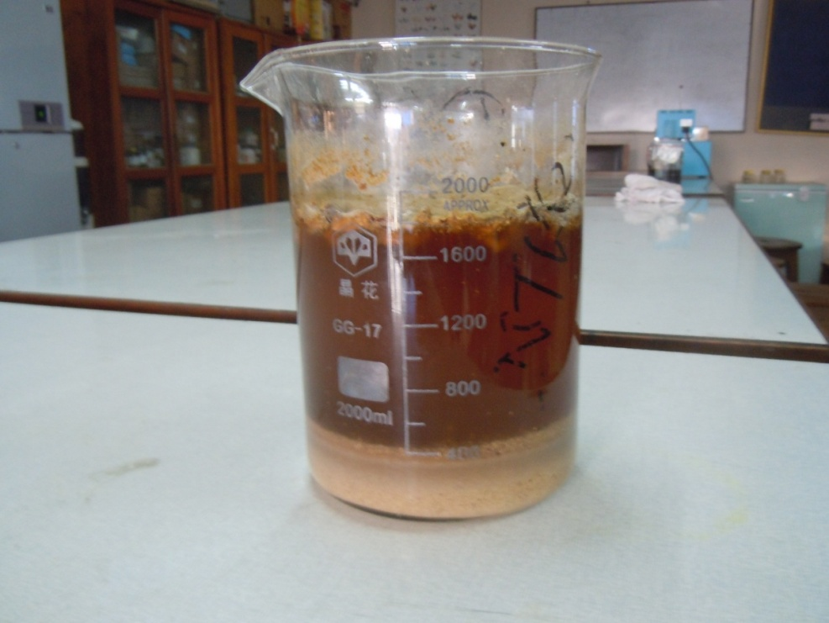
Fig: fermentation of fungus in corn starch based medium.

PHOTOGRAPHIC IMPRESSIONS

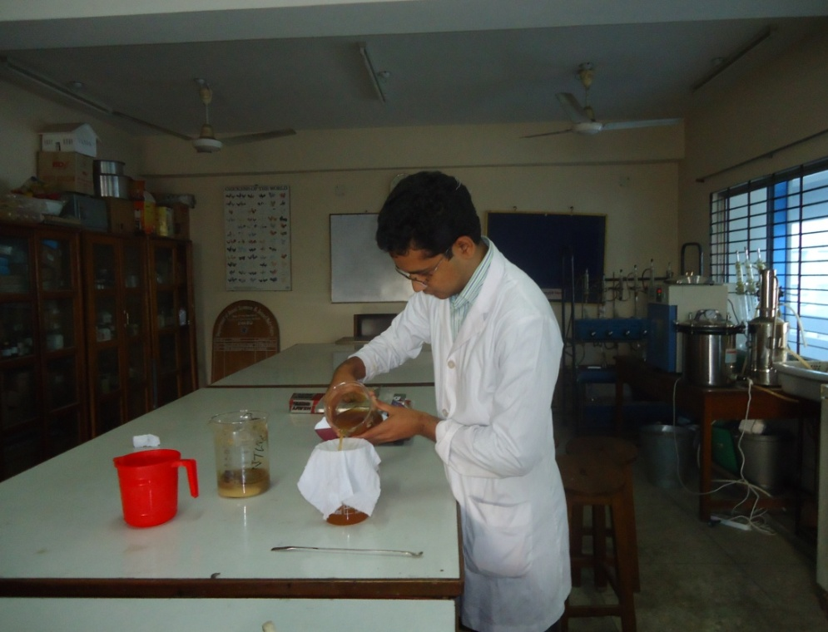
Fig: filtration of crude phytase through cotton cloth.

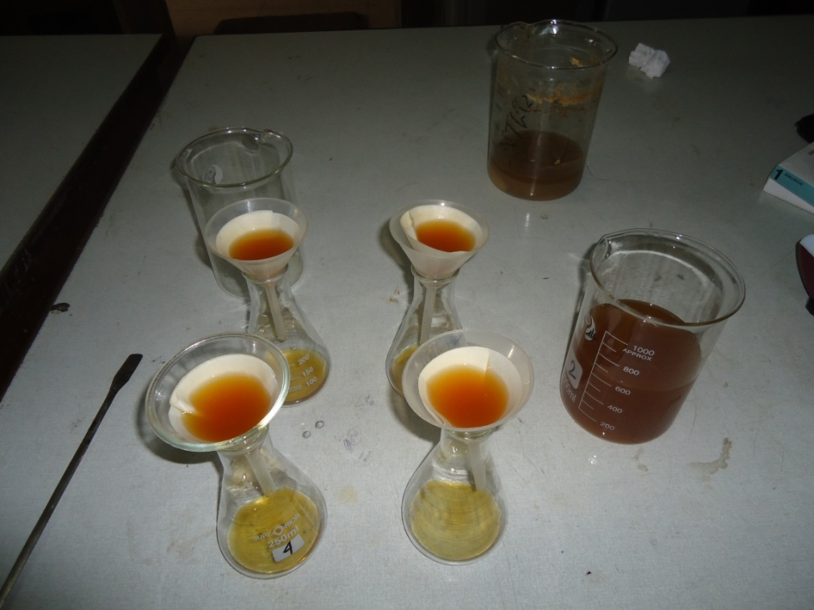
Fig: filtration of crude phytase through filter paper.

CHAPTER -VI
CONCLUSION

In conclusion, a novel phytase is presented in this report. By the use of this enzyme farmers can ensure the phosphate in poultry feed easily. Our poor farm owner will be interested to use this enzyme due to its lower price and availability in market than those of imported. It is easy to use & store and has no waste. No sophisticated instrument required to formulate it. We can easily prepare it in our country in large amount phosphates. In addition, an efficient method for production of the enzyme was developed.

REFERENCES

Aoyagi, S. and D. Baker, (1995). Effect of microbial phytase and 1,25 dihdroxycholecalciferol on dietary copper utilization in chicks. Poult. Sci., 74:121-126.

Ahmed, F. (2008): Problems of egg production remedy of it, in poultry farms. Punashcha, Reg. no- DA 1440, September-2008. pp- 14

B.B.S. (1998). Statistical pocket book of Bangladesh, ministry of planning, Government of peoples republic of Bangladesh.

Bisset j. and Widden, P.(1972). Can J Micrivial 18:1399-1404.

Billington, D. C. (1993) The Inositol Phosphates. Chemical Synthesis and Biological Significance. Verlag Chemie, Weinheim

Bitar, K. and Reinhold, J. G. (1972) Phytase and alkaline phosphatase activities in intestinal mucose of rat, chicken, calf, and man. Biochim. Biophys. Acta 268, 442-452.

Blank, G. E., Pletcher, J. and Sax, M. (1971) The structure of myo-inositol hexaphosphate, dodecasodium salt octama-contahydrate: a single crystal x-ray analysis. Biochem. Biophys. Res. Commun. 44, 319-325.

Cheryan, M. (1980) Phytic acid interactions in food systems. CRC Crit. Rev. Food Sci. Nutr. 13, 297-335

Craxton, A, Caffrey, J. J., Burkhart, W., Safrany, S. T. and Shears, S. B. (1997) Molecular cloning and expression of a rat hepatic multiple inositol polyphosphate phosphatase. Biochem. J. 328, 75-81.

Davies, N. T. (1982) Effects of phytic acid on mineral availability. In Dietary Fiber in Health and Disease. Vahoung, G. V. and Kritchevsky, D., Eds., Plenum Press, New York.

Deshpande, S. S. and Cheryan, M. (1984) Effect of phytic acid, divalent cations, and their interactions on alpha-amylase activity. J. Food Sci. 49, 516-524.

De Rham, O. and Jost, T. (1979) Phytate protein interactions in soybean extracts and lowphytate soy protein products. J. Food Sci. 44, 596-600.

Department of livestock Service, (2002

Dubey, R.C. (2005). A text book of biotechnology. PP-282

Dvorakova, J., Volfova, O. and Kopecky, J. (1997) Characterization of phytase produced by Aspergillus niger. Folia Microbiol. 42, 349-352.

Dvorakova, J. (1998) Phytase: Sources, Preparation and Exploitation. Folia Microbiol. 43, 323-338
Fan L. T., Gharpuray MM and Lee YH (1987). Cellulose hydrolysis. Berlin, Germany: Springer-Verlag 3;1-68

Fretzdorff, B, Brummer, J. M. Rochen, W., Greiner, R., Konietzny, U. and Jany, K. D. (1995) Reduktion des Phytinsaure-Gehaites bei der Herstellung von Backwaren und Getreidenahrmitteln. AID-Verhraucherdienst 40, 12-20.

Graf, E., Empson, K. and Eaton, J. W. (1987) Phytic acid. A natural antioxidant. J. Biol. Chem. 262, 11647-11651.

Greaves, M. P., Anderson, G. and Webley, D. M. (1967) The hydrolysis of inositol phosphates by Aerobacter aerogenes. Biochim. Biophys. Acta 132, 412-418.

Greiner, R., Konietzny, U. and Jany, K. D. (1993) Purification and characterization of two phytases from Escherichia coli. Arch. Biochem. Biophys. 303, 107-113

Haque, Q.M.E. (2001) Poultry industry in Bangladesh and strategies for its improvement 2nd international poultry show and seminer. 16:15-24

Jaddav, N. V. (2007). Hand book of poultry production and management, 2nd Ed, PP164-166.

Jain, J. L.(2001). Fundamental of biochemistry., PP 277-289

Johnson and Tate, 1969

Katchalsi-Katzin, and L. Goldstein (eds.), (1968).Enzyme Technology. PP-71-95.

Kumakura M (1997). Preparation of immobilized cellulose beads abd their application to hydrolusis of cellulosic materials. Process Biochem. 32:555-559.

Laboure, A. M., Gagnon, J. and Lescure, A. M. (1993) Purification and characterization of a phytase (myo-inositol hexakisphosphate phosphohydrolase) accumulated in maize (Zea mays) seedlings during germination. Biochem. J. 295, 413-419.

Maugenest, S., Martinez, I. and Lescure, A. M. (1997) Cloning and characterization of a cDNA encoding maize seedling phytase. Biochem. J. 322, 511-517.

Nayini, N. R. and Markakis, P. (1984) The phytase of yeast. Food Sci. Technol. 17, 126-132.

Pallauf, J. and Rimbach, G. (1996) Nutritional significance of phytic acid and phytase. Arch. Anim. Nutr. 50, 301-319.

Pant M. C. (1993). Self assessment in Biochemistry. Jaypee brothers medical publishers, PP-25.

Rahman, M.M., Rahman, M.M., Rahman, A., Islam, A.H.M.N., Miah, A.H., Mazumder, J.U., and Bhattacharjee, A.S. (1998): Observation on out breaks and sub-sequent control of Infectious bursal disease in the central poultry farm in Bangladesh. Bangladesh Veterinary Journal. Vol.- 30(1-2). pp- 13-17.

Reddy, N. R., Pierson, M. D., Sathe, S. K. and Salunkhe, D. K. (1989) Phytates is cereals and legumes. CRC Press, Inc., Boca Raton, Fla.

Rimbach, G. and Pallauf, J. (1992) The effect of a supplement of microbial phytase on zinc availability. Z. Ernahrungswiss. 31, 269-277

Remus, J. (2005). Poultry and environment reap the benefits of newgeneration phytase. Feedtech (International feed production and applied nutrition), 9:22-25.

Shah, V. and Parekh, L. J. (1990) Phytase from Klebsiella sp. No. PG-2: Purification and properties. Indian J. Biochem. Biophys. 27, 98-102.

Shimizu, M. (1992) Purification and characterization of phytase from Bacillus subtilis (natto) N-77. Biosci. Biotechnol. Biochem. 56, 1266-1269 Vadra, S.K. (2007). Biotechnology and its use, PP-44

Singh B, Satyanarayan T (2006) A marked enhancement in phytase production by a thermophilic mould Sporotricum thermophile using statistical designs in a cost effective cane molasses medium. J Appl Microbiol 101:344–352

Wodzinski, R. J. and Ullah, A. H. J. (1996) Phytase. Adv. Appl. Microbiol. 42, 263-302.

Book: Illustrated Genera of Imperfect Fungi, 4th edition , by H.L. Barnett & Barry
B. Hunter

Website:
www.enzymedia.com
www.ublcorp.com

Appendix

Table 01: Name of some enzyme preparation available in market:
SL. NO. | COMMERCIAL NAME | PACK SIZE | MARKET PRISE (taka) | COMPANY
01. | Polzyme WS | 250ml | 165.00 | Square
02. | En-Six Plus | 25Kg  1 Kg | 8700.00  390.00 | Square
03. | Feed-Fit  SQ-phytase premix | 500gm | 475.00 | Square
04. | Acmezyme | 100g  500g | 160.00  600.00 | Acme
05. | Notozyme | 25 kg | 8250.00 | Novertis
06. | Alquerzin | 100g | 195.00 | ACI
07. | Caplix | 1 kg | 400.00 | Speed
08. | Liquid enzyme | 500 ml | 384.00 | Navana
09. | Enzyvet | 1 liter | 185.00 | Jayson
10. | Liquzyme | 1 liter | 375.00 | Speed
11. | Lolyzyme | 1 kg | 100.00 | Loly
12. | Nuzyme | 1 kg | 700.00 | PFPL
13. | Eoxazyme-G2 | 1 kg | 2000.00 | Jayson
14. | Rena phytase | 1 kg | 115.00 | Renata

