PRODUCTION OF ORGANIC SELENIUM FOR LIVESTOCK’S AND POULTRY
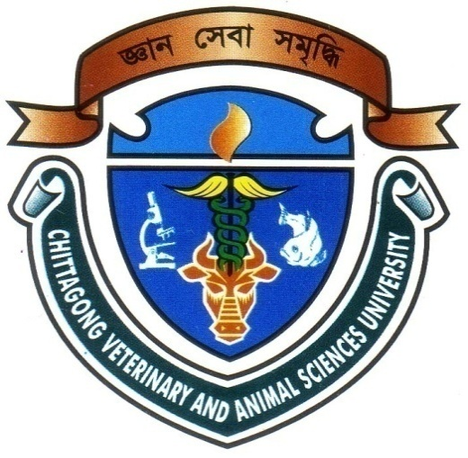

A Production Report Submitted
By
Roll: 2007/27
Registration No: 313
Intern ID: C-24

Report presented In Fulfillment of the Requirement for the
Degree Doctor of Veterinary Medicine

Chittagong Veterinary and Animal Sciences University
Khulshi, Chittagong.

February, 2013
PRODUCTION OF ORGANIC SELENIUM FOR LIVESTOCK’S AND POULTRY
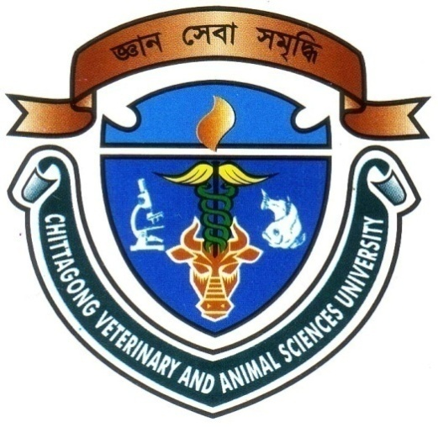

A Production report submitted as per approved style and content

Signature of Supervisor

Name: Professor Ashraf Ali Biswas
Designation: Head of the Department
Department: Animal Science And Animal Nutrition.

Chittagong Veterinary And Animal Sciences University

February, 2013
PRODUCTION OF ORGANIC SELENIUM FOR LIVESTOCK’S AND POULTRY
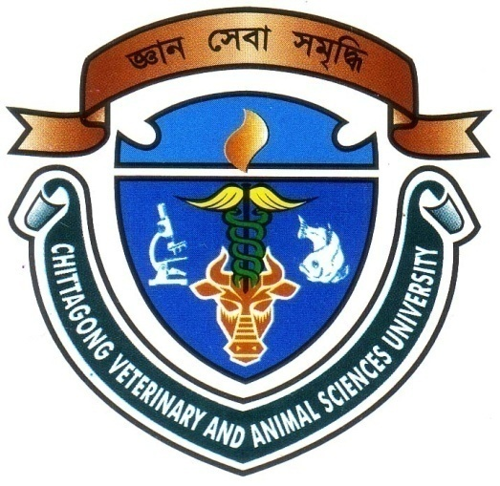

A Production report submitted as per approved style and content

Signature of Author
Name: Afroza Sultana
Roll No:2007/27
Registration No:313
Intern ID:C-24

Chittagong Veterinary And Animal Sciences University

February, 2013
CONTENTS
SL. NO | TOPICS | PAGE NO.
01 | ACKNOWLEDGEMENTS | I
02 | ABSTRACT | II
03 | INTRODUCTION | 1 - 2
04 | REVIEW OF LITERATURE | 3 - 6
05 | METHODS AND MATERIALS | 7 - 9
06 | RESULTS AND DISCUSSION | 10 - 11
07 | CONCLUSION | 12
08 | DESCRIPTION ABOUT SELENIUM | 13 - 21
09 | REFERENCES | 22 - 28

ACKNOWLEDGEMENTS

At the inception, I wish to acknowledge the immeasurable grace and profound kindness of the Allah, the supreme ruler of universe without whose desire I could not include this report.

In planning, conducting and completing the study, it is my great privilege to express my deep sense of gratitude and profound regards to my honourable Supervisor Professor Ashraf Ali Biswas, Head of the Department, Department of Animal Science and Animal Nutrition, Chittagong Veterinary And Animal Sciences University, Chittagong, Who has involved during every steps of this report from its inception to completion.

I would also like to express my special gratitude to my respected teacher’s Dr. Md. Azizur Rahman and Dr. Md. Mohiuddin for providing me important direction.

I acknowledge to all respondents of the study areas and different institution without whose willingness to provide information this study would not be possible to perform.

The Author

I
ABSTRACT
Selenium yeast, produced by growing select strains of beneficial organism in selenium-rich media, is a recognized source of organic food-form Se, but the determination of its exact composition with respect to the Se species present produced conflicting results. Improved methods of analysis have since reveled it to contain 90+ % of its Se in the form of selenomethionine, the principal organic nutritional form of Se for higher animals and humans. So beneficial organism media also widely used as a protein source. This study is conducted to know the amount of organic selenium produced by the beneficial organism. Amount of those organic selenium from this media estimated by chemical test. It was found that media contain 17 mg per gm of beneficial organism media. The safety record of Se yeast is excellent. During the three decades of its world-wide use as a source of supplement Se, no cases of Se poisoning have occurred due to dosage or formulation errors.

Keywords: Selenium; Selenium yeast; Beneficial organism, Selenomethionine; Supplement selenium; Selenium poisoning

II

