A STUDY ON
PREVALENCE OF SALMONELLA IN HISEX BROWN STRAIN AT KAZI POULTRY FARM IN CHITTAGONG

Submitted By-
Roll no: 2005/101
Reg. No: 276
Intern ID No: F-62
Session: 2004-2005

Faculty of Veterinary Medicine
Chittagong Veterinary and Animal Sciences University
Khulshi, Chittagong-4225.

June, 2013

A STUDY ON
PREVALENCE OF SALMONELLA IN HISEX BROWN STRAIN AT KAZI POULTRY FARM IN CHITTAGONG
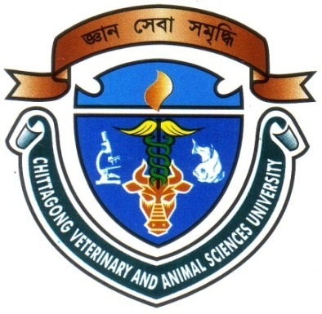

Approved as to style & content by

Signature of the Supervisor

Name: DR. Mukta Das Gupta
Designation: Lecturer
Department: Microbiology.
Date: 13.06.2013

Date:

Signature of the Author

Name: SUJAN DAS
Roll No: 2005/101
Reg. No.: 276
Intern ID: F-62
Date of submission: 13.06.2013

Date Of Submissiom:

Date of submission: 05/04/2010

CHITTAGONG VETERINARY AND ANIMAL SCIENCES UNIVERSITY

KHULSHI, CHITTAGONG-4225
June, 2013
Serial no. | Name of the contents | Page no.
 | Acknowledgement | i
 | Abstract | ii
 | List of table
i | Introduction | 01-03
ii | Review of Literature | 04-07
iii | Methodology | 08-09
iv | Results and Discussion | 10-13
v | Conclusion | 14
vi | References | 15-22
CONTENTS

ACKNOWLEDGEMENT

I am ever grateful and very much obliged to the Almighty without whose grace it would have never been possible to pursue this study in this field of science and to complete this clinical report writing for the degree of Doctor of Veterinary Medicine (DVM).
I sincerely value the patience, guidance and mentorship from my internship supervisor DR. Mukta Das Gupta, Lecturer, Dept. of Microbiology, Faculty of Veterinary Medicine, Chittagong Veterinary and Animal Sciences University during the entire period of this study to complete this report.
I would like to express my deep sense of gratitude and thanks to Professor Dr. A.S. Mahfuzul Bari, honorable Vice Chancellor, CVASU and Professor Dr. Md Masuduzzaman, Dean, Faculty of Veterinary Medicine, CVASU and Professor DR. A. K. M. Saifuddin, Director, S. A. Quadery Teaching Veterinary Hospital, CVASU, Chittagong.
I express my sincere gratitude and thanks to Dr. Bibek Chandra Sutradhar, Director, External Affairs, CVASU for constant inspiration, cordial co-operation and valuable suggestion for completion of the report.
I also express my sincere gratitude and thanks to my dear friend, Imran and those Veterinary Field Assistants and farmers who helped me by giving their information and cordial co-operation.
Last but not the least, I would ever thankful to all my well wishers, family members for their inspiration, appreciation and blessings throughout my entire life.

The author

i
Abstract

The present study was conducted to determine the seroprevalence of Salmonella infections in poultry. This study covered seroprevalence and pathological lesions in different organs produced by Salmonella in Kazi layer farm of Chittagong district during January-May 2013. The materials were blood samples and visceral organs (liver, lung, spleen and intestine) from live and dead birds respectively. The used methods were rapid serum agglutination test by commercially available Salmonella antigen kit and postmortem examination. The overall seroprevalence was 60% in live birds and the rate of seroprevalence was higher in my study at the age of 48 weeks in live birds. Pathologically friable, bronze color liver with focal necrosis, various grades of enteritis, and hemorrhagic and congested egg follicles with stalk formation were found.

Keywords: Salmonella, Seroprevalence, Rapid Serum Agglutination test.

ii

