Chapter-1
INTRODUCTION
Bangladesh has a long historical record of poultry raising under traditional backyard farming. Commercial poultry raising started in Bangladesh is a similar scale by the Department of Livestock Services (DLS). The DLS introduced the poultry development program through the pure line breeding stock, which brought economic return to the distressed women and unemployed youth along with some interested semi urban poultry raisers to meet the growing demand of egg and meat. Although poultry industry has seen a tremendous development, still it considered as a sub-sector of agriculture, which is playing a significant role in the agro based economy of Bangladesh as well as enhancing the Gross Domestic Product (GDP) of Bangladesh.
Bangladesh is a densely populated agro based developing country. Majority percent of people live under the poverty line. The per capital availability is hardly around 20 eggs, one of the lowest in the world as against per capita consumption of about 200 eggs per annum as recommended by the Nutritional Advisory Council. Per capita egg and meat consumption is 2 eggs/week and 120gm/week respectively (BBS, 1995).
Many people are suffering from acute shortage of animal protein in Bangladesh. Remarkable growth in the poultry industry in Bangladesh in the recent year has already contributed significantly in reducing the acute shortage in protein supply. Poultry and eggs are a major source of animal protein for all ages human. The share of poultry in the animal protein of human diet is estimated to be 30% (DLS-1995). Poultry meat is now being the second most popular meat of the world with 55 million tons or 28% of the total meat consumption in 1999.
It also plays an important role in reducing the gap of protein supply in the country. About 75 percent of eggs and 78 percent of meat is produced under scavenging system of production.
So a view to meeting the protein gap within a shortest possible time, there has been a shift of policy emphasis on intensive poultry farming in recent years. Consequently, a number of poultry farms have been established on commercial basis in and around the cities and towns and are belonged to high yielding strains, and are raised exclusively on poultry ration. A large number of hatcheries also established on commercial basis. The local hatcheries produce
about 11.80 million layer and 61.0 million broiler day-old chicks in 1999-2000 which is about half of the present demand for commercial farming.
Due to fulfill the promising demand of poultry and layer chicks, presently some broiler and layer parent stocks and grandparent stock are reared in Bangladesh. All these efforts were taken by some private companies, such as BRAC, Paragon, Usha, Kazi farms, Dhaka Hatchery, Biman Poultry etc.
However, scientific and efficient management practice is the prerequisite to get the optimum production and benefit from the poultry farm. Therefore, this study was undertaken to learn the layer farm management practices adopted in Liza Poultry Farm, Chittagong. The objectives of the study are as follows:-
- To know the overall management system- housing, rearing, feeding, bio-security, disease control, egg collection and marketing of egg of the Liza Poultry farm.
- To know the production performance (profit and loss) of the farm.
- To evaluate the profitability of the farm in relation to productivity of the layer chicken.

Chapter-2
REVIEW OF LITERATURE

According to FAO, 1997 appropriate size of the operation, maintaining highly productive stock, efficient utilization of resources, better housing, adoption of standard hygienic practices, reducing cost of production and adequate planning for marketing of the products play a major role in making commercial egg production more profitable.

Kumar and Mahalati (1998) reported lower costs of production and higher returns for larger than smaller flocks.

Elwardany et al 1998 stated that efficient utilization of feed and avoiding unnecessary feed wastage would minimize total cost of production. Thus, management of egg laying birds in an appropriate rearing environment would ensure better profitability.
Farooq et al., 2002 stated the disease in any stage of production affect the productivity of the farm. He suggest to avoid overcrowding, effective use of brood-grow house under better hygiene, appropriate light schedule and use of cages instead of floor houses for egg type layers will reduce mortality

Alam et al. 1998 reported the intensive farm rearing system has got more production and high profit by rearing the hybrid and exotic breed.

Talukdar et al., 2010 also cited the environmental effect of production performance due to managemental effect.

FAO, 2008 country report stated that disease outbreak and low biosecurity and managemental practice decrease the average production performance in both commercial and smallholding poultry farm in Bangladesh.

Kabir et al., 2010 conducted a research on Isa brown strain at Mymensingh and stated the effect of management in production of egg of the layer. He found lower production than the expected level due to poor management and environmental effect.

Ershad, 2005 reported production of eggs per layer per year was 230.15, 141.11 and 43.88 in intensive, semi intensive and traditional farms, respectively.

Chapter-3

MATERIALS AND METHODS

The study was accomplished by following methods:
- Farm and location
- Study period
- Study method
- Direct observation
- Involvement in activities
- Data collection
- Data analysis

Study areas (Farm and location):
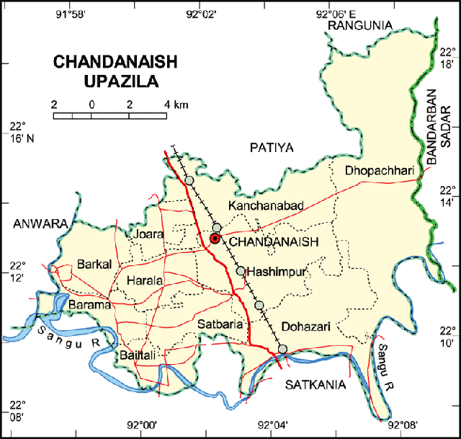
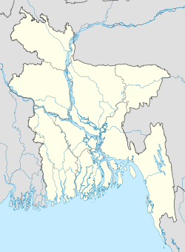
The study was conducted to Liza Poultry farm, Chandanaish, Chittagong (22.2111°N 92.0417°E). The Liza Poultry farm is one of the famous poultry farm in Chittagong region. The duration of the study was 1st January to 30th January, 2013. The case study was done on the layer strain Isa Brown. The total layer population of the farm was 19,500 laying hens and pullet was 5500 in number during the study period.

Methods of data collection:

A structured questionnaire was developed containing the basic question with a view to extract information regarding management and preventive measures undertaken in relation to the objective set (Annex:1). Emphasis was given to the key consideration of managemental different sector like housing, feeding and watering, procurement, disease control measure, bio-security and marketing of the produced egg. The entry system, drainage system, garbage disposal, hand bath, foot bath, showering system, personal hygiene management etc also considered under the point of bio-security. With the objective of collecting above mentioned information the author own self selected and visited the farm.

Chapter-4
RESULT AND DISCUSSION

4.1 MANAGEMENT OF THE FLOCK
4.1.1 Housing:
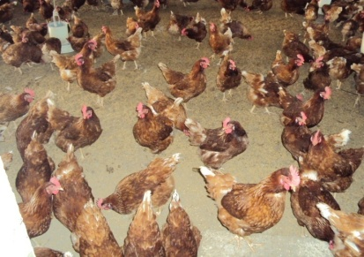
There are a total 6 shed in the farm where 4 for laying hen, one for the pullet and one for Day old chick. The houses are oriented in north south direction and roof made by tinshed. Secondary roofing materials (Partex board) also used to maintain the temperature of the room. The each shed consist of the area of 240×33 square feet. Both Floor rearing and cage rearing system are followed in the farm. The rice husk is used as the litter materials in the farm. In this poultry farm, 16 hours lighting schedule is maintained for layer stock.
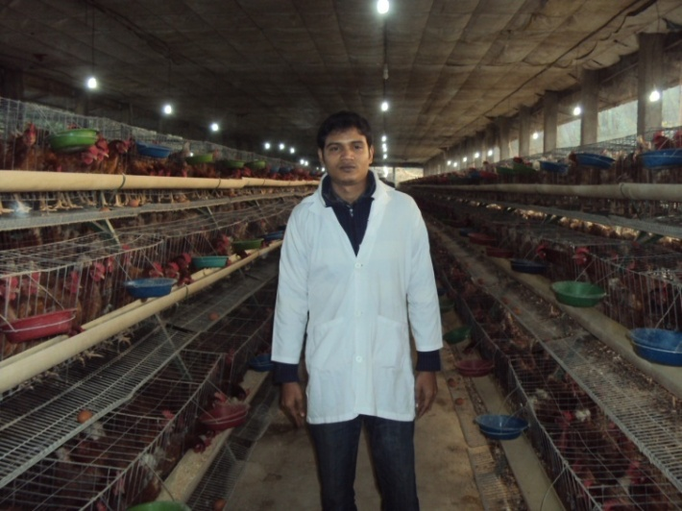
Fig: Inner view of Liza Poultry farm shed of 4 no shed. | Fig: Housing of floor rearing system in the farm.
4.1.2: Personnel and farm structure:
There are a total 35 staff in the farm working full time with specific jobs. The staff list is presented as below:
Name of the post | Number of employee
Manager | 01
Assistant Supervisor | 03
Shed attendant | 18
Guard | 06
Sweeper | 06
Driver | 01
4.1.2: Rearing system:
There are two methods of rearing is followed in the farm
- Cage rearing
- Floor rearing

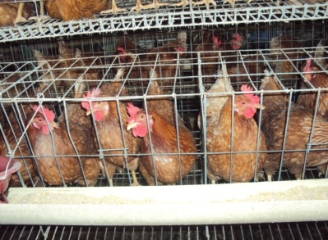
Fig: graphical representation of rearing system. | Fig: cage and floor rearing system in the farm.

Among the total population of layer chicken the 13500(66%) hen is reared in cage system and 6,500(34%) hen reared in floor rearing system.
4.1.3 Feeding:
Feeding is another most important component of modern poultry farming. The profitability or loss of poultry farming mostly depends upon the feeding management. About 50-55% cost of the total farming is involved for feeding. In Liza Poultry farm they have their own feed mill and supply fresh feed to the shed regularly. Feed is given to the shed two times daily-at the early morning and at noon. Restricted feeding is also maintained in the farm. It starts from 4 weeks of age and goes up to 20 weeks.
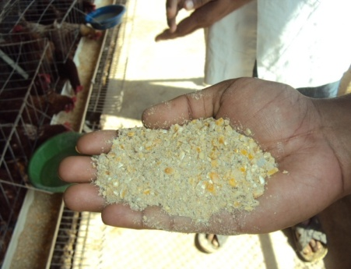
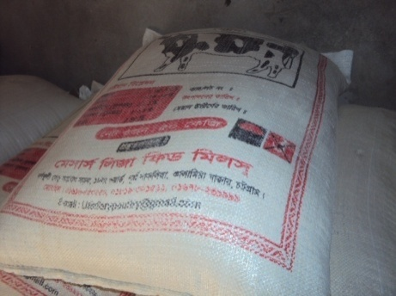

Fig: Feeds from own feed mill. | Fig: Inspecting the Feed

4.1.4 Bio-security and sanitation:
A sanitation program should be devised to control contamination, and the results of the program should be checked regularly. The sanitation program of the layer farm is as follows:
- All equipments, floor, wall are cleaned regularly.
- Disinfectants are used alternatively in the footbath.
- Dead chickens were disposed immediately from the farm and incinerated in incineration pit.
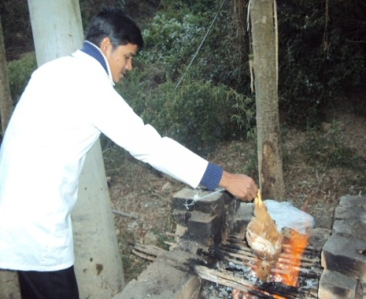
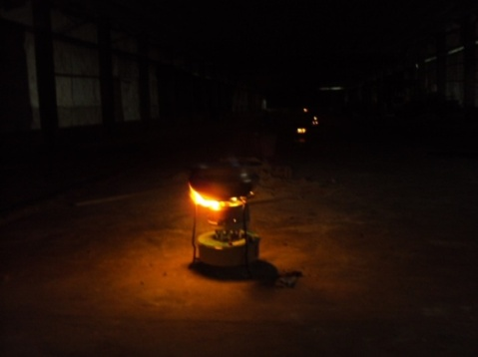
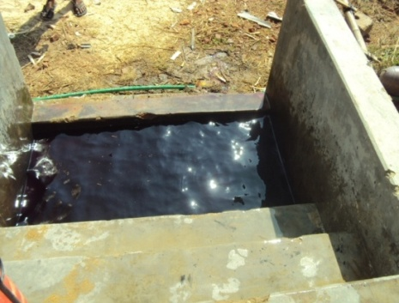
Fig: Bio-security measurement of the Liza Poultry farm.

Disinfectants used in Liza Poultry farm:
For disinfection of shed, internal shed equipments and shed surroundings etc. through spray or pressure pump. The disinfectant solution used for making solution as per recommendation of the company as follows:

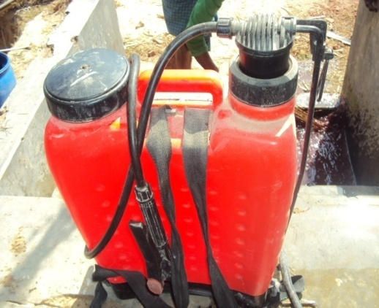
Fig: manual spray machine.
- Malathion=25ml/10L water
- Sevin=35gm/10L water
- Halamid=10gm/L water
- Iosan=10ml/L water
- Povisep=10ml/L water
- Formalin=1L/9L water
- Antec long life 250 S=5ml/L water
- Phenol(carbolic acid)
- Sarakil=5ml/L water
- Vircon S=5gm/L water with bird
- Vircon S=10gm/L water without bird
- H2O2 50%=410ml H2O2 (50%) per 20L of water
N.B. Liza poultry farm use the disinfectants from Jayson, ACI, Renata company.

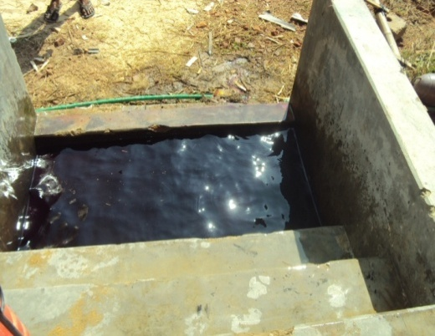
Fig: Foot bath.
Footbath for shed and gate:
The disinfectant solution used for making solution as per recommendation of the company as follows:
- Antec=10ml/L water
- Halamid=10gm/L water
- Povisep=10ml/L water
- Savlon(conc.)=40ml/L water
- TH4+ =10ml/L water
- Sarakil=5ml/L water
4.1.5 Feed allowance in production period:
Feed supply depends on the age of the bird and production rate. Peak feed allowance is 120gm at 33 weeks of age when the layer hen are in peak production. At 25th week the production rate is 65% and 118 gm feed is supplied at this time.

Table-1: Feed allowance in production period:
Production rate (%) | Feed consumption (gm)
65 | 115
70 | 118
75 | 120
80 | 122
85 | 124
90 | 125
94 | 125
98* | 125
*Expected rate of egg production by owner.

4.1.6 Nutritive value of feed:
In layer starter the ME and CP level is highest (ME-2860, 2750 and 2850 respectively; CP-19%, 15% and16%) followed by layer grower and layer layer. In starter ration the CP level is higher than the grower and layer ration. Excessive amount of ME in the layer diet causes hen too fatty that reduces their productivity.
4.2.1 Egg collection:
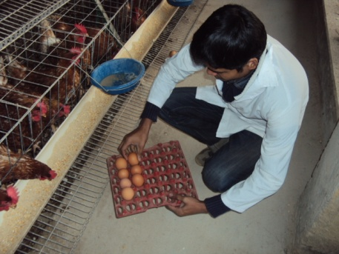
Eggs were collected manually from each shed once daily from 9 am to 1 pm. After collection, eggs were clean with soft towel soaked with Savlon ® antiseptic solution. Dirt was removed by knife through slight rubbing. Then grading was done in grading room. During grading of eggs, de-shaped eggs, jumbo eggs, small sized, broken eggs, excessively dirty eggs, abnormal color eggs were discarded. Eggs of uniform size were selected for marketing. No eggs are being stored as the marketing system is local and instant selling.
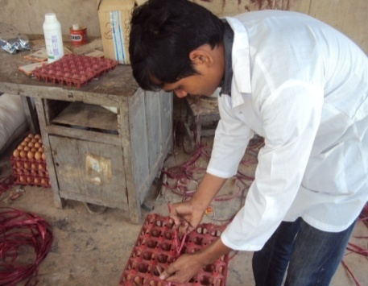
4.2.2 Marketing of Egg:
The eggs are collected from the shed in the morning. The collected and graded eggs are transported to local market(Kala Mia Bazar, Bakolia) for selling by the won transport system. The bepary buy these eggs at whole sale rate and distributed to the consumer. The flow chart of the marketing system is as follows:
Liza Poultry farm
Chandanaish
Kala Mia Bazar, Ctg, city
Retailer
Consumer
Bepary
Transported by own vehicles

Fig: Marketing of eggs by Liza poultry farm.
4.3.2 Health management:
The medication and vaccination scheduled of the Liza Poultry Farm is as follows-
Age(Days) | Name of the vaccine & drugs | Route | Dose
1-4 | Antibiotic + vitamin | Drinking water
5 | IB + ND (Live) | Eye drop | 1 drop/bird
7 | IBD (Live) | Eye drop | 1 drop/bird
7 | IBD + ND ( Killed) | S/C (Neck) | 0.3 ml/bird
9-11 | Tylosine | Drinking water
9-11 | Debeaking
12-14 | Anti Cocci | Drinking water
15 | IBD+ (Live) | Eye drop | 1 drop/bird
17 | Marek’s | S/C (Neck)
18 | IB + ND (Live) | Eye drop | 1 drop/bird
22-23 | Tylosine | Drinking water | 25gm/1000birds for 2 days
26-28 | Anti Cocci | Drinking water
32-34 | Fowl pox
40-42 | Anti Cocci | Drinking water
47 | Coryza | I/M (Breast muscle) | 0.5 ml/bird
50 | Anthelmentic | Drinking water
53-54 | Tylosine | Drinking water
57 | ND (Live) | Drinking water
64 | Debeaking
72 | Cholera vaccine | S/C (Neck) | 1 ml/bird
85 | Coryza | I/M (Breast muscle) | 0.5 ml/bird
90 | Tylosine | Drinking water
95 | Anthelmentic | Drinking water
100 | IB + ND (Live) | Drinking water
105 | IB + ND + EDS | S/C (Neck) | 0.5 ml/bird
112 | Cholera vaccine | S/C (Neck) | 1 ml/bird
125 | Tylosine | Drinking water
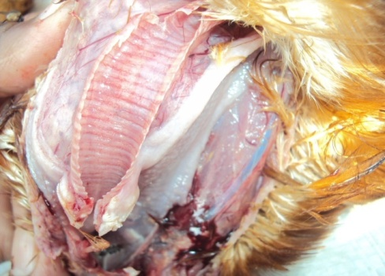
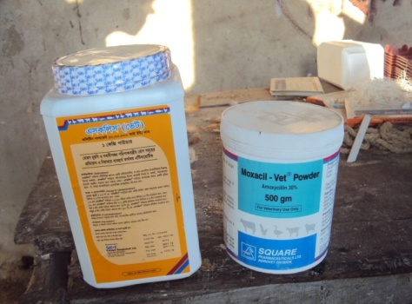
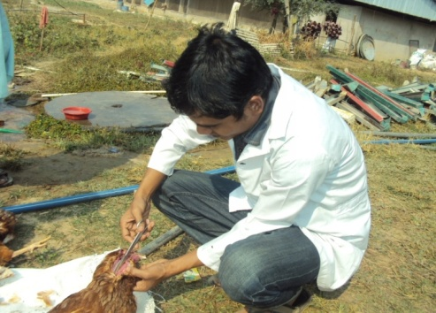
Fig: Disease diagnosis by postmortem in the farm (Gumboro and Newcastle disease)

4.3.1 Disease and vaccination:
Emergence and re-emergence of different diseases is the major constraint for developing the poultry sector in Bangladesh. Unfortunately there is no registered veterinarian employed in the Liza Poultry farm. Sometimes they take consultancy from experienced veterinarian to diagnose the disease in major outbreak period. The diseases commonly faced in the layer farm are controlled by vaccination and bio-security management.
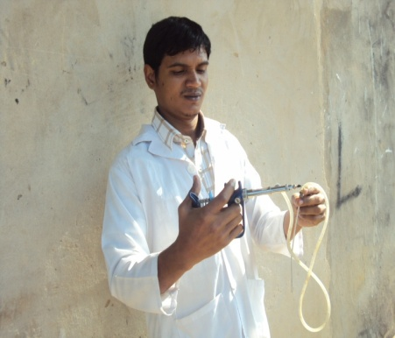

Fig: vaccination gun.

4.4.1 Profit ability of the farm:
The reported farm is one of the most reputed farm in Chittagong region for their profitability. The income and cost of management of the farm for last three years is given below-
In 2010,
Total income=Selling of egg+Biogas+Litter+Spent bird
=365×17000×7.8+200000+10000+2000×200
=49009000 BDT
Total Cost:
1) Feed Cost:(120×365×20000×29)/1000 BDT
=25404000 BDT
2) Electricity:100000 BDT
3) Medicine & Vaccination: 200000 BDT
4) Cost of day old chicks:25000×45 BDT
=1125000 BDT
5) Personnel Cost:
a) Manager-12×30000 BDT=360000 BDT
b) Asst. Supervisor=3×12×12000 BDT=432000 BDT
c) Shed attendant=18×12×6000 BDT=1296000 BDT
d) Night Guard: 6×12×4000 BDT=288000 BDT
e) Sweeper: 06×12×3000=216000 BDT
f) Driver: 1×12×8000 BDT=96000 BDT

Total Cost = 29517000 BDT
Total profit = Total income-Total cost
= (49009000-29517000) BDT
= 19492000 BDT
N.B: Marketing cost, local taxes, depreciation cost, maintenance cost and other cost not considered.
In 2011,
Total income = Selling of egg+Biogas+Litter+Spent bird
= 365×17000×8.2+200000+10000+2000×200
= 501491000 BDT
Total Cost:
1) Feed Cost: (120×365×20000×29)/1000 BDT
= 25404000 BDT
2) Electricity: 100000 BDT
3) Medicine & Vaccination: 200000 BDT
4) Cost of day old chicks: 25000×45 BDT
= 1125000 BDT
5) Personnel Cost:
a) Manager-12×30000 BDT=360000 BDT
b) Asst. Supervisor=3×12×12000 BDT=432000 BDT
c) Shed attendant=18×12×6000 BDT=1296000 BDT
d) Night Guard: 6×12×4000 BDT=288000 BDT
e) Sweeper: 06×12×3000=216000 BDT
f) Driver: 1×12×8000 BDT=96000 BDT

Total Cost=29517000 BDT
Total profit=Total income-Total cost
= (501491000-29517000) BDT
=21364000 BDT

N.B: Marketing cost, local taxes, depreciation cost, maintenance cost and other cost not considered.
In 2012,
Total income=Selling of egg+Biogas+Litter+Spent bird
=365×17000×8.6+200000+10000+2000×200
=54932500 BDT
Total Cost:
1) Feed Cost :( 120×365×20000×29)/1000 BDT
=25404000 BDT
2) Electricity: 100000 BDT
3) Medicine & Vaccination: 200000 BDT
4) Cost of day old chicks:25000×45 BDT
=1125000 BDT
5) Personnel Cost:
a) Manager-12×30000 BDT=360000 BDT
b) Asst. Supervisor=3×12×12000 BDT=432000 BDT
c) Shed attendant=18×12×6000 BDT=1296000 BDT
d) Night Guard: 6×12×4000 BDT=288000 BDT
e) Sweeper: 06×12×3000=216000 BDT
f) Driver: 1×12×8000 BDT=96000 BDT

Total Cost=29517000 BDT
Total profit=Total income-Total cost
= (54932500-29517000) BDT
=25415500 BDT
N.B: Marketing cost, local taxes, depreciation cost, maintenance cost and other cost not considered.
The reported farm seem to be a profitable condition for last three years for its the higher production rate (about 94%) and the high rate of market price of egg at the local market. The farm maintains a well established bio-security program, which has enables them to become disease free or free of emergence of diseases. Moreover of the reported farm also use the feed from their own feed mill (Liza Feed Mill) which has lowered the feed cost for the owner, which has increases the profit of the farm. In comparison to the standard layer farm, the reported farm has no registered veterinarian or husbandry graduates. Although the farm maintains strong bio security program but they lack of modern equipments like-automated feeder or drinker and computerized data system, drainage system, personnel safety. They use register book for their record keeping. The reported farm has no established diseases diagnostic techniques. They take consultancy from the registered veterinarian. Sometimes they send samples to the nearest laboratory for detection of anti-body profile of the bird. In some cases it gives false test result.
The total profit of the farm in 2010 is 19492000 BDT, where total income was 49009000 BDT and total cost was 29517000 BDT. Similarly the total profit of the farm in 2011 is 21364000 BDT, where total income was 50149100 BDT and total cost was 29517000BDT and the total profit of the farm in 2012 is 25415500 BDT, where total income was 54932500 BDT and total cost was 29517000 BDT.
So it is understandable that only by the proper management system a layer farm would be highly profitable to the farmer and will input in the national economy in increasing rate.

Chapter-5
CONCLUSION AND RECOMMENDATION
The conclusion derived from the result - the productivity was 90-94%, which was good. From the above study about Liza poultry farm, it can be noted that the overall condition of this farm is very good. Its location, structure, hygiene, shed management, flock management, litter management, vaccination, egg collection and their marketing all are acceptable level. This layer farm may provide a nice economic opportunity to the farm owner. During the placement feeding, housing, collection, cleaning and disinfection of the farm and disposal of shed waste were directly observed. Strict hygiene and bio-security measures were followed in every steps of farming operation.
The measures taken during the study period were strictly maintaining the bio-security program in every step of farming operation; Proper hygienic measures should be taken; Vehicle disinfections should be done properly; should appoint a registered veterinarian.

References

Alam, J., A. Sayeed, A. Rahman, F. Yasmin and J.Begum, (1998). An Economic Study on Poultry Farms in Bangladesh. Bang. J. Livest. Res., 1: 1-5.
Eaton, R.C., Greene, D.H., Bioloke, D.H., Biloke, H.L., and Bethke, R.M. (1961). Influence of season and age of sexual maturity on Broad Breasted Bronze Turkey. Poultry Science, 40, 1399.
Ershad, S.M.E. (2005). Performance of Hybrid Layers and Native Hens under Farmers’ Management in a Selected Area of Bangladesh. International Journal of Poultry Science: 4. No. 4: 228-232
Hays, F.F. (1933). Transmitting ability of genes in males for egg size. Poultry Science, 20, 227.
Huque, Q.M.E. (1993). Current Status of Poultry Production and Marketing System in Bangladesh Agricultural Research Council, UAAID/Checchi and Company Consulting, Inc.
ISA Brown. (2006). Hendrix Genetic Company, France.
Jull, M.A. (1970). Poultry Breeding. Third edition: Jhon wiley and sons, New York, 26, 285.
Morris, I.R., and Fox, S. (1960). The use of listh to delay sexual maturity in pullets. Animal Breeding Abstract, 28, 458.
North, M.O. (1984). Commercial chicken production manual, 3 publishing company Inc. West port C.T.
Oluyemi, J.A., and Robert, F.A. (1979). Management and housing of adult birds,In, poultry production in warm wet climates, pp. 49-106.
Rahman, M. (2003). Growth of poultry industry in Bangladesh: Poverty alleviation and employment. Proceeding of the 3rd international poultry show and seminar, February 28 to March 2, 2003, held in Bangladesh China Friendship Conference Centre (BCFCC), Sher-e-Bangla Nagar, Dhaka, pp. 1-7.
Samad, M.A. (2005). Poultry Science and Medicine, 1st edition. LEP Publication, BAU Campus, Mymensingh, Bangladesh.

Annex: 1

A Questionnaire survey on management and production performance data collection from Liza poultry farm
- Basic information:
- Name of the farm
- Location of the farm
- Owner name
- Number of employee
- Area of the farm
- Average population of bird
- Number of shed

- Data collection on feeding and daily practice:
- Rearing system
- Source of feed
- Average feed intake per bird
- Total amount of feed consumed per day

- Bio-security practices:
- Use of foot bath
- Sprayer to the visitors
- Disinfection practice to vehicle
- Fumigation
- Control of wild bird

- Data on production:
- Average egg production
- Peak production time
- Peak production percent

- Data on disease control:
- Prevalence of common diseases
- Vaccination
- Disease diagnostic procedure
- Prophylactic treatment.

