CHAPTER I

INTRODUCTION

Bangladesh is the country of south Asia, bordering the Bay of Bengal, between Burma and India. Bangladesh has a total area of 143,999 sq. km. The total population is 164 million (BBS, 2010). Of them 47% live below the poverty line and 27% live in extreme poverty. Over 25 million people are classified as the poorest by any standard of development (BBS, 2005)

Bangladesh is by mid 2008 classified as a low income country, i.e. with a GDP per capita of US $ 450 in 2006 below the cutting line of US $ 935 (World Bank, 2008). Its population is more than 144 million in 2006 places it as the seventh most populous country in the world (Xist, 2008). The economy of Bangladesh is agro based. About 21.77% of Gross Domestic products (GDP) come from agriculture sector of which livestock alone share 7.23%. (BBS, 2005-2006). Bangladesh have 24.7 million cattle, 0.86 million buffalo, 1.34 million sheep and goat, 195 million poultry(DLS2006). About 89% of rural households rear poultry and average number of bird per house is approximately 6.8 (The Bangladesh Census of Agriculture, 1996). Poultry industry is an emerging agribusiness started during eighties in Bangladesh. Broiler and layer farming is an important part of commercial poultry enterprise. It provides a large part of increasing demand for animal protein, cash income and creates employment opportunities. Broiler production in Bangladesh is increasing day by day. The higher price and non-availability of feed ingredients are two major limitations to the growth of commercial broiler enterprises. The feed cost alone accounts 60-70% of total production cost and the broiler farming requires quality feed at reasonable cost to make farming profitable (Bulbul and Hossain, 1989). Therefore, it is imperative to explore cheaper locally available feedstuff to reduce feed cost. About 80% feedstuffs used in poultry ration are being imported. As a result, the cost of feed prepared for poultry using those grains stand high. Computing feed with conventional feed ingredients available hardly permits profitable poultry production.

Now attention is, therefore being focused on cheap but suitable alternative feedstuff, especially crop residues and industrial by product, to sustain livestock industry(Al Hassan,1985).The evaluation of unconventional feed resources alongside other strategies would reduce pressure on the demand for conventional feed ingredient and accelerate the attainment of feed security for poultry (Fajimi et al;1993). For this purpose saw dust can be used as unconventional feed resources for livestock. Million of lignocelluloses material(saw dust) which are wasted every year are found around industrial sites such as sugar mills and saw mills can be used as unconventional feed ingredient (Piden and Bender, 1975). Sawdust have been used as diluents for adapting cattle feed (D.A. Dinius and Williams, Dept. of agricultural, Beltsville, Maryland,2005).

Dairy farmer who are critically short of cash and normal forages, straw or Stover might consider feeding of hard wood saw dust or thin savings in limited amounts. Some research done at every experiment stations suggested that total ration dry matter as a partial replacement for forage(Richard S.Adams, pennstate Emeritus, professor of dairy science,8148633917).The inclusion of 5-15% sawdust in maize based diets for cattle was found to maintain better rumen function as evidence by fewer cases of bloat and liver lesions and less ruminal perakaratosis (Zora varadyova, imrich Zelenak ,piter siroka, Slovak republic academy of science).During fiber feeding to bird fiber reduces density of the diets (Savoryand Gentle,1976)and makes more feed in order to acquire enough for metabolic activities (Abdelsamic et, al ,1982). Japanese quails feed on diets diluted with either oak sawdust or cellulose powder consumed more feed than birds feed on the same diets undiluted (low fiber), (Savory and gentle,1976).

Sawdust is a byproduct of tree timber. It has a great value in nutritional basis. Sawdust is abundant and found thought the year in developing country, the utilization of sawdust will reduce the cost of livestock feed. Sawdust will not competitive with human feed. Despites of wide range of advantages, the quality of sawdust available in the Bangladesh is questioned. Therefore, the present study was aimed to-
i.To investigate the chemical composition of sawdust in Rangamati district of Chittagong, Bangladesh .
ii.To assess the nutritional value of this sawdust as animal feed.
CHAPTER II

REVIEW OF LITERATURE

Sawdust is a byproduct of sawmills and is the cheapest sources of energy and protein for livestock and poultry. Sawdust is one such product that abundantly and cheaply available during the all season.

It is a byproduct of cutting lumber, with a saw. It is composed of fine particles of wood. Sawdust is a huge sawmills waste and produced during cutting of timber with a saw. Although it has been recognized as an excellent sources of energy, protein etc but underutilized by human. Sawdust contains high value of vitamin and mineral. W.B. Anthony, John P. Cunningham, R.R. Harris (1968) have made an experiment about utilization of sawdust in ruminant. Ruminant animals can utilize cellulose materials as food because of a valuable symbiotic relationship with microorganism present in rumen section of their digestive tract. Cellulose pulps and wood waste have been fed as maintenance rations to cattle and horses during times of great national emergencies.

King (1984), Sawdust can be used as rabbit feed. If rabbit feed contain 3-4% fiber , rabbit have been eating edges of wooden hutches. In experimental diets, purified wood cellulose is often given as an attempt to reduce feed cost.

T.A. Omale, O. Conwudike (1981), Treated rabbit diet with sawdust (soft wood and hard wood) 6% solution of NAOH and then again treated with 0.3% solution of NAOH. The rate of gain increase in rabbit those are treated with 6%NAOH containing sawdust feed than 0.3% NAOH containing sawdust feed.

Ferguson (1942); Saurimen et al (1985), The alkaline treatment for sawdust resulted in a marked increase in the digestibility of all constituents except lignin and provided highly digestible product.

Hunter et al (1981), Stated that, the main value of sawdust appears to be as a source of dietary fiber in rabbit diet ration.

Richad, S. Adans, Pemstste Emeritus (1997), The estimated nutrient content of hardwood sawdust or thin savings is on a dry matter basis: crude protein 1.65%, acid detergent fiber 81%, TDN 0.33%, NEL 300 Mcal/lb, calcium 11%, phosphorus 0.02%. The feeding value may be higher than individual by its energy content due to the contribution to the physical needs of the ruminant.

Mokhtar S. Radwan (EL-Fayoum, Egypt), The chemical analysis of sawdust was: crude protein (2.53), Either extract (0.76%) ,NFE (24.53%), crude fiber (60.25%), Ash (1.86%), those for dry matter digestibility coefficient were 72.6%, 62.0%, 71.8% and72.2% and those for organic matter were 73.8%, 63.8%, 72.4% and 72.o % respectively.

(W.B.Anthony, John, P.Cunnigham, R.R .Harris, 1968), Cellulose pulps and wood waste have been feed as maintenance rations to cattle and horses during times of great national emergencies.

QU RAT-UL-AIN, S.AIG AND M.SALEEM, Punjab, Lahore, Pakistan,(54590), A comparative proximate analysis of sawdust and rice husk was performed under department of botany, Lahore. They found the following proximate parameter. In sawdust, moisture (7.8%), ash (2.2%), fat (2.3%). In rice husk contain moisture (7.5%). Ash (17.35%), fat (8.2%).

Robert E.CODY, J.L.MORRILL AND C.M HIBS (1972), About 25% sawdust appeared to be the most desired level for roughage substitution. Higher level occasionally induced impaction of digested. Voluntary regulation of feed intake comparable with Morrison recommendation for rapid growth of calves accomplished with feed containing 35% sawdust.

Dboke and Mooke, olabisi onabanjo university, Nigeria, The two scientist were made a study about chemical analysis of composition of wood waste (sawdust). Sawdust contain DM (997.20), ASH (6.40), CP (8.80), CF(676.10), EE(14.70), total Carbohydrate (294.00). All component were analyzed by g/kg dry matter basis.

Fiber reduces density of diets (Savory and Gentle, 1976), and makes birds to consume more feed in order to acquire enough energy for metabolic activities (Abdelsamie et al;1983;Moran,1997;Fanjiyi and ologhobo; scott et al;1982).

Sawdust has been fed in all concentrate ration as a roughage substitute in ruminant (Marion et all;1959), Anthony and Cunningham (1968), Dinius et all;(1970) and constituents except lignin and provided highly digestible products (Ferguson, 1942; Saarinen et al., 1958). However, the chemical treatment of sawdust is costing (Mïllett et al, 1970). Although treating sawdust with sodium hydroxide, boiling or fermenting with poultry manure can increase the nutritive value for sawdust, it needs chemicals, effort and in addition to that needs special experience to run these treatments. It is so easy to rabbit keepers to know the proportion of sawdust that can be incorporated into diets. Hunter et al. (1981) kanstra, (1973, 1974) Macastoretal, (1970). Chemical treatment which alter the lignin cellulose bonds have increased the digestibility of various wood wastes. (Wilson and Pidgen,1964;Tarkaw and Feist 1968,1969;Feist et al,1970)

The vitro dry matter digestibility has been improved by alkali and acid treatment of sawdust (Millet et al; 1970). The digestibility become increase diluents to mixing of acid and alkali into sawdust. The adding reagent with sawdust NaOH and H₂SO₄ (Meller berger et al;1971, Butterbaugh and Johnson1974).

D.B. oke and M.O. oke (2007) the effect of feeding graded level of sawdust Daniellia ogea tree on the performance and carcass characteristics of broiler chickens. Experiment was investigated by the effect of sawdust obtained from Daniellia ogea tree were formulated with is nitrogenous (22% crude protein) and energy 2.60Kcal/g Each after experiment the daily weight gains were increased and dressing percentage, gut weight was also increased significantly.

Savory and Gentle (1976), said sawdust reduces density of diets and makes birds to consumes more feed in order to acquire enough energy for metabolic activities (Abdelsamic et al;1983 Moran1977; Fanjiyi and Ologhobo,1999;Scott et al;1992).

Sobamiwa(1993),Poultry species particularly the broiler chicks have consistency demonstrated in elastic response to dietary fiber.

Savory and Gentle1976), said Japanese quails fed on diet diluted with either oak sawdust or cellulose power(High fiber) consumed more feed than birds fed on the same diets undiluted (low fiber).

Sobamiwa(1993), said Poultry species particularly the broiler chicks have consistency demonstrated in elastic response to dietary fiber.

Oluyemis J.A. and F.A. Robert, (2000) said, Fiber levels as low as 1-2% and as high as 9% (Hauseretal, 1945), have been recommended for growing broiler. Young bird can tolerate dietary fiber contain of 13 and 15% respectively for efficient functioning of their alimentary tract (Sainsbury, 1980).

(Abdelsamie et al;1983), reported that increased fiber content of diets led to increase in weight and length of gastrointestinal tract.

Zemak, B.F. B.J. Kosikova, J. Augustine and D. Joniok, (1979), Sawdust have antibiotic properties like lignin component. Inhibitory effect of compound with guaiacyl and syringyl structure representing the structure of native lignin; were studied on model cellulose of bacteria, yeast, yeast like microorganism and mould. Lignin composed exhibited the most inhibitory effect on growth of the studied microorganism.

D.A. Dinius and E.E.Williums (1975), Above scientist were made an experiment of 2,3 and 4.Atotal of 160 growing steer were group fed and abruptly switched from forage to the concentrate diet diluted with varying percentage of sawdust, fed to 5 or 10 days, and then fed only concentrate for another 10 to30 days. The steer tended to go off feed , when abruptly switched from forage to 20 to30% sawdust diets or from the 50% sawdust diet to the all concentrate diet. The sawdust were withdraw from 50% to 0% by decreasing the dietary percentage of forage while increasing the percentage of concentrate during a 10-day interval had fewer off feed problem tended to have higher weight gain for cattle the total feeding period than sawdust fed cattle. during a 10-day interval had fewer off feed problem tended to have higher weight gain for the total feeding period than sawdust fed cattle.

Chemical composition of saw dust
Sawdust is the main component of particle board. Nutritionally it contain 94.50% dry matter, 2.53% crude protein, 60.25% crude fiber, 0.76% either extract, 10.80%ash, 24.53%NFE (Mokhtar and S.Radwan). In addition to sawdust contain vitamin and phosphorus and mineral. It contain Calcium oil (0.11%) and phosphorus (0.02%), (Richard.S.Adans et al1997). Research journal of poultry science (2007), determined the proximate value of Ogea sawdust, Dry matter (997.200, Ash (6.40), Crude protein(8.80), Crude fiber(676.10), Either extract(14.70). All values are determined as g/kg dry matter basis.

Richard, S.Adams. Pennstate(1997), reported chemical composition of saw dust contain crude protein(1.60%), acid detergent fiber(81%), TDN(33%), Fresh or green sawdust contain 40-505 dry matter ,or kiln dried sawdust contain 85-88% dry matter.
Saw dust contain fat and lignin component which protect the plant against predators during alive condition.

Zemak .B.F.B.J kosikova, J.Augustine and Djoniok(1979), reported sawdust have antibiotic like activity which similar to lignin component. Inhibitory effect of compound with guaiacyl and syringyl structure representing the structure of native lignin.

CHAPTER III

MATERIALS AND METHODS

Collection of sample
Samples were collected by using simple random sampling technique. Fifteen sawdust samples of different plants were selected randomly. Approximately 500 grams of sawdust was collected as for individual plant. Sample were raped up by polythene bag and preserved in the laboratory for chemical analysis.

Preparation of sample
Samples were subjected to grinder to make it homogenous powder. Later on, it was mixed properly and exposed to shade to cool down for sampling.

Analysis of sample
Chemical analyses of the samples were carried out in triplicate for moisture, dry matter (DM), crude protein (CP), crude fiber (CF), nitrogen free extracts (NFE), ether extracts (EE) and total ash in the animal nutrition laboratory, Chittagong Veterinary and Animal Sciences University, Chittagong, Bangladesh as per AOAC (1994).

Data analysis
Data related to chemical composition of rice polish were compiled by using Microsoft Excel 2007. Chi-square test was performed to analyze the data by using Statistical Package for Social Sciences (SPSS 16.0). For each Chi-square test, reference value for the relative component was obtained from text book (Banerjee, 1995) to use as the test value for that particular component. Statistical significance was accepted at 5% level (P<0.05)

Sample
Fresh
Fresh
Fresh
Fresh
Fresh
Fresh
Drying on hot air oven at 105$℃$ up to constant of weight at 24-48 hours. Successive drying at one hour interval.
Extract by Soxhlet apparatus with diethyl ether for 6-8 hours. Dry the collection flask at 100$℃$ over night.
Acid boiling for 30 minutes with 1.25% H₂SO₄ solution at constant volume. Alkali boiling for 30 minutes with 1.25% NaOH at constant volume . Burning in heater ,followed by ignition in Muffle burner for 6-8 hours.

Burning in electrical heater with in crucible at 115-200$℃$ up to no smoke. Ignition in muffle farness at 550-600$℃$ for 6-8 hours.
It is a calculative value . %NFE=100-(%CP+%MOISTURE+%CF+%EE+%Ash)
Digestion with concentrate H₂SO₄ and digestion mixture keep up to clean or green residue . Distillation with 40% NaHO solution to trap the ammonia by using 2% Boric acid solution . Titration with 0.1N HCl solution.
DM
CP
CF
EE
Ash
NFE
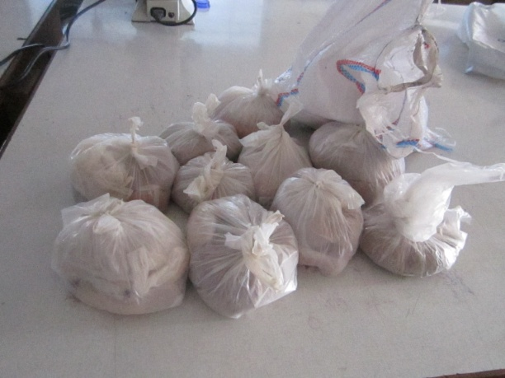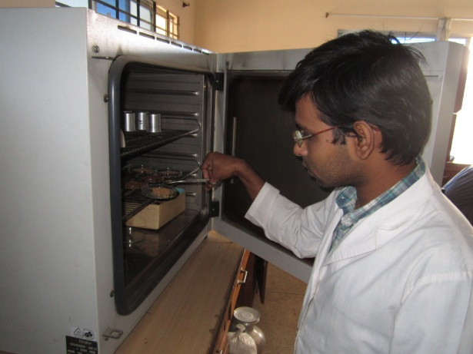
Figure 1: Sample collection Figure 2: DM estimation

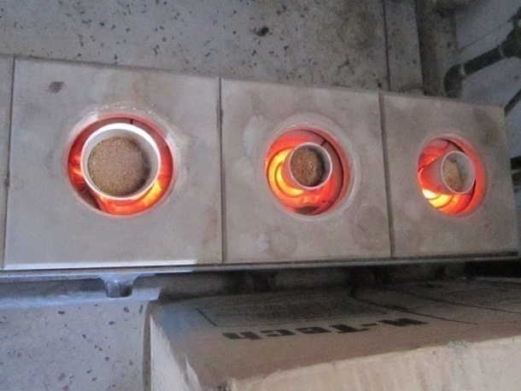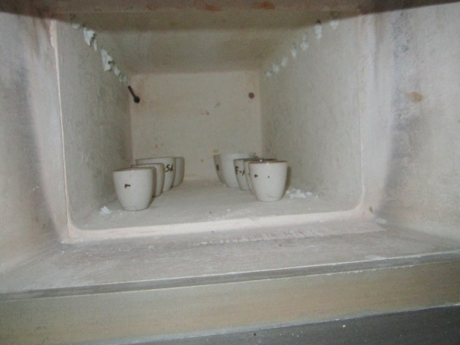
Figure 3: Ash (Burning the sample) Figure 4: Ignition of sample for Ash

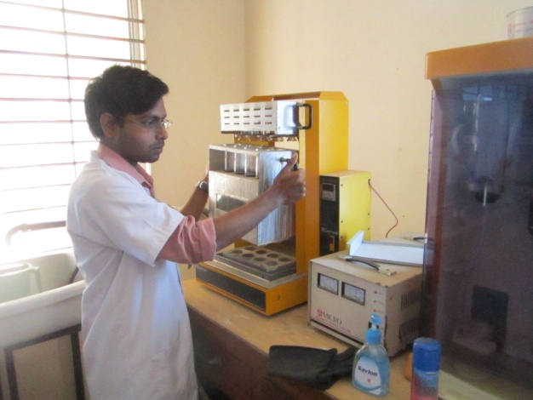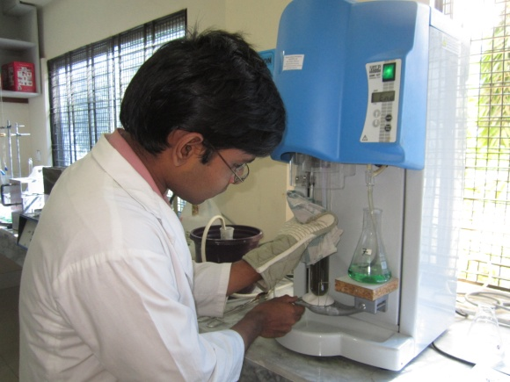
Figure 5: CP estimation (Digestion) Figure 6: CP estimation (Distillation)
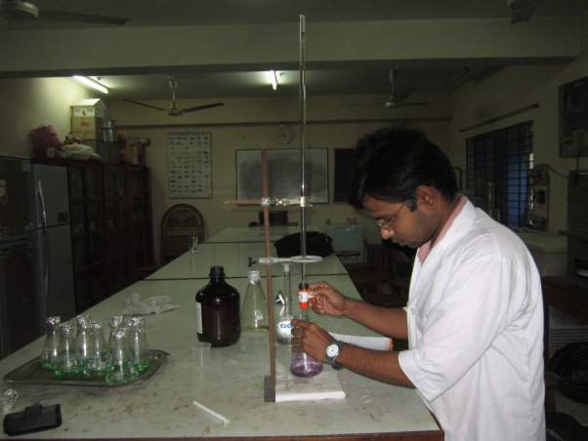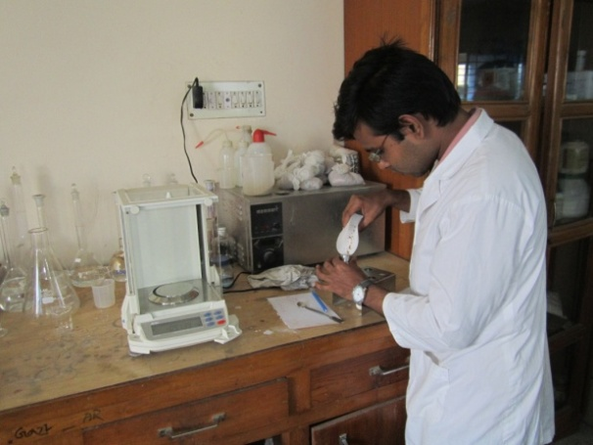
Figure 7: CP estimation (Titration) Figure 8: EE estimation sample taking

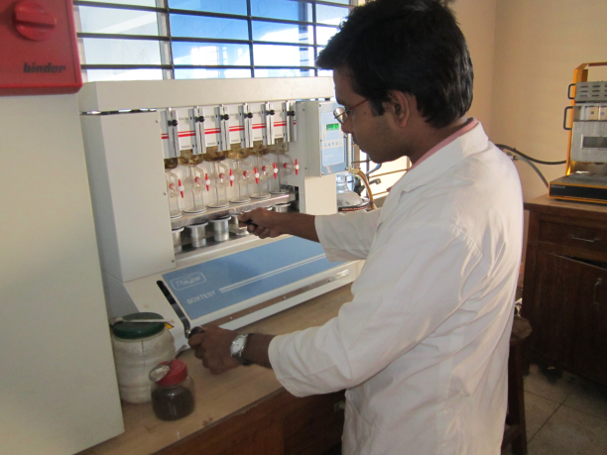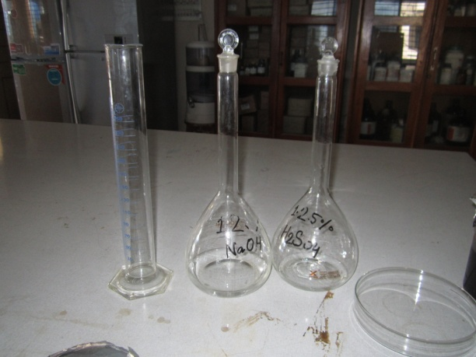
Figure 9: EE estimation Figure 10: Solution for CF estimation

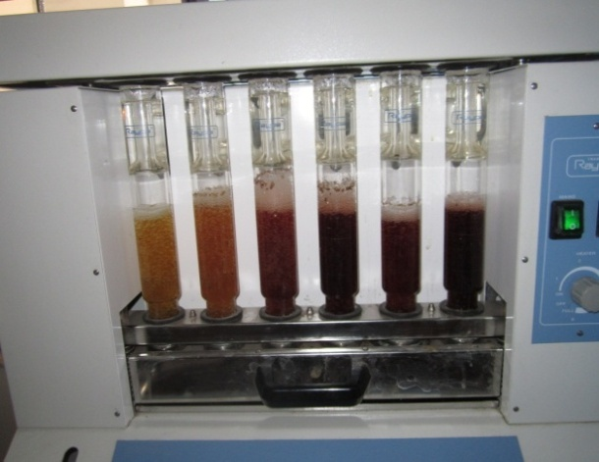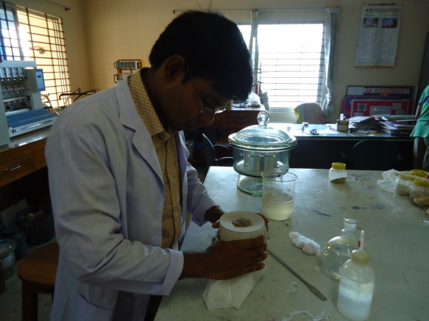Figure 11: CF estimation Figure 12: CF estimation by manual

CHAPTER IV

RESULT & DISCUSSION
The chemical composition of different wood trees are shown in table 1.
Table 1 : Chemical composition of individual sawdust (N=15)

Local Name | Scientific Name | Nutritive value%
 |  | MS | DM | ASH | CP | CF | EE | NFE
Gamari | Gemelina arborea | 32 | 68 | 0.75 | 0.70 | 41.09 | 1.06 | 24.4
Koroy | Samania samun | 42 | 58 | 0.50 | 1 | 35 | 1.09 | 20.41
Tiarasi | Aphananiixis polystachya | 22 | 78 | 0.80 | 1.05 | 60.75 | 0.15 | 15.25
Jam | Syzygium cumini | 29 | 71 | 3 | 0.87 | 42 | 1.16 | 23.97
Gudda | Dipterocarpus costatus | 20 | 80 | 2.8 | 1.4 | 58 | 0.98 | 16.82
Phul cumary | Dipterocarpus alatus | 27 | 73 | 1.3 | 1.05 | 55.95 | 0.01 | 14.69
Sundari | Heritiera fomes | 33 | 67 | 1.25 | 1.75 | 43 | 0.057 | 20.02
Konok chapa | Breguiera cylindrica | 18 | 82 | 0.60 | 1.05 | 61 | 0.77 | 18.53
Sagun | Tecna grandis | 23 | 77 | 5.13 | 1.57 | 56.64 | 1.67 | 12.02
Kathal | Artocarpus heterophyllus | 13.5 | 86.5 | 7.46 | 1.05 | 41.50 | 1.88 | 36.61
Sal | Shorea robus | 10 | 90 | 7 | 1.22 | 62.30 | 1.76 | 17.72
Garjan | Rhizophora mucronata | 30 | 70 | 0.75 | 1.05 | 49.05 | 0.61 | 18.54
Chompa phool | Ceriops decandra | 23 | 77 | 2.4 | 0.70 | 61.8 | 0.38 | 11.72
kacu gass | Bruguiera cylindrica | 38 | 62 | 0.60 | 1.75 | 32.22 | 3.46 | 14.16
Loha kat | Mesua ferrea | 16 | 84 | 1 | 1.75 | 66. | 0.41 | 23.97

Note: MS=Moisture; DM=Dry matter; Ash=Total Ash; CP=Crude protein; CF=Crude fiber; EE=Ether extracts; NFE=Nitrogen free extract.

In terms of moisture content, the highest was found in Koroy tree 42% & the lower in Sal tree 10%. Dry matter % high in Sal tree (90%) and low in Koroy (58%). Ash % high in kathal (7.46%) and low in koroy (0.5%). Crude protein % high in Loha kat and Kacu gass (1.75%) and low in Gamarai and champa phool (0.7%). Crude fibre % high in Loha kat (66%) and low in koroy (35%). Ether extracts % high in kacu gass (3.46%) and low in tiarasi (0.15%). Nitrogen free extracts % high in kathal (36.61%) and low in chopma phool (11.72%).

Table 2: Mean Chemical composition of different types of sawdust(N=15)

Parameters | Minimum | Maximum | Mean | SD | S.E | Sig.
Moisture (g/100g) | 10 | 42 | 25.1 | 9.04 | 2.33 | $$*$$
DM (g/100g) | 58 | 90 | 74.9 | 9.04 | 2.33 | $*$
CP (g/100g) | 0.70 | 1.75 | 1.20 | 0.36 | 0.09 | NS
CF (g/100g) | 32.22 | 66 | 51.08 | 11.07 | 2.86 | $*$
NFE (g/100g) | 11.72 | 36.61 | 19.25 | 6.29 | 1.63 | $*$
EE (g/100g) | 0.01 | 3.46 | 1.03 | 0.90 | 0.22 | NS
Ash (g/100g) | 0.50 | 7.46 | 2.35 | 2.34 | 0.60 | $*$
^{SD}(Standard deviation); ^{SE}(Standard error); ^{NS}(P$>0.05)$ ; $*$(P$<$0.01)

Diagramed presentation of Mean value of Moisture, DM, CP, CF, NFE, EE, Ash of sawdust:

Figure 13: Diagrammatic presentation of Nutritive value of sawdust.

In present study, the mean value for moisture obtained 25.1$±2.33$(g/100g) but in previous study ( Mokhtar and S.Radwan) found 5.5(g/100g) moister in sawdust. QURAT –UL AIN et al also obtained 7.8 (g/100g) moister in sawdust which is contradictory with the present study. It may be due to the state of sawdust during study period. In previous study they use sundry sample for proximate analysis but in present study it was fresh sample immediate after collection, so moisture percentage was found higher.

The mean value for dry matter in sawdust was obtained 74.9$±2.33$(g/100), which is not similar with Mokhtar and Radwan findings 94.5 (g/100g) dry matter in sawdust.

QURAT-UL AIN et al also found 92.2 (g/100g) dry matter in sawdust which is also contradictory. It was also due to high moisture content of fresh sawdust in present study compared to sundry saw dust in previous study.

In addition, the mean value for crude protein was obtained 1.20$±.36$(g/100g) in sawdust. The result does not agree with Mokhtar and S. Radwan who found 2.53 (g/100g) crude protein in sawdust. The result of present study is contradictory with QURAT-UL- AIN et al who found 8.53 (g/100g) in sawdust. It may be due to the stage of maturation and also type of wood trees.

The mean value for crude fiber was obtained 51.08$±2.86$(g/100g). The result is somewhat dissimilar with Mokhtar and S.RADWAN et al who found 60.26 (g/100g) crude fiber in sawdust. QURAT-UL AIN et al also found 60.20 (g/100g) crude fiber in sawdust. However, the result of the current study is not similar with Dboke and Mooke et al who found 67.6 (g/100g) crude fiber in sawdust. In this case my argument is same. The obtained crude fiber of the present study is lower then the previous study which may be due to the lignifications of the fibers and also due to type of trees.

The current study determined the mean value of ether extract in saw dust was 1.03$±.22$(g/100g). The result is almost similar with Mokhtar and Radwan who found the ether extract 0.76 (g/100) in sawdust. Dboke and Mooke who found 1.47 (g/100g) ether extract in sawdust. So the result of the current study is contradictory with QURAT-UL AIN et al who found 2.3 (g/100g) ether extract in sawdust.

In present study, the mean value for ash was obtained 2.35$±.60$(g/100g). The result match with the findings of QURAT-UL AIN et al who found 2.2 (g/100g) ash in sawdust. But result is contradictory with Mokhtar and S. Radwan who found 10.80 (g/100g) ash in saw dust.

The mean value for nitrogen free extract was 19.25$±1.63$(g/100g). The result is almost similar with Mokhtar and S. Radwan who found NFE value 24.03 (g/100g).

CHAPTER V

CONCLUSION

Sawdust is a vital source of fiber for livestock. A wide range of in vivo and in vitro studies speculate that, livestock can utilize fibers available in sawdust. Additionally, it contains crude protein and ether extracts which may be used for poultry and livestock as well. Present study reveals that the quality of sawdust may vary from species to species. Therefore, it could be suggested that, sawdust should be incorporated with conventional feedstuffs at an optimal margin after laboratory analysis. However, it needs to explore more intensive studies in future to investigate sustainable methods for inclusion of this useful fiber in livestock diets.

CHAPTER VI

REFERENCES

Abdelsamie RE, Ranaweera KN, Nano WE (1983). The influence of fibre content and physical texture of the diet on the performance of broilers in the tropics. British Poultry Science, 24(3): 383-90.

Anthony WB and Cunningham Jr. TP (1968). Hardwood sawdust in all concentrate rations for cattle. Journal of Animal Science, 27: 1159. (Abstract).

Anthony WB, Cunningham Jr. TP and Harris RR (1969). Hardwood sawdust as feed for ruminants. Advances in Chemistry Series, 95: 315-327.

AOAC (2000). Official Methods of Analysis. Association of Official Analytical Chemists. (17thed). Gaithersburg, Maryland, USA.

Baker F (1942). Microbial synthesis and autolysis in the digestive tract of hervivora. Nature, 149: 582.

Bearse GE, Millerandc VL, Mc-clary F (1940). The effect of various types of fiber and bulk on cannibalism. Poultry Science, 19: 210.

Bederkar AR, Sastry VRB and Mahajan JM (1984). A note on comparative productive performance of rabbits on roughage and concentrate diets. Livestock Adviser, 9 (6): 46-49.

Bulbul SM and Hossain MD (1989). Probable problems of poultry feed formulation in Bangladesh. Poultry Advisor, 12 (3): 27-29.

Cody RE, Moril JL and Hibbs CM (1968). Evaluation of health and performance of bovines fed wood fiber as a roughage source or intake regulator. Journal of Dairy Science, 51:952. (Abstract) .

Davis F and Briggs GM (1947). The growth-promoting action of cellulose in purified diets for chicks. Journal of Nutrition, 34(3): 295-300

Dinius DA, Peterson AD, Long TA and Baumgardt BR (1970). Intake and digestibility by sheep of rations containing various roughage substitutes. Journal of Animal Science, 30: 309.

EI-Sabban FF, Baumgardr BR, Kradel DC, Rothenbacher H and Long TA (1969). Oak sawdust in beef cattle finishing rations. Journal of Animal Science, 28: 872 (Abstract).

EI-Sabban FF, Long TA and Baumgardt BR (1971). Utilization of oak sawdust as a roughage substitute in beef cattle finishing rations. Journal of Animal Science, 32:749.

Harpster HW (1980). Digestibility of hydrolyzed oak sawdust for sheep. Journal of Animal Science, 51 (1): 145.

Hegde SN, Rolls BA, Turvey A and Coates ME (1978). The effect on chicks of dietary fibre from different sources: a growth factor in wheat bran. British Journal of Nutrition, 40: 63-69.

Hoover WH and Heitmann RN (1972). Effect of dietary fibre levels on weight gain, cecal volume and volatile fatty acids. Journal of Nutrition, 102: 375-380.

Hungate EE (1944). Studies on cellulose fermentation. I. The culture and physiology of an anaerobic cellulose-digesting bacterium. Journal of Bacteriology, 48: 499.

Keith EA and Daniels LB (1976) Acid or alkali-treated hardwood sawdust as a feed for cattle. Journal of Animal Science, 42(4): 888-892.

Marion PT, CE Fisher and Robinson ED (1959). Ground mesquite wood as a roughage for yearling steers. Journal of Animal Science, 18:1174. (Abstract).

McCartor MM, England MW and Hefley HM (1972). Effect of various roughages in high concentrate beef cattle diets on animal performance and carcass characteristics. Journal of Animal Science, 34:142.

Mellenberger RW, Satter LD, Millett MA and Baker AJ (1971). Digestion of aspen, alkali-treated aspen and aspen bark by goats. Journal of Animal Science, 32:756.
Oke DB and Oke MO (2007). Effects of feeding graded levels of sawdust obtained from Daniellia ogea tree on the performance and carcass characteristics of broiler chickens. Research Journal of Poultry Sciences, 1(1): 12-15.

Omole TA and Onwudike OC (1981). Investigations of the treatment of sawdust for rabbit feeding. 1. Effect of sodium hydroxide treatment. Animal Feed Science and Technology, 6: 43-50.

Radwan SM (1994). Use of sawdust as a source of fiber in rabbit. Egyptian Journal of Rabbit Science. 4 (2) : 23-24. Retrieved from.
http:/agris.fao.org/agris-search/search/display.do?f=1998/EG/EG98009.xml; EG1998001772

Savory CJ and Gentle MJ (1976). Changes in food intake and gut size in Japanese quail in response to manipulation of dietary fibre content. British Poultry Science, 17: 561-570.

Sheehy EJ (1939). Effect of fiber and bulk in the diet of the chicken on their growth and prevention of feather picking and cannibalism. Proceedings of the 7th World's Poultry Congress, Cleveland, 205.

Sibbald IR, Slinger SJ and Ashton GC (1960). The weight gain and feed intake of chicks fed a ration diluted with cellulose or kaolin. Journal of Nutrition, 72: 441.

Slyter AL and Kamstra LD (1974). Utilization of pine sawdust as a roughage substitute in beef finishing rations. Journal of Animal Science, 38:693.

Sowande OS, Akinleye BC, Ogundipe BA and Idowu OMO (2002). Nutritive potentials of sawdust from mixed wood species. Proceedings of the 27th Annual Conference of the Nigerian Society for Animal Production, pp. 99-100.

Winer BJ, Brown R and Michels KM (1991). Statistical Principles in Experimental Design. (3rded). New York: McGraw-Hill.

Wilson RK and Pigden WJ (1964). Effect of sodium hydroxide treatment on the utilization of wheat straw and poplar wood by rumen microorganisms. Canadian Journal of Animal Science, 44: 122.

