Nutritive values of unconventional feeds available in
Bandarban district of Bangladesh

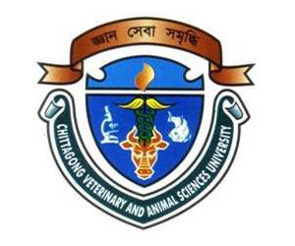

A Report
By

_________________________________
(MOHAMMAD HASANUL KARIM)
Roll No: 07/49, Reg. No: 336
Internship ID: E-45, Session: 2006-2007

Submitted in partial of the requirement for the fulfillment of the degree of
Doctor of Veterinary Medicine (DVM)

Approved as to style and content by

_____________________________
(MD. EMRAN HOSSAIN)
Associate Professor
Department of Animal Science & Nutrition
Chittagong Veterinary and Animal Sciences University
Khulshi, Chittagong-4202

February, 2013
Nutritive values of unconventional feeds available in
Bandarban district of Bangladesh

A Report
By

Roll No: 07/49, Reg. No: 336
Internship ID: E-45, Session: 2006-2007

Submitted in partial of the requirement for the fulfillment of the degree of Doctor of Veterinary Medicine (DVM)

Approved as to style and content by

_____________________________
(MD. EMRAN HOSSAIN)
Associate Professor
Department of Animal Science & Nutrition
Chittagong Veterinary and Animal Sciences University
Khulshi, Chittagong-4202

February, 2013
Nutritive values of unconventional feeds available in Bandarban district of Bangladesh

INDEX

Contents | Page No.
1. Abstract | 01
2. Introduction | 01-02
3. Materials and Methods | 03
3.1 Study area | 03
3.2 Collection of sample | 03
3.3 Preparation of sample | 03
3.4 Analysis of sample | 03
3.5 Calculation of ME | 03
3.6 Statistical analysis | 03
4. Results and Discussion | 04-11
4.1 Pumpkin leaf | 04-05
4.2 Bilimbi leaf | 05-06
4.3 Giant reed leaf | 06-07
4.4 Cogon grass | 07-08
4.5 Hilly grass | 08
4.6 Shegun leaf | 08-09
4.7 Green coconut peel | 09-10
4.8 Banana tree | 10-11
5. Conclusion | 11
6. References | 11-14

Nutritive values of unconventional feeds available in
Bandarban district of Bangladesh

1. Abstract
________________________________________________________________

The study was undertaken during 22nd July to 22nd November, 2012 to find out the chemical composition of different types of unconventional feeds available in Bandarban areas of Bangladesh. Total 08 different types of feeds such as Pumpkin leaf, Bilimbi leaf, Giant reed leaf, Cogon grass, Hilly grass, Shegun leaf, Green coconut peel and Banana tree were collected from study areas. Samples were collected, chopped and tested immediately for moisture content and remaining samples were sun-dried, processed and analyzed for chemical analysis using standard procedure. Chemical analyses of the samples were carried out in triplicate for dry matter (DM), crude protein (CP), crude fiber (CF), nitrogen free extract (NFE), ether extract (EE) and total ash (TA) in the animal nutrition laboratory, Chittagong Veterinary and Animal Sciences University, Chittagong, Bangladesh. Metabolizable energy (ME) was calculated mathematically for all samples by using standard formula. Crude protein content in pumpkin leaf was 25.0 g/100g, bilimbi leaf 11.9 g/100g, giant reed leaf 8.6 g/100g, cogon grass 8.4 g/100g, hilly grass 6.8 g/100g, shegun leaf 11.9 g/100g, green coconut peel 4.9 g/100g and banana tree 15.6 g/100g. Results indicated that, all samples had substantial amount of proximate components that might have been used as alternative feed resource for dairy cattle. It could therefore, be inferred that, these unconventional feeds might be used as alternative feed resources for dairy animals in scarcity of traditional feeds.
________________________________________________________________

Key words: Unconventional feed, moisture, dry matter, crude protein, crude fiber, nitrogen free extracts, ether extract and total ash.

2. Introduction

Livestock is an integral part of the farm economic of Bangladesh. Bangladesh has a very high density of population considering the total land mass and the cultivable land. Livestock production depends upon several factors, such as health care management, breeding, nutrition etc. However, it is considered that the most important constraint to livestock development in Bangladesh is the shortage of feed and fodder (Rahman, 2011).

Bridging the gap between teeming population and food production is one of the important tasks of developing countries like Bangladesh. Expensive staple foods and policy constraints on food imports are the major factors worsening the food situation in developing countries (Weaver, 1994). Protein-energy deficiency has been recognized as the most common form of malnutrition in regions where people depend mainly on starch-based diets (FAO, 1994; Pelletier, 1994; Weaver, 1994; Michaelsen and Henrik, 1998). Livestock production, animal husbandry and maintenance of soil fertility play important role in rural development and in turn the economy of developing countries. Livestock nutrition is also one of the critical constraints to increase animal productivity in developing countries (ILRI, 1995) and perpetual gap persists between the demand and supply of digestible crude protein and total digestible nutrients to livestock in Asian continent (Singh et al., 1997).

Moreover, providing adequate good-quality feed to livestock to raise and maintain their productivity is and will be a major challenge to agricultural scientists and policy makers all over the world. Increase in population and rapid growth in world economies will lead to increase in demand for animal products; an increase of approximately 30 % in both meat and milk production is expected in the coming 20 years. At the same time, the demand for food crops will also increase. Future hopes of feeding the millions and safeguarding their food security will depend on the enhanced and efficient utilization of unconventional resources that cannot be used as food for humans, as feed for livestock. (Jutzi, 2004).

In addition, a large area of land in the world is degraded, barren or marginal and the amount is increasing every year. This also calls not only for identification and introduction of new and lesser-known plants capable of growing in poor soils, which can play a vital role in the control of soil erosion in addition to providing food and feed. In developing countries, livestock are fed mainly on agro-industrial by-products containing a larger proportion of ligno-cellulosic feeds like cereal straws, stovers, sugarcane by-products and similar other feeds. These feeds are poor in protein, energy, minerals and vitamins. Addition of foliage from tree leaves or supplementation with seed meals or even urea can improve the utilization of low quality roughages mainly through the supply of nitrogen to rumen microbes. The use of simple but robust techniques for evaluation of the nutritional quality of these feed resources will contribute to their efficient utilization (http://www.fao.org/docrep/ARTICLE/AGRIPPA/570_EN.htm).

The higher price and acute scarcity of conventional feed ingredients create problems to the profitable commercial dairy and poultry farming in Bangladesh. Therefore, attention is gradually being focused on cheaper alternative feeds, especially, those are available in our country but people are unknown to them. The use of unconventional feed resources along with other strategies may reduce pressure on the demand for conventional feed ingredients and promote achievement of feed security for dairy sector.
3. Materials and methods

3.1 Study area

Most of the feeds are available in the hills of Bandarban. Therefore, the current study was conducted in hilly areas of Bandarban district.

3.2 Collection of sample

Samples were collected from hills in Bandarban. Each sample was collected as much as possible amount. Samples were wrapped up by polythene bag and sent to the Animal Nutrition Laboratory, Chittagong Veterinary and Animal Sciences University, Chittagong.

3.3 Preparation of sample

Fresh samples were cut into the smallest pieces and measured moisture by hot air oven. Then samples were subjected to grinder to make it homogenous powder. Later on, it was mixed properly and exposed to shade to cool down for sampling. Individual samples were kept in air tight polythene bag and identified by marker and subjected to chemical analyses.

3.4 Analysis of sample

Chemical analyses of the samples were carried out in triplicate for DM, CP, CF, NFE, EE and TA in the animal nutrition laboratory, Chittagong Veterinary and Animal Sciences University, Chittagong, Bangladesh (AOAC, 2006).

3.5 Calculation of Metabolizable Energy

Metabolizable Energy (ME) was calculated from proximate components by mathematical formula as per Lodhi et al. (1976).

3.6 Statistical analysis

Data related to chemical composition of unconventional feeds were compiled by using Microsoft Excel 2007. Chi-square (χ²) test was performed to analyze the data by using SPSS 16.0. Statistical significance was accepted at 5 % level (P<0.05).

4. Results and Discussion

Chemical composition of unconventional feeds (Pumpkin leaf, Bilimbi leaf, Giant reed leaf, Cogon grass, Hilly grass, Shegun leaf, Green coconut peel and Banana tree) particularly, moisture, dry matter (DM), Crude protein (CP), Crude fiber (CF), Nitrogen free extracts (NFE), Ether extracts (EE) and ash contents in different unconventional feed samples have been presented in Table 1.

Table 1. Chemical composition (g/100gDM) of the unconventional feeds available in Bandarban

English name | Scientific name | ME# | DM | CP | CF | NFE | EE | Ash
Pumpkin leaf | Cucurbita maxima | 1802.0 | 14.0 | 25.0 | 20.4 | 40.1 | 0.7 | 13.8
Bilimbi leaf | Averrhoa bilimbi | 1980.8 | 32.2 | 11.9 | 32.3 | 43.3 | 2.6 | 9.9
Giant reed leaf | Arundo donax | 2054.9 | 34.0 | 8.6 | 29.5 | 49.3 | 2.4 | 10.2
Cogon grass | Imperata cylindrica | 1591.1 | 32.0 | 8.4 | 41.2 | 42.3 | 1.1 | 7.0
Hilly grass | Cynodon dactylon | 1741.0 | 33.4 | 6.8 | 40.2 | 43.9 | 1.3 | 7.8
Shegun leaf | Tectona grandis | 2323.8 | 34.6 | 11.9 | 26.2 | 49.5 | 4.3 | 8.1
Green coconut peel | Cocos nucifera | 2863.2 | 12.0 | 4.9 | 30.2 | 56.8 | 1.8 | 6.3
Banana tree | Musa paradisiaca | 1909.7 | 4.0 | 15.6 | 27.7 | 40.3 | 1.3 | 15.1
Level of Sig. |  | *** | *** | *** | NS | NS | NS | NS
#Metabolizable energy (kcal/kg); ^{DM}Dry matter; ^{CP}Crude protein; ^{CF}Crude fibre; ^{NFE}Nitrogen free extract; ^{EE}Ether extract; ^{NS}Non-significant (P>0.05); ***Significant at 0.1 level (P<0.001)

4.1 Pumpkin leaf (Cucurbita maxima)

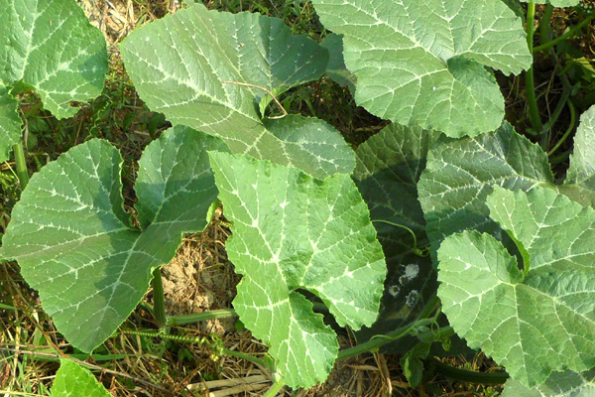Pumpkin leaf is one of the important crops which belong to the family, Cucurbitaceae. The local name of pumpkin leaf is Misty kumra shak and scientific name is Cucurbita maxima. Pumpkin leaf is very common in Bangladesh. This is found all over the country. Most parts of the pumpkin are edible, including the fleshy shell, the seeds, the leaves, and even the flowers. It is a traditional vegetable crop, grown mainly for its leaves, fruits, and seeds and consumed either by boiling the leaves and fruits or by roasting or baking the seeds (Facciola, 1990). Pumpkins are grown all around the world for a variety of reasons ranging from agricultural purposes such as animal feed to commercial and ornamental sales. Of the seven continents, only Antarctica is unable to produce pumpkins; the biggest international producers of pumpkins include the United States, Canada, Mexico, India, and China. The traditional American pumpkin is the Connecticut field variety.

Pumpkin leaves, fruits, flowers and seeds are health promoting food. Different parts of the plant have been used as medicine in some developed world. The leaves are haematinic, analgesic, and also used externally for treating burns. Traditionally, the pulp is used to relieve intestinal inflammation or enteritis, dyspepsia and stomach disorders (Sentu and Debjani, 2007). Pumpkin fruit is an excellent source of vitamin A which the body needs for proper growth, healthy eyes and protection from diseases. It is rich in vitamin C, vitamin E, lycopene and dietary fiber (Pratt and Matthews, 2003; Ward, 2007). It has also been featured in various systems of traditional medicine for several ailments such as antihypertensive, antibacterial, intestinal antiparasitia, anti-inflammation and antalgic (Bown, 1995; Burkill, 1985; Chiej, 1984; Chopra et al., 1986; Rahman et al., 2008).

In our analysis, pumpkin leaf contained 1802.0 kcal ME/kgDM, 14.0 g/100g dry matter, 25.0 g/100g crude protein, 20.4 g/100g crude fiber, 40.1 g/100g nitrogen free extracts, 0.7 g/100g ether extracts and 13.8 g/100g ash (Table 1). The result is in agreement with Idris (2011) who found 13.0 g/100g dry matter, 8.72 g/100g crude protein, 20.17 g/100g crude fiber and 17.2 g/100g ash in pumpkin leaf. The potential of a particular feed is determined primarily by its nutrient composition. Leafy vegetables like pumpkin leaves are known to add taste and flavour, as well as substantial amounts of protein, fiber, minerals, and vitamins to the diet (Oyenuga and Fetuga, 1975).

Sheela et al., (2004) and Kubmarawa et al., (2009) also reported that leafy vegetables are generally good sources of nutrients and, are highly beneficial for the maintenance of good health and prevention of diseases. They further opined that leafy vegetables are rich in carotene, ascorbic acid, riboflavin, folic acid and minerals like calcium, iron and phosphorous. Thus, similar to human being, pumpkin leaf could be a good feed source for livestock.

4.2 Bilimbi leaf (Averrhoa bilimbi)

Bilimbi leaf is a member of the Oxalidaceae family.The local name of Bilimbi leaf is Bilambu and scientific name is Averrhoa bilimbi. Mature bilimbi leaf is usually 3-6 cm long, alternate, imparipinnate and cluster at branch extremities. There are around 11 to 37 alternate or sub-opposite oblong leaflets. The leaves are quite similar to those of the Otaheite gooseberry. Possibly originated in Moluccas, Indonesia, the species are now cultivated and found throughout the Philippines, Indonesia, Sri Lanka, Bangladesh, Myanmar and Malaysia. It is also common in other Southeast Asian countries. In India, where it is usually found in gardens, the bilimbi has grown wild in the warmest regions of the country. This is essentially a tropical tree, less resistant to cold.

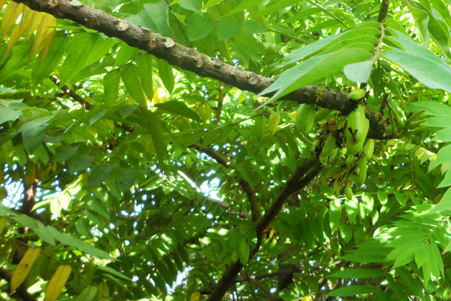The leaf of A. bilimbi is used for the treatment of stomachache and parotitis. The fruit is used to treat dyspepsia, colitis and also dental caries. It is also used to treat bleeding haemorrhoids, bleeding gums, mouth ulcers, dental caries and to alleviate internal haemorrhoids. Infusion of the flowers is a remedy for mouth ulcers and oral thrush (Dalimartha, 2008; Peter, 2007 and WAF, 2010). Leaf decoction also heals inflammation of rectum and as paste of it is applied on affected surface area for mumps, rheumatism and pimples. Leaves, flower and fruit are consumed for stomachache, wounds, stomatitis, whooping cough, bleeding gums, ache and hypertension as well as antitussive and antidiabetic (Peter, 2007). It is also good for scabies (Batugal et al., 2004).

In present study, bilimbi leaf contained 1980.8 kcal ME/kgDM, 32.2 g/100g dry matter, 11.9 g/100g crude protein, 32.3 g/100g crude fiber, 43.3 g/100g nitrogen free extracts, ether extracts 2.6 g/100g and 9.9 g/100g ash (Table 1). Bilimbi leaf is favourite to goat. It can also be used for cattle and sheep in our country as unconventional feed.

4.3 Giant reed leaf (Arundo donax)

Giant reed (Arundo donax) is a perennial rhizomatous grass which is widely diffused in subtropical and warm temperate regions. From its native area, probably Eastern Asia, it has been dispersed all over the world by humans who use it for multiple purposes such as roof thatching, reeds in woodwind instruments, sweeping materials, fishing rods etc. Its spontaneous and rapid growth allows A. donax to be considered as an invasive weed (Pilu et al., 2012). It is an erect, perennial, bamboo-like grass (Bell, 1997 and Perdue, 1958).

In traditional medicine, it is utilized as a diuretic, sudorific and for dropsy treatment (Perdue, 1958; Shamel, 1917; Gucel, 2010; Guarrera, 2007).
A. donax has been used industrially to produce cellulose, paper and rayon (Perdue, 1958; Facchini, 1941).

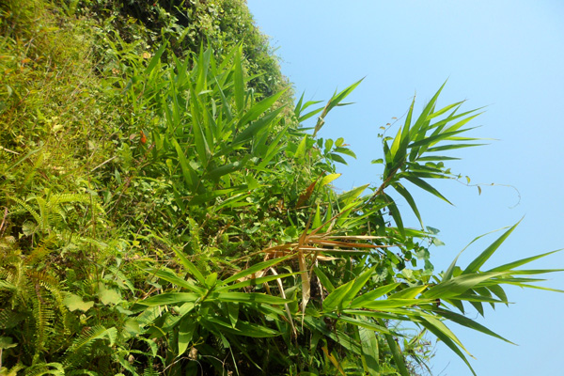Giant reed leaf is abundantly available in the hilly areas of Bandarban. From the nutritional analysis, it contained 2054.9 kcal ME/kgDM ME, 34.0 g/100g dry matter, 8.6 g/100g crude protein, 29.5 g/100g crude fiber, 49.3 g/100g nitrogen free extracts, 2.4 g/100g ether extracts and 10.2 g/100g ash (Table 1). Only the hilly people use this leaf as feed of their domestic animals. It is a good source of protein. Thus giant reed leaf may be used as an alternative protein source for livestock.

4.4 Cogon grass (Imperata cylindrical)

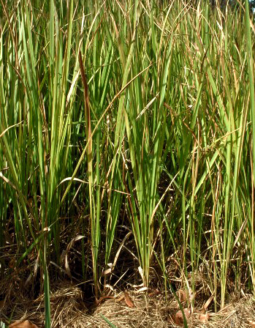The local name of cogon grass is Shon and scientific name is Imperata cylindrical. Cogon grass is a perennial, rhizomatous grass that grows from 2 to 4 feet in height. The leaves are about an inch wide, have a prominent white midrib, and end in a sharp point. Leaf margins are finely toothed and are embedded with silica crystals. The upper surface of the leaf blade is hairy near the base; the undersurface is usually hairless. The flowers are arranged in a silvery, cylindrical, branching structure, or panicle, about 3-11 inches long and 1½ inches wide (Swearingen, 2009).

It is used for thatching the roofs of traditional homes in throughout south-east Asia. It is planted extensively for ground cover and soil stabilization near beach areas and other areas subject to erosion. Other uses include paper-making, thatching and weaving into mats and bags. However, it’s most common usefulness may be seen in its medicinal properties which include astringent, antipyretic, diuretic, tonic, and styptic actions. It is used in traditional Chinese medicine. A number of cultivars have been selected for garden use as ornamental plants. Young inflorescences and shoots may be eaten cooked, and the roots contain starch and sugars and are therefore easy to chew (http://en.wikipedia.org/wiki/Imperata_cylindrica).

Cogon grass is a valuable feed for cattle, goat and sheep. In present study, cogon grass contained 1591.1 kcal ME/kgDM, 32.0 g/100g dry matter, 8.4 g/100g crude protein, 41.2 g/100g crude fiber, 42.3 g/100g nitrogen free extracts, 1.1 g/100g ether extracts and 7.0 g/100g ash (Table 1). As an unconventional feed, cogon grass can be used as alternative feed resource for dairy animals in scarcity of traditional feeds.

4.5 Hilly grass (Cynodon dactylon)

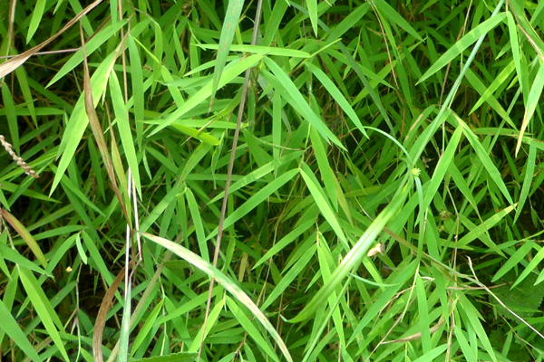Hilly grass is a kind of herb that contains fibers. It grows enormously in hills of Bandarban district. Generally local people of that region use it as feed of domestic ruminants.
In present study, hilly grass contained 1741.0 kcal ME/kgDM, 33.4 g/100g dry matter, 6.8 g/100g crude protein, 40.2 g/100g crude fiber, 43.9 g/100g nitrogen free extracts, 1.3 g/100g ether extracts and 7.8 g/100g ash (Table 1). It is a good source of vitamins and minerals. This grass is widely available in hilly areas, so this feed can be used as unconventional feed for livestock.

4.6 Shegun leaf (Tectona grandis)

Shegun is the common name for the tropical hardwood tree. The english name of shegun leaf is teak leaf and scientific name is Tectona grandis. It is native to south and south east Asia, mainly Bangladesh, India, Indonesia, Malaysia, and Burma, but is naturalized and cultivated in many countries, including those in Africa and the Caribbean (http://en.wikipedia.org/wiki/Teak). Myanmar accounts for nearly one third of the world's total teak production. Teak is a large, deciduous tree that is used for animal feed. It has small, fragrant white flowers and papery leaves that are often hairy on the lower surface.
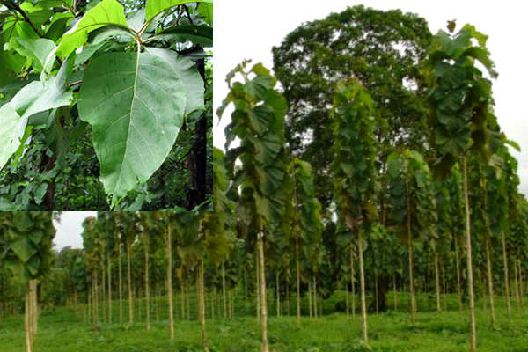Teak leaves are four-sided branchlets; bear the very large leaves which are shield for three to four months during the latter half of the dry season. The leaves are shiny above and hairy below with vein network clear about 30 x 20 cm but young leaves up to 1.0 m long. The leaves yield the dye which is used to colour clothes. Teak is probably the best protected commercial species in the world (Mbuya et al., 1992). 1g of teak leaf powder could remove 86.73% of cadmimum (II) from 50 ml aqueous solution (Acton, 2011). So it has antitoxic properties. In Indonesia, teak leaves are also used for producing mold starter culture (Lusas et al., 1989; Applewhite, 1989).

In present study, teak leaf contained 2323.8 kcal ME/kgDM, 34.6 g/100g dry matter, 11.9 g/100g crude protein, 26.2 g/100g crude fiber, 49.5 g/100g nitrogen free extracts, 4.3 g/100g ether extracts and 8.1 g/100g ash (Table 1). It a good source of minerals and protein. Thus teak leaf may be an alternative feed resource for animals.

4.7 Green coconut peel (Cocos nucifera)

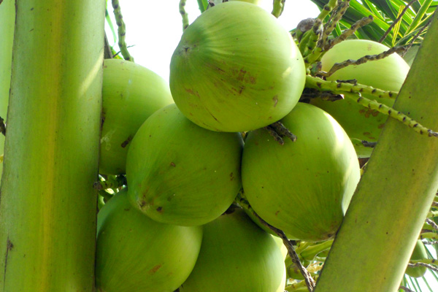The local name of Green coconut peel is Dab and scientific name is Cocos nucifera. Green coconut is one of the most nutritious of all fruits. The whole coconut tree may be utilized, but the main products are obtained from the fruit: copra and oil, lauric acid, coconut milk, fiber, flour, coconut water from immature fruit which is used in several application, e.g. food, animal feed, soaps, detergents and cosmetics.
The green coconut is truly one of nature’s natural wonder. Every part of the coconut is used for some purpose. From this tree we can derive everything necessary to sustain life. It is a source of food and drink to nourish the body, medicine to maintain and restore health and materials to build shelter, clothing and tools to provide the necessities of life. That’s why, it is called the ‘tree of life’ (Fife, 2005; Haden, 2009).

Coconut shell-oil is used for external application in eczema, ringworm, chronic skin diseases (Khare, 2004). The coconut oil is also used as an emetic and as a purgative (Trivedi, 2006). It is very rare to use as animal feed in our country. It has great nutritive value. It is highly rich in carbohydrates. In present study it contained 2863.2 kcal ME/kgDM, 12.0 g/100g dry matter, 4.9 g/100g crude protein, 30.2 g/100g crude fiber, 56.8 g/100g nitrogen free extracts, 1.8 g/100g ether extracts and 6.3 g/100g ash (Table 1). A polysaccharide factor isolated from coconut water is found to be immunogenic and oil from coconut shell fiber antimicrobial (Khare, 2004). So, green coconut peel can be used as unconventional feed resource for livestock.

4.8 Banana tree (Musa paradisiaca)

The local name of banana tree is Kola tree and scientific name is Musa paradisiaca. The banana tree is actually the largest herbaceous flowering plant in the world. This starch-rich fruit doubles as a meal many a time. It has been found that bananas have curative properties both scientifically and traditionally. Birds and animals, especially monkeys and elephants love bananas.

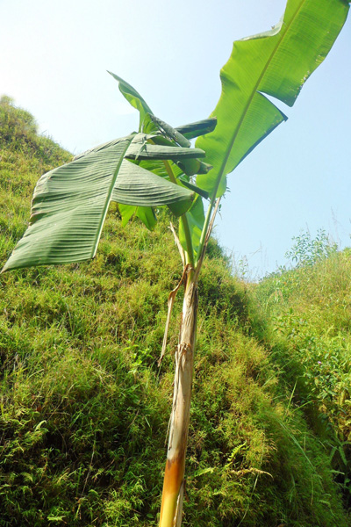There are many healing and medicinal properties of banana tree. The high content of iron in bananas increases the production of hemoglobin in the blood -therefore they are very good for anemia. Basically, all part of the banana tree have medicinal application. Fruits, leaves, peels, root and stalks from banana plants have been used orally or topically as a medicine for treating diarrhoea and dysentery, in the healing of intestinal lesions in colitis (Stover and Simmonds, 1987). The banana plant is used in folkloric medicine for treating inflammation, pain and snake-bite by the Sumu (Ulwa) people of south-eastern Nicaragua (Coe and Anderson, 1999; Lim, 2012).
In our study, banana tree contained 1909.7 kcal ME/kgDM, 4.0 g/100g dry matter, 15.6 g/100g crude protein, 27.7 g/100g crude fiber, 40.3 g/100g nitrogen free extracts, 1.3 g/100g ether extracts and 15.1 g/100g ash (Table 1). Banana tree is very common and available in all region of Bangladesh. It is one of the leading sources of iron and advisable for anemic animals. Thus banana tree can be an alternative feed source for livestock.

5. Conclusion

The results of this findings revealed that the unconventional feeds are good sources of carbohydrates, protein and energy. The leaves are good source of Iron, Copper, Potassium and Manganese which meet the recommended daily allowance. Adequate consumption of these plant leaves may help in preventing adverse effects of dietary deficiencies. Also properly utilized unconventional feeds can be reduced pressures on the conventional feeds, which is will ultimately reduce the production cost of livestock and their products and by-products.

6. References

Acton QA (2011). Transition Elements: Advances in research and Application. Scholarly Editions, Atlanta, Georgia. pp. 36.
AOAC (2006). Official Methods of Analysis of AOAC International. Association of Official Analytical Chemists. 18th edition (Editor: William Horwitz, George W. Latimer), Gaithersburg, USA.
Applewhite TH (1989). Vegetable Protein Utilization in Human Foods and Animal Feedstuffs. American Oil Chemists’ Society, USA. pp. 365.
Batugal PA, kanniah J, Lee SY and Oliver JT (2004). Medical plants Research in Asia. Vol. 1. International Plant Genetic Resources Institute, Serdang 43400 Selangor Darul Ehsan, Malaysia. pp. 160.
Bell GP (1997). Ecology and management of Arundo donax and approach to riparian habitat restoration in southern California. In: Plant Invasinn: Studies from North America and Europe.
Bown D (1995). Encyclopaedia of herbs and their uses. Dorling Kindersley, London. pp. 424.
Burkill HM (1985). The useful plants of West Tropical Africa. Vol. 1. Families A-D. Royal Botanic Gardens, Kew. pp. 960.
Chiej R (1984). Encyclopaedia of medical plants. MacDonald, London. pp. 447.
Chopra RN, Nayar SL and Chopra IC (1986). Glossary of Indian medicinal plants (including the supplement). Council Scientific Industrial Research, New Delhi, India. pp. 330.
Coe F and Anderson GJ (1999). Ethnobotany of the Sumu (Ulwa) of Southeastern Nicaragua and Comparisons with Miskitu plant lore. Econ. Bol., 53: 363-383.
Dalimartha S (2008). Atlas tumbuhan obat Indonesia: menguak kekayaan tumbuhan obat Indonesia, Volume 5, Pustaka Bunda, Jakarta. pp. 6-10.
Facchini P (1941). La canna gentile per la produzione della cellulosa nobile, I’impresa agricolo industriale di Torviscosa. Milano: SINA VISCOSA.
Facciola S (1990). Cornucopia-A Source Book of Edible Plants, Kamping Publications, California, USA. pp. 677.
FAO (1994). The State of Food and Agriculture. FAO agricultural series # 27, FAO/UN, Rome.
Fife B (2005). Coconut Cures: Preventing and Treating Common Health Problems with Coconut. Piccadilly Books, Ltd. Colorado Springs, USA. pp. 16-17.
Guarrera PM (2007). Handicrafts, handlooms and dye plants in Italian Folks tradition, Ind. J. Traditional. Knowledge., 7: 67-69.
Gucel S (2010). Arundo donax L. (Giant reed) use by Turkish Cypriots. Ethnobotany. Res. Appl., 8: 245-248.
Haden R (2009). Food Culture in Pacific Islands. ABC CLIO, LLC, Santa Barbara, California, USA. pp. 66-67.
http://en.wikipedia.org/wiki/Imperata_cylindrica.
http://en.wikipedia.org/wiki/Teak.
http://www.fao.org/docrep/ARTICLE/AGRIPPA/570_EN.htm.
Idris S (2011). Department of Chemistry, Federal University of Technology, Minna, NigerState, P. M. B. 65, Nigeria. Am. J. Chem., 1(2): 56-59.
ILRI (International Livestock Research Institute) (1995). Global agenda for livestock research. In: Proceedings of a Consultation. (Editors, Gardiner P R and Devendra C), Nairobi, Kenya.http://www.ilri.org/InfoServ/Webpub/Fulldocs/ga_sasia/GA_SASIA.pdf.

Jutzi SC (2004). Assessing Quality & Safety Of Animal Feeds. FAO, Viale delle Terme di Caracalla, Rome, Italy. pp. 55-56.
Khare CP (2004). Indian Herbal Remedies. Society for New Age Harbals, New Delhi, India. pp. 156-157.
Kubmarawa D, Andenyang IFH and Magomya AM (2009). Proximate composition and amino acid profile of two non-conventional leafy vegetable (Hibiscus cannabinus and Haematostaphis bartery). African J. Food Sci., 3(9). pp. 233-236.
Lim TK (2012). Edible Medical and Non-medical plants: Fruits, Volume 3. Springer, New York, USA.
Lodhi GN, Daulat S and Ichhponani JS (1976). Variation in nutrient content of feedingstuffs rich in protein and reassessment of the chemical method for metabolizable energy estimation for poultry. J Agric. Sci., 86(2): 293-303.
Lusas EW, Erickson DR and Nip W (1989). Foods Uses of Whole Oil and Protein Seeds. American Oil Chemists’ Society, USA. PP. 106.
Mbuya LP, Msanga HP, Ruffo CK, Birnie A and Tangnas B (1992). A selection of useful trees and shrubs for Kenya, their identification, propagation and management for use by agriculture and pastoral communities. ICRAF, Nairobi.
Michaelsen KF and Henrik F (1998). Complementary feeding: A global perspective. Nutr., 14: 763-766.
Oyenuga VA and Fetuga BC (1975). Dietary importance of fruits and vegetables. In: 1st National Seminar on Fruits and Vegetable, National Horticultural Research Institute, Ibadan, Nigeria. pp. 19-23.
Pelletier DL (1994). The potentiating effects of malnutrition on child mortality: Epidemiological evidence and policy implications. Nutr. Rev., 52: 409-415.
Perdue RE (1958). Arundo donax-source of musical reeds and industrial cellulose. Econ. Bot. 12: 368-404.
Peter KV (2007). Underutilized and Underexploited Horticultural Crops. Vol. 2. New India Publising Agency, New Delhi, India. pp. 47.
Pilu R, Bucci A, Badone FC and Landoni M (2012). Giant reed (Arundo donax L.): A weed plant or a promising energy crop? African J. Biotecnol., 11(38): 9163-9174.
Pratt SG and Matthews K (2003). SuperFoods RX: Fourteen Foods That Will Change Your Life, Harper Collins, New York, USA. pp. 352.
Rahman AHMM, Anisuzzaman M, Ahmed F, Raful IAKM and Naderuzzaman ATM (2008). Study of nutritive value and medicinal uses of cultivated cucurbitis. J. Appl. Sci. Res., 4(5): 555-558.
Rahman MM (2011). Livestock Feed Marketing In Bangladesh: Problems and Prospects, University of Rajshahi, Bangladesh.
http://www.studymode.com/essays/Livestock-Feed-Marketing-In-Bangladesh-Problems-598715.html.
Sentu S and Debjani G (2007). Effect of ripe fruit pulp extract Cucurbita pepo Linn. In: Aspirin-induced Gastric and Duodenal Ulcer in Rats, S.N. Pradhan Center for Neurosciences, University of Calcutta, Kolkata, India. pp. 639-645.
Shamel AD (1917). Origin of the stripped cane. J. Hered. 8: 471-472.
Sheela KK, Nath NG, Vijayalakshmi D, Yankanchi GM and Patil RB (2004). Proximate composition of underutilized green leafy vegetables in Southern Karnataka, J. Human Ecol., 15(3). pp. 227-229.
Singh K, Habib G, Siddiqui MM and Ibrahim MNM (1997). Dynamics of feed resources in mixed farming systems of south Asia. In: Crop Residues in Sustainable Mixed Crop/Livestock Farming Systems. (Editor, Renard C), CAB International, Wallingford, pp 113-130. http://www.ilri.org/InfoServ/Webpub/Fulldocs/Cropresidues/chap%206.htm#TopOfPage.
Stover RH and Simmunds NW (1987). Bananas. 3rd edn. Tropical agriculture series. Longman, Essex. pp. 468.
Swearingen J (2009). WeedUS Database of Plants Invading Areas in the United States: Cogon Grass (Imperata cylindrical). http://www.invasive.org/weedus/subject.htm?sub=2433.
Trivedi PC (2006). Medical Plants: Traditional Knowledge. I. K. International Pvt. Ltd. New Delhi, India. pp. 243.
Ward E (2007). 7 Nutrients Your Diet May Be Missing. Available online: http:// www. Medicinenet.com/script/main/art.asp?articlekey=76710.
Weaver LT (1994). Feeding the weanling in the developing world, Problems and solutions. Int. J. Food Sci. Nutr., 45: 127-134.
World Agro Forest. http://www.worldagroforestry.org/treedb2/AFTPDFS/Averrhoa_bilimbi .pdf [Accessed on 9/11/2010].

