Vegetable wastes as an alternative to conventional feeds
for the livestock of Bangladesh

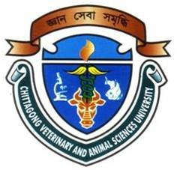

A Report
By

_______________________
(MD. IMRAN AHMED)
Roll No: 2007/47, Reg. No: 334
Internship ID: E-43, Session: 2006-2007

Submitted in partial of the requirement for the fulfillment of the degree of
Doctor of Veterinary Medicine (DVM)

Approved as to style and content by

___________________________
(MD. EMRAN HOSSAIN)
Associate Professor
Department of Animal Science & Nutrition
Chittagong Veterinary and Animal Sciences University
Khulshi, Chittagong-4202

February, 2013
Vegetable wastes as an alternative to conventional feeds
for the livestock of Bangladesh

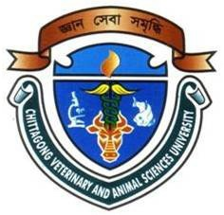

A Report
By

Roll No: 2007/47, Reg. No: 334
Internship ID: E-43, Session: 2006-2007

Submitted in partial of the requirement for the fulfillment of the degree of
Doctor of Veterinary Medicine (DVM)

Approved as to style and content by

____________________________
(MD. EMRAN HOSSAIN)
Associate Professor
Department of Animal Science & Nutrition
Chittagong Veterinary and Animal Sciences University
Khulshi, Chittagong-4202

February, 2013
Vegetable wastes as an alternative to conventional feeds
for the livestock of Bangladesh

INDEX

Contents | Page No.
1. Abstract | 1
2. Introduction | 1-2
3. Materials and Methods | 2-3
3.1 Study area | 2
3.2 Collection of sample | 2
3.3 Preparation of sample | 2
3.4 Analysis of sample | 3
3.5 Calculation of ME | 3
3.6 Data analysis | 3
4. Results and Discussion | 3-9
4.1 Bean leaf (Lablab purpureus) | 4
4.2 Bottle gourd (Lagenaria siceraria) | 4-5
4.3 Brinjal peel (Solanum melongena) | 5-6
4.4 Banana peel (Musa sapientum) | 6
4.5 Pithraj leaf (Aphanamixis polystachya) | 6-7
4.6 Potato peel (Solanum tuberosum) | 7-8
4.7 Pumpkin peel (Cucurbita moschata) | 8
4.8 Sal leaf (Shorea robusta) | 8-9
4.9 Tiger’s claw leaf (Erythrina variegata) | 9
5. Conclusion | 9-10
6. References | 10-13

Vegetable wastes as an alternative to conventional feeds
for the livestock of Bangladesh

- Abstract
________________________________________________________________

The study was undertaken during 16th July to 16th November 2012 to observe the chemical composition of different types of vegetable wastes available in Rangunia upazilla of Chittagong district, Bangladesh. Total 11 (6 vegetable peel/skin and 5 leaves) different types of feed samples were collected from the study areas. Chemical analyses of the samples were carried out in triplicate for moisture, dry matter (DM), crude protein (CP), crude fiber (CF), nitrogen free extracts (NFE), ether extracts (EE) and total ash in the animal nutrition laboratory, Chittagong Veterinary and Animal Sciences University, Chittagong, Bangladesh. Results indicated that, all samples had substantial amount of proximate components that might have been used as alternative feed resource for dairy cattle. Crude protein content in bottle gourd peel was 7.0 g/100g, pumpkin peel 16.5 g/100g, brinjal peel 12.3 g/100g, potato peel 13 g/100g, green banana peel 7g/100g, ripe banana peel 6.8g/100g, bottle gourd leaf 33.6 g/100g, bean leaf 28.2 g/100g, tiger’s claw leaf 18.4 g/100g, sal tree leaf 16.3 g/100g and pithraj leaf 15.3 g/100g. It could therefore, be inferred that, these vegetable wastes might be used as an alternative feed resource for dairy animals in scarcity of traditional feeds if available at cheaper price.
________________________________________________________________

Key words: Vegetable wastes, moisture, dry matter, crude protein, crude fiber, nitrogen free extracts, ether extracts and total ash

2. Introduction

The economy of Bangladesh is mainly based on Agriculture. Livestock plays a crucial role in the agricultural economy. About 36.0 percent of the total animal protein comes from the livestock products in our everyday life. Around 25 percent peoples of the country are directly engaged in livestock sector, and 50 percent peoples are partly associated in livestock production. The contribution of livestock sub-sector to the GDP was 2.95 percent, which was estimated about 17.32 percent to agriculture. The growth of GDP for livestock was 7.23 percent. Bangladesh has 24 million cattle, out of which 6 million are dairy cattle of local and crossbreds (DLS, 2008).

The majority of the dairy cattle are in the hands of smallholder dairy producers. The country has one of the highest cattle densities of 145 large ruminants/square kilo meter compared with 90 for India, 30 for Ethiopia, and 20 for Brazil (Karim, 1997). The numbers of dairy farms are estimated at about 1.4 million with an average herd size of 1-3 cows (Hemme, 2008). Dairying is a part of the mixed farming systems in Bangladesh (Saadullah, 2001) and a predominant source of income, nutrition and jobs (Miyan, 1996; Haque, 2009). Dairying is also considered a powerful tool to develop a village micro economy of Bangladesh (Shamsuddin et al., 2007) to improve rural livelihoods and to alleviate rural poverty.

Nevertheless, the higher price and acute scarcity of conventional feeds are two major constraints to the profitable commercial dairying. Replacing traditional feeds to unconventional feeds can be beneficial for the farmer. Using shrub, tree leaves, tender shoots and twigs as fodder is a traditional practice in the villages. Recently, there has been increasing recognition of the use of shrub and tree fodder as livestock feed (Saadullah, 1989). Therefore, current study was undertaken to find out the chemical composition of different types of vegetable wastes that could be used as potential unconventional feeds for livestock.

3. Materials and Methods

3.1 Study area

Rangunia is a sub-district of Chittagong. There are lots of small and large dairy farms in Rangunia. Small dairy farm owner mostly practicing the use of unconventional feed. Therefore, that place is selected as the study area for collection of sample.

3.2 Collection of sample

Samples were collected by using simple random sampling technique. Total 11 different types of unconventional feeds were selected randomly. Approximately 2000 grams of each sample were collected. Samples were wrapped up by polythene bag and preserved in the laboratory for chemical analysis.

3.3 Preparation of sample

Samples were subjected to grinder to make it homogenous powder. Later on, it was mixed properly and exposed to shade to cool down for sampling. Individual samples were identified by marker and subjected to chemical analyses.

3.4 Analysis of sample

Chemical analyses of the samples were carried out in triplicate for moisture, DM, CP, CF, NFE, EE and ash in the animal nutrition laboratory and PRTC laboratory in Chittagong Veterinary and Animal Sciences University, Chittagong, Bangladesh as per AOAC (1994).

3.5 Calculation of ME

Metabolizable energy (ME) was calculated separately for all 11 different samples. Calculation was performed by using the mathematical formula as per Lodhi et al. (1976).

3.6 Statistical analysis
Data related to chemical composition of unconventional feeds were compiled by using Microsoft Excel 2007. Chi-square (χ²) test was performed to analyze the data by using SPSS 16.0. Statistical significance was accepted at 5 % level (P<0.05).
4. Results and Discussion

Chemical composition of these unconventional feeds particularly, moisture, dry matter (DM), crude protein (CP), crude fiber (CF), nitrogen free extract (NFE), ether extract (EE) and total ash contents in different samples have been presented in Table 1.

Table 1. Chemical composition (g/100g) of the unconventional feeds.

English name | Scientific name | ME$ | DM | CP | CF | EE | NFE | ASH
Bean leaf | Lablab purpureus | 2510.4 | 18.8 | 28.2 | 15.7 | 3.5 | 41 | 11.6
Bottle gourd leaf | Lagenaria siceraria | 2470.1 | 8.1 | 33.6 | 11.2 | 4.2 | 32.8 | 18.2
Bottle gourd peel | Lagenaria siceraria | 2278.1 | 6.6 | 7.0 | 23.0 | 2.1 | 58.3 | 9.6
Brinjal peel | Solanum melongena | 2231.2 | 10.5 | 12.3 | 26.8 | 1.6 | 52.7 | 6.6
Green banana peel | Musa sapieutum | 2659.5 | 11.7 | 7.0 | 24.1 | 6.0 | 54.1 | 8.8
Pithraj leaf | Aphanamixis polystachya | 2879.5 | 64.0 | 15.3 | 18.5 | 11.1 | 48.0 | 7.1
Potato peel | Solanum tuberosum | 2594.4 | 16.3 | 13.0 | 12.5 | 0.9 | 64.6 | 9.0
Pumpkin peel | Cucurbita maxima | 2704.8 | 13.3 | 16.5 | 14.8 | 1.9 | 62.2 | 4.6
Ripe banana peel | Musa sapieutum | 2634.8 | 7.7 | 6.8 | 16.8 | 7.8 | 56.5 | 12.1
Sal leaf | Shorea robusta | 2764.1 | 64.1 | 16.3 | 14.2 | 4.3 | 58.8 | 6.4
Tiger's claw leaf | Erythrina variegata | 2715.5 | 71.6 | 18.4 | 16.1 | 6.0 | 51.4 | 8.1
Level of sig. |  | *** | *** | *** | NS | * | NS | NS
$Metabolizable energy (Kcal/kg); ^{DM}Dry matter; ^{CP}Crude protein, ^{CF}Crude fibre, ^{NFE}Nitrogen free extract, ^{EE}Ether extract; ^{NS}Non-significant (P>0.05); *Significant at 5 % level (P<0.5); ***Significant at 0.1 % level (P<0.001)

In present study ME, DM, CP, CF, EE, NFE, ASH were determined for some selected unconventional feeds to make a decision whether they could be suitable for an alternative supplement of traditional feed.

4.1 Bean leaf (Lablab purpureus)

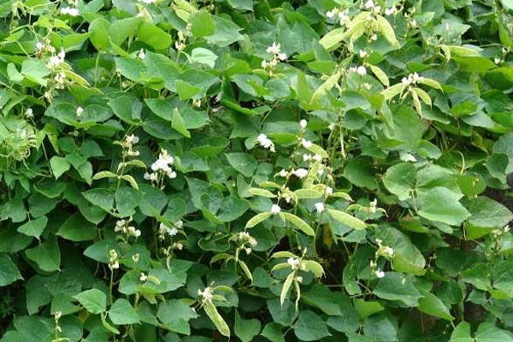
Scientific name is Lablab purpureus. It is an annual or short-lived perennial dual-purpose legume. It belongs to the family Fabaceae and genus Lablab. grown in the tropics. The seed and immature pods can be used for human food (Purseglove, 1968) while the herbage is used as a feed supplement for ruminant grazing during the dry season (Schaaffausen, 1963). Reports are however, limited on its use as a feed resource for monogastric animals. In present study, bean leaf contained 2510.4 Kcal/kg ME, 28.2 g/100g crude protein, 15.7 g/100g crude fibre, 3.5 g/100g ether extracts, 41 g/100g nitrogen free extracts and 11.6 g/100g ash. In a study Lablab purpureus had 76.4 g/100g dry matter in leaf and incase of stem it was 84.1 g/100g for rongai variety (Karachi, 1997). Protein content was 25 g/100g for leaves and 11.88 g/100g for stems. Ajayi et al. (2009) found 41.8 g/100g crude fiber 26.9 g/100g DM, 18.1 g/100g CP, 28.5 g/100g CF and 2.6 g/100g EE in bean leaf. Aganga and Autlwetse (2000) reported 16.4 g/100g CP for whole plant Lablab hay. The DMD for the leaf and stem was 64.4 g/100g and 44.2 g/100g respectively.

4.2 Bottle gourd (Lagenaria siceraria)

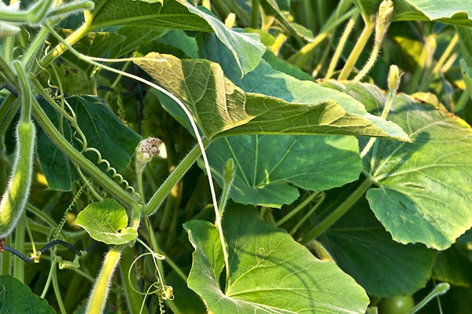
The local name of bottle gourd is Pani Lau and scientific name is Lagenaria siceraria. It is cultivated throughout our country. The fruits are eaten as vegetable. The fruits are cool and very much useful to human health in summer season. Decoction of leaves mixed with sugar is given in jaundice. Warm juice of tender stem relieves earache (Vashista, 1974). The edible portion of immature fruit is about 84 %.

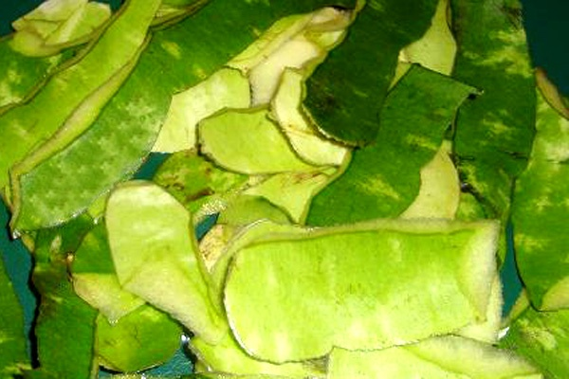
Bottle gourd with peel contains more crude fiber, acid detergent fiber, hemicelluloses, iron, phosphorus, zinc then bottle gourd without peel (Milind and Satbir, 2011). Leaves contain cucurbitacin B. Extracts of the plant have shown antibiotic activity (Gorasiya et al., 2011). In present study, bottle gourd peel contained 2278.1 Kcal/kg ME, 7.0 g/100g crude protein, 23.0 g/100g crude fibre, 2.1 g/100g ether extracts, 58.3 g/100g nitrogen free extracts and 9.6 g/100g ash and bottle gourd leaf contained 2470.1 Kcal/kg ME, 33.6 g/100g crude protein, 11.2 g/100g crude fibre, 4.2 g/100g ether extracts, 32.8 g/100g nitrogen free extracts and 18.2 g/100g ash (Table 1) However, the result of the current study is contradictory with Gopalan et al. (2004) who found DM 12.0 g/100g, CP 2.0 g/100g, CF 1.0 g/100g, EE 6.0 g/100g, ash 2.0 g/100g. Thus bottle guard could be an alternative feed source for livestock.

4.3 Brinjal peel (Solanum melongena)

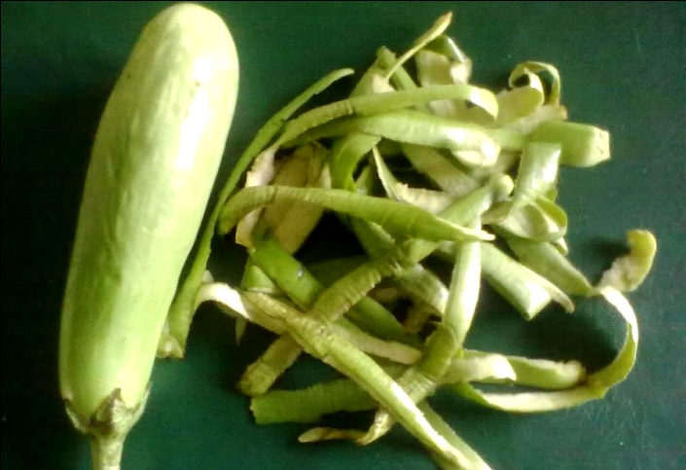
The Solanum melongena is a member of the plant family Solanaceae. The plant bears a fruit of the same name, commonly used in cooking. As a nightshade, it is closely related to the tomato and potato. It was domesticated in India from the species. Cows eating GM brinjal produced significantly (14.3%) more milk, almost as if they were treated by a light hormone in 42 days only (re.indiaenvironmentportal.org.in/files/seralini-background.doc). In present study, brinjal peel contained 2231.2 Kcal/kg ME, 12.3 g/100g crude protein, 26.8 g/100g crude fibre, 1.6 g/100g ether extracts, 52.7 g/100g nitrogen free extracts and 6.6 g/100g ash.

4.4 Banana peel (Musa sapientum)

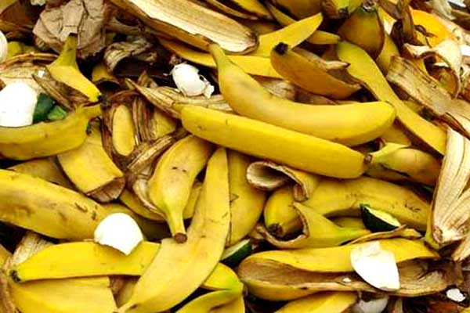
Scientific name Musa sapientum. This is a herbaceous plant of the family Musaceae. It is a fast-growing plant with a 3-5 m high stem and almost every part of it is usable. According to Leslie (1976), it is now cultivated throughout the tropics. Akinyosoye (1991) reported that the plant is cultivated primarily for its fruits and to a lesser extent for the production of fibre. The peel has been reported to be useful in making banana charcoal, an alternative source of cooking fuel in Kampala. Kudan (1973) reported that the peels in conjunction with other substances create a liniment for reducing acuteness of the arthritis and pains. The proportion of the banana which is wasted as peel is 18-20 % (Dividich et al., 1976). The nutritive value of ripe banana peel was slightly better than the almost ripe and green peel (Tartrakoon et al., 1999).

In present study, green banana peel contained 2659.5 Kcal/kg ME, 7 g/100g crude protein, 24.1 g/100g crude fibre, 6 g/100g ether extracts, 54.1 g/100g nitrogen free extracts and 8.8 g/100g ash. Ripe banana peel contained 2634.8 Kcal/kg ME, 6.8 g/100g crude protein, 16.8 g/100g crude fibre, 7.8 g/100g ether extracts, 56.5 g/100g nitrogen free extracts and 12.1 g/100g ash. The result is inconsistent with Tartrakoon et al. (1999) who found ME 4383 Kcal/kg, DM 91.62 g/100g, CP 5.19 g/100g, CF 11.58 g/100g, EE 10.66 g/100g, Ash 16.30 g/100g, for green banana peel and ME 4593 Kcal/kg, DM 95.66 g/100g, CP 4.77 g/100g, CF 11.95 g/100g, EE 14.56 g/100g, Ash 14.58 g/100g, for ripe banana peel. Thus, properly processed banana peel could be a good source of unconventional feed for livestock (Anhwange, 2008).

4.5 Pithraj leaf (Aphanamixis polystachya)

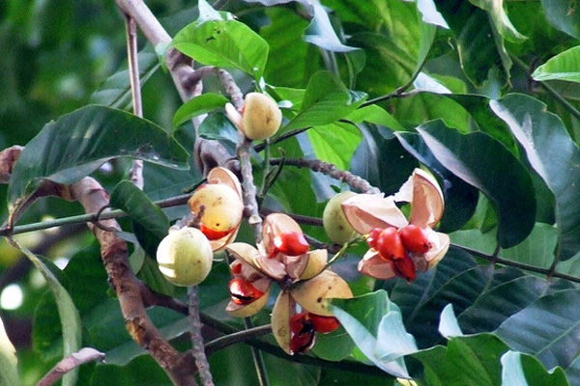
It belongs to Meliaceae family. Scientific name is Aphanamixis polystachya. This is a large tree with bunches of rounded lobular fruits and glossy deep brown seeds, grows wild and planted in forests and roadsides all over the country (Ghani, 2003). The plant is extensively used in traditional system of medicine for various ailments in different Asian countries like spleen and liver complications, tumors, rheumatism. The plant is reported to possess antitumor (Rabi and Gupta, 1995), hepatopro-tective (Gole and Dasgupta, 2002), insecticidal (Talukder and Howse, 1993), antibacterial, antifungal and immuno-suppressive (Ghani, 2003) activities. Leaves contain diter-pene alcohol and beta-sitosterol, seeds yield polystachin, an alkaloid, a glycoside and a saponin (Ghani, 2003). In present study, the pitraj leaf contained 2879.5 Kcal/kg ME, 15.3 g/100g crude protein, 18.5 g/100g crude fibre, 11.1 g/100g ether extracts, 48.0 g/100g nitrogen free extracts and 7.1 g/100g ash.

4.6 Potato peel (Solanum tuberosum)

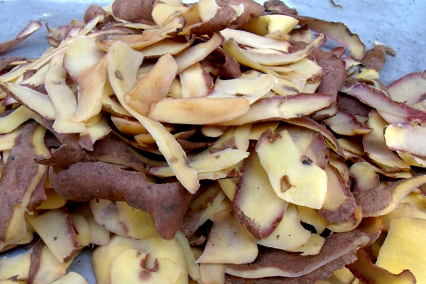
The potato is starchy, tuberous crop from the perennial Solanum tuberosum of the Solanaceae family. Potato plants are herbaceous perennials that grow about 60 cm high. During the peeling process, 30 to 40 % of the potatoes and vegetables become waste. Waste generated by peeling commonly called peeling Potato peels contain an array of nutritionally and pharmacologically interesting components such as phenolic compounds, glycoalkaloids, and cell wall polysaccharides, which may be used as natural antioxident, precursors of steroid hormones, and dietary fibre. The utilization of by-products also contributes to reduce amounts of wastes and thus to sustainable production (Schieber et al., 2003). In present study, potato peel contained 2594.4 Kcal/kg ME, 13 g/100g crude protein, 12.5 g/100g crude fibre, 0.9 g/100g ether extracts, 64.6 g/100g nitrogen free extracts and 9 g/100g ash. The result is in close agreement to Boyles (2004) who found 85 g/100g moisture and also with Mahmood et al. (1998) who found 14.70 g/100g CP and 7.65 g/100g Ash.

4.7 Pumpkin peel (Cucurbita moschata)

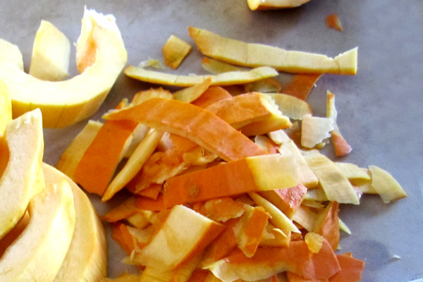
The local name is mistikumra and scientific name is Cucurbita moschata. The fruits are edible and eaten as vegetable. Mature fruits of squash gourd are used as a table vegetable for baking in pies and for making jam and also livestock feed. The flesh is usually fine-grained and mild-flavored and thus suitable for baking (Chakravarty, 1982). Besides these it is a source of Vitamin A and Vitamin C (Rahman et al., 2008). In present study, pumpkin peel contained 2704.8 Kcal/kg ME, 16.5 g/100g crude protein, 14.8 g/100g crude fibre, 1.9g/100g ether extracts, 62.2 g/100g nitrogen free extracts and 4.6 g/100g ash. So, pumpkin peel is nutritionally sound and may be good feed for livestock.

4.8 Sal leaf (Shorea robusta)

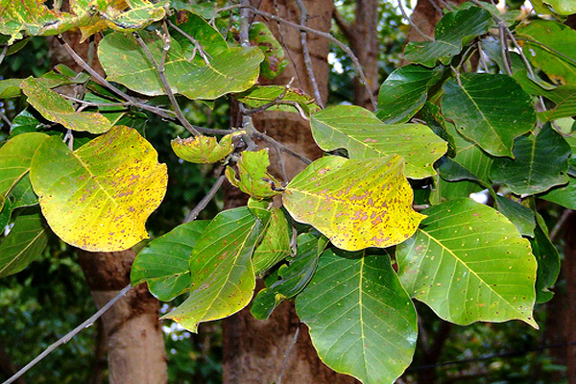
The sal (Shorea robusta) is one of the dominant tree species in tropical deciduous forests. The sal tree is a hardwood timber tree up to 30-35 m tall. The crown is spreading and spherical. Leaves are 20 cm long, simple, shiny and glabrous, delicate green, broadly oval at the base. Fruits are 1-1.5 cm large and ovoid (Orwa et al., 2009). Sal seed leaves are used as roughage of medium to poor quality (Orwa et al., 2009). The used leaves/plates are readily eaten by goats and cattle that roam the streets freely. In present study, Sal leaf contained 2764.1 Kcal/kg ME, 16.3 g/100g crude protein, 14.2 g/100g crude fibre, 4.3 g/100g ether extracts, 58.8 g/100g nitrogen free extracts and 6.4 g/100g ash which is contradictory with the other investigators (Makkar et al., 1998; Salo, 1965; Sen, 1938) who found 11.3 g/100g CP, 27.4 g/100g CF, 3.2 g/100 EE, 3.9 g/100g NFE and 6.4 MJ/kg ME.

4.9 Tiger’s claw leaf (Erythrina variegata)

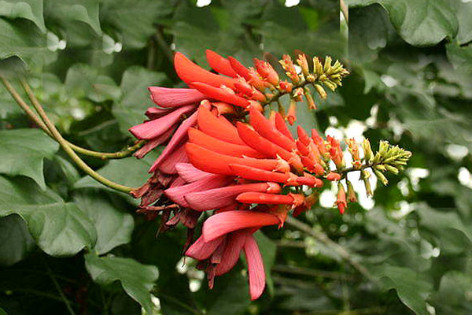
The foliage of Erythrina variegata makes an excellent feed for most livestock. A tree of average size, pruned three or four times a year,
produces from 15 to 50 kg of green fodder annually depending on growing conditions. Legume trees offer a renewable and cheap source of feed protein for ruminant animals in smallholder farms in tropical regions. Erythrina species belong to a legume family that can be found throughout the tropics (Whistler and Elevitch, 2006). The juice of fresh leaves from some Erythrina species is used in traditional medicine, where it is considered to be a sedative and an analgesic (Ratnasooriya and Dharmasiri, 1999; Deb et al., 2009). Erythrina variegata foliage has high crude protein content, 19 to 22 g/100g in dry matter (DM), and can be an excellent feed for most livestock (Kibria et al., 1994; Aregheore and Perera, 2004; Kongmanila and Ledin, 2009). Tiger’s claw leaf contained 2715.5 Kcal/kg ME, 18.4 g/100g crude protein, 16.1 g/100g crude fibre, 6.0 g/100g ether extracts, 51.4 g/100g nitrogen free extracts and 8.1 g/100g ash. The result is almost similar to (Kibria et al., 1994) who found CP ranged from 19-22 g/100g. Leaves normally contain 16 to 18 g/100g crude protein and have an IVDMD of 50 g/100g. The leaves have no known toxicity for cattle (Hegde, 1994).

5. Conclusion
Bangladesh has large livestock population. Feeding the draught animals as well as milch animals is the priority for rationing the available feed stuffs. The available feed stuffs are mainly crop residues, agro-industrial by products and unconventional feed stuffs. The role of unconventional feeds in ruminant nutrition continues to increase. The utilization of unconventional feeds will not only benefit the milk and beef industry but also increase the economic return. Unconventional feed can also be used during the scarcity of tradition feed.
6. References
Aganga AA and Autlwetse MN (2000). Utilization of Sorghum forage, millet forage, veldt grass and buffel grass by tswana sheep and goat when fed Lablab purpureus L. as protein supplement. Asian-Aust. J. Anim. Sci., 13:1035-118.

Ajayi FT, Babayemi OJ and Taiwo AA (2009). Mineral solubility of Panicum maximum with four herbaceous forage legume mixtures incubated in the rumen of N'Dama steers. Anim. Sci. J., 80 (3): 250-257.
Akinyosoye VO (1991). Tropical Agriculture Maemillan Publishers limited, Ibandan, pp: 65-68.
Anhwange BA (2008). Chemical Composition of Musa sapietum (Banana) Peels. J. Food Technol., 6(6):263-268.
AOAC (1994). Association of Official Analytical Chemists. Official Methods of Analysis, (17th edn). Gaithersburg, Maryland, USA.
Aregheore EM and Perera D (2004). Effects of Erythrina variegata, Gliricidia sepium and Leucaena leucocephala on dry matter intake and nutrient digestibility of maize stover, before and after spraying with molasses. Anim. Feed Sci. Technol., 111: 191- 201.
Boyles S (2004). Feeding potato processing wastes and culls to cattle. Potato processing wastes and culls_OSU Extension Beef Team Library. Ohio State University Extension. http://beef.osu.edu/library/potato.html.
Chakravarty HL (1982). Fascicles of Flora of India. Botanical Survey of India, Calcutta.
Deb S, Arunachalamand A and Das AK (2009). Indigenous knowledge of Nyishi tribes on traditional agroforestry systems. Ind. J. Traditional Knowledge, 8:41-46.
Dividich J, Ceoffory F, Canope I and Chenost M (1976). Using waste bananas as animal feed. World Anim. Rev., 20 (20):22-30.
DLS (2008). Department of livestock services. Annual report on livestock, Division of Livestock Statistics, Ministry of Fisheries and Livestock, Farmgate, Dhaka, Bangladesh.
Ghani A (2003). Medicinal plants of Bangladesh, 2nd edn. The Asiatic Society of Bangladesh, Dhaka, pp. 106.
Gole MK and Dasgupta S (2002). Role of plant metabolites in toxic liver injury. Asia Pacific J. Clin. Nutr., 11(1): 48-50.
Gopalan C, Rama Sastri BV and Balasubramanian SC (2004). Nutritive Value of Indian Foods, National Institute of Nutrition, ICMR, Hyderabad.
Gorasiya HJ, Paranjap A and Murti K (2011). Pharmacognostic and pharmacological profile of lagenaria siceraria (molina) standley: a review. Pharmacology online, 3: 317-324.
Haque SAM (2009). Bangladesh: Social gains from dairy development. In: Animal Production and Health Commission for Asia and the Pacific and Food and Agriculture Organization (APHCA-FAO) publication on smallholder dairy development: Lessons learned in Asia, RAP publication (http://www.aphca.org/publications/files/Dairy%20Lessons%20Learned%20Publication%20FINAL.pdf).
Hegde NG, BAIF (1994). Development Research Foundation, Kaindhenu, Senapati Bapat Marg, Pune 411016, India; and Karl Dalla Rosa, NFTA. http://www.winrock.org/fnrm/factnet/factpub/FACTSH/E_variegata.html.
Hemme T (2008). IFCN Dairy Report. International Farm Comparison Network. IFCN Dairy Research Center. Kiel Germany.
Karachi M (1997). Growth and nutritive of Lablab purpureus accessions in semi arid Kenya. Tropical Grasslands, 31: 214-218.
Karim Z (1997). Agriculture for 21st century in Bangladesh. In: A final draft policy report on National Livestock Development Policy, Ministry of Fisheries and Livestock, Dhaka, Bangladesh.
Kibria SS, Nahar TN and Mia MM (1994). Tree leaves as alternative feed resource for Black Bengal goats under stall-fed conditions. Small Ruminant Research 13: 217-222.
Kongmanila D and Ledin I (2009). Chemical composition of some tropical foliage species and their intake and digestibility by goats. Asian- Aust. J. Anim. Sci., 22:803-811.
Kudan MJ (1973). Encyclopedia of Fruits, Vegetables, Nuts and Seeds for Healthful Living. Parker Publishers Inc. Hattiesburg Maryland.

Leslie SC (1976). An Introduction to the Botany of Tropical Crops. 2nd edn. Longman Group Limited London, pp: 153-155.
Lodhi GN, Daulat Singh and Ichhponani JS (1976). Variation in nutrient content of feeding stuffs rich in protein and reassessment of the chemical method for metabolizable energy estimation for poultry. J. Agric Sci., 86(2): 293-303.
Mahmood AH, Greenman J and Scragg AH (1998). Orange and potato peel extracts: Analysis and use as Bacillus substrates for the production of extracellular enzymes in continuous culture. Enzyme microb technol., 22:130-137.
Makkar HPS and Becker K (1998). Do tannins in leaves of trees and shrubs from African and Himalayan regions differs in level and activity?. Agroforestry Systems, 40:59-68.
Milind P and Satbir K (2011). Is bottle gourd a natural Guard? Int. Res. J. Phar., 2(6): 13-17.
Miyan HA (1996). Towards sustainable development: The national conservation strategy of Bangladesh. Consultancy report on the livestock sector. Ministry of Environment and Forestry, Dhaka, Bangladesh.
Orwa C, Mutua A, Kindt R, Jamnadass R and Anthony S (2009). Agroforestry Database: a tree reference and selection guide version 4.0. World Agroforestry Centre, Kenya.
Purseglove JW (1968). Tropical crops (Dicotyledons) Longmans, Green and Co. Ltd. London, UK. Vol., 1:273-276.
Rabi R and Gupta RC (1995). Antitumor and cytotoxic investigation of Amoora rohituka. Int. J. Pharmacol., 33(4): 359-61.
Rahman AHMM, Anisuzzaman M, Ahmed F, RafiulIslam AKM and Naderuzzaman ATM (2008). Study of NutritiveValue and MedicinalUses of Cultivated Cucurbits. J. Appl. Sci. Res., 4(5):555-558.
Ratnasooriya WD and Dharmasiri MG (1999). Aqueous extract of Sri Lankan Erythrina indica leaves has sedative but not analgesic activity. Fitoterapia 70, 311-313.
re.indiaenvironmentportal.org.in/files/seralini-background.doc
Saadullah M (1989). Shrubs and tree fodders for farm animals. Proceedings of a workshop in Denpasar, Indonesia, 24-29 July 1989.
Saadullah M (2001). Smallholder dairy production and marketing in Bangladesh. In: Smallholder dairy production and marketing-opportunities and constraints; Proceedings of a South-South workshop held at National Dairy Development Board (NDDB) Anand, India, 13-16 March 2001.
Salo ML (1965). On the content of cell wall constituents in various plant materials. Maataloustieteellinen Aikakauskirja, 37:127-13.
Schaaffhausen RV (1963). Economical methods for using the legume (Dolichos lablab) for soil improvement, food and feed. Turialba, 13:172-178.
Schieber A, Hilt P, Streker P, Endress H-U, Rentschler C and Carle R(2003) A new process for the combined recovery of pectin and phenolic compounds from apple pomace. Innovative Food Science and Emerging technologies 4, 99-107.
Sen KC (1938). The nutritive values of Indian cattle feeds and the feeding of animals. Indian Council of Agricultural Research, New Dehli, Bulletin No. 25, 1-30.
Shamsuddin M, Alam MM, Hossein MS, Goodger WJ, Bari FY, Ahmed TU, Hossain MM and Khan AHMSI (2007). Participatory rural appraisal to identify needs and prospects of market-oriented dairy industries in Bangladesh. Trop. Anim. Health and Prod., 39:567-581.
Talukder FA and Howse PE (1993). Deterrent and insecticidal effects of extracts of pithraj, Aphanamixis polystachya (Meliaceae), against Tribolium castaneum in storage. J. Chem. Ecol., 19(11): 2463-2471.
Tartrakoon T, Chalearmsan N, Vearasilp T and Meulen UT. The Nutritive Value of Banana Peel (Musa sapieutum L.) in Growing Pigs. Deutscher Tropentag 1999, in Berlin.
Vashista PC (1974). Taxonomy of Angiosperms. P.B.M. Press, New Delhi, India.
Whistler WA and Elevitch CR (2006). Erythrina variegata (coral tree). Species Profiles for Pacific Island Agro forestry (http://www.traditionaltree.org ).

