CHAPTER I
INTRODUCTION
Milk is very valuable food, readily digested and absorbed. It consists of nutrients, which are needed for proper growth and maintenance of body. Milk and milk products form a significant part of the diet and a substantial amount of our food expenditures goes on milk and other dairy products. Human population of Chittagong metropolitan is over 3.5 million (www.ccc) and total estimated demand (250 ml/day/person) of fluid milk is 875000 litre/day. The amount of produced milk in this city area is very negligible against the demand. To meet the demand of fluid milk of such a huge human population different sources of fluid milk is available here namely as commercial farm milk, different distribution point and market milk of different brands though the quality of milk is beyond question. As a developing country Bangladesh is a low quantity milk producing nation having production of 2.11 million tons of fluid milk annually as per FAO statistics with per capita production of 13 kg/ capita/year. (http://www.fao.org). According to the most recent data of DLS milk production of Bangladesh is 2.27 million tons (DLS, 2004-2005). The total number of cattle population is 22.87 million and the total numbers of the registered dairy farms are 5364 in all over Bangladesh. (http://www.dls.gov.bd/about_us.htm).According to FAO statistics in 2002 Bangladesh produced 0.35 percent of total world milk production. This represents around 6.7 and 2.5 percent of the milk production of Pakistan and India respectively or less than 2 percent of the milk production of South Asia. According to Bangladesh burrow of statistics the in 1996 the total milk production was 1.57 million metric tons and demand 240 gm/person/day, where as availability is only 37 gm per capita per day (BBS, 1997). So, Most of the people of our country have been suffering from malnutrition, especially protein, calcium and vitamin deficiency. Bangladesh has to import around 250,000 tons of milk equivalents annually to satisfy national milk demand. But adding of adulterate and preservative is a great problem in Bangladesh.
Adulteration means mixing something impure with something genuine, or an inferior article with a superior one of the same kind. It usually refers to mixing other matter of an inferior and sometimes harmful quality with food or drink intended to be sold. The supplied milk is generally found adulterated (Islam et al. 1984). This adulterated milk may cause various diseases to the consumers. For this reason it is important to examine adulteration of milk in details.
The most common adulteration is to addition of water in milk but more sophisticated adulteration are practiced as e.g. adding starch or flour, cane sugar, low priced powder milk, vegetable oil etc. to increase total solids (FAO, 1984).The detection of the adulterants in milk has been approached by the scientists in number of ways. Firstly by knowing the physical and chemical properties (Specific gravity, water, Fat, SNF and TS) and their percentage in milk and then detect the abnormalities in proportion. In this way market milk can be examined for adulteration of water or skimming of milk (removal of fat). The variation in the standard physical property of milk helps to suspect the adulterants present in the milk. On the other hand, presence of flour, sugar, milk powder and starch can be tested chemically. Thus, the known adulterants of the milk can be detected physically and chemically.

There is a wide range of gap between production and requirement of milk. Dishonest producers, middlemen and vendors increase the volume of milk by various ways like by adding water with other solid materials. Dry milk powder and flour are usually added in milk after adulteration with water. It is difficult to determine this type of adulteration through visual observation. Sometimes goat or buffalo milk are mixed with cow milk. Occasionally chemical preservatives and coloring agents are added to milk. Sometimes milk fat is withdrawn from milk. All of these are known as adulteration of milk.
The natural preservatives of milk are lactoperoxidase, thiocynate and hydrogen peroxide (FAO, 1999). As we know the commercial life of milk ranges from 4.5 to 6 hours in our country depending upon hygienic quality of milk and environmental temperature. In order to prevent the loss of commercial life sometimes preservatives are being used in raw milk in different areas of Bangladesh. Generally hydrogen peroxide, banana leaves, water hyacinth, formalin, L.P-system, carbonates and bicarbonates, boric acid and borax etc are used. Among these some are very harmful for human health.
There is always a chance of adding preservatives with the raw milk by the middlemen/baperies for keeping the shelf life of the milk for longer time. In the retailing practice in the Chittagong Metropolitan area the collected non brand packed milk is sold directly to the consumers or stored in deep freeze (0 to -2⁰ C) for further sales.
This type of study conducted limited in Bangladesh. So research work related to this topic must be conducted more times in various seasons.

Objectives of the Study:
1. Detection of the physical and chemical quality of farm produced milk (FPM), different distributing point milk (DPFM) and brand milk(BM) of different areas of Chittagong Metropolitan.
2. Detection of type of adulteration in milk.
3. Detection of type of preservatives added in milk.

CHAPTER II
Review Of literature

Milk has always been a source of quality food from the pre- historic time. It is well known that milk is almost perfect food for all mammalian including human being. Several hundreds of research work has been conducted in relation with the quality of the milk and its marketing frauds through the world. Some work has done in Bangladesh also. Important findings of that research works in connection to this study are reviewed in this section

2.1 Constituents of Milk
Chandan (1997) and Singh et al. (1997) showed that milk is a complex colloidal dispersion of fat globules and protein (casein, whey) in an aqueous solution of lactose, minerals, and other minor constituents. Milk is made up of 12.6% milk solids (3.7% fat, 8.9% milk solids-not-fat).
In general, the gross composition of cow's milk in the U.S. is 87.7% water, 4.9% lactose (carbohydrate), 3.4% fat, 3.3% protein, and 0.7% minerals (referred to as ash). Milk composition varies depending on the species (cow, goat, and sheep), breed (Holstein, Jersey), the animal's feed, and the stage of lactation. (http://www.milkfacts.info)

2.2 Nutritive Value of Milk
Milk is the almost perfect food of nature providing energy, protein and vitamin-minerals composition for a sustainable health. Milk is a nutrient-dense food providing a high concentration of nutrients in relation to its energy content. The energy provided by milk depends mostly on its fat and carbohydrate contents. Whole milk (3.2% milk fat) provides 150 kcal/cup (8 oz.); 2% reduced fat milk provides 121 kcal/cup; 1% low fat milk provides 104 kcal/cup; and nonfat (fat free, skim) milk provides 90 kcal/cup. The addition of nonfat milk solids, sugars, and other energy-yielding components also influence milk's calorie content. .

Walstra, P. and R. Jennees (1984) reported cow's milk is an excellent source of high-quality protein, providing varying amounts of the essential amino acids that humans cannot synthesize. Only the sulfur amino acids (methionine and cystine) in milk proteins are slightly limiting as compared with the adult's estimated requirement of essential amino acids. The protein of milk is not a single compound but includes three major proteins namely, casein (80% of total protein) and lactalbumin (18%) and lactoglobulin (2%). The essential amino acids like tryptophan and lysine are present in large quantity in milk which are deficient in vegetable protein. Besides glutamic acid present in cows milk are three times higher than in human milk, which results a reduction of cholesterol level in blood. Oratic acid of milk protein improves liver detoxification. Another content taurine is responsible for the development of immature brain tissue of mammalian young.
Jensen (1995) and Fox (1992) stated that Cow's milk protein is rich in lysine and complements many plant proteins, which normally are limited in this amino acid. Moreover because of its high quality, cow's milk protein is used as a standard reference protein to evaluate the nutritive value of food proteins.
Dionysius et al. (1997) observed that individual milk proteins have a wide range of beneficial health and functional effects. For example, antibacterial properties of peptides derived from bovine lactoferrin have been demonstrated. Also, limited evidence from in vitro and experimental animal studies indicates that milk proteins may protect against cancer. Whey proteins in particular appear to be anti carcinogenic, possibly as a result of their ability to enhance immunity.
Takada et al. (1997) detected that whey proteins increased bone strength in experimental animals.
European Dairy Association (1997) described that whey protein concentrates and isolates are used as ingredients in a number of formulated food products.
Fox (1992) showed that cow's milk is a heterogeneous mixture of proteins. About 80% of the total protein in milk is casein and 20% is whey protein. Milk also contains small amounts of various enzymes (e.g., lipoprotein lipase, alkaline phosphates, lactoperoxidase) and traces of non protein nitrogenous compounds (e.g., ammonia, urea, creatinine, creatine, and uric acid).Casein constitutes about 80% of the total nitrogen present in the milk. Alpha lactalbumin, constitutes about 3.5 % of the total nitrogen content. Milk protein is particularly rich in lysine and valine, which is poor in the cereal protein. It posses high digestibility, biological value and growth promoting value. They are about equal to human milk protein in infant nutrition.
Ziegler (1983) reported that the principal carbohydrate in milk is lactose, a natural disaccharide consisting of one galactose and one glucose unit. Lactose accounts for about 54% of the total solids-not-fat content of whole milk and about 30% of its calories (about 9% of the calories of 2% reduced fat milk). The lactose content of milk varies by species. Cow's milk contains about 4.8% lactose (12 to 12.5% lactose/cup), whereas human milk has 7% lactose (15 to 18 g lactose/cup). The higher concentration of lactose in human milk explains why lactose is used to enrich breast milk substitutes or infant formula.
Millar (1999) found that minor quantities of glucose, galactose, and oligosaccharides present in milk. Glucose and galactose are the products of lactose hydrolysis by the enzyme lactase. He assumed that galactose may have a unique role in the rapidly developing infant brain.
Wong (1988) identified that milk fat as a source of energy, essential fatty acids, fat-soluble vitamins, and several other potential health-promoting components.
It is commonly the most valuable constituent of milk. Milk fat is a natural fat with unique physical, chemical, and biological properties. This fat contributes to the appearance, texture, flavor, and satiability of dairy foods.
UPHA (1997) discussed that milk has special significance in nutrition, due to the presence of wide range of fatty acids and high content of short chain volatile fatty acids. Among animal fats, milk fat is unique because it contains a relatively high proportion of short-chain and medium-chain saturated fatty acids, many of which are not found in other fats.
German et al. (1998) identified that milk fat contains about 7% short-chain fatty acids (C4 to C8), 15 to 20% medium-chain fatty acids (C10 to C14), and 73-78% long-chain fatty acids (C16 and higher). It is easily digestible and serves as the concentrated source of energy and each gram of fat furnishes 9 calories energy, which is 2.25 times more than protein and carbohydrate. It is a carrier of fat-soluble vitamins and helps in lactose assimilation.
Parodi (1979) stated that milk fat as a natural fat with unique physical, chemical, and biological properties. This fat contributes to the appearance, texture, flavor, and satiability of dairy foods.
Minerals constitute less then 1% in milk. Milk is the important source of calcium, phosphorus and very small quantity of iron, copper, lithium, barium, strontium and silica. In normal milk chloride and lactose ratio remains fairly constant. (http://www.ars.usda.gov/main/main.htm.)

Fox (1997) and Jensen (1995) stated that milk and other dairy foods contain all of the water-soluble vitamins in varying amounts required by humans. Milk is fairly a good source of vitamins such as thiamine and riboflavin. Except vitamin C it provides particularly all the ingredients necessary to promote and maintain life. Enzymes found in the milk include lipase, alkaline phosphatase, acid phosphatase, xanthinie oxidase, peroxidase, protease, amylase, catalase and lactase.

2.3 Physical Parameters of Milk
Islam et al. (2002) stated that milk is yellowish white in color as physical parameter. He reported that milk samples collected from BAU university dairy farm showed 80% yellowish white and 20% of the samples had whitish color.
Eckles et al (1951) reported that color of the milk depends upon the breed, amount of fat and solids present and on the nature of feed consumed by cow.
Islam et al (2002) conducted a study and suggested that proper hygienic measure during milking and not using odd flavored feed prior milking produces milk with normal flavor.
Water form the largest fraction of milk and ranges from 80 to 90% depending upon the species and breed. Water serves as a carrier for all the constituents of milk. (http://www.milkfacts.info)
Debnath et al. (2009) found in their study that the specific gravity of milk from different sources from Chittagong metropolitan area varied from 1.025 to 1.028 and vendor supplied rural milk had the lowest value of it.
Azad et al. (2007) demonstrated in a comparative study that the specific gravity of milk do not significantly differs in different month of the year. The maximum, minimum and average specific gravity of milk obtained from Bhaghabarighat area was 1.0288(February), 1.0262 (October) and 1.0260 respectively.
Rahman (1995) reported in his study that the specific gravity of milk were 1.025±.001, 1.023±.001, 1.023±.001 from Manikjonj Chilling plant, Takerhat Pasteurization plant and Baghabarighat Dairy Plant respectively.
Islam (1993) found the average specific gravity of milk was 1.0276±0.001.
Islam et al. (1984) reported that the specific gravity of milk obtained from BAU Dairy Farm and Local market were 1.031 and 1.026 respectively. He stated that Lower specific gravity indicates that milk was adulterated with water. Milk Fat has some influence on the specific gravity of milk. As the higher fat content of milk, the lower will be the specific gravity.
Eckles et al. (1951) demonstrated the normal range of specific gravity of whole milk is 1.027 to 1.035 with an average of 1.0320.

2.4 Chemical parameters
Debnath et al. (2009) demonstrated in his experimental study that the butter fat of milk from different sources from Chittagong metropolitan area varied from 3.52 to 4.01 and vendor supplied rural milk had the highest value of it.
Rahman (1995) observed that the average fat% of milk samples collected from Baghabarighat Dairy plant was 4.28±0.028.
Talukdar (1989) observed indigenous dairy cow’s milk of Trishal Thana of Mymensingh District contained 4.72% fat.
Judkins and Keener (1960) reported that the average fat% of milk sample was 2.5 to 8.0%.
PFA Rules (1976) published that to the market milk should contain at least 4.0% fat in Chandigarh and in Haryana and punjab, 3.5% fat and 8.0% SNF.
IDRI annual report (1948) showed that commercially fat is the important constituents of milk. It is also the most variable fraction in milk. The average percentage of milk of Holstein Friesian is 3.5%, Sindhi 4.9%, Shahiwal 4.5%.
Debnath et al. (2009) studied SNF% 8.33, 7.98, 7.85, 8.2 from farm produced milk, vendor supplied farm milk, and vendor supplied rural milk and brand market milk respectively in Chittagong metropolitan area.
Rahman (1995) observed that the average SNF content of milk collected from Pasteurization Plant and Baghabarighat Dairy Plant were 6.67%, 7.2%, 7.04% and 7.96% respectively.
The milk solids-not-fat contains protein (3.4%), lactose (4.8%), and minerals (0.7%). (http://www.milkfacts.info)
Islam et al. (1984) also reported that lower SNF% in local market milk than that of the milk from BAU Dairy Farm, Mymensingh.
USPHS (1965) and Itzerot (1960) described milk contains minimum 8.5% solids-not-fat.
Panero (1975) proposed that, if the milk is not adulterated the SNF should be more than equal to lactose+protein+0.7.
Judkins and Keener (1960) reported that the normal acidity of market milk may range from 0.08 to 0.23 percent.

2.5 Adulteration and Preservative of Milk
Debnath et al. (2009) found in his experimental study that 45.83% of vendor supplied farm milk and 31.56% of vendor supplied rural milk was adulterate with water.
Pal et al. (1989) demonstrated that added sugar in milk is a very common adulteration problem in dairy industry. Addition of sugar with the milk increase SNF in milk. Addition of 0.2% sugar in milk increase lactometer reading by one degree of 60⁰ F.
Ding and Chang (1987) raw milk is often adulterated with dried milk and one of the commonest forms of adulteration of fresh milk sold in summer time in Taiwan.
Fox and Gruffest (1986) studied the effect of sodium chloride of milk. They examined that the pH of raw bulk milk decreased from 6.62 to 6.40 with increasing addition of NaCl up to 500mµ.
Hussain, (1987) found moida (Flour) was one of the common adulterants used by the Goala. Admixture of milk with Moida (flour) reacted with iodine solution and formed blue color.
Islam et al. (1984) tested the quality of fluid milk available in Mymensingh Town. The market sample tested get significantly (p>0.01) higher percentage of water than the controlled sample collected from BAU Dairy Farm. But the total solids, solids not Fat, Lactose and protein in Market samples were found significantly (p>0.01) lower than collected samples. Acidity and ash content for the market samples were found slightly lower than controlled samples.
The Pennsylvania Department of Agriculture has adopted a regulation which states that milk with freezing point above -0.525⁰ C is considered, unless proved to be free of water.
Barmand (1978) studied the adulteration of raw milk, he examined 500 samples which shown that 0.22% had a freezing point above-0.525⁰ C which is an indication of adulteration of milk with water.
Rangappa and Acharya (1974) conducted test result showed that 76% of the collected samples were impure and Admixture of water with milk was one of the most common adulterants.
Agarwala and Sharma (1961) stated addition of water, skimming and watering reduces that fat .They reported that addition of water not only involves the dilution of the milk but also the danger of introducing germs with polluted water.
Campbell and Marshall (1961) stated adulterants of milk are often toxic to human health.
Debnath et al. (2009) conducted a study to detect the preservative used in different sources of milk in Chittagong metropolitan area. He found that 10.52 % of the vendor supplied rural milk was tainted with formalin.

CHAPTER III
Materials and Methods

The experiment was conducted at the Dairy science and Laboratory under the Department of Dairy and Poultry Science, Chittagong Veterinary and Animal Sciences University.
3.1 Collection of Sample:
Two types of sample namely farm produced milk (FPM), different distributing point milk (DDPM) and brand milk (BM) of different brands were collected from dairy farms, vendors, and retail shops, respectively from different areas of Chittagong Metropolitan.
3.1.1 Duration of Study: 20th September to 12th December’2012
3.1.2 Number of Samples:
A total of 65 samples were collected for this study.
3.1.3 Procedure of sampling:
The samples were collected from bulk sources of milk through proper mixing. Soon after collection samples were kept in cool box for ceasing the activity of acid forming microorganism.

Fig : Layout of sample collection.

The farm produced fluid milk samples were collected directly from selected farms after completing milking from Khulshi area, Chittagong. The volume of each sample was 500ml.
In case of samples of different distributing point milk (DDPM) were collected from different selective point and from selective person. The volume of each sample was 500ml.
In case of the brand milk (BM) the samples were collected from retail shops, cooling corners and departmental shops of the selected area. The half litter (500ml) packets were procured in this case.

3.2 Methods followed for milk testing:
Due to the collection and sampling procedure the collected milk samples were kept in the refrezarator at 4⁰ C until test were conducted. The cooled milk samples were pre warmed for few minutes to regain room temperature.

- Chemical composition (specific gravity, fat percentage, protein percentage, lactose percentage) was determined by Lactoster machine (Germany).
- Preservative detection tests were done by Milk testing-rapid examination (ISI, 1960)
- Adulteration detection tests were done by the procedure given Milk testing rapid examination (ISI, 1960)

Data Management:
Data management was conducted by using Microsoft Excel program.
SPSS 11.5 statistical software was used for the analyzing purpose. (Source: web page -http://www-01.ibm.com/support/docview.wss?uid=swg21592093)

PHOTO GALLERY
Image 1: Collection of milk sample from Monzu dairy.

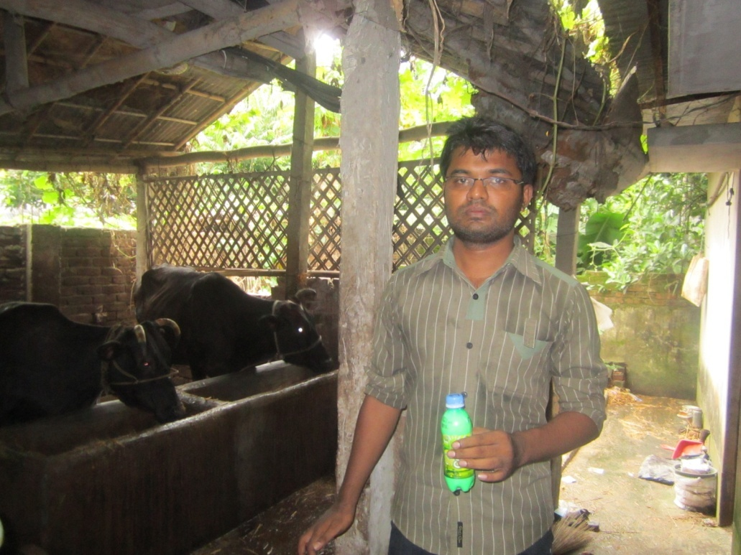
Image 2: Collection of milk sample from Subas dairy.
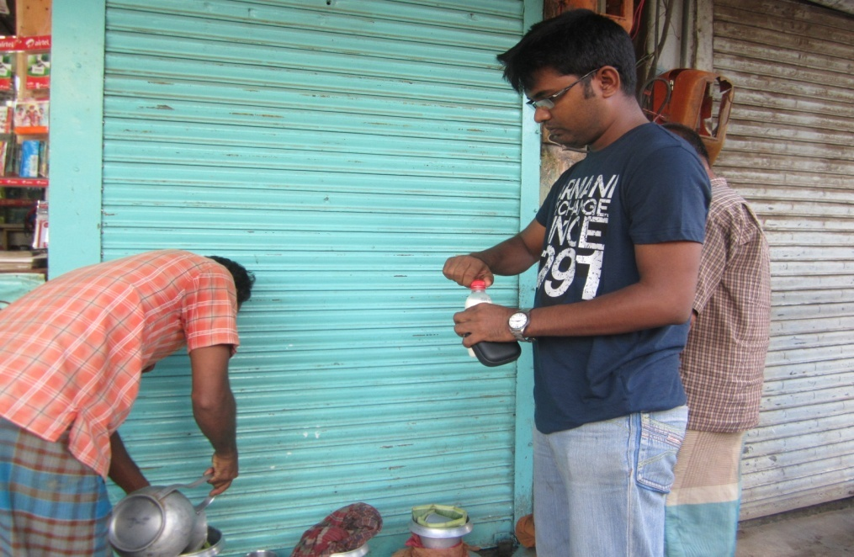
Image 3: Collection of milk sample from Solasahar.

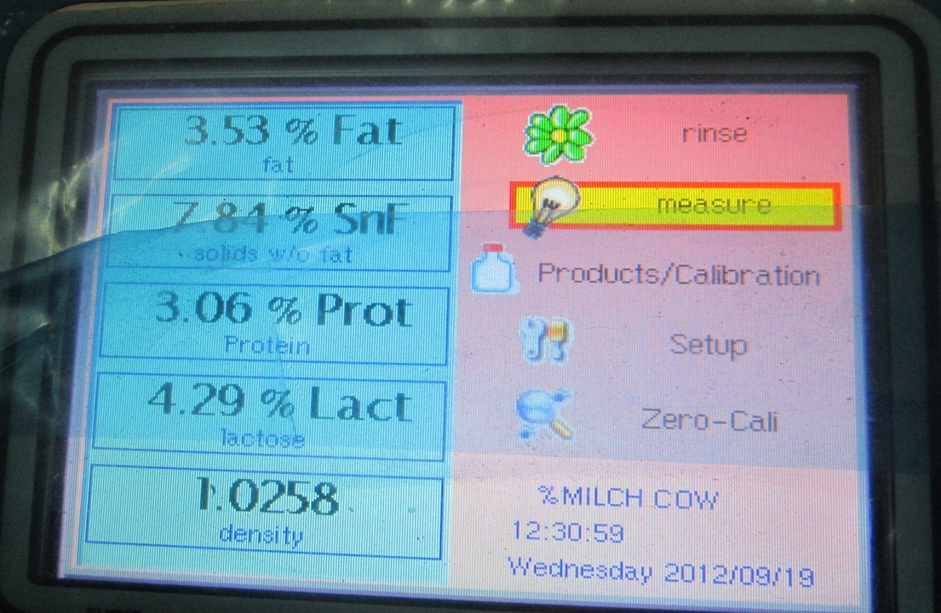
Image 4: Determination of milk composition by Lactostar machine.

SAMPLE COLLECTION MAP`

CHAPTER IV
RESULTS & DISCUSSION

4.1 Physical and Chemical Quality
4.1.1.Chemical quality
4.1.1.1. Farm milk:
Table: 1 shows that the average specific gravity of farm milk is ( 1.030± 0.017) which ranges from 1.028 to 1.035.Highest specific gravity found in Subas dairy (1.035±0.009) and lowest in Saleh dairy (1.025±0.002). De, S. (2000) reported that specific gravity of farm milk of all area remained within the normal range of specific gravity of milk. This results also agrees with research findings of Islam et al. (1993) and Eckles et al. (1951).

The average BF content of farm milk is (3.78±0.33)% which ranges from 2.17% to 4.44%. Highest BF found in Monzu dairy (4.07±0.14)% and lowest in CVASU farm (3.16±0.35)%. This results agrees with Debnath et al. (2009).

The average SNF content of farm milk is (8.34±0.57)% which ranges from 7.63% to 9.20%. Highest SNF found in Monzu dairy (8.62±0.33)% and lowest in CVASU farm (7.95±1.010). This results agrees with Debnath et al. (2009).

The average protein content of farm milk is (3.36±0.22. )% which ranges from 2.98 % to 3.44%. Highest protein found in Monzu dairy (3.51±0.11)% and lowest in CVASU farm (3.19±0.39). Eckles et al. (1951) stated that milk should contain 3.80% protein which agrees with our result.

The average lactose content of farm milk is (4.48±0.46)% which ranges from 4.13% to 5.09%. Highest lactose found in CVASU farm (3.51±0.11)% and lowest in Kader dairy (4.38±0.095)%. Eckles et al. (1951) stated that milk should contain 4.80% lactose. Our result is little lower may be due to breed variation.

Table 1: Nutritional and chemical composition of different farm milk (mean±standard error).
Name of the farm | Specific gravity | BF% | SNF% | Protein% | Lactose%
Monzu dairy | 1.021±0.001 | 4.07±0.14 | 8.62±0.33 | 3.51±0.11 | 4.675±0.45
Subas dairy | 1.035±0.009 | 3.62±0.55 | 8.22±0.33 | 3.34±0.20 | 4.59±0.49
Saleh dairy | 1.025±0.002 | 4.33±0.85 | 8.43±0.72 | 3.27±0.09 | 4.49±0.26
Kader dairy | 1.027±0.002 | 3.69±0.41 | 8.50±0.48 | 3.47±0.30 | 4.38±0.09
CVASU farm | 1.034±0.002 | 3.16±0.35 | 7.95±1.010 | 3.19±0.39 | 4.68±0.52
AVERAGE | 1.030±0.017 | 3.78±0.33 | 8.34±0.57 | 3.36±0.22 | 4.48±0.46
Level of significance | NS | NS | NS | NS | NS
NS=Non significant

4.1.1.2. Brand milk:

Table: 2 shows that the average specific gravity of brand milk is (1.027±0.005 ) which ranges from 1.024 to 1.029. Highest specific gravity found in Milk vita (1.029±0.009) and lowest in Farm fresh (1.026±0.003). This results agrees with research findings of Azad et al. (2007).

The average BF content of brand milk is (3.52±0.11)% which ranges from 3.36% to 3.77%. Highest BF found in Pran (3.65±0.04)% and lowest in Arong (3.43±0.07)%. This results agrees with standards of BSTI.

The average SNF content of brand milk is (8.23±0.38)% which ranges from 7.63% to 8.87%. Highest SNF found in Milk vita (8.62±0.33)% and lowest in Farm fresh (7.92±0.49). This results agrees with research findings of Debnath et al. (2009).

The average protein content of brand milk is (3.22±0.12)% which ranges from 3.00 % to 3.47%. Highest protein found in Milk vita (3.42±0.09)% and lowest in Farm fresh (3.15±0.17).

The average lactose content of brand milk is (4.39±0.13)% which ranges from 4.19% to 4.83%. Highest lactose found in Milk vita (4.452±0.21)% and lowest in Farm fresh (4.25±0.13)%. Eckles et al. (1951) stated that milk should contain 4.80% lactose. Our result is little lower may be due to breed variation.

Considering above data it can easily be said that milk of Milk vita is superior and milk of Farm fresh is inferior in quality among brand milk.

Table 2: Nutritional and chemical composition of brand milk (mean±standard error).
Name of the brand milk | Specific gravity | BF% | SNF% | Protein% | Lactose%
Arong | 1.026±0.001 | 3.43±0.07 | 8.13±0.25 | 3.15±0.164 | 4.41±0.13
Milk vita | 1.029±0.009 | 3.48±0.11 | 8.76±0.50 | 3.42±0.095 | 4.45±0.21
Pran | 1.027±0.006 | 3.65±0.04 | 8.11±0.12 | 3.17±0.034 | 4.44±0.19
Farm fesh | 1.026±0.003 | 3.55±0.21 | 7.92±0.49 | 3.15±0.167 | 4.25±0.15
AVERAGE | 1.027±0.005 | 3.52±0.11 | 8.23±0.38 | 3.22±0.124 | 4.39±0.17
Level of significance | NS | NS | NS | NS | NS
NS=Non significant

4.1.1.3.Different distributing point milk:
Table: 3 shows that the average specific gravity of point milk is (1.024±0.0043) which ranges from 1.012 to 1.027. Highest specific gravity found in Baddar hat (1.027±0.002) and lowest in Citygate (1.021±0.0013). This results agrees with research findings of Debnath et al. (2009).
The average BF content of point milk is (3.32±0.34)% which ranges from 2.25% to 4.5%. Highest BF found in Baddarhat (3.60±0.67)% and lowest in City gate (2.98±0.212)%. USPHS (1965) stated milk should not contain less than 3.25% fat which agrees with our result. Some sample showed lower value that was due to water adulteration.

The average SNF content of point milk is (6.89±0.32)% which ranges from 3.39% to 8.46%. Highest SNF found in Karnafuli bridge (7.5±0.23)% and lowest in Citygate (6.08±0.47). Debnath et. al. (2009) reported that 7.85% butterfat presents in distributing point milk. Our result showed lower value that was due to more water adulteration or breed variation.

The average protein content of point milk is (2.73±0.29)% which ranges from 1.52 % to 3.33%. Highest protein found in Karnafuli bridge (2.83±0.17)% and lowest in Citygate (2.51±0.33). Eckles et al. (1951) stated that milk should contain 3.80% protein which agrees with our result. Our result shows lower value due to water adulteration.

The average lactose content of point milk is (3.67±0.02)% which ranges from 2.11% to 4.53%. Highest lactose found in Karnafuli bridge (3.99±0.39)% and lowest in baddar hat (3.64±0.19)%. Eckles et al. (1951) stated that milk should contain 4.80% lactose. Our result showed lower value , that is due to water adulteration.

Considering above data it can easily be said that milk of Karnafuli bridge is superior and milk of Citygate is inferior in quality among distribution point milk.

Table 3: Nutritional and chemical composition of different distributing point milk (mean±standard error).
Name of the farm | Specific gravity | BF% | SNF% | Protein% | Lactose%
Citygate | 1.021±0.0013 | 2.98±0.21 | 6.08±0.47 | 2.51±0.33 | 3.49±0.16
Solasahar | 1.023±0.009 | 3.23±0.13 | 7.06±0.34 | 2.82±0.43 | 3.57±0.21
Baddar hat | 1.027±0.002 | 3.52±0.67 | 6.90±0.24 | 2.76±0.22 | 3.64±0.19
Karnafuli bridge | 1.025±0.001 | 3.40±0.66 | 7.50±0.24 | 2.83±0.17 | 3.99±0.34
AVERAGE | 1.024±0.004 | 3.32±0.34 | 6.89±0.32 | 2.73±0.29 | 3.67±0.23
Level of significance | NS | NS | NS | NS | NS
NS=Non significant

Figure: 2 shows comparison of nutritional and chemical composition among farm milk, brand milk and different point milk samples from this figure it can be easily understood that farm milk is superior milk among these sample considering all parameters of nutritional and chemical composition. Besides this brand milk showed standard quality of BSTI and distribution milk showed poor quality compared to farm milk and brand milk.

Figure 2: Nutritional and chemical comparison among farm milk, brand milk and distributing point milk

4.1.2. Adulteration
4.1.2.1. Farm milk
Table 4: shows that 40% sample of Subas dairy, 25% sample of Kader dairy, 20% sample of CVASU farm adulterated with percentage of water added is 5%, 4%, 4.5%, respectively. Other adulteration like starch, powder milk, cane sugar not detected in farm milk.

Table 4: Adulteration status of milk collected from different dairy farms.
Name of the farms | Type of adulterants detected in the collected samples
 | Water |  | % of added water | Starch |  | Powder milk |  | Cane sugar
 | +ve% | -ve% |  | +ve% | -ve% | +ve% | -ve% | +ve% | -ve%
Monzu dairy | 00 | 100 | Nil | 00 | 100 | 00 | 100 | 00 | 100
Subas dairy | 40 | 60 | 05 | 00 | 100 | 00 | 100 | 00 | 100
Saleh dairy | 00 | 100 | Nil | 00 | 100 | 00 | 100 | 00 | 100
Kader dairy | 25 | 75 | 04 | 00 | 100 | 00 | 100 | 00 | 100
CVASU farm | 20 | 80 | 4.5 | 00 | 100 | 00 | 100 | 00 | 100

4.1.2.2. Brand milk
Table:5 shows that in case of Farm fresh 20% sample adulterated with water and percentage of water added is 4%. Other adulteration not found in case of brand milk. All the brand milk maintain standard of BSTI.

Table 5: Adulteration status of different brand milk collected from market.
Name of the brand milk | Type of adulterants detected in the collected samples
 | Water |  | % of added water | Starch |  | Powder milk |  | Cane sugar
 | +ve% | -ve% |  | +ve% | -ve% | +ve% | -ve% | +ve% | -ve%
Arong | 00 | 100 | Nil | 00 | 100 | 00 | 100 | 00 | 100
Milk vita | 00 | 100 | Nil | 00 | 100 | 00 | 100 | 00 | 100
Pran | 00 | 100 | Nil | 00 | 100 | 25 | 75 | 00 | 100
Farm fresh | 20 | 80 | 04 | 00 | 100 | 50 | 50 | 00 | 100

Table-6: shows that all the samples collected from six different entry points were adulterated with water. The added water percentage were 18, 16, 12 and 08 in Citygate, Solasahar, Bahaddar hat, Karnafuli Bridge. The highest added water percentage (18%) was detected in Citygate sample and lowest (8%) in Bahaddar hat sample. More water adulteration in case of milk might be due to neutralize the developed acidity in milk aiming to increase the commercial life of milk as well as increase the volume of milk. This result agrees with the research findings of Das et al. (2010).
Other adulteration like starch, powder milk, cane sugar not detected in farm milk .

Table 6: Adulteration status of milk collected from different collection points.

Sample Collection Points | Type of adulterants detected in the collected samples
 | Water |  | % of added water | Starch |  | Powder milk |  | Cane sugar
 | +ve% | -ve% |  | +ve% | -ve% | +ve% | -ve% | +ve% | -ve%
Citygate | 100 | 00 | 18 | 00 | 100 | 00 | 100 | 00 | 100
Solasahar | 100 | 00 | 16 | 00 | 100 | 00 | 100 | 00 | 100
Bahaddar hat | 100 | 00 | 08 | 00 | 100 | 00 | 100 | 00 | 100
Karnafuli Bridge | 100 | 00 | 06 | 00 | 100 | 00 | 100 | 00 | 100

4.1.3. Preservatives
Preservative has not found in any sample during the study. Although Debnath et al (2009) found 10.52% of point milk tainted with formalin in Chittagong area. Our result disagrees due to seasonal variation.

CHAPTER-V
CONCLUSION
From the above discussion it may be concluded that nutritional quality of farm milk was excellent, most brand milk maintain standards of BSTI and different point milk was below standard quqlity of milk. Water adulteration was very common in CMA specially in different distribution point milk. No preservative found during the study period due to low temperature of the environment (temperature approximately 18_20ºC). Considering the quality, farm milk were superior, brand milk were standard according to BSTI and milk of different distributing points are inferior in quality.

REFERENCES

APHA (American public Health association).1984. Standard Methods for the Examination of Dairy products.
Aggarwala, A. C. and Sharma, R. M. 1961. A Laboratory Manual of Milk Inspection. 4th edition Asia Publishing House, Madras; pp.206.
Azad, M. A., Hasanuzzaman, M., Azizunnesa, Shil, G. C. and Barik , M. A. 2007. Milk Production Trend, Milk Quality and Seasonal Effect on it at Baghabarighat Milk Shed Area, Bangladesh. Pakistan Journal of Nutrition, 6: 363-365.
BBS (Bangladesh Bureau of Statistics). 1997. Statistical Year Book of Bangladesh Ministry of Planning.
BBS (Bangladesh Bureau of Statistics). 2001. Human population census, 2001.
Barnard, S. E. 1978. Freezing points and milk adulteration. Dairy Science. Abstract. 40(7): 414.
BSTI (Bangladesh Standards and Testing Institution).
Campbel, J. R. and Marshall, R. T. 1961. The Science of providing milk for man. Standard edition, Megraw-Hill Book Company, New Delhi. pp. 487-49.
Chandan, R. 1997. Dairy-Based Ingredients. Standard Paul, Minn.: Eagan Press.
Singh, H., McCarthy, O. J. and Lucey, J. A. 1997. Physico-chemical properties of milk. In: Advanced Dairy Chemistry Volume 3. Lactose, Water, Salts And Vitamins . 2nd edition, Fox, P.F. (edition). New York: Chapman & Hall. pp. 469.
De, S. 2000. Outlines of Dairy Technology. Oxford University Press, London. pp. 1-2.
Debnath, G.K., Kober, A.K.M.H. and Chanda, G. C. 2009. Quality of Fluid Milk Available in Chittagong Metropolitan Area, proceedings of the sixth annual scientific conference of CVASU, Bangladesh.
Ding, H. C. and Chang, T. C. 1986. Detection of reconstituated milk in fresh milk. Journal of Chinese Agricultural Chemical Society, 23: 406-411.
Dionysius, D. A. and. Milne, J. M. 1997. Antibacterial peptides of bovine lactoferrin: purification and characterization. Journal Dairy Science, 80: 667.
EDA (European Dairy Association) 1997. Nutritional Quality of Proteins. Brussels, Belgium.
Eckles, C., Combs, C. and Macy, H. 1951. Milk and milk products 4th edition, Mcgraw-Hill book company, New York, Toronto, London. pp. 22-23.
FAO 1984. Milk and milk products testing procedures, co-operative dairy organization and Extension programme (Phase: II) Bangladesh.
FAO 1999. Manual on the use of LP-system in milk handling and preservation, Animal Production Service, FAO Animal production and Health Division.
Fox, P. E. and Grufferty, M. B. 1997. Effect of added NaCl on some physiochemical properties of milk. Dairy Science, Abstract. 48:482.
Fox, P. F. 1992. Proteins. Advanced Dairy Chemistry, 1:52-63.
German, J. B. and Dillard, C. J. 1998. Fractionated milk fat: composition, structure, and functional properties. Food Technology, 52: 33.
ISI (Indian Standard Institution). 1984. Hand book of Food Analysis part XII-XV, ISI, Delhi.
ISI (Indian Standard Institute). 1960. Milk testing-rapid examination, 1479 (part I), ISI ,Delhi.
ISI (Indian Standard). 1958. Determination of milk fat by Gerber method (part I), ISI, Delhi.
Islam, M. N., Hussain, S.M.I and Mannan, A.K.M.A. 1993. Studies on the physical parameters and chemical qualities of market milk in Mymensingh town (Bangladesh). Banglasesh journal of Animal Science. 13: 52.
Islam, M. S., Zaman, M. M., Quadir, M. M., Hasan, M. N. and Hossain, M. I. 2002. Study on the Assessment of Chemical Qualities of Milk Produced by Primary Cooperative Societies (Milk Vita). Pakistan Journal of Biological Sciences. 5:1261-1263.
Jensen, R.G. 1995. Handbook of Milk Composition. New York: Academic Press.
Judking, H. F. and Keener H. A. 1960. Milk production and processing. 4th edition, New York. pp. 227-230.
Khurody, D. N. 1974. Dairing in India. 1st edition, Asia Publishing House, Bomday. pp. 186-193.
Miller, G. D., Jarvis, J. K. and McBean, L. D. 1999. Handbook of Dairy Foods and Nutrition. 2nd edition, Boca Raton, Fla.: CRC Press.
Pal, P. K., Battacharya, A. M., Das, M. K. and Bandyopadhyay, T. S. 1989. Rapid detection of added sugar in mlk. The Indian Journal of Dairy Science 32: 405.
Panero, R. 1975. New method for differentiating watered milk from low quality milk. Revista Espanola decrease Lecheria. 94: 235-238.
Parodi, P.W. 1976. Distribution of isomeric octadecenoic fatty acids in milk fat. Journal of Dairy Science, 59:98-103.
PFA 1976. (The prevention of the Food Adulteration Rules) New Delhi.
Rangappa, K. S. and Achaya, K. T. 1975. Indian Dairy Science, 2nd edition, Asia Publishing House, Bombay. pp. 30.
Takada, Y., Matsuyama, H., Kato, K., Kobayashi, N., Yamomura, J. I., Yahiro, M. and Aoe, S. 1997. Milk whey protein enhances the bone breaking force in ovariectomized rats. Nutrition Research, 17: 1709.
Talukder, O.G. M. 1989. A study on the physical and chemical quality of milk collected from different markets and villages of trisal Upazilla. M. Sc. Thesis, Department of Dairy Science, BAU, Mymensingh.
USPHS (United States Department Of Public Health Services). 1965. Grade “A” Pasteurized milk Ordinance.
Walstra, P. and Jennesss, R. 1984. Dairy Chemistry and Physics. A wiley Intrascience Publication. New York. pp. 107.
Wong, N. P., Jenness, R., Keeney, M. and. Marth, E. H. 1988. Fundamentals of Dairy Chemistry. 3rd edition, New York: Van Nostrand Reinhold Co.
Yadav, A. N. and Sarawant, B. L. 1982. Note on the physical and chemical qualities of Markets milk in Varanasi Town, India. Asia Journal of Dairy Research. 1: 74-76.
Ziegler, E. E. and Fomon, S. J. 1983. Lactose enhances mineral absorption in infancy. Journal of Pediatr. Gastroenterol. Nutrition. 2: 288.

