CHAPTER I
INTRODUCTION

Slaughterhouse or abattoir is a facility where animals are killed for consumption as food products. An ideal slaughterhouse fulfils the features such as antemortem and postmortem carcass inspection, hygienic management and condemnation of diseased animal to ensure the best quality consumable animal products (FAO, 1994). Therefore, slaughter house inspection is a very important responsibility of the local veterinary authority and municipality to determine whether or not the animal was suffering from any disease or disease condition that makes the carcass inconsumable.

Food animal carcasses are a possible source of several infectious zoonotic diseases such as tuberculosis, leptospirosis, salmonellosis, campylobactoriosis, anthrax, hydatidosis etc (Scott et al., 1987). The emergence of high pathogenic avian influenza (HPAI) and anthrax have made the society more concerned about the health issues and quality of slaughtered animal carcass (Tulayakul et al., 2008). FAO impose veterinary public health systems and services to strengthen veterinary supervision as well as the inspection of animal slaughter, slaughterhouse hygiene and meat (www.fao.org/foodchain).

While slaughterhouse inspection is mandatory and assessment of carcass quality is strictly followed in developed countries the scenario of underdeveloped and third world country is quite opposite (Joshi et al., 2003). In Bangladesh there were no slaughterhouses yet established with appropriate facilities; instead, traditional slaughtering places and slaughter slabs are present in municipalities and city corporations throughout the country (Alam et al., 2010).

The lung is one of the vital organs of the body and it is one of the most susceptible parts of the body for various pathological affections (McGavin et al., 2001). In carcass inspection lung gets condemned for consumption if there is any pathological evidence of significant infectious diseases or disease conditions. Lungs get affected with various diseases such as parasitic diseases like hydatidosis, verminous pneumonia; bacterial diseases such as tuberculosis, abscess, pasteurellosis; viral diseases such as rhinitis, influenza and fungal diseases like mycoplasmosis, aspergillosis are the most common infectious causes of condemnation of lung. Besides, several other pathological affections are commonly found in lung in slaughterhouses where fibrosis, abscess, atelectasis, cysts, hemorrhages, congestion, edema, and pneumonia are most common (McGavin et al., 2001).

Several factors such as species, breeds, sex, age, origin of the animal, seasonal variations etc may play role in the incidence of pathological affections of lung in slaughtered animal (Jared et al., 2010). The condemnation policy and practice may vary from country to country depending on the infection load and socio-economic condition. Therefore these factors are very impotent guideline for the meat inspectors to determine the carcass quality and to make certification standards (Herenda et al., 2000).

Bangladesh is a Muslim country while the larger part of the population is non vegetarian and largely dependent on meat based food. Cattle and buffalo are the largest source of meat in this country. Although there is 23.90 million cattle and 1.0 million buffalo in this country (DLS, 2002, Bangladesh Agricultural Census, 1977, FAO, 2002.) hundreds of thousands of live cattle and buffalo are being imported each year to meet up the increasing demand (Alam et al., 2010). The prevalence of disease and disease conditions in this animal defers largely from that of the local animal population (Kabir et al., 2010) and therefore investigation is required to identify and to ensure the quality consumption.

Several studies have been conducted on pathological affections of slaughtered carcass in different part of the world (Belkhiri et al., 2009 and Mellau et al., 2010). In Bangladesh although there are some sporadic reports from different slaughterhouses of the country (Kabir et al., 2010, Basak et al., 2011 and Ahmedullah et al., 2007) very few studies have highlighted on the incidence of pathological affections of lung.

Gross pathological examination is the most common practice to conduct slaughterhouse survey throughout the world. Hence histopathological study of the gross affections also consolidates the diagnostic precision and thereby implies positive impact on effective survey and so secure public health (Belkhiri et al., 2009).

Chittagong is the second largest metropolitan city and the economic capital Bangladesh. Chittagong City Corporation encompasses 168 square kilometer area and 5.5 million human populations. There are established slaughterhouses in Chittagong city where Firingibazar is the largest one. Yet there is no reported study on the incidence pathological affections in slaughtered carcasses from the slaughterhouses of Chittagong metropolitan.

So, considering the above facts in mind, the present study was undertaken with the following
Objectives:
- To identify the incidence of pathological affections of lung in slaughtered animals carcasses in a selected slaughterhouse of Chittagong metropolitan.
- To determine the frequency of different pathological lesions among the affected lung.
- To identify the gross and microscopic features of these lesions.

CHAPTER II
REVIEW OF LITERATURE

Pathological affections have been studied in slaughterhouses of all over the world by several researchers. But very few studies have been conducted on lung affections found in slaughterhouses. Therefore, the literature cited in different journals and publications on pathological affections of lungs and other organs are reviewed in general:

Akbor et al., (2007) studied the pathological conditions of trachea and lungs of slaughtered buffaloes in Barisal district, Bangladesh. He found that the gross tracheal lesions were were haemorrhage and congestion in lungs (16.25%), hard nodule formation (7.5%), cyst in lungs (6.25%), emphysematous lung (5%) and thickened pleura (2.5%). In histopathology, congestion (5%) and mild tracheitis (8.75%) were recorded as tracheal lesions. Histopathological examination of lungs noticed a number of conditions or lesions such as chronic interstitial pneumonia (3.75%), edema fluid (3.75%), broncho-pneumonia (3.75%), bronchitis (2.5%), bronchiolitis (2.5%), pneumonia-congested stage (8.75%), hydatid cyst (6.25%), fibrinous pneumonia (3.75%), healed nodule (7.5%), purulent broncho-pneumonia (1.25%), fibrino-purulent pneumonia (1.25%), subacute fibrinous pneumonia (1.25%), pulmonary adenomatosis (1.25%), pleuritis (2.5%) and hemosiderosis (3.75%).

Bala et al., (2011) conducted a research in Nigeria to identify Species-specific prevalence of tuberculosis in lungs in different animals. The observed prevalence was 1.6%, 0.4%, 0.3%, and 0.3% for cattle, sheep, goats and camels respectively.

Battelli et al., (2002) reported high prevalence of hydatidosis in lungs from all countries of the Middle East and Arabic North Africa.

Benito et al., (2006), Daryani et al., (2007) and Garippa et al., (2004) identified cystic Ecchinococcosis (CE) as one of the most important lung affection and important zoonotic diseases of great social importance.

Berhe (2009) observed 32.1% prevalence of pulmonary hydatidosis slaughtered cattle at Mekelle municipal abattoir, Sudan.

Elmahdi et al., (2004) reported hydatidosis has been reported to have a prevalence of 45% in camels, 3% in cattle and 7% in sheep.

Ernest et al., (2004) reported that 48% of cattle, 34.7% of goat, 63.8% of sheep and 10% of dogs were infected with E. granulosus (Cystic hydatidosis) in Tanzania.

Garippa et al., (2004) and Ibrahim et al. (2008) identified that raising small ruminants (extensive or semi extensive grazing), illegal slaughtering of the animals, and the presence of high number of dogs is the predisposing cause of high rate of hydatidosis.

Getaw et al., (2009) identified hydatidosis in 46.8% cattle, 29.3% sheep, and 6.7% goats Sudan.

Gourlay (1970) found Atelectasia and hepatization have been observed respectively at a rate of 5.03% and 2.32%.

Ibrahim et al., (2004) studied that Cystic Ecchinococcosis (CE) is an important problem for public health and the economy in many parts of the world.

Kabir et al., (2010) worked in slaughterhouses of Rajshahi district in Bangladesh and reported that the prevalence of hydatidosis was highest (26.01%) followed by fascioliasis (20.74%), amphistomiasis (19.62%). The prevalence of these diseases was higher in older animals. The prevalence of hydatidosis, fascioliasis and amphistomiasis was higher in male in case of cattle and goats. Out of 3510 examined animals, the parasitic infections due to one or more disease conditions were found in 1216 (83.28%) of 1460 cattle and 187 (30.16%) of 620 buffaloes, 738 (76.08%) of 970 goats and 189 (41.08%) of 460 sheep.
Kebede et al., (2009) found a prevalence of 34.5% (143/420) and 16% (64/400) hydatid cysts in cattle slaughtered at Bahir Dar and in Wolaita Sodo abattoir of Sudan respectively.

Mellau et al., (2010) reported that pneumonia was the leading cause of condemnation of lung in slaughterhouses and it was responsible for 4594 (30.1%), 1495 (31.4%) and 1072 (33.6%) of all the condemned lungs in cattle, sheep and goats, respectively. Anthracosis, pleurisy, melanosis and pulmonary tuberculosis were only recorded in cattle attributing to 7.3%, 6.4%, 2.9%, and 0.7% of lung condemnations.

Miazi et al., (2010) conducted a study to investigate about the prevalence of parasitic diseases in different abattoirs in selective area of Bangladesh. The overall prevalence of hydatidosis was highest (26.01%) followed by fascioliasis (20.74%), amphistomiasis (19.62%). He mentioned the diseases were higher in older animals and females. He also reported that proportional prevalence of different disease conditions in cattle was much higher in Hariana breed than those of local and crossbred cattle. According to his study buffaloes are more prevalent with different parasitic disease.

Mohamadin and Abdelgadir (2011) mentioned the highest infection rate of hydatidosis (2.8%) was found in cattle followed by sheep (1.4%). The most affected organs in cattle were the lung and liver (37.5% for each).

Moro et al., (2008) mentioned that six species have of Ecchinococcosis been recognized about which Echinococcus granulosus (which causes cystic echinococcosis), Echinococcus multilocularis (which causes alveolar echinococcosis), and Echinococcus vogeli and Echinococcus oligarthrus (which cause polycystic echinococcosis). He have shown that these diseases are an increasing public health concern and that they can be regarded as emerging or re-emerging diseases.

Njoroge et al., (2002) in Kenya found 19.4% of cattle, 3.6% of sheep, 4.5% of goats and 61.4% of camels were found infected with hydatidosis.
Rahman et al., (2006) also identified congestion, emphysema, hemorrhage, abscess and anthracosis as common affections in lung from a study of slaughtered cattle in Mymensingh town. Histopathological findings of congestion were characterized by hemorrhage, a large number of leukocytes infiltrations in the lumen of the alveoli, bronchitis, bronchiolitis, proliferation of fibrous connective tissue and hyperplasia of bronchiolar epithelia. Histopathologically, emphysema was identified by the distended alveoli with thin and atrophied alveolar walls. In anthracosis, carbon particles were found in stroma and alveolar lumen. In pleuritic lesions, there was a proliferation of fibrous connective tissue along with the infiltration of mononuclear reactive cells. Abscesses were characteristic of the accumulation of neutrophils surrounded by immature fibroblasts forming a capsule like structure.

Swai et al., (2011) reported that currently in Tanzania, there is limited documentation of zoonoses in slaughtered stock. Lack of awareness of meat-borne zoonosis can put the lives of livestock producers, abattoir workers and the general public at risk from infection.

Tappe et al., (2011) studied out of 4564 livestock, 245 (5.4%) were infected by Echinococcus granolosus, among them, 2.7% were sheep, 8.6% were cattle and 12.9% were water buffalos. The highest frequency of cysts was pulmonary type of hydatid cyst. About 38% of cysts were fertile and the other 62% were infertile. The fertility rates of hydatid cyst in sheep, was 37% for liver and 26% for lung; in water buffalo, it was 46% for liver and 44% for lung; and in cattle, it was 43% for liver and 39% for lung infection.

Valero et al., (1992) cited that 41% of the lungs had lesions consistent with infection by Muellerius capillaris, 33% with Dictyocaulus filaria, and 8% with both species. The prevalence of parasitic lesions increased with age.

CHAPTER III
MATERIALS AND METHODS

3.1. Study area and duration
This study was carried out by 28 visits to Firingibazar slaughterhouse from January to May 2012. In the month of March no visits was conducted for certain causes. All the animals slaughtered in these working days were counted and demographic data like species, age, sex, origin, body condition etc was carefully recorded.

3.2. Sampling strategy
A total of 882 animals were carefully examined at the lairage (docking area) to record the demographic data. At slaughter slabs when the carcasses are bled and completely opened, the visceral organs were thoroughly examined by close inspection and palpation. Lungs suspected with pathological affections were isolated from the carcass and washed with water for detailed gross examination. Gross pathological lesions were detected and recorded with the aid of an experienced pathologist following FAO meat inspection manual (Herenda et al. 1994). From each and every suspected lung with pathological affections, samples were collected with the help of the butcher leader and city corporation meat inspector. The tissue samples were carried to CVASU pathology laboratory in cool boxes as early as possible and fixed at 10% neutral buffer formalin for histopathological study.

3.3. Histopathological study
For histopathological study formalin fixed tissue samples were washed and dehydrated in graded ethanol and embedded in paraffin wax. Fixed tissues were sectioned at 5 μm thickness and stained with hematoxylin and eosin as per standard method (Luna, 1968).

3.3.1. Equipment and appliances for histopathology
- Sample from animals (Lungs)
- 10% neutral buffered formalin
- Chloroform
- Paraffin
- Alcohol
- Tape Water
- Xylene
- Hematoxylin and Eosin Stain
- Distilled water
- Clean Slides
- Cover slips
- Mounting media (DPX)
- Microscope

3.3. 2. Collection of tissue and tissue processing
During tissue collection the following point were taken into consideration; the tissues were collected in conditions as fresh as possible. Normal and diseased tissues were collected side by side. The thickness of the tissues were as less as possible (5mm approximately). Formalin fixed tissues were processed by following protocol.
Fixation: 10% neutral buffered formalin was added in the plastic container. (10 folds of the tissue size and weight) and fixed for 3-5 days.
Washing: The tissues were trimmed into a thin section and washed over night in running tape water to remove formalin.
Dehydration: The tissues were dehydrated by ascending ethanol series to prevent shrinkage of cells as per following schedule. The tissues were dehydrated in 50%, 70%, 80%, 95%, 100%, 100%, 100% ethanol one hour in each.
Cleaning: The tissues were cleaned in chloroform for 3 hours to remove ethanol (two changes; one and half hr in each).
Impregnation: Impregnation was done in melted paraffin (56- 60°c) for 3 hours.
Sectioning: Then the tissues were sectioned with a microtome at 5-µm thickness. A small amount of gelatin was added to the water bath for better adhesion of the section to the slide. The sections were allowed to spread on warm water bath at 40-42°C. Then the sections were taken on grease free clear slides.
Drying: The slides containing section were air dried and kept in cool place until staining.

3.3.3. Routine hematoxylin and eosin staining procedure
The sectioned tissues were stained as described below:
- The sectioned tissues were deparaffinized in three changes of xylene (three minutes in each)
- Then the sectioned tissues were rehydrated through descending grades of alcohol (three changes in absolute alcohol, three minutes in each; 95% alcohol for two minutes; 80% alcohol for two minutes; 70% alcohol for two minutes) followed by distilled water for five minutes.
- The tissues were stained with Harris hematoxylin for fifteen minutes.
- Washed in running tap water for 10-15 minutes.
- Then the tissues were differentiated in acid alcohol by 2 to 4 dips (1 part HCL and 99 parts 70% alcohol).
- Washed in tap water for five minutes followed by 2-4 dips in ammonia water until sections were bright blue.
- Stained with eosin for one minute.
- Differentiated and dehydrated in alcohol (95% alcohol: three changes, 2-4 dips each; absolute alcohol: three changes 2-3 minutes for each).
- Cleaned in xylene: three changes (five minutes each).
- Tissues were mounted with cover slip by using DPX.
- The slides were dried at room temperature and examined under a low (10X) and high (40X, 100X) power objectives.

3.4. Statistical analysis
The obtained data form gross and microscopic examination was imported, stored and coded accordingly using Microsoft Excel-2007. Chi Square test was done for determination of association between the variables by using statistical software STATA/IC-11. Significance was determined in 95% confidence interval when P<0.05.

CHAPTER IV
Results
4.1. Incidence of pathological affections in lungs:
Form 28 visits over 4 months period a total of 882 carcasses (660 cattle and 222 buffalo) examined where different types of pathological affections were found in 128(14.51%) lung. The incidence of lung affections was found higher in April-May (27.21%) month compared to that of in January (8.45%) and in February (14.03%) (Table 1). About 15.90 % cattle and 10.36% buffalo lung showed more or less pathological affections.
Table: 1. Incidence of pathological affections in lung over the study period:
Month of Visit | No. of Visits | No. Animal Slaughtered | observed Lung lesions |  |  | Overall Percentage
 |  |  | Cattle | Buffalo | Overall
January | 8 | 272 | 12 | 11 | 23 | 8.45%
February | 15 | 463 | 59 | 6 | 65 | 14.03%
April-May | 5 | 147 | 34 | 6 | 40 | 27.21%
Total | 28 | 882 | 105 | 23 | 128 | 14.51%

Table: 2. Occurrence of pathological affections in lung in different species (Cattle and Buffalo):
Observed Animal Species | No. Animal Slaughtered | No. of affected Lung | Percentage
Cattle | 660 | 105 | 15.90%
Buffalo | 222 | 23 | 10.36%
Total | 882 | 128 | 14.51%

4.2. Frequency of different lesions among the affected lungs
Based on gross examination, the frequencies of different pathological lesions in lungs are demonstrated in Figure: 1. Hydatid cysts was the most frequent affection found in 53.90% case which is followed by emphysema (30.23%), atelectasis (12.50%), pulmonary hemorrhage (12.50%), congestion (7.03%), nodular lesions (3.12 %) and abscess (0.78%). It is to be mentioned that mixed type lesions, i.e. multiple lung affections observed in many cases. The gross features of the pulmonary lesions have been demonstrated in Fig: 1.

N= Total Affected Lung =128
Figure: 1. Observed proportion of lung lesions over the study period
In the present study the most common pathological affections found in cattle lung was hydatid cyst (58.09%) which is significantly higher than Buffalo (34.78%). On the other hand, in Buffalo lung incidence of pulmonary nodule (8.69%) and hemorrhages (39.13%) was significantly higher than that of cattle where 1.90% and 0.06% cattle lung affected respectively. Although pulmonary abscess was common pathological affection in buffalo lung, no such lesion was observed in cattle (Table. 2).

Table. 3. The pathological affections found in lung between cattle and buffalo.
Pathological Affections | Cattle (N=105) |  |  | Buffalo (N=23) |  |  | P value
 | No | Percentage (%) | 95% CI | No | Percentage (%) | 95% CI
Hydatid Cyst | 61 | 58.09 | 48.52-67.67 | 8 | 34.78 | 14.69-54.88 | 0.0211*
Atelectasis | 13 | 12.38 | 5.99-18.77 | 3 | 13.04 | -1.16-27.25 | 0.4653
Emphysema | 36 | 34.28 | 25.08-43.49 | 3 | 13.04 | -1.16-27.25 | 0.0225*
Nodule | 2 | 1.90 | -.75-4.56 | 2 | 8.69 | -3.19-20.58 | 0.0450*
Congestion | 7 | 6.66 | 1.83-11.51 | 2 | 8.69 | -3.19-20.58 | 0.3652
Hemorrhage | 7 | 0.06 | 1.82-11.51 | 9 | 39.13 | 18.54-59.72 | 0.0001*
Abscess | - | - |  | 1 | 4.34 | -4.26-12.95 | 0.0160

4.3. Gross Pathology
Grossly, the lungs of the slaughtered animal showed around seven types of pathological affections. Hemorrhagic lesions of variable size indicating agonal stress were visible in mostly the apical and middle lobe of lungs (Fig: 2.A). Dark colored extravessated blood spot was visible on the lung surface with marked streaks of ribs impression. Along with such lesion dark depressed area was visible indicating atelectasis (Fig: 2.B). Pulmonary emphysema was characterized by crepitating swelling and congestion (dark red) particularly on the apical and caudal lobe of the lung (Fig: 2.C). Engorged pulmonary vessels marked with dark blue coloration at the middle and caudal lobe indicated interstitial emphysema (Fig: 2.D). In some cases partial hepatization and consolidation was found in some lungs which eluted yellowish pus indicating purulent pneumonia (Fig: 2.E). Only few buffalo lung showed solid elevated lesions in the lung parenchyma as an indication of pulmonary abscess (Fig: 2.F). Hydatid cyst on lung was most common and appeared as large watery or yellowish fluid filled space occupying lesion distributed over the organ. Multiple cysts on lung parenchyma made a polycystic appearance (Fig: 3.A). These cysts were often visible in clustered form in the pleura and thoracic cavity (Fig. 3.B). Atelectasis was visible alongside with the cystic lesion as a dark and depressed area in most of the cases (Fig: 3.C). Firm to hard opaque cysts found as a degenerated and calcified cyst in considerably fewer lungs (Fig: 3.D)

4.4. Histopathology
The lung samples with selected gross pathology were carefully examined under microscope after preparation of the histopathological slides. Microscopically the hydatid cyst is characterized by remnant of fibrous wall of cyst with accumulation of reactive cells predominantly of mononuclear origin (Fig: 4.A). As the cyst occupies a large portion of the lung parenchyma Atelectasis was concurrent with such lesion. Pulmonary emphysema was microscopically visible with severe enlargement of alveolar space with variable degree of pulmonary congestion (Fig. 4.B). Atelectatic lung showed collapse of the alveolar space with increased thickness of the septa. The blood vessel of the affected part was congested (Fig: 4.C). The interalveolar septa were severely distended with gas in the microscopic sections in case of interstitial emphysema (Fig: 4.D). In a nodular lesion purulent bronchopneumonia was visible under microscope where the massive infiltration of neutrophils occluded the lumen of the alveolar space and the terminal bronchi (Fig: 4.E). In addition, few macrophages and plasma cells were also found accumulated in the affected part of the tissue section. Hepatization of lung and nodular consolidation was characterized microscopically with dense accumulation of with lymphocytes, macrophages and giant cells copious eosinophilic exudates in the tissue section (Fig: 4.F). There was diffuse alveolar necrosis and edema in the inter-alveolar septa and sloughing of bronchial mucosa. Healed nodule was characterized by the nodular areas showed excessive proliferation of fibrous connective tissue indicating the feature of healing. Sub-acute pneumonia was characterized by the presence of immature collagen fiber associated with few reactive cells.

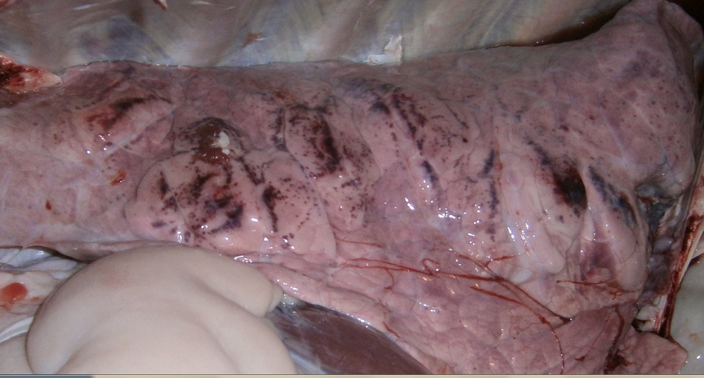
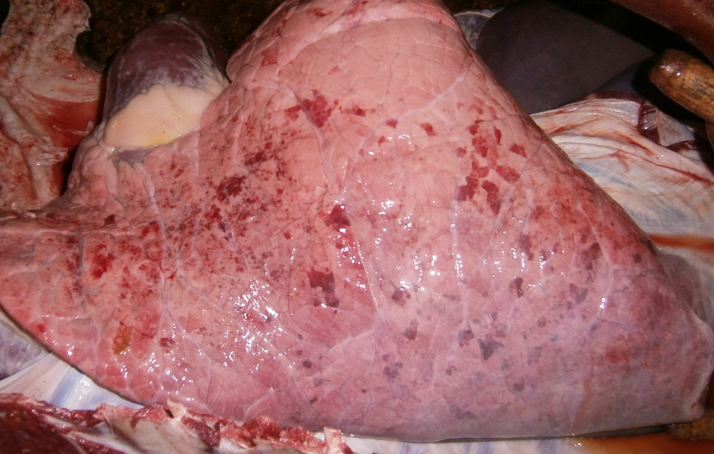

B
A

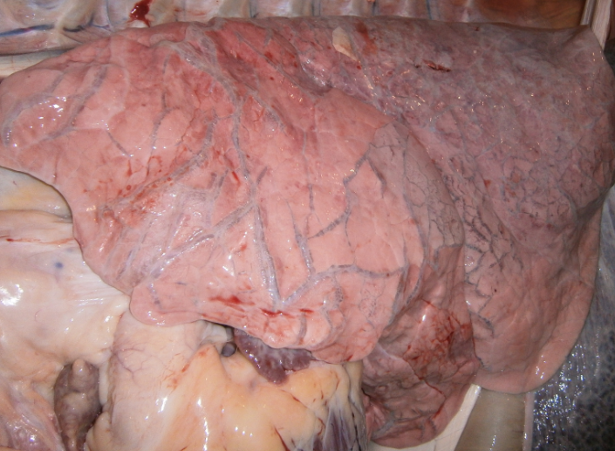
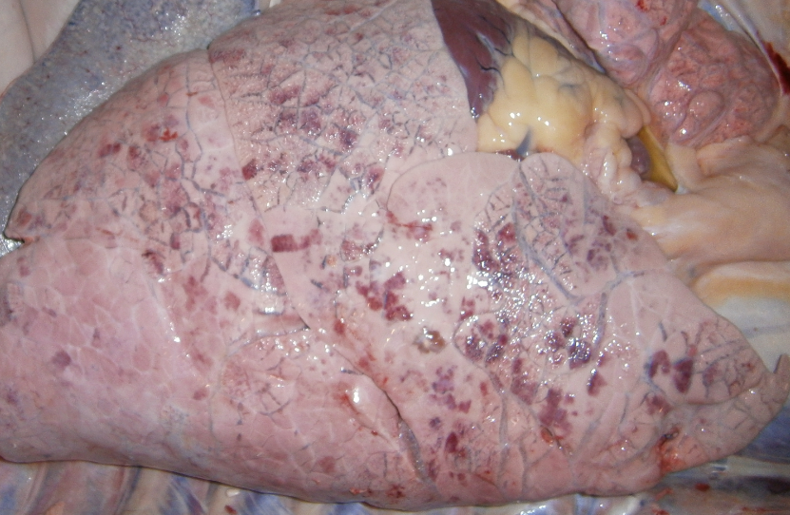

F
E
C
D

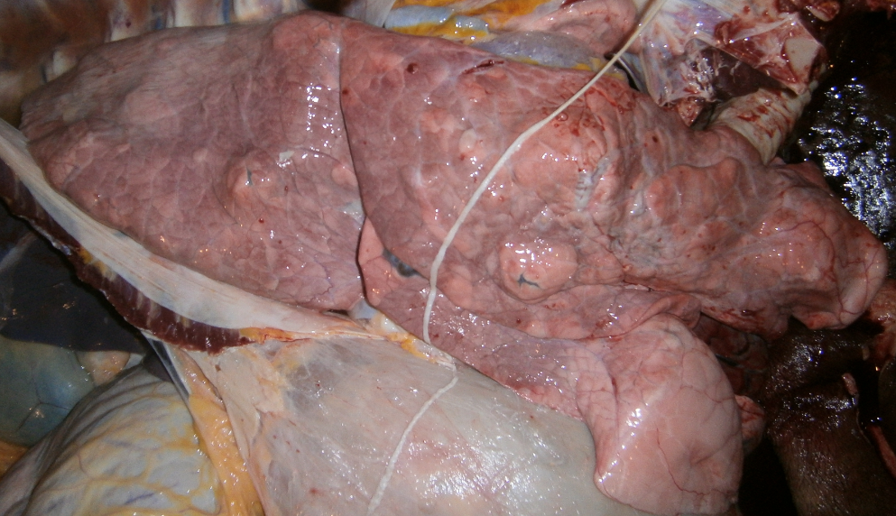
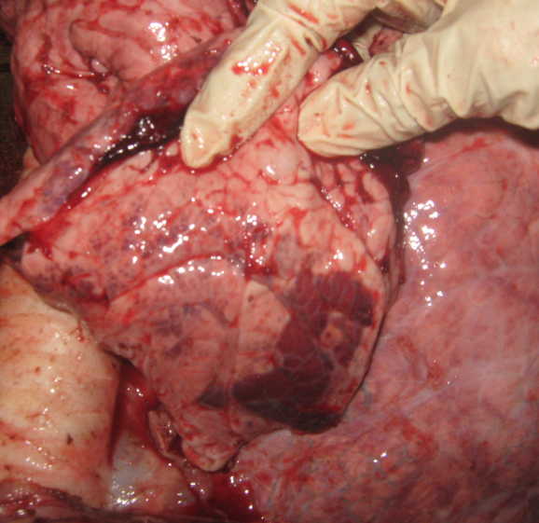

Fig: 2. Pathological affections of lung in slaughtered animal: A. Agonal hemorrhage on the surface of the lung; B. Old hemorrhage and Atelectasis in lung; C. Marked alveolar emphysema and congestion (dark red) on the apical and caudal lobe; D. Severe interstitial emphysema, marked distention of the veins (blue color) in middle and caudal lobe; E. Hepatization (consolidation) indicating pneumonia; F. Abscess in all over the lung parenchyma.

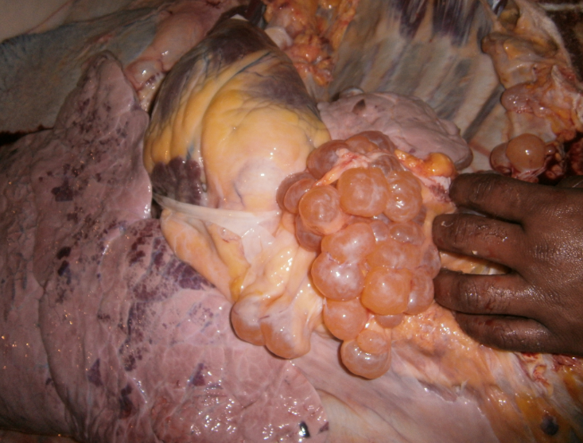
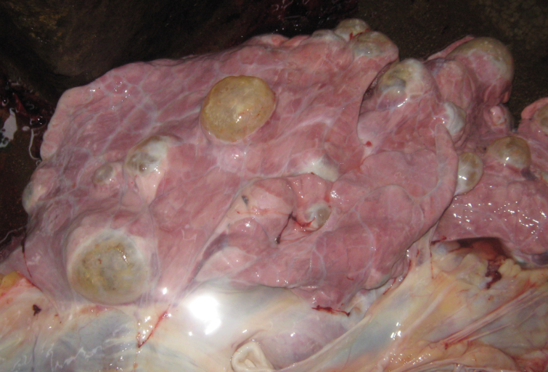

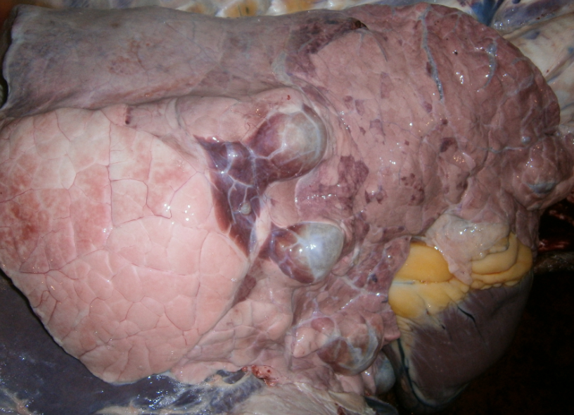
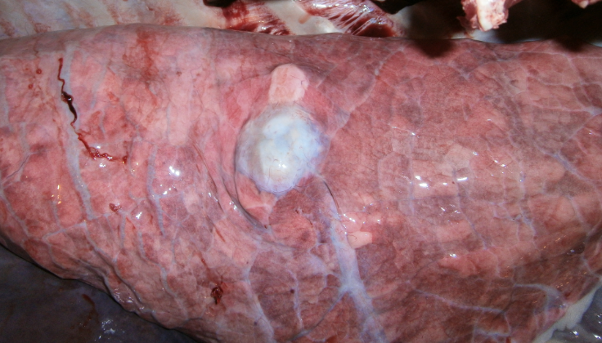
D
C
A
B

Fig: 3. Gross pathological changes caused by hydatidosis in lung: A. Polycystic lung with large yellow fluid filled viable cyst; B. Viable cyst in the pleura and lung in clustered appearance; C. Large space occupying hydatid cyst causing marked Atelectasis (dark red and depressed) in surrounding lung tissue; D. Old degenerated cyst and fibrosis in lung.

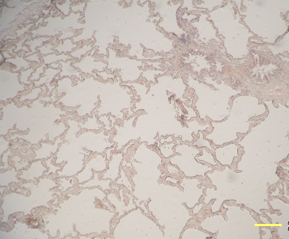
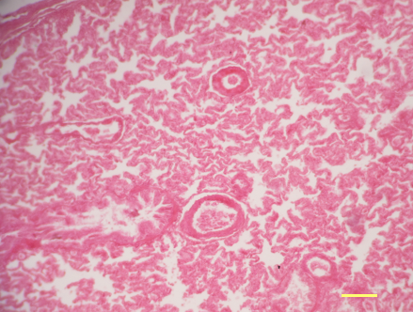
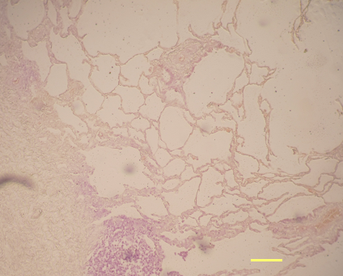
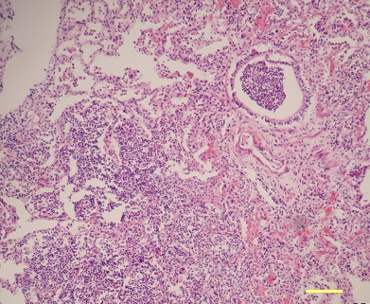
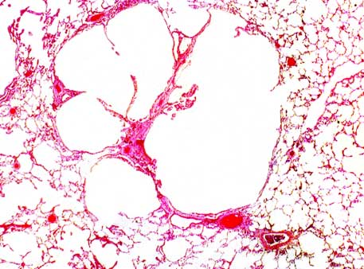
F
A
C
E
B
D

100 $µ$

100 $µ$
100 $µ$
100 $µ$
100 $µ$
100 $µ$

Fig: 4. Histopathology of lung lesions: A. Hydatid cyst in lung characterized by remnant of cyst wall with accumulation of reactive cells; B. Pulmonary congestion and alveolar emphysema; C. Pulmonary atelectasis; D. Interstitial emphysema in lung where alveolar septa are distended with gas as well as alveolar space; E. Purulent bronchopneumonia in lung, accumulation of neutrophils in bronchiolar airway; F. Pulmonary hepatization (pneumonic lung) where alveolar space is filled with copious exudates.

CHAPTER V
DISCUSSION
In the present study overall 14.51% carcasses showed different types of pathological affection in lung and the observed prevalence of lung affections was comparatively higher in April-May month than January and February. This variation might be due to the seasonal effect as April-May is considered as hot summer season whereas to January and February are considered as winter.

The different pathological affections in lung tissue were hydatid cyst, atelectasis, emphysema, pulmonary nodule, abscess, hemorrhage, congestions and degenerated cysts. Rahman et al., (2006) also identified congestion, emphysema, hemorrhage, abscess and anthracosis as common affections in lung from a study of slaughtered cattle in Mymensingh town. Similar lesions have been described by many previous authors (Hussain et al., 1992; Jones et al., 1997; Jubb et al., 1997; Radostits et al., 2002). Some other gross lesions like black coloured lungs, pus in lungs were recorded by Jubb et al., (1997) and Radostits et al. (2002), but no such lesions were observed in the present investigation.

About 15.90% cattle and 10.36% buffalo lung essentially showed pathological affections. This prevalence is quite below than a previous study on slaughtered buffalo in Barisal town in which the pathological affections was 37.5% in buffalo lungs Akbor et al. (2007). This variation might be resulted from the difference in the sampling population where in the present study instead of local buffaloes, most of the buffaloes are imported from India. Kabir et al., (2010) demonstrated comparatively higher prevalence of helminth infections in the imported cattle and buffalo from India.

Hydatid cyst is the most frequently found pulmonary lesion in the present study which comprises 53.90% of all cases. This result is comparable with the findings of Belkhiri et al., (2009), who reported hydatidosis as the commonest lung affection in slaughterhouses of Algeria. Many reports from Bangladesh also demonstrated high prevalence of hydatid cysts in the slaughtered carcasses (Ahmedullah et al., 2007; Kabir et al. 2010 and Basak et al., 2011). Significantly higher prevalence of hydatid cyst was observed in cattle lung compared to buffalo in this study. This variation might be resulted from Kabir et al., (2010). In a previous study 6.25 % cyst were found in Buffalo lung form Barisal district of Bangladesh (Akbor et al., 2007). Hydatidosis is responsible for considerable economic losses due to the condemnation of carcass throughout the world for many years (Acha and Szyres, 1989; Ali-Lemouyes 1978; Zerouala 1984; Soule, 1994 and Jaiem, 1984). These lesions are commonly observed around the year with an increase in frequency during autumn and winter seasons (Belkhiri et al., 2009).

In this study the pulmonary emphysema has been observed at a frequency of 30.23% among the lung affections, taking the second place after the hydatid cyst. This result come in close agreement with the findings of Belkhiri et al., (2009) who also placed emphysema in the second position among the bovine pulmonary lesions found in slaughterhouses of Algeria. Akbor et al., (2007) studied only 4% emphysematous lung from slaughterhouses of Mymensingh, Bangladesh. Statistically significant variation was observed in relation with the frequency pulmonary emphysema between cattle and buffalo pulmonary lesions where emphysema found in 34.28 % of lung lesions in cattle compared to 13.04% in buffalo. Such difference might be due to the physical factors of the buffalo. Besides, the sample size of the buffalo lung was comparatively lower in this study.

Pulmonary emphysema is often considered as a secondary lesion to traumatic pericarditis or pulmonary abscess (Blood and Henderson, 1976). Besides, suppurated form of bronchopneumonia, pulmonary strongylosis, some forms of viral pneumonias also causes such lesion in lung (Espinasse et al., 1985; Villemin, 1974 and Schelcher, 1997). Agonal emphysema is common in slaughtered animals resulted from agonal expiration (McGavin et al., 2001). Struggling and agonal respiration often causes interstitial emphysema which is manifested by thick interlobular septa where accumulated air within the alveoli breaks through the alveolar walls and leaks into the interstitium.

Atelectasis was observed in about 12.50% cases of all lung affections. Rahman et al. (2006) also reported Atelectasis in lungs of slaughtered cattle in Mymensingh. Belkhiri et al., (2009) also reported 5.03% cases of pulmonary Atelectasis in his study. Atelectasis is the collapse of certain portion of pulmonary tissue in absence of air content in alveoli (Jones et al., 1997). These lesions are classically localized in the apical and cardiac lobes, and more rarely in the diaphragmatic one. Pulmonary Atelectasis usually results from infections with mycoplasmosis and pasturellosis (Ahmed, 1998; Benmahdi, 1989; Blood and Henderson, 1976).

Pulmonary hemorrhages are related to severe septicemia or traumatic lesion to the lung. Agonal hemorrhage resulted from seizures and struggling during slaughter also results in pinpoint hemorrhage over lung surface particularly in the anterior lobes. The reason behind the higher rate of hemorrhagic lesion in buffalo is not clear at this moment and requires further investigation. The frequency of pulmonary congestion among the lung affections found 7.03% which is in agreement with the results of Belkhiri et al., (2009). On the other hand, Akbar et al., (2007) reported quite higher frequency (16.25 %) of pulmonary congestions in buffalo lung. Pulmonary congestion occurs due to the obstruction of the pulmonary vessels and passive which is sometimes followed by pulmonary edema (Blood and Henderson, 1976). The most common causes of pulmonary congestion are euthanasia and narcosis. Left-sided cardiac insufficiency, inflammation and degeneration of the myocardium or infarction of the heart muscle also cause such condition.

Abscess and nodular lesions were observed in lower frequency (3.12%) in this study. Nodular lesions in lung are observed in variety of infectious and non infectious condition such as tuberculosis, granulomatous pneumonia, neoplastic growth etc (McGavin et al., 2001). Akbar et al., (2007) and Rahman et al., (2006) showed similar low frequency of pulmonary nodules in their respective study. Pulmonary nodules had been observed in suppurative pneumonia and verminus bronchopneumonia in previous studies (Habacha, 1993). Besides, consolidated pus and the degenerated lesions past infectious phenomena might result in nodular lesions (Brunet, 1991). Tuberculosis is another cause of nodular affections in lung single or clusters of nodule are common (McGavin et al., 2001). Belkhiri et al., (2009) and Benateya (1980) reported 0.45% and 0.02% cases of tuberculosis in lung.

CHAPTER VI
CONCLUSION
Considerably high incidence of lung affections were found in the slaughtered animal carcasses in Chittagong metropolitan area where hydatid cyst was the most common among them. The frequency of lung lesions seems to be high in hot summer season. More elaborative study is essential to identify the several risk factors associated with such condition. Bacteriological and molecular investigation is recommended to determine the incidence of potential zoonotic pathogen from the Slaughtered animal carcass.

CHAPTER VII
Reference

Abayneh, T. and Urga, B. 2007. Study on management practices and work-associated health of draught oxen around Debreberhan, Central Ethiopia. Livestock Research for Rural Development 19 :1-12

Ahmedullah, F., M. Akbor, M.G. Haider, M.M. Hossain and Khan, M.A.H.N.A. 2007. Pathological investigation of liver of the slaughtered buffaloes in barisal district. Bangladesh J. Vet. Med 5: 81-85.

Alam, M.R., Jabbar, M.A., Uddin, M.S., Kibria, A.S.M.G., Gregory, N.G. and Silva-Fletcher, A. 2010. Skin injuries identified in cattle and water buffaloes at livestock markets in Bangladesh; Veterinary Record 167: 415-419.

Bala, A.N., Garba, A.E., and Yazah, A. J. 2011. Bacterial and parasitic zoonoses encountered at slaughter in abattoir, Northeastern Nigeria, Vet. World 4(10):437-443.

Basak, P., Rashid, S.M.H., Isalm, M.N. and Hossain, M. 2011. Pathological investigation of liver of slaughtered cattle in dinajpur district of Bangladesh. Bangladesh research publication journal 5(2): 86-91.

Bekele, M. and Belay, I. 2011. Evaluation of Routine Meat Inspection Procedure to Detect Bovine Tuberculosis Suggestive Lesions in Jimma Municipal Abattoir, South West Ethiopia. Global Veterinaria 6 (2):172-179.

Belkhiri, M., Tlidjane, M., Benhathat, Y. and Meziane, T. 2009. Histopathological study and pulmonary classification of bovine lesions . African Journal of Agricultural Research 4 (7): 584-591.

Berhe, G., Tadesse G., Kiros, H. and Abebe, N. 2010. Concurrent Infection of Hydatidosis and Fasciolosis in Cattle Slaughtered at Mekelle Municipal Abattoir, Tigray Region. Ethiop. Vet. J 14 (2): 39-49.

Bhuiyan, A.K.F.H. Study on the Status, Trends, Utilization and Performance of Fangr and Their Wild Relatives, International Livestock Research Institute (ILRI).

Bob, T. 2007. Making a Killing ,U.S. Beef and Catttle industry; 45.

Çetinkaya, B., Ertas H.B., Öngör H. and Muz, A. 2000. Detection of Leptospira Species by Polymerase Chain Reaction (PCR) in Urine of Cattle , Turk. J. Vet. Anim. Sci 24: 123–130.

Dakhly, K.M.E., Hassan, W.H. and Lotfy, H.S. 2007. Some parasitic and bacterial causes of liver affections in ruminants. BS. VET. MED. J. 23(1): 62-68.

Elmahdi, I.E., Ali, Q.M., Magzoub, M.M., Ali Abrahim, A.M., Saad, M.B. and Romig, T., 2004. Cystic echinoccosis of livestock and humans in central Sudan.

Ernest, E., Kassuku, A. and Kazwala, R. 2004. Studies on the epidemiology of echinococcosis/ hydatidosis in Ngorongoro district, Arusha region, Tanzania, International Arch Hydatid 35, 43.

Ezeh, A.O., Ellis , W.A., Kmety, E., Adesiyun, A.A. and Addo, P.B. 1989. Bacteriological examination of bovine kidneys for leptospires in Plateau State, Nigeria. Rev. sci. tech. Off. int. Epiz. 8 (4): 1005-1008.

FAO, 1994. Food and Agriculture Organization of the United Nations Rome.

FAO, Department of Livestock Services (projection), 2002. Bangladesh Agricultural Census 1977.

FAO/UNEP/WHO, 1994. Guidelines for Echinococcosis/Hydatidosis Surveillance, Prevention and Control. FAO, Rome. pp. 147

Fleming, R., Eng, P. and MacAlpine, M. 2005. Composting Blood (Slaughterhouse Waste) Mixed With Various Substrates.

Food chain crisis management frame work. www.fao.org/foodchain.

Garippa, G., Varcasia, A. and Scala, A., 2004. Cystic echinococcosis in Italy from the 1950s to today. Parassitologia 46: 387-391.

Getaw, A., Beyene, D., Ayana, D., Megersa, B., Abunna, F., 2009. Hydatidosis: Prevalence and its economic importance in ruminants slaughtered at Adama municipal abattoir, Central Oromia, Ethiopia. Acta Tropica. 21(2):12-22

Herenda, D., Chambers, P.G., Ettriqui, A., Seneviratna P. and. Silva, da T.J. P. 2000. Manual on meat inspection for developing countries.

Ibrahim, M.M. 2010. Study of cystic echinococcosis in slaughtered animals in Al Baha region, Saudi Arabia: Interaction between some biotic and abiotic factors. Acta Tropica 113: 26–33.

Jacinta, B.C., Scholtens, R.G. and Kasali, O. 1983. Parasites of sheep at the international Livestock Centre for Africa Debre Berhan station, Ethiopia.

Jacinta, E., 1983. Investigations on Fascioliasis in the Ethiopian Highlands around Debre Berhan. MSc Thesis. Institute of Tropical Medicine and Parasitology, Leiden University, The Netherlands. pp. 1-29.

Januškevičienė G., Paulauskas, V., Dailidavičienė, J. and Juozaitienė, V. 2010. Analysis Of Pathologic Lesions In The Livestock And Poultry Slaughtered In The Meat Establishments Of Lithuania. Veterinarija Ir Zootechnika 52 (74):1-12

Jared C. and Roach, et al., 2010; Analysis of Genetic Inheritance in a Family Quartet by Whole-Genome Sequencing Acta Tropica. 21(2):12-22

Jones, T.C., Hunt, R.D. and King, N.W. 1997. The digestive system. In: Veterinary pathology. 6th Edn. Carrroll Cann (Ed). Williams & Wilkings, U.S.A. pp. 125–130.

Joshi, D.D., Maharjan, M., Johansen, M.V., Willingham, A.L. and Sharma, M. 2003. Improving meat inspection and control in resource-poor communities: the Nepal example. Acta Tropica 119-127.

Kabir, M.H.B., Eliyas, M., Hashem. M.A., Mohiuddin. and Miazi, O.F. 2010. Prevalence of zoonotic parasitic diseases of domestic animals in different abattoir of Comilla and Brahman Baria region in Bangladesh. Uni.j. zool. Rajshahi. Univ 28: 21-25.

Kebede, N., Mitiku, A., Tilahun, G., 2009a. Hydatidosis of slaughtered animals in Bahir Dar Abattoir, Northwestern Ethiopia. Trop. Anim. Hlth. Prod. 41(1): 43-50.

Kithuka, J.M., Maingi, N., Njeruh, F.M., and Ombui, J.N. 2002. The prevalence and economic importance of bovine fasciolosis in Kenya- an analysis of abattoir data. Onderstepoort Journal of Veterinary Research 69: 255-262.

Lawrie, R.A. and Ledward, D.A. 2006. Lawrie’s meat science (7th ed.). Woodhead Publishing Limited Cambridge, UK. pp. 123-130

McEvoy, J.M., Doherty, A.M., Sheridan, J.J., Blair, I.S. and McDowell, D.A. 2003. The prevalence of Salmonella spp. in bovine faecal, rumen and carcass samples at a commercial abattoir. Journal of Applied Microbiology 94: 693–700.

McEwen, S.A. 1987. Zoonoses in the Slaughterhouse, Can Vet J. May 28(5): 269–270.

McGavin, M.D., Carlton, W.W. and Zachary, J.F. 2001, Liver,biliary system,exocrine pancreas, Thomson’s special veterinary pathology; 3rd Edn. pp. 947-974.

Mellau, L.S.B., Nonga, H.E. and Karimuribo, E.D. 2010. A slaughter house survey of lung lesion in slaughtered cattle,saheep and goats at Arusha,Tanzania. Research journal of veterinary science 97(2):77-82
Mohamadin, S.A. and Abdelgadir, A. E. 2011. Study on hydatid cyst infection in Slaughterhouses in Khartoum state, Sudan. Archives of Applied Science Research 3 (6):18-23.

Moro, P. and Schantz, P.M. 2009. Echinococcosis: a review. International Journal of Infectious Diseases 13: 125—133.

Njoroge, E.M., Mbithi, P.M., Gathuma, J.M., Wachira, T.M., Magambo, J.K., Zeyhle, E. 2002. A study of cystic echinococcosis in slaughter animals in three selected areas of northern Turkana, Kenya. Vet.Parasitol. 104: 85–91.

Nouichi, S. 2009. Superficial Bacterial Contamination of Ovine and Bovine Carcasses at El Harrach Slaughterhouse (Algeria). European Journal of Scientific Research 38:474-485.

Pfukenyi, D. M., and Mukaratirwa, S. 2004. A retrospective study of the prevalence and Seasonal variation of Fasciola gigantica in cattle slaughtered in the major abattoirs of Zimbabwe between 1990-1999. Onderstepoort Journal of Veterinary Research 71: 181-187.

Radostits, O.M., Blood,D.C. and Gay C.C. 1995. Disease of alimentary system. In: Veterinary medicine. 8th edition. Bailliere Tindall, London,England pp. 1102-1233

Raji, M.A., Salami, S.O. and Ameh, J.A. 2010. Pathological conditions and lesions observed in slaughtered cattle in Zaria abattoir. Journal of Clinical Pathology and Forensic Medicine 1(2): 9 – 12.

Rao, S.P.N. 2010. Sterilization and Disinfection(www.microrao.com).

Roberts, T. 1983. Benefit Analysis Of Selected Slaughter House Meat Inspection Practice; wp-71.

Rollin, P. 2010. Re-Emergence of Rift Valley Fever in Madagascar.

Salih, M., Degefu, H. and Yohannes, M. 2011. Infection Rates, Cyst Fertility and Larval Viability of Hydatid Disease in Camels (Camelus dromedarius) from Borena, Kereyu and Harar Areas of Ethiopia, Global Veterinaria 7 (6): 518-522.

Santos-Benito FF, Muñoz-Quiles C, Ramón-Cueto A. 2006. Long-termcare of paraplegic laboratory mammals. J Neurotrauma 23:521-536.

Sarder, M. R. I., G. U. Ahmed, M. F. A. Mollah and M. S. Haque. 1995. Effect of stocking density on growth of African catfish, Clarias gariepinus fry. Bangladesh J. Fish. 14 (1-2): 37-40. Science 328, 636.

Scott, J.C., Stefaniak, J., Pawlowski, Z.S. and McManus, D.P., 1997. Molecular genetic analysis of human cystic hydatid cases from Poland: identification of a new genotype group (G9) of Echinococcus granulosus. Parasitol. 114: 37-43.

Smeyne RJ, Jackson-Lewis V. 2005. The MPTP model of Parkinson’s disease. Brain Res Mol Brain Res 134:57-66.

Sohair, I.B. and Eman, M.N. 2009. Histopathological and bacteriological studies on livers affected with fascioliasis in cattle, Egypt. J. Comp. Path. & Clinic. Path 22:19 – 45.

Soulsby, E.J.L., 1982. Parasitic Zoonoses, 2nd ed., London, Academic Press, NC. pp 402.

Swai, E.S. and Schoonman, L. 2012. A survey of zoonotic diseases in trade cattle slaughtered at Tanga city abattoir: a cause of public health concern. Asian Pacific Journal of Tropical Biomedicine. 12: 55-60.

Tappe, K. H., Mousavi, S. J. and Barazesh A. 2011. Prevalence and fertility of hydatid cyst in slaughtered livestock of Urmia city, Northwest Iran. Journal of Parasitology and Vector Biology. 3(2): 29-32.

Taylor, J.D., Fulton, R.W., Lehenbauer, T.W., Step, D.L. and Confer, A.W. 2010. The epidemiology of bovine respiratory disease: What is the evidence for predisposing factors. Canadian Veterinary Journal 1095–1102.
Terefe, D., Wondimu, A. and Gachen D.F. 2012. Prevalence, gross pathological lesions and economic losses of bovine fasciolosis at Jimma Municipal Abattoir. Ethiopia.,Journal of Veterinary Medicine and Animal Health; 4(1): 6-11.
Tilahun, G., Tesfu, K., Berhanu, E., Legesse, W., Ahmed, A., Nega, B., and Girmay, M., 2006. Pilot control of fasciolosis and related animal fluke infections by the use of Endod and reduced morbidity: I pre-intervention studies. Ethiopian Veterinary Journal 10 (1): 67-70.
TSE management at the slaughterhouse; Tropical Medical Parasitology 98: 473–479.

Tulayakul, P., Sithisarn, P., Sanguankiat, A., Khuntamoon, T., Poolkhet , C., Kasorndorkbua , C. and Kasemsuwan, S. 2008. Development of Disease Monitoring and Follow-up System in Cattle Slaughter House, The 15th Congress of FAVA.

Valero, G., Alley, M.R., Manktelow, B.W. 1992. A slaughterhouse survey of lung lesions in goats, Newzeland Veterinary Journal 40 (2):45-51.

