Acknowledgement

First of all I acknowledge to the Almighty, who has given the opportunity to accomplish of the report.

I am very grateful to my supervisor Dr. Mohammad Lutfur Rahman, Professor, Department of Anatomy and Histology, Chittagong Veterinary and Animal Sciences University. I would like to thank to my supervisor for his scholastic guidance, sympathetic supervision and simultaneous inspiration, during the study period and also preparation of clinical report.

I am also thankful to all of those who assisted me with this work specially Dr. Subrata kumar Shill and my friends for their constructive comments and suggestions for improvement of this report.

The Author

CHAPTER I

ABSTRACT

Veterinary practitioners have limited access to information about brain and cranial nerves in goat, cat and chicken. The anatomy of brain and the point of origin of some cranial nerves are very dissimilar. This study dealt with the comparative anatomy of brain of goat, cat and chicken. The study revealed not only the process of removal of brain but also the similarities and dissimilarities of structures of brain and the protective function of cranium. Like human, goat, cat and chicken have brains that help them think and assess things in their day-to-day lives. Although not exactly like a human's, the goat, cat and chickens' brains do have a lot of the same parts, with some variation of course.

CHAPTER II

INTRODUCTION

The brain enclosed within the cranial cavity. The anatomy of the intracranial portion of the Central Nervous System (CNS) is generally well conserved between species (Romanes, 1986).

The anatomy of the brain is complex due to its intricate structure and function. This amazing organ acts as a control center by receiving, interpreting, and directing sensory information throughout the body (Levin and Hoffman 2008). There are three major divisions of the brain. They are the forebrain, the midbrain, and the hindbrain. The spinal cord is the continuation of hind brain (medulla oblongata), from which spinal nerves originate and distribute all over the body. Stimuli carried through nerves and send message to the brain and respond according to stimuli. Thus it maintains the physiology of an animal (Tartaglia, 2002).

While the course will emphasize the human brain, observation and evolution indicate that there are many similarities between the goat, cat, chicken brain and the human brain. Even the differences are instructive and help us to learn about the brain. Being able to locate important structures in the goat, cat, and chicken brain will great benefit to understanding how structures are related to each other in human brain. If the same structure exists in both brains (and most structures are same), they are in same relative location. During the course of the study, I pointed out some differences between brains of goat, cat and chicken (Smith et al, 2001).

This topic covered the comparative anatomy of intracranial part of central nervous system of goat, cat and chicken. Intracranial part of CNS mainly consist of brain and cranial nerves, and brain may be divided into four major part are cerebrum, cerebellum, pons and medulla oblongata. Like all mammals and birds, the goat, cat and chicken have 12 pairs of cranial nerves (Kent, 2001). The brain is covered by a tough fibrous sheet known as meninges (Ghosh, 2003). The hypophysis cerebri or pituitary body is lodged in the "sella turcica," a recess formed by the anterior and posterior basisphenoid bones of calvarium (Getty, 1975). The Pituitary and hypothalamus correspond with brain and maintain the body physiology.

There are some diseases and conditions related to the brain, these are accidental trauma, tumor, Gid disease (coenuriasis), cysticercosis. In most cases these diseases are curable after surgical removal. Thus the proper knowledge on brain anatomy may prove important when considering surgical approaches to the CNS. It is also important in pathophysiology of specific diseases. The neurological problem in goat, cat and chicken are of significant clinical, public health and economic importance.

Objectives
- To specify the anatomical location of cranial cavity of goat, cat and chicken.
- To observe the differences and similarities among the brains.
- To learn about different parts of brain and cranial nerves with their functions.

CHAPTER III

LITERATURE REVIEW

Very limited numbers of studies on comparative anatomy of brains of goat, cat and chicken have done in Bangladesh. Most of the studies examined on the human, sheep and dog brain in Bangladesh and other country as well. But very few studies are related to present study. The important studies that have relevant to the present study are discussed here.

Fankhauser D. B. (2003) studied on the removal of the brain and cranial nerves in cat. The study showed the protective function of the cranium, the relationship of meninges, the branching of cranial nerves into the floor of cranium.

Romanes G. J. (1986) studied about intra cranial part of brain and practical aspect of studying anatomy of head region in Cunningham’s Manual of practical anatomy,

Tartaglia L. and Waugh A. (2002) correlated the physiology and function of brain with endocrine system in veterinary physiology and applied anatomy.

Liebich K. (1983) showed the anatomy of skull, brain of domestic animals in veterinary anatomy of domestic mammals.

Kurths, Jürgen; Zho, Changsong; Zamora-López, Gorka, (2011), explored the brain function from anatomical connectivity. The study showed that the functions of different parts of brain and the gross anatomy of brain.

Getty R. (1975) described about the nervous system of ruminants, carnivores, equine, porcine and birds. The study dealt about both central and peripheral nervous system.

Thomson (2007) studied about the dissection of nervous system of cat. He showed the way of removal of cat brain. The study also dealt with the procedure of dissection of cat brain.

Thomson (2007) Sheep brain dissection guide showed the procedure of dissection sheep’s brain. The purpose of the sheep brain dissection was to familiarize students with the three dimensional structure of brain and the method of studying the brain. The guide described the terms used to specify the location and relative of various brain structures. It also described the way of examination of the exterior of the brain and the mid-sagittal plane of the brain.

Kent and Carr (2001) showed the comparisons of central nervous system among different species in Comparative Anatomy of the Vertebrates (9th edition). For example, birds (specially hawks and eagle) have brilliant eye sight because of their large optic lobe.

Levine and Hoffman (2008) studied the brain of the Horse, Ox, and Dog and associated vessels and found that branching of the cranial nerves varies to some degree in these species, but the exit points from the skull are very dissimilar.

CHAPTER IV

METHODOLOGY

The study required 3 goat brains, 2 cat brains and 3 chicken brains which were collected from adult healthy animals (average body weight were 7.49 kg, 2.58 kg and 1.25 kg, respectively).

i. Euthanasia of animals:
The goats, cats and chicken were euthanized by administration of saturated magnesium sulphate (50ml, 20ml and 5ml, respectively per animal) intravenously. At first sedation of cats were performed with ketamine (8mg/kg body weight) for better restraining. Goats were sedated with diazepam (2mg/kg body weight).

ii. Boundary of cranial cavity
The dorsal wall or roof is formed by the occipital, interparietal, parietal and frontal bones. The lateral wall is formed chiefly by the temporal and frontal bones and the wing of the presphenoid. The ventral wall or inter cranial base may be regarded as three fossae. The rostral cranial fossa supports the frontal and olfactory parts of the cerebrum, formed by presphenoid. The middle cranial fossa is the widest part of the cavity. It extends caudad to the spheno-occipital, thus corresponding to the besisphenoid bone. The caudal cranial fossa corresponds to the basilar part of occipital bone (Getty, 1975).

iii. Materials required for the Collection of brains
For the collection of brain the materials required are -Spot lighting, hacksaw blade, fine pointed scalpel, bone cutter, flat jawed pliers and rat tooth forceps.

iv. Removal of goat and cat brain

At first the surface of all muscles of the skull of a skinned goat and cat were cleaned well. The occipital bone well below the occipital protuberance were cleaned.
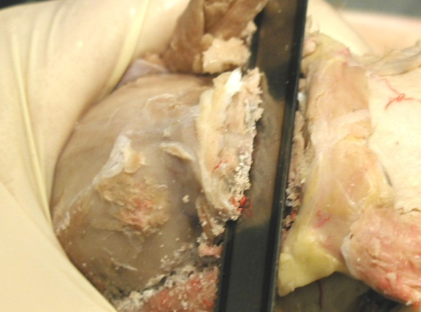

Fig: 1

A first cut was done across the rear of the occipital bone, well below the occipital protuberance as low on the skull as muscle allows by using hacksaw-blade and extended the cut through the widest portion of the cranium, on either side of the anterior portions of the occipital and parietal bones (cutting the Right and Left side).
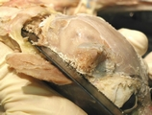
Fig:2

The previous cuts (keep them shallow) was continued laterally through the temporal bones. The cuts were made as the widest part of the skull for easy removal of the brain.
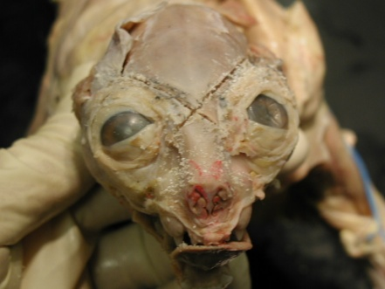
The last two cuts were made, one each above the Right and Left superciliary ridges, so that the cuts form an X between the eyes. These cuts met the cut through the temporal bone. There are two layers of frontal bone which must be cut in the front due to frontal sinuses; therefore the cuts between the eyes must be much deeper than the other cuts.

Fig: 3

The frontal bone is difficult to cut because of the large frontal sinuses. A cut was made through both the exterior and interior layers of bone to free up the front of the unit. All the bones from the dorsal and lateral surfaces of the skull was slowly chiped away until the brain exposed. Between the cerebrum and cerebellum is a transverse bony partition the tentorium cerebelli, which should be removed carefully. The spinal cord was severed transversely at the foramen magnum. The brain out of the floor of the cranium was gently lifted (Fig: 4) Levine and Hoffman 2008 also remove the brain in his study in such manner.

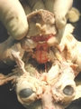

Fig:4 chipping away of brain from calvarium

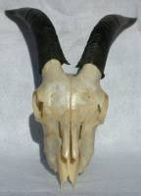

Fig: 2 Area of trephining of removal of goat brain as cat

v. Removal of chicken brain
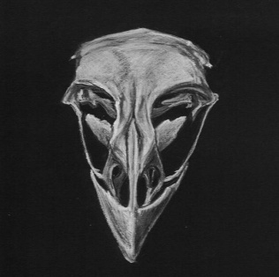

Fig: 3 Area of trephining of removal of chicken brain

Bird posses one of the most highly specialized skull among the living vertebrates. General areas are easily discernible as a pair of extensive frontal bones dorsally and smaller parietal bones more caudally, which, with the frontals, constitute the roof of the brain case. The entire dorsal rim of the orbit is formed by the lateral extent of the frontal bones. The nasal bones articulate with the rostral border of the frontal bones at the naso-frontal hinge.

For removal of the brain first the surface of all muscle of the skull of a skinned chicken was cleaned. A first cut was made across the rear of the occipital bone, well below the occipital protuberance as low on the skull as muscle allows by using hacksaw blade and Extended the cut through parietals and dorsal rim of the orbits (right & left side). The cuts were continued until meeting of the cuts at the middle of the orbits, so that the cuts form an X between the eyes. All the bones from the dorsal and surface of the skull were slowly chipped away until the brain exposes. The meninges should be removed carefully. The spinal cord transversely at the foramen magnum should be cut. The brain out of the floor of the cranium was gently lifted.

V1. Dissection of brain
For the dissection of brain the required materials were dissection pan, scalpel, probe and scissors.

Procedure for dissection
A frontal section was made through a cerebral hemisphere to examine the medial plane and arbor vitae. Before dissection the brains were stored in preserved solution (10% formalin) because right after collection the brains were soft and dissection was difficult at that time (Thomson 2007).

Dissection of brain was done to find out differences and similarities of the mid-sagittal plane of the brain.

CHAPTER V

RESULT AND DISCUSSION

General comparisons of brain of goat, cat and chicken
points | Goat | Cat | Chicken
Size | Relatively larger than others | Larger than chicken | Smallest
Shape | slightly elongated | Almost rounded | Like playing card symbol of spade.
Volume | 70cm³ | 20cm³ | 3cm³
Weight | Average 74.75 gm | Average 21.2 gm | Average 3.28 gm

Dorsal view

Dorsal view
Points | Goat | Cat | Chicken
Sulci and zyri | huge in number | Relatively less in number | absent
Surface | Irregular | Irregular | Smooth
Hind brain (cerebellum & medulla oblongata) | prominent | prominent | Relatively great mass (more prominent)

Lateral view
Points | Goat | Cat | Chicken
Optic lobe | absent | absent | prominent
Optic chiasma | In front of mammilary body | In front of mammilary body | directly rostral to the optic lobe.

Ventral view

Ventral view

Points | Goat | Cat | Chicken
Olfactory bulb | less prominent than cat | More prominent | rudimentary
Olfactory tract | prominent | prominent | rudimentary
Pyriform lobe | Well developed | Well developed | rudimentary
Pons | distinct | distinct | Indistinct
Trapezoid body | distinct | distinct | Indistinct
Pyramid | distinct | distinct | Indistinct
Ventral view of cranial nerves
I. Olfactory (sensory) | Bulbs are prominant | Bulbs are very prominant | Not promonant
II. Optic (sensory) | Insert into colliculus of brain | Insert into colliculus of brain | Inserted into optic lobe

MID-SAGITTAL VIEW

Mid sagittal view

Points | Goat | Cat | Chicken
Septum lucidum | well defined | Poorly defined | Poorly defined
Corpus callosum | Very much prominent | Very much prominent | Not prominent
Optic chiasma | Small in size | Small in size | Comparatively Large
Arbor vitae | well branched | well branched | Poorly branched

- Nerves were severed during removal of brains.
The cavity encloses the brain with its membranes and vessels. It is relatively small and ovoid in shape (Getty, 1975). Anatomy of the brains of different animals are very much differ from each other but the functions of different parts of brain in different animals including human are almost same. Weight and size of the goat brain is larger than the others but the hind mass (cerebellum and medulla oblongata) is relatively greater than others. In the dorsal and mid-sagittal plane, the surface of chicken brain is smooth and the structures are indistinct on the other hand the structures are distinct in the goat and cat brain.
Chicken has excellent sight and balance like reptiles due to its well developed optic lobe and cerebellum because birds love to eat moving feeds and should keep watching on the prey from long distance (specially in hawks, eagles) but the smelling capacity is very poor due to its undeveloped olfactory bulb than others. On the other hand cat has strong smelling capacity because their olfactory bulbs are prominent. Sulci and zyri increase the surface of brain so the number of nerve cells depends on the number of sulci and zyri. In chicken, there is no sulcus and zyrus it means in chickens perception of sense is very low whereas the perception is very high in other animals.
The forebrain is responsible for a variety of functions including receiving and processing sensory information, thinking, perceiving, producing and understanding language, and controlling motor function. There are two major divisions of forebrain: the diencephalon and the telencephalon. The diencephalon contains structures such as the thalamus and hypothalamus which are responsible for such functions as motor control, relaying sensory information, and controlling autonomic functions (Kurths, Jürgen; Zho, Changsong; Zamora-López, Gorka, 2011). The telencephalon contains the largest part of the brain, the cerebrum. Most of the actual information processing in the brain takes place in the cerebral cortex. .
The midbrain and the hindbrain together make up the brainstem. The midbrain is the portion of the brainstem that connects the hindbrain and the forebrain. This region of the brain is involved in auditory and visual responses as well as motor function.
The hindbrain extends from the spinal cord and is composed of the metencephalon and myelencephalon. The metencephalon contains structures such as the pons and cerebellum. These regions assist in maintaining balance and equilibrium, movement coordination, and the conduction of sensory information. The myelencephalon is composed of the medulla oblongata which is responsible for controlling such autonomic functions as breathing, heart rate, and digestion (Getty, 1975)

CHAPTER VI

CONCLUSION

One of the great truths of studying biology is the saying that “anatomy precedes physiology”. The anatomy of the intracranial portions of the central nervous system is generally well conserved between species. Most observed differences are in supporting structures, such as surrounding of brain, size, and weight and some structures of brains. A little difference also found in functions of brains of these species otherwise the function of brains almost similar. The purpose of the study is to familiarize with the three dimensional structure of brains and teach us the great methods of studying brain. Understanding these similarities and differences, however, may prove important when considering surgical approaches to the central nervous system or the pathophysiology of specific diseases.

CHAPTER VII

REFERENCE

1. Fankhauser D.B. 2011. Removal and study of cat brain

2. Getty R. Anatomy of domestic animal (5th edition): nervous system; vol- 1&2.

3. Kent G. C., and Carr R. K. Comparative Anatomy of the Vertebrates (9th edition): nervous system. Pp: 387-420.

4. Kurths, Jürgen; Zho, Changsong; Zamora-López, Gorka. 2011. Exploring brain function from anatomical connectivity". Frontiers in Neuroscience 5.

5. Levin J. M., Levin G.J., Hoffman A.G. and Bralton G.B. 2008. Comparative anatomy of the horse, ox and dog: The brain and associated vessels- Compendium Equine, 2: Pp 153-162.

6. Marshall J. C., Morriss G. M. 2004. Functional anatomy of the humane brain, Pp:
415.

7. Mumnethaler M., Mattle H., Tuab E. 2006. Neuro and ophthalmology, vol-27, Pp:
334.

8.Romanes G. J. (1986)Cunningham’s Manual of practical anatomy. Pp: 207-270.

9. Smith J.M., James M.F., Bockhorst K. H. J., Smith M. I., Papadakis N. G. 2001. Investigation of feline brain anatomy for the detection of cortical spreading depression with magnetic resonance imaging; Pp: 537-554.

10. Thomson (2007) Sheep Brain Dissection Guide: dissection of the sheep’s brain Pp
1-13.

