Chapter-1: Introduction

Parasitic infections caused by helminthes and protozoan parasites are the most prevalent in human in developing countries. Among them, intestinal parasitic infection is the deadliest, causing significant deaths in different areas around the globe (Mumtaz et al., 2009). There have been 100 species of helminthes reported from the human alimentary tract and among them Ascaris Lumbricoides (A. lumbricoides, roundworm), Necator americanicus (N. americanicus, hookworms) and Trichiuris trichiura (T. trichiura, whipworm) are the most common (Mumtaz et al., 2009). These geohelminths and soil- transmitted helminthes are the most prevalent in tropical and subtropical region of developing countries where sanitation and water facilities are poor. These parasitic infections may result in several health conditions like malnutrition, anemia, cognitive impairment and increased susceptibility to other infections (Fareid et al., 2011). In addition to their physical effects, intestinal helminthes infections also impair mental growth of children, hamper educational achievement, and ultimate hinder the economic development of an individual as well as society. According to World Health Organization (WHO), there should not be any less observation and incorporation in controlling the parasitic infestation rather suggested to come up with a multi-disease control approach with Tuberculosis (TB), Malaria and HIV/AIDS (Holland et al., 1989).
Every year, one in ten children died globally from diarrheal disease that results in 800,000 fatalities annually worldwide (Liu et al., 2010). Around 300 million infections have resulted in severe morbidity, especially in those with a heavy burden of worms. The risk factors concerned with the infection usually correlated with poverty, poor environmental hygiene and deprived health services” (Uddin and Khanum, 2006). There

are other factors like climatic conditions, unsafe drinking water, and lack of toilet facilities that contribute to the high prevalence of intestinal parasites in the tropical and subtropical countries (Ali et al., 1999). The prevalence of intestinal parasites globally reported as Ascaris (20%), hookworm (18%), Trichuris trichiura (10%) and E. histolytica (10%) and in India, it is varies from 12.5% - 66% following a difference in prevalence rates for individual parasites (Dudeja et al., 2012). The actual mortality from intestinal helminthiasis is unknown as it is difficult to estimate. Eventually, it has been reported that hookworm disease causes about 65,000 deaths per year where ascariasis about 60,000 deaths, and trichuriasis about 10,000 deaths (Crompton et al., 2002). These death rates were accredited to the hurdles caused by heavy infections and with the presence of co-infections.
In Bangladesh, studies showed that, intestinal parasitic infections are present everywhere all the time (Shakur and Ehsan, 1993). Number of studies have examined infants and young children below 24 months of age and found that 50 % of 2-year-old children had Ascaris infection, 25 % Trichuris and 21 % had hookworms in Bangladesh (Helen Keller International., 2006). Among the helminthes and protozoan parasites, A. lumbricoides, A. duodenale, T. trichura, Enterobius vermicularis and Entaboeba histolytica, Giardia lamblia are commonly found in Bangladesh (Banu et al., 2003; Khanum et al., 2008). Though these infection creates different public health problems among the hosts directly or indirectly and can cause nutritional impairment, retard physical and mental development of children and adolescents, few studies found on the prevalence of parasite among the infant and young children in comparison to other groups like women in the world and it is the case in Bangladesh too. Moreover, parasites are the oldest pathogens

and remain as an important part of diseases among the world’s poor who are the most susceptible population. Young children are particularly susceptible because of their movement and more involvement with domestic work. Importantly, study in Chattogram metropolitan areas are seldom found and the scenario of intestinal parasites is yet to be noticed. Therefore, the present study was undertaken to investigate the helminthes parasites in children of 6 months-12 years of age to estimate the parasitic disease burden, evaluation of potential risk factors and to identify the prevalence of parasites.

Chapter-2: Review of Literature

When microorganisms depend on other organisms to survive are called parasites. There are various types of parasites; some affect their host and cause diseases or other health conditions like malaria, pneumonia etc. (Brazier, 2018). King at el (1990) reported that, pregnant women in third world countries pose a particular threat to intestinal parasitic infections. The parasitic infections (infestations) that are widely known globally such as Ascaris lumbricoides 20%, Hookworm 18%, Trichuris trichiura 10% and Entamoeba histolytica 10% (Kang et al., 1998). A. lumbricoides, T. trichiura, hookworms and Schistosoma are mainly responsible for causing intestinal nematode infections. Moreover, it is recognized as a major health problem that is estimated to infect over one quarter of the world’s population, affecting nutritional and development growth (Punsawad et al., 2018).
By affecting our digestive system, intestinal parasitic infections harm human health which led to health problems associated with ingestion, digestion and absorption causing anorexia, nutrients mal-absorption and anemia (Hadju et al., 1996; Eve et al., 1997; Oberhelman el al., 1998), and eventually death resulting from intestinal obstruction (King et al., 1990). Maternal iron deficiency anemia and reduced fetal growth are associated with chronic parasitic infections (Weigel et al., 1996). More or less, all of the mentioned diseases compelled the researchers to have a deep research on the intestinal parasites over the last few years (Ali-Slitayeli et al., 1989; WHO, 1986).
Giardia duodenalis (syn. G. intestinalis, G. lamblia) is a common intestinal parasite infecting human populations worldwide. High infection rates of giardiasis have been

reported in developing countries in which many groups and communities are at higher risk due to poverty, poor hygienic practices, lack of or limited access to adequate healthcare, safe drinking water and sanitation services. In contrast, in developed areas, the prevalence of giardiasis is lower, and G. duodenalis is a frequent cause of epidemic waterborne diarrheal disease (Tandukar et al., 2018).
Giardiasis has a range of clinical manifestations, from asymptomatic infections to a chronic diarrheal syndrome, malabsorption, and weight loss. However, asymptomatic giardiasis is the most frequent clinical presentation in developing countries. In these settings, children are frequently exposed to infection and many of them are malnourished and harbor a great burden of Giardia infection. Nonetheless, based on new approaches to assess pathogen-specific diarrhea agents in these settings, the Giardia burden has not been associated to diarrhea in this population (Sagebiel et al., 2009).
In view of genetic characteristics and the great variability of hosts, G. duodenalis isolates can be classified into at least eight assemblages (A-H). Among these genetic groups, assemblages A and B are considered to be potentially zoonotic, since they infect humans, as well as a wide range of mammals. According to the multi-locus genotyping of 18SrRNA, gdh, tpi, bg followed by sequencing analysis, human isolates can later be placed in sub-assemblages AI, AII, BIII and BIV. Molecular epidemiological surveys have provided insights into the genetic diversity of isolates infecting human populations in low-resource communities in which infection has been commonly reported in children. Regardless of the clinical impact of endemic giardiasis, infected children are potential sources of cysts through which the infection is disseminated and transmitted to other

children and adults in close contact, in the same way as observed in childcare environment (Calik et al., 2011).
In case of preventing the intestinal parasitic infections, sanitary measures are considered very effective along with improvement in housing, sewage disposal and water supply (Abedel-Hafez et al., 1986; Kasuya et al., 1989; Loose, 1997). Personal hygiene and domestic cleanliness is the most important factor in terms of prevention of intestinal protozoa (Develoux et al., 1990). And most importantly, having proper knowledge regarding the ecology and epidemiology of a parasite provides a basis of a control program (Weidong et al., 1996).

There are certain factors that attributes to the global prevalence and intensity of protozoan and helminthic infections like geographical climatic factors, human activities and socioeconomic status (WHO, 1981). Kan & Poon (1987) found that, in highly endemic areas, due to the ease and frequency of transmission, high prevalence was concerned with higher intensities of infection. The children aged from 4-12 years, found to be more vulnerable to soil transmitted helminths infections. The reason pointed out towards the fecal-oral route of transmission or susceptibility due to lack of immunity (John et al., 1998). The incidence of intestinal parasites can vary widely even in small areas. Therefore, the rainy and dry seasons may provide a contributing factor, so precise studies are needed to define the seasonal fluctuation in the incidence of intestinal parasites (Reinthaler et al., 1988).

There are certain ways through the intestinal parasites can be transmitted but the most popular mode is the fecal-oral route (Reinthaler et al., 1988; WHO, 1986). This transmission mode differs in its appearance, as it may occur in the contamination of hands. Hands become impure after defecation, particularly when the water is contaminated with feces that are used for anal cleansing (Han et al., 1986). Moreover, fingernail contamination as well as anal itching may happen as reported. Buscher and Haley in 1972 found eggs of Ñnirobcius verinecularis with active larvae under the fingernails of some children. The epidemiology of H. nana is not quite understood, but its ability is unlike most other tapeworms to complete their development to an adult from an ingested egg, and that infection is associated with contamination of fingers or foods with feces (Mason et al., 1986). Baldawi et al., (1989) also concluded that it is possible to get human infections from eggs of H. nana in rodent feces, although this type of infection is uncommon. Needham et al (1998) stated in a report that there is a chance of most people getting exposed to fecal-borne soil transmitted helminth infections while using human feces as a fertilizer. Geophagy (soil eating) can also increase the risk in transmission of geo-helminthiasis among children (Geissler et al., 1998). Moreover, walking barefooted and drinking water from unprotected well water increase the infection as well as the density rate of helminths (Elkins, 1984).
Water contamination can also work as a transmission mode in this infection. G. lamblia cysts are often transmitted through water supplies contamination. Sometimes, it may be transmitted by direct spread from person to person or through the use of communal toilets (Mason et al., 1986). Ali-Shtayeh et al., (1989) stated that E. histolytica, G. faribifa and

A. lumbricoides, may infect humans when they come in touch with polluted water, soil, vegetables or other polluted foods.
There are some studies done on the subject regarding which gender is more exposed to this infection. Anderson (1986) addressed that the predisposing factors for intestinal parasitic infections and causes of predisposition perhaps are many in number and vary from person to person. It may encompass several behavioral, social, genetic and nutritional factors. Utizinger et al., 1999 could relate the variation that exists in intestinal parasitic infections to different factors dealing with the infection. Personal hygiene, nutritional status, environmental factors and the nature of the infective stage are some of these factors. Studies that conducted on intestinal helminth infections referred to stress as one of the behavioral and social factors. And most importantly, studies on lab rodents and nematode infections of these rodents found that the genetic and nutritional factors are probably of great significance (Anderson, 1986). Poverty, along with the lack of sanitation system, sort of poses as predisposing factors to parasitic infections (Arene and Akabogu, 1986; Mason et al., 1986). Some studies suggested that helminth infections are more likely to increase in dirty sanitation than other intestinal organisms, and comparisons of helminthes prevalence may therefore be a reliable indicator of the impact of these improvements on health status of the community (Mason et al., 1986). The prevalence of intestinal parasitic infections eventually may provide a signal in regard to the necessity of better sanitation facilities.
Wherever poverty, poor sanitation, insufficient health care and overcrowding are entrenched, intestinal parasitic infections remain (Eve et al., 1997; Arene and Akabogu, 1986). Ascariasis is an example of socioeconomic status that is reflected on

environmental practices and also indicates the presence or lack of health awareness. It is seen that in the poor urban habitations, intestinal parasites grow at a larger rate. Environmental factors are one of the factors when the survival and transmission of intestinal parasites aggravate or alleviate the impact of these infections on people (Crompton and Savioli, 1993; Kan and Poon, 1987). Some significant factors also affecting regional basis or local infection levels are related to the population in itself, which determine the parasite prevalence (WHO, 1986).
The incidence of intestinal parasites has been reported to have seasonal variation in different areas in the different regions. It is also noticed that in winter months the prevalence rates are lower where the incidence rate increases with increasing temperature like reaching a peak in summer months (Ali-Shtayh et al., 1989). The time of the year is very crucial while interpreting the epidemiologic data, as the high temperature and humidity may arouse the development of intestinal protozoa. Reintlialer et al., (1988) found that in the rainy season, the rate of E. hislolytica infection was highest. King et al., 1990; Olitzki (1933) noticed that there is seasonal variation in the prevalence of A. lumbricoides and T. trichiura in the Jewish inhabitants of Jerusalem (Jumba-Muksa and Gunders, 1971). On other hand, Collins & amp; Edwards (1981) expressed their different opinion. They claimed that the climatic factors perhaps are not the leading reason for the different frequencies of the infection. Since T. trichiura eggs are much less resistant to moisture and temperature variations. Also, the optimum infection of H. nana was in the warmer months of the year, May through October.
As the children wear the least clothes, in this season that may increase the chances of fecal contamination of the hands, finger-nails and thus subsequent infection (Buscher and

Hally, 1972). WHO (1986) identified determinants of the high prevalence rates in the developing countries in both tropical and subtropical climates. Some of these determinants include poverty, inadequate sanitation, absence of safe drinking water supplies, ignorance of health promoting practices, high birth rates and ecological conditions favorable to the survival, multiplication of many disease vectors, and intermediate hosts responsible for transmitting infection to human beings.
The provision of piped water would be expected to be associated with reduction of parasite prevalence, particularly where transmission is influenced by contact with infected water or poor hygiene or where the parasite is waterborne. Mason et al., (1986) predicted less often for the same infections if clean water is readily available, such infections may be transmitted by contact with water (Schistosomiasis), direct fecal contamination (Hymenolepiasis) or ingestion of tainted water (Giardiasis). Crompton &amp; Savioli (1993) showed that the contamination of the vegetables that are grown in rural areas was attributed to the use of fertilizers prepared from human excreta or untreated sewage effluents. Crompton & Savioli (1993) showed that the vegetables grown in rural areas use fertilizers which are impacted due to pollution and prepared fertilizers from human excrement or untreated wastewater effluent. They made an assumption that L. G. and cysts were the pollutants of urban slum areas and have been commonly detected in the supply of drinking water.
The prevalence and severity of helminthiasis transmitted by soil among children is an indicator of living standards and environmental sanitation as well as other socio- economic factors, such as family size and income, availability of food, standard childcare dietary practices and other community cultural characteristics (Kan and Poon, 1987).

Several studies in North America, Europe and elsewhere have shown that closed populations have a high prevalence of intestinal parasitism due to lack of good hygienic conditions in the lake. In these studies, Amebiasis and Giardiasis were the most prevalent protozoan infections (Omer et al., 1991).
In Saudi Arabia, a study conducted by Siddiqui (1981) found a low rate of infection of intestinal parasites related to the topography, the environment as well as climate of the region, and the uncrowned location of terraced houses. Cancrini et al., (1989) and Alkija (1986) attributed that poor sanitation and overcrowding are prone to the heavy infection rates. Low intestinal parasites were found in Labrador, Canada, due to extreme environmental conditions, topography, changes in human behavior in food preparation and sanitation (Sole and Carole, 1980).
The severity of intestinal helminth infection appears to vary by age, and is typically highest in the vulnerable years of childhood (Eve et al., 1998). Anderson (1986) found that the age at which the highest intensity occurred was 5-10 years old in the areas with endemic infections for A. lumbricoides and T. Trichiura, where the prevalence of Hookworm increased with growing age (Booth et al., 1997). The highest intensity of infection has been found in school going children (Ramdath et al., 1995; Brooker et al., 1999). Guatt et al., (1999) stated that it could be possible to use prevalence of infection in school aged children as a tool for predicting prevalence in the communities. Olsen (1998) and Guyatt et al., (1999) narrated benefits of sampling children at schools as a representative of the community.

Several studies conducted on ecological and epidemiological aspects of parasites, mentioned changes in prevalence and intensity of infections in relation to age (Weidong et al., 1996). Kan and Poon (1987) reported that there is a high possibility of both sexes to get affected in case of children. N. nana is such a common parasite of man as well as rodents in many parts of the world, the prevalence in males and females was also the same. The noteworthy part is that infections were experienced much more frequently in children and adolescents than adults (Buscher and Haley, 1972). On the contrast, G. lanibilia another infection increase in individuals of older age (Omer et al., 1991). National parasitological surveys show that the prevalence of infection can vary widely within a country for each parasite (Booth & Bundy, 1992), with respect to regional distribution.

Hlaing et al., (1984) declared that in developing countries in the tropics, A. lumbricoides have been endemic. In particular, hookworm infections are a problem in agricultural areas with excess water supplies, which play a crucial role in the management of hookworm infections in agricultural areas (Massoud et al., 1980). In the developed countries, in man the level of helminthes infection is low without vast need of chemotherapy or vaccination. The scenario is different in the developing countries; the level of infection is very high where the interventions concerned with hygiene have not been piloted yet, due to financial and social problems (Roose, 1997). Moreover, the conditions of nature or the environment both have great impact on intestinal parasites through its effect on the survival of the intermediate hosts (Hall et al., 1982).

In developing countries, parasitic infections contribute considerably to morbidity and mortality among young children. Bangladesh is a developed country with a huge population density (Rashid et al., 2011). According to census, the population is around
168.07 million with density approximately 1140/km2 where one third of her population is children. Multiple gastro-intestinal parasites affect children that further cause mal- nourishment and anemia in children. The location and tropical climate of Bangladesh both favors the harbor of parasites (Hossain et al., 2003). Though in the past, the impact of parasitic infection was not taken highly, but in recent years, there has been research done on the impact of parasitic infection in humans, especially among children. Researchers have been trying to find out the risk factors associated with parasitic infection and how it affects the children in different aspects (Hoque et al., 2007).
Intestinal parasites are widely prevalent in developing countries, probably due to poor sanitation and inadequate personal hygiene. The other factors attributable to the prevalence of these infections are poverty, illiteracy, tropical hot and humid weather conditions and contaminated drinking water resources. Consequently, the epidemiological pattern of these parasites varies in different geographical regions. It is estimated that, as much as 60% of the world's population is infected with gut parasites, which may play important role in causing morbidity and mortality especially among the children group due to intestinal infection (Sah et al., 2013).

The enteric protozoan parasites and the soil-transmitted helminthes are responsible for gastrointestinal disturbances leading to infections. The WHO report states that, amoebiasis caused by the protozoan parasite E. histolytica is the most common parasitic

cause of morbidity and mortality, with an estimate of about 50 million infections worldwide followed by giardiasis caused by G. intestinalis/duodenalis and cryptosporidiosis caused by Cryptosporidium spp. A. lumbricoides and Hymenolepis nana are the commonest nematode and cestode respectively affecting approximately 1 billion people. The commonest parasitic infections reported globally are A. lumbricoides (20%), hookworm (18%), T. trichuira (10%) and E. histolytica (10%)
(WHO, 1987).

Intestinal parasitic infections (IPIs) are ubiquitous in humans, both in urban and rural environments from tropical and subtropical countries (Bundy et al., 1988). The poorest and most deprived communities are at increased risk of intestinal parasitic infections, which are present in more than a quarter of the world’s population. The frequency of intestinal parasites is an indicator of low socioeconomic development of a population, which is directly associated with educational deficits and poor sanitary conditions (Bauhofer et al., 2020). However, in tropical developing countries, rural life is by itself associated with a high risk of infections due to negligible health knowledge, lower socio- economic conditions, inadequate environmental sanitation, insufficient water supply and higher contact rates with wildlife and domestic reservoirs of infection. Rural populations experience a vicious cycle of malnutrition and re-infections leading to continuous morbidity and perpetuation of poverty cycles. IPIs are a public health problem caused by helminths and intestinal protozoa. Globally, the soil-transmitted helminthes A. lumbricoides, hookworm and T. trichiura and the protozoan E. histolytica, G. intestinalis and Cryptosporidium sp. are the most common intestinal parasites. Except for E. histolytica, Cryptosporidium sp. and Balantidium coli, they are unable to invade

the mucosal tissues or other organs (Gabbad et al., 2014). In the recent years, there has been a growing recognition that Blastocystis sp. presents pathogenic potential, although its virulence mechanisms are not understood. They infect a wide range of animals including birds, amphibians, reptiles, insects and mammals, including humans. Although the current knowledge of reservoirs for human infection is limited, it is known that a vehicle for Blastocystis sp. transmission is close contact with animals. Blastocystis sp. has potential pandemic distribution, possibly reaching 30% in industrialized countries and up to 76% in developing nations (Worrel et al., 2016).
A research done in the slum areas of Southern Delhi came out with a result of 26.1% incidence of intestinal parasites in the study population (Dudeja et al., 2012). Approximately a sample of 2907 participated in this study where most of the patients were from the largest slums of Delhi. While comparing this study with other case studies done around Delhi, the prevalence rate of the present study was higher than the other areas. One vital reason seemed to contribute to the problem is the target population who were living in the slums. The sanitation and unhygienic drinking facilities cause diseases in these slums. Another thing was the percentages of parasitic infection in male patients were more than female patients in the study. Therefore, the study showed a higher rate of infection among females (30%) in comparison to the males (24%). The age group of 5-20 years was highly affected with the parasitic infection including school going children and teenagers (Dudeja et al., 2012). A clear indication of parasitic infection from this study was sanitation and proper drinking facility of that slum area. Furthermore, lack of education and awareness is also responsible.

This study came in conclusion with a need for sanitation and drinking water facilities along with having awareness of hygiene regarding the parasitic infection among the local people of these slum areas. Moreover, school going children should not eat food from open stalls every now and then (Dudeja et al., 2012).
There was another study done among the outdoor patients of Dhaka University Medical Centre regarding the parasitic infection. There were significant results found in this study concerning the topic. From that study, the prevalence of infection was higher in females than male who were included in the study (Khanum et al., 2009).
The patients who were drinking un-boiled water were in higher numbers than the patients were used to drink filtered or boiled water. The patients were diagnosed with intestinal parasite infections because of un-boiled drinking water (Khanum et al., 2009). The study was done among the outdoor patients where teachers, students and staff were included. The staffs of University of Dhaka were at higher risk of parasitic infestation in comparison with teachers and students. One prominent factor is the lack of health education and awareness about parasitic infections among them (Khanum et al., 2009). A parasite that is A. lumbricoides was found common in the study and the students were mostly affected by this. This study also pointed out that daily habit, hygiene, environment and other ecological factors matter most in terms of causing parasitic infection (Khanum et al., 2009)
Parasitic Infection is also interconnected with child malnutrition. When parasites affect the digestive system, a person may not intake food that later leads to loss of nutrition and other diseases (Hesham et al., 2005).

There have been several studies done on vitamin A deficiency and parasitic infections. If a person has Vitamin A deficiency, there is a higher chance of that person of getting infected by parasitic infections. The clear association of malnutrition and parasitic infection indicates growth retardation and anemia (Hesham et al., 2005). After analysing these studies, it is clear that different risk factors are associated with parasitic infections in the body. There is a need to proper research on these topics in the developing nations with the involvement of the WHO and other developed countries. This parasitic infection is sometimes called the ‘cancer of the developing nation’ (Hesham et al., 2005). The present study focuses on finding out the possible causes and factors affecting the children following the strengths and weaknesses of the study.
Life cycle of Giardia spp.

- Giardia cysts are the infective stage of G. intestinalis. As few as 10 cysts can cause infection
- These cysts are ingested by consuming contaminated food or water, or fecal- orally. They can survive outside the body for several months, and are also relatively resistant to chlorination, UV exposure and freezing
- When cysts are ingested, the low pH of the stomach acid produces excystation, in which the activated flagellum breaks through the cyst wall. This occurs in the small intestine, specifically the duodenum. Encystation releases trophozoites, with each cyst producing two trophozoites. (Bernander et al., 2001)

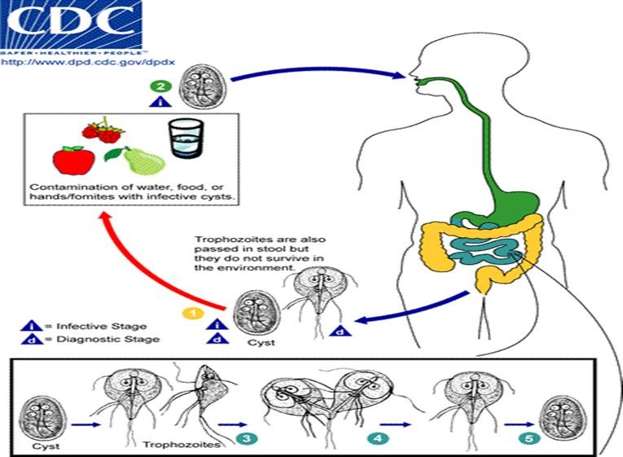

Figure 1: Life Cycle of Giardia spp. Collected from CDC (center for disease control and prevention)
- Within the small intestine, the trophozoites reproduce asexually (longitudinal binary fission) and either float free or are attached to the mucosa of the lumen.
- Some trophozoites then encyst in the small intestine. Encystation occurs most likely as a result of exposure to bile salts and fatty acids, and a more alkaline environment. Both cysts and trophozoites are then passed in the feces, and are infectious immediately or shortly afterward Person-to-person transmission is possible. Animals can also be infected with Giardia, and beavers have been associated with giardia outbreaks, although not definitively.

Life Cycle of Ascaris lumbricoides

- Adult worms live in the small intestine of people. There, females may produce about 200,000 eggs per day. The eggs are excreted with stool.
- Only fertilized eggs cause infection.

- The fertilized eggs develop in the soil. The eggs develop best in moist, warm, shaded soil.
- People become infected when they swallow Ascaris eggs, often in food that came in contact with soil contaminated with human stool containing fertilized Ascaris eggs.
- The eggs hatch and release larvae in the intestine.

- The larvae penetrate the wall of the small intestine and travel through the lymphatic vessels and bloodstream to the lungs (Tietze et al., 1991).
- Once inside the lungs, larvae pass into air sacs (alveoli) in the lungs, move up the respiratory tract and into the throat, and are swallowed. When the larvae reach the small intestine, they develop into adult worms.

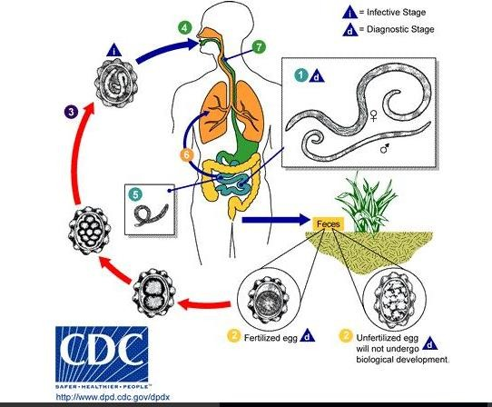
Figure 2. Life cycle of Ascaris lumbricoides collected from CDC (center for disease control and prevention)

Life cycle of Trichuris trichura
- The unembryonated eggs are passed in feces.
- In the soil, the eggs develop into a 2-cell stage.
- The cells continue to divide (advanced cleavage stage).
- Then the eggs embryonate and become infective in 15 to 30 days. They may be ingested when hands or food are contaminated with feces or feces-containing soil.
- The eggs hatch in the small intestine and release larvae.
- Larvae mature and establish themselves as adults in the cecum and ascending colon
(Bundi et al., 1989).

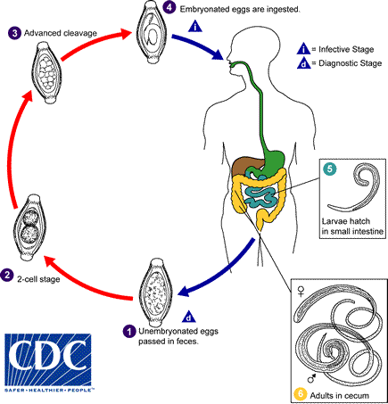

Figure 3: Life cycle of Trichuris trichura Collected from CDC (center for disease control and prevention)

Chapter-3: Materials and Methods

Study Area

This study was conducted in Chattogram city area of Bangladesh. Chattogram is the second populated city after capital Dhaka. It has a total area of 168.07 square kilometers. Due to over population and industrialization many small and large congested slums have established in different parts of the city. In this study, six big slums (Foy’s lake, Akbor Shah, Kulgaon, Bahar Signal, Bakolia, Dewanhat) from different location of the city were selected purposively for sample and data collection.
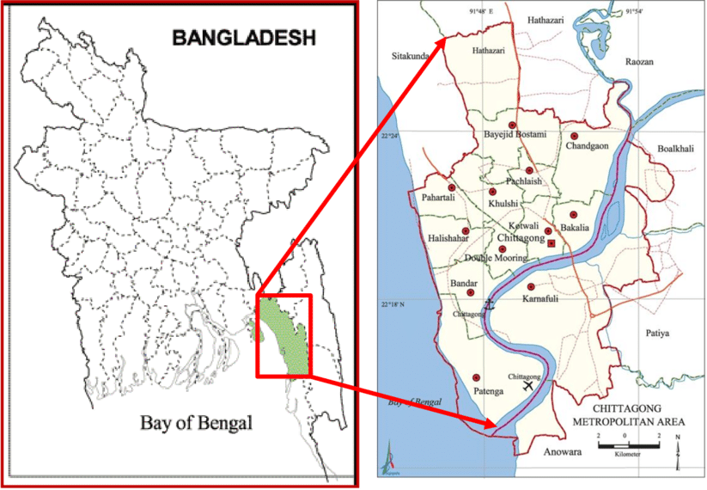

Figure 4: Map of Chattogram metropolitan area

Study Population

The study was conducted during the period of June’ 2019 to December’ 2019 on children in between 6 months to 12 years of age in different slums under Chattogram Metropolitan area having malnutrition, anemia, and abdominal pain. In the study, children were recruited upon permission obtained from their parents.

Data Collection

A simple questionnaire was prepared to collect information related to demography, sanitation, water source, use of anthelmintic, practice of hand wash, and other hygiene. The questionnaire was used to count and track all the eligible children recruited into the study. Before the interview, the purpose of the study was informed to all guardians of participants. No incentives were given for participating in the survey as the participation was fully voluntary. A total of 400 completed questionnaires were obtained and used for comparing laboratory results.

Stool Sample Collection

A single stool sample (10-20gm) was collected from each child in a labeled sterile screw- cap container. The container was supplied to the guardian of the participants on previous night and explained to collect the sample without contaminating it with water or urine. The containers were checked for labeling, leakage and immediately transported to the clinical pathology laboratory at CVASU via a cool box. Sample stored in a deep freezer at -20⁰C until the examination was performed. Care was taken to avoid freeze—thaw cycles for the stool specimens.

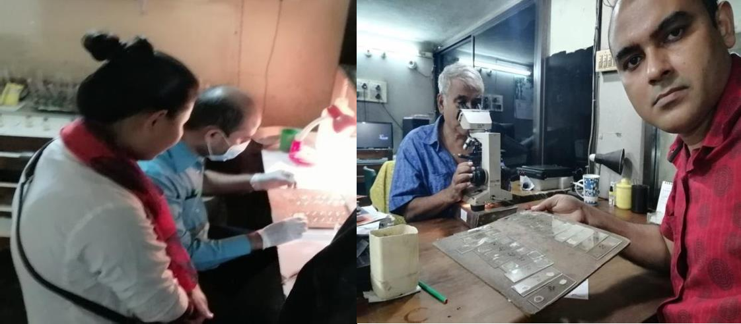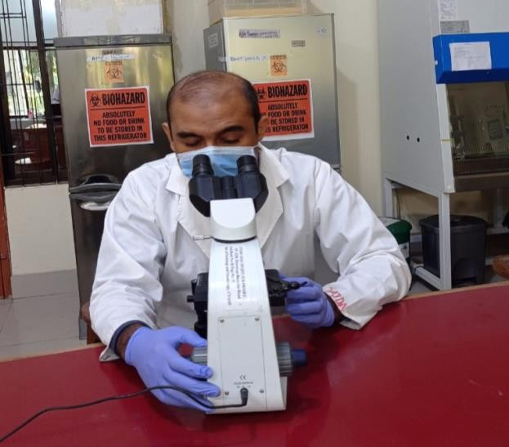

Figure 5: Sample preparation and microscopic examination

Detection of Parasites

All stool samples were examined for identifying parasite eggs using direct smear, method. All samples were subjected to routine microscopic examination by normal saline and lugol’s iodine wet mount preparations. The samples were processed within the day of collection. The eggs were identified on the basis of specific morphological details. In direct smear, a drop of water was mixed with a small portion of sample on the slide and

covered with cover slip. Then the preparation is examined microscopically using 10X objective with the condenser iris closed sufficiently to give good contrast. All findings were recorded according to identification number of the sample.

Data Analysis

The data from the questionnaire was entered into Microsoft Excel and transferred into Statistical Package for Social Science (SPSS) software for analyzing. The results will be expressed as frequencies and proportions. We performed descriptive statistics for determining the frequency distributions of items within each question and visualize the results.

Ethical Consideration

This study was carried out in accordance with the recommendations of the Chattogram Veterinary and Animal Sciences University’s ethics committee. Approval number was CVASU/Dir (R&E) EC/2019/39(2/2). Data were collected anonymously following an informed consent obtained from the parents of each participant.

Chapter-4: Results

In this study, 400 samples were analyzed and three (3) species of gastrointestinal parasites were identified in six slum areas of Chattogram Metropoliton area. Ascaris lumbricoides (Figure 6A), Trichuris trichiura (Figure 6B) and Giardia spp (Figure 6C), were found to be prevalent as 3.25%, 1% and 2% respectively in the study. None of them found statistically significant (Table 1).

Table 1: Types of parasites found in stool sample with their prevalence

Sl. No. | Species of parasite | Number of positive (N) | Prevalance (%)  (95% CI)
1 | Giardia intestinalis | 8 (400) | 2 (0.95-3.97)
2 | Trichuris trichiura | 4 (400) | 1 (0.29-2.64)
3 | Ascaris lumbricoides | 13 (400) | 3.25 (1.85-5.53)

Figure 6 represents the prevalence of parasites found in different conditions assuming to have an impact on the parasitic infection.
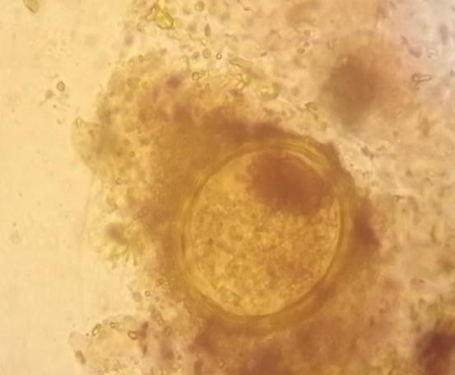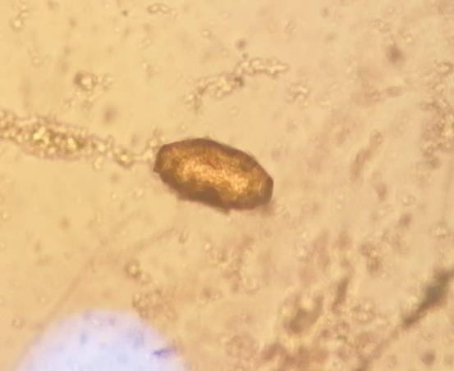

Figure: 6 (A) Figure: 6 (B)

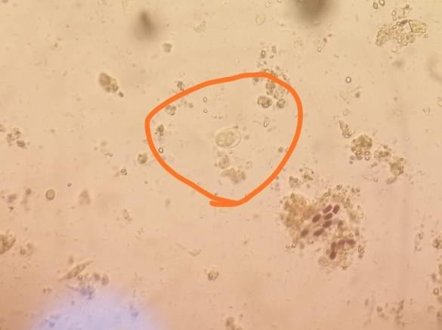
Figure: 6 (C)

Figure 6: (A) microscopic view of an egg of Ascaris spp., (B) microscopic view of an egg of Trichuris spp., (C) microscopic view of an egg of Giardia spp.
In risk factors analysis, it is revealed that, boys were more prone to the infection (7.59%) than girls (5.37%). Prevalence found lower in the group who used anthelmintic drugs

(5.84%) in compare to non-administered group (6.5%) which was expected. Similarly, the prevalence was high in the group who were using open toilet (7.28%) than the group using sanitary latrine (5.15%). Unexpectedly, subject used to have tube well (8.73%) water was showing more prone of having parasites than the group used to drink water from WASA (4.03%) and other sources (6.0%). There were almost no differences found in between the group used to drink boiled water (6.33%) and un-boiled water (6.20%). Similarly, hand wash after toilet (6.33%) or not (6.20%) did not show any remarkable differences in the study. However, hand wash before and after food found to have mentionable effect on the affecting with intestinal parasites. Children used to wash hand before and after food showed 4.58% prevalent and not used to wash hand before and after food showed 8.75% prevalent of intestinal parasites. Habit of wearing sandal in toilet showed 5.84% prevalent and not wearing sandal showed 6.50% prevalent of intestinal parasites (Table2). None of factors found significant in this study.

Table 2: Descriptive analysis of the risk factors associated with parasitic infection in slum areas oc Chattogram Metropoliton Areas.

Particular | Types | Number | Percentage (%) | Presence of parasite | Percentage  of positive (%) | P value
Sex | Boy | 158 | 39.50 | 12 | 7.59 | 0.369
 | Girl | 242 | 60.50 | 13 | 5.37
Source of Water | Tube  well | 126 | 31.50 | 11 | 8.73 | 0.304
 | WASA | 124 | 31.00 | 5 | 4.03
 | Others | 150 | 37.50 | 9 | 6.00
Boiled Water | Yes | 158 | 39.50 | 10 | 6.33 | 0.958
 | No | 242 | 60.50 | 15 | 6.20
Toilet condition | Sanitary | 194 | 48.50 | 10 | 5.15 | 0.380
 | Open  space | 206 | 51.50 | 15 | 7.28
Regular  Nail Cutting | Yes | 158 | 39.50 | 10 | 6.33 | 0.958
 | No | 242 | 60.50 | 15 | 6.20
Taken anti- helminthic | Yes | 154 | 38.50 | 9 | 5.84 | 0.791
 | No | 246 | 61.50 | 16 | 6.50
Hand Wash Before & after food | Yes | 240 | 60.00 | 11 | 4.58 | 0.092
 | No | 160 | 40.00 | 14 | 8.75
Hand Wash after Toilet | Yes | 158 | 39.50 | 10 | 6.33 | 0.958
 | No | 242 | 60.50 | 15 | 6.20

Wears Sandal | Yes | 154 | 38.50 | 9 | 5.84 | 0.791
 | No | 246 | 61.50 | 16 | 6.50

Table 4: Distribution of parasites in different slum areas in Chattogram metropolitan areas.
Parasites | Distribution
 | Foy’s lake  (N=60) | Akbarshah (N=70) | Kulgaon (N=65) | Bahar Signal  (N=55) | Bakolia (N=70) | Dewanhat (N=80)
Ascaris  lumbricoides | 2 | 0 | 4 | 1 | 3 | 3
Trichuris  trichiura | 1 | 0 | 2 | 0 | 0 | 1
Giardia spp. | 1 | 0 | 2 | 2 | 2 | 1

In this study, Kulgaon slum area found to be more prevalent for three of parasites where Ascaris lumbricoides (4) showed dominant in compare to Trichuris trichiura (2) and Giardia spp. (2). However, none of helminth parasites could identified in Akbarshah areas of CMC. Foy’s lake, Bakolia and Dewanhat showed almost similar in number of positive parasites with higher in number in the case of Ascaris lumbricoides.

Discussion
Parasitic infections are the most common social health problems frequently witnessed in developing countries like Bangladesh. This health problem is more prevalent among children and certainly careful diagnosis of symptoms reported by the patents is preferable. Few studies found to be conducted on the prevalence of parasitic infections in separate surroundings such as health care hospital and schools children in Chattogram, but our present study gave focus on the prevalence of parasitic infections in children living in different slums of Chattogram area. This study not only will help the healthcare professionals and physicians to get adequate knowledge about the reasoning of the high burden of parasitic infection in children but also will be able to provide necessary involvement needed to reduce the burden of this infection.
In this study, a total of 400 samples were studied and the prevalence of gastro-intestinal parasites named Ascaris lumbricoides in the stool samples among the study population were found to be 3.25%, Trichuris trichiura 1% and Giardia spp. 2%. The results of this study show that, among different species of gastrointestinal parasites Giardia spp. Trichuris trichiura and Ascaris lumbricoides were found more prevalent in the study area. A study held in South Chennai India where Entamoeba coli were found to be the most predominant parasite in the communities with 59 (23%) positive cases. Among helminthes, Ascaris lumbricoides was predominant with 16 (2%) positive cases followed by Trichuris trichiura with 3 (1.1%) positive cases (Dhanabal et al., 2014) which was opposite to the result of our study where Ascaris Lumbricoides was found to be more prevalent with 52% positive and no Entamoeba coli could detected.

In this respective study, boys (7.59%) showed higher prevalence rate of parasites in their stool samples in comparison with females (5.37%), that have been carefully observed in a similar study done in rural and urban populations in Puducherry, South India (Langbang et al., 2019). This finding can be an indication that, probably males are more exposed to environmental factors. Our result also administered that, the prevalence of parasites was lower comparatively than those who used anthelmintic drugs in the study group which is not unexpected. The percentage was 5.84% in comparison to non-administered groups which is 6.5%.
Inadequate sanitary measures and drinking facilities contribute highly to this high prevalence of parasitic infection. Therefore, hand washing practice that ordinarily should interrupt the transmission of some of the parasites is expectedly inadequate in situations where water supply takes a lot of manual effort and the tendency is to use water sparingly. This led in further transmission by direct and indirect contact. The watery portion contaminates bodies of water used by humans and the buried wastes contaminate underground surface water (Rai et al., 2005). In our study, the results revealed that, the prevalence was higher in the group who were using open toilets (7.28%) than the sanitary latrine (5.15%) which is coincide with a study conducted in Karachi, Pakistan (Mumtaz et al., 2009).
There is a need for behavioral change in hygiene practices as present practices of the slum children make them vulnerable to possible infection. When asked from the participants, some of them responded by saying that they do not boil or have the facility to filter the water. In addition, due to the sanitation system, not every household had toilets in the study area from which it is evident that each toilet is shared by 8-10 people.

This situation makes the sanitation and the surrounding environment unhealthy and unapproachable for a healthy living style.
This study has some limitations. The sample taken 10-20mg is very small in amount. A tiny drop of sample is examined under microscope. So it is very much possible that parasite egg is absent in that tiny drop of sample. The questionnaire was included only few variables. Samples were taken based on the convenience way devoid of randomization. Another big limitation was that, this study only included microscopic examination for identification of parasites. No molecular techniques were used for confirmatory diagnosis. However, this study provides windows for initiating further research throughout the country.

Conclusions:

Parasitic infections are indicators of the quality of drinking water and sanitation in a society. Conducted over a year, a very large number of samples (400) were included in this study. The participants of this study were mostly belonged to the six largest slums of Chattogram city. Results indicated that a low sanitation and avoid of the use of anthelmintic drugs were two common problems among the high prevalent children. Hence there is substantial need to regulate living standards in the poorer sections of the city. The study highlights the need of large scale screening and the spreading of awareness regarding the enteric parasitic infection. Moreover there is need to educate parents about general hygiene and sanitation to protect their children from very young age. Parasitic infections have severe negative impact on the psychological and physical development of a child. So, integrated intervention strategies should be taken not to reduce the disease burden. As a whole the study indicates the need of greater interest in part of local community towards spreading awareness and providing better primary health care in these neglected communities.

References:

Abedel-Hafez, M. M., El-Kady, N., Bolbol, A. S. and Bakunina, M. H. 1986. Prevalence of intestinal parasitic infections in Riyadh district, Saudi Arabia. Annals of Topical Medicine and Parasitology. 80(6): 631-634.
Ahmed T, Mahfuz M, Ireen S, Ahmed AS, Rahman S, Islam MM, Alam N, Hossain MI, Rahman SM, Ali MM and Choudhury FP. 2012. Nutrition of children and women in Bangladesh: trends and directions for the future. Journal of Health, Population, and Nutrition, 30(1), p.1.
Anderson RM 1986. The population dynamics and epidemiology of intestinal nematode infections. Transition of the Royal Society of Tropical Medicine and Hygiene. 80: 686- 696.
Ali-Shtayeh MS, Shaheen SF, Abu-Zeid I, Faidy YR. 1989. Prevalence and seasonal fluctuation of intestinal parasitic infections in Nablus area, West Bank of Jordan. Journal of Tropical Medicine and Parasitology. 1: 67-72.
Arene F0, Akabogu OA. 1986. Intestinal parasitic infections in preschool children in the Niger delta. Journal of Hygiene, Epidemiology, Microbiology and Immunology. 30(l): 99-102.
Alakija W. 1986. Prevalence of intestinal parasitic disease agents in stools of people in a rural area of Nigeria. Annals of Tropical Medicine and Parasitology. 80(5): 545-547.

Banu H, Khanum H and Hossain MA, 2010. Parasitic infestation among the adolescent girls of Bangladesh.
Bernander, R., Palm, J.D. and Svärd, S.G., 2001. Genome ploidy in different stages of the Giardia lamblia life cycle. Cellular Microbiology, 3(1), pp.55-62.
Booth M, Bundy DA, Albonico M, Chwaya HM, Alawi KS. 1997. Associations among multiple geohelminth species infections in schoolchildren from Pemba Island. Parasitology, 116, 85-93.
Bundy, D.A.P. and Cooper, E.S., 1989. Trichuris and trichuriasis in humans. Advances in Parasitology, 28, pp.107-173.
multiple geohelminth species infections in schoolchildren from Pemba Island. Parasitology. 116: 85-93.
Booth M, Bundy DA. 1992. comparative prevalence off A. lumbricoides, T. trichuris and hookworm infections and the prospects for combined control. ; Parasitology. 105: 151- 157.
Buscher HN, Haley J. 1972. Epidemiology of H. Nana infections of Punjabi villagers in west Pakistan. Transaction Journal of Tropical Medicine and Hygiene. 21(I): 42-44.
Baldawi FA, Mahdi NK, Abul-Hafez BX. 1989. Resistance of mice to infection with the human strain of H. nana. Annals of Tropical Medicine and Parasitology. 85(3): 275-277.
Brazier Y. 2018. What to know about parasites. Medical News Today. [cited 2021 Jan

12]. Available from: Https://Www.Medicalnewstoday.Com/Articles/220302#-Symptoms

Brooker S, Peshu N, Warn PA, Mosobo M, Guyatt HI, Marsh K. and Snow, R. H. 1999. The epidemiology of hookworm infection and its contribution to anemia among preschool children on the Kenyan coast. Transaction of the Royal Society of Tropical Medicine and Hygiene. 93: 240-246.
Crompton DWT, Savioli L. Intestinal parasitic infections and urbanization. 1993 Bulletin of the World Health Organization 71 (1): 1-7.
Cancrini G, Bartoloni A, Paradisi F, Nunez LE. 1989. Parasitological observations on three Bolivian localities including rural communities, cities and institutions. Annals of Tropical Medicine and Parasitology. 83(6): 591-594.
Dhanabal J, Selvadoss PP, Muthuswamy K. 2014. Comparative Study of the Prevalence of Intestinal Parasites in Low Socioeconomic Areas from South Chennai, India. Journal of Parasitology Research,
Develoux M, Alarou A, Mouchet F. 1990. High prevalence of giardiasis in an urban population in Niger. Journal of Tropical Medicine and Hygiene. 93:355-356.
Dudeja M, Nandy S, Das A, Alam S, Tiwari R. 2012. Prevalence of intestinal parasites in slum areas of southern Delhi. International journal of Microbiology Research, 4, 312-315.
Elkins DB. 1984. A survey of intestinal helminths among children of different social communities in Madras, India Transaction of the Royal Society of Tropical Medicine and Hygiene. 78: 132-133.
Eve E, Feraz E, Thatcher VE. 1997. Parasitic Infections in Villagers from Three Districts of Brazilian Amazon. Annals of Tropical Medicine and Parasitology. 1: 79-87.

Fareid MA, Alshankyty IM, Amer OH. 2011. Prevalence of intestinal parasitic and bacterial pathogens in diarrhoeal and non-diarrhoeal school children’s at Hail, Saudi. NY Science Journal, 4, pp.106-113.
Geissler PW, Mwaniki D, Thiong F, Friis H. 1998. Geophagy as a risk factor for geo helminth infections: a long study of Kenyan primary school children. Transaction of the Royal Society of Tropical Medicine and Hygiene. 92: 7-11.
Guyatt, H. L. and Bundy, D. A. 1993. Estimation of intestinal nematode prevalence: influence of parasite matting patterns. Parasitology. 107: 99-106.
Hadju, V., Stephenson, L. S., Abadi, K., Mohammed, H. 0., Bowman, D. D. and Parker, R. S. 1996. Improvement in appetite and growth in helminthes-infected schoolboys, three and seven weeks after a single dose of Pyrantel Pamoate. Parasitology. 113: 497-504.
Hesham MS, Edariah AB, Norhayati M. 2005. Intestinal parasitic infections and micronutrient deficiency: a review. Available from: Https://Www.Unboundmedicine.Com/Medline/Citation/15559182/Intestinal_parasitic_in fections_and_micronutrient_deficiency:_a_review_ .
Han, A. M., Oo, K. N., Aye, T. and Hlaing, T. 1986. Personal toilet after defecation and the degree of hand contamination according to different methods used. Journal of the Tropical Medicine and Hygiene. 89: 237-241
Hall, A., Latham, M. C., Crompton, D. W., Stephenson, L. S. and Wolgemuth, J. C. 1982. Intestinal parasitic infection of men in four regions of rural Kenya. Journal of the Royal Society of Tropical Medicine and Hygiene. 76(6):728-733.

Holland, C.V., Asaolu, S.O., Crompton, D.W., Stoddart, R.C., Macdonald, R. and Torimiro, S.E., 1989. The epidemiology of Ascaris lumbricoides and other soil-transmitted helminths in primary school children from Ile-lfe, Nigeria. Parasitology, 99, pp.275-285.
Hlaing, T., Saw, T., Aye, H. H., Lwin, M. and Myint, T. M. 1984. Epidemiology and A. LunibricoiJes i n Okpo village, rural Burma Traimaction of the Royal Society of Tropical Medicine and Hygiene. 78: 497-504.
Jjumba-Mukasa, 0. R. and Gundersa, A. E. 1971. Changing pattern of intestinal helminth infections in Jerusalem. American Journal of Tropical Medicince and Hygiene. 20(I): 109-115.
Kan SP, Poon GK. 1987. Prevalence, distribution and intensity of soil transmitted helminthiases among Malaysian children. Public Health. 101: 243-251.
Khanum H, Ahmed S, Uddin MH, Rahman, ABMM, Dey RR, Farhana R. 2008. Prevalence of intestinal parasites and anaemia among the slum male children in Dhaka city. Journal of Biological Sciences.
King, P. A., Duthie, S. J. and Ma, H. K. 1990. Intestinal helminths in pregnant Vietnamese refugees. Transaction of the Royal Society of Tropical Medicine and Hygiene, 84: 723.
Langbang D, Dhodapkar R, Parija SC, Premarajan KC, Rajkumari N. 2019. Prevalence of intestinal parasites among rural and urban populations in Puducherry, South India - A community-based study. Journal of Family Medicine and Primary Care, 8(5), 1607–1612.

Mason PR, Patterson BA, Loewnson R. 1986. Piped water supply and parasitism in Zimbabwean school children. Transaction of the Royal Society of Tropical Medicine and Hygiene. 80. 88-93.
Mumtaz S, Siddiqui H, Ashfaq T. 2009. Frequency and risk factors for intestinal parasitic infection in children under five years age at a tertiary care hospital in Karachi. JPMA. The Journal of the Pakistan Medical Association, 59(4), 216–219.
Needham, C., Kim, H. T., Hoa, N. V., Cong, L. D., Michael, E., Drake, L.,Hall, A. and Bundy,

A. P. 1998. Epidemiology of soil transmitted nematode infection in Ha Nam Province, Vietnam. Tropical Medicine and International Health. 11(3):904-912.
Oberhelman, R. A., Guerrero, E. S., Fernandez, L L., Silio, M., Mercado, D.,Comiskey, N., ihenacho, G. and Mera, R. 1998. Correlation between Intestinal Parasitosis, Physical Growth, And Psychomotor Development among Infants and Children from Rural Nicaragua. American Society of Tropical Medicine and Hygiene. (4): 470- 475.
Omar, M. S., Al-Awad, M. E. and Al-Madani, A. A. 1991. Giardiasis and amoebiasis infections in three Saudi closed communities. Journal of Tropical Medicine and Hygiene. 94: 57-60.
Olsen, A. 1998. The proportion of helminthes infections in a community in western Kenya which would be treated by mass chemotherapy of schoolchildren. Transaction of the Royal Society of Tropical Medicine and Hygiene. 92: 144-148.
Rai DR, Rai SK, Sharma BK, Ghimire P, Bhatta DR. 2005. Factors associated with intestinal parasitic infection among school children in a rural area of Kathmandu Valley, Nepal. Nepal Medical College Journal: NMCJ, 7(1), 43–46

Ramdath, D. D., Simeon, D. T., Wong, M. S. and Grantham-McGregor, S. M.1995. Iron status of school children with varying intensity of T, trichiura infection. Parasitology. 110: 349- 351.
Reinthaler, F. F., Mascher, F., Klem, G. and Sixl, W. A survey of gastrointestinal parasites in Ogun state south west Nigeria. Annals of Tropical Medicine and Parasitology. 1988; 82(2): 181-184.
Roose, M. H. 1977. The role of drugs in the control of parasitic nematode infections: must we without? Parasitology. 144: S137-S144.
Shakur MS, and Ehsan MA. 1993. Intestinal Parasites. A frequent association and contributing factor of loose motion in malnourished children. Bangladesh Journal Child Health, 17(1), pp.10-13.
Siddiqul, M. A. The prevalence of human parasites in Al-Baha, Saudi Arabia, a preliminary survey. Annals of Tropical Medicine arid parasitology. 1981; 75(5): 565-566.
Sole, T. D. &amp; Croll, A. 1980. Intestinal parasites in man in Labrador, Canada. Journal of Tropical Medicine arid Hygiene. 29(3): 364-368.
Tietze, P.E. and Tietze, P.H., 1991. The roundworm, Ascaris lumbricoides. Primary Care, 18(1), pp.25-41.
Utzinger, J., Goran, E. K., Marti, H. P., Tanner, M. and Lengerler, C. 1999. Intestinal amoebiasis, giardiasis and geo helminthiases: their association with other intestinal parasites and reported intestinal symptoms. Transition of the Royal Society of Tropical Medicine and Hygiene. 93. 137-141.

Weidong, P., Xianmin, Z., Xiaomin, C., Crompton, D. W., Whitehead, R. R., Jians in, X., Hiangeng, W., Jiyuan, P., Yang, Y., Weixing, W., Kaiwu, X. and Yongxin, Y. 1996. Ascaris, people and pigs in a rural community of Jiangxi province, China Parasitology. 133: 545-557.
Weigl MM, Calle A, Armijos RX, Vega IP, Bayas BV, Montenegro CE. 1996. The effect of chronic intestinal parasitic infection on maternal and perinatal outcome. Journal of Gynecology and Obstetrics.52: 9-17
WHO.1981. Intestinal protozoan and helminthic infections WHO technical report series No.

666.Geneva.

Appendix A

Questionnaire for data collection

Information to be read to the respondent

We wish to learn about the prevalence of different gastrointestinal parasites among children living in different slums within Chattogram city area. The information you provided will be used for the development of effective solution. Your answers will not release to anyone and will remain anonymous. Your name will not be written on the questionnaire or be kept in any other records. Your participation is voluntary and you may choose to stop the interview at any time.
Thank you for your assistance.

Part 1

ID no:

Name of the child: Age: Gender: Name of the guardian:
Address:

Part 2

Source of drinking water: Tube well/ Supply from WASA/ other…………….

Do you boil your water before drinking: Yes No Condition of toilet: Sanitary latrine Open place

Did you take an anthelmintic course? Yes No If yes, please mention the month……………..
Do you wash your hand before eating your food? Yes No Do you wash your hand after toilet? Yes No
Do you cut your nail regularly? Yes No Do you wear sandal? Yes No

Signature of the data collector

………………………………

Brief bio-data of the Author

Dr. Meah Mohammad Kamal Uddin has passed the Secondary School Certificate Examination in 1996 followed by Higher Secondary Certificate Examination in 1998. He obtained his Bachelor in medicine and bachelor of surgery (MBBS) Degree in 2007 from University of science and Technology Chittagong (USTC), Bangladesh. Now, he is a Candidate for the degree of Masters in Public Health (One Health) under the One Health Institute, CVASU. He has immense interest to continue research on infectious disease, Public health and epidemiology through One Health approach.

