Chapter 1: Introduction
1.1 Background
Bangladesh is a developing country situated in south-east Asia with a population of 160,996,000 people (UNICEF, 2020). With its greatest asset being its population, especially the children, various measures are continuously being taken to provide utmost care to its women of childbearing age and to its children. This is proven from time to time by achievement of certain goals set by international organizations such as WHO. Child death rates have been cut down by 63% over a 20-year span where the under-five mortality rate has been constantly declining from 140 deaths in the 1990s to around 31.94 deaths per 1000 live births in 2017 (UNICEF, 2020). The aim is to further reduce it so that sustainable developmental goals (SDGs) of fewer than 25 deaths per 1000 live births by 2030 can be reached.
Some of the factors that has helped achieving this success was through setting up community clinics thus enhancing access to care, and by improving immunization coverage hence limiting the spread of infectious diseases. However, diseases like pneumonia and diarrhea still take lives on a daily basis. Diarrhea is the second leading cause of death in children under 5 years of age, coming just after respiratory tract infections (Organization, 2019). Nearly 1.7 billion cases of childhood diarrhea occur every year across the world; and about half a million children die from this (ICDDR;B, 2016).
Rotavirus is the most important causative agent of serious dehydrating diarrhea among infants and young children (Kapikian & Chanock, 1990) where an estimated 1, 28,500 deaths occurred worldwide in 2016 (Troeger, et al., 2018). Infection from rotavirus is the most frequent cause of diarrhea among children under five years around the world (Kurugol, et al., 2003), including Bangladesh (Satter, et al., 2017). While vaccination for rotavirus is expected to curb down the number of cases, efficacy of the vaccine varies widely (Bern, et al., 1992). Vaccines were not as effective possibly due to existence of diverse rotavirus strains (Mameli, et al., 2012). Besides evaluating the prevalence of strains affecting the child population in Bangladesh, effective measures are needed to employ to prevent spread of infection while an effective vaccine is being developed. To establish a prevention and control strategy against rotaviral diarrhea in children, we need valid data on prevalence and its risk factors. In Bangladesh, we retrieved very few published data on prevalence and risk factors of rotaviral infection in children.
A significant number of prevalence and deaths among children below 5 years of age has been reported due to rotavirus infections worldwide in the past years, with majority of the deaths occurring in sub-Saharan Africa. More than 258 million episodes of diarrhea among children under-5 were contributed by rotaviral infections in 2016 (Troeger, et al., 2018). In Bangladesh, a study by ICDDR,B in 2006 estimated 5765 to 13430 deaths among children under five between 2001 to 2004 from rotaviral gastroenteritis (Luby, et al., 2006). Although, introduction of rotavirus vaccines reduced the number of deaths drastically in high income nations with a efficacy up to 100% in some industrialized nations, the same was not observed in middle income and low income nations (Mameli, et al., 2012). Reasons given for the varied efficay was that in developing countries it is owing to several host and environmental factors.These included high levels of coinfections with other pathogens, malnutrition, concurrent administration of OPV, diversity in rotavirus strains and many more.
The clinical signs of rotaviral gastroenteritis are indistinguishable from other infections causing similar condition. Therefore, diagnosis of rotavirus infection is made by the detection of the virus in stool specimens of the children affected by gastroenteritis. This detection can be made by a number of techniques such as electron microscopy, antigen detection assays, polyacrylamide gel electrophoresis, reverse transcription polymerase chain reaction (RT-PCR) and viral isolation. (Parashar, et al., 2013) Among them, the enzyme linked immunosorbent assays (ELISAs) and immunochromatographic assays are the most widely used antigen detection tests (Thomas , et al., 1988). However, in research laboratories, RT-PCR is used commonly to detect viral genome (Iturriza Gómara, et al., 2004). Recently, immunochromatographic test (ICT) is becoming popular as this rapid test has considerable amount of sensitivity and specificity, easy to conduct at bed side, require less experienced person and it can provide results in 10-15 minutes (Biswas, et al., 2019)

1.2 Rationale
Despite the introduction of oral rotavirus vaccines (ORVs) and WHO’s recommendation to include this in all National health programs worldwide, significant yet incomplete progress has been made in reducing disease burden in low- and middle-income countries, Bangladesh being one of them. Since Bangladesh is a tropical country and rotavirus infections are found year-round, it is necessary to find other factors, that hinder successful disease control. Across low income and middle-income counties, one in every ten deaths among children below 5 years of age is attributed to diarrhea. In these countries, variation in death rates is assumed to be the result of interventions that protect children, treat diseases and prevent infections altogether. In Bangladesh, lack in prevalence and risk factors data on rotaviral diarrhea at national and regional level was observed. Therefore, we aimed to conduct a standard survey in Chattogram region of Bangladesh to provide reliable data on prevalence and risk factors to be used in national and regional disease prevention and control strategy.
1.3 Objectives of the study
The objectives of this study were as below:
- To estimate the relative prevalence of rotavirus infection among under-five children with diarrhea.
- To identify the risk factors associated with contracting rotavirus infection among children under-five.

Chapter 2: Review of literature
Globally, the leading causes of death in children below 5 years of age are infectious diseases, congenital anomalies, preterm birth and birth asphyxia/trauma (WHO, 2020). Among the infectious diseases, diarrhea and pneumonia are the main culprit making up about one fourth of all deaths in this age group (UNICEF, 2016).
Diarrhea is the second leading cause of death in children under five, killing around 525,000 children each year worldwide. Infection with several viral, bacterial and parasitic organisms can lead to symptoms of diarrhea. Among them, two most common organisms involved are Rota virus and Escherichia coli (WHO, 2017).
2.1 Rotavirus
Rotavirus is a segmented and double stranded RNA virus that causes viral gastroenteritis, especially in young children. The genus rotavirus belongs to the Reoviridae family and the virion consists of 11 segments of double- stranded RNA that are surrounded by a naked, double layered icosahedral capsid. It consists of an RNA dependent RNA polymerase that helps in its replication process. Although many domestic animals get infected by specific strains of rotaviruses, the link between human infections with anima strains are yet to be established.
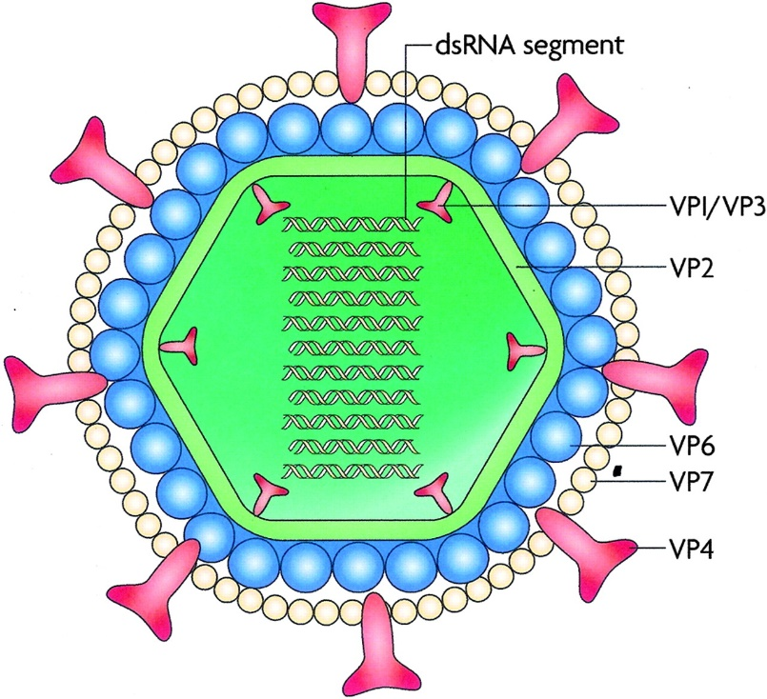
Figure 1 -Structure of the rotavirus
Source: (Angel, et al., 2007)
2.2 Subtypes
The viral particle consists of three circular layers of protein surrounding the genome. The outer protein layer consists of two viral proteins: VP4 and VP7. Based on the antigenic specifications of these two proteins the serotype classification of rotavirus is done. Both the VP7 and VP4 protein provoke the production of neutralizing antibodies and are involved with defensive immunity. The VP7 serotype is designated as a G serotype since VP7 is a glycoprotein. Similarly, the VP4 serotype is designated as a P serotype since VP4 is protease sensitive. There are 15 G serotypes that were identified so far where the G serotype and G genotype are identical. Among them, ten G serotypes have been found in humans (G1-G6, G8-G10, G12). In comparison to this, the P serotype and genotype are different and hence are designated differently. P serotypes are designated as P followed by a number (e.g., P 10), while P genotype is designated as P followed by a number in brackets (e.g., P [10]). There are 14 P serotypes (nine of which have been recovered in humans) and 23 P genotypes (10 of which have been identified in humans) that have been established so far. The genes coding the G and P antigens are added independently, allowing various combinations of G and P to be observed (Santos & Hoshino, 2005).
The 7 principal groups of rotaviruses have been identified so far, are labeled A through G. However, only the A, B, and C groups have been detected in humans. Since their first detection over four decades ago, the A group has been established as the most important cause of acute severe gastroenteritis in children and infants in both developed and developing nations (Levinson, 2016).
2.3 Pathogenesis
This virus replicates within the mucosal cells of the small intestine, leading to excessive secretion of fluids and electrolytes to the bowel lumen. The resulting loss of glucose, salt and water leads to non-bloody diarrhea with no inflammation. Since the virus is resistant to stomach acid, it can easily reach the small intestine. The watery diarrhea is presumed to be caused by the stimulation of the enteric nervous system. The immunity to rotavirus infection is not so clear. There is a possibility that intestinal IgA that is directed towards specific serotypes protects against reinfection and that IgA from colostrum protects newborns for up to 6 months. The infection is limited to the gastrointestinal tract, especially the small intestine.
2.4 Replication
Rotavirus attaches to host cell surface at the site of the b-adrenergic receptor. Following entry of the virion into the cell, the RNA dependent RNA polymerase of the virion synthesizes mRNA from each of the 11 segments within the host cell cytoplasm. These 11 mRNAs are then translated in to corresponding structural and non-structural proteins. One among these, an RNA polymerase, synthesizes minus strands that become a part of the genome of the progeny virus. Around the minus strand, an incomplete capsid is formed by capsid proteins. Next, the plus strands of the progeny genome segments are synthesized. Virus is released from the host cytoplasm by cell lysis.
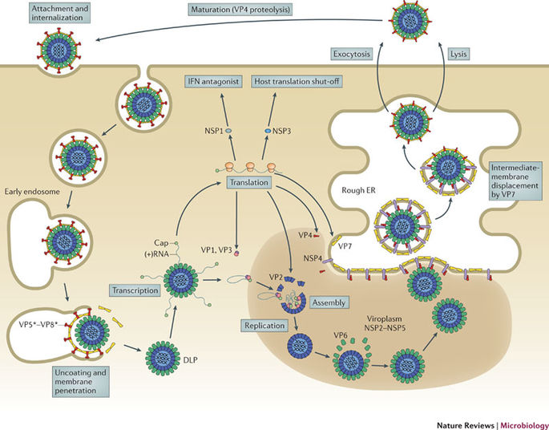
Figure 2- Replication of rotavirus
Source: (Shane, et al., 2012)
2.5 Clinical manifestations
The symptoms suggestive of a rotavirus infection include nausea, vomiting, fever, abdominal pain and watery diarrhea. Dehydration is found prominent in many cases with one study showing a significant association of vomiting and dehydration with rotavirus infections (Alkali, et al., 2015)
Complications of rotavirus infections are similar to those of other acute gastroenteritis and include severe diarrhea leading to dehydration, metabolic acidosis, seizures, etc. (Karampatsas, et al., 2018)
In adults, rotavirus infection is usually spread by the fecal-oral route and manifests with headache, malaise, nausea, abdominal cramping, diarrhea and fever. Sometimes the infection is symptomless. In immunocompromised adults, the symptoms are variable with some individuals showing no symptoms and others having severe and sustained infections. (Evan & Weber, 2004)
2.6 Epidemiology
Group A is the most common group implicated worldwide to cause rotavirus infection in children and infants (Luchs & Timenetsky, 2016). Undeniably, Group A rotaviruses was stated to be major cause of severe gastroenteritis both in humans as well as in animals worldwide including whales, snakes, cows and pigs (Alkali, et al., 2015)
Group A rotaviruses are found in both humans and animals. Group B was detected in humans, cattle, pigs, dogs and rats. Group C was found in humans, cattle, dogs ferrets and pigs (Estes & Kapikian, 2007). Group H was first detected in Bangladesh and China and more recently among pigs in Japan and Brazil (Nagashima, et al., 2008; Molinari, et al., 2014).
2.6.1 Rotavirus as an emerging and re-emerging disease
Among the strains, four common G types (G1-G4) in combination with P[4] or P[8] represents about 88% of all strains worldwide. In addition to this, type G9 in combination with P [6] or P [8] has emerged to be globally important G type due to its increasing frequency worldwide (Santos & Hoshino, 2005).However, based on geographical location, the serotypes were distributed unevenly across continents with most unusual strains being found in Africa, Asia and South America. In Bangladesh, following nationwide floods of 1988, the frequency of rotavirus mixed infection increased from 8.1% to 22.7%. Again, some unusual combinations of P-G have been detected with relatively high rates in different parts of the world, suggesting genetic stability and the capability of spreading among the populations there. Since, rotaviruses have been observed to undergo constant genetic variations, strains can be found which cannot be typed. Besides, implementation of vaccination in National Immunization Programs can exert immunological pressures that could influence the diversity of rotavirus strains worldwide (Roczo-Farkas, et al., 2018).
2.6.2 Prevalence in children
Although adults usually have minor symptoms, gastroenteritis caused by rotavirus is most severe in young children due to dehydration and electrolyte imbalance that are life threatening.
Although mortality rates had declined around the world, the situation in Africa was different since mortality rates of children under five was seven times more than that in European nations. In Nigeria, one study showed the prevalence to be 25.5% (Alkali, et al., 2015). The study also agreed that 20% of all diarrhea related deaths had rotaviral infections as the etiology. In western nations, incidences have gone down since the introduction of vaccinations. However, in Bangladesh, prevalence and mortality rate due to rotaviral diarrhea in children is yet to be published at a large scale. Data regarding rotaviral disease burden in different age groups and its associated risk factors is still an obscured area.
2.6.3 Distribution and reservoir
Both animals and humans can be reservoirs for rotavirus infection.
2.6.4 Transmission
When transmitted within the same species (such as human-human, calf–calf, etc.), rotavirus is highly infectious.
Rotavirus is presumed to be transmitted by the fecal-oral route (Dennehy, 2000).The infection occurs worldwide and by 2 years of age, most children have already been infected by rotavirus, with children in industrialized parts of the world developing it comparatively later than the developing nations. (Alkali, et al., 2015). The incubation period is 48 hours (CDC, 2019). Personal contact, contaminated food and water are usually implicated for transmission. The infection is more common in winter season (Patel, et al., 2013). Rotavirus is very infectious and is highly stable in the environment and can survive for weeks on surfaces and in water. (Bishop, 1996)
Infected individuals expel significant quantities of viral particles prior to onset of symptoms, and in about one third of the cases, up to a week after the symptoms have disappeared. Many people expel the virus without experiencing any diarrhea (Mukhopadhya, et al., 2013)
In closed environments such as homes and hospitals, person- to- person transmission can lead to spread of infection. Transmission between children in day care centers is caused by direct contact and through contaminated food and/or toys. (Dennehy, 2000). The infectious dose is between 10,000 and 10 million viral particles and infected stools generally contain about 100 billion viral particles per milliliter (Bishop, 1996).
2.7 Risk factors
2.7.1 Age and distribution of rotavirus deaths
According to the World Health organization, as of 2016, globally 215 000 child deaths occurred during 2013 due to rotavirus infection as compared to 528 000 at the beginning of the millennium (WHO, 2021).
Deaths due to rotavirus infection in children accounted for approximately 3.4% of all child deaths with a cause-specific mortality rate (rotavirus deaths per 100 000 population under age five) of 33. Four countries – Angola, Sierra Leone, Somalia and Chad had an under five rotavirus mortality rates of greater than 150 (WHO, 2021). Studies have shown a variation in age and gender distribution with most studies agreeing with the fact that Rotavirus A infections affect the under- five age group with majority of cases occurring in infancy (Magzoub, et al., 2013). No significant variation has been observed in gender, though male children had slightly higher rates of infection than females. (Navrongo Rotavirus Research Group, 2003).

2.7.2 Season
In developed countries, winter epidemics are observed with outbreaks occurring usually in nurseries. Rotavirus infections occur all-round the year but may have seasonal peaks. In temperate climates, incidences of rotavirus infections increase during winter season (Dockrell, et al., 2018).
As a result, infants born after winter season in temperate countries will not have enough exposure to the virus until the following year, but children born in tropical countries will be exposed all year. However, in tropical climates, incidences occur all year round and seasonal variations may be observed with higher incidences in dry seasons and less in rainy seasons. (Navrongo Rotavirus Research Group, 2003) Therefore, average age of onset of infection is younger in tropical countries as compared to temperate ones. (Parasher, et al., 2003).
2.7.3 Socio economic factors
Children living in densely populated areas (Wilking, et al., 2012) or in households with increased number of individuals have a higher chance of being infected by rota virus. The risks are also high among children exposed to day care settings and children whose parents have a lower level of education. (Dennehy, et al., 2006)
2.8 Diagnosis
In most cases of viral gastroenteritis, the diagnosis does not involve the laboratory tests. However, a diagnosis can be made by the detection of rotavirus in the stool using radioimmunoassay or enzyme-linked immunosorbent assay (ELISA). Earlier, demonstration of rotavirus in stool was done by immunoelectron microscopy where antibodies aggregated the virions and hence allowed them to be visualized by the electron microscope. However, this technique is not feasible economically and hence not in use for diagnostic purposes. Besides this, diagnosis can also be made by observing a fourfold or greater rise in antibody titer. The virus can also be cultured; however, isolation of virus is not done from clinical specimens. Latex agglutination test is another method for diagnosing rotavirus infection. (Peace-Brewer, et al., 2001). The frequently used methods for diagnosis are as follows:
2.8.1 ELISA
The Enzyme Linked Immunosorbent Assay (ELISA) is a test that detects and measures antibodies against specific antigens obtained from serum samples or, in case of rotavirus, from stool samples. This assay depends on the attachment of enzyme molecules that are conjugated to specific antibodies. These antibodies then bind to their specific target which may either be an antigen or an antibody depending on whether the ELISA is designed to detect antigen or antibody. After binding, these enzymes generate a colorimetric product in the presence of substrate that is proportional to the number of antigen-antibody complexes formed. ELISA sensitivity and specificity against rota virus identification was found satisfactory (90-95%) in earlier study (Thomas, et al., 1988). However, ELISA is frequently used for research purpose rather for diagnosis.
2.8.2 Enzyme immunoassay kit (EIA)
For rotavirus detection, fecal rotavirus antigen ELISA kits (Epitope Diagnostics, Inc. San Diego, CA 92121, USA) are used to detect rotavirus antigen in stool samples. Here, monoclonal antibodies against the product of sixth viral gene (VP6) is used in a sandwich type method. The EIA is highly sensitive, but it requires expertise and well-established laboratory set up.
2.8.3 rtPCR and real time rtPCR
Real time rtPCR also called qPCR is a technique of conducting polymerase chain reaction in real time. In a conventional rtPCR, the DNA from the sample is amplified and the product of this amplification is observed by the end of the process (end-point analysis). However, in real time rtPCR, measurement of the amplification product is made as the reaction progresses.
First amplification reactions are set up with PCR reagents and unique primers. The reactions are then run using real-time PCR instruments and the collected data is analyzed by a software. Fluorescent reporter molecules (DNA binding dyes or fluorescent labeled sequence specific primers) are added in each reaction well which then produces increased fluorescence with an increase in the amount of DNA produced.
The main advantage of real-time PCR over PCR is that initial number of copies of the DNA template can be measured with accuracy and high sensitivity using real time PCR (BioRad, 2021)
2.8.4 Immunochromatographic test (ICT) or rapid test
Rapid test using latex agglutination or lateral flow immunochromatography is a superior substitute to ELISA and EIA for diagnosis with good sensitivity. Results of rapid test can be achieved within 15 to 20 minutes while EIA takes 3 to 5 hours. It is a bed side test and it does not require much expertise. The sensitivity and specificity of ICT was estimated as 80.7% and 100%, respectively considering ELISA as gold standard (Mehta & Baveja, 2017). However, other studies reported 90-95% sensitivity and 97-100% specificity of ICT (Dhiman, et al., 2015, Ibrahim, et al., 2015).
2.9 Treatment and control measures
There is no specific antiviral therapy available for rotavirus infection. However, four vaccines against rotavirus are available and prequalified by WHO namely Rotarix, RotaTeq, Rotavac and Rotasiil. Two of them are monovalent and two pentavalent, however all four of them are oral live attenuated vaccines. In Bangladesh, two out of the four vaccines (Rotateq and Rotarix) are available.
2.9.1 Rotarix
Rotarix is a live, attenuated vaccine that contains the single most common rotavirus serotype (G1) causing disease in the United States.
2.9.2 RotaTeq
Rotateq is another live reassortant vaccine that contains five rotavirus strains. All five rotaviruses in the Rotateq vaccine are reassortant where gene for outer surface of human rotavirus is inserted in to a bovine strain. The bovine strain is non-pathogenic for humans, but the human outer surface protein elicits an immune response and IgA immunity is developed in the gastrointestinal tract.
2.9.3 Rotavac
This vaccine has been introduced in India since 2014. It is an alive attenuated vaccine having the serotype G9P[11] and it is given orally in three doses beginning at 6 weeks of age and up to 8 months. Each dose is given at least 4 weeks apart.
2.9.4 Rotasiil
This is a lyophilized pentavalent vaccine. It comprises of human bovine reassortant strains with serotypes G1, G2, G3, G4 and G9. It is a thermostable vaccine and can be preserved without refrigeration at temperatures below 25 degrees. (Naik, et al., 2017)
For all vaccines, there have been reports of an increased risk of intussusception among users. Thus, all vaccines are contraindicated in people with a history of intussusception. Another vaccine, Rotashield, was previously approved and is now withdrawn due to high rates of intussusception among the recipients.
2.9.5 General control measures:
Since rotavirus can spread through contaminated hands, environmental surfaces and objects, proper hand washing techniques need to be implemented and hands should be washed before meals. Occasionally, virus can spread from food and water, hence food should be cooked well, and water should be purified before drinking. However, only good hygiene and sanitation alone are not enough to control the spread of this virus. Hence, orally attenuated rotavirus vaccines are also necessary.
Diagnosis of rotaviral infection cannot be made based on clinical symptoms alone. Hence, in a child with diarrhea, assessment of the level of dehydration and treating it with the adequate amount of oral rehydration solution is the first step. If rehydration cannot be maintained with oral solution and the condition is deteriorating, intravenous infusion is required. Breast feeding should be continued along with rehydration and disease maintenance. Feeding should be started as soon as possible as this can reduce both the severity and duration of diarrhea(Parashar, et al., 2013).
2.9.6 Immunity
A primary infection induces a local as well as a systemic immune response to the serotype accountable for the infection, in addition to a high percentage of other serotypes. Thus, after an initial infection, 88% of children obtain protection against severe infection. After another infection, 100% of children develop immunity against severe infection, with majority of them developing immunity against any rotavirus disease (Fischer , et al., 2002).
In developing countries, By the age of one year, 65-80% of children get rotavirus antibodies within themselves, and 95% of children get antibodies by the age of 2 years (Fischer , et al., 2002). This is why the incidences of symptomatic illness drops rapidly after 2 years of age with repeated infections being either asymptomatic or accompanied by mild symptoms.
Generally, infants below 3 months of age with rotavirus infections are asymptomatic, while those infected for the first time after that age usually show symptoms. The explanation for this finding is not entirely clear but seems to be linked to the presence of maternal antibodies below this age.
Although immunity develops to natural infection, vaccination is a better option for young children with no history of intussusception. The monovalent and multivalent vaccines have shown efficacy in large trails in Africa and the Americas. They have now been licensed in many countries to help prevent rotavirus infections.
2.9.7 Recommended vaccination schedule:
Vaccination should be given at the recommended ages- usually at 2 and 4 months or 2, 4 and 6 months. This schedule prefers early immunization of children who are at higher risk of morbidity and mortality due to rotavirus diarrhea. However, in areas of difficult access and/or high diarrheal mortality, the vaccine could be administered later, at any time of immunization contact and before one year of age.
2.10 Public Health significance
It was estimated in 2003 that between 1986 and 2000, 111 million episodes of infantile diarrhea per year were caused by rotavirus infection- that strictly required at-home care, around 25 million medical visits, about 2 million hospitalizations, and an average of 440,000 deaths worldwide (OPAS, 2016). This means that by the time a child reaches 5 years of age, almost all of them may have experienced an episode of rotavirus diarrhea: one out of five children may have received medical consultation; one out of 65 has been hospitalized, and one out of about 293 has died (Parasher, et al., 2003). Nearly every child is infected with rotavirus at least once before the age of five, with the first infection usually occurring before age three.
In the year 2008, diarrhea from rotavirus A (RVA) resulted in 453,000 deaths among children under five worldwide, making up about 37% of deaths attributable to diarrhea and 5% of all deaths in children <5 years (Tate, et al., 2012). More recently, it was estimated that RVA caused approximately 197,000 deaths in 2011, which means that it is still the most important cause of diarrhea-related mortality worldwide. It was estimated for 14 countries in Latin America that RVA caused 6,302 deaths and 229,656 hospitalizations annually in the absence of RVA vaccination. While the incidence of rotavirus infection in developed and developing countries is similar, 80% of deaths occur in developing countries (Chen, et al., 2012).
2.11 Conclusion
Rotavirus infections are life threatening to children and a major cause of diarrhea related deaths in under- five children. Following the introduction of vaccines, although there was a reduction in number of rotavirus infection cases, a shift in the strains infecting children has been observed. Hence it has become necessary to evaluate risk factors that may be associated with disease spread so as to implement other preventive measures simultaneously along with vaccination. Large scale studies are therefore necessary to conduct to gather baseline information about the prevalence in different risk groups.

Chapter 3: Materials and Methods
3.1 Description of the study area
Chattogram is a large port city situated in the southeast coast of Bangladesh. It covers an area of 5283km² and has a population of 8.42 million (2016). The city has Chittagong Hill Tracts on one side and the Bay of Bengal on another side (BBS, 2018) The Chattogram District is further subdivided in to Zillas and Upazillas. Due to its dense population, especially in the urban areas, incidences of communicable diseases are quite frequent. (CDA, 2019)
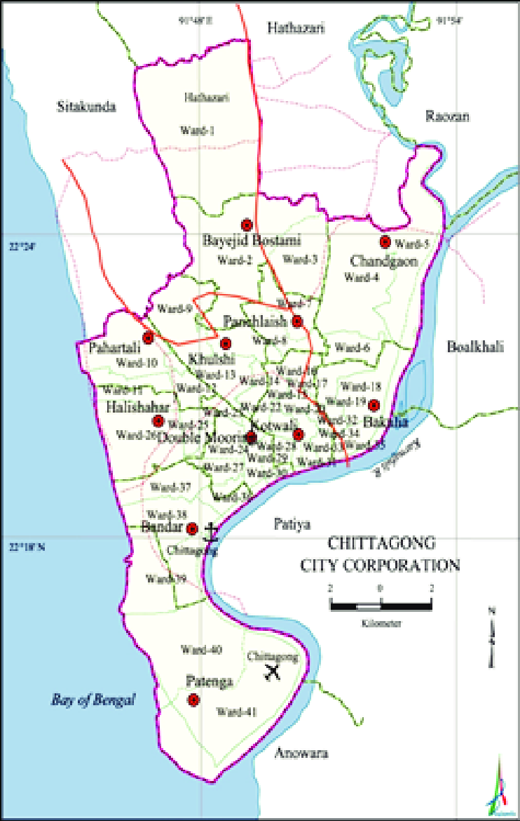
Figure 3. Map of Chattogram City
Source: (Zahur, 2019).
3.2 Study Design
This study was a cross sectional survey where data was collected from children matching the case definition who were admitted at either of two different hospitals within Chattogram city- Chittagong Medical College Hospital and BGC Trust Medical College Hospital. Pretested semi-structured questionnaires that included child details such as age gender; parental education and economic level; contact history, travel history, living conditions and sanitary practices were all recorded into a data collection sheet. Then stool samples were collected from the child and sent for laboratory examination following standard protocol.
3.3 Case definition
Hundred and fifty children below the age of five (up to 59 months of age), with acute gastroenteritis (diarrhea, abdominal pain, nausea, vomiting, fever and chills) who were admitted to either of the two hospitals were included in the study. Prior to collection of data, approval was obtained from the ethical committee of both hospitals. Children with chronic diarrhea (Diarrhea lasting more than two weeks) were excluded from this study. Written informed consent was obtained from the children’s guardians.
3.4 Study period
The study was conducted in a six months’ time period from July to December 2019.
3.5 Sample collection
Fresh stool samples were collected from symptomatic children within 24 to 48 hours after admission in wide necked sterile plastic containers. This was then stored in a refrigerator at 4⁰C and was transported that same day to the laboratory in a cold box after which they were stored at -20⁰C until assayed.
3.6 Data collection
Alongside specimen collection, information on risk factors were collected from the child’s parents or guardians and recorded in a pre-tested semi structured questionnaire. The questionnaire used for epidemiological data collection are given in the appendix.
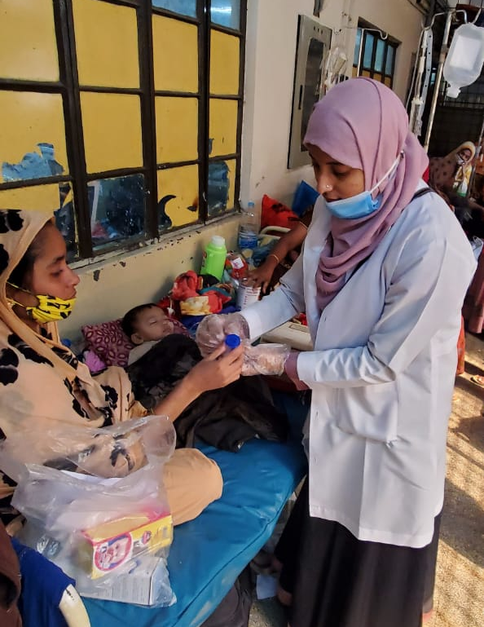
Figure 4- Sample collection
3.7 Sample analysis
Initially, macroscopic examination of each sample was conducted by observing the consistency, colour, presence of blood, mucus, segments or worms. After labeling, the stool samples were sent for the detection of rotavirus antigen and stored at -20°C until they were assayed.
3.7.1 Detection of Rotavirus by immunochromatography
For rotavirus antigen testing, ICT RIDA Quick Rotavirus kits (r-Biopharm, Germany) were used. This is a single step ICT lateral flow test and was conducted according to the manufacturer’s instruction guidelines. (Weitzel, T, et al., 2007)
Lateral flow immunochromatographic assays or rapid tests are simple devices that are used to detect the presence of any target substance within a liquid sample. In this case, the target was rotavirus within stool samples. It works on the sample principles as the ELISA test. Here, liquid samples run along the surface of a pad containing reactive molecules that can show a visual positive or negative result. The pad soaks and the liquid then reach the second conjugate pad containing the reagents required for an optimal chemical reaction between the antigen and antibody. Once marked, this antigen continues through the pad across to the lest and control lines. The test line shows a color if positive, while the control line shows a color irrespective of test results to show if the sample has flown through. Finally, the liquid enters the wick which acts as a waste collector.
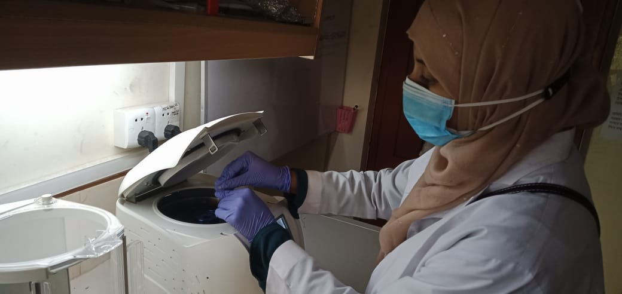
Figure 5- centrifugation of the sample before adding to ICT test strip
3.7.2 ICT result interpretation
Appearance of two bands (one red and one blue) was considered rota positive test and appearance of only one blue band as rota-negative. Absence of any bands rendered the test result as invalid.
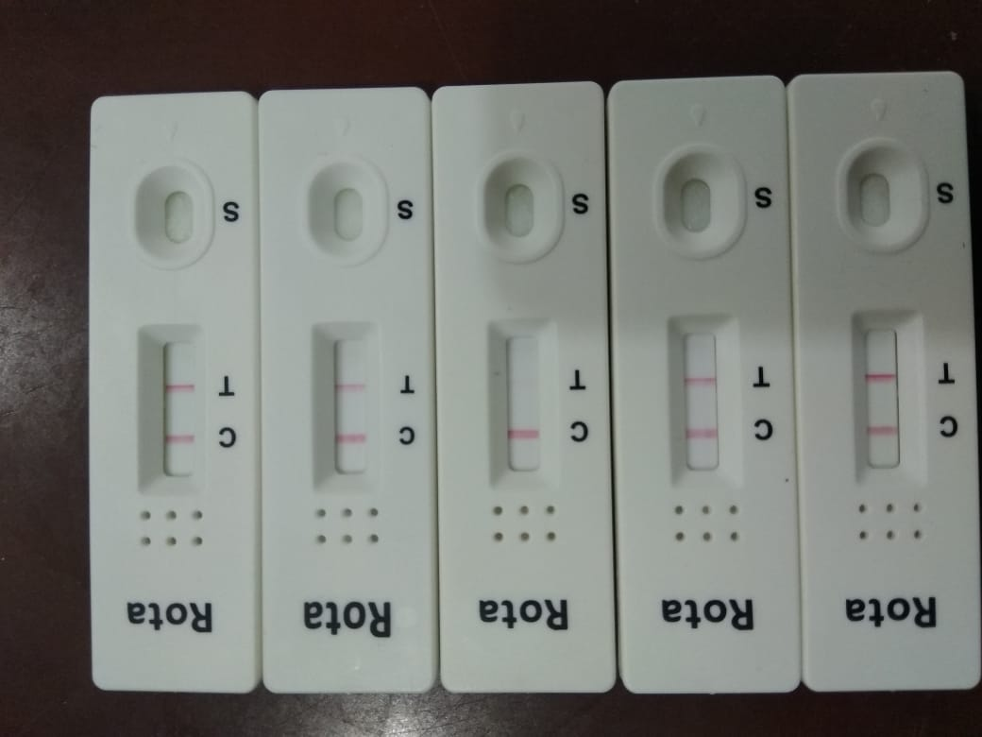
Figure 6 - ICT test results
3.8 Statistical analysis
Data collected using the questionnaire and laboratory results were compiled into a Microsoft Excel spreadsheet. The data was then analyzed using STATA/IC 13 (StataCorp 4905, Lakeway Drive, College Station, Texas 77845, USA).
3.8.1 Descriptive analysis
Descriptive statistics of demography of the study population was calculated as frequency and percentage and displayed in graphs using Microsoft Excel. Frequency and percentages (prevalence) of rotaviral diarrhea cases was estimated stratified by different variables such as age, gender, location, contact history and living conditions of the child.

3.8.2 Risk factor analysis
3.8.2.1 Univariable logistic regression
To evaluate the association between independent variables (risk factors/determinants) with dependent variable (sample positive/negative), univariable analysis was performed using χ² test and univariable logistic regression models in STATA-IC 13. Independent variables with a P-value of ≤ 0.10 in univariable analysis was considered for inclusion in the multivariable logistic regression model.
3.8.2.2 Multivariable logistic regression
A model of multivariable logistic regression was built using independent variables found significant in the univariable analysis. Backward elimination process was followed to reach the final model. A p-value ≤0.05 was considered significant in the multivariable model.

Chapter 4: Results
The present study was conducted at Chattogram district and data was collected over a period of six months (July 2019- Dec 2019) from hospitals situated in two different locations within the district. A total of 150 children below 5 years of age who presented with acute watery diarrhea were enrolled in the study. About half of the respondents lived in urban areas (n=74) while the rest lived in rural areas (n=76) of Chattogram district. Immunochromatographic test (ICT) or rapid test was used for the diagnosis in this study. Among all the respondents, 70 (prevalence was 46.7% with a 95% CI between 38.7-54.0 ) children were found positive for rotavirus infection while the rest were ICT negative.
4.1 Descriptive statistics of the children included in the study
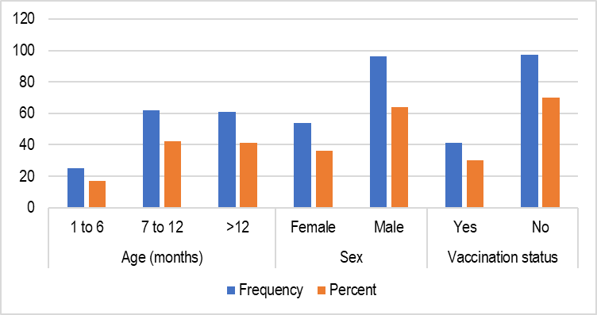
Figure 7: Demography of the children with gastroenteritis included into the study.
Figure 7 illustrates the variation in age group, gender and vaccination status among the study subjects. In our study 17% of the study population were consisting of 1-6 months of age followed by 42% and 41% of 7-12 and >12 months of age, respectively. 64% of the population were male and the rest female.
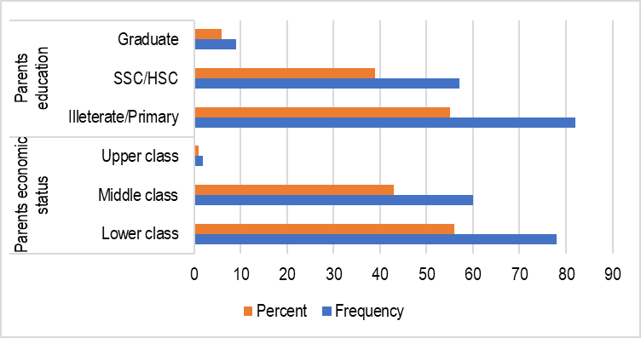
Figure 8: Parents education and economic status of the children with gastroenteritis included into the study

55% of parents of the study subjects were illiterate or had only primary education. Only 6% (n=9) of them completed graduation. Most of the children of the study came from either a lower class or middle class family;56% and 43% respectively.
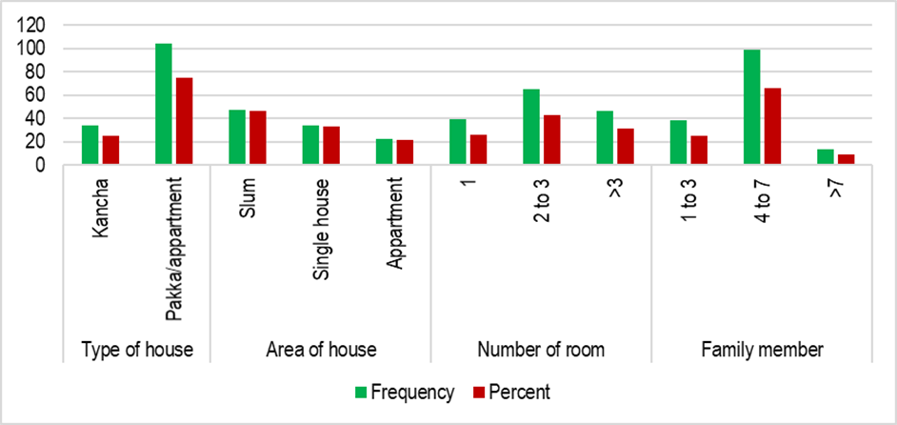
Figure 9: Distribution of housing related variables of the children with gastroenteritis included into the study

Figure 9 above illustrates the variation in types and areas of houses along with the number of rooms and family memebrs of the study subjects. Three fourths of the total subjects (75%, n=104) lived in pakka or apartment houses. 46% of the children live in slum areas (n=47), 43% of them had more than one room at home (n= 111). Maximum (n=99,66%) of the study population belonged to a family having 4-7 family members.
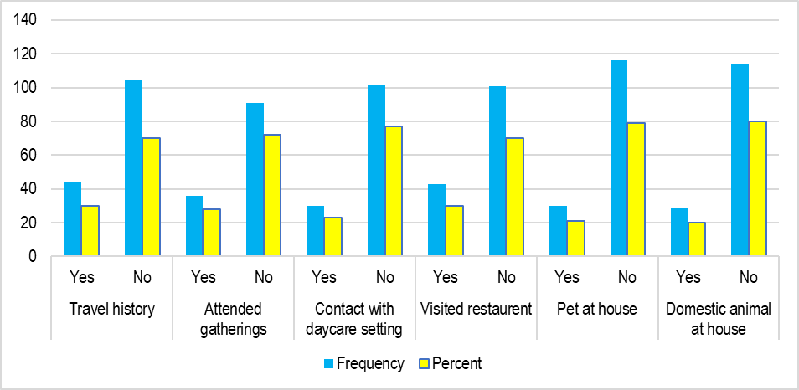
Figure 10: Distribution of contact related factors of the children with gastroenteritis included into the study
The barchart above (figure 10) shows the descriptive data of the contact factors of children who were admitted to hospital for gastroenteritis during the study period. Although some of the respondents had a travel history (30%), had contact with other animals (20%) or children (23%), or had food from outside the house at restaurant settings (30%), majority of the respondents didnot have such a history.
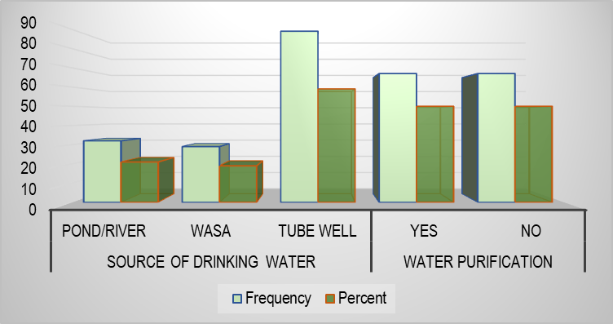
Figure 11: Distribution of drinking water related factors of the children with gastroenteritis included into the study
Most of the children affected by gastroenteritis took water from tube wells (59%, n=89), followed by children taking pond or river water (21%, n=32) and water from WASA. (19%, n=29). Half of the children’s households did not purify water before drinking.

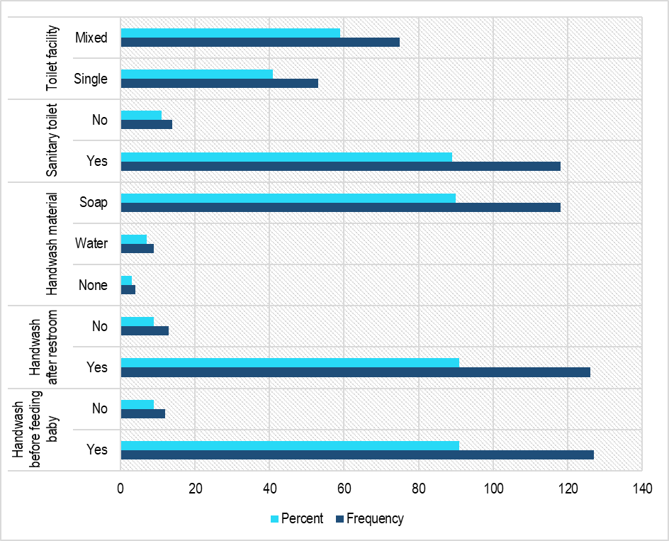
Figure 12: Distribution of parents’ hygiene related factors of the children with gastroenteritis included into the study
Figure 12 shows distribution of the factors related to parental hygiene of the children affected by gastroenteritis. Among all study subjects, 75 (59%) of the children’s families had mixed toilet and 118 (89%) families used sanitary latrines. In terms of hand washing practice, majority of the parents washed their hands with soap (n=118, 90%), after using the rest room (n=126, 91%), and before feeding the baby (n=127, 91%). In other words, majority of parents of the children followed hygienic measures.
4.2 Determinants/ risk factors of rotavirus infections among children with gastroenteritis
In the study, multiple risk factors/ determinants were surveyed to find which ones most likely caused rotaviral gastroenteritis in the study population. The factors evaluated were age, gender, rotavirus vaccination status, parental economic status, environmental factors and parental hygiene practices,etc.
Results presented in Table 1 shows different variables analyzed using univariable significance tests to identify determinants or risk factors of rotaviral infections among children under five years of age. Prevalence of rotaviral infection was least in the 1 to 6 months age group (32%, reference group) compared to the 7 to 12 months (52% OR=2.26) and above 12 months (49%, OR=2.05) age group. Despite the odds of having rotaviral infection more than twice in the above 6 months age groups, no statistically significant difference has been observed (p value>0.05). In case of gender, rotaviral infections were significantly (p=0.03) more prevalent in male children (53%, OR=2.08) compared to female children. In case of economic status, children of middle class parents had a slightly higher odds (OR=1.07) of being infected by rotavirus. Only two children were belonged to the upper economic class family and both were ICT positive for rotaviral infections. Regarding parents education, children of graduate parents had a lower chance of being infected by rotavirus(OR=0.33), and so were children living in apartment buildings (OR=0.53).
In case of family size, children from large families (having more than 3 family members) had a significantly higher odds of having rotaviral infections (p=0.04). Surprisingly, children with a travel history (p=0.05), who attended large gatherings (p=0.03) and who visited restraunts (p=0.03) prior to illness had significantly lower chance for rotaviral infections.
Table 1: Univariable analysis to identify risk factors for rotavirus infection in children.
Variable | Category | Total observation | Number positive(%) | OR | P value
Age | 1 to 6 | 25 | 8 (32) | Ref. | -
 | 7 to 12 | 62 | 32 (52) | 2.26 | 0.10
 | >12 | 61 | 30 (49) | 2.05 | 0.14
Gender | Female | 54 | 19 (35) | Ref. | -
 | Male | 96 | 51 (53) | 2.08 | 0.03
Economic status | Lower | 78 | 35 (45) | Ref. | -
 | Middle | 60 | 28 (47) | 1.07 | 0.30
 | Upper | 2 | 2 (100) | - | -
Parents education | Illiterate/primary | 82 | 38 (46) | Ref. | -
 | SSC/HSC | 57 | 29 (51) | 1.19 | 0.59
 | Graduate | 9 | 2 (22) | 0.33 | 0.18
Type of house | Kaccha | 43 | 13 (38) | Ref. | -
 | Pakka/apartment | 104 | 48 (46) | 1.38 | 0.42
Area of house | Slum | 47 | 22 (47) | Ref. | -
 | Single house | 34 | 19 (56) | 1.43 | 0.42
 | Apartment | 22 | 7 (32) | 0.53 | 0.24
Number of rooms | 1 | 39 | 17 (44) | Ref. | -
 | 2 to 3 | 65 | 33 (51) | 1.33 | 0.47
 | >3 | 46 | 20 (43) | 0.99 | 0.43
Family member | 1 to 3 | 38 | 14 (37) | Ref. | -
 | 4 to 7 | 99 | 53 (54) | 1.97 | 0.04
 | >7 | 13 | 3 (23) | 0.51 | 0.36
Travel history | No | 105 | 54 (51) | Ref. | -
 | yes | 44 | 15 (34) | 0.48 | 0.05
Pet at home | No | 116 | 55 (47) | Ref. | -
 | Yes | 30 | 13 (43) | 0.84 | 0.69
Domestic animal at home | No | 114 | 52 (46) | Ref. | -
 | Yes | 29 | 14 (48) | 1.11 | 0.79
Attended gatherings | No | 91 | 47 (52) | Ref. | -
 | Yes | 36 | 11 (31) | 0.41 | 0.03
Contact with daycare settings | No | 102 | 50 (49) | Ref. | -
 | Yes | 30 | 11 (37) | 0.60 | 0.23
Visited restaurant | No | 101 | 52 (51) | Ref. | -
 | Yes | 43 | 14 (33) | 0.45 | 0.03
Drinking water | Pond/river | 32 | 17 (53) | Ref. | -
 | WASA | 29 | 17 (59 | 1.25 | 0.66
 | Tube well | 89 | 36 (40) | 0.59 | 0.17
Water purification | No | 67 | 35 (52) | Ref. | -
 | Yes | 67 | 29 (43) | 0.69 | 0.29
Handwash before feeding baby | No | 12 | 8 (67) | Ref. | -
 | Yes | 127 | 58 (46) | 0.42 | 0.16
Disinfectant materials | None | 4 | 2 (50) | Ref. | -
 | Water | 9 | 5 (56) | 1.25 | 0.85
 | Soap | 118 | 55 (47) | 0.87 | 0.89
Sanitary toilet | No | 14 | 5 (36) | Ref. | -
 | Yes | 118 | 55 (47) | 1.57 | 0.44
Toilet facility | Single | 53 | 24 (45) | Ref. | -
 | Mixed | 75 | 38 (51) | 1.24 | 0.54

Following univariable analysis, a multivariate logistic regression analysis was conducted including probable factors found significantly causing rotaviral infections (Table 2). Three variables, namely age, gender and number of family members remained in the final model with a p-value of 0.05 and below. As shown in the table, children above 6 months of age, male children, and children belonging to families with more than 3 family members had a higher chance of being rota-positive.
Table 2: Final multivariable logistic regression model to identify risk factors for rotaviral infection in children
Variable | Category | OR | 95% CI | P value
Age (month) | 1 to 6 | Ref. | - | -
 | 7 to 12 | 3.17 | 1.10-9.11 | 0.03
 | >12 | 2.62 | 0.92-7.46 | 0.07
Gender | Female | Ref. | - | -
 | Male | 2.18 | 1.03-4.62 | 0.04
Family member | 1 to 3 | Ref. | - | -
 | 4 to 7 | 2.15 | 1.05-4.85 | 0.05
 | >7 | 0.71 | 0.15-3.31 | 0.43

4.3 Frequency of clinical signs among rota-positive children
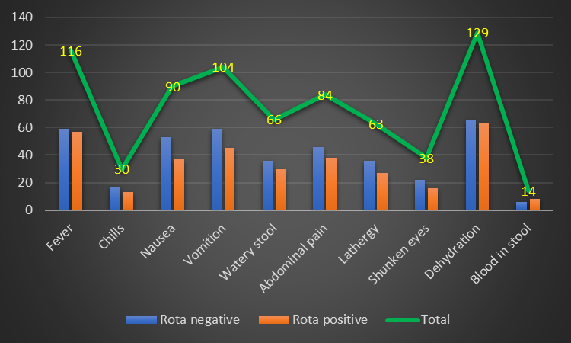
Figure 13: Presence of different clinical signs in rota positive and rota negative children
The most common symptoms of gastroenteritis in our study group were fever, nausea, vomiting and dehydration; and the least common were bloody stools followed by chills and sunken eyes (figure 13). Although bloody stool was the least common sign, rota-positive cases (n=8) had a slightly higher frequency of bloody stools than rota-negative cases(n=6). There was no obvious difference in frequency of different clinical signs between rota positive and negative cases.

Chapter 5: Discussion
5.1 Prevalence of rotaviral diarrhea among children under five years of age
Globally, rotaviral infections are considered to be one of the leading causes of morbidity and mortality (Fidhow, et al., 2017). This enormous burden has made the development of a rotavirus vaccine integral for the mitigation of spread across the world. In this study rotavirus was found to be an important cause of acute gastroenteritis among children below five years of age with a prevalence of 46.7%. Multiple studies conducted across the world showed a prevalence similar to this (Fidhow, et al.,2017; Al-Badani, et al.,2014; Salim, etal.,2014). However, in a study conducted at different hospital settings in the city of Chattogram had a much higher prevalence rate (63.3%) compared to our study (Biswas, et al., 2019). In that study, both immunochromatography and ELISA was employed and when ELISA was considered as the golden standard, ICT had a sensitivity of 80.7% and specificity of 100%. Another study from Egypt also differed from our study in a similar way (Ibrahim, et al., 2015). Reporting a high prevalence rate of 76.9% this study used RT-PCR for the diagnosis of rota-positive cases. Hence, it is plausible that our study showed a low prevalence due to a slighly low sensitivity of the assay method used. Moreover, the total number of cases in the studies mentioned above was almost half the number of cases in our study therefore undermining the validity of those studies.
5.2 Risk factors of Rota- positive cases in underfive children of Chattogram
In case of age variation, children below the age of 6 months had lower risks of being infected by rotaviral infections and more males were affected than females. This is yet another finding consistent with many other rotaviral studies (Ibrahim,et al.,2015; Biswas,et al.,2019; Salim, et al., 2014). Although, some studies showed incidences of acute gastroenteritis to be more frequent in the 0-6 months age group compared to other age groups in under 5 children, rotavirus induced gastroenteritis was rare in this age group (Fox, et al., 1990). One reason cited in these studies was the fact that most children under 6 months of age were exclusively breast feed (Fidhow, et al., 2017; Al-Badani, et al., 2014; Naficy, et al., 1999). Infact, cases of acute gastroenteritis was more common in bottle fed children than in breast fed children (Hans-Iko, et al., 2008; Sánchez-Uribe, et al., 2013). So, breast feeding was found to be a protective factor against infection by rotavirus. An exclusively breast fed child’s intestinal flora mainly consisted of Bifidobacterium and Lactobacillus species compaed to formula-fed infants whose pattern of intestinal flora was similar to that of adults (Peterson, R, et al., 2013). One clinical study stated Lactobacillus species induced intestinal colonization and protection against rotavirus associated diarrhea (Kaila, et al., 1992). However, there were studies that did not find such differences (Clemens, et al., 1993; Duffy, et al., 1986).
As for gender variation, there were studies that did not find any significant variation between gender when comparing rates of rotaviral infection. Almost all studies conducted in developing nations had an increased incidence of acute gastroenteritis in male children than in female children (Biswas, et al., 2019; Ibrahim, et al., 2015; Salim, et al., 2014). One study found a less significant association between hospitalization and male gender (Hans-Iko, et al., 2008) thus suggesting disparities in seeking treatment based on gender preferences. This leads to a conclusion that female childen are less likely to be taken to hospital for treatment unless they are severly ill as compared to their male counterparts. Extended study is needed to be conducted to evaluate if differences in physiology or genetics between genders have an effect on difference in prevalence.
Our findings additionally suggest that socioeconomic factors contributed to the development of acute gastroenteritis among children, though no statistically significant association was observed between rotaviral infections and socioeconomic class. Previous studies varied widely in these findings. Some found lower socioeconomic class to be associated with increased incidences or rota- positive cases (Biswas, et al., 2019) while other studies found an association between low education level and rota-positive cases (Sánchez-Uribe, et al., 2013). However, no study was found reporting a significant association between the two.
Children living in families with more than three family members showed a significant association with development of rotavirus infections in our study. Occurrences were reported higher in larger families in another study (Sánchez-Uribe, et al., 2013), however, here occurrences were higher in families with 7 or more members. In our study, we observed highest frequency in families with 3 to 7 members, and families with more than 7 family members did not show a significant association possibly owing to low study power due to having less observation in this group. However, it can be stated that over crowding could be a contributory factor to the development of rotaviral infections, as mentioned in the Dennehy study (Dennehy, et al., 2006).
When considering environmental factors in the spread of rotaviral infections, our study found no significant association between cases who drank purified or boiled water or water from sources like rivers/ ponds, however studies reviewed both nationally and internationally that were contrary to this finding (Fidhow, et al., 2017; Biswas, et al., 2019). In fact, one study done in the same district found lower cases of rotaviral infections in children who took boiled water (Biswas, et al., 2019). The same study also found a positive impact of rotaviral vaccinations in children where non vaccinated child had higher frequency of rotaviral infection. This finding was also not consistent with our study as cases of rotavirus infections didnot differ significantly between vaccinated and unvaccinated children. Effectiveness of rotavirus vaccines could be the plausible explaination of this phenomena. One meta-analysis showed the effectiveness of rotavirus vaccinations as 53% against rotaviral infcetions, 73% against hospitalizations and 74% against severe diarrhea (Santos, et al., 2016). In fact, the effectiveness of vaccination varied across different countries and different age groups (Burnett, et al., 2020). One cause of rotaviral infection despite vaccination could be the emergence of a different genotype that the vaccine is ineffective against (Santos, et al., 2016). Another factor that needs to be taken in to consideration is the immunological status of the vaccinated children. Malnourished or undernourished children are at higher risk of developing infections irrespective of vaccination status (Fidhow, et al., 2017).
Since rota virus can be spread by direct contact from person to person, evaluation of contact history was done and a significant association was found in children who travelled, attended gatherings and visited restaurants prior to onset of illness in univariable analysis. However, in each cases, it was surprisingly observed that when there was any kind of contact history, it had a protective effect. When all variables were tested together in multivariable analysis to account for the confounding effect of the variables, the association between contact variables and the outcome became statistically insignificant and was excluded from the final model. Therefore, it can be stated that the protective effect showed by different contact variables in univariable analysis was confounded by other variables. Moreover, no significant difference has been observed between effective hand washing techniques maybe because of having less observations in some categories (8 negative responses against 58 positive responses for ‘washing hands before feeding baby’).
5.3 Clinical symptoms associated with rotaviral infections
In our study, the clinical symptoms for gastroenteritis were nearly similar for both rota-positive and negative cases. Yet similar studies have showed worse symptoms in children infected by rotavirus (Biswas, et al., 2019), with some studies finding a significant association of disease severity with rota-positive cases (Ibrahim, et al., 2015). This finding is debatable since comparison of prevalence of rotaviral infections between inpatients and outpatients showed no significant difference (Al-Badani, et al., 2014). In other words, based on severity of clinical presentation, we cannot say who is infected by rotavirus and who is not. From our observation, it can be stated that diagnosis of rotaviral diarrhea cannot be relied on clinical signs, rather, laboratory techniques are needed for confirmation.

Chapter 6: Conclusion
From the above results and discussion, we can come to this deduction that rotavirus infections are not so infrequent among children suffering from acute gastroenteritis. Even though this study used immunochromatographic method for rapid diagnosis of rotavirus infections among children, the accuracy could hardly be doubted since previous studies have showed sensitivity of the ICT to be close to that of ELISA test (El-Morsy, et al., 2017). Children below six months of age were less likely to be affected by rotavirus and female children had lower prevalence of rotaviral infection in our study. Prevalence of rotavirus was also significantly higher in larger families. All these suggest that factors other than socioeconomic status, educational qualification of parents and contact history were involved in the spread of rotavirus infection in the study area. Clinical features of acute gastroenteritis for rota-positive and rota-negative cases were similar in this study, however, more occurrences of bloody stools in rota positive cases as compared to negative cases raises a suspicion about the severity of illness in such patients.

Chapter 7: Recommendations
Further research on mode of disease transmission, prevalence of different types of rotaviral infections and effective methods for diagnosing cases of different strains of rotavirus is necessary in order to get a clear picture on the distribution and determinants of rotaviral infections among children in Chattogram district, Bangladesh.
Hence, future research should be focused on
- Using RT-PCR and ELISA tests to confirm the prevalence as well as the risk factors for rotavirus infections among under five children in Chattogram district.
- A comparison of sensitivity of all serological tests used to identify cases of rotavirus infections in children.
- Distribution of rotaviral infections among different areas within the district.
- Comparing clinical symptoms between rota-positive and age, gender matched rota-negative controls.
- Identify association between severity of disease and rota virus infection using a larger sample size and Vesikari clinical scoring system.

Chapter 8: Limitations
As with other studies, this study was not without limitations. Mentioned below are a few of them.
- Although an attempt was made to collect a large sample size, due to limited study period of 6 months and resources, the sample collected was 150.
- Moreover, sample collection places were limited to only two major hospitals, one in urban, and another in a rural area. Inclusion of more hospitals from different areas of the district may have given us a better understanding of the true case scenario.
- Due to budget limitations, only immunochromatography was used as the assay method for diagnosis of rota positive cases. Additional use of other tests such as RT-PCR and ELISA could help exclude false positives and identify missed cases.
- The questionnaire was filled out after interviewing parents or caregivers of the sick study subjects. Hence, there are chances of bias during data collection.

References
Al-Badani, A., Al-Areqi, L., Majily, A., Al-Sallami, S., Al-Madhagi, A. and Amood AL-Kamarany, M., 2014. Rotavirus diarrhea among children in Taiz, Yemen: Prevalence—risk factors and detection of genotypes. International journal of pediatrics, 2014.
Alkali, B. R., Daneji, A. I., Magaji, A. A. & Bilbis, L. S., 2015. Clinical symptoms of human rotavirus infection observed in children in Sokoto, Nigeria. Advances in Virology, pp. 1-6.
Angel, J., Franco, M. A. & Greenberg, H. B., 2007. Rotavirus vaccines: recent developments and future considerations. Nature Reviews Microbiology, 5(7), p. 531.
BBS, 2018. BBS.,2018. Statistics and Information Division. Ministry of planning. Government of The People’s Republic of Bangladesh.
BioRad, 2021. What id Real time- PCR. [Online]
Available at: https://www.bio-rad.com/en-bd/applications-technologies/what-real-time-pcr-qpcr?ID=LUSO4W8UU [Accessed 21 1 2021].
Bishop, R. F., 1996. Natural history of human rotavirus infection. In Viral Gastroenteritis. Archives of Virology, Volume [suppl]12, pp. 119-128.
Biswas, S.K., Sultana, N., Badruddoza, M., Azim, M.A. and Biswas, R.S.R., 2019. Immunochromatographic Test and ELISA for Detection of Rotavirus in Fecal Sample: A Comparative Study. Chattagram Maa-O-Shishu Hospital Medical College Journal, 18(2), pp.7-11.
Burnett, E., Parashar, U. D. & Tate, J. E., 2020. Real-world effectiveness of rotavirus vaccines, 2006–19: a literature review and meta-analysis. The Lancet Global Health, 8(9), pp. e1195-e1202.
CDA, 2019. Introduction & History, Chittagong and CDA. [Online] Available at: http://cda.gov.bd/intro-history-objective/ [Accessed 21 1 2021].
CDC, 2019. Rotavirus-clinical information. [Online] Available at: https://www.cdc.gov/rotavirus/clinical.html#:~:text=The%20incubation%20period%20for%20rotavirus,cause%20the%20most%20severe%20symptoms [Accessed 20 1 2021].
Chen, S. C., Tan, L. B., Huang, L. M. & Chen, K. T., 2012. Rotavirus infection and the current status of rotavirus vaccines. Journal of the Formosan Medical Association, 111(4), pp. 183-193.
Clemens, J., Rao, M., Ahmed, F., Ward, R., Huda, S., Chakraborty, J., Yunus, M., Khan, M.R., Ali, M., Kay, B. and Van Loon, F., 1993. Breast-feeding and the risk of life-threatening rotavirus diarrhea: prevention or postponement? Pediatrics, 92(5), pp.680-685.
Dennehy, P. H., 2000. Transmission of rotavirus and other enteric pathogens in the home. The Pediatric infectious disease journal, 19(10), pp. s103-s105.
Dennehy, P.H., Cortese, M.M., Bégué, R.E., Jaeger, J.L., Roberts, N.E., Zhang, R., Rhodes, P., Gentsch, J., Ward, R., Bernstein, D.I. and Vitek, C., 2006. A case-control study to determine risk factors for hospitalization for rotavirus gastroenteritis in US children. The Pediatric infectious disease journal, 25(12), pp.1123-1131.
Dhiman, S., Devi, B., Singh, K. & Devi, P., 2015. Comparison of enzyme linked immunosorbent assay and immunochromatography for rotavirus detection in children below five years with acute gastroenteritis. Journal of clinical and diagnostic research, 9(9), pp. 1-6.
Dockrell, D. H., Sundar, S. & Angus, B. J., 2018. Infectious Disease. In: S. H. Ralston, I. D. Penman, M. W. J. Strachan & R. P. Hobson, eds. Davidson's principles and practice of medicine. s.l.:Elsevier, p. 249.
Duffy, L.C., Byers, T.E., Riepenhoff-Talty, M., La Scolea, L.J., Zielezny, M. and Ogra, P.L., 1986. The effects of infant feeding on rotavirus-induced gastroenteritis: a prospective study. American Journal of Public Health, 76(3), pp.259-263.
El-Morsy, E.S.M., Zaky, M.E., Alhusseny, M.A., Abd Elfatah, A.A. and Ahmed, S., 2017. Comparative Study of Diagnostic Methods for Rotavirus in Children Hospitalized for Diarrheal Disease in Mansoura Pediatric Hospital. American Journal of Biomedical Science and Engineering, 3(6), pp.64-70.
Estes, M. K. & Kapikian, A. Z., 2007. Rotaviruses. In: D. M. Knipe, et al. eds. Fields virology. Philadelphia: Lippincott Williams & Wilkins, p. 1917–1974.
Evan, J. A. & Weber, S. G., 2004. Rotavirus infection in adults. The Lancet Infectious disease, Volume 4, pp. 91-99.
Fidhow, A.M. and Samwel, A., 2017. Molecular epidemiology and associated risk factors of rotavirus infection among children< 5 yrs hospitalized for acute gastroenteritis in North Eastern, Kenya, 2012. The Pan African Medical Journal, 28(Suppl 1).
Fischer, T.K., Valentiner-Branth, P., Steinsland, H., Perch, M., Santos, G., Aaby, P., Mølbak, K. and Sommerfelt, H., 2002. Protective immunity after natural rotavirus infection: a community cohort study of newborn children in Guinea-Bissau, west Africa. The Journal of infectious diseases, 186(5), pp.593-597.
Fox, R., Leen, C.L., Dunbar, E.M., Ellis, M.E. and Mandal, B.K., 1990. Acute gastroenteritis in infants under 6 months old. Archives of disease in childhood, 65(9), pp.936-938.
Hans-Iko, H., Salma, N. & Giaquinto, C., 2008. Risk Factors for Severe Rotavirus Gastroenteritis. Pediatr Infect Dis J, Volume 27, pp. S11-S19.
ICDDR;B, 2016.Cholera and other diarrhoeal disease [Online] Available at https://www.icddrb.org/news-and-events/press-corner/media-resources/cholera-and-other-diarrhoeal-diseases [Accessed on 9/1/2021].
Ibrahim, S.B., El-Bialy, A.A., Mohammed, M.S., El-Sheikh, A.O., Elhewala, A. and Bahgat, S., 2015. Detection of Rotavirus in children with acute gastroenteritis in Zagazig University Hospitals in Egypt. Electronic physician, 7(5), p.1227.
Kaila, M., Isolauri, E., Soppi, E. & Virtanen, E., 1992. Enhancement of the circulating antibody secreting cell response in human diarrhea by a human Lactobacillus strain. Pediatric Research, 32(2), pp. 141-144.
Karampatsas, K., Osborne, L., Seah, M. L. & Tong, C., 2018. . Clinical characteristics and complications of rotavirus gastroenteritis in children in east London: A retrospective case-control study. Plos one, 13(3), p. e0194009.
Levinson, W., 2016. RNA nonenveloped viruses. In: Review of medical microbiology and immunology. New York: McGraw Hill, pp. 339-340.
Luchs, A. and Timenetsky, M.D.C.S.T., 2016. Group A rotavirus gastroenteritis: post-vaccine era, genotypes and zoonotic transmission. Einstein (Sao Paulo), 14(2), pp.278-287.
Magzoub, M. A., Bilal, N. E., Bilal, J. A. & Osman, O. F., 2013. Rotavirus infection among Sudanese children younger than 5 years of age: a crosssectional hospital-based study. Pan African Medical Journal, Volume 16, p. 88.
Mehta, N. & Baveja, S., 2017. Comparative study of enzyme linked immunosorbent assay and immunochromatography for rotaviral detection in children below five years with acute diarrhea.. MedPulse International Journal of Microbiology, 4(3), pp. 23-26.
Molinari, B.L., Lorenzetti, E., Otonel, R.A., Alfieri, A.F. and Alfieri, A.A., 2014. Species H rotavirus detected in piglets with diarrhea, Brazil, 2012. Emerging infectious diseases, 20(6), p.1019.
Mukhopadhya, I., Sarkar, R., Menon, V.K., Babji, S., Paul, A., Rajendran, P., Sowmyanarayanan, T.V., Moses, P.D., Iturriza‐Gomara, M., Gray, J.J. and Kang, G., 2013. Rotavirus shedding in symptomatic and asymptomatic children using reverse transcription‐quantitative PCR. Journal of medical virology, 85(9), pp.1661-1668.
Naficy, A.B., Abu-Elyazeed, R., Holmes, J.L., Rao, M.R., Savarino, S.J., Kim, Y., Wierzba, T.F., Peruski, L., Lee, Y.J., Gentsch, J.R. and Glass, R.I., 1999. Epidemiology of rotavirus diarrhea in Egyptian children and implications for disease control. American journal of epidemiology, 150(7), pp.770-777.
Nagashima, S., Kobayashi, N., Ishino, M., Alam, M.M., Ahmed, M.U., Paul, S.K., Ganesh, B., Chawla‐Sarkar, M., Krishnan, T., Naik, T.N. and Wang, Y.H., 2008. Whole genomic characterization of a human rotavirus strain B219 belonging to a novel group of the genus Rotavirus. Journal of medical virology, 80(11), pp.2023-2033.
Naik, S.P., Zade, J.K., Sabale, R.N., Pisal, S.S., Menon, R., Bankar, S.G., Gairola, S. and Dhere, R.M., 2017. Stability of heat stable, live attenuated Rotavirus vaccine (ROTASIIL®). Vaccine, 35(22), pp.2962-2969.
Navrongo Rotavirus Research Group, 2003. Incidence and risk factors of paediatric rotavirus diarrhoea in northern Ghana. Tropical medicine & international health, 8(9), pp. 840-846.
OPAS, 2016. About Rotavirus, Washington DC: Pan American Health Organization.
Parashar, U. D., Nelson, E. A. S. & Kang, G., 2013. Diagnosis, management, and prevention of rotavirus gastroenteritis in children. BMJ, Volume 347, p. f7204.
Parasher, U. D., Hummelman, E. G. & Bre, J. S., 2003. Global illness and deaths caused by rotavirus disease in children. Emerg Infect Dis, 9(5), pp. 565-72.
Patel, M.M., Pitzer, V., Alonso, W.J., Vera, D., Lopman, B., Tate, J., Viboud, C. and Parashar, U.D., 2013. Global seasonality of rotavirus disease. The Pediatric infectious disease journal, 32(4), p.e134.
Peace-Brewer, A. L., Kane, K. L. & Folds, J. D., 2001. Immune response and methods for detection of infectious diseases. In: J. C. Thomas & D. J. Weber, eds. Epidemiologic methods for the study of infectious diseases. New York: Oxford University Press, pp. 233-240.
Peterson, R, R., Cheah, W. Y., Grinyer, J. & Packer, N., 2013. Glycoconjugates in human milk: protecting infants from disease. Glycobiology, 23(12), pp. 1425-1438.
Roczo-Farkas, S., Kirkwood, C.D., Cowley, D., Barnes, G.L., Bishop, R.F., Bogdanovic-Sakran, N., Boniface, K., Donato, C.M. and Bines, J.E., 2018. The impact of rotavirus vaccines on genotype diversity: a comprehensive analysis of 2 decades of Australian surveillance data. The Journal of infectious diseases, 218(4), pp.546-554.
Salim, H., Karyana, I.P.G., Sanjaya-Putra, I.G.N., Budiarsa, S. and Soenarto, Y., 2014. Risk factors of rotavirus diarrhea in hospitalized children in Sanglah Hospital, Denpasar: a prospective cohort study. BMC gastroenterology, 14(1), pp.1-6.
Sánchez-Uribe, E., Esparza-Aguilar, M., Gastañaduy, P.A., Desai, R., Patel, M. and Richardson, V., 2013. Risk factors associated with rotavirus gastroenteritis during a community outbreak in Chiapas, Mexico during the postvaccination era. Journal of the Pediatric Infectious Diseases Society, 2(1), pp.15-20.
Santos, N. & Hoshino, Y., 2005. Global distribution of rotavirus serotypes/genotypes and its implication for the development and implementation of an effective rotavirus vaccine. Reviews in medical virology, 15(1), pp. 29-56.
Santos, V.S., Marques, D.P., Martins-Filho, P.R., Cuevas, L.E. and Gurgel, R.Q., 2016. Effectiveness of rotavirus vaccines against rotavirus infection and hospitalization in Latin America: systematic review and meta-analysis. Infectious diseases of poverty, 5(1), pp.1-12.
Shane, D. T., Sarah, M. M. & John, T. P., 2012. Structural insights into the coupling of virion assembly and rotavirus replication. Nature reviews of microbiology, 10(3), pp. 165-177.
Tate, J.E., Burton, A.H., Boschi-Pinto, C., Steele, A.D., Duque, J. and Parashar, U.D., 2012. 2008 estimate of worldwide rotavirus-associated mortality in children younger than 5 years before the introduction of universal rotavirus vaccination programmes: a systematic review and meta-analysis. The Lancet infectious diseases, 12(2), pp.136-141.
Thomas, E. E., Puterman, M. L., Kawano, E. & Curran, M., 1988. Evaluation of seven immunoassays for detection of rotavirus in pediatric stool samples. Journal of clinical microbiology, 26(6), pp. 1189-1193.
UNICEF, 2016. One is too many- Ending child deaths from pneumonia and diarrhea, New York: UNICEF.
Weitzel, T., Reither, K., Mockenhaupt, F.P., Stark, K., Ignatius, R., Saad, E., Seidu-Korkor, A., Bienzle, U. and Schreier, E., 2007. Field evaluation of a rota-and adenovirus immunochromatographic assay using stool samples from children with acute diarrhea in Ghana. Journal of clinical microbiology, 45(8), pp.2695-2697.
WHO, 2017. Diarrhoeal disease: WHO.
WHO, 2020. Children: improving survival and well-being: WHO.
WHO, 2021. Immunizations, Vaccines and biologicals. [Online] Available at: https://www.who.int/immunization/monitoring_surveillance/burden/estimates/rotavirus/en/ [Accessed 9 January 2021].
Wilking, H., Höhle, M., Velasco, E., Suckau, M. and Eckmanns, T., 2012. Ecological analysis of social risk factors for Rotavirus infections in Berlin, Germany, 2007–2009. International journal of health geographics, 11(1), pp.1-12.
Zahur, M., 2019. Hazard, risk and resilience: overview of two major urban areas of Bangladesh. Knowledge E social sciences, pp. 549-566

Brief Bio-date of the Author
Dr. Fatematuz Zohra passed Secondary School Certificate examination in 2002 followed by Higher Secondary Certificate Examination in 2004. She obtained her Bachelor of Medicine & Bachelor of Surgery Degree in 2013 from BGC Trust Medical College, Chattogram, Bangladesh. Now She is a Candidate for the Degree of Masters in Public Health (One Health) under the One health institute CVASU. She Published two scientific original articles in international journal. She has immense interest to continue her carrier in research field on infectious disease AMR and food safety disease epidemiology through One health approach.

