**CHAPTER I**

**INTRODUCTION**

PPR is a highly contagious, fast-spreading and killer disease of domestic small ruminants, especially goats and sheep. In Bangladesh, goats have been found more susceptible than sheep. The disease was first reported in Ivory Coast, West Africa in 1942. The disease then spread to Near East and Arabian Peninsula in countries including the Islamic Republic of Iran, Iraq, Israel, Jordan, Kuwait, Lebanon, Oman, Saudi Arabia, the United Arab Emirates and Yemen, and there is serological evidence from the Syrian Arab Republic and Turkey. In Bangladesh, first outbreak of PPR occurred in the eastern district of Meherpur in 1993, which then spread to other districts causing havoc to goat populated areas. In epidemic areas, the morbidity rate of the disease has been found to reach around 100% with a mortality rate of about 80%. PPR is endemic in the Sahel area west of Africa and central Africa. In Egypt the first epidemic was recorded in January 1987 in goats at Kafr Hakim, Embeba, Giza governorate and in lambs in 1989 at Fayoum Governorate (www.blri.gov.bd). The virus which causes PPR, the peste des petits ruminants virus (PPRV), belongs to the morbillivirus group of the paramyxovirus family of viruses. It is closely related to the rinderpest virus of cattle and buffaloes, the measles virus of humans, the distemper virus of dogs and some wild carnivores, and the morbilliviruses of aquatic mammals. To date, genetic characterization of PPR virus strains has allowed them to be organized into four groups; three from Africa and one from Asia. One of the African groups of PPRV is also found in Asia. The epidemiological significance of these groupings is less clear at present than that of rinderpest virus groupings (http://www.fao.org). Its local name is kata.

Rinderpest vaccine production section is the oldest section of Department of Livestock Services. The following vaccine were produced in this section.

**a)** Moist Goat Tissue Vaccine from 1947 to 1956 at Comilla.  
**b)** Freeze Dried Goat Tissue Vaccine (G.T.V) from 1957 to 1998 at Dhaka.  
**c)** Tissue Culture Rinderpest Vaccine (T.C.R.V) from 1985 to 2000 at Dhaka.

In 2001 as per O.I.E. pathway, Bangladesh has declared provisionally free from Rinderpest. After a long run the Department of Livestock Service of bangladesh has decided to produce P.P.R (Pesti Des Petits Ruminant) vaccine in Rinderpest vaccine production laboratory at Livestock Research Institute, Mohakhali, Dhaka.

The eminent Scientist Dr. Bijon Kumar Shil Of Bangladesh Livestock Research Institute (BLRI), Savar has developed P.P.R Vaccine and BLRI authority handed over the master seeds of P.P.R vaccine to the Department of Livestock Services (Rinderpest Section of LRI) on 26 November 2001.From that time in LRI with the cooperation of BLRI the P.P.R laboratory prepared to produce P.P.R vaccine with the help of the project of livestock vaccine production for the prevention of animal diseases. In 2002 in Rinderpest section has start to produce P.P.R vaccine. In the Mean time the Government of Bangladesh and Food and Agriculture Organization (FAO) jointly has taken a project "on emergency control of P.P.R epidemic project T.C.P/BGD/0168(E)" on 2002. Under this project the P.P.R vaccine production laboratory has well equipped and the scientist and technical staffs were trained up under the direct supervision of FAO vaccine expert Dr. K.B.T Litamoi and upgraded this vaccine. He also produced P.P.R Xerovac (Thermostable vaccine) vaccine in this laboratory through traditional freeze dried machine due to lack of specialized freeze dried machine for xerovac P.P.R vaccine stopped since 2002. It is hopeful that the modernization of vaccine production technology and extensions of laboratory facility project has decided to procure a freeze dried machine of Xerovac P.P.R vaccine by 2010. Now Bangladesh is shelf sufficient in P.P.R vaccine production as per demand of the country. Capacity of P.P.R vaccine production nearly 10 million doses per year of this laboratory (***www.blri.gov.bd).***

**Objectives of the study :**

1. To know the clinical sign, post mortem findings of PPR of goats.
2. To estimate the proportionate incidence of PPR of goat relative to breed, age, sex and area.
3. To enlist the symptomatic treatment for PPR affected goats given.

**CHAPTER II**

**REVIEW OF LITERATURE**

**Rahman et al., 2011** said that the present PPR outbreak occurred in a small flock of goats in July, 2007, the

rainy season. Out of 37 goats 19 (51%) developed clinical disease, and 5 (13.5%) died.

Age distribution of morbidity and mortality is shown in Table 1.

Table 1. Age distribution of morbidity and mortality due to PPR in a small flock of goats.

|  |
| --- |
| Age groups No. of flocks No. affected No. died |
| 0-4 months 8 7 3 |
| 5-8 months 9 9 2 |
| 9-12 months 5 2 - |
| 13-24 months 12 1 - |
| > 24 months 3 - - |

Goats under one year of age had highest morbidity and mortality. In endemic situation it is expected that very young kids would be protected by maternal antibodies. It has been observed, however, that although PPR is widespread in Bangladesh, seroprevalence varied from region to region (6 to 49%); only 12.5% goats were seropositive in Mymensingh region (E. H. Chowdhury, unpublished). It is very likely that young kids of the flock under study were born to non-immune does. The immune status of the older goats is not known. Of the 19 affected goats 8 had recently been purchased from a local market.Immediately before this outbreak, goats in the neighbouring villages were affected bya disease with similar signs. Animal movement, particularly introduction of newanimals into a flock, is considered an epidemiologically significant event in the spreadof PPR ***.***

**Blood et al., 2000**said that Kids over 4 months and under 1 year of age are most susceptible to the disease. Sahelian breeds of sheep and goats are believed to be more resistant than the dwarf breeds in the humid and sub humid zones of West Africa. In a particular flock the risk of an outbreak is greatly increased when a new stock is introduced or when animals are returned unsold from livestock markets. Recovered animals have life time immunity.

**Smith & Sherman**, **1994** said that because control of livestock movements through markets and between villages is so difficult, the main thrust of PPR control in endemic regions currently is vaccination using a tissue culture derived rinderpest vaccine. The vaccine provides cross protection against PPR for at least 1 year and probably longer. Newer homologous vaccines are under development. Vaccination should be specifically directed at young animals between 3 and 4 months of age who are at highest risk of clinical PPR because of waning material antibody levels. In the face of outbreaks, the spread of PPR is limited by ring vaccination of surrounding herd. Although vaccination in the affected herd itself during the acute phase may actually trigger more clinical cases. When PPR occurs in non endemic areas, total eradication is advised by slaughter and proper disposal of all sick and exposed sheep and goats.

**Fraser et al., 1991** said that PPR is also known as pseudorinderpest of small ruminants, pest of sheep and goats, kata, stomatitis-pneumoenteritis syndrome, contagious pustular stomatitis and pneumoenteritis complex. It is an acute or subacute viral disease of goats and sheep characterized by fever, necrotic stomatitis, gastroenteritis and pneumonia. It was first reported as clinical entity in the Ivory coast in 1942 and subsequently in Senegal, Ghana, Togo, Benin and Nigeria. Sheep are less susceptible than goats, cattle are only sub clinically infected. Men is not at risk.

**Hirsh et al., 2004** said that Peste des petits ruminants (PPR) virus is a morbilli virus that produces a rinderpest like disease in goats and sheep. The virus is closely related to rinderpest virus, thus distinction between the two is very important given the current effort to eradicate rinderpest from the world. Of particular importance is that fact PPR virus infections of small ruminants are the major reservoir of the virus.

**Sil et al., 2001** said thatin Bangladesh, PPR vaccine (an avirulent escapes mutant PPR vaccine) used for goat vaccination against PPR @ 1ml s/c injection at 3 months of age and at one year interval as booster dose.

**S. C. Banik et al., 2008** said that Peste des Petits Ruminants (PPR) is the French name of a Rinderpest-like disease in sheep and goats firstdescribed in Ivory Coast, West Africa in 1942. Many others prefer the appellation of stomatitis-pneumoniaenteritis complex disease, pseudo-rinderpest of small ruminants and kata. But official instances like FAO and OIE use the French name PPR. It is an acute highly contagious and fatal disease of small ruminants, caused by *Morbillivirus* close to Rinderpest virus and characterized by fever, necrotic stomatitis, gastro-enteritis and pneumonia. In unprotected animals the morbidity can be up to 100% and mortality may be 20 to 90% and in severe outbreaks with 100% case fatality particularly in goats (Samad, 2008). PPR virus was considered a variant of Rinderpest virus, specially adapted for goats and sheep that had lost its virulence for cattle. It is now known that the two viruses are distinct though closely related antigenically. Goats and sheep are the natural hosts of PPR, but goats appear to be more susceptible and suffer a more severe clinical disease than sheep. In endemic areas, goats more than 4 months up to 24 months age are affected (Samad, 2008). PPR was once thought to be only an African problem, but the recent outbreaks in Middle East and Indian sub-continent cause alarming losses of animals especially goats. Outbreaks of PPR are now known to be common in India, Nepal, Bangladesh, Pakistan, Bhutan and Afghanistan. PPR virus first reported in India in 1987 from an outbreak in Tamil Nadu and since then the disease has been reported from all over the country. The outbreaks of a Rinderpest-like disease later confirmed by World Reference Laboratory to be PPR have been occurring in goats since 1993 in Bangladesh (Barrette *et al*., 1997). The seroprevalence of PPR has been reported to be 36.0% in sheep, 49.17% in goats and 19.05% in cattle from Bangladesh ( Razzaque *et al*., 2004 ). The outbreaks of PPR caused 74.13% morbidity and 54.83% mortality in Black Bengal goats in Bangladesh (Islam *et al*., 2001, Das *etal*., 2007). This paper describes the sero-surveillance and effects of immunization in sheep and goats immunized against PPR in Bangladesh***.***

**Subir & hemayetul, 2011** said thatthe susceptibility of Black Bengal goats to PPR was higher than other breeds. The results of this study showed that PPR is an important goat disease in the studied areas. Thus, an appropriate control strategy has to be designed and applied, which could involve prevention of contact with infected goats and vaccination against the PPR virus.

**Aytekin et al., 2011** said that in this study; there were statistically significant differences between all parameters. White blood cells (WBCs), MCV, MCH and MCHC parameters were significantly high, but HGB, RBCs, PCV and PLT parameters were low in infected group compared to those of control group*(Table 2)*. Olaleye et al.25 there was initial neutrophilic leucocytosis during the phase of fever followed by marked lymphopaenic leucopaenia which progressed terminally in most of the infected goats. Leucocytosis obtained in the present study may be occurs due to development of neutrophilia during the febrile period.

**Kataria et al.,2007**  said that,The total serum protein values decreased but globulin concentration increased indicating immune response towards infection. The higher globulin concentration was achieved at the expense of compensatory fall in albumin levels.

**Kataria et al., 2007** alsosaid that, The course of the disease was acute and subacute, few of the animals died even in 36 hours of onset of the disease. The affected animals initially were severely depressed with a sudden rise in body temperature reaching almost 42 °C in some cases, and the fever persisted for 7-8 days. From the onset of fever, most animals had a serous nasal discharge which progressively turned into mucopurulent discharge, leading to severe respiratory distress. Areas of erosions were most commonly seen on the visible nasal mucous membranes and muco-cutaneous junctions with inflammation around the mouth. In many of the animals, lesions similar to orf developed at mucocutaneous junction of mouth. The erosive and necrotic stomatitis started as areas of hyperemia at gums, cheeks, dental pad and or anterior dorsal part of tongue with frothy salivation. The areas later developed into irregular non-haemorrhagic lesions and in some of the cases circular raised but flat non-bleeding lesions were present on the tongue. There was a great amount of necrotic debris on the older lesions. The individuals with severe oral lesions had visible swelling around mouth. A non-haemorrhagic diarrhea was observed in all affected animals, developing 2-3 days after onset of the disease. Conjunctivitis was recorded with lachrymal discharge which became mucoid resulting in sticky eyelids.

**CHAPTER III**

**MATERIALS AND METHODS**

**3.1 Place and period of study:** A cross sectional study was conducted on PPR affected goats in “Upazilla Veterinary Hospital”, Boalkhali, Chittagong and SAQTVH of CVASU, Chittagong for period of three months and from 16th July to 6th September, 2012 and 12th February to 26th February,2013.

**3.2 Population and tools used for data collection:**

103 diseased goats at different ages and sex were registered from different unions of Upazilla Veterinary Hospital, Boalkhali during the part of internship period. There were two ways to have gathered patients one was a clinic at which farmers willingly came with patients with complain, another one was at field where veterinary surgeon along with myself went to the field for registration of diseased goats and giving treatment.

A structured record keeping sheet was used for registration of diseased data of goats with their demographic information (species, age, sex and breed), nature of feeding apart from owner.

**3.3 Laboratory Diagnosis**

**Collection of sample**

Approximately 5 ml of blood was collected aseptically from the jugular vein of each suspected 10 PPR infected goats and 10 healthy goats in vial containing Na EDTA @ 2 mg/ ml. All samples for hematological analysis were stored in 4˚C and tested within 24 hours after collection in the Department of Physiology, Pharmacology and Biochemistry, Chittagong Veterinary and Animal Sciences University.

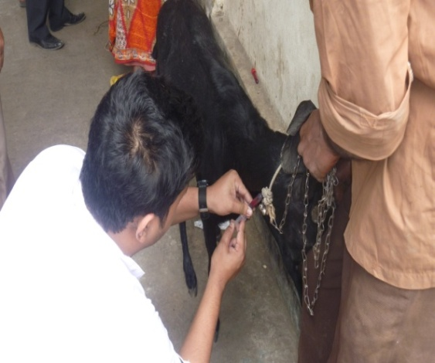 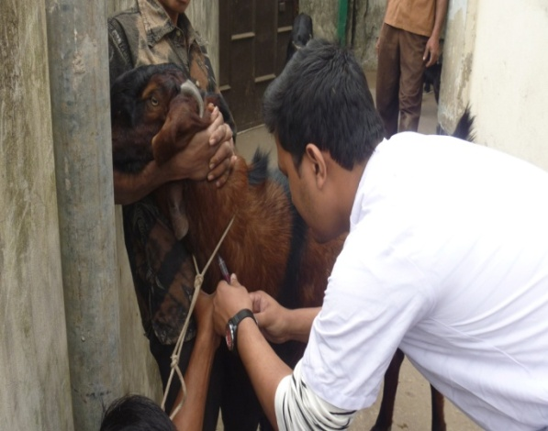

**Fig.: Blood collection from suspected PPR affected goat.**

**Hematological analysis**

Blood were collected from 10 infected goat of PPR and healthy goat aseptically from the jugular vein in vials containing Na EDTA at 2 mg/ ml. The Following haematological analysis were performed: Total erythrocyte count (TEC), total leukocyte count (TLC), differential leukocyte count (DLC), hemoglobin content (Hb), Packed cell volume (PCV) and erythrocyte sedimentation rate (ESR).

TEC and TLC were determined by hemocytometer and Hb by Hellige Shali method. All differential counts of leukocytes were prepared as thin blood smear stained by Wright’s method. All the above parameters as TEC, TLC, Hb, PCV, ESR, and DLC were performed according to the method described by **Shastry** (1983).

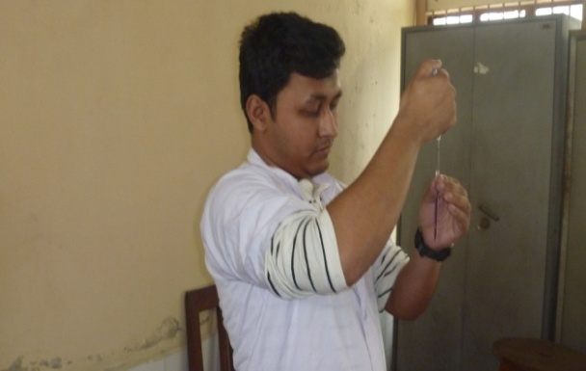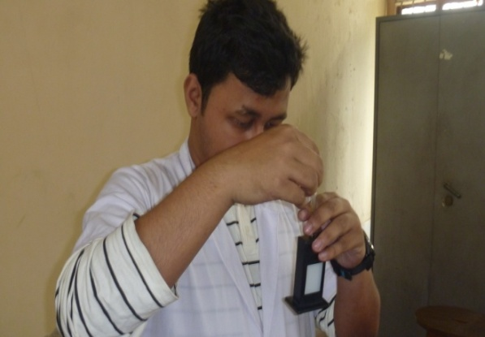

**Fig.: ESR test Fig. : Hb test**

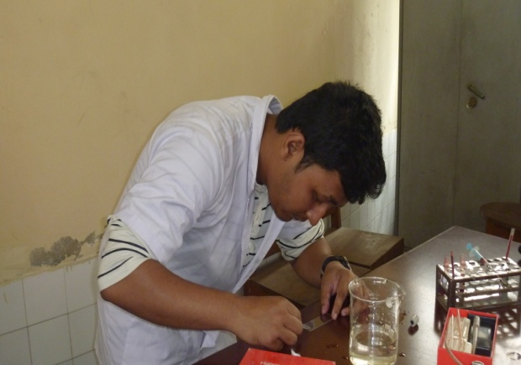 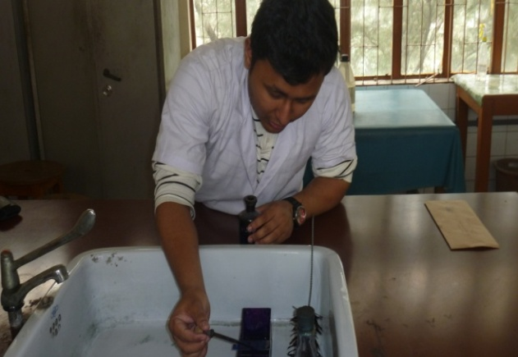

**Fig. : DLC**

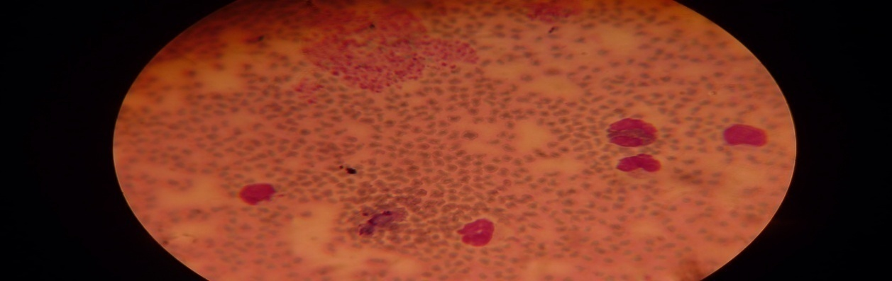

**Fig.: DLC**

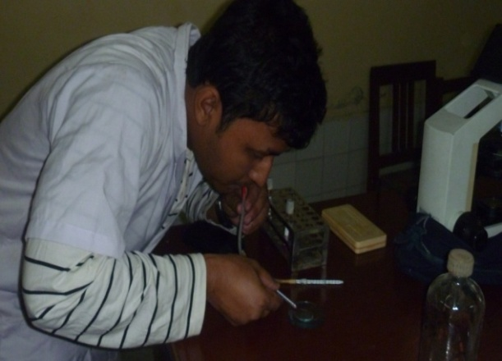 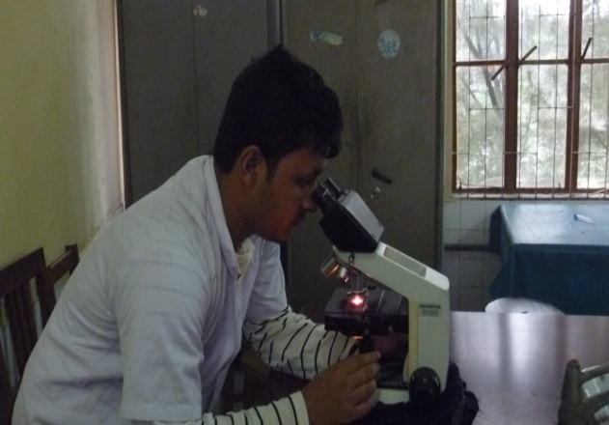

**Fig.: TEC**

**Biochemical analysis**

Total protein and Albumin value of the samples were observed well.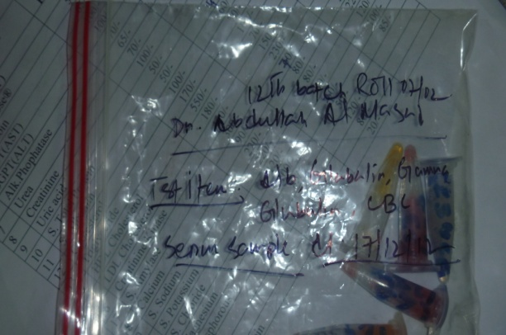 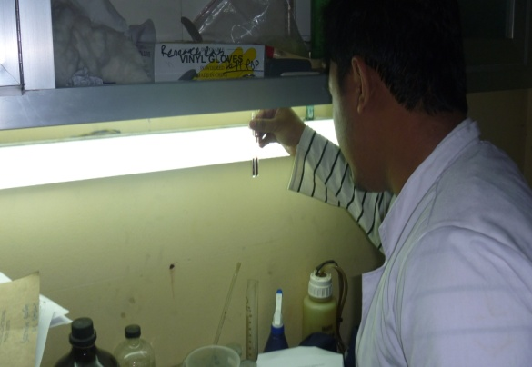

Fig. : Blood samples.

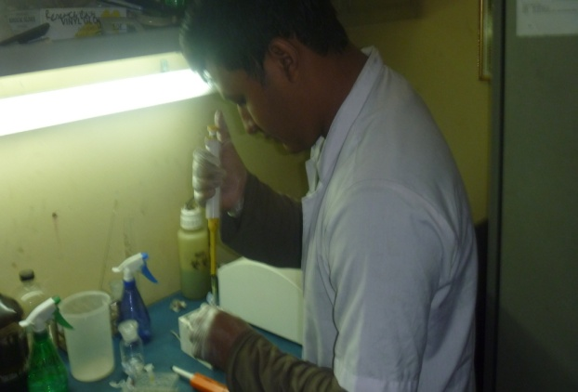 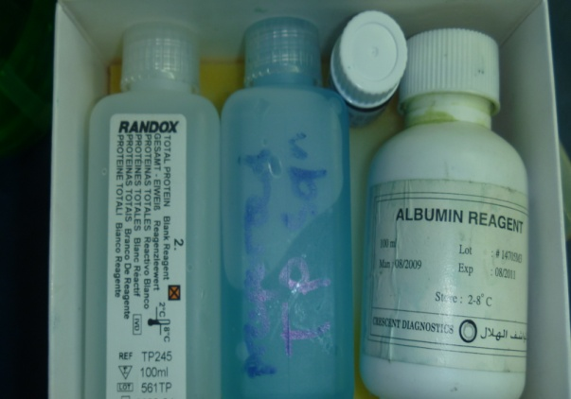

Fig. : Reagents for biochemical analysis.

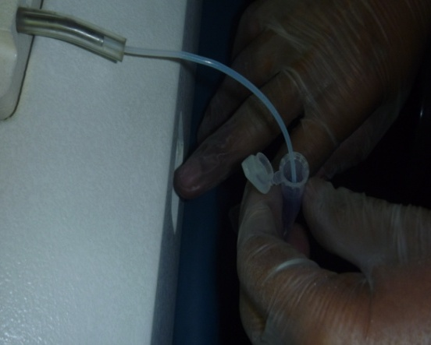

Fig. : Humalyzer machine

**Biochemical analysis**

**3.4 Statistical Analysis:**

All tested data were recorded in a data recording sheet and obtained data were imported in the Microsoft Excel-2007 and transferred into the statistical software STATA-11 for analysis. A descriptive analysis was carried out for the obtained mean, standard deviation, minimum, maximum, of every hematological parameter.

Also, a analysis was carried out to express the results in frequency percentage and risk ratio of PPR in goats in Boalkhali.

**Risk in exposed**

**Risk ratio =**

**Risk in unexposed**

**3.5 Case definition of PPR :**

Certain clinical signs, physical examination, post mortem findings were used to diagnose PPR (Peste des petits ruminants).

**Clinical signs :**

Clinical signs appear an average of two to six days after natural infection with the virus (the incubation period). This is followed by the sudden onset of fever with rectal temperature of at least **40° to 41oC.** Affected animals are markedly depressed and appear sleepy. Their hair stands erect giving them a bloated appearance, especially the short-haired breeds. Soon after this stage, a clear watery discharge starts to issue from the eyes, nose and mouth, later becoming thick and yellow as a result of secondary bacterial infection [**(Figure 1)**](http://www.fao.org/docrep/003/x1703e/x1703e00.htm#Figure%201).

The discharges wet the chin and the hair below the eye; they tend to dry, causing matting together of the eyelids, obstruction of the nose and difficulty in breathing.

One to two days after fever has set in, the mucous membranes of the mouth and eyes become very reddened ([**Figure 2**](http://www.fao.org/docrep/003/x1703e/x1703e00.htm#Figure%202)).

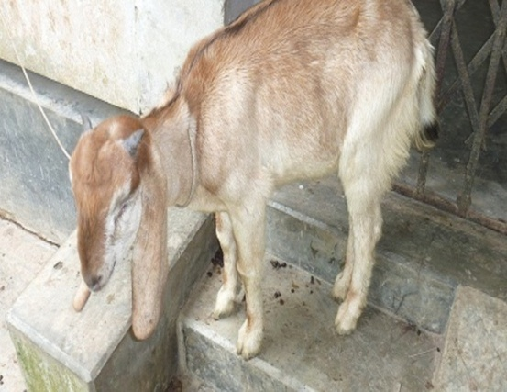 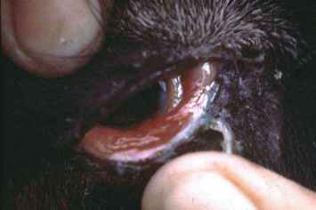

**Figure 1 Figure 2**

Then epithelial necrosis causes small pin-point greyish areas to appear on the gums, dental pad, palate, lips, inner aspects of the cheeks and upper surface of the tongue. These areas increase in number and size and join together. The lining of the mouth is changed in appearance. It becomes pale and coated with dying cells ([**Figure 3**](http://www.fao.org/docrep/003/x1703e/x1703e00.htm#Figure%203)**)** and, in some cases, the normal membrane may be completely obscured by a thick cheesy material **(**[**Figure 4**](http://www.fao.org/docrep/003/x1703e/x1703e00.htm#Figure%204)**).**

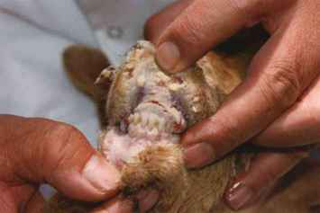

[**Figure 3**](http://www.fao.org/docrep/003/x1703e/x1703e00.htm#Figure%203)[**Figure 4**](http://www.fao.org/docrep/003/x1703e/x1703e00.htm#Figure%204)

Underneath the dead surface cells there are shallow erosions. In mild cases these changes may not be severe and will require careful examination to be seen. Gentle rubbing across the gum and palate with a finger may yield a foul-smelling material containing shreds of epithelial tissue. Similar changes may also be seen in the mucous membranes of the nose, the vulva and the vagina. The lips tend to swell and crack and become covered with scabs **(**[**Figure 5**](http://www.fao.org/docrep/003/x1703e/x1703e00.htm#Figure%205)**).**

As the disease progresses, a characteristic foul smell exudes from the mouth. Affected animals resist attempts to open their mouths because of the pain.

Diarrhoea commonly appears about two to three days after the onset of fever. ([**Figure 6**](http://www.fao.org/docrep/003/x1703e/x1703e00.htm#Figure%206)**)**

Although, in early or mild cases, it may not be obvious. The feces are initially soft and then watery, foul-smelling and may contain blood streaks and pieces of dead gut tissue. Where diarrhea is not an obvious presenting sign, the insertion of a cotton wool swab into the rectum may reveal evidence of soft feces which may be stained with blood.

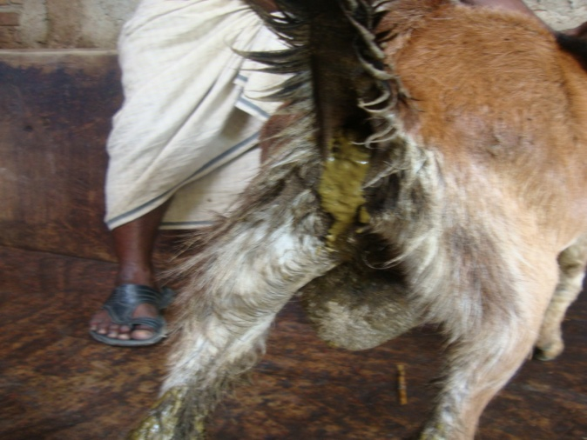 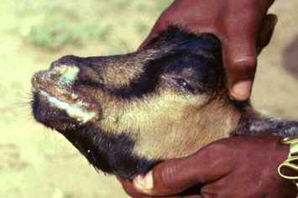   
[**Figure 5**](http://www.fao.org/docrep/003/x1703e/x1703e00.htm#Figure%205)[**Figure 6**](http://www.fao.org/docrep/003/x1703e/x1703e00.htm#Figure%206)

**Post mortem findings**

The carcass of an affected animal is usually emaciated, the hindquarters soiled with soft/watery faeces and the eyeballs sunken. The eyes and nose contain dried-up discharges. The following changes may be seen:

**Mouth**

Dirty-white, false membranes; erosions on the gums, soft and hard palates, tongue and cheeks and into the oesophagus.

**Lips**

Swollen; erosions and possibly scabs or nodules in late cases.

**Nasal cavity**

Congested (reddened) lining; clear or creamy yellow exudates; erosions.

**Lungs**

Dark red or purple areas; firm to the touch, mainly in the anterior and cardiac lobes (evidence of pneumonia) **(Figure 7 & 8)**

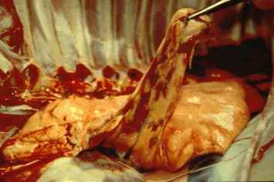 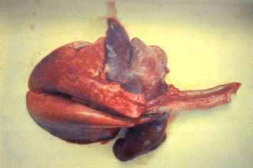

**Figure 7 Figure 8**

**Lymph nodes (associated with the lungs and the intestines)**

Soft and swollen. Abomasum Congested (reddened) lining;haemorrhages.

**Small intestines**

Congested (reddened) lining; haemorrhages; some erosions.

**Large intestines (caecum, colon and rectum)**

Small red haemorrhages along the folds of the lining, joining together as time passes and becoming darker, even green/black in stale carcasses. . The lesions in gastrointestinal tract consisted of few erosions in the mucosa from where blood oozed out, large intestines were congested, especially at the caeco-colic junction with streaks of blood on mucosal crests (Zebra-stripes) though the zebra-stripes were not seen in all the carcasses. **(Figure 9).**

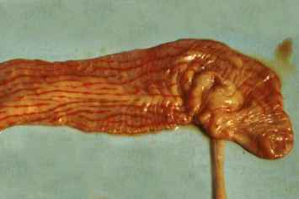

**Figure 9: PPR in a goat: "zebra striping" in the large intestine.**

**Differential diagnosis**

PPR is frequently confused with other diseases that present fever and grossly similar clinical signs, especially when it is newly introduced. When carrying out an investigation, examination of the way the disease behaves in the herd or flock is as important as the findings on a single goat or sheep. The most frequent sources of confusion are:

**Mouth lesions**

Could be a symptom of: rinderpest, foot-and-mouth disease, bluetongue or contagious ecthyma (orf or "sore mouth").

**Difficult breathing**

Could be a symptom of: pneumonic pasteurellosis or contagious caprine pleuropneumonia (CCPP).

**Diarrhoea**

Could be a symptom of: coccidiosis or gastro-intestinal helminth infestations. Pneumonia is usually a very obvious presenting sign in PPR so, without doubt, pneumonic pasteurellosis and CCPP have caused the most difficulty in differential diagnosis.

**Pneumonic pasteurellosis**

is a purely respiratory disease of sheep and goats caused by the bacterium Pasteurella haemolytica. Dark red/purple areas, firm to the touch, are evident mainly in the anterior and cardiac lobes of the lung There are no oral lesions or diarrhoea. The numbers of affected and dead animals are usually lower than for PPR except under exceptional conditions of stress and crowding such as can occur when large numbers of sheep are assembled for trade. The main problem of differentiation arises when oral lesions and diarrhoea are either absent or not very obvious in PPR, as is sometimes the case. Using appropriate culture media, Pasteurella haemolytica bacteria are easily isolated in pure and profuse culture from pneumonic lungs of sheep, even from the lungs of PPR-affected animals. Isolation of Pasteurella haemolytica bacteria from the lungs of sheep, therefore, neither confirms a diagnosis of primary pneumonic pasteurellosis nor rules out the presence of PPR. Diagnostic tests for detecting PPRV should be carried out in all suspected cases of pneumonic pasteurellosis where there is a risk of PPR.

**Contagious caprine pleuropneumonia (CCPP)**

is a disease of goats (sheep are not affected) caused by a Mycoplasma sp. Like PPR, it is characterized by fever, difficult/abnormal breathing and coughing, but there mouth lesions or diarrhoea are not present in CCPP. At post mortem examination, the lung lesions in CCPP are more diffuse and a fibrinous fluid is found in the chest cavity. Fibrin deposits cover the lungs and are frequently connected to the chest wall by fibrinous strands). In PPR high-risk areas it is advisable to rule out PPR by laboratory testing of, at least, serum samples from convalescent flocks, even if CCPP is suspected.

**Rinderpest disease**

in small ruminants has been described primarily in Asia. Generally, this disease occurs in small ruminants only when they are in contact with affected cattle or buffaloes, so it is important during investigations to examine all species. Confirmation requires the resources of a specialist laboratory. The samples required for laboratory confirmation of both rinderpest and PPR are identical. As the Global Rinderpest Eradication Programme (GREP) progresses, it becomes increasingly important that PPR and rinderpest be differentiated because, at this stage of the programme, any outbreak of rinderpest anywhere represents an international emergency.

**Foot-and-mouth disease (FMD)**

is more commonly seen in sheep than goats. The most important distinguishing features of FMD, other than the appearance of the lesions, are the absence of breathing problems and diarrhoea, and the presence of lameness (often marked). Sudden death of very young lambs without other signs often occurs. The oral lesions when present are often very small and difficult to see; the mouth does not exude such a foul odour as in PPR. Bluetongue, like PPR, is characterized by fever, discharges and oral lesions. However, it differs from PPR in: the presence of oedema of the head region; bluish discoloration of the oral cavity, the coronary band of the hooves and the less hairy parts of the body; and lameness.

**Bluetongue**

virus infection is endemic throughout the regions of the world affected by PPR. Clinical disease is, however, not generally experienced in indigenous breeds in these countries, being mainly restricted to exotic introduced animals. The presence of antibody to bluetongue viruses in single samples does not confirm a provisional diagnosis of bluetongue.

**Contagious ecthyma (orf /"sore mouth"/ contagious pustular dermatitis)**

is often confused with PPR because of the nodules and thick scabs sometimes seen on the lips in the late stages of PPR. Confusion is especially likely to arise in severe cases of orf where lesions extend into the mouth and nose. In uncomplicated orf, there is usually no oral necrosis, diarrhoea or pneumonia.

**Treatment:**

Symptomatic treatments were given for given for PPR cases with a wide range of drugs such as antibiotic, antihistaminic, fluid therapy and also given advice to maintain hygiene.

Table: Following therapy was given with dose, route, duration.

|  |  |  |  |  |  |  |
| --- | --- | --- | --- | --- | --- | --- |
| Drugs name | Company’s name | Generic name | Dose | Route | Duration(days) | Expected period of recovery |
| Eracef vet 1gm  Ceftron vet 1gm  Trizon vet 1gm | Popular  Square  Acme | Ceftriaxone | Mixed with 3.5 ml lidocaine,  ½ vial/12-20 kg goat | I/M, I/V  (pregnancy safe drug) | 5 days | 7 days |
| Renamycin  100mg/LA | Reneta | Oxytetracycline | 10 mg/kg | I/M,I/V | 7 days | 8-10 days |
| Diadin | Reneta | Sulfadimidine Na | 0.165gm(0.5 ml/kg bwt. At first day followed by 0.25 ml/kg bwt. | I/V,S/C | 5 days | 6-8 days |
| Anti hista vet | Square | Pheniramine meleate | .5-2mg/kg | I/M | 5-7 days |  |
| Glucolyte | Acme | Oral rehydrated  Solution | 0.5 litre/adult goat at every day | orally | 3 days |  |

.

Antibiotic: To check secondary bacterial infection as PPR is as immunosuppressive disease.

Antihistaminic drug : It was used to check the release of histamine and reduce allergic reactions of antibiotics.

Oral Rehydrated solution : To maintain electrolyte balance.

Advice : To keep PPR affected animal far from healthy animals.

**CHAPTER IV**

**RESULTS**

A brief study was done by collecting datas of PPR affected and non affected goats of Boalkhali upazilla during the study period.

**Table 1: Incidence of PPR in Boalkhali.**

|  |  |  |  |  |  |
| --- | --- | --- | --- | --- | --- |
| **Name of variable** | **Category** | **PPR (+ve)** | **PPR(-ve)** | **Total** | **Risk ratio** |
| **Age(Month)**  **N=103** | Min-12 | 25  (43.85%) | 32 | 57 | 0.78 |
| 13-25 | 17  (38%) | 29 | 46 | 0.586 |
| **Breed**  **N=103** | Black Bengal | 30  (59%) | 21 | 51 | 1.4 |
| Jamunapari | 12  (23%) | 40 | 52 | 0.3 |
| **Sex**  **N=103** | Male | 28  (46%) | 42 | 60 | 0.66 |
| Female | 14  (32%) | 29 | 43 | 0.483 |
| **Area**  **N=103** | Boalkhali | 42  (41%) | 61 | 103 | 0.68 |

Different hematological parameters of PPR affected goats were studied by collecting blood samples from SAQTVH, CVASU and analyzing these samples in Physiology lab of CVASU.

**Table 2: Different hematological parameters of PPR affected goats.**

|  |  |  |  |  |  |  |
| --- | --- | --- | --- | --- | --- | --- |
| **Catagory** | **Variable** | | **Mean±SEM** | **95% CI** | **P - Value** | |
| TEC (million/cmm) | Normal | | 12.15±0.43 | 11.17-13.12 | 0.000 | |
| Diseased | | 5.70±0.52 | 4.52-6.30 |
| TLC (thousand/cmm) | Normal | 7.71±.51 | | 6.54-8.87 | | 0.1544 |
| Diseased | 6.583±.48 | | 5.5- 7.66 | |
| Hb (gm%) | Normal | 10.3±.53 | | 9.11- 11.49 | | 0.0008 |
| Diseased | 7.44±.25 | | 6.86-8.01 | |
| PCV (%) | Normal | 30.37±1.66 | | 26.6-34.14 | | 0.8617 |
| Diseased | 30 ± 1.05 | | 27.62-32.38 | |
| ESR(mm in 1st hour) | Normal | 0 | | 0 | | 0.3434 |
| Diseased | .05 ±.05 | | -.06- .16 | |
| Monocyte(%) | Normal | 2.9±.31 | | 2.19-3.61 | | 0 |
| Diseased | 2.1±.27 | | 1.47-2.72 | |
| Lymphocyte(%) | Normal | 60.2±1.14 | | 57.61-62.78 | | 0.0001 |
| Diseased | 68 ±.33 | | 67.24-68.75 | |
| Neutrophil(%) | Normal | 35.7±1.05 | | 33.31-38.08 | | 0.0001 |
| Diseased | 25.9±.62 | | 24.49-27.3 | |
| Eosinophil(%) | Normal | 4.2±.55 | | 2.95-5.45 | | 0.5042 |
| Diseased | 3.7±.37 | | 2.87- 4.53 | |
| Basophil(%) | Normal | .5 ±.16 | | .12- .88 | | 0.4433 |
| Diseased | .3 ±.21 | | -.18- .78 | |
| Total protein | Normal | 7.1 ± .23 | | 7.1- .23 | | 0.0000 |
| Diseased | 3.15±.16 | | 3.15 .16 | |
| Albumin | Normal | 42.77± 1.07 | | 40.35- 45.18 | | 0.0000 |
| Diseased | 16.88 ± 1.03 | | 14.54-19.22 | |

**Physical examination findings :**

High temperature ranging from 104◦ -107 ◦ F. Dehydrated animals examined by skin fold test. Erosion in the gum and dental pad.Gentle rubbing across the gum and palate with afinger yield foul smelling materials shreds of epithelial tissue.

Whistling sound detected on indirect auscultation from lung and trachea. The feces are initially soft and then watery, foul-smelling and may contain blood streaks and pieces of dead gut tissue.

**CHAPTER V**

**DISCUSSIONS**

ThePeste des Petits Ruminants (PPR) is an immune deficiency disease which affects most of the organs of the body of the affected animals. All of the affected goats were found with shooting diarrhea with rise of body temperature .Affected animals appears restless , dry mucopurulent afterwards which gave a putrid odor to the breath . Diarrhea was followed by progressive dehydration and emaciation. PPR in this Form can induce abortion and morbidity and mortality is more frequent in young animals (Fraser, 1986). The mortality of goats in PPR cases is usually higher due imbalance of different electrolytes. Body temperature of affected goats was varied in between 104˚F-107˚F which was the indication of infectious diseases. Temperature dropped down in the later stages of diarrhea due to emaciation and dehydration **(Chakrabarty 1997, Sil 2000)**. Since profuse diarrhea occurs during PPR infection, the affected animal shows arch back due to pain in abdomen from excessive peristaltic movement in the intestine.

According to age, the higher proportionate incidence was encountered to be 43.85% at age category (Min-12 months). **Blood et al.** said that, Kids over 4 months and under 1 year of age are most susceptible to the disease ,do agree with the present findings. Young age group are more susceptible to develop disease. This may be due to development of immunity with the increase of age.

According to breed, the higher proportionate incidence (59%) was recorded in Black Bengal goat than Jamunapari (23%). The findings of the study agree with the results of **Subir & Hemayetul 2011,** said that,The susceptibility of Black Bengal goats to PPR was higher than other breeds.

PPR is rapidly transferred from one diseased goat to another. The finding of the study agree with the results of **Rahman et al.,2011** said that , Of the 19 affected goats 8 had recently been purchased from a local market. Immediately before this outbreak, goats in the neighbouring villages were affected by a disease with similar signs. Animal movement, particularly introduction of new animals into a flock, is considered an epidemiologically significant event in the spread of PPR.

The results do agree with **Aytekin et al, 2011** said that, In this study; there were statistically significant differences between all parameters. White blood cells (WBCs), MCV, MCH and MCHC parameters were significantly high, but HGB, RBCs, PCV and PLT parameters were low in infected group compared to those of control group*(Table 2)*. Olaleye et al.25 there was initial neutrophilic leucocytosis during the phase of fever followed by marked lymphopaenic leucopaenia which progressed terminally in most of the infected goats. Leucocytosis obtained in the present study may be occurs due to development of neutrophilia during the febrile period.& **Kataria et al., 2007** said that, The total serum protein values decreased but globulin concentration increased indicating immune response towards infection. The higher globulin concentration was achieved at the expense of compensatory fall in albumin levels.

It was found that, Hb (gm %) and PCV (%) was significantly decreased in PPR affected goats and due to dehydration and decreased anemia. In differential leukocyte counts percentage of various leukocytes counts were decreased in affected goats but only increased lymphocyte counts. The value of Hb, PCV, lymphocyte, TEC and neutrophil, TP, Albumin counts were significantly differed in between healthy and PPR affected goats.

**CHAPTER VI**

**LIMITATION OF THE STUDY**

1. The true estimate value of PPR was underestimated because the study could not be covered all PPR and total population of the area.
2. Clinical signs basically were used to diagnose the case definition.
3. Every case could not be followed up for looking treatment response.

**CHAPTER VII**

**CONCLUSION**

The values of all hematological parameters were decreased in PPR affected goats as compared to healthy goats except lymphocyte counts. Total erythrocyte count was significantly decreased in PPR affected goats and corresponding Hb (gm %) and PCV (%) were also decreased. The Hb% and PCV value reflect the downturn of the TEC count. ESR count was 0 mm in 1st hour in both cases. Total leukocyte count was higher in healthy goat as compared to affected goats though this value does not cross the normal limit but total lymphocyte count was increased in comparison to healthy goats. So, it can be concluded that total lymphocyte counts was increased in PPR affected goats. Biochemical parameters total protein and albumin reduced drastically.

Goat population in Bangladesh has been estimated at 25 million made-up mainly from highly prolific Black Bengal breed. Control of an epidemic disease like PPR will require various tools, availability of an efficacious vaccine will be the most important prerequisite. Goats inoculated with inactivated PPR virus was found to stimulate the animals to such an extent that animals got resistance against the challenged dose of field isolates of PPR virus. Black Bengal goats are more susceptible to PPR than Jamunapari. Young goats of both breeds are more prone to have PPR than older. Appropriate knowledge on the epidemiology of the virus and the disease has to be generated in order to develop a control strategy for Bangladesh. Awareness should be created among farmers about PPR by calling meeting & doing seminars.

**REFERENCES**

Aytekin, I., Mamak, N., Ulusan,A., Kalinback, A., (2011). Clinical, Hematological, Biochemical & Pathological Findings in lambs with Peste des Petits Ruminannts, Kafkas Univ Vet Fak Derg(2011), 17(3): 349-355.

Blood, D.C., Radostis, O.M., Gay, C.C. (2000): Diseased caused by viruses and Chlamydia-I, Veterinary Medicine 9th edn. W. B. Saunders, London:1038.

BLRI, Research achievement & activities (1999), P-27-28.

Chakrabarty (1997) and Sil (2000). A textbook of Preventive Veterinary Medicine. P: 72-76.

Fraser, C.M. (1991) : Peste des Petits Ruminants (PPR). The Merck Veterinary Manual. 7th edn. Merck and co. Inc U.S.A. : 402.

Hirsh, D.C., Maclahlan, N.J., Walker, R.L.(2004): Paramyxoviridae, Filoviridae, and Boranaviridae, Veterinary Microbiology 2nd edn. Blackwell Publishing, U.S.A. : 373.

Kataria, A.K., Kataria, N., Gahlot, A.K., (2007). Large Scale Outbreaks of peste des petits ruminants in sheep and goats in thar desert of INDIA, Sol vet Res 2007; 44(4): 123-32.

Rahman, M.A, Sharmin, I., Noor, M. (2011) Peste des petits ruminants virus infection of goats in Bangladesh: Pathological investigstion, molecular detection and isolation of the virus, The Bangladesh Veterinarian (2011) 28 (1):1-7.

Sarkar, S., Islam, M.H.,(2011) Prevalence and Risk Factor Asssesment of Peste des petits ruminants in goats in Rajshahi,Bangladesh Vet. World. 2011: 4(12) : 546-549.

Sil, B.K. (2000) A brief introduction its diagnosis and control, peste des petits ruminants, The Bangladesh Veterinarian 18(2): 12-15.

Smith, M.C., Sherman, D.M. (1994): digestive system, Goat Medicine, 1st edn. Lea and febiger, U.S.A.: 373.

**ANNEX**

**Format of case recording sheet :** date:../…/…

**Case no.**

|  |  |  |  |
| --- | --- | --- | --- |
| 0 | 0 | 0 | 1 |

**Owner’s name and address:**

Name……………………Vill……………………………P/O………………………Union….

**Demographic information of goat:**

|  |  |  |
| --- | --- | --- |
| Breed | Age | Sex |
|  |  |  |

|  |  |  |  |
| --- | --- | --- | --- |
| Color: | Mortality | Morbidity | Identification Mark: |
|  |  |  |  |

Total no. of goats of the owner:

|  |  |  |
| --- | --- | --- |
| Male | Female | Total |
|  |  |  |

Vaccination: Yes/ No Vaccination time:

|  |
| --- |
| Anamnesis…………………………………………………………………… |
| Feeding…………………………………………………………………………… |

Diagnosis:

|  |  |
| --- | --- |
| Tentative…………………………………. | Confirmation…………………… |

|  |  |  |  |  |  |  |
| --- | --- | --- | --- | --- | --- | --- |
| Date | Observation | Temp. | Pulse | Resp. | H.R | Treatment |
|  |  |  |  |  |  |  |

Advice……………………………………………………………………

Signature…………………..

Designation ……………….