A STUDY ON CLINICAL INVESTIGATION OF NAVEL ILL IN BOVINE CALVES AT MITHAPUKUR UPAZILA IN RANGPUR DISTRICT

ABSTRACT

The study was undertaken to investigate the navel ill in calves associated with some risk factors. Navel ill is an open wound in the umbilical cord complicated by different bacteria and fly larvae, which is characterized by umbilical inflammation, abscess formation and high temperature. In this study a total number of 25 cases of navel ill of bovine calves were studied at Upazila Veterinary Hospital, Mithapukur, Rangpur from 16th July to 15th September 2012.The study was conducted with the help of a preset questionnaire, clinical examination and observing presenting clinical signs of the patient. In this study the risk factors were housing system, age, sex, breeds, complication of disease and their management at individual level. Result revealed that calves reared on mud floor were found infected at higher rate (72%) than those on concrete floor (8%) and semi-concrete floor (20%). The infection rate was higher at the age of 0-15 days (56%) than 16-30 days (32%) and 31-60 days (12%). On the other hand male calves were found more infected (68%) than female calves (32%). In unhygienic environmental condition the infection rate was higher (84%) than hygienic condition (16%). The development of navel ill from open wound can be prevented by practicing improved hygiene, proper sanitation and control of flies.

Key words: Navel ill, risk factor, calves.

CHAPTER-I

1. INTRODUCTION

A calf is an offspring of cattle all over the world but neonatal calves are seems to be affected with umbilical infections. Localized inflammation or infection of the contents of the umbilical cord external to the body wall is referred to navel ill (omphalitis). Which is characterized by umbilical abscess and high temperature? Omphalophlebitis, omphaloarthritis, and urachitis are terms used further describe the extension of inflammation or infection from the external umbilicus to the intra-abdominal segment of the umbilical vein, umbilical arteries, and urachus respectively (Kasari, 1993).

Navel ill is a term that describes several conditions affecting the umbilicus (navel cord). The navel cord contains blood vessels that supply the calf with oxygen and nutrients during gestation. It occurs as a result of infection entering via the umbilical cord at, or soon after, birth. This infection can result in a range of signs depending on where the bacteria spread on. Chronic umbilical infections have an unfavourable influence on the general condition and health of the animal. In developing fetus the various components of the umbilical cord pass through the ventral abdominal wall. These comprise the umbilical vein which leads to the liver, two umbilical arteries which arise from the iliac arteries and the urachus passing to the bladder. At birth the amniotic membrane of the cord when torn and gradually the umbilical vein and the urachus close, although they temporarily remain outside the umbilicus. The risk of infection is greater when the cord is torn very short. Infection occurs soon after birth and may result in omphalitis, omphalophlebitis and omphaloarteritis. The age of calves for its occurrence is usually in the first week of life (Virtala et al., 1996b)

From the local infection at navel, extension may occur to the liver or via the urachas to the bladder and result in chronic ill health, or to produce systemic septicemia. In blood born infections localization is most common in the joints producing a suppurative or non-suppurative arthritis (Blood et al., 1989). There is usually a mixed bacterial flora including E. coli, Proteus spp, Staphylococcus spp. Actinomyces pyogenes etc affecting umbilicus. The facultative myiasis may produced flies, such as houseflies, blowflies, flash flies can be responsible for navel infections (Susan et a1., 1998). Though the infection is highly dependent on antibody level in the body (Blood et a1., 1989) but it also depends on the management after birth (Hungerford et a1., 1991). The housing and floor management is very important after birth Male calves have more chance of getting infection and calves remain in high risk within 3-5 days according to the antibody level in the blood (Hungerford et al., 1991). The mortality is also high during this time due to development of septicemia (Blood et al., 1989). Myiasis can complicate the condition and joint ill can consequence the condition through septicemia (Susan et a1., 1998; Blood et a1., 1989 and Hungerford et a1., 1991).

Considering the above mentioned facts, navel ill research was carried out with the following objectives:
- To know the relationship of navel ill with the floor management of the housing.
- To know the relationship of navel ill with age & sex of calves and nature of complications take places.
- To identify the risk factors those are related to the disease directly and/or indirectly to the production of this disease.

CHAPTER –II

2. REVIEW OF LITERATURE

2.1. Etiology of Navel ill in calf:
The most frequently isolated pathogen from navel ill is Actinomyces pyogens in mixed infection with other bacteria usually E .coli (Kasari, 1993).

(Blood et al., 1989) reported that navel ill due to bacteraemia or septicemia is caused by E. Coli, Listeria monocytogenes, Pasteurellu spp., Streptococci or salmonella spp. Bacteraemia with localization in joints caused by streptococci, micrococci, and E. insidiosa, gas gangrene of the navel caused by Cl. septicum, and Cl. oedematiens. septicemia caused by E. coli and L.monocytogenes. Non-specific infections caused by pyogenic organisms including Corynebacterium pyogenes, Sphaeroporus necrophorus. Streptococcus and Micrococcus spp and Pasteurella spp. occur in all spp.

(Hungerford et al., 1991) reported that Clostridium septicum rarely clostridium chauvoei, Spherophorus necrophorus, Micrococcus Staphylococcus pyogenes, Corynebacterium pyogenes, and Pasteurella hemolytica etc causing infection.

2.2. Predisposing factors of Navel ill in calf:
2.2.1. Age :
(Samad et al., 2001) reported that within one week of age the infection is very common. It is reported that the infection rate is high (73.03%) at 0-30 days of age than 31-90 days of age (24.72%) and it is very low (2.25%) in >90 days .In farm condition the calf mortality rate is very important factor that directly affect the farm economy. Navel ill is one of the most important factors for calf morbidity and mortality. During navel ill, if not treated properly the infection may spread at liver as well as joint by ascending route and cause liver abscess & joint ill respectively. It is reported that the morbidity rate of calf is about 2.40% and among them the mortality rate is 0.27% at 0-30 days of age but no mortality reported above 30 days of age.
2.2.2. Sex :
Das & Hashim, (1986) reported that the navel infection is very high in male (66.7%) in comparison to female (33.3%). The occurrence of this disease ratio in male and female is 2:1. Urine contamination alone with the unhygienic condition aggravates this condition.

2.2.3. Breed :
(Das & Hashim, 1996) reported that local breeds are more susceptible to umbilical infection than crossbred animals. It is reported that about 66.7% local calves are affected with umbilical infection than crossbred calves (33.30%).

2.2.4. Season :
(Samad et al., 2001) reported that season wise occurrence of navel ill calves maintained under farm and rural managemental systems were 37.08% and 34.83% during summer & rainy season respectively and 28.09% in winter season.

2.2.5. Calf housing :
(Quigley, 1997) reported that calves born in mud are at very high risk for systemic disease. So, proper sanitary condition should be maintained at the time of birth especially the floor should adequately cleaned.

2.2.6. Newborn feeding :
(Samad et al., 2001) reported that 63.25% newborn calves under rural conditions are deprived from first colostrums of their mothers because the first colostrums are usually thrown on the river or pond water or on the grasses with the believe that it would be toxic to the newborn calves.

(Bain et al., 1963) reported that colostrums has a high content of bacterial antibodies which if taken by the neonate in the first 24 hours of life, it give a strong passive immunity against any infections the mother may carry. Dirty conditions in particular events premises that are contaminated by discharges from mothers favor the occurrence of the cases. Poor nutrition or the presence of any stress factors, such as chilling, will precipitate the occurrence of the diseases. The author defined joint ill as mainly a septicemia with localization particularly in the joints with abscess formation there.

(Hurvell and Fell, 1970) and (Irwin, 1974) reported that low calf serum immunoglobulin levels have been related to higher morbidity and mortality of calves.

2.3. Mode of infection of Navel ill in calf :
(Leadley and Sojda, 2001) reported that the umbilical cord is a hollow tube. Pathogens traveling up the cord's interior have easy access to the calf's circulatory system by the way of the liver. Bacteria that invade the liver enter the blood. They are circulated throughout the body. Septicemia and joint ill are common names for diseases that result from this contamination.

(Hungerford et al., 1991) reported that infection may take place via the navel at birth or the germ may be via the navel at birth or the germ may be taken in with infected feed, milk or water. This will vary very widely with the type of organism concerned and its virulence. Infection in some cases is intra uterine.

2.4. Pathogenesis of Navel ill in calf :
(Susan et al., 1998) reported that facultative myiasis producing flies: Musca domestica (the house flies), Calliphora, Lucilia, and Phormia spp (the blow flies or bottle flies), and Sarcophaga spp can be responsible for navel infection. Under normal condition, adult flies of these genera lay their eggs in feces or in decaying animal carcasses. In facultative myiasis, the adult flies are attracted to a moist wound, skin lesion, or soil hair coat. A common site is the breech, wound in the skin as adult female flies feed in these sites, lay their eggs. The eggs hatch, producing larvae (maggots) that move independently about the own surface ingesting dead cells, exudates, secretions & debris but not living tissues. These conditions are known as strike. These larvae irritate, injure, & kill successive layer of skin & produce exudates. Maggots can tunnel the thin epidermis in to the sub cutis. These process produces tissue cavities in the skin that measures up to several centimeters in diameter. Unless the process is halted by appropriate therapy, the infected animal may die from shock, intoxication, histolysis, or infection. A peculiar, distinct, pungent odor permeates the infested tissue & the affected animal. Advanced lesions may contain thousands of maggots. Adult female flies are attracted to fresh skin wound on any warm-blooded animal, where they lay their eggs. Several thousands eggs are laid by the female during her lifetime. Newly infested wound contain screw worm larvae of a single age; older and larger wounds may contain larvae of various ages & of different species of flies. The malodorous reddish brown fluid produced in the wound usually drains & may stain the hair or wool around or below the wound. Even a small & relatively inconspicuous wound infested with screw worm larvae attracts not only more screw worm flies but also facultative myiasis producing flies. Necrotic tissues attract more flies. The wound can become greatly enlarged due to multiple infestations & unless treated, usually results in death of the animals.

(Blood et al., 1989) reported that the usual pattern of development in neonatal infections is a septicemia, with a severe systemic reaction, or a bacterimia with few or no systemic sign followed by localization in various organs. If the portal of entry is the navel local inflammation occurs called navel ill, which can be easily overlooked if clinical examination is not thorough. From the local infection at the navel, extension may occur to the liver or via the urachus to the bladder and result in chronic ill health or systemically to produce septicemia. In blood born infections localization is most common in the joints producing a suppurative or non-suppurative arthritis. Less commonly there is localization in the eye to produce panopthalmitis on the heart valves to produce valvular endocarditis or in the meninges to cause meningitis. Most of these secondary lesions take some time to develop and signs usually appear in 1 to 2 weeks of age. Dehydration and electrolyte imbalance can occur very quickly in newborn animals whether diarrhoea and vomiting are present or not. This is probably due to deprivation of fluid intake as much as to loss of fluid. The extreme depression observed in many cases is probably caused by biochemical changes in addition to the effects of bacterial toxins.

2.5. Clinical signs of navel ill in calf
(Susan et al., 1998) reported that the first indication that an animal is infested in exudation of serum and matting of the hair coat over the site of penetration. In light skinned animals, a small inflammatory area is noticeable in the center or to one side of which a tiny hole is visible. These lesions may be palpated as they develop. On the third or fourth day, the larvae are 1.5-2 cm long & produce abscess like lesions resembling those of Hypoderma spp in cattle. These lesions vary in size, shape, position, & the number of larvae they may contain. The hair coat often becomes parted over the summit of the lesions & reveals an opening 2-3 mm in diameter. The posterior aspect of the larva is visible through these openings through which it breathes. These openings are generally circular & well defined. Small animals infested with five or more larvae for several days become emaciated, & the skin becomes dry & looses its luster. The penetration of the skin by the larvae, their development in the subcutaneous tissues & secondary bacterial infections produce intense irritation & inflammation of the tissues.

(Hungerford et al., 1991) found that temperature is raised, varying from normal to 106 F. The joint illness may be in the fetlock, stifle or in the hock most frequently and less frequently, in the hip, shoulder, knee, elbow and flexor tendons. More than one joint is often involved. There may be inflammation and abscess formation in the navel. Enteritis with a severe scouring may occur, particularly with Salmonella infections. Pneumonia, coughing and nasal discharges are quite common in some infections such as Corynaebacterium pyogenes. Nervous symptom such as continual walking and refusing to suck has been noted. Death may be very rapid from septicemia.

(Bain et al., 1963) found that abscess formation is classed as abscess in the soft structures as a primary condition leading to a systemic reaction, with toxemia, and extension of the pyogenic infection. He notes that abscess formation would account 13% of his cases. He defined joint ill mainly a case of septicemia with localization particularly in the joints, with abscess formation there.

(Britney et al., 1984) reported that it is one of the disease conditions which has serious effect on future survival and productivity of calves.

2.6. Treatment of Navel ill in calf :
(Susan et al., 1998) Chemo prophylaxis consists of wetting to complete saturation of susceptible areas with suitable insecticidal & larvicidal preparations, such as the organophosphate insecticides or cyromazine, a specific larvaecide in dips & sprays. Jetting is the most efficient insecticide is forced into the fleece usually locally to the breech, along the back, & head under high pressure. Protection can last for 6-8 weeks but where the primary fly is resistant, it may last only 2-3 weeks. Weekly application of ronnel (2.5%) under pressure to wounds until heal can be highly beneficial, particularly for screw worm infestation. Before suitable agents are applied, all hairs & debris should be removed from the struck area & around it. The larvae located deep within the tissue must be extracted. Ivermectin at dosages of 50,100 & 300 μg/ kg administered to infested cattle resulted in 100% larval mortality for at least 6, 12, and 14 days, respectively.

(Hungerford et al., 1991) reported that Chloromycetin in full doses should be injected or, alternatively a combination of penicillin (long acting) and streptomycin in full dose rates. Navel abscess should be opened, under general anesthesia, with a cruciate incision. Following incision of course systemic antibiotic should be injected i/m. In case of joint ill anesthetize the neonate and aspirate the inflamed joints. Use a 16-gauge needle, as the joint fluid may be turbid. Shave and sterilize the skin, inject one of the prednisolone compounds or betamethasone and 1 gram streptomycin sulfate may be injected in one or two occasions.

(Blood et al., 1989) reported that treatment in the joint infection is difficult to achieve because of the poor blood supply to the part and the low levels of the antibacterial drugs which develop in the synovial fluid after their parenteral administration. It is customary to administer broad spectrum antibiotics, or a combination of penicillin and streptomycin, intramuscularly if the causative bacteria are not identified. Intra articular injection is not usually practiced unless synovial exudates are aspirated for diagnosis or in treatment. In both cases careful asepsis and an accurate technique is required.

2.7. Prevention and Control of Navel ill in calf :
(Leadley and Sojda, 2001) reported that when dipping the navel, it should use a strong tincture of iodine. Tincture of iodine also contains alcohol, which will help to seal and dry the cord.

(Susan et al., 1998) reported that with respect to the prevention, owners should be educated about the effectiveness of treating all skin wounds. Animals with skin wounds should be confined to fly free areas. The hair coat should be kept clean of urine or feces & should not be permitted to become matted. The control of adult flies in the field & the destruction of their breeding places are excellent preventive measures. A thorough sanitation program is necessary to control fly population in and around livestock population. All manure accumulations should be removed at least twice a week or handled properly, if stored on the premises, to minimize the fly breeding. If solid manure management practices are applied efforts should made to reduce manure moisture. If a liquid manure pit is used, manure should not be allowed to accumulate above the waterline, either floating or sticking to the sides, because this is an ideal site for fly production. Insecticides should be considered as supplementary to sanitation and management measures aimed at preventing flies breeding. Space sprays, mists or fogs with quick `knockdown' but no residual action can be used for immediate reduction of high number of adult flies. Other measures for control of adult flies include use of insecticide resin strips or various fly baits. These measures also can be applied directly to fly breeding sources; however, this should be considered only for fly breeding spots that cannot be eliminated by normal sanitation practices.

(Smith and Sherman, 1994) reported that after birth umbilical stump should be dipped in iodine. Tincture of iodine is nearly universally recommended for this task. Some authors recommended that 7% tincture of iodine while other consider 2% tincture of iodine or povidone iodine to be preferable. Excess length of the cord should be trimmed off with clean scissors and fresh end is thoroughly dipped in iodine.

(Hungerford et al., 1991) reported that management and hygiene is of utmost importance. Clean pasture, clean bedding in calving stalls, ligation of umbilical cords, swabbing with tincture of iodine and isolation of all cows suspected to be carriers, are all important features. It is suggested that dipping the navel cord and umbilicus of calves in tincture of iodine immediately after birth will minimize umbilical infection.

(Blood et al., 1989) reported that prophylactic measures should include removal of infection from the environment or removal of the animal from the infected environment, increasing the specific resistance of the newborn animal and suitable management to increase non-specific resistance. When attempting to remove the infection from the environment the problem of whether the infection derives from an intra or extra uterine source must receive consideration. lntrauterine infection necessitates local uterine or systemic treatments of the dam to eliminate the infection from the uterus before conception occurs. Swabs of the uterine contents should be examined before and after treatment of the suspected animals. Disinfections of the maternity quarters are recommended. A rotation of fields should be used for animals at pasture. Increasing the specific resistance of the new born can be carried out by vaccination of the dam in the latter part of pregnancy as described above or by the use of specific antiserum immediately after birth. An adequate supply of colostrums or alternatively blood transfusions should be provided to ensure non specific resistance. In specific cases where infection is probable antibiotics or sulphonamides should be used prophylactically. Suitable management practices should be followed with particular reference to feeding methods when animals are reared artificially. An adequate supply of nutrients and vitamins should also be provided for the dam and the newborn. Movement of
the heavily pregnant and newborn animals should be avoided. Disinfections of the navel at birth are a worthwhile practice in all circumstances but are essential under conditions of heavy environmental contaminations.

CHAPTER –III
3. MATERIALS AND METHODS

3.1. Study area
The study was carried in Upazila Veterinary Hospital, Mithapukur in Rangpur District.

3.2. Study period
The total study period was 2 months from 16th July to 15th September 2012.

3.3. Population
A total 25 no. of cases were found and their different housing system, age, sex, breed were observed to investigate the incidence of navel ill.

3.4. Preparation of the interview schedule
The interview schedule was prepared to fulfill the objectives of the study. The questions were set in the interview schedule chronologically, so that the farmers can provide information in a systematic manner.

3.5. Variables and their measurement
Some factors of navel ill were taken as variables of the study. Those were age, sex, breed, antiseptic used after birth, types of floor where the calf is reared.

MAP OF STUDY AREA
Rangpur district
Figure: Mithapukur upazila, Rangpur.

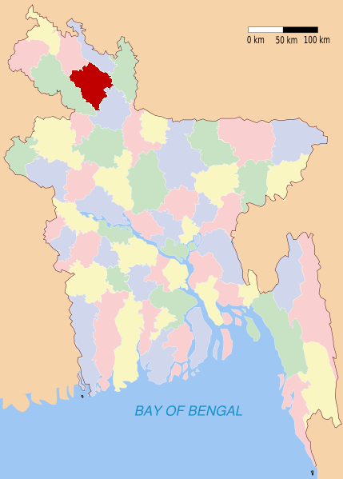
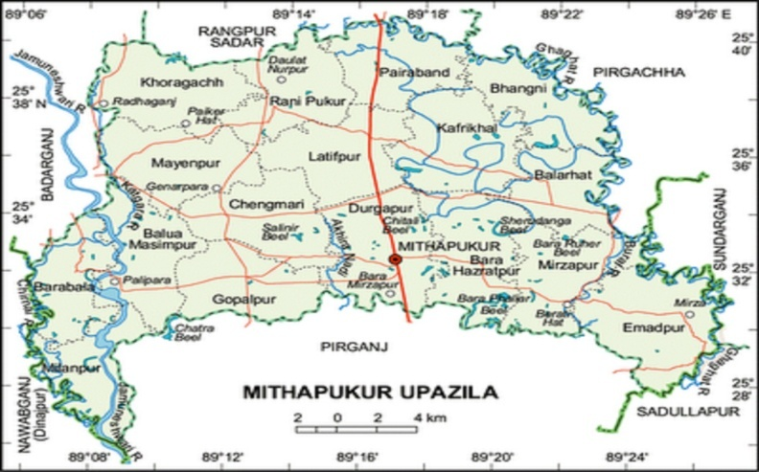

3.6. Clinical examination of the patient was done by 3 ways:
⇓
⇓ ⇓ ⇓
Distal inspection | Close inspection | Palpation
⇓ ⇓ ⇓
General appearance  - Dull and depressed  - Lie down  - Swelled navel area  - Swelled joint area | Appearance of local area  - Swelled area  - Pus and bloody discharge  - Maggot coming out.  - Foul smell  - Swelled joint area | Area palpation  - Hard mass and pain  - Blood mixed pus  - Needle aspiration of pus from joint

3.7. Presenting clinical signs:
- The navel area was swelling with heat and pain.
- Pus coming out from the infected area.
- Raised temperature up to 105F.
- Animals were usually unable to stand, stiffed gait.
- Swelled joint area.
- In some cases myiasis in the navel area.

3.8. Treatment:
Steps were taken for general correction of navel ill :
The patient was restrained physically and placed dorsoventrally.

The navel area was sterilized by using tincture of iodine.

If the area was sealed by fibrous tissue then a small incision was given on the area.

For drained out the pus manual pressure was applied.

Tincture of iodine or potassium permanganet solution was applied in the area by using cotton holding with forceps and wash properly to destroy the pyogenic membrane.

Finally a tincture iodine mixed gauge was left in the area without any suture to maintain proper drainage of the discharges.

The local antibiotic was given in the area along with systemic antibiotics.
Steps were taken for the complication of navel ill with myiasis (maggot infestations) :

The patient was restrained physically and placed dorsoventrally.

The navel area was sterilized by using tincture of iodine.

Then visible maggots were removed from the wound by holding them with a forceps.
As much as possible, maggot was removed from the wound.

Then oil of turpentine or naphthalene powder was applied within the wound by forceps.

The patient was left for sometimes to make the oil of turpentine or naphthalene powder working.

Then all the inactivated worms were removed from the wound.

Finally a tincture iodine mixed gauge was left in the area without any suture to maintain proper drainage of the discharges.

Finally the local antibiotic was given in the area along with systemic antibiotics.
Steps were taken for the consequence of navel ill ( joint ill) :

The patient was restrained and placed carefully.

The joint area was sterilized by using tincture of iodine.

In case of highly swollen the joint area needle aspiration was done to remove the accumulated serous fluid from the joint as it can minimize pain sensitivity of the patient.

Then 0. 2 % potassium permanganate solution was pushed in to the joint to wash it.
Then systemic and local antibiotic was given to the patient.
Table: 1 The variable treatments were given after surgical correction

Sl. No | Drugs used | Generic name | Trade name | Dose prescribed | Route | Duration
1 | Antibiotics | Procaine penicillin, Benzyl penicillin & Streptomycin | SP-Vet | 1 ml/15 Kg | i/m | 5 days
 |  | Procaine penicillin, Benzyl penicillin & Streptomycin | Streptopen | 1 ml/15 Kg | i/m | 5 days
 |  | Oxytetracyclin Hydrochloride | Renamycin LA | 1 ml/10 Kg | i/m | 7 days
2 | NSAIDS | Diclofenac sodium | Clofenac vet | 1ml/20 kg | i/m | 4 days
 |  | Ketoprofen | Kop-Vet | 1 ml/30 kg | i/m | 4 days
3 | Antihistaminis | Pheniramin maleate | Histavet | 2 ml/calf | i/m | 5 days
 |  | Pheniramin maleate | Antihista vet | 2 ml/calf | i/m | 5 days
 |  | Promethazine | Dellergen | 2 ml/calf | i/m | 5 days
4 | Steroids | Dexamethasone sodium phosphate | Dexavet | 1 ml/calf | i/m | 1 day

3.9. Prevention and control:
Navel ill and subsequently occurred joint ill can be control by the following ways-

- Polyarthritis can be prevented by allowing adequate colostral milk since IgG level is lowered in colostrum deprived calf and foals.
- Navel cord should be dipped in Tr. Iodine or povidone iodine after birth.
- Floor should be scrubbed and disinfected prior to calving.
- Navel sucking by other calf or mother should be prevented.
- External genitalia of the mother should be cleaned prior to delivery.
- Any surgical operation (castration, docking etc) should be done with adequate pre-caution under full coverage of antibacterial umbrella.
- Fly repellant should be used to curb down the fly population and thus spread to infection.

CHAPTER-IV

4. RESULT AND DISCUSSION

Table: 2
Distribution of different demographic, managemental and environmental factors:
Variables | Category | Infectd | Total no. of cases | Percentage  (%)
Demographic
Age | 0-15 days | 14 | 25 | 56
 | 16-30 days | 8 | 25 | 32
 | 31-60 days | 3 | 25 | 12
Sex | Male | 17 | 25 | 68
 | Female | 8 | 25 | 32
Breed | Local breed | 19 | 25 | 76
 | Cross breed | 6 | 25 | 24
Managemental |  |  | 25
Types of floor | Concrete floor | 2 | 25 | 8
 | Semi-concrete floor | 5 | 25 | 20
 | Mud floor | 18 | 25 | 72
Antiseptic used after birth | Not used | 19 | 25 | 76
 | Used | 6 | 25 | 24
Environmental | Hygienic | 4 | 25 | 16
 | Unhygienic | 21 | 25 | 84

The distribution of different variables among the 25 calves with their frequencies and percentages were presented in Table-2.

Age :
During the study period it was found that among the 25 no of infected calves, 14 calves were within 0 -15 days and 8 calves were within 16-30 days and 3 calves were within 31-60 days of age. The result was representing around 56% of the total cases were within 0-15 days, 32% of the cases were within 16-30 days & 12% were within 31-60 days of old. It was found that calves of 0-15 days of age group got highest percentage of infection and the lowest percentage of infection was found in 31-60 days old calves. It was perhaps due to build up of active immunity. (Samad et al., 2001) reported that within one week of age the infection is very common & reported that the infection rate was high (73.03%) at 0-30 days of age than 31-90 days of age (24.72%) and it was very low (2.25%) in >90 days
The graphical representation of the result is shown below:

Fig-1: Percentage of infection in different age category.

Sex :
In the study it was found that the infection rate was higher in male ( 68%) than female (32%).(Hungerford et al., 1991 and Susan et al., 1998) observed that the males were highly susceptible to the infection than the females. The males were having urethral opening nearer to the navel area where as females are having the opening distended from navel region (Hungerford et al., 1991). As a result the navel areas of males have more chance to be soiled by urine. The graphical representation of the result is shown below :

Fig-2: Percentage of infection in sex category.

Breed :
In local breed the rate of infection (76 %) was higher than the cross breed (24 %).This result may be due to availability of local breed in the study area. (Das and Hashim, 1986) reported that local breeds were more susceptible to umbilical infection than crossbred calves. The graphical representation of the result is shown below:

Fig-3: Percentage of infection in breed category.

Types of floor :
In floor type variable, out of 25 infected calves, 18 were reared in mud floor, 5 were in semi concrete floor and 2 in concrete floor and the higher percentage of infection (72 %) was occurred in calves which were reared on mud floor than semi concrete (20%) and concrete floor (8 %). The calves which were reared in mud floor, the navel region always remain in close contact with mud and mud harbor various pathogenic organisms (Quigley, 1997) which infect the navel region (Leadley and Sojda, 2001). The graphical representation of the result is shown below:

Fig-4: Percentage of infection in different floor system.

Uses of anticeptics :
From the study shown that if antiseptic is not used the rate of infection is higher (76%) than use of antiseptic (24%). This may be due to inhibition of microbial migration into the calves body. The use of correct navel dipping product that minimize the potential infection of navel cord by disinfecting the navel region. Tr. of iodine contains alcohol which helps to seal and dry the cord (Quigley, 1997).

Fig-5: Percentage of infection in using & not using antiseptic category.

Environmental condition :
Unhygienic condition is the main predispose cause of infection. In rural condition, most of calves are reared with their dam on the mud floor. The manure and urine are mixed and create very unhygienic condition. In this study among the infected calves 84% calves were found to rear in unhygienic condition. The contents of unhygienic environment enter through the open cord end & cause the infection. This infection may invade the liver from where they circulated through the body & causes septicemia and joint ill that result from this contamination (Quigley, 1997). The chance of infection is 6.5 times higher in unhygienic condition than hygienic condition. The result is graphically represented in below:

Fig-6. Percentage of infection in hygienic & Unhygienic environment Category.

Table-3: Navel ill found irrespective of complications

Complications | Animals affected | Total no of animals | Percentage  (%)
Non descriptive abscess formation | 17 | 25 | 68
Infection with myiasis | 6 | 25 | 24
Infection consequence arthritis | 2 | 25 | 8

During the study period among 25 infected cases non descriptive abscess formation were found in 17 calves ,which represents 68% , of the total cases. The infections with myiasis were in 6 calves, which represent 24%. The navel infection consequences with arthritis were found in 2 in number, which represents 8% of the total cases. Navel ill can be complicated with abscess formation as a primary condition leading to a systemic reaction, with toxemia , and extention of the pyogenic infection. (Bain et al., 1963).

Fig-7. Percentage of infection with complication.
CHAPTER-V
5. CONCLUSION

Bangladesh is a tropical country of Asia and potential place for breeding of flies. Flies are the major cause of formation of myiasis in open wound. Navel ill of bovine calf is a major open wound which is complicated by fly larvae and bacterial invasion. Navel ill is one of the major cause of calf mortality in Bangladesh. The investigation was undertaken to determine the variation in degree of navel infection associated with different housing system, age, sex and, breeds of calves. From the observation it is clear that the calves of below one month of age remain at high risk to navel infection and mortality. Again Male calves are more susceptible to navel ill because of the anatomy, bulls navels tend to dry slower than heifers and they are thus at more risk of navel ill. They have also more chance of contamination through urine. Farm management such as mud floor & not using antiseptic at the navel region after birth are the main causes of infection. In all cases environmental factor i.e. unhygienic condition was the common cause of navel infection.

To prevent the navel infection following measure can be suggested:
- Extension service should be provided to the farmers for increasing awareness about the control and prevention of navel ill.
- During parturition clean and hygienic environment should be provided.
- Sterilized blade or knife or scissors should be used to cut the navel cord.
- Proper disinfectant (such as iodine) and fly repellent should be applied around the navel cord.
- To check the post operative infection sanitary condition of the farm or cattle shed should be maintained.

Limitation or shortfall of the study
During my study period at mithapurkur upazila in rangpur distict the following limitation were encountered:

- Due to the short duration of the study period the relationship of navel ill with the season cannot be studied. We know that season plays a great role in the occurrence of the disease.

- Small number of sample size. If the sample size of the calves population in which I conducted my study will large, then the result may become more accurate than this result.

CHAPTER-VI
6. REFERENCES

Blood DC, Radostits OM, Gay CC and Arundal JH, (1989). Diseases of the newborn in Veterinary Medicine. 7th edition. Bailliere Tindall Ltd. Oxford, London. PP. 40-42.

Bain DM and Crutis PE, (1963). A Knackery survey of calf diseases. Vet. Rec. 86:454-456.

Britney JB, Martin SW, Stone JB and Curtis RA, (1984). Analysis of early calfhood health status and subsequent dairy herd survivorship and productivity. Preventive Veterinary Medicine 3, 45-52.

Chakrabarti A, (2005). A Text book of Preventive Veterinary Medicine, New Delhi. PP: 493-496.

Chand SK and Nayak BC, (1977). Pathological studies on the mortality in young calves. Indian Animal Health J: 16(2): 145-149. Curtis, P. E. (1970). A knackery survey of calf diseases. Vet. Rec. 86: 454-456.

Das BC and Hashim MA, (1996). Studies on surgical affections in calves. Bangladesh Vet. J. 30: 53-57.

Ettinger SJ, (1989). Veterinary Intenzal Medicine. 3rd edition. WB Sounders Company Ltd. London, UK. PP. 2329-2336.

Hungerford TG, (1991). Navel infection of calves in Disease of the livestock. 7th edition. Angus & Robertson Publications Ltd. Sydney. PP:79-86.

Hurvell B and Fay H, (1970). Comparative study of the gammaglobulin level in sera of market calves in relation to their health. Acta Vet. Scand. 11: PP: 341-360.

Hossain MM, Hossain M1, Baki MA and Mondol MM, (1988). Studies on occurrence of diseases in bovine calves in selected areas of Mymensingh district of Bangladesh. Bangladesh Vet. J. 22: 71-82.

Irwin CVR, (1974). Incidence of diseases in colostrums deprived calves. Bangladesh Vet. Rec. 94: 105-106.

Jones TC, Hunt RD and king NW, (1996). Disease caused by bacteria in Veterinary Pathology. (6th ed.). A Waverly Company Ltd. USA. PP: 455.

Kettle DS, (1994). Medical arid Veterinary Entomology. (2nd ed.). CAB International Ltd. UK. PP: 268.

Kasari RT, (1993). Omphalitis and its sequelae in ruminants. In: Howard, J.L. (3rd ed.). Current Veterinary Therapy, Food Animal Practice. Philadelphia: W.B Sounders Company. Pp 101 – 103

Leadley S and Sojda P, (2001). Newborn navel care. www.calfnotes.com

Quigley J, (1997). Navel disinfections. www.calfnotes.com

Samad M A and Hoque MS, (1996). Prevalence of clinical diseases in dairy cross-bred cows and calves in urban areas in Dhaka. Bangladesh Vet. J. 30: 118-129.

Smith and Sherman, (1994). Diseases caused by bacteria in Veterinary Pathology. (6th ed.). A Waverly Company Ltd.USA.PP.455.

Susan and Handy, (1998). Diseases of new born calf, American journal of Preventive Medicine. 15 ( 4): 379-397.

Sama MA, (2001). Poshu Palon O Chikitshavidya. (2nd ed.). LEP Pub. No. 08. BAU campus, Mymensingh.

Virtala AM, Mechor GD, Grohn YY and Erb HN, (1996b). Morbidity from nonrespiratorydisease and mortality in dairy heifers during the first three months of life. J Am Vet Res 208: 2043 – 2046.

ANNEX-1
Questioner for Data Collection

Sl No. Date:

1. Name of the owner & Address :…………
2. Name of the farm :……………….
3. Description of the animal :
a) Age…………………..b) Breed…………….c) Sex…………..
d) BCS……………………e) Date of birth (approximately)………

f) Body temperature………………..g) Breeding history…………
4. From when you have seen this infection…………….
5. Is it a congenital case…………………….
6. After birth of the calf have you use any antiseptic to the umbilical region of the calf…………………..
7. Have you use any fly repellent to the house after birth……………
8. Housing type: Intensive/semi-intensive/other…………..
9. Type of floor of the house…………….
10. Have you used any disinfectant to the floor and how frequent………
11. Where the calves lie on………......................
12. Stay with dam…………………………….
13. After birth colostrum eat or not…………………..
14. Environment (Hygienic/Unhygienic)……………………….

ANNEX-2
Different Images of navel ill of calves
Navel ill with non-descriptive abscess formation in calves

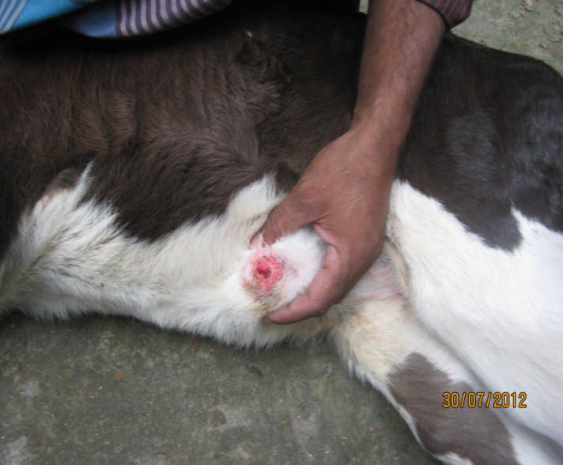
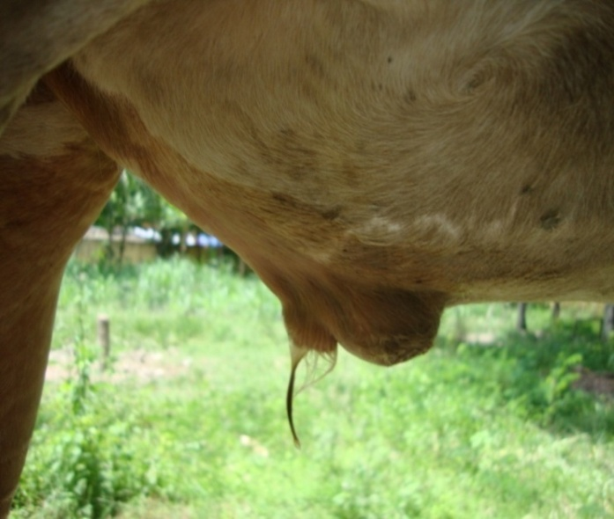

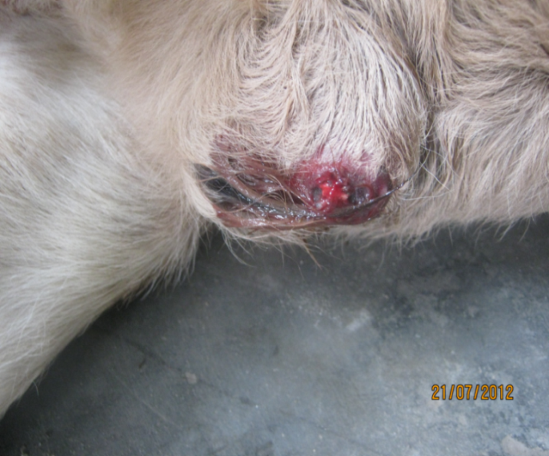
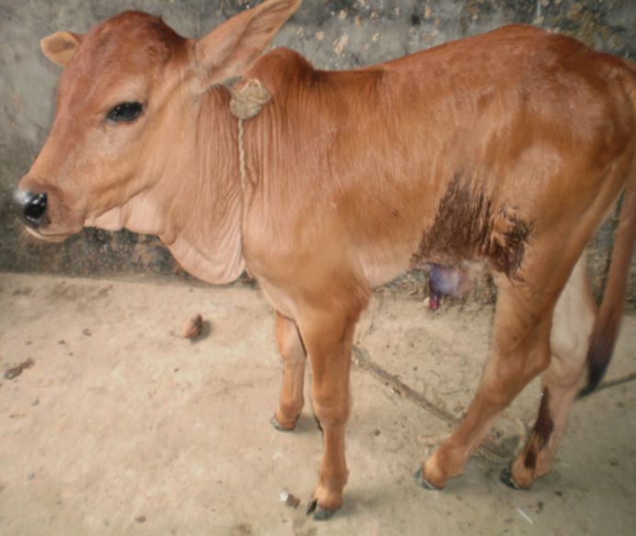

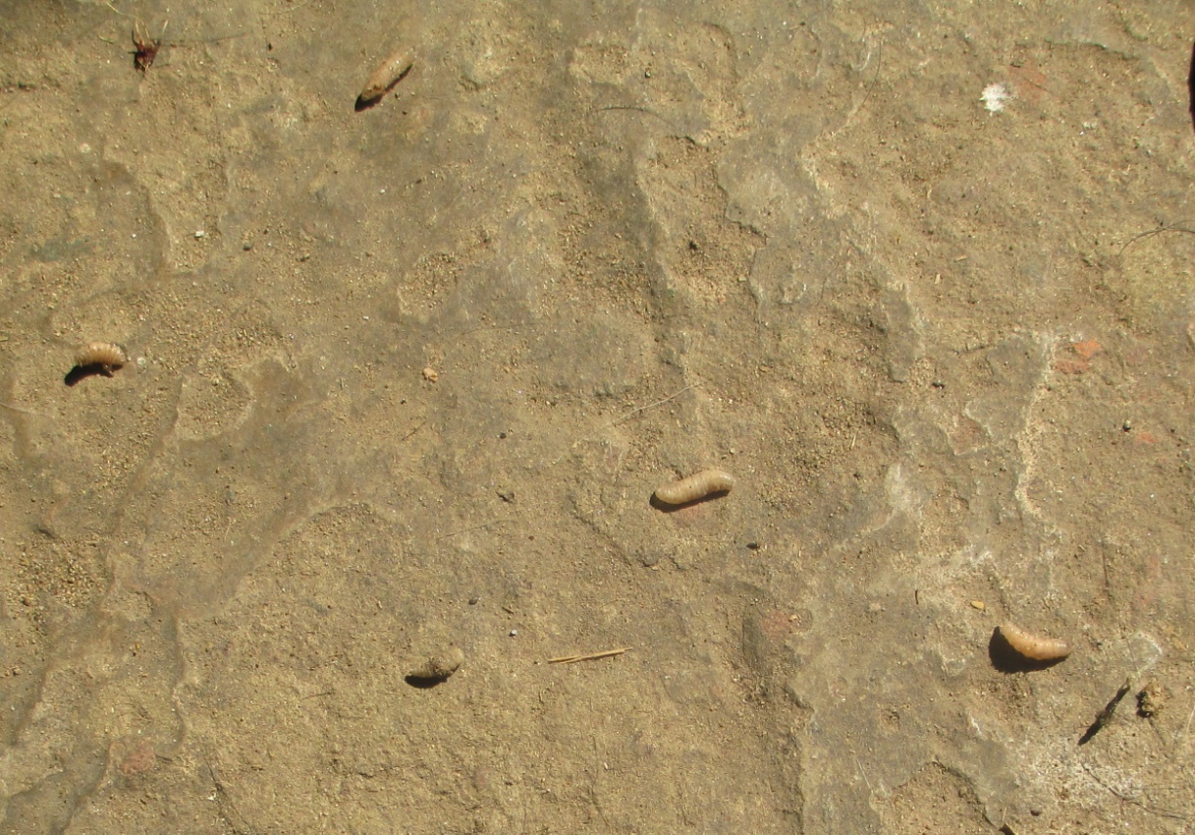
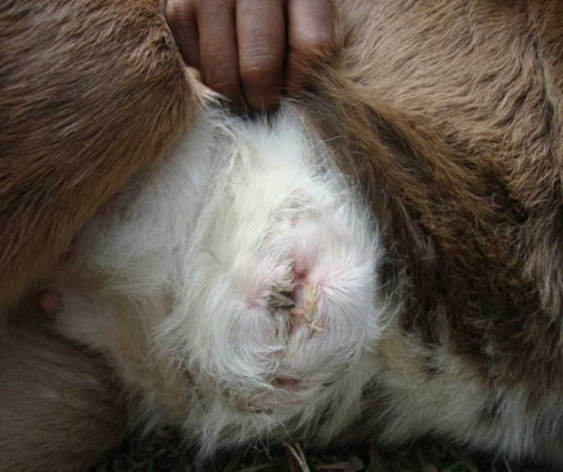
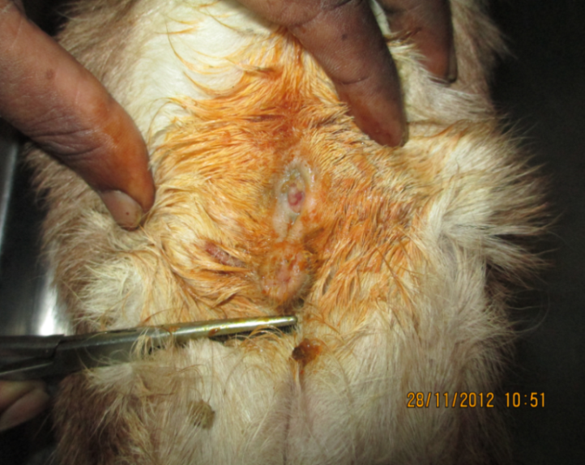
Maggot from infected navel region
Navel ill with maggot infestation in a calf

