CHAPTER-I

INTRODUCTION

Bangladesh is an agro based country and its economy is mostly depends on agriculture. About 52% of the gross domestic product (GDP) agriculture sector of which crops alone share 43.5 %, livestock 69%, fisheries 5.05% and forestry 3.8% (Economic census, 2005).

Gastro-intestinal parasites are problems among calf population in Bangladesh. The infection rates are variable depending upon different intrinsic and extrinsic epidemiological and biological factors. The economic losses may be in the form of mortality, decreased productivity, reduced weight gain and other means resulting globally from parasitic diseases. Most cattle population in Bangladesh comes from primitive and low productive breeds. Most animals are reared in house under the age old traditional husbandry practices. Many cattle are over worked and most of them under fed or half fed during most of the time of the years. They are not supplied with adequate balanced ration. As a result the general nutritional status of most of the cattle is in subnormal level, which greatly increases susceptibility to parasitic diseases to the newborn calves. (Blood et al., 1990).

In Bangladesh, parasitic infestation is the major cause of hindering the development of livestock population (Jabber and Green, 1983). The climate of Bangladesh is suitable for parasites, which are to great extent responsible for calf mortality in this country. The mortality rates of crossbreed calves are more than that of indigenous one ( Haque, 1986). Gastro-intestinal parasite like Paramphistomum, Fasciola, Ascaris, Bunostomum, Strongyloides are common in Bangladesh.

The hot and humid climatic conditions in Bangladesh are highly conductive for the development and multiplication of parasites. Anorexia and reduced feed intake coupled with the direct effect of the parasites on the on the host contribute to reduce weight gain and lowered production (Soulsby, 1982). A number of different studies carried out in different parts of the country revealed that parasitic infections are remnant in livestock. (Saifuzzaman, 1996, Roy et al; 2000; Samad, 2001). Loss of production in cattle industry in Bangladesh in terms of mortality, milk and meat production and loss of production due to parasitism may extend up to 50% of the total production (ADB, 1986).

The agro-ecological and geo-climatic conditions of Bangladesh are highly favorable for the growth with multiplication of gastro-intestinal parasites. Calves are neglected as they do not bring any immediate financial return and the costs of rural condition in Bangladesh are usually maintenances just to use letting down of milk in cows. As a result most of the calves maintained under traditional management system start eating grass at their early life, which invariable expose to early infection (M.A. Samad, 2001).

Gastro-intestinal parasites have been recognizing to the emaciated poor growth rate, digestive disorder, ill health and mortality in calves in Bangladesh (Motalib and Alam, 1983; Hossain et al., 1990; Haque and Samad, 1996).

Most of the earlier reports of calf diseases in Bangladesh have been confined on the general morbidity and mortality rates based on the hospital with farm recorders clinical and sub-clinical parasitic infection and necroscopic examination of dead calves. (Hossain et al.; 1988, 1992)

The geo climatic condition in a certain locality is one of the factors that determines the type and severity of parasitic infection on grazing animals (Arambulo & Moran, 1981)

Debnath et.al (1990) reported that 45% calves up to 4 months of age died due to gastro-intestinal parasitic infection. The temperature, humidity and rainfall of the country are highly favorable for parasites.
In this country a limited number of studies on some epidemiological aspects of different gastro-intestinal parasites have been carried out by Islam et al. (1971), Rahman and Razzak (1973), Rahman and Ahmed (1991), in indigenous breed of cattle.

OBJECTIVES

The present study had been undertaken in Debiganj Upazilla of Panchagar District with the following objectives:
- To find out the prevalence of various gastro-intestinal parasite infections in native and crossbred calves.
- To know the common parasitic infestation of the Calf.

CHAPTER-II
REVIEW OF LITERATURE

- Ahmed (1970) recorded 38.66% infection with Bunostomum spp. 17.23%with Capillaria spp, 19.30% with Trichuris spp. 1.70%with Agriostomum spp & 8.51% with Neoascaris spp. In cattle & buffalo.
- Baruah et al, (1981), found larvae of Toxocara vitulorum appeared in the colstrum & milk of cows sampled 17 days post partum
- Chowdhury (1970) reported that gastrointestinal nematodiasis especially Trichuris, Capillaria, Neoascaris, Angiostomum & Bunostomum were more prevalent in exotic crosses than native.
- Gautum et al, (1976), conducted a study on transmammary transmission of N. vitulorum & reported that early 3 months of age was most susceptible for ascarids infestation.
- Gupta (1986), reported that Ascarid worms were the largest among all nematodes found in intestine of animal. Adult ascarid competes with the intestinal wal for metabolized & thus results in digestive disturbances & poor growth of young animals. He reported that prevalence of ascariasis was related to over crowding, large population size & use of same pasture year after year, feeding on floor, irregular deworming, grazing animals, etc. he also reported that the eggs of ascarids could survive in environment up to 5 years.
- Hanif et al (2003), out of diarrheic calves, 98(67.58%) were found to be affected with gastrotinal helminthes parasites. The occurrences of Neoascaris spp is 4.82%.
- Mia et al, (1975), carried out a study on the route of infection of buffalo calves by N. vitulorum & reported that calves mostly affected by Ascariasis at the age of 0-2 months through ingestion of colostrums & milk.
- Rahman & Razzak (1983), examined fecal sample of 838 cattle from Comilla district & found 37% infection among cattle population. The Neoascaris vitulorum was recorded in 8%.
- Rahman & Mondal (1983) reported about 8.6% Neoascaris vitulorum infection in cattle of Bangladesh.
- Samad et al; (2003), Toxocara vitulorum infection was recorded at the age of 15 days but higher infection rate was recorded in calves aged between 31-90 days (85.71%) of age in comparison to 10-30 (7.14%) & 90-180 (7.14%) days.
- M.A Samad was conducted a study on GIT parasitism in calves under traditional management in Bangladesh. He has shown that 63.32% had dual and only 2.94% had triple parasitic infection. The parasitic infestation was recorded in calves up to 30 days (3.73), higher level of infection was observed between 271 to 365 days. The prevalence of Strongyloides is 4046%, Trichuris 3.52%, Fascioliasis 11.20%, Paramphistomiasis 38.92%, Moneziasis 2.35%, Balantidiasis 3.52% and Coccidiasis 8.93%.
- Mondol, (1997); have mentioned that that ruminant mostly cattle, goat, sheep and buffalo are vulnerable to several helminthes parasite in Bangladesh. These are trematod, cestode and nematode. Among the trematodes Fasciola, Amphistomes and Schistosomees are most important.
- Qudir et al., (1981), has shown that Schistosomiasis is a sporadic disease in Bangladesh. The epidemiology of trematodes is greatly influenced by husbandry practice and abundant of snail are intermediate host.
- Bhuiyan (1970) mentioned that the economic losses caused by Fasciola gigantica infection in ruminant in term of term of liver damage was taka 3.2 million.
- Islam et al., (1989), mentioned that the Paramphistomum spp is most prevalent in Ruminant in Bangladesh. Controversies over the pathogencity of the adult Amphistomes still exist in the country. However marine infection can cause severe diarrhea. About 60% to 90% slaughtered cattle, buffaloes, sheep and goat had Paramphistomum infection.
- Hossain et al., (1994) examined 115 gastro-intestial parasitic infestation cases of buffalo. They mentioned fluke infection with Fasciola gigantica and Amphistomes (single and / or mixed) was detected in 67 (58.7%) animals while clical infection with Neoascaris vitulorum and Strogylides, Haemonchus spp., Trichostrogyhus spp., and Mecistocirrus spp. Where diagnosed in 39(33.9%) and 9(7.8%) cases respectively.
- Mohsin et al., (1991) studied on comparison between Hematological values of 40 Fasciola infected and 40 dewormed, apparently healthy Zebu cattle (young and adult). A significantly (p<0.01) lower total erythrocyte count, hemoglobin and packed cell volume were observed in both infected and adult cattle than those of healthy animals.
- Alim et al., (2000) examined 106 liver samples of which 78 were infected with Fasciola gigantica, 54 with Gigantocotyle explanatum and 38 with both the parasites.
- Hossain et al., (1994) conducted a study on pathological examination of 173 slaughtered buffaloes revealed some disease condition in 85 (49.13%) cases. The identified diseases were hepatic Fascioliasis (45.88) and Paramphistomiasis (16.47%).
- Howlader et.al. (1991) examined 77 liver and feces sample. They showed the no. of livere flukes (Fasciola gigantica) per animal varied from 1 to 14 (mean=5.27) and the no. of fluke eggs per gram (epg) of feces ranged from 100 to 900 (mean=363.64). A good correlation was observed between epg and no. of flukes in the liver. Overall fluke and epg ratio was 1:76.
- Mia et.al. (1975), Gautam et.al. (1976), Banerjee et al.,(1983), Roberts et al., (1990). Reported that ascariasis occurs throughout the world and clinically manifested usually in young animals where as adult animals act as carrier. The usual mode of infestation by Ascariasis is the ingestion of egg containing larvae but incase of Neoascaris vitulorum infestation occurs through ingestion of colostrums and milk. Transplacental transmission was also recorded in calves.

CHAPTER-III
MATERIALS AND METHOD

1. Study area:
The present study was conducted in Upazila Veterinary Hospital, Debiganj, Panchagarh, Bangladesh. There are about 33601 hectors lands in this Upazila. Most of the cattle in this area are reared by farmers at their homestead and are managed under the rural husbandry practice. A cross sectional study was designed which was performed in Upazila Veterinary Hospital on randomly selected samples of animal.
2. Study population and sampling:
At first the calves are included in this study by observing clinical signs of parasitic infestation (Off feed, rough coat, poor body condition, pot belly, chronic diarrhea and mandibular edema). The study was conducted with 430 calves among them 312 were native and 118 were crossbreed calf which were selected randomly from Debiganj Upazila Veterinary Hospital of Panchagar District for a period of 15thJuly 2009 to 15th November 2009.
3. Study design:
The breed characteristics were determined by inspecting the phenotypic characters of the animal or by carefully questioning the owner and from the record of A.I. register. In this study the animal was grouped into two groups namely native and crossbred. In this study the animals were grouped into four according to age. The age of animals of groups A, B, C and D were up to 3 months, > 3 months to 6 months and > 6 months to 9 months and > 9 months to 12 month respectively.
4. Data collection:
During the study period all the data regarding to animals are directly collected from animal owner by cross-question. And all the data are incorporated into data collection sheet. Following is the format of data collection sheet;
Data Collection record
Date:
Sample code number:
Name of the village:
Name of the union:
Name of the Upazila:
Any river or Low land grazing areas which are present near the village? Yes/no; if yes how much distance:
Number of cattle in the house of the owner:
Type of feeding: feed lot / free grazing
Physical condition of dam:
Deworming of calves and dams was performed or not:
Age of calves on the day of sample collection:
Sex: male/female:
Any diseases recorded in the past year? Yes/no; if yes which disease:
Clinical presence of any diseases on the day of sample collection: Yes/No; if yes which diseases suspected?
Any record of outbreak of major diseases had occurred nearby this village? Yes/No; if yes how much distance:
Result of coproscopic examination:

5. Coproscopic examination procedure:
About 15 gm fecal materials were collected from each of the selected animals directly from the rectum or from freshly voided feces in polythene bags. The sample was shifted to the veterinary hospital of Debiganj Upazila where it was stored in the refrigerator and was examined within 2-6 hours. At first the samples were examined for parasitic ova using direct smear method. If three smears were negative, then the case was considered negative in the study. Then from positive cases the numbers of eggs were counted by using “Modified Stoll’s Dilution Technique”. 3 g of feces were mixed well and put in 100 ml beaker containing 42 ml of water, some glass beads were added to it. Then it was thoroughly mixed with stirrer. 0.15 ml was taken by 01 ml syringe and put on glass slide and covered with cover slip. The slide was placed under microscope and examined.
The eggs were identified on the basis of morphological features described by Soulsby (1982) and counted. The counts were made from each sample and the mean of it was considered as EPG (Eggs per gram of feces). From positive cases 30% samples were selected randomly and total EPG were determinate.
6. Data analysis:
At the end of the study period all the result was analyzed for calculating the incidence of parasitic diseases of different group of calves.

PICTURE OF PARASITIC CASES
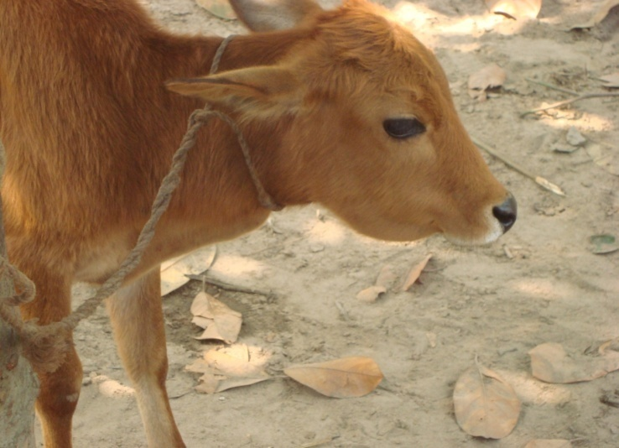
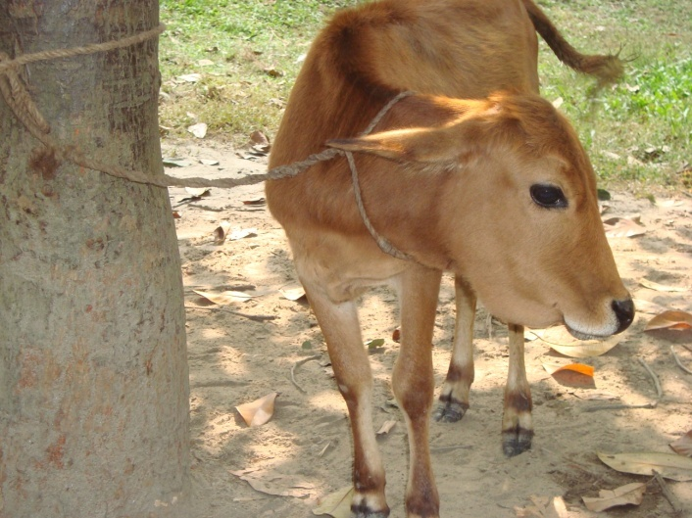

Fig: Fasciola gigantica infection Fig: Fasciola gigantica infection

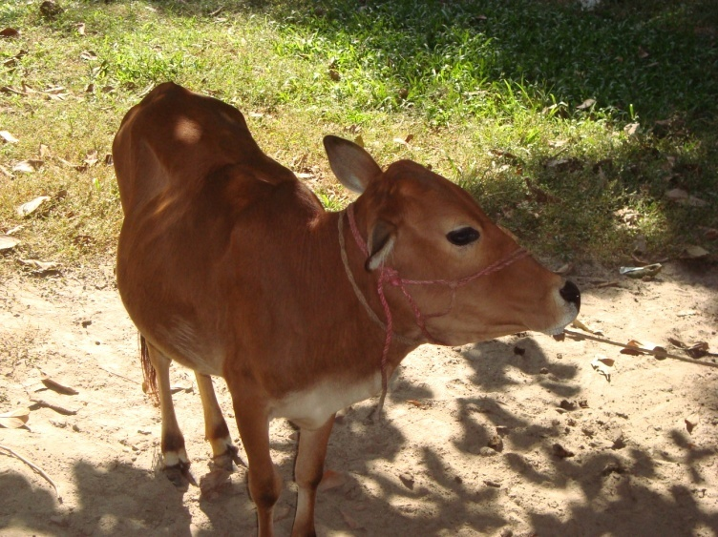
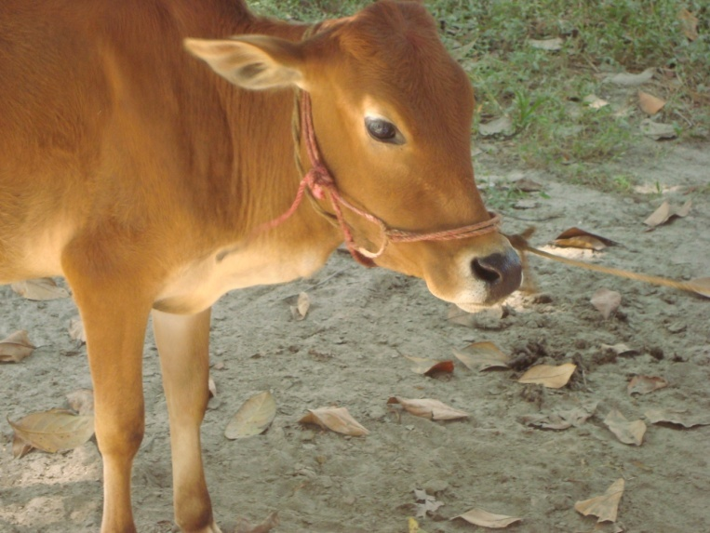

Fig: Bunostomum spp infection Fig: Toxocara vitulorum infection

CHAPTER-IV
RESULT AND DISCUSSION

The prevalence of parasitic infection in native and crossbred cattle is presented in Table 1. The overall prevalence of gastro-intestinal parasites of native calf was higher than that of cross breed except Trichuris (4.46%). The rate was almost similar in native and crossbred calves. Ross et al. (1959) reported that the Bos indicus are more resistant to parasites than Bos taurus. Haque (1986) also reported that the gastro-intestinal parasitic infection rate was higher in crossbred calf.
Table 1. Prevalence of different gastro-intestinal parasites in native and crossbred calf as observed by coproscopic examination.
Breed | No. of cases (%)
 |  | Fasciola | Bunostomum |  | T.vitulorum | Strongylid | Strongyloides | Trichuris | Schistosoma | Moneizia
Native  (N=312) | n=180 | 30 (9.61) | 30 (9.61) |  | 70 (22.43) | 10 (3.21) | 12 (3.84) | 6 (1.92) | 17 (5.45) | 5 (1.60)
Cross-breed (N=118) | n=60 | 10 (8.47) | 8 (6.78) |  | 25 (21.19) | 4 (3.39) | 4 (3.39) | 3 (2.54) | 5 (4.24) | 1 (.85)
Total | 240 | 40(18.08) | 38(16.39) | 95(43.62) |  | 14(6.6) | 16(7.23) | 9(4.46) | 22(9.69) | 6(2.45)
N= Number of animals examined, n= Number of positive cases (%)
Overall infection among calves T.vitulorum (43.62%) was highest. & Moneizia (2.45%) was lowest.

Table 2. Age wise prevalence of different gastro-intestinal parasites in native and crossbred calf as observed by coproscopic examination.
Age of animal  (month) | N=430 | Breed | Number of cases (%)
Age of animal  (month) | N=430 | Breed | Fasciola | Bunostomum | T.vitulorum | Strongylid | Strongyloides | Trichuris | Schistosoma | Moneizia
Up to 3 | n=46 | Native | 0 (0) | 0 (0) | 30 (9.61) | 0 (0) | 2 (0.64) | 0 (0) | 2(0.64) | 1 (0.32)
Up to 3 | n=46 | Cross | 0 (0) | 0 (0) | 10 (8.47) | 1 (0.85) | 0 (0) | 0 (0) | 0(0) | 0 (0)
>3-6 | n=47 | Native | 2 (0.64) | 3 (0.96) | 20 (6.41) | 1 (0.32) | 4 (1.28) | 2 (0.64) | 2(0.64) | 1 (0.32)
>3-6 | n=47 | Cross | 0 (0) | 0 (0) | 8 (6.78) | 2 (1.7) | 0 (0) | 1 (0.85) | 1(0.85) | 0 (0)
>6-9 | n=71 | Native | 8 (2.56) | 10 (3.20) | 12 (3.85) | 6 (1.92) | 4 (1.28) | 2 (0.64) | 9(2.88) | 2 (0.64)
>6-9 | n=71 | Cross | 4 (3.39) | 4 (3.38) | 3 (2.54) | 0 (0) | 1 (0.85) | 1 (0.85) | 3(2.54) | 1 (0.85)
>9-12 | n=76 | Native | 20 (6.41) | 17 (5.45) | 8 (2.56) | 3 (0.96) | 2 (0.64) | 2 (064) | 4(1.28) | 1 (0.32)
>9-12 | n=76 | Cross | 6 (5.08) | 4 (3.38) | 4 (3.38) | 1 (0.85) | 3 (2.54) | 1 (0.85s) | 1(0.85) | 0 (0)
N= Number of animals examined, n= Number of positive cases (%)
The age wise prevalence rate of different gastro-intestinal parasites between native and crossbred calf are presented in Table 2. In the table the infection rates of T.vitulorum (43.6%), Strongylid (6.6%) and Strongyloids (7.23%) were very high in the young animals starting from the age group of < 3 months and gradually declined. In the age group > 3-6 months and > 9 months the infection rates were very much and the rates were almost similar in both native and crossbred calf. Overend et al. (1984) reported same findings. The infection rate of Fasciola, Bunostomum and Schistosoma were highest in the age group of > 9 months. The increase in prevalence of these parasites with the age has been reported by Rahman and Mondol (1983). In the present study it was observed that prevalence increased with age in a linear pattern it is due to grazing behavior.

Table 3. Season wise prevalence of different gastro-intestinal parasites in native and crossbred calf as observed by coproscopic examination.
Season | N=430 | Breed | Number of cases (%)
Season | N=430 | Breed | Fasciola | Bunostomum | T.vitulorum | Strongylid | Strongyloides | Trichuris | Schistosoma | Moneizia
Winter | n=  59 | native | 3(0.96) | 7(2.24) | 19(6.08) | 3(0.96) | 4(1.28) | 2(0.64) | 4(1.28) | 1(0.32)
Winter | n=  59 | cross | 1(0.85) | 2(1.69) | 10(8.47) | 1(0.85) | 1(0.85) | 0(0) | 1(0.85) | 0(0)
Autumn | n=  51 | native | 5(1.60) | 6(1.92) | 14(4.49) | 2(0.64) | 3(0.96) | 2(0.64) | 5(1.60) | 2(0.64)
Autumn | n=  51 | cross | 3(2.54) | 1(0.85) | 2(1.69) | 1(0.85) | 2(1.69) | 1(0.85) | 2(1.69) | 0(0)
Rainy | n=  130 | native | 22(7.05) | 17(5.45) | 37(11.86) | 5(1.60) | 5(1.60) | 2(0.64) | 8(2.56) | 2(0.64)
Rainy | n=  130 | cross | 6(5.08) | 5(4.24) | 13(11.02) | 2(1.69) | 1(0.85) | 2(1.69) | 2(1.69) | 1(0.85)
N= Number of animals examined, n= Number of positive cases (%)
Season wise prevalence rates of different parasitic infections are presented in the Table 3. The highest prevalence rates of different parasites were observed in the rainy season (July to October). The infection rate was highest in rainy season (58.51%) & lowest infection rate was in autumn (22.65%).In winter the infection rate was 27.32%. The present study correlated with the findings of the Eysker and Ogunsusi (1980). The high rate of infection in rainy season is quite reasonable. Because during this time the rainfall is abundant and there is abundance of intermediate hosts of Fasciola. The temperature and humidity become optimum for larval development of parasites in this season and are favorable for the migration and development of infective stage in snails. In the rainy season the highest gastro-intestinal parasitic infestation was observed.

Table 4.Grazing wise prevalence of different gastro-intestinal parasites in native and crossbred cattle as observed by coproscopic examination
 | N=430 | Breed | No. of cases (%)
 | N=430 | Breed | Fasciola | Bunostomum | T.vitulorum | Strongylid | Strongyloides | Trichuris | Schistosoma | Moneizia
Free Grazing | N1=167 | Native (n=128) | 26(8.33) | 23(7.37) | 47(15.06) | 7(2.24) | 7 (2.24) | 4(1.28) | 11(3.52) | 3(0.96)
Free Grazing | N1=167 | Crossbreed (n=39) | 8(6.78) | 6(5.08) | 14(11.86) | 2(1.7) | 3(2.54) | 2(1.7) | 3(2.54) | 1(0.84)
Feedlot | N2=73 | Native (n=52) | 4(1.28) | 7(2.24) | 23(7.37) | 3(0.96) | 5(1.60) | 2(.64) | 6(1.92) | 2(0.64)
Feedlot | N2=73 | Crossbreed (n=21) | 2(1.7) | 2(1.7) | 11(9.32) | 2(1.7) | 1(0.84) | 1(0.84) | 2(1.7) | 0(0)
N= Number of animals examined, n= Number of positive cases (%)
N1= number of positive case in free grazing.
N2= number of positive case in feed lot.
Highest infection rate was observed in free grazing calf due to a lot of parasitic exposure. The infection rate in free grazing was 74.04%. Infection rate in
The maximum rate of infection of gastro-intestinal parasite was recorded in crossbred calf. With the exception of Trichuris. The infection rates of Fasciola, Bunostomum, Trichuris and Schistosoma were highest in the age group > 9 to 12 months and lowest in age group Up to 3 months.

- Here is mentioned that all the percentage which are calculated above have done separately among native and cross breed calf.

CHAPTER-V
CONCLUSION

The study revealed a high prevalence of T.vitulorum in calves in relation to ages, sexes, breeds, etc. in the study area. Parasitic infected mother likely to occur in new born calves. However, poor management, unavailability of drugs, lack of awareness of the farmers also enhances the high incidence of the infection. Gastrointestinal helminthiasis is the major cause of stunted growth of calves & may lead to death which intern results heavy economic loss. So preventive measures have to be under taken. Calves should be dewormed at regular intervals with an appropriate anthelmintic. Calves should be dewormed at regular within 7-14 days of age as preventive measures against gastrointestinal infection. Veterinary services as well as drugs should be available in hand. Management system & overall hygienic conditions should be improved for better growth rate of calves. This study may be extended in wider scale to other geo-physiology and socio-economically different areas of the country to verify & compare the results & to take necessary steps against gastrointestinal infection.

CHAPTER-VI
REFERENCES

- Blood D.C. Radostits O.M. Henderson J.A. Arundel J.H. and Gay C.C. (1990). Veterinary Medicine. 7th edn., The English Language Book Society and Bailliere Tindall

- Islam K.S. Shaikh H and Soliman KN (1971). Occurrence of visceral Schistosomiasis of cattle and goats in East Pakistan. Proc. Pakistan Science Conference, University of Peshwar. P. 16.

- Rahman M.H. and Razzak (1973). Incidence of helminth parasites infecting cattle in the Kotowali Thana of Comilla. First Bangladesh Veterinary Conference. BAU, Mymensingh. P-25.

- Rahman M.F. and Ahmed Z. (1991). Final report of “Pilot project for the control of parasitic disease of animals in Bangladesh”, Bangladesh Livestock Research Institute, Dhaka.

- Soulsby E.J.L. (1982). Helminths, Arthropods and Protozoa of Domestic Animals. 7th Edition., The English Language Book Society and Bailliere Tindall.

- Ross J.G. Lee R.P. and Armour J. (1959). Haemonchosis in Nigerian Zebu Cattle: The influence of genetic factors in resistance. Veterinary Record 71: 27-31.

- Haque M.A. (1986). Effects of sex, age, breed, season and system of management in the infectivity of gastro-intestinal parasitism in cattle. A thesis submitted to the Dept. of Medicine, Faculty of Veterinary Science, BAU, Mymensingh.
- Overend D, Veale P.I. and Copeland J.W. (1984). An epidemiological study of Trichostrongylidiasis in dairy cattle grazing in irrigated pasture. Australian Veterinary Journal 61: 6-8.

- Rahman M.H. and Mondol M.H. (1983). Helminth parasites of cattle (Bos indicus) in Bangladesh. Indian Parasitology 7: 173-174.

- Ahmed A.D.M.N. (1970) incidence of parasitic disease in Bangladesh. In nutritional symposium on Agricultural research held in Dhaka 22-23, Dec., Bangladesh Agricultural Research council; Abstract, D-6.

- Chowdhury S.A. (1970). Survey & taxonomy of the intestinal nematode specially of the genera Trichuris, Capillaria, Neoascaris, Angiostomum and Bunostomum of cattle or buffaloes in Bangladesh (M.Sc. vet) Thesis F.V.4.EPAU, Mymensingh.

- Dewan M.L. Hossain M.I. and Baki M.A. (1979), pathological investigation on the mortality of buffalo calves of Bangladesh. Bangladesh Veteterinary Journal. 13:1-7.

- Gupta, S.G. (1986), Pattern and control of N.vitulorum infection in calves. Indian Veteterinary Journal. 53: 965-966.

- Hossain M.I. Dewan M.I.& Baki, M.A. (1980). Preliminary studies on the efficacy of Tetramisol HCL against transmammary migration of Toxocara (Neoascaris) vitulorum Larvae in Buffaloes cows. Bangladesh Journal of Agriculture Science; 7:25-28.

- Hossain M.I.Baki M.A.& Hossain M.M. (1988); Anthelmintic Efficacy of Tetramisol, Coopane & krimos against T. vitulorum in buffaloes calves. Bangladesh Veteterinary Journal. 13:1-7.

- Hussein M. Omar & Omar O. Barrigh (1991), Biology & Pathophysiology of Toxocara vitulorum infection in Rabbit model, Veterinary Parasitology. 40, 257-266.

- Hossain M.A. Islam M.S. Rahaman M. S. latif A. Hossain A. Prodhan M.A. (1994) Deworming: A General tactic for Improvement of health production in cattle. The Bangladesh Veteterinary . 11 (1-2); 15-17.

- Jabber M. A. & Green D.A.G. (1983). The status & potential of livestock within the context of agricultural development of Bangladesh. The university of Wales, Aberysth Eyth, pp-113

- Mia S.A. Dewan M.L. Uddin M. & Chowdhury M.U.A. (1975). The route of infection of buffalo calves by Toxocara ( Neoscaris) vitulorum. Tropical Animal Health Production. 7: 153-156.

- Mostafa M. Hasan Q. & Sobhan M.A.(1983) Efficacy of some indigenous medicinal plants against gastrointestinal nematodiasis in cattle & their comparative activities with that of Nemafex. Bangladesh Veteterinary Journal. 13:1-7.

- 21.M. A. Hafiz et al, (2003), Gastrointestinal helminthes infection in diarrhoeic calves & evaluation of some anthelmintic against them. Bangladesh Veteterinary Journal. Vet. 20 (1): 13-18.

- Pandey N.N. & Mishra S.K. (1985). Clinico biochemical & therapeutic studies on anemia associated with N.viotulorum in cow calves. Indian journal veteterinary Medicine. 5: 129- 131.

- Roberts J.A. (1989); the extra parasitic life cycle of T.vitulorum in the village environment of Srilanka, veteterinary.res. comm. 13:377-388.

- Roberts J. A.(1992) preventive treatment against toxocariasis in bovine calves. Veterinary Parasitology. 44: 118-119.

- Rahman M. H. & Mondal M.M.H. (1983), Helminths parasites of cattle (Bos Indicus) in Bangladesh. Indian J. Parasitol. 7:173-174.

- Rahaman M.H. & Razzak, A. (1973). incidence of helminthes parasite infecting cattle in Kotowali thana of Comilla. First Bangladesh veteterinary. Conference, BAU, Mymensingh, Pp-35.

- Sinha sahali (1967).incidence & nature of helminthic infection in bovines in West Bengal. Indian veteterinary Journal 41:7.

- Satija K.C. Gera. K.I. & Sharma S.S. (1973). Ascariasis in Buffaloes calves . Indian veteterinary Journal vet. J. 50: 868-871.

- Soulsby E.J.L. (1982). Helminthes, arthropods & protozoa of Domesticated animals 7th edition. Baillere & Tindal, London.

- Ahmed.S.(1970).Survey and taxonomy of intestinal nematodes specially of the genera Trichuris spp, Angiostomum spp and Bunostomum spp. Of cattle aned buffaloes M.Sc. (Vet.science).Thesis submitted to the Dept. of Parasitology,BAU,Mymensing.

- Alim M.A.,Mondol M.M.H. Islam M.K. and Khan M.A.H.N.A.(2000).a note on pathology of Fasciola gigantic and Gigantocotyle explanatum in the livers and gallbladders of buffaloes. The Bangladesh veterinarian,17(2),124-125.

- Arambulo M. and Moran. D.N. 1981. Nematodes occurring in ruminants in Perambuco Region of Brazil.British veterinary journal; 142-237.

- Bhuyian. M.A. (1970). A survey of helminthes parasitizing the livers of domesticated ruminants in East Pakistan University, Pakistan.

- Boray, J.C.(1985).Flukes of domesticated animals, Pest and Predator. World animal science, B2, Elsevier sciences publishers B.V., The Netherlands, pp.179-217.

- Debanath N.C.Sill BK,Selim S.A. Prodhan M.A.M. and Howlader MMR (1990). A retrospective study of calf mortality and morbidity on small holder traditional farms in Bangladesh. Preventive Veterinary Medicine, 9:1-7.

- Durrani M.Z. (1965). Food losses due to Animal parasites, seminar on food production & consumption. Agriculture University, Ly all-West Pakistan.

- Garrels. G. (1975). Gastrointestinal parasitic infestation of cattle in some villages of Dhaka and Tangail district of Bangladesh.Bangladesh veterinary journal; 9(1-40;9-10.

- Haq. M.A.(1986). Effect of age, breed and season on the prevalence of gastro-intestinal helminthes in cattle under rural and farm condition M.Sc. Thesis submitted to the Dept. of pathology.BAU, Mymensingh.

- Hassan.Z. (1964).Investigation into the intestinal helminthes load in local goats. Indian Veterinary Journal.4l; 543-546.

- Hoque M.M.,Alam M. and Rahaman M.L.(1992).Helminthes infection in cattle in Feni district of Bangladesh. The Bangladesh veterinarian, 9(1-20, 105-106.

- Hoque M.S. and Samad M.A.(1996). Prevalence of clinical diseases in dairy cross breeds cows and calves in the urban areas in Dhaka, Bangladesh. Bangladesh Veterinary journal.30:118-129.

- Hossain M.A., Huq A.K.M.M. and Haque A.K.M.F. (1994). Pathological investigation on buffalo diseases in Bangladesh-3.Survey of buffalo diseases. The Bangladesh veterinarian 11. (1-20,123-127.

- A.S.M.A. Hannan, M. Mostafa, M.A. Hoque and M.A. alam(2001).Efficacy of Ivomec.Pour on against gastrointestinal nematodes, lice and ticks in goats. The Bangladesh veterinarian; 18(2); 95-98.

- Ahmed S. (1970).Survey and taxonomy of intestinal nematodes specially of the genera Trichuris spp, Neoscaris spp, Angiostomum spp and Bunostomum spp, of cattle and buffaloes M.Sc. (Veterinary Science) Thesis submitted to the Dept. of parasitology,BAU,Mymensingh.

- Arambulo,M. and Moran,D.N.(1981).Nematodes occurring in Ruminants in the permambo Regions of Brazil. British Veterinarian journal 142,237.

- Charles T.P.(1989). Seasonal Prevalence of Gastro-intestinal Nematodes of Goats in pernambuco stat Brazil. veterinary Parasitology.30; 335-343.

- Devendra L.A.(1981). Indian journal of Animal Science 62(1);50.

- Garrels G.(1975).Gastro-intestinal parasitic infestation of cattle in some villages of Dhaka and Tangail Districts of Bangladesh. Bangladesh veterinary journal, 9(1-4); 9-10.

- M.Giasuddin, M.M. Islam,E.H. Khan and A.H.M. Kamal. Cattle health improvement through deworming. The Bangladesh veterinarian ;( 1995); 12(1-2); 13-15.

- Soulsby,E.J.L.1982. Helminthes, Arthropods and Protozoa of Domesticated animals.7th edn. Bailliere,London.

- Debnath N.C. Sill B.K, Selim S.A, Prodhan M.A.M. and Howlader M.M.R(1990).A reproductive study of calf mortality and morbidity on small holder traditional farms in Bangladesh. Preventive veterinary medicine.9;1-7.

- Hoque M.M. Alam.M. And Rahman M.L.(1992).Helminthes infection in cattle in Feni district of Bangladesh. The Bangladesh veterinarian,9(1-2)105-106.

- M.N.Alam,M.Mostofa and M.A. Awal(1995);Comparative efficacy of some Fasciolicides against bovine Fascioliasis. Bangladesh veterinary journal;29;79-81.

- Motalib M.A. Alam M.S.(1983) The possible economic effect of gastrointestinal nematodes in young cattle in Pabna milk shed areas of Bangladesh. Bangladesh Veterinary journal.17:5-9.

- G.M.Urquhart, J.Armour, J.L.Duncan. A.M. Dumn, F.W. Jermings. Veterinary parasitology(1985).75-77,96-97.

- Devendra,L.A.(1981)Indian journal of animal science 62(1):50.

- Hafezur (1996).Gastrointestinal parasitic infestation of cattle in some villages of Dhaka and Tangail district of Bangladesh. Bangladesh veterinary journal; 9(1-40;9-10.

- Jones(1997).Seasonal prevalence of gastrointestinal nematodes of cattle in pernambuco state Brazil. Veterinary parasitology.30:335-343.

- M.A. Karim, M. Mostofa and M.M. Hossain. Efficacy of Teniazole against gastrointestinal nematodes in calves of Bangladesh Agricultural University dairy farms. The Bangladesh veterinarian ;( 1999)16(2); 72-75.

- M.A.S. Sarkar and A. Rahman.Efficacy of Morantel citrate in citrate in calf strongylosis.The Bangladesh veterinarian ;( 2000); 17(1); 52-53.

- M.A.Samad. Epidemiological studies on gastrointestinal parasitosias is in calves under traditional management in Bangladesh. Bangladesh veterinary journal (2001)35(1-2); 09-18.

- M.N.Alam, M.Mostofa and M.A.Awal. Comparative efficacy of some Fascioliasis against bovine Fascioliasis. Bangladesh veterinary journal (1995); 29; 79-81.

