**INTRODUCTION**

In Bangladesh, there are about 34.5 millions of goats (FAO, 2003). About 97.90% of goats are distributed in rural areas and 2.10% in urban areas (BBS, 1986). In addition to its production of high quality of meat, Black Bengal goat provides world famous skin. But goat rearing is hindered by various problems, among them parasitism is an important limiting factor especially in Bangladesh as because the climatic condition of the country favors the development and survival of various parasites. In fact, goats of Bangladesh are affected by various intestinal helminths (Qadir, 1967; Haq and Shaikh, 1968). These parasites reduce appetite with concomitant reduction of food intake, an increased passage of food through the digestive tract, indirectly may be the cause of decreased food utilization and eventually decrease the synthesis of protein in the skeletal muscle (Soulsby, 1965).

In Bangladesh, parasitic infection is the major cause of hindering the development of livestock population **(Jabber and Green, 1983).** The climate of Bangladesh is suitable for the parasites, which are to great extent responsible for kid mortality in this country. Gastro-intestinal parasites like *Oesophagostomum, Trichuris, Moniezia, Ascaris, Paramphistomum* are most common in Bangladesh.

The hot and humid climatic conditions in Bangladesh are highly conductive for the development and multiplication of parasites. Anorexia and reduced feed intake coupled with the direct effect of the parasites on the host contribute to reduce weight gain and lowered production **(Soulsby, 1982).** A number of different studies carried out in different parts of the country revealed that parasitic infections are rampant in livestock (Saifuzzaman, 1996, Roy *et al*., 2000; somad, 2001). The Geo-climatic condition in a certain locality is one of the factors that determines the type and severity of parssitic infections in grazing animals (arambulo & Moran, 1981).

So far, except some preliminary observation, very little attention has been paid to determine seasonal prevalence and to study the pathological conditions produced by intestinal helminths in Black Bengal goats in Chittagong.

**OBJECTIVES:**

Therefore, the present research work was undertaken to study prevalence, population dynamics, effects of seasons on the prevalence of intestinal helminths in Black Bengal goats in Chittagong and pathological effects produced by them.

**RIVIEW 0F LITERATURE:**

A survey of the lungs from 4284 goats killed at a slaughterhouse in the North Island of New Zealand during the winter of 1990 revealed only ten cases of non-parasitic bronchopneumonia. However, 41% of the lungs had lesions consistent with infection by *Muellerius capillaris*, 33% with *Dictyocaulus filaria*, and 8% with both species.(**Valero *et al.,* 1992)**

A 2-year abattoir survey was carried out to determine the prevalence, abundance and seasonal incidence of gastro- intestinal (GI) nematodes and trematodes (flukes) of sheep and goats in the semi-arid zone of eastern Ethiopia that reveals thirteen species belonging to 9 genera of GI nematodes *(Haemonchus contortus, Trichostrongylus axei, T. colubriformis, T. vitrinus, Nematodirus filicollis, N. spathiger Oesopha- gostomum columbianum, O. venulosum, Strongyloides papillosus, Bunostomum trigonocephalum, Trichuris ovis, Cooperia curticei and Chabertia ovina)*, and 4 species belonging to 3 genera of trematodes (*Fasciola hepatica, F. gigantica, Paramphistomum {Calicohoron} microbothrium and Dicrocoelium dendriticum) were recorded in both sheep and goats.The results showed that Haemonchus, Trichostrongylus, Nematodirus, Oesophagostomum, Fasciola and Paramphistomum* species were the most abundant helminth parasites of sheep and goats in eastern Ethiopia. **(Sissay *et al* 2007)**

A study todetermine the prevalence of hydatid cysts in slaughtered sheep in northwest region of Iran where sheep livers were investigated pathologically at the municipal slaughterhouse of Tabriz, Northwest region of Iran, with prevalence value of 23.57%, being recorded. Prevalence was higher in under 1 year old sheep compared with over 1 year old sheep. This study showed sheep are the most important intermediate hosts for Echinococcus granulosus in this area. The high prevalence of the cysts in sheep suggests that sheep clearly have an important role to play in the continuation of the E. granulosus life cycle in Northwest Iran(**Ghazani *et al* ,.2008)**

**JOHNSON *et al.* 1999., examined** 675 caprine livers from a slaughterhouse in the Greater Muscat area in the Sultanate of Oman and revealed that 63 (9.3%) exhibited gross pathological changes leading to condemnation of this organ. Forty of these livers (71.4%) exhibited one major abnormality, whereas the remaining 28.6% had two or more lesions. The most frequently occurring disorder was diffuse hepatic lipidosis (4.0%), followed by bacterial associated abscesses (2.4%), cysticercosis (1.9%), and eosinophilic granulomata (1%).

**Prakash *et al,* 2007.** in their study to investigate the prevalence of neurocysticercosis among free ranging pigs and to study the type of pathomorphological lesions in affected brains, a total of 200 brains were collected from pigs slaughtered at a local abattoir, between August, 2005 to March, 2006. Gross and histopathological examination revealed 3 % (6/200) occurrence of neurocysticercosis in pigs. Taenia solium cysticercosis is an under-rated zoonosis and is a leading cause of epilepsy due to neurocysticercosis in human population of India.

**Geraldine *et al* ()** determined the prevalence of T. gondii in pigs from Peru and the United States by Western blot. The presence of IgG antibodies to T. gondii from serum samples was determined. Blood samples were collected from 137 pigs at a slaughterhouse in Lima, Peru, and 152 pigs at a slaughterhouse in Georgia. Of the serum samples collected from swine, 27.7% (n = 38) from Peru and 16.4% (n = 25) from the United States were positive for T. gondii. Swine represent a significant source of human infection with T. gondii in Peru and the United States

A survey on extra-intestinal porcine helminths was conducted at three slaughter slabs that receive pigs from Mbulu, a district endemic for porcine cysticercosis in northern Tanzania by ante-mortem lingual examination for *Taenia solium* cysticercosis followed by post-mortem inspection. In addition, a laboratory procedure was performed to determine whether any of these domestic pigs were infected with *Trichinella* species. Parasites detected were *Ascaris suum* (44.3%), *Echinococcus granulosus* (4.3%) and *Taenia hydatigena* (1.4%).(:**Ngowi *et al., 2004)***

**Marcos *et al*. 2001** conducted an experimental study to find out hepatic fibrosis and *Fasciola hepatica* infection in cattle in a slaughterhouse of Lima, Perú by necropsy and histopathological examination from 24 fresh cattle livers from infected animals and two uninfected controls. The study conclude that as the number of F. hepatica adult forms increases, the likelihood of developing liver fibrosis will also increase in cattle.

**Khanmohammadi *et al*. 2008** conducted a study to investigate the level of infected buffaloes with hydatid cysts at Tabriz abattoir in Iran between years of 2006 to 2007 by examining head, lung and liver of 856 buffalos (156 males and 702 females). The amount of infection to hydatid cyst were reported to be 30%, 27%, 25.73% and 26.4% in spring, summer, fall and winter, respectively. The level and place of cysts in different organs were investigated which in left lung was about 78% and in right lung about 1.07%.

**Chartier *et al.* 1990** reported that a total of 781 cattle was examined at the Bunia slaughterhouse (Ituri) from August 1986 to December 1987. From the study prevalences were 96.5% for paramphistomes, 58.1% for Schistosoma sp., 58.7 to 61.9% for Fasciola sp., 90.5% for Haemonchus sp. and 75.5% for Oesophagostomum sp. Regarding the association with trematodes, 41.3% of the 516 examined animals were simultaneously positive for the three helminths and there was a significant relationship between the infection with Fasciola sp. and Schistosoma sp. Regarding the association with Fasciola sp., Haemonchus sp. and Oesophagostomum sp., a total of 44.5% of the 265 examined animals harboured the three parasites together, but infections seemed not to be linked. Moreover, the corresponding gross lesions were moderate suggesting a low level of the parasitic burdens.

**Waruiru *et al.,*1998** examinedthe gastrointestinal tracts of 672 crossbred cattle were obtained from various abattoirs in Kiambu District, Kenya from August 1992 to July 1993 for the presence of gastrointestinal nematodes. Eight nematode species were found in 583 (86.8%) of the animals. The nematodes were, in order of prevalence: *Haemonchus placei* (67.0%), *Cooperia pectinata* (53.0%), *Cooperia punctata* (41.7%), *Oesophagostomum radiatum* (38.4%), *Trichostrongylus axei* (24.3%), *Nematodirus helvetianus* (19.6%), *Trichuris globulosa* (9.7%) and *Strongyloides papillosus* (3.6%).

**Onyango-Abujea *et al.,* 1996** described in their study for diagnosis of Taenia saginata cysticercosis in Kenyan cattle by antibody and antigen ELISA that there is no association between antibody levels and the cyst burdens in either experimentally or naturally infected cattle. They assumed one possible reason is that the ELISA only detects live cysts, while lesions left by dead cysts are more noticeable at meat inspection

**Belem *et al.,* 2001** conducted asurvey for the parasites of abomasums, small, and large intestines in 94 bovines conveyed to the main slaughterhouse of Ouagadougou from the central and northern part of Burkina Faso allowed the identification of nine different worm species such as *Cooperia punctata, Cooperia pectinata, Haemonchus contortus, Trichostrongylus colubriformis, Bunostomum phlebotomum, Moniezia expensa, Avitellina sp., Oesophagostomum radiatum, and Trichuris sp.* Among them *Cooperia sp.* was the most prevalent (89.4/), followed by H. contortus (66/), and O. radiatum (42.6/). The other worm species were much less prevalent.

**Solismaa *et al*. 2008** found Onchocerca sp. microfilariae (mf), 240 μm long, range 225–260 μm, 5.4 μm thick in 37% of the skin biopsies of 209 cattle from their experimental study on investigation of filarial nematodes in cattle, sheep and horses in Finland.

Mondol, 1997; have mentioned that ruminant mostly cattle, goat, sheep and buffalo are vulnerable to several helminthes parasite in Bangladesh. These are trematode, cestode and nemtode. Among the trematodes Fasciola, Amphistomes and Schistosomes are most important.

**Uddin et al.,** was conducted a study on the overall infection rate of different species of gastro-intestinal helminthes in Bandarban district. They showed the infection rates were *Haemonchus spp.* (42.5%), *Bunostomum spp.* (55.83%), *Oesophagostomum spp.* (24.17%), *Trichuris spp.* (12.08%), *Strongylus spp.* (15.42%), *Fasciola spp.* (15.42%), *Paramphistomum spp.* (56.66%) and *Moniezia spp.* (11.25%)

**Hossain et all.,** (1994) conducted a study on pathological examination of 173 slaughtered buffaloes revealed some disease condition is 85 (49.13%) cases. The indentified diseases were hepatic fascioliasis (45.88%) and Paramphistomiasis (16.47%)

**MATERIALS AND METHODS**

***Prevalence of intestinal helminthes in Black Bengal goat:***

The investigation was carried out in the in the Chittagong district for the period of 6 months from June 2009 to November 2009. Animals were selected from three (3) slaughter houses of chittagong district. These slaughter house are situated at Oxygen, Firinghi Bazar and Jhawtola at Chittagong district. Animals were thoroughly investigated to detect the general health conditions and the clinical manifestations of parasitic diseases such as emaciation, diarrhoea, anaemia, bottle jaw. Immediately after slaughter, the intestines were collected after giving knots on both ends such as at the starting of the duodenum and ending of the rectum. Then the intestines were brought to the laboratory of CVASU packing with a polythene bag as soon as possible. After shifting to the laboratory, the intestines were examined carefully from the parietal surface for detect the gross pathological changes, if any. Then the intestine was cut along the log axis with the help of scissors and the internal mucus membranes were also thoroughly examined. Parasites were collected according to the procedures described by Urquhart *et al*. (1996). Collected parasites were washed several times in normal saline, and nematodes were preserved in luke-worm 70% alcohol but trematodes and cestodes were preserved in 10% formalin. Nematodes were identified by preparing temporary slides adding one drop of lactophenol (Cable, 1957) following the keys and descriptions given by Yamaguti (1961) and Soulsby (1982). Cestodes and trematodes were identified by preparing permanent slides (Cable, 1957) by using the keys and descriptions of Yamaguti (1958) and Soulsby (1982).

**Statistical analysis:**

The number of parasites were recorded and the data had been input in Excel.Statistical analysis was done by using SPSS software.

***Pathological lesions***

Gross pathological lesions were observed carefully and recorded .

**RESULTS AND DISCUSSION**

Prevalence

From the study it was evident that prevalence of gastrointestinal helminths in Black Bengal goat was very high (94.67%) (Table 1). Similar experiments were conducted by earlier scientists in different breeds of goats in various countries. Hassan (1964) reported that 82.1% goats were positive for helminth infections whereas Patel et al. (2001) recorded 54.92% gastrointestinal helminth infection in goats in India. However, this variation in between the present and earlier results might be due to the differences among the geographical locations and climatic conditions of the experimental areas, method of study, sample size, breed of the animals. Bangladesh is a tropical country with hot-humid environment. This climatic condition is suitable for the development and survival of many parasites. Besides, in Bangladesh most of the goats are reared in rural areas in scavenging or semi scavenging system (Devendra, 1970). In this type of rearing, goats graze on the fields. Probably, this type of practice plays a vital role in the high rate of parasitic infection.

***Table 1. Prevalence and population dynamics of intestinal helminth parasites in Black Bengal goats.***

|  |  |  |  |  |
| --- | --- | --- | --- | --- |
| Name of parasites | Number of animals infected  (N = 150) | Prevalence  (%) | Worm load | |
| Range | Mean ± SE |
| *O. columbianum* | 138 | 92 | 2-114 | 29.91±2.00 |
| *T. ovis* | 85 | 56.66 | 1-17 | 5.70±0.47 |
| *Monieza spp* | 17 | 10.66 | 1-9 | 2.59±0.54 |
| Total | 142 | 94.67 | 1-114 | 34.02±2.20 |

N = No. of animals examined.

Prevalence of *O. columbianum* (92%) was the highest but that of *Monieza spp.* (10.66%) was the lowest (Table 1). Same type of experiment was carried out by Hassan (1964) who reported that 92.7% goats were positive to *Oesophagostomum* spp. and 10.9% to *Moniezia* spp*.*infection. Qadir (1967) and Haq and Shaikh (1968) also recorded the high prevalence of *O. columbianum* in goats in Mymensingh district throughout the year. The cause of higher prevalence of *O. columbianum* can not be explained exactly but it can be assumed that bionomics of this parasite may be associated with this matter. They are abundant on the grass blades especially during the morning and in the evening (Soulsby, 1982). On the other hand, goats are habituated in the eating of grass from the top level (Devendra, 1970). Therefore, chance of gaining infection with *O. columbianum* in Black Bengal goat remains very high. Besides, in this study, viscera were collected from the slaughterhouse. So, obviously almost all goats were adult. But infection with *Moniezia* spp. usually occurs in young goats (Soulsby, 1982).

Prevalence of *T. ovis* was 56.66% in Black Bengal Goats. In case of *T. ovis*, infective stage is egg containing first stage larva (Soulsby, 1982), and goats become infected by the ingestion of infective eggs during grazing. In this case, infective eggs are not capable of active movement. So, they remain at the level of grass root (soil). So, chance of infection in browser goats with *T. ovis* remains logically relatively lower than that of the *O. columbianum*.

Prevalence of *O. columbianum* was higher in the winter (100%) than the rainy (84%) season (Table 2). In tropical and subtropical areas, in *O. columbianum* infections, the prolonged survival of the L4 within the nodules in the gut wall and the lack of an effective immunity made control difficult until the advent of effective anthelmintics (Urquhart *et al.*). Prevalence of *T. ovis* was higher in the winter (54%) than the rainy (42.6%) season (Table 2). On the other hand Prevalence of *Moniezia spp*. is also higher in winter (17.3%) than the rainy (5.33) season. Moniezia spp. infection is common in kids during their first year of life and less common in older animals. A seasonal fluctuation in the incidence of moniezia infection can apparently be related to active periods of the forage mite vectors during the summer in temperate areas. The cysticercoids can overwinter in the mites. (Urquhart *et al*).

***Table 2. Prevalence and population dynamics of helminth parasites in Black Bengal goat in summer and winter seasons***

|  |  |  |  |  |  |  |  |
| --- | --- | --- | --- | --- | --- | --- | --- |
| Name of Parasites | Season | | | | | | Chi-squre value |
| Winter(N=75) | | | Rainy (N=75) | | |
| Animals infected | | Worm load | Animals infected | | Worm load |
| No. | % | No. | % |
| O.columbianum | 75 | 100 | 3-114a  35.00±2.86b | 63 | 84 | 2-8a  23.86±2.59b | 13.04 |
| T.ovis | 54 | 72.05 | 1-17  6.98±0.64 | 32 | 42.66 | 1-9  3.53±0.45 | 13.19 |
| *Monieza spp* | 13 | 17.33 | 1-9  2.77±0.69 | 4 | 5.33 | 1-3  2.00±0.41 | 0.37 |
| Total | 75 | 100 | 1-114  41.53±3.15 | 67 | 89.33 | 1-82  25.52±2.57 | 0.41 |

N= No.of animals examined, a= Range, b= Mean±SE

Contemporarily, prevalence of other gastrointestinal helminths identified was relatively higher in winter than that in the rainy (Table 2). Almost Similar studies were conducted by Asanji and Williams (1987), who reported increased helminth infection from August to January in Africa. They recorded the highest and lowest relative densities in October and July respectively. In Bangladesh, winter usually begins with mild cold and passes through moderate cold and temperature ranging from 18.03-23.66ºC. This climatic condition is suitable for the development and survival of many geo-parasites like *Oesophagostomum* spp., *Trichuris* spp. etc. Arthropod vectors like oribatid mites (which transmit *Moniezia* spp.), which live on the pasture, are more available in winter than summer (Urquhart *et al.*, 1996). Probably for these reasons, prevalence of such type of helminth parasites was relatively higher in winter.

***Pathological lesions in helminth infection***

***O. columbianum***

Grossly nodule formation was commonly observed in *O. columbianum* infection. Nodules were hard, raised, slightly yellowish to green in color measuring 0.25X0.50 cm in size (Fig 1). This finding conforms to the findings of Lapage (1962), Soulsby (1965) and Smith *et al.* (1992). The larvae penetrate the mucosa at any point from the pylorus to the anus in order to reach the deeper parts of the sub-mucosa where they encyst and undergo moulting. Local tissue sensitivity develops in animals due to repeated exposure to these parasites and the subsequent entry of the larvae into the submucosae which provokes an intense tissue reaction. The parasites produce some glandular secretions (Cephalic and oesophageal) which considered as responsible for the chronic inflammation in the intestinal wall (Smith *et al.*, 1992; Lapage, 1962) resulting proliferation of the fibrous tissues. Histologically the lesions were characterized by the infiltration of large numbers of eosinophils, lymphocytes, macrophages and by the formation of foreign body giant cells. Besides, destruction and desquamation of epithelial cells of intestinal wall associated with the hyperplasia of the goblet cells and infiltration of plasma cells were noticed (Fig. 2 & 3). Thangathurai and Rao (2002), Powers (1961), Soulsby (1965) and Mondal and Islam (1994) observed the similar changes. Cross or longitudinal sections of parasites were not observed possibly due to the section of tissues in improper angle.



Fig. 1. Nodular lesions (arrows) on the intestinal wall due to *O. columbianum* infection



Fig. 2. Accumulation of mucus in caecum and colon with attached *T. ovis* (arrow).

**T.ovis**

Most infections caused by *T.ovis* are light and asymptomatic. In some cases a large numbers of worms cause a diptheritic inflammation of the caecal mucosa. This results from the subepithelial location and continuous movement of the anterior end to the whipworm as it searches for blood and fluid.In moderate infection, slight catarrhal inflammation along with the anchored parasites was observed (Fig. 2)**.** Petechial haemorrhages on the mucosa, cellular infiltration such as infiltration of lymphocytes, eosinophils and macrophages on the caecum and colon and proliferation of goblet cells were noticed. This finding is conformed to the observations of Kumar and Lal (1987) and Saha and Bhowmik (1998). *T. ovis* penetrates the intestinal wall by their anterior parts. Probably during the process of penetration, they cause mild to moderate degree of damage in the intestinal surface, resulting petecheal haemorrhages. As the parasitic infection is a long standing insult on the intestinal wall, especially in untreated cases, so they cause destruction of the lining epithelium where they predominantly inhabit. Due to this continuous irritation of the adult parasites on the intestinal wall, catarrhal inflammation occurs. That is why goblet cells were increased in numbers and size (Soulsby, 1965). In trichurosis, lymphoid nodules on the lamina propria were enlarged from which it can be assumed that the parasite may produce some chemical mediators that cause lymphoid proliferation locally.

#### Moniezia spp.

During the present study, no considerable changes were detected in *Moniezia* spp. infection. But it is well known that they cause indigestion, diarrhoea and are associated with the poor absorption of ready-made nutrients resulting malnutrition. Although generally regarded as of little pathogenic significance there are a number of reports, especially from eastern Europe and Newland, of heavy infections causing unthriftiness, diarrhea and even intestinal obstruction. However, *Moniezia* infections are so obvious, both in life, because of the presence of proglottids in the faeces, and at necropsy, that other causes of ill health may be overlooked (Urquhart *et al,1996)*

**CONCLUSION**

Parasitic infections are a major constraint on livestock production in our country and still parasitism is one of the major health problems confronting the goat industry. Parasitic infections continue to play a significant role in limiting the ability of livestock to realize their full productivity potential and the sustainability of production systems. The study clearly suggests that Black Bengal goats are susceptible to intestinal helminths in both winter and rainy seasons and most of the parasites recovered are associated with the production of variable degree of pathological lesions. However poor management, unavailability of drugs, lack of awareness of the farmers also enhances the high incidence of infections. Gastro-intestinal parasitic infection is the major cause of stunted growth of Black Bengal goat and may lead to death which intern results heavy economic loss. That is why, proper attempts should be made to control all these parasites. Preventive measures should be undertaken. Animals should be dewormed at regular interval with an appropriate anthelmintic. Veterinary services as well as drugs should be available in hand. Management system and overall hygiene conditions should be improved for better growth of cattle and to improve overall hygiene conditions should be improved for better growth of Black Bengal goat and to improve overall production performances.

**REFERENCES**

**Agrawal V (1966).** The effects of temperature on the survival and development of the free-living stages of *Oesophagostomum columbianum* (Curtice, 1890) (Nematodes), *Transactions of the American Microscopical Society* 85: 99-106.

**Asanji MF and Williams MO (1987).** A qualitative and quantitative survey and seasonal dynamics of gastrointestinal helminth parasites of livestock in Sierra Leone, *Bulletin of Animal Health and Production in Africa* 35: 191-199.

**Ahmedullah, F., Akbor, M., Haider, M. G., Hossain, M. M., Khan, M. A. H. N. A., Hossain, M. I. and Shanta, I. S. 2007.** Pathological investigation of liver of the slaughtered buffaloes in Barisal district *Bangladesh Journal of Veterinary Medicine.* 5 (1 & 2): 81–85

**Arambulo, M. and Moran, D.N. 1981**. Nematodes occurring in rumirants in permambuco Region of Brazil. *British veterinary Journal*; 142,237

**BBS (1986).**, Bangladesh Bureau of Statistics. (Statistics Division), Ministry of Planning, Government of the People Republic of Bangladesh, Dhaka,*Statistical Pocketbook of Bangladesh* pp. 258.

**Belem A.M.G., and Ouedraogo O.P., and Bessin, R. 2001.** Gastro-intestinal nematodes and cestodes of cattle in Burkina Faso. Biotechnologie, Agronomie, Sociأ©tأ© et Environnement - Biotechnology, Agronomy, Society and Environment (BASE), 5:22-27

**Chartier.C., Bushu, M. and Anican U. 1990.** Characteristics of helminthic parasitism in cattle in Ituri (Haut-Zaire).*Revue d'élevage et de médecine vétérinaire des pays tropicaux* 43(4):491-7.3031.

**Cable RM (1957). *An Illustrated Laboratory Manual of Parasitology***, 4th edn., Burges Publishing Co., Minneapolis 15, Minnesota, USA.

**Devendra C (1970).,** Commonwealth Agricultural Bureaux, Farnham Royal, Bucks, England ***Goat Production in the Tropics***. pp. 88.

**FAO (2003). *FAO Production Yearbook***, Food and Agricultural Organization of the United Nations, Rome, Italy. Vol. 57, p. 147.

**Haq S and Shaikh H (1968).** A Survey of Helminth Parasiting the Gastro-intestinal Tracts of Goats and Sheep in East Pakistan. *East Pakistan Journal of Veterinary Science* 2: 54-62.

**hossain M A.** Huq A. K, M . M and Haque A. K. M. F. (1994). Pathological investigation on buffalos diseases in Bangladesh- 3 Survey of buffalo diseases. *The Bangladesh veterinarian 11 (1-2) 123-127*

**Hassan Z (1964).** Investigation into the intestinal helminths load in local goats. *Indian Veterinary Journal* 41: 543-546.

**Jabber. M.A and Green, D.A.G. (1983)**. The status and potential of livestock within the context of agricultural development policy in Bangladesh. *The University of Wales, Aberysthwyth, pp. 113*

**Kotpal RL (2001).,** Invertebrates, 8th edn.; Rastogi Publication, New Delhi, India, *Modern Textbook of Zoology* pp. 158.

**Kumar S and Lal SS (1987).** Oedema due to Trichuris ovis: a case report. *Archiva Veterinaria* 18: 33-36.

**Khanmohammadi, M., Maghami, S. G. & Zadeh M. Z. 2008.** The Prevalence Of Hydatidosis By Sex, Season And Location In Slaughtered Buffaloes At The Tabriz Abattoir In 2006-2007. *The Internet Journal of Veterinary Medicine. 4 (2)*

**Lapage G (1962).** Bailliere, Tindall and Cox Ltd. London, ***Mönnig’s Veterinary Helmithology and Entomology***. 5th edn., pp. 213-214.

**Luna LG (1968).** *Manual of Histologic Staining Method of the Armed Forces Institute of Pathology.* 3rd edn., McGraw-Hill Book Company, New York.

**Meeusen NT (1999).** Immunology of helminth infections, with special reference to immunopathology. *Veterinary Parasitology* 84: 259-273.

**Mondal MMH and Islam MK (1994**). Prevalence and pathological effects of *Trichuris* infection in Black Bengal goats. *Bangladesh Veterinary Journal* 28: 15-20.

**M.** **Giasuddin, M.M. Islam, E.H Khan and A.H.M Kamal. (1995);** Cattle health improvement through deworming. *The Bangladesh veterinarian 12 (1-2) 1315.*

**Mostafa MG (1989). *Methods of Statistics***. Fourth edn., Karim Press and Publications, Dhaka, pp. 296-298.

**Onyango-Abujea, J. A., Hughesb, G., Opichaa, M. Nginyia, K. M., Rugutta, M. K.,Wrightb S. H. and Harrisonb, L. J. 1996.** Diagnosis of Taenia saginata cysticercosis in Kenyan cattle by antibody and antigen ELISA. Veterinary Parasitology. 61(3-4):221-230

**Patel MD, Nauriyal DS, Hasnani JJ and Gupta RS (2001).** Prevalence of gastrointestinal parasitism in goats maintained under semi-intensive and field management systems. *Indian Journal of Veterinary Medicine* 21: 99-101.

**Petrie A and Watson P (1999).** *Statistics for Veterinary and Animal Science*. First edn., Blackwell Science, USA, pp. 81-85.

**Powers KG (1961).** Bionomics of the genus *Trichuris* Roederer, in sheep. *Dissertation Abstracts* 22: 2116-2117.

**Qadir ANMA (1967).** Investigation on the incidence of gastrointestinal parasites of goats in the East Pakistan Agricultural University Campus. *Bangladesh Veterinary Journal* 15: 58-61.

**Qadir ANMA (1979).** Natural infection of goats by male Schistosome. *Bangladesh Veterinary Journal* 13: 53-54.

**Saha SB and Bhowmik MK (1998).** Pathomorphological changes in spontaneous trichuriasis in goat. *Indian Journal of Animal Health* 37: 37-38.

**Schesselman JJ (1982).** *Case Control Studies.* 2nd edn., Oxford University Press, New York, pp174-177.

**Singh KP and Parihar NS (1990).** Pathology of fluke infestations in livers of sheep and goats. *Indian Journal of Animal Sciences* 58: 890-894. Soulsby. E.J.L (1982). Helminths, Arthropods and protozoa of domesticated animals. 7th edition. Baillier Tindall. London

**Saifuzzaman (1996); Roy et al., (2000); Samad (2000);** Chowdury *et al* (2003). Parasitic infestations in cattle*. Bangladesh veterinary journal (2004), 38(1-2):25-33*

**Solismaa, M., Laaksonen, S., Nylund, M., Pitkänen, E., Airakorpi, R. and Oksanen, A. 2008.** Filarioid nematodes in cattle, sheep and horses in Finland. *Acta Veterinaria Scandinavica*, 50:20

**Smith HA, Jones TC and Hunt RD (1992).** *Veterinary Pathology*. 4th edn., Lea and Febiger, London, UK pp. 743-744.

**Soulsby EJL (1965).** *Textbook of Veterinary Clinical Parasitology*. Vol. I- Helminths. Blackwell Scientific Publications Ltd., Oxford, UK pp.1120.

**Soulsby EJL (1982).** *Helminth, Arthropod and Protozoa of Domesticated Animals*. 7th edn., Bailliere Tindall, London 809p.

**Thangathurai R and Rao DGK (2002).** Occurrence of enteric parasitism of goats in Bidar Region (Karnataka). *Indian Journal of Animal Health* 41: 151-152

**Waruiru, R.M., Nansen P., Kyvsgaard, N.C., Thamsborg, S.M., Munyua, W.K., Gathuma, J.M. and Bogh, H.O. 1998.** An abattoir survey of gastrointestinal nematode infections in cattle in the central highlands of Kenya. *Veterinary Research Communications* .22(5)

**Urquhart GM, Armour J, Duncan JL, Dunn AM and Jennings FW (1996).** *Veterinary Parasitology*. 2nd edn., Blackwell Science Ltd., London pp. 102-103.

**Uddin K.H. Miah M.F and Taimure J.J.F.A (1994)** Gastro-intestinal helminthes infection of cattle in Chittagong hill tract area of Bangladesh. *Bangladesh journal of livestock research, 1 (2, 5) 8*

**Yamaguti S (1961). *Systema Helminthum*,** Vol. II. Interscience Publishers, Inc. New York.

PHOTOGRAPHS

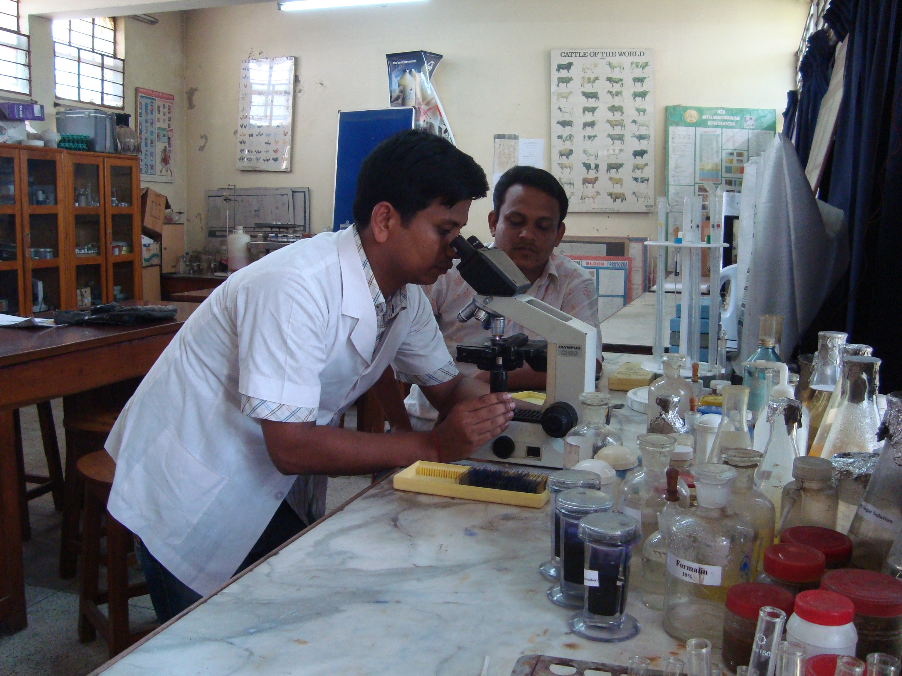

Fig. Identification of Parasites in microscope

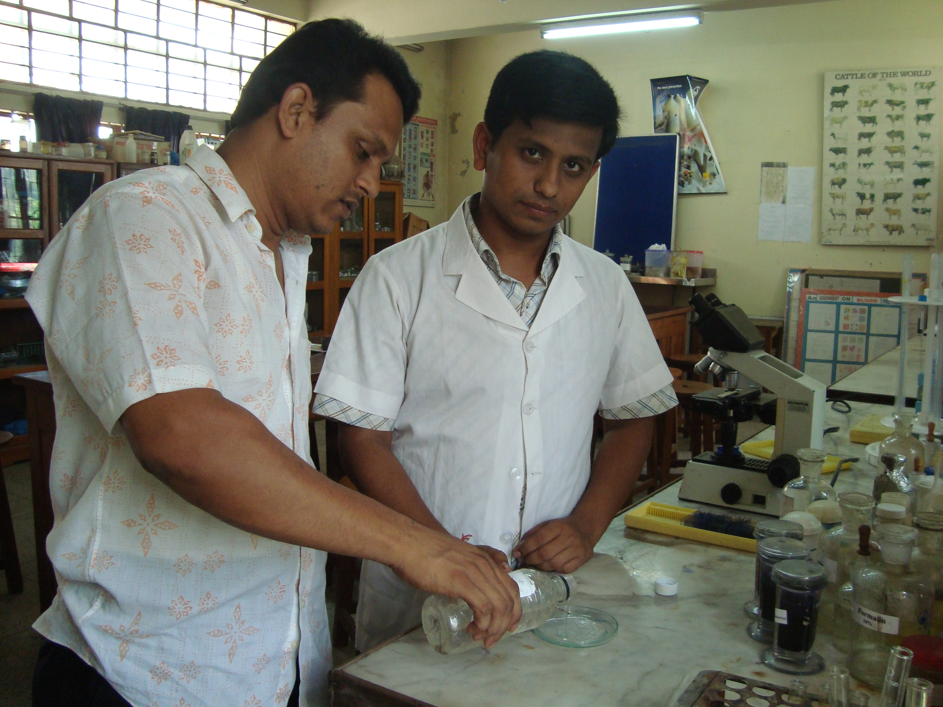

Fig. Preservation of Parasites.