A case report on diagnosis and surgical management of sebaceous gland tumor in Dalmatian dog
A clinical report submitted in partial satisfaction of the requirement for the Degree of Doctor of Veterinary Medicine (DVM)
By:
Md. Nazmul Islam
Roll No: 17/56
Registration No: 01892
Intern ID: 47
Session: 2016-17

Faculty of Veterinary Medicine
Chattogram Veterinary and Animal Sciences University
Khulshi, Chattogram – 4225, Bangladesh
A case report on diagnosis and surgical management of sebaceous gland tumor in Dalmatian dog
Approved by:

Dr. Mohammad Belayet Hossain
Professor
Department of Physiology Biochemistry and Pharmacology

Faculty of Veterinary Medicine
Chattogram Veterinary and Animal Sciences University
Khulshi, Chattogram – 4225, Bangladesh
Contents

Statement of Author | 04
List of Figures | 05
Abstract | 06
Introduction | 07 – 08
Case Presentation | 08 – 09
Anesthesia and Surgical Technique | 09 – 11
Histopathological Study | 11 – 12
Results | 12 – 13
Discussion | 14 – 15
Limitation | 15
Acknowledgement | 15 – 16
Disclosure of interest | 16
References | 16 – 18
Biography of the author | 19

Statement of Author

I, Md. Nazmul Islam, hereby declare that I have successfully completed all of the duties listed in this report and submitted on 28th November, 2022. Books, regional and worldwide publications, and other sources were used to collect the data. The required citations have all been made. As a result, I am entirely accountable for gathering, processing, maintaining, and disseminating all information gathered for this report.

The Author

List of Figures
SL No. | Figure | Page No.
1 | Clinical findings of the dog with dullness & underweight. | 08
2 | Tumor mass on the toe of right hind limb | 08
3 | Shaving of the hair of skin for surgical preparation | 09
4 | Application of antiseptic agent on surgical area | 09
5 | Initial incision on skin around the tumor mass | 09
6 | Excision of the tumor | 09
7 | Removal of the tumor from its root with body | 09
8 | Stitching the surgical wound | 10
9 | Surgical wound is closed with simple interrupted suture | 10
10 | Application of bandage as protective measure | 10
11 | Taking impression smear of tumor mass on slide | 10
12 | Drying the slide by air dryer | 10
13 | Staining with Giemsa Stain. | 10
14 | After 7 days, the surgical wound was healed (before removing the stitches) | 11
15 | Histopathological findings | 12

Abstract
A unique case of sebaceous gland tumor in 8 years aged Dalmatian dog with 27.8 Kg body weight was presented to Teaching & Training Pet Hospital and Research Center, Sector – 18, Road no – 5B, Purbachal New Town, Dhaka. The dog had a round shaped tumor mass of 5 cm diameter on the toe of right hind limb. The dog was quite dull with decreased food intake.The dog went through physical examination by the duty doctor. Then the doctor checked the inner content of mass through paracentesis and confirmed that it was neoplastic growth. So he decided to remove the mass surgically. The dog was generally anesthetized through chemical agent in a properly aseptic environment. Then the mass was excised by skilled surgeon with minimum blood loss. The surgery was performed with minimum traumatic process to surrounding tissues to prevent tumor seeding. After resection, the surgical wound was stitched with proper knot security. Finally a week long medicine was prescribed as post-operative management including broad spectrum antibiotic, anti-histaminic and pain killer drug. According to the opinion of the surgeon, the prognosis of this surgery was good. On the other hand, impression smear was taken on clean slide from the tumor mass for histopathological study so that confirmatory diagnosis could be aided. Under microscope it was visualized after Giemsa staining that the nuclei were hyperchromatic and the cytoplasm was more basophilic with vacuolation formation. In this report, histopathological findings and related factors were also compared with other previous reports.

KEYWORDS:
Dalmatian dog, sebaceous gland tumor, aseptic surgery, histopathological study, vacuolation.

Introduction
Sebaceous glands are alveolar glands that are prevalent throughout the hair-bearing skin of mammals and are situated close to the hair follicle. Through a duct at the infundibulum, these glands are linked to the hair follicle (upper portion of the follicle). The alveolar structures of sebaceous glands are lined by reserve cells, which differentiate into mature sebocytes and are finally excreted by holocrine secretion (Nikkari, 1974). Sebum, an oily substance secreted by them, interacts with sweat and other epidermal lipids to lubricate the skin and hair. Sebum can serve as a chemical and physical barrier against germs, including infections, and helps the skin retain moisture and stay hydrated. Sebum also includes proteins, inorganic ions, and immunoglobulin (IgA), indicating that it likely contributes to local immunological defense. When sebum penetrates the hair follicle, it is contaminated with lipase-producing bacteria, causing the generation of free fatty acids that may have antimicrobial effects (Pye, 2021).

Dogs have a similar range of neoplasms as do people since they share an environment and are exposed to the same carcinogens. Sebaceous tumor represents the third most common type of skin tumors, as it accounts for 22-35% of all cutaneous epithelial tumors (Costa et al., 2007). It is characterized by a low incidence rate and 5 – 10% rate of mortality(Wali and Al-Mujaini, 2010). They are classified into sebaceous adenoma, sebaceoma, and sebaceous carcinoma (SC) (Flux, 2017). In dogs and cats, SC accounts for 0.7% and 0.9%, respectively, of cutaneous tumors (Gautam et al., 2017). It is an aggressive, infrequent, and malignant cutaneous tumor that develops from the adnexal epithelium of sebaceous glands (Ghosh et al., 2008).

These tumors are often located near the skin, where sebaceous glands are abundant (Kass and Hornblass, 1989). At presentation, SCs are generally approximately 10 mm in size (Rao et al., 1982). The age range of prevalence is typically between 8 and 13 years, and there is no gender difference in the occurrence of SC (Goldschmidt and Hendrick, 2002).

Sebaceous carcinoma can resemble an inflammatory illness for years (Gonzalez-Fernandez et al., 1998). Because of this, a biopsy is necessary to confirm the diagnosis and distinguish it from mimics including benign sebaceous neoplasms, various adnexal tumors, and basal cell carcinoma (Knackstedt and Samie, 2017). Early identification and appropriate treatment may help improve the prognosis (Cicinelli and Kaliki, 2019) but there is still a certain recurrence rate. Some veterinarians report that cryotherapy can be used to treat Sebaceous gland tumor (Angileri et al., 2020). The most effective management of the tumor is by surgical removal of the localized tumors on the skin (Shields et al, 2005).On the other hand, microscopically sebaceous gland tumor can be characterized by large polyhedral shaped, abundant, clear, vacuolated cytoplasm (Patel et al., 2019).

Case Presentation
An eight years old Dalmatian breed male dog of 27.8 kg body weight was brought to Teaching and Training Pet Hospital and Research Center, Purbachal New Town, Dhaka, Bangladesh with a history of swollen mass on right hind leg (Figure – 02) and unusual gait. The tumor was developing for 7-8 months. The respective doctor examined the dog. On clinical examination, the dog's rectal temperature was 101°F. Its heart &pulse rates were 79 and 92 beats per minute, respectively. The animal was found to be dull and somewhat underweight (Figure – 01). A protruding mass of about 5 cm diameter was observed on the toes of right hind limb. Paracentesis was done to determine the nature of the fluid inside that mass and fresh blood was found there. Based on history and clinical signs, the swollen mass was primarily suspected for tumor. The duty doctor decided to remove that tumor by surgical method. Then he referred it to the laboratory for the investigation of histopathological study for the confirmatory diagnosis.

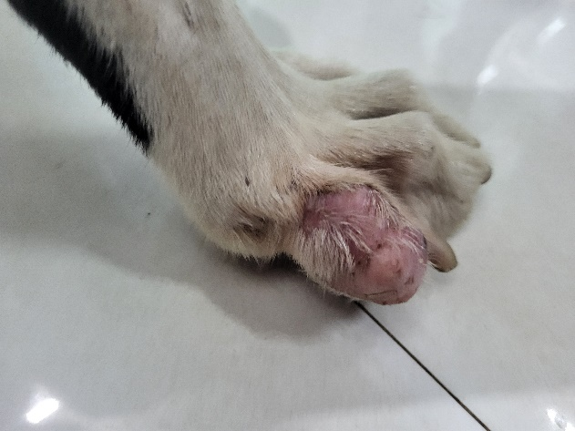
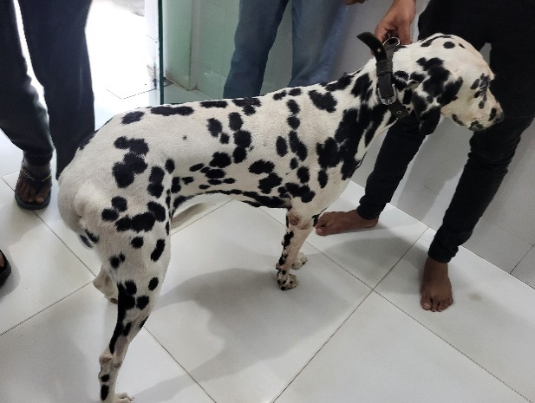
Figure – 02: Tumor mass on the toe of right hind limb
Figure – 01: Clinical finding of the dog with dullness
& underweight.
Anesthesia and Surgical Technique
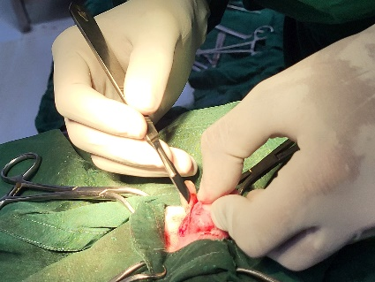
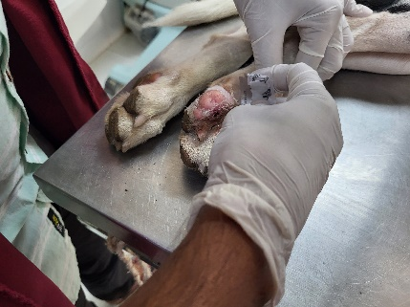
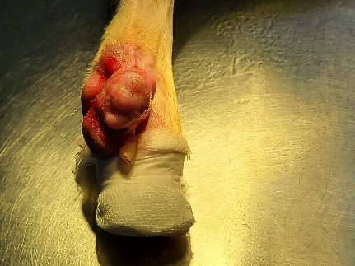
The dog was initially sedated by 1.35 ml Inj. Xylaxin intramuscularly (Xylazine Hydrochloride @1.0 mg/Kg body weight, 23.32 mg/ml, 30 ml vial, Indian Immunological Ltd). After some while, the dog became calm and felt asleep. Then the affected area of toes of right hind limb was shaved (Figure – 03) and aseptically prepared for surgery. The main anesthesia was performed by 2.8 ml Inj. Easium (Diazepam @ 0.5mg/Kg body weight, 10 mg/2ml, 2 ml ampoule, Opsonin Pharma Ltd) and 5.6 ml Inj. G Ketamine (Ketamine Hydrochloride @8 – 15 mg/Kg body weight, 50 mg/ml, 10 ml vial, Gonoshasthaya Pharmaceuticals Ltd) by intravenous (IV) route. Excision of tumor included the tumor and 1 cm wide margins of normal tissue in three dimensions (i.e., length, width, and depth) (Figure – 06). Resections was performed as atraumatically as possible to protect adjacent tissue and to prevent tumor seeding. A length-to-width ratio of 4:1 was used when making elliptic incisions around the tumor (Figure – 05). As the ellipse was started through all layers (skin, subcutaneous tissue, and fascia or muscle), a suture was placed through them to maintain alignment and prevent retraction of one layer from the others. The blood supply was ligated as early as possible to prevent systemic spread of tumor cells. After the excision of the tumor, the closure of the surgical wound was completed by Suturing incised edges of the flap together (Figure – 08). For post-operative treatment, a systemic antibiotic named Inj. Trizon Vet-1gm, 1 vial IM route, once daily for 7days (Ceftriaxone sodium @ 15 – 50 mg/Kg body weight, 1gm/vial, ACME Laboratories Ltd), an antihistaminic drug named Inj. Phenadryl Vet, 1.5 ml IM route (Diphenhydramine Hydrochloride @ 1 mg/Kg body weight, 20 mg/ml, 10 ml vial, ACME Laboratories Ltd) once daily for 7 days and a pain killer named Inj. Mel-vet, 1.5 ml Subcuteously (Meloxicam @1 mg/Kg body weight, 20 mg/ml, 10 ml vial, ACME Laboratories Ltd) once daily for 5 days. Protective bandage was provided on surgical area (Figure – 10) and restricted movement for 7 days was also suggested.
Figure – 03: Shaving of the hair of skin
for surgical preparation
Figure – 05: Initial incision on skin
around the tumor mass

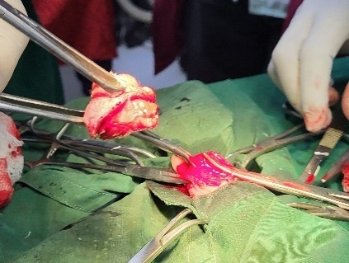
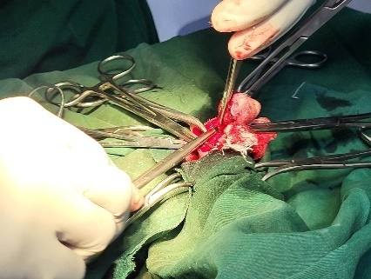
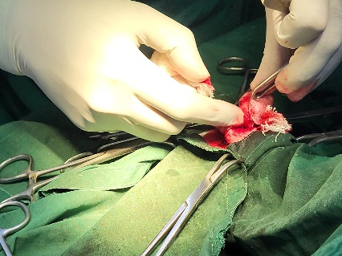
Figure – 07: Removal of the tumor
from its root with body

Figure – 06 (B): Excision of the tumor
Figure – 06 (A): Excision of the tumor

Figure – 04: Application of antiseptic agent
on surgical area

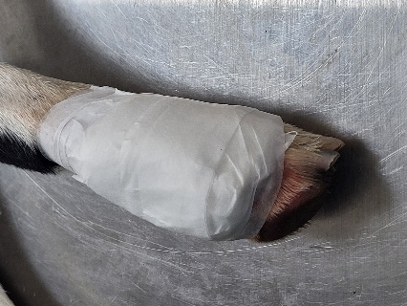
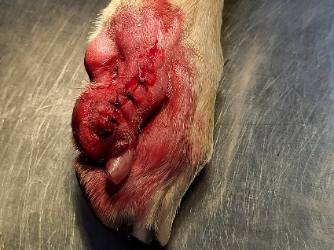
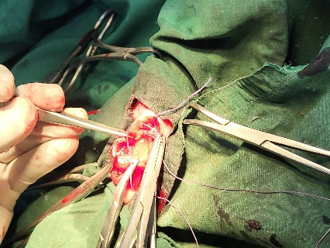
Figure – 10: Application of bandage as
protective measure
Figure – 09: Surgical wound is closed with
simple interrupted suture

Figure – 08: Stitching the surgical wound

Histopathological Study
The cut surface of the excised tumor mass was blotted a number of times to remove surface blood and serum, and the dried surface was applied to a clean, dry slide with air dryer. Then impression smear was taken from that tumor mass (Figure – 11). The slide was quickly air dried and then stained with Giemsa stain (Figure – 12, 13).

Under microscope, the neoplastic cells existed both singly and in cluster. Round to oval cluster cells were observed. The nuclei had a strong anisonucleoliosis and were pleomorphic, hyperchromatic. The cytoplasm had several fine vacuoles of different sizes and was somewhat basophilic (Figure – 15).

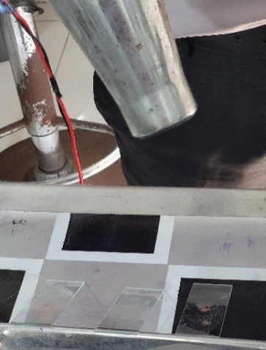
Figure – 11: Taking impression smear
of tumor mass on slide
Figure – 12: Drying the slide by
air dryer
Figure – 13: Staining with Giemsa
Stain.

Results
After 7 days from completing the surgery, surgical wound of affected area of toe was healed and stitches were removed on the same day. There was no wound complication found (Figure – 14). According to owner’s statement, the dog was taking foods normally. Before surgery the dog was quite dull and depressed, but at this time the dog was in playing mood. The duty doctor again checked other health parameters and those were normal.

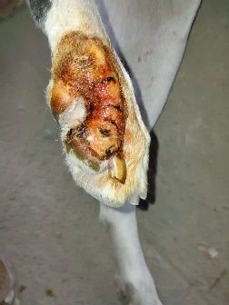
Figure – 14: After 7 days, the surgical wound was
healed (before removing the stitches)

Based on the clinical & gross finding and histopathology, this case was diagnosed as sebaceous gland tumor. It was benign type and benign sebaceous tumors are common in dogs and they can be numerous (Pakhrin et al., 2007). Intracytoplasmic lipid vacuoles were seen in the tumor cells under microscope, however the level of vacuolation varies from cell to cell. The nuclei had significant pleomorphism, were larger in size and hyperchromatic.

Discussion
The findings of this report have similarity with the previous reports exist on sebaceous gland tumor in dogs. In a case report documented in Okayama University Medical School, Okayama, Japan, fresh blood through local paracentesis is an indication of neoplastic growth (Hamazaki and Tanaka, 1978). In this report, the doctor aspirated fresh blood through paracentesis which was a sign of neoplasia.
B
A

Figure – 15: Histopathological findings. Giemsa stain, x100.
A: Hyperchromatic nuclei (Ajayi et al., 2020)
B: Numerous finely vacuolations in more basophilic cytoplasm

According to a case report on sebaceous gland tumor of the external acoustic meatus in a Cocker Spaniel dog in China, the best treatment for dog’s external acoustic meatus tumor is surgical removal (Dong et al., 2021). In current case, the doctor also surgically removed the tumor mass and the Dalmatian dog got relief from that tumor. In a case report of sebaceous tumor on 8-years old female Boerboel dog in Nigeria, it is stated that the basophilic cytoplasm contains several vacuoles and the nuclei were pleomorphic (Figure – 15A). They also found considerable mitotic figures under microscope (Ajayi et al., 2020). In this case of dog, the histopathological study revealed that the basophilic cytoplasm had numerous vacuolation, but there found no mitotic figure clearly (Figure – 15B).

In another study held in Veterinary Teaching Hospital, Mosul, Iraq, neoplastic sebaceous cells were present in glandular form in case of third eyelid tumor in cat & dog, and they visualized hyperplasia inside neoplastic mass characterized by large cuboidal or columnar shaped cells with larger nuclei comparatively (Al-Mahmood et al., 2022). In this report, it was seen under microscope that the nuclei were larger in size than normal.

According to a study on 59 samples of canine sebaceous tumors from paraffin blocks that were located on the archive of the Veterinary Anatomic Pathology Laboratory of Federal Fluminense University, in Niterói, RJ, Brazil, female dogs are comparatively more susceptible to sebaceous gland tumor than male individuals. They found that 41.51% males are affected (Costa et al., 2020) and this current report is prepared on a case of a dog which is male. It is also stated in that study the age ranged from 5 to 15 years. Another report in India, the authors stated that the highest incidence was documented for 9 to 12 years (39.13%) of age group (Patel et al., 2019). In case of this current report, the dog was of 8 years old.
Limitation
There was a lack of modern microscope with high resolution, thus microscopy was not at the desired level.

Acknowledgement
The author wishes to acknowledge the immeasurable mercy of Almighty ‘Allah’, the foremost authority and supreme ruler of the universe, who permits the author to complete this work successfully. The author expresses his deepest perception of gratitude, respect, and immense gratefulness to his honorable teacher and supervisor, Dr. Mohammad Belayet Hossain, Professor, Department of Physiology Biochemistry and Pharmacology, Chattogram Veterinary and Animal Sciences University for his academic guidance, generous supervision, precious advice, constant inspiration, radical investigation and effective judgment in all steps of this report. The author expresses his genuine gratitude and respect to the honorable teacher Prof. Dr. Md. Alamgir Hossain, Dean, Faculty of Veterinary Medicine, and Prof. Dr. A. K. M. Saifuddin, Director of External Affairs, Chattogram Veterinary and Animal Sciences University for proceeding with this internship program.

Disclosure of Interest
The author declares that there is no competing interest because the study was conducted personally.

References:
- Pye C. Canine sebaceous adenitis. The Canadian Veterinary Journal. 2021 Mar;62(3):293.
- Costa FB, da Silva KV, da Silva Leite J, Silva FB, dos Santos Batista BP, de Melo JF, Ferreira AM. Histopathological study of canine sebaceous tumors and their association with PCNA expression by immunohistochemistry. Revista Brasileira de Ciência Veterinária. 2020 Dec 9;27(3).
- Wali UK, Al-Mujaini A. Sebaceous gland carcinoma of the eyelid. Oman journal of ophthalmology. 2010 Sep;3(3):117.
- Flux K. Sebaceous neoplasms. Surgical pathology clinics. 2017 Jun 1;10(2):367-382.
- Gautam HE, Masand AJ, Asrani RK. Sebaceous carcinoma in a dog. Haryana Vet. 2017;56(1):111-112.
- Nikkari T. Comparative chemistry of sebum. Journal of Investigative Dermatology. 1974 Mar 1;62(3):257-267.
- Ghosh SK, Bandyopadhyay D, Gupta S, Chatterjee G, Ghosh A. Rapidly growing extraocular sebaceous carcinoma occurring during pregnancy: a case report. Dermatology online journal. 2008 Aug 1;14(8).
- Kass LG, Hornblass A. Sebaceous carcinoma of the ocular adnexa. Survey of ophthalmology. 1989 May 1;33(6):477-490.
- Rao NA, Hidayat LC, McLean LC, Zimmerman LE. Sebaceous carcinomas of the ocular adnexa: a clinicopathologic study of 104 cases, with five-year follow-up data. Human pathology. 1982 Feb 1;13(2):113-122.
- Goldschmidt MH. Tumors of the skin and soft tissues. Tumors in domestic animals. 2002:45-117.
- Shields JA, Demirci H, Marr BP, Eagle Jr RC, Shields CL. Sebaceous carcinoma of the ocular region: a review. Survey of ophthalmology. 2005 Mar 1;50(2):103-122.
- Gonzalez-Fernandez F, Kaltreider SA, Patnaik BD, Retief JD, Bao Y, Newman S, Stoler MH, Levine PA. Sebaceous carcinoma: tumor progression through mutational inactivation of p53. Ophthalmology. 1998 Mar 1;105(3):497-506.
- Knackstedt T, Samie FH. Sebaceous carcinoma: a review of the scientific literature. Current treatment options in oncology. 2017 Aug;18(8):1-3.
- Cicinelli MV, Kaliki S. Ocular sebaceous gland carcinoma: an update of the literature. International ophthalmology. 2019 May;39(5):1187-1197.
- Angileri M, Furlanello T, De Lucia M. Cryotherapy to treat benign skin tumours in conscious dogs. Veterinary dermatology. 2020 Apr;31(2):163-e32.
- Patel MP, Ghodasara DJ, Jani PB, Joshi BP, Dave CJ. Incidence and Histopathology of Sebaceous Gland Tumors in Dogs. Indian Journal of Veterinary Sciences & Biotechnology. 2019 Apr 20;14(4):29-32.
- Pakhrin B, Kang MS, Bae IH, Park MS, Jee H, You MH, Kim JH, Yoon BI, Choi YK, Kim DY. Retrospective study of canine cutaneous tumors in Korea. Journal of Veterinary Science. 2007 Sep 1;8(3):229-236.
- Dong J, Fan C, Liu D, Li P. Diagnosis and analysis of a sebaceous gland tumour of the external acoustic meatus in a Cocker Spaniel dog. Acta Veterinaria Brno. 2021 Apr 13;90(1):87-89.
- Ajayi OL, Antia RE, Oladipo TM, Aduloju OS. Sebaceous carcinoma in an 8-year old female Boerboel. Revue Vétérinaire Clinique. 2021 May 1;56(2):77-82.
- Costa FB, da Silva KV, da Silva Leite J, Silva FB, dos Santos Batista BP, de Melo JF, Ferreira AM. Histopathological study of canine sebaceous tumors and their association with PCNA expression by immunohistochemistry. Revista Brasileira de Ciência Veterinária. 2020 Dec 9;27(3).
- Al-Mahmood SS, Khalil KW, Edreesi AR. Histopathology and Immunohistochemistry of tumors in animals attending veterinary teaching hospital. Iraqi Journal of Veterinary Sciences. 2022 Apr 1;36(2):309-314.
- Hamazaki M, Tanaka T. HEMANGIOSARCOMA OF THE BREAST—CASE REPORT WITH SCANNING ELECTRON MICROSCOPIC STUDY—. Pathology International. 1978 Jul;28(4):605-613.

Biography of Author

Md. Nazmul Islam, the second child of Md. Tazul Islam Islam and Mrs. Nazma Sultana, is graduating with Doctor of Veterinary Medicine (DVM) from Faculty of Veterinary Medicine, Chattogram Veterinary and Animal Sciences University, Chattogram, Bangladesh. He earned a GPA of 5.00 while passing the Secondary School Certificate Examination (SSC) at Bangladesh Nou-Bahini School in Chattogram in 2013 and the Higher Secondary Certificate Examination (HSC) at Bangladesh Nou-Bahini College in Chattogram in 2015. He is now working on his 12-month internship. He is really enthusiastic about learning new things and expanding his practical knowledge in order to become a qualified veterinarian and contribute to the development of the national economy.

