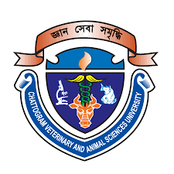
Physico-chemical, textural and sensory evaluation of sponge cake supplemented with pumpkin flour

Bibi Khadiza
Roll No.: 0119/13
Registration No.: 671
Session: January-June (2019-2020)

A thesis submitted in partial fulfillment of the requirements for the degree of Master of Science in Applied Human Nutrition and Dietetics

Department of Applied Food Science and Nutrition
Faculty of Food Science and Technology
Chattogram Veterinary and Animal Sciences University
Khulshi, Chattogram-4225, Bangladesh

June 2022
Authorization
I hereby declare that I am the sole author of the thesis. I also authorize the Chattogram Veterinary and Animal Sciences University (CVASU) to lend this thesis to other institutions or individuals for the purpose of scholarly research. I further authorize the CVASU to reproduce the thesis by photocopying or by other means, in total or in part, at the request of other institutions or individuals for the purpose of scholarly research. I, the undersigned, and author of this work, declare that the electronic copy of this thesis provided to the CVASU Library, is an accurate copy of the print thesis submitted, within the limits of technology available.

The Author
June 2022

Physico-chemical, textural and sensory evaluation of sponge cake supplemented with pumpkin flour

Bibi Khadiza
Roll No.: 0119/13
Reg No.: 671
Session: January–June (2019–2020)
This is to certify that we have examined the above Master’s Thesis and have found that it is complete and satisfactory in all respects, and that all revisions required by the thesis examinations committee have been made

….……………………………….
(Mohammad Mozibul Haque)
Supervisor
Assistant Professor
Department of Applied Food Science and Nutrition

………………………………………..
(Kazi Nazira Sharmin)
Associate Professor
Department of Applied Food Science and Nutrition
Chairman of the Examination committee

Department of Applied Food Science and Nutrition
Faculty of Food Science and Technology
Chattogram Veterinary and Animal Sciences University
Khulshi, Chattogram-4225, Bangladesh
June 2022

DEDICATED TO MY RESPECTED AND BELOVED FAMILY AND TEACHERS

Acknowledgements
This thesis becomes a reality with the kind support and help of many individuals. I would like to extend my sincere thanks to all of them.
Foremost. I want to offer this endeavor and my gratitude to the ‘Almighty Allah’ for the wisdom he blessed upon me, the strength, peace of my mind and good health in order to complete the thesis for the degree of Masters of Science (MS) in Applied Human Nutrition and Dietetics.
I would like to express my special gratitude and heartiest appreciation to my honorable supervisor, Mohammad Mozibul Haque, Assistant Professor, Department of Applied Food Science and Nutrition, Faculty of Food Science and Technology, CVASU, for his guidance and constant supervision as well as for providing necessary information regarding this research. His prompt inspirations, timely and scholarly advice, enthusiasm and dynamism have enabled me to complete my thesis.
I thank profusely to the director and technical officers associated with this research work of Department of Applied Food Science and Nutrition, Department of Fishing and Post–Harvest Technology, Department of Animal Science and Nutrition, Department of Physiology, Biochemistry and Pharmacology, Department of Applied Chemistry and Chemical Technology, Department of Food Processing and Engineering, CVASU for their kind help and co-operation throughout my research period in performing the research activities precisely in those laboratory.
I gratefully acknowledge the financial assistance from Research and Extension of Chattogram Veterinary and Animal Sciences University.
Last but not least, the co-operation and help received from family and friends, their cheerfulness and inspiration during the course of the study are greatly acknowledged.

The Author
June 2022
Table of Contents
Acknowledgements iv
Abbreviation x
Abstract xi
Chapter 1: Introduction 1
Chapter 2: Review of Literature 3
2.1 Pumpkin - General aspect 3
2.2 Constitute of pumpkin fruit 4
2.3 Vitamin A content in pumpkin flour 5
2.4 Antioxidant capacity 6
2.5 Phytochemicals 6
2.5.1 Polyphenol 7
2.5.2 Flavonoids 7
2.6 Use and application of pumpkin flour 7
2.7 History of bakery foods 8
2.8 Pumpkin flour in cake 8
2.9 Conclusion 8
Chapter 3: Materials and Methods 10
3.1 Study period and study area 10
3.2 Collection of samples and preparation of pumpkin flour 10
3.3 Production of pumpkin cake 11
3.4 Proximate composition Analysis 14
3.5 Mineral analysis 14
3.5.1 Determination of Potassium (K⁺) 14
3.5.2 Determination of Phosphorus (P) 15
3.5.3 Determination of Magnesium (Mg) 15
3.5.4 Determination of Iron (Fe) 15
3.6 Determination of vitamin A 16
3.7 Determination of Antioxidant Capacity 17
3.8 Extraction preparation 18
3.8.1 Total Phenolic Content (TPC) 18
3.8.2 Total flavonoid content (TFC) 18
3.9 Statistical analysis 19
Chapter 4: Results 20
4.1 Proximate composition of pumpkin cake 20
4.2 Antioxidant property of pumpkin flour 21
4.3 Antioxidant property of pumpkin cake 21
4.4 Vitamin A content of pumpkin flour 22
4.5 Vitamin A content of pumpkin cake 22
4.6 Phytochemical composition of pumpkin flour 22
4.7 Energy content of pumpkin cake 23
4.8 Phytochemical composition of pumpkin cake 23
4.9 Mineral content in pumpkin cake 24
4.10 Sensory evaluation 25
Chapter 5: Discussion 26
5.1 Proximate analysis of pumpkin cake 26
5.2 Vitamin A content of pumpkin flour and cake 27
5.3 Antioxidant capacity of pumpkin flour and cake 27
5.4 Total polyphenol content of pumpkin flour and cake 28
5.5 Total flavonoid content of pumpkin flour and cake 28
5.6 Mineral content of pumpkin cake 29
5.7 Nutritional composition of pumpkin cake 30
5.8 Sensory evaluation of pumpkin cake 31
Chapter 6: Conclusion 32
Chapter 7: Recommendations and Future Perspectives 33
References 34
Appendices 40

List of Tables
Table 2. 1: Proximate composition of pumpkin fruits 4
Table 2. 2: Proximate composition of Cucurbita maxima flour 5
Table 2. 3: Mineral content of Cucurbita maxima powder 5
Table 3. 1: Formulation of pumpkin cake 12
Table 4. 6: Proximate analysis of pumpkin cake 20
Table 4. 1: Antioxidant capacity of pumpkin flour 21
Table 4. 2: Antioxidant capacity of pumpkin cake 21
Table 4. 3: Vitamin A content of pumpkin flour 22
Table 4. 4: Vitamin A content of pumpkin cake 22
Table 4. 5: Phytochemical composition of pumpkin flour 23
Table 4. 7: Phytochemical composition of pumpkin formulated cake 24
Table 4. 8: Mineral content of pumpkin cake 24
Table 4. 9: Hedonic rating test for sensory evaluation of pumpkin cake 25

List of Figures
Figure 3. 1: Flow sheet for pumpkin flour production 11
Figure 3. 2: Development of pumpkin cake 13
Figure 4. 1: Comparison of energy content in pumpkin cake 23

Abbreviation
% | Percentage
& | And
CHO | Carbohydrate
DPPH | 2,2-diphenyl-1-picrylhydrazy
gm | Gram
Kg | Kilogram
GAE | Gallic acid equivalent
M | Meter
µg | Microgram
SPSS | Statistical Package for Social Science
UV | Ultraviolet
Etc | Et cetera
AOAC Association of Official Analytical Chemists

Abstract
Pumpkin (Cucurbita maxima) is rich in different types of nutrients specially vitamin A. In Bangladesh pumpkin widely used as vegetables though use as cake flour is not popular yet. Vitamin A deficiency disease including night blindness in children. Moreover, malnutrition is a great problem due to many reasons which should be overcome by using cost effective method in food production. Pumpkin is rich in nutrient content that can be used for the formulation of some basic types of food. This study aimed to develop sponge cake supplemented with pumpkin flour from pumpkin flash and to evaluate phytochemicals, bioactive compounds, antioxidant capacity, sensory and nutritional parameters. The protein, fat, fiber and total energy content of pumpkin cake increased with the addition of highest amount of pumpkin flour and the results are 8.1%, 21.8%, 2.5% and 410% respectively for Sample-1, 2, 3,and 4 per 100 g of cake. But in case of carbohydrate content, cake formulated with highest amount of pumpkin flour shows the lowest value compare to other Samples and control, as the percentage of cake four is decreased. Where the highest value of carbohydrate content in Sample-4 is 45.2% and the carbohydrate content of Sample-1, 2, 3 is 47.9%, 46.7%, 45.4% respectively. The moisture content decreased with increasing the amount of pumpkin flour. Sample-1 (with 20% pumpkin flour) has the highest value (23.4%) and 30% pumpkin flour cake (Sample-4) has the lowest value (21.2%). The magnesium, phosphorus, iron, potassium content were 9.1, 482.6, 38.5, 236.2 mg/100g respectively in sample-4 shows the highest value than control. Vitamin A content and antioxidant capacity of cake increased with addition of pumpkin flour and sample-4 shows the highest value which is 365.6 μg and RAE and 2.4 mg TE per 100 gm respectively and control shows the lowest value (310.1% and 2% respectively). Due to the nutritive value of pumpkin flesh flour, cake were prepared with three different substituted levels of pumpkin flesh flour in all-purpose flour (Sample 2=20%, Sample 3=25% and Sample 4=30%) were compared with control (Sample 1=0% pumpkin flour). Sensory results revealed 30% incorporation with pumpkin flour was best accepted by panelists. Conclusively, healthy, nutritious and palatable cake can be prepared successfully from pumpkin flour.
Keywords: Pumpkin cake, Nutrition, Antioxidant Capacity, Sensory, Deficiency.

Chapter 1: Introduction
Pumpkin belongs to the family of cucurbitaceae and is an annual climber plant found in most places. It is commonly used as a vegetable. Pumpkin is one of the cucurbitaceae plants, which is traditionally used to treat skin disease, insomnia, measles, jaundice, cancer and enhances endurance. In Brazil, pumpkins are mainly grown by family farms and are marketed locally due to their high perishability and low profit margins. Pumpkins are known to be a high-energy food source and process a significant amount of total fiber: 1.1g/100g in cooked pulp without peel and seeds (Michele et al., 2021). Dietary fiber is very important for health, especially for the prevention of cardio-metabolic disease due to its role in satiety, glucose control, maintenance of normal gastrointestinal function and microbiota (Louise et al., 2018). It is a gentle and safe remedy for a number of diseases, because pumpkin is an effective tapeworm remover for children and pregnant women is unfit for potent and toxic agents (Sopan et al., 2014). Epidemiological studies suggest that diet plays a crucial role in the prevention of many chronic diseases related to free radicals. Pumpkins are grown around the world as a vegetable and medicine. Pumpkin itself is a high-yielding vegetable, easy to grow and therefore cheap. Its pulp is a delicious and healthy additive found in a wide range of products for both children and adults. Pumpkins have received a lot of attention for its nutritional value and health protection in recent years. Pumpkin fruits are a valuable source of vitamins, minerals, fiber, carbohydrates, and antioxidants. Polysaccharides from pumpkin have hypoglycemic activity and for that the products from pumpkin can reduce the blood glucose level (Renata et al., 2014). It has been shown that there are large differences in the nutrient components between pumpkins grown in different areas and different species. In the past few decades, much research has focused on the scientific evaluation of the properties of pumpkin main nutritional components and their preparation as food or medicinal functional components. Pumpkin extracts used for anti-diabetic, antihypertensive, antitumor, immunomodulation, antibacterial, intestinal anti-parasitia, anti-inflammation, have been reported (Ting et al., 2007). Pumpkin has great potential as raw material in the manufacture of healthy food but the contributions to minerals, vitamins and proteins in human nutrition is limited due to presence of anti-nutrients but technologies such as germination and fermentation could be used to decrease anti-nutritional substances and to improve nutritional value.
Due to low caloric value (15-25 kcal in 100 g) and the presence of easily digestible nutrients, pumpkins have become a useful part of slimming diets (Amani et al., 2017). Pumpkin fruits can regulate metabolism and lower blood sugar levels, as well as exhibit detoxifying and slightly draining properties. Despite the squash’s high potential, it’s still an underappreciated vegetable by both consumers and food producers (Amani et al., 2017). That’s why pumpkins are processed into different kinds of food products. Pumpkin can be processed into flour, which has a longer shelf life. Pumpkin flour is used for its highly desirable flavor, sweetness and deep yellow-orange color (Eman et al., 2019). It has been reported to be used to supplement cereal flours in caked goods such as cakes, cookies, breads, for soups, sauces, instant noodles, and condiments, and as a natural coloring in pasta and flour mixes (Minarovicova et al., 2018). Baked goods are consumed as a staple food all over the world. In recent decades, baked goods have been intensively researched foods by fortifying active ingredients such as dietary fiber, bioactive peptides, minerals and vitamins etc. to increase their therapeutic values (Eman et al., 2019). Pumpkin powder can be used as a concentrated source of vitamin A in baked goods and confectionery. Pumpkin flour could also be used for its flavor, sweetness, deep yellow-orange color, and significant amount of fiber (Das et al., 2015).
The demand for new nutritionally healthy and sustainable foods has increased significantly. So this study is designed to utilize pumpkin flour for the development of pumpkin flour formulated cake for nutritional improvement and evaluating the nutritional content and organoleptic attributes of formulated cakes.
Aim and Objectives:
ⅰ. To prepare pumpkin flour formulated cake.
ⅱ. To analyze and compare the nutritional composition, phytochemicals, mineral, vitamin A content and antioxidant capacity of the prepared cake formulated with pumpkin flour.
ⅲ. To compare the overall acceptability of the developed product.

Chapter 2: Review of Literature
Pumpkin (Cucurbita maxima) is a winter squash that I round with smooth, slightly ribbed skin and most often yellow and orange in color. It is a plump, nutritious orange vegetable and highly nutritious dense food. Pumpkin flesh, seed and leaves are rich in vitamins and minerals.

2.1 Pumpkin - General aspect
Classification of pumpkin
Family : Cucurbitaceae
Botanical Name : Cucurbita Maxima
Kingdom : Plantae
Order : Cucurbitales
Genus : Cucurbita
Color : Light yellow color to bright orange
Source:https://www.itis.gov/servlet/SingleRpt/SingleRpt?search_topic=TSN&search_value=22373#null/
Pumpkin is a dicotyledonous seed vegetable rich in nutrients including polysaccharides, protein, essential amino acids, carotenoids, minerals and so on (Ting et al., 2007). Its fruits are used in various ways as it is a good source of various kinds of essential nutrients. Due to its good taste, it is a part of the diet in almost every country of the world. Mature and immature pumpkin fruits, leaves, flowers are processed and used in various ways. Pumpkin has some health benefits including spermatogenesis, wound healing, anti-microbial, anti-inflammatory properties etc. Due to these properties in some countries pumpkin is used as medicine particularly in Hungary, Mexico, China, Spain.

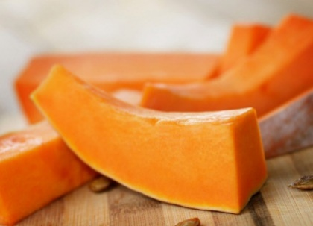
Fig-1: Pumpkin fruits and flesh

2.2 Constitute of pumpkin fruit
Pumpkin is multi-fuctional well-known fruits, full of nutrients and used in various way as food and formulated with other food to enhance the nutritional quality. Due to health promising property it used in many country functional food such as in Australia, Hungary, Chain, Spain, and several Asian and African country. Its fruit contain flesh, seeds and peels that are high in primary and secondary metabolites such as protein, carbohydrates, monounsaturated and polyunsaturated fatty acids, carotenoids, different types of vitamins including vitamin A, vitamin E and many other bioactive compounds such as flavonoid, polyphenol etc. The nutritional content of pumpkin is depends on shape, size, color, flavor, origin and cultivation environment of pumpkin. Table 2.1 shows the nutritional composition of pumpkin fruits.
Table 2. 1: Proximate composition of pumpkin fruits
Components (100 gm) | Jirapa et al., 2006 | Mayyawadee et al., 2011
Moisture | 84.32 | 93.24
Protein | 1.29 | 0.98
Fat | 1.45 | 0.15
Ash | 1.26 | 0.76
Fiber | 1.17 | 0.56
Carbohydrate | 10.51 | 5.31
Beta-carotenoid (mg/100gm) | 2.43 | -

Table 2. 2: Proximate composition of Cucurbita maxima flour
Component (g) | Anuruddika et al., 2020 | Jirapa et al., 2006 | Mayyawadee et al., 2011
Moisture | 14.80 | 6.01 | 10.96
Energy (kcal) | 313.00 | - | -
Crude protein | 8.95 | 3.74 | 9.65
Carbohydrate | 67 | 78.77 | 72.41
Total ash (g) | 5.56 | 7.24 | 5.37
Crude fiber (%) | 3.25 | 2.90 | 0.81

Minerals are required for the growth and maintenance of functional activity of the cell. Vegetables provide necessary mineral needs for individuals in both organic and inorganic combinations. Minerals in pumpkin fight against disease like arthritis, inflammatory disease etc (Maheshwari et al., 2015).
Table 2. 3: Mineral content of Cucurbita maxima powder
Components | Anuruddika et al., 2020 | Ashiq et al., 2021 | Udara et al., 2019
Potassium (mg) | 2690.54 | 1592 | -
Iron (mg) | 8.33 | 41.50 | 0.80
Magnesium (mg) | 154.46 | - | 0.125
Phosphorus (mg) | 39.15 | - | 44
Zinc (mg) | - | 15.21 | 0.32
Sodium (mg) | - | 17.87 | -

2.3 Vitamin A content in pumpkin flour
Vitamin A is the combination of Beta carotene and retinol, highly present in coloured food and a fat soluble vitamin. Beta carotene is widely known as an antioxidant which is incorporated with vitamin E and helps to reduce free radicals from the body . It is essential for the development and growth of embryos, reproduction, maintenance of the immune system, and most importantly for vision. Vitamin A plays an important role for proper functioning of eyes, heart,liver, lungs and other organs of the body. A diet high in carotenoids helps to regenarate new cells and reduce skin related problems such as hyperpigmentation, sun damage etc. Vitamin A 262 μg/100gm (Mayyawadee et al., 2011)

2.4 Antioxidant capacity
Antioxidants act as scavengers and prevent the formation of free radicals or reactive oxygen inside the body produce due to different metabolism. These free radical are the main reasons of DNA damage, irregular cell division which may cause cancer (Barry et al., 1996). Tissue damage caused by free radicals is believed to play an important role in the pathogenesis of multiple disease when they become cumulative such as cancer, cataract, coronary heart disease etc (Narasinga et al., 2003). In human diet antioxidant plays an important role. Various types of pumpkin produce in different country in different can play an important role in pre-diabetics, diabetes and vascular defects due to antioxidant activity. To estimate the antioxidant capacity, DPPH free radical test is used (Sánchez et al., 1998). Pumpkin contains antioxidants such as tocopherol, carotenoid, phenolic acid, flavonoid, bilirubin albumin etc (Wahyono et al., 2020). The rinds of Cucurbita maxima had the higher antioxidant value (33.8%), estimated by DPPH and the pulp of Cucurbita maxima and the seed of Cucurbita moschata had 29.6% and 25.4% respectively (Indrianingsih et al., 2019).

2.5 Phytochemicals
Phytochemicals are non-nutritive chemical compounds found in plants, vegetables such as flavonoids, polyphenols, beta-carotene etc. They have a crucial role in preventing some diseases like coronary heart disease, hyper-cholesterolaemia etc. These phytochemicals have different capacities to prevent different types of disease. Apart from these they enhance the immune system, act as prevention of diabetes and retard aging. The Indian medical system used many plants and herbs as medicine due to the presence of phytochemicals. These phytochemicals are non-toxic and contribute to the prevention of many chronic diseases (Narasinga et al., 2003).

2.5.1 Polyphenol
Polyphenols are secondary metabolites largely present in fruits, vegetables and cereal. Diet rich in polyphenols may give protection against cancer, osteoporosis, cardiovascular disease and neurodegenerative disease. In food, it avails to the bitterness, color, odor, oxidative stability etc (Kanti et al., 2009). In various plant species more than 8000 polyphenolic compounds have been found (Kanti et al., 2009). The effects of polyphenols on human cancer cell lines are mostly protective and induce a reduction in the number of tumors or their growth (Kanti et al., 2009). In neurodegenerative disease oxidative stress and damage to the brain is an important process. As polyphenols are high in antioxidant property, their consumption may give protection against neurological disease.

2.5.2 Flavonoids
Flavonoids are phenolic compounds that are essential components of the non-energy part of the human diet and commonly found in plants, fruits and vegetables, berries etc. there are more than 5000 different flavonoids. The average intake of flavonoids may depend on the country but approximately 23 mg/day is considered as suitable for everyone (Martínez et al., 2002). The main physiological effects of flavonoids are- neutralizing and free radical scavenging, metal chelate formation, specific interaction with molecular targets including inhibition of inflammation and cellular proliferation and inhibition of lipid peroxide etc (Zoltán et al., 2013). Some flavonoids have inhibitory effects including antioxidant effects, protein kinase C modulation, blocking of cell cycle etc.

2.6 Use and application of pumpkin flour
In many countries, the food industry is seeking the use of high nutritional raw materials such as pumpkin for the development of processed foods and diversification of agricultural production. The use of pumpkin flour instead of all-purpose flour increases the nutritional quality of the products (Rordriguez et al., 2020). Pumpkin flour can be processed into flour which has a logner shelf-life (Mayyawadee et al., 2011). Pumpkin flour can find suitable applications in the food processing industry for the development of novel products due to its nutritional and functional properties. Pumpkin flour can be used as a thickener in soup, gravy, fabricated snacks and as an ingredient in bakery products such as sandwich bread, sweet bread. Butter cake, chiffon cake and instant noodles (Mayyawadee et al., 2011). The use of pumpkin flour with wheat flour may decrease the volume of the products but it increases the crumb hardness and yellowness of the products (Wongsagonsup et al., 2015) and can be used as an alternative to wheat flour.

2.7 History of bakery foods
Baking is a millennia old process, and bakery products range in complexity from the simple ingredients of plain pastry to the numerous components of cakes. Bread and bakery product development has a long history. The most archeological history indicates that baking may have started around 21,000 B.C, when people learned how to mix wheat grain meal with water and bake it on stone heated by fire (Weibiao et al., 2007).
In earlier days, bakery business started in small bakeries with large varieties of products (Weibiao et al., 2007). But now people start baking commercially on a large scale. Baking industries look forward to increasing the quality of the products with maximum amount of nutrients with less additives considering all groups of people to fulfill their daily nutritional requirements.

2.8 Pumpkin flour in cake
Pumpkin is a mild-flavored yellow or orange vegetable that stands out as a source of fiber and nutrients. However, products made with pumpkins are still being researched in Brazil due to the high perishability in nature and the lack of eating habits of local baked goods (Michele et al., 2021). Pumpkin flours is rich in polysaccharide, fat, fiber, ash vitamin A, potassium, phosphorus, iron, magnesium and for such good quality attribute pumpkin flours are used in food industry for so many purpose including a thickener in soup, gravy, fabricated snacks (Mayyawadee et al., 2011).

2.9 Conclusion
Pumpkin flesh is very useful due to their nutritional composition, therapeutic and functional properties. They can be used in bakery items as an alternative to wheat flour due to its functional and nutritional properties and can be consumed as daily snacks. Pumpkin snacks are harder than typical snacks and nutritional content is higher than the wheat flour snacks. The color of pumpkin flour is yellow to light orange in color and use of this flour gives a natural yellow or orange color to food and this attracts children to have pumpkin flour made food. Pumpkin flour is considered as functional and healthy food due to its fiber, protein and bioactive compounds. Choosing healthy snacks in a good ratio increases energy levels and counteract hunger by fueling the body on a regular basis.

Chapter 3: Materials and Methods

3.1 Study period and study area
This research work was carried out for four months. All the experimental procedure were carried out in the laboratory of the Department of Applied Food Science and Nutrition, Poultry Research and Training Center, Department of Food Processing and Engineering, Department of Physiology, Pharmacology and Biochemistry at Chattogram Veterinary and Animal Sciences University (CVASU) Chattogram.

3.2 Collection of samples and preparation of pumpkin flour
From local market of Chattogram pumpkins were collected. The seeds and skins were dissected from the vegetable and washed thoroughly to remove dirt and any foreign material.
After that, the pumpkin flash was placed on a tray and dried in the sunlight for six consecutive days. Dried pumpkin taken and ground into powder form with the help of a grinder and then sieved them. After that the pumpkin flour was kept in a zip-lock plastic bag and kept at 4°C in the refrigerator till examinations.

Collection of pumpkin

Separation of seeds, skins and dirt from pumpkin

Wash and clean the flesh of pumpkin

Sliced the pumpkin into small thin pieces

Dried in sunlight

Grinding

Sieved

Stored in air-tight container

Figure 3. 1: Flow sheet for pumpkin flour production

3.3 Production of pumpkin cake
The pumpkin cake was prepared by mixing pumpkin flour, all-purpose flour and other ingredients including salt, sugar, baking powder, whole egg, non-fat dry milk, soybean oil, icing sugar and water followed by the method described by (Hosseini et al., 2018) with slight modification. Four formulations of cake were made where Sample-1 contained 100 gm all-purpose flour but no pumpkin flour and remarked as control. Sample-2 contained 20 gm pumpkin flour and 80 gm all-purpose flour. Sample-3 had 25 gm pumpkin flour and 75 gm all-purpose flour. Sample-4 contained 30 gm and 70 gm pumpkin flour and all-purpose flour respectively. Other ingredients remained the same in each formulation. Cakes were developed substituting all-purpose flour at 20, 25 and 30% with pumpkin flour, represented in Table 3.1.

Table 3. 1: Formulation of pumpkin cake
Ingredients (g) | Sample-1 (control) | Sample-2 (20%) | Sample-3 (25%) | Sample-4 (30%)
Pumpkin flour | 0 | 20 | 25 | 30
All-purpose flour | 100 | 80 | 75 | 70
Whole egg | 72 | 72 | 72 | 72
Icing sugar | 72 | 72 | 72 | 72
Soya bean oil | 57 | 57 | 57 | 57
Non- fat dry milk | 2 | 2 | 2 | 2
Baking powder | 2 | 2 | 2 | 2
water | 30 | 30 | 30 | 30

All ingredients were weighed first. Then icing sugar and soya bean oil were poured in a bowl and mixed properly. After adding egg the mixture of sieved flour, pumpkin flour, baking powder, and rapidly non-fat dry milk was poured in a bowl and mixed for some time. Water is then added and again mixed until a smooth paste is formed. For each cake 30gm cake batter was poured into a cake pan and bake at 180$℃$ for 25min in a convection oven. After baking the cake should be allow to cool for 30 min and should remove from the pan. Cooled caked were stored in air-tight polythene bag before sensory evaluation and physico-chemical analyses.

Prepare all the ingredients

Take pumpkin flour and all-purpose flour in a bowl

Icing sugar and soya bean oil were poured in bowl and mixed for 4 min

Egg was added to bowl and mixed for 2min

All dry material is then sieved and added to bowl and mixed well

Water is added to the mixture and mixed until a smooth batter is formed

In a cake pan cake batter were poured and baked at 180$℃$ for 25min

Baked cake allowed to cool for 30 min

Analysis of acceptability

Proximate analysis

Figure 3. 2: Development of pumpkin cake

3.4 Proximate composition Analysis
The standard method of AOAC was used to determine the moisture content of the sample. The protein, fat, fiber and ash content of cake were analyzed on a dry weight basis according to the Association of Official Analytical Chemists (AOAC, 2016). The moisture was measured by oven drying at 105ºC to constant weight. The crude protein value was measured by Kjeldahl method (percentage of Nitrogen is multiplied by 5.85). Soxhlet apparatus is use for the extraction of total lipid content which can be determined by AOAC method. Ash was measured gravimetrically in a muffle furnace by heating at 550ºC to constant weight. All determinations were done in triplicate and the result was expressed as mean value.

3.5 Mineral analysis
This method involves the extraction of minerals from the organic food matrix by digestion. Powdered sample of pumpkin cake was digested in an acid solution consisting of HNO3 and HClO4 into 2:1 ratio. One gram of pumpkin cake sample was weighted in a conical flask. 7 ml HNO3 and 3 ml HClO4 were added and then the flask was placed in a hot plate at 200W for 3 minutes until complete digestion. The solution was cooled down and filtered through filter paper into a 100 ml standard flask and diluted to the volume with distilled water. This solution was used for mineral content determination. Mineral contents (potassium, magnesium, phosphorus, iron) were determined by using a biochemical analyzer (Humalyzer 3000). Commercially available biochemical kit (Randox) was used for biochemical assay. All the analyses were expressed in mg/100g.

3.5.1 Determination of Potassium (K⁺)
Sodium tetraphenylboron reacts with potassium to produce a fine turbidity of potassium tetraphenylboron. The intensity of turbidity is directly proportional to the concentration of potassium in the sample. For the preparation of blank solution, 1 ml potassium reagent and 0.02 ml deionized water added into cuvette by pipette. For standard solution, 1 ml potassium reagent and 0.02 ml potassium standard and for sample solution, 1 ml potassium reagent and 0.02 ml sample extract were added into cuvette. After mixing these were incubated at retention time for 5 minutes. The absorbance of standard and sample were measured against blank within 15 minutes. The ratio of sample absorbance to standard absorbance is multiplied by standard concentration (mg/dl) and potassium concentration was obtained in mg/d.

3.5.2 Determination of Phosphorus (P)
For blank solution preparation only 1 ml phosphorus reagent, for standard 1 ml phosphorus reagent, 10 µL phosphorus standard and for sample solution 1 ml phosphorus reagent, 10 µL sample extract were added into cuvette by pipette. Later these were mixed and incubated for 5 minutes. The absorbance of sample and standard were measured against the blank. The ratio of sample absorbance to standard absorbance is multiplied by standard concentration (mg/dl) and concentration of phosphorus was obtained in mg/dl.

3.5.3 Determination of Magnesium (Mg)
The method is based on the specific binding of calmagite, a metallochromic indicator and magnesium at alkaline pH with the resulting shift in the absorption wavelength of the complex. The intensity of the cromophore formed is proportional to the concentration of magnesium in the sample. For the preparation of reagent blank solution 1 ml reagent was taken in cuvette. 1 ml reagent and 10 µL sample extract were added into cuvette for the preparation sample solution. For the standard solution preparation, 1 ml reagent and 10 µL magnesium standard were taken in cuvette. After mixing let these cuvettes stand for 2 minutes at room temperature. The absorbance of sample and standard at 520 nm were measured against the reagent blank. The ratio of sample absorbance to standard absorbance is multiplied by standard concentration (mg/dl) and concentration of magnesium was obtained in mg/dl.

3.5.4 Determination of Iron (Fe)
The iron is dissociated from transferring-iron complex in weakly acid medium. Liberated iron is reduced into the bivalent from by means of ascorbic acid. Ferrous ions give with Ferrozine a colored complex. The intensity of the color formed is proportional to the iron concentration in the sample. For the preparation of blank solution, 1 ml reagent was added into cuvette with the help of pipette. For standard preparation, 200 µL standard and 1 ml reagent were added. 200 µL sample extract and 1 ml reagent were added for the preparation of sample solution. After mixing, incubated these for 10 minutes at room temperature. The absorbance of standard and sample were measured against blank. Concentration of iron was obtained in µg/dl.

3.6 Determination of vitamin A
Vitamin A was measured using colorimeter. The contribution of both retinol and betacarotene is used to determine the total Vitamin A content of a specific food. Proteins are precipitated with alcohol and retinol and carotenes extracted into light petroleum. After reading the intensity of the yellow color due to carotenes, the light petroleum is evaporated and the residue dissolved in chloroform before carrying out the color reaction. Allowance is made for the carotene contribution to the reaction (Bradley and Hornback, 1973). Retinol present in sample reacts with trifluoroacetic acid (TFA). During the reaction of sample and TFA, a blue color is observed indicating the presence of retinol in sample. The blue color is transient, so if the color develops, it must be observed within 2 seconds after adding the reagent (Guamuch et al., 2007). For each sample preparation 100 mg sample, 1 ml distilled water and 2 ml ethanol was taken in a tube and mixed with a vortex mixer. The tube was centrifuged for 15 minutes at 3000 rpm and then 1 ml supernatant was taken. First carotene was determined. For blank solution preparation 6 ml S2 reagent and for standard preparation 6 ml standard reagent were taken into cuvette by pipette. For sample solution preparation 1 ml sample extract, 2 ml S1 reagent and 3 ml S2 reagent were taken into a cuvette by pipette. All mixed well with a vortex mixer and a mechanical shaker for 10 minutes. The tubes were centrifuged for 10 minutes at 3000 RPM. Then 2 ml blank, standard and supernatant from sample were collected and the absorbance was read at 420 nm against the blank. This was done without delay to prevent solvent evaporation and destruction of carotenoids by light. Then the retinol was determined. For the preparation of sample solution 2 ml sample extract that was prepared in carotene determination, was taken and evaporated the contents of the sample cuvette to dryness in a 50°C water bath. After evaporation, 100 µl S4 reagent and 1 ml S5 reagent were added in the sample cuvette. For the blank solution preparation 100 µl S4 reagent and 1 ml S5 reagent were taken into cuvette by pipette. For standard solution preparation 100 µl standard reagent and 1.0 ml S5 reagent were taken. These were mixed well with a vortex mixer. The absorbance was recorded at 620 nm at exactly 2s after adding the reagent. Because S5 reagent is a strong acid with an irritant vapor.
The carotene, retinol and total vitamin content were measured as follows,
Retinol (mg/l) = (0.0759 × Absorbance) + 0.1023
Carotene (mg/l) = (- 0.0167 × Absorbance) + 0.0091
Where, 0.0759 and 0.0167 are slope; 0.1023 and 0.0091 are intercept
Total vitamin A (RAE) = µg of retinol + (µg of beta-carotene / 6)

3.7 Determination of Antioxidant Capacity
The antioxidant activity of pumpkin cake and flour was determined on the basis of radical scavenging capacity on the DPPH (2, 2-Diphenyl-1-picrylhydrazyl) stable free radical. Antioxidant capacity of the extracts was determined by the method described by (Azlim et al., 2010) with slight modification. 1 gm sample was taken in falcon tube. After that 10 ml absolute methanol was added and left for 72 hours. Continuous straining was done after 4 hours intervals. The filtrate was collected after 72 hours, and the methanolic extract was found. Stock solution (1 mg/ml) of extract was diluted to concentrations of (0.50, 1.00, 1.50, 2.00, 2.50) mg/ml in methanol. DPPH solution was prepared by dissolving 6.0 mg of DPPH in 100 ml absolute methanol. The methanolic DPPH solution (2 ml) was added to 1 ml of each extract solution of different concentrations and the mixture was left for 30 minutes. The absorbance was read at wavelength 517 nm. Control was prepared by adding 1 ml of methanol to 2 ml of DPPH solution. Trolox was used as standard. Antioxidant capacity based on the DPPH free radical scavenging activity of extracts was calculated and expressed as milligrams of Trolox equivalents (TE) per gram of extracts (mg TE/g).3.8 Determination of Bioactive Compounds

3.8 Extraction preparation
10 gm of sample was taken for other TPC and TFC in Falcon tube. After that 10 ml absolute ethanol was added and left for 72 hours. Continuous straining was done after 4 hours interval. After 72 hours, filtrate was collected and ethanoic extract found.

3.8.1 Total Phenolic Content (TPC)
TPC of the extracts were determined according to the Folin-Ciocalteu reagent method described with slight modifications (Al-Owaisi et al., 2014). Total polyphenol content (TPC) of the roselle jam determined according to the Folin-Ciocalteu method reported by Vergani et al. (2016) with slight modifications. 1 ml ethanoic extract was taken in a falconer tube and added 1.5 ml of FC reagent and left for 3 mins at room temperature. Then 1.5 ml Na₂CO₃ (7.5%) was added into the mixture and left for 60 minutes. The absorbance was read at wavelength 765 nm using a UV-VIS Spectrophotometer (UV2600, Shimadzu Corporation, USA) and C₂H₅OH was used as the blank. TPC was calculated and revealed as mg of gallic acid equivalents (GAE) per gram of extracts (mg GAE/g).

3.8.2 Total flavonoid content (TFC)
Total flavonoids content (TFC) of the samples was determined by using the aluminum chloride colorimetric process reported by Chang et al. (2002) with slight modifications. Stock solution (1 mg/mL) of extracts was prepared and aliquots of 0.5 mL of diluted extract diluted with 1.5 mL of 95% C₂H₅OH in a cuvette. Then 0.1 mL of 10% AlCl₃, 0.1 mL of 1 mol/L potassium acetate and 2.8 mL of distilled water were added to the immixture in the cuvette. The immixture left at room temperature for 30 min. The absorbance was read at wavelength 415 nm in UV-visible spectrophotometer (UV2600, Shimadzu Corporation, USA) and 10% aluminum chloride substituted with D.H2O of the same quantity were used as the blank. Total flavonoids amount in the sample was calculated by comparing absorbance of the sample extracts with a quercetin standard curve. TFC estimated and revealed as mg quercetin equivalents (QE) per gram of extract (mg QE/g).

3.9 Statistical analysis
Data were recorded and entered into the MS Excel -2013 and exported to Statistical Package for Social Sciences (SPSS version 20.0). Descriptive statistics (mean and standard deviation) were performed for proximate composition, antioxidant capacity and sensory evaluation of pumpkin flour and cake. Proximate composition and sensory evaluation data of cake were analyzed by using One-way ANOVA procedures to assess a significant level of variation at 95% confidence level. Level of significance was shown at P<0.05.

Chapter 4: Results

4.1 Proximate composition of pumpkin cake
Proximate composition of pumpkin cake is shown on table 4.6, almost all the samples are significantly different. Sample-1 had the highest moisture content ($23.1±0.18$) %, whereas Sample-4 had lowest (21.2$±0.16)$%. Protein content was higher in Sample-4 (8.1$±0.06)\%$ comparatively than Sample-1, 2 and 3. Fat content ($21.8±0.10)$% was also higher in Sample-4 than other formulations. The highest value of ash content was found in Sample-4 ($1±0.05) \%$and the lowest value (0.7$±0.05$) % was found in Sample-1. Fiber content was higher in Sample-4 (2.5$±0.11)\%$and lower in Sample-1 (0.7$±0.10)\%.$ Carbohydrate content was higher in Sample-1 (47.9±0.79) % and lower in Sample-4(45.2± 0.17) %.
Table 4. 1: Proximate analysis of pumpkin cake
Parameters | Sample-1 (control) | Sample-2 (20%) | Sample-3 (25%) | Sample-4 (30%) | P value
Moisture (%) | 23.1$±$0.18ª | 23.4$±0.08$ª | 22.9$±0.08$^{b} | 21.2$±0.16$ª | 0.000
Protein (%) | 7$±0.06$ | 6.7$±0.03$ | 7.2$±0.06$ | 8.1$±0.06$ | 0.000
Fat (%) | 21$±0.06$ª | 20.5$±0.07$ª | 21.$±0.1$^{b} | 21.8$±0.10$ª | 0.000
Ash (%) | 0.7$±0.05$ | 1$±0.05$ | 1.1$±0.05$ | 1.$±0.05$ | 0.000
Fiber (%) | 0.7$±0.1$ª | 1.7$±0.18$ª | 2.1$±0.05$ª | 2.5$±0.11$^{b} | 0.000
CHO (%) | 47.9$±0.79$ | 46.7$±0.14$ | 45.4$±0.68$ | 45.2$±0.17$ | 0.001
Total Energy (Kcal) | 408.2$±3.41$ª | 398.2$±1.21$ª | 399.7$±1.77$ª | 410$±1.39$^{b} | 0.000
Legends: All values showed ME$±$ SD of data. ME= Mean, SD= Standard Deviation. The presence of different superscripts along a row indicates a significant difference and the same superscripts are not significantly different at P<0.05.
1,2,3,4 represents Formulation 1 (0% pumpkin flour), Formation 2 (20% pumpkin flour), Formation 3 (25% pumpkin flour), Formulation 4 (30% pumpkin flour) respectively.

4.2 Antioxidant property of pumpkin flour
Antioxidant capacity of pumpkin flour at different wavelengths is shown in Table 4.1. From the table, the mean value of antioxidant capacity of pumpkin flour was found to be (3.1$±0.00$2) mg TE/100gm. (The value showed ME $±$ SD of data. ME = Mean. SD = Standard Deviation)
Table 4. 2: Antioxidant capacity of pumpkin flour
SL. no | Conc (mg/100g)
1 | 3.067
2 | 3.063
3 | 3.065

4.3 Antioxidant property of pumpkin cake
Antioxidant value of pumpkin flour in different wavelengths is shown in Table-4.2. Sample-4 had the highest (2.4$±0.0005 mg TE/100gm)$ value of antioxidant whereas Sample-1 had the lowest (2$±0.01$2 $mg TE/100gm)$ value of antioxidants.
Table 4. 3: Antioxidant capacity of pumpkin cake
Sample no. | Conc (mg/100g)
Sample-1(c) | 2$±0.01$2
Sample-2 (20%) | 2.1$±0.001$
Sample-3 (25%) | 2.4$±0.002$
Sample-4 (30%) | 2.4$±0.0005$
P value | 0.362

4.4 Vitamin A content of pumpkin flour
Vitamin A content in pumpkin flour is (233.3$±1.50)$ $μ$g RAE per 100 gm. This variation may be occurred due to drying condition and other condition
Table 4. 4: Vitamin A content of pumpkin flour
Sample no. | Conc (mg /100gm)
1 | 231.5
2 | 234.2
3 | 234

4.5 Vitamin A content of pumpkin cake
The findings for Vitamin A content in pumpkin formulated cake were presented in Table 4.4. From the table, a significant increase was observed. Sample A (Control) had the lowest value where Sample D had the highest value which was supplemented with 30% seed flour.
Table 4. 5: Vitamin A content of pumpkin cake
Formulations | Vitamin A (µg RAE/100g)
Sample-1 (c) | 310.1^{d}
Sample-2 (20%) | 326.8^{c}
Sample-3 (25%) | 354.2^{b}
Sample-4 (30%) | 365.6ª
P value | 0.000

4.6 Phytochemical composition of pumpkin flour
The results of bioactive compounds such as Total Flavonoid Content and Total Polyphenol Content are presented in table 4.4. Variation may occur due to the effect of sunlight and methodology.

Table 4. 6: Phytochemical composition of pumpkin flour
Sample | Total Flavonoid Content (TFC) (mg QE/100 g) | Total Phenolic Content (TPC) (mg GAE/100mL)
Pumpkin flour | 5.2$±0.04$ | 1.9 $±0.122$
Legends: Means ± SD and values in the same column with the same superscripts are not statistically significant (P>0.05)

4.7 Energy content of pumpkin cake
Figure 4.1 shows the energy content of four formulations of pumpkin cake. Energy content in Sample-4 was calculated in the highest amount (410$±1.39$Kcal/100 g) and lowest (398.2$±1.21$Kcal/100 g) in Sample-2.

Figure 4. 1: Comparison of energy content in pumpkin cake.

4.8 Phytochemical composition of pumpkin cake
The results of bioactive compounds such as Total Flavonoid Content and Total Polyphenol Content are presented in table 4.7. There is a significant different value found among all samples. Sample-4 carries the highest value of Total Flavonoid Content (TFC) (39.7±0.067) where sample-4 contains the highest value (1.8±0.034) of Total Polyphenol Content (TPC) mg GAE/100ml. Lowest value of Total Flavonoid Content (21.5±0.070) mg QE/100gm and Total Phenolic Content (0.3± 0.0075) mg GAE/100ml found in sample-2.
Table 4. 7: Phytochemical composition of pumpkin formulated cake
Formulation | Total Flavonoid Content (TFC) (mg QE/100 g) | Total Phenolic Content (TPC) (mg GAE/100mL)
Sample-1 (control) | 21.5±0.07^{b} | 0.7± 0.0105
Sample-2 (20%) | 27.4±0.084^{b} | 0.3± 0.0075
Sample-3 (25%) | 33.6±0.143^{b} | 0.4±0.0162
Sample-4 (30%) | 39.7±0.067ª | 1.8±0.034
P value | 0.000 | 0.000
Legends: Means ± SD and values in the same column with the same superscripts are not statistically significant (P>0.05).

4.9 Mineral content in pumpkin cake
The value of nutritionally valuable mineral is presented in Table 4.3. Pumpkin cake contained moderate concentration of minerals. Although only fair amount of phosphorus was present.
Table 4. 8: Mineral content of pumpkin cake
Minerals | Sample-1 (control) | Sample-2 (20%) | Sample-3 (25%) | Sample-4 (30%) | P value
Phosphorus | 50.7± 2.18^{b} | 451± 3.60ª | 473.7± 4.04ª | 482.7± 2.51ª | 0.000
Potassium | 39±0.80^{b} | 118.6±1.48ª | 157.7±1.22ª | 236.2±1.4ª | 0.000
Iron | 12.5±2.01^{b} | 26.1±0.85ª | 24.6±1.43ª | 38.5±1.02ª | 0.000
Magnesium | 5.3± 2.51 | 7.3± 2.51 | 7± 1.76 | 9.1±0.81 | 0.234
Legends: Means ± SD and values in the same column with the same superscripts are not statistically significant (P>0.05)

4.10 Sensory evaluation
Table 4.9 shows the highest (ME$± SD$ ) score for color, odor, softness, sweetness, crumbness, appearance was recorded (6.4$±0.51$, 5.8$±0.91,$5.8$±1.03$, 6$±1.05$, 5.9$±0.73$, 6.2$±0.42$ ) respectively in the case of Sample-4. Sample-4 had the highest acceptance rate (6.1$±0.73$). On the other hand, Sample-1, 2 (5.4$±1.34$, 5.4$±0.69$) scored least acceptance compared to other samples.
Table 4. 9: Hedonic rating test for sensory evaluation of pumpkin cake
Parameters | Sample-1 (control) | Sample-2 (20%) | Sample-3 (25%) | Sample-4 (30%) | P value
Color | 5.5$±$1.58 | 5.4$±0.96$ | 6$±0.66$ | 6.4$±0.51$ | 0.120
Odor | 5.1$±$1.66 | 5.6$±0.96$ | 5.7$±0.94$ | 5.8$±0.91$ | 0.552
Softness | 4.8$±1.68$ | 5.2$±1.03$ | 5.1$±1.37$ | 5.8$±1.03$ | 0.391
Sweetness | 5.4$±1.50$ | 5.5$±0.85$ | 5.8$±0.91$ | 6$±1.05$ | 0.938
Crumbness | 5.2$±1.31$ | 5.4$±1.35$ | 5.8$±1.03$ | 5.9$±0.73$ | 0.652
Appearance | 5.7$±1.33$ | 5.6$±0.84$ | 6$±0.66$ | 6.2$±0.42$ | 0.417
Overall Acceptability | 5.4$±1.34$ | 5.4$±0.69$ | 5.7$±0.48$ | 6.1$±.73$ | 0.280
Legends: All values shown in ME ± SD of data. ME = Mean, SD = Standard Deviation. The presence of different superscripts along a row indicates a significant difference and the same superscripts are not significantly different at P<0.05.

Chapter 5: Discussion

5.1 Proximate analysis of pumpkin cake
In my study, protein, fat, fiber and energy content is significantly increased but the carbohydrate content is decreased in pumpkin formulated cake with increasing the percentage of pumpkin flour. The content of carbohydrate was calculated by subtracting the crude protein, ash, fat, moisture from 100% of the cake. 45.2% of total carbohydrate was found in sample-4 (30% pumpkin flour) which is lower than the control sample (47.9%). In Hosseini et al., (2018) pumpkin formulated cake with 15% of pumpkin four shows the value of 50.6%. Which clearly indicates that, carbohydrate content decrease with increasing the content of pumpkin flour. Here the decrease of carbohydrate content is due to increase in the pumpkin flour content as cake flour is the principal contributor of carbohydrate (Mudasir et al., 2013). On the other hand, the moisture content of cake is significantly decreased with increasing the percentage of pumpkin flour. And low moisture content is good for any kind of products as it increase the shelf life of the product. From our study we can also see that, the moisture content of pumpkin cake has decreased significantly as the percentage of pumpkin flour has increased. Most of the inorganic constituents or minerals remains in ash. Total ash content is significantly increased with increasing the percentage of pumpkin flour. Fiber is a crucial component of complex carbohydrates. It is always found only in plants, particularly vegetables like green vegetables, fruits, nuts and legumes. Food incorporated with dietary fiber helps to increase the textural properties of foods including stabilizes fat and emulsion (Nyam et al., 2013). Fiber content of pumpkin cake was found to be 2.5% in the study. The cause of reduction of fiber content depending on degradation of structural polysaccharide or hemicellulose during storage (Mudasir et al., 2013). In our finding sample-4 shows the higher percentage of fiber that is 2.5% which is lower than control sample. Which indicate that, pumpkin increase the fiber content of the product, as pumpkin fruit is a good source of fiber. . As energy was found to be 410% in Sample-4 from the study indicates pumpkin cake can meet the daily energy needs of an adult and school going children.

5.2 Vitamin A content of pumpkin flour and cake
Vitamin A increases the immune power of the human body and that’s why it is known as an anti-inflammation vitamin (Zhiyi et al., 2018). The value of vitamin A in pumpkin flour from the study is found to be 233.2$±1.5$ $μ$g RAE per 100 gm which is slightly lower than the value found in Mayyawadee et al., (2011). This variation may occur due to the effect of sunlight during drying and affect the attribute of pumpkin flour as sunlight destroys vitamin A content.
Our study revealed that the content of vitamin A significantly increased with increasing the percentage of pumpkin flour and shows that there is significant difference between sample-4 and control. Sampe-4 with 30% pumpkin flour formulated cake contains the highest value of vitamin A which reported 365.6 $μ$g RAE per 100 gm and this value is higher from earlier study found in (Mayyawadee et al., 2011) and this is due to the ingredients used for making cake may contain some vitamin A.

5.3 Antioxidant capacity of pumpkin flour and cake
Antioxidants prevent the formation of free radical produce in our body due to metabolism.(Barry et al., 1996). From the results the antioxidant capacity of pumpkin flour was (2.4$±0.0005 mg TE/100gm$). Which indicates that pumpkin flour is a good source of antioxidants and it can be used as an alternative of cake flour. As pumpkin flour contains antioxidants, if it is used in incorporation with fat or lipids, it can reduce the oxidation of lipids which can increase the shelf life of the product.
According to our study, pumpkin formulated cake shows that there is no significant difference in antioxidant capacity among all the samples with control. The antioxidant capacity shows high in Sample-4 that is 2.422 mg TE/100gm and Sample-1, 2, 3 have a value of 2.386, 2.103, 2.035 mg TE/100gm respectively.

5.4 Total polyphenol content of pumpkin flour and cake
Bioactive compounds play an important role in biological functions for humans, beside basic nutrition, for example maintenance of the immune system and chronic disease prevention. Polyphenols scavenge free radicals such as peroxides, hydro-peroxides of lipid hydroxyl (Sopan et al., 2014). The total polyphenol content of pumpkin flour was found (1.9$±0.122)$ mg GAE/100mL. Which indicates pumpkin flour is a significant source of polyphenols.
Increasing the pumpkin flour content results the significant increase in total phenols (the range of 433-2203 mg/L). The higher levels of substitution leads to manufacture products with a higher expansion rate than the control sample (Moghadasi et al., 2019).
In our study, total polyphenol content of pumpkin cake in Sample-4 (with 30% pumpkin flour) had the highest value (1.8±0.034) and Sample-2 (with 20% pumpkin flour) showed the least value. Therefore, in another study shows that, product made from pumpkin flour such as bread shows a significant difference in total phenolic content with the increase of pumpkin flour content. 5.39 mg GAE/g shows the highest phenolic content in pumpkin formulated bread formulated with 20% pumpkin flour, where bread with no pumpkin flour contain 1.39 mg GAE/g total phenolic content (Wahyono et al., 2020). Which means product with high pumpkin flour content shows a significant difference in total phenolic content as the content of pumpkin flour increased.
The phenolic compounds present in plants possess many hydroxyl groups which have very strong scavenging activity. This is why pumpkin is used in traditional medicine as an anthelmintic (an agent used to expel worms), taeniacide (an agent which kills tapeworms) (Sopan et al., 2014).

5.5 Total flavonoid content of pumpkin flour and cake
Flavonoids are the low molecular weight polyphenolic secondary metabolites which plays a variety of biological activity in plants animals. Flavonoids are liable for the aroma and color of fruits (Amalesh et al, 2011). The Total flavonoid Content (TFC) of pumpkin flour estimated 5.2$±0.04$ mg QE/100 g in the study indicates a significant amount of flavonoid is present in pumpkin flour.
In human and animal health, the biological and pharmacological activities of flavonoids have been extensively studied and have demonstrated a wide range of anti-inflammatory, anti-oxidant, anti-microbial and anti-cancer properties (Aidyn et al., 2014).
Sample-4 shows the highest flavonoid value (39.7±0.067) and control sample (wheat flour) shows the lowest value (21.5±0.070) and there is significant difference between Sample-1(control) and Sample-4(30% pumpkin flour) which means if the amount of pumpkin flour increased the flavonoid content in pumpkin cake significantly increased.

5.6 Mineral content of pumpkin cake
Pumpkin is a valuable source of minerals. Pumpkin fruits is mainly a good source of potassium, magnesium, iron, phosphorus and other minerals. Magnesium is an essential cofactor for all enzymatic system involved in DNA processing, synthesis of DNA and DNA replication (Andrea et al., 2001). It is also a component of bone and teeth incorporated with phosphorus (Elinge et al., 2012). I our study, the highest magnesium content reported (9.1%) in Sample-4, and control sample reported the lowest magnesium content (5.3%) which means there is no significant difference between Sample-1 and Sample-4. Food with high magnesium content help to cure osteoporosis in old age people (Sara et al., 2013). High intake of potassium decrease the rate of cardiovascular disease mortality (Feng et al., 2008). The highest value of potassium content is (236.2±1.4) was quantified in sample-4. The value of potassium significantly increased by increasing the amount of pumpkin flour in cake.
The highest value of phosphorus content in cake that is estimated in Sample-4 is 482.7±2.51 mg/100gm indicates that the cake contain a significant amount of phosphorus and phosphorus content significantly increased with increasing pumpkin flour. Phosphorus acts as a buffer that prevents change in the acidity of the body fluids (Elinge et al., 2012). Phosphorus is pivotal for energy production and essential for skeletal and non-skeletal tissues (Ranjana et al., 2021).
Trace elements such as iron plays significant role in the transportation of oxygen through blood throughout the body, energy production synthesis of DNA and secretion of several enzyme (Marcio et al., 2018). Iron is essential to maintain hemoglobin level. Hemoglobin made up hem and globin. The protein that carries the oxygen throughout the circulatory system, is the main store of iron in the human and it’s considered as functional marker of iron status. Iron is also necessary to prevent infection, inflammatory disease etc (Amelie et al., 2012). The iron content in cake is quantified (38.5±1.02) mg/100gm and the content is higher than the value estimated in Ashiq et al., (2021) and the iron content in formulated cake increased significantly by increasing the percentage of pumpkin flour.

5.7 Nutritional composition of pumpkin cake
Four formulated pumpkin flour cake made from all-purpose flour and pumpkin flour were evaluated. Proximate analysis of pumpkin cake shows that the moisture content of the cake is influenced by the percentage of the pumpkin flour. Increasing the percentage of pumpkin flours shows a decrease in moisture content. Sample-4 with 30% pumpkin flour shows the lowest moisture content (21.2$±0.16$), while Sample-2 with 20% pumpkin flour shows the highest moisture content (23.4$±0.08$). Low level of moisture content increases the shelf life of the product (Kanwal et al., 2015). Higher moisture content decreases the shelf life and quality of the product. The total amount of mineral present in food known as total ash content. Ash content in Sample-3 is higher (1.1$±0.05$), and Sample-1 contain low level ash (0.7$±0.05$). By increasing the formulation level of pumpkin flour the level of fiber is also increased. Sample-1 (control) reported the lowest fiber content (0.7$±0.1$) due to low fiber content in cake flour and sample-4 formulated with 30% pumpkin flour reported highest fiber content (2.5$±0.11$). Diets high in fiber are good for human health. Fiber reduces constipation by increasing the digestion of food. Fiber helps to control cholesterol and reduce the risk of cancer (Kanwal et al., 2015). According to Brazilian regulation (Brazil, 2012), the food products should have a minimum of 2.5gm of total fiber per portion is classified as a ‘source of fiber’ (Michele et al., 2021).
Protein is necessary for tissue growth and development of our body. High protein was observed in Sample-4 (8.1$±0.06$) with 30% pumpkin flour while Sample-2 (6.7$±0.03$) shows the lowest protein content. Increasing protein content in diet is acceptable. Protein from vegetable sources is good for health (Domenico et al., 2020).
Fat is a macronutrients whose main function is to produce heat and regulates the temperature of the body. Besides that, fat is a concentrated source of energy. Fat helps to protects the internal parts of the body including heart, kidney lungs etc (Mohammed et al., 2017). Sample-4 (21.8$±0.10)$contain highest fat content and Sample-2 (20.5$±0.07$) contain low fat content.
The carbohydrate content ranges from 47.87% in Sample-1 to 45.24% in Sample-4. This indicates as the pumpkin flour percentage increases the percentage of carbohydrate disease. The Recommended Dietary Allowance (RDA) for carbohydrates is 130g/day for adults and children aged 1 year or more. This recommendation is based on the amount of sugar and starch needed to provide the brain with enough glucose (Slavin et al., 2018). Energy content from Sample-2 to Sample-3 is 398.22% to 399.65% and Sample-1 to Sample-4 is 408.19% to 410.04% indicates that pumpkin cake is a good source of energy which may fulfill daily energy requirements of an adult.
For growth, metabolism and nutrition a small amount of vitamin is required (Bardaa et al., 2016). Vitamin A level is highest in Sample-4 (with 30% pumpkin flour) and low in Sample-1 (no pumpkin flour). Sample-4, 3, 2 had 365.62, 354.21, 326.81 µg RAE vitamin A per 100 gm respectively and Sample-1 with no pumpkin flour had 310.05 µg RAE vitamin A per 10 gm. So it is observed that addition of pumpkin flour increases the level of vitamin A. The recommended daily amount of vitamin A is in the range of (600 – 900 µg RAE) for adults (for both male and female) and (300 – 400 µg RAE) for children (Russell et al., 2001).

5.8 Sensory evaluation of pumpkin cake
The sensory evaluation is done for pumpkin cake formulated with different percentages of pumpkin flour. Where sample-2, 3 and 4 contains 20%, 25% and 30% pumpkin flour, respectively. Then formulated cake compared to control cakes which contain no pumpkin flour (Sample-1). Pumpkin cake formulated with different ratios of pumpkin flour significantly affected the sensory attributes of cake.
In case of color, odor, softness, sweetness, crumbness the sensory evaluation shows that there is no significant difference between controls with samples.
Regarding the overall acceptability, there is no significant difference is present in overall acceptability between control and the formulated samples.

Chapter 6: Conclusion
Cake is a popular bakery food item and consumed by all kinds of people. This study revealed that by using pumpkin flour with wheat flour or by using only pumpkin, flour we make many healthy and nutritious snack items including cakes, biscuits, chips, muffin cakes and many other bakery items. The results show the acceptability of pumpkin formulated cakes using different percentages of pumpkin flour along with wheat flour. In proximate analysis, pumpkin cakes were high in fat, protein carbohydrate and energy and these contents are getting higher with increasing the percentage of pumpkin flour in cake. Pumpkin itself is a good source of vitamins including vitamin A and other trace elements like potassium, phosphorus, iron, magnesium etc can make the cake more suitable for the consumption without compromising flavor and taste. Pumpkin cake is considered as functional food due to having an ample amount of bioactive compounds including antioxidants, flavonoids and polyphenols. As making pumpkin flour is easy and cost effective, people can make flour from local pumpkin and can reduce the post-harvest loss of pumpkin. Cake made from pumpkin flour is yellow to orange in color because pumpkin is a good source of carotene. This gives a pleasant appearance to the products and reduces the use of harmful color which bakers commonly used in their products. This pumpkin cake is a good choice for children who normally resist eating pumpkin as vegetables. Formulating pumpkin flour together with wheat flour can be recommended to boost human nutrient intake. Since pumpkin is high in nutritional vegetables like protein, carbohydrate, fat, energy etc, cake formulated with pumpkin flour can be regarded as one of the best bakery/ snacks items for all groups of people.

Chapter 7: Recommendations and Future Perspectives
Flours from pumpkin have received a lot of attention in recent years for its nutritional and health protection value. Most of the people in our country, especially in villages, are suffer from malnutrition due to many reasons. In this case, cakes from pumpkin flour could be a good source of nutrients and energy. The present study conducted to investigate the supplementation and quality (proximate and mineral analysis of cake, vitamin A content of flour and cake, bioactive compounds such as flavonoid, antioxidant, polyphenol content of cake and flour, sensory) evaluation of pumpkin formulated cake made from pumpkin flour. In our country, pumpkin is available vegetable and can be used in the development of many functional foods for the malnourished children and people by considering the nutritional factors. On the basis of present investigation, the following suggestions and prospects are made for the further research work:
- Vitamin c and fat soluble vitamins including vitamin D, K, E should be analyzed.
- The physical analysis characteristics test and shelf life of the cake should be analyzed.
- The composition may be modified with different flavors and different kinds of flour to increase the taste and nutritional value.
- Modern packaging and storage conditions would be developed for better quality of cakes
- Sufficient steps should be taken to enrich commercially available cake with more nutritional value.
- The findings will be helpful from a therapeutic point of view as they have medicinal value.
- Awareness should be created about the health benefits of pumpkin flour and pumpkin cake and its possibility of being scope for the food industry.

References

AlJahani, A. and Cheikhousman, R. 2017. Nutritional and sensory evaluation of pumpkin-based (Cucurbita maxima) functional juice. Nutrition & Food Science.
AOAC. 2016. Official Methods of Analysis, Association of official Analytical Chemists.
Arachchige, U.S., Dinali, W.A.M., HBAAK, L., Madhubhashini, M.N. and Marasinghe, M.A.W.N. 2019. Development of extruded snacks using pumpkin flour. Energy, 26, p.1.
Azlim Almey, A.A., Ahmed Jalal Khan, C., Syed Zahir, I., Mustapha Suleiman, K., Aisyah, M.R. and Kamarul Rahim, K. 2010. Total phenolic content and primary antioxidant activity of methanolic and ethanolic extracts of aromatic plants' leaves. International Food Research Journal, 17(4).
Bardaa, S., Ben Halima, N., Aloui, F., Ben Mansour, R., Jabeur, H., Bouaziz, M. and Sahnoun, Z. 2016. Oil from pumpkin (Cucurbita pepo L.) seeds: evaluation of its functional properties on wound healing in rats. Lipids in health and disease, 15(1), pp.1-12.
Bhat, M.A. and Bhat, A. 2013. Study on physico-chemical characteristics of pumpkin blended cake. Journal of Food Processing & Technology, 4(9), pp.4-9.
Bird, R.P. and Eskin, N.M. 2021. The emerging role of phosphorus in human health. In Advances in Food and Nutrition Research. Academic Press. (Vol. 96, 27-88)
Casgrain, A., Collings, R., Harvey, L.J., Hooper, L. and Fairweather-Tait, S.J. 2012. Effect of iron intake on iron status: a systematic review and meta-analysis of randomized controlled trials. The American journal of clinical nutrition, 96(4), pp.768-780.
Castiglioni, S., Cazzaniga, A., Albisetti, W. and Maier, J.A. 2013. Magnesium and osteoporosis: current state of knowledge and future research directions. Nutrients, 5(8), pp.3022-3033.
Das, S. and Banerjee, S. 2015. Production of pumpkin powder and its utilization in bakery products development: a review. International Journal of Research in Engineering and Technology, 4(5), pp.478-481.
Elinge, C.M., Muhammad, A., Atiku, F.A., Itodo, A.U., Peni, I.J., Sanni, O.M. and Mbongo, A.N. 2012. Proximate, mineral and anti-nutrient composition of pumpkin (Cucurbita pepo L) seeds extract. International Journal of plant research, 2(5), pp.146-150.
Guamuch, M., Makhumula, P. and Dary, O. 2007. Manual of Laboratory methods for fortified foods (Vitamin A, Riboflavin, Iron and Iodine).
Halliwell, B. 1996. Antioxidants in human health and disease. Annual review of nutrition, 16(1), pp.33-50.
Hartwig, A. 2001. Role of magnesium in genomic stability. Mutation Research/Fundamental and Molecular Mechanisms of Mutagenesis, 475(1-2), pp.113-121.
He, F.J. and MacGregor, G.A. 2008. Beneficial effects of potassium on human health. Physiologia plantarum, 133(4), pp.725-735.
Hosseini Ghaboos, S.H., Seyedain Ardabili, S.M. and Kashaninejad, M. 2018. Physico-chemical, textural and sensory evaluation of sponge cake supplemented with pumpkin flour. International Food Research Journal, 25(2), pp. 854-860
Huang, Z., Liu, Y., Qi, G., Brand, D. and Zheng, S.G. 2018. Role of vitamin A in the immune system. Journal of clinical medicine, 7(9), pp.258.
Hussain, A., Kausar, T., Din, A., Murtaza, M.A., Jamil, M.A., Noreen, S., Rehman, H.U., Shabbir, H. and Ramzan, M.A. 2021. Determination of total phenolic, flavonoid, carotenoid, and mineral contents in peel, flesh, and seeds of pumpkin (Cucurbita maxima). Journal of Food Processing and Preservation, 45(6), pp.15542.
Indrianingsih, A.W., Rosyida, V.T., Apriyana, W., Hayati, S.N., Nisa, K., Darsih, C., Kusumaningrum, A., Ratih, D. and Indirayati, N. 2019, March. Comparisons of antioxidant activities of two varieties of pumpkin (Cucurbita moschata and Cucurbita maxima) extracts. In IOP Conference Series: Earth and Environmental Science (Vol. 251, No. 1, p. 012021). IOP Publishing, pp.1-6.
Kanwal, S., Raza, S., Naseem, K., Amjad, M., Bibi, N. and Gillani, M. 2015. Development, physico-chemical and sensory properties of biscuits supplemented with pumpkin seeds to combat childhood malnutrition in Pakistan. Pakistan Journal of Agricultural Research, 28(4), pp.400-405.
Lie, L., Brown, L., Forrester, T.E., Plange-Rhule, J., Bovet, P., Lambert, E.V., Layden, B.T., Luke, A. and Dugas, L.R. 2018. The association of dietary fiber intake with cardiometabolic risk in four countries across the epidemiologic transition. Nutrients, 10(5), pp.628.
Maheshwari, P., Prasad, N. and Batra, E., Papitas-The Underutilized Byproduct and the Future Cash Crop-A, p.32-34.
Malkanthi, A. and Hiremath, U.S. 2020. Pumpkin powder (Cucurbita maxima)-supplemented string hoppers as a functional food. International Journal of Food and Nutritional Sciences, 9(1), pp.2-2.
Martinez-Florez, S., Gonzalez-Gallego, J., Culebras, J.M. and Tunon, M.J. 2002. Flavonoids: properties and anti-oxidizing action. Nutricion hospitalaria, 17(6), pp.271-278.
Minarovicova, L., Laukova, M., Karovicova, J. and Kohajdova, Z. 2018. Utilization of pumpkin powder in baked rolls. Potravinarstvo.
Moghadasi, m. and hosseini, g.s. 2019. Formulation of functional puffy snack containing pumpkin powder.
Mohammed, S.F., Gimba, I.K. and Bahago, E.J. 2017. Production and quality evaluation of instant sorrel (zobo) drink produced by infusion, dehydration and size reduction methods. Journal of Nutrition and Health Sciences, 4(2), pp.205.
Montesano, D., Gallo, M., Blasi, F. and Cossignani, L. 2020. Biopeptides from vegetable proteins: New scientific evidences. Current Opinion in Food Science, 31, pp.31-37.
Mouradov, A. and Spangenberg, G. 2014. Flavonoids: a metabolic network mediating plants adaptation to their real estate. Frontiers in plant science, 5, pp.620.
Nyam, K.L., Lau, M. and Tan, C.P. 2013. Fibre from pumpkin (Cucurbita pepo L.) seeds and rinds: physico-chemical properties, antioxidant capacity and application as bakery product ingredients. Malaysian Journal of Nutrition, 19(1).
Pandey, K.B. and Rizvi, S.I. 2009. Plant polyphenols as dietary antioxidants in human health and disease. Oxidative medicine and cellular longevity, 2(5), pp.270-278.
Pongjanta, J., Naulbunrang, A., Kawngdang, S., Manon, T. and Thepjaikat, T. 2006. Utilization of pumpkin powder in bakery products. Songklanakarin Journal of Science and Technology, 28(1), pp.71-79.
Rao, B.N. 2003. Bioactive phytochemicals in Indian foods and their potential in health promotion and disease prevention. Asia Pacific Journal of clinical nutrition, 12(1).
Rordriguez-Lora, M.C., Ciro-Velasquez, H.J., Salcedo-Mendoza, J.G. and Serna-Fadul, T. 2020. Development and characterization of a dehydrated mixture based on pumpkin flour (Cucurbita maxima) incorporating modified starch of yam (D. alata cv. Diamante 22) with potential application for instantaneous soups. Revista Mexicana de Ingenieria Quimica, 19(3), pp.1011-1025.
Rozylo, R., Gawlik-Dziki, U., Dziki, D., Jakubczyk, A., Karas, M. and Rozylo, K. 2014. Wheat bread with pumpkin (Cucurbita maxima L.) pulp as a functional food product. Food technology and biotechnology, 52(4), pp.430-438.
Russell, R., Beard, J.L., Cousins, R.J., Dunn, J.T., Ferland, G., Hambidge, K., Lynch, S., Penland, J.G., Ross, A.C., Stoecker, B.J. and Suttie, J.W., 2001. Dietary reference intakes for vitamin A, vitamin K, arsenic, boron, chromium, copper, iodine, iron, manganese, molybdenum, nickel, silicon, vanadium, and zinc. A report of the panel on micronutrients, subcommittees on upper reference levels of nutrients and of interpretation and uses of dietary reference intakes, and the standing committee on the scientific evaluation of dietary reference intakes food and nutrition board Institute of medicine, pp.797.
Saeleaw, M. and Schleining, G. 2011, April. Composition, physicochemical and morphological characterization of pumpkin flour. In Proceeding of the 11th International Congress on Engineering and Food , pp. 10-13.
Saleh, E.H., Mansour, E.H. and Youssef, H.E. 2019. Utilization of pumpkin fractions in the preparation of pan bread as a functional food. In 6th Annual International Scientific Conference, Specific studies and their role in activating tourism for the development of the national economy, Tanta University, Faculty of Specific Education, March (Vol. 6, No. 9), pp.1-13.
Samanta, A., Das, G. and Das, S.K. 2011. Roles of flavonoids in plants. Carbon, 100(6), pp.12-35.
Sanchez‐Moreno, C., Larrauri, J.A. and Saura‐Calixto, F. 1998. A procedure to measure the antiradical efficiency of polyphenols. Journal of the Science of Food and Agriculture, 76(2), pp.270-276.
Scarton, M., Nascimento, G.C., Felisberto, M.H.F., Moro, T.D.M.A., Behrens, J.H., Barbin, D.F. and Clerici, M.T.P.S. 2021. Muffin with pumpkin flour: technological, sensory and nutritional quality. Brazilian Journal of Food Technology, 24, pp.1-12.
Simao, M., Camacho, A., Ostertag, A., Cohen-Solal, M., Pinto, I.J., Porto, G., Hang Korng, E. and Cancela, M.L., 2018. Iron-enriched diet contributes to early onset of osteoporotic phenotype in a mouse model of hereditary hemochromatosis. PloS one, 13(11), p.e0207441.
Slavin, J.L. 2018. Carbohydrate Quality: Who Gets to Decide. Cereal Foods World, 63(3), pp.96-98.
Sopan, B.A., Vasantrao, D.N. and Ajit, S.B. 2014. Total phenolic content and antioxidant potential of cucurbita maxima (pumpkin) powder. International Journal of Pharmaceutical Sciences and Research, 5(5), pp.1903-1907.
Vergani, L., Vecchione, G., Baldini, F., Voci, A., Ferrari, P.F., Aliakbarian, B., Casazza, A.A. and Perego, P. 2016. Antioxidant and hepatoprotective potentials of phenolic compounds from olive pomace. Chemical Engineering Transactions, 49, pp.475-480.
Wahyono, A., Dewi, A.C., Oktavia, S., Jamilah, S. and Kang, W.W. 2020. Antioxidant activity and total phenolic contents of bread enriched with pumpkin flour. In IOP Conference Series: Earth and Environmental Science (Vol. 411, No. 1, p. 012049). IOP Publishing.
Wahyono, A., Dewi, A.C., Oktavia, S., Jamilah, S. and Kang, W.W. 2020. Antioxidant activity and total phenolic contents of bread enriched with pumpkin flour. In IOP Conference Series: Earth and Environmental Science (Vol. 411, No. 1, p. 012049). IOP Publishing, pp.1-7.
Wongsagonsup, R., Kittisuban, P., Yaowalak, A. and Suphantharika, M. 2015. Physical and sensory qualities of composite wheat-pumpkin flour bread with addition of hydrocolloids. International Food Research Journal, 22(2), pp.745-752.
Zhou, T., Kong, Q., Huang, J., Dai, R. and Li, Q. 2007. Characterization of nutritional components and utilization of pumpkin. Food, 1(2), pp.313-321.
Zhou, W. and Therdthai, N. 2007. Manufacturing of bread and bakery products. Handbook of food products manufacturing, pp.265.

Appendices
Appendix A: Anti-Oxidant Capacity of Pumpkin Cake
Standard Table of Trolox:
No | Sample ID | Type | Conc(ppm) | WL517.0
1 | std1 | Standard | 0.500 | 0.272
2 | std2 | Standard | 1.000 | 0.221
3 | std4 | Standard | 1.500 | 0.185
4 | std5 | Standard | 2.000 | 0.133
5 | std6 | Standard | 2.500 | 0.092
Standard Curve:
S
t
a
n
d
a
r
d

C
u
r
v
e
0
.
5
0
0
1
.
0
0
0
1
.
5
0
0
2
.
0
0
0
2
.
5
0
0
0
.
2
9
0
0
.
2
5
0
0
.
2
0
0
0
.
1
5
0
0
.
0
7
3
y = - 0.0894539 x + 0.314536
r2 = 0.99735
Sample graph
S
a
m
p
l
e

G
r
a
p
h
1
5
1
0
1
5
3
.
1
7
1
3
.
0
0
0
2
.
5
0
0
1
.
9
1
8

Appendix B: TFC (Total Flavonoid Content) of Pumpkin Cake
Standard Table of Qwercetin:
 | Sample ID | Type | Conc(ppm)WL415.0 |  | Wgt.Factor | Comments
 | Std_1 | Standard | 2.000 | 0.004 | 1.000 | Dilution Factor 1
 | Std_2 | Standard | 3.000 | 0.010 | 1.000 | Dilution Factor 1
 | Std_3 | Standard | 4.000 | 0.014 | 1.000 | Dilution Factor 1
 | Std_4 | Standard | 6.000 | 0.020 | 1.000 | Dilution Factor 1
 | Std_5 | Standard | 7.000 | 0.024 | 1.000 | Dilution Factor 1
 | Std_6 | Standard | 8.000 | 0.029 | 1.000 | Dilution Factor 1

Standard Curve:
S
t
a
n
d
a
r
d

C
u
r
v
e
2
.
0
0
0
4
.
0
0
0
6
.
0
0
0
8
.
0
0
0
0
.
0
3
1
0
.
0
2
0
0
.
0
1
0
0
.
0
0
1

y = 0.00385110 x - 0.00271158
r2 = 0.98868
Sample graph:

Appendix C: TPC (Total Phenolic Content) of Pumpkin Cake
Standard table of Gallic Acid:
 | Sample ID | Type | Conc(ppm)WL760.0 |  | Wgt.Factor
1 | STD1 | Standard | 1.000 | 0.763 | 1.000
2 | STD2 | Standard | 2.000 | 0.780 | 1.000
3 | STD3 | Standard | 3.000 | 0.920 | 1.000
4 | STD4 | Standard | 4.000 | 1.007 | 1.000
5 | STD5 | Standard | 5.000 | 1.074 | 1.000
6 | STD6 | Standard | 6.000 | 1.115 | 1.000
7 | STD7 | Standard | 7.000 | 1.230 | 1.000
8 | STD8 | Standard | 8.000 | 1.314 | 1.000
Standard Curve:
S
t
a
n
d
a
r
d

C
u
r
v
e
1
.
0
0
0
2
.
0
0
0
4
.
0
0
0
6
.
0
0
0
8
.
0
0
0
1
.
4
0
1
1
.
2
0
0
1
.
0
0
0
0
.
8
0
0
0
.
6
5
8
y = 0.0768527 x + 0.687090 r2 = 0.99301
Appendix D: Hedonic test for pumpkin cake
Date: Sample code:
Gender: Male / female Age:
Instruction:
You are given four samples. Please start your evaluation from left to right. Evaluate each attribute by circling the appropriate scale which indicates your degree of liking. Rinse your mouth with plain water before tasting each sample. (1 – Dislike Extremely, 2 – Dislike moderately, 3 – Dislike slightly, 4 – Neither like nor dislike, 5- Like slightly, 6 – Like moderately, 7 – Like extremely)
Color
Dislike Extremely Neither Like or Dislike Like Extremely
Odor Dislike Extremely Neither Like or Dislike like Extremely

Softness
Dislike Extremely Neither Like or Dislike like Extremely
Sweetness
Dislike Extremely Neither Like or Dislike like Extremely
Crumbness

Dislike
Extremely

Dislike
Extremely

Neither like or dislike
Neither Like or Dis
like

Like Extremely

Like extremely

Ap
pearance

Overall acceptability

Dislike Extremely Neither Like or Dislike like Extremely
Comments (If any)
Appendices E: Photo Gallery
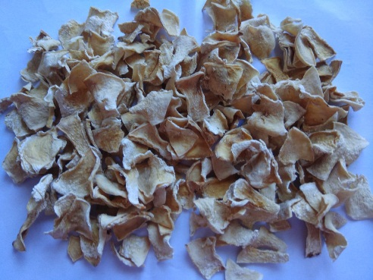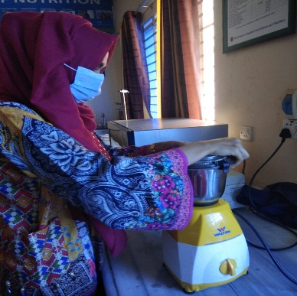
Dried pumpkin Grinding
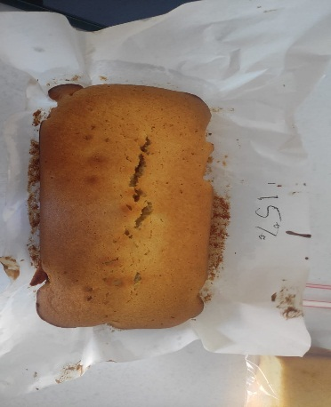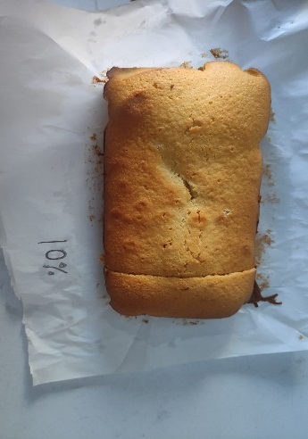
Sample with 20% pumpkin flour Sample with 25% pumpkin flour
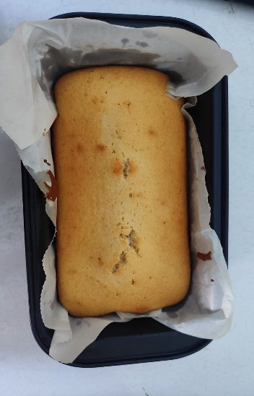
Sample with 30% pumpkin flour

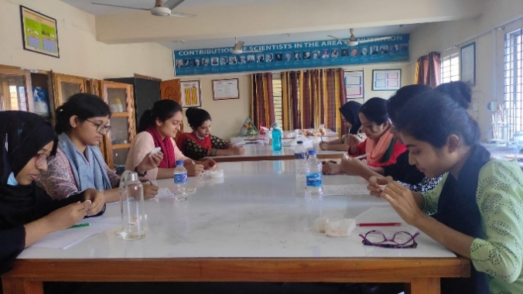
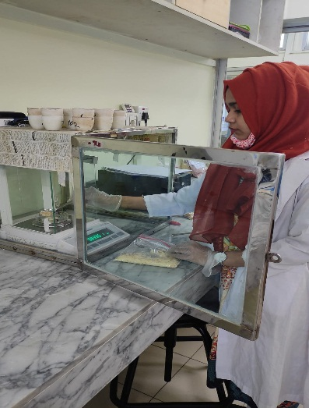
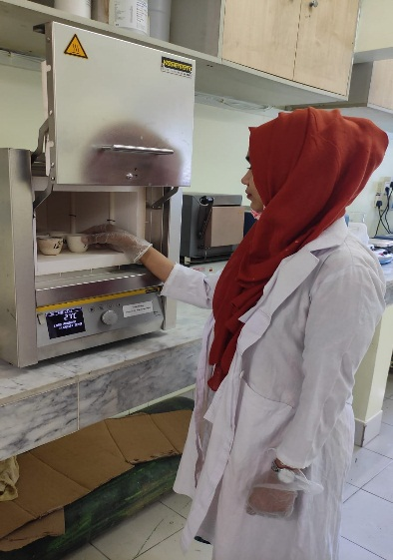
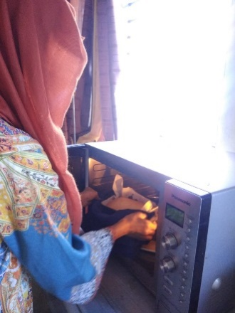
Baking of cake Sensory evaluation

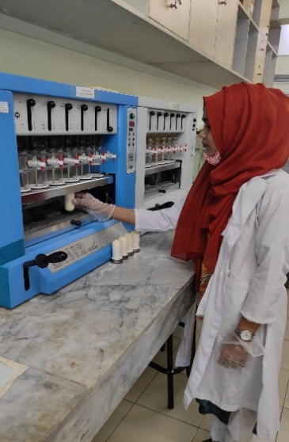
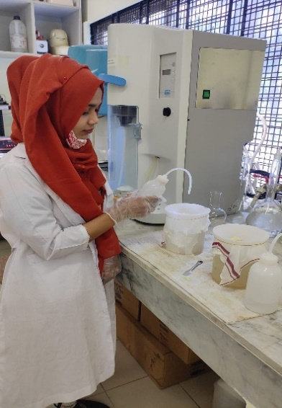
Weighing of sample Ash determination
Fiber extraction Protein digestion
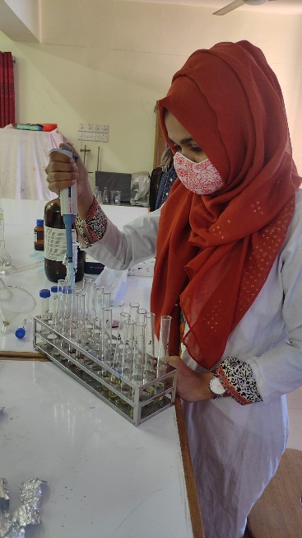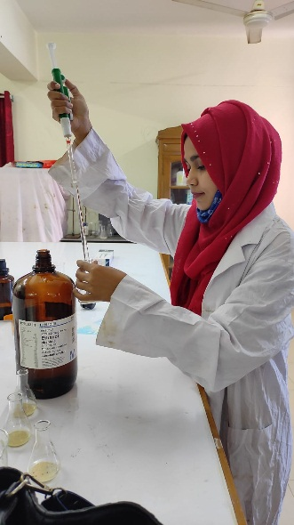
Preparation of sample for spectrophotometer analysis
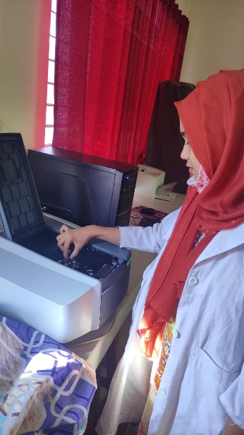
Working is UV spectrophotometer
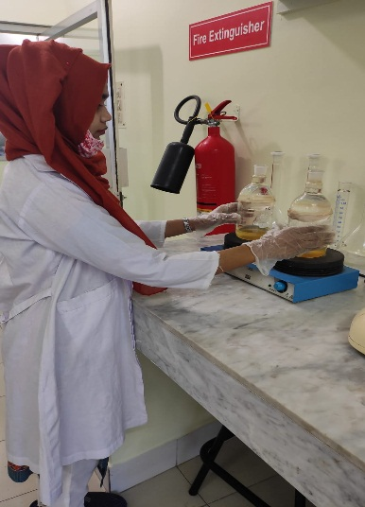
Fat digestion
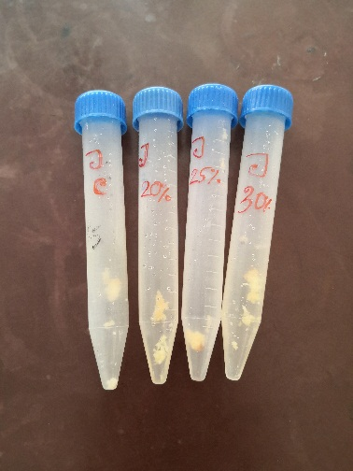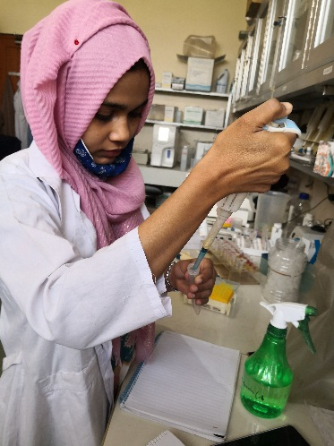
Samples of vitamin A determination Sample preparation
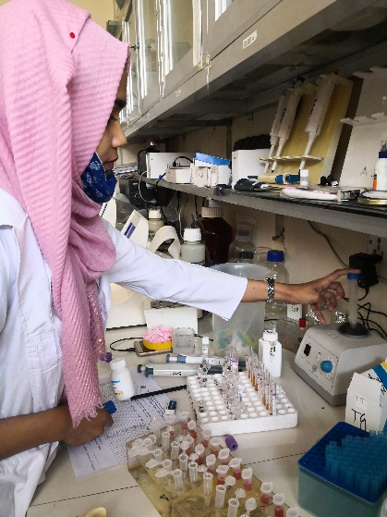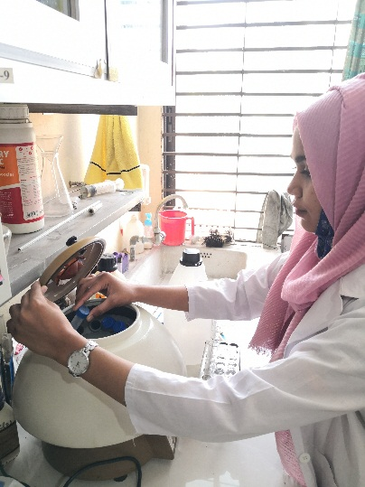
Agitation of sample Centrifugation
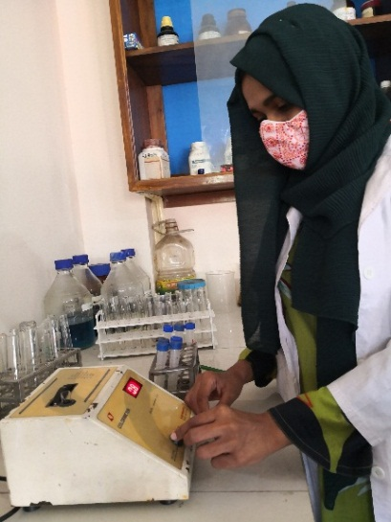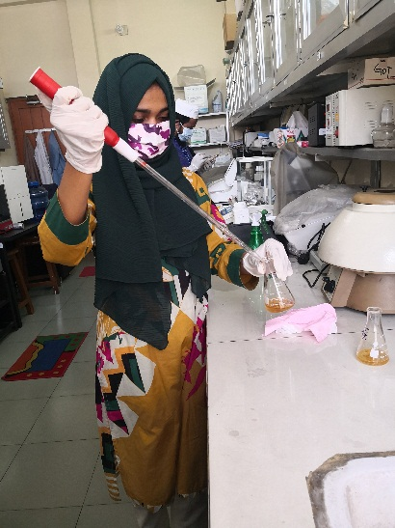
Absorbance determination Sample determination for mineral
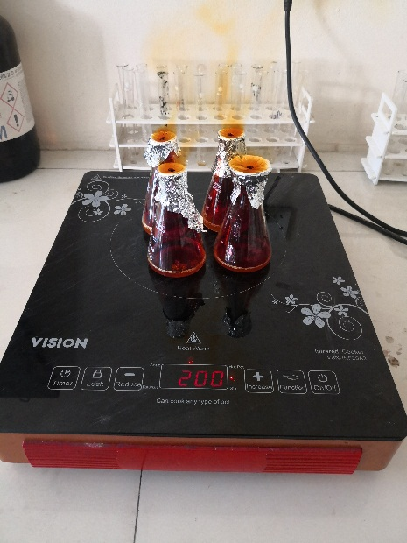
Digestion for mineral determination

Brief Biography
Bibi Khadiza passed the Secondary School Certificate Examination in 2011 and then Higher Secondary Certificate Examination in 2013. She obtained her B.Sc (Honors) in Food Science and Technology from the Faculty of Food Science and Technology at Chattogram Veterinary and Animal Sciences University, Chattogram, Bangladesh. Now, she is a candidate for the degree of Master of Science in Applied Human Nutrition and Dietetics under the Department of Applied Food Science and Nutrition, Faculty of Food Science and Technology, Chattogram Veterinary and Animal Sciences University (CVASU). She has an immense interest in improving the health status of poor people through proper guidance and suggestions and creating awareness about food science and nutrition

