Chapter-1: Introduction

It was never before the people of our planet moved to cities at the rate of the beginning of the third millennium. Half of the world's population already lives in cities, with estimates that at least 60% of the world's population will live in large areas by 2030. More people will live in cities; even more, will live in mega-cities. After many years of improvement in the health sector worldwide, it has been found that cities have become an essential setting for health promotion. The Healthy City approach was first developed by World Health Organization in the European region. A healthy city continuously creates and strengthens these physical and social environments, enabling people to fulfils all life functions and support each other in developing maximum potential. WHO uses the Healthy Cities definition of Hancock and Duhl that focuses on the "process that creates the possibility of health in people" instead of an end state. They felt that a Healthy City could not be described by data tables but had to be experienced (DUHL, 1986). Hancock and Duhl came up with 11 characteristics of a Healthy City. It is mainly conscious of maintaining health and striving to improve it (WHO). These healthy cities' approach focused on facilitating community-based health-improving initiatives. People inthe city, mainly the poor and newcomers, experience stress and exposure, which leads to various health problems like malnutrition, respiratory diseases, infectious and non-communicable diseases (Goldstein and Kickbusch, 1996). Therefore, any city can turn into a healthy city by improving the environment of the surroundings, community resources and people's health. To apply the healthy city strategic plan, we need to identify the community's health resources, health determinants and barriers.

Chattogram city is located in the southeastern part of Bangladesh. In this city, an overwhelming number of people live under the poverty line due to a lack of economic opportunities, unemployment and illiteracy. Most people have poor health outcomes due to their challenges in accessing proper healthcare. Pregnant women face many health issues due to poor delivery systems and also suffer from worm infections due to lack of knowledge and poor sanitary practices. Besides, they have inadequate nutrition knowledge and suffer a lot from malnutrition. The pandemic of coronavirus disease caused by severe acute respiratory syndrome has become a global concern since January 2020 (Chowdhury et al., 2020). Currently, Bangladesh is facing the second and third waves of COVID-19, which has proved to be the deadliest in Bangladesh (Ahsan and Ravelo 2021). Nowadays, the number of cases is increasing in Chattogram due to a lack of people's consciousness and not strengthening the social protection rules by the government. Besides, Infectious disease like Hepatitis virus has become common in Bangladesh. Hepatitis E virus is one of the main causes of acute hepatitis in this country, and in case of pregnancy, it becomes fatal. Due to polluted water supply and poor sanitation issues, the numbers of cases are still prevalent in Chattogram district (Biswas et al., 2019).

Moreover, Bangladesh is one of the 30 high TB-burden countries and accounts for 3.6% of the global total. Most of the previous TB cases are positive for Multi-drug resistant TB because of poor implementation of TB measures, such as the absence of policies, lack of proper knowledge, training, heavy workload etc. (Nazneen et al., 2021). Along with the increase in COVID-19 cases, the number of dengue cases is also increasing in Bangladesh. According to report of Directorate General of Health Services (DGHS), 2,286 dengue cases were reported in July (Shilpi, 2021). The increase in dengue cases is due to a lack of knowledge of mosquito nets, lack of spraying insecticides in affected areas and improper drainage systems.

In recent years, the proportion of people who are "happy" with the city's welfare has increased, and the quality of life has improved. In addition, the subjective dimension uses quality of life measurements as indicators of well-being, health, etc. Therefore, quality of life and well-being are affected by health, and health city programs seem to enhance the well-being of citizens. In this study, we examined the impact of the healthy city program on citizens' satisfaction. We analyzed the structural relationship between the healthy city program and happiness using quality of life as a parameter. In addition, by measuring health, quality of life and well-being indexes, we have created baseline data to improve the well-being index of residents of Chattogram. This city is actively implementing health city programs. In response to Healthy Cities initiatives in several countries, including Bangladesh, Nepal and Thailand, the WHO Regional Office is developing a Healthy Cities programme, which will be a collaborative effort between the Environmental Health Programme and the Programme on Health Promotion and Protection. Bangladesh has used funding from the WHO "Countries in Greatest Need" facility to support projects in Chattogram. A new project in Cox's Bazaar Bangladesh has recently secured funds for a project from the UN Development Programme "LIFE" programme and the Netherlands; implementation will be monitored and supported by country UN Development Programme staff and WHO. Collaboration with the Asian Development Bank's urban infrastructure programme has been arranged to implement the project in Cox's Bazaar. Therefore, this paper aims to assess the role of the World Health Organization's healthy city model in improving public health and the environment in Chattogram City Corporation. Besides, this paper will present the current health status and environmental condition.

Objectives:
- General Objectives:
To determine status of health related environment at Chattogram city area.
- Specific environment:
- To determine demographic public of respondents.
- To find out health related environment of respondents.

Chapter-2: Literature Review

A healthful city, as defined in the Zagreb statement (WHO, 2009), is a town for all its residents: inclusive, supportive, sensitive, and conscious of their various wishes and expectancies. Numerous needs and expectancies. It provides inspiring conditions and opportunities, allowing for and supporting a healthy lifestyle for people of all ages and ages. It provides a tangible and built environment that promotes, creates, and supports health, recreation and well-being, security, communication, accessibility and mobility, and a sense of pride and cultural identity, and responds to the needs of all its citizens (Tulchinskyet et al., 2014). The public health aspects of a built-up area include the visible parts of the areas where people live and work. These include homes, buildings, roads, open spaces, recreational infrastructure, commerce, physical activity, such as running, bike paths, gym equipment that promotes exercise and recreation, and access to groceries and fruit-packed groceries. These resources are designed to promote exercise, reduce stagnation habits, and promote healthy eating and recreation. Roads, industries, and commercial area management are part of Healthy Cities, and public health can be improved by planning and implementing far-sighted local authorities. Reducing industrial and air pollution from the power plants and roads is essential to improving urban living. In developing countries, the urban slum environment, which does not have enough safe water or sanitation, promotes disease and inequality that can be eradicated by healthy urban areas (Tulchinskyet et al., 2014).

The first official launch of the Healthy Cities Project took place in Lisbon in April 1986, when participants from 21 cities met to explore ideas for a healthy city and how the project could improve. The initial goals of the four- to the six-city project had to be adjusted to meet the growing interest in the project, and by 1988, 24 European cities were involved. The Healthy Cities Network has grown into a global network of 1400 cities and towns (Figures 1–3).

A healthy city constantly creates and develops those tangible and social spaces and expands those social resources that enable people to support each other in all health activities and self-development to reach their full potential, Ashton et al. (1986).Most importantly, a city is unhealthy if it cannot afford to provide its citizens with the necessities of life:
- Safe and adequate food,
- Safe water,
- Shelter,
- Sanitation, and
- Freedom from poverty and fear.

However, these alone are not enough, and most people expect the worst - a range of environmental, economic, physical, social, and cultural needs. In the spirit of Alma Ata, cities should deal with common health problems affecting their citizens. Today these include many ethical issues, such as alcohol, drugs, tobacco, HIV and other sexually transmitted diseases, obesity, violence, and death and external injuries, including road accidents. Essential requirements - or, in the Ottawa Charter language, health requirements - must be met if the health and well-being of all citizens are to be supported and maintained. The city's state plays a vital role in this, having a place of choice regardless of national policy requirements. In England, the relocation of public health teams to local government from health care trusts could improve the performance of the goals and objectives of the Healthy Cities Project. The local government's political climate may have had an impact - for better or worse - on the structure and type of public health work, including how they use and interpret scientific evidence (Phillips and Green, 2015).

The work of Health Cities has since created a public health service in many other places, such as schools, hospitals, workplaces, prisons, markets, islands, nightclubs, and stadiums. The strength of this approach seems to lie in providing a cohesive social and environmental context in which public health practice can be further developed holistically.

Despite the continuing compliance of the methods based on the New Public Health plans, there is limited evidence of their impact. However, to varying degrees, many of the ideas contained in this approach focus on public health. In particular, viewing arrangements as flexible social and environmental organizations ultimately focus on broader health decisions and provide good entry points for public health action ( John et al., 2017).

An important issue is how national programs can impact the project. In some lands, it has been helpful to establish the "National Healthy. Urban Commission "or network. A clear commitment by such bodies to local government policies that reduce discrimination or exclusion of poor communities from social and economic health and services can be very informative to assist local efforts. Perfect health development methods in the Healthy City project include "healthy villages," "improved health schools, "health facilities, "and "health-promoting hospitals." In addition, partnerships aimed at tackling their services, health service, and municipal health facilities responsible for providing health services, managing health facilities, or administration hospitals. Such problems may include making the life of mother and child resources easily accessible in neglected areas, strengthening the family planning, improving health education, or introducing better, more appropriate, and more readily available standard medication for diseases (Goldstein and Kickbusch, 1996).

Health Cities may be a "private" project in a particular city or part of a more significant development effort that includes city infrastructure, land management, municipal finance, and industrial development. These may include the Integrated Healthy Cities and Sustainable Cities Program in Ibadan, Nigeria (where the city health system is integrated with the urban development plan), the Joint Healthy Cities initiative, and urban infrastructure development launched in Bangladesh by the WHO, Asian Development Bank. WHO actively promotes the approach of Healthy Cities around the world by organizing inter-state meetings in every region regularly to review the progress of participating cities and to facilitate the exchange of health and environmental technologies and knowledge of successful projects.

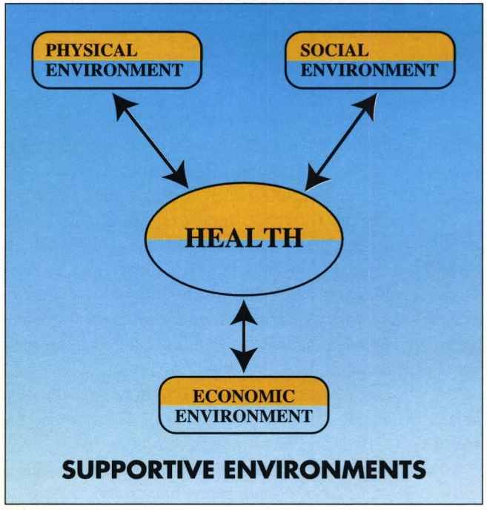

Fig:1-In cities, all aspects of the environment ore interlinked and impinge on the citizens' health (Source: Goldstein and Kickbusch, 1996)

Participating project coordinators are included in the international database, and newsletters and technical reports are regularly distributed to interested people are included in the international database, and newsletters and technical reports are regularly distributed to interested people.

Chapter-3: Materials and Methods

3.1. Research Design
This study attempted to empirically analyze the structural causality between the Healthy City program and citizens’ happiness index through quality of life. To this end, the Healthy City program was used as an independent variable, and the happiness index was used as a dependent variable. Quality of life was selected as a parameter to mediate the Healthy City program and the happiness index.

3.2. Setting and Study Participants
The topic of the study has been theorized as well as objectives have been selected. The data collection procedure, including a questionnaire survey by conducting literature reviews and sample number selection with the same procedure; and then the primary data have been collected through a household survey and the secondary data has been collected through some secondary sources like google search engine, google scholar, research gate and other online sources. Secondary data were collected from the research articles, short communication, and case studies from the source like Science direct, Elsevier, ACM, Cite SeerX, JSTOR, Emerald Insite, EbscoHost Pub Med, CINHAL etc. The collected data have been analyzed through some specific statistical software e.g. - MS Excel and R-Studio. Samples are collected from whole over the city (City Corporation) randomly irrespective of gender, age, religion, economic condition, educational status. A total 200 samples were collected from hospital, colleges and different residential home of inhabitants of Chattogram City Corporation. A set of questionnaire of two parts are formed. First part (Part-A) was unstructured and Second part (Part-B) was structured compromised of Multiple Choice Questions.

3.3. Samples for Data Collection
In order to analyze the structural relationship between the Healthy City program and the happiness index centered on selected regions, a survey was conducted for residents living in the area where the Healthy City program was being implemented. The Healthy City program seeks to positively change peoples’ lifestyle by understanding the physical environment of the area and its impact on the health of the residents. To this end, a sustainable Healthy City is created by improving various environmental factors, such as the activation of local health institutions, park construction, support of walking and cycling facilities, public sports facilities, and atmospheric and noise environments. Thus, it is judged that the residents who live in the region in which the Healthy City program is enforced are likely to experience the Healthy City program in a living environment. A face-to-face survey was carried out from 1 January to 31 March2022 in areas implementing the Healthy City program. The participants of this study were residents who participated in the Healthy City program in Chattogram City Corporation. Some health care centers, city corporation’s hospitals and private hospitals were involved in this study, where medical officers, nurses and medical assistants were in charge of preventing and managing chronic diseases. It also encouraged the use of these institutes to make health carea reality. We conducted surveys of residents visiting the residents’ centers, colleges, city corporation office and medical centers. Specific research methods were collected immediately after researchers and trained research assistants explained the purpose of the research and the questionnaire and distributed the self-administered questionnaire. In Chattogram City Corporation, of the 21 distributed questionnaires were collected and used for analysis.
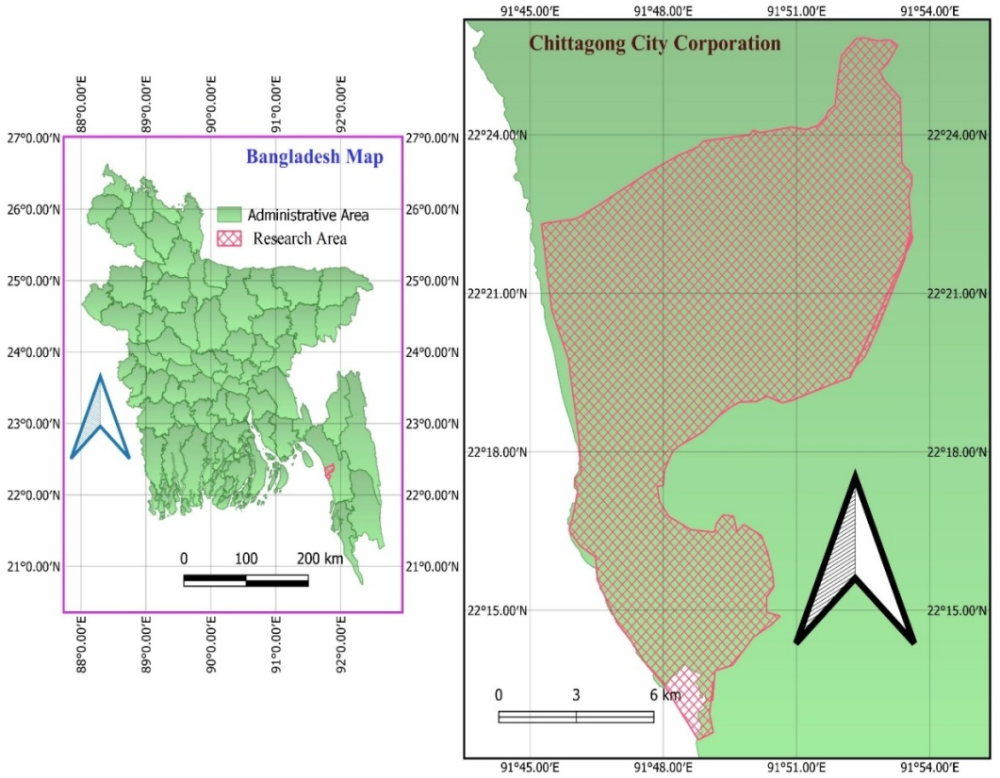

Fig-2: Sampling Map (Formed by QGIS3.24.0)

3.4 The Healthy City Program
The Healthy City program intends to scientifically diagnose citizens’ health problems and systematically analyze the causes and factors of the problems in order to establish a city plan and implement a new health policy. In addition, since the Healthy City program is based in the community and is a citizen-led program, it must reflect the local reality and the citizens’ health level. Thus, in order to implement a systematic Healthy City program, the status and distribution of health resources in the region must be apprehended and reflected upon (Heritage and Dooris, 2009). The planning and implementing processes of the Healthy City program are complicated; the more complicated the plan of the program is, the harder it is to evaluate. Furthermore, because the content of the program differs depending on the characteristics of each city and its development stage, it is not easy to evaluate the Healthy City program. In particular, it is difficult to grasp causal relationships in the Healthy City program. Since there are many factors that directly or indirectly affect city health, it is difficult to conclude that the cause of changes to citizens’ health could be one factor only (the Healthy City program). Although it may not be easy to verify a direct, causal relationship between health and the Healthy City program, systematic health promotion in the Healthy City program has strengthened the sustaining power for citizens’ health improvement (Baum et al., 2006). The survey items of the Healthy City program were composed based on the monitoring, accountability, reporting, and impact assessment framework proposed (Leeuw and MARI, 2006). With respect to the principles of the Healthy City program, this framework includes policy support, Healthy City-related organizations, health promotion programs and activities, participation in the community, partnerships, and environmental protection (Kang et al., 2011).

3.5. Happiness Index
Happiness is a feeling of sustainable wellbeing, but not momentary emotions or moods. Happiness is strongly subjective because it exists within an individuals’ experience and is an evaluation according to the individual’s thoughts about his or her life McDowell, 2006. The theories and standards of happiness differ according to social and cultural characteristics that the individuals experience. Therefore, happiness may enable the successful maintenance of life in a good condition. Since the attributes of happiness are connected to the individual’s subjective and variable mental state, there are difficulties in implementing policies associated with citizens’ happiness. However, there are objective and universal attributes of happiness, as well as individual subjective and relative ones. In other words, common factors related to happiness could be extracted as quantifiable attributes Cloninger, 2013. Health and happiness have a mutual influence, and the presence of disease affects abstract emotions such as happiness. The goal of the Healthy City program is to promote the health of local residents; consequently, it is expected to bolster the happiness index of residents. Factors affecting happiness are roughly classified into income, personal attributes, social attributes, relationships with others, and political environment. Health is highly associated with psychological factors and social attributes. The survey items on the happiness index were composed based on the precedent studies that assessed whether the demographical and sociological factors, such as income level, marital status, education, and occupation, might influence happiness and health (Johansson, 1973, and Dolan et at., 2008). The measures of happiness index derived from previous studies included economic stability, family interaction, interpersonal relationships, and health; extensive validity tests were conducted. In addition, the scale utilizedby Hervás and Vázquez Hervás and Vázquez, 2013, Kaczmarek, Bujacz, and Eid Kaczmarek et al., 2015, and others was used to measure the relationship between individuals’ life satisfaction, psychological and social environments, and happiness (Table 1).

3.6. Quality of Life
Quality of life (QOL) is a relative concept that is altered according to the political, economic, and social environment of the society as well as the personal characteristics, living conditions, values, and customs of the members of society. As the relative feelings should be evaluated, which the members of society might feel on the environmental change in order to define the quality of life, most of them tend to have subjective characteristics (Diener et at, 2009). Quality of life, related to health, means the subjective quality of life that may be directly or indirectly affected by an individual’s health status or physical or mental health recognition. It is mainly used to measure health care outcomes and health status. Quality of life may be gratified according to personal ability, but the level may vary depending on the living environment provided by the government. Particularly, it is closely related to the administration of the local government, which is associated with the daily life of the residents. The ultimate goal of local administration lies in improving the quality of life of citizens, which should imply seeking a solution to enhance the quality of life for each individual. Accordingly, the Healthy City program is being actively implemented, which makes citizens fulfill all activities necessary for living by improving their health (Maggino and Zumbo, 2012). Therefore, the survey items regarding quality of life were composed based on the Activities of Daily Living, developed (Katz et al.,1970). For the development of K-ADL questions, items we recollected and categorized for patients with physical disabilities, such as patients at government hospitals, private hospitals, community health centers, medium-sized hospitals, public health centers, and outpatient departments. Consequently, the validity and reliability of the questions were also verified Katz et al.,1970 and Kim, 2011. Furthermore, we attempted to measure our own physical function, role activities, personal satisfaction with life, and health status by using EQ-5D,a measuring tool on the Health-Related Quality of Life scale (Herdman et al., 1998)

Chapter-4: Result

The health of people living in cities is strongly determined by their living and working conditions, the quality of their physical and socio-economic environment, and the quality and accessibility of medical services. A healthy city is about transforming the way individuals, communities, private and voluntary organizations, and local governments think, understand, and make decisions about health Duhl, 1986. Ultimately, a healthy city is about improving the physical, mental, social and environmental well-being of those who live and work in the city. Defining, explaining, and measuring the "health" of one or two cities is a complex task. It must take into account the physical, mental, emotional and mental health of the citizens. Several factors interact to affect an individual's health. They can be divided into four main categories: health promotion, medical services, social care and environmental improvement (including physical, social and economic environment).

To convey the big picture of health, the indicators covered the areas of health, medical services, environment and socio-economic conditions. The purpose of collecting such data was to facilitate the development and prioritization of more evidence-based rational health policies. This information also needs to support the development of urban health profiles (CHPs) and lay the foundation for specific urban health plans to improve and maintain the health of citizens. Therefore, HCI is part of a logical advance and began with the collection of data that is routinely available to identify aspects of the city that contribute to or undermine the health of the population. This information, in turn, collects appropriate local data to create urban health profiles, informs policies and administrative measures, creates sound public policies based on evidence, and ultimately those policies. Can be built and expanded by promoting the implementation of Webster and Sanderson, 2013.

This study got these following result in terms of healthy cites of Chattogram, Bangladesh and presented the result as follows;

4.1. Frequency of Health Checkup

Fig-3: Frequency of Health Checkup by the inhabitants of Chattogram City

Among the 200 (Two Hundred) samples, result showed that 40% (80 out of 200) peoples do their health Checkup when they need for it. These 40% people only seek medical health checkup only when they get sick and advised to do checkup by the physician. Only 7.5% peoples do their health checkup once in every three months.

4.2. Source of drinking water
Result shows that among 200 samples 155 (77.5%) families use water from government provides drinking water (WASA), 30 (15%) families use tube-well water and rest 15(7.5%) families use bottle water for drinking.

Fig-4: Water sources for drinking by city dwellers.

4.3. Physical environment of living place
Study shows that 40% inhabitants of city have sufficient air, 2.5% inhabitants have sunny physical conditions surrounding their residents. 27.5% city dwellers have dark and 25% have wet physical conditions surrounding their living places.

Fig-5: Physical environment of living place of inhabitants.
4.4. Surrounding condition of living place
This report found that 37.5% families of the city have sufficient light and fresh air in their resident, 27.5% families were experienced sound pollution, and 5% families have some poultry or dairy farms nearer to their living places. Only 12.5% families have dustbins nearer to their houses.

Fig-6: Surrounding environment of living places.

4.5. Sanitary arrangement
Research shows that 47.5% families of the city use modern toilets, 37.5% families use normal latrine, and 15% families use normal traditional latrine for their toilet purposes.

Fig-7: Sanitary status of city inhabitants of Chattogram City Corporation.

4.6. Personal hygienic condition
This study shows that 95% peoples always maintain personal sanitary measures, 3.5% maintain hygienic measures occasionally and only 2% people never follow personal hygienic measures after using toilets.

Fig-8: Personal Hygienic Condition of City dwellers.

4.7. Garbage management system
Figure bellow shows that 92.5% families use dustbins for the management of their household garbage management and only 7.5% families do not use any dustbins or hygienic systems for their household wastes and garbage. These 7.5% families throw theirs wastes and garbage here and their creating environmental pollution.
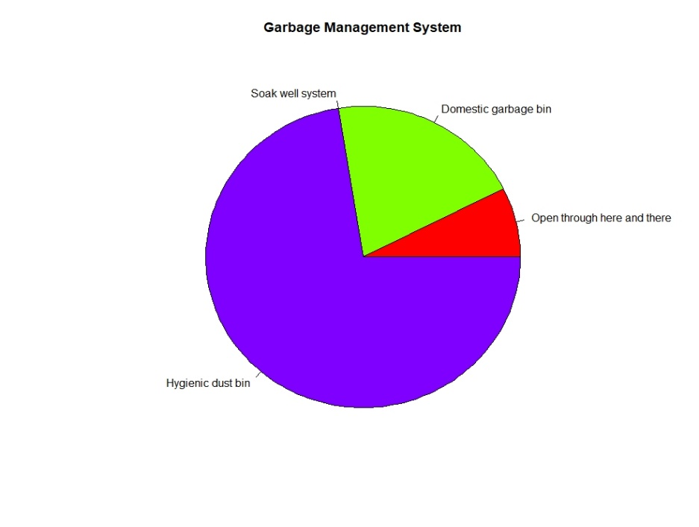
Fig-9: Garbage Management status of city dwellers of Chattogram City Corporation.
4.8. Medical facilities
Result from structured questionnaire shows that

Fig-10: Status of Medical facilities available in the city corporation area.

4.9. Vaccination facilities
Study found that 87.5% peoples get vaccination facilities from the nearest health centers and 5% peoples said that they can get vaccination facilities easily at the door.

Fig-11: Scenario of vaccination facilities for the city dwellers.
4.10. Status of chronic disease
Research found that only 15% peoples have chronic diseases and rest 85% peoples have no chronic diseases.

Fig-12: Status of disease type of inhabitants of City Corporation.

4.11. Status of hereditary disease
Result shows that 52.5% peoples living in this urban area have diabetic, 20% peoples suffer from high blood pressure, and 27.4% peoples suffer from other hereditary diseases.

4.12. Overall cleaness of hospital
Figure below shows the overall cleaness condition of government and non-government hospitals

Fig-13: Over all cleanness status of hospitals.

4.13. Overall health condition
Study shows that 70% peoples are in good physical health, 25% peoples are mildly physical impaired, 1.5% peoples are severely physically impaired, and 1% peoples are moderately physically impaired.

Fig-14: Overall health conditions of city peoples.

4.14. Total health condition:
From result it is seen that 64% peoples of the Chattogram City Corporation have acute disease and 16% peoples of the city have chronic disease and 20% peoples of the city have none types of diseases.

Fig 15: Number of Participants based on age

Fig-16: Gender of Participants (Male & Female)

Chapter-5: Discussion
Deploying healthy city projects in metropolitan areas worldwide has proven to be a powerful way to improve urban health and the urban environment, especially for low-income residents. Designation as a Healthy City means new initiatives are being implemented or planned to address priority city health and environmental issues through a new coalition of government and community organizations. So far, developing projects and activities in healthy cities have followed different paths from region to region. The Structured Healthy Cities Program exists in Europe. The Healthy Cities approach was first developed and promoted by the WHO European Regional Office (Planning Tanks, www.planningtank.com). However, in other regions, the healthy city approaches still organized strengthened, and not structured-sustainable and systematic development. WHO has begun discussions on promoting and developing a healthy city approach as an essential interregional program for urban health and the environment over the next few years. Its particular strength is its ability to address the key policy objectives of the WHO General Program of Action:
- Integrating human health and development into community goals
- Ensuring equitable access to health services
- Promoting and protecting the health
- Prevention and control of specific health problems
This approach is an essential part of the WHO's global health and environmental strategy approved by the World Health Organization in May 1993.While this program can focus on important health and environmental issues, it will also address other urban health issues in line with regional priorities. In this case, it may be the WHO's "inter-program" function, which will facilitate the implementation of an integrated multi-program health plan at the city and local levels (Planning Tanks, www.planningtank.com).Key benefits of WHO Regional Healthy City's accredited programs can include:
- Greater effectiveness of WHO programs in an essential area of ​​city health;
- strong links between WHO and the existing Healthy City programs aimed at improving urban living conditions in all regions;
- A more practical approach to the WHO goal of integrating health and human development into community policies and thus contributing to sustainable development;
- Developing WHO skills in supporting public health policies and programs at the local and city level.

The total number of Healthy Cities is not known with certainty. In the European Region, it is estimated some 600 cities are currently conducting Healthy City type activities, with 35 receiving WHO "designation" (see below for the explanation of "designation"). In the American Region, the number may be 100 cities; in the African Region, it may be 30; in the Eastern Mediterranean Region, it may be 30; in the Western Pacific Region, it may be 30; and in the Southeast Asian Region, it may be 10. An adequate reporting system (or office to coordinate networking) is currently lacking in all regions except the European Region.

African Region
A Healthy Cities network in Francophone countries has been established, including Brazzaville, Congo, Dakar-Medina and Rufisque, Senegal, Niamey and Dosso, Niger, Port Bouet, Ivory Coast, and a coordinating office for this network has been set up in Dakar Senegal. Support for this network has come mainly from the Canadian Government, the Quebec network of Healthy Cities, and the WHO/African Regional Office. There is a WHO Collaborative Center at the Center for Urban and Regional Planning, University of Ibadan, Nigeria, which has been active in Nigeria, including the 1991 National Health Cities Conference and the local Healthy City project in Ibadan. A new WHO Collaborating Centre for Urban Health in South Africa was designated in January 1995, and the staff of this center is active in a well-established Healthy Cities project in Johannesburg. Collaboration between this Centre and the Healthy Cities coordinator in the African Regional Office will support the development of a regional network of Healthy Cities. Other project cities in Africa include Accra, Ghana, and a new project supported by UNDP/LIFE commenced in Dar es Salaam Tanzania. In collaboration with Germany, the African Regional Office sponsored a major regional conference on urban health in Harare in 1993.
American Region
In the American Region, city-orientated activities following, in essence, the Healthy City approach has been underway for over five years. In Latin America and the Caribbean, the movement is based on the municipality as the primary political and administrative unit, which is the model approach in almost every country. This means that the initiative's scope in the countries goes beyond the limits of urban areas since rural and suburban areas are included within the municipal boundaries. There is no single specific structure for technical cooperation on Healthy Cities. The Health Promotion and Protection Division (HPP) supports the countries and provides technical cooperation. The main strength lies in the country offices, which are organizing functional teams with the group of consultants from the different technical programs and Divisions, especially Health Services (HSP), Health and Environment (HPE), and HPP, to support national projects and significantly to strengthen the Network of Healthy Municipalities Movement within countries. In different countries, they are identified differently. For example, in Costa Rica, there are "local cantons," in Mexico "healthy municipalities," in Chile "Healthy Cities," and in the Caribbean "healthy islands." The total number of cities/islands is estimated at 50 to 100. In addition, there is a network of healthy cities in the USA in Indiana established and coordinated through the University of Indiana School of Nursing (also a WHO Collaborating Centre), a Californian network, and a Quebec Healthy Cities and Towns Network. A total of 6 cities participate in the Indiana network. Several major conferences on healthy cities have been held in the Region. The UNDP/LIFE Healthy Cities Programme supports a project in Managua, Nicaragua.

Eastern Mediterranean Region
Healthy Cities activities in the Eastern Mediterranean Region were started in 1988. In 1990, the WHO Regional Office convened a Healthy Cities conference in Cairo, which formulated a general strategy for the Region to concentrate on improving city health and the environment through integrated environmental management. The Conference was instrumental in expanding Healthy Cities activities in the Region. Such activities are now underway in Iran, Pakistan, Egypt, and Tunisia. Cyprus recently initiated a project in the City of Paphos, and Kuwait, Oman, and Egypt are developing activities. A second Regional Conference on Healthy Cities was held in Tunisia in June 1994, and a regional development plan for Healthy Cities was prepared. Tunis is the Coordinator of a Maghrebin Healthy Cities network that includes four Healthy Cities in Algeria. The First Healthy Cities Conference in the Gulf States was held in November 1994 in Dubai and is expected to lead to a Gulf Healthy Cities network. At this Conference, it was noted that the city of Dubai has a Healthy City Project and that Oman is running a "Healthy Villages" program. New projects supported by UNDP/LIFE have commenced in Fayoum, Egypt, and Quetta, Pakistan.

The Regional Office is establishing a regional program (network) on Healthy Cities. A focal point and an eleven-member Task Force for the program have been established and have had their first meeting; a work plan has been prepared. Regional and national initiatives were part of the EMR Healthy Cities Coordinators meeting plan, held during the WHO/UNEP Intercountry Meeting on Supportive Environments and Healthy Cities in Manama, Bahrain, in September 1995.EMRO plans to develop pamphlets and media materials and support promotional events such as Healthy City Week. World Health Day in 1996 will be used to launch new projects in those cities wishing to join the EMR Network. One of the renowned institutions in the Region in the urban health and environment field may be designated as a WHO Collaborating Centre on Healthy Cities.
The European Region
The first WHO Healthy Cities Project involving 30 cities from 16 countries was successfully implemented from 1987 until 1992. A second project was started in 1993 involving 42 cities from 23 different countries. Many participating countries have developed national networks of Healthy Cities, so there are now hundreds of cities associated with the Project. A "network of European networks" (EURONET) has been established with a coordinating center in Toulouse, France. Healthy Cities has become an essential strategy for implementing city-level sectoral health programs in the European Region, often using the approach of the "multi-city action plan", where several participating cities may decide to collaborate closely with each other in addressing a common health problem, eg, AIDS, diabetes, accidents, etc. Each city simultaneously starts its program while sharing information on the situation analysis, strategies, progress in implementation, etc., with other participating cities. Healthy Cities serves to integrate many diverse programs at the city and local level, allowing for more coordinated program delivery. One feature of the program in the European Region, not currently implemented in other regions, has been the "designation" of each participating city as a Healthy City after the city makes specific commitments or achieves certain criteria. Only a tiny proportion of the cities that participate in Healthy Cities in Europe have designated cities (approximately 35 out of 600), and the non-designated ones are considered part of a "movement" rather than WHO project cities. The project cities presumably get a more significant share of WHO's resources (staff inputs, inputs from various WHO programs, limited financial support, etc.). It appears Mayors value the designation highly and make political capital from it.

In Europe, many Collaborating Centers for Healthy Cities work have been established. They include the City of Rennes in France, the University of Limburg in Maastricht, Netherlands, Nottingham School of Public Health in Bristol, UK, and the University of Geneva in Switzerland.

Southeast Asian Region
In response to Healthy Cities initiatives in several countries, including Bangladesh, Nepal, and Thailand, the WHO Regional Office is developing a Healthy Cities program, which will be a collaborative effort of the Environmental Health Programme and the Programme on Health Promotion and Protection. Bangladesh has used funding from the WHO "Countries in Greatest Need" facility to support projects in Chattogram. A new project in Cox's Bazaar Bangladesh has recently secured funds for a project from the UN Development Programme "LIFE" program and the Netherlands; implementation will be monitored and supported by country UN Development Programme staff and WHO. Collaboration with the Asian Development Bank's urban infrastructure program has been arranged to implement the Project in Cox's Bazaar. A Healthy Cities Project has been initiated in Nepal, covering three municipalities and relating directly to the World Bank Metropolitan Environment Improvement Programme (MEIP) for Kathmandu. A significant feature of the Healthy Cities work in Bangladesh and Thailand is the detailed evaluation being undertaken in cooperation with the London School of Hygiene and Tropical Medicine and South Bank University London. A project costing study of the Bangkok Healthy Cities Project has recently commenced that will have important implications for fund-raising and replicating projects in additional cities in Thailand.

Western Pacific
In this Region, considerable work in urban health has been undertaken by the Environmental Health Centre (EHC) and the Regional Office, and there is an increasing demand for urban health work of the Healthy Cities type, for example, in China, Malaysia, and Viet Nam. An urban health workshop for several municipalities was held in Viet Nam in October 1994. Urban health activities will be initiated to link up with the MEIP plans for the Hanoi-Haiphong region. There is a recently established task force on urban health in the Regional Office. EHC has established links with the Urban Management Programme of the World Bank/UNDP/UNCHS, which has a regional office in Kuala Lumpur and also MEIP. While there are long-established Healthy Cities programs in Japan, Australia, and New Zealand, it is anticipated that the newly developed program in several Malaysian cities (Johore Bahru, Kuching) may become a model for the Region. A WHO Regional Workshop on Urban Health and Environmental Management in Johor Bahru Malaysia in May 1995 demonstrated reasonable progress in Healthy Cities work in several cities and improved cooperation between various external support agencies working at the city level, including Habitat, UNDP, WHO, and World Bank.

From this study, it is found that 77.5% peoples use government provided drinking water, more than 95% peoples maintain proper personal hygienic system, 92.5% peoples use standard dustbin for their household waste-garbage management, 87.5% peoples get various types of vaccines from government, NGO. It also showed that 70% peoples are in good physical health.

On the other hand, study showed that more than 50% have diabetic, less than 50% have residents with sufficient air and light, only 47% families have hygienic toilet facilities. Result shows that health condition of Chattogram City Corporation improved in very slow rate and it’s the contribution not only WHO healthy City Programme but also their educational influences and social health awareness. So, Role of WHO Healthy City Programme was not found well enough to improve the health status of this city corporation.
Chapter-6: Recommendation and Future perspectives
The research suggests the following recommendations to improve people’s health and making the Chattogram city a “Healthy City”.
Health promotion plays a great role in transforming people’s health. It aims to engage and empower individuals and involves communities to choose healthy behaviors. Thus, it reduces the risk of developing chronic illness and other diseases. To promote healthy activities we need to educate people on importance of good health. Besides, we need to start health education in schools, colleges and also in workplaces. We need to reach each and every corner of Chattogram city to promote health and give health services to the people in need.
A good environment is essential for living a healthy life. To ensure good environment the government should take steps to create awareness among people. For example, people must throw their waste in a particular place without throwing it here and there. The waste collectors should collect waste regularly to keep the place clean and environment friendly. Moreover, people should start replacing disposable items with reusable items such as using paper cup instead of plastics. Additionally, Government should take steps to make people aware about conserving water and electricity and should make available for the people in need.
People should maintain hygiene practices such as, washing hands, brushing teeth, cleaning tongue, taking shower properly, etc. to avoid sickness. Also, people should follow a routinely health checkup. The government should take measures to make medical services available for all kinds of people. Besides, people should consume nutritious food to remain health. There are still many people who are not getting enough food for living. Therefore, the government should help those people to get nutritious and adequate amount of food.

Chapter-7: Conclusion
This study has provided insights into current health conditions and environmental conditions in terms of health promotion, medical services, environment and socio-economic conditions in Chattogram City. It also explained the role of healthy city model of WHO to improve the public health and environment of the city. The findings of the study shows that many people are still living in unhygienic environment such as wet areas, polluted air, sound pollution and insufficient light. Moreover, it was found that about 64% of people suffer from acute disease, 16% have a chronic illness, and only 20% have no disease, which has become a matter of concern. The study findings also generated evidence that could be useful in formulating policies and interventions that address modifiable factors to improve physical, mental, social and environmental conditions to achieve improved health and wellbeing for the people in Chattogram.

Research Questionnaire
On
Roles of WHO Healthy city Program improving environment and public health.
PART-A
Sample’s Particulars (Personal Information).
1.Name | : |  | 2. Gender |  | : | Male/Female/Eunuch
3.Age | : |  | 4.Complexion |  | :
5.Religion | : |  | 6.Profession |  | :
6.E.Qualification | : |  | 7.Maritial Status |  | : | Married/Unmarried/  Divorcee/Widow.
8.Spouse’s  Profession | : |  | 9. Spouse’s Edu. Qualification |  | :
10. Number of  Family Members | : |  | Special Remarks |  | :
10. Present
Address
11. Mobile No | :

PART-B
1. How often do you get a health checkup?
- Once in 3 months
- Once in 6 months
- Once a year
- Only when needed
- Never get it done
- Other

2. Do you have any chronic diseases?
- Yes
- No
3. Do you have any hereditary conditions/diseases?
- High blood pressure
- Diabetes
- Hemophilia
- Thalassemia
- Huntington
- Other (Please specify)
4. Are you habitual to drugs and alcohol?
- Yes to both
- Only to drugs
- Only to alcohol
- I am not habituated to either
5. How would you evaluate your overall health? Would you say you are:
In good physical health. (No significant illnesses or disabilities. Only routine medical care such as annual checkups required.)
Mildly physically impaired. (You have only minor illnesses and/or disabilities which might benefit from medical treatment or corrective measures.)
Moderately physically impaired. (You have one or more diseases or disabilities which are either painful or which require substantial medical treatment.)
Severely physically impaired. (You have one or more illnesses or disabilities which are either severely painful or life threatening, or which require extensive medical treatment.)
Totally physically impaired. (Confined to bed and requiring full-time medical assistance or nursing are
to maintain vital bodily functions.)

6. When making health care decisions for your family, who is the primary decision maker?
Male (or husband)
Female (or wife)
Jointly (both husband and wife
7. What is the source of your drinking water?
- Tube-well
- WASA
- Bottle Waters.

8. Physical Environment of the Living place is
- Dry
- Wet
- With sufficient Air
- Dark
- Sunny

9. Surrounding Environment of the Living place is:
- With dustbin
- Opened Drain
- Industrial dust
- Sound pollution
- Poultry or dairy farms exists
- With sufficient light and fresh air
- None of them

- What types of sanitary arrangement is used?
- Traditional and unhealthy latrine
- Normal latrine
- Developed toilet with adequate water flush system,
- What types of garbage management system is used ?
- Open through here and their
- Domestic garbage bin
- Soak well system
- Hygienic dustbin
- Is Basic needs of all members of the family met?
- Yes
- No
- Total health condition of all family member is
- Suffering from acute disease
- Chronic disease
- Autism person
- Medical Facility’s Opportunity is
- Easily medical facility from government
- Not get easily
- Get medical treatment from private hospital
- Get medical treatment from NGO
- Vaccination Facilities’ is
- Easily Available at the door
- Easily available in the health center
- Not Easily available
- Personal hygienic System is
- Always maintain
- Occasional Maintain
- Never
- Does the hospital you regularly visit have equipment for modern diagnosis and treatment?
Yes
No
Not sure
- Does the hospital have modern operating room facilities?
Yes
No
Not sure
19. Overall cleanliness of the hospital is
Very satisfied
Somewhat satisfied
Neutral
Somewhat dissatisfied
Very dissatisfied
- Not sure
- Efficiency of nursing care is
Very satisfied
Somewhat satisfied
Neutral
Somewhat dissatisfied
Very dissatisfied
Not sure
21. Friendliness and courtesy of staff are
Very satisfied
Somewhat satisfied
Neutral
Somewhat dissatisfied
Very dissatisfied
Not sure
22. Cost of health care is
Very satisfied
Somewhat satisfied
Neutral
Somewhat dissatisfied
Very dissatisfied
Not sure
References:
- https://www.questionpro.com/blog/health-survey-questions/
- https://www.questionpro.com/survey-templates/health-care-opinion-survey/

References

Ashton, J., Grey, P., & Barnard, K. (1986). Healthy cities—WHO's new public health initiative. Health promotion international, 1(3), 319-324.

Ahasan, N, Ravelo, JL 2021, July 14. Bangladesh battles third wave of COVID-19. devex. https://www.devex.com/news/bangladesh-battles-third-wave-of-covid -19-100340.

Bozicevic, I., Rode, O. D., Lepej, S. Z., Johnston, L. G., Stulhofer, A., Dominkovic, Z., ... & Begovac, J. (2009). Prevalence of sexually transmitted infections among men who have sex with men in Zagreb, Croatia. AIDS and Behavior, 13(2), 303-309.
Balia, S, Jones, AM 2008. Mortality, lifestyle and socio-economic status. Journal of Health Economics, 27 (1): 1–26. https://doi.org/10.1016/j.jhealeco.2007. 03.001

Baum, F, Jolley, G, Hicks, R, Saint, K, Parker, S. 2006. What makes for sustainable Healthy Cities initiatives?--a review of the evidence from Noarlunga, Australia after 18 years. Health Promotion International, 21(4): 259–265. https://doi.org/10.1093/heapro/dal023

Biswas, RSR, Hasan, FU, Sultana, A, Uddin, MK, Chowdhury, D, Rosy, SN, Mamun, SMH 2019. A Documentation of Hepatitis Outbreak in Chattogram. Chattagram Maa-O-Shishu Hospital Medical College Journal, 17(2): 2–5. https://doi.org/10.3329/cmoshmcj.v17i2.39768

Chowdhury, SR, Sunna, TC, Sanjoy, S 2020. Response to covid-19 in Bangladesh: Strategies to resist the growing trend of covid-19 in a less restricted situation. Asia Pacific Journal of Public Health, 32 (8): 471–472. https://doi.org/ 10.1177/1010539520951689

Cloninger, C. 2013. What makes people healthy, happy, and fulfilled in the face of current world challenges? Mens Sana Monographs, 11 (1): 16. https://doi.org/10.4103/0973-1229.109288

Corburn, J 2009. Toward the Healthy City: People, Places, and the Politics of Urban Planning (Urban and Industrial Environments) (Illustrated ed.). The MIT Press.https://doi.org/10.1007/s11524-011-9560-y
De Leeuw, E MARI, 2006. Monitoring, Accountability, Reporting, Impact assessment. In Proceedings of the A Framework for Networks of Healthy Cities, presented to the WHO Network of European National Healthy Cities Networks Business Meeting, Turko, Finland, 18-21 October 2006.

Diener, E, Scollon, NC, Lucas, RE 2009. The Evolving Concept of Subjective Well-Being: The Multifaceted Nature of Happiness. SpringerLink.https:// link.springer.com/chapter/10.1007/978-90-481-2354-4_4?error=cookiesnot_ supported & code=9cbbe345-cb0b-4bd8-9bf0-9dd0dc2cef21

Dolan, P, Peasgood, T & White, M 2008. Do we really know what makes us happy? A review of the economic literature on the factors associated with subjective well-being. Journal of Economic Psychology, 29(1): 94–122. https://doi.org/10.1016/j.joep.2007.09.001

DUHL, LJ 1986. The healthy city: Its function and its future. Health Promotion International, 1(1): 55–60. https://doi.org/10.1093/heapro/1.1.55

Goldstein, G, and Kickbusch, I 1996. A healthy city is a better city. World Health. https://apps.who.int/iris/bitstream/handle/10665/330422/WH-1996-Jan-Feb-p4-6-eng.pdf?sequence=1

Herdman, M, Fox-Rushby, J & Badia, X 1998. A model of equivalence in the cultural adaptation of HRQoL instruments: the universalist approach. Quality of life Research, 7(4): 323-335. https://pubmed.ncbi.nlm.nih.gov/9610216/

Heritage, Z, Dooris, M 2009. Community participation and empowerment in Healthy Cities. Health Promotion International, 24 (Supplement 1), i45–i55.https:// doi.org/10.1093/heapro/dap054

Hervás, G, and Vázquez, C 2013. Construction and validation of a measure of integrative well-being in seven languages: The Pemberton Happiness Index. Health and Quality of Life Outcomes, 11(1), 66.https://doi.org/10.1186/1477-7525-11-66

Hogan, M J, Leyden, K M, Conway, R, Goldberg, A, Walsh, D, McKenna-Plumley, PE 2016. Happiness and health across the lifespan in five major cities: The impact of place and government performance. Social Science & Medicine, 162, 168–176. https://doi.org/10.1016/j.socscimed.2016.06.030

Johansson, S 1973. Review Symposium On the 1968 Level of Living Survey in Sweden. Acta Sociologica, 16 (3): 211–224. https://doi.org/10.1177/00016 9937301600304

Kaczmarek, LD, Bujacz, A, Eid, M 2014. Comparative Latent State–Trait Analysis of Satisfaction with Life Measures: The Steen Happiness Index and the Satisfaction with Life Scale. Journal of Happiness Studies, 16(2): 443–453. https://doi.org/10.1007/s10902-014-9517-4

Kang, E, Park, HJ, Kim, JE 2011. Health Impact Assessment as a Strategy for Intersectoral Collaboration.Journal of Preventive Medicine and Public Health, 44(5): 201–209. https://doi.org/10.3961/jpmph.2011.44.5.201

Katz, S, Downs, TD, Cash, HR, Grotz, RC 1970. Progress in Development of the Index of ADL. The Gerontologist, 10 (1 Part 1): 20–30. https://doi.org/ 10.1093/geront/10.1_part_1.20

Kim, IH 2011. Age and Gender Differences in the Relation of Chronic Diseases to Activity of Daily Living (ADL) Disability for Elderly South Koreans: Based on Representative Data. Journal of Preventive Medicine and Public Health, 44(1): 32–40. https://doi.org/10.3961/jpmph.2011.44.1.32

Michalek, I. M., Loring, B., & John, S. M. (2017). A systematic review of worldwide epidemiology of psoriasis. Journal of the European Academy of Dermatology and Venereology, 31(2), 205-212.

Maggino, F, Zumbo, BD 2011. Measuring the Quality of Life and the Construction of Social Indicators.Handbook of Social Indicators and Quality of Life Research, 201–238. https://doi.org/10.1007/978-94-007-2421-1_10

McDowell, I 2006. Measuring Health: A Guide to Rating Scales and Questionnaires (3rd ed.) [E-book]. Oxford University Press. https://doi.org/10.1093/acprof: oso/9780195165678.001.0001
Nazneen, A, Tarannum, S, Chowdhury, K I, Islam, MT, Islam, SM, Ahmed, S, Banu, S, Islam, MS 2021. Implementation status of National Tuberculosis Infection Control guidelines in Bangladeshi hospitals. PLOS ONE, 16(2). https:// doi.org/10.1371/journal.pone.0246923

Phillips, G., & Green, J. (2015). Working for the public health: politics, localism and epistemologies of practice. Sociology of health & illness, 37(4), 491-505.

Petrovic, D, de Mestral, C, Bochud, M, Bartley, M, Kivimäki, M, Vineis, P, Mackenbach, J, Stringhini, S 2018. The contribution of health behaviors to socioeconomic inequalities in health: A systematic review. Preventive Medicine, 113, 15–31. https://doi.org/10.1016/j.ypmed.2018.05.003

Shilpi, SI 2021, August 4. Dengue alert: CU survey team finds Aedes larvae at 15 spots in Chattogram. Unb.Com.Bd. https://unb.com.bd/category/Special/ dengue-alert-cu-survey-team-finds-aedes-larvae-at-15-spots-in-chattogram/76486

Tulchinsky, T. H.,Varavikova, E. A., Bickford, J. D. 2014. The New Public Health (3rd ed.). Academic Press.

Veenhoven, R 2007. Healthy happiness: effects of happiness on physical health and the consequences for preventive health care. Journal of Happiness Studies, 9 (3): 449–469. https://doi.org/10.1007/s10902-006-9042-1

Webster, P, Sanderson, D 2012. Healthy Cities Indicators-A Suitable Instrument to Measure Health? Journal of Urban Health, 90(S1): 52-61. https://doi.org/ 10.1007/s11524-011-9643-9

Zajacova, A, Hummer, RA, Rogers, RG 2012. Education and Health among US. Working-Age Adults: A Detailed Portrait across the Full Educational Attainment Spectrum. Biodemography and Social Biology, 58(1): 40–61. https://doi.org/10.1080/19485565.2012.666122

