A comparative study on prevalence of various clinical diseases and disorders in Cattle and Goat with therapeutic management in two thana of Pabna district.



A clinical report submitted by

Roll no: 2003/44
Reg. no: 140
Internship ID: I-42
Session: 2002-2003

A clinical report presented in partial fulfillment of the requirement for the degree of DVM (Doctor of Veterinary Medicine).

Chittagong Veterinary And Animal Sciences University.
Pahartali, Chittagong.
June, 2009

A comparative study on prevalence of various clinical diseases and disorders in Cattle and Goat with therapeutic management in two thana of Pabna district.

A clinical report submitted as per approved style and content.

Signature of Author:  (Md. Shohidul Islam Khokan)  Roll no: 2003/44  Reg. no: 140  Internship ID: I-42  Session: 2002-2003  Date : | --------------------------------  Signature of supervisor:  (Dr. A. S. M. Golam Kabria)  Lecturer  Department Anatomy and Histology  Chittagong Veterinary and Animal Sciences University  Faculty of Veterinary Medicine  Date :

June, 2009.

Plagiarism Certificate

I am giving surety that all of the informations were collected by myself through interviewing and in a correct & appropriate way this study was performed by me.
I also admit that I have not copied any information or model or any other methodology to analyze the whole study from any of my classmates.

Date:
Signature of the Author

ACKNOWLEDGEMENT

The author is ever grateful and indebted to the Almighty Allah without whose grace it would have never been possible to pursue this study in this field of science and to complete this production report writing for the Degree of Doctor Of Veterinary Medicine (DVM).

The author would like to express his deep sense of gratitude and thanks to Professor Dr. Nitish Chandra Debnath, Vice Chancellor of Chittagong Veterinary and Animal Sciences University.

The author would like to express his deep sense of gratitude and heartfelt appreciation to Professor Dr. M.A.Motin Prodhan, Dean of Chittagong Veterinary and Animal Sciences University.
It is deemed as a proud privilege and extra terrestrial pleasure to express authors ever indebtedness, deepest sense of gratitude, sincere appreciation and profound regards to authors reverend and beloved teacher and Supervisor Dr. A. S. M. Golam Kibria Department of Anatomy and Histology, Chittagong Veterinary And Animal Sciences University for her scholastic guidance, uncompromising principles, sympathetic supervision, valuable advice, constant inspiration, affectionate feeling, radical investigation and constructive criticism in all phases of this study and preparing the manuscript also.

The author highly express his sincere gratitude and gratefulness to the internship Coordinator, Ashraf Ali Biswash, Associate professor, Department of Animal Science And Nutrition, Chittagong Veterinary And Animal Sciences University., for his constant inspiration, cordial co-operation, valuable suggestion for completion of the report work.

The author would like to express his helpful appreciation and thanks to DR. Md. Mahbubur Rahman, Veterinary Surgeon, Santhia for his kind co-operation during the study period.

The author is a ever indebted to his father, mother, brothers, sisters, maternal uncles, grand mother, grand father and other relatives for their sacrifices, blessing and encouragement to get him in this position.
The Author

Index

List of the contents:
Sl.no. | Chapter | Name of the contents: | Page:
01. |  | Acknowledgement | i
02. |  | List of Contents | ii
03. |  | List of tables and Graphs | iii
04. |  | List of abbreviation | iv
05. |  | Abstract | 1
06. | Chapter-I | Introduction | 2-3
07. | Chapter-II | Review of literature | 4-19
08. | Chapter-III | Methodology | 20-23
09. | Chapter-VI | Result | 24-42
10. | Chapter-V | discussion | 43-48
11. | Chapter-VI | Conclusion | 49
12. |  | Problems, Limitation | 50
13. |  | Bibliography | 51-56
14. |  | Appendix | 57-58

List of tables

Table No. | Name of the tables | Page no.
Table -4. (i) | Comparative Prevalence of diseases and disorders in young, cows and bulls, and goat & sheep.
Table -4. (ii) | Frequency and distribution of clinical diseases and disorders in cattle on the basis of category.
Table -4. (iii) | Frequency of distribution of clinical diseases and disorders in Goat and sheep on the basis of category
Table -4. (iv) | Comparative disease prevalence in various categories of cattle and goats

LIST OF THE GRAPHS:

Figure. No. | Name of the graphs | Page:
4.1 | Prevalence of diseases and disorders in calves.
4.2 | Prevalence of diseases and disorders in cattle.
4.3 | Prevalence of diseases and disorders in goats
4.4 | Comparative disease prevalence of cattle and goat.

ABBREVIATIONS
Abbreviations | Elaborations
PPR | Peste des Petits Ruminants
DLS | Directorate of Livestock Services
GDP | Gross Domestic Product
FMD | Food and Mouth Disease
BQ | Black Quarter
I.e. | That is
CE | Contageous Ecthyma
no. | Number
Tk. | Taka
BBS | Bangladesh Bureau of Statistics
FAO | Food & Agriculture organization
Na | Sodium
CuSO₄ | Copper sulphate

Khokon, M. S. I., (2009). A comparative study on prevalence of various clinical diseases and disorders in Cattle and Goat with therapeutic management in two thana of Pabna district.

ABSTRACT

The study was carried out at Santhia and Sujanagar thana of Pabna district for a period of three months (November, 08 to February, 09).To determine the comparative prevalence and proportional incidence of clinical diseases and disorders in calves, adult cattle and sheep-goat. These clinical diseases and disorders were categorized into 7 groups on the basis of treatment required namely, bacterial diseases, viral diseases, parasitic infestation, nutritional disorders, reproductive cases, surgical cases and other diseases. In this study total 120 sick calves, 200 adult cattle and 120 sheep-goat were investigated among these diseases and disorders was revealed that in calves most commonly killer diseases were recorded a fever 14.17% diarrhoea 11.67%,GI nematodiasis 12.5%,FMD 10%, fascioliasis 8.33%, joint ill 4.16%, navel ill 2.5%, urolithiasis 5%. But in cattle the highest record was parasitic 26.1% followed by mastitis 6%, milk fever 9%, fascioliasis 8.5%, repeat breeding cows 7.5%, retained placenta 3%, endrometritis 2%. And incase of sheep-goat PPR 12.5%, fever 16.67%, diarrhoea 14.16%, pneumoniua 15%, bloat 4.16%, tetanus 2.5 gid diseases 1.67%. In this study PPR, milk fever, fascioliasis, repeat breeding cows were important notification. Comparatively parasitic diseases were highest 26.1% in cow and 8.45% in goat, followed by 25% bacterial infection in cattle where as 29.6% in sheep and goat, nutritional disorder in cattle was 9.55% and in goat 8.82% and reproductive cases 9.55% in cow where as 4.41% in goat. Most of the infectious diseases were treated with Penicillin, Ampicillin, Amoxicillin, Sulpha drugs, Steptomycin + Penicillin, Oxytetracyclin, Gentamycine and Metranidazole. also used some supportive drugs like vita-B complex, vita-C, rumentonic mixture, stomachic mixture astringen mixture, CuSO4 solution, anti histamine, diclofenac Na. expectorant, oral saline and ice application were practiced.

Keywords: Prevalence, Diseases, Cattle, Goat, Comparative, Treatment

v
CHAPTER-I

INTRODUCTION

Bangladesh is densely populated crop growing countries in the world and livestock has been an important component mixed farming system practiced in Bangladesh for centuries ( Alam. J., 1993). About 60% of draught power for crop production, a substantial amount of power for transportation of goods, meat & milk for human consumption, hides, bones, horns as raw materials for industry and for export manure for crop fields and fuel for domestic use are all derived from the livestock for the country Animals are fed mostly on crop by-products and residues, which have little alternative use for human being. The magnitude of contribution of the livestock sector to the GDP is 3.5and in Bangladesh (BBS, 2006). It generates 13% of the total foreign exchange earning and provides full time employment to about 20% of the rural population. Despite its substantial importance much less attention has been given in development plans by policymakers to the livestock sector compared to the crop sector primarily because of the poor state of knowledge about methods and problems of production and utilization of the livestock in the country. In addition, livestock disease is one of the most important barriers towards livestock development in this country. As a result, there is an acute shortage of livestock products like milk, meat and eggs. The domestic production of milk, meat and eggs accounts for 13.58%, 10.50% and 22.78% of the minimum requirements respectively. Accordingly per capita availability of milk 33.95 ml/day, meat 12.61 gm/day and eggs 0.455/week are highly deficits against the per capita requirements of milk 250ml/day, meat 120gm/day and egg 2/week (GOB, 2008). Similarly, there is also an acute storage of animal power of tillage operation and the extant of storage appears to be 7.5% in terms of number of draught cattle herds, but the production raise to 40.90% when estimate is made on the basis of power unit. There are about 22.50 million cattle and 21.70 million goats in our country (DLS, 2008). In Bangladesh livestock play a sustainable agriculture employment generation. In Bangladesh Black Bengal goat is one of them for its genetic characters due to its superior quality such as more prolificacy, skin quality etc. Bangladesh earn foreign currency every year about 2.32 million square meter leather area is produced annually from the goat skins that helps earn foreign exchange amounting to tk.180 cores (Rahman and Sil, 2002). There are more than 56000 goat and sheep farms operating in Bangladesh (DLS, 2000).

Livestock is an integrated component of farming system plays a crucial role in the traditional economy of Bangladesh. Ruminants especially large (cattle and buffaloes) ruminants constitute the major portion of the Livestock. Most of these animals are reared in rural area under smallholder traditional management system. Large ruminant are used for draught power, meat and milk production Whereas small ruminants (sheep and goats) are mainly utilized for meat purpose. Although goat milk are used some extent of human consumption. These ruminants are not only important for draught power, meat and milk but also important for good quality leather and a source of income to farmers. But various typed of diseases (for eg. FMD, Footrot, Actinomycosis, Navel ill, Maggot wound or myiasis, Abscess, Fracture, BQ, Brucellosis, Mastitis etc.) responsible for discomfort , loss of market value, weight, milk production draught power of animal and goat husbandry is primarily the work of small to marginal farmers and landless labors. Due to the various diseases of livestock the endemic status of PPR in Bangladesh with mortality rate of 50% or more in susceptible goat population PPR is consider being one of the main limitation to production of small ruminant industry. ( Sil et al., 1995) estimated an economic loss of tk.4168.4 thousands for 475 FMD affected cattle due to calf mortality, reduced milk yield and plough loss. Annual financial loss amounting to tk.8118 cores (US $221 million)was estimated to be down grading and rejection of leathers associated with the defects caused by skin diseases lesions and post mortem and industrial defects (Dey and Nooruddin,1993). Most of our animals are unhealthy, emaciated and their productive performances are not satisfactory due to mainly malnutrition and diseases. It has been estimated that about 10% animal die annually due to diseases and the cost benefit ratio had shown to be 1:8 for vaccination and 10:25 for deworming (Rahman et. al., 1993). Analyze the case records the clinical incidence of diseases in cattle was 12%, (Rahman and Ahmed, 1994) reported clinical incidence of goat diseases was 8% and (Rahman et al., 1995a) reported mortality 2.5%of goats under farm and rural conditions. Pabna district is one of the important site for the livestock population specially in Santhia and Sujanagar thana and most of the common livestock disease are frequently found in this area.

By considering above mentioned fact this study was conducted in comparatively livestock concentrated district; Pabna with following objectives:-

- To determine the clinical prevalence of diseases and disorders in calves, cows, bulls and goats.
- To determine the types of drugs used for the treatment of clinical incidence of diseases and disorders in cattle & goats.

CHAPTER –II

REVIEW OF LITERATURE

2.1. Prevalence of diseases and disorders in young animals
Amin et al., (1988) reported diarrhoea in calves, caused by enterotoxigenic and enter pathogenic strain of Escherichia coli of the 266 diarrheic samples examined bacteriologically, only 16(6.02%)yielded E. coli infection Hossain et al., (1988) determined the cause of death of 142 bovine calves and found that 54.22% cause of death was due to helminthes infections. Haque and Samad (1986) recorded two cases of congenital abnormalities in calves one with congenital hydrocephalus and one with tailless ness and Artesia ani. Shearer (1986)recorded abscess of the umbilicus in 10 calves and treated by laparotomy and excision. Other identified disease conditions included pneumonia (15.49%), pneumo-enteritis (2.82%), tympany (4.93%), enteritis (9.86%), tetanus (2.82%),black quarter (2.11%), malnutrition (2.11%) and edema of brain (o.70%). Hossain and hossanin (1989) conducted pathological examination of 142 dead calves, of which 22 (15.49%) was diagnosed pneumonia as the cause of death. Singh et al., (1994)reported the occurrence of human group a rotavirus in diarrhoeic faecal sample of 18.28% calves in Bangladesh.

2.1.1. Fever
Fever is an elevation of core body temperature above the critical temperature Fever is also a combination of hyperthermia and toxemia. History of sudden onset. anorexia, dry muzzle, increased thirst, depression, constipation, increased breathing and heart rate Diagnosis of fever can be confirmed on recording the rectal temperature. The normal average rectal temperature of Horse, Cattle, Sheep and goat 100_5°F. 101.5°F 102. °F. lO3 °F, respectively. Radostits et al., (2004). In 12.1% fever cases in cattle and 10.37% fever cases in goats from Bangladesh (Hoque and samad 1997).

2.1.2. Umbilical hernia
Umbilical hernia is the protrusion of a portion of the abdominal contents through an accidental or normal physiological opening in the abdominal wall to lie beneath the skin, which remains intact. Frank, (1983). In 47.10% proportionate incidence rate of umbilical hernia in calves which represented the high occurrence among the surgical affections in calves. (Das and Hiashim 1996).

2.1.3. Black Quarter
Black Quarter is an infections disease in ruminant particularly in young cattle are characterized by the inflammation of muscle, severe toxeamia and a high rate of mortality. Barns et aI., (1987). The prevalence of disease was recorded to be higher in low laying areas where the carcass were disposed off in a primitive and unhygienic manner Increase protein-feeding increase the susceptibility of Black quarter (BQ) (Haque et al., 1953). Spring to Autumn is the suitable time for the occurrence of Black quarter (BQ) The mortality rate of Black quarter (BQ) is very high it may be up to 90%. Rahman et a1.,( 1997). In India, the disease is sporadic in nature. Infection rate to the extent of 85% has been recorded from Madras, Bombay, Mysore and hyderabad and Only 15% from rest parts of the country. Nilkantha. N( 1954). In Bangladesh the morbidity and mortality rate of black quarter is 50.74%and 0.4% respectively (Samad et al., 2000).

2.1.4. Abscess
The abscess is characterized by a localization of infection and presence of pus in a cavity. In animals a number of organisms may be pyogenic in action; the Staphylococci, Steptococci spp, Corynebacterium pyogenes, Corynebacterium pseudotuberculous E coli, pseudomonous aeruginosa Actinomyces bovis Actinobacillus lignieresi and other organisms may also be a factor. Frank (1970). In 1.2°% incidence of abscess in cattle. Hossain et al., (1986) and 0, 37% prevalence rate of abscess in cattle. (Rahman et al., 1999).

2.1.5. Navel- ill
It revealed that infection of the umbilicus and associated structures occurs commonly in newborn farm animal and appears to particularly common in calves. Infection of the umbilicus occurs soon after birth may result in omphalitis, omphalophlebitis, omphaloarteritis or infection of urachus with possible extension to the bladder, causing cystitis. Bouckaert et al., (1965). The incidence rate of 6.40% of Navel-ill in calves among Surgical affiection (Das and Hiashim 1996).

  - Prevalenee of diseases and disorders in cows and bulls
Mia and haque (1993b) examined 7000 cattle for skin diseases,and recorded humpsore, demodectic mange and papillomatosis as most common skin diseases in cattle. Rahman et al., (1994)reported the clnical incidence of 8.35% fascioliasis, 4.94% gastro-intestinal nematodes, 1.45% humpsore, 2.08% mange,1.74%coccidiosis and 1.01% babesiosis in cattle in mymensingh destrict Muller and owens (1988) reported an overall incidence of retained placenta in Holstein cows. They observed lower incidence rate of retained placenta in august to November compared to other months. Garrels (1989) made an mvestigation of parasitic diseases on 500 cows in six villages of Dhaka and tangail districts who recorded paramphistomiasis (64.4%),stronglye infection (34.0%), fasioliasis (22.4%), balantidiasis(13.6%), coccidiosis (12.20%), capillariasis(12.2%) and strongyloidosis (1.8%). He also observed that 50% of the cows were infected with more than two different parasitic diseases.

Rahman et at., (1988d) analysed the 205 clinical cases of lameness in cattle attended at the veterinary clinic of Bangladesh agricultural university of the 205 lameness cases, 115 (56.09%) had muscular rheumatism, 39 (19.02%) traumatic injury,19(9.27%) arthritis and periarthritis, 9(4.39%) angioneurotic edema 3(1.47%) ulceration of the solar surface,3(1.47%) obturator paralysis,2(0.97%) undiagnosed. Cappa and vecchiotti (1997) reported 18% incidence rate of retained placenta over a ten years period with variability between years. They recorded higher incidence rate of retained placenta in cows, with variable incidence rates of different farms, seasons and years. Das et al.,(1996) isolated the toxigenic strains of Clostridium tetani from soil samples collected from different disrricts of west Bengal.
Prasad et al., (1996) recorded anorexia syndrome as one of the common problems amongst the non-specific clinical entities in routine ruminant practice. They found that anorexon® (Pfizer) tablet as effective drugs in the treatment of non-specific anorexia syndrome. The role-played in spread the disease by cattle fairs, common grazing areas, movement of affected animals and transmission through man and recovered carrier animal was significant. Malhotra and kapur (1982) conducted epidemiological studies on mastitis which revealed that mastitogenic agent like staphylococci, streptococci, E.coli, and pseudomonas spp. Were widespread on different body sites of the cows , milker’s hands, milking cans and in the milk sample. Shukla et al., (1983) reported and overall 8.4%incidence of retained placenta in local breed of cows but the incidence rate was found higher in crossbred cows.

2.2.1. Babesiosis
Samad and Shahidullah (1984) reported 1.19%clinical incidence of bovine babesiosis in the district of Pabna . they found berenill as a effective therapeutic agent against bovine babesiosis . Islam et al., (1984) reported the clinical features of 30 cattle affected with gastro-intestinal nematode infection . they found loss of appetite , bottle jaw , diarrhea as the clinical finding of this cases.

Hassan et al., (1986) analyzed the 13694 case records on Pabna cattle from 1980 to 1984 of which only 3484 (25.41%) cases were recorded as surgical and reproductive disorders . of 2371 cases of surgical disorders . 1072 (45.2%) were wound cases ,194 (8.2%) fracture 180 (7.6%) Grid disease ,174(7.4%)trauma , 125(5.3%) urolithiasis 92(3.9%) posthitis 90(3.8%) corneal opacity, 81(3.4%) humpsore , 55(2.4%) congenital defects 54(2.3%) burns 45 (1.9% castration 41 (1.7%) lameness 41(1.7%) gangrene 34(1.4%) yolk gall 28(1.2%) abscess, 22(0.9%) dehorning 18 (0.8%) hernia and 32 (1.3) others conditions amin and samad (1987 ) detected that 10.98% diarrhea syndrome producing cattle had one more groups of nematode infection. The highest prevalence rate of nematode infection in cattle was recorded during summer (12.72%),followed by autumn (11.69%),spring (10.35%) and lowest in winter (9.37%).

Dewan and Rahman (1987) reported an overall 24.23% incidence rate of retained placenta in dairy cows at the savar dairy farm, Dhaka. Haque et al., (1987) conducted bacteriological investigation on swabs and muscles pieces collected from the affected parts of 33 black quarter infected cattle. Clostridium chauvoei was isolated and identified in all the lasted animals. Shukla and parekh (1987) reported 3.35% incidence rate of uterovaginal ptolapse in cows. They observed that 100 days milk production and reproductive performance were severely affected by utero-vaginal prolapsed.

Amin and samad (1988) reported fascioliasis in 16.12% diarrhea syndrome producing cattle from Bangladesh. Haque et al., (1988a) recorded 0.04% general clinical incidence of black quarter and 50.74%cases fatality rate among cattle population at Pabna district maximum susceptibility to this infection was recorded up to 2 years of age warmer months of the year. Haque et al., (1988b) conducted clinical examination of 27 black quarter affected cattle and recorded high rectal temperature,increased pulse and respiratory rates and characteristic signs of lameness and tympany. The affected muscles were swollen, hot painful with crepitating sounds on finger palpation Joosten et al., (1988) estimated the economic losses causes by retained placenta an amount of 471 per year for a 100-cow’s farm with an average incidence of the condition 6.6% . the loss was calculated due to increased calving interval, increasing culling rate,loss of milk production, and cost of veterinary treatment and drugs Kamaruddin and pandit (1988) recorded that foot-and-month disease appeared commonly in endemic and occasionally in epidemic patterns in cattle population in Bangladesh. The disease was reported from almost all the districts throughout the year and the number of find incidents varied from districts to district throughout the yeat with a higher frequency in Dhaka , faridpur and Pabna. Occourrence of fmd also varied from month to month or season to season with higher seasonal incidence for September,October ,November and qapril (pre to post monsoon season ). Samad (1988b) recorded and overall 0.18%clinical prevalence of babesia bigemina infection and 6.91% mortality retes among cattle population in Bangladesh. The clinical prevalence of babesiosis in cattle had been recorded in all four seasons of the year in Bangladesh but the highest prevalence rate was recorded in summer (0.57%) and lowest in winter (0.06%) only adult animals were found to be affected and high susceptibility of crossbred cattle to babesiosis than indigenous stock. The economic loss due to mortality and treatment of such disease were estimated at tk 14,62,360.7 per annum. Sen et al., (1988) isolated salmonella organisms from 8 (2.95% ) apparently healthy cattle,of which six were isolated from lymph nodes, one from bile of slaughtered cattle and the remaining one from rectal swabs.

2.2.2. Fescioliasis
Islam and samad (1989) recorded 57 (46.37%) cases of cattle affected with fascioliasis and amphistomiasis on the basis of fecal examination. Samad et al., (1989) analyzed the case records of retained placenta of 4595 calving during the period of seven years at Saver dairy farms reveal that 39.15% cows had retained placenta . highest incidence of retained placenta was recorded in summer (42.27%) followed by rainy season (40.13%)and lowest during winter (35.73%) months. Nooruddin and Dey (1990) recorded an overall 62.0% of 13421 cattle ,and 28.8% of 5771 goat affected with skin diseases. Howlader et al., (1990) reported 21% overall prevalence overall prevalence rate of fasioliasis, 46%paramphistomiasis, and 8% schistosomiasis in cattle under rural condition at mymensingh. They found higher prevalence of fluke indestation during monsoon and post-monsoon period. Das et al., (1992) recorded 24.4% incidence rate of foot disease in bovines in west Bengal. They found regular overgrown hoof (9.8%) as the most common foot disorder, followed by scissors claw (5.5%), interdigital lesion (0.7%) and eruption of sole (0.6%). Saikia et al., (1992) examined 3008 cattle of which 13.96% affected with foot diseases. They noted highest affection in Jersey cross (18.02%), followed by Friesian (17.41 %). Sindhi cross (17.22%) and Red Dane cross (14.57%) whereas much less number was recorded in local animals (1.72%).

2.2.3. Mastitis
The incidence of clinical mastitis ranges from 10- 12 % per 100 cows at risk per year Blood et at.,( 1994).In 171 randomly selected dairy herds, the average annual incidence rate of clinical mastitis was 12.7quarter cases per 100 cows per year. The most frequent isolates, from clinical cases were E. coil 16% starphylococcus aureus, 14% Streptococcus uberis, Streptococcus dysgalactiae (8%) Blood (1994). And incidence of mastitis is more in exotic and crossbred than Zebu one High yielding dairy cows were mostly affected with mastitis. This variation seemed to be due to manage mental problems specially, unhygienic milking shed and tools used and neglecting in the housing accommodation Roy, (2001). In 11.5% sub clinical mastitis and 13.3% prevalence rate of clinical mastitis in cross bred dairy cows in Bangladesh. (Rahman et al., 1997)

2.2.4. Foot-and-mouth disease (FMD)
Foot and mouth disease revealed that it is an extremely contagious, acute disease of all cloven-footed animals, caused by a virus and characterized by fever vesicular eruption in the mouth and on the foot Blood et al., (1989). In clinical examination of 575 randomly selected cattle in the outbreak area in Tangail revealed that only 60 (10 43%) animals were affected with FNID of which 3 (5.0%) severely affected calves died. Islam et al., (1998). The prevalence rate of FMD in cattle is 10.05% Hoque and Samad (1996). And 5.78% prevalence rate of FMD in cattle. (Sarker et al., 1999).

2.2.5. Tympanic indigestion
The excessive accumulation of gas in the rumen is called ruminal tympany. The gas may be accumulated in free from separated from ingesta (called tympany) of may be mixed with ingesta in the form of froth (called bloat). Primary causes (frothy bloat) mainly due to dietary origin- legume pasture. succulent grass and overfeeding of grain (carbohydrate). Characteristic signs . distended abdomen with extreme tightness of skin. Percussion on the left Para lumber Vermunt,( 2004). Fosa- produces tympanic sound. Puncture of the left distended Para lumber fosa with a needle free gas will be removed and subsidence of the ruminal distention, whereas, in bloat, only small amount of gas are removed before frothy materials block the needle. In 4.0% and 0.37% prevalence of tympany in buffaloes and cattle respectively. (Rahman et al., 1999).

2.2.6. Simple indigestion
Simple indigestion is a common disease primarily affecting non-grazing (stall fed) ruminants, usually associated with some dietary abnormality, and is characterized clinically by in appetence to anorexia. Anorexia is a loss of appetite or lack of desire to eat. Three criteria must be fulfilled before a diagnosis of simple indigestion can be made : (a) Abnormal ruminal motility (b) Abnormal rumen contents and (c) Exclusion of all known disorders affecting the ruminant gastro-intestinal tract. Brukink, H et al., (1988). and 29 % incidence of indigestion among hospital cases in cattle (Sen et al., 1988).

2.2.7. Diarrhoea
Diarrhoea in calves, caused by enterotoxigenic and enteropathogenic strain of Escherichia coil of the 266 diarrhaeic samples examined bacteriologicaly, only 16 (6.02%) yielded E coli infection. Amin et al., (1988). In 6.94% incidence of nonspecific diarrhoea in dairy cows 8.99% in cow- calves and 12.23% in goats. (Hoque and Samad, 1996-1997).

2.2.8. Endometritis
Endometritis is a inflammation of endometrium in 1.4% occurence of endometritis in Black Bengal goat Ahmed(1983), in 21.3% metritis complex from a dairy farm. Ali et al., (1997). And in 5.66% metritis and 6.80% pyometra was found in cows at the AI centre from Bangladesh. (Islam et al., 1998).

2.2.9. Retain placenta
In 37% incidence of retain placenta was found in cows. Rahman et al., (1999). And 29.8% of retained placenta have been recorded in cows. (Ali et al., 1997). And in 29.8% of retained placenta recorded in cattle in Bangladesh (Bhuiyan et al., 1999)

2.3. Prevalence of diseases and disorders in goat and sheep
Mia (1967) reported the high incidence rate of urinary calculi in castrated goats of urban areas due to excessive feeding of wheat bran which is very rich in phosphate. Qadir (1967) recorded Haemonchus contortus, Oesephagostomum columbianum, Strongyloides spp. Trichuris spp., Trichostrongylus .spp, Moniezia spp. and rumen flukes of different species among slaughtered goats at Mymensingh slaughter house. Incidence throuhgout the year was high with Haemonchus contortus and Oesephagostomum without any significant seasonal variations. Huq and ,Shaikh (1968) examined 320 viscera of sheep and goats and found that 28. 13% sheep and goats infected with various gastro-intestinal helminthes. Incidence of Haemonchus contortus and Oesephagostomum columbianum was very high. Rahman and Ahmed (1974). conducted a three years survey on goat diseases. The incidence of gastro-intestinal parasitism was 13.8% and Gid disease was 4.34°ro. Rahman et a1.,(1975a) studied the diseases of goats in Bangladesh under farm and rural condition of Mymensingh. They found 25% mortality rate in in kids and 43.45% in adult goats due to gastro-intersinal parasitism. Rahman et al., (I975c) surveyed 13000 goats carcasses at abattoirs and found 9-17% incidence of fascioliasis, 35-65% oesophagostomiasis, 55-70% cysticercosis and 12-20% hydatidosis. Ali et al., (1976) recorded congenital atresi ani in kinds at Mymensingh. Mclntosh (1978) recorded urolithiasis as a disease of multifactorial origin. The dietary factors play a significant role in their occurrence.

Rahman et al., (1978) reported the Occurrence of Psoroptic mange in a Black Bengal goat with its clinico-pathological findings. Rao et al., (1978) reported an outbreak of tetanus in sheep after vaccination against entertotoxaemia. Hossain et a/. (1979) reported the clinico-pathological findings of and urethral rupture in a Jamunapuri goat. Samad et al., (1979) reported the occurrence of Fasciola gigantica infection in sheep and goats with the therapeutic efficacy of Accedit^{(R)}, Bilevon-M^{(R)} and Zanil^{(R)} against ovine and caprine fascioliasis. Ramirez and Pijoan (1979) reported 10.4% incidence rate of pneumonia in goats in Mexico. They found that the incidence of pneumonia was directly proportional to the environment temperature but not related to the rainfall. Qadir (l98la) reported the seasonal influence of gastro-intestinal nematode infection in goats under farm condition. The peak infection period for Haemonchus spp. extended from June to September and that of Trichostrongylus spp. and Oesephagostomum spp. from June to November and August to January respectively. Qadir (1981b) recorded the peak infection period of Fasciola gigantica between July to September, with gradually declined till January. Little of insignificant iniection occurred from February to June. Sriraman et al., (1982) reported 40.79% mortality rate in goat of Andhra Pradesh due to pneumonia and 28.16% caused by enteritis. 13unerjee et al., (1985) recorded 5.8°% and 42.22% prevalence rates of pneumonia and other lung affections in goats detected at slaughter and postmortem examination, respectively in India. Hossain et al., (1985) reported complete uterine prolapse in a Jamunapuri doe.

Ali et al., (1987) recorded an overall 2.17% respiratory disorders of 2400 Black Bengal goats on pathological examination. These were dictyocaulosis (0.13%), hydatidosis (0.17%), pulmonary abscess (0.38%), purulent broncho-pneumonia (0.88%), nodular lymphocytic peribronchitis (0.46%) and some unidentified lesions (0.17%). Nooruddin et al,(1987) reported overall 26.8% prevalence rate of skin diseases in Black Bengal goats.Dewan and Das (1988) suggested that urolithiasis could be prevented either by adding 4% sodium chloride in concentrate ration or provided water and green pasture (grass) and leafs. Koul et al, (1988) reported the 24.22% mortality in goats due to pneumonia and 22.66% caused by enteritis. Majeed et al., (1988) recorded an incidence of 14.3% uterine prolapse in ewes in India. They observed that this condition mainly occurred immediately after parturition and occasionally several hours afterwards.

2.3.1 Contagious ecthyma
Contagious ecthyma (CE) is an acute viral disease primarily of young sheep and goats caused by contagious ecthyma virus belongs to the genus parapoxviru sand characterized by the development of pustular and scabby lesions on the muzzle lips. (Samad, 2000 ). Prevalence of CE was 1.3% in goats. (Nooruddin and Barik 1989).

2.3.2. Rabies
Rabies is a highly fatal viral infection of the CNS, which occurs in all warm blooded animals, and is transmitted by the bites of affected animals. Dog has been and still is the major source of rabies in Bangladesh The prevalence of rabies was .5% in buffaloes. Rahman et al (1999). In 0.28% incidence of rabies cattle (Hossain et al., 1994). And in 1.65%rabies cases found in cattle. (Sarker et al., 1999).

2.3.3PPR (Pesti des petits ruminants)
In Bangladesh it is thought that the disease might have come from India PPR in goat has been recorded in 1992; from the border belt areas of southwestern districts (Sathkhira, jessore and Barguna) of Bangladesh. PPR is a contagious disease of sheep and goats caused by a morbilli virus of the paramixoviridae family, reported that the peste des petits ruminants is a contagious disease and its out break spread immediately. Islam et al., (2001). It has been reported that the Black Bengal goats (67.24%) are more susceptible to PPR that Jamunapari breed (32.76%). Debnoth, ( 1995). In epidemic areas morbidity rate has been estimated to be 80% to 90% accompanied by a mortality rate of 50% to 80%. Saha et al., ( 1983). In endemic condition, it may be less dramatic or may occur as a sub clinical or even in apparent form. Debnath (1995).
The incidences of PPR (53%) were noticed despite the regular vaccination of goats using live rinderpest vaccine and this indicated that the vaccine used in the field failed to protect goats against existion local PPR virus strain. (Sil et at. 1995)

2.3.4. Tetanus
It is an acute infectious disease affecting all domesticated species and humans caused by the toxins (tetanospasmin, tetanolysin) of the bacterium Chlostridium tetani. It has world wide distribution and a very high mortality rate Initial signs are usually stiffness and unsteady gait, in ruminants bloat is often seen. As the disease progresses the muscles of_jaw are affected and die animal is unable to eat and drools saliva. The spores of Chlostridium tetani can survive far years in the soil and are found is the animal faeces Infection is usually via deep wounds that become contaminated with sail containing the spores. The out break of tetanus in sheep after Vaccination against enteratoxaemia was 2.5% in goats . ( Rao et a1. 1978).

  - Clinical signs of some diseases and disorders as follows

2.4.1. FeverSudden increased temperature – young , goat and sheep ≥104°F and cattle ≥103°F, Anorexia, increased thirst, depression, dry muzzle. increased breathing rate and heart rate , mucous membrane of nose, mouth, vagina often showed viscid and sticky. some time erection of hair in body coat (Hoque and samad 1997).

2.4.2. Anorexia
Anorexia syndrome was determined by owner’s complaint of varying degree of decreased feed intake with either partial or complete absence of appetite. increased heart and respiration rate. (Blood, D.C., et al., 1983).

2.4.3. Digestive disorders
Diarrhoea syndrome was associated with soft of fluidly consistency of faeces and some times unpleasant odor. occasionally shooting type of diarrhoea recorded in cattle. diarrhoeatic animals revealed soiling of fluidly faeces at the perineal and hind leg regions and marked dehydration identified by skin fold test. (Csontos, L. et al., 1978)

2.4.4. Respiratory disorders
Respiratory disorders mainly pneumonia was diagnosed by auscultation – abnormal sound, dyspnea, open mouth breathing, increased respiratory rate, inappetite and sometimes fever were recorded. (Dulac, G.C. and Binns, M., 1989).

2.4.5. Corneal opacity
Corneal opacity varying from the faint cloudiness of early keratitis, to solid white of advanced keratitis was recorded clinically. pain sensation on cornea, partial or complete cease of lacrimation. (Durhan, P.J.K. et al., 1978).

2.4.6. Foot diseases
Foot diseases and disorders include Foot rot, lameness, FMD complication, and over growth of hoof. It was identified by physical examination of the suspected animals. (Hall, H. T. B., 1977).

2.4.7. Mastitis
Mastitis is not only responsible for economic losses in dairy industries but also acts as one of the biggest obstacle in the achievement of white revolution of country. the main clinical signs is swollen and hot udder with pain , teat cannel obstruction sometimes pus found , rapid decreased the milk production after treatment. (Blood, D.C., et al., 1983)

2.4.8. Black quarter
BQ is a disease of young healthy animals it was clinically identified swelling of affected site and there crepitating sound. increased temperature upto 104°F( Kini, S. et al., 1986 ).

2.4.9. Navel ill
The presence of inflammatory lesion on the umbilicus in young animal within 3 month of age were considered as navel ill, palpation of the enlarged umbilicus revealed pain and draining of purulent materials with or without needle punched, increased rectal temperature. (Chatterjee, A. 1989).

2.4.10. Salmonellosis and colibacillosis
Clinical signs of Salmonellosis affected calves had foul smelling yellowish diarrhoea , nasal and ocular discharges and sometimes nervous sign found. Enterotoxic colibacillosis was recorded in newborn calves less then 3 weeks of age. Clinically profuse and watery diarrhoea with pale yellow to white color, occasionally streaked with blood flakes and very foul smelling. Defecation was frequent and buyttocks were soiled, dehydration, weeks and sub-normal rectal temperature. (Blood, D.C., et al., 1983).

2.4.11. FMD
Presence of fever , profuse salivation and vesicular eruption in the mouth and on the feet of some animal with the history of rapid spread of the disease in bovine population were regarded as FMD. Clinically presence of anorexia, depression, inappetite and lameness. (Rao, A. K. et al., 1993).

2.4. 12.Tetanus
the main clinical signs were the muscular spasm, stiff gait, the prolaps of the third eyelid and lock jaw. stiffness becomes more obvious and involves the head, neck, all four extremities and tail. It also response to external stimuli, erect ear and drooling of saliva. Tetanic convulsions, accompanied by opisthotonos and off feed. (Baker, J. L. et al., 1988).

2.4.13. PPR
PPR was determined by inappetance, high fever (107-108°F), oculonasal serous discharge, followed by cofluent necrotic lesions with ulceration on the lips tongue and cheeks. Profuse diarrhoea may be developed on 3 to 4th days. On 4 to 5th days the oculonasal discharge become mucopurulent followed by extreme dehydration coughing, respiratory distress and death on 7 to 10th days( Chandra Choudhury, S. P. et al., 1995).

2.4.14. Papilomatosis
Solid out growth of epidermis, may be sessile or pedunculated. cauliflower like appearance on head and neck,it also called warts. (Blood, D.C., et al., 1983).

2.4.15. Fascioliasis and paramphistomiasis
Acute fascioliasis; after massive intake of metacercariae:
Rapid loss of condition Abdominal pain / becoming jaundiced Severe liver damage Sudden death within 6 weeks due to blood loss resulting from hemorrhage
Sub chronic fascioliasis; caused by migrating immature flukes: Loss of condition, Unthriftiness, Severe anemia, Liver failure and Death within 10-20 weeks
Chronic fascioliasis; most common symptoms, found in Bangladesh, develop slowly: Severe anemia, Chronic inflammation of liver, Enlargement of bile duct, Lowered appetite, Gradual loss of condition and bottle jaw .
Clinical sign of paramphistomiasis. Anorexia, Watery fetid diarrhea which soils the breach and hind legs, Weakness, depression and dehydration, Sub-maxillary edema, Rough coat and drop in production. ( Rolfe, P. F. et al., 1994).
2.4.16. GI Nematodiasis
Although more or less similar signs are produced by the different disease of the nematodiasis but severity depends on age of the host, number of parasites, nutritional status and affected organs.Gastro-enteritis associated lesions cause impaired digestion and absorption, resulting in diarrhea, anorexia and emaciation. The young animals start to loss weight and fail to grow and decrease in production in adults. In certain diseases, especially haemonchosis, parasites are vigorous blood suckers cause anemia and hypoproteinemia. It may lead to development of edema under the lower jaw (bottle jaw). ( Rolfe, P. F. et al., 1994)
2.4.17. Babesiosis
Loss of appetite, dullness, depression, weakness, high body temperature (103ºF -107ºF), labored breathing, suppression of rumination, dryness of the muzzle, constipation, anemia, jaundice, hemoglobinuria and death. ( Banerjee, D. P. et al., 1983).

2.4.18. Milk fever
Hypocalcemia, paresis, general muscular weakness, circulatory collapse and depression of consciousness, anorexia, scant faeces, normal rectal temperature and lateral recumbency (Blood, D.C., et al., 1983).

2.4.19. Ketosis
Digestive form-depressed, decreased production, inappetanec 1st refuse grains then refuse silage continue refuse hay and finally refuse all feed. cow may wooy appearance due to s/c fat degeneration, faeces dry and covered with mucous. Nervous form- circling movement, crossing of leg, head pressing, salivation and hyperesthesia. (Blood, D.C., et al., 1983).

2.4.20. Bloat
Ruminant animal produced large volume of gas during the normal process of digestion. this gas either was belched up or passes through the GI tract. If some things interferes with gas escape from the rumen ,bloat occurs. In advanced cases the animal will go down. Death is rapid at this stage , and is due to the swollen rumen compressing the lungs, interfere with breathing and tissue oxygenation , and obstructing blood flow. ( Western, et al., 1979).

2.4.21.Uterine prolaps
Majority of the incidence of uterine prolaps were recorded at post partum but occasionally before parturition, usually during the last trimester of gestation. Majority of the cases of prolapseuterus were brought for treatment quite late or with improper reduction with uterine mass occupying the vaginal passage, as a result these cases of prolaps uterine mass become soiled, inflamed and edematous. (Dollers, et al., 1993).

2.4.22. Retained placenta
After parturition placenta did not removed normally with in 12 hours, it mostly occurred in 1st calving and due to abortion or still birth . the retained placenta frequently found in cow . (Dollers, et al., 1993).

2.4.24. Urolithiasis
Urinary calculi, caused obstruction were mainly recorded castrated goat and stone was lodged in sigmoid plexus, urethral process and occasionally in the neck of the bldder. Animal with urinary obstruction exhibited signs of abdominal pain by kicking at the belly treading with hind feet and frequent lying down and getting up. Urinate with severe straining and a few drops of blood strained urine discharged. rupture of the urethra of bladder was recorded in few cases, which caused accumulation of urine in the surrounding subcutaneous tissues resulted defuse swelling. (Blood, D.C., et al., 1983).
2.4.25. Abscess: The swollen area contained purulent materials sometimes hot and pain sensation present on the swollen area.(Dollers, et al., 1993).
2.4.26. Atresia ani: There is no opening for defecation it is a congenital abnormalities of young calves or kid. (Dollers, et al., 1993).

CHAPTER-III

METHODOLOGY

3.1. Study area: The study was carried out in two different UVH (Santhia Upazilla Veterinary Hospital and Sujanagar Upazilla Veterinary Hospital ) and many village area under Pabna district using a questionnaire developed due to Pabna district is one of the important site for the livestock population specially in Santhia and Sujanagar thana and most of the common livestock disease are frequently found in this area.

3.2. Target population: All suspected domestic animals including young and adult

3.3. Source of population: Visit the village area and UVH

3.4. Study population: 120 young calves, 200 cow & bulls and 120 sheep-goat.

3.4. Duration of the study: The period of study was 8 weeks standing from November 16, 08 to February 17, 09.

3.5. Type of study Cross sectional study.

3.6. Techniques and tools use for data collection:
120 young calves, 200 cow & bulls and 120 sheep-goat, at different sex were registered from different villages and Upazilla Veterinary Hospital, Santhia Sujanagar thana of Pabna district during the part of internship period. There were two ways of gathered patient, one was hospital at where farmers willingly came with the patient, another way was field visit with veterinary surgeon for treatment of diseases animals. A prepared questionnaire (Appendix- I) was used for collecting various types of information regarding to age, sex, owner’s complaint, management, previous treatment and preventive measures during animal examination.The general clinical examination inspection, palpation, percussion, auscultation, method were applied to examine the animals. Clinical history collected from the owners themselves.
3.7. Process of clinical examination to diagnose the diseases or disorders in animals.

- Clinical history ( anamnesis)
a). Signalment: Case number, date of administration, species, breed, age, sex, class, physiological state, temperament, and body weight.
b). Owner’s name, address, occupation and socio- economic status.
c). Owner’s complaint: It includes mainly the major presenting problems.
d). disease history: (i) present history. (ii) past history. (iii)epidemiologic history like- hard size, morbidity and mortality ctc.
e). Management history;
i. General management techniques
ii. Indoor and out door environment
iii. Production system
iv. Nutrition, feeds and feeding
v. Breeding policy
vi. Production performance.
- Examination of the individual animal
a). Distant inspection and direct auscultation ( general inspection and general examination)
i. General appearance and activities
Demeanor, physical condition, posture, gait, eating, defecation, urination, voice, respiratory, ruminal and other sound ctc.
ii. Body regions
Rumination, respiratory character, abdomen size, skin and coat, head (eyes, ear, horn, face, nose, tongue and lips etc.) tail, digit, mammary gland, testes, vulva, prepuce, umbilicus, brisket and lymph node etc.
b). Physical examination
i. General physical examination includes - inspection , palpation, percussion, auscultation, methode
ii. Special physical examination includes – skin fold test, weakness test and deafness test.( Amelendu, C. 1996).
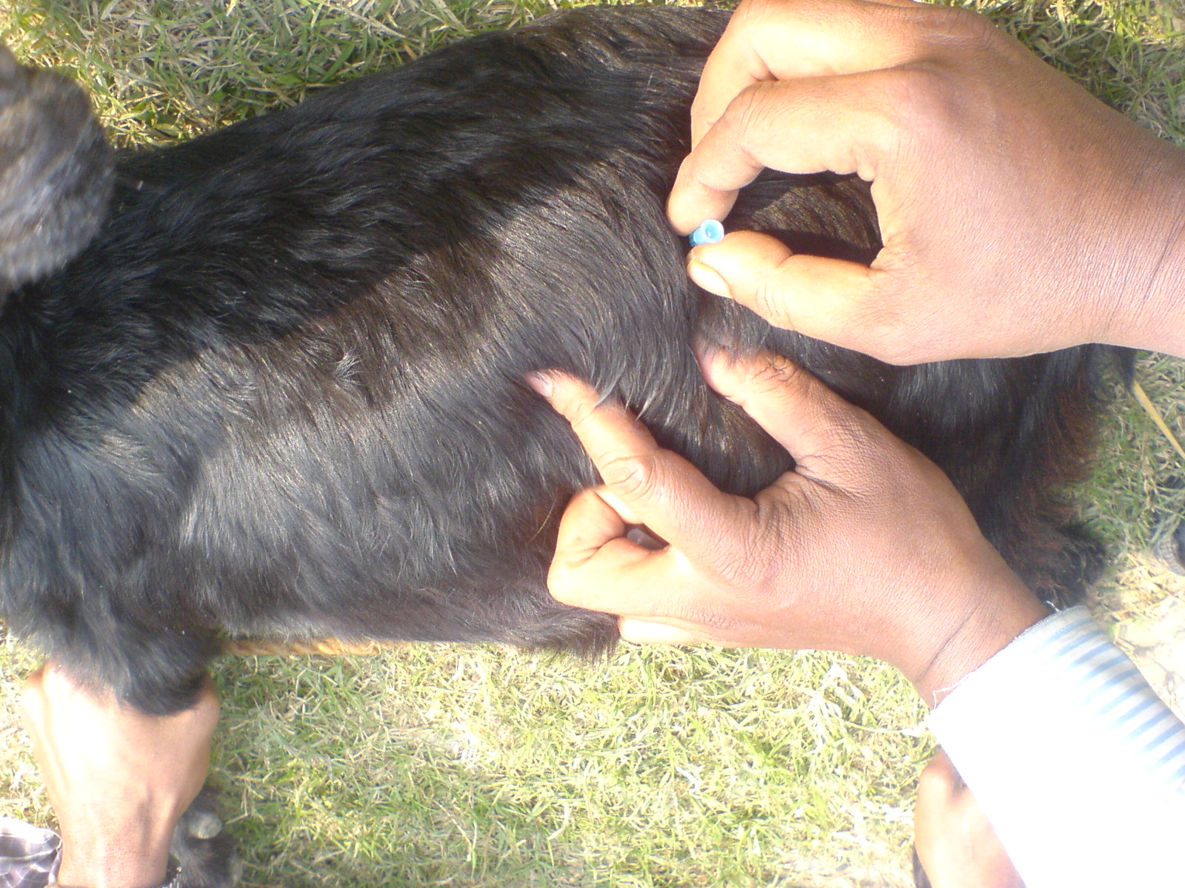
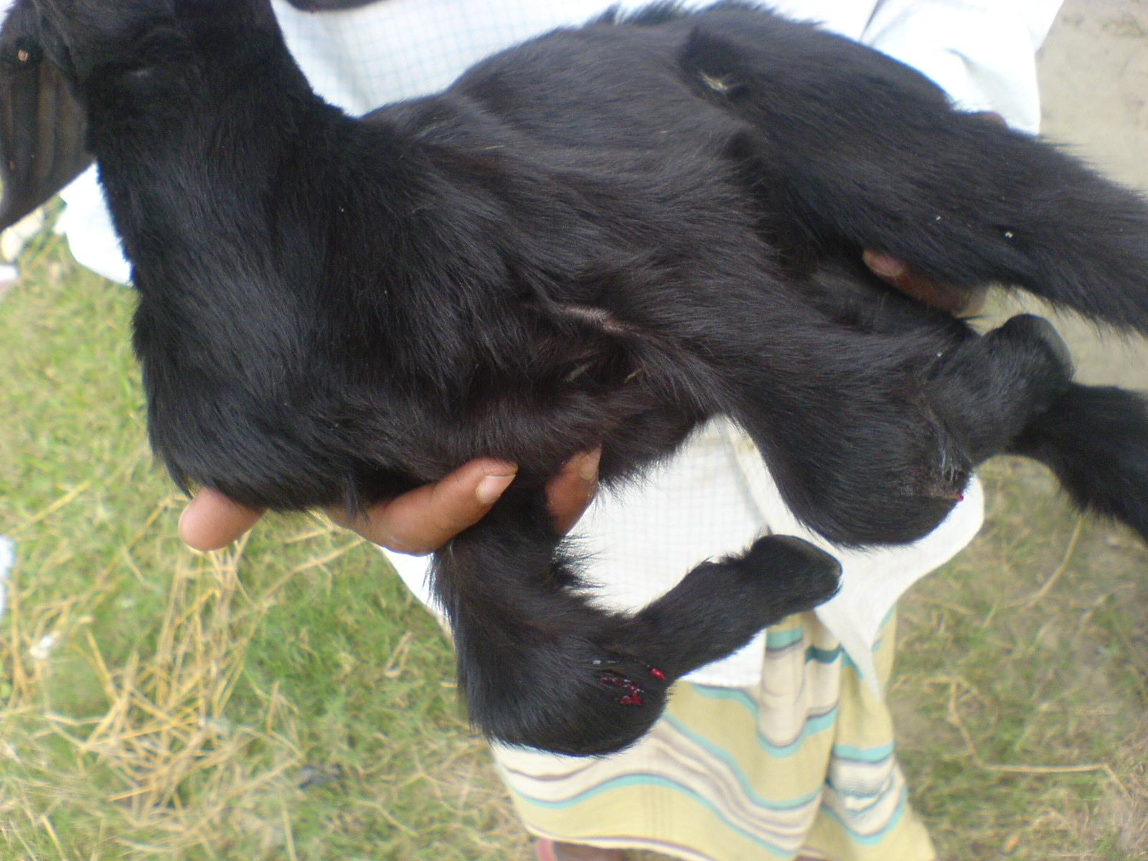
Some picture that was found during study

picture- 01 Joint ill Picture-02; Bloat ( 2.4.20)
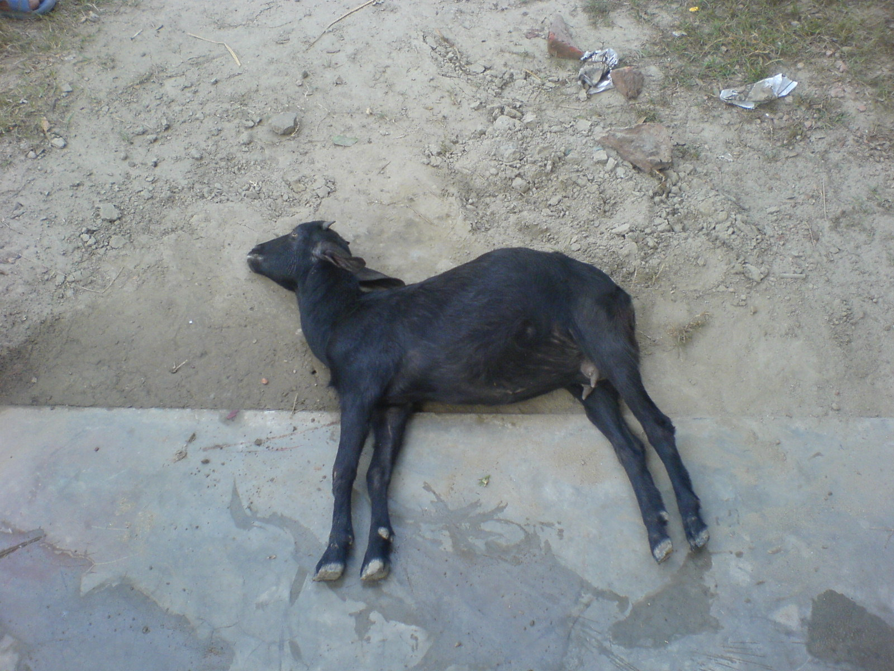
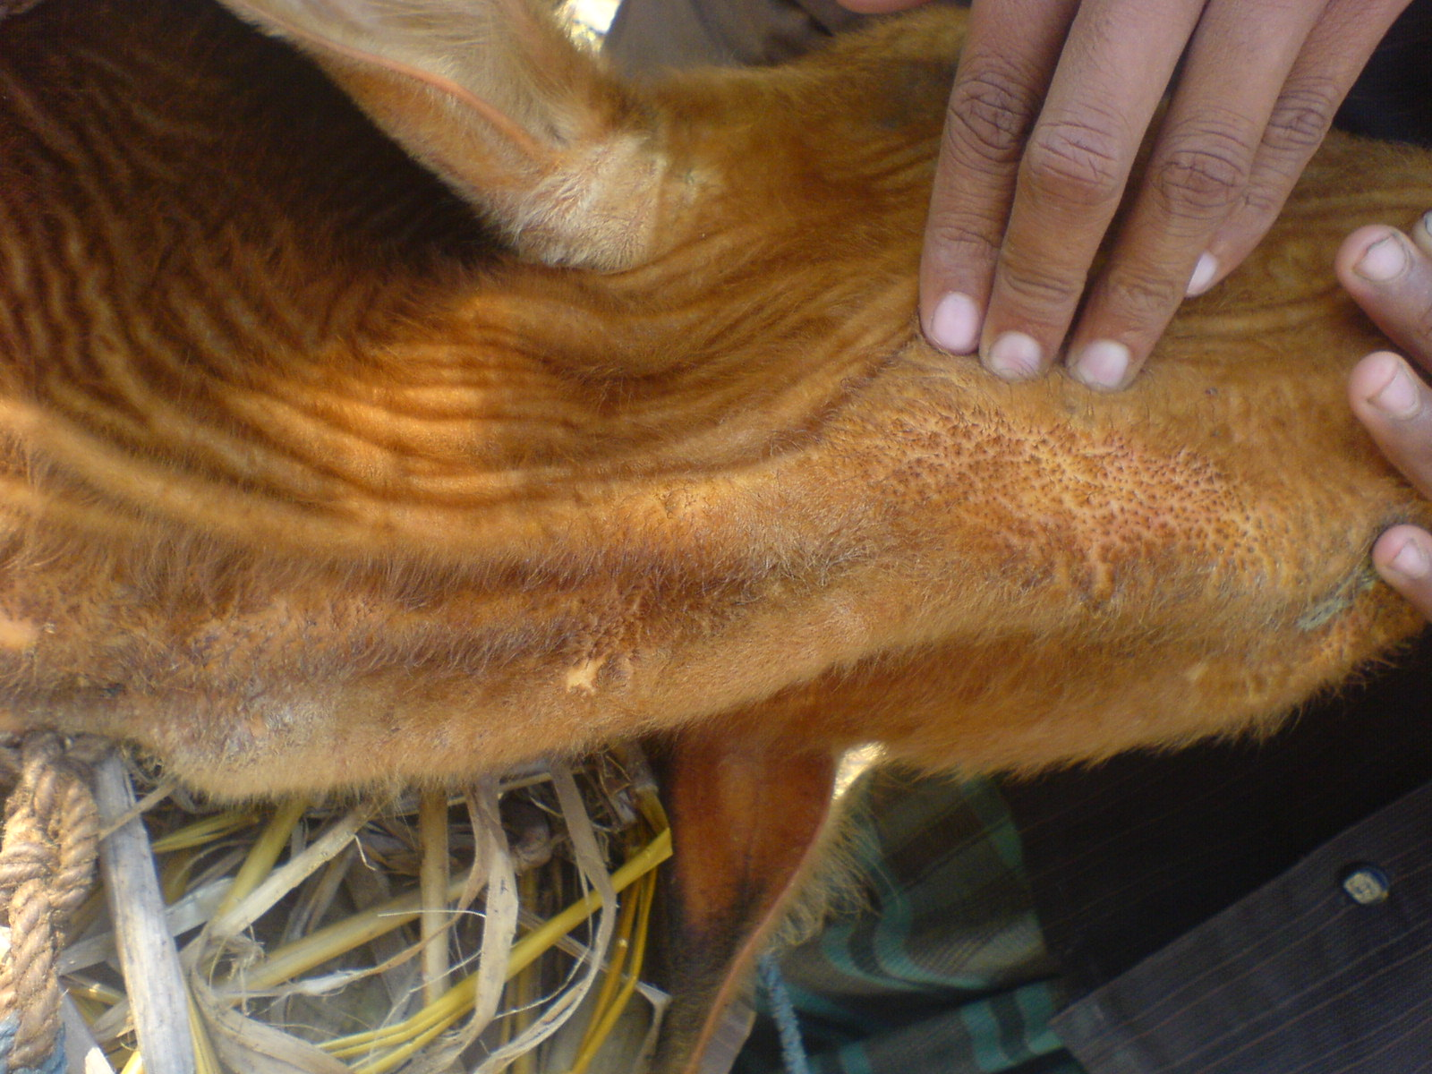

Picture-03; Skin disease ( 4.7.24) Picture-04; Tetanus ( 2.4.12)
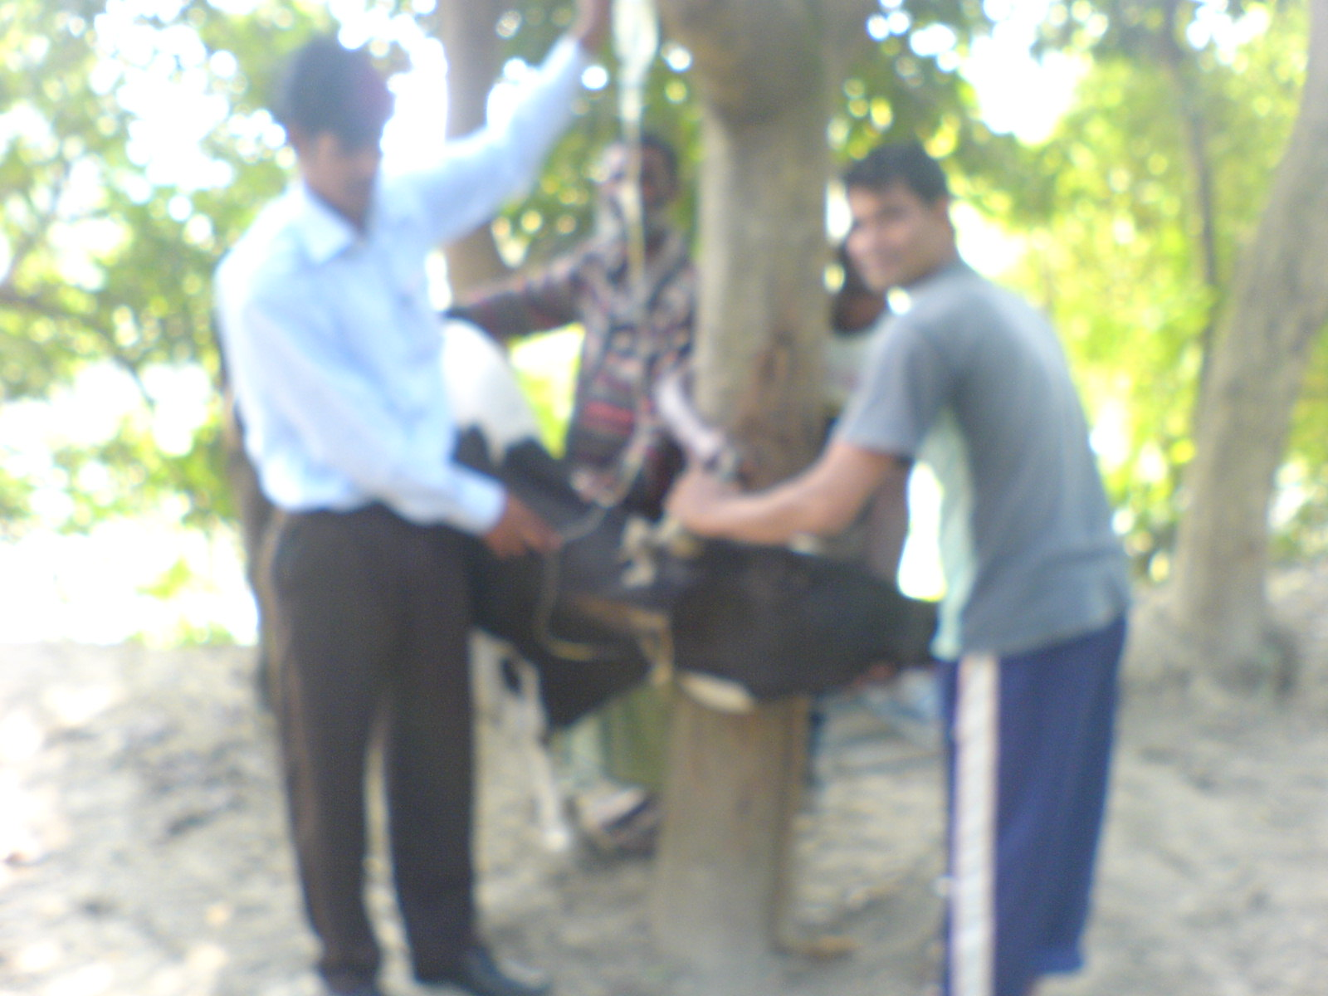
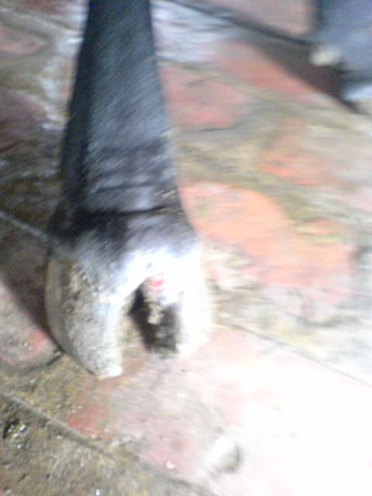

Picture-05; Treatment of milk fever ( 4.7.19 ) Picture-06; FMD ( 2.4.11)
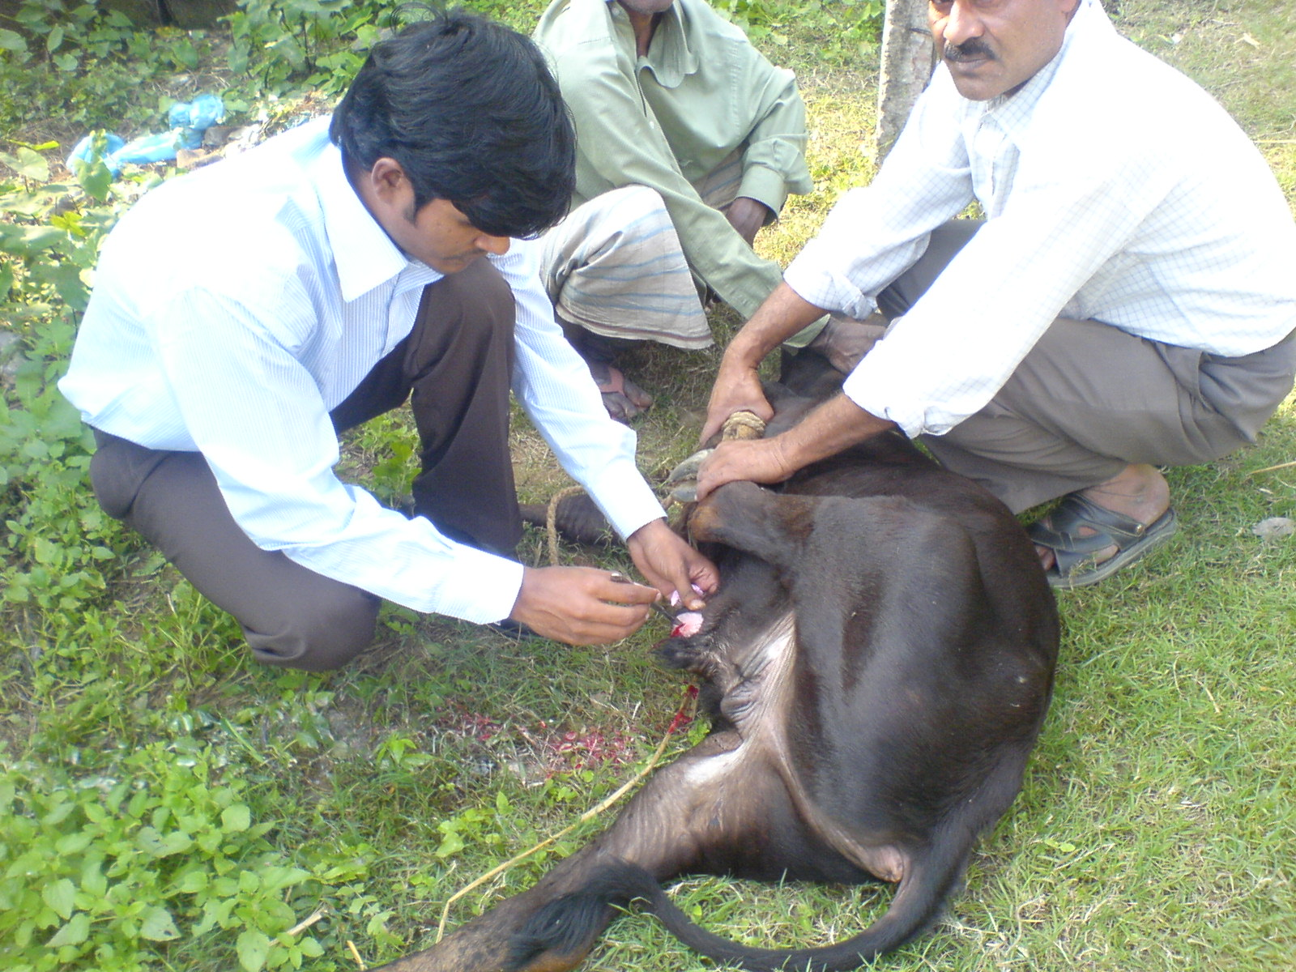
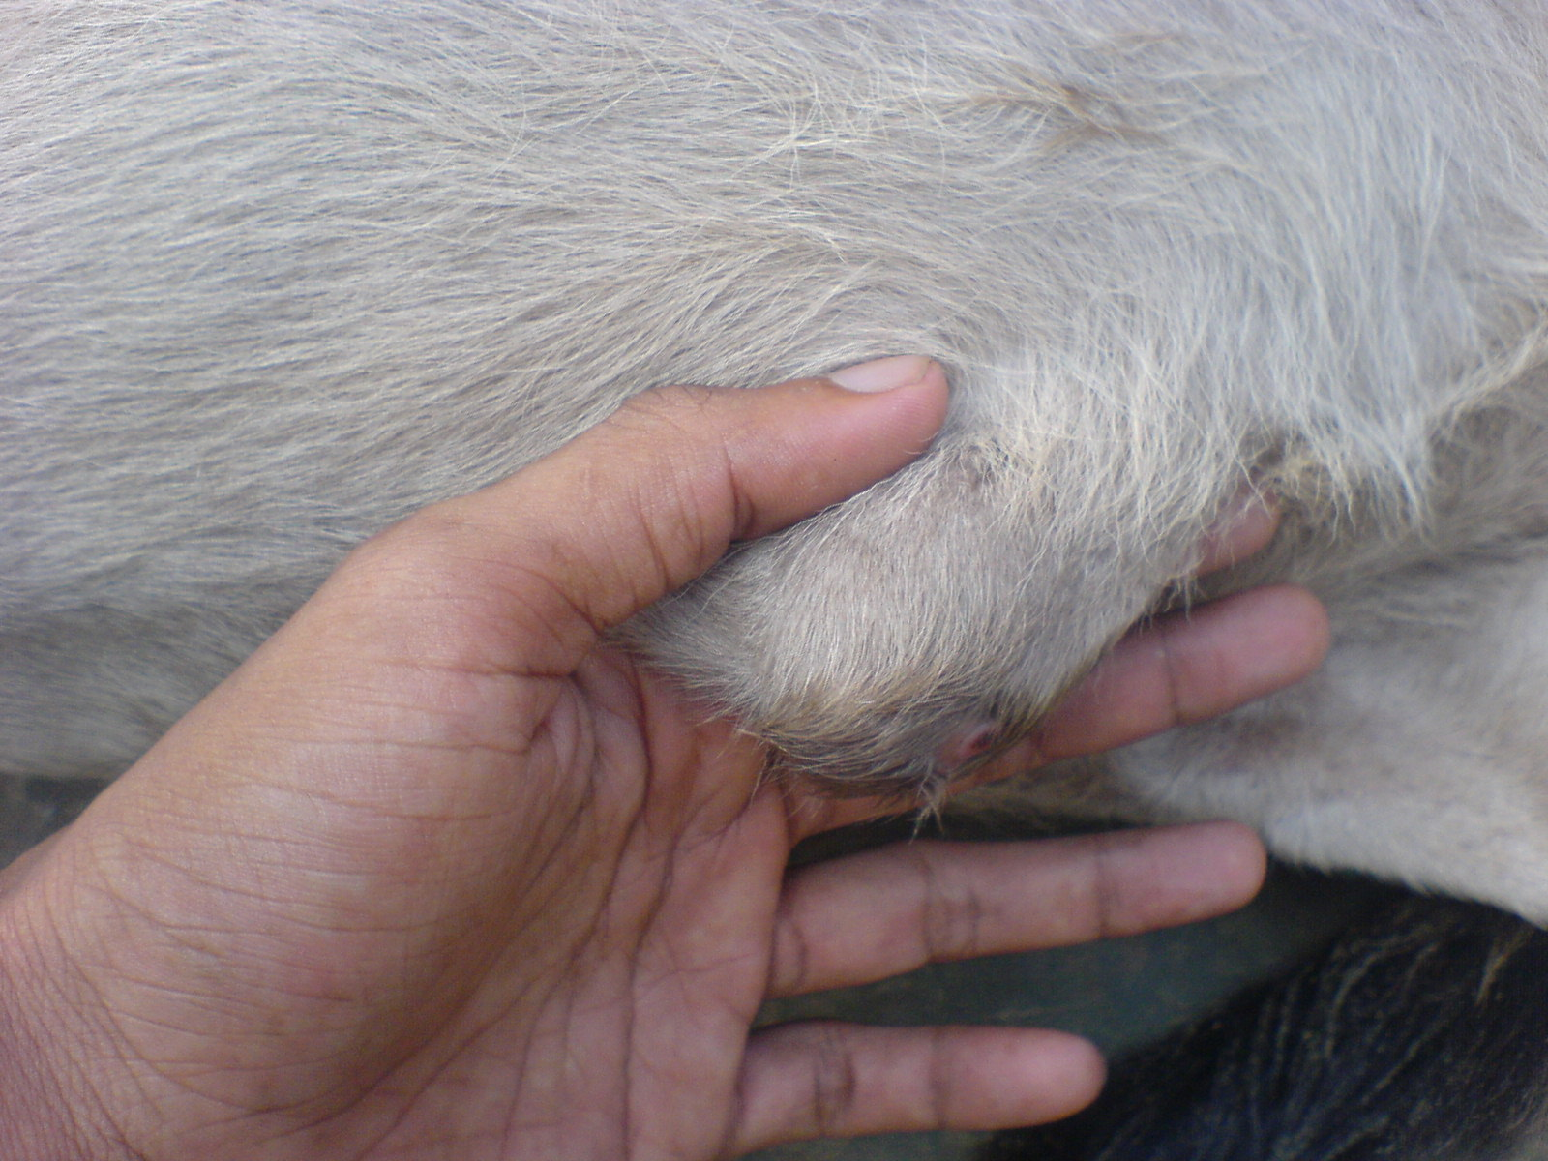

Picture-07; Abscess ( 2.4.25) Picture-08; Operation of abscess ( 4.7.26)
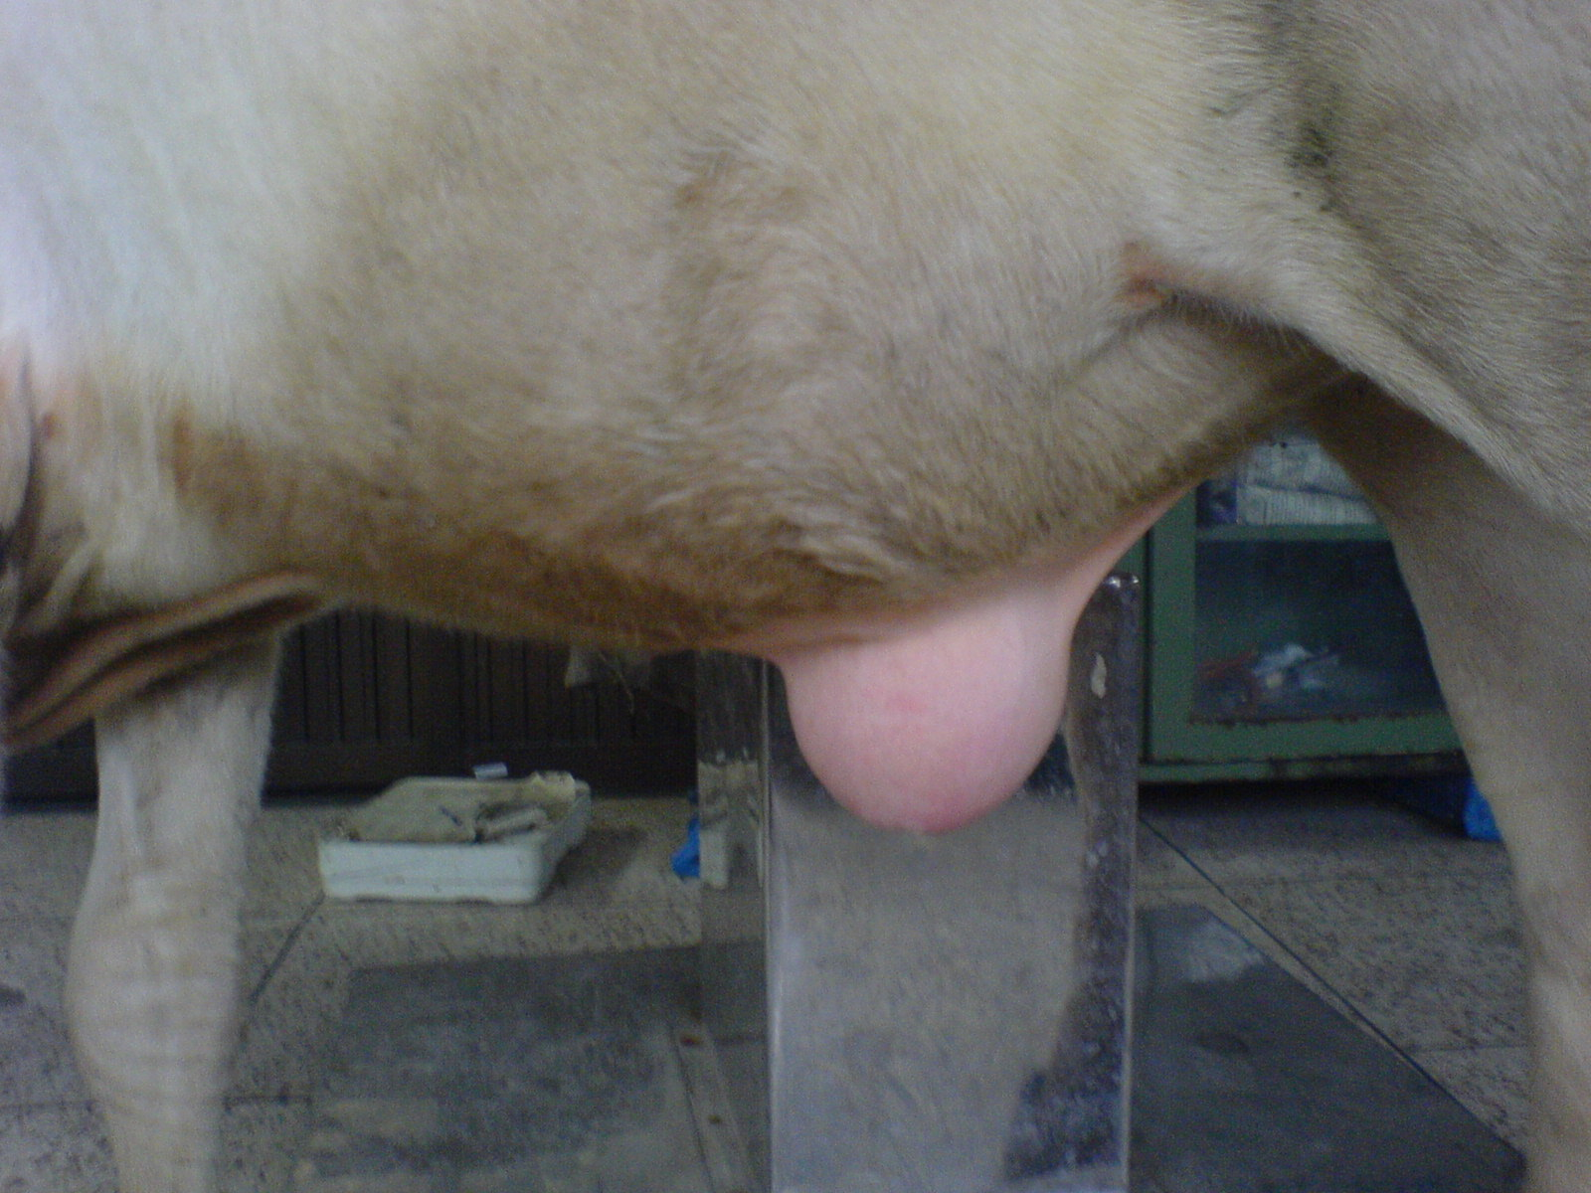
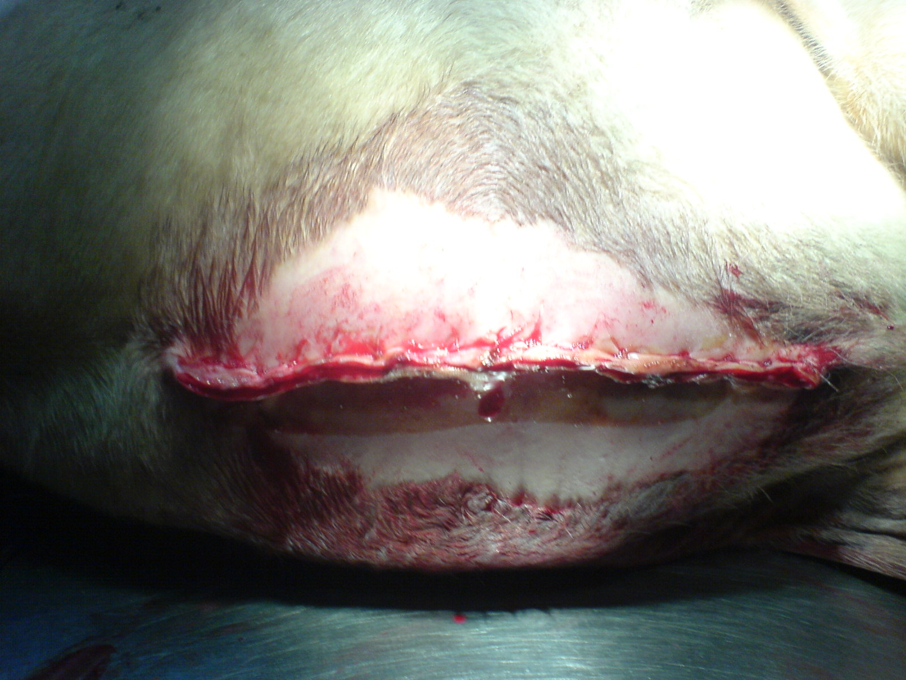

Picture-09; Hernia Picture-10; After correction of hernia
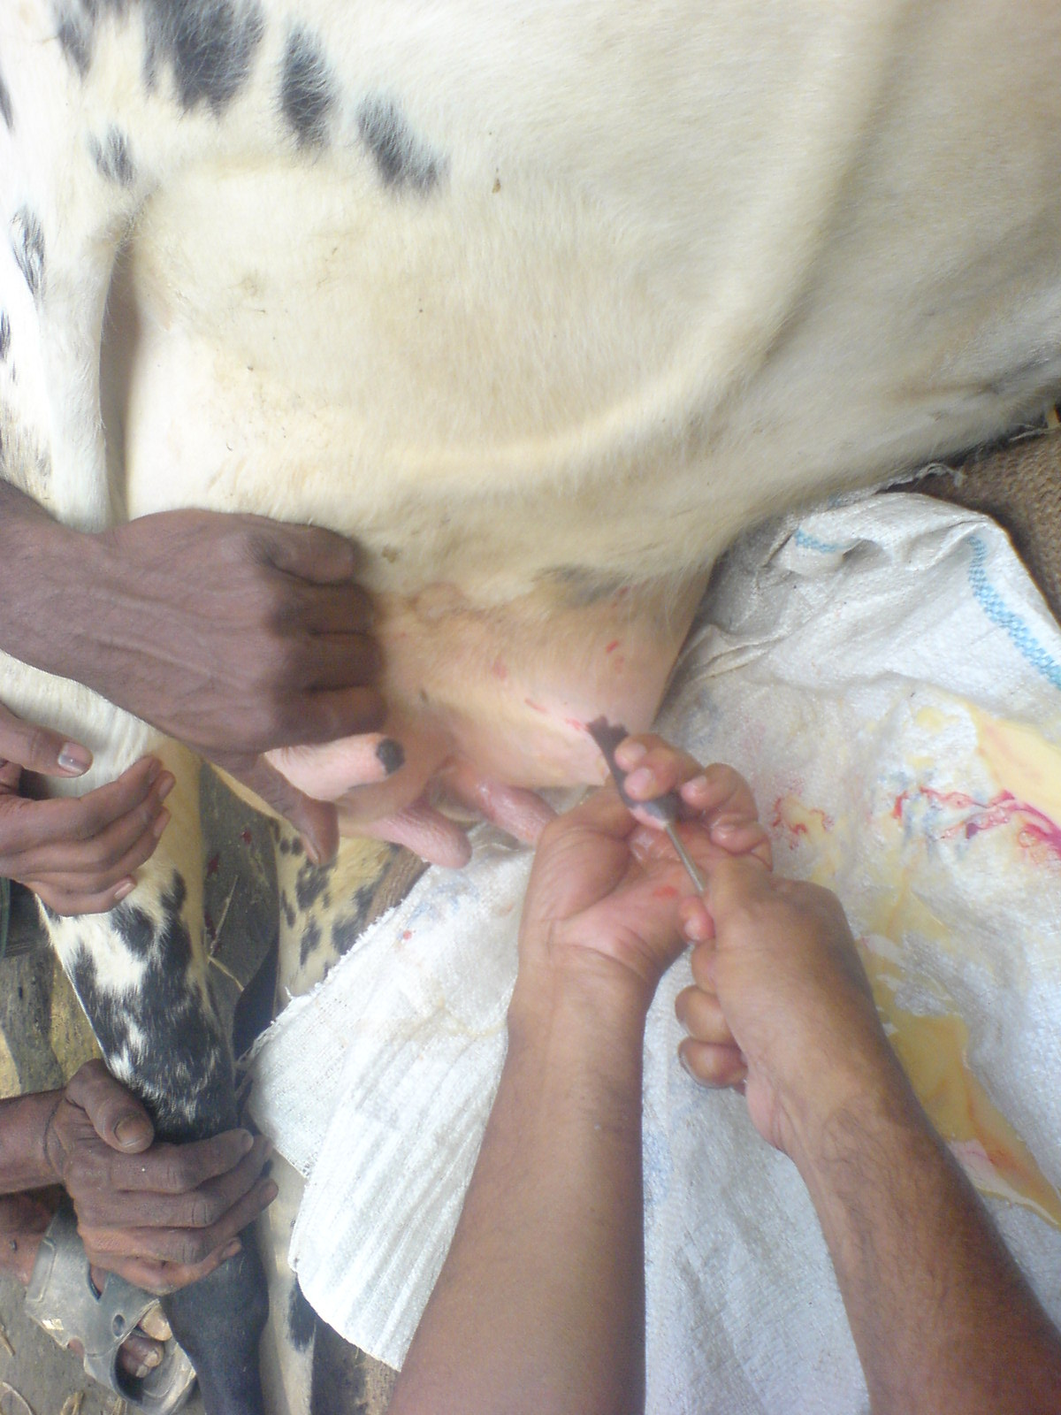
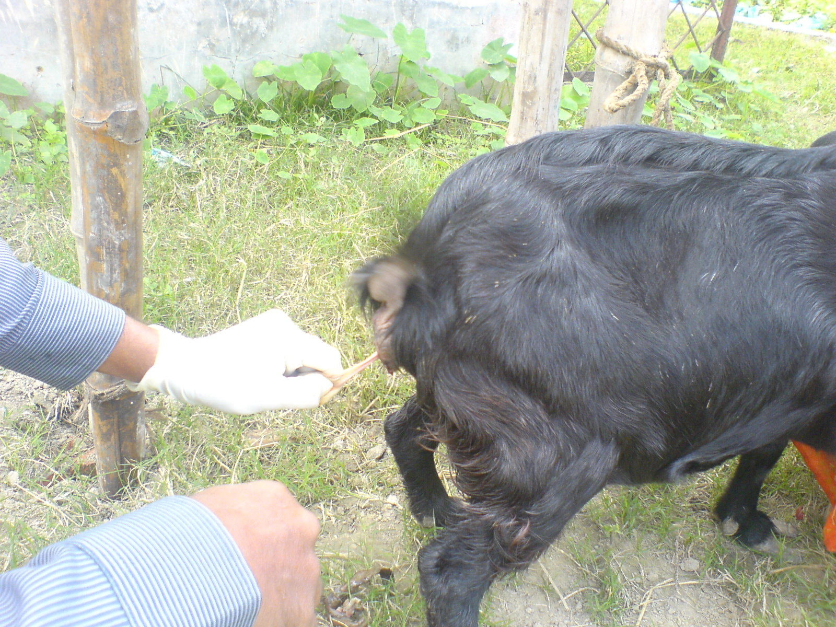

Picture-11; Case of mastitis ( 2.4.7) Picture-12; Retain placenta ( 2.4.22)
CHAPTER –IV
RESULT
Clinical and laboratory investigations were carried out to determine the general clinical prevalence of diseases and disorders in domestic animals at Pabna district from 17.10.08 to 16.02.09
4.1. Prevalence of diseases and disorders in young animals.
In total 14 major diseases and disorders recorded among 120 young examined during the period and the result presented in Figure- 4.1. It is evident that 14.17% (n=17) were affected with fever, 11.67%(n=14) with digestive disorders (Diarrhoea), 8.33%(n=10) with respiratory disorders (Pneumoniua), 6.66%(n=8) with skin diseases, 4.16%(n=5) with joint ill, 4.16%(n=5) with abscess, 2.5%(n=3) with navel ill, 10%(n=12) with FMD, 8.33%(n=10) with fescioliasis, 6.66%(n=8) with Salmonellosis, 10%(n=12) with colibacillosis, 12.5%(n=15) with GI nematodiasis, and 1.66%(n=2) with congenital defect.

Figure- 4.1. Prevalence of diseases and disorders in calves.

4.2. Prevalence of diseases and disorders in cows and bulls
In total 21 major diseases and disorders recorded among 200 cows and bulls investigated during the period and the result presented in Figure 4.2. It is evident that in 12.5% (n=25)were affected with fever, 5% (n=10) with anorexia, 9% (n=18) with digestive disorders (Diarrhoea), 4.5% (n=9) with respiratory disorders (Pneumoniua), 2% (n=4) with corneal opacity, 6% (n=12) with mastitis, 2% (n=4) with endrometritis, 5.5% (n=11) with FMD, 8.5% (n=17) with fascioliasis, 10% (n=20) with GI nematodiasis, 3% (n=6) with Schistosomiasis, 2.5% (n=5) with babesiosis, 9% (n=18) with milk fever, 4% (n=8) with ephemeral fever, 1% (n=2) with warts, 3% (n=6) with retained placenta, with uterine prolaps, 2% (n=4)with distocia and 7.5% (n=15) with repeat breeding cows.

Figure- 4.2. Prevalence of diseases and disorders in cattle.
4.3. Prevalence of diseases and disorders in goat and sheep
In total 15 major diseases and disorders recorded among120 examined during the period and the result presented in table - 4.3. It is evident that in sheep 16.67% (n=20)were affected with fever, 14.16% (n=17) with digestive disorders (Diarrhoea), 15% (n=18) with respiratory disorders (Pneumoniua), 2.5% (n=3) with tetanus, 2.5% (n=3) with corneal opacity, 1.67% (n=2) with foot diseases, 2.5% (n=3) with mastitis, 10.83% (n=13) with fascioliasis, 6.67% (n=8) with GI nematodiasis, 4.16% (n=5) with bloat, 2.5% (n=3) with retained placenta, 1.67% (n=2) with urolithiasis, 5% (n=6) with kitosis, and 1.67% (n=2) with Gid diseases.

Figure- 4.3: Prevalence of diseases and disorders in goats
4.4. Comparative Prevalence of diseases and disorders in young, cows and bulls, and goat & sheep
The comparative Prevalence of diseases and disorders in young, cows and bulls, and goat&sheep are presented in table -4.(i) . It is evident from the result presented that fever, Pneumoniua, Diarrhoea, GI nematodiasis commonly recorded in young, cattle, goat and sheep

Navel ill 2.5% Salmonellosis 1.66% Colibacillosis 6.66% Congenital defect 10% Joint ill 4.16% were recorded only in calves not in cows or goat. FMD was recorded 10% in calves and 5.5% in adult cattle but not in goat. Tympani and bloat 1.5%, Mastitis 6% ,Babesiosis 2.5%, Milk fever 9%, Ephemeral fever 4% ,Endrometritis 2%, Retained placenta 3% were recorded in cows. The most highest prevalence of diseases, fever 16% in goat. and GI nematodiasis in calves.

Table-4. (i): Comparative Prevalence of diseases and disorders in young, cows and bulls, and goat&sheep
Sl. no. | Diseases and disorders | young animals |  | Cow and bulls affected |  | goat and sheep
Sl. no. | Diseases and disorders | No. | % | No. | % | No. | %
01 | Fever | 17 | 14.17 | 25 | 12.5 | 20 | 16.67
02 | Digestive disorders (Diarrhoea) | 14 | 11.67 | 18 | 9 | 17 | 14.16
03 | Respiratory disorders (Pneumoniua) | 10 | 8.33 | 9 | 4.5 | 18 | 15
04 | Abscess | 5 | 4.16 | - | - | 4 | 3.16
05 | Tympani and bloat | - | - | 3 | 1.5 | 3 | 2.5
06 | Anorexia | - | - | 10 | 5 | - | -
07 | BQ | 2 | 1.66 | - | - | - | -
08 | Corneal opacity | - | - | - | - | 3 | 2.5
09 | FMD | 12 | 10 | 11 | 5.5 | - | -
10 | PPR | - | - | - | - | 15 | 12.5
11 | Warts | 3 | 2.5 | 2 | 1 | - | -
12 | Mastitis | - | - | 12 | 6 | 3 | 2.5
13 | Babesiosis | - | - | 5 | 2.5 | - | -
14 | GI nematodiasis | 15 | 12.5 | 20 | 10 | 8 | 6.67
15 | Milk fever | - | - | 18 | 9 | - | -
16 | Ephemeral fever | - | - | 8 | 4 | - | -
17 | Endrometritis | - | - | 4 | 2 | - | -
18 | Schistosomiasis | - | - | 6 | 3 | - | -
19 | Fascioliasis | 11 | 8.25 | 17 | 8.5 | 13 | 10.83
20 | Retained placenta | - | - | 6 | 3 | 3 | 2.5
21 | Uterine prolaps | - | - | 1 | .5 | - | -
22 | Distocia | - | - | 4 | 2 | - | -
23 | Tetanus | - | - | - | - | 3 | 2.5
24 | Urolithiasis | 6 | 5 | - | - | 2 | 1.67
25 | Gid diseases | - | - | - | - | 2 | 1.67
26 | Skin diseases | 8 | 6.66 | - | - | - | -
27 | Joint ill | 5 | 4.16 | - | - | - | -
28 | Navel ill | 3 | 2.5 | - | - | - | -
29 | Salmonellosis | 2 | 1.66 | - | - | - | -
30 | Colibacillosis | 8 | 6.66 | - | - | - | -
31 | Congenital defect | 12 | 10 | - | - | - | -
Total | total no. of diseases | 14 |  | 21 |  | 15

4.5. Frequency of diseases on the basis diseases of category due to treatment facilities.

4.5.1. Category basis disease distribution in cattle

The bacterial diseases were mostly found in 1- 5 years old cattle the table-4.(ii) represent that Mastitis (n=15), Endrometritis(n=4), Pneumoniua (n=37), Colibacillosis (n=8) and other disease mostly found in young animals.

Table- 4. (ii): Frequency and distribution of clinical diseases and disorders in cattle on the basis of category.
Sl. no. | Category o diseases | Diseases and disorders | Cattle (year) |  |  | total no.
Sl. no. | Category o diseases | Diseases and disorders | up to 1year | >1-5years | >6years | total no.
01 | Bacterial diseases | BQ | - | 2 | - | 2
01 | Bacterial diseases | Mastitis | - | 9 | 6 | 15
01 | Bacterial diseases | Endrometritis | - | 3 | 1 | 4
01 | Bacterial diseases | Salmonellosis | 2 | - | - | 2
01 | Bacterial diseases | Pneumoniua | 10 | 3 | 6 | 37
01 | Bacterial diseases | Colibacillosis | 8 | - | - | 8
02 | Viral diseases | FMD | 2 | 6 | 3 | 11
02 | Viral diseases | Papilomatosis | 3 | 2 | - | 5
02 | Viral diseases | Ephemeral fever | - | 3 | 5 | 8
02 | Viral diseases | Rabies | - | 1 | - | 1
03 | Parasitic infestation | Fascioliasis | 11 | 9 | 8 | 28
03 | Parasitic infestation | Schistosomiasis | - | 4 | 2 | 6
03 | Parasitic infestation | GI nematodiasis | 15 | 8 | 12 | 35
03 | Parasitic infestation | Tick infestation | - | - | 2 | 2
04 | Nutritional disorder | Milk fever | - | 8 | 10 | 18
04 | Nutritional disorder | Simple indigestion | 14 | 10 | 8 | 32
04 | Nutritional disorder | Tympany and bloat | - | 1 | 2 | 3
05 | Reproductive cases | Retained placenta | - | 4 | 2 | 6
05 | Reproductive cases | Uterine prolaps | - | 1 | - | 1
05 | Reproductive cases | Distocia | - | 2 | 2 | 4
05 | Reproductive cases | Repeat breeding | - | 10 | 5 | 15
06 | Surgical cases | Abscess | 4 | 1 | - | 5
06 | Surgical cases | Navel ill | 3 | - | - | 3
06 | Surgical cases | Hernia | 1 | - | - | 1
07 | Others | Fever | 17 | 15 | 10 | 32
07 | Others | Anorexia | 2 | 5 | 3 | 10
07 | Others | Babesiosis | - | 3 | 2 | 5

4.5.2. Category basis disease distribution in goat
In addition there were PPR, pneumonia, Parasitic infestation and surgical case reported in table -4. (iii) in goat more frequently found diarrhoea 14.16%.

Table- 4. (iii): Frequency of distribution of clinical diseases and disorders in Goat and sheep on the basis of category.
Sl. no. | Category o diseases | Diseases and disorders | Cattle (year) |  |  | total no.
Sl. no. | Category o diseases | Diseases and disorders | up to 6month | 1-2years | >2years | total no.
01 | Bacterial diseases | Pneumoniua | 2 | 12 | 4 | 18
01 | Bacterial diseases | Mastitis | - | 2 | 1 | 3
01 | Bacterial diseases | Colibacillosis | - | 1 | - | 1
01 | Bacterial diseases | Tetanus | - | 3 | - | 3
02 | Viral diseases | PPR | - | 9 | 6 | 15
02 | Viral diseases | Papilomatosis | - | - | -
02 | Viral diseases | Rabies | - | 2 | - | 2
03 | Parasitic infestation | Fascioliasis | - | 8 | 5 | 13
03 | Parasitic infestation | Gid diseases | - | 2 | - | 2
03 | Parasitic infestation | GI nematodiasis | 2 | 4 | 2 | 8
04 | Nutritional disorder | Diarrhoea | 5 | 7 | 5 | 17
04 | Nutritional disorder | Simple indigestion | 8 | 6 | 7 | 21
04 | Nutritional disorder | Bloat | - | 2 | 3 | 5
05 | Reproductive cases | Retained placenta | - | 2 | 1 | 3
05 | Reproductive cases | Distocia | - | 1 | - | 1
05 | Reproductive cases | Repeat breeding | - | 6 | 2 | 8
06 | Surgical cases | Abscess | - | 3 | 1 | 4
06 | Surgical cases | Navel ill | 2 | - | - | 2
06 | Surgical cases | Hernia | - | - | -
06 | Surgical cases | Over groth of hoof | - | 1 | - | 1
07 | Others | Fever | 2 | 5 | 3 | 10
07 | Others | Anorexia | - | 3 | - | 3
4.6. Comparative disease prevalence in different categories of cattle and goats
In addition there were 25% bacterial infection in cattle where as 29.6% in sheep and goat. another most prevalence diseases was parasitic infestation 26.1% in cow and 8.45% in goat , nutritional disorder in cattle was 9.55% and in goat 8.82% and reproductive cases 9.55% in cow where as 4.41% in goat.

Table- 4.(iv): Comparative disease prevalence in different categories of cattle and goats.
Sl. no. | Category of diseases | No. of affected in cattle | Prevalenc  % | No.of affected in sheep&goat | Prevalence  %
01 | Bacterial diseases | 68 | 25 | 40 | 29.6
02 | Viral diseases | 25 | 9.2 | 17 | 6.25
03 | Parasitic infestation | 71 | 26.1 | 23 | 8.45
04 | Nutritional disorder | 26 | 9.55 | 24 | 8.82
05 | Reproductive cases | 26 | 9.55 | 12 | 4.41
06 | Surgical cases | 9 | 3.3 | 6 | 2.20
07 | Others | 47 | 17.28 | 13 | 4.78

Figure- 4.4: Comparative disease prevalence of cattle and goat.

4.7. Clinically treatment of the diseases and disorders in young, cattle and goat and sheep.
The different clinical examination techniques and laboratory methods were used to investigate the clinical prevalence of diseases and disorders in young calves, cattle and sheep-goats during this three months of period, a total of 120 calves, 200 cows and 120 goats were examined clinically and the samples considered significant for diagnostic purposes were used the diagnostic techniques. Of the 120 calves, 200 cows and 120 goats examined, 14 major diseases and disorders were recorded in calves, 21 in cows and 15 in goats during this three month of investigation period.
4.7.1. Fever
The etiology of fever has not been identified in this clinical investigation. However. fever has been well recognized as the syndrome in which hyperthermia and toxaemia are produced by organisms circulating in the blood stream. Differentiation from hyperthermia, where there is no toxemia. The characteristic features of infectious fever included sudden onset, high body temperature ( 103-105°F), anorexia, dullness, depression, disinclination to move and sometimes vomiting or diarrhoea (Blood and Radostits, 1989). These fever cases were considered infectious fever and accordingly, antibiotics were used as therapeutic management, which responded well in this study.
Drugs were used for the treatment of fever
Diseases or disorders | Antibiotics/ Sulphonamides | Total no. used | Supportive drugs | Total no. used
Fever | Penicillin | 18 | Vita-B complex | 30
Fever | Ampicillin/amoxicillin | 14 | Diclofenac Na. | 12
Fever | Sulpha drugs | 8 | Rumentonic mixture | 14
Fever | Steptomycin+ penicillin | 12
Fever | Oxytetracyclin | 6
Fever | Gentamycine | 2

4.7.2. Anorexia
Traditionally used bitter stomachic are being generally prescribed for the treatment of the disease. However, Hypobeta-20^{(R)} (Marek Sharp and Dohme) and Anorexon^{(K)} (Pfizer Ltd.) have been reported to be quite effective in the treatment of non-specific anorexia syndrome in ruminants (Prasad.et al, 1976, Samad. et al, 1978).
Drugs were used for the treatment of Anorexia
Diseases or disorders | Name of drugs symptomatic | Total no. used
Anorexia | Vita-B complex | 12
Anorexia | Rumentonic mixture and stomachic mixture | 6

4.7.3. Digestive disorders(mainly diarrhoea)
Dearrhoea is one of the major health problem in animals especially in young calves with a multi-factorial etiology which leads to significant morbidity and some etiological agents of diarrhoea like gastro-intestinal parasites. colibacillosis and salmonellosis have been identified in this study which have been described separately. Other than these agents associated with diarrhoea have been described under this heading. Gastro-intestinal parasited
Drugs were used for the treatment of Digestive disorders
Diseases or disorders | Antibiotics/ Sulphonamides | Total no. used | Supportive drugs | Total no. used
Digestive disorders | Penicillin | 15 | Astringen mixture | 35
Digestive disorders | Ampicillin/amoxicillin | 8 | oral saline | 12
Digestive disorders | Sulpha drugs | 25
Digestive disorders | Steptomycin+ penicillin | 13
Digestive disorders | Oxytetracyclin | 9
Digestive disorders | Gentamycine | 2
Digestive disorders | Metranidazole | 30

4.7.4. Respiratory disorders
Drugs were used for the treatment of Pneumonia
Diseases or disorders | Antibiotics/ Sulphonamides | Total no. used | Supportive drugs | Total no. used
Pneumonia | Penicillin | 14 | Anti histamine | 20
Pneumonia | Ampicillin/amoxicillin | 7 | Expectorant | 13
Pneumonia | Sulpha drugs | 9 | Rumentonicmix | 18
Pneumonia | Steptomycin+ penicillin | 14
Pneumonia | Oxytetracyclin | 8
Pneumonia | Gentamycine | 4

4.7.5. Corneal opacity
Drugs were used for the treatment of corneal opacity
Diseases or disorders | Name of drugs | Total no. used
Corneal opacity | 1% silver nitrate solution | 3
Corneal opacity | Cloramphenicol eye drop | 2
Corneal opacity | Vita-B complex | 4

4.7.6. Foot diseases
Foot diseases and disorders vis-a-vis lameness cause major economic loss to the airy and beef industries as well as reduce bullock power while it is one of the most neglected conditions affecting bovines and accordingly, the reports are very rare
Drugs were used for the treatment of foot diseases
Diseases or disorders | Antibiotics/ Sulphonamides | Total no. used | Supportive drugs | Total no. used
Foot diseases | Penicillin | 8 | CuSO4 solution | 10
Foot diseases | Steptomycin+ penicillin | 6 | Vita-C | 8
Foot diseases | Oxytetracyclin | 2 | Vita-B complex | 6
Foot diseases | After treatment a bandages was provided for protection of affected area.

4.7.7. Mastitis
The clinical occurrences of mastitis in cow and goats have been reported from Bangladesh (Rahman and Samad, 1984) However, mastitis is not only responsible for great economic losses to the dairy industry but also acts as one of the biggest obstacles in the achievement of white revolution in the country. Epidemiological studies on mastitis revaled that mastitogenic agents are widespread on different body sites of the cows, milks hand. milking cows and in the milk samples.
Drugs were used for the treatment of Mastitis
Diseases or disorders | Antibiotics/ Sulphonamides | Total no. used | Supportive drugs | Total no. used
Mastitis | Gentamycine | 13 | Anti histamine | 7
Mastitis | Steptomycin+ penicillin | 10 | Diclofenac Na. | 12
Mastitis | Ampicillin | 8 | Ice application | 10
Mastitis | Oxytetracyclin | 2 | Coconut oil with corpur | 2

4.7.8. Black quarter
The isolation and characterization of the causative agent of BQ, Clostridium chauvoei, epidemiologry, clinico-pathological changes, therapeutic efficacy of antibacterial drugs and changes in serum protein and leukocytes in serum in BQ affected cattle have been studied in Bangladesh (Haque et a1, 1987 , 1988a,b).
Drugs were used for the treatment of BQ
Diseases or disorders | Antibiotics/ Sulphonamides | Total no. used | Supportive drugs | Total no. used
BQ | Penicillin | 4 | Anti histamine | 3
BQ | Ampicillin/amoxicillin | 2 | Rumentonic drugs | 2
BQ | Steptomycin+ penicillin | 3
Some time open the gaseous area and use locally antibiotics powder for immediate result.

4.7.9. Navel ill
Infection of the umbilicus and its associated structures occurs commonly in newborn farm animals and appears to be particularly common in calves but this disease has not been reported in literature from Bangladesh. However, this disease is commonly occurs in calves within 2-5 days after birth and characterized by painful and enlarged umbilicus and draining purulent material as described by Shearer (198b).
Drugs were used for the treatment of Navel ill
Diseases or disorders | Antibiotics/ Sulphonamides | Total no. used | Supportive drugs | Total no. used
Navel ill | Penicillin | 4 | Anti histamine | 6
Navel ill | Ampicillin/amoxicillin | 3 | Diclofenac Na. | 5
Navel ill | Steptomycin+ penicillin | 5 | Rumentonic drugs | 2
Navel ill | Oxytetracyclin | 2

4.7.10. Salmonellosis and colibacillosis
Although salmonellosis is noe of the commonly prevalent disease in animals but there is a paucity of published report in inland literature on its clinical occurrence in Bangladesh. Outbreaks of neonatal salmonellosis in dairy calves have been reported elsewhere Greene and Demsey, (1986). Clinical salmonellosis cases in calves characterized by foul smelling yellowish diarrhoea, nasal and ocular discharges, coughing. omphalitis, swollen joints and central nervous signs,
Colibacillosis in one of the most common diseases of newborn farm animals, caused by pathogenic Escherichia co1i. This disease is most common in calves under 3 days of age and occasionally occurs in calves up to several days of age when there is a mixed infection with viral enteropathogens.
Drugs were used for the treatment of Salmonellosis and colibacillosis
Diseases or disorders | Antibiotics/ Sulphonamides | Total no. used | Supportive drugs | Total no. used
Salmonellosis and colibacillosis | Sulpha drugs | 10 | Rumentonic drugs | 11
Salmonellosis and colibacillosis | Steptomycin+ penicillin | 8 | Astringen mixture | 9
Salmonellosis and colibacillosis | Oxytetracyclin | 4 | Oral saline | 5
Salmonellosis and colibacillosis | Metranidazole | 12

4.7.11. FMD
Recently, Rahman et a1. (1991) identified the occurrence of Type O, Asia-1 and Type C, FMD virus in cattle of Bangladesh. FMD is major diseases affecting the cattle in Bangladesh. It is by tar the most important disease owing to its universal prevalence, perennial occurrence, and high economic implications. Winter epidemics are attributed to weather conditions favoring virus survival and monsoon epidemics due to heavy rain and flooding necessitated movements of large number of animals to higher ground and close herding and contact result outbreaks.
Drugs were used for the treatment of FMD
Diseases or disorders | Antibiotics/ Sulphonamides | Total no. used | Supportive drugs | Total no. used
FMD | Sulphamethazine | 4 | Anti histamine | 4
FMD | Steptomycin+ penicillin | 2 | Diclofenac Na. | 3
FMD | Oxytetracyclin | 3 | Rumentonic drugs | 2
FMD | Ampicillin | 2

4.7.12.Tetanus
The report on the incidence of tetanus in animals especially in goats is very limited in inland literature. However, this disease occurs in all farm animals all over the world mainly as individual sporadic cases, although outbreaks are occasionally reported in sheep (Rao et al, I978). Toxigenic strains of Clostridium tetani, causative agent of tetanus have been isolated from soil samples collected from different districts of West Bengal Das et al., (1976). Puncture wounds of the hoofs and introduction to the genital tract at the time of parturition are the usual portals of entry of this organism.
Drugs were used for the treatment of Tetanus
Diseases or disorders | Antibiotics/ Sulphonamides | Total no. used | Supportive drugs | Total no. used
Salmonellosis and Colibacillosis | Tetanus anti sera | 2 | Anti histamine | 2
Salmonellosis and Colibacillosis | Penicillin | 1 | Rumentonic drugs | 1
Salmonellosis and Colibacillosis | Steptomycin+ penicillin | 2
Salmonellosis and Colibacillosis | Ampicillin | 1

4.7.13. PPR
In Bangladesh it is thought that the disease might have come from India PPR in goat has been recorded in 199; from the border belt areas of southwestern districts (Sathkhira, jessore and Barguna) of Bangladesh. and reported that in endemic condition, it may be less dramatic or may occur as a sub clinical or even in apparent form.
Drugs were used for the treatment of PPR
Diseases or disorders | Antibiotics/ Sulphonamides | Total no. used | Supportive drugs | Prevalence
PPR | Sulphar drugs –IV | 12 | Anti histamine | 10
PPR | Steptomycin+ penicillin | 9 | Rumentonic drugs | 6
PPR | Dextrose saline | 12
PPR | Amoxicillin | 7

4.7.14. Papilomatosis
The occurrence of papillomatosis in Bangladesh is well known but detail a study on this disease has not yet been made in this county. However, papillomatosis is a chronic proliferative disease, caused by DNA virus belonging to the Family Papovaviridae. The incidence rate of papillomatosis is supported to be much higher in imported and crossbred cattle than in the indigenous ones. The disease is not of much importance but its high infectivity, chronic illness leading to unthritliness and the damage of the skin due to generalized warts are matters of concern and lead to much economic losses.
Drugs were used for the treatment of papilomatosis
Diseases or disorders | Name of drugs | Total no. used
Papilomatosis | Autohaemotherapy | 3
Papilomatosis | Autogenous vaccine | 1
Papilomatosis | Vita-B complex | 2

4.7.15. Fascioliasis and Paramphistomiasis
The clinical occurrence of fascioliasis in assciation with diarrhoea in ruminants have been reported from Mymensingh Samad et al., (1979), Amin and Samad, 1988, Islam and Samad, 1989) The occurrence of higher rate of a clinical infection of fascioliasis during summer (May to July) and autumn (August to October) months in both cows and goats are in conformity with the earlier report of Qadir (1981b) who reported the peak infection period of Fasciola infection during July to September.
Drugs were used for the treatment of Fescioliasis and Paramphistomiasis
Diseases or disorders | Anthelmintics | Total no. used | Supportive drugs | Prevalence
Fascioliasis and Paramphistomiasis | Triclabendazole and Levamizole | 25 | Vita-B complex | 25
Fascioliasis and Paramphistomiasis | Albendazole | 20 | Stomachic mixture | 7
Fascioliasis and Paramphistomiasis | Oxyclozanide | 3 | Oral saline | 12
Fascioliasis and Paramphistomiasis | Nitoxynil | 4

4.7.16. GI Nematodiasis
The highest incidence rate of gastro-intestinal nematode infection during summer months in calves, cows and goats in comparison to other seasons are in conformity with the earlier report of Arnin and Samad (1987). However. Qadir (1967) und Huq und Shuikh (1968) reported the prevalence of gastrointestinal parasitic infection in sheep and goats of Mymensingh, Garrel.s (1975) reported in cattle of Dhaka and Tangail and Pharo (1981) reported in cattle from Pabna district Islam et al., (1984) also studied gastro-intestinal nematode infection in cattle of Bangladesh Agricultural University Veterinary Hospital who recorded loss of appetite, bottle-jaw and diarrhoea syndrome due to these parasitic infection.
Drugs were used for the treatment of GI Nematodiasis
Diseases or disorders | Anthelmintics | Total no. used | Supportive drugs | Total no. used
GI Nematodiasis | Piparazine cytrate | 14 | Vita-B complex | 20
GI Nematodiasis | Triclabendazole and Levamizole | 13
GI Nematodiasis | Albendazole | 9 | Stomachic mixture | 8
GI Nematodiasis | Fenbendazole | 2 | Oral saline | 10
GI Nematodiasis | Ivermectine | 4

4.7.17. Schistosomiasis
Drugs were used for the treatment of Schistosomiasis
Diseases or disorders | Anthelmintics | Total no. used | Supportive drugs | Prevalence
Schistosomiasis | Na antimony tartarate | 4 | Vita-B complex | 5
Schistosomiasis | Anthiomaline | 2 | Oral saline | 4

4.7.18. Babesiosis
It is a protozoan and tick born disease in domestic animals
Drugs were used for the treatment of Babesiosis
Diseases or disorders | Name of drugs | Total no. | Supportive drugs | total no.
Babesiosis | Diminazine diaceterate- Berenil | 2 | Haematinic mixture | 2
Babesiosis | Oxytetracyclin | 2 | Rumentonic drugs | 3
Babesiosis | Bupervaquone | 1

4.7.19. Milk fever
. The clinical occurrence of Milk fever cases in cows have been reported from Bangladesh (Ali and Ahmed 1968) but detail studies on this disease has not yet been made from Bangladesh. Milk fever is a disease of high milk producing cows, usually developed with 48 hours of calving but the incidence is very low in local breed cows due to poor milk production.
Drugs were used for the treatment of Milk fever
Diseases or disorders | Name of drugs | Total no. used
Milk fever | Calcium Preparation | 18
Milk fever | 5% dextrose saline | 12
Milk fever | Dexamethasone | 5
Milk fever | Metranidazole | 4

4.7.20. Ketosis
Ketosis is a disease, caused by impaired metabolism of carbohydrate and volatile fatty acids of high milk yielding cows& goats with high incidence at the stage of peak milk production.

Drugs were used for the treatment of Ketosis
Diseases or disorders | Name of drugs | Total no. used
Ketosis | Procole solution | 5
Ketosis | 40-50% dextrose saline | 3
Ketosis | Dexamethasone | 4
Ketosis | propiline glycole | 2
Supportive | vita- B-12 | 5

4.7.21. Bloat
Excessive accumulation of gas in the rumen is called ruminal tympany. The gas may be accumulated in free from separated from ingesta (called tympany) of may be mixed with ingesta in the form of froth (called bloat). Primary causes (frothy bloat) mainly due to dietary origin- legume pasture. succulent grass and overfeeding of grain (carbohydrate). Characteristic signs . distended abdomen with extreme tightness of skin. Percussion on the left Para lumberfosa- produces tympanic sound. Puncture of the left distended Para lumber fosa with a needle free gas will be removed and subsidence of the ruminal distention, whereas, in bloat, only small amount of gas are removed before frothy materials block the needle
Drugs were used for the treatment of bloat
Diseases or disorders | Name of drugs | Total no. used
Bloat | Anti bloat solution | 3
Bloat | Normal saline | 2
Bloat | Remove gas by needle punched | 2
Bloat | Remove gas by incision | 1

4.7.22. Uterine prolaps
Utero-vaginal prolapse causing great economic loss to the fanners. Affected animals not only produce less milk but also lose their future reproductive efficiency. Neglect by the farmers of delay in the treatment of this malady may result in permanent damage to the reproductive organs followed by their dysfunction. A judicious and timely use of preventive and corrective measures, mainly with the object to remove the exciting cause could be considered as a rational way to treat the condition.

Drugs were used for the treatment of Uterine prolaps
Diseases or disorders | Name of drugs | Total no. used
Uterine prolaps | Sugar application | 3
Uterine prolaps | Ice application | 2
Uterine prolaps | Antispasmotic drugs | 3
Uterine prolaps | Oxytocine | 2

4.7.23. Retained placenta
In cattle the fetal membranes are physiologically expelled within 12 hours after delivery of the fetus but retention for longer period must be considered a pathologic condition. It is usually associated with infections, abortions, dystocia, premature condition. It is usually associated with infections, abortions, dystocia, premature birth, multiple pregnancies and deficiencies of hormones, vitamins and trace elements. estimated economic losses due to retained placenta on the basis of calving interval, increasing culling rate, loss of milk production and costs of Veterinary treatment and dugs revealed that the total loss was pound 471/year for a 100 cows farm.
Drugs were used for the treatment of Retained placenta
Diseases or disorders | Name of drugs | Total no. used
Retained placenta | Oxytocine | 5
Retained placenta | Metranidazole | 3
Retained placenta | PPM wash | 4
Retained placenta | Diclofenac Na. | 2

4.7.24. Skin diseases
Various types of skin diseases was found during the study period.
Drugs were used for the treatment of Skin diseases
Diseases or disorders | Name of drugs | Total no. used
Skin diseases | Ivermectin | 6
Skin diseases | Whitfield ointment | 2
Skin diseases | ABC ointment | 4
Skin diseases | Dusting powder | 3
Skin diseases | Neomycin ointment | 2

4.7.25. Urolithiasis
Urolithiasis is a disease of multifactorial origin but dietary factors play a significant role in their occurrence. Urinary obstruction due to calculi was mainly observed in fatty castrated goats. The high incidence of urinary calculi observed in urban area (Dhaka city) might to be due to excessive feeding of wheat bran which is very rich in phosphate as has been reported by Mia (1967).
Drugs were used for the treatment of Urolithiasis
Diseases or disorders | Antibiotics/ Sulphonamides | Total no. used | Supportive drugs | total
Urolithiasis | penicillin | 4 | PPM wash | 2
Urolithiasis | Steptomycin+ Penicillin | 5 | Dusting powder | 3
Surgery | manually palpate and remove by incisions in appropriate location
4.7.26. Abscess
Abscess in animals is commonly encountered in Veterinary practices in Bangladesh. However, both subcutaneous and internal abscesses have been reported in animal's elsewhere (Ramakrisna et al., 1982, Shearer, 1986, Singh et al, 1988).
Drugs were used for the treatment of Abscess
Diseases or disorders | Antibiotics/ Sulphonamides | Total no. used | Supportive drugs | Prevalence
Abscess | Penicillin | 6 | PPM wash | 6
Abscess | Steptomycin+ Penicillin | 4 | Dusting powder | 3
Surgery | surgically remove pus by incisions in appropriate location
4.7.27. Atresia ani
Congenital malformations of the rectum and anus are fairly common in all domesticated animals. Among the anomalies, arteria ani is of frequent occurrence in our country but occasionally this condition was associated with defects of other body systems like taillessness, supernumerary laimbs (Hossain et al., 1980, Ali and Hossain, 1986, Samad and Huque, 1986).
Drugs were used for the treatment of Atresia ani
Diseases or disorders | Antibiotics/ Sulphonamides | Total no. used | Supportive drugs | Prevalence
Atresia ani | Penicillin | 2 | PPM wash | 2
Atresia ani | Steptomycin+ Penicillin | 1 | Dusting powder | 1
Surgery | surgically made a round opening in anus area and application parsting suture

CHAPTER-V
DISCUSSION
In this investigation several kinds diseases were recorded and compare with previous study.
prevalence is varies from previous study due to vaeious causes like age, sex , condition, season of study, location of study etc
Discussion the result of some diseases as follows

5.1. Fever
In this study fever syndrome was recorded 17 (14.17%)) in calves, 25 (12.5%) in cows and 20 (16.67 %) in goats. This finding was very close to 12.1% in cattle reported by(Hoque and samad 1997). But variation found in goats, (10.37%). this variation might be due to lack of proper care and management of goat and might be error in data collection.
5.2. Anorexia
Complete absence of appetite (anorexia) was recorded 10 (5%) in cows wide variation with the found of Huq and ,Shaikh (1992). (15%) in cattle. It might be change of ration or change of feeding system.

5.3. Doarrhoea

Diarrhoea was recorded in 11.67% (n=14) calves, 9% (n=18) cows and in 14.16% (n=17) goats. ). But 6.94% incidence of nonspecific diarrhoea in dairy cows 8.99% in cow- calves and 12.23% in goats. (Hoque and Samad, 1997). it was similar to the current study.

5.4. Respiratory disorders
Respiratory disorders mainly Pneumonia were recorded 37(11.56%) in cattle 18 (15%) in sheep-goats. where as Hossain et al., (1988) found that 17.22% cause of death was due to respiratory disorders, and other identified disease conditions included pneumonia (15.49%), pneumo-enteritis (2.82%). It indicates that housing and other managemental system might be improved.
5.5. Corneal opacity
Corneal opacity was recorded 3 (2.5%) in goat and 4(2%) in cattle with very related to Prasad et al., (1980b) reported overall 2.25% incidence rate of corneal opacity.

  - Foot diseases
A total of 2 (1.67%) goats were recorded to be affected with foot diseases and disorders. Saikia et al., (1992) reported 13.96% incidence rate of foot diseases in bovine in Assam and Das et al., (1992) reported 24.40% foot diseases in bovine from West Bengal. Rahman et al., (1995) reported traumatic injury (19.00%), arthritis (9.00%), angioneurotic oedema (4.00%), ulceration of sole (1.50%), obturator paralysis (1.50%), congenital spastic paresis (1.50%), foot rot (1.00%), rickets (2.00%) and the 4.00% remained undiagnosed.

  - Mastitis
Clinical mastitis was recorded in 12(6%) cows and 3 (2.5%) goats. But (Samad et al., 2000). 16% clinical and sub clinical mastitis recorded in 1st lactating cows in Bangladesh. There found wide range of variation and this variation may be public awareness about mastitis and dry cow therapy with appropriate drugs. Research would be required to control this disease in Bangladesh.

  - Black quarter

BQ was mostly found in young and healthy animals. Black Quarter was recorded only in 2(1.6%) cows. where as Haque et al., (1988a) reported an overall 0.04% clinical incidence rate of Black quarter in cattle. The findings of highest clinical incidence rate of BQ during summer (1.12%) in comparison to autumn (,0.56%), winter (0.28%) and spring (0.29%) months supports the earlier report of Haque et al., (1988) who recorded highest infection rate during warmer months of the years. this variation occurred due to improper vaccination of the animals.

  - Navel ill
Navel-Ill was recorded only in 3(2.5%) calves this study. It was far difference from previous study the incidence rate of 6.40% of Navel-ill in calves reported by (Das and Hiashim 1996). The prevalence was lower and it may be due to improve the calves management.

5.10. Salmonellosis and colibacillosis
In this study period, a total of 2 (1.66%) salmonellosis cases were recorded in calves. However, the 9.80% clinical cases of salmonellosis recorded in this study correlated with the report of Guptu and Choudhuiry (1978) who reported 11.80% Salmonella spp. India.
Colibacillosis was recorded in 8 (6.66%) calves but not in cows or goats. This study recorded 7.17% diarrhoeal diseases in calves associated with this infection, which is much lower than that of 32.43% rate recorded by Amin et al., (1988). This difference might revealed from by proper hygienic measure taken for animals.

5.11. Foot-and-month disease
Foot -and-month disease (FMD) was recorded in 11(5.5%) cows but not in goats on the basis of clinical findings. The highest clinical prevalence rate of' FMD in calves (3.03%) during winter in comparison to spring (2.79%), summer (1.97%) and autumn (2.26%)recorded in this study supports the earlier report of Kumuruddin and Panndit (1988) It might occurred due to lack of proper vaccination or less accuracy of vaccine.

5.12. Tetanus
Tetanus was recorded only in 3(2.5%) goats in this study period. The out break of tetanus in sheep after Vaccination against enteratoxaemia was similar 2.5% in goats( Rao et a1. 1978).

5.13. PPR
PPR was recorded 15(12.5%) in goat during the study period. Black Bengal goats (67.24%) are more susceptible to PPR that Jamunapari breed (32.76%). Saha et al.,(1983) found that in epidemic areas morbidity rate has been estimated to be 80% to 90% accompanied by a mortality rate of 50% to 80%. Debnath (1995). The variation was high might be improve the PPR vaccine in Bangladesh.
  - Papilomatosis
Papilomatosis of warts was recorded in 3(2.5%) claves and 2(1%) cows. Koul, G.L. Somvansha, et al., (1988). reported that in cattle and goat Papilomatosis was found 1.7% in Banglkadesh. It was nearly close to pervious study.

5.15. Fascioliasis and Paramphistomiasis
Fascioliasis and Paramphistomiasis was found frequently and in the study areas. recorded in 11(8.25%) calves ,17 (8.5%) in cows and 13(10.83%) goats during this period. 21.00% sub-clinical prevalence of fascioliasis in cattle reported by Holader et al., (1990) which is higher than clinical incidence of 7.02% recorded in cattle in this study

  - GI Nematodiasis
Gastro-intestinal nematodiasis was recorded in 15 (12.5%) calves, 20 (10%) cows and 8 (6.67%) goats. These results support the earlier report of Amin and Samad (1987⁻) who reported that 10.98% diarrhoeic cattle had one or move groups of nematode infection in GI tract.

  - Schistosomiasis
Schistosomiasis was recorded in 6(3%) cows in this study. The clinical occurrence of Schistosomiasis in cattle has been reported 2.5% from Bangladesh (Islam and Samad, 1989) but a detail study on this disease has not yet been made from the country.

  - Babesiosis
Babesiosis caused by Bubesia bigemina was recorded only in 5 (2.5%) cows However, comparatively lower prevalence rat (0.16%) of clnical babesiosis in cattle has been reported from other parts of Bangladesh by Samad (1988b). The clinical prevalence of babesiosis in cattle had been recorded in all the four seasons of the year in this study but comparatively higher prevalence rates were recorded during summer and autumn (1.22%) in comparison to winter (1.02%) and spring (1.10%) months. These findings are in conformity with the earlier report of Samad and Shuhidullah (1984) who reported highest prevalence of clinical babesiosis in cattle during summer and lowest in winter season correlates with the prevalence of large number of ticks in summer and less in winter months. This variation depends on the tick population of the study area.

  - Milk fever
Milk fever was recorded only in 18 (9%) cows. But the prevalence was low 33% incidence of milk fever in Jersey, 15.3% in Brown Swiss, 8.6% in Guernsey, 6.0% in Ayrshire and 5.6% in Holstein-Friesian cows reported by (Ali and Ahmed, 1968).

5.20. Ketosis
Ketosis was recorded in 3 (2.5%) milch goats. However, this incidence result could not be compared due to lack of similar inland report.

5.21. Bloat
Tympany and bloat was recorded 2.5%(n=3) in goat and 1.5%(n=3) in cattle during the study period. Rahman et al., (1999) who reported 4.0% and 0.37% prevalence of tympany in buffaloes and cattle respectively.

  - Uterine prolaps
Prolapse of genitalia is regarded as one of' the major reproductive disorders in farm animals. Utero-vaginal prolapse was recorded in 0.5%(n=1)in cows in this study. However. the incidence of 14.30% utero-vaginal prolapse in cows ( Majeed et al.,1988), 3.35% in cows( Shukhla and Parekh 1987) and 11.7% in buffaloes ( Sheth,1970), have reported elsewhere. there was found wide variation from previous study it might be improve the management of animal.

5.23. Retained placenta
Retention of placenta was recorded in 6(3%) in cows and 3 (2.5%) during this study period. However, the higher incidence rates of 24.23% and 39.15% retained placenta have been reported in Dairy Cows complicated with brucellosis (Dewun and Rahman, 1987, Samad et al., 1989) it differ due to the improvement of the parturition and proper care of pregnant cows.

5.24. Skin diseases
Skin diseases mainly dermatitis was recorded in 6.66% (n=8) calves, and5.6% (n=7) goats. However, 1liliu and Haque (1967b) reported that humsore to be the common skin diseases, followed by demodectic mange and papillomatosis (7-8%) in adult cattle of Bangladesh. Rahman et al., (1978) reported Psoroptic mange in goats. Samad et al., (1979) reported demodectic mange in cattle, and Noruddin et al. (1987) reported different skin diseases in Black Bengal goats comparable with the results of this study

5.25. Urolithiasis
Urolithiasis was recorded in 6(5%) in calves and 2(1.67%) goats. The clinical incidence of urinary obstruction in goats due to urolithiasis have been reported 2.5% from Bangladesh (Mia, 1967, Hossain et al, 1974, Dewan and Das, 1488). This abnormal variation occurred due to the study area calves fed more concentrated feeds then milk as a result the prevalence of urolithiasis was high in calves then goat.

5.26. Abscess
Abscess was recorded only in 5(4.16%) in calves and 4(3.16%) in goat but not any abscess in adult cattle during study period.

5.27. Atresia ani
Congential malformation mainly atresia ani, was recorded in 2(1.67%) new born calves during this three months study period. Similar atresia ani 1.7% cases in kids (Ali et al., 1976) and calves (.Surnud urzd Huyrae, 1986) have been reported from Bangladesh.

CAPTURE-VI
CONCLUTION
Livestock play an important role in agro-economy of Bangladesh. But different kinds of diseases and disorders lower its performance. This study was carried out to detect prevalence of commonly occurring diseases and disorders in two Upazilla of Pabna district during November, 08 to February, 09. this study revealed that fever was the common and highest syndrome (14.17%) and followed by Diarrhoea 11.67%, Pneumoniua 8.33%, joint ill 4.16%, abscess 4.16%, navel ill 2.5%,Salmonellosis and colibacillosis 10%, GI nematodiasis 12.5%, and 1.66%with congenital defect found in calves and in adult cattle FMD 5.5%, mastitis 6%, endrometritis 2%, fascioliasis8.5%, Schistosomiasis 3%2, babesiosis 5%, milk fever 9%, ephemeral fever 4%, retained placenta3%, distocia 2%, and 7.5% with repeat breeding cows as well as in sheep- goat in 16.67% were affected with fever, 14.16% with Diarrhoea, 15% with respiratory disorders (Pneumoniua), 2.5% with tetanus, 2.5% with corneal opacity, 1.67% with foot diseases, 2.5% with mastitis, 10.83% with fascioliasis, 6.67% with GI nematodiasis, 4.16% with bloat, 2.5% with retained placenta, 1.67% with urolithiasis, 5% with kitosis, and 1.67% with Gid diseases. There were 25% bacterial infection in cattle where as 29.6% in sheep and goat. Most prevalence diseases was parasitic infestation 26.1% in cow and 8.45% in goat , nutritional disorder in cattle was 9.55% and in goat 8.82% and reproductive cases 9.55% in cow where as 4.41% in goat. Most of the infectious diseases treatment with Penicillin, Ampicillin/amoxicillin, Sulpha drugs, Steptomycin + penicillin, Oxytetracyclin, Gentamycine and metranidazole. Used some supportive drugs like vita-B complex, vita-C, rumentonic mixture, stomachic mixture astringen mixture, CuSO4 solution, anti histamine, diclofenac Na. expectorant, oral saline and ice application. all the clinically examined animals were treated accordingly but this result could not be compiled in this limited study. therefore future attempts could be made on the evaluation of different drugs on individual diseases to determine the effectiveness but less expansible drugs usable under local condition. And to make a conclude decision at national level detailed and further study is needed.

Problems and limitations

During my study period in pabna district following limitation was encountered:

- Most of the owners of Cattle farms thought that the investigator was an agent of Government authority and therefore, they initially did not want to co-operate with the researcher.
- Due to short duration of the study period the relationship of different types of diseases and disorders with the season can not be studied. We know that season plays a great role in the epidemiology of some disease for which prevalence or incidence varies with the season.
- Small number of sample size, If the sample size of animal population in which I conducted my study will large, then the result may become more accurate than this result.
- Lack of laboratory diagnostic facilities in studied area.

BIBLIOGRAPHY

Ahmed A., Samad and Amjad H., (1993). Occurrence of pyometra in a abattoir survey of Bengal goats in Mymensingh. Bang. vet. J. 13: 24-33.
Alam, J., (1993)Livestock-the sector for more investment in Bangladesh. Asian Livestock 18:77-81.
Alam, M.M., Haque, A.K.M.F., Nigar, S., Haque, M., Choudhury, N.S., and,Ahmed,
M.U., (1994). Rotavirus infection in children and calves in association with acute gastro-enteritis. Bangladesh Vet.J.28 : 35-40.
Ali, K.M and Ahmed, A., (1968). Milk fever in ruminants. Fak. J. Vet. Sci. 2 : 74-77.
Ali,M.A and Hossain, M.A. (1986). A newborn calf with two supernumerary limbs and atresi ani Indian Vet. J. 63 : 872.
Ali, M.A., Ahmed, .J. U.and Rahman, M.H., (1976). Congential atresi ani in kids. Bangladesh Vet. J. 10: 67-b8.
Ali, M.R., Uddin. M., Das. P.M., Baki, M.A., and,Sobhun, M.A., (1987). Pathological investigation of the respiratory disorders in Black Bengal goats. Bangl. Vet. 4 I-4.
Ali, M.A., Ahmed J.U. and Rahman, M.H., (1976). Congenita atresia ani in kids. Bang. Vet. J. 10: 67-68.
Ali MR, Uddin M., Das PM., Baki Ma. And Sobhan MA., (1987). Pathological investigation of the respiratory disorders in Black Bengal goats Bang. Vet. J. 4: 1-4.
Anon, Animal Production Year Book, FAO Year Book, Rome. (2001).
ASR/UNDP. Livestock subsector, Bangladesh Agricultural Sector Review, UNDP BGO/87/023, compendium. (1988-1989). vol. 11, March, 1989.
Amin, M.R.and Samad, M.A., (1987). Clinico-therapeutic studies on gastrointestinal neamtode infection in diarrhoeic cattle. Bangl. Vet. 4 : 25-28.
Amin,M.R and Samad M.A., (1988). Clinico-therapeutic studies on bovine fascioliasis. Bangl.Vet. 5: 20-22.
Amin, M.M., Rahman, M.H., Ali, M.R., Huq, H. I., and Chowdhurv, K.A., (1988). Diarrhoea due to enterotoxigenic Escherichia coli in calves. Bangladesh Vet. J. 22 : 7-12.
Anon., (2001). Animal Production Year Book, FAO Year Book, Rome
ASR / UNDP. (1989). (Livestock subsector), Bangladesh Agriculture Sector Review,
UNDP BGO/87/023,1988.Compendium Vol.11, March, 1989.

Banerjee, M., Gupta, P.P and Singh, N., (1985). Incidence and types of pulmonary
affection in sheep and goats of Lothian (Punjab). Indian J. Anim. Hlth. 24 : 21-23.

Bhuiyan, Amin MR and Islam MR Effect of successful fertility in goats due to reproductive disorder. Bang. Vet. J. (1998) 17: 20-23.
Bhuiyan, Ahmed, Mian AS and Rahman A. Studies on the diseases of goats in Bangladesh. Trop. Anim.Hlth .Prod. (1970). 842.
Blood, D.C. Radostits, O.M. Disease caused by viruses. In Blood, D.C (ed) Veterinary medicine. 9th edn, Billiene TIndall; London. Philadelphia, Sydney, Tokyo, Toronto (2000).1244-1250.
Blood, D.C. Radostits, O.M. Disease caused by helminth parasites. In blood, D.C. (ed). Veterinary Medicine. 7th edn. Bailliene Tindall, London, Philadelphia, Sydney, Tokyo, Toronto (1989). PP: 1069-1070.
Blood,D.C. Radostit.v, M. (1989). Veterinary Medicine. 7`^{h} edn. Bailliere & 'hindal, London.
Cappa, V. and Vecchiotti, G.G., (1976). Factors associated with placental retention in cows. Italianadi Baiatria 8 :234-241 (Vet. Bull. 47, 5177).
Chowdhurv,B., Majumdar,R and Bhattacharyya, A. K., (1990). Studies on the correlation between macro-and micro-techniques of CFT for typing FMD virus. Indian J. Amin. Hlth. 29 : 175-177.
Das. S. K., Bhattacharyu, H.M., Sengupta, D.N and Ghosh, S., (]976). Isolation of totogenic C'lo.stridinm tetani from soil samples of dityerent districts of West Bengal. Indian J_ Anim. Hlth. 15: 105-107.
Das,U., Moitra, S.L.and Chakrabortv, M.K., (I992). Investigation of incidence of bovine foot disorders in West Bengal-An abattoir study. Indian Vet. J. 69 : 18U-181.
Debnath N.C., (1995). Peste des petits Ruminants (PPR). An overview, proceeding of the BSVER symposium on eradication of rinderpest and related disease 2 Dec. Dhaka: 9-13.
Dewan. M.L. and Rahman, M.H., (1987). Studies on retention of placenta in Savar dairy cows. Bangladesh Vet. J. 21 : 49-53.
Dewan, M.L and Das, P.M., (1988). Effect of sodium chloride on the incidence of urolithiasis in Black Bengal goats. Bangladesh Vet. J. 22 : 31-34.
Donovan, E.F. (1980) In: Current Veterinary Therapy viii
Small Animal Practice, ed.R.W.Kirk, P.1212.Philadelphia:W.B.Saunders.
Ekesbo, I., (1966) Acta Agr.Scand.Suppl, 15
Ellerby, J., Jochumsen, P.andVeirup, H. (1969) Kgl. Vetoglandbohogst.
Sterilitsfoskn Aarsberetn. 77.

Edward, S.A. (1979) J.Agr.Sci. Camb. 93,359.
Frank, E.R. Veterinary Surgery, (1970). 7th end: 245-248.
Frank, T., Aderson, K.L. Smith, A.R. Whitmore, H.L. and Gustafsson, B.K., (1983). Theriogenology: 20-103.
Garrels, G., (1975). Gastro-intestinal parasitic infestation of cattle in some villages of Dacca and Tangail districts in Bangladesh. Bangladesh Vet. J. 9 : 9-10.
Greene, H.J.and Uempsey,D., (1986). Bovine neonatal salmonellosis : an outbreak in dairy calf rearing unit. Irish Vet. J. 40 : 30-34.
Garrels, G., (1975). Gastro-intestinal parasitic infestation of goat some village of Dhaka and Tangail districts in Bangladesh, Bang, Vet. J. 9 (1-4): 9-10.
G.H. Grant., P.M. Johnachan, D., Oliviera and S. Pitterson., (1998). Seroprevalence of Caprine arthritis encephalitis in the Jamaican goat population. Trop. Anim. Hlth. Prod. J. 20: 181-182.
GOB, (1991). Report of the taskforces in Bangladesh Development Strategies
or 1990’s volume two and four, University press limited, Dhaka, Bangladesh
Grommers, F.J., Brands, F.A. and Shoenmarks., A. (1965). Tijdschr.Diergeneesk, 90,23
Gupta,P.D., and Chowdhurv. M.M., (1978). Isolation and sero-typing of Salmonella and E. coli from calves with diarrhoea. Indian J. Anim. Hlth_ 17 : 155-157.
Haque, M.E Samad, M.A and Rahman, A., (1987). Isolation and characterization of' Clostridium chuuvoei from cattle. Bangl_ Vet. 4 : 22-24.
lfaque, M. E. Samad, M.A and Rahman, A. (1988a). Epizootiological investigation of Black quarter in cattle of Banglaesh. Bangl. Vet. 5: 10-13.
Haque, M.A., Samad, M.A and Rahman, A., (1988b). Clinico-pathological studies on Black quarter infected cattle. Bangl. Vet. 5 : 14-19.
Haque, M.A., Sen, M. M and Rahman, A., (1979). Clinico-pathological report on urethral rupture in Jamunapuri goat. Bangladesh Vet. J. 12: 53-55.
Hannan M.A., Ahmed M.D. and Huq M.M., (1985). Observation production loss due to indigestion of goats. Journal Pathology, 37: 14-19.
Hoque, M.S. and Samad M.A. Present status of clinical diseases of goats in the urban areas in Dhaka. Bang. Vet. J. (1997). 31: 35-40.
Hossain, M.M and Hossain ,M.I., (1989). Pathological observation on pneumonic lesion of bovine calves. Bangl. Vet. 6 : 27-30.
Hossain M.A., Ali, K.M. and Hashim, M.A., (1980). Teratology-newborn calf with a supernumerary limb and atresia am (case report). Vet. Med. Rev. 2 : 178-179.
Hossain, M.A .,Ali, K.M and., (1985). Uterine prolapse in a doe. Bangl. Vet. 2: 3-4.
Hossain, M.A., Shahidullah, M. and Ali, M.A., (1986). A report on surgical diseases and reproductive disorders recorded at Veterinary Hospital of Bangladesh Agricultural University, Mymensingh. Bangladesh Vet. J. 20: 1-S.A reports on surgical diseases and reproductive disorders recorded at Veterinary Hospital of Bangladesh Agricultural University, Mymensingh. Bangladesh Vet. J. 20: 1-5.
Hossain, M.M., Hossain M.I., Baki, M.A and Mondal, M.M.H., (1988) Studies on occurrence of diseases in bovine in selected areas of Mymensingh district of Bangladesh. Bangladesh Vet. J.22: 77-82.
Howlader, M.M. R., Chowdhury, S.M.Z.H., Taimur, M.J.F.A. and Johan, S., (1990). Fluke infestations of cattle in some selected villages of Bangladesh. Bangl. Vet. 7: 45-47.
Huqe,S. and Shuikh, H., (l968). A survey of helminths parasitising the gastro-intestinal tracts of goats and sheep in East Pakistan. Pak. J. Vet. Sci. 2:54-62.
Islam, M.A and Samad, M.A., (]989). Efficacy of commercial fasciolicides against mixed infectin of fascioliasis and amphistomiasis in cattle. Bang]. Vet. 6: 2732.
Islam, S., Islam, A. and Rahman, A., ( l984). Clinical aspects of gatrointestinal nematodes infection in cattle. Bangladesh Vet. J. 18: 59-61.
Islam MR., Shamsuddin M. Rahman MA., Das P.M. and M.L., (2001). An outbreak of PPR of Black Bengal goats in Mymensingh, Bangladesh. Department of pathology, Faculty of veterinary science, Bangladesh Agriculture University, Mymensingh, Bangladesh. Bang. Vet. J. 18 (1): 14-19.
Joosten, I.Stelwagen, J. and Dijkhuizen, A. A., (1988). Economic and reproductive consequences of retained placenta in dairy cattle. Vet. Rec. 123: 53-57.
Kamaruddin, K.M. Pandit, K.K., (1988). Pattern of Foot-and-mouth disease virus infection in cattle of Bangladesh. Bangl. Vet. 5: 54-58.
Koul, G.L., Somvansha, S. and Riswas, J.C., (1988). Mortality pattern in Pashmina goats. Indian Vet.J. 65: 847-849.
Majeecl, A. F., AI-kushali, M.M. and Ali, .J.B., (1988). Incidence and hematology of uterine prolapse in awassi ewes. Indian Vet. J. 65: 1025-1027.
Malhotra, B.D. and Kapur, M.P., (1982). Epizootiological studies on bacterial bovine mastits. Indian Vet. J. 59: 921-926.
Mclntosh, G.S., (1978). Urolithiasis in animals. Aust. Vet. .l. 54: 267-271.
Mia, A.S (1967). Urinary calculi in farm animals and its surgical treatment. Pak. J. Vet. Sci.l: 20-23.
Mia, A.S. and Haque, M.A., (1993). Virus diarrhoea in East Pakistan. Pak. J. Vet. Sci. 1:22-25.
Mia, Taimpur MJFA and Nanday P., (1967). The distribution and epidemiology of urolithiasis of goats. Bang. J. 41: 50-54.
Mondol, Bhuigan MA. and Chudhvry SMZH., (1974). Occurrence of corneal opacity observed in urban area in Mymensingh. Bang. Vet. J. 19: 50-61.
Nooruddin, M., Haque MH., Barik MA. and Islam SMN., (1987). Occurrence of skin diseases in Black Bengal goats. Bang. vet. J. 4: 5-9.
Opasina. B.A. and Putt S.N.H., (1985). Outbreakas of peste des petits ruminants in village goat flocks in Nigeria. Trop. Amin. Hlth. Prod. 17.219-224.
Rahman, A., Ahmed, M.U. and Mia, S.A., (1976). Studies on the diseases of goats in Bangladesh. Mortality of goats under rural and farm conditions. Trop. Anim, Hlth, Prod. 8: 90.
Rahman, A., chawdhuri S.S., Gupta P.P. and Yadam CL., (1975). Observation of liver due to Fasciola gigantia infctions in goat. Thesis, Bangladesh Agricultural University. Bang. Vet. J. 6: 27-32.
Rahman, A., Howlader and Jahans., (1972). Fluke infestations of goat in some selected villages of Bangladesh. Bang. Vet. J. 7: 45-47.
Rahman, A., Samad, M., A. and Huq, M.M., (1978). Clinico pathological studies on psoroptic mange in a goat. Bang. Vet. J. 13: 53-55.
Rahman M.M. and Samad M.A., (1984). A note on the incidence of mastitis in Black Bengal goats. Bang. Vet- J. 8: 11.
Ramirez, R. and Pijoam, C., (1979). Annual frequency of pneumonic lesions among the goats and lambs slaughtered in Mexico. Revista Latin americana de Microbiologica 21: 65 (vet. Bull. 50, 5881).
Rasbech, N. O., Jochumsen, P. and Christiansen, I. J. (1967) Kgl.
Vetoglandbohogst. Sterilitsfoskn. Aarsberetn. 265
Roy P.S., Aiford BR. and Nelson JH., (1954). Occurrence of liver fluke of slaughtered goat in Kenya. Vet. J. 117: 229-235.
Saha W., Trach H. and Sharma AK., (1983). Peste des petits Ruminants of goats in India, Vet. Re. 138: 150-151.
Samad. M.A., Sen. M.M. and Rahman, A., (1979). Comparative efficacy trial with Acedist, Bilevon-Mand zanil on sheep and goats naturally infected with Fasciola gigantica. Bang. Vet. J. 13: 11-16.
Sill BK., Ahmed S. and Barik MA., J. (1995). Epidemiological investigation on peste des petits ruminants of goat in Bangladesh. Bang. Vet. 5: 10-13.
Tutt, J. B. (1944) Vet. J., 100, 154, 182
Vermunt, J., (2004). Topic in cattle medicine J. Vets. T. Seri; 17: 22-23.
Williams, K.R. (1949) Proc. N. Z. Soc.Anim.Prod., 85.

Wright, J.G. (1958) Vet. Rec., 70, 347.

Appendix -1
Sl. No. | Name of Owner’s |  | Signs
01 | Age
02 | Sex
03 | Breed
04 | Weight
05 | Owner’s complain
06 | Temperature
07 | Respiration rate
08 | Pulse rate
09 | Body condition
10 | General attitude
12 | Gait
13 | Skin
14 | Eyes
15 | Nose
16 | Mouth
17 | Tongue
18 | Brisket
19 | Edema
20 | Mammary gland
21 | Cough
22 | Rumen motility
23 | Rumen content
24 | Faeces
25 | urine
26 | Duration of illness
27 | Tentative diagnosis

Signature of Clinician
Date

Appendix- II
Registration Form
Patient | Address | Species | Sex | Age | B.Wt. | Complain | condition | Rx | Remarks

