ABSTRACT

The study was conducted to demonstrated the accurate diagnosis of disease and to know the blood parameter change in relation to these respective diseases .In this study blood parameter judgment was performed in three groups of surgical cases. Group one considered 5 patients with pyometra. Group two considered 2 patients with urolithiasis, and group three considered 6 patients with abscess. In case of first group blood parameters findings were PCV (39.76±3.49%), Hb (12.63±0.723g/dl), WBC (16.38±5.59thousand/^{mm3}), RBC (6.15±0.74million/^{mm3}), Eosinophil (2±0.7%), Neutrophil (87.2±0.836%), Lymphocyte (10.6±1.34%),Total protein (6.69±1.35gm /100ml). In case of 2nd group blood parameter findings were PCV (23±2.6%), Hb (7.62±0.72g/dl), WBC (19.4±5.89thousand/^{mm3}), RBC (4.18±0.77mollion/^{mm3}), Eosinophils (1.3±0.51%), Monocyte (2.16±0.4%), neutrophils (83.16±7.46%), Lymphocyte (13.3±7.4%), total protein (4.38±0.84g/dl). In case of 3rd group blood parameter findings were PCV (39.5±4.53%), Hb (13.42±1.27g/dl), WBC (12±1.27thousand/^{mm3}), RBC(11.3±2.9mollion/^{mm3}), Eosinophils (2%), Monocyte (1.5±0.7%), Neutrophils (34±1.4%), Lymphocyte (62.5±4.9%), total protein (5.4±0143gm/100ml), blood urea nitrogen(33±1.4g/dl). I shell try to make confirmatory diagnosis of some disease on the basis of haematological change.

Key word: Abscess, Haematological, Pyometra, Urolithiasis,

Chapter 1

INTRODUCTION

Bangladesh is an agrarian South Asian developing country. Livestock plays important role to GDP (6.5%) of Bangladesh (Anon, 2003). Among the total population of Bangladesh, 25% are directly where as 50% are indirectly dependent upon the livestock. But these livestock anguish a lot of diseases, which slow down the economic improvement of our country. But most of the cases presumptive diagnosis of disease is based on the clinical history and clinical sign. That’s why the revitalization rate is lower. To address this problem, I attempted to diagnose some surgical cases on the basis of blood parameters analysis. Hematological and biochemical parameters of blood reflect the health and physiological state of an animal. Types of management and other physiological status like age, sex, stage of pregnancy, lactation and disease condition affect the haematological parameters. It would be a real value to establish the normal hematological value at various physiological status so that the value can be used during confirm pathological diagnosis (Holman, et al.1966).

A sound knowledge in clinical chemistry and hematology plays crucial role in confirmatory diagnosis of different diseases. It is especially important to know the changes of haematological picture of the patient before going to doing a surgery.

The presentation of a brief history and summary of clinical findings, complete haemograms, and suggestions for interpretation provide a means here by typical situations can be discussed.
Considering above views this study was taken with the following objectives
- To study the physiological condition of the disease animals.
- To diagnosis the surgical case of animals by doing the following tests.
- To determine the haematological parameter (TEC, TLC, DLC, PCV, & ESR).
- Determine the biochemical parameters.
-Blood urea nitrogen.
-Total serum protein
Chapter 2

REVIEW OF LITERATURE
2.1 Pyometra:
Pyometra is a common metoestral disease of adult bitches (Dow, 1958). It is characterised by uterine bacterial infection with pus accumulating in the uterus and systemic illness (Børresen, 1975). The disease is associated with a variety of clinical symptoms and is life-threatening in severe cases (Sevelius, Tidholm and Thorén-Tolling, 1990; Okano, Tagawa and Takase, 1998). Increased risk of the development of pyometra has been associated with e.g. hormone therapy and nulliparity (Niskanen & Thrusfield, 1998), whereas for contrast overt pseudopregnancy might be a protective factor (Fidler et al., 1966).

The clinical manifestations of canine pyometra are well described in the literature (Hardy & Osborne, 1974; Børresen, 1975). A bitch suffering from pyometra is classically presented in metoestrus, with a history of a variety of symptoms associated with both genital and extragenital lesions. A purulent vaginal discharge is often present provided the cervix is open. Common symptoms associated with the polysystemic disease are dehydration, polydipsia, polyuria, lethargy, abdominal pain, anorexia, vomiting or diarrhoea, fever or hypothermia, abnormal colour of the mucous membranes and elevated heart- and respiratory rates (Børresen, 1979).

Pyometra induces disturbed organ functions which are noted in the hematological and blood biochemical examinations. Classically there is leucocytosis, with neutrophilia and left shift in the differential white blood cell count (Børresen, 1980). Occasionally leucopenia is present (Børresen, 1980).

A normocytic, normochromic anemia is thought to reflect the chronicity of the disease, decreased erythropoesis due to toxic effects on the bone marrow, lack of available iron and loss of erythrocytes to the uterus (De Schepper, Van Der Stock and Capiau, 1987).
Dehydration often complicates the evaluation of anemia (Børresen, 1980). Hypoalbuminemia and hyperproteinemia are frequent findings, reflecting loss of albumin via the kidneys and increased production of gammaglobulines (Åsheim, 1965; Børresen, 1980; Børresen and Skrede, 1980).
Doxey (1966b) summarized the leucocyte responses seen in the different types of canine pyometra (Sow 1957). In Dow type 11 the haematological values were within normal limits. In Sow type 111(acute) pyometra, WBCs varied between approximately and 7210⁹ /1 in closed cases and between 7 and 3810⁹ /1 in open cases. In Sow type IV (chronic pyometra) the counts were between 30 and 11610⁹ /1 in colsed cases and between 6 and 7710⁹ /1 in open cases. In Sow types 111 and 1V, immature neutrophils, metamyelocytes and myelocytes are often present in the blood but even in these types the blood picture may be nortmal in early cases. Anaemia is not a constant finding but occurs most often in type 1V cases. Monocytosis and eosinopenia are other changes seen in cases of pyometra.

Decreased levels of the enzyme alanine aminotransferase (ALAT), due to inhibition of liver enzyme synthesis or hepatic membrane damage, and increased levels of aspartate aminotransferase (ASAT) are also associated with pyometra (De Schepper, Van Der Stock & Capiau, 1987). Evaluation of admitted bitches with pyometra often includes parameters assessing kidney function since renal disease and renal failure are not uncommon complications to pyometra (Capiau, De Schepper & Van Der Stock, 1987; Stone et al., 1988; Wheaton et al., 1987, Åsheim 1964, 1965)

Doxey (1966b) reports its occurrence in chronic (Dow type IV) pyometra and a dog suffering from peritonitis was found by Riser (1974) to have PCV of 0.28 1/1 and a reticulocyre count of only 2 per cent. An infective agent is not a prerequisite for this type of anaemia. Several explanations have been offered for the development of this type of anaemia. Leucocytsis may cause crowding of the narrow, termed myelophthisic’ anaemia; toxins may suppress marrow activity and nutritional deficiencies may develop (Loeb 1969). Relation to the latter hypothesis, low plasma iron concentrations have been observed.

According to the (Whitney,1956;Talanti,1959) lymphocyte, monocyte, and eosinophils counts tend to vary depending on the degree of stress or toxemia. In most instances, as in other chronic suppurative disease, lymphocyte numbers remain within their normal range, except when depressed by sever stress, and monocyte numbers are generally significantly elevated, as in most chronic disease involving suppuration.
In a group result of pyometral case the mean, absolute monocyte count was 5,250±3,700 SD. Eosinophil may be present, possibly in response to the decomposition of tissue.

In the differential leukocyte count of the several types of domestic animals the most significant species characteristic is the neutrophil lymphocyte (N:L)ratio. using means for neutrophils & lymphocytes in health for the various animals, the N:L ratio are 3.5 for the dog, 1.8 for the cat, 0.5 for cattle(Schalm,1962).

According to the (Asheim, 1964; Renton et al .;1971) total leukocyte counts of 25,ooo or greater, with mature neutrophils outnumbering immature form. In pyometra associated with a closed cervix, the total leukocyte count may approach 100,000/µl.
The PCV level also increase which range 36-40%.

Occasionally leukaemoid reactions, with counts in the region of 10010⁹ /1, occur in which blast cells and other immature forms may be present in the blood. This response may affect neutrophils, eosinophils or lymphocytes. Neutrophil leukaemoid reactions may be triggered by a variety of conditions such as infections and malignancies. A typical leukaemoid reaction was described by Willson and Brown (1965) and occurred in a dog which was suffering from pyometra. The WBC reached 111.610⁹ /198.6 per cent of the cells of the neutrophil series, embracing all stages of development.

Dow (1958, 1959a) reported that the mean age of clinical case was 8.2 years, with only, 12% of the cases under 6 years of age. It is common in bitches with abnormal oestrous cycles and pseudopregnency (Dow, 1959b; Whitney, 1967). Fiddler et al. (1966), how ever found no relationship to parity or estrous characteristics; this opinion now widely accepted pyometra is a disease of the luteal phase, with most bitches showing clinical signs between 5 and 80 days after the end of oestrous

According to the (Bloom, et al. 1944) there is usually marked leucocytosis (20,000 to 10, 0000 or more), with the average total leukocyte count being 50,000/microliter or over. There is marked neutrophilic shift to the left.

The total number of leukocytes is frequently elevated in cases of pyometra (Khuen et al., 1940), although the degree is much less marked in case of open-cervix pyometra compared with closed-cervix pyometra,(Morris et al,1942). However an elevated white cell counts is not always present (Sheridan, 1979).

2.2 Urolithiasis:
Decomposition of crystals of various salts in any part of the urinary tract is known as urolithiasis. Calculi or stone are generally observed in the renal tubules or urinary bladder. It has got species, sex and site specificity. It is more common in male calf and dog. Stone may be formed in the pelvics of the kidney, ureter, urinary bladder, neck of the bladder and urethra.
According to Amalendu Chakrabarti (2006) serum urea and creatinne level will be increased.
According to the Kallfelz, F. A. et al. (1987), in case of urolithiasis erythrocyte are normal. There may be a moderate leucocytosis with a slight shift to the left.

It is reported that calculi might be detectable on rectal examination. Occasionally acute pain accompanied by stiffness of the gait and pain on pressure over the loins were observed. Obstruction of the urethra by a calculus was common in cattle and caused a characteristics syndrome of abdominal pain with kicking at the belly. Treading with the hind feet and switching of the tail. Repeated twitching of the penis was often observed and the animal might make strenuous effort s to urinate, accompanied by straining, grinding and grating of the teeth a few drops of blood stained urine (Blood et al., 1989).

It is reported that the concentration of urea in serum or blood is increase in chronic or acute nephritis and in urolithiasis (Chauhan, 1995) and might be detectable on rectal examination. Occasionally acute pain accompanied by stiffness of the gait and pain on pressure over the loins were observed. Obstruction of the urethra by a calculus was common in cattle and caused a characteristics syndrome of abdominal pain with kicking g at the belly. Treading with the hind feet and switching of the tail. Repeated twitching of the penis was often observed and the animal might make strenuous effort s to urinate, accompanied by straining, grinding and granting of the teeth a few drops of blood stained urine (Blood et al., 1989). It is advisable that the external genitalia should be examined for evidence of injury, abnormal conformation, masses or urine scale. The hallmark of urine retention disorder is a large urinary bladder a digital rectal examination should be performed to asses’ anal tone, the pelvic canal, lumbosacral sensitivity the prostrate gland, and the pelvic urethra. A digital vaginal examination also allows palpation of the vaginal tract and urethral orifice for urolith of obstructive masses (Ettinger, et al.2001). Decreased protein content is observed in urolithiasis (Chauhan, 1995). Urinary calculi caused pyelonephritis, cystitis, and urethral obstruction. Obstruction of one ureter might cause death from uremia. The important effect of urolithiasis was in the production of urethral obstruction, particularly in weather and steers rupture of the bladder or urethra occurred and the animal s died of uremia or secondary bacterial infection. Ruptured of the bladder was more likely to occur with a spherical, smooth calculus which caused complete obstruction of the urethra. Rupture of the urethra was more common with irregularly shaped stones, which caused partial obstruction and pressure necrosis of the urethral wall (Blood et al., 2000).

2.3 Abscess:
In small abscesses and most urinary tract infections, increased number of leucocytes is minimal. Slight or moderate neutrophilia may occur in many other conditions, for example intestinal lymphangiectasia (Mattheeuws et al., 1974) and cholangiohepatitis (La Croix and Pulley 1974).

Infections with pyogenic organisms such as occur in large abscess, pyelonephritis, peritonitis, pneumonia, osteomyelitis, meningitis, etc, may produce a marked neutrophilia. Values in the region of 30-4010⁹ neutrophils/1 with immature (band) cells present are commonly encountered during infections (Kammermann-Luscher 1974b)
Neutrophilia often occurs in certain types of neoplasm (Kammermann-luscher 1974b), particularly when a abscess becomes necrotic. Riser (1974) considered persistent leucocytosis and neutrophilia occurs during uncomplicated recovery from surgical procedures.

Neutrophilia may also occur in both acute and chromic pancreatitis. This disease is particularly common in the dog but the etiology is in doubt (Medway 1969). In soft tissue abscess such as myocarditis, leucocytosis may persist after the primary disease has subsided (Detweiler et al., 1968).
In infectious mononucleosis in the dog, the number of monocytes is often between 20 and 40 per cent of the total leukocyte count and counts between 50 and 65 percent are not uncommon (Groulade, 1972).

Abscessation and cellulitis of tip of the proximal part of the tail occur in steers feedlots and may extend to the hind quarter and scrotum.(Buczek, J. et al.,1984).
Monocytosis had also been reported to occur in cases of sarcoptic mange in dogs (Ramakrishnam et al., 1972). Numbers of circulating monocytes are often increased when granulomatous lesions or lesions containing cellular debris are present. Acute muscle or liver necrosis may result in neutrophilia and monocytosis.

Eosinophilia has been observed if the abscess wound renewed to maggot wound in dogs (Groulade and Laurian 1957). According to the (Blood, et al. 2000) unless the infection is completely isolated by a fibrous tissue capsule, there will be a leucocytosis with a left shift and elevation of polymorphonuclear leukocytes.

According to the (Oscar, W. Schalm.1965) bacterial infection with localization and pus formation stimulate a marked neutrophilia. Before the abscess becomes encapsulated, the total count may be marked to extreme.

Table: Differential diagnosis if abscess.
Parameters | Abscess | Cyst | Haematoma | Tumours | Hernia
One set | 3-5 days | Months | Recent | Months | Weeks
Inflammation | +ve | -ve | ±ve | Usually -ve | Usually -ve
Palpation | Irregular  fluctuation | Regular  fluctuation | Crepitate | Nofluctuation | No fluctuation
Conformation | Soft when  Mature. | Hard | Hard, soft in  Old case | Hard | Soft
Exploration  with needle | Pus | Clear fluid | Clotted  blood | Fresh blood | Abdominal  content

Chapter 3
MATERIALS AND METHODS
3.1 Study Location:
A study was conducted during internship program from March to May, 2009 (3 months) at Chittagong Veterinary and Animal Sciences University (CVASU), Bangladesh and Tamil Nadu Veterinary and Animal Sciences University (TANUVAS), India.

During this clinical placement I had carried out the study on surgical cases that were brought to Teaching Veterinary Hospital (TVH) at the following ways:
- After registration of animals in the hospital I had talked with the owner to know his complain and then physical examination (temperature, heart rate, pulse rate and respiratory rate) of animals were done thoroughly.

3.2 Collection of blood and processing of blood:
Approximately 5 ml of blood for each case was drawn aseptically from the Jugular vein (Goat) and saphenous /radial vein in case of dog and 3 ml was transferred to a sterile vial containing anticoagulant (ethylene diamine tetra acetate, 5-10 mg for 5 ml of blood) to determine hematological parameters. All samples for hematological analysis were processed immediately after the collection of blood samples.
3.3. Separation and storage of serum sample:
Remaining 2 ml was loaded in a vaccutainer tube to collect serum sample. Vacuutainer tube was kept in slanting position at room temperature for 1 hour. After that separated serum was drawn with the micropipette and kept in an eppendorf tube for further analysis of total protein (TP) and Blood urea nitrogen (BUN). Separated serum was centrifuged at 3000 rpm for 10 minutes and stored at 4ºC in refrigerator.
3.4. Analysis of Blood sample:
Hemoglobin (Hb), packed cell volume (PCV), erythrocyte sedimentation rate (ESR), total erythrocyte count (TEC), total leukocyte count (TLC) and differential leukocyte count (DLC) were determine as per procedure set by Shastry (1983).
3.5. Analysis of serum sample:
Separated serum samples were analyzed for total protein (Biuret method) and blood urea nitrogen through auto-biochemical analyzer (Humalyzer 3000)
3.4 Methods of estimation of differentials leukocyte count (DLC):
3.4.1 Apparatus:
- Microscope
- Glass slide
- Blood lenset or needle
- Staining stray
- Cotton
- Blowing pipe
3.4.2 Reagents:
  - Wright’s stain (Na phosphate-3.2g, K-6.63g, Distilled water-100cc)
  - Immersion oil
  - Distilled water
  - Spirits

3.4.3 Procedure:
a. Preparation of blood smears:
1. A drop of blood was placed at the right end of the slide.
2. The slide was kept on the table and hold firmly by thumb and fore fingers of the left hand. Then the even edge of the 2nd slide (spreaders) was placed near the drop of the blood towards the middle of the slide.
3. The 2nd slide was drawn towards the drop of blood of an angle of 45º and the blood was spread along its edge. This broad the blood forward and a smear was produced.
b. Staining of blood film:
1. When blood film was dried, it was placed on the staining rake. Enough Wright’s stain (8-10 drops) were poured over the slide to cover the blood smear and allowed to stand for 1 minute.
2. Distilled water about double of the quantity of the stain was added and rinsed by blowing pipe and allowed to stand for 5 minutes.
3. The film was then washed with distilled water with out much distributing the slide till the film become pinkish.
4. The slide was put against a support in an inclined position, stained smear facing down and allowed to dry in the air.
3.4.4 Counting of WBC:
- The slide was placed under microscope and a drop of immersion oil was placed on the slide and cell was identified by using high power objective (100X) and following parallel strip method.
- Different types of cells were counted by tally method. Here 200 cells counting in the best method.
There are mainly two type of WBC
- Granulocytes
Eosinophils
Neutrophil
Basophile
- A granulocytes
Lymphocyte
Monocyte

3.5 Method of estimation of RBC
3.5.1 Materials required:
- Microscope
- Haemocytometer- It includes Newberg counting Chamber, red pipette (RBC diluting pipette) covers lip
- Syringe with needle
- Cotton and spirit
- Diluting fluid- Hayemi’s solution, Grower and toison solution .
- Blood
Composition of Hayem’ s solution:
  - Nacl- 2.0gm
  - No2so4-5.0gm
  - Hg2cl2-0.5өgm
  - Distilled Water – 200cc

3.5.2 Procedure:
- A dry and clean counting chamber was placed under the microscope. After words, the chamber was examined under low power objective (10x) without the cover slip in order to understand the ruling.
- Blood mixed properly with EDTA was drawn into the RBC pipette up to the mark 0.5 keeping the pipette nearly horizontal.
- The diluting fluid was sucked into the pipette until the minter of blood and the fluid reaches the 101 mark about the bulb. The pipette was rotated and inverted (8 knot motion) several times to ensure mixing of minute of blood with the diluting fluid.
- Charging the counting Charging
  - A few drops of mixture were discarded from the pipette and wiped out its tip. Diluted fluid mixture was allowed to form at the tip of the pipette. The tip was placed on the surface of the chamber touching the edge of the cover slip at an angle of 45˚ to the horizontal. The diluted blood was allowed to flow evenly and slowly under the cover slip by capillary action.
  - A few minutes were spent before starting the count to allow the corpuscles to settle.

V) Counting of RBC:
a) All corpuscles (RBC) were counted in 80 smallest squares i.e 5 mall square (4 corner squares and a central square).
b) In counting the cells which touched the left hand lines on the upper lines of the square were taken to be with in the square and those which touched the lowered right lines were omitted as outside the square. The definite technique was followed to avoid the duplicate counting and counting was started from the upper left chamber.

Dilution obtained:
The volume of the bulb is 100 (101-1=100) from the tip of the pipette to the mark 1 the pipette contains diluting fluid only and which docs not take part in the dilution. Thus 100 volumes of diluted blood (in the bulb) contain 0.5 volume of blood and 99.5 volumes of diluting fluid giving a dilution of halt in

3.5.3 Calculation:
The total number of cells was multiplied by the calculation factor i.e 10,000 and expressed the result in million/mm³ by dividing the total number of cell by 1 million.
Calculation factor:
Area of the chamber: 5 /25mm² +1/5 mm²
Depth of the chamber: 1/10 mm.
Dilution of pipette: 1:200=1/10,000 mm²

3.6 Methods of estimation of hemoglobin:
3.6.1 Apparatus and reagents:
1. Sahli’s (sahli – Adams) anemometer or hemoglobinometer- it consist of
  - Color measuring box or com palter
  - Sahli- Adams hemoglobin tube
  - Hemoglobin pipette
  - A thin glass rod or jitter.
  - Dropper.
2. Sterile blood lancet
3. Reagent: N/10 HCl
4.70% alcohol and distilled water.
3.6.2 Procedure:
N/10 HCl was taken in the graduated to be of the hemoglobinometer up to mark 20 percent or 3ml of the blood was sucked into hemoglobin pipette (holding it rarely horizontal) up to the 20 micro liter. There should be no air bubble in the pipette. The blood of the pipette was transferred slowly into acid of the mining up to the pipette and returned it to the pipette mining tube.
Next little distilled water was sucked up to the pipette and there was added to the mixture.
The mining tube was kept inlets place in the matching box for the formation of acid haematin which give dark blow color to the solution. Now distilled water was added gradually drop by drop to acid haematin solution in gradually tube and stirred for through mixing. In this way distilled water was added till color to acid haematin solution exact match with the color at standard
The graduated mining to be was removal from the matching box and the volume of the build was red both in purchase and in gm.
3.7 Methods of determination of packed cell volume:
3.7.1 Apparatus and Reagents:
    - Wintrobe’s of haematocrit tube
    - Centrifuge machine
    - Test tube
    - Capillary pipette
    - Disposable syringe
    - Cotton.
Paul hellers Reagents:
Composition:
Potassium-oxalate=0.8gm
NH₄ oxalate = 1.2gm
Distilled water = 100ml.
    - Procedure:
1.0.2ml of Paul holler’s mixture was taken in a test tube. The 2ml of blood was added into the test tube containing anticoagulant fluid.
2. The blood was thoroughly mixed with the fluid by gently shaking the test tube.
3.With the help of a capillary pipette Wintrob’s tube was filled with blood starting at the bottom s’ with drawing the pipettes’ the tube was filled from below upwards. The tube was filled up to the mark 10. It any air bubble it may removed from the top of the column of blood so that it stood exactly at 10.
4. The Wintrobe’s tube was centrifuged by a rate of 2500-3000 RPM for about 30mins.
3.7.3 Observation:
After centrifugation the blood was separate into 3 layers
- A tall bottom layer of packed red cells.
- A very thin middle layer of WBC & platelets. (called Buffy coat )
- Top coyer of clear plasma.
3.8 Methods of determination of erythrocyte sedimentation rate:
3.8.1 Materials and reagents require:
- Wintrobe’s tube
- Test tube
- Test tube rake
Paul Heller mixture or Double oxalate minute.
Normal Composition:
K-oxalate: 0.8gm
NH4-oxalate 1.2gm
Distilled water: 100 ml
3.8.2.Procedure:
- 2ml of blood was collected and transferred to the tube containing the anticoagulatnt in the proportion of 1-2 mg of dried powder for each .ml of blood .
2. Blood was drawned in a capillary tube and wintrobe’s tube was filled up to mark o cm from above to the bottom.
3. The tube was placed in vertical position and reading was taken after 1 hrs.
4. At the end of 1 hrs the height at the clear plasma was taken from the graduation, this reading give the ESR in mm in lst hrs.

Statistical analysis:
The data obtained were recorded in the Microsoft Excel and transfer into the statistical software STATA-7 for analysis. A descriptive analysis was carried out for the obtained data. The data were expressed as mean and standard Deviation.

3.8.4 Ultrasonography:
Ultrasonography was perform for the diagnosis of pyometra of bitch. By the ultrasound uterus detected filled with fluid. The diameter of the uterus increase and folded upon itself.

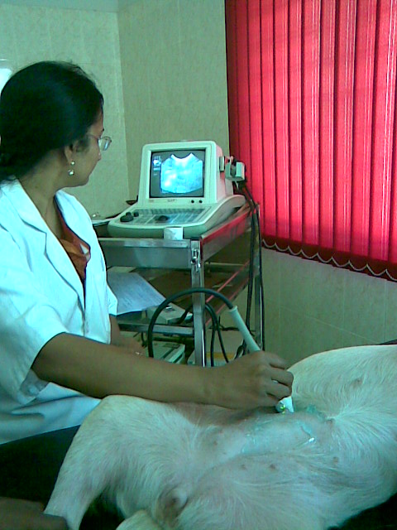
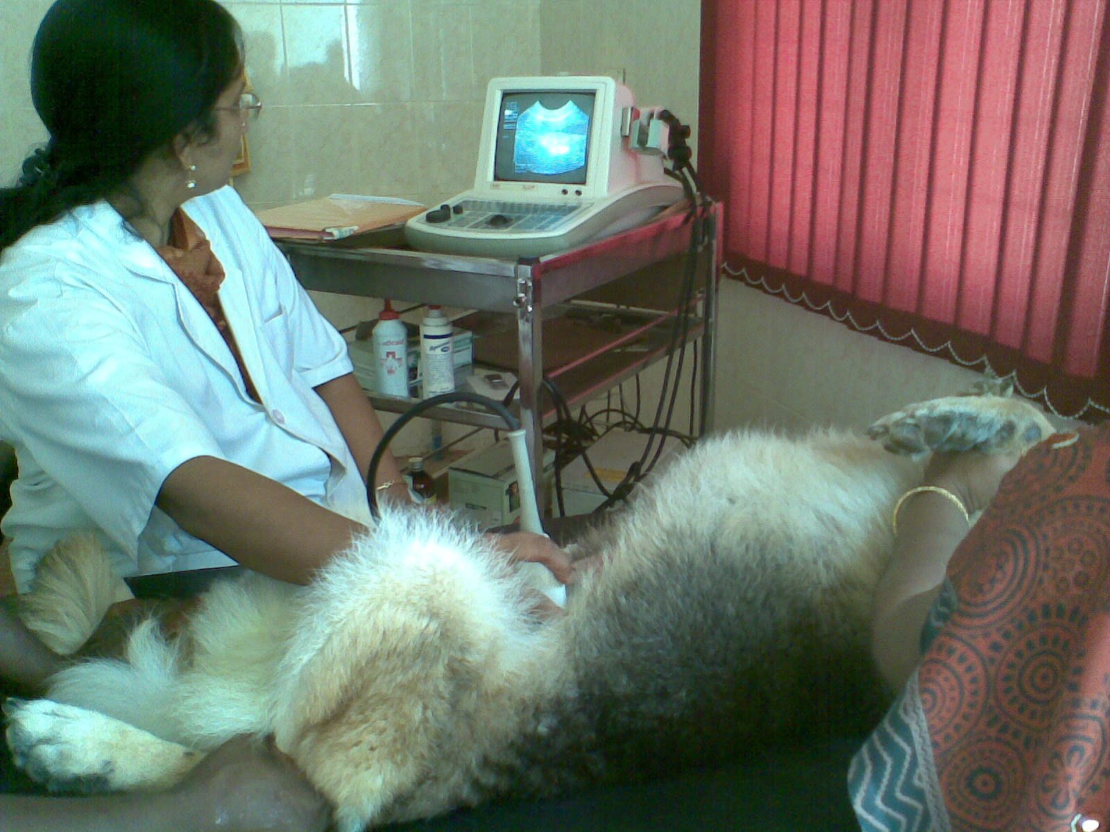

Figure: Diagnosis of pyometra with ultrasound.

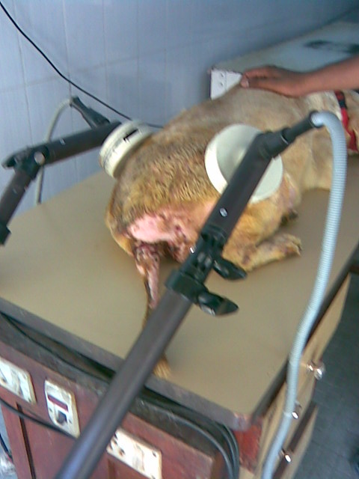
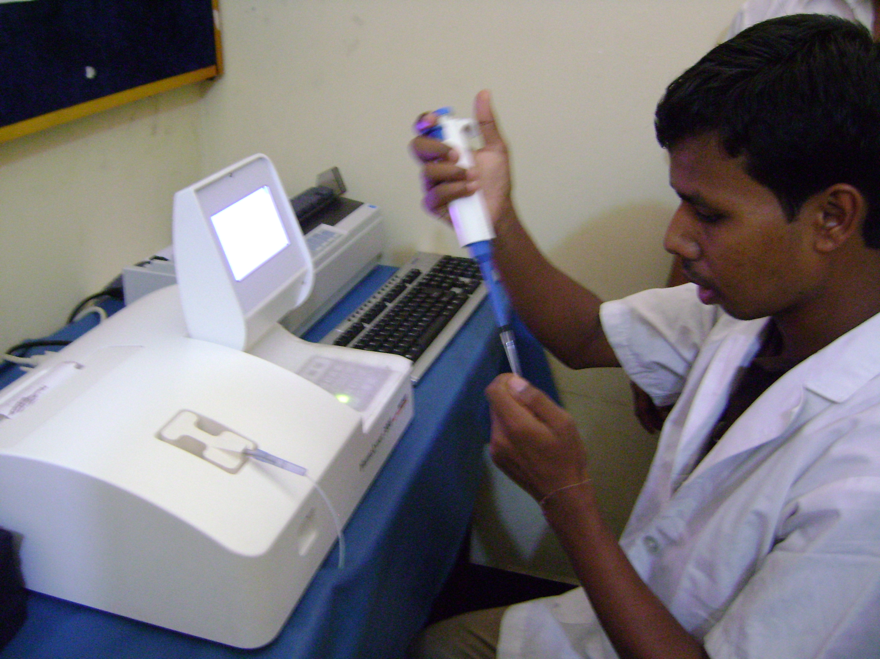

Fig: Treatment of abscess patient Fig: Determination of total protein with
With Diathrapy auto-biochemical analyzer (Humalyzer)

Chapter 4

RESULTS AND DISCUSSION

4.1 Group one (pyometra of Dog):
In group one the patients (bitchs) state some clinical sign as animals has been lethargic with a reduced appetite. Increase thirst and vomiting are irregularly. The bitch was in oestrus a few weeks prior to the illness. There was a vulvar discharge, owner may considered this to be a continuation of oestrus. The abdomen of bitch distended, this is associated with improvement in the general health. It like to be pregnant. The temperature was normal or slightly elevated. There was intermittent opening of the cervix, with relative good health following the discharge of pus. the discharge has thin consistency, light chocolate brown in colour and characteristic odour. The vulva was enlarged and there was discoloration or blistering of the perivulval tissues.

According to the clinical sign the cases tentatively diagnosed as the case of pyometra. For the confirmatory diagnosis and to know the harematological change in pyometra blood sample was collected. Confirmatory diagnosis also done by the ultrasonograpyh
The findings of blood parameter psychoanalysis as follows.
Table: The Haemograms in pyometra in the dog.
SL  No | Breed | Age  (years) | Clinical  Comment |  | PCV  % | TLC  (Thousand  /mm³) | TEC  (mi/  mm³) | DLC% |  |  |  |  | ESR | Hb | TP  gm/  100ml
 |  |  |  |  |  |  |  | E% | M | N | L | B | ESR | Hb | TP  gm/  100ml
1 | Spize | 4 | pyometra |  | 44.8 | 15.5 | 5.24 | 2 | 0 | 88 | 10 | 0 | - | 17.5 | 8.5
2 | Spize | 5 | pyometra |  | 36 | 21.2 | 5.47 | 2 | 0 | 88 | 10 | 0 | - | 12 | 7.12
3 | German  shapard | 5.25 | pyometra | 40 |  | 19.2 | 6.63 | 3 | 0 | 87 | 9 | 0 | - | 13.2 | 7.36
4 | Dalmatin | 4 | Pyometra |  | 41 | 15.7 | 6.84 | 1 | 0 | 87 | 12 | 0 | - | 13.5 | 8.6
5 | 6  years | 6 | pyometra |  | 37 | 18.73 | 6.6 | 2 | 0 | 86 | 12 | 0 | - | 12.5 | 7.21
 |  |  | Mean ±  Standard  deviation |  | 39.76±  3.49 | 18.086±  2.42 | 6.15±  0.741 | 2±  0.7 |  | 87.2  ±  0.83 | 10.6±  1.34 |  |  | 12.6  ±  0.72 | 7.7±  o.7

E=Eosinophil N=Neutrophil L=lymphocyte M=Monocyte, B=Basophil.
TP= Total protein BUN= blood urea nitrogen.
The table shows the haematological parameter of dog affected with pyometra.

The highest value of PCV was (44.4) and the lowest value of PCV (36). In case of pyometra according to the (Asheim, 1964; Renton, et al., 1971) the PCV range (36-40) may accompany pyometra. The study as well illustrate that. The PCV value not more than normal (37-55%) value but it was higher (39.76±3.49% ), that significantly prop up the pyometra.
The highest value of leukocyte was (21.2thousand/mm3) and lowest value (15.5thoisand/mm3). According to the (Børresen, 1980) characteristically leucocytosis with neutrophilia found in case of pyometra. The study also demonstrate that. Because the normal value of neutrophil were (60-70%) but the study value were (87.2±0.83%).

According to the ( Khuen et al.,1940) the total number of leukocyte is frequently elevated in case of pyometra. Study also reveled, in case of pyometra total leukocyte count increase (18.086±2.42thuosand/mm³) than the normal value(12-18 thousand/ mm³).
The highest value of total protein (8.6g/dl) and lowest value was (7.12g/dl).
According to the (Børresen, 1980) in case of pyometra hyperprotenimia due to
hyperglobulinemia was found. The study also reveled that. The normal value of total
protein in dog (5.4-7.6gm/100ml), but the demonstrated value was
(7.7±0.7gm/100ml).
The highest value of erythrocyte (6.6million/mm3) and lowest value (5.24million/mm3). According to (De Schepper, Van Der Stock & Capiau, 1987). Erythrocyte number in pyometral case lower than the normal value (5-9million/mm3). Though the study value was not lower than normal value but it nearby to the lowest value.
The highest value of haemoglobin (17.5g/dl) and lowest value (12g/dl). The study value within the normal (12-17g/dl).

4.2 Group two (Uroliyhiasis of goat)
In group two 2 patient was handle . The patient show the symptoms, frequent attempt to urinate but only a few drop of urine with blood- tinged pass each time. patient was restless and exhibit sever pain on palpation. Animals loss of appetite. On the basis of these clinical findings catherization was done. In catherization cather passing obstructed. That indicate calculi in the urethra. After that findings blood sample was collected to confirmatory diagnosis of the disease and to know the haematological change.

4.3 Differential diagnosis:
Obstruction of the urethra in goat is almost always caused by a calculus and is characterized clinically by anuria or dribbling, swishing of the tail, abdominal pain with kicking at the abdomen or stamping the feet, and a progressively worsening condition.
Non obstructive urolithiasis may be confused with pyelonephritis or cystitis, and differentiation only by radiographical examination.

Breed | Age  years | Clinical  comment | PCV  % | Hb  g/dl | TLC  (Thousand/  ^{mm3}) | TEC  (mi/  ^{mm3}) | DLC% |  |  |  |  | TP | BUN
 |  |  |  |  |  |  | E | M | N | L | B | TP | BUN
Black  bangle | 1.7 | urolithiasis | 37 | 12.52 | 11.7 | 9.23 | 2 | 1 | 43 | 54 | 0 | 5.5 | 34
Jamu-  napari | 2 | urolithiasis | 42 | 14.32 | 13.51 | 13.4 | 2 | 2 | 35 | 61 | 0 | 5.31 | 32
 |  |  | 39.5±  4.53 | 13.42  ±  1.27 | 12.6±  1.27 | 11.3±  2.9 | 2 | 1.5±  o.7 | 34± | 62.5±  4.94 |  | 5.4±  0.13 | 33±  1.41
Table :Haemograms in urolithiasis in the Goat.

The table shows the haematological parameters of goat affected with urolithiasis.
The highest value of blood urea nitrogen (34gm/100ml) and lowest value (32gm/100ml). According to Amalendu Chakrabarti (2006) in case of urolithiasis blood urea nitrogen level increase. The study also demonstrated that. The normal level of blood urea nitrogen in goat (20-30mg/100ml) but the estimated value is (33±1.41mg/100ml).
The highest value of erythrocyte (13.4 million/mm3) and lowest value (9.23 million/mm3). According to the Kallfelz, F. A. et al.(1987) in case of urolithiasis erythrocyte level remain normal. The study also illustrated that. The normal value of RBC in goat was (8-18 million/mm3), and the estimated RBC value was (11.3±2.9Million/mm3).
The highest value of leukocyte (13.51 thousand/mm3) and lowest value (11.7thousand). According to the Kallfelz, F. A. et al.(1987) in case of urolithiasis leukocyte level increase that is leucocytosis. The study also illustrated that. The normal level of leukocyte in goat was (8-12 thousand/^{mm3}) and the estimated leukocyte value was (12.6±1.27thousand/mm3).

The highest value of total protein (5.5gm/100ml) and lowest value (5.31gm/100ml).
According to the Chauhan (1995), in case of urolithiasis total protein level decrease that is hypoprotenimia. The study also demonstrated that. The normal level of total protein in goat was (6.25-6.5mg/100ml) and the study value of total protein was (5.4±0.13mg/100ml).
The highest value of PCV (42%) and lowest value (37%). The study value increase than the normal value.

4.4 Group Three ( abscess of dog):
In group three 6 patient was handle. the patient had superficial abscesss in the perineal region, thigh muscless. That was developing superficially at first as a localized, painful, inflammation swelling in the perineal region, and the swelling region feel warm, tender and tense. The tip of the swelling less tense. An irregular fluctuation was detected by palpation. center of the swelling become softer and the skin at this point was thin. Confirmatory diagnosis was done by explorsation of pus with needle. After the confirmatory diagnosis and before the surgical correction of abscess blood sample was collected to know the haematological change due to abscess. Abscess was differentiate from cyst, haematoma, tumours, and Hernia.

Table : Haemograme of abscess in the dog.
Breed | Diseases | Age  (years) | PCV  % | Hb  g/dl | TLC  (Thousand/  mm³) | TEC  (million/  mm³) | DLC% |  |  |  |  | ESRR  in mm 1st ^{t} hour | TP(gm  /dl)
 |  |  |  |  |  |  | E | M | N | L | B | ESRR  in mm 1st ^{t} hour | TP(gm  /dl)
Spize | Abscess | 3.5 | 21 | 7.05 | 22.4 | 3.46 | 1 | 2 | 87 | 10 | 0 | - | 4.06
ND | Abscess | 4.1 | 22 | 7.36 | 21.56 | 3.56 | 1 | 2 | 86 | 11 | 0 | - | 4.05
Lab | Abscess | 6 | 21 | 7.03 | 23.42 | 3.53 | 2 | 3 | 85 | 10 | 0 | - | 4.03
ND | Abscess | 3 | 28 | 9 | 7.8 | 5.34 | 2 | 2 | 68 | 28 | 0 | - | 6.1
Dalmatian | Abscess | 7 | 23 | 7.6 | 22.45 | 4.56 | 1 | 2 | 87 | 10 | 0 | - | 4.02
ND | Abscess | 4 | 23 | 7.7 | 19.3 | 4.63 | 1 | 2 | 86 | 11 | 0 | - | 4.02
 |  |  | 23±2.6 | 7.62±  0.72 | 19.4±5.89 | 4.18±  0.77 | 1.3  ±  o.5 | 2.16  ±  0.4 | 83.1  ±  7.46 | 13.3  ±  7.6 |  |  | 4.38±  0.84

The highest value of neutrophil (87%) and the lowest value (68%). According to the (Pollack, et al. 1956) infection with pyogenic organism and in large abscess, may produce a marked neutrophilia. The study also demonstrated that. The normal value of neutrophil (60-77%) but the study value was higher (83.1±7.46%). As the lowest study value (68%) it may be not infected with pyogenic organism.

The highest value of leukocyte (22.45 thousand/^{mm3}) and the lowest value (7.8 thousand/^{mm3}). According to the (Blood, et al. 2000) in case of abscess produce leucocytosis. The study also illustrate that. The normal value of leukocyte were (6-18thousand/ ^{mm3}) but the study value were (19.4±5.89 thousand/^{mm3}. The lowest value of leukocyte within the normal range.
Chapter 5

CONCLUSION

The study was conducted to know the process of diagnosis of diseases by analyzing the blood parameters of patients. In case of pyometra leucocytosis with neutrophilia and increase level of PCV correlate with tentative diagnosis. In urolithiasis case, haematological and biochemical findings show a relationship with reference value. In case of abscess though there was not so significant change but there was leucocytosis and neutrophilia that the land marks of abscess diagnosis with haematological analysis..

Chapter 6

REFERENCE

Anon. (2003). Economic Review. Livestock Sub-sector, Directorate of Livestock service (DLS), Bangladesh.191-193.
Asheim, A. (1964). comparative pathophysiological Aspect of the Glomerulonephritis Associated with pyometra in dog. Acta vet. Scand.,5:188,1964.
Blood, D. C., Radostitis, O. M., Gay, C.C. and Arundel, J. H. (2000). Diseases of the urinary system. In : Veterinary Medicine, A text book of the Diseases of cattle, Sheep, Pigs, Goats and Horses, 9th edition. Bailliere Tindall Ltd. The University Printing House, Oxford, 24-28 Oval Road, London NW17DX, 493-499, 1877
Bloom, Frank. (1944). The blood and bone marrow pyometra. North. Am. Vet. (25): 483. 84. 486. 488.
Børresen, B. and Skrede, S. (1980). Pyometra in the dog - a pathophysiological investigation. V. The presence of intrahepatic cholestasis and “acute phase reaction”. Nordisk veterinary medicine.( 32): 378-386.
Børresen, B. (1975). Pyometra in the dog - a pathophysiological investigation. I. The pyometra syndrome, a review. Nordic veterinary medicine .(27): 508-517.
Børresen, B. (1979). Pyometra in the dog - a pathophysiological investigation. II. Anamnestic, clinical and reproductive aspects. Nordic veterinary medicine. ( 31): 251-257.
Børresen, B. (1980). Pyometra in the dog - a pathophysiological investigation. ІV. Functional derangement of extragenital organs. Nordic veterinary medicine. (32): 255-268.
Buczek, J. (1984). Localize infection and inguinal abscess. Med. Wet., (40): 643- 707.
Capiau, E. De Schepper, J. and Van Der Stock, J. 1987. Renal failure and serum enzymes in 127 dogs with pyometra. Vlaams diergeneeskundig tijdschrift. (56): 214-220.
Chakrabarti, A. (2006). Disease of the urinary system. Clinical Veterinary Medicine. 3rd revised and enlarged edition. 396-405.
Chauhan, R. S. (1995).Text Book of Veterinary clinical and laboratory diagnosis,184-185.
De Schepper, J., Van Der Stock, J. and Capiau, C. (1987). The characteristic pattern of aspartate aminotransferase and alanine aminotransferase in the bitch with the cystic endometrial hyperplasia - pyometra complex. Effect on medical or surgical treatment. Veterinary research and communications .(11). 65-75.
Dimopoullos, G. T. and Cunningham, C. H. (1961). Electrophoretic and serum neutrilization infection bronchitis of chicken.Amer. J. Vet. Res. (17): 755.
Dow, C. (1958 ). Infertility in Bitch vet. Rec. (70):1102.
Dow, C.(1959a) J. Comp. Path. (69): 237.
Dow, C.(1959b) J. path. Bact.(78):267.
Ettinger, S.J. (2001). Urinary Obstruction and Functional Urine retension. In: Pocket Companion to Text Book of Veterinary Internal Medicine, Third edition. W.B. Saunders Company, USA.493-496.
Fidler, I.J., Brodey, R.S., Howson, A. E. and Cohen, D. 1966. Relationship of oestrus irregularity, preudopregnancy, and pregnancy to canine pyometra. Journal of the American veterinary medical association (149). 1043-1045.
Gretillat, S. (1976). variation in the blood picture of red Maradigoat as a function of its gastrointestinal parasitism. Act a tropica 33(3):240-245.cited in Vet. Bull,47 (4 :2128).
Groulde, P. (1965a).Clinique canine. Librairie Maloine, S. A., Paris. vol. (1): 9.

Gustafasson, B. E. and laurel, C. B.(1958). Gamma Globulins in germ free Rats. J. Exp. MED, 108: 251.
Hardy, R.M. and Osborne, C.A. (1974). Canine pyometra: pathophysiology, diagnosis and treatment of uterine and extra-uterine lesions. Journal of the American animal hospital association (10): 245-267.
Hhuen, E. C., Park, S. E. and koestner, A. (1977). Amer. J. Vet. (21):666.
Holman, H.H. and S. M. DEW. (1966). The blood picture of the goat. V. Variation due to season, sex & reproduction. Res. Vet. Sci.( 7): 276-286.
Kallfelz, F. A. (1987) Disease of urinary system. Cornell Vet. (77): 33.
Marshak, R.R. (1962). Studies on Bovine lymphosarcoma. I. clinical Aspects pathological alterations, and Herd-studies.Cancer Res.(22):202,1962 Abst.J.AmVet. Med. A,140:942.
Morris , M. L., Allison, J. B. and white, J. I.(1942) Amer. J. Vet. Res.(3):100.
Niskanen, M. and Thrusfield, M.V. (1998). Associations between age, parity, hormonal therapy and breed, and pyometra in Finnish dogs. The veterinary record (143): 493-498.
Oscar, W. Schalm.(1965). Veterinary Haematology,451,456,460.

Pollack, S. (1956). prostatic abscess in the dog. J. Am. Vet. Med. Assoc. 129:274. 75.
Renton, J. P. Douglas, T. A., and Watts, C. (1971). pyometra in the Bitch. J. Small Anim. Prac. (12): 249.
Riser, W. H. (1947). The Behavior of the peripheral Blood Elements in Panleukopenia (Agranulocytosis)of the domestic cat. Amer. J. VET. Res., 8:82.
Schalm, O.W. (1962). Leukocyte Response to Disease in various Domestic Animals. J.Am.Vet.Med (.140): 557.
Sevelius, E., Tidholm, A. and Thorén, K. (1990). Pyometra in the dog. Journal of the American animal hospital association( 26): 33-38.
Shastry, G. A.(1983). Veterinary clinical pathology. 3rd edition., CBS publishers and distributors, New Delhi.
Sheridan, V. (1979). Vet. Rec. (104):417.
Sieracki, J. C. (1955). The neutrophilic leukocyte.Ann.N.Y.Acad.sci, (59):690.
Stone, E.A., Littman, M.P., Robertson, J. L. and Bovée, K. C. (1988). Renal dysfunction in dogs with pyometra. Journal of the American veterinary medical association 193, 457-464.
Talanti, S. (1959). Observation on pyometra in dogs, with Reference to the hypothalamic-hypophysial Neurosecretory System. Amer. J. Vet.Res. (20): 41.
Thomas colville, Joanna M. Bassert (1958) clinical Anatomy and Physiology for Veterinary Technicians, 2nd edition.233.
Vanugopalan, A. (2000) Part 1-General surgery. Essentials of Veterinary Surgery. Eighth edition. 95-97.
Wheaton, L.G., Johnson, A.L., Parker, A.J. and Kneller, S.K. (1987). Results and complications of surgical treatment of pyometra: a review of 80 cases. Journal of the American animal hospital association (25): 563-568.
Whitney, J. C. (1969). polydipsia and its relationship to pyometra. J. Small Anim. Pract., (10):48

APPENDIX

A RECORD KEEPING DATD SHEET

Data sheet during examination of the animal
Owners name :…………………………………………………………………
Address : ……………………………………………………………………..

Vill: ………………. Thana :…………………Dist:……………
Registration no :………………………………
Date :………………………………
PATIENTS DESCRIPTION:
Species :……………………..
Sex :………………………
Breed :………………..
Age :………………………
Body weight :…………….
Owner’s complaint :
Feeding habits: ………….
Clinical findings :………………

Tentative diagnosis :…………….

Blood collection :……………………..

…………..
Signature

