Haematological Analysis of Some Surgical Cases of Goat (Urolithiasis) and Dog (Abscess and Pyometra)

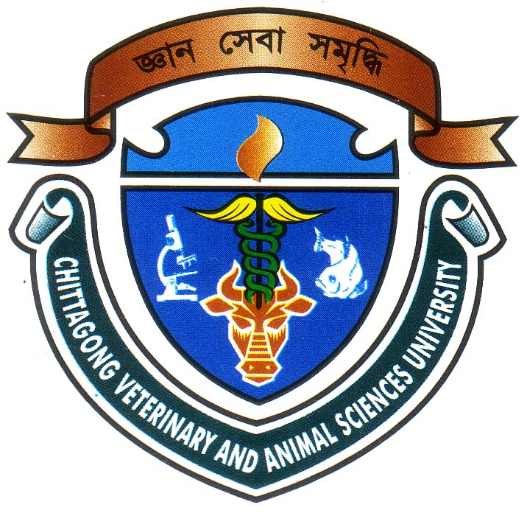

A Clinical Report submitted as per approved style and content

A partial fulfillment for the degree of Doctor of Veterinary Medicine (DVM)

………..............…………
Supervisor
Dr. S. K. M. Azizul Islam.
Assistant Professor
Department of Physiology, Biochemistry and Pharmacology
Chittagong Veterinary and Animal Sciences University, Khulshi, Chittagong

……………………….
Author
Name: Anukul Chandra Sen
Roll No: 2003/39
Reg. No: 135
Intern ID: H- 37
Date of submission: 18 June.

Haematological Analysis of Some Surgical Cases of Goat (Urolithiasis) and Dog (Abscess and Pyometra)

A Clinical Report Submitted By

Roll No: 2003/39
Reg. No: 135
Intern ID: H- 37
Session: 2002 – 2003

Report presented in partial fulfillment for the Degree of

Doctor of Veterinary Medicine (DVM)

Faculty of Veterinary Medicine
Chittagong Veterinary and Animal Sciences University
Khulshi, Chittagon-4202
June’ 2009

