food, feeding and grooming behavior of large indian
Civet (Viverra Zibetha) in captivity
at Chittagong Zoo.

a report submitted By:
Roll No: 2003/20
Reg. No.: 116
intern id: d-18
Session: 2002-2003

REPORT SUBMITTED in partial fulfillment for the
degree of DVM (doctor of veterinary medicine)

faculty of veterinary medicine
Chittagong veterinary and animal sciences
university, ctg.

april, 2009.

food, feeding and grooming behavior of large indian
Civet (Viverra Zibetha) in captivity
at Chittagong Zoo.

Approved as to style and content

...........................................
Shahnaz Sultana (Supervisor)
Assistant Professor
Department of Basic Science
Chittagong Veterinary and Animal Sciences University
Chittagong

date of submission: 22.04.09.

Acknowledgement

I am very much grateful and express indebtedness to my Supervisor Shahnaz Sultana, Assistant Professor, Department of Basic Science, CVASU, for suggesting the problems, kind information co-operation, advice, heartfelt help, sympatric encouragement, supervisor, valuable suggestions and guidance.

I thank Associate professor, Ashraf Ali Biswash, Director of External Affairs, Department of Animal Science and Animal Nutrition, CVASU, for providing the important information.
I am grateful to Prof. Dr. Matin Pradhan, Dean, Faculty of Veterinary medicine for providing me facilities during the study.

I express my gratitude to the authority of Chittagong Zoo for giving permission me to work at the zoo.

I am also grateful to Dr. Md. Monjur Morshed Chowdhury, Curator, Chittagong Zoo, Chittagong who extended kind co-operation, advice, suggestions and provided other necessary facilities during my research work.

My heart-felt thanks goes to Dr. Md. Monjur Morshed Chowdhury, Curator, Chittagong Zoo, Chittagong for taking photographs for this research work.

I also express my gratitude to all the staffs of Chittagong Zoo for their help during my research study.

My heart felt gratitude goes to my beloved parents, brothers and maternal uncles for their encouragement, advice and financial supports.

I am also thankful to all my friends, well wishers and my roommate Razibul and Yasin, Subroto for their inspiration and help.

I am thankful to my friend Md. Razibul Alam to give me some advice during my research work.

I am thankful to Subrata Dey for his earnest help in all computers processing of this work.

The Author
Contents

Chapter Title Page NO.

- Title Page 1
- Recommendation 2
- Acknowledgement 3-4
- Content 5
- List of Tables 6
- List of Figures 7
- List of Plates 8
- abstract 9

Chapter 1: Introduction

1.1 General 10
1.2 Aims and Objectives 11 Chapter 2: Study area

2.1 Introduction 12
2.2 Civet Cages 12

Chapter 3: Materials and methods

3.1 Introduction 15
3.2 Study Animal 15
3.3 Equipment Used 15
3.4 Length-weight Measurement 15
3.5 Measurement of Food Consumption 16
3.6 Grooming Behavior 16
3.6.1 Self Grooming 16 3.6.2 Social Grooming 16

Chapter 4: Observations, Results and discussion

4.1 Introduction 18
4.2 Length-weight Measurements 18
4.3 Food Supplied 18
4.4 Feeding Behavior 18-19
4.5 Food Consumption 19-20
4.6 Grooming Behavior
4.6.1 Daily Time Spent Grooming 20
4.6.2 Hourly Time Spent Grooming 20

Chapter 5: References 27-28

Chapter 6: Appendices 29-32

List of Tables

Sl. No. Title Page NO.

  - Field work schedule 20
  - Measurements of large Indian Civet at Chittagong Zoo 20
  - Foods supplied to the large Indian Civet at Chittagong Zoo 21
  - Food items supplied (per day) for 2 Civet at Chittagong Zoo 21
  - Food consumption by Civet at Chittagong Zoo 21

List of Figures

Sl. No. Title Page NO.

2.1A Map of Bangladesh (B) Map of Chittagong district showing the study area 13
2.2 Schematic map of Chittagong Zoo 14
4.1a Daily maximum time spent in self grooming different areas of the body 22
4.1b Daily minimum time spent in self-grooming different areas of the body 22
4.2a Daily maximum time spent in social grooming different areas of the body 23
4.2b Daily minimum time spent in social-grooming different areas of the body 23
4.3a Hourly maximum and minimum time spent in self grooming by
large Indian Civet 24

4.3b Hourly maximum and minimum time spent in social grooming by 24
large Indian Civet

List of plates

Sl. No. Title Page NO.

Plate 3.1 Total length measurements of large Indian Civet by a measuring tap 17
Plate 3.2 Tail length measurements of large Indian Civet by a measuring tap 17
Plate 4.1 Supplied food items of large Indian Civet 25
Plate 4.2 Rejected food items of large Indian Civet 25
Plate 4.3 Cage with large Indian Civet 26

Abstract

Length-weight measurements, food and feeding behavior of large Indian Civet(Viverra zibetha) are carried out at Chittagong Zoo, Chittagong, during December to February 2008-2009. A group of two Civet individuals was studied. The study was based generally on two days observations in a week. The total length weighed and food and feeding behavior were noted by direct observations and measurement. The food items generally supplied to the Civet at Chittagong Zoo are beef only. The average food consumption was 350 gm per day per animal and this is about 5.12% of body weight. When the large Indian Civet see the caretaker coming with their foods, they come down from the platform and/or sitting places and make a to and fro movements on the floors of the cages. They drank water before and after feeding. Self-grooming includes scratching of its own skin and hair roots. In social-grooming the individuals scratch skin and fur of one another.
Chapter 1: Introduction

  - General
Bangladesh supports two species of civet, these are the large Indian Civet (Viverra zibetha) (Husain 1974, Khan 1982, Sarker and Sarker 1988).

Large Indian Civet (in Bangla called “Bagdhas”), (Carnivora: Mammalia), is a small slender animal with short legs and small rounded external ears (pinnae) located at the side of its head. Body is covered with fur, usually dark brown with golden flecks; but it may vary seasonally and individually. The tail is dark brown and is at least one-third of its body length. It is primarily insectivorous though it also feeds opportunistically on small vertebrates (Cavallini and Serafini 1995).

The large Indian Civet is well known for its aggressive hunting behavior. It eats rodents and snakes, such as cobra (Naja spp.). Civet is used as a biological pest control agent because they are known to prey mainly on rates and mice. But their predatory habits often disrupt the ecosystems into which they are introduced (Microsoft Encarta Encyclopedia 2007).

The large Indian Civet is distributed to Northern Indian from Kashmir to Bengal, Orissa and Assam extending eastwards into Burma and the Malay countries and westwards into Afghanistan, Baluchistan, Persia and Mesopotamia (Prater 1980). In Bangladesh it is widely distributed throughout the country (Husain 1974; Khan 1982, 1985; Sarker and Sarker 1988).

Food consumption and feeding behavior of large Indian Civet have been studied by several workers in different parts of the world (for e.g., in Hawaii: Pemberton 1925, 1933, Dotty 1945; Puerto Rico: Wolcott 1953, Pimental 1955; Carribean Islands: Seaman 1952, Nellis and Everad 1983; Trinidad: Urich 1931).

  - Aims and Objectives
The aims and objectives of present work were to study:
- Length-weight measurements of the species in captivity;
- Food and feeding habit; and
- Grooming behavior.
Chapter 2: Study area

  - Introduction
Chittagong Zoo (22°22’ N and 91°48’ E) is situated near to Foy’s lake at Pahartoli under Khulshi Police Station within Chittagong District (Fig. 2.1). It is about 6km north-west of the Chittagong City Centre (for details see Saha 2001).

There are 67 species (Appendix 1) being displayed in the Chittagong Zoo of which Small Indian Civet is one of them.

2.2 Civet Cages
There are two cages (large cage and small cage) in which the large Indian Civets have been kept. The length of the large cage is 831.25 cm, width 373.75 cm and height 288.75 cm. It has been made by corrugated iron sheets. Inside the large cage there is two resting platform (Fig. 2.2). The length of the small cage is 258.75 cm, width 145 cm and height is 143.75 cm. There is no platform inside the cage.

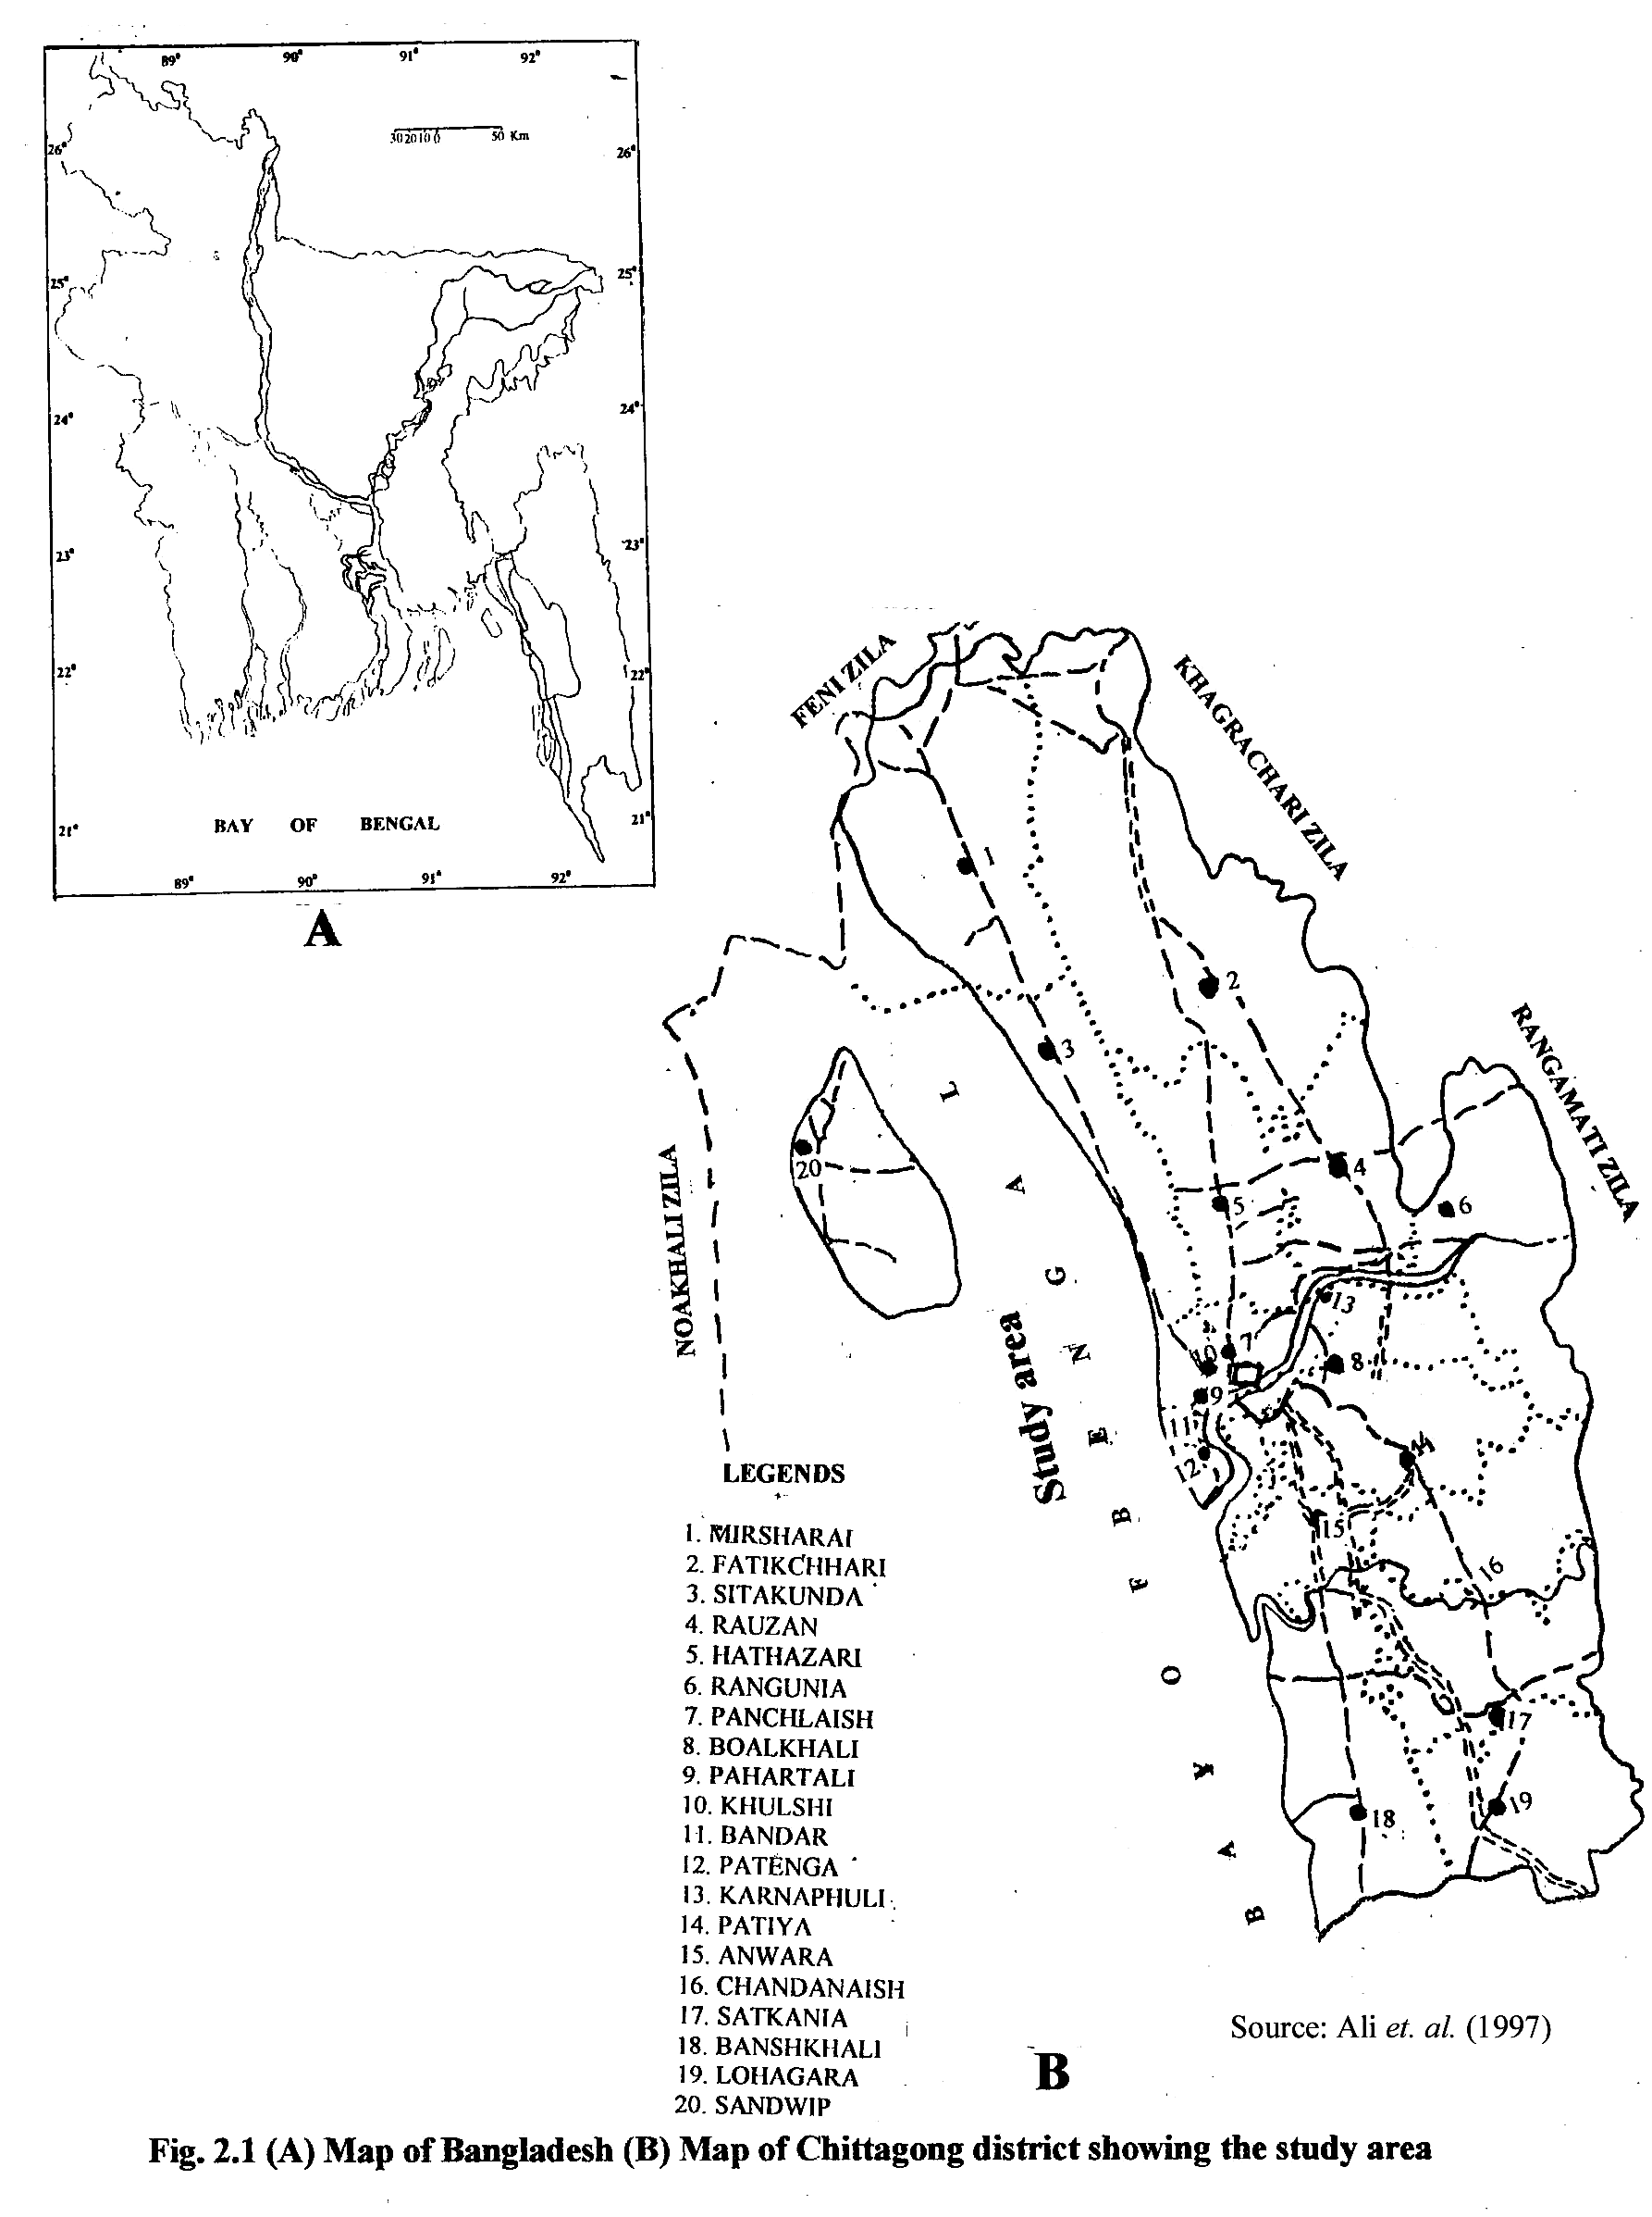
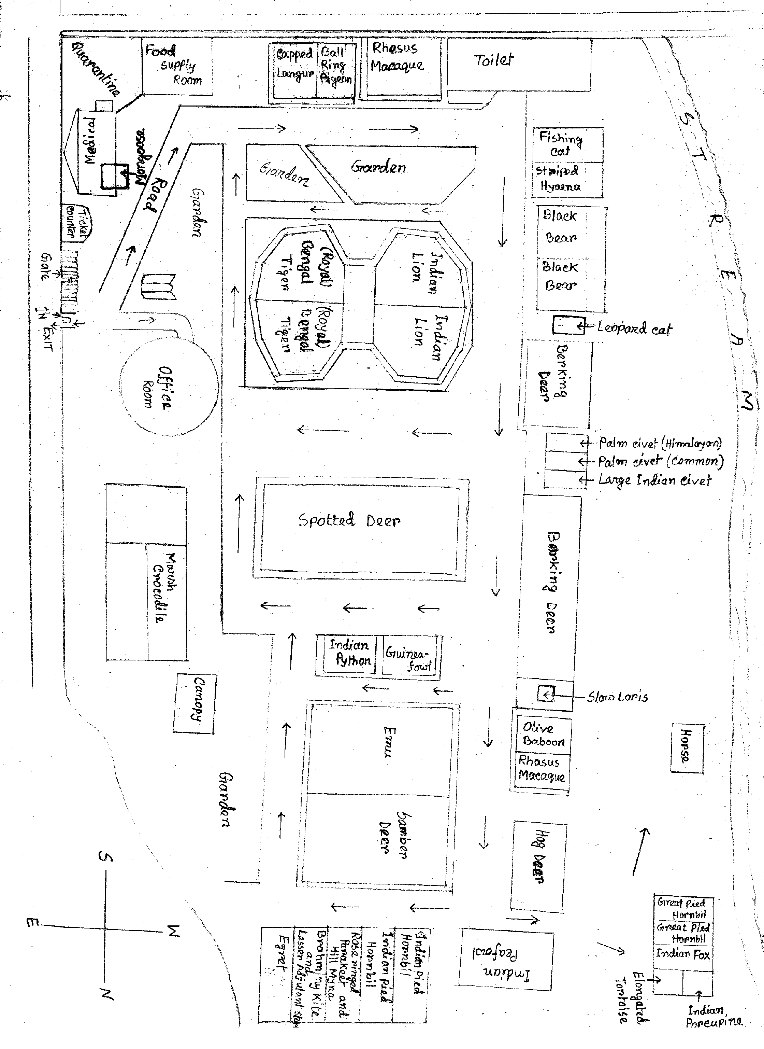
Fig. 2.2 Schematic map of Chittagong Zoo
Chapter 3: materials and methods

3.1 Introduction
Length-weight measurements, food and feeding behavior, and grooming behavior of The large Indian Civet were studied in captivity at Chittagong Zoo, Chittagong during December to February 2008-2009.

3.2 Study Animal
There were two individuals of large Indian Civet inside one cage at Chittagong Zoo.

3.3 Equipment Used
The following equipments were used during this study:
    - one note book
    - pencil and eraser
    - tray
    - balance
    - gloves
    - scale
    - camera
    - One calculator.

3.4 Length-weight Measurement
Total length and tail length were measured by a centimeter scale. First the keeper holds one Civet and then measurements were taken. Similarly the other Civet was measured. Weight was determined by weighing Civet with the help of a single pan balance. Cage with one Civet and empty cage were weighed separately and then deducted the later from the former. The other Civet was weighed in similar way.

3.5 Measurement of Food Consumption
One type of food item is supplied (beef) to the Civet over the trays placed inside the cages. Foods are supplied at Chittagong Zoo in the afternoon during 1600 to 1700 hours, so the observations were noted from 1600 hours and continued until 1800 hours.

Foods was weighed using local commercial balance before supplying to the Civet and left-over food was removed and weighed again after 24 hours to find the total consumption of food. Feeding techniques and feeding behavior were noted in long notes through direct observations.

  - Grooming Behavior
Grooming behavior of Small Indian Civet is a part of daily activities. Scan sampling methods (Altman 1974) were followed at 10 min intervals. Ten minutes interval ensures that each scan is individual and independent. Two types of grooming behavior, self and social, were considered in this study and these were, recorded after feeding time.

    - Self Grooming
It means actively grooming or scratching its own skin or roots of hair. The self grooming areas considered for this study was belly, leg and tail.

    - Social Grooming
It means an individual scratching fur of another one. The considered social grooming areas were head, belly, leg and tail.

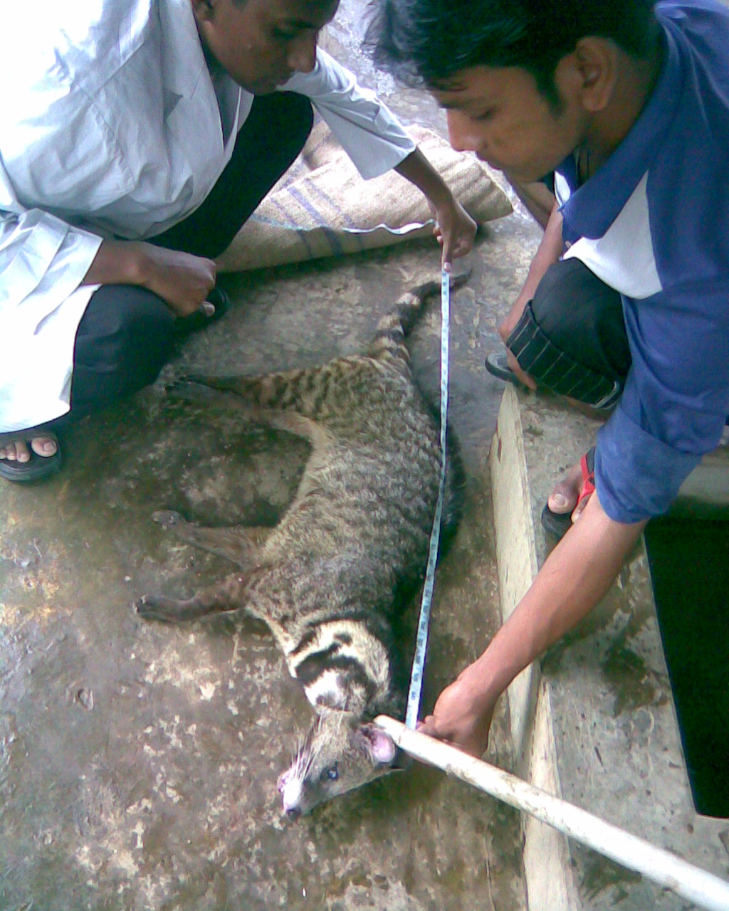
Plate 3.1 Total length measurements of large Indian Civet by a measuring tap

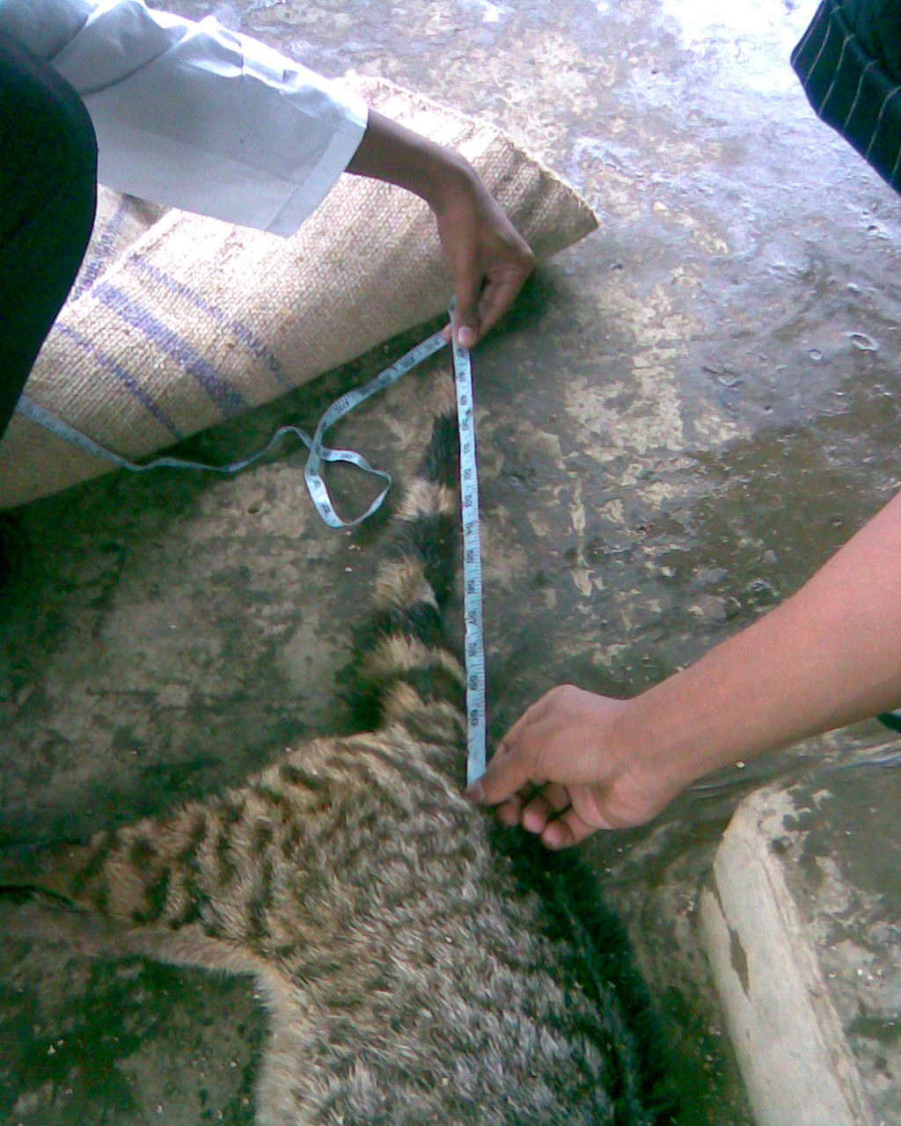

Plate 3.2 Tail length measurements of large Indian Civet by a measuring tap
Chapter 4: Observations, results and discussion

4.1 Introduction
Data were collected on Civet in captivity at Chittagong Zoo over ten to thirteen days in each month during December to February 2008-2009 (Table 4.1).

  - Length-weight Measurement
The measurements of the studied Civets have been presented in table 4.2, which reveals that they slightly gained weight at the end of the study period. The total length of large Indian Civets is 114.3 cm (Prater 1980) and weighed 6.350 kg (range 6.250-6.450 kg) (Sarker and Hiren 1993).

  - Food Supplied
Only one type of food is supplied to the large Indian Civet at Chittagong Zoo during 1600 to 1700 hours (Table 4.3). The quantity of food items supplied (per day) for two Civets is given in Table 4.4.

  - Feeding Behavior
Feeding behavior was observed in both cages. Civets move randomly within the cages and sit over the hanging platform and/or in the corner of the cages. When they see the caretaker to carry the foods they come down from the platform and/or sitting places and make a to and fro journey on the floors of the cages.

Large Indian Civets preferred cattle beef. Sometimes they ate the bones.

During feeding they sit down on their bellies and held a single piece of food by their forelegs and then put it straight into the month. The first feeding bout is 10 to 15 minutes after supplying the food and then they take a rest for 5 minutes or so, or walk within the cage.

After having a good meal civet clean their claws by licking with tongue.

Civet was observed to drink water from the supplied bowl before and after meal. In captivity, Civet depends on supplied foods and do not have alternative choice, so, there is very little amount of food left unused in the cages.

Sometimes it was observed that they stand on their hind legs and move their head and neck to see around.

  - Food Consumption
The Civet is a nocturnal omnivore. Its primary food source is fruit such as chiku, mango, and rambutan. It will also eat small mammals and insects. It also has a fondness for palm flower sap which, when fermented, becomes toddy, a sweet liquor. It inhabits forests, parks and suburban gardens with mature fruit trees, fig trees and undisturbed vegetation. Its sharp claws allow it to climb trees and house gutters.

On average, 700 gm of food was supplied to 2 Civet i.e., 325 gm for each individual which was 5.12% of its body weight (Table 4.5). The main food items of civet is meat

Prater (1980) reported that it feeds on anything it can kill like rats, mice, scorpions, centipedes, wasps and insects of all kinds. It also feeds on all kinds of small mammals (Boitani and Bartoli 1986). The large Indian Civet is a pest controlling agent. It was first introduced into the Caribbean Island for the purpose of controlling rats, which caused considerable damage to the sugarcane plantation (Espeut 1982). The Civet is highly predacious and has been reported to feed on vertebrate matters such as toads and frogs, lizards, birds and small rodents (Gorman 1974).

Dotty (1945) reported that the fights between rats and the large Indian Civet. He (1945) also mentioned civet always grabbed the rat by the back of the neck and then it pierced the long sharp teeth through the neck and began to crash the rat’s bones.

William (1918) reported the food items of the species as insects, spiders, snails, slugs, frogs, lizards, snakes, birds, eggs of birds and reptiles, all kinds of rodents, crabs, fish and fruits. Blanford (1888) reported that the Small Indian Civet is an excellent rat-catcher soon clearing a house of rats and mice.

4.6 Grooming Behavior
4.6.1 Daily Time Spent Grooming
Large Indian civet spent highest percentage of time in self grooming (76%) during December 2008 (Fig. 4.1a) and lowest percentage (4%) in January 2009 (Fig. 4.1b). Large Indian civet spent highest percentage time in social grooming (44.44%) in February 2008 (Fig. 4.2a) and lowest (3.7%) during December 2008 (Fig. 4.2b).

    - Hourly Time Spent Grooming
Large Indian civet spent highest time in self-grooming (70%) at 1600 hours (Fig. 4.3a). Large Indian civet spent highest time in social grooming (44.44%) at 1600 hour (Fig. 4.3b).

Table 4.1 Field work schedule
Month | Total Days | Observation Hours
December | 10 | 30
January | 11 | 33
February | 13 | 39

Table2 Measurements of large Indian Civet at Chittagong
Month | Sex | Total length (cm) | Tail length (cm) | Weight (kg)
December | Male  Female | 122.3  114.3 | 43.18  38.1 | 6.45  6.25
February | Male  Female | - | - | 6.56  6.36

Table 4.3 Foods supplied to the large Indian civet at Chittagong Zoo
English name | Local name | Scientific name | Family
Beef | Gosh/mangso - | - | -
Cattle stomach | - | - | -
Boiled chicken egg | - | - | -

Table 4.4 Food items supplied (per day) for 2 Civet at Chittagong Zoo
 | Food items | Quantity (gm)
 | Fish
 | Beef | 716.67
 | Cattle stomach
 | Boiled chicken egg

Table 4.5 Food consumption by Civet at Chittagong Zoo
Month | No of animals | Daily supplied food (gm) | Daily rejected food (gm) | Daily consumed food (gm) | Consumed food per day per animals
December 2008  January 2009  February 2009 | 2  2  2 | 740  705  705 | 20  15  15 | 720 690  690 | 360  345  345
Total |  | 2150 | 50 | 2100 | 1050
Average |  | 716.67 | 16.67 | 700 | 350

Fig. 4.1a Daily maximum time spent in self grooming by large Indian Civet
(Appendix 2)

Fig. 4.1b Daily minimum time spent in self grooming by large Indian Civet (Appendix 2)

Fig. 4.2a Daily maximum time spent in social grooming by large Indian Civet
(Appendix 3)

Fig. 4.2b Daily minimum time spent in social grooming by large Indian Civet
(Appendix 3)

Fig. 4.3a Hourly maximum time spent in self grooming by large Indian Civet
(Appendix 4)

Fig. 4.3b Hourly minimum time spent in social grooming by large Indian Civet
(Appendix 5)
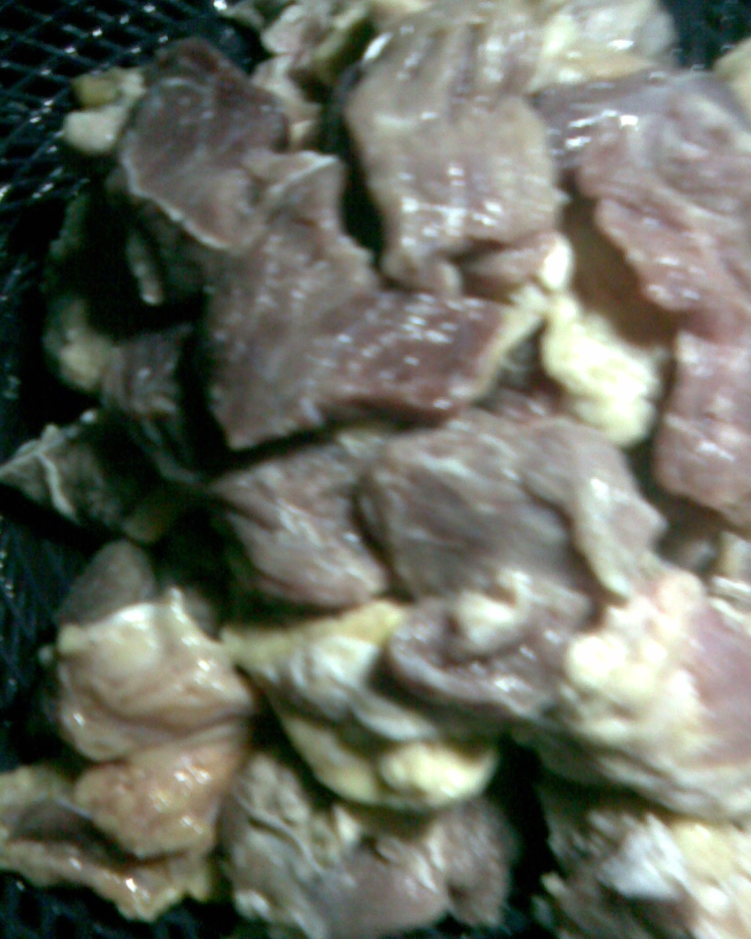

Plate 4.1 Supplied food items of large Indian Civet

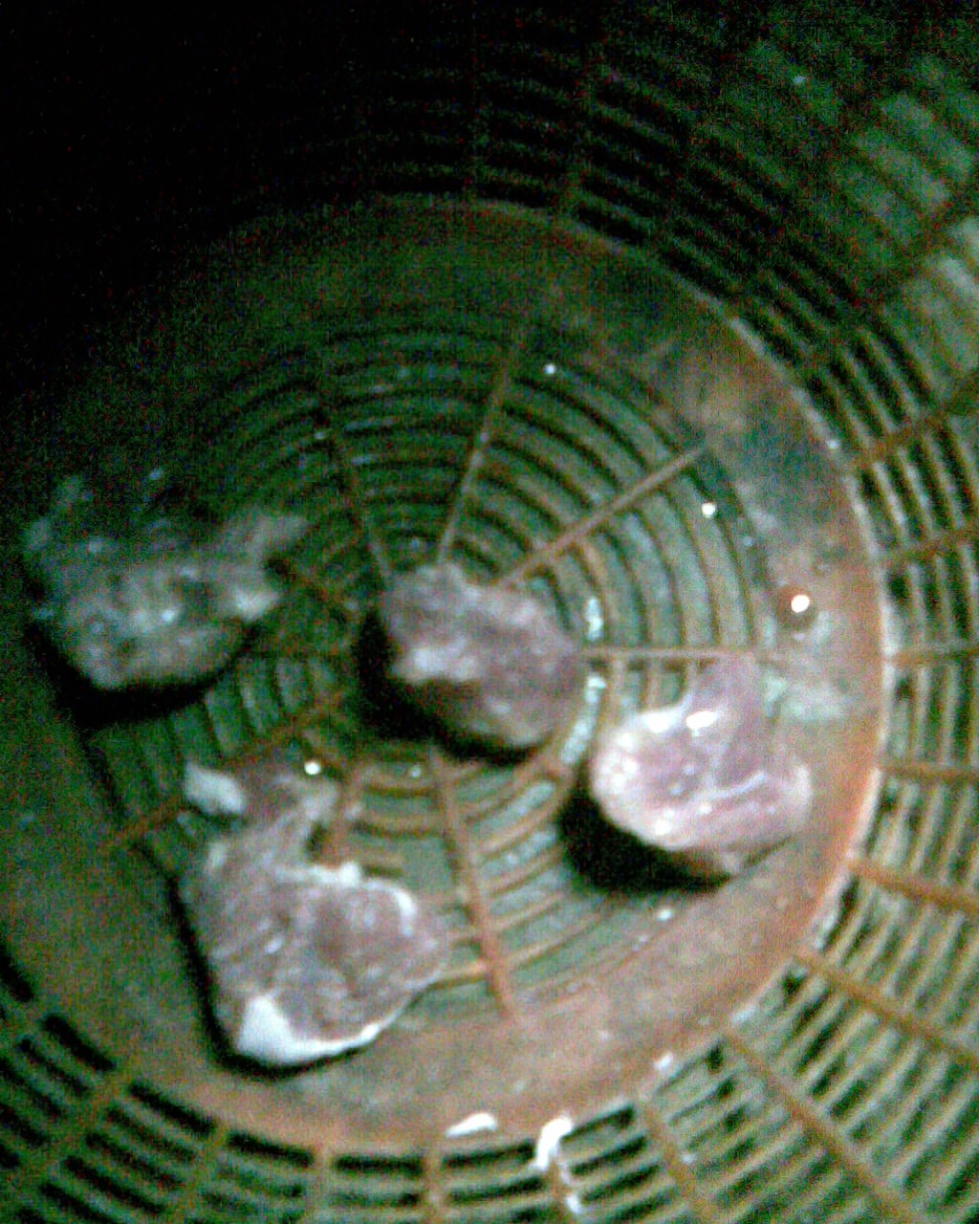

Plate 4.2 Rejected food items of large Indian Civet

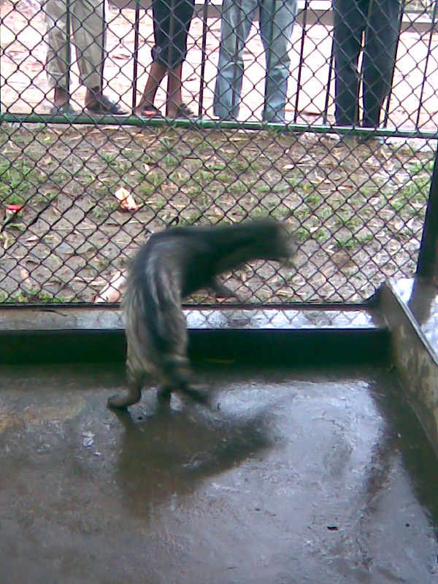

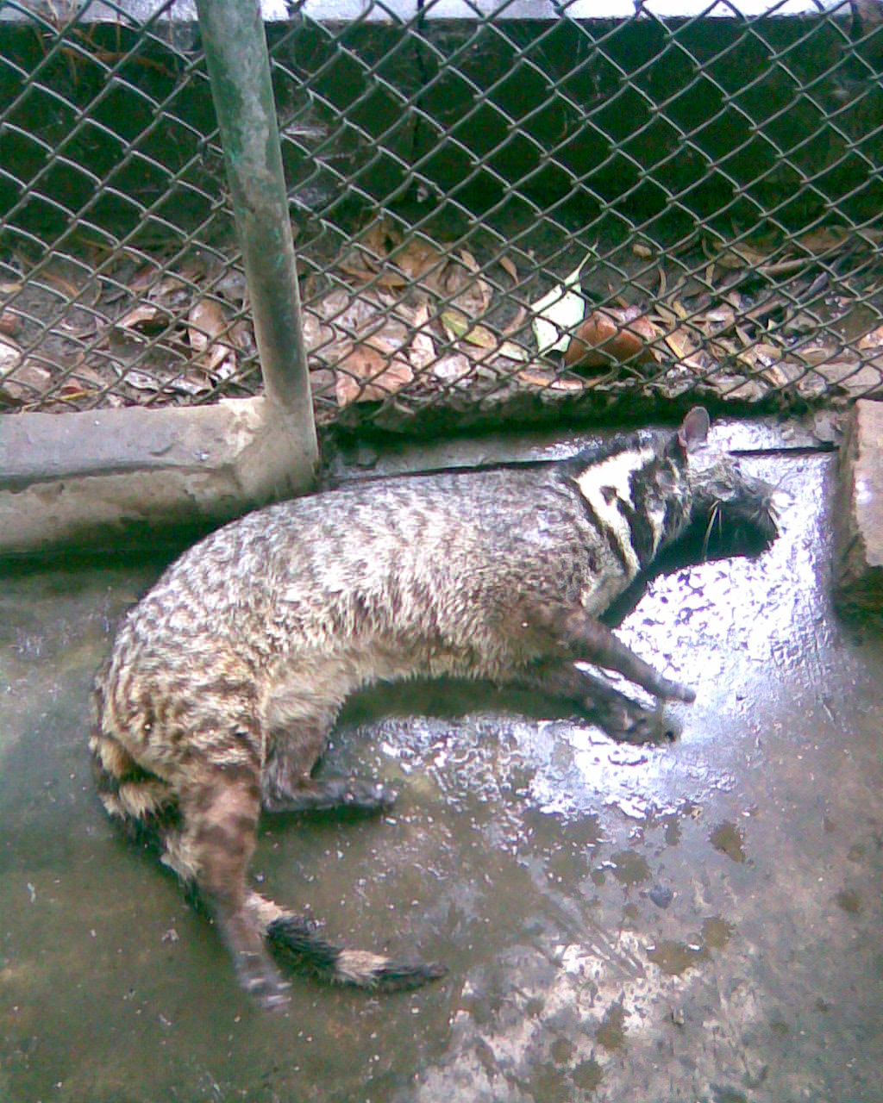
Plate 4.3 cage with large Indian Civet

Chapter 5: References
Wozencraft, W. C. (16 November 2005). Wilson, D. E., and Reeder, D. M. (eds). ed.Mammal Species of the World (3rd edition ed.). Johns Hopkins University Press. pp. 551. ISBN 0-801-88221-4. http://www.bucknell.edu/msw3.
Mustelid Specialist Group (1996). Paradoxurus hermaphroditus. 2006 IUCN Red List of Threatened Species. IUCN 2006. Retrieved on 12 May 2006.
Singh, L. A. K. (1982). "Stomach Contents of a Common Palm Civet, Paradoxurus hermaphroditus (Pallas)". J. Bombay Nat. Hist. Soc. 79 (2): 403–404.
http://www.straightdope.com/columns/read/2306/does-civet-come-from-tortured-cats
Calisher, Charles H. et al. "Bats Prove To Be Rich Reservoirs for Emerging Viruses." Microbe (American Society of Microbiology). Vol. 3, No. 11, 2008, p. 526. 6 Jan. 2009.
Press, Associated. "Civets, Other Wildlife Off the Chinese Menu." MSNBC. 18 Apr. 2008. 6 July 2008
<http://www.msnbc.msn.com/id/12371160/>.

Altmann, J 1974. Observational study of behavior: sampling methods. Bahaviour. 69: 227-267.
Blanford, W T 1988. The fauna of British India including Ceylon and Burma: Mammalia. Taylor and Francis, London.
Boitani, L and Bartoli, S 1986. The MacDonald encyclopedia of mammals.
Dotty, R 1945. Rat control of Hawaiian sugarcane plantations. Hawaii plant. Rec. 49: 71-239.
Husain, K Z 1974. An introduction to the wildlife of Bangladesh. F. Ahamed, Dhaka.
Khan, M A R 1982. Wildlife of Bangladesh: a checklist. Dhaka University Press, Dhaka.
Khan, M A R 1985. Mammals of Bangladesh: a field guide. N. Reza, Dhaka.
Nellis, D E and Everad, C O R 1983. The Biology of civet in the Caribbean Islands. Studies on the fauna of Curacao other Caribbean Islands. 64 : 1-162.
Nowaks, R M 1999. Walkers’ Mammals of the world. Volume 1. Sixth Edition. Johns Hopkins University Press, Baltimore.
Prater, S H 1980. The book of Indian animals 3rd edition with corrections. Bombay Nat Hist Soc., Bambay.
Reoberts, T J 1977. Mammals of Pakistan. Ernest Benn Ltd. Tonbridge, Kent.
Sarker, N J and Hiren, S 1993. Food consumption and feeding behavior of civet in captivity. Bangladesh J. 21(2): 109-114.
Sarker, S U and Sarker, N J 1988. Wildlife of Bangladesh (a systematic list with status, distribution and habitat). The Rico Printers, Dhaka.

Chapter 6: Appendices

Appendix 1. Animal list of Chittagong Zoo
Class-Reptilia (systematic based on Khan 1982)
Scientific Name | Name of animal | Order | Family | No. of animal
1.Indotestudo elongate | Elongated Tortoise | Cholonia | Emydidae | 8
2. Python molurus  Molurus | Indian python | Squamata | Boidae | 13
3. Crocodylus  Palustris | Marsh Crocodile | Crocodylia | Crocodylidae | 2

Class- Aves (systematic based on Ali 1996)
Scientific Name | Name of Animal | Order | Family | No. of animal
1. Numida meleagris | Guinea fowl | Galliformes | Phasianidae | 28
2. Coturnix coturnix | Common Quail | ” | ” | 9
3. Lophura leucomelana | Kalij pheasant | ” | ” | 1
4. Tarkish pheasant | Turkey | “ | “ | 3
5. Pavo cristatus | Common Indian pea fowl | ” | ” | 11
6. Anthracoceros  Malabaricus | Indian pied Hornbill | Bucerotiformes | Bucerotidae | 5
7. Buceros biornis | Great pied Hornbill | ” | ” | 4
8.Eudynamus scolopacsa | Indian cuckoo | Cuculiformes | cuculidae | 2
9. Psittacula eupatria | Large Indian parakeet | Psittaciformes | Psittacidae | 14
10. Tyto alba | Barn Owl | Apodiformes | Tytonidae | 1
11. Bubo zeylonensis | Brown Fish Owl | Strigiformes | Strigidae | 1
12. B. bubo | Great Horned Owl | ” | ” | 1
13. Streptopelia decaocto | Ringed pigeon | Columbiformes | Columbidae | 2
14.Columba punicea | Peacock Tailed pigeon | ” | ” | 8
15. C. livia | Blue Rock pigeon | ” | ” | 2
16. Gallicrex cinerea | Water cock | Gruiformes | Rallidae | 2
17. Porphyrio porphyrio | Purple Moorhen | ” | ” | 2
18. Milvus migrans | Periah Kite | Ciconiiformes | Accipitridae | 16
19.Haliatus leucoryphus | Fishing Eagle | ” | ” | 1
20. Haliastur Indus | Brahminy Kite | ” | ” | 2
21. Gyps fulvus | Griffon Vulture | ” | ” | 3
22. Agyopius monachus | Black Vulture | ” | ” | 1
23. Phalacrocorax niger | Little Cormorant | ” | Phalacrocoracidae | 4
24. Ardeola grayii | Pond Heron | ” | Ardeidae | 7
25. Bubuleus ibis | Cattle Egret | ” | ” | 2
26. Egretta intermedia | White-bellied Heron | ” | ” | 10
27. E. garzztta | Little Egret | ” | ” | 8
28. Ardeola grayii | Pond Heron | ” | ” | 5
29. Nycticorax  nycticorax | Night Heron | ” | ” | 8
30. Leptoptilos  javanicus | Lesser Adjutant Stork | ” | Ciconiidae | 2
31. L. dubius | Greater Adjutant Stork | ” | ” | 1
32. Gracula religiosa | Hill Myna | Passeriformes | Sturnidae | 5

Class Mammalia (systematic based on Khan 1982)
Scientific Name | English name | Order | Family | No. of animal
1. Nycticebus bengalensis | Slow Loris | Primates | Loridae | 2
2. Macaca leonina | Pig-tailed Macaque | ” | Cercopithecidae | 2
3. Macaca mulatta | Rhesus Macaque | ” | ” | 36
4. Presbytis pileatus | Capped Langur | ” | ” | 8
5. Vulpes bengalensis | Bengal Fox | Carnivora | Canidae | 3
6. Selenarctos thibetanus | Black Bear | ” | Ursidae | 4
7. Lutra lutra | Common Otter | ” | Mustelidae | 1
8. Viverra Zibetha | Large Indian Civet | ” | Viverridae | 4
9. Paradoxurus  hermaphroditus | Common Palm Civet | ” | ” | 3
10. Paguma larvata | Palm Civet | ” | ” | 1
11. Herpestes javanicus | Small Indian Mongoose | ” | Herpestidae | 4
12. Panthera tigris | (Royal) Bengal Tiger | ” | Felidae | 1
13. Panthera leo persica | Indian Lion | ” | ” | 5
14. Hyaena hyaena | Striped Hyaena | ” | ” | 1
15. Prionailurus  viverrinus | Fishing Cat | ” | ” | 1
16. P. bengalensis | Wild Cat | ” | ” | 1
17. Rusa Unicolor | Samber Deer | Artiodactyla | Cervidae | 3
18. Axis porcinus | Hog Deer | ” | ” | 1
19. Axis axis | Spotted Deer | ” | ” | 8
20. Muntiacus vaginalis | Barking Deer | ” | ” | 18
21. Caprolagus hispidus | Rabbit | Lagomorpha | Leporidae | 15
22. Hystrix indica | Indian Porupine | Rodentia | Hystricidae | 3

Appendix 2. Daily maximum and minimum time spent in self grooming different
Areas of the body by Large Indian Civet

Body area groomed | Maximum time spent |  | Minimum time spent
Body area groomed | Month | % | Month | %
Leg | December | 76.00 | February | 20.00
Tail | January | 26.00 | December | 16.00
Belly | February | 20.00 | January | 4.00

Appendix 3. Daily maximum and minimum time spent in social grooming
Different areas of the body by Large Indian Civet

Body area groomed | Maximum time spent |  | Minimum time spent
Body area groomed | Month | % | Month | %
Head | February | 44.44 | December | 11.11
Belly | January | 42.85 | February | 22.22
Leg | December | 20.00 | January | 6.98
Tail | January | 22.22 | January | 3.70

Appendix 4. Hourly maximum and minimum time spent in self grooming different areas of the body by Large Indian Civet

Body area groomed | Time spent
Body area groomed | % | Hour
Belly  Leg  Tail | 20.00  53.33  26.67 | 1600
Belly  Leg  Tail | 10.00  70.00  20.00 | 1700

Appendix 5. Hourly maximum and minimum time spent in social grooming different areas of the body by Large Indian Civet

Body area groomed | Time spent
Body area groomed | % | Hour
Head  Belly  Leg  Tail | 42.85  35.00  15.00  7.15 | 1600
Head  Belly  Leg  Tail | 44.44  22.22  11.12  22.22 | 1700

