EVALUATION OF SOME SERUM BIOCHEMICAL PARAMETERS BETWEEN LACTATING AND NON LACTATING DAIRY COWS IN SELECTED DAIRY FARMS UNDER CHITTAGONG DISTRICT

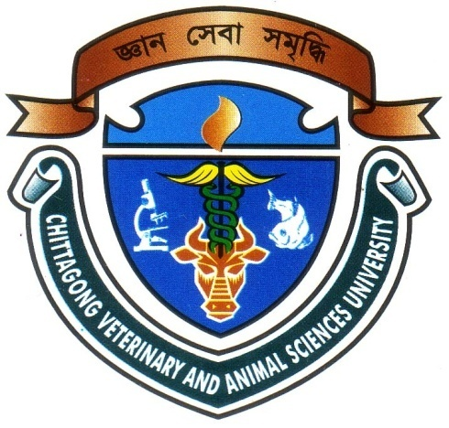

A CLINICAL REPORT SUBMITTED BY:
Intern ID-D-25
Roll No.2006/28
Reg. No.266
Session: 2005-2006

Report presented in partial fulfillment for the degree of Doctor
OF
Veterinary Medicine (DVM)

Faculty of Veterinary Medicine
CHITTAGONG VETERINARY AND ANIMAL SCIENCES UNIVERSITY
Zakir Hossain Road, Khulshi, Chittagong-4202
May, 2012

EVALUATION OF SOME SERUM BIOCHEMICAL PARAMETERS BETWEEN LACTATING AND NON LACTATING DAIRY COWS IN SELECTED DAIRY FARMS UNDER CHITTAGONG DISTRICT

This Clinical report submitted as per approved style and content

--------------------------------  Signature of Author  (Rajib Sarker)  Roll No: 2006/28  Reg. No: 266  Intern ID: D-25  Session: 2005-2006 | --------------------------------  Signature of supervisor  (DR. Mohammad Belayet Hossain)  Associate Professor  Dept. of Physiology , Biochemistry and Pharmacology  Chittagong Veterinary and Animal  Sciences University
May, 2012

CONTENTS

Chapter | Topics | Page  No.
 | ACKNOWLEDGEMENT | i
 | LIST OF ABBREVIATIONS | ii
 | ABSTRACT | iii
CHAPTER I | INTRODUCTION | 01-02
CHAPTER II | REVIEW OF LITERATURE | 03- 06
CHAPTER III | MATERIALS AND METHODS. | 07-12
CHAPTER IV | RESULTS | 13
CHAPTER V | DISCUSSION | 14- 15
CHAPTER VI | CONCLUSION | 16
CHAPTER VII | REFERENCE | 17-22
 | APPENDIX | 23-25

ACKNOWLEDGEMENT

All praises are due to Almighty Creator, who enable the author to complete this work successfully. The author is really grateful to the farm owner and farm manager of Molla, Jarif and Paharikha Dairy Farm for their kind cooperation.

The author expresses his deep sense of gratitude, heartfelt respect and immense indebtedness to his supervisor Dr.Mohammad Belayet Hossain, Associate Professor, Department of Physiology, Biochemistry & Pharmacology, Chittagong Veterinary & Animal Sciences University for his guidance & valuable suggestions and inspiration.
The author would like to express his deep sense of gratitude and gratefulness to Dr. Mohammad Mahmudul Hassan, Assistant Professor, and to Dr. Md. Amir Hussein Saikat , Lecture, Department of Physiology, Biochemistry & Pharmacology, Chittagong Veterinary and Animal Sciences University for their constant inspiration and valuable suggestion for completion of the report work.

I would like to give special thanks to Mr. Md. Rafiqul Islam, Laboratory technician and Mr. Md. Enamul Hossain , laboratory attendant, Dept. of of Physiology, Biochemistry & Pharmacology, for their help during lab.Work.

The author would like to express his pleasure and thanks to Dr. Md. Perves, MS, student, Dept. of Medicine and surgery during collection of blood.

Supervisor’s help and co-operation have been received from many persons during the tenure of this place of report. The author is immensely grateful to all of them, although it is not possible to mention every one by name

The Author

i

LIST OF ABBREVIATIONS

Abbreviations | Elaborations
AI | Artificial Insemination.
ANOVA | Analysis of Variance
DI | Deciliter
HF | Holstein Friesian
NSAIDs | Non Steroidal Anti-inflammatory Drugs
PPM | Potassium per manganate
MG | Miligram
NL | Non Lactating
TP | Total protein
RPM | Rotation per minute

ii
Evaluation of Some Serum Biochemical Parameters Between Lactating and Non Lactating Dairy Cows in Selected Dairy Farms under Chittagong District
ABSTRACT

Physiological status-related changes in serum biochemical values are known to occur in many species. Few published studies include comparative measurements of serum biochemical parameters in crossbred dairy lactating, dry and pregnant cows. The aim of our study was to determine and compare some serum biochemical parameters of lactating and non lactating dairy cattle in selected dairy farms of Chittagong district. Fifty cross breed clinically healthy lactating cows and fifty clinically healthy cross breed non lactating cows blood, total protein, albumin glucose, calcium and phosphorus of serum were determined by using biochemical analyzer. There were insignificant variations found in most biochemical parameters (p < 0.05) and albumin was only significant variation. But the values of glucose and phosphorus is within the reference range value and the value of total protein, albumin, calcium are not with in reference range. The results of the study showed that among serum biochemical parameters total protein level in non- lactating cow (82.32 ± 2.15gm/l) was higher than the value of lactating cow(81.28 ±2.41 gm./l). The serum albumin level in non-lactating cow(27.45± 5.06 gm. /l) was significantly higher than the albumin level in lactating cow(14.09± 2.05 gm. /l) .But glucose level in lactating cow (63.01± 6.67 mg/dl) was higher than glucose level in non- lactating cow(58.47 ±3.84mg/dl). The calcium level in lactating cow (63.02 ± 6.67mg/dl) was very higher than calcium level in non lactating cow (20.06± 2.51mg/dl). Calcium level in lactating cow was higher because of higher absorption of calcium from stomach and bone to blood level for production of milk. Another parameter phosphorus level in non- lactating cow( 7.26 ± .41mg/dl) was higher than in lactating cow(6.52 ± .308 mg/dl) It may be concluded that biochemical variation present between lactating cow and non lactating cow and it is very important for interpretation of laboratory data and also for physiological diagnosis.

Key Words: Cross bred cows, lactating cow, non lactating cow, serum biochemistry, reference value, Total protein, albumin, glucose, calcium, phosphorus.

iii

