Assessment of Nutritional Quality and Value Addition
of Ripened Jackfruit for Poultry Feed

A Report Submitted by:

Intern ID: A-08
Roll No. : 2006/09
Reg. No. : 247
Session: 2005-2006

AS THE PARTIAL FULFILLMENT FOR THE DEGREE
OF

DOCTOR OF VETERINARY MEDICINE (DVM)



Faculty of Veterinary Medicine,
Chittagong Veterinary and Animal Sciences University,
Khulshi, Chittagong - 4202.

May 2012.

Assessment of Nutritional Quality and Value Addition
of Ripened Jackfruit for Poultry Feed

A Report Submitted as Per Approved Style and Content

Signature of Author  Name: Md. Saiful Bari  Intern ID: A-08  Roll No. : 2006/09  Reg. No. : 247  Session: 2005-2006 | Signature of Supervisor  Name: Md. Manirul Islam.  Designation: Assistant Professor  Depatment of  Animal Science & Animal Nutrition.  Chittagong Veterinary and Animal  Sciences University  Khulshi, Chittagong - 4202.

Chittagong Veterinary and Animal Sciences University
Khulshi, Chittagong - 4202.

May 2012.

CONTENTS

Chapter | Topics | Page No.
 | Acknowledgement | i
 | Abstract | ii
I | Introduction | 1-2
II | Review of literature | 03-04
III | Research Methodology | 05-08
IV | Result and discussion | 09-18
V | Conclusion | 19
VI | References | 20

-: List of the Table:-

Table no. | Title | Page no.
1 | Nutritional composition and value addition of Jackfruit (%). | 10

-: List of the Graphs:-

Graph no. | Title | Page No.
1 | Dry matter content of different parts of a jackfruit as a whole (%). | 11
2 | ME content of different parts of a jackfruit as a whole (%). | 12
3 | Crude protein content different parts of a jackfruit as a whole (%) | 13
4 | Crude fiber content of different parts of a jackfruit as a whole (%)  . | 14
5 | Nitrogen free extracts content of different parts of a jackfruit as a whole (%). | 15
6 | Ether extracts content of different parts of a jackfruit as a whole (%). | 16
7 | Ash content of different parts of a jackfruit as a whole (%). | 17
8 | Calcium content of different parts of a jackfruit as a whole (%). | 18
9 | Phosphorus content of different parts of a jackfruit as a whole (%). | 19

-: List of the Figures:-
Figure no. |  | Title | Page  No.
1 |  | Weighing of Jack fruit | 07
2 |  | Separating of perianths. | 07
3 |  | Weighing of perianths. | 07
4 | Weighing of extra matter. |  | 07
5 | Drying of extra matter. |  | 08
6 | Drying of seeds. |  | 08
7 | Estimation of EE. |  | 08
8 | Estimation of Ash. |  | 08
9 | Estimation of CP. |  | 08
10 | Estimation of EE. |  | 08

ACKNOWLEDGEMENT

All praises are due to Almighty “Allah” who has created everything of the nature and who enable the author to complete this report. The author does not have adequate words to express his heartfelt sense of gratification sincere appreciation to his benevolent teacher and report supervisor. The author expresses his sincere gratitude, heartful respect and immense indebtness to his supervisor Md. Manirul Islam, Assistant Professor. Department of Animal science and Animal nutrition, Chittagong Veterinary and Animal Sciences University for his valuable advice, guidance, suggestions, inspiration and who was involved with this study through its inception. Special thanks to Ashraf Ali Biswas, Professor & Director (External affairs), Department of Animal science and Animal nutrition, for his valuable advice and co-operation. I would like to give special thank to DR. Md. Zohorul Islam, Lecturer. Dept. of Microbiology, Chittagong Veterinary and Animal Sciences University for giving valuable advice about report writing and for providing opportunity to test the collected sample. I would like to express my deep sense of gratitude and thanks to Vice Chancellor, Dr. A S Mahfuzul Bari and Dr. Md. Masuduzzaman, Dean, Faculty of veterinary medicine, Chittagong Veterinary and Animal Sciences University.

Supervisors’ help and co-operation have been received from many persons during the tenure of this place of report. The author is immensely grateful to all of them, although it is not possible to mention every one by name.

The Author:

i

Assessment of Nutritional Quality and Value Addition
of Ripened Jackfruit for Poultry Feed
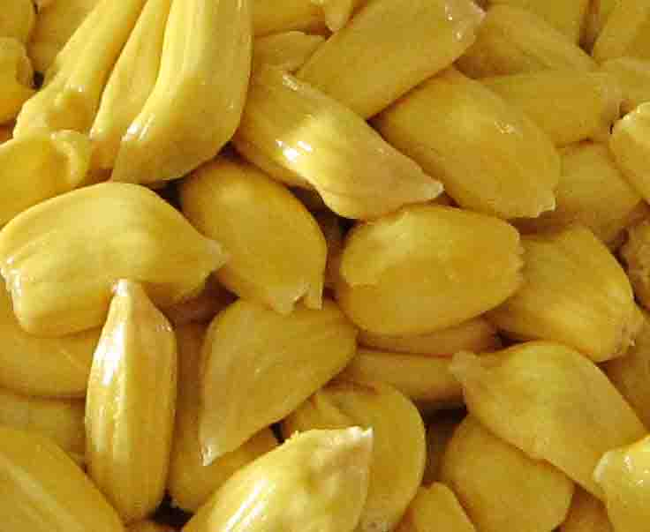

Abstract
The present study was conducted to evaluate the nutritive value of ripened jackfruit collected from different market of Thakurgaon, Sylhet & Chittagong region. A total of 50 samples were analyzed to evaluate the chemical composition and metabolizable energy content of jackfruit. After breaking, the ripened jackfruits were divided into four parts: jackfruit body (43.08%), seed+exocarp (8.99%), seed–exocarp (7.13%) and exocarp (1.86%) and analyzed them separately. The nutritive value of jackfruit body was also analyzed and found accordingly, DM (98.70%), ME (2310.25 kcal/kg), CP (12.6%), CF (27.5%), NFE (44.90%), EE (6%), Ash (7.72%), Ca (1.59%), & P (0.26%). The nutritive value of seed without exocarp were DM (97.80%), ME (2931.52 kcal/kg), CP(15.7%), CF (6%), NFE (71.86%), EE (1.02%), Ash(3.22%), Ca (1.20%), & P(0.28%) while the contents of jackfruit seed+exocarp were DM (98.12%), ME (2827.65 kcal/kg), CP (14.0%), CF (9.50%), NFE (70.34%), EE (1.05%), Ash(3.22%), Ca (1.15%), & P (0.43%). In addition the Exocarp possesses DM (98.50%), ME (1589.06 kcal/kg), CP( 10.5%), CF (48%), NFE(36.16%), EE (1.09%), Ash(2.75%), Ca (1.10%), & P (0.20%). The nutrient contents of different parts were found significantly (P<0.01, <0.05) different. The CP content of seed without exocarp was highest (15.7%) in comparison with others parts of the fruit while the lowest in exocarp (10.50%). Moreover, the ME, CF, EE and NFE contents also differ significantly (P<0.01). The study was conducted with the aim of using surplus jackfruit in summer season as poultry feed and to compare its nutritional value as a supplement in poultry diet. So, the different parts or as a whole ripened jackfruits may be used as a supplement with value addition in poultry ration formulation.

Key words: Assessment, nutritional quality, poultry feed, ripened jackfruit and value addition.

