Variation in branches of the abdominal aorta in New Zealand white (Orictolagus cuniculus) rabbit
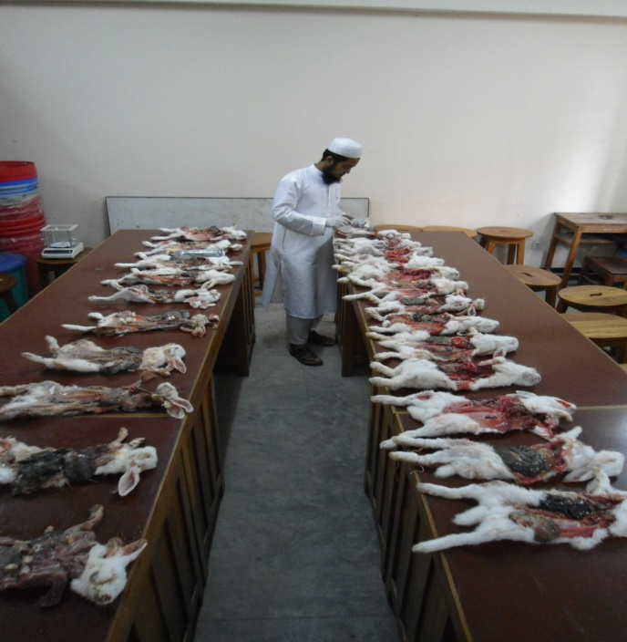
A Clinical Report Submitted
By
Roll No: 2006/24
Registration No: 262
Intern ID: C-21
Session: 2005-2006
Report Presented In Partial Fulfillment of the Requirement for
the Degree of Veterinary Medicine(DVM)

Chittagong Veterinary and Animal Sciences University
Khulshi, Chittagong-4202

