

**EFFECTS OF ACIDIFICATION ON FISH LARVAL ABUNDANCE AT TEKNAF COAST, BANGLADESH**

**Md. Al-Mamun**

Roll No. 0120/04

Registration No. 856

Session: 2020-2021

**A thesis submitted in the partial fulfillment of the requirements for the degree of Master of Science in Fisheries Resource Management**

**Department of Fisheries Resource Management**

**Faculty of Fisheries**

**Chattogram Veterinary and Animal Sciences University**

**Chattogram-4225, Bangladesh**

**JUNE, 2022**

**Authorization**

I hereby declare that I am the sole author of the thesis. I authorize the Chattogram Veterinary and Animal Sciences University (CVASU) to lend this thesis to other institutions or individuals for the purpose of scholarly research. I further authorize the CVASU to reproduce the thesis by photocopying or by other means, in total or in part, at the request of other institutions or individuals for the purpose of scholarly research.

I, undersigned, and author of this work, declare that the electronic copy of this thesis provided to the CVASU Library, is an accurate copy of the print thesis submitted, within the limits of the technology available.

**Md. Al-Mamun**

**June, 2022**

**EFFECTS OF ACIDIFICATION ON FISH LARVAL ABUNDANCE AT TEKNAF COAST, BANGLADESH**

**Md. Al-Mamun**

Roll No. 0120/04

Registration No. 856

Session: 2020-2021

**This is to certify that we have examined the above Master’s thesis and have found that is complete and satisfactory in all respects, and that all revisions required by the thesis examination committee have been made**

|  |  |
| --- | --- |
| **--------------------------------------------**  **Dr. Mohammad Mejbah Uddin** | **-------------------------------------------------**  **Dr. Sk Ahmad Al Nahid** |
| **Supervisor** | **Co-supervisor** |

**----------------------------------------------**

**Dr. Sk Ahmad Al Nahid**

**Chairman of the Examination Committee**

**Department of Fisheries Resource Management**

**Faculty of Fisheries**

**Chattogram Veterinary and Animal Sciences University**

**Chattogram-4225, Bangladesh**

**JUNE, 2022**

***Acknowledgments***

*The author is indebted to Almighty Allah who enabled him to complete the research work and write up the dissertation successfully for the degree of Master of Science (MS) in Fisheries Resource Management under the Department of Fisheries Resource Management, Chattogram Veterinary and Animal Sciences University (CVASU).*

*The author expresses his sincere thanks and gratitude to his supervisor* ***Dr. Mohammad Mejbah Uddin,*** *Professor, Department of Anatomy & Histology, CVASU for his valuable supervision and guidance. It was really a great pleasure and an amazing experience for him to work under his supervision.*

*The author expresses his profound gratitude to his co-supervisor,* ***Dr. Sk Ahmad Al Nahid****, Associate Professor and Head,* *Department of Fisheries Resource Management, CVASU for his valuable advice, scholastic guidance, suggestions, and inspiration. His dynamism, vision, and confidence inspired him and gave him confidence and strength.*

*The author sincerely expresses his deepest sense of gratitude and indebtedness to* *honorable Vice-chancellor* ***Prof. Dr. Goutam Buddha Das*** *and* ***Prof. Dr. Mohammed Nurul Absar Khan****, Dean, Faculty of Fisheries, CVASU for their supportive administrative co-ordination to fulfill his research.*

*The author expresses his profound gratitude to his honorable teacher* ***Shahida Arfine Shimul****, Assistant Professor, Department of Fisheries Resource Management, CVASU for her valuable guidance and intellectual suggestions to complete the research.*

*The author is greatly indebted to his senior brother* ***Saifuddin Rana*** *for his encouragement and cooperation at every stage of this study from its inception to completion.*

*The author expresses his thanks to the lab technician* ***Bokhteyar Hossain*** *and* ***Supria Biswas*** *of the Aquatic Ecology laboratory for their cooperation during the research work.*

*Last but not least, the author expresses his deepest sense of gratitude to his beloved parents* ***Md. Abu Hanif*** *and* ***Anuara Begum*** *for their sacrifice, blessings, and encouragement.*

*The Author*

***Md. Al-Mamun***

**CONTENTS**

**Page No.**

**Acknowledgements i**

**Contents ii**

**List of Tables v**

**List of Figures** **vi**

**List of Plates vii**

**List of Appendices viii**

**Abbreviation ix**

**Abstract x**

**Chapter-1 Introduction** **1**

* 1. Significance of the research **3**
  2. Objectives of the research **4**

**Chapter-2** **Review of literature 5**

* 1. Fish Larvae **5**

2.2 Ocean Acidification **5**

2.3 Determination of Ocean acidification **7**

2.4 Impacts of ocean acidification on Fish Larvae **7**

**Chapter-3** **Materials and methods** **10**

3.1 Study area **10**

3.2 Sampling procedure **10**

3.3 Water quality determination **11** 3.3.1 Field data collection **11**

3.3.2 Alkalinity Measurement in the Laboratory **11** 3.4 Derivation of ocean acidification factors **12**

3.5 Determination of diversity of fish larvae at the Teknaf coast **12**

3.6 Identification of fish larvae **13**

3.7 Data analysis and interpretation  **13**

**Chapter-4** **Results**  **16**

4.1 Hydrological Parameters of Teknaf coast **16** 4.1.1 Water Temperature (°C) **16**

4.1.2 pH **16**

4.1.3 Total Alkalinity **17**

4.1.4 Salinity **17**

4.2 Monthly Fluctuation of the Hydrological Parameters of Teknaf coast **18**

4.3 Ocean acidification factors of Teknaf coast **18**

4.3.1 pCO2 **18**

4.3.2 HCO3- **19** 4.3.3 CO32- **19**

4.3.4DIC **20**

4.3.5 ΩAragonite **20**

4.3.6 ΩCalcite **21**

4.4 Larval Abundance of Teknaf coast **21**

4.5 Interaction between pCO2 & pH of Teknaf coast **22**

4.6 Interaction between pCO2 & Larval abundance of Teknaf coast **23**

4.7 Interaction between pH & Larval abundance of Teknaf coast **24**

4.8 Relationship with pCO2, pH & Larval abundance of Teknaf coast **25**

4.9 Relationship among Ocean Acidification factors of Teknaf coast **25**

**Chapter-5 Discussion 28**

5.1 Temperature **28**

5.2 pH **28**

5.3 Alkalinity **29**

5.4 Salinity **29**

5.5 Ocean Acidification factors **29**

5.6 Relationship with pCO2, pH & Larval abundance of Teknaf coast **30**

**Chapter-6 Conclusion 32**

**Chapter-7**

**Recommendations 33**

**References 34**

**Appendices 47**

**List of Tables**

**Table No. Title Page No.**

Table 1 Statistical analysis of hydrological parameters **26**

& ocean acidification factors

Table 2 Correlations between pCO2 & pH of Teknaf coast **27**

Table 3 Correlations between pCO2 & Larval abundance **27**

of Teknaf coast

Table 4 Correlations between pH & Larval abundance of Teknaf coast **27**

**List of Figures**

**Figure No. Title Page No.**

Figure 1 Monthly variations of water temperature of Teknaf coast **16**

Figure 2 Monthly variations of pH of Teknaf coast **16**

Figure 3 Monthly variations of Alkalinity of Teknaf coast **17**

Figure 4 Monthly variations of Salinity of Teknaf coast **17**

Figure 5 Monthly Fluctuations of Hydrological Parameters  **18**

of Teknaf coast

Figure 6 Monthly pCO2 variations of the Teknaf coast  **18**

Figure 7 Monthly HCO3- variations of the Teknaf coast **19**

Figure 8 Monthly CO32- variations of the Teknaf coast **19**

Figure 9 Monthly Dissolved Inorganic Carbon (DIC) variations **20**

of the Teknaf coast

Figure 10 Monthly ΩAragonite variations of the Teknaf coast **20**

Figure 11 Monthly ΩCalcite variations of the Teknaf coast **21**

Figure 12 Monthly variation of Larval abundance of Teknaf coast **21**

Figure 13 Interaction between pCO2 & pH of Teknaf coast **22**

Figure 14 Interaction between pCO2 & Larval abundance **23**

of Teknaf coast

Figure 15 Interaction between pH & Larval abundance of Teknaf coast **24**

Figure 16 Relationship with pCO2, pH & Larval abundance **25**

of Teknaf coast

Figure 17 Relationship among ocean acidification factors of Teknaf coast **26**

**List of** **Plates**

**Plate No. Title Page No.**

Plate 1 Sampling location on google map **10**

Plate 2 Bongo Net **11**

Plate 3 Sample of Fish larvae **14**

Plate 4 Separation of fish larvae **14**

Plate 5 Counting of fish larvae **14**

Plate 6 Identification of fish larvae **14**

Plate 7 Observation of fish larvae **14**

Plate 8 Labeling and preservation of fish larvae **14**

Plate 9 Some identified fish larvae **15**

Plate 10 Determination of Total Alkalinity **15**

**List of Appendices**

**Appendices No. Title Page No.**

Appendix A: Hydrological Parameters of Teknaf coast  **47**

Appendix B: Derived Ocean acidification factors of Teknaf coast **47**

Appendix C:Abundance of Fish Larvae (larvae/1000 m3) at **48**

Teknaf coast

**ABBREVIATION**

OAOcean Acidification

CO2 Carbon Dioxide

pCO2 Partial Pressure of Carbon Dioxide

CO32- Carbonate Ion

CaCO3 Calcium Carbonate

BOB Bay of Bengal

DIC Dissolved Inorganic Carbon

ppm Parts per million

yr-1 Per Year

AT Total Alkalinity

CT Dissolved Inorganic Carbon

NDIR Non-dispersive infrared

mg/l Milligram per litter

mg  Milligram

kg Kilogram

μm Micrometer

μatm Micro atmosphere

°C Degree Celsius

DO Dissolve oxygen

PSU Practical salinity units

Ω Omega

SD Standard Deviation

i.e. That is

SPSS Statistical Package for Social Science

et al. Associates

**Abstract**

The study aimed to investigate the effects of acidification on fish larvae abundance at the Teknaf coast. From January 8 to December 14, 2021, samples of fish larvae were collected at every month from the Teknaf coast. From the bottom to the surface, Bongo-Net with a 500 µm mesh size was being towed. A total of 1,120 larvae were gathered from the research area during the survey. In the study region, 93 larvae/1,000 m3 were found to be the mean density of all fish larvae. The hydrological parameters such as water temperature, pH, salinity, and total alkalinity were determined to find out the effects of these variables on the larvae abundance along the Teknaf coast. The average values of the parameters including water temperature, pH, salinity, and total alkalinity were found at 28.41°C, 8.36, 23.57 PSU, and 113.25 mg/l respectively. The ocean acidification factors including pCO2, HCO3-, CO32-, DIC, ΩAragonite, and ΩCalcite were also determined by using the "seacarb" package of R programming to find out the effects of these variables on the larvae abundance along the Teknaf coast. The average values of the factors including pCO2, HCO3-, CO32-, DIC, ΩAragonite, and ΩCalcite were found 128.72 µatm, 0.000751 mole/kg, 0.000138 mole/kg, 0.000892 mole/kg, 2.3544 and 3.7028 respectively. The results showed an insignificant relationship between pCO2 and fish larvae abundance throughout the Teknaf coast. However, there was a negative correlation between pCO2 and pH. The findings of this research indicate that OA affects fish larvae abundance at Teknaf coast. Regional fisheries management organizations will be better able to make decisions about the management of the extremely valuable fish larvae as a result of future population-level predictions of the impacts of ocean acidification.

**Keywords:** ocean acidification; larval abundance; pCO2; pH; Teknaf coast

**Chapter-1**

1. **Introduction**

Fish larvae refer to the life stage prior to attaining the full complement of fin ray elements, the complete development of scales, and the loss of all larval characteristics (Neira et al., 1998).

Ocean acidification, or the ongoing lowering of the pH of Earth's oceans, is brought on by the absorption of carbon dioxide (CO2) from the atmosphere. As a result of human-caused carbon dioxide (CO2) emissions, the ocean's chemistry has undergone significant alteration (Sabine et al., 2004; Orr et al., 2005; Doney et al., 2009). When the ocean absorbs too much CO2 from the atmosphere, chemical reactions occur that lower the pH of the saltwater and release hydrogen ions (Zeebe, 2012). The chemical process of ocean acidification is anticipated to go mostly unchecked. The pH of the world's oceans has decreased by around 0.1 units since the industrial revolution, and if CO2 emissions are not reduced significantly by the year 2100, they are projected to fall by another 0.4 units (Caldeira & Wickett, 2003; Bopp et al., 2013). According to Kroeker et al., 2013 & Sunday et al., 2014, long-term ocean acidification will have far-reaching consequences for marine ecosystems, so it's crucial to know how high CO2 and low pH levels influence marine organism fitness.

The levels of CO2 in the atmosphere and the oceans often balance one another. Between 30 and 50 percent of global man-made CO2 emissions have so far been absorbed by the seas (Feely et al., 2004; Sabine et al., 2004; Orr et al., 2005), has a substantial effect on the chemistry of ocean water by increasing dissolved CO2 (aq), H2CO3 (carbonic acid), HCO3- (bicarbonate ions), and H+ (hydrogen ions) while decreasing CO32-carbonate ions (Fabry et al., 2008). Rising pCO2 levels since the start of the industrial revolution have caused a 0.1 unit decrease in the average sea-surface pH (i.e., the ocean has become more acidic and less alkaline). Average sea-surface pH is predicted to decrease by 0.3-0.4 units in 2100 and up to 0.7 units by 2300 as a result of the ocean’s absorption of atmospheric CO2 (Caldeira & Wicket 2003). In comparison to millions of years ago, these pH shifts in the ocean are more significant and rapid (Feely et al., 2004).

One of the ocean's major marine ecosystems, the Bay of Bengal (BOB), is characterized as a moderately productive ecosystem because it lacks significant seasonal upwelling (Madhupratap et al., 2003). Low sea surface salinities were a result of significant monsoonal precipitation, according to Shankar et al. (2002), notably in the northern region of BOB. The majority of earlier biological investigations in BOB concentrated on seasonal variations in primary production as well as the type and number of mesozooplankton (Achuthankutty et al., 1980; Nair et al., 1981; Madhupratap et al., 2003) but little is understood about the effect of acidification on fish larvae abundance of Teknaf Coast.

One of the larger estuaries in the Bangladeshi coastal region that has not experienced significant human interference is the Naaf River estuary. The Naaf is an estuary with wide and continuous contact with the Bay of Bengal, providing great potential for the colonization of fishery species. The Naaf River has a biodiversity that is comparable to or greater than many other river systems in Bangladesh, making it not only an ecological hotspot in terms of species number but also in terms of the ecological niche and life cycles. The estuary of the Naaf river has a significant impact on the tidal range in the Teknaf coastal region. The region has a warm tropical temperature and enough rainfall to sustain a wide range of biological diversity. One of the world's 80 km long longest ecosystems of sand beaches is on the Teknaf Peninsula. For the species of the Indo-Himalayan & Indo-Malayan ecological sub-regions, it serves as a transitional area. The area has significant mangrove, mudflat, beach, and sand dunes ecosystems, as well as canals, lagoons, and marine habitats. Both natural and planted stands of mangrove forest may be found on the Teknaf Peninsula, however, they are primarily found in the intertidal zone. The mangroves of the Teknaf peninsula provide habitat for 161 different fish species. One of the first protected areas in Bangladesh was the Teknaf Reserved Forest.

It is generally known that the early stages of marine species suffer from ocean acidification. Lower growth and survival rates are observed in bivalve as well as gastropod larvae growing in low pH or high pCO2 environments compared to those growing in ambient ocean pH conditions (Talmage & Gobler, 2011; Onitsuka et al., 2014). Because of the increased breakdown of carbonate ions, coral larvae and juveniles growing in environments with low pH and high pCO2 show slowed calcification rates (Albright et al., 2010). Additionally, certain marine organisms' energy budgets may be disturbed by low pH. Juvenile crabs, for example, may require more energy to maintain normal rates of shell calcification in low pH conditions, which may worsen their general body condition (Long et al., 2013). A number of studies show that larval fish may also be vulnerable to the impacts of ocean acidification (Baumann et al., 2011; Bignami et al., 2013; Murray et al., 2014; Stiasny et al., 2016). The removal of metabolic CO2 from the body may be hindered, especially in saltwater with elevated CO2 levels. The primary factor influencing such diffusion is the pCO2 difference between the blood's relatively high CO2 concentration and the environment's comparatively low CO2 concentration. Under circumstances of ocean acidification, a rise in ambient pCO2 may lessen the gradient between blood & the environment. There may be an increase in metabolic CO2 retention as a result, or there may be a compensation reaction that involves the body actively moving ions that are associated with acid and base and creating bicarbonate to maintain internal pH (Melzner et al., 2009; Heuer & Grosell, 2014). Ion regulation may be impacted by exposure to high CO2 and low pH levels. Fish developing in OA conditions may subsequently have a variety of detrimental effects, including slower development, sensory impairment, and higher mortality (Frommel et al., 2012; Nilsson et al., 2012; Allan et al., 2015; Bromhead et al., 2015).

Despite the fact that alterations in the chemistry of saltwater can impair marine fish larvae, it is not always clear how big these effects are on the whole and what they indicate for population growth. Research on the effects of pCO2 and pH fluctuations on the number of larvae along the Teknaf Coast will help to clarify this matter and provide the basis for the current study.

* 1. **Significance of the research**

This research is very important to know the actual condition of the abundance of the fish larvae of the fish species of the Teknaf Coast. This research will generate necessary information from which some fruitful steps can be taken to increase the fish larval abundance of the Teknaf Coast.

After gathering information, some suggestions can be provided to take appropriate decisions on reducing the degree of acidification and improving the fish larval abundance of the Teknaf Coast. This research will help to compare the fish larval abundance among other coasts of Bangladesh.

* 1. **Objectives of the research**

The objective of the research work is as follows:

1. To provide an actual scenario of the ocean acidification of the Teknaf Coast.
2. To identify and evaluate the effects of ocean acidification on the larvae abundance of the Teknaf Coast.

**Chapter-2**

1. **Review of literature**
   1. **Fish Larvae**

Neira et al., (1998) stated that larvae refer to the stage of life that comes before the fin ray components are fully developed, the scales are fully formed, and all larval characteristics have been eliminated. They also reported that preflexion, flexion, and postflexion are the phases of larval development based on the progression of notochord flexion during the formation of the caudal fin.

Loy et al. (2001) described in their research that fish go through significant changes in overall form and structural features throughout the larval stage.

Depending on gene expression and environmental factors, these developmental stages might range from gradual to sudden (Gilbert & Bolker, 2003).

Individuals change into juveniles, which morphologically resemble adults, after passing through the larval stage (Osse et al., 1997).

According to Moteki, 2002; Moteki et al., 2002; and Pena & Dumas, 2009; different larval stages can develop new skills for biological activities, which in turn allows them to inhabit their chosen habitats and explore new environmental circumstances due to physiological, anatomical, and behavioral modifications, including eating behavior, dentition, and swimming capacity.

For effective fisheries management, it is critical to understand the biology of the early life stages of fish (Hickford, 2000; Strydom et al., 2014).

* 1. **Ocean Acidification**

Due to an increase in human CO2, the carbonate system of the world's oceans (pH, alkalinity, pCO2, and CaCO3 saturation state) is undergoing fast change (Whitfield, 1975; Broecker et al., 1977; Broecker et al., 1979; Feely & Chen, 1982; Feely et al., 1984; Kleypas et al., 1999; Caldeira & Wickett, 2003; Orr et al., 2005; Feely et al., 2008).

In a process known as "ocean acidification," chemical reactions that reduce the concentration of carbonate ions (CO32-), the pH of seawater, and the saturation states of the biologically significant CaCO3 minerals calcite (Ωcalcite) and aragonite (Ωaragonite) take place when caused by humans CO2 is absorbed by seawater (Broecker & Clarke, 2001; Caldeira & Wickett, 2003; Orr et al., 2005; Doney et al., 2009).

Since the beginning of the industrial age, the pH of sea surface waters has so far reduced by around 0.1 (Caldeira & Wickett, 2003; Orr et al., 2005), with a decline of 0.0018 yr-1 recorded over the past 25 years at various open-ocean time-series locations (Bates, 2007; Bates & Peters, 2007; Santana-Casiano et al., 2007; Dore et al., 2009).

CO2 levels in the atmosphere might exceed 500 ppm by the middle of the century, and 800 ppm by the end (Friedlingstein et al., 2006).

The findings of time-series research and large-scale sea CO2 assessments conducted over the past 20 years demonstrate that ocean acidification is a predicted result of rising atmospheric CO2 (Feely et al., 2004; Bates & Peters, 2007; Santana-Casiano et al., 2007; Dore et al., 2009; Takahashi et al., 2009) and is unrelated to the uncertainties and effects of climate change.

Although anthropogenic atmospheric CO2 is the primary cause of ocean acidification, sulfur and nitrogen are also important in some coastal areas (Doney et al., 2007).

CO2 levels in the atmosphere are currently at about 383 ppm by volume, which is the most it has been in at least 650,000 years. It is expected to rise by 0.5 percent per year during the twenty-first century (Petit et al., 1999; Houghton et al., 2001; Augustin et al., 2004; Siegenthaler et al., 2005).

Atmospheric CO2 is currently projected to increase at a rate that is nearly 100 times faster than it has in the past 650,000 years (Siegenthaler et al., 2005).

Only half of man-made CO2 has stayed in the atmosphere in recent decades; the other half has been absorbed by the terrestrial biosphere (about 20 percent) and the seas (about 30 percent) (Feely et al., 2004; Sabine et al., 2004).

In the less than 250 years since the industrialization, the pH of surface ocean waters has decreased by 0.1 pH units (representing an increase in hydrogen ion concentration of about 30% compared to the pre-industrial value) and is expected to decrease by another 0.3-0.4 pH units through the end of this century (Mehrbach et al., 1973; Lueker et al., 2000; Caldeira & Wickett 2003; Feely et al., 2008).

There has probably not been a pH fluctuation of this magnitude in Earth's history for more than 20 million years (Feely et al., 2004).

* 1. **Determination of Ocean acidification**

The CO2 system in the ocean is typically constrained by four measurements: AT, CT, pCO2, and pH (Dickson, 2010).

In order to calculate the pCO2 of seawater, Watson et al., (2017) evaluate four alternative techniques.

1) VINDTA, which measures the amount of CT and AT,

2) Analysis of AT and pHT using spectrophotometry,

3) Measuring AT and pHNBS using electrodes,

4) Direct CO2 measurement with a portable CO2 equilibrator and NDIR gas analyzer.

They discovered that these four approaches can provide relatively similar pCO2 estimations, with the three methods most commonly used in the field (electrode pHNBS, spectrophotometric pHT, and CO2 equilibrator) having assessment errors of 3.5-4.6 percent for pCO2.

* 1. **Impacts of ocean acidification on Fish Larvae**

Compared to juveniles and adults, fish embryos and young larva are frequently more sensitive to pH changes (Brown & Sadler, 1989), therefore these early life stages are the most likely to experience substantial consequences of ocean acidification.

Due to varying ion exchange and respiration processes, young fish may be more susceptible to the effects of OA than adult fish (Jonz & Nurse, 2006); a scenario that may be made worse by their increased surface-to-volume ratio (Kikkawa et al., 2003; Ishimatsu et al., 2004).

To present, research on larval fishes has shown that low pH causes a considerable loss in survival (Kikkawa et al., 2003; Ishimatsu et al., 2004; Kikkawa et al., 2004), and that CO2-induced acidification has greater detrimental consequences than acid addition alone (Hayashi et al., 2004; Kikkawa et al., 2004).

Compared to adult fish, fish in their early life stages have been demonstrated to be more sensitive to high CO2 (Pörtner et al., 2005).

Ocean acidification has a negative impact on some species' survival, growth, tissue health (Frommel et al., 2012), metabolism (Franke & Clemmesen, 2011), and behavior (Munday et al., 2009a; Dixson et al., 2010; Simpson et al., 2011; Baumann et al., 2012; Devine et al., 2012; Domenici et al., 2012; Ferrari et al., 2012a, b).

Larval and juvenile development (Baumann et al., 2012), embryonic development (Tseng et al., 2013), tissue/organ health (Frommel et al., 2012), and survival (Baumann et al., 2012) have all been reported to be negatively affected by increased pCO2.

Several studies have found that high pCO2 has direct consequences on marine fish larval growth, metabolism, behavior, survival, otoliths, and skeletal formation (Munday et al., 2011b; Baumann et al., 2012; Frommel et al., 2014; Pimentel et al., 2014).

However, a number of research on ocean acidification present contradictory findings both within and across taxonomic groupings, casting doubt on the conventional presumption that all creatures are vulnerable to this supposed threat (Hendriks et al., 2010).

Fish were not included in the 59 research papers (49 species) examined by Hendriks et al., (2010) because the impact of ocean acidification on larval and adult fish has, up until recently, garnered far less attention than calcifying invertebrates.

A crucial stage of fish ontogeny is the extremely vulnerable larval stage. Larvae have substantial cumulative mortality at this stage of their development, which is mostly caused by small changes in development, predation, and selection pressure (Houde, 1989).

When the larval stage is successfully completed, it affects ecological systems in the juvenile or adult habitats, stock replenishment, and population interconnectivity (Cowen & Sponaugle, 2009).

Few studies have examined the vulnerability of early stages of economically significant fish species, such as codfish (Frommel et al., 2014) and yellowfin tuna, to climate-driven alterations (Bromhead et al., 2015).

The detrimental effects of climate-driven changes in temperature and pCO2 may have significant effects on the abundance and distribution of marine fish stocks (Pörtner & Peck, 2010), given the significance of survival rates and larval growth to the year-class success in marine fish populations (Peck et al., 2012).

Fish larvae are often deficient in many of the intricate physiological traits that enable juvenile and adult fishes to adapt to shifting environmental conditions, making them more susceptible to environmental disturbance (McKim, 1977; Kikkawa et al., 2003; Munday et al., 2008).

Therefore, data on the consequences of acidification at the earliest stages are required for a more thorough knowledge of the effects on populations. Ocean acidification may thus create an ecological challenge for fish (Pankhurst & Munday, 2011).

Numerous studies demonstrate that increased pCO2 levels and survival do not directly correlate in the "near future" (Munday et al., 2011a ; Frommell et al., 2012). In many species, it is believed that sub-lethal OA effects might cause the most harm to communities and individuals (Briffa et al., 2012).

However, several of the same studies (Munday et al., 2009b; Franke & Clemmesen, 2011; Moran & Stttrup, 2011; Munday et al., 2011a; Frommel et al., 2012, 2013) either found no significant negative effects or even positive effects on growth and development, swimming ability (Munday et al., 2009b), and otolith growth (Franke & Clemmesen, 2011; Simpson et al., 2011; Munday et al., 2011a; Frommel et al., 2012).

Other research did not find any appreciable impacts of rising pCO2 on fish larvae, pointing to species-specific adaptations to shifting ocean conditions (Harvey et al., 2013; Hurst et al., 2013; Maneja et al., 2013).

**Chapter-3**

1. **Materials and Methods**
   1. **Study area**

The study was conducted at the Naf Estuary (N 20.730300, E 92.3421011) Teknaf coast, Bangladesh, with monthly sampling from January to December 2021. The sampling location is presented in Figure 1.

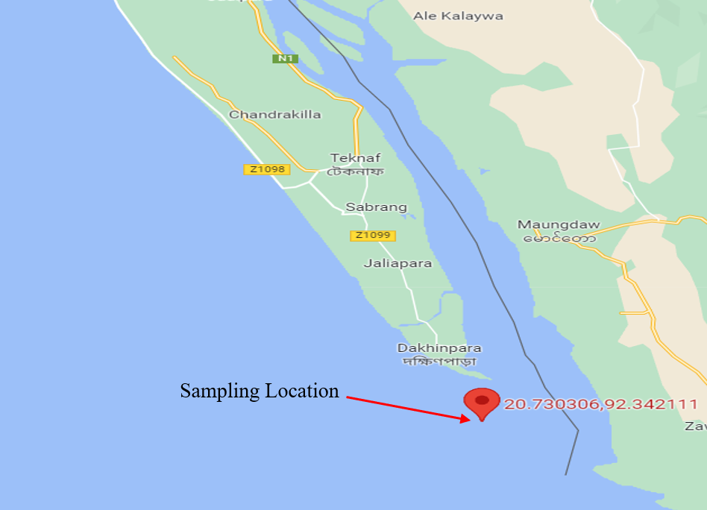

Plate 1. Sampling location on google map

* 1. **Sampling procedure**

Fish larvae were collected using a bongo net (Figure 2) with a 0.50 m mouth diameter, 1.3 m length, and 500 µm mesh at the body. Each tow covered approximately 2 km of the surface area during the sampling time, which lasted 10 minutes throughout the day. The amount of seawater filtered during each tow was measured using a flow meter (Model: KC Denmark A/S 23.090-23.091). The collected specimen was taken to the Aquatic Ecology Laboratory at Chattogram Veterinary and Animal Sciences University and preserved in 90% ethanol before being sorted according to morphology and other characteristics. Then it was immediately preserved in 90% ethanol.



Plate 2. Bongo Net

* 1. **Water quality determination** 
     1. **Field data collection**

Water temperature, salinity, pH, and alkalinity of the sampling region were measured on-site using a Celsius thermometer, a refractometer (PC Stester 35), a pH meter (YSI pH100A), and an alkalinity test kit (HACH FF-1), respectively, to determine the acidification condition. Gas-tight bottles were used to collect seawater, preventing air bubbles from getting trapped when the bottles were sealed to measure pH and alkalinity. All the field data are collected from the Teknaf coast to determine the acidification condition of Teknaf coast.

* + 1. **Alkalinity Measurement in the Laboratory**

The titrimetric method was used to measure the alkalinity of the collected sample water in the laboratory. For alkalinity measurement, in a conical flask, 50 ml of sample water was added. After that, 2 to 4 drops of phenolphthalein indicator were given to the sample. Since the sample's color remained unchanged, there was no phenolphthalein alkalinity present. After that, a new 50 ml of water sample was measured and placed in a different flask along with 2 to 4 drops of methyl orange indicator. The color changed to yellow. The sample was then titrated against a standard H2SO4 (0.02N) solution. Until the yellow color changed to pink, titration was continued.

The required amount of acid (H2SO4) was recorded and final the result was calculated by the following formula:



* 1. **Derivation of ocean acidification factors**

The ocean acidification factors such as pCO2, HCO3-, CO32-, DIC, ΩAragonite and ΩCalcite were derived from the R programming language and CO2SYS software. The ocean acidification factors were not determined on the spot due to the lack of technology. Salinity, temperature, total alkalinity (AT), Dissolved Inorganic Carbon (DIC), pCO2, and H+ concentration data can all be used to estimate the amounts of acid-base species in seawater. The input parameters for this study's "seacarb" package of R programming are pH, AT, salinity, and temperature.

* 1. **Determination of diversity of fish larvae at the Teknaf coast**

From particular locations in the Teknaf coast, eggs and fish larvae were collected. Fish larvae were captured using a bongo net from subsurface water. To measure the amount of water flowing through the Bongo net, a flow meter was attached to it. Later, each fish larva was separated from the zooplankton based on morphology and other attributes. The samples were standardized based on the number of fish larvae found per 1,000 m3 of filtered seawater. The number of fish larvae per 1000 m3 was calculated using the equation (Lirdwitayaprasit, et al., 2008) below:

Diameter of the Bongo net, d= 0.50 m

The radius of the Bongo net, r=0.25 m

The opening area of the Bongo net = πr2

=3.1416 × (0.25)2

=0.19635 × 2; as there were two openings in each net

=0.392

Water volume passed in each sampling =

Indicated number of revolutions× Pitch of the impeller (0.3) × Opening area of the net (m2) ×1000

The number of revolutions associated with a tow is 1988 (noted from the Digital Flow Meter attached to the net). The amount of water that went through the plankton net was:

Volume= 1988 × 0.3 × 0.3927 × 1000

= 126615.72 L

=126.62 m3

Number of larvae per 1000 m3 = (Number of larvae in the sample×1000) ÷ Water volume passed

One larva was counted from a sample of the Teknaf estuary in December. The volume of water passed in that sampling was 126.62 m3.

So, the number of larvae per 1000 m3 = (1 × 1000) ÷ 126.62 m3

=7.897 ≈ 8

* 1. **Identification of fish larvae**

A stereo microscope (Optica, C-B3) was used to identify the fish larvae of the Teknaf coast. The pictures of the identified larvae were taken using a Desktop (WinPad 10,1 HD-WPU10).

* 1. **Data analysis and interpretation**

The collected data were classified, summarized, and analyzed using Programming Language R (Version 3.6.3), SPSS (Version 22.0), and Microsoft Excel (Version 2019).

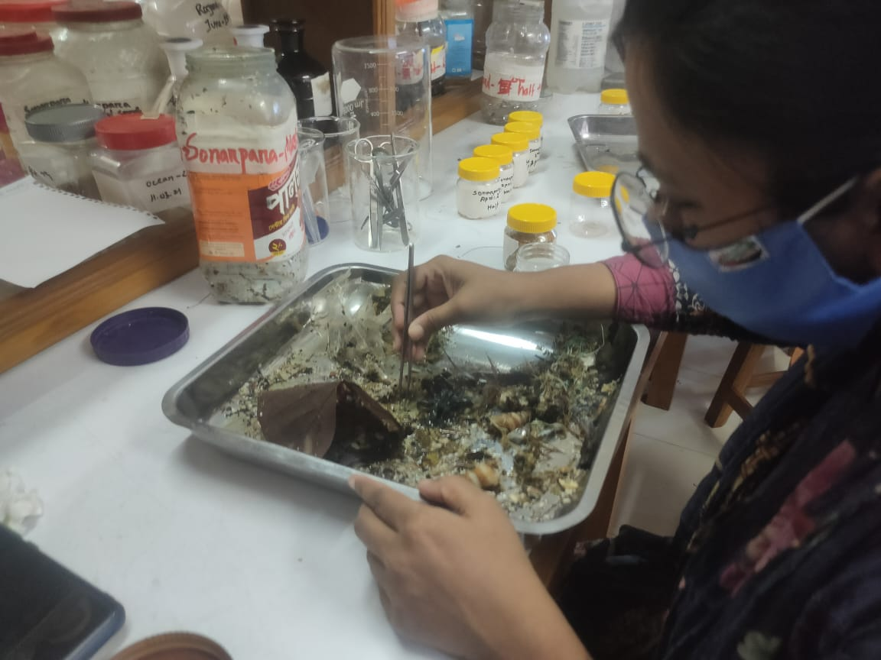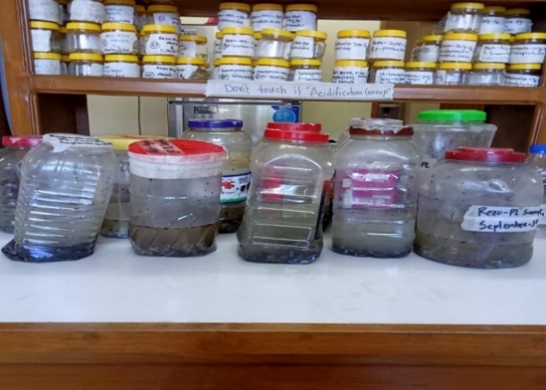**Photo Gallery**

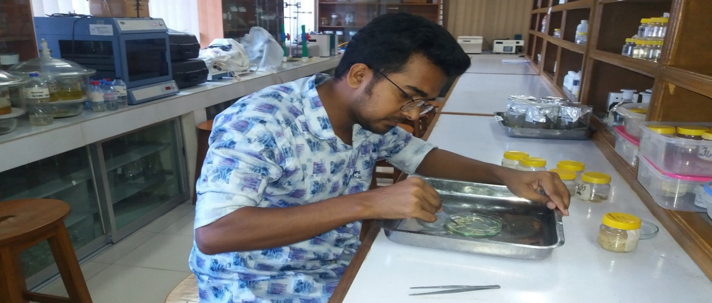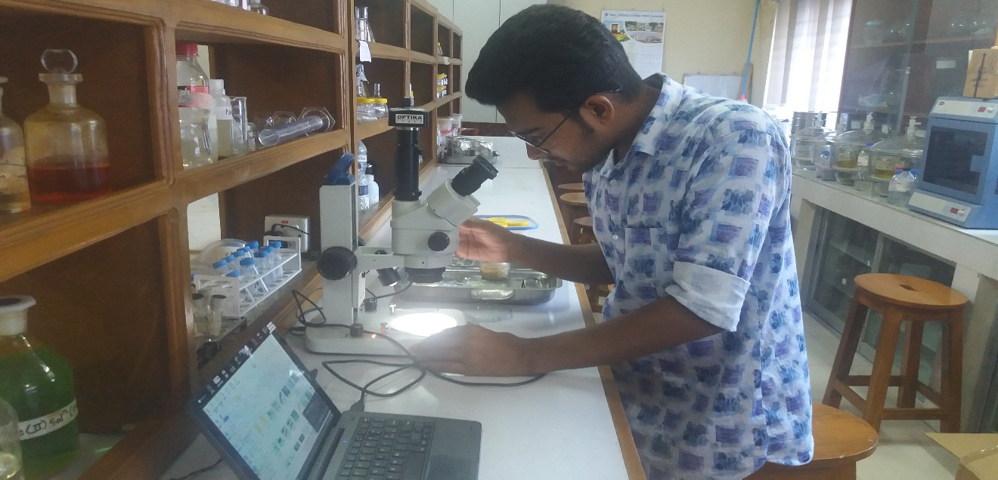

Plate 3. Sample of Fish larvae

Plate 4. Separation of fish larvae

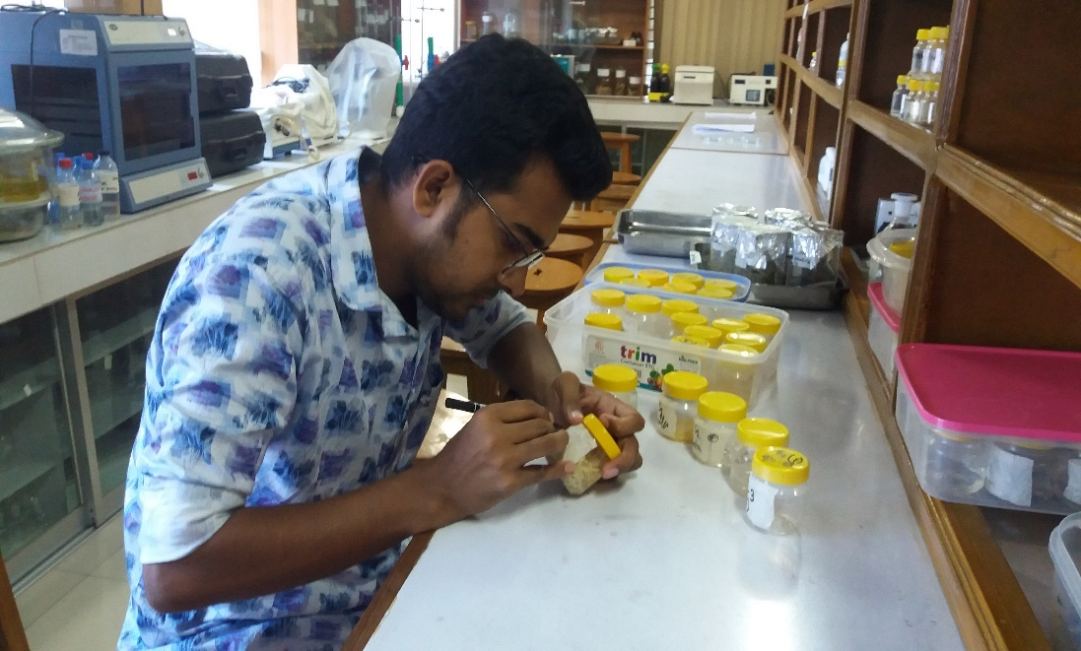

Plate 6. Identification of fish larvae

Plate 5. Counting of fish larvae

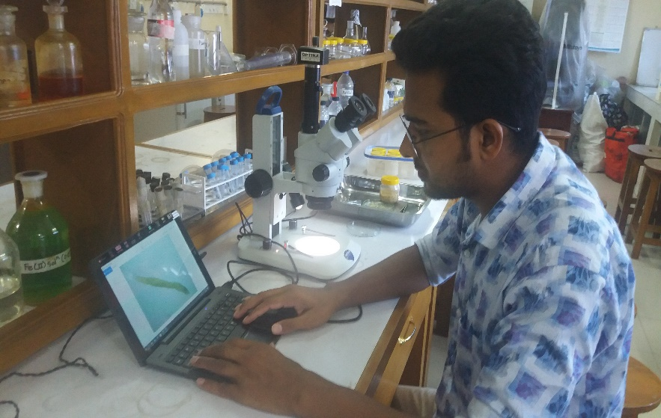

Plate 8. Labeling and preservation of fish larvae

Plate 7. Observation of fish larvae

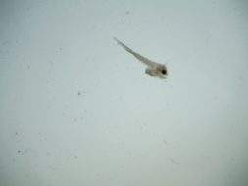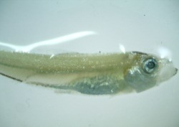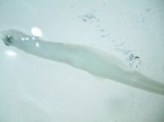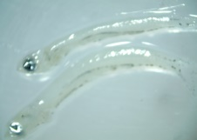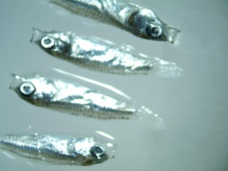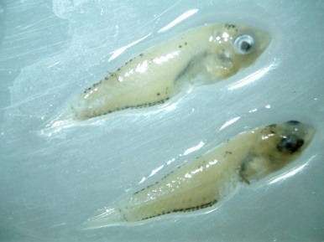

Plate 9. Some identified fish larvae

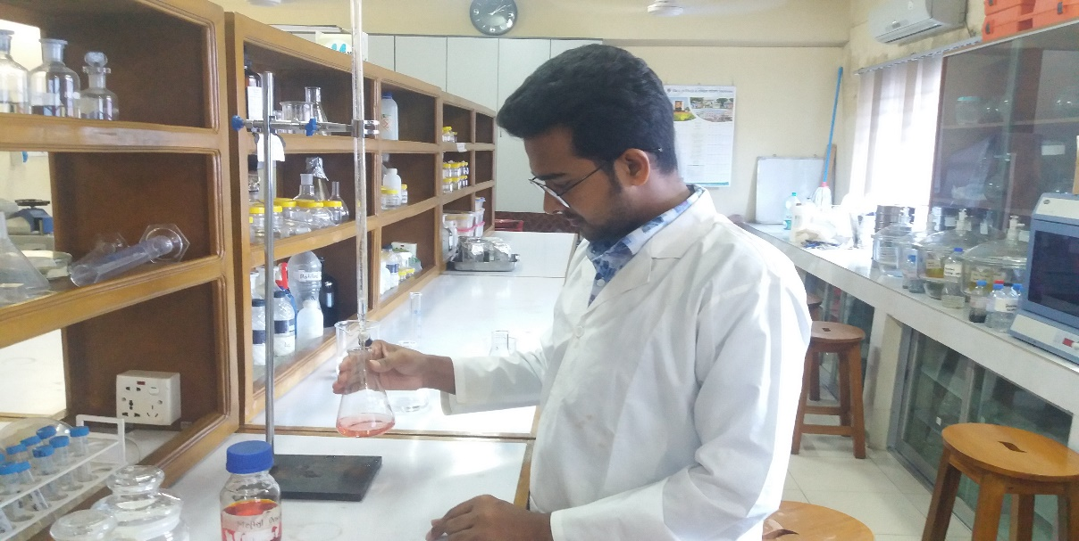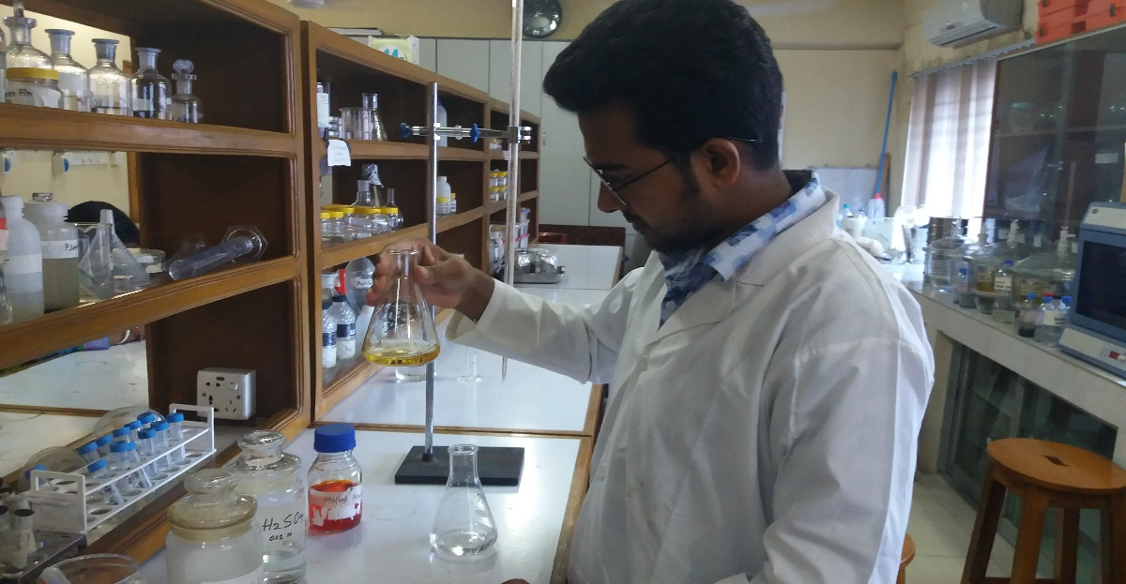

Plate 10. Determination of Total Alkalinity

**Chapter-4**

1. **Results**
   1. **Hydrological Parameters of Teknaf coast**
      1. **Water Temperature (°C)**

The estimated value of water temperature ranges from 22.6°C to 32°C. The highest value of water temperature was estimated 32.0°C in April and lowest value of water temperature was estimated 22.6°C in January (Figure 1). The average water temperature was 28.41°C ± 2.5551 (Table 1).

Figure 1. Monthly variations of water temperature of Teknaf coast

* + 1. **pH**

The estimated value of pH ranges from 7.9 to 9.1. The highest value of pH was estimated 9.1 in August and lowest value of pH was estimated 7.9 in February, which is presented in Figure 2. The average water pH was 8.36 ± 0.3339 (Table 1).

Figure 2. Monthly variations of pH of Teknaf coast

* + 1. **Total Alkalinity**

Total alkalinity ranges from 52 mg/l to 170 mg/l. Maximum alkalinity was estimated 170 mg/l in February and minimum alkalinity was estimated 52 mg/l in August (Figure 3). The average alkalinity was 113.25 mg/l ± 39.315 (Table 1).

Figure 3. Monthly variations of Alkalinity of Teknaf coast

* + 1. **Salinity**

The estimated value of salinity ranges from 8 PSU to 34 PSU. The highest value of salinity was estimated 34.0 PSU in May and lowest value of salinity was estimated 8.0 PSU in August, which is presented in Figure 4. The average salinity was 23.57 PSU ± 7.99 (Table 1).

Figure 4. Monthly variations of Salinity of Teknaf coast

* 1. **Monthly** **Fluctuations of the Hydrological Parameters of Teknaf coast**

Figure 4. Monthly variations of Salinity of Teknaf coast

Insignificant change was observed in case of temperature and pH but significant change was observed in case of total alkalinity and salinity, which is presented in Figure 5.

Figure 5. Monthly Fluctuations of the Hydrological Parameters of Teknaf coast

* 1. **Ocean acidification factors of Teknaf coast**

**4.3.1. pCO2**

The estimated value of pCO2 ranges from 5.0143 µatm to 464.3816 µatm. The highest value of pCO2 was estimated 464.3816 µatm in February and lowest value of pCO2 was estimated 5.0143 µatm in August, which is presented in Figure 6. The average value of pCO2 was 128.72 µatm ±124.414 (Table 1).

Figure 6. Monthly pCO2 variations of the Teknaf coast

**4.3.2 HCO3-**

The estimated value of HCO3- ranges from 0.0002 mol/kg to 0.0014 mol/kg. The highest value of HCO3- was estimated 0.0014 mol/kg in February and lowest values of HCO3- was estimated 0.0002 mol/kg in August (Figure 7). The average value of HCO3- was 0.000751 mol/kg ± 0.00037 (Table 1).

Figure 7. Monthly HCO3- variations of the Teknaf coast

**4.3.3 CO32-**

The estimated value of CO32- ranges from 0.0001 mol/kg to 0.0002 mol/kg. The highest value of CO32- was estimated 0.0002 mol/kg in January, March, November, and December. The lowest value of CO32- was estimated 0.0001 mol/kg in February and from April to October. The variations of these values are presented in Figure 8. The average value of CO32- was 0.000138 mol/kg ± 0.0000337 (Table 1).

Figure 8. Monthly CO32- variations of the Teknaf coast

**4.3.4 DIC**

The value of Dissolved Inorganic Carbon (DIC) ranges from 0.0003 mol/kg to 0.0015 mol/kg. The highest of DIC was estimated 0.0015 mol/kg in February and lowest value of DIC was estimated 0.0003 mol/kg in August (Figure 9). The average value of DIC was 0.000892 mol/kg ± 0.0003874 (Table 1).

Figure 9. Monthly Dissolved Inorganic Carbon (DIC) variations of the Teknaf coast

**4.3.5** **ΩAragonite**

The estimated value of ΩAragonite ranges from 1.3772 to 3.2091. The highest value of ΩAragonite was estimated 3.2091 in November and lowest value of ΩAragonite was estimated in October (Figure 10). The average value of ΩAragonite was 2.3544 ± 0.5524 (Table 1).

Figure 10. Monthly ΩAragonite variations of the Teknaf coast

**4.3.6** **ΩCalcite**

The estimated value of ΩCalcite ranges from 2.1329 to 4.9515. The highest value of ΩCalcite was estimated 4.9515 in November and lowest value of ΩCalcite was estimated 2.1329 in October (Figure 11). The average value of ΩCalcite was 3.7028 ± 0.8595 (Table 1).

Figure 11. Monthly ΩCalcite variations of the Teknaf coast

**4.4. Larval Abundance of Teknaf coast**

A total of 1,120 specimens of fish larvae were found in the study location. The highest 361 fish larvae were found in October and no fish larvae were found in September (Figure 12). The Average number of fish larvae was found 93 ± 133.209 (Table 1).

Figure 12. Monthly variation of Larval abundance of Teknaf coast

**4.5 Interaction between pCO2 & pH of Teknaf coast**

According to Pearson correlation, if the value is between 0.7 and 1.0, it means the correlation between the two variables is strong, and the negative value means negative correlation. In this research, a strongly negative correlation was found between pCO2 and pH of the Teknaf coast (Table 2). According to Pearson correlation, p value < 0.05 means a significant relationship between two variables. In this research, the p value was found at 0.003, which is less than 0.05 (Table 2). So, the correlation between pCO2 and pH of the Teknaf coast is significant, which is presented in Figure 13.

Figure 13. Interaction between pCO2 & pH of Teknaf coast

**4.6.** **Interaction between pCO2 & Larval abundance of Teknaf coast**

The rise of pCO2 in ocean water mainly affects the carbonate system of ocean water. The increase in the value of pCO2 decreases the value of water pH and, ultimately, reduces the survivability of larvae. According to Pearson correlation, if the value is between 0.3 and 0.7, it means the correlation between the two variables is moderate, and the negative value means negative correlation. In this research, a moderately negative correlation was found between pCO2 and larval abundance along the Teknaf coast (Table 3). According to Pearson's correlation, if the p value > 0.05, it means an insignificant relationship between two variables. In this research, the p value was found at 0.243, which is greater than 0.05 (Table 3). So, the correlation between pCO2 and larval abundance along the Teknaf coast is insignificant, which is presented in Figure 14.

Figure 14. Interaction between pCO2 & Larval abundance of Teknaf coast

**4.7. Interaction** **between pH & Larval abundance** **of Teknaf coast**

Carbonic acid is formed as a result of CO2 dissolving in the ocean. In the water, this carbonic acid diffuses, producing hydrogen ions and bicarbonate. Since the pH scale applies the equation pH =-log [H+] to describe acidity, a rise in hydrogen ion concentration results in an increase in acidity. pH is an important parameter to describe the actual condition of ocean acidification. If the value of pH decreases, the ocean water will become more acidic. According to Pearson correlation, if the value lies between 0.3 and 0.7, it means the correlation between the two variables is moderate, and the positive value means positive correlation. In this research, a moderately positive correlation was found between pH and larval abundance along the Teknaf coast (Table 4). According to Pearson's correlation, if the p value > 0.05, it means an insignificant relationship between two variables. In this research, the p value was found at 0.235, which is greater than 0.05 (Table 4). So, the correlation between pH and larval abundance along the Teknaf coast is insignificant, which is presented in Figure 15.

Figure 15. Interaction between pH & Larval abundance of Teknaf coast

* 1. **Relationship with pCO2, pH & Larval abundance of Teknaf coast**

In the first few months the abundance of fish larvae remains stable, but in the last few months, there were ups and downs in the abundance of fish larvae due to the fluctuation of pCO2 and pH, which is presented in Figure 16. The population of fish larvae was high in June, August, and October, even when the pH level did not fluctuate significantly. The abundance of fish larvae was quite low in July and September, despite the high pH value. The number of fish larvae reached its peak in October, even though the pH level in that month stayed below the average. The number of fish larvae was at its lowest in September, although the pH remains above the monthly average.

Figure 16. Relationship with pCO2, pH & Larval abundance of Teknaf coast

**4.9 Relationship among** **Ocean Acidification factors of Teknaf coast**

The positive and negative relationship were found among ocean acidification factors of Teknaf coast, which is presented in Figure 17. The positive relationship was found between Omega Aragonite and Omega Calcite. The positive relationship was also found between pCO2 and HCO3-. The negative relationship was found between pCO2 and larvae abundance of Teknaf coast. The negative relationship was also found between Omega Calcite and larvae abundance of Teknaf coast. The availability of fish larvae was significantly changed by these variables as well.

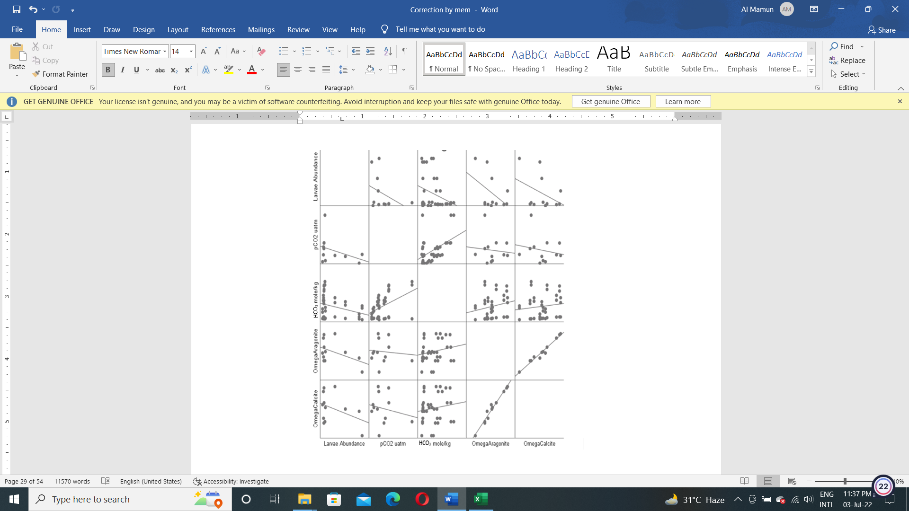

Figure 17. Relationship among ocean acidification factors of Teknaf coast

**Table 1.** **Statistical analysis of hydrological parameters & ocean acidification factors**

|  |  |  |  |  |
| --- | --- | --- | --- | --- |
| Parameters / Factors | Minimum Statistic | Maximum Statistic | Mean Statistic | Std. Deviation Statistic |
| Larval Abundance per 1000 m3 | 0 | 361 | 93.33 | 133.209 |
| Temperature (°C) | 22.6 | 32.0 | 28.417 | 2.5551 |
| pH | 7.9 | 9.1 | 8.367 | 0.3339 |
| Total Alkalinity (mg/l) | 52 | 170 | 113.25 | 39.315 |
| Salinity (PSU) | 8.0 | 34.0 | 23.575 | 7.9900 |
| pCO2 (µatm) | 5.0143 | 464.3816 | 128.724861 | 124.4143399 |
| HCO3- (mol/kg) | 0.0002 | 0.0014 | 0.000751 | 0.0003704 |
| CO32- (mol/kg) | 0.0001 | 0.0002 | 0.000138 | 0.0000337 |
| DIC (mol/kg) | 0.0003 | 0.0015 | 0.000892 | 0.0003874 |
| ΩAragonite | 1.3772 | 3.2091 | 2.354402 | 0.5524414 |
| ΩCalcite | 2.1329 | 4.9515 | 3.702874 | 0.8595012 |

**Table 2.** **Correlations between pCO2 & pH** **of Teknaf coast**

|  |  |  |  |
| --- | --- | --- | --- |
| **Correlations** | | | |
|  | | pCO2 | pH |
| pCO2 | Pearson Correlation | 1 | -.771** |
| Sig. (2-tailed) |  | .003 |
| N | 12 | 12 |
| pH | Pearson Correlation | -.771** | 1 |
| Sig. (2-tailed) | .003 |  |
| N | 12 | 12 |
| **. Correlation is significant at the 0.01 level (2-tailed). | | | |

**Table 3. Correlations between pCO2 & Larval abundance of Teknaf coast**

|  |  |  |  |
| --- | --- | --- | --- |
| **Correlations** | | | |
|  | | Larval Abundance | pCO2 |
| Larval Abundance | Pearson Correlation | 1 | -.365 |
| Sig. (2-tailed) |  | .243 |
| N | 12 | 12 |
| pCO2 | Pearson Correlation | -.365 | 1 |
| Sig. (2-tailed) | .243 |  |
| N | 12 | 12 |

**Table 4.** **Correlations between** **pH & Larval abundance of Teknaf coast**

|  |  |  |  |
| --- | --- | --- | --- |
| **Correlations** | | | |
|  | | Larval  Abundance | pH |
| Larval Abundance | Pearson Correlation | 1 | .371 |
| Sig. (2-tailed) |  | .235 |
| N | 12 | 12 |
| pH | Pearson Correlation | .371 | 1 |
| Sig. (2-tailed) | .235 |  |
| N | 12 | 12 |

**Chapter-5**

1. **Discussion**

The link between oceanic factors and fish larval abundance has been highlighted in several articles. According to recent research, the negative effects of increased pCO2 on larvae produced from subsequent spawning can be reduced or eliminated when brood stock is exposed to it before spawning (Miller et al., 2012). All groups of the same species may respond differently to CO2 stress, and the early developmental stage of marine fish faces several constraints with high death rates throughout development (Frommel et al., 2013).

* 1. **Temperature**

One of the most important aspects of water quality that affects all other aspects of water is temperature. The temperature has a significant impact on chemical and biological processes. According to Běhrádek, J. (1930), 10°C temperature increase can cause chemical and biological activity to double. Therefore, warmer water than cold water has a greater impact on the dissolving oxygen requirement for fish and other aquatic species. The average temperature for the present research was 28.41°C. According to Boyd (1990), aquatic species in the tropical and subtropical regions cannot grow below 26 to 28°C. Consequently, the Teknaf coast's temperature is favorable for fish growth.

* 1. **pH**

One of the key indicators of water quality is pH, which measures the amount of hydrogen ions (H+) in the water. Fish metabolism, development, and other physiological activities are all reduced by an acidic pH, according to Swingle (1967). In this study, the value of pH ranges from 7.9 to 9.1. The average water pH was 8.36. Numerous variables, including the amount of dissolved minerals in the water, trash dumped, photosynthesis, water turbulence, bacterial activity, chemical components of runoff pouring into the water body, sewage overflows, and even aerosols and airborne dust, can affect pH fluctuations (Faires, 1993). According to Hossain et al. (2012), the recommended limit of pH fluctuation is 6.5 to 9.2 and the observed pH value of this research was 7.9 to 9.1. Though the fluctuation of water pH was found, it did not cross the recommended limit of pH fluctuation.

* 1. **Alkalinity**

Alkalinity is the water's ability to buffer acids and bases to keep the pH level constant. The alkalinity was found between 52 mg/l to 170 mg/l. Alkalinity had higher variation within a different month. The standard limit of alkalinity is more than 100 mg/l (Faires, 1993). Moderate alkalinity expresses moderate salinity in the water (Biswas et al., 2011).

**5.4 Salinity**

The Results showed that the salinity level was found between 8 PSU to 34 PSU and the average was 23.57 PSU. Salinity can be affected by different factors. The salinity of an estuary ranges from 5 ppt to 35 ppt (Vernberg, 1974). According to Ahmed (1983), the salinity in the estuarine area of Karnafully ranged from 3.30 ppt to 22.93 ppt, whereas Mahmood (1990), determined that the salinity in Chakaria estuary ranged from 6.14 ppt to 32.5 ppt. Evaporation increases the seawater's salinity and adding freshwater by rainfall or runoff, which dilutes the seawater, reduces the salinity (Hossain et al., 2015).

* 1. **Ocean Acidification factors**

The volume of carbon dioxide gas dissolved in saltwater is known as pCO2 (partial pressure of carbon dioxide). According to Diaz et al., (2019), pCO2 is the main factor of ocean acidification for biological organisms and elevated levels of pCO2 (550 μatm) have severe effects on larval growth. During the research period, pCO2 values ranged from 5.0143 μatm to 464.3816 μatm. The mean value of pCO2 was 128.72 µatm. So, there were not found severe effects of pCO2 on larval growth. Scanes et al., (2014) also revealed that larval abundance is negatively correlated with pCO2, and a level of more than 300 μatm has a negative impact on larval abundance. Other important ocean acidification factors are HCO3-, CO32-, DIC, ΩAragonite, and ΩCalcite.

Spyres et al., (2000) published that a significant component of saltwater and a crucial indicator of ocean acidification is dissolved inorganic carbon (DIC), which is normally made up of CO32-, HCO3-, and CO2 (aq). The ideal value of DIC for organisms is less than 0.002 mol/kg. The average value of DIC was 0.000892 mol/kg which is less than the ideal value of DIC. So, the derived value of DIC was not harmful to the aquatic organisms along the Teknaf coast.

Since the aragonite saturation state measures carbonate ion concentration, it is frequently used to evaluate ocean acidification. The aquatic organisms became stressed when the aragonite saturation state drops below 3, and shells and other aragonite structures start to dissolve when the saturation level drops below 1 (Jiang et al., 2015). During the research period, the value of ΩAragonite ranged from 1.3772 to 3.2091 and the average value of ΩAragonite was 2.3544. So, the aquatic organisms along the Teknaf coast did not become stressed when the value of ΩAragonite was above 3.

The ability of saltwater to dissolve the CaCO3 shells and skeletons of marine creatures is determined by its saturation state for CaCO3. According to Corlis & Honjo (1981), undersaturated saltwater (ΩCalcite <1) is dangerous for calcifying organisms in the absence of defense systems. The value of ΩCalcite ranged from 2.1329 to 4.9515 and the average value of ΩCalcite was 3.7028 in the present study. The derived value of ΩCalcite was greater than 1 and so it was not dangerous for the calcifying organisms along the Teknaf coast.

* 1. **Relationship with pCO2, pH & Larval abundance of Teknaf coast**

The number of fish larvae is affected by a variety of factors, including the level of acidification. There is individual variation in certain species' somatic and behavioral reactions to high pCO2 (Munday et al., 2010; Ferrari et al., 2011; Munday et al., 2012), and in one study, when resistant juveniles were released into the wild, their rates of predation-based death were reduced (Munday et al., 2012), indicating the possibility of quick adaptation and selection as well as larger population resilience to ocean acidification (Frommel et al., 2012). Though selection could slow down at higher pCO2 levels if species are resistant (Munday et al., 2010; Ferrari et al., 2011). Furthermore, it is not apparent if the traits of resistant populations are inherited (Munday et al., 2012). In addition, Munday et al. (2011) and other studies like Hurst et al. (2013) only evaluated survival on a single day, which may or may not have been the final day of any elevated mortality. As a result, mortality rates couldn't be estimated even if there was an end-point measurement. On the continental shelves of the Andaman Sea, Munk et al. (2004) examined the interaction between chemistry, physics, and plankton biology. They noticed that a hydrographic front was forming at the same time as the mid-shelf (50-65m bottom depth) when mesozooplankton and fish larvae abundance peaked. Significant abundance gradients have been found throughout the shelf in other tropical studies, but no recurring patterns associated with hydrography or other variables have been found (Leis, 1993; Williams et. al., 1988). Other studies have examined hatching success and found no indication of the consequences of ocean acidification, including Munday et al. (2009b); Franke & Clemmesen (2011); Frommel et al. (2013); Hurst et al. (2013, 2016).

The results of this research showed that for the first few months the abundance of fish larvae remains stable, but in the last few months, there were ups and downs in the abundance of fish larvae. Ocean acidification is caused by a reduction in pH, which has an impact on fish larvae abundance. However, the author noticed in this research that the population of fish larvae stays high in June, August, and October, even when the pH level did not fluctuate significantly. The abundance of fish larvae was quite low in July and September, despite the high pH value. The number of fish larvae reached its peak in October, even though the pH level in that month stayed below the average. The number of fish larvae was at its lowest in September, although the pH remains above the monthly average. As a result, not only is ocean acidification to blame for changes in larval abundance but so are other factors. Lower recruiting to the spawning stock will result from higher death rates in the juvenile stage, whether directly via reduced survival or indirectly through decreased health, for marine fish populations. Future research must take into account the interaction impacts of shifting ocean pH, dissolved oxygen, and water temperature to increase the accuracy of projections concerning the future of fish species and their ecological sustainability (Gruber, 2011).

To obtain a better understanding of the general picture of fish larval abundance throughout the Teknaf coast, more study is necessary into the relationships between the fish larvae and oceanographic parameters in different monsoon systems.

**Chapter-6**

1. **Conclusion**

This research showed an insignificant relationship between ocean acidification and larvae abundance along the Teknaf coast. Ocean acidification is caused by a reduction in pH, which has an impact on fish larvae abundance. But in this research, the increase in the value of pCO2 did not affect the larvae abundance by lowering the pH value. The value of pCO2 influences the value of other ocean acidification factors. It is difficult to find out the one specific cause that is responsible for reducing the larvae abundance along the Teknaf coast. The hydrological parameters of the Teknaf coast were within the ideal ranges. Results should be carefully analyzed, and it's critical to remember that there will be a chance for adaptation and acclimatization. Therefore, it's also anticipated that these mechanisms can mitigate the detrimental effects on fish larvae. The findings of this research will help to understand how ocean acidification affects fish species that are important for management, economics, and ecological concerns. Future research should concentrate on how these environmental variables may influence fish species that are significant for commercial at higher organizational levels, in order to assist leaders and policy-makers in taking preventative action. Regional fisheries management organizations will be better able to make decisions about the management of the extremely valuable fish larvae as a result of future population-level predictions of the impacts of ocean acidification. This is especially true with regard to achieving important sustainability-related goals.

**Chapter-7**

1. **Recommendations**

Pollution and global warming are two of the many factors that accelerate ocean acidification. The following actions will be helped to save the ocean in the long term-

* The use of fossil fuels, which are responsible for the emission of carbon dioxide, must be reduced.
* Renewable energy should be used to return the environment to its original state.
* Land runoff should be monitored to protect the coral reefs, which are crucial to keeping the ocean in good condition.
* The forests that are considered the lungs of the world must be protected. The majority of the carbon dioxide emissions into the air are absorbed by the forests.
* Rules and regulations must be implemented to protect the marine environment from degradation of the marine habitats.
* The use of electricity, which is indirectly responsible for carbon emissions, should be reduced.
* Water should be saved from being wasted to prevent ocean acidification.
* Local items should be used to reduce the carbon emissions during the transportation of items from one place to another.
* The use of plastic, which takes hundreds of years to entirely vanish, must be stopped.
* Paper, cotton cloth, metal, or glass materials that will be better for the environment should be used.
* The waste materials should be recycled to protect the environment from ocean acidification.
* The growth of marine plants should be ensured along the Teknaf coast to reduce ocean acidification.
* The habitats along the Teknaf coast must be protected from degradation to improve the coastal environment.
* Offshore drilling, which is responsible for the degradation of water quality, must be stopped.
* The alkalinity of the ocean water should be increased to minimize the ocean acidity.

**References**

Achuthankutty CT, Madhupratap M, Nair VR, Nair SR & Rao TSS. 1980. Zooplankton Biomass & Composition in the Western Bay of Bengal during Late SW Monsoon.

Ahmed SN, McKee ML & Shevlin PB. 1983. An experimental and ab initio study of the addition of atomic carbon to water. Journal of the American Chemical Society, 105(12): 3942-3947.

Albright R, Mason B, Miller M & Langdon C. 2010. Ocean acidification compromises recruitment success of the threatened Caribbean coral Acropora palmata. *Proceedings of the National Academy of Sciences*, *107*(47): 20400-20404.

Allan BJ, Domenici, Munday PL & McCormick MI. 2015. Feeling the heat: the effect of acute temperature changes on predator-prey interactions in coral reef fish. *Conservation Physiology*, *3*(1): cov011.

Augustin L, Barbante C, Barnes PR, Barnola JM, Bigler M, Castellano E & Zucchelli M. 2004. Eight glacial cycles from an Antarctic ice core. *Nature*, *429*: 623-628.

Bates NR. 2007. Interannual variability of the oceanic CO2 sink in the subtropical gyre of the North Atlantic Ocean over the last 2 decades. *Journal of Geophysical Research: Oceans*, *112*(C9).

Bates NR & Peters AJ. 2007. The contribution of atmospheric acid deposition to ocean acidification in the subtropical North Atlantic Ocean. *Marine Chemistry*, *107*(4): 547-558.

Baumann H, Talmage SC & Gobler CJ. 2011. Reduced early life growth and survival in a fish in direct response to increased carbon dioxide. Nat Clim Chang.

Baumann H, Talmage SC & Gobler CJ. 2012. Reduced early life growth and survival in a fish in direct response to increased carbon dioxide. *Nature Climate Change*, *2*(1): 38-41.

Běhrádek J. 1930. Temperature coefficients in biology. *Biological Reviews*, *5*(1): 30-58.

Bignami S, Enochs IC, Manzello DP, Sponaugle S & Cowen RK. 2013. Ocean acidification alters the otoliths of a pantropical fish species with implications for sensory function. *Proceedings of the National Academy of Sciences*, *110*(18): 7366-7370.

Biswas H, Cros A, Yadav K, Ramana VV, Prasad VR, Acharyya T & Babu PVR. 2011. The response of a natural phytoplankton community from the Godavari River Estuary to increasing CO2 concentration during the pre-monsoon period. Journal of Experimental Marine Biology and Ecology 407: 284-293.

Bopp L, Resplandy L, Orr JC, Doney SC, Dunne JP, Gehlen M & Vichi M. 2013. Multiple stressors of ocean ecosystems in the 21st century: projections with CMIP5 models. *Biogeosciences*, *10*(10): 6225-6245.

Boyd CE. 1990. Water quality in ponds for aquaculture. Agriculture Experiment Station, Auburn University, Alabama, 482 pages.

Briffa M, de la Haye K & Munday PL. 2012. High CO2 and marine animal behaviour: potential mechanisms and ecological consequences. *Marine pollution bulletin*, *64*(8): 1519-1528.

Bromhead D, Scholey V, Nicol S, Margulies D, Wexler J, Stein M & Lehodey P. 2015. The potential impact of ocean acidification upon eggs and larvae of yellowfin tuna (*Thunnus albacares*). *Deep Sea Research Part II: Topical Studies in Oceanography*, *113*: 268-279.

Broecker WS, Takahashi T, Andersen NR & Malahoff A. 1977. Neutralization of fossil fuel CO2 by marine calcium carbonate.

Broecker WS, Takahashi T, Simpson HJ & Peng TH. 1979. Fate of fossil fuel carbon dioxide and the global carbon budget. *Science*, *206*(4417): 409-418.

Broecker W & Clark E. 2001. A dramatic Atlantic dissolution event at the onset of the last glaciation. *Geochemistry, Geophysics, Geosystems*: *2*(11).

Brown DJA & Sadler K. 1989. Acid toxicity and aquatic animals. In *Society for experimental biology. Seminar series* (Vol. 34, pp. 31-44).

Caldeira K & Wickett ME. 2003. Anthropogenic carbon and ocean pH. *Nature*, *425*(6956): 365-365.

Corliss BH & Honjo S. 1981. Dissolution of deep-sea benthonic foraminifera. Micropaleontology: 356-378.

Cowen RK & Sponaugle S. 2009. Larval dispersal and marine population connectivity. *Annual review of marine science*, *1*: 443-466.

Devine BM, Munday PL & Jones GP. 2012. Rising CO2 concentrations affect settlement behaviour of larval damselfishes. *Coral Reefs*, *31*(1): 229-238.

Díaz-Castañeda V, Cox TE, Gazeau F, Fitzer S, Delille J, Alliouane S & Gattuso JP. 2019. Ocean acidification affects calcareous tube growth in adults and reared offspring of serpulid polychaetes. *Journal of Experimental Biology*, *222*(13), jeb196543.

Dickson AG. 2010. The carbon dioxide system in seawater: equilibrium chemistry and measurements. *Guide to best practices for ocean acidification research and data reporting*, *1*: 17-40.

Dixson DL, Munday P L & Jones G P. 2010. Ocean acidification disrupts the innate ability of fish to detect predator olfactory cues. *Ecology letters*, *13*(1): 68-75.

Domenici P, Allan B, McCormick MI & Munday PL. 2012. Elevated carbon dioxide affects behavioural lateralization in a coral reef fish. *Biology letters*, *8*(1): 78-81.

Doney SC, Fabry VJ, Feely RA & Kleypas JA. 2009. Ocean acidification: the other CO2 problem. *Annual review of marine science*, *1*: 169-192.

Doney SC, Mahowald N, Lima I, Feely R, Mackenzie FT, Lamarque JF & Rasch PJ. 2007. Impact of anthropogenic atmospheric nitrogen and sulfur deposition on ocean acidification and the inorganic carbon system. *Proceedings of the National Academy of Sciences*, *104*(37): 14580-14585.

Dore JE, Lukas R, Sadler DW, Church MJ & Karl DM. 2009. Physical and biogeochemical modulation of ocean acidification in the central North Pacific. *Proceedings of the National Academy of Sciences*, *106*(30): 12235-12240.

Fabry VJ, Seibel BA, Feely RA & Orr JC. 2008. Impacts of ocean acidification on marine fauna and ecosystem processes. *ICES Journal of Marine Science*, *65*(3): 414-432.

Faires LMH. 1993. Methods of analysis by the US Geological Survey National Water Quality Laboratory: determination of metals in water by inductively coupled plasma-mass spectrometry (Vol. 92). US Department of the Interior, US Geological Survey.

Feely RA & Chen CTA. 1982. The effect of excess CO2 on the calculated calcite and aragonite saturation horizons in the northeast Pacific. *Geophysical Research Letters*, *9*(11): 1294-1297.

Feely RA, Byrne RH, Betzer PR, Gendron JF & Acker JG. 1984. Factors influencing the degree of saturation of the surface and intermediate waters of the North Pacific Ocean with respect to aragonite. *Journal of Geophysical Research: Oceans*, *89*(C6): 10631-10640.

Feely RA, Sabine CL, Lee K, Berelson W, Kleypas J, Fabry VJ & Millero FJ. 2004. Impact of anthropogenic CO2 on the CaCO3 system in the oceans. *Science*, *305*(5682): 362-366.

Feely RA, Fabry VJ & Guinotte JM. 2008. Ocean acidification of the North Pacific Ocean. *PICES Press*, *16*(1): 22-26.

Ferrari MC, Dixson DL, Munday PL, McCormick MI, Meekan MG, Sih A & Chivers DP. 2011. Intrageneric variation in antipredator responses of coral reef fishes affected by ocean acidification: implications for climate change projections on marine communities. *Global Change Biology*, *17*(9): 2980-2986.

Ferrari MC, McCormick MI, Munday PL, Meekan MG, Dixson DL, Lönnstedt O & Chivers D P. (2012a). Effects of ocean acidification on visual risk assessment in coral reef fishes. *Functional Ecology*, *26*(3): 553-558.

Ferrari MC, Manassa RP, Dixson DL, Munday PL, McCormick MI, Meekan MG & Chivers DP. 2012b. Effects of ocean acidification on learning in coral reef fishes. *PloS one*, *7*(2), e31478.

Franke A & Clemmesen C. 2011. Effect of ocean acidification on early life stages of Atlantic herring (*Clupea harengus*). *Biogeosciences*, *8*(12): 3697-3707.

Friedlingstein P, Cox P, Betts R, Bopp L, von Bloh W, Brovkin V & Zeng N. 2006. Climate-carbon cycle feedback analysis: results from the C4MIP model intercomparison. *Journal of climate*, *19*(14): 3337-3353.

Frommel AY, Maneja R, Lowe D, Malzahn AM, Geffen AJ, Folkvord A & Clemmesen C. 2012. Severe tissue damage in Atlantic cod larvae under increasing ocean acidification. *Nature Climate Change*, *2*(1): 42-46.

Frommel AY, Schubert A, Piatkowski U & Clemmesen C. 2013. Egg and early larval stages of Baltic cod, Gadus morhua, are robust to high levels of ocean acidification. *Marine Biology*, *160*(8): 1825-1834.

Frommel AY, Maneja R, Lowe D, Pascoe CK, Geffen AJ, Folkvord A & Clemmesen C. 2014. Organ damage in Atlantic herring larvae as a result of ocean acidification. *Ecological Applications*, *24*(5): 1131-1143.

Gilbert SF & Bolker JA. 2003. Ecological developmental biology: preface to the symposium1. *Evolution & Development*, *5*(1): 3-8.

Gruber N. 2011. Warming up, turning sour, losing breath: ocean biogeochemistry under global change. Philosophical Transactions of the Royal Society A: Mathematical, Physical and Engineering Sciences, 369(1943): 1980-1996.

Harvey BP, Gwynn‐Jones D & Moore PJ. 2013. Meta‐analysis reveals complex marine biological responses to the interactive effects of ocean acidification and warming. *Ecology and evolution*, *3*(4): 1016-1030.

Hayashi M, Kita J & Ishimatsu A. 2004. Comparison of the acid-base responses to CO2 and acidification in Japanese flounder (*Paralichthys olivaceus*). *Marine Pollution Bulletin*, *49*(11-12): 1062-1065.

Hendriks IE, Duarte CM & Álvarez M. 2010. Vulnerability of marine biodiversity to ocean acidification: a meta-analysis. *Estuarine, Coastal and Shelf Science*, *86*(2): 157-164.

Heuer RM & Grosell M. 2014. Physiological impacts of elevated carbon dioxide and ocean acidification on fish. *American Journal of Physiology-Regulatory, Integrative and Comparative Physiology*, *307*(9): R1061-R1084.

Hickford MJH. 2000. Patterns of distribution and abundance of larval fish in a southern temperate region.

Hossain MS, Das NG, Sarker S & Rahaman MZ. 2012. Fish diversity and habitat relationship with environmental variables at Meghna River estuary, Bangladesh. *The Egyptian Journal of Aquatic Research, 38(3): 213-226.*

Hossain MS, Chowdhury SR, Sharifuzzaman SM & Sarker S. 2015. Vulnerability of the Bay of Bengal to Ocean Acidification. *IUCN, International Union for Conservation of Nature, Bangladesh Country Office.*

Houde ED. 1989. Subtleties and episodes in the early life of fishes. *Journal of Fish Biology*, *35*: 29-38.

Houghton JT, Ding YDJG, Griggs DJ, Noguer M, van der Linden PJ, Dai X & Johnson CA (Eds.). 2001. *Climate change 2001: the scientific basis: contribution of Working Group I to the third assessment report of the Intergovernmental Panel on Climate Change*. Cambridge university press.

Hurst TP, Fernandez ER & Mathis JT. 2013. Effects of ocean acidification on hatch size and larval growth of walleye pollock (*Theragra chalcogramma*). *ICES Journal of Marine Science*, *70*(4): 812-822.

Hurst TP, Laurel BJ, Mathis JT & Tobosa LR. 2016. Effects of elevated CO2 levels on eggs and larvae of a North Pacific flatfish. *ICES Journal of Marine Science*, *73*(3): 981-990.

Ishimatsu A, Kikkawa T, Hayashi M, Lee K & Kita J. 2004. Effects of CO2 on marine fish: larvae and adults. *Journal of oceanography*, *60*(4): 731-741.

Jiang LQ, O'Connor SA, Arzayus KM & Parsons AR. 2015. A metadata template for ocean acidification data. *Earth System Science Data*, *7*(1): 117-125.

Jonz MG & Nurse CA. 2006. Ontogenesis of oxygen chemoreception in aquatic vertebrates. *Respiratory physiology & neurobiology*, *154*(1-2): 139-152.

Kikkawa T, Ishimatsu A & Kita J. 2003. Acute CO2 tolerance during the early developmental stages of four marine teleosts. *Environmental Toxicology: An International Journal*, *18*(6): 375-382.

Kikkawa T, Kita J & Ishimatsu A. 2004. Comparison of the lethal effect of CO2 and acidification on red sea bream (*Pagrus major*) during the early developmental stages. *Marine Pollution Bulletin*, *48*(1-2): 108-110.

Kleypas JA, Buddemeier RW, Archer D, Gattuso JP, Langdon C & Opdyke BN. 1999. Geochemical consequences of increased atmospheric carbon dioxide on coral reefs. *science*, *284*(5411): 118-120.

Kroeker KJ, Kordas RL, Crim R, Hendriks IE, Ramajo L, Singh GS & Gattuso JP. 2013. Impacts of ocean acidification on marine organisms: quantifying sensitivities and interaction with warming. *Global change biology*, *19*(6): 1884-1896.

Leis JM. 1993. Larval fish assemblages near Indo-Pacific coral reefs. *Bulletin of Marine Science*, *53*(2): 362-392.

Lirdwitayaprasit P, Nuangsang C, Puewkhao P, Rahman M J, Oo AH & Sein AW. 2008. Composition, abundance and distribution of fish larvae in the Bay of Bengal. *SEAFDEC, Thailand*: 93-124.

Long WC, Swiney KM, Harris C, Page HN & Foy RJ. 2013. Effects of ocean acidification on juvenile red king crab (*Paralithodes camtschaticus*) and Tanner crab (*Chionoecetes bairdi*) growth, condition, calcification, and survival. *PloS one*, *8*(4): e60959.

Loy A, Bertelletti M, Costa C, Ferlin L & Cataudella S. 2001. Shape changes and growth trajectories in the early stages of three species of the genus *Diplodus* (Perciformes, Sparidae). *Journal of Morphology*, *250*(1): 24-33.

Lueker TJ, Dickson AG & Keeling CD. 2000. Ocean pCO2 calculated from dissolved inorganic carbon, alkalinity, and equations for K1 and K2: validation based on laboratory measurements of CO2 in gas and seawater at equilibrium. *Marine chemistry*, *70*(1-3): 105-119.

Madhupratap M, Gauns M, Ramaiah N, Kumar SP, Muraleedharan PM, De Sousa SN & Muraleedharan U. 2003. Biogeochemistry of the Bay of Bengal: physical, chemical and primary productivity characteristics of the central and western Bay of Bengal during summer monsoon 2001. *Deep Sea Research Part II: Topical Studies in Oceanography*, *50*(5): 881-896.

Mahmood N. 1990. Study on imigration of commercially important penaeid shrimp postlarvae in the estuarine area of Chakaria, Cox's Bazar Bangladesh (Doctoral dissertation, Institut Akuakultur Tropika).

Maneja RH, Frommel AY, Geffen AJ, Folkvord A, Piatkowski U, Chang MY & Clemmesen C. 2013. Effects of ocean acidification on the calcification of otoliths of larval Atlantic cod *Gadus morhua*. *Marine Ecology Progress Series*, *477*: 251-258.

McKim JM. 1977. Evaluation of tests with early life stages of fish for predicting long-term toxicity. *Journal of the Fisheries Board of Canada*, *34*(8): 1148-1154.

Mehrbach C, Culberson CH, Hawley JE & Pytkowicx RM. 1973. Measurement of the apparent dissociation constants of carbonic acid in seawater at atmospheric pressure 1. *Limnology and oceanography*, *18*(6): 897-907.

Melzner F, Gutowska MA, Langenbuch M, Dupont S, Lucassen M, Thorndyke MC & Pörtner HO. 2009. Physiological basis for high CO2 tolerance in marine ectothermic animals: pre-adaptation through lifestyle and ontogeny? *Biogeosciences*, *6*(10): 2313-2331.

Miller GM, Watson SA, Donelson JM, McCormick MI & Munday PL. 2012. Parental environment mediates impacts of increased carbon dioxide on a coral reef fish. *Nature Climate Change*, *2*(12): 858-861.

Moran D & Støttrup JG. 2011. The effect of carbon dioxide on growth of juvenile Atlantic cod *Gadus morhua*. *Aquatic Toxicology*, *102*(1-2): 24-30.

Moteki M. 2002. Morphological aspects of feeding and improvement in feeding ability in the early larval stages of red sea bream *Pagrus major*. *Fisheries science*, *68*(5): 996-1003.

Moteki M, Ishikawa T & Fushimi H. 2002. Changes in feeding function inferred from osteological development in the early-stage larvae of the Japanese flounder, *Paralichthys olivaceus*, reared in the laboratory. *Aquaculture Science*, *50*(3): 285-294.

Munday PL, Jones GP, Pratchett MS & Williams AJ. 2008. Climate change and the future for coral reef fishes. *Fish and Fisheries*, *9*(3): 261-285.

Munday PL, Dixson DL, Donelson JM, Jones GP, Pratchett MS, Devitsina GV & Døving KB. 2009a. Ocean acidification impairs olfactory discrimination and homing ability of a marine fish. *Proceedings of the National Academy of Sciences*, *106*(6): 1848-1852.

Munday PL, Donelson JM, Dixson DL & Endo GG. 2009b. Effects of ocean acidification on the early life history of a tropical marine fish. *Proceedings of the Royal Society B: Biological Sciences*, *276*(1671): 3275-3283.

Munday PL, Dixson DL, McCormick MI, Meekan M, Ferrari MC & Chivers DP. 2010. Replenishment of fish populations is threatened by ocean acidification. *Proceedings of the National Academy of Sciences*, *107*(29): 12930-12934.

Munday PL, Gagliano M, Donelson JM, Dixson DL & Thorrold SR. 2011a. Ocean acidification does not affect the early life history development of a tropical marine fish. *Marine Ecology Progress Series*, *423*: 211-221.

Munday PL, Hernaman V, Dixson DL & Thorrold SR. 2011b. Effect of ocean acidification on otolith development in larvae of a tropical marine fish. *Biogeosciences*, *8*(6): 1631-1641.

Munday PL, McCormick MI, Meekan M, Dixson DL, Watson SA, Chivers DP & Ferrari MC. 2012. Selective mortality associated with variation in CO2 tolerance in a marine fish. *Ocean acidification*, *1*: 1-5.

Munk P, Bjørnsen PK, Boonruang P, Fryd M, Hansen PJ, Janekarn V & Østergaard JB. 2004. Assemblages of fish larvae and mesozooplankton across the continental shelf and shelf slope of the Andaman Sea (NE Indian Ocean). *Marine Ecology Progress Series*, *274*: 87-97.

Murray CS, Malvezzi A, Gobler CJ & Baumann H. 2014. Offspring sensitivity to ocean acidification changes seasonally in a coastal marine fish. *Marine Ecology Progress Series*, *504*: 1-11.

Nair SS, Nair VR, Achuthankutty CT & Madhupratap M. 1981. Zooplankton composition and diversity in western Bay of Bengal. *Journal of Plankton Research*, *3*(4): 493-508.

Neira FJ, Miskiewicz AG & Trnski T. 1998. *Larvae of temperate Australian fishes: laboratory guide for larval fish identification*. UWA Publishing.

Nilsson GE, Dixson DL, Domenici P, McCormick MI, Sørensen C, Watson SA & Munday PL. 2012. Near-future carbon dioxide levels alter fish behaviour by interfering with neurotransmitter function. *Nature Climate Change*, *2*(3): 201-204.

Onitsuka T, Kimura R, Ono T, Takami H & Nojiri Y. 2014. Effects of ocean acidification on the early developmental stages of the horned turban, Turbo cornutus. *Marine biology*, *161*(5): 1127-1138.

Orr JC, Fabry VJ, Aumont O, Bopp L, Doney SC, Feely RA & Yool A. 2005. Anthropogenic ocean acidification over the twenty-first century and its impact on calcifying organisms. *Nature*, *437*(7059): 681-686.

Osse JWM, Van den Boogaart JGM, Van Snik GMJ & Van der Sluys L. 1997. Priorities during early growth of fish larvae. *Aquaculture*, *155*(1-4): 249-258.

Pankhurst NW & Munday PL. 2011. Effects of climate change on fish reproduction and early life history stages. *Marine and Freshwater Research*, *62*(9): 1015-1026.

Peck MA, Huebert KB & Llopiz JK. 2012. Intrinsic and extrinsic factors driving match–mismatch dynamics during the early life history of marine fishes. In *Advances in ecological research* (Vol. 47, pp. 177-302). Academic Press.

Peña R & Dumas S. 2009. Development and allometric growth patterns during early larval stages of the spotted sand bass *Paralabrax maculatofasciatus* (Percoidei: Serranidae). *Scientia Marina*, *73*(S1): 183-189.

Petit JR, Jouzel J, Raynaud D, Barkov NI, Barnola JM, Basile I & Stievenard M. 1999. Climate and atmospheric history of the past 420,000 years from the Vostok ice core, Antarctica. *Nature*, *399*(6735): 429-436.

Pimentel MS, Faleiro F, Dionísio G, Repolho T, Pousão-Ferreira P, Machado J & Rosa R. 2014. Defective skeletogenesis and oversized otoliths in fish early stages in a changing ocean. *Journal of Experimental Biology*, *217*(12): 2062-2070.

Pörtner HO, Langenbuch M & Michaelidis B. 2005. Synergistic effects of temperature extremes, hypoxia, and increases in CO2 on marine animals: From Earth history to global change. *Journal of Geophysical Research: Oceans*: *110*(C9).

Pörtner HO & Peck MA. 2010. Climate change effects on fishes and fisheries: towards a cause‐and‐effect understanding. *Journal of fish biology*, *77*(8): 1745-1779.

Sabine CL, Feely RA, Gruber N, Key RM, Lee K, Bullister JL & Rios AF. 2004. The oceanic sink for anthropogenic CO2. *science*, *305*(5682): 367-371.

Santana‐Casiano JM, González‐Dávila M, Rueda MJ, Llinás O & González‐Dávila EF. 2007. The interannual variability of oceanic CO2 parameters in the northeast Atlantic subtropical gyre at the ESTOC site. *Global Biogeochemical Cycles*: *21*(1).

Scanes E, Parker LM, O’Connor WA & Ross, PM. 2014. Mixed effects of elevated pCO2 on fertilisation, larval and juvenile development and adult responses in the mobile subtidal scallop *Mimachlamys asperrima* (Lamarck, 1819). *PLoS One*, *9*(4): e93649.

Shankar D, Vinayachandran PN & Unnikrishnan AS. 2002. The monsoon currents in the north Indian Ocean. *Progress in oceanography*, *52*(1): 63-120.

Siegenthaler U, Stocker TF, Monnin E, Luthi D, Schwander J, Stauffer B & Jouzel J. 2005. Stable carbon cycle climate relationship during the Late Pleistocene. *Science*, *310*(5752): 1313-1317.

Simpson SD, Munday PL, Wittenrich ML, Manassa R, Dixson DL, Gagliano M & Yan HY. 2011. Ocean acidification erodes crucial auditory behaviour in a marine fish. *Biology letters*, *7*(6): 917-920.

Spyres G, Nimmo M, Worsfold PJ, Achterberg EP & Miller AE. 2000. Determination of dissolved organic carbon in seawater using high temperature catalytic oxidation techniques. *TrAC Trends in Analytical Chemistry*, *19*(8): 498-506.

Stiasny MH, Mittermayer FH, Sswat M, Voss R, Jutfelt F, Chierici M & Clemmesen C. 2016. Ocean acidification effects on Atlantic cod larval survival and recruitment to the fished population. *PloS one*, *11*(8): e0155448.

Strydom N, Kaunda-Arara B & Mwaluma J. 2014. A Guide to commonly occurring larval stages of fishes in Kenyan coastal waters.

Sunday JM, Calosi P, Dupont S, Munday PL, Stillman JH & Reusch TB. 2014. Evolution in an acidifying ocean. *Trends in ecology & evolution*, *29*(2): 117-125.

Swingle HS & Swingle WE. 1967. Problems in dynamics of fish populations in reservoirs.

Takahashi T, Sutherland SC, Wanninkhof R, Sweeney C, Feely RA, Chipman DW & De Baar HJ. 2009. Climatological mean and decadal change in surface ocean pCO2, and net sea-air CO2 flux over the global oceans. *Deep Sea Research Part II: Topical Studies in Oceanography*, *56*(8-10): 554-577.

Talmage SC & Gobler CJ. 2011. Effects of elevated temperature and carbon dioxide on the growth and survival of larvae and juveniles of three species of northwest Atlantic bivalves. *PloS one*, *6*(10): e26941.

Tseng YC, Hu MY, Stumpp M, Lin LY, Melzner F & Hwang PP. 2013. CO2-driven seawater acidification differentially affects development and molecular plasticity along life history of fish (*Oryzias latipes*). *Comparative Biochemistry and Physiology Part A: Molecular & Integrative Physiology*, *165*(2): 119-130.

Vernberg WB, De Coursey PJ & O'Hara JAMES. 1974. Multiple environmental factor effects on physiology and behavior of the fiddler crab, *Uca pugilator*. Pollution and Physiology of Marine Organisms. FJ Vernberg & WB Vernberg, eds.

Watson SA, Fabricius KE & Munday PL. 2017. Quantifying pCO2 in biological ocean acidification experiments: A comparison of four methods. *PLoS One*, *12*(9): e0185469.

Whitfield M. 1975. The effect of increases in the atmospheric carbon dioxide content on the carbonate ion concentration of surface ocean water at 25°C. *Limnology and Oceanography*, *20*(1): 103-108.

Williams DM, Dixon P & English S. 1988. Cross-shelf distribution of copepods and fish larvae across the central Great Barrier Reef. *Marine Biology*, *99*(4): 577-589.

Zeebe RE. 2012. History of seawater carbonate chemistry, atmospheric CO2, and ocean acidification. *Annual review of earth and planetary sciences*, *40*: 141-165.

**Appendices**

**Appendix A:** **Hydrological Parameters of Teknaf coast**

|  |  |  |  |  |
| --- | --- | --- | --- | --- |
| Month | Temperature (°C) | pH | Total Alkalinity (mg/l) | Salinity (PSU) |
| Jan | 22.6 | 8.2 | 164 | 26.6 |
| Feb | 28.1 | 7.9 | 170 | 28.1 |
| Mar | 28.9 | 8.2 | 165 | 26.2 |
| Apr | 32 | 8.1 | 104 | 32 |
| May | 30.5 | 8.1 | 116 | 34 |
| June | 27.6 | 8.4 | 102 | 22 |
| July | 28.6 | 8.6 | 82 | 20 |
| Aug | 28.9 | 9.1 | 52 | 8 |
| Sep | 29.9 | 8.8 | 70 | 9 |
| Oct | 29 | 8.2 | 78 | 25 |
| Nov | 30.2 | 8.4 | 124 | 25 |
| Dec | 24.7 | 8.4 | 132 | 27 |

**Appendix B: Derived** **Ocean acidification factors of Teknaf coast**

|  |  |  |  |  |  |  |
| --- | --- | --- | --- | --- | --- | --- |
| Month | pCO2 (μatm) | HCO3- (mol/kg) | CO32- (mol/kg) | DIC (mol/kg) | ΩAragonite | ΩCalcite |
| Jan | 199.7992 | 0.0012 | 0.0002 | 0.0014 | 2.5680 | 4.0219 |
| Feb | 464.3816 | 0.0014 | 0.0001 | 0.0015 | 1.9164 | 2.9360 |
| Mar | 198.0539 | 0.0012 | 0.0002 | 0.0014 | 3.1649 | 4.8756 |
| Apr | 144.7597 | 0.0007 | 0.0001 | 0.0008 | 1.9163 | 2.8605 |
| May | 160.4084 | 0.0008 | 0.0001 | 0.0009 | 2.0983 | 3.1332 |
| June | 69.9502 | 0.0006 | 0.0001 | 0.0008 | 2.3185 | 3.6634 |
| July | 29.3424 | 0.0004 | 0.0001 | 0.0006 | 2.3522 | 3.7501 |
| Aug | 5.0143 | 0.0002 | 0.0001 | 0.0003 | 2.0456 | 3.5317 |
| Sep | 19.5141 | 0.0004 | 0.0001 | 0.0005 | 2.2851 | 3.9124 |
| Oct | 89.2348 | 0.0005 | 0.0001 | 0.0006 | 1.3772 | 2.1329 |
| Nov | 79.1559 | 0.0007 | 0.0002 | 0.0009 | 3.2091 | 4.9515 |
| Dec | 85.0837 | 0.0008 | 0.0002 | 0.0010 | 3.0012 | 4.6653 |

**Appendix C: Abundance of Fish Larvae (larvae/1000 m3) in Teknaf coast**

|  |  |
| --- | --- |
| Month | Larval Abundance |
| Jan | 14 |
| Feb | 22 |
| Mar | 13 |
| Apr | 12 |
| May | 9 |
| June | 208 |
| July | 26 |
| Aug | 334 |
| Sep | 0 |
| Oct | 361 |
| Nov | 113 |
| Dec | 8 |

**BRIEF BIOGRAPHY OF THE AUTHOR**

This is Md. Al-Mamun; son of Md. Abu Hanif and Anuara Begum from Melandah Upazila under Jamalpur district of Bangladesh. He passed the Secondary School Certificate Examination in 2012 from Gazipur Cantonment Board High School, followed by Higher Secondary Certificate Examination in 2014 from Gazipur Cantonment Board College. He obtained his B.Sc in Fisheries (Hons.) Degree in 2019 from Faculty of Fisheries, Chattogram Veterinary and Animal Sciences University (CVASU), Chattogram, Bangladesh. Now, he is a candidate for the degree of MS in Fisheries Resource Management under the Department of Fisheries Resource Management, Faculty of Fisheries, Chattogram Veterinary and Animal Sciences University, Chattogram, Bangladesh.