ABSTRACT
The study was done From July to December 2021, to evaluate the fisher community's means of subsistence along the Jamuna River near Saria Kandi Upazila in the bogura area of Bangladesh. Data from 42 fisherman in the selected area were gathered using a well-structured questionnaire. According to the survey, 81% of fishermen were Muslims, and 48% of fishermen were between the ages of 31 and 50. It was also discovered that most fishermen 48% in the sampled area belonged to families of between five and six people. About 40% of fishermen had small families with three to four members, 48 % had medium families and 12% had large families. Only 22% of fishermen, fishing was their sole source of income. In addition to fishing, 19% of people worked in agriculture, 20% in daily labour, 22% in livestock rearing, and 17% in small businesses. Majority of the fishermen were primary level (33%). A little amount of them illiterate 5% because of could sign only were considered literate and higher secondary 5% among them secondary level 29% as well as 28% the fishermen were from can sign only. The majority of fisherman 62% received medical care from village doctors, followed by 33 % from the Upazila health complex and the remaining 5% from kobiraz and others so on. Vast number of the people 95% had tin shed house those were made of tin roofing, 0nly 5% have semi-paka house among them 55% fishermen build house in the khas land and 45% were live in their own place. The income distribution among the fishermen was as follows: 33% had low income 53% had medium income and 14% had high income 53 % of fisherman reported having a medium monthly income. Only 12 % of them achieved financial independence and remaining 88 % rely on loans for their basic fishing needs. 72 % of the fishermen in the sample were found to utilize slab toilets, compared to 12 % who used modern toilets and 2 % who used pit toilets. It is important to highlight that 14% of fisherman did not have access to bathrooms. Electricity facilities were made fulfil to fisherman. The study revealed that the fishermen of Jamuna River were mostly illiterate, poor income, lack of training exposure and lack of awareness about their health facilities and sanitation. So, provide soft term loan and building people awareness have been suggested to improve the livelihood status of fishermen in Jamuna River.

Keywords: Present status, livelihood, fishermen, Fisher community, Saria Kandi.
Chapter 1
1.0 Introduction
Since the beginning of humanity’s culture, fish has been regarded as one of the most significant nutritional components, and it is Bangladesh's main source of protein. Around 10% of the world's population, including 4.3 billion people who get 15% of their protein from fish, depends on fisheries for a living. In Bangladesh, fish and the fishing industry are extremely important for employment, income, nutrition, and gains in foreign exchange. Due to the abundance of fish in the national diet, Bangladeshis are known as Maache-Bhate Bengalis, which translates to "a Bengali is formed of fish and rice."
Fisheries provide full- and part-time work opportunities for about 1.78 million people. Additionally, this industry accounts for roughly 60% of the country's intake of animal protein and 19% of the overall amount of protein consumed in the average Bangladeshi diet. Additionally, this industry contributes 4.39 % to the GDP, 2.46 % of all export earnings, and 22.76 % of the agrarian sector. Bangladesh produced more fish than was needed in 2016–17, with a 41.34 lakh MT annual output as against a 40.50 lakh MT annual need, in accordance with the Fisheries Statistical Yearbook 2016–17 (Statistics BBO. 2018). Huge water features, including rivers, canals, and natural depressions, are a blessing for Bangladesh (haors and beels). There are 230 rivers encircling Bangladesh, and the total length of all rivers, streams, and canals is thought to be greater than 24,000 km. Alam et al. (1995), sectors of Fish and Fisheries have an enormous significance in the socio-economic growth of fisherman families, with a BDT 2,442 (or around 70% less) importance as a whole nation than the per capital income. Fisherman in Bangladesh have been denied access to their cultural legacy since the beginning of time, and it is a significant aspect of our community's isolation. When a livelihood can survive the agricultural sector, which contributes for about 3.00 % of total export revenue, 3.74 % of GDP, and 22.23 % of all occupation, then it is sustainable.
In the fiscal years 2008–2009, there were 370MT of fish produced annually, and they were able to rebound from shocks and strains. While not damaging the nation's natural resource base in 2008–09, fish also improved its assets and capacities both now and, in the future, contributing around 58 % of the country's animal protein intake. Currently, an individual consumes fish annually. Different strategies had been used to eliminate poverty the annual fish demand, which is 29.74 metric tons, and the, which is 17.52 kg. As a result, expanding fish production has been identified as a sustainable livelihood strategy to address the country's malnutrition problem. There are 1.4 million full-time and part-time jobs created by the fishing industry with its own fundamental values and beliefs, for efforts aimed at reducing poverty for 11 million people (Haque et al., 2021) From the standpoint of the primary examination of capital assets in the context of the beels surrounds outdoors, a sizable portion of rural families engage in occasional fishing. Having a consistent income is a way of fishermen are among the most at risk when it comes to the objectives, scope, and priorities for Bangladeshi communities.
They are impoverished regardless of developments, and in order to advance the elimination of poverty and improve economic conditions over time the fishing industry directly and indirectly supports the livelihoods of about 10% of the population. Aquaculture increased by 5.9% over the past five years, adding to our daily animal protein intake of nearly 60% and contributing roughly 4.39 % of the nation's GDP (Statistics BBO., 2011). Aquaculture development is uneven and insufficient across the nation. More than 60% of the animal protein consumed in this nation comes from fish, which is a significant portion of the population's main source of animal protein (DoF, 2019). This sector of the economy is important for Bangladesh. Post-harvest activities include, for example, fish marketing, distribution, processing, and export (Haque et al., 2021). Therefore, for the nation's sustainable development, Fish production, preservation, marketing, and distribution all need actively promotes.
1.1 Livelihood assessment of fishermen
A person's lifestyle is defined by their skills, resources (cultural and psychosocial), and needs for a means of subsistence. By catching fish, exchanging fish, drying fish, preserving aquatic life, and weaving nets, fishing communities protect their way of life from hoar. Due to their low income, they are among the most marginalized and vulnerable communities in Bangladesh. The fishermen who risk their lives by going out in bad weather to collect fish to supply the need for animal protein are sometimes denied access to many basic necessities and are regarded as the poorest of the poor. The majority of them are food insecure. They have to fight for their lives constantly. In coastal areas, particularly in emerging nations, fishing communities continue to predominate among the impoverished (FAO, 2007). Fishermen's living conditions are by no means favourable they cannot catch fish year-round since they do not have unlimited access to the water body. The capacities, resources, activities, and access to these that collectively define the level of living obtained by each household make up livelihood. These resources include natural, physical, human, financial, and social capital.
If a livelihood can endure stresses and shocks, recover from them, and retain or expand its capacities and resources in the present and the future without diminishing the natural resource base, it is sustainable (Chamber.,1992). There are many ways to eradicate poverty in rural areas, and the sustainable livelihood strategy has steadily expanded to include its own core values and guiding principles for development efforts that prioritize eradicating poverty (DFID)., 2003). Five main types of capital were listed in the framework for sustainable livelihoods: social, natural, financial, physical, and human capital (Scoones, 1994).
The strategy is essentially based on a study of capital assets using fundamental principles in light of the surrounding environment. In order to improve the quality of life for future generations, it is appropriate to determine the objectives, scope, and importance to improvement. Advancement in eradicating poverty (Scones, 1994). It is important to evaluate the viability of the rural fish farmer's livelihood in light of their financial difficulties and other difficulties.
Furthermore, although having significant ecological, commercial, and socioeconomic value to Bangladesh's economy, significant research on the hoar fisherman of north-eastern Bangladesh has not yet been conducted. Improving people's quality of life is essential for effective progress. Individuals from all categories, particularly the most defenceless group the fishing industry. For this enhancement, knowledge of the local fishermen is critical and absolutely necessary. But not enough is known about how the Bangladeshi fishing community makes a living. There have been some studies on the socioeconomic circumstances of fishermen in Bangladesh, but none of them have focused on particular information about livelihoods like access to organizations, vulnerabilities to livelihoods, or outcomes. One of the top nations in the world for fish production is Bangladesh. Fish and fishery resources are essential to Bangladesh's socioeconomic development in order to fight malnutrition, generate foreign exchange, and create job opportunities. The majority of the fishermen in this area lack numerous conveniences. They constantly battle for survival, but because they lack fishing equipment, they make less money and the majority of them live in substandard conditions. Bangladesh’s fisheries industry has a big potential to boost the country's socio-economic development, economic recovery, decrease of poverty, employment opportunities, food security, and foreign exchange earnings. Individuals from all categories, particularly the most defenceless group the fishing industry. For this enhancement, knowledge of the local fishermen is critical and absolutely necessary. But not enough is known about how the Bangladeshi fishing community makes a living. This nation is fortunate to have an abundance of wetlands, fish species, and aquatic resources. The vast majority of water features in our country, including rivers, lakes, ponds, floodplains, and marshes, constitute essential fisheries resources (Debnath et al., 2019). In this country, during the wet monsoon, seasonal flood plain wetlands remain submerged for three to four months, (from July to November), during which time they generate a large quantity of little fish. Livelihood consists of the skills and resources.
Many rural family members like to go for fishing in rivers and other open bodies of water. 9,95,805 metric tons of the country's total fish production are produced by open water fisheries in inland waters, which occupy 3.91 million hectares (DoF, 2015). Inland catch fisheries are primarily sourced from rivers. With their tributaries and distributaries, roughly 700 rivers with a combined length of about 24,140 kilometres flow through the nation (Wazed, 1991). Fishing on the river has been a source of income for fishermen since prehistoric times. One of Bangladesh's most vulnerable communities is the fishing industry. By any measure, they are indigent, and the fishermen's economic situation has gotten worse over the years. If a way of life enables people to handle stressors and shocks, recover from them, and maintain or increase their skills and if it uses resources both now and in the future without compromising the biodiversity, it is sustainable (Chambers, 1992).

1.2 Justification of the study
The Sariakandi Upazila's fishermen and the entire fishing community nearby are greatly impacted by the Jamuna River's fisheries and means of subsistence. Regarding money generating, job creation, and providing a means of subsistence for the underprivileged fishing population, this river is extremely significant. However, there is not enough information accessible about the situation of the Sariakandi Upazila's fisher community. Therefore, the current study represents an effort to look into the socioeconomic situation of the local fishing community. The study took into account to the Jamuna River fishermen in the surroundings of Karnibari and Kutubpur in the Sariakandi Upazilla of the Bogura district. This river area has never been the subject of research.
1.3 Significance of the study:
The study's goal was to observe the social change situation in the village of Jamuna in the Bogura region and to make recommendations for improving social development concerns in rural areas.
- It is about advancing evidence-based policy and creating a community of understanding that can result in social change.
- Respondents to focus groups noted the need for media, NGOs, and government service providers to communicate more frequently and with greater detail on social change.
- This encompasses both macro-level (national and international) and micro-level impacts (community and household).
- It also acknowledges the variety of actors from the private sector to state ministries that have an impact on livelihoods.
1.4 Objectives of the research:
The aims of the research to investigate the conditions of the fishing villages along the Jamuna River's sources of livelihood. The specific objectives are to:
- To assess the present socio-economic condition of the fishing communities and
- To know the major constrains of their life adjacent Jamuna River near Sariakandi Upazila.

Chapter 2

2. Review of Literature
Mondal et al. (2016), conveyed research on the situation of the fishing community on the Jamuna River in Saria Kandi, Bogura from August to December 2015. According to the survey, 58 % of fisherman were between the ages of 30 and 50, and 87 % of them were Muslims. The average family size of fisherman was three to four people that was 65 %. For more than 56.5% of fishermen, fishing is their sole source of income. In addition to fishing people engaged in agriculture, day labour, cattle rearing, and small businesses. As regards 14 % of fisherman could only sign their names, and 74 % illiterate of study. The majority of fisherman (68.5%) received medical care from village doctors. The majority of inhabitants (55%) live in kacha houses with tin roofs. The majority of fisherman (45%) had a medium yearly income (61,000-120,000 TK), compared to 23% of fishermen with low incomes (35,000-60,000 TK) and 32% of fishermen with high incomes (over 1,20,000 TK). The poor living conditions of the majority of fishermen may be caused by a lack of other employment opportunities, inadequate educational opportunities lacking access to credit and sanitary facilities, personal fishing nets, and government aid like Vulnerable Group Feeding cards.

According to Hossain MA et al. (2020) in the Sunamganj districts they discovered that the majority of fisherman are in the middle age range and have average-sized families. Only 3.1% of fisherman received loans from NGOs, compared to 56.3 % who took out loans from various banks. As the amount of land that fishermen held was shrinking daily, their financial situation was seen to be extremely poor. Although there has been a noticeable improvement in monthly income over the past ten years, it was still insufficient for a better standard of living. Their socioeconomic situation was not consistent with the growth of the national economy. For households with just one wage earner, borrowing is anticipated to rise by an average of 77%. Due to early or sudden flooding, 89.9% of fisherman were concerned about their future financial situation. Together, these factors suggest that the overall state of the economy was not good due to increased levels of illiteracy, increased debt, and natural calamity such silodosin order to help them improve their financial status, the government and non-governmental agencies should provide their children with access to a decent education and increase opportunities so they won't need to take out loans. Additionally, a dam or embankment needs to be built to protect them from flooding.

Md. Ibrahim et al. (2018) this initiative assumed that the majority of Bangladeshis were fisherman and that their way of life is precarious. the study was carried out on the Amtali Upazila in the Barguna district at three distinct locations: Atharo Gachia, Chowra, and Gulishakhali. This study focused on the situation of the riverside fisherman in the study region and makes management suggestions to improve that situation. Chowra and Gulishakhali had the highest median incomes over 2,000 Tk (10 %). On the other hand, the majority (90%) of fisherman from Atharo Gachia were discovered to be working in agriculture, with the exception of the rest of the districts. Various issues faced by fishermen, including social, economic, and technological issues, were discovered during the subject area's assessment. The study advised that GOs, NOGs, and local leaders step forward to address this issue in order to improve the livelihood position of fishermen.

Rahman MM et al. (2021) worked on a study to update the socioeconomic circumstances and way of life of the fishing community near the Chalan beel area in Faridpur Upazila of Pabna District. The majority of fisherman (40%) were between the ages of 31 and 45, while more than two thirds of respondents (68%) identified as Muslims, with the remaining respondents being Hindus. Fishermen who responded to the survey had literacy rates of 30% and illiteracy rates of 70%. The responder fisherman also experienced a variety of typical illnesses, such as gastritis (36%), diarrhoea (24%), fever (23%), etc. In this area, only 7% of fishermen had dwellings, compared to 70% who lived in tin sheds, 18% who lived in half-buildings, and 5% who lived in Kacha homes (constructed of mud and straw) (made of concrete). Over time, as Bangladesh developed gradually as a country, all of the fishermen had access to electricity facilities, tube-well water for drinking, and mobile phones.

According to Ali H. et al. (2009) the socioeconomic concerns associated with fish farming and the fish farmers' standard of living in a few selected neighbourhood’s in Tarakanda upazila of the Mymensingh district. The majority of fish farmers were between the ages of 31 and 40, and 45 % of households had four or more family members, 57.5% nuclear households and 42.5% multiple households were represented. 85 % of people are Muslims, while 15 % are Hindus, with an average education level of 8.2 years. Approximately 50% of the dwellings were tin shed, while the remaining 23%, 23%, and 4% were katcha, semi-pucca, and pucca, respectively. The farmers' average yearly income was estimated to be BDT 42,500, and 90% of them paid for their farming out of their own pockets, with only 10% taking out loans. About 62.5% of farmers utilized semi-pucca sanitary methods, 12.5% used pucca, and 25% used katcha sanitary methods. Ninety-five % of farmers had access to power, compared to five % who did not. Approximately 90 % of farmers used their own tube well, while 10 % utilized a neighbour’s. A total of 40% of farmers obtained medical care from village doctors or kobiraz, 45% had access to the upazila health complex, 12.5% visited an MBBS doctor, and 2.5% chose not to seek treatment because of a lack of funds. The biggest obstacles to fish cultivation were a lack of scientific understanding, poor seed and feed supplies, a lack of funding, and a lack of marketing infrastructure.
Kabir KMR et al. (2012) worked on a study to assess the means of sustenance used by the fisherman. The majority of fisherman (50 %) were between the ages of 31 and 40, and 95 % of them were Muslims. The principal occupation of more than 70% of fishermen was fishing, followed by agriculture for 20% and daily labour for 10%. Fewer than two % of the fisherman could write nothing but their names, and 88 %, 10 %, and 0 % of the fishermen had any post-primary or post-secondary education, proportionately. The village doctors treated about 60% of the fisherman, the upazila health complex treated 30%, and the remaining 10% of the fishermen received care from MBBS (Bachelor of Medicine and Bachelor of Surgery). Thirty percent of fisherman had no access to sanitary facilities, whereas 10 % utilized semi-paka and 60 % of fishermen used kancha. About 40% of fishermen had their own tube well for drinking water, 50% used a shared tube well, and the final 10% used a neighbour’s tube well. Government Vulnerable Group Feeding Cards may not be available in some locations. Lack of scientific knowledge, education, and government support were the key challenges.
Saberin IS. et al (2017) A survey was conducted to assess the socio-economic status of the fishers of the old Brahmaputra River in Mymensingh Sadar Upazila from April 2011 to March 2012. The research revealed that besides fishing, the fishers occasionally undertook a variety of non-fishery related activities. The average annual income ranged from 25,000-84,000 BDT which significantly depends on fishing effort, season of the year and market price of fish. Majority of them belonged to age range 15-30 years (59.25%). Almost 63% of the fishermen were illiterate and cannot write their names, while only 14.81% had received education up to primary level. It was also revealed that family size of 60% of the fishermen were medium consisting of 5-7 members while only 10% had small family size of 2-4 members. Despite their low income and large family sizes, 80% of the fishermen were living in semi-constructed houses. Sometimes for coping with adverse situation many of them took loans from different national and local NGOs like BRAC, ASSA. A declining trend of fish resources in the river and lack of working capital were identified as the major constrains for the fishers of the Old Brahmaputra River.
Bhuyan, S. et al. (2016), their study was carried out to assess the livelihood status of traditional fishing community of the Meghna River adjacent to Narsingdi District from September 2015 to March 2016. Data were collected through the well-structured questionnaire survey from Noyapara, Daspara, Birpur and Boiddamara char close to Meghna River. A total of 100 fishermen were selected randomly for interview. The findings of the present study revealed some interesting facts and showed most of the fishermen were Hindus (63%) belong to the age group of 24-45 years. Almost 71% of the fishermen were illiterate and got medical help mainly from village doctors (80%). It was found from the investigation that most of the houses were kacha (65%) and with poor sanitation facilities. For coping with adverse situation most of them (85%) take loan from somiti (Asha).
Flowra, FA. et al. (2009) reportedthat to carried out in Dahia beel under Natore District of Bangladesh to study the livelihood aspects including the status of fishes for a period of twelve months (June 2007 – May 2008). Questionnaire based interview was taken for a total of 90 fishermen. Most of them (45.5%) were found landless (land less than 0.067 ha) category. Limited diversity in profession (agriculture 5.5%; daily labor, 4.5% and others, 3.5%) other than fishing was recorded in the study area. Daily income of 63.33% fishermen was found between Tk. 51 and 75 per day. No easy access to the beel for fishing by the genuine fishermen was one of the major problems. Further research is required with emphasis on the co‐management of the beel to improve the fishermen livelihood.
Joadder, AR.et al. (2008). Socio-economic condition of fishermen of Mail beel was conducted during the period of September 2005 to June 2006. Interviews were taken from different intermediaries like aratdars, baparies, farias, retailers and fishermen. The Socio-economic characteristics like age, family size, educational status and daily income of members of fishermen of around the Mail beel area were studied. In this connection earner`s dependency was also important aspect. The age structure showed that 31-40 years age groups were mainly engaged in fishing and the percentage was 28.57 in average of total population. The next groups were 41-50 age group (22.85%), 51-60 age group (8.57%), above 60 age group (2.85%), 20-30 age group (22.85%) and below 20 age group (14.28%), respectively. The total population study revealed that there were 55.84% male adult and male children, 44.16% female adult and female children population. The socio-economic status of the fishermen could be developed through increasing education and giving technical support. Overall, the socio-economic status of the fishermen is very dull and fishermen community in the study area is poorer among the poor.

Chapter 3
3.0 Materials and Methods
Planning is one of the most crucial aspects in completing a thesis. The plan is created after carefully assessing the justification for the study and the body of literature that is currently available. In a scientific article, the latter is referred to as the "Materials and Methods" section.
3.1 Location of the study area
The study was conducted to the Jamuna River fishermen in the surrounding area of Karnibari as well as Kutubpur in the Saria Kandi Upazilla of the Bogura district. The study area was 408.45 sq. km, located in between 24°44' and 25°04' north latitudes and in between 89°31' and 89°45' east longitudes.
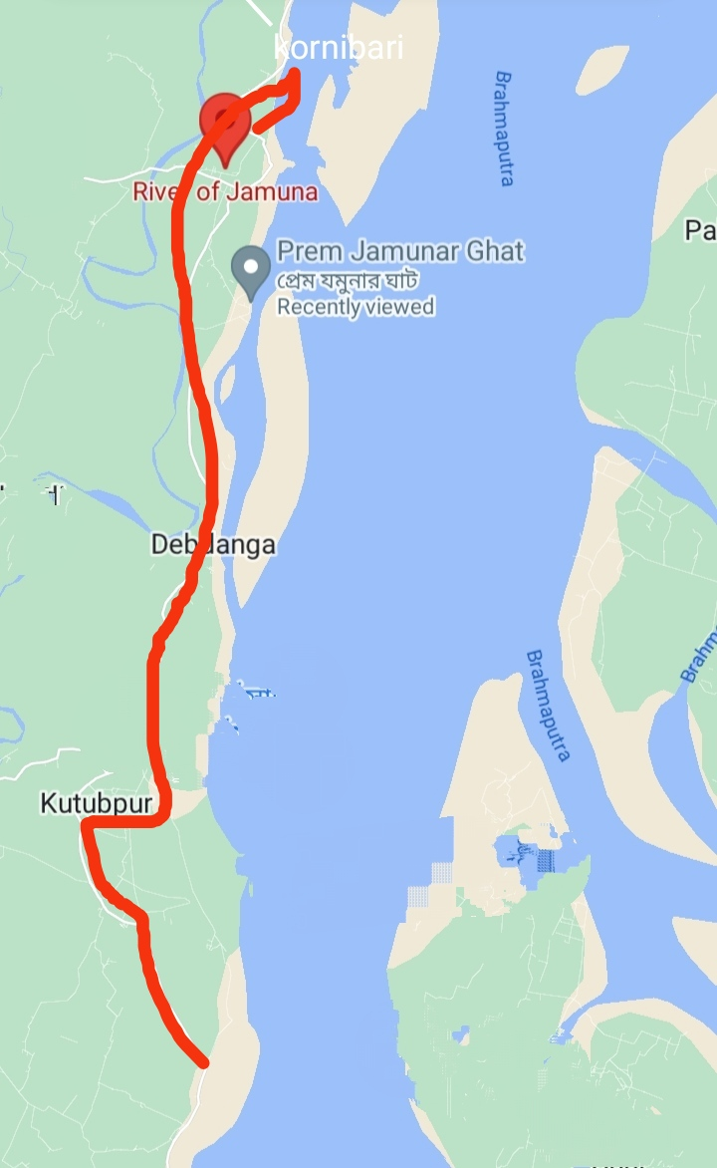
Fig.3.1: Karnibari and Kutubpur fishing community

3.2 Study period
From July to December 2021, a six-months period was used for this study. During this time, numerous field trips were taken to gather the essential data. First field visit was conducted in July, 2021. Second field visit was conducted in September, 2021. Third field visit was conducted in November, 2021.
3.3 Survey methodology:
3.3.1 Preliminary survey:
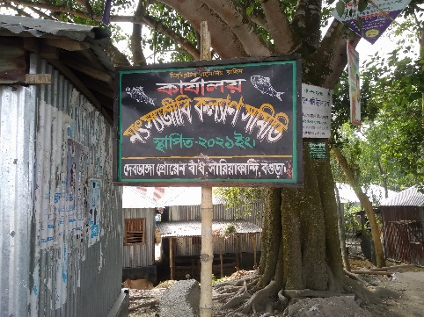
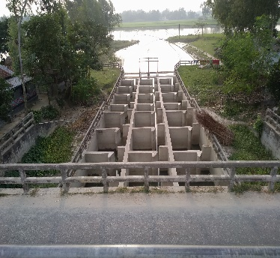
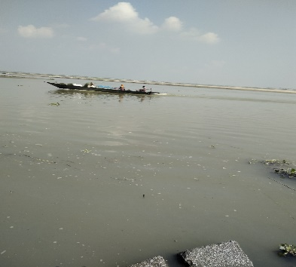
A preparatory observation was carried out in the survey area based on secondary data. after that the survey decision was conducted for study (Fig.3.2).

Fig.3.2: Preliminary survey
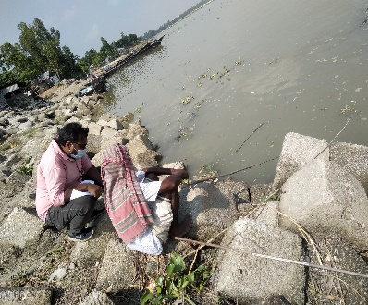
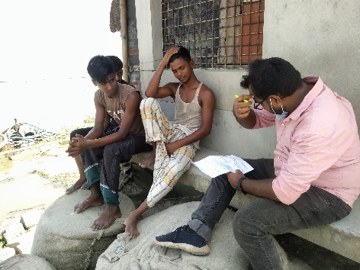
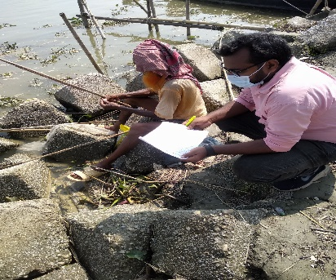
3.3.2 Primary data collection: Open and closed both questionnaires include questions about the sociodemographic status of the fishermen, their income and occupation, the size of their families, the availability of health and sanitation services, the type of fishing equipment they use, and other topics. Primary data from 42 fishermen were collected through in-person interviews with the aid of numerous methodological Participatory Research Approach (PRA) tools, including Focus Group Discussion (FGD) and Crosscheck Interviews (CI) with key informants at home or river sites while fishing (Fig.3.3 & Fig.3.4).
Fig.3.3: Personal interview
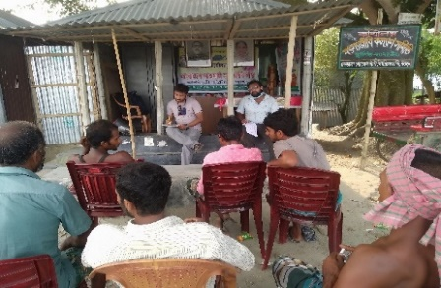
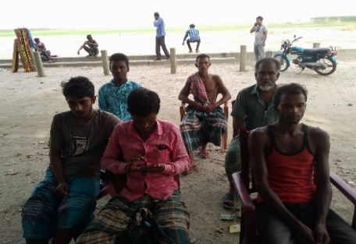
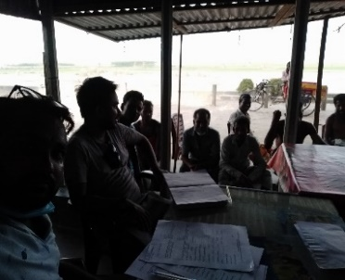
Fig.3.4: Focus Group Discussion (FGD)
3.3.3 Secondary data collection
Significant secondary data on the socioeconomic status of fishermen were gathered by the Upazila Fisheries Office through the collection of literature, publications, quarterly reports, and yearly reports. The District Fisheries Officer (DFO), the Upazilla Fisheries Officer (UFO), Bogura Saddar, and the ADC (revenue) provided the various information in the region's concentration and the condition of the fishermen in the Jamuna River. A preparatory observation was carried out in the survey area based on these data.
3.4 Survey procedure: The whole study procedure was given below through a flowchart (Fig.3.5).
Primary data about the situation of the fishermen in the Jamuna River were gathered.
An initial survey was conducted as stages of the experiment. area.
In accordance with the study's goals, a questionnaire was created.
Primary data collection
Personal interview
Focus Group Discussion (FGD)
Field visit

Crosscheck Interviews (CI)
Data processing and analysing

Fig.3.5: Flow chart of study procedure
3.5 Data processing and analysing:
All of the information was gathered and analysed by MS-Excel 2019 before being presented in textual, tabular, and graphical forms in order to comprehend the current situation of the livelihood status and constraints of the fishermen in the examined area.

Chapter 4
4.0 Results
4.1 Human Capital
4.1.1 Religious status
Muslims made up the vast majority of the fishermen. About 81 % of riverine fishermen were muslims and 19 % were hindus (Fig. 4.1).

Fig. 4.1: Population ratio of fishermen
4.1.2 Age structure
Based on four specific age groups, teenagers (13–18 years old), young people (19–30 years old), middle-aged persons (31–50 years old), and the elderly—the age structure of the sampled fishermen was analysed (51-70 years). According to the study's findings, 48% of respondents were between the ages of 31 and 50, while only 14% of the sampled population was under the age of 18, and only 9% of respondents were under the age of 13 and the opposite age group under elderly middle of 29% (Fig.4.2).

Fig.4.2: Age Distribution of fishermen
4.1.3 Family size
According on the size of their families, the fishermen were divided into three groups: small families (3–4 people), medium families (5–6 people), and large families (7-10 people). In the sampled area, the majority of fishermen (48%) belonged to families with five or more members. According to the current survey, about 40% of fishermen had small families with three to four members, 11 % reported bigger families with more than seven people, while 48% were middle households with five to six people (Fig.4.3).

Fig.4.3: Family size of fishermen
4.1.4 Family type
Based on the type of family, the fishermen were separated into two further groups: such as nuclear families (parents are not included) and joint families (parents are included). 67% of relevant households were nuclear families, while 33 % were joint families (Fig.4.4).

Fig.4.4: Family types of fishermen
4.1.5 Educational status
Majority of the fishermen were primary level (33%). Some of them illiterate (5%) and higher secondary (5%). Second places were educated secondary level (29%). Another part of the fishermen was from can sign only (28%). Educational status improving day by day (Fig.4.5).

Fig.4.5: Educational status of fishermen
4.2 Financial capital
4.2.1 Monthly income
33% of the fisherman in the research field had low earnings, it was observed (5,000 to 10,000TK), 53% had medium incomes (11,000 to 20,000 TK), and 14% had high incomes (above 21,000 TK) (Fig.4.6).

Fig.4.6: Monthly income of fishermen

4.2.2 Credit Access
Only the impoverished people could get financial loan from national and local NGOs like BRAC, Asha, and Grameen Bank to buy boats and fishing equipment. For their fishing needs, 88 % of people borrow money from their neighbours, family, non-profit organizations, and cooperatives. Only 12 % of people achieved financial independence (Fig.4.7).

Fig.4.7: Loan facilities of fishermen
4.2.3 Saving condition
The study was remarkable that 33% of the fishermen deposit money, otherwise 67% have no deposition account in the study area (Fig.4.8).

Fig.4.8: Saving condition of fishermen

4.2.4 Occupational status
According to the statistics gathered, the community of fishermen in the Saria Kandi Upazila earns the majority of their money from fishing. However, some of them hold employment engaged with fishing, such farming, herding cattle, managing small businesses, and performing day labour. According to the current report, 22% of fishermen rely only on fishing for their livelihood. However, 19 % of fishermen also work in agriculture, 20 % do daily labour and fish, and 22 % raise animals while fishing, while 17 % of fishermen also work in other occupations (Fig.4.9).

Fig.4.9: Occupational status of fishermen
4.3 Physical capital
4.3.1 Housing condition
The structure of housing condition was a sign of the inhabitants' social standing. Four categories of fisher dwelling conditions were identified: houses built of straw or bamboo, tin-shads, semi-pucca, and pucca. According to the survey, the majority of individuals (95%) have tin shed homes with tin roofing, just 5% have semi-pucca houses (Fig.4.10).

Fig.4.10: Housing condition of fishermen
4.3.2 Housing area
The housing area were categorised into two. 55% fishermen build house in the khas land and 45% were live in their own place (Fig.4.11).

Fig.4.11: Housing area of fishermen
4.3.3 Living place
The data were collected from two distinct areas. 52% data were collected from karnibai and 48% data collected from kutubpur (Fig.4.12).

Fig.4.12: Living place of fishermen
4.3.4 Living methodology
62% of Fishermen of the research area permanently live and 38% also living there from another place (Fig.4.13).

Fig.4.13: Living methodology of fishermen
4.3.5 Medical facilities
Unsatisfactory health services were available to fishermen in the research area, and it was found that 62% of their families depended on local doctors who lacked medical science knowledge. Another 33% of fishermen received healthcare from the upazilla health complex, and the final 5% received healthcare from kobiraz and others (Fig.4.14).

Fig.4.14: Health facilities of fishermen
4.3.6 Sanitation facilities
The Saria Kandi fishing village was discovered to utilize four different types of restroom facilities. These restrooms included modern, slab, pit, and none. 72% of the fishermen in the sample were found to utilize slab toilets, compared to 12% who used modern toilets and 2% who used pit toilets. It was important to highlight that 14% of fisherman did not have access to bathrooms (Fig.4.15).

Fig.4.15: Sanitation facilities of fishermen
4.3.7 Electricity facilities
According to the results of the current survey, the demand for electricity facilities for fisherman had been satisfied (Fig.4.16).

Fig.4.16: Electricity facilities of fishermen
4.3.8 Water Supply Infrastructure
In the field of study, 62% of people had their own tube well, 24% shared one, 9% lived next door, and 5% used a government or non-profit tube well for their drinking water supplies (Fig.4.17).

Fig.4.17: Drinking water facilities of fishermen

4.3.9 Cooking facilities
In this research, most of the fishermen use wood or straw as a cooking energy. About 83% uses straw/ wood for their cooking purposes and only 17% uses cylinder gas otherwise (Fig. 4.18).

Fig. 4.18: Cooking facilities of fishermen
4.4 Social capital
4.4.1 Learning of fishing technique
Most of the people learn fishing technique from neighbour. In the present study, 60% learn from neighbour and 40% learn from their own family (Fig.4.19).

Fig.4.19: Learning of fishing technique of fishermen
4.4.2 Taken help from Government
In the study area ,52% fishermen get help from Govt. such as rice, money and eid gift. otherwise, 48% people did not get any kind of help from Govt (Fig.4.20).

Fig.4.20: Taken help from Govt. of fishermen
4.4.3 Taken help from NGO
Most of the fisherman in the study region borrowed money from various NGO (Non-Government Organization). About 90% people involved loan facility and only 10% fishermen did not involve in those facilities (Fig.4.21).

Fig.4.21: Taken help from NGO of fishermen
4.4.4 Cooperative society
It was found that 21% fishermen were member of a worker cooperative society and 55% were financial cooperative society named “motsojibisomity”. 24% were not member of any kind of cooperative society (Fig. 4.22).

Fig. 4.22: Cooperative society Cof fishermen
Chapter 5
5.0 Discussion
This study has looked at a number of socioeconomic and demographic factors that relate to the fishermen's source of living in the Bogura district. After following this study, majority of fisherman were in their middle years of age and have average-sized families. The elementary education has been attained in the families of fishermen because the majority of them have completed class 5 and their children have largely completed primary education.
Since the property that the fishermen in this study owned was shrinking daily and their monthly income had not significantly increased over the previous ten years, their financial situation was extremely precarious. The majority of fisherman financed their necessities by taking out loans from local business people or dadon businessmen, while a small minority did so via non-profit organizations. According to this study, 22% of the fishermen caught fish year-round and their numbers were declining daily due to the Jamuna river's declining fish catch.
According to the age structure, people ranged in age from 13 to over 70. According to the questionnaire interview, there were 4 people (9%) in the 13–18 age range, 12 people (29%) in the 19–30 age range, 20 people (48%) in the 31–50 age range, and 6 people (14%) beyond the age of 50. Both Ahmed et al. (2015) in Tangail and Ahmed et al. (2012) in the coastal area reported that 66 % and 70% of respondents were under the age of 40.
According to Ali et al. (2009) the majority of fish farmers (50 %) in the Mymensingh region and the majority of fishermen (60 %) in the Lohalia River, Patuakhali, are between the ages of 31 and 40.
According to the survey, muslims made up (81%) of fisherman, and hindus made up (19%) of them. In the Lohalia River, Patuakhali, investigation by Ali et al. (2009) it was discovered that 75% of the fishermen were Muslims.
According to the report, 67 % of families were nuclear and 33 % of fishermen's families were joined. In the Mymensingh district, about 42.5 % of fish farmers were joint families, and the remaining 57.5 % were nuclear families. The fishermen were divided into four groups according to family size: small (2-4), medium (5-7), and large families (7-10) The family with 5–6 people had the highest proportion (48 %). The huge family obtained the lowest proportion (12%). In the district of Mymensingh, the majority of fish farmers (45%) belonged to families with four to five members.
The fisherman makes every effort to live a comfortable life, but they were unable to due to a lack of funds. can't deal with the rising cost of the everyday necessities in the current situation. Along with fishing, they also perform other tasks like day labour, agricultural work, and net repair. The fisherman made BDT 7000 on average each month. The projected BDT 84,000 average yearly income of fisherman in the study area is significantly less than the BDT 207,000 national average income.
The majority of the population in the research area was reported to be illiterate. But the capacity to write one's name was seen as literate (28 %) majority of people (33%) had completed primary school; 29% had completed secondary; and 5% had completed higher secondary. In the Jamuna River settlements, the literacy rate was unsatisfactory. In Sundarbans Ahamed et al. (2012) study, literacy rates were found to 23%.
Only the organized impoverished members can get financing from national and local NGOs ( Non-Government Agency) like BRAC and Grameen Bank to buy boats and fishing equipment. For their fishing business, 88 % of people borrow money from friends, family, neighbours, non-profit organizations, and some co-operatives, which is comparable to the results of Alam s. et al. (2008) in the Jamalpur district. Only 12 % of people reached self-sufficiency and did not require financial assistance.
The structure of the home revealed the inhabitant of social standing. In an effort to learn more about the people's living conditions, a survey was conducted. Only 5% of people had semi-paka homes, while the majority of them (95%) live in tin sheds with tin roofs. Every other building was made of straw or bamboo or was a pucca. The majority of the floor materials used by fishermen (94%) in the gallamary fishing settlement were batcha, according to Samima et al. (2000)
About 55% fishermen build house in the khas land and 45% were live in their own place. Desperately 62% Fishermen of the research area permanently live and 38% also living there from another place.
Sanitation facilities were at a moderate level for the majority of persons in the research area. 72 % of the fishermen in the sample were found to utilize slab toilets, compared to 12 % who used modern toilets and 2 % who used pit toilets. It is significant to note that 14% of fisherman used agricultural land, crop fields, ails (land boundaries), canals, bushy areas, and concealed places as latrines because they lacked latrines. Because ability and education are intimately tied to awareness of basic cleanliness. In Tangail, the CPP found that 4% of fishermen's households lacked latrines.
Poor health facilities for fishermen were found in the research field, and it was discovered that 62 % of fishermen's households relied on village doctors who lacked medical science knowledge, 33 % of fishermen received healthcare from the upazilla health complex, and the remaining 5 % received healthcare from kobiraz.
According to the results of the current survey, the demand for electricity facilities for fisherman has been satisfied. According to data from the 100% of fishermen's households used electricity. In the fishing community of Gallamary in Khulna, Samima et al. (2000) reported that 20% of people used electricity.
The study finds that due to higher rates of illiteracy, larger loans, and natural calamities like floods and flash floods, the general livelihood situation of the fishermen in Bogura is not particularly favourable. Therefore, the right steps should be taken by both government and non-government groups to raise the standard of living for fishermen in the sariakandi regions. The findings of this research might get some consequences for policy that would make it simpler for other interested parties to take the appropriate measures and for the government to enhance the quality of life for the fishermen in the Sariakandi regions.

Chapter 6
6.0 Conclusions
Fishermen's Livelihood Restraints The majority of fishermen encountered a variety of issues when fishing as well as selling their catch in the neighbourhood market; A local extortionist claimed that extortion was the main problem other issues included a lack of marketing resources, inadequate credit facilities, a lack of fishing knowledge, improper equipment, interruptions by robbers as well as occasionally by locals themselves. The majority of fishermen were extremely underprivileged and had little money to invest in nets and other fishing gear. They are not given any consideration in society at all. They primarily lack literacy and subsist on food handouts. Due of their extreme poverty, their kids frequently choose fishing over attending school. As a result, they continue to be illiterate and unable to make contributions to the advancement of their community generation after generation.
Fishermen living close to the Jamuna River have an unsatisfactory standard of living. The Fishermen had such a low level of education due to a lack of knowledge and the low earnings of the fishermen home; the research of the underprivileged fishermen pupil doesn't progress very far. The government should take some significant action by offering various management policies as well as additional support during the fishing prohibition season. This can be accomplished through the provision of the VGF card. To improve the living conditions of the fishermen, for different NGO activities in the area, there must be assurances.
Regarding the availability of the loan that may be used to improve the revenue procedure, the NGOs must be cooperative. Government support should provide access to both health facilities and other amenities. Therefore, sufficient administrative engagement is required to create proper guidelines for the community people's utilization of resources.
Inadequate socioeconomic conditions prevailed among the fisherman in the Jamuna River's surroundings in the Sariakandi Upazila. Many conveniences were taken away from the fishermen. The lack of awareness and the low money of the fishing families are to blame for the inadequate development of schooling. It makes logical to build some educational institutions in the neighbourhood as a result. The study areas are located outside of the town and because there isn't a market there, they must rely on middlemen and wholesalers to sell their fish. As a result, they did not receive the correct payment for the fish. During the fishing prohibition season, the government should introduce certain important management regulations, provide some additional options for earning money, and issue VGF cards. A variety of NGO activity must be supported in the neighbourhood to better the living conditions of the fishermen to ensure the fishermen's good socioeconomic position, the government support must enhance loan facilities as well as health facilities.
Without improving socioeconomic conditions or mainstreaming the fishing families It will be difficult to achieve the SDGs by 2030 and become a middle-income country by 2021 for those who live below the poverty line or marginal poverty line and develop Bangladesh by 2041.
From the study some major constraints were identified are listed below:
- Insufficient government help to the fishing community
- Banning period are burning question for their livelihood.
- Lack of alternative livelihood during banning season they suffer from very much.
- Original poor fishermen cannot get proper facilities because of middlemen.
- Fishing catch reduce by dint of changing river course.
- Lack of public awareness about harvesting of fish.
- Lack of proper knowledge people conflict with fisheries officers during ban period.

Chapter-7
7.0 Recommendations and future perspectives
According to this study, the following recommendation may be improvised:
- Govt. and NGO should be taken to ensure proper sanitary, drinking water, health security, educational facility to improve living condition of fishermen.
- It should be ensured alternative livelihood system during the banning period.
- Proper distribution of VGF cards should be maintained strictly.
- The significance of fisheries productivity should be increased through the biological system.
- To maintain the administration of water bodies, registered fishing associations should be eligible for loans with short terms and low interest rates.
- Measures to repay bank loans could be implemented in the form of pilot projects with the assistance of outside parties or NGOs (during the fish harvesting season).
- The fishermen's main worries were low annual catches, poor fishing equipment, overfishing, and confrontations in fishing regions. By enforcing the laws and regulations and controlling overfishing, the necessary arrangements should be made to conserve them. While some fish species had their numbers reduced, others had their numbers enhanced.
- More than half of the fisherman were discovered to have had no training. Therefore, extension agents should give them with practical and need-based training on the value of fisheries variety with the assistance of NGOs and other rural development organizations. The authorized authorities should also offer alternative sources of revenue to supplement the current single source of income.
- The government should set aside areas for fishing and offer marketing resources. This will significantly reduce fishing-related conflict in the area.

REFERENCES
Ahamed F, Hossain MY, Fulanda B, Ahmed ZF and Ohtomi J. 2012. Indiscriminate exploitation of wild prawn post larvae in the coastal region of Bangladesh: A threat to the fisheries resources, community livelihoods and biodiversity. Ocean & coastal management, 66: 56-62.
Ahmed N, and Troell M. 2010. Fishing for prawn larvae in Bangladesh: an important coastal livelihood causing negative effects on the environment. Ambio, 39(1): 20-29.
Alam MF and Bashar MA. 1995. Structure of cost and profitability of small-scale riverine fishing in Bangladesh. J. Res. Prog, 9: 235-241.
Ali H, Azad MAK, Anisuzzaman M, Chowdhury MMR, Hoque M and Sharful MI. 2009. Livelihood status of the fish farmers in some selected areas of Tarakanda upazila of Mymensingh district. J. Agrofor. Environ, 3(2): 85-89.
Beall J. 1998. The gender and poverty nexus in the DFID White Paper: opportunity or constraint? Journal of International Development: The Journal of the Development Studies Association, 10(2): 235-246.
Bhaumik U and Saha SK. 1994. Perspectives on socio-economic status of the fishermen engaged in fishing in the estuaries of Sundarbans. Environment and ecology. Kalyani, 12(1): 181-185.
Bhuyan S and Islam S. 2016. Present status of socio-economic conditions of the fishing community of the Meghna River adjacent to Narsingdi district. Bangladesh J. Fish. Livest. Prod, 4, 192.
Chambers R. 1992. Rapid appraisal: rapid, relaxed and participatory. Institute of Development Studies discussion paper, 311.
Debnath D, Bhattacharjya BK, Yengkokpam S, Sarkar UK, Hassan MA, Das AK and Das BK. 2021. An overview of enclosure culture in inland open waters of India: Responding to socio-economic, ecological, and climate change issues in inland fisheries. Aquatic Ecosystem Health & Management, 24(4): 85-92.

De M, Hussain MA, Alam MM, Mazlan AG, and Simon KD. 2011. Impact of Sariakandi fish pass on fisheries diversity of Bangali river, Bogra, Bangladesh. Aquaculture, Aquarium, Conservation & Legislation, 4(5): 621-626.
DoF. 2019. Yearbook of Fisheries Statistics of Bangladesh, 2018-19. Fisheries Resources Survey System (FRSS), Department of Fisheries, Bangladesh: Ministry of Fisheries and Livestock, 2019. Volume 36: 135p.
FAO. 2007. Food and agriculture organization. Bangladesh Country Profile.
FAO. 2014. Food and agriculture organization. Bangladesh Country Profile.
Flowra FA, Alam MB, Hossain MA, Samad MA and Galib SM. 2009. Livelihood aspects of fishermen of the Dahia Beel under Natore District, Bangladesh. Bangladesh Journal of Progressive Science and Technology, 7(2): 283-284.
Halim MA, Haque SA, Islam MS, Rayhan A and Sku S. 2017. Socio-economic aspects of fisher communities in Kafrikhal Beel under Mithapukur Upazila, Rangpur, Bangladesh. Int. J. Fauna Biol. Stud, 4(1): 119-124.
Hoque AM. 2013. River erosion: vulnerability & its social consequences on the life of women: a study at Chondonbaisha & Kutubpur in Sariakandi, Bogra. Rev. Eur. Stud, 5, 99.
Hossain MA, Sathi SS, Hossain, MS, Akter MF and Ullah MO. 2020. Assessing the livelihood status of fishermen at Sunamganj District in Bangladesh. Biom. Biostat. Int. J, 9(1): 16-20.
Hossian M. 2007. A preliminary survey on the fishermen and socio-economic status of fishermen of the Old Bramhmaputra River (Doctoral dissertation, MS Thesis, Department of Fisheries Management, Bangladesh Agricultural University, Mymensingh).
Ibrahim M, Khan ME, Hasan MM and Khanam R. 2018. Livelihood condition of fishermen at Amtali Upazila, Barguna, Bangladesh. International Journal of Fisheries and Aquatic Studies, 6(3): 13-24.
Islam MF, Haque SA, Islam MS, Das PS and Rahman M. 2021. Socio-economic status of fisher communities in Dengar beel under Melandah Upazila, Jamalpur, Bangladesh. Asian Journal of Medical and Biological Research, 7(2): 164-173.
Islam MM, Islam F, Akter MS, Kundu Gk, Barman A, and Khan MI. 2020. Transformative adaptations to climate change: cases from the Jamuna river fishing communities of Bangladesh. Journal of Fisheries and Environment, 44(3): 1-18.
Joadder AR. 2008. Socio-economic condition of fishermen of the “Mail Beel” under Mohanpur Upazila of Rajshahi district in Bangladesh. Research Journal of Biological Sciences, 3(10): 1178-1181.
Kabir KR, Adhikary RK, Hossain MB, and Minar MH. 2012. Livelihood status of fishermen of the old Brahmaputra River, Bangladesh. World Applied Sciences Journal, 16(6): 869-873.
Kostori MFA. 2012. Socio-economic condition of fishermen of the Chalan Beel under Tarash Thaha of Sirajganj in Bangladesh. Bangladesh Research Publications Journal, 6(4): 393-402.
Mondal DK, Halim MA, Rahman MM, Tayebi KA, Siddiky MM and Ali A. 2016. Present status of fisher community of Jamuna River in Sariakandi, Bangladesh. Young, 28(28), 14.
Mondol MMR, Sarker MAA and Hossain MA. 2006. Present Fisheries Status of Sariakandi Fish Pass, Sariakandi, Bogura. Journal of Bio-Science, 14: 137-137.
Rahman MA, Ahmed F, Islam MS and Khan MA. 2015. Pond fish culture and needs for credit: A study in selected areas of Tangail district. Journal of the Bangladesh Agricultural University, 13(452-2016-35845): 117-124.
Rahman MM, Motin MA, Islam MS, Haque SA, Islam MF and Rahman M. 2021. Assessing livelihood and socio-economic status of fishermen community adjacent to Chalan beel area in Faridpur upazila, Pabna, Bangladesh. Journal of Bioscience and Agriculture Research, 28(01): 2324-2334.
Statistics BBO. 2011. Statistical yearbook of Bangladesh. Statistics Division, Ministry of Planning, Dhaka, Government of the People’s Republic of Bangladesh.
Statistics BBO. 2018. Statistical yearbook of Bangladesh. Statistics Division, Ministry of Planning, Dhaka, Government of the People’s Republic of Bangladesh.
Solesbury W. 2003. Sustainable livelihoods: A case study of the evolution of DFID policy (pp. 1-36). London: Overseas Development Institute.
Thompson J and Scoones I. (1994). Challenging the populist perspective: Rural people's knowledge, agricultural research, and extension practice. Agriculture and human values, 11(2): 58-76.
Wazed A. 1991. Bangladesher Nadimala (Rivers of Bangladesh, in Bangla). Nandini Printing and Publication, Dhaka, Bangladesh.
Zaman M and Naser MN. 2019. Fish species using the fish passage between Jamuna and Bangali river at Sariakandi, Bogra. Journal of Biodiversity Conservation and Bioresource Management, 5(2): 53-62.

