A REPORT ON
STUDY ON BLACK BENGAL GOAT’S MANAGEMENT AND MILK YIELD

A PRODUCTION REPORT SUBMITTED
BY
S M Ahosanul Alam Rajon
Intern ID: D-31
Roll No: 2012/35
Registration No: 763
Session: 2011-12

Report Presented In Partial Fulfillment for the Degree of Veterinary Medicine.

Chittagong Veterinary and Animal Sciences University
Khulshi, Chittagong.
November 2017

A REPORT ON
STUDY ON BLACK BENGAL GOAT’S MANAGEMENT AND MILK YIELD
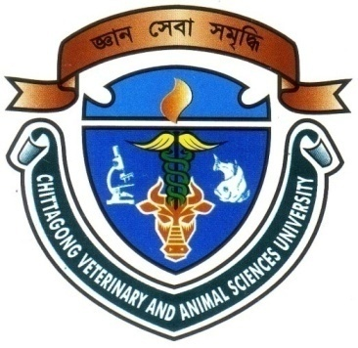

Approved by:

…………………………………………………………….
Professor Md. Abdul Halim
Department of Agricultural Economics and Social Sciences

Chittagong Veterinary and Animal Sciences University
Khulshi, Chittagong-4225, Bangladesh

November 2017

CONTENTS

CHAPTER | NAME OF CONTENTS | PAGE NO.
 | ACKNOWLEDGEMENT | i
 | ABSTRACT | ii
I. | INTRODUCTION | 1-2
II. | MATERIALS & METHOD | 3-4
III. | RESULTS & DISCUSSION | 5-8
IV. | CONCLUSION | 9
 | REFERENCES | 10-12

LISTS OF TABLES

Table | Title | Pages
Table 1 | Effect of farm on milk yield of Black Bengal goats | 6
Table 2 | Effect of data collected date on milk yield of Black Bengal goats | 7
Table 3 | Effect of data collected date of farm on milk yield of Black Bengal goats | 7

ACKNOWLEDGEMENT

All praises are due to “Almighty Allah”, who has given the opportunity to accomplish of this report successfully.

The author wishes to express her deepest sense of gratitude, sincere appreciation, indebtedness and profound regards to his respected teacher and reverend supervisor, Professor Dr. Md. Abdul Halim, Dean, Faculty of Veterinary Medicine, Chittagong Veterinary and Animal Sciences University, for his constructive and constant guidance in planning and execution of this research work, continuous encouragement, scholastic guidance, and affectionate feelings throughout the course of research work.
The author whishes to express her gratitude to Professor Dr. A K M Saifuddin, Director External Affairs, Chittagong Veterinary and Animal Sciences University, for his supervision and kind co-operation during the period of internship.

The authors also grateful to the farmers of the studied farm.

Finally, it is my pleasure to express big thanks to all of my well-wishers, roommates, close friends for this encouragement and inspiration to complete my production report during study period.

The Author

ABSTRACT

This study was conducted to investigate the management practices and milk yield of Black Bengal goats under different farms at Saghata upazilla of Gaibandha District of Bangladesh during the period of March, 2017 to April, 2017. The farms were visited several times to know their daily activities and management. The kids were kept separately from their mother from overnight. In morning their weight was taken before milk feeding. Then they were allowed to suck their dam. After completing the milk feeding kids were weighted again. The amount of milk yield in a day was calculated between the differences of weight of kid after milk feeding and weight of kid before milk feeding. Data were collected from 12 female Black Bengal goats with their subsequent milk yield at weekly intervals. The 12 female Black Bengal goats were selected. The milk yield of Black Bengal goat’s breeds under 3 different farms was studied. The average milk yield of farm 1, 2 and 3 are 225 ± 10.29, 214.22 ± 9.83 and 214.06 ± 8.04 respectively. The average milk yield of Data collected date are 172.5 ±9.46 to 280.42 ± 16.45 for the time of 1 to 8 respectively. In this study it has been seen that the milk yield is more in that farm which have good management facilities and somewhat lower production in that farm which have less management facilities.

Key words: Goats, management, feeding, milk yield, farms.

ii

