Chapter 1
Introduction
1.1 Background of the study
Deer was among the most beautiful wild animals of the nature and people love them for their beauty. Body of deer was covered with multiple colors. As deer was a wild animal, so we could hardly seen their around us. Deer farming business had a great opportunity for earning better livelihood and creating good employment sources. Commercial deer farming business could be a part of this. Commercial deer farming is very profitable like other livestock farming business. Deer meat is highly expensive than cow, buffalo, goat, sheep, duck or chicken meat. Usually deer eats grass, leaves or grains like other livestock animals such as goat, cow or sheep. So it is very easy to feed them. Deer was a wild animal, and the population in the wild animals decreasing gradually. Raising deer commercially, we could make a good income source and at the same time could save this animal form being extinct. Deer products had huge demand and high value in the market.
But there were some problems with this lucrative business. Commercial deer farming business was not permitted by the Government of some countries like Bangladesh. So before planning for starting this business, we should contact with our nearest wildlife service center and asked them if commercial deer farming was permitted in our country or not. In Bangladesh there were many deer species present, like Spotted deer or Chital (Axis axis), Hog deer or Laguna (Axis porcinus), Musk deer or Kasturi (Moschuschrysogaster), Swamp deer or Barahsingha (Cervusdevaucelli), Sambar or Jarayo (Cervus unicolor), Barking deer or Ratuwa (Muntiacus muntijak)s etc. But this study was carried out about spotted deer.

1.2 Scientific classification of spotted deer
Kingdom: Animalia
Phylum: Chordata
Class: Mammalia
Order: Artiodactyla
Family: Cervidae
Genus: Axis
Species: Axis axis
1.3 Government Act for Deer Farming
In Bangladesh Government declared act for deer farming. One person who was interested he could rear only 10 spotted deer. If anyone wanted to transport deer or their meat he should had inform forestry department for transfer certificate and after getting certificate he should transfer deer or their meat. If anyone wanted to rear deer he should had collected the license from the forestry department and he should paid 500 taka for each license. The license should be renewed in every year. The possession fee and renewed fee of each deer was 100 taka. Spotted deer could not be reared away 15 kilometers from the forest where spotted deer were present. If any deer gave birth or died then the owner should informed forestry department around 15 days. (Wildlife conservation and security act, 2012).
1.4 Justification of the study
Nowadays world population was increasing rapidly and people were searching for some new farming ideas which could ensure food security and created a suitable and profitable income source. Deer farming could be such a new dimension in farming business in Bangladesh. No systematic study had yet been undertaken about deer farming in Bangladresh, hence need for the research. The concerned person, policy makers will be benefited from the recommendation of the study.

1.5 Objectives of the study
The study was guided by the following objectives:

- To identify the production and management practices of deer farming.
- To examine the bio security level of deer farming.
- To estimate the cost of per deer rearing n the study areas.
- To find out the constraints of deer farming and suggested probable recommendation.

Chapter 2
Materials and Methods

2.1 Period of survey
The study was conducted in various captive, zoo, and safari park in Dhaka, Chittagong , Cox’s bazaar and Pirojpur districts from 2nd January to 17th September in 2017.
2.2 Selection of study area
Selection of the study area is an important step for a research. The areas were selected on the availability of large number of deer rearing. J.N.Dairy farm from Bohardarhat; Chittagong Zoo in Foy’s-lake; Bangabandhu Sheik Mujibur Rahman safari park in Dulahazara; Rajlakshmi dairy farm in Nazirpur, Pirojpur and Bangladesh National Zoo in Dhaka were selected purposively for this study. Data was collected through survey method.
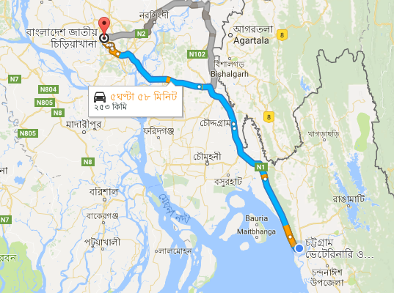
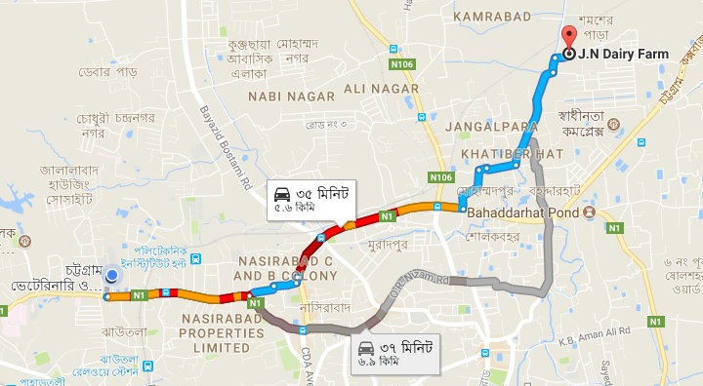

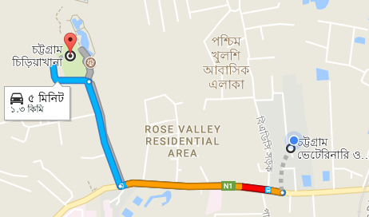
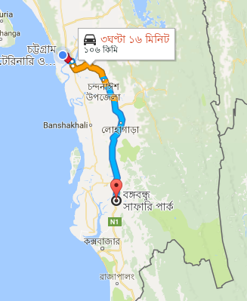

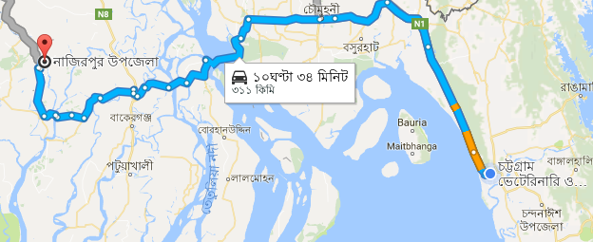

Fig-1: Study Areas

Fig 1: Study Area

2.3 Study Population
A total of 530 deer were studied from five study areas. Male and female, mature and immature deer were present in that farm.

2.3 Collection of Data
A survey questionnaire was developed and pre-tested, then finalize to collect quantitative data. Survey questionnaire/interview schedule was prepared in the light to the objectives of the study. Data were collected from the farm owner and inspector, management head and workers of the captive, zoo and safari park. Primary data was used for this study.

2.4 Data analysis techniques
After data collection, the questionnaires will be checked for completeness, cleaned, organized, coded then entered into MS-Excel and SPSS for analysis. Descriptive analysis like percentages, table, graph and diagram were used for this study.

Chapter 3
Result and Discussion
3.1 Housing
Housing is very important for commercial deer farming business. In the wild condition, deer used to live under big trees or near any grassland. But for commercial deer farming it is important to make a comfortable and suitable house. Deer usually like high and dry place for living. The size of the house depends on the number of the deer to raise. The housing systems that were practiced in different farms were given below.
Table-1: Housing system of different farms, zoo and safari park
Name of the farm | Housing system | Space per deer(square feet)
J.N. Dairy Farm | Fully confined | 2
Rajlakshmi Dairy Farm | Fully confined | 2
National Zoo | Semi-intensive | 20
Chittagong zoo | Semi-intensive | 10
Dulahazra Safari Park | Free range | 50
Fully confined: It was a system in which deer are continuously kept under housing in confinement with limited access in which they were stall fed. This system of management required more labour and high cash input. However, this had the advantage of close supervision and control over the animals. In this method, the dung was collected in one place and used as a good fertilizer. Less space was sufficient for more number of animals. In fully confined system per deer requires only 2 sq ft space on an average (table 1).
Semi-intensive: Semi-intensive system of deer production was an intermediate compromise between extensive and intensive system followed in some flocks having limited grazing. It involved extensive management but usually with controlled grazing of fenced pasture. It consisted of provision of stall feeding, shelter at night under shed and 3 to 5 hours daily grazing and browsing on pasture and range. In this method, the feed cost was somewhat increased. Table 1 shows, per deer requires 10 to 12 sq ft space in semi intensive housing system on an average.
Free range: Grazing the deer in the entire pasture and leaving them there for the whole season was the free range system of rearing. In this method feed cost was very much reduced. It was not conducive to make the best use of the whole grasses. Around 50 sq ft space requires per deer for free range system in safari park (table 1).
3.2 Feeding
Deer usually like to eat grass, leaves, corn, grain etc. like other livestock animals. Sometime vegetables, fruits are offered. Their eating habits are the same as goats, cows, sheep and other herbivorous domestic animals. Along with providing nutritious feeds, adequate supply of fresh and clean water according to their demand also supplied. Deer are feed daily two times a day during the time between 10:30-11am to 3:30-4:30pm.

Table-2: Per deer per year feeding practices in different farms
SL No | Items | J.N. Dairy Farm |  | Rajlakshmi Dairy Farm |  | National Zoo |  | Chittagong Zoo |  | Dulahazra Safari Park
 |  | Amount (kg) | Cost (taka) | Amount (kg) | Cost (taka) | Amount (kg) | Cost (taka) | Amount (kg) | Cost (taka) | Amount (kg) | Cost (taka)
1 | Gram | 18.25 | 1095 | 18.25 | 1095 | 18.25 | 1095 | 18.25 | 1095 | 18.25 | 1095
2 | Wheat bran | 54.75 | 876 | 54.75 | 876 | 91.25 | 1460 | 91.25 | 1460 | 91.25 | 1460
3 | Green grass | 1095 | 3285 | 1095 | 3285 | 365 | 1095 | 1095 | 3285 | 0 | 0
4 | Cabbage | 91.25 | 912.5 | 91.25 | 912.5 | 0 | 0 | 0 | 0 | 0 | 0
5 | Banana and other fruits | 36.5 | 1825 | 36.5 | 1825 | 36.5 | 1825 | 36.5 | 1825 | 36.5 | 1825
6 | Salt | 3.65 | 62 | 3.65 | 62 | 3.65 | 62 | 3.65 | 62 | 3.65 | 62
7 | Vitamin mineral premix | 3.65 | 292 | 3.65 | 292 | 3.65 | 292 | 3.65 | 292 | 3.65 | 292
8 | Total cost(Tk.) | 1303.05 | 8347.5 | 1303.05 | 8347.5 | 518.3 | 5829 | 1248.3 | 8019 | 153.3 | 4734

*Feeding budget was calculated according to the local price in Chittagong. Scales haven’t been differentiated as per age, sex and status of the animal. All deer are given same diet.

Gram, wheat bran, green grass, cabbage, banana and other fruits, salt, vitamin mineral premix were provided by different farms. Dulahazra safari park did not provide green grass because the deer had the opportunity to grazzing. J.N. dairy farm and Rajlakshmi dairy farm provided cabbage but National zoo, Chittagong zoo and Dulahazra safari park did not provided cabbage.

Fig-2: Amount of feed and feed costs per deer per year in different farms
Fig-2 shown that the amount of feed in J.N. dairy farm and Rajlakshmi dairy farm were similar (1303.05kg). Per deer cost of feed was less in National zoo (Tk.5829) than Chittagong zoo (Tk.8019) because in National zoo less amount of green grass were required than Chittagong zoo. In National zoo deer were kept in semi-intensive housing system. So deer had a great opportunity for grazing. But in Chittagong zoo there were no scope of grazing. In Dulahazra Safari Park the amount of feed (153.3kg) and feed costs (Tk.4734) were minimum due to the high opportunity of grazing.

3.3: Biosecurity
Bio-security means rules and actions designed to protect a population from unwanted organisms that affects pastures and or livestock at national, regional and individual farm level. It involves the Systemic adoption of practices designed to keep out pests and infectious. Different types of bio-security practiced in different farms which are given below:
- Livestock purchases: Arranged a pre-purchase visit to the animals could be seen and the management standard assessed.
- Quarantine: Quarantine means complete isolation. For quarantine use a separate building or a double fenced paddock with at least 10 feet separation from the stock. Regularly examined the animal during quarantine period for signs of infectious diseases.
- Farm Security: Farm security means use of physical and chemical barriers to prevent disease entry and spread within the farm. Discourage the general public and other visitors from coming into direct contact with the livestock. Maintained a guest book or register for visitors.
- Hygiene and farm environment: Ensured provision of fresh clean water at all times. Feeders should be removed regularly. Disinfectant footbaths should be placed at the entrances to buildings and between separate areas within buildings Disposable gloves should be used when handling or examining animals to reduce the risk of picking up and transferring infectious organisms.

Table-3: Bio-security practiced in different farms
SL NO | Name of the farm | Livestock purchases | Quarantine | Farm security | Hygiene and farm environment | Percentage of biosecurity
1 | J.N. Dairy Farm | 0 | 0 | 1 | 1 | 50
2 | Rajlakshmi Dairy Farm | 0 | 0 | 1 | 1 | 50
3 | National Zoo | 1 | 1 | 1 | 1 | 100
4 | Chittagong Zoo | 1 | 1 | 1 | 1 | 100
5 | Dulahazra Safari Park | 1 | 1 | 1 | 0 | 75
*No = 0 and Yes = 1
Table 3 shows that J.N. dairy farm and Rajlakshmi dairy farm maintained the lowest biosecurity level (50%). They did not practice livestock purchase and quarantine. Livestock purchase and quarantine were cost effective. Dulahazra safari park maintained the 75% of biosecurity level. They did not maintain 100% because the animals are reared in extensive housing system. As a result they did not maintain the hygiene and farm environment accurately. On the other hand National zoo and Chittagong zoo maintained 100% biosecurity level because the deer were reared in semi-intensive housing system.

3.4 Disease
Deer at low population densities on natural range are generally not affected by disease to any significant extent. Deer in their first 12-15 months of life are more susceptible to disease than adults. Treatment of sick deer is analogous with that of domestic animals. Prevention of diseases by nutritional management, testing, vaccination, drenching and dipping, is more important than treatment. The deer in safari park, Chittagong zoo and National Zoo, veterinary facility is provided periodically or when necessary. So, cost of veterinarian services is no regular or uniform and it was mentioned under the heading contingencies. Any unwanted situation if seen is quickly reported by the security person recruited there. At the National Zoo, during 8-10am in the morning, the person recruited for management should look at the cleanliness and situation of deer in the cage.
Table-4: Different diseases in different farms
Name of Farm | Name of Diseases
 | BQ | FMD | Myiasis | Horn Fracture | Feed intoxication | Common cold
J.N. Dairy Farm | 0 | 0 | 1 | 0 | 1 | 1
Rajlakshmi Dairy Farm | 0 | 0 | 1 | 0 | 1 | 1
National Zoo | 1 | 1 | 1 | 1 | 1 | 1
Chittagong Zoo | 0 | 0 | 1 | 1 | 0 | 1
Dulahazra Safari Park | 1 | 1 | 1 | 1 | 1 | 1
*No = 0 and Yes = 1
Common cold and myiasis were very common in deer. Figure-3 shown that common cold and myiasis are highest (23%) and FMD (9%) was lowest. Common cold was highest due to environmental changes and myiasis was due to injury in their body. FMD and BQ were lowest because all farms used vaccine against FMD and BQ.

Fig-3: Percentage of Different Diseases in Deer
Here BQ was 13%, horn fracture was 14% and feed intoxication was 18%. Horn fracture occurred due to fighting of deer. Feed intoxication occurred due to feeding of bad quality of feeds.
3.5 Vaccination:
Mainly Anthrax, BQ, FMD and HS vaccine were given in the study areas.
Table-5: Vaccination Schedule
Name of Vaccine | Age of Vaccination | Dose |  | Route | Booster
Anthrax | 2nd month | 0.5 ml |  | S/C | Yearly
Black Quarter | 3rd month | 2 ml |  | S/C | Every 6 month interval
Foot and Mouth Disease | 4th month | Type | Deer | S/C | Every 4-6 month interval
 |  | Monovalent | 1 ml
 |  | Bivalent | 2 ml
 |  | Trivalent | 3 ml
HS | 2nd year | 1 ml |  | S/C | Yearly
All vaccines were given in subcutaneously. Anthrax vaccine was given in 2nd month of age and doses were 0.5 ml. Black Quarter was given in 3rd month of age and doses were 2 ml. Foot and Mouth diseases were given in 4th month of age. It was three types such as monovalent, bivalent and trivalent. Monovalent was given in 1 ml, bivalent 2 ml, trivalent 3 ml. Hemorrhagic septicemia was given in 2nd year of age and doses were 1 ml.
3.5 Herd management
Deer rapidly adapt to the presence of man and machinery when they were enticed with palatable feeds. When deer were confined, they should not be over-crowed, allowing the handler to easy move amongst them and carry out drenching, ear tagging, vaccination and pour-on dipping. Deer farm was cleaning regularly. If there present any injury then management and treatment were immediately done. Deworming was performed regularly to prevent parasitic diseases.
3.6 Cost of deer farming
Two types of cost were present in deer farming. They were fixed cost and recurrent cost. Here housing cost, equipment cost and animal cost were fixed cost and feed cost, labor cost, medicine, vaccine, disinfectants cost, electricity cost, other cost were recurrent cost.
Table-6: Total cost for per deer for one year
SL NO | Items | Price (TK) | Percentage (%)
1 | Cost of fawn | 70000 | 78.91
2 | Feed cost | 8347.5 | 9.41
3 | Labor cost | 6000 | 6.76
4 | Medicine, vaccine, disinfectants cost | 2400 | 2.71
5 | Electricity cost | 1200 | 1.35
6 | Others cost | 500 | 0.56
7 | Housing (depreciation cost) | 205 | 0.23
8 | Equipment (depreciation cost) | 62 | 0.07
9 | Total | 88714.5 | 100
Feed cost was one of the major cost items for deer farms. Costs of feed included gram, wheat bran, green grass, cabbage, banana and other fruits, salt and vitamin mineral premix etc. The purchased feeds were valued according to the average prices actually paid by the owners of the deer farms. Among total costs highest cost found in cost of fawn (78.91%).was where labor cost, feed cost, medicine, vaccine and disinfectants cost were 6.76%, 9.41% and2.71%,respectively. In deer farms tools and equipments such as

Fig-4: Different cost of deer farming
water pot, feed pot, bulb, dipping vat etc. were used. In this study only depreciation cost of this items were estimated 0.07% of the total cost. The cost of housing (Tk.205) was calculated by taking into account of depreciation cost, interest on housing value and repairing cost.

Chapter 4.
Problems and Recommendation
There are a lot of problems are faced by the deer farm owners, zoo inspector for deer rearing. These problems are listed in the following tables and discussed below:
Table-7: Identification of problems for deer farmers
SL NO | Particulars of problem | Number of farms | % of total respondent
1 | High price of deer | 2 | 40
2 | Non availability of deer | 2 | 40
3 | Insufficient technical knowledge | 2 | 40
4 | Capital problem | 1 | 20
5 | Lack of proper training | 2 | 40
6 | Marketing problem | 5 | 100
7 | Insufficient electric supply | 1 | 20

Table-7 showed problems of respondents for deer farming and the extent of their response in percentage. The table revealed that the maximum number of respondents were recorded the marketing problems which was 100%. Followed by reported problems as per response were high price of deer (40%), non availability of deer (40%), insufficient technical knowledge (40%), lack of proper training (40%). The lowest reported problems were capital problem (20%) and insufficient electric supply (20%).
Recommendations:
To overcome the difficulties of deer farming the following recommendations were made by the owners of the deer farms.
- The government should give permission to the people for deer farming and marketing.
- The government and non-government organizations should play vital role in making provisions for deer feed in the country so that the owners of deer farms could purchase feed with reasonable price.
- To get rid of the problem of credit the provision of soft term loan for deer business should be made with immediate effect on easy terms and conditions.
- Availability of fawn should be increased in reasonable price.
- Frequent training should be arranged for the owners of deer farms.
- Regular supply of electricity should be measured.
- Suitable transportation and communication system should be developed.

Chapter 4.
Conclusion

Spotted deer farming is growing industry in Indian subcontinent. Venison (which having low calories, fat, cholesterol, high protein and iron), attractive skin and its esthetic velvet antler make the spotted deer more demandable to human. The male deer produce a pair of horn every year which has a very high value. Deer meat is very tasty and delicious The acceptance of deer meat is much more than other meats. Diseases are less in deer than other livestock animals. So commercially deer farming is a sustainable income and employment source for youth. Unemployed educated young people can easily start this business. Only hygienic practice, proper management, skilled supervision and control monitoring can make farm profitable. If the govt. policies favor this farm, it will become high productive farm within 10 years and also help to regulate the population, prevent damage and prevent the exploit the deer resource.

Chapter 5.
References

Ables, E.D., 1977. The Axis Deer in Texas. Texas A and M Press, USA.

Adam, C.L., 1994. Feeding. In: Management and Disease of Deer, Alexander, T.L. and D. Buxton (Eds.). 2nd Edn., The Veterinary Deer Society, London, Great Britain, pp: 44-54.

ARC, 1980. The Nutrient Requirements of Ruminant Livestock. Commonwealth Agricultural Bureaux, England.

Azad, M. A. K., Hossain, M. M.& Bhuiyan, A. K. F. H. 2005. Feeding and Management of Spotted Deer at Dhaka Zoo. International Journal of Zoological Research,1(1), 48-52.

Bhaktapur, 2012. A Case Study on management practices of spotted deer (Axis axis) in Godawrideer research center (GDRC) and central zoo-Bharat Khadka Khwopa College, Nepal.

Denholm, L.J., 1984. The Nutrition of Farmed Deer. Sydney University Press, Sydney, pp: 662-691.

FAO, 1982, Deer Farming Guidelines on Practical Aspect.

Fennessy, P.F., Moore G.H. and Corson I. D., 1981. Energy requirements of red deer. Proc. New Zealand Soc. Anim. Prod., 41: 167-173.

Flesch, J.S., Mulley R.C. and Mulley P.N., 1999. The growth rate and metabolisable energy intake of farmed fallow deer between 12 and 25 weeks of age. Aust. Deer Farm.,10:14-17.

French, C.E., Meewan L.C., Magruder N.D., Ingram H. H. and Swift R.W., 1956. Nutrient requirements for growth and antler development in the white-tailed deer. J. Wild l. Manage., 20: 221-221.
.
Hendricks, H.H., 1975. The status of the tiger (Panthera tigris Linne, 1758). Saaugetiere Mitteilungen, 23: 161-199.

Hudson, R.J., 1999. Wildlife production: Trends and issues. Diversified Livestock.

Kay, R.N.B. and Staines B.W., 1981. The nutrition of the red deer. Nutr. Abst. Rev., 51: 601-622.

Kelly, R.W. and Moore G.H., 1978. Reproductive Performance in Farmed Red Deer. In: Advances in Deer Farming, Drew, D.R. (Ed.). Editorial Services Ltd., Wellington, pp: 46.

Khan, M.A.R., 1986. Wildlife in Bangladesh mangrove ecosystem. J. Bombay Natl. Hist. Soc., 83: 32-40.

Miao, Z.H., Glatz P.C., English A. and Ru Y.J., 2001. Managing fallow deer and red deer for animal house research. ANZCCART News, 14: 1-8.

Ministry of Agriculture and Forestry, 2003. Situation and outlook for New Zealand agriculture and forestry-dear. The Forestry Industry in New Zealand.

Mitchell, B. and Brown D., 1974. The effects of age and body size on fertility in female red deer. XIth Int. Congr. Game Biol., 13: 89-98.

Chapter 6.
Photo Gallery

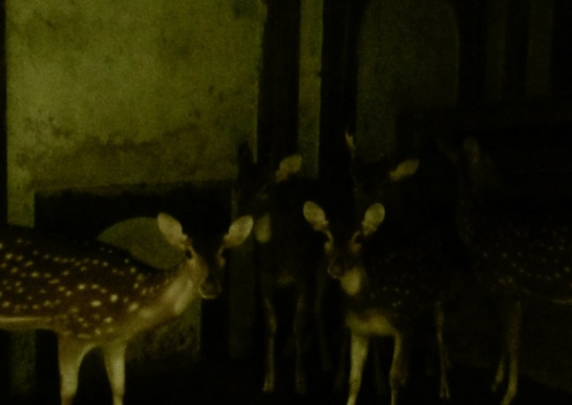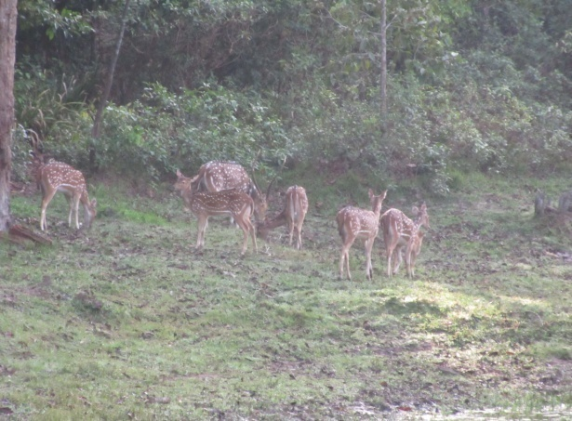
At J.N. Dairy Farm, Bohardarhat, Chittagong At B.S.M.R Safari Park, Cox’s Bazar

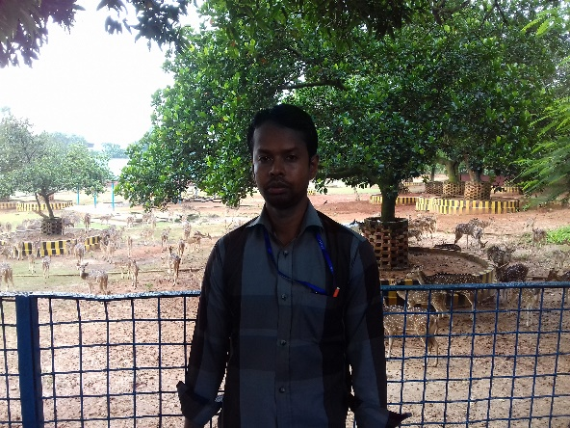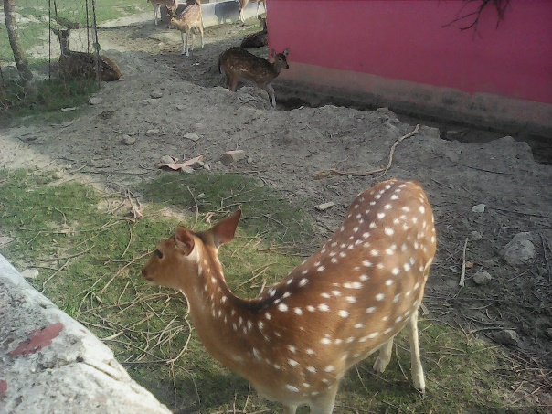

At Bangladesh National Zoo, Dhaka At Rajlakshmi Dairy Farm, Nazirpur, Pirojpur

Chapter 7.
Biography

The author is Nipul Bairagi, an intern student of Chittagong Veterinary and Animal Sciences University, Origin from Gobardhan, Nazirpur, Pirojpur. By this December 2017 he will receive the Doctor of Veterinary Medicine (DVM) degree, during this period of time he attends so many training program, seminar and conference in home and abroad related his degree for better exposure knowledge and experience. He finished his primary, secondary and higher secondary education from Barisal Board and belonging within top five top students in his class. He is personally self dependent one, like to do his work with due response, active, punctually and dutifully.

