Chapter I

Introduction

Bangladesh is agriculture based subtropical country. Livestock is an important sub-sector of agriculture which plays an important role to promote human health and poverty alleviation. Milk and meat are good source of nutrition for human. Cattle are being using for milk, meat, draft power for cultivation, rural transport and manure for increasing soil fertility. About 20% of the people directly depends on the livestock sector and thus contributes around 16.5% to the country GDP. The population size of cattle in Bangladesh is 237.85 million (DLS, 2016).About 1.66% of GDP comes from livestock (DLS, 2016).The cattle production is an important part of livestock.Dairying is an integral part of crop-livestock system and this is particularly important for the rural poor, including the functionally landless, many of whom regard livestock as a main livelihood option (Uddin et al., 2011). About 75% of the rural people rely on livestock, particularly dairy,to some extent for their livelihood, which clearly indicates that the poverty reduction potential of the livestock subsector is high(DLS, 2007).
Now a day’s cross bread cows are popular in Bangladesh. They are mainly used for producing more milk. Reproductive efficiency is a main factor for improvement of dairy cattle.Currently artificial insemination (AI) is expanding quickly and it covers about 35 to 40% cows in Bangladesh. For improving the production potential and genetic merit of the nondescript indigenous cows, superior germ plasms have been introduced all over the country through AI (Sarder et al., 2001). The scientific of Bangladesh is lacking a comparative scenario and backyard level success of artificial insemination in Bangladesh. Therefore this study was carried out with the following objectives,

- To know the artificial insemination scenario in hill area and plain land.
- To know the reproductive performance of hill area and the plain land.

Chapter II

Materials and Methods

2.1 Study area and study period:
This study was conducted in three upazila of Bangladesh namely Sadar from Pirojpur, district, Matlab from Chadpur district and sadar from Khagrachari district. This study was conducted from01.03.2017 to 06.04.2017 and 05.07.17 to 03.8.17.
Pirojpur district area is about 164.64 sq.km located in between 22̊ 29̍and 22̊ 41̍ north latitudes and in between 89̊ 53̍ and 90̊ 02̍ east longitudes. In between this area Pirojpur sadar is located. Chandpur is located between 23̊ 29̎to 24̊ 04̎ North latitudes and between 90̊ 06̎ to 91̊ 0̎ east longitude. Khagrachari district is an area of 2699.55 sq.km located in between 22̊ 38̍ and 23̊ 44̍ north latitudes and in between 91̊ 44̍ and 92̊ 11̍east longitude.

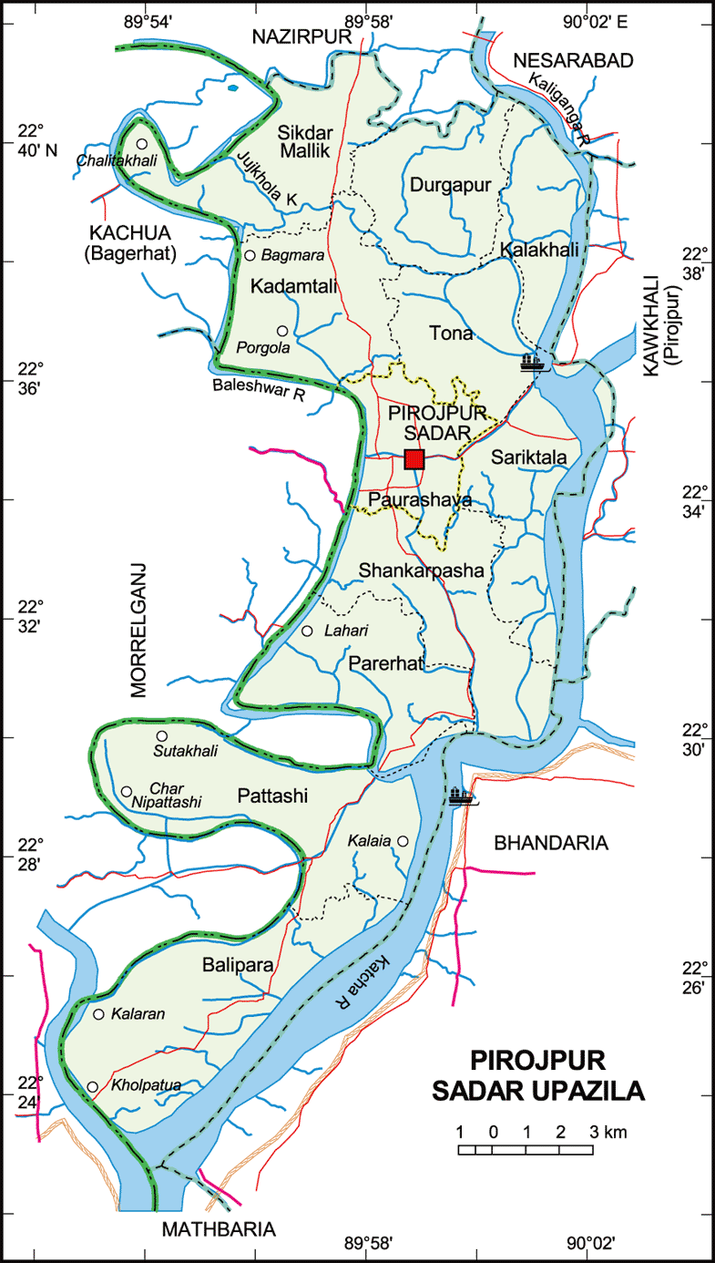
Fig:Pirojpur sadar
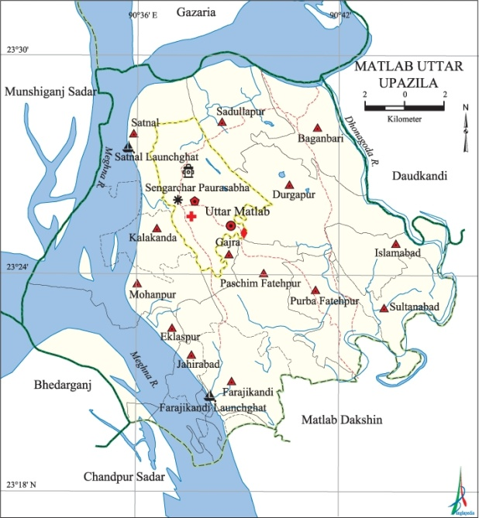
Figure: Matlab upazila
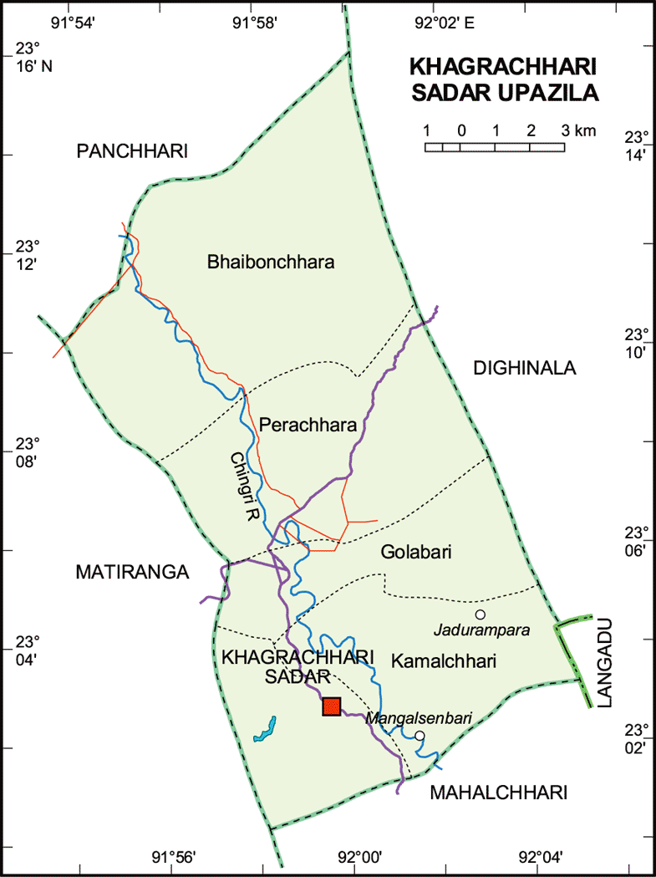
Figure:Khagrachari sadar

2.2 Population size:
The population was taken from different three districts. 80 from Pirojpur sadar, Pirojpur, 69 from Khagachari, Chittagong, 86 from Matlab, Chadpur. Total population size of the study was 235.
2.3Data collection:
The data was from the back yard or smallholding farmer from three selected upazila and the farmer were selected randomly.
For date collection, the first task of the study was to develop a questionnaire. The questionnaire included both open and close ended question. Then data were collected by personal visits to farm and interview with the farmers.
2.4 Data analysis:
All the collected data were entered into MS excel (Microsoft office excel-2010, USA). Descriptive and graphical analyses were performed using graphed software version 5.04 (wwuu.graphad.com).

Chapter: III

Results and discussion
This study was conducted in different three area of Bangladesh in a period of about two month. Same questioner was filled up indifferent three areas which was included with different reproductive data like artificial insemination condition, lactation yield in relation with service per conception and age.
3.1 Insemination practices in smallholding cattle:
In the present study it was found that in hill area practice of artificial insemination was less than 20% and natural insemination was more than 80% (Figure 1). On the other hand in plain land percentage of artificial insemination was more than 80 and natural insemination was less than 20%.In previous study it is found that in high altitude or hill area natural insemination is practiced with their available bull and artificial insemination percent is very low and its almost 21% (Meena et al., 2008) which support the findings of the present study.
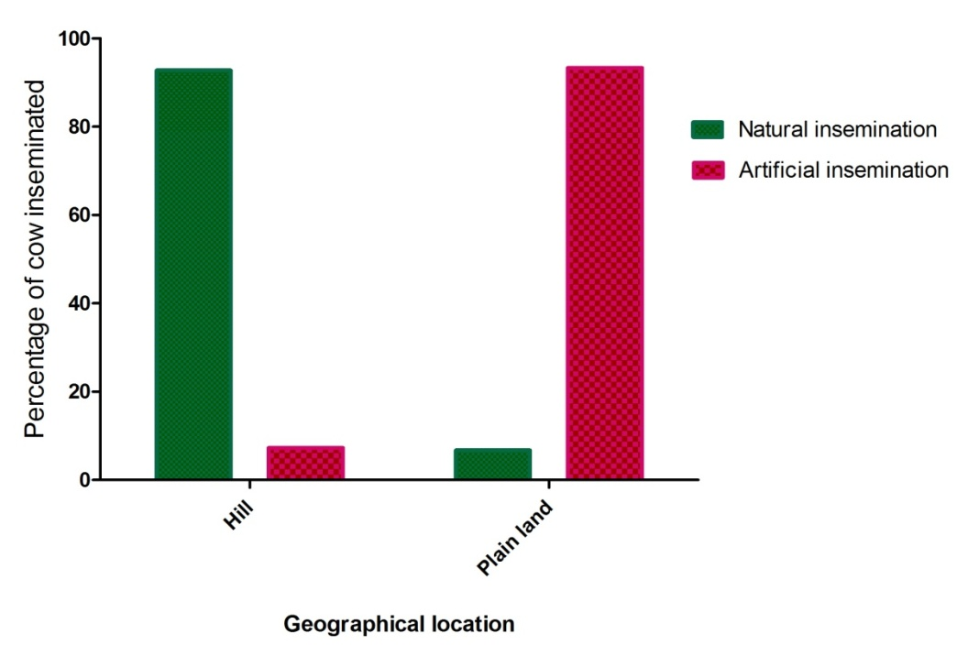
Figure 1: Distribution of insemination practices in hill and plain land

3.2 Reproductive performance:
3.2.1 Service per conception and calving interval:
Table 1shows the mean value of service per conception and calving intervals. There we found significance difference in calving interval in hill area and in the plain land. This finding reflects that more use of natural insemination increases the success rate of insemination and thereby reduce the calving interval.
Table 1: Reproduction parameters (Mean±SEM) for small holder cattle in hill and plain land
Parameter | Hill | Plain land | P value
Service per conception (SPC) | 1.45±0.05 | 2.6±0.51 | 0.1475
Calving interval | 12.85±0.27 | 14.95±0.60 | 0.0274

3.2.2 Age of cow and service per conception:
Our result shows that age and service per conception is not proportional to each other. Figure 2 indicate that age group 2 to 3 years and >7 year required more service than animals of 3 to 6 year of age. This meaning that the conception rate is higher in 3 to 6 years aged cow.
In previous study found that at 1-2 services a relatively higher conception rate were observed in age group 3.5-5 and 6 years cross brad and local breeds (Khan et al. 2015) which support this study.
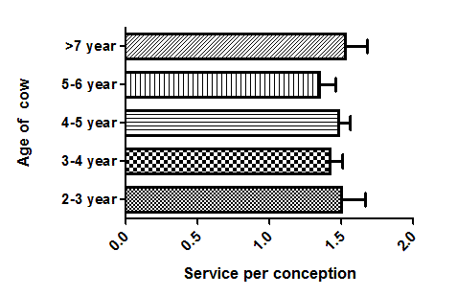
Figure 2: Service per conception with the age of cow
3.2.3 Lactation yield versus service per conception:
In this present study it was found that the low yielding cattle needs less services per conception. Cows producing 100 litter milk in per lactation need only 1 service per conception but cows producing >1500 litter milk per lactation require 2 services per conception. It denotes high yielding cows require more service per conception which indicate a negative correlation between milk yield and service per conception.
In previous another study there found that the negative association between milk yield and fertility is commonly reported in US Holstein cattle (Melendez and Pinedo et al., 2007; Washburn et al., 2002; de Vries and Risco, 2005) which agree with this present study.
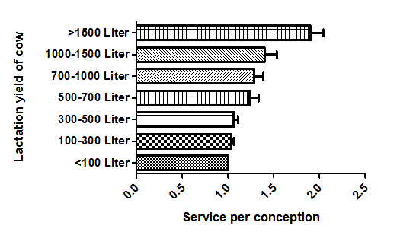
Figure 3: Service per conception in relation to lactation yield

Chapter: IV
Limitations
There may have some recall bias. Because the farmers were not well educated and they didn’t maintain any herd book as it was the data from the small holding farmers.

Chapter V

Conclusion

For improvement of our country livestock sector plays an important role. Back yard farming in rural area is also plays very important role in daily economy of the farmers. This study revealed artificial insemination is being substantially used in plain area where in hill area natural insemination is predominant. From this above study it can be said that introduction of artificial insemination in hill area in large scale can improve the productivity as well as the country economy. For the plain land, introduction of improved management practices is necessary to increase the reproductive performances because fertility and other reproductive traits are of low heritable trait.

References

Department of livestock services, DLS (2007). Government of Bangladesh
Department of livestock services, DLS (2016). Government of Bangladesh
deVries, A., and Risco, C.A., (2005). Trends and seasonality of reproductive performance in Florida and Georgia dairy herds from 1976 to 2002. Journal of Dairy science, 88:3155–3165
Khan, M.R.K.,Uddin, J. and Gofur, MD.R. (2015). Effect of age, parity and breed on conception rate and number of service per conception in artificially inseminated cows. Bangladesh livestock journal, 1: 1-4
Meena, H. R., Ram, H., Shahoo, A., and Rasool, T. J. (2008).Livestock husbandry scenario at high altitude Kumaon Himalaya.Indian Journal Of Animal Sciences 78 (8):882-886
Melendez, P., and Pinedo, P., (2007). The Association Between Reproductive Performance and Milk Yield in Chilean Holstein Cattle. Journal of Dairy science, 90:184–192
Sarder, M.J.U., Joarder, O.I. and Ali, M.S. (2001). Semen production in relation to the age and season of Friesian cross and Sahiwal bulls for artificial insemination. Journal of Biosciences, 9: 39-46
Uddin, M. M., Sultana, M. N., Alqaisi, O., Ndambi, O. A., Hemme, T., Peters, K. J. (2011). Milk production trends and dairy development in Bangaldesh. Outlook on Agriculture, 40: 263-271

Washburn, S. P., Silvia, W. J., Brown, C. H., McDaniel, B. T., and McAllister, A. J., (2002). Trends in reproductive performance in Southeastern Holstein and Jersey DHI herds. Journal of Dairy science, 85:244–251
Reproductive info:
- Service used: A.I …… or….. Natural insemination………………………………………
- Service per conception: …………………………………………………………………..
- Semen used: From same bull/semen ……, From different bull/semen
- Batch of semen: …………………………………………………………………………..
- Breed of sire: …………………………………………………………………………..
- Body condition score: …………………………………………………………………
- Birth weight of calf: ……………. Calf weight: ………………………………………
- Calf feeding/milk feeding (yes or no): ………… if yes, amount: …………………….
- History of abortion/still birth: …………………………………………………………………………………………
- Duration of calving to first heat (in days): ……………………………………………
- Non return rate: ……………………………………………………………………….
- Calving interval: ……………………………………………………………………..
Other managements
- History of: Deworming (yes or no) ………………… Time: …………………………
- History of vaccination (yes or no):…………………………………………………….
if yes, name of the vaccine given:………………………………………………….
History of antibiotic use (yes or no): ………If yes, name of the drug used………………. ………………………………………….……………..……………………………………

Thank you

ACKNOWLEDGEMENT

The author wishes to acknowledge the immeasurable grace and profound kindness of Almighty “ALLAH” the supreme authority and supreme ruler of universe, who empowers the author to handle the case and to complete the case report successfully.
The author wishes to express his deep sense of gratitude and thanks to, Dr. Ashutosh Das, Department of Genetics and Animal Breeding, Chittagong Veterinary and Animal Sciences University for his skillful supervision and guidance to make this report. The author further wants to thank the farmers who are the part and parcel of this livestock sector, without their contribution this study couldn’t be fulfilled.
Finally the author expresses thanks and warmest sense of gratitude to his parents and all well-wishers.

The author,
December, 2017

BIOGRAPHY

I Syed Imran, the author of this report would like to introduce as Intern. Doctor of Chittagong Veterinary and Animal Sciences University (CVASU) have passed four years academic career in Faculty of Veterinary Medicine and attended several clinical training programs on Veterinary Medicine in Bangladesh, India. As a student of Veterinary science, the main mission and vision of my life is to do something better and creative job by dint of my academic knowledge and experience, for the development of livestock as well as development of the economic condition of our country. This report on An evaluation of insemination practices and reproductive traits in cattle on smallholdings of Bangladesh is the first step to fulfill my dream. I strongly assure that I have done all the works furnished here in this report and I hold entire responsibility of the information given here which are collected from different books, journal and websites.

