EFFECTS OF DIETARY ESSENTIAL OILS (Eucalyptus globulus) AS ALTERNATIVE TO ANTIBIOTICS IN BROILER

Md. Ariful Hasan
Roll No: 0117/18
Registration No: 00438
Session: 2017-2018

A thesis submitted in the partial fulfillment of the requirements for the
Degree of Master of Science in Applied Human Nutrition & Dietetics

Department of Applied Food Science and Nutrition
Faculty of Food Science and Technology
Chattogram Veterinary and Animal Sciences University
Chattogram-4225, Bangladesh

June 2019

AUTHORIZATION

I, Md. Ariful Hasan assure that I have performed all works furnished here in this report. The Information has been collected from books, national and international journals, websites and other references. All references have been acknowledged duly.
I hereby declare that I am the sole author of the thesis. I also authorize the Chattogram Veterinary and Animal Sciences University (CVASU) to lend this thesis to other institutions or individuals for the purpose of scholarly research. I further authorize the CVASU to reproduce the thesis by photocopying or by other means, in total or in part, at the request of other institutions or individuals for the purpose of scholarly research.

Therefore, I hold entire responsibility for collection, compilation, preservation and publication of all data accumulated here in this report. I, the undersigned, and author of this work, declare that the electronic copy of this thesis provided to the CVASU Library, is an accurate copy of the print thesis submitted, within the limits of the technology available.

----------------------------
The Author
June 2019

EFFECTS OF DIETARY ESSENTIAL OILS (Eucalyptus globulus) AS ALTERNATIVE TO ANTIBIOTICS IN BROILER

Md. Ariful Hasan
Roll No: 0117/18
Registration No: 00438
Session: 2017-2018

This is to certify that we have examined the above Master’s thesis and have found that is complete and satisfactory in all respects, and that all revisions required by the thesis examination committee have been made.

--------------------------------------------------------

(Professor Dr. Md. Manirul Islam)
Supervisor

--------------------------------------------------------
(Md. Altaf Hossain)
Chairman of the Examination Committee

Department of Applied Food Science and Nutrition
Faculty of Food Science and Technology
Chattogram Veterinary and Animal Sciences University
Chattogram-4225, Bangladesh
June 2019

Dedication

DEDICATED TO MY BELOVED PARENTS

ACKNOWLEDGEMENTS
First and foremost I thank almighty Allah for the blessing and opportunity to pursue higher education and to accomplish the thesis for the degree of Masters of Science (MS) in Applied Human Nutrition & Dietetics.
I pay heartily gratitude to Professor Dr. Goutam Buddha Das, Vice-Chancellor, Chattogram Veterinary and Animal Sciences University (CVASU) for giving special opportunity and providing such research facilities.
Mere indebted thanks may not suffice the privilege to express my profound sense of gratitude to my supervisor Professor Dr. Md. Manirul Islam, Department of Animal Science and Nutrition, CVASU for unequivocal motivation, benevolent guidance, affectionate encouragement and constant supervision during the entire period of investigation and preparation of manuscript.
I feel much pleasure to convey my profound thanks Md. Altaf Hossain, Head and Assistant Professor, Department of Applied Food Science and Nutrition , CVASU for his valuable advice, scholastic guidance, inspiration and suggestions during my study period.
I am grateful to Professor Dr. Jannatara Khatun, Dean, Faculty of Food Science and Technology, CVASU for her kind cooperation and providing necessary facilities to carry out this research.
Especially I would like to thank DR. Kona Adikhary, Lecturer, Department of Animal Science and Nutrition and Md. Showkat Ullah for their support during the whole experimental period. Last but not least, I express my deepest sense of gratitude to my beloved family members and my friends for their sacrifice, blessings and encouragement.
The Author
June 2019

TABLE OF CONTENTS

Authorization………………………………………………………………… |  |  |  |  | II
Acknowledgements………………………………………………………….. |  |  |  |  | V
List of Tables………………………………………………………………… |  |  |  |  | VIII
List of Figures………………………………………………………………... |  |  |  |  | IX
List of Abbreviations………………………………………………………… |  |  |  |  | X
Abstracts……………………………………………………………………... |  |  |  |  | XI
CHAPTER-I: INTRODUCTION |  |  |  |  | 1-3
 |  | 1.1 General Feature……………………………………………………… |  |  | 1
 |  | 1.2 Objectives …………………………………………………………… |  |  | 3
CHAPTER-II: REVIEW OF LITERATURE |  |  |  |  | 4-10
 |  | 2.1 Essential oils ………………………………………………………. |  |  | 4
 |  |  | 2.1.1 Effect of essential oils on feed palatability and digestibility and nutrient metabolism…………………………………………… |  | 5
 |  | 2.2 Eucalyptus………..……………………………………………....... |  |  | 5
 |  |  | 2.2.1 Scientific Classification………………………………………. |  | 6
 |  |  | 2.2.2 Botanical Information………………………………………… |  | 6
 |  |  | 2.2.3 Morphological Description …………………………………... |  | 7
 |  |  | 2.2.4 Geographical Distribution…………………………………….. |  | 7
 |  | 2.3 Eucalyptus essential oil……………………………………………… |  |  | 7
 |  |  | 2.3.1 Use of Eucalyptus essential oil………………………………. |  | 10
CHAPTER-III: MATERIALS AND METHODS |  |  |  |  | 11-21
 |  | 3.1 Trial area…………………………………………………………….. |  |  | 11
 |  | 3.2 Study period…………………………………………………………. |  |  | 11
 |  | 3.3 Eucalyptus Essential oil extraction………………………………...... |  |  | 11
 |  |  | 3.3.1 Collection of Eucalyptus leaves………………………………. |  | 11
 |  |  | 3.3.2 Cleaning of leaves…………………………………………….. |  | 11
 |  |  | 3.3.3 Distillation of oil……………………………………………… |  | 12
 |  | 3.4 Design of the experiment…………………………………………… |  |  | 13
 |  | 3.5Animals and housing…………………………………………………. |  |  | 14
 |  | 3.6 Cleaning and sanitation.…………………………………………….. |  |  | 15
 |  | 3.7 Diets ……………………………………………………………….. |  |  | 15
 |  | 3.8 Experimental Water Preparation…………………………………… |  |  | 18
 |  | 3.9 Feeding of birds……………………………………………………. |  |  | 18
 |  | 3.10 Medications………………………………………………………… |  |  | 18
 |  | 3.11 Carcass measurement ……………………………………………… |  |  | 19
 |  | 3.12 Analysis of meat……………………………………………………. |  |  | 19
 |  | 3.13 Hematological analysis…………………………………………….. |  |  | 20
 |  | 3.14 Data collection……………………………………………………... |  |  | 21
 |  | 3.15 Data analysis………………………………………………………. |  |  | 21
CHAPTER- IV: RESULTS |  |  |  |  | 22-26
 | 4.1 Growth performance…………………………………………………. |  |  |  | 22
 |  |  |  | 4.1.1 Average daily gain (ADG) …………………………………… | 22
 |  |  |  | 4.1.2 Average daily feed intake (ADFI)……………………………. | 22
 |  |  |  | 4.1.3 Feed conversion ratio (FCR) ………………………………… | 22
 | 4.2 Blood serum Parameters………..…………………………….......... |  |  |  | 24
 | 4.3 Chemical Composition of meat……………………………………… |  |  |  | 25
 | 4.4 Carcass Characteristics………………………………………………. |  |  |  | 25
 | 4.5 Mortality……………………………………………………………. |  |  |  | 26
CHAPTER-V: DISCUSSION……………………………………………… |  |  |  |  | 28
CHAPTER-VI: CONCLUSIONS…………………………………………. |  |  |  |  | 31
CHAPTER-VII: RECOMMENDATIONS ……………………………… |  |  |  |  | 32
REFERENCES……………………………………………………………... |  |  |  |  | 33-43
APPENDICES............................................................................................... |  |  |  |  | 44-47
BRIEF BIOGRAPHY……………………………………………………… |  |  |  |  | 48
List of Tables

Table Number | Title of the table | Page
Table 1 | Chemical constitutes of E. globulus essential oil vapor | 8
Table 2 | Chemical constitutes of E. globulus essential oil | 9
Table 3 | Ingredients names with chemical composition of the broiler grower ration (1-14 days) | 16
Table 4 | Ingredients names with chemical composition of the broiler grower ration (15-28 days) | 17
Table 6 | Effects of eucalyptus essential oil on growth performance in broiler | 23-24
Table 7 | Effects of eucalyptus essential oil on blood parameters in broiler. | 24
Table 8 | Effects of eucalyptus essential oil on meat proximate components in broiler | 25
Table 9 | Effects of eucalyptus essential oil on carcass characteristics and relative organ weight in broiler | 26
Table 10 | Effects of eucalyptus essential oil on Cost-benefit analysis in broilers | 27

List of Figures

Figure number | Name of the figure | Page
Figure 1 | Eucalyptus tree | 6
Figure 2 | Leaf preparation | 11
Figure`3 | Essential oil distillation | 12
Figure 4 | Steam distillation process | 12
Figure 5 | Dividing the chicks into different dietary treatment groups | 13
Figure 6 | Design of the experiment | 13
Figure 7 | Temperature and humidity maintain during Brooding period | 14
Figure 8 | Vaccination of poultry | 18
Figure 9 | Collection of internal organs | 19
Figure 10 | Meat sample analysis | 19
Figure 11 | Hematological analysis | 20
Figure 12 | Weight recording | 21
Figure 13 | Mortality of bird | 26

List of Abbreviations

Abbreviation | Elaboration
GRAS | Generally Recognized As Safe
ADG | Average Daily Gain
g/b | Gram/bird
g/b/d | Gram/bird/day
FDA | the Food and Drug Administration
WHO | World Health Organization
% | Percentage
°C | Degree centigrade
°F | Degree Farenhite
v/v | Volume/ Volume
w/v | Weight/ Volume
EO | essential oil
BDT | Bangladeshi taka
FCR | Feed Conversion Ratio
LDL | Low density Lipoprotein
HDL | High Density Lipoprotein
SE | Standard Error
DM | dry matter
CP | crude protein
CF | crude fiber
EE | ether extracts
TA | and total ash
Fig | Figure
FAO | Food and Agriculture Organization

Abstracts
The study was conducted to investigate the effects of different levels of Dietary Essential Oils (Eucalyptus globulus) on growth performance, carcass characteristics, meat quality and blood parameters in broiler. A total of 96 day old Ross 308 unsexed broiler chicks were randomly distributed into four dietary treatment groups: T₀= Control (basal diet); T₁= Antibiotics (basal diet+ 0.1% amoxiciline in drinking water); T₂ = Essential oil (basal diet+ 0.4ml/L eucalyptus oil, DM basis ); T₃= Essential oil (basal diet+ 0.8ml/L eucalyptus oil, DM basis). Each treatment group consist of 3 replications having 6 birds in a completely randomized design for 28 days trial period. Results indicated that, in 1st week T₁ treatment group has the highest average daily gain (ADG). During 2nd ,3rd and 4th week T₁ treament group has highest Average daily gain (ADG) while T₀ stands for lowest in every week (P< 0.05).
But in terms of FCR T₃ has the highest feed conversion ratio while T₁ has the lowest. A significant increase in blood HDL level while decreased LDL and total cholesterol in all treatments compared to control (P< 0.05). Considering meat quality, crude protein (CP), ether extract (EE) and ashes were decreased singnificantly in all treatment groups compared to control. In case of mortality T₃ treatment group has shown the best result compared to control group. In conclusion, dietary supplementation of Eucalyptus globulius essential oil decreased weekly weight gain, better FCR, decreased mortality, CP, EE, total ashes and blood HDL level. On the other hand, it reduced blood LDL and total cholesterol level.
Keywords: Broiler, Eucalyptus globulius, essential oil, growth performannce, carcass characteristics.

Chapter-I
Introduction
  - General Feature
Poultry is considered as a cheap and readily available protein source for human consumption worldwide. In the third world country like Bangladesh poultry sector has proven its promise in eliminating protein deficiency especially from the lower middle class people. But with the rapid growth of poultry sector a major human health concern is noticed relating to the excessive and uncontrolled abuse of antibiotics which is leading to antibiotic resistant bacteria, a major threat to human race. This increasing use of antibiotics may lead to the spread of antibiotic-resistant bacteria in both pigs and humans, which is identified as a signiﬁcant public health threat (Yang et al., 2015). Antibiotics used at sub therapeutic doses also the use of antimicrobial growth promoters have been found beneficial for rapid growth performance in animal production level and prevention of disease occurrence (Barton et al., 2000; Snel et al., 2002). Since 2006 European Union banned the use of Antibiotic Growth Promoters (AGP) in food animal production (Bengtsson and Wierup, 2006). The U.S. Food and Drug Administration placed restrictions on antibiotic use in animals in December 2016 (Zhao et al., 2007). For this reason, it is crying need to develop alternatives to antibiotics to prevent diseases and improve bird performance for the use of organic poultry producers. Beneficial effects of plants and plant extracts that have traditional use are evaluated in many studies. Most common beneficial effects of those plants and plant extracts are stimulating endogenous digestive enzymes and antioxidants (Lee et al., 2004).
Plant-derived products (phytobiotics) are natural, less toxic than antibiotics, and typically residue free in comparison with synthetic antibiotics or inorganic chemicals. Many are certified as Generally Recognized as Safe (GRAS) by the Food and Drug Administration (FDA) and therefore, make them acceptable to use as feed additives in organic poultry production (Wang et al., 1998).
Several growth and health promoting properties have been attributed to phytobiotics usage in poultry. These benefits are derived by improving gut health including increasing digestibility (Mitsch et al., 2004; Kroismayr et al., 2008), modifying digestive secretions, and sustaining and improving gut histology (Williams and Losa, 2001; Kreydiyyeh et al., 2003; Jamroz et al., 2003). Furthermore, some phytobiotics stabilize the microbiome, which reduces microbial toxins (Steiner, 2006; Windisch et al., 2008; Perič et al., 2010). This, in turn, reduces inflammation and; therefore, protein production can be allocated to growth as opposed to production of immune modulators (Kroismayr et al., 2008; Steiner, 2006).
Scientist have found organic acids (Eckel et al., 1992; De Lange et al., 2010), probiotics (Heo et al., 2004, 2013; Musa and Seri, 2009), enzymes (Bedford and Cowieson, 2012; Kiarie et al., 2013), medium chain fatty acids (Boyen et al., 2008), antimicrobial peptides (Choi et al., 2013) and essential oils (Windisch et al., 2008; Randrianarivelo et al., 2010; Gong et al., 2013) as effective alternatives to antibiotics in feeds.
Among phytobiotics, essential oils have gained more interest due to their antimicrobial and growth promoter properties. Essential oils are compounds obtained by distillation or solvent extraction from aromatic plants, herbs, or spices (Yang et al., 2009). Many EOs contain multiple active components and these components are primarily used to protect the plants from damage caused by insects and bacteria. Each component may have a different mechanism of action and these components can work synergistically (Senatore, 1996; Russo et al., 1998).
The leaves of the eucalyptus tree have been used in aboriginal medicinal remedies for thousands of years. Nowadays they are also used in modern medicine to treat various common ailments. Eucalyptus oil has antibacterial effects on pathogenic bacteria in the respiratory tract. The Inhaled eucalyptus oil vapors are a decongestant and treatment for bronchitis. Cineole controls airway mucus hyper secretion and asthma via anti-inflammatory cytokine inhibition. Eucalyptus oil also stimulates immune system response by effects on the phagocytes ability of human monocyte derived macrophages (Priyanka et al., 2017). Eucalyptus and peppermint oils proved to be able to implement innate-cell mediated, humoral immune response and have a potent immune modulatory effect in chickens (Awaad et al., 2010).
Essential oils have been widely used as traditional medicines to improve health or cure diseases in humans as it has the ability to possess antimicrobial, anti-inﬂammatory and antioxidative activities (Kim et al., 2008; Brenes and Roura, 2010). The bioactive components in essential oils have been identiﬁed and some progress have been made to elucidate the mechanisms underlying the functions of these compounds in animals, leading to increased research efforts to use essential oils to replace antibiotics in animal feeds (Li et al., 2012). However, the application of essential oils in the feed has been mainly based on the antimicrobial effects. Moreover, the minimum inhibitory concentration (MIC) of most essential oils are much higher than the acceptable levels in animal industry in terms of cost-effectiveness and feed palatability (Yang et al., 2015).
Previous researches had been conducted by mixing Eucalyptus oil directly in feed. As Eucalyptus oil is volatile so it is possible to loss mostly by evaporation. Therefore, the present research has been designed by dissolving eucalyptus essential oil into water might be a new approach and it will reduce evaporation.
Research questions:
Will present research be able to provide a better result?
Will we get a better alternative to antibiotics?
Will eucalyptus oil positively affect the growth performance, blood parameter and meat quality?
Will it be cost effective for poultry farmers?
  - Objectives
    - General Objective
This research aims to find an alternative to commercially used antibiotics by using eucalyptus essential oil.
    - Specific Objectives
- To find an effective alternative to antibiotics.
- To investigate the growth performance of broiler in supplementation of essential oil.
- To assess the effect of essential oil on meat quality in broiler.
- To determine the blood parameters in supplementation of essential oil.

Chapter-II
Review of literature
2.1 Essential oils
Aromatic, volatile and oily liquids extracted from plant materials such as seeds, ﬂowers, leaves, buds, twigs, herbs, bark, wood, fruits and roots are named as essential oils (Brenes and Roura, 2010). Among 3,000 known essential oils, 300 of which have commercially importance and used in pharmaceutical, agronomic, food, sanitary, cosmetic and perfume industries as effective alternatives or complements to synthetic compounds (Bakkali et al., 2008). In recent years the food industry and animal producers have increased their interest in the use of Essential Oil (EO), not only for their anti-oxidative and anti-inflammatory properties, but also for their antimicrobial, coccidiostatic, antihelmintic and anti-viral effects (Wei and Shibamoto, 2007; Rhodes et al., 2006; Burt, 2004; Nakatani, 2000; Craig, 1999; Cuppett and Hall, 1998; Hirasa and Takemasa, 1998; Halliwell et al., 1995;). Multiple oils, including carvacrol, thymol , obtained from oregano (Origanum glandulosum) or eugenol (EUG) obtained from the oil cloves (Eugenia caryophillis), are reported to inhibit many pathogenic bacteria (Applegate et al., 2010; Kollanoor et al., 2010; Si et al., 2006; Dorman and Deans, 2000)
EOs are gaining more interest in conventional and organic poultry nutrition, primarily focusing on the improvement of gut functions. Stabilizing the microflora in the digestive tract is one of the positive effects of EO, which improves nutrient utilization and absorption. EOs improve nutrient utilization and absorption by increasing the activity of digestive enzymes including trypsin and amylase (Jang et al., 2004; Lee et al., 2003). Additionally, active components increase intestinal secretions of mucus, which prevents the adhesion of pathogens (Jamroz et al., 2006).
Essential oils are more effective against gram-positive than gram-negative bacteria because the gram-negative bacteria have an effective permeability barrier against external noxious agents (Vaara, 1992). Essential oils have been proven as an alternative to antibiotics by many researchers because they have antimicrobial, anti-inﬂammatory, antioxidative, and coccidiostatic properties. They enhance digestibility (Chitprasert and Sutaphanit, 2014) and immunity (Brenes and Roura, 2010), promote gut health by minimizing the effect of the pathogenic bacteria (Chitprasert and Sutaphanit, 2014), and control odor and ammonia emission (Varel, 2002).
Some researchers recorded that the supplementation of the mixture of herbs (thyme, bay, sage, myrtle leaf, fennel and citrus essential oil) to the broiler´s diets, significantly improved live weight, feed efficiency and carcass characteristics of the broilers (Alçiçek et al., 2004, 2003).
It is reported that herbal extracts or active substances may increase feed intake and may improve secretion of endogenous digestive enzymes (Jamroz et al., 2003; Craig, 1999).Besides that, it has been reported that essential oils have antibacterial effects in chickens (Skoufos et al., 2016; Giannenas et al., 2014; Bölükbaşi et al ., 2008, 2009; Faleiro et al., 2003; Cowan, 1999).
2.1.1 Effect of essential oils on feed palatability and digestibility and nutrient metabolism

Flavor and odor of feed promotes with the addition of essential oils for this reason feed palatability and intake increase (Kroismayr et al., 2006). It is believed that the increased feed palatability associated with the supplementation of essential oils could also be due to their antioxidative properties that can preserve the qualities of diets and prevent the release of unfavorable odors from the diets (Sola-Oriol et al., 2011; Franz et al., 2010). So it might be possible to replace chemical antioxidants (e.g., ethoxyquin and butylated hydroxytoluene) which are frequently used in the animal diet with enough amounts of essential oils (natural antioxidants), particularly when chemical antioxidants are prohibited (Yang et al., 2015).

2.2 Eucalyptus
Eucalyptus (family Myrtaceae) is a genus of tall, evergreen tree which is an Australian native, that have around 700 species. It is a magnificent tree cultivated worldwide for its oil, gum, pulp, timber, medicine and aesthetic value. Among the various wood and non-wood products, essential oil found in its foliage is the most important one which have extensive use in perfumery, food and pharmaceutical industry. In addition, the oil possesses a wide spectrum of biological activity including anti-microbial, fungicidal, insecticidal/ insect repellent, herbicidal, acaricidal and nematicidal (Batish et al., 2008).
2.2.1 Scientific Classification
Kingdom : Plantae
Class : Magnoliapsida
Order : Myrtales
Family : Myrtaceae
Genus : Eucalyptus
Species : Globulus
2.2.2 Botanical Information
Species used : The family includes more than 500 species such as
E. biostatic : Southern Blue Gum, Eurabbie, Victorian Blue Gum
E. globules : Tasmanian Blue Gum
E. maiden : Maiden's Gum
Synonyms : Southern blue gum, Tasmanian blue gum, Maiden” gum
Category : Strong nervine and anxiolytic
Plants parts used : Leaf and Barks
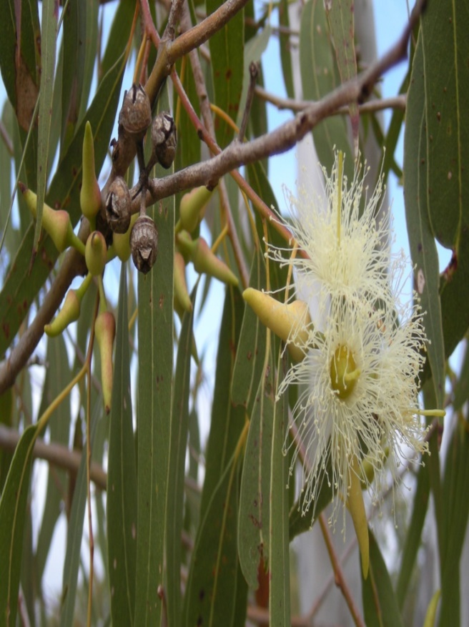
Figure 1: Eucalyptus tree
2.2.3 Morphological Description
The Eucalyptus globulus bark sheds often, peeling in large strips. The broad juvenile leaves are borne in opposite pairs on square stems. They are about 6 to 15 cm long and covered with a blue-grey, waxy bloom, which is the origin of the common name "blue gum". The mature leaves are narrow, sickle-shaped and dark shining green. They are arranged alternately on rounded stems and range from 15–35 cm (5.9–13.8 in) in length. The buds are top-shaped, ribbed and warty and have a flattened operculum (cap on the flower bud) bearing a central knob. The cream-colored flowers are borne singly in the leaf axils and produce copious nectar that yields a strongly flavored honey. The fruits are woody and range from 1.5–2.5 cm (0.59–0.98 in) in diameter (Pereira et al., 2014).
2.2.4 Geographical Distribution
Eucalyptus globulus is naturally distributed in Tasmania and south-eastern Australia, but is now widely planted and naturalized in subtropical regions around the world. In tropical Africa it is found in cool highland regions, especially in Ethiopia, where it was introduced around 1890. The introduction of Eucalyptus globulus to Ethiopia is said to have played a major role in the development of the country (Gobel et al., 2002). In recent years Eucalyptus globulus is seen to be cultivated in Bangladesh and India mostly for timber.
2.3 Eucalyptus essential oil
Eucalyptus oils in the trade are categorized into three broad types according to their composition and main end-use: medicinal, perfumery and industrial (Vigo et al., 2004). The most prevalent is the standard cineole-based "oil of eucalyptus", a colourless mobile liquid with a penetrating, camphoraceous, woody-sweet scent. China produces about 75% of the world trade, but most of this is derived from camphor oil fractions rather than being true eucalyptus oil. Significant producers of true eucalyptus oil include South Africa, Portugal, Spain, Brazil, Australia, Chile and Swaziland ( Salari et al., 2006). Global production is dominated by Eucalyptus globulus. However, Eucalyptus kochii and Eucalyptus polybractea have the highest cineole content, ranging from 80-95%. The British Pharmacopoeia states that the oil must have a minimum cineole content of 70% if it is pharmaceutical grade. Rectification is used to bring lower grade oils up to the high cineole standard required. Global annual production of eucalyptus oil is estimated at 3,000 tonnes. The eucalyptus genus also produces non-cineole oils, includes piperitone, phellandrene, citral, methyl cinnamate and geranyl acetate. Eucalyptus oil should not be confused with the term "eucalyptol", another name for cineole.
According to (Tyagi et al., 2011) the major constituents of E. globulus essential oil were 1,8-cineole (45.4%), limo-nene (17.8%), p-cymene (9.5%), c-terpinene (8.8%), a-pinene (4.2%) and a-terpineol (3.6%).
Chemical constitutes of E. globulus essential oil vapor and oil found by (Tyagi et al., 2011) is shown Table 1 and Table 2.
Table 1. Chemical constitutes of E. globulus essential oil vapor
RT (min) | Compound | Percentage
8.5 | a-Pinene | 4.0
12.5 | a-Phellandrene | 2.4
14.0 | Limonene | 29.9
14.3 | 1,8-Cineole | 34.6
14.8 | b-Ocimene | 0.5
15.2 | c-Terpinene | 7.4
16.1 | p-Cymene | 10.5
17.6 | Epoxylinalol | 0.1
22.4 | Linalool oxide | 0.1
24.7 | Linalool | 0.2
25.9 | Fenchol | 0.1
26.5 | Terpinen-4-ol | 0.5
27.6 | Menthol | 0.2
28.1 | Pinocarveol | 0.2
29.3 | a-terpineol | 0.8
 | Monoterpene hydrocarbon | 54.7
 | Oxygenated monoterpenes | 36.8
 | Total identified compound | 91.5%
Retention Indices on AB-Innowax column, Relative area percentage without using the FID response correction factor, RT: Retention Time (min), (Results are based on GC-MS; MS acquisition started after 4 min).
Table 2. Chemical constitutes of E. globulus essential oil.
RT (min) | Compound | Percentage | RI
6.4 | a-Pinene | 4.2 | 1036
9.0 | b-Myrcene | 1.5 | 1156
9.1 | a-Phellandrene | 1.3 | 1173
9.5 | a-Terpinene | 0.4 | 1188
10.1 | Limonene | 17.8 | 1206
10.4 | 1,8-Cineole | 45.4 | 1233
10.8 | b-Ocimene | 1.0 | 1238
11.2 | c-Terpinene | 8.8 | 1247
11.9 | p-Cymene | 9.5 | 1269
13.3 | Epoxylinalol | 0.1 | –
17.7 | Linalool oxide | 0.2 | 1423
19.8 | Linalool | 0.5 | 1506
21.1 | Fenchol | 0.1 | 1574
21.7 | Terpinen-4-ol | 1.4 | 1601
22.0 | a-Humulene | 0.1 | 1607
22.7 | Menthol | 0.1 | 1612
23.3 | Pinocarveol | 0.4 | –
24.4 | a-Terpineol | 3.6 | 1731
24.5 | Borneol | 0.1 | 1735
28.4 | Geraniol | 0.1 | 1797
 | Monoterpene hydrocarbons | 44.5
 | Oxygenated monoterpenes | 52.0
 | Total of identified compound | 96.6%

Retention Indices on AB-Innowax column, Relative area percentage without using the FID response correction factor, RT: Retention Time (min), (Results are based on GC-FID; MS acquisition started after 4 min).
2.3.1 Use of Eucalyptus essential oil
A number of studies have demonstrated the antimicrobial properties of Eucalyptus essential oils against a wide range of microorganisms. E. citriodora oil has been shown to have a wide spectrum of antifungal activity. In addition, Eucalyptus camaldulensis and Eucalyptus urophylla are also well known for their antibacterial (Cimanga et al., 2002) and antifungal (Su YC et al., 2006) activities. Several studies have focused on the anti-fungal properties of Eucalyptus essential oils (Somda I et al., 2007; Ramezani H et al., 2002). Research carried out by (Han et al., 2011) shows that the performance of pig fed eucalyptus MCFA blend was the same as that of antibiotics.
Traditionally, many Eucalyptus species are used in Chinese folk medicine. For example, hot water extracts of dried leaves of Eucalyptus citriodora (lemon-scented Eucalyptus) are used as anti-inflammatory, analgesic and antipyretic remedies for the symptoms of respiratory infections, such as cold, flu, and sinus congestion (Silva et al., 2003). The essential oils produced by E. citriodora are used for medicinal and pharmaceutical purposes (Ghisalberti, 1996; Leung et al., 1996).
In Japan ‘‘Eucalyptus leaf extract’’ has been approved as a natural food additive, and is also included as one of the antioxidants in the ‘‘List of Existing Food Additives in Japan’’ (Amakura et al., 2002). Recent studies focus on the functional aspects of the Eucalyptus extracts/ essential oil. Eucalyptus extracts exhibit various biological effects, such as antibacterial, antifungal, antihyperglycemic and antioxidant activities (Takahashi T et al., 2004).
Chapter-III
Materials and methods

3.1 Trail area
The study was conducted in experimental poultry shed of Department of the Animal Science and Nutrition, Chattogram Veterinary and Animal Sciences University, Khulshi, Chattogram-4225, Bangladesh.

3.2 Study Period
The overall research work was designed and performed from July 2018 to March 2019. July was considered as a representation of monsoon seasons (Islam et al., 2006). In July, average maximum temperature records cited as 29 to 32°C and humidity was 78 to 82% (BMD, 2017).

3.3 Eucalyptus Essential oil extraction

3.3.1 Collection of Eucalyptus leaves
Fresh Eucalyptus leaves were collected from several locality of Chattogram region from1st September to 15th October, 2018.
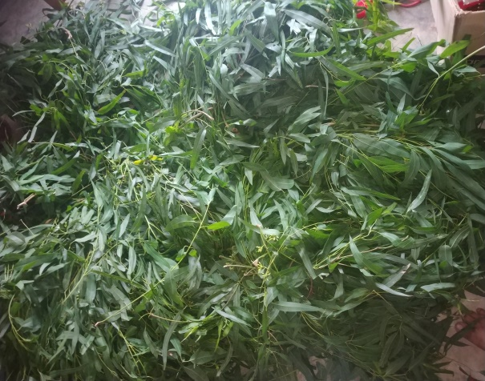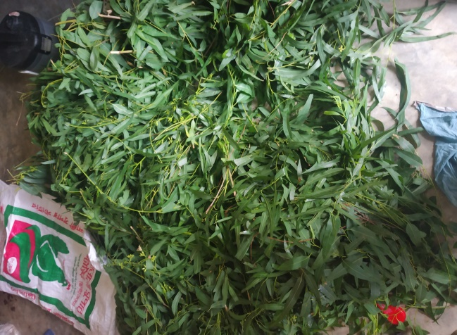
Fig 2: Leaf preparation
3.3.2 Cleaning of leaves
Freshly collected leaves are separated from stem. All kinds of foreign particles are removed from leaves then leaves are taken in a basket. After that leaves are washed with tape water to remove any kinds of dirt.
3.3.3 Distillation of oil
Fresh washed leaves are kept in distillation pot then distilled water added to the pot after that lid is tightly fitted to pot, condenser is carefully connected as though no steam can be leaked. After arranging all properly gentle heat is applied from gas stove. Cold water is used to condense the steam.
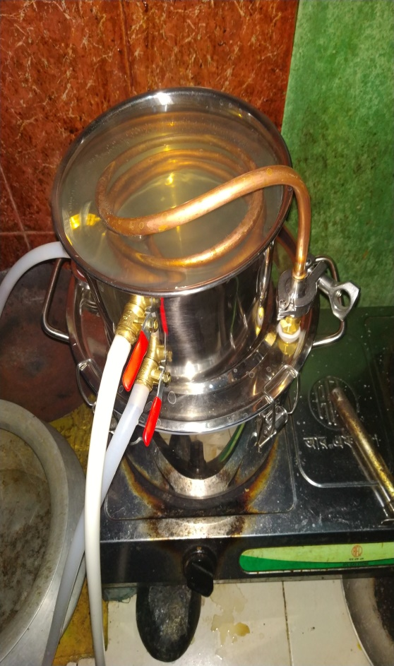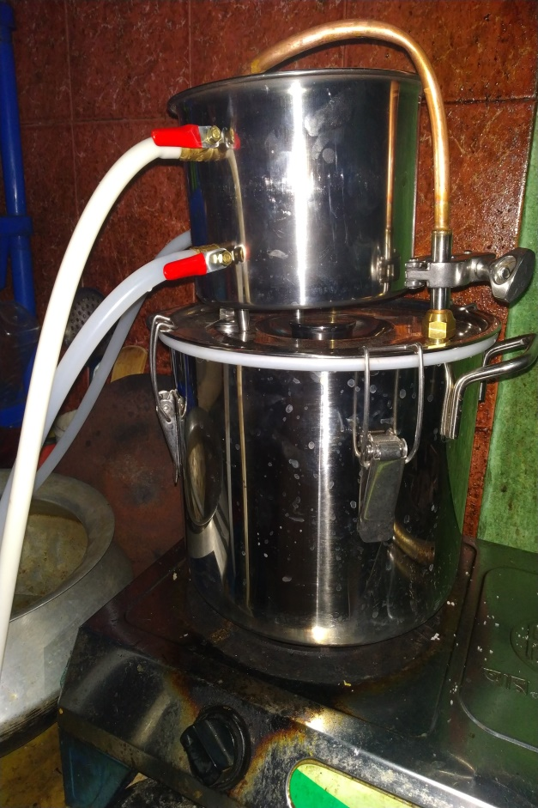
Fig 3: Essential oil distillation
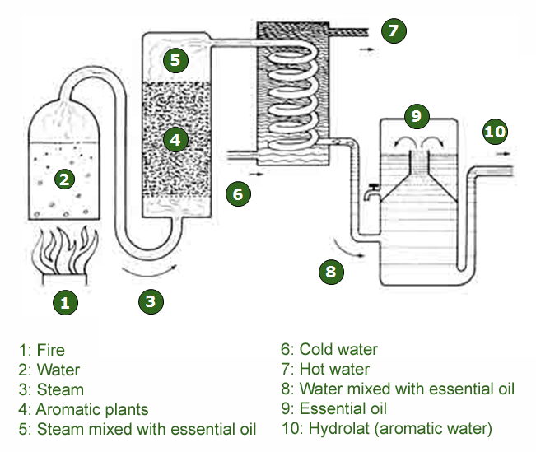
Figure 4: Steam distillation process
3.4 Design of the experiment
Ninety six chicks were divided randomly into four dietary treatment groups consisting
3 replications having 6 birds in a completely randomized design for 28 days.
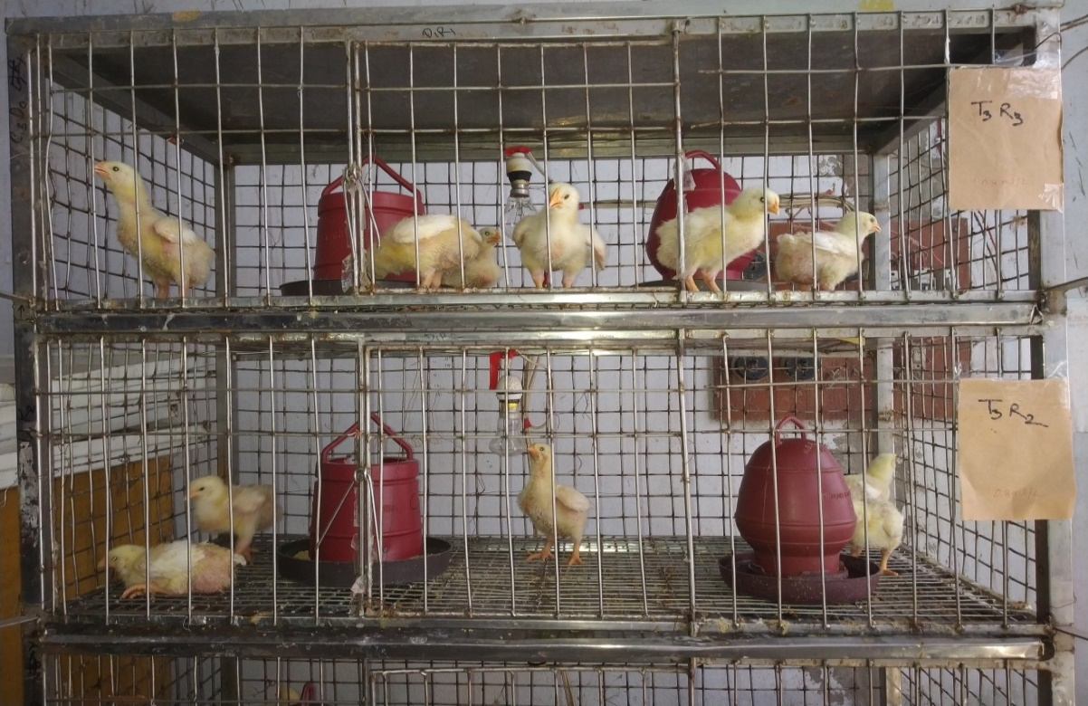
Figure`5: Dividing the chicks into different dietary treatment groups
T₀ = Control (Normal water), T₁: Antibiotic (Normal water + Renaquine), T₂: Eucalyptus essential oil (Water + 0.4 ml oil/L) and T₃: Eucalyptus essential oil (Water + 0.8ml oil/L)
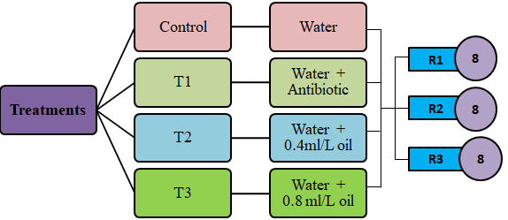
Figure 6: Design of the experiment
3.5 Animals and housing
Ninety six day old unsexed broiler chicks of Ross 308® were purchased from Progressive Hatcheries Limited, address Chattogram, Bangladesh. All the chicks were examined for abnormalities and uniform size. Average body weight of the chicks was 40.74±0.26 g. The experimental shed was brick cemented with corrugated metal wiring. Floor space for each bird was 0.17 square feet in brooding box and 0.75 square feet in the cage. The cages were further divided into 12 pens. The pens were selected in an unbiased way for uniform distribution of chicks. The chicks were brooded for two weeks. Each pen was allocated for 6 birds. Dry and clean newspaper was placed in the brooding box and changed for every 6 hours. Room temperature and humidity was maintained using 40 watt incandescent lamps and ceiling fans. The birds were exposed to continuous lighting. During brooding period, chicks were brooded at a temperature of 95 °F, 90 °F, 85 °F and 80 °F for the 1st, 2nd, 3rd and 4th weeks, respectively with the help of incandescent bulbs. Temperatures were measured by using thermometer.
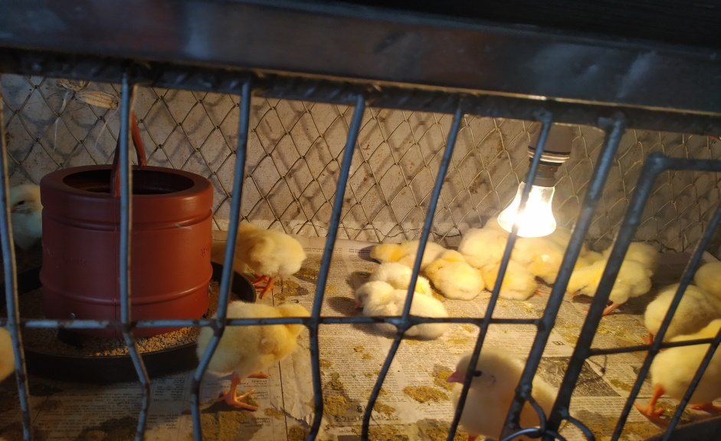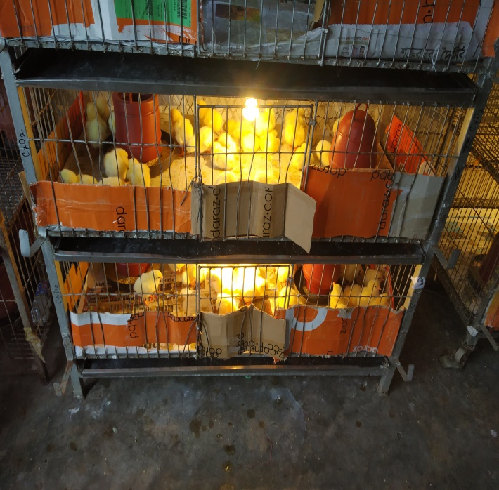
Figure 7: Temperature and humidity maintain during Brooding period

3.6 Cleaning and sanitation
The shed was thoroughly cleaned and washed by using tap water with caustic soda. For disinfection, phenyl solution (1% v/v) was sprayed on the floor, corners and ceiling. Following spray, cleaning was done by using brush and clean water. Brooding boxes, rearing cages and pens were cleaned in the same manner. After cleaning and disinfection, the house was left one week for proper drying. After drying, all doors and windows were closed. The room was fumigated (Adding 35 ml of formalin to 10 g potassium permanganate per cubic meter) and sealed for 24 hours. On the next day, lime was spread on the floor and around the shed. Footbath containing potassium permanganate (1% w/v) was kept at the entrance of the poultry shed and changed daily. Feeders were cleaned and washed with Temsen® solution (0.3% v/v) weekly before being used further. Drinkers were washed with potassium permanganate (1% w/v) and dried up daily in the morning.

3.7 Diets
Feed ingredients were purchased from Pahartali market, Chattogram, Bangladesh. During purchase, cleanliness and date of expiry were checked. Five different types of rations were formulated. Each ration had two different types i.e., starter (0 to 14 days) and finisher (15 to 28 days). All rations were iso-caloric and iso-nitrogenous. The composition of different feed ingredients and nutritive value of starter and grower rations are given in Table 3 and Table 4

Table 3. Ingredients names with their chemical composition of the broiler starter ration (1-14 days)
Ingredients  (as percent feed basis) | T₀ | T₁ | T₂ | T₃ | T₄
Maize | 59.50 | 59.25 | 59.00 | 59.25 | 59.00
Rice polish | 1.50 | 1.25 | 1.00 | 1.25 | 1.00
Soya bean meal | 33.20 | 33.20 | 33.20 | 33.20 | 33.20
Vegetable oil | 2.25 | 2.25 | 2.25 | 2.25 | 2.25
Supplement | 0.00 | 0.50 | 1.00 | 0.50 | 1.00
Molasses | 0.30 | 0.30 | 0.30 | 0.30 | 0.30
Limestone | 1.50 | 1.50 | 1.50 | 1.50 | 1.50
Vit-min premix¹ | 0.20 | 0.20 | 0.20 | 0.20 | 0.20
Common salt | 0.25 | 0.25 | 0.25 | 0.25 | 0.25
DCP² | 1.00 | 1.00 | 1.00 | 1.00 | 1.00
DL-Methionine³ | 0.25 | 0.25 | 0.25 | 0.25 | 0.25
L-Lysine⁴ | 0.02 | 0.02 | 0.02 | 0.02 | 0.02
Toxin binder⁵ | 0.03 | 0.03 | 0.03 | 0.03 | 0.03
Total | 100.00 | 100.00 | 100.00 | 100.00 | 100.0
Estimated chemical composition
Met. Energy⁶(kcal/kg) | 2965.82 | 2965.75 | 2965.13 | 2966.23 | 2966.30
Crude protein (%) | 20.65 | 20.63 | 20.63 | 20.68 | 20.70
Crude fiber (%) | 3.90 | 4.10 | 4.50 | 4.00 | 4.40
Calcium (%) | 0.94 | 0.98 | 1.00 | 1.10 | 1.30
Phosphorus (%) | 0.75 | 0.65 | 0.60 | 0.80 | 0.84
Lysine (%) | 1.20 | 1.14 | 1.17 | 1.17 | 1.60
Methionine (%) | 0.54 | 0.57 | 0.60 | 0.65 | 0.67
Cysteine and Methionine (%) | 0.74 | 0.75 | 0.73 | 0.70 | 0.67
Tryptophan(%) | 0.25 | 0.23 | 0.22 | 0.32 | 0.29
¹Vitamin-mineral premix (Per kg vitamin mineral premix provided-Vitamin A 5000 IU, D3 1000 IU, K 1.6 mg, B1 1 mg, B2 2 mg, B3 16 mg, B6 1.6 mg, B9 320 μg, B12 4.8 μg, Cu 4 mg, Mn 40 mg, Zn 20 mg, Fe 2.4 mg, I 160 μg); ²DCP (18% P, 23% Ca); ³DL-Methionine (Purity 99.0%); ⁴L-Lysine (Purity 99.0%); ⁵Toxin Binder (Purity 98%, all imported from Poland); ⁶Metabolizable energy (kcal/kg).
Table 4. Ingredients names with chemical composition of the broiler grower ration (15-28 days)
Ingredients (as percent feed basis) | T₀ | T₁ | T₂ | T₃ | T₄
Maize | 60.10 | 59.95 | 59.60 | 59.95 | 59.60
Rice polish | 1.85 | 1.60 | 1.35 | 1.60 | 1.35
Soya bean meal | 31.00 | 31.00 | 31.00 | 31.00 | 31.00
Vegetable oil | 3.50 | 3.50 | 3.50 | 3.50 | 3.50
Supplement | 0.00 | 0.50 | 1.00 | 0.50 | 1.00
Molasses | 0.30 | 0.30 | 0.30 | 0.30 | 0.30
Limestone | 1.50 | 1.50 | 1.50 | 1.50 | 1.50
Vit-min premix¹ | 0.20 | 0.20 | 0.20 | 0.20 | 0.20
Common salt | 0.25 | 0.25 | 0.25 | 0.25 | 0.25
DCP² | 1.00 | 1.00 | 1.00 | 1.00 | 1.00
DL-Methionine³ | 0.25 | 0.25 | 0.25 | 0.25 | 0.25
L-Lysine⁴ | 0.02 | 0.02 | 0.02 | 0.02 | 0.02
Toxin binder⁵ | 0.03 | 0.03 | 0.03 | 0.03 | 0.03
Total | 100 | 100 | 100 | 100 | 100
Estimated chemical composition
Met. Energy⁶(kcal/kg) | 3057.9 | 3057 | 30.57.5 | 3057.75 | 3058
Crude protein (%) | 19.75 | 19.59 | 19.45 | 19.74 | 19.78
Crude fiber (%) | 6.17 | 6.22 | 6.25 | 6.21 | 6.23
Calcium (%) | 0.94 | 0.92 | 0.9 | 0.97 | 0.99
Phosphorus ( %) | 0.73 | 0.7 | 0.68 | 0.8 | 0.89
Lysine (%) | 1.05 | 1.04 | 1.02 | 1.25 | 1.35
Methionine (%) | 0.53 | 0.52 | 0.51 | 0.6 | 0.68
Cysteine and Methionine (%) | 0.74 | 0.73 | 0.72 | 0.67 | 0.64
Tryptophan (%) | 0.23 | 0.22 | 0.21 | 0.22 | 0.25
¹Vitamin-mineral premix (Per kg vitamin mineral premix provided-Vitamin A 5000 IU, D3 1000 IU, K 1.6 mg, B1 1 mg, B2 2 mg, B3 16 mg, B6 1.6 mg, B9 320 μg, B12 4.8 μg, Cu 4 mg, Mn 40 mg, Zn 20 mg, Fe 2.4 mg, I 160 μg); ²DCP (18% P, 23% Ca); ³DL-Methionine (Purity 99.0%); ⁴L-Lysine (Purity 99.0%); ⁵Toxin Binder (Purity 98%, all imported from Poland); ⁶Metabolizable energy (kcal/kg).

3.8 Experimental Water Preparation
Normal tape water is provided in all the treatment groups. Iso propeyl alcohol is added as an emulsifier to dissolve Eucalyptus essential oil into water where T0= Normal tape water, T1= Tape water + Antibiotic, T2= Tape water + 0.4% Eucalyptus essential oil, T3= Tape water + 0.8% Eucalyptus essential oil

3.9 Feeding of birds
Feed was prepared manually and supplied ad-libitum to the birds on round small feeder and waterer for 0-7 days. After 7th day, small round feeders and waterers were replaced by medium linear feeders (2.21 ft X 0.25 ft.) and round waterers. At 15th day, large linear feeder (3.5 ft. X 0.38 Ft.) and round waterers (3-liter capacity) were provided for feeding and drinking of the birds.
3.10 Medications
All birds were vaccinated against Newcastle disease (BCRDV live) and Infectious Bursal Disease on the 4th day followed by a booster dose on 14th day. After each vaccination, multivitamin (Rena-WS, Renata; 1g/ 5liter of drinking water) was supplied along with Vitamin-C to overcome the effect of stress due to vaccination and cold shock.
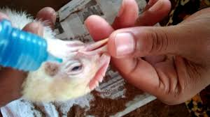
Figure 8: Vaccination of poultry

3.11 Carcass measurement
At the end of the 28 day trail, one bird was randomly selected from each replicate and killed by severing the jugular vein and carotid artery. Once a bird was adequately bleed out, it was scalded and feather was removed. After de-feathering, the birds were eviscerated and the head and feet were removed as per technique described by Jones (1984). During evisceration process, abdominal fat, liver, spleen and Versa were excised separately and weighed. Dressed birds were weighed to obtain a dressed carcass weight.
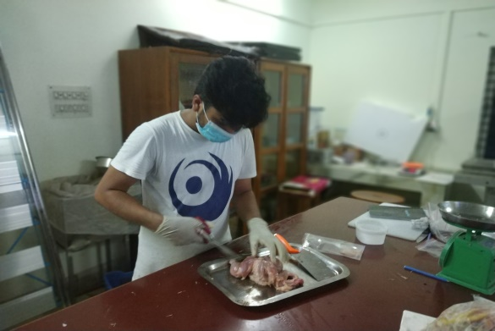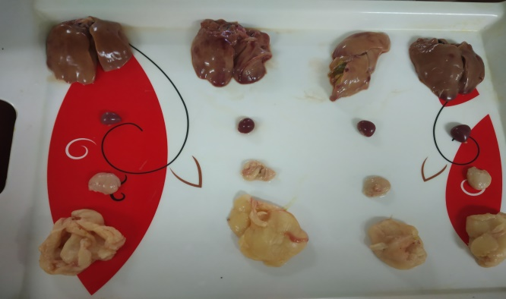
Figure 9: Collection of internal organs
3.12 Analysis of meat
After slaughter, 120 g of meat was collected in the air tight bag from each carcass for estimation of the chemical composition of meat. Meat samples were kept at 5°C in air tight bag. After that, chemical analyses of the meat samples were carried out in triplicate for dry matter (DM), crude protein (CP), crude fiber (CF), ether extracts (EE) and total ash (TA) in the animal nutrition laboratory, Chattogram Veterinary and Animal Sciences University, Chattogram as per AOAC (2006).
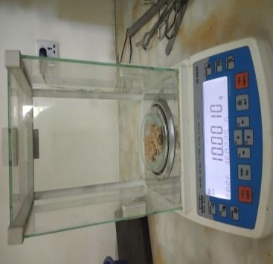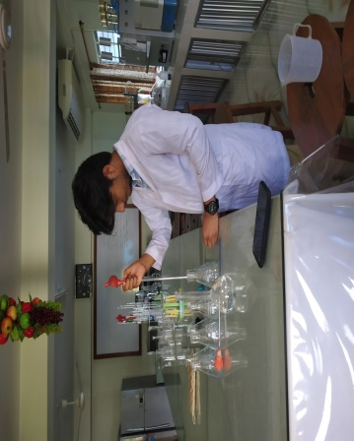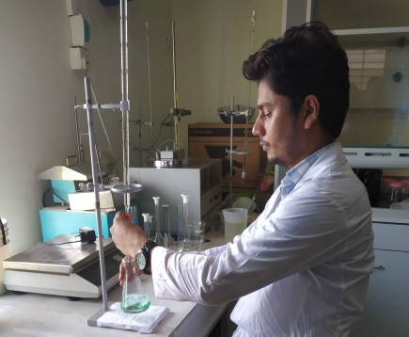
Figure 10: Meat sample analysis

3.13 Hematological analysis
Blood samples were collected from the brachial vein of four birds from each group (Two birds from each replicate) using a 3 ml sterile syringe and a 23-gauge needle. Each blood sample was transferred immediately into a sterile tube containing the anticoagulant, ethylene diamine tetra acetic acid and 5ml blood was kept without anticoagulant. Blood was collected without anticoagulant from a total of four birds from each group at 28th days of age. Clotted blood in the vacutainer tube was centrifuged at 3000 rpm for 20 minutes and prepared serum was collected into the ependroff tube by micropipette. Sera samples were marked and stored in -20°C until being analyzed for LDL, HDL, total cholesterol and triglyceride. Randox® veterinary reagent kits were used for determination of the blood parameter of interest. Serum sample was mixed with the respective reagents in an ependroff tube. The serum with reagent was aspired by spectrophoto-metric method which measured the target parameter and immediately the printed result was recorded.
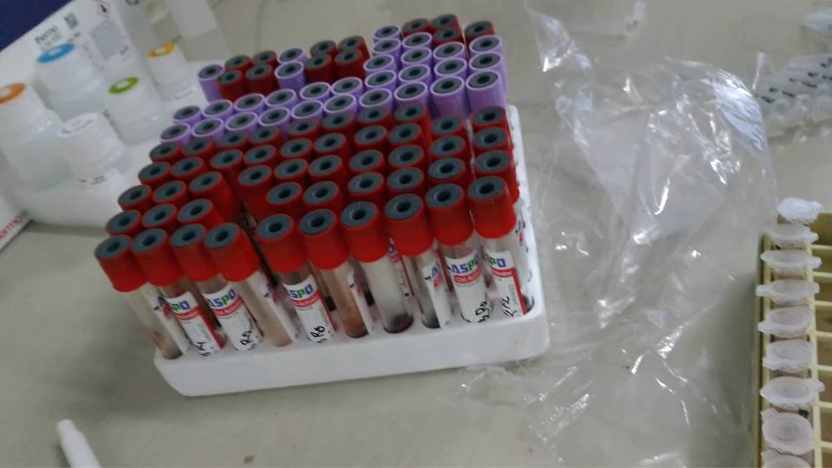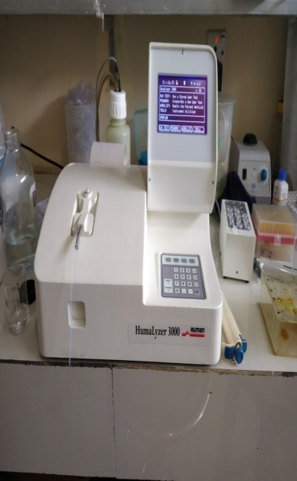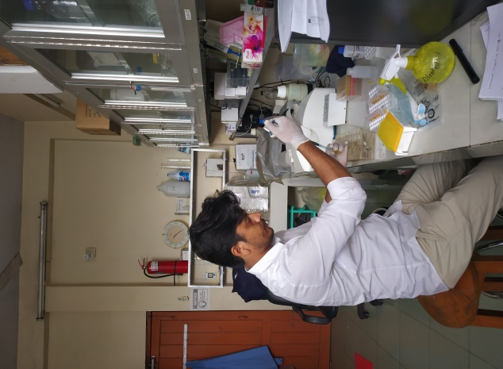
Figure 11: Hematological analysis

3.14 Data collection
Weight gain, feed intake and FCR were recorded at weekly intervals. Carcass characteristics, hematological and biochemical parameters were recorded at 4th week. Weight gain was calculated by deducting initial body weight from the final body weight of the birds. Feed intake was calculated by deducting leftover from the total amounts of feed supplied to the birds. FCR was calculated dividing feed intake by the weight gain.
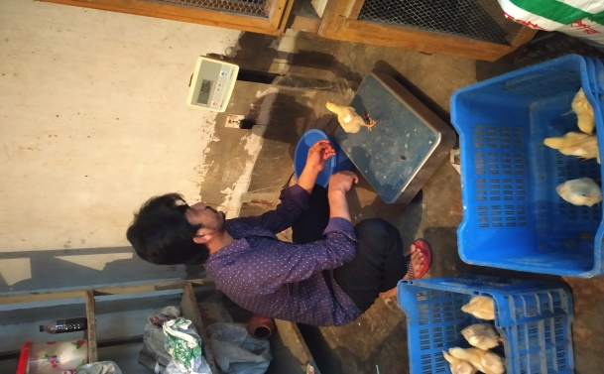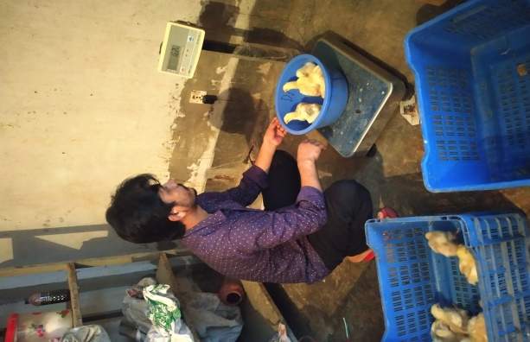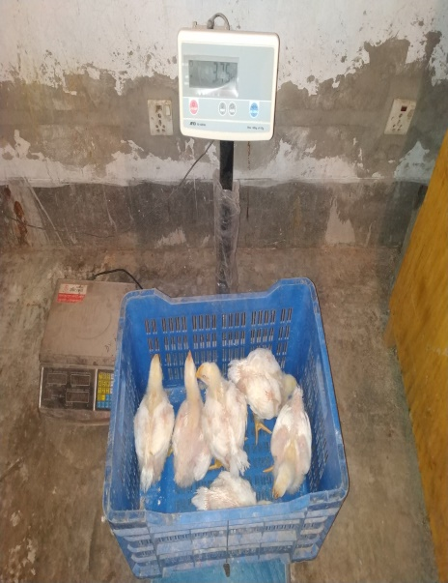
Fig 12: Weight recording
3.15 Data analysis
Data were compiled in MS Excel. Raw data related to weight gain, feed intake, FCR, carcass characteristics, hematological and biochemical parameters were tested for normality by using normal probability plot and analyzed for ANOVA by using SAS (2009). Means showing significant differences were compared by Duncan’s Multiple Range Test (Duncan, 1955). Statistical significance was accepted at p<0.05 for F-tests.

Chapter-IV
Results
The objective of the conducted study was to observe and interpret effects of Eucalyptus essential oil by observing growth performance, carcass characteristics and biochemical parameters of Ross-308 broilers.
4.1 Growth performance
Growth performance of the experimental broiler which include average daily gain (ADG), average daily feed intake (ADFI) and FCR are shown in the table 6.

4.1.1 Average daily gain (ADG)
No significant variation was observed in ADG for T₂ and T₃ during 1st, 2nd and 3rd week (P>0.05) compared to control. A significant increase in ADG was found during 2nd and 4th week (P<0.05) compared to control and treatment groups. Highest ADG was found in antibiotic supplemented group during 2nd, 3rd and 4th week of age. At fourth week, significant difference (P<0.05) observed between the treatment groups where T₁ showed the best performance while T₃ is the worst (Table 6).
4.1.2 Average daily feed intake (ADFI)
Tables 6 represent the average daily feed intake for different treatment groups of this experiment. Average daily feed intake significantly differed among the treatment, antibiotic and control group (P<0.05). During 1st and 2nd week, T₁ has the highest ADFI while T₂ and T₃ has the lowest (P<0.05). In 3rd week, T₀ and T₁ have the higest feed intake while T₂ and T₃ have the lowest (P<0.05). During 4th week, T₁ treatment group have the highest feed intake and T₃ treatment group stand for the lowest (P<0.05).
4.1.3 Feed conversion ratio (FCR)
The feed conversion ratio during 1st and 2nd week reduced significantly (P<0.05) in T₂ and T₃ treatment groups while it was found higher for T₁ group. At 3rd and 4th week, T₁ showed the highest FCR value while T₃ group has the lowest (P<0.05).

Table 6. Effects of eucalyptus essential oil on growth performance in broiler
Age of birds | Parameters | Treatments |  |  |  | P-Value
 |  | T₀  (Mean± SE) | T₁  (Mean± SE) | T₂  (Mean± SE) | T₃  (Mean± SE)
1st week | Initial wt (g/b) | 55.06 ± 0.06 | 55.06 ± 0.06 | 55.00± 0 | 55.11±0.06 | 0.49
 | Final wt (g/b) | 233.89± 0.56 | 233.33 ± 0.96 | 231.11± 1.11 | 230.56± 0.56 | 0.0565
 | ADG(g/b/d) | 25.55± 0.08 | 25.47± 0.13 | 25.16± 0.16 | 25.07± 0.09 | 0.06
 | ADFI(g/b/d) | 33.5 5^{b} ± 0.38 | 35.32ª± 0.33 | 30.867^{c}± 0.50 | 30.41^{c}± 0.23 | <0.0001
 | FCR | 1.31^{b}± 0.01 | 1.39ª± 0.01 | 1.23^{c}± 0.01 | 1.21^{c}± 0.01 | <0.0001
2nd week | Initial wt (g/b) | 233.89 ± 0.56 | 233.33± 0.96 | 231.11 ± 1.11 | 230.56 ± 0.56 | 0.06
 | Final wt (g/b) | 598.89ª± 8.41 | 606.67^{ab}±11.55 | 572.78^{bc}± 7.22 | 569.44^{c}± 5.30 | 0.03
 | ADG(g/b/d) | 52.14^{ab}± 1.22 | 53.33ª ±1.58 | 48.81^{b}± 0.96 | 48.41^{b}± 0.76 | 0.04
 | ADFI(g/b/d) | 70.43^{b}± 2.42 | 76.42ª± 1.81 | 61.33^{c}± 1.24 | 59.87^{c}± 0.96 | 0.0004
 | FCR | 1.35^{b}± 0.02 | 1.43ª± 0.01 | 1.26^{c} ± 0.01 | 1.24^{c} ± 0.01 | <0.0001
3rd week | Initial wt (g/b) | 598.89^{ab} ± 8.41 | 606.67ª ± 11.55 | 572.78^{bc} ± 7.22 | 569.44^{c} ± 5.30 | 0.03
 | Final wt (g/b) | 917.22 ± 22.22 | 919.45 ± 4.01 | 876.11 ± 8.41 | 875.00 ± 0.96 | 0.05
 | ADG(g/b/d) | 45.48 ± 2.05 | 44.68 ±1.11 | 43.34± 0.36 | 43.65 ± 0.84 | 0.6261
 | ADFI(g/b/d) | 63.54 ± 3.18 | 64.67 ± 2.25 | 54.02 ± 0.23 | 52.66 ± 0.83 | 0.005
 | FCR | 1.40^{b} ± 0.01 | 1.45ª ± 0.01 | 1.25^{c} ± 0.01 | 1.21^{d} ± 0.01 | <0.0001
4th week | Initial wt (g/b) | 917.22 ± 22.22 | 919.44 ± 4.01 | 876.11 ± 8.41 | 875.00 ± 0.96 | 0.05
 | Final wt (g/b) | 1297.22ª ± 6.96 | 1330.55ª ± 12.99 | 1223.33^{b} ± 15.12 | 1176.66^{c} ± 10.13 | <.0001
 | ADG(g/b/d) | 54.28^{ab} ± 2.74 | 58.73ª ± 1.79 | 49.60^{b} ± 0.96 | 43.10^{c} ± 1.39 | 0.002
 | ADFI(g/b/d) | 76.33^{b} ± 3.53 | 87.88ª ± 2.43 | 62.83^{c} ± 1.09 | 52.88^{d} ± 2.01 | <.0001
 | FCR | 1.40^{b} ± 0.01 | 1.50ª ± 0.01 | 1.27^{c}± 0.003 | 1.23^{d} ± 0.01 | <.0001
^{abc} Different superscipt in the same row indicate significant variation among treatments (P<0.05).
Each data indicates means of three replications consisting of six birds per replication (n=18)
T₀= Control (basal diet);T1=Antibiotics (basal diet+ 0.1% amoxiciline in drinking water);T2= Essential oil (basal diet+ 0.4ml/L eucalyptus oil in drinking water);T3=Essential oil (basal diet+ 0.8ml/L eucalyptus oil in drinking water).
SE= Standard error

4.2 Blood serum parameters
Different serum parameters estimated have been presented in table 7. A significant reduction (P<0.05) of LDL value was found in treatment T₃ group while it was statistically non-significant for other treatment groups (P>0.05). HDL value was found higher in all three treatment groups except control (P<0.05). In case of total cholesterol T2 group shows the highest value, whereas T1 group showed the highest triglyceride level among treatment groups (P<0.05).
Table 7. Effects of eucalyptus essential oil on blood serum parameters in broiler.
Parameters | Treatments |  |  |  | P- Value
 | T₀  (Mean± SE) | T₁  (Mean± SE) | T₂  (Mean± SE) | T₃  (Mean± SE)
LDL(mg/dl) | 78.20ª ± 1.85 | 71.20ª ± 0.72 | 79.43ª ± 2.65 | 45.50^{b} ± 6.16 | 0.0004
HDL(mg/dl) | 44.77^{b} ± 0.91 | 57.87ª ± 5.19 | 65.00ª ± 2.12 | 70.10ª ± 4.53 | 0.0058
Total cholesterol(mg/dl) | 123.03^{b} ± 2.64 | 129.07^{b} ± 5.64 | 144.43ª ± 4.77 | 115.60^{b} ±1.85 | 0.0057
Triglyceride(mg/dl) | 26.77^{b} ± 2.92 | 82.33ª ± 17.93 | 62.83ª ± 1.01 | 17.10^{b} ± 1.32 | 0.0031
^{ab} Different superscipt in the same row indicate significant variation among treatments (P<0.05).
Each data indicates means of three replications consisting of two birds per replication (n=6)
T₀= Control (basal diet);T1=Antibiotics (basal diet+ 0.1% amoxiciline in drinking water);T2= Essential oil (basal diet+ 0.4ml/L eucalyptus oil in drinking water);T3=Essential oil (basal diet+ 0.8ml/L eucalyptus oil in drinking water).
SE= Standard error

4.3 Chemical Composition of meat
Value of moisture, ether extract (EE), crude protein (CP) and ashes have been estimated from the lab tests of carcass of different treatment groups. The biochemical lab tests indicated that T₃ treatment group showed the lower moisture content (P<0.05). While higher CP was obtained from T₁ and T₀ (P<0.05). An increased EE and ash value were obtained in T₀ treatment group (P<0.05).
Table 8. Effects of eucalyptus essential oil on meat proximate components in broiler
Parameters | Treatments |  |  |  | P- Value
 | T₀  (Mean± SE) | T₁  (Mean± SE) | T₂  (Mean± SE) | T₃  (Mean± SE)
DM (%) | 24.93ª ± 1.33 | 24.66^{ab} ± 0.34 | 23.77^{c} ± 0.067 | 24.07^{bc} ± 0.15 | 0.0113
Moisture (%) | 75.07^{ab} ± 0.13 | 75.33ª ± 0.34 | 76.23ª ± 0.067 | 72.57^{b} ± 1.57 | 0.5808
CP (%) | 26.19ª ± 0.16 | 26.66ª ± 0.12 | 24.74^{b} ± 0.21 | 24.27^{b} ± 0.21 | < 0.0001
EE (%) | 2.20ª ± 0.15 | 1.67^{ab} ±0.34 | 1.44^{b} ± 0.23 | 0.66^{c} ± 0.08 | 0.0078
Ash (%) | 1.38ª ± 0.03 | 1.28^{b} ± .03 | 1.34^{ab} ± 0.02 | 1.25^{b} ± 0.03 | 0.0664
^{abc} Different superscipt in the same row indicate significant variation among treatments (P<0.05).
Each data indicates means of three replications consisting of two birds per replication (n=6)
T₀= Control (basal diet);T1=Antibiotics (basal diet+ 0.1% amoxiciline in drinking water);T2= Essential oil (basal diet+ 0.4ml/L eucalyptus oil in drinking water);T3=Essential oil (basal diet+ 0.8ml/L eucalyptus oil in drinking water).
SE= Standard error

4.4 Carcass Characteristics
Different carcass characteristics have been presented in table 9. Comparative weights of different treatment groups among the carcass component (meat) and weights of different organs have been sequentially described. There is no significant difference in live weights, liver, bursa and abdominal fat. Though T₃ showed the best dressed weight while T₀ have found the lowest (P>0.05). In case of spleen weight T₀ showed the higher value (P>0.05).

Table 9. Effects of eucalyptus essential oil on carcass characteristics and relative organs weight in broiler

Parameters | Treatments |  |  |  | P- Value
 | T₀  (Mean± SE) | T₁  (Mean± SE) | T₂  (Mean± SE) | T₃  (Mean± SE)
Live Wt (%) | 1303.33 ± 82.12 | 1350 ± 70.00 | 1330 ± 10.00 | 1156.67 ± 94.93 | 0.2914
Dress (%) | 55.03^{c} ± 0.43 | 58.56^{b} ± 0.51 | 58.89^{b} ± 0.49 | 61.20ª ± 0.33 | 0.2281
Liver (%) | 2.56 ± 0.29 | 2.74 ± 0.17 | 2.61 ± 0.15 | 2.78 ± 0.26 | 0.8895
Spleen (%) | 0.17ª ± 0.03 | 0.12^{ab} ± 0.01 | 0.10^{b} ± 0.01 | 0.10^{b} ± 0.01 | 0.0698
Bursa (%) | 0.19± 0.04 | 0.24 ± 0.02 | 0.19 ± 0.05 | 0.14 ± 0.003 | 0.2585
Abdominal fat (%) | 1.78 ± 0.11 | 1.36 ± 0.31 | 1.72 ± 0.17 | 1.29 ± 0.08 | 0.2414
^{ab} Different superscipt in the same row indicate significant variation among treatments (P<0.05).
Each data indicates means of three replications consisting of six birds per replication (n=18)
T₀= Control (basal diet); T1=Antibiotics (basal diet+ 0.1% amoxiciline in drinking water); T2= Essential oil (basal diet+ 0.4ml/L eucalyptus oil in drinking water); T3=Essential oil (basal diet+ 0.8ml/L eucalyptus oil in drinking water).
SE= Standard error
4.5 Mortality
Mortality of bird are shown in the following bar diagrum. From the diagrum it is clear that mortality of T₀ treatment group is higher then any other group . lowest mortality is observed in the T₃ treatment group where T₃ is treated with 0.8ml/L eucalyptus oil in drinking water.

Figure 13: Mortality of bird
Table 10. Effects of eucalyptus essential oil on Cost-benefit analysis in broilers (BDT=Bangladeshi taka)
Parameter/bird | Treatments
 | T₀ | T₁ | T₂ | T₃
Live weight (kg) | 1.27 | 1.33 | 1.22 | 1.17
Selling price (BDT) | 165.00 | 172.00 | 160.00 | 150.00
Total feed intake (kg) | 1.70 | 1.80 | 1.50 | 1.40
Total Feed cost (BDT) | 71.50 | 75.60 | 63.00 | 58.80
Dug cost (antibiotic) | 0.00 | 13.8 | 0.00 | 0.00
EO cost (BDT) | 0.00 | 0.00 | 5.00 | 10.00
Other cost (BDT)¹ | 50.00 | 50.00 | 50.00 | 50.00
Total cost (BDT) | 121.50 | 139.40 | 118.00 | 118.00
Net profit (BDT) | 43.50 | 32.60 | 42.00 | 32.00
Net profit /kg (BDT) | 34.25 | 24.06 | 34.42 | 27.35
¹Other costs including chick cost, vaccination and transportation cost.

Chapter-V
Discussion
Effects on performance of different probiotics and dry leaves treated chicks have been discussed during these 28 days of feed trial under this chapter. Weight gain, feed intake, feed conversion ratio, serological parameters, biochemical changes and carcass characteristics has been given more emphasis.
5.1 Average daily gain (ADG)
Current study has revealed that treatment with E. globulus EO decreases Average daily gain (ADG) comparing the control group. Current study partially agrees with the research conducted by Farhadi et al. (2016) where dietary supplementation of eucalyptus leaf powder decreased BWG during 7-28 days of age, but dietary addition of Eucalyptus EO had no effect on BWG.
But this is directly opposite to the result found by Ibrahim et al. (2018). A study conducted by Ibrahim et al. (2018) showed that weight gain increases with the increase of Eucalyptus oil concentration actually they have found best result when they treated with 600 mg/kg of feed compared to control group but unfortunately this result does not agree with the result of current study. May be direct consumption of eucalyptus oil with water have negative effect on weight gain. Lower weight gain may be due to lower feed intake in the treatment group. During the study T₁ treatment group which is treated with antibiotic have the highest weight gain because antibiotics used at sub therapeutic doses also the use of antimicrobial growth promoters have been found beneficial for rapid growth performance in animal production level and prevention of disease occurrence (Barton et al., 2000; Snel et al., 2002).
5.2 Average daily feed intake (ADFI)
In present study, gradual decrease in feed intake has been observed actually T₃ treatment group have the lowest figure compared to control group. After 4th week T₁ treatment group has the highest feed intake unfortunately this result does not fully agree with Farhadi et al. (2016). Farhadi et al. (2016) found no effect on feed intake due to Eucalyptus EO supplementation but broilers receiving 3,000 mg/kg ELP in their diet had lower FI during 7-28 days of age.
Antibiotic treated group showed highest feed intake, this may because antibiotics used at sub therapeutic doses also the use of antimicrobial growth promoters have been found beneficial for rapid growth performance in animal production level and prevention of disease occurrence (Barton et al., 2000; Snel et al., 2002).

5.3 Feed conversion ratio (FCR)
In the research conducted by Farhadi et al. (2016) where dietary supplementation of eucalyptus leaf powder and Eucalyptus EO have no effect on FCR during 7-28 days of age but in our research we found that dietary addition of Eucalyptus EO had better impact on FCR.
T₃ treatment group which is treated with Eucalyptus essential oil (Water + 0.8ml oil/L) showed the best performance in FCR this is because dietary essential oils can improve digestion (Anonymous, 1997; Mellor, 2000 a,b). It might be reasoned that spices and herbs, from which essential oils are derived, have been shown to positively affect food digestion (Pradeep et al., 1991; Pradeep and Geervani, 1994). A number of studies have reported the effect of spices or their active components on bile salt secretion (Bhat and Chandrasekhara, 1987; Bhat et al., 1984, 1985; Sambaiah and Srinivasan, 1991).
5.4 Blood serum parameters
Estimation of serum parameters in the current study shows that there are significant changes in serum parameters among the various treatment groups. HDL concentration is found higher in Water + 0.8ml oil/L treated groups while found lower value in control group. In case, LDL, it’s higher in control groups and found lower in Water + 0.8ml oil/L treated group. Total cholesterol is also found higher in control groups and lowest value was found in Water + 0.8ml oil/L treated group. It might be due to synergistic effects of phytochemicals. Decreased level of LDL and Total cholesterol components in treatment groups makes the efficacy of essential oil treated groups while the increased level of HDL components also validate the efficacy of same treatment groups on serological components (Yang et al., 2009) .

5.5 Chemical Composition of meat
Chemical estimation of the meat composition shows that moisture components is less in Water + 0.8ml oil/L treated group that of the other treatment groups while Crude protein percentage is higher in T₀ and T₁ while EE and Ashes are both higher in the T₀ group.
5.6 Carcass Characteristics
Carcass characteristics show that, weight percentage has no significant difference among the treatment groups but dressing percentage is higher in T₃ treatment group. No significant weight difference is found in internal organ which is similar to the result found by (Ibrahim et al., 2018).
5.7 Mortality
Mortality rate shows that mortality of bird is higher in T₀ treatment group where no antibiotic or essential oil were added. In case of antibiotic it stands 2nd in position in terms of mortality. Best result was found in T₃ treatment group where it was treated with eucalyptus essential oil (0.8ml oil/L) but (Farhadi et al., 2016) concluded that there is no influence on mortality by the dietary supplementation of Eucalyptus EO.
Mortality may be reduced because essential oils have the ability to possess antimicrobial, anti-inﬂammatory and antioxidative activities, (Kim et al., 2008; Brenes and Roura, 2010).

Chapter-VI
Conclusion
The study investigated the effects of Eucalyptus essential oil supplementation on the performance parameters, carcass characteristics and blood parameters in commercial broiler under intensive rearing system. Highest weight gain was observed in birds fed with antibiotic supplement. Optimum feed intake and better FCR were observed in birds fed with Water + 0.8ml oil/L supplement. There were drastically changes in the serum parameters in comparison with the reference level especially in LDL, HDL, Total cholesterol. There is no significant change in weight gain but dressing percentage is higher in birds fed with Water + 0.8ml oil/L supplement. But a significant decrease in mortality was observed. However, a long term investigation with larger sample size and multi-dimensional temporal pattern is suggested for increasing sensitivity and validity of the study under field condition.

Chapter-VII
Recommendations
Eucalyptus globulus essential oil has shown negative effect on growth performance of the broiler so right now Eucalyptus globulus essential oil cannot be recommended as a diet supplement of broiler. More research is required to use it as an effective supplement for broiler. But if we want to produce low fat meat Eucalyptus globulus essential oil can be used but the long term effect of supplementation on productive performance of broilers should be investigated in future.
Due to some unavoidable constraints and technical limitations, some vital blood parameters like glucose, calcium, phosphorus and other trace minerals both in meat and blood were not analyzed. These parameters could have vital impact on human health and will explore new horizon for investigating those parameters as future study.

References
Alçiçek A, Bozkurt M, Çabuk M. 2003. The effect of an essential oil combination derived from selected herbs growing wild in Turkey on broiler performance. South African Journal of Animal Science.33(2):89-94.
Alçiçek A, Bozkurt M, Çabuk M. 2004. The effect of a mixture of herbal essential oils, an organic acid or a probiotic on broiler performance. South African Journal of Animal Science. 34(4):217-222.
Amakura Y, Umino Y, Tsuji S, Ito H, Hatano T, Yoshida T, Tonogai Y. 2002 . Constituents and their antioxidative effects in eucalyptus leaf extract used as a natural food additive. Food Chemistry.77(1):47-56.
Anonymous. 1998. Feed additives: the added value to feed. NEFATO Vereniging van Netherlandse Fabrikanten van Voedertoevoegingen. Aalsmeer.
Applegate TJ, Klose V, Steiner T, Ganner A, Schatzmayr G. 2010. Probiotics and phytogenics for poultry: myth or reality?. Journal of Applied Poultry Research. 19(2):194-210.
Awaad MH, Abdel-Alim GA, Sayed KS, Ahmed A, Nada AA, Metwalli AS, Alkhalaf AN. 2010. Immunostimulant effects of essential oils of peppermint and eucalyptus in chickens. Pakistan Veterinary Journal. 30(2).
Bakkali F, Averbeck S, Averbeck D, Idaomar M. 2008. Biological effects of essential oils–a review. Food and chemical toxicology. 46(2):446-75.
Barton MD. 2000. Antibiotic use in animal feed and its impact on human health. Nutrition research reviews. 13(2): 279-299.
Batish DR, Singh HP, Kohli RK, Kaur S. 2008. Eucalyptus essential oil as a natural pesticide. Forest Ecology and Management. 256(12):2166-74.
Bedford M, Cowieson A. 2012. Exogenous enzymes and their effects on intestinal microbiology. Anim Feed Sci Technol. 173(1):7685.
Bedford M. (2000). Removal of antibiotic growth promoters from poultry diets: implications and strategies to minimise subsequent problems. World's Poultry Science Journal. 56(4): 347-365.
Bengtsson B, Wierup M. 2006. Antimicrobial resistance in Scandinavia after a ban of antimicrobial growth promoters. Animal biotechnology. 17(2): 147-156.
Bhat BG and Chandrasekhara N. 1987. Effect of black pepper and piperine on bile secretion and composition in rats. Nahrung 31: 913-916.
Bhat BG, Sambaiah K, and Chandrasekhara N. 1985. The effect of feeding fenugreek and ginger on bile composition in the albino rat. Nutritional Reports International 32: 1145-1151.
Bhat BG, Srinivasan MR and Chandrasekhara N. 1984. Influence of curcumin and capsaicin on the composition and secretion of bile in rats. Journal of Food Science and Technology 21: 225-227.
Bolukbasi SC, Erhan MK. 2007. Effect of dietary thyme (Thymus vulgaris) on laying hens performance and Escherichia coli (E. coli) concentration in feces.
Boyen F, Haesebrouck F, Vanparys A, Volf J, Mahu M, Van Immerseel F, Rychlik I, Dewulf J, Ducatelle R, Pasmans F. 2008. Coated fatty acids alter virulence properties of Salmonella Typhimurium and decrease intestinal colonization of pigs. Veterinary microbiology 132(3-4): 319-327.
Brenes A, Roura E. 2010. Essential oils in poultry nutrition: Main effects and modes of action. Animal Feed Science and Technology. 158(1-2):1-4.
Brenes A. and Roura E. 2010. Essential oils in poultry nutrition: Main effects and modes of action. Animal Feed Science and Technology. 158(1-2): 1-14.
Burt S. 2004. Essential oils: their antibacterial properties and potential applications in foods—a review. International journal of food microbiology. 94(3):223-53.
Chitprasert P, Sutaphanit P. 2014. Holy basil (Ocimum sanctum Linn) essential oil delivery to swine gastrointestinal tract using gelatin microcapsules coated with aluminum carboxymethyl cellulose and beeswax. Journal of agricultural and food chemistry. 62(52):12641-8.
Choi SC, Ingale SL, Kim JS, Park YK, Kwon IK. Chae BJ. 2013. An antimicrobial peptide-A3: effects on growth performance, nutrient retention, intestinal and faecal microflora and intestinal morphology of broilers. British poultry science. 54(6): 738-746.
Cimanga K, Kambu K, Tona L, Apers S, De Bruyne T, Hermans N, Totté J, Pieters L, Vlietinck AJ. 2002. Correlation between chemical composition and antibacterial activity of essential oils of some aromatic medicinal plants growing in the Democratic Republic of Congo. Journal of ethnopharmacology. 79(2):213-20.
Cowan MM. 1999. Plant products as antimicrobial agents. Clinical microbiology reviews. 12(4):564-82.
Craig WJ. 1999. Health-promoting properties of common herbs. The American journal of clinical nutrition. 70(3):491s-9s.
Craig WJ. 1999. Health-promoting properties of common herbs. The American journal of clinical nutrition. 70(3):491s-9s.
Cuppett SL, Hall CA. 1998. Antioxidant activity of the Labiatae. Advances in food and nutrition research. 42:245-72.
De Lange CFM, Pluske J, Gong J, Nyachoti CM. 2010. Strategic use of feed ingredients and feed additives to stimulate gut health and development in young pigs. Livestock Science. 134(1-3): 124-134.
Dorman HJ, Deans SG. 2000. Antimicrobial agents from plants: antibacterial activity of plant volatile oils. Journal of applied microbiology. 308-16.
Eckel B, Kirchgessner M, Roth FX. 1992. Influence of formic acid on daily weight gain, feed intake, feed conversion rate and digestibility, 1: investigations about the nutritive efficacy of organic acids in the rearing of piglets. Journal of Animal Physiology and Animal Nutrition (Germany, FR).
Faleiro ML, Miguel MG, Ladeiro F, Venancio F, Tavares R, Brito JC, Figueiredo AC, Barroso JG, Pedro LG. 2003. Antimicrobial activity of essential oils isolated from Portuguese endemic species of Thymus. Letters in applied microbiology. 36(1):35-40.
Farhadi D, Karimi A, Sadeghi G, Sheikhahmadi A, Habibian M, Raei A, Sobhani K. 2017. Effects of using eucalyptus (Eucalyptus globulus L.) leaf powder and its essential oil on growth performance and immune response of broiler chickens. Iranian journal of veterinary research. 18(1):60.
Franz C, Baser KH, Windisch W. 2010. Essential oils and aromatic plants in animal feeding–a European perspective. A review. Flavour and Fragrance Journal. 25(5):327-40.
Ghisalberti EL. 1996. Bioactive acylphloroglucinol derivatives from Eucalyptus species. Phytochemistry. 41(1):7-22.
Giannenas I, Papaneophytou CP, Tsalie E, Pappas I, Triantafillou E, Tontis D, Kontopidis GA. 2014. Dietary supplementation of benzoic acid and essential oil compounds affects buffering capacity of the feeds, performance of turkey poults and their antioxidant status, pH in the digestive tract, intestinal microbiota and morphology. Asian-Australasian journal of animal sciences. 27(2):225.
Gong J, Yin F, Hou Y, Yin Y. 2014. Chinese herbs as alternatives to antibiotics in feed for swine and poultry production: Potential and challenges in application. Canadian Journal of Animal Science 94(2): 223-241.
Halliwell B, Aeschbach R, Löliger J, Aruoma OI. 1995. The characterization of antioxidants. Food and Chemical Toxicology. 33(7):601-17.
Han YK, Hwang IH, Thacker PA. 2011. Use of a micro-encapsulated eucalyptus-medium chain fatty acid product as an alternative to zinc oxide and antibiotics for weaned pigs. Journal of Swine Health and Production. 19(1):34-43.
Heo JM, Opapeju FO, Pluske JR, Kim, JC, Hampson DJ, Nyachoti CM. 2013. Gastrointestinal health and function in weaned pigs: a review of feeding strategies to control post‐weaning diarrhoea without using in‐feed antimicrobial compounds. Journal of animal physiology and animal nutrition. 97(2): 207-237.
Heo JS, Park JW, Lee KW, Lee SK, Joh JW, Kim SJ, et al. 2004. Posttransplantation lymphoproliferative disorder in pediatric liver transplantation. Transpl Proc. 36(8): 23078.
Hirasa K, Takemasa M. 1998. Spice science and technology. New York Marcel Dekker pg. 220

Ibrahim ISSE, Mukhtar MA, Mohamed KA, 2018. Response of broiler chicks to different levels of eucalyptus essential oil. world journal of pharmacy and pharmaceutical sciences,Volume 7, Issue 4, 167-176
Jamroz D, Orda J, Kamel C, Wiliczkiewicz A, Wertelecki T, Skorupinska J. 2003. The influence of phytogenic extracts on performance, nutrient digestibility, carcass characteristics, and gut microbial status in broiler chickens. Journal of Animal and Feed Sciences. 12(3):583-96.
Jamroz D, Orda J, Kamel C, Wiliczkiewicz A, Wertelecki T, Skorupinska J. 2003. The influence of phytogenic extracts on performance, nutrient digestibility, carcass characteristics, and gut microbial status in broiler chickens. Journal of Animal and Feed Sciences. 12(3):583-96.
Jamroz D, Wertelecki T, Houszka M, Kamel C. 2006. Influence of diet type on the inclusion of plant origin active substances on morphological and histochemical characteristics of the stomach and jejunum walls in chicken. Journal of Animal Physiology and Animal Nutrition. 90(5‐6):255-68.
Jang IS, Ko YH, Yang HY, Ha JS, Kim JY, Kang SY, Yoo DH, Nam DS, Kim DH, Lee CY. 2004. Influence of essential oil components on growth performance and the functional activity of the pancreas and small intestine in broiler chickens. Asian-Australasian Journal of Animal Sciences. 17(3):394-400.
Kiarie E, Romero LF, Nyachoti CM. 2013. The role of added feed enzymes in promoting gut health in swine and poultry. Nutrition research reviews. 26(1): 71-88.
Kim SW, Fan MZ, Applegate TJ. 2008. Nonruminant nutrition symposium on natural phytobiotics for health of young animals and poultry: mechanisms and application. Journal of animal science, 86(suppl_14): E138-E139.
Kollanoor Johny A, Darre MJ, Donoghue AM, Donoghue DJ, Venkitanarayanan K. 2010. Antibacterial effect of trans-cinnamaldehyde, eugenol, carvacrol, and thymol on Salmonella Enteritidis and Campylobacter jejuni in chicken cecal contents in vitro. Journal of Applied Poultry Research. 19(3):237-44.
Kreydiyyeh SI, Usta J, Knio K, Markossian S, Dagher S. 2003. Aniseed oil increases glucose absorption and reduces urine output in the rat. Life sciences, 74(5): 663-673.
Kroismayr A, Sehm J, Pfaffl MW, Schedle K, Plitzner C, Windisch W. 2008. Effects of avilamycin and essential oils on mRNA expression of apoptotic and inflammatory markers and gut morphology of piglets. Czech J Anim Sci, 53(53): 377-387.
Kroismayr A, Steiner T, Zhang C. 2006. Influence of a phytogenic feed additive on performance of weaner piglets. journal of animal science (Vol. 84, pp. 270-270).
Lee KW, Everts H, Kappert HJ, Frehner M, Losa R, Beynen AC. 2003. Effects of dietary essential oil components on growth performance, digestive enzymes and lipid metabolism in female broiler chickens. British poultry science. 44(3):450-7.
Lee KW, Everts H, Kappert HJ, Van Der Kuilen J, Lemmens AG, Frehner M, Beynen AC. 2004. Growth performance, intestinal viscosity, fat digestibility and plasma cholesterol in broiler chickens fed a rye-containing diet without or with essential oil components. Int. J. Poult. Sci, 3(9): 613-618.
Li P, Piao X, Ru Y, Han X, Xue L, Zhang H. 2012. Effects of adding essential oil to the diet of weaned pigs on performance, nutrient utilization, immune response and intestinal health. Asian-Australasian journal of animal sciences. 25(11): 1617.
Mellor, S., 2000a. Antibiotics are not the only growth promoters. World Poultry 16 (No 1): 14-15.
Mellor, S., 2000b. Nutraceuticals – alternatives to antibiotics. World Poultry 16 (No 2): 30-33.
Mitsch P, Zitterl-Eglseer K, Köhler B, Gabler C, Losa R, Zimpernik I. 2004. The effect of two different blends of essential oil components on the proliferation of Clostridium perfringens in the intestines of broiler chickens. Poultry science, 83(4): 669-675.
Musa HH, Wu SL, Zhu CH, Seri HI, Zhu GQ. 2009. The potential benefits of probiotics in animal production and health. J. Anim. Vet. Adv. 8(2): 313-321.
Nakatani N. 2000. Phenolic antioxidants from herbs and spices. Biofactors. 13(1-4):141-6.
Oyen, L.P.A. and Dung, N.X. 1999. Plant resources of South-East Asia (Vol. 19). Backhuys Publ.
Pereira V, Dias C, Vasconcelos MC, Rosa E, Saavedra MJ. 2014 .Antibacterial activity and synergistic effects between Eucalyptus globulus leaf residues (essential oils and extracts) and antibiotics against several isolates of respiratory tract infections (Pseudomonas aeruginosa). Industrial Crops and Products. 52:1-7.
Perić LI, Milošević NI, Žikić DR, Bjedov SI, Cvetković DR, Markov SI, Mohnl MI, Steiner TO. 2010. Effects of probiotic and phytogenic products on performance, gut morphology and cecal microflora of broiler chickens. Archives Animal Breeding. 53(3):350-9.
Pradeep KU and Geervani P. 1994. Influence of spices on protein utilization of winged bean (Psophocarpus tetragonolobus) and horsegram (Dolichos biflorus). Plant Foods for Human Nutrition 46: 187-193.
Pradeep KU, Geervani P and Eggum BO. 1991. Influence of spices on utilization of sorghum and chickpea protein. Plant Foods for Human Nutrition 41: 269-276.
Ramezani H, Singh HP, Batish DR, Kohli RK. 2002 . Antifungal activity of the volatile oil of Eucalyptus citriodora. Fitoterapia. 73(3):261-2.
Randrianarivelo R, Danthu P, Benoit C, Ruez P, Raherimandimby M, Sarter S. 2010. Novel alternative to antibiotics in shrimp hatchery: effects of the essential oil of Cinnamosma fragrans on survival and bacterial concentration of Penaeus monodon larvae. Journal of applied microbiology. 109(2): 642-650.
Rhodes PL, Mitchell JW, Wilson MW, Melton LD. 2006 . Antilisterial activity of grape juice and grape extracts derived from Vitis vinifera variety Ribier. International journal of food microbiology. 107(3):281-6.
Russo M, Galletti GC, Bocchini P, Carnacini A. 1998. Essential Oil Chemical Composition of Wild Populations of Italian Oregano Spice (Origanum v ulgare ssp. h irtum (Link) Ietswaart): A Preliminary Evaluation of Their Use in Chemotaxonomy by Cluster Analysis. 1. Inflorescences. Journal of Agricultural and Food Chemistry. 46(9):3741-6.
S, Smita V, Polly G. . To Study the Pharmacological Effect and Beneficial Effect of Eucalyptus Globulus in Different types of Diseases. International Journal of Research in Pharmacology & Pharmacotherapeutics. Vol-6(1): 81-88
Salari MH, Amine G, Shirazi MH, Hafezi R, Mohammadypour M. 2006.Antibacterial effects of Eucalyptus globulus leaf extract on pathogenic bacteria isolated from specimens of patients with respiratory tract disorders. Clinical Microbiology and Infection.12(2):194-6.
Sambaiah, K., and K. Srinivasan, 1991. Secretion and composition of bile in rats fed diets containing spices. Journal of Food Science and Technology 28: 35-38.
Senatore F. 1996 . Influence of harvesting time on yield and composition of the essential oil of a thyme (Thymus pulegioides L.) growing wild in Campania (Southern Italy). Journal of agricultural and food chemistry. 44(5):1327-32.
Si W, Gong J, Tsao R, Zhou T, Yu H, Poppe C, Johnson R, Du Z. 2006. Antimicrobial activity of essential oils and structurally related synthetic food additives towards selected pathogenic and beneficial gut bacteria. Journal of Applied Microbiology. 100(2):296-305.
Silva J, Abebe W, Sousa SM, Duarte VG, Machado MI, Matos FJ. 2003. Analgesic and anti-inflammatory effects of essential oils of Eucalyptus. Journal of ethnopharmacology. 89(2-3):277-83.
Skoufos I, Giannenas I, Tontis D, Bartzanas T, Kittas C, Panagakis P, Tzora A. 2016. Effects of oregano essential oil and attapulgite on growth performance, intestinal microbiota and morphometry in broilers. South African Journal of Animal Science. 46(1):77-88.
Snel J, Harmsen HJM, Van der Wielen PWJJ, Williams BA. 2002. Dietary strategies to influence the gastrointestinal microflora of young animals, and its potential to improve intestinal health. Nutrition and health on the gastrointestinal tract, 37-69.
Solà-Oriol D, Roura E, Torrallardona D. 2011. Feed preference in pigs: Effect of selected protein, fat, and fiber sources at different inclusion rates. Journal of animal science. 89(10):3219-27.
Somda I, Leth V, Sereme P. 2007. Antifungal effect of Cymbopogon citratus, Eucalyptus camaldulensis and Azadirachta indica oil extracts on sorghum seed-borne fungi. Asian Journal of Plant Sciences. 6(8):1182-9.
Steiner T. 2006. Managing gut health: natural growth promoters as a key to animal performance. Nottingham university press.
Su YC, Ho CL, Wang EI, Chang ST. 2006. Antifungal activities and chemical compositions of essential oils from leaves of four eucalyptus. Taiwan Journal of Forest and Science, 21, 49–61.
Takahashi T, Kokubo R, Sakaino M. 2004. Antimicrobial activities of eucalyptus leaf extracts and flavonoids from Eucalyptus maculata. Letters in applied microbiology. 39(1):60-4.
Tyagi AK, Malik A. 2011.Antimicrobial potential and chemical composition of Eucalyptusglobulus oil in liquid and vapour phase against food spoilage microorganisms. Food Chemistry. 126(1):228-35.
Vaara M. 1992. Agents that increase the permeability of the outer membrane. Microbiology and Molecular Biology Reviews. 56(3):395-411.
Varel VH. 2002. Carvacrol and thymol reduce swine waste odor and pathogens: stability of oils. Current microbiology. 44(1):38-43.
Vigo E, Cepeda A, Perez‐Fernandez R, Gualillo O. 2004. In‐vitro anti‐inflammatory effect of Eucalyptus globulus and Thymus vulgaris: nitric oxide inhibition in J774A. 1 murine macrophages. Journal of Pharmacy and Pharmacology. 56(2):257-63
Wang RJ, Li DF, Bourne S. Can 2000 years of herbal medicine history help us solve problems in the year 2000, Biotechnology in the feed industry , 1998 Nottingham Proc. Alltech's Ann. Symp: 27391
Wei A, Shibamoto T. 2007. Antioxidant activities and volatile constituents of various essential oils. Journal of agricultural and food chemistry. 55(5):1737-42.
Wenk C. 2006. Are herbs, botanicals and other related substances adequate replacements for antimicrobial growth promoters. Antimicrobial growth promoters: 329-40.
Williams P. 2001. The use of essential oils and their compounds in poultry nutrition. World poultry, 17: 14-15.
Windisch W, Schedle K, Plitzner C, Kroismayr A, 2008. Use of phytogenic products as feed additives for swine and poultry. Journal of animal science. 86(suppl_14): E140-E148.
Windisch W, Schedle K, Plitzner C, Kroismayr A. 2008. Use of phytogenic products as feed additives for swine and poultry. Journal of animal science. 86(suppl_14):E140-8.
WindischW, Kroismayr A. 2006. The effects of phytobiotics on performance and gut function in monogastrics. World Poult. Nutr. Forum ,
Yang C, Chowdhury MA, Huo Y, Gong J. 2015. Phytogenic compounds as alternatives to in-feed antibiotics: potentials and challenges in application. Pathogens. 4(1):137-56.
Yang C, Chowdhury MA, Huo Y, Gong J. 2015. Phytogenic compounds as alternatives to in-feed antibiotics: potentials and challenges in application. Pathogens, 4(1): 137-156.
Yang C, Chowdhury MA, Huo Y, Gong J. 2015. Phytogenic compounds as alternatives to in-feed antibiotics: potentials and challenges in application. Pathogens, 4(1): 137-156.
Yang Y, Iji PA, Choct M. 2009. Dietary modulation of gut microflora in broiler chickens: a review of the role of six kinds of alternatives to in-feed antibiotics. World's Poultry Science Journal. 65(1):97-114.
Zhao J, Harper AF, Estienne MJ, Webb Jr KE, McElroy AP, Denbow DM. 2007. Growth performance and intestinal morphology responses in early weaned pigs to supplementation of antibiotic-free diets with an organic copper complex and spray-dried plasma protein in sanitary and nonsanitary environments. Journal of Animal Science. 85(5): 1302-1310.

Appendices

Appendix A: Carcass Characteristics
Treatment | Live weight in kg | Kill weight in kg | Dressed weight in g | Liver weight in g | Spleen weight in g | Bursa weight in g | Abdominal fat weight in g
T₀R₁ | 1.14 | 1.11 | 700 | 35.8 | 2.07 | 2.61 | 18.81
T₀R₂ | 1.37 | 1.33 | 710 | 32.44 | 3.01 | 3.15 | 23.2
T₀R₃ | 1.4 | 1.35 | 740 | 30.41 | 1.66 | 1.52 | 27.84
T₁R₁ | 1.37 | 1.34 | 810 | 39.61 | 1.65 | 2.71 | 25.64
T₁R₂ | 1.22 | 1.2 | 720 | 35.75 | 1.81 | 3.02 | 9.94
T₁R₃ | 1.46 | 1.42 | 840 | 35.01 | 1.45 | 4 | 20.58
T₂R₁ | 1.31 | 1.28 | 760 | 30.07 | 1.49 | 3.79 | 20.91
T₂R₂ | 1.34 | 1.3 | 800 | 37.24 | 1.5 | 1.83 | 27.65
T₂R₃ | 1.34 | 1.29 | 790 | 36.79 | 0.91 | 2.04 | 20.01
T₃R₁ | 1.22 | 1.2 | 780 | 40.13 | 0.96 | 1.59 | 17.53
T₃R₂ | 0.97 | 0.93 | 600 | 24.01 | 1.1 | 1.4 | 11.54
T₃R₃ | 1.28 | 1.23 | 740 | 32.71 | 1.52 | 1.79 | 15.75

Appendix B: Serum parameters

Treatment | LDL | HDL | Total Cholesterol | Triglyceride
T₀R₁ | 74.5 | 43.4 | 117.9 | 30.5
T₀R₂ | 79.9 | 44.4 | 124.5 | 21
T₀R₃ | 80.2 | 46.5 | 126.7 | 28.8
T₁R₁ | 72.5 | 67 | 139.5 | 114.4
T₁R₂ | 71.1 | 49 | 120.1 | 52.4
T₁R₃ | 70 | 57.6 | 127.6 | 80.2
T₂R₁ | 77.9 | 63.4 | 141.3 | 64.6
T₂R₂ | 84.6 | 69.2 | 153.8 | 62.8
T₂R₃ | 75.8 | 62.4 | 138.2 | 61.1
T₃R₁ | 57.1 | 62.2 | 119.3 | 19.7
T₃R₂ | 36.1 | 77.9 | 114 | 15.4
T₃R₃ | 43.3 | 70.2 | 113.5 | 16.2

Appendix C: Weekly weight record in kg

Treatment | Initial | 1st week | 2nd week | 3rd week | 4th week
T₀R₁ | 0.33 | 1.41 | 3.57 | 5.37 | 7.7
T₀R₂ | 0.33 | 1.4 | 3.69 | 5.77 | 7.83
T₀R₃ | 0.331 | 1.4 | 3.52 | 5.37 | 7.82
T₁R₁ | 0.331 | 1.41 | 3.76 | 5.55 | 8.12
T₁R₂ | 0.33 | 1.39 | 3.64 | 5.53 | 7.85
T₁R₃ | 0.33 | 1.4 | 3.52 | 5.47 | 7.98
T₂R₁ | 0.33 | 1.38 | 3.48 | 5.28 | 7.37
T₂R₂ | 0.33 | 1.4 | 3.48 | 5.33 | 7.48
T₂R₃ | 0.33 | 1.38 | 3.35 | 5.16 | 7.17
T₃R₁ | 0.33 | 1.39 | 3.42 | 5.24 | 7.07
T₃R₂ | 0.331 | 1.38 | 3.36 | 5.26 | 7.16
T₃R₃ | 0.331 | 1.38 | 3.47 | 5.25 | 6.95

Appendix D: weekly weight gain in kg

Treatment | 1st week | 2nd week | 3rd week | 4th week
T₀R₁ | 1.08 | 2.16 | 1.8 | 2.33
T₀R₂ | 1.07 | 2.29 | 2.08 | 2.06
T₀R₃ | 1.069 | 2.12 | 1.85 | 2.45
T₁R₁ | 1.079 | 2.35 | 1.79 | 2.57
T₁R₂ | 1.06 | 2.25 | 1.89 | 2.32
T₁R₃ | 1.07 | 2.12 | 1.95 | 2.51
T₂R₁ | 1.05 | 2.1 | 1.8 | 2.09
T₂R₂ | 1.07 | 2.08 | 1.85 | 2.15
T₂R₃ | 1.05 | 1.97 | 1.81 | 2.01
T₃R₁ | 1.06 | 2.03 | 1.82 | 1.83
T₃R₂ | 1.049 | 1.98 | 1.9 | 1.9
T₃R₃ | 1.049 | 2.09 | 1.78 | 1.7

Appendix E: Weekly feed intake in kg

Treatment | 1st week | 2nd week | 3rd week | 4th week
T₀R₁ | 1.4148 | 2.8728 | 2.502 | 3.262
T₀R₂ | 1.4338 | 3.1602 | 2.9328 | 2.9252
T₀R₃ | 1.37901 | 2.8408 | 2.5715 | 3.43
T₁R₁ | 1.5106 | 3.337 | 2.5418 | 3.855
T₁R₂ | 1.4734 | 3.2175 | 2.7405 | 3.5032
T₁R₃ | 1.4659 | 3.074 | 2.8665 | 3.7148
T₂R₁ | 1.281 | 2.583 | 2.25 | 2.6543
T₂R₂ | 1.3375 | 2.6624 | 2.2755 | 2.709
T₂R₃ | 1.2705 | 2.4822 | 2.2806 | 2.5527
T₃R₁ | 1.2826 | 2.4969 | 2.1658 | 2.2692
T₃R₂ | 1.29027 | 2.4552 | 2.28 | 2.337
T₃R₃ | 1.2588 | 2.5916 | 2.1894 | 2.057

Appendix F: Feed conversion ratio

Treatment | 1st week | 2nd week | 3rd week | 4th week
T₀R₁ | 1.31 | 1.33 | 1.39 | 1.4
T₀R₂ | 1.34 | 1.38 | 1.41 | 1.42
T₀R₃ | 1.29 | 1.34 | 1.39 | 1.4
T₁R₁ | 1.4 | 1.42 | 1.42 | 1.5
T₁R₂ | 1.39 | 1.43 | 1.45 | 1.51
T₁R₃ | 1.37 | 1.45 | 1.47 | 1.48
T₂R₁ | 1.22 | 1.23 | 1.25 | 1.27
T₂R₂ | 1.25 | 1.28 | 1.23 | 1.26
T₂R₃ | 1.21 | 1.26 | 1.26 | 1.27
T₃R₁ | 1.21 | 1.23 | 1.19 | 1.24
T₃R₂ | 1.23 | 1.24 | 1.2 | 1.23
T₃R₃ | 1.2 | 1.24 | 1.23 | 1.21

Appendix G: Meat quality analysis

 | moisture (Sample 10g) |  |  |  | Protein (Sample 0.5g)
Treatments | Wt of petridish | Final wt | Moisture % | dry matter | Titration value | Cp%
T₀R₁ | 39.9 | 42.38 | 24.8 | 75.2 | 15.1 | 26.425
T₀R₂ | 35.95 | 38.47 | 25.2 | 74.8 | 15 | 26.25
T₀R₃ | 37.7 | 40.18 | 24.8 | 75.2 | 14.8 | 25.9
T₁R₁ | 34.05 | 36.56 | 25.1 | 74.9 | 15.3 | 26.775
T₁R₂ | 38.59 | 41.08 | 24.9 | 75.1 | 15.3 | 26.775
T₁R₃ | 36.4 | 38.8 | 24 | 76 | 15.1 | 26.425
T₂R₁ | 36.66 | 39.05 | 23.9 | 76.1 | 14.2 | 24.85
T₂R₂ | 36.07 | 38.44 | 23.7 | 76.3 | 13.9 | 24.325
T₂R₃ | 36.06 | 38.43 | 23.7 | 76.3 | 14.3 | 24.75
T₃R₁ | 36.02 | 38.45 | 24.3 | 75.7 | 15 | 26.25
T₃R₂ | 34.2 | 37.1 | 29 | 71 | 15.2 | 26.763
T₃R₃ | 34.1 | 37 | 29 | 71 | 13.8 | 24.102

Brief Biography
Md. Ariful Hasan completed B.Sc. (Hon’s) in Food Science and Technology from the Faculty of Food Science and Technology of Chattogram Veterinary and Animal Sciences University (CVASU), Chattogram, Bangladesh with CGPA 3.52 (out of 4.00). Now, he is a candidate for the degree of MS in Human Nutrition and Dietetics under the Department of Applied Food Science & Nutrition, Chattogram Veterinary and Animal Sciences University (CVASU). He has immense interest to work in public health perspective like production of antibiotic residue free egg, meat, meat products and milk. He has also interest in Natural preservatives, Bio preservation of food, functional food product development, phytobiotics, essential oils and their use in human welfare.

