COMMON MANAGEMENT PRACTICES AND MARKETING SYSTEMS IN POULTRY FARMING AT CHITTAGONG DISTRICT IN BANGLADESH
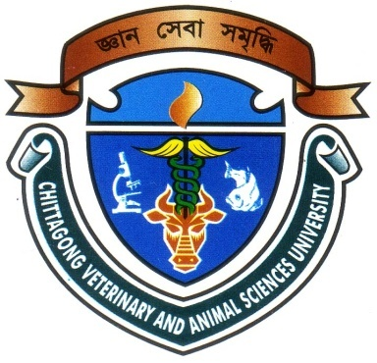

A Production Report Presented in Partial Fulfillment of the Requirement for the Degree of Doctor of Veterinary Medicine

A Report submitted by

Roll No: 12/44

Reg. No: 0776

Intern ID: D-40

Session: 2012-2013

Faculty of Veterinary Medicine

Chittagong Veterinary and Animal Sciences University

Khulshi, Chittagong-4225
COMMON MANAGEMENT PRACTICES AND MARKETING SYSTEMS IN POULTRY FARMING AT CHITTAGONG DISTRICT IN BANGLADESH

A Production Report Submitted as per approved styles and contents

--------------------------  (Signature of Author)  Priya Ghosh  Roll No: 12/44  Reg. No: 0776  Intern ID: D-40  Session: 2012-2013 | -------------------------------  (Signature of Supervisor)  Abdul Rahman  Assistant Professor  Department of Agricultural Economics and Social Sciences,  Faculty of Veterinary Medicine

Chittagong Veterinary and Animal Sciences University

Khulshi, Chittagong-4225
November, 2017.

