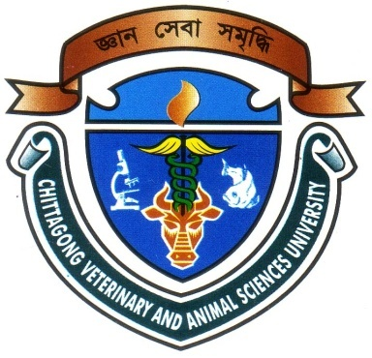
Effect of Genotype (Aseel and Nacked Neck) and Rearing System on Growth of Chicken n Bangladesh

A Production Report Presented in Partial Fulfillment of the Requirement for the Degree of Doctor of Veterinary Medicine (DVM)

A Production Report submitted

By

Intern ID: F-52

Roll No: 11/110

Reg. No: 00677

Session: 2010-2011

Faculty of Veterinary Medicine

Chittagong Veterinary and Animal Sciences University

Khulshi, Chittagong-4202

November, 2017

Effect of Genotype (Aseel and Nacked Neck) and Rearing System on Growth of Chicken n Bangladesh

A Production Report Submitted as per approved style and content

--------------------------  (Signature of Author)  Avijit Dhar  Roll No: 11/110  Reg. No: 00677  Intern ID: F-52  Session: 2010-2011 | -------------------------------  (Signature of Supervisor)  Md. Akhtar-Uz-Zaman  Professor  Department of Dairy and Poultry Science  Faculty of Veterinary Medicine

Chittagong Veterinary and Animal Sciences University

Khulshi, Chittagong-4202

November, 2017
IV

