Survey on Artificial Insemination in Dairy Cows at Boalkhali Upazilla, Chittagong
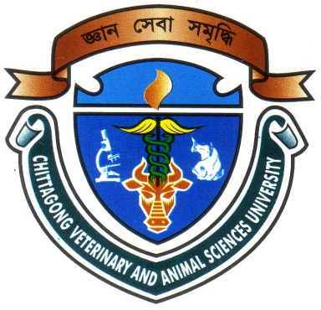

Report presented in partial fulfillment of the requirement for the degree of Doctor of Veterinary Medicine

A Report Submitted by
Roll no: 12/28
Intern ID No: C-25
Reg No: 00750
Session: 2011-2012

Faculty of Veterinary Medicine
Chittagong Veterinary and Animal Sciences University
Zakir Hossain Road, Khulshi, Chittagong-4225

November, 2017

Survey on Artificial Insemination in Dairy Cows at Boalkhali Upazilla, Chittagong

e

Production Report Submitted as per approved style and content

--------------------------------------------- -----------------------------------------
Signature of the student  AJOY DEV NATH  Roll No: 12/28  Reg No: 00750  Intern ID: C-25  Session: 2011-2012 | Signature of the supervisor  DR. TAHMINA BILKIS  Assistant professor  Department of Genetics and Animal Breeding  Faculty of Veterinary Medicine  Chittagong Veterinary and Animal Sciences University

Faculty of Veterinary Medicine
Chittagong Veterinary and Animal Sciences University
Zakir Hossain Road, Khulshi, Chittagong-4225

November, 2017

