Study on Genetic Variations in Survivability and Feed Consumption of the Cross Breeds of (Naked Neck and Fayoumi) and (RIR and Naked Neck)
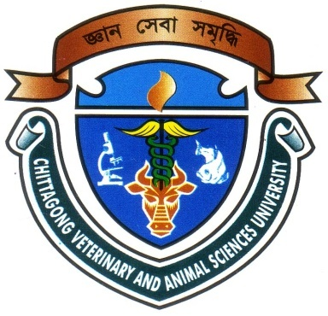

A Production Report Presented in Partial Fulfillment of the Requirement for the Degree of Doctor of Veterinary Medicine (DVM)

A Production Report submitted

By

Intern ID: F-51

Roll No: 11/109

Reg. No: 00669

Session: 2010-2011

Faculty of Veterinary Medicine

Chittagong Veterinary and Animal Sciences University

Khulshi, Chittagong-4202

November, 2017

Study on Genetic Variations in Survivability and Feed Consumption of the Cross Breeds of (Naked Neck and Fayoumi) and (RIR and Naked Neck).

A Production Report Submitted as per approved style and content

--------------------------  (Signature of Author)  Shuvo Singha  Roll No: 11/109  Reg. No: 00669  Intern ID: F-51  Session: 2010-2011 | -------------------------------  (Signature of Supervisor)  Md. Akhtar-Uz-Zaman  Professor  Department of Dairy and Poultry Science  Faculty of Veterinary Medicine

Chittagong Veterinary and Animal Sciences University

Khulshi, Chittagong-4202

November, 2017

