Chapter I: Introduction

The domestic turkey is a large poultry bird, one of the two species in the genus Meleagris and the same as the wild turkey (Domestic turkey, wikipedia). Turkeys (Meleagris gallopavo) are native to the American (North and South America) and Europe continent. They have been considered as traditional thanksgiving and Christmas fare since the Pilgrims hunted wild turkeys to decorate their tables on the first Thanksgiving Day (J.C. Moreki et al.,2015). Female domestic turkey has referred to as hens, and the chicks are called poults. In the unied States, the male are referred to as toms.

Demand for poultry products has been increased rapidly in Bangladesh, and impelled by rising levels of income, population and urbanization (Asaduzzaman et al., 2017). Domestic turkey is a popular form of poultry. Turkey occupies an important position next to chicken, duck, guinea fowl and quail as the most striking sector (Turkey Management Guide, 2012). It plays an important role in provoking the economic and nutritional status of varied population (Turkey Management Guide, 2012).

Turkey rearing is really very fun and enjoyable and can be a dynamic educational activity and become a source of economical, high-quality meat (Small flock turkey production, 2004). Turkey production is an important and highly profitable agricultural industry with an evolving global demand for its products (Yakubu et al., 2013) and they are adaptable to wide range of climatic conditions (Ogundipe and Dafwang, 1980). It is raised throughout temperate parts of the world, partially because industrialized farming has made it very cheap for the amount of meat it produces. It grows faster and become suitable for slaughter within a short time. Turkey farming for meat production is more popular than commercial egg production from turkey because their growth rate is more compared to chicken. Some people keep a or several tom for breeding purpose or as a pet.

Turkey is a newly introduced poultry species in Bangladesh (Asaduzzaman et al., 2017). It was first brought to Bangladesh as part of an exotic hobby (Turkey farming spreads wings). People are rearing turkey as an ornamental bird with a limited extent without having prior experience. Mainly interested farmers started turkey farming by importing day-old turkey chicks (Poult) from neighboring country, India (Asaduzzaman et al., 2017). It was still not so popular in Bangladesh because poultry or chicken market is already established. Many people do not know about the quality of turkey meat. The interest in turkey farming has increased significantly in Bangladesh. It becomes a ray of hope for poultry farmers, who have been battling losses due to increasing prices of chicken and their feed in recent times. Now, several poultry farmers are taking initiative to set up new turkey farms (Turkey farming spreads wings).

Turkey farming is suitable for small and marginal farmers as it can be easily grown in free range or under semi-intensive system with less investment for shelter, equipment and management as well as less risk of diseases. The expenditure on turkey farming is very low (Turkey farming spreads wings). Farming system is similar to other poultry birds farming like chickens, ducks, quails etc (Turkey production). Turkey farming can easily be started by hatching eggs or by raising young poults. They can be grown and home processed without the use of expensive processing equipment, or they may be sold to live markets (auctions) or to neighbors (Small flock turkey production, 2004). The turkeys eat the same food that is available in the market for chicken. The birds also eat grass and vegetables. As a result, farmers do not have to depend only on the food available in the market (Turkey farming spreads wings). Turkeys are excellent insect foragers. Crops and vegetables that are troubled by a significant insect population can be control by turkeys (Grimes et al., 2007). Moreover, the birds can be kept in open areas. Diseases are also rare in turkeys (Turkey farming spreads wings).

It is essential to obtain stock from a known disease-free source. Stock should originate from hatcheries that are members of the National Turkey Improvement Plan. Members regularly test and eliminate stocks with egg-borne diseases, including pullorum, typhoid, paratyphoid, and pleuropneumonia-like organisms (PPLO). To further reduce the threat of disease, raise turkeys away from other poultry (Small flock turkey production, 2004). The care and management of turkey flocks depend on age, location, season, facilities, health, and many other factors (J.C. Moreki et al.,2015). The estimated chicken meat consumption in Bangladesh is to be about 48100 tons. Turkey meat consumption is more negligible than total annual chicken meat consumption. The interest in turkey rearing has increased significantly in Bangladesh. The district Chittagong occupies an important place in Bangladesh because of availability of all facilities. So, the report was develop to evaluate the existing management system of turkey farming for meat products and the breeding stock used to produce commercial poults and understanding the profitability of the turkey farmers. Continued research is necessary to provide additional information about the needs and preferences of turkeys along with exploring alternative or innovative practices. As new scientifically based economically feasible practices are developed, management should implement these methods into existing systems.

The specific objectives of the study:
➢ To study the common management practices of turkey farms in Chittagong
➢ To identify the better management practices
➢ To determine the productivity, cost and return aspects of turkey farms.

Chapter II: Materials and Methods

2.1. Description of the study area and duration: The study was conducted at Chittagong district in Bangladesh. It is located in the south-eastern region of Bangladesh. The places of my study were different upazila under Chittagong district. Data were collected from the turkey farms in Rangamati, Fotikchori, Potiya, Khulshi and Agrabad CDA. The study was carried out for the periods of 2 months from 8th August, 2017 to 15th October, 2017 from different areas under Chittagong district.

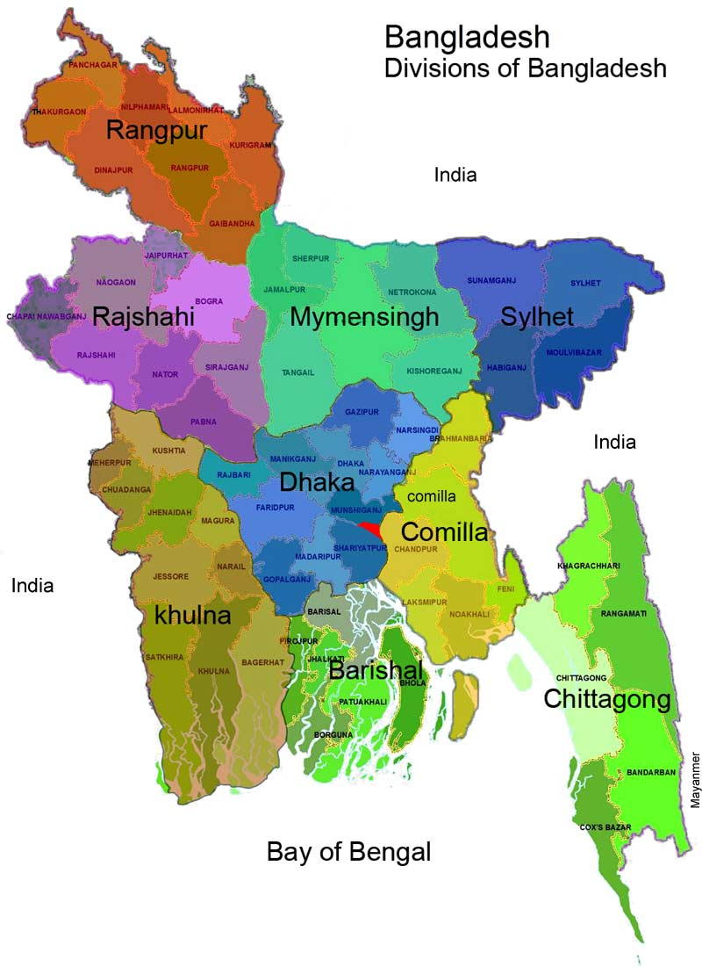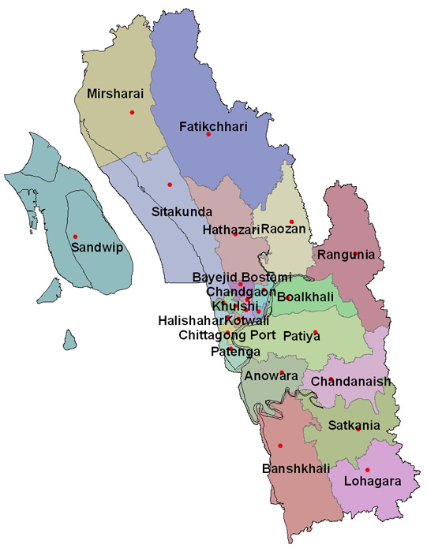
Figure 1: Geographical area of study

2.2. Sources of data: Data were obtained from both primary and secondary sources. The primary data used in the study were generated from field survey of the study area which includes turkey farmers’ personal information (age and education level), housing, feeding, breeding, management, disease, marketing, problems and profitability of the turkey farmers. Some parameters like flock size, number of egg production, weight of egg, male and female ratio etc. were also taken. Smallholder turkey farmers who stocked at least ten turkeys were identified and selected for the study. Personal interviews were conducted where appropriate and made observation during field visits to each of the participating farms. The secondary data were obtained through review of literature from official documents, Journals, libraries, research institutes, internet etc.

2.3. Methods of data collection: Direct observation, interview and analytical methods were applied during collection of data for the study. Data were collected through direct interview schedule with the aid of structured questionnaires. The questionnaire was carefully designed keeping in mind the objectives. Before launching the survey, the questionnaire was pretested and improved accordingly. In order to collect the more purified data of various farms an organized questionnaire was formatted (Nauta et al., 2001; De Jong and Van Soest, 2001). The researcher performed all the interviews to ensure consistency in data quality.

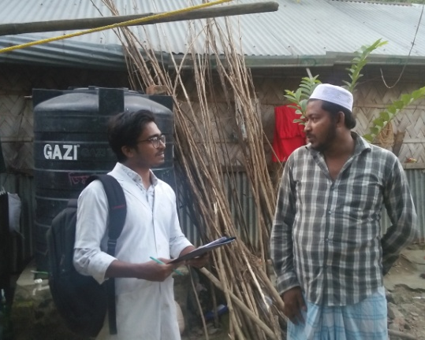

Figure 2: Data collection from Khulshi

2.4. Statistical analysis: Collected data were compiled, tabulated and analyzed and qualitative data were converted into quantitative forms by means of suitable score whenever needed and the local units were converted into standard unit scales. The data were put on the master sheet in Microsoft Office Excel 2007 and were arranged in tabular form. The obtained data imported to software STATA-13 (STATA Corporation 4905, Lakeway River, College Station, Texas 77845, USA) for analysis. Descriptive statistics (i.e. means, frequencies etc) was done to estimate the different variables (Uddin et al.,1999).

2.5. Common management practices:
2.5.1 Poult collection
Owner of the farm collect poults from other farmers. Price of poult varies from time to time. It would vary from 700 TK (Minimum) to 2300 TK (Maximum).
2.5.2 Brooding
Brooding was maintained in some farms. Farmer use chick guard around the poults and hoover above the poults. Some farmers did natural brooding by hen.
2.5.3 Feeding
All the farmers provide both commercial feed available in the market and vegetables. Farmers maintain the following time schedule to provide feed.
Table 1.Feeding state on feed consumption
Feeding regime | No. of farms
Ad-libitum | 1
Once a day | 0
Twice a day | 3
Thrice a day | 1

2.5.4 Vaccination
Those farmers who did vaccination was maintained the following schedule.
Table 2.Vaccination Schedule for turkey
Name of disease | Name of vaccine | Age of administration
ND | ND – B1 Strain | Day Old
Fowl pox | Fowl Pox | 4th & 5th Week
ND | ND – (R2B) | 6th Week
Cholera | Cholera Vaccine | 8 – 10 Week

Chapter III: RESULTS

3.1. General description of the farm:
It was revealed that 20 % farms size (Number of turkeys) are < 20, 40% farm size are 20-50 and 40% farm size are > 50. 40% turkeys are farm borne and remaining 60% turkeys from outside of the farm. During study it was found that farm had 37.5% Broad breasted turkey, 37.5% Broad breasted turkey and 25% Royal palm.
Table 3. Analysis of different parameters related to farms
Variables | Categories | No. of farm | Percentage (%) of farms
Farm size | < 20 | 1 | 20
 | 20-50 | 2 | 40
 | > 5o | 2 | 40
Source of bird | Farm borne | 2 | 40
 | External | 3 | 60
Breed | Broad breasted white | 3 | 37.5
 | Broad breasted bronze | 3 | 37.5
 | Royal palm | 2 | 25
Number of turkey | Tom | 52 | 8.52
 | Hen | 106 | 17.38
 | Poult | 452 | 44.10

3.2. Management practices followed by the owners of turkey:
3.2.1. Housing:
Housing in turkey farm is an important input and major component of the initial capital investment. The main reason to provide housing for birds is to provide protection from the weather. Housing also provides protection from predators, reduces the spread of pathogens and provides protection from vandalism. Good housing with all types of essential facilities available is very necessary for commercial turkey production. The structures are constructed and designed in consideration of bird welfare and efficiency of production.
Table 4. Different parameters related to housing
Variables | Categories | No. of farms | Percentage (%) of farms
Rearing system | Free range | 2 | 40
 | Intensive | 2 | 40
 | Semi-intensive | 1 | 20
Element of house | Bamboo | 1 | 20
 | Tin | 2 | 40
 | Brick+Wood | 2 | 40
Type of litter used | Rice husk | 2 | 40
 | Saw dust | 2 | 40
 | Sand | 1 | 20
Cleaning frequency of floor | Once Daily | 3 | 60
 | 2 times daily | 1 | 20
 | Once weekly | 1 | 20
Cleaning frequency of feeding trough | Once Daily | - | -
 | 2 times daily | 4 | 80
 | 3 times daily | 1 | 20
 | 2 times weekly | - | -
Cleanliness of  feeding trough | Clean | 4 | 80
 | Not clean | 1 | 20

3.2.2. Feeding management:
Food resources are also major input in turkey farming. Good and nutritious feed keeps the bird healthy and productive. All the farmers fed their turkeys with commercial feeds and vegetables. The farmers fed their breeder turkeys with different classes of commercial chicken feed. 40% of turkey farmers used ordinary chicken layer ration for their breeder turkeys, 40% made use of broiler breeder ration and 20% fed any available ration. All farmers provide vegetables to their turkeys. Turkey consume vegetables about 70% of total feed. 20% farmers provide ad-libitum feed for their birds, 60% of the turkey farmers provide twice and 20% provide thrice daily.

Table 5.The types of feed offered to turkeys

Type of feed | No. of farms | Percentages (%)
Commercial feed | 4 | 80
Commercial+ Homemade feed | 1 | 20
Type of commercial feed offered
Any feed available | 1 | 20
Breeder layer rations | 2 | 40
Broiler ration | 2 | 40

Table 6.Quantity of feed taken by turkey
Farm No. | Ingrediants | Quantity(gm)/bird/day
 |  | Poult | Adult
Farm 1 | Commercial feed | 20 | 130
 | Vegetables | 50 | 150
Farm 2 | Commercial feed | 50 | 100
 | Vegetables | 100 | 150
Farm 3 | Commercial feed | 25 | 70
 | Vegetables | 30 | 100
Farm 4 | Commercial feed | 50 | 140
 | Vegetables | 110 | 200
Farm 5 | Commercial feed | 65 | 100
 | Vegetables | 80 | 135

3.2.3. Breeding:
In natural mating the male; female ratio is 1:5 for medium type turkeys and 1:3 for large types. On an average 40-50 poults is expected from each breeder hen. Toms are rarely used for mating after first year due to reduced fertility. There is a tendency in toms to develop affinity towards a particular female.
All the interviewed farmers followed natural breeding for reproduction of turkey. None of the farmers used artificial insemination (AI) as an assisted reproductive technique for turkey breeding.

3.2.4. Health management:
Some common diseases of turkeys include blackhead, Newcastle disease (ND), fowl cholera, fowl pox and infectious coryza. The study showed that while 80% farmers had encountered diseases like New Castle disease, 40% Fowl pox, Infectious coryza and 20% Fowl cholera, Mycoplasmosis etc. Most of the time, they treat the infected turkeys by local veterinarian.

Table 7.Percentage of some common diseases in turkeys
Diseases | No. of farms | Percentages (%)
Newcastle Disease (ND) | 4 | 80
Fowl cholera | 1 | 20
Fowl pox | 2 | 40
Infectious coryza | 2 | 40
Mycoplasmosis | 1 | 20
Salmonellosis | 1 | 20

3.2.5. Vaccination:
Vaccination is not performed routinely by most of the farmers. In the study area, 80% farmers did ND vaccine, only 20% performed Fowl pox and Fowl cholera vaccine.

Table 8. Distribution of vaccinated and non-vaccinated farms
Name of Vaccine | Vaccine given or not
 | Yes (%) | No (%)
ND | 3 (60%) | 2 (40%)
Fowl pox | 1 (20%) | 4 (80%)
Cholera | 1 (20%) | 4 (80%)

3.3. Costs and returns:
The estimated costs and return of turkey farming shows the profitability of the farmers.
Table 9.Economic parameters in turkey farming
Male – Female ratio |  |  | 1:5
Average egg weight |  |  | 65gms
Average day old poult weight |  |  | 50gms
Age at sexual maturity |  |  | 30weeks
Average egg number |  |  | 80 -100
Incubation Period |  |  | 28 days
Average body weight at 20 weeks |  |  | 4.5 – 5 (f) 7-8(m)
Egg production period |  |  | 24 weeks
Marketable age | Male |  | 7 months
 | Female |  | 17 – 18 weeks
Marketable weight | Male |  | 7.5 kg
 | Female |  | 5.5 kg
Food efficiency |  |  | 2.7 -2.8
Average feed consumption upto marketable age |  | Male | 24 -26 kg
 |  | Female | 17 – 19 kg
Mortality during brooding period |  |  | 3-4%

Here, variable cost, fixed cost (only depreciation cost), total cost, income from selling turkey and cost-benefit ratio were analyzed to calculate the farm profitability. The cost-benefit ratio of the farms are 2.73, 2.23, 2.88, 3.31 and 2.12 respectively.

Table 10.Cost-benefit analysis of the farms for one year

Parameters/Items | Farm 1 | Farm 2 | Farm 3 | Farm 4 | Farm 5
1. Variable Cost
Total Poult cost (Tk) | 320000 | 600000 | 34000 | 14000 | 6000
Feed cost (Tk/kg) on an average | 35 | 35 | 35 | 35 | 29
Total feed intake (Kg) | 14628 | 10286 | 2014 | 843 | 974
Total Feed cost (Tk) | 511980 | 360010 | 70490 | 29505 | 28246
Medicine | 20000 | 15000 | 8000 | 8000 | 9000
Miscellaneous | 25000 | 10000 | 5000 | 5000 | 5000
Total variable cost(TVC) | 876980 | 985010 | 117490 | 56505 | 48246
2. Fixed Cost
Depreciation cost on housing | 30000 | 20000 | 2000 | 3400 | 5000
Labour | 80000 | 60000 |  |  | 120000
Equipment(Depreciation cost) | 25000 | 9000 | 2000 | 2000 | 8000
Total fixed cost(TFC) | 135000 | 89000 | 4000 | 5400 | 133000
3. Total cost (TC)= TVC+TFC | 1011980 | 1074010 | 121490 | 61905 | 181246
4.Total revenue from selling of turkey (TR) | 2760000 | 2400000 | 350000 | 205000 | 384000
Gross Margin (GM) =TR-TVC | 1883020 | 1414990 | 232510 | 148495 | 335754
Net Income(NI) = GM-TFC | 1748020 | 1325990 | 228510 | 143095 | 202754
Profit Margin (%) = NI/TR×100 | 63.33 | 55.25 | 65.29 | 69.80 | 52.80
Benefit Cost Ratio (BCR) = TR/TC | 2.73 | 2.23 | 2.88 | 3.31 | 2.12

Photo Gallery
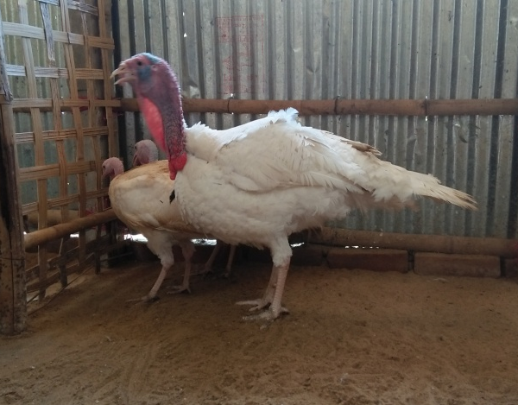
Fig 3.1. Broad-breasted bronze turkey Fig 3.2. Broad-breasted white turkey

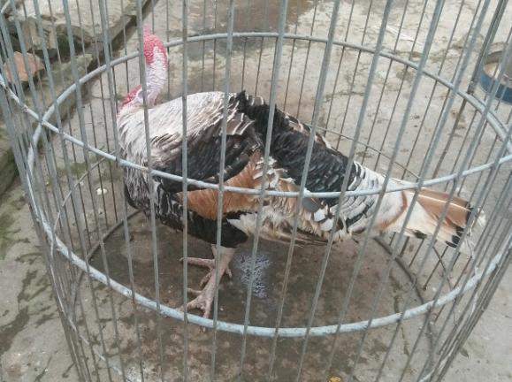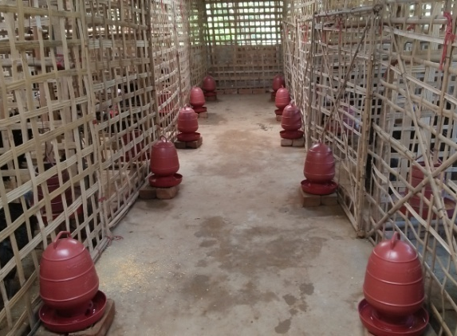
Fig 3.3. Royal palm breed of turkey Fig 3.4. Housing for turkey

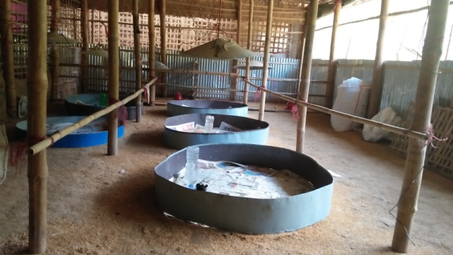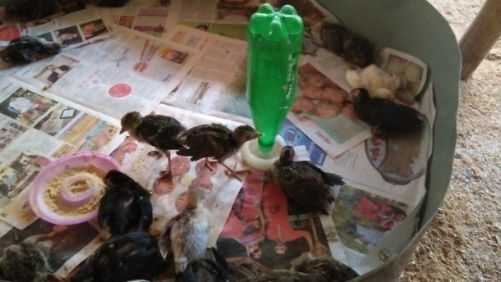
Fig 3.5. Brooder for the poult Fig 3.6. Poults in the chick guard

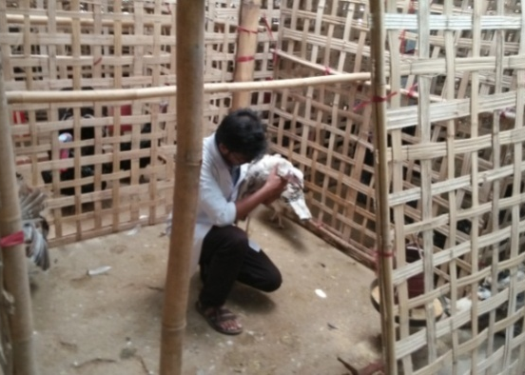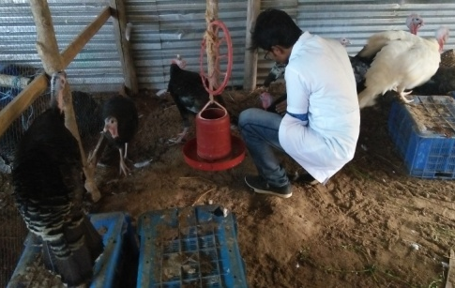
Fig 3.7. Examination of turkey Fig 3.8. Examination of feeder and drinker

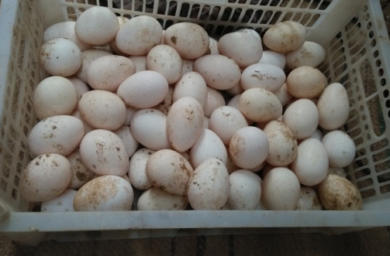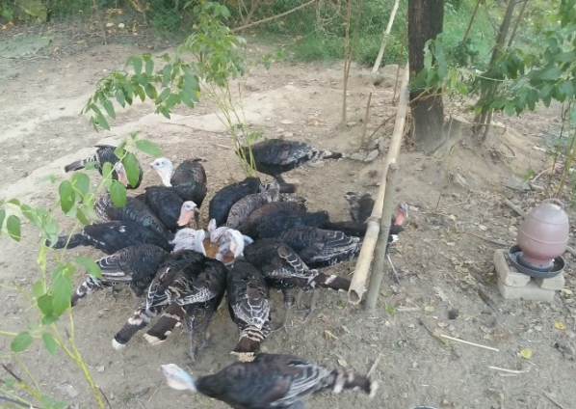
Fig 3.9. Eggs of turkey Fig 3.10. Free range turkey rearing

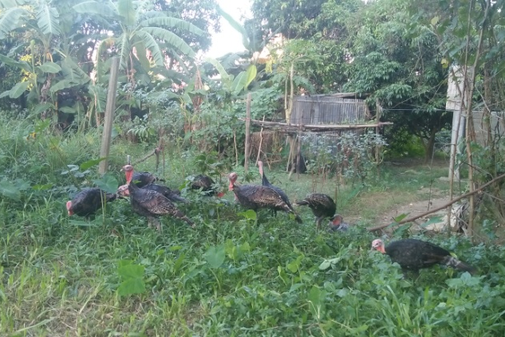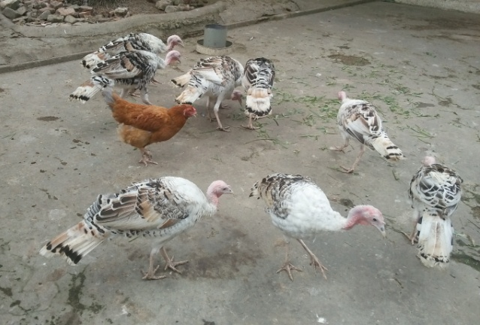
Fig 3.11. Free range turkey rearing Fig 3.12. Free range turkey rearing

Chapter IV: DISCUSSION

Turkey farming is a new farming concept in Bangladesh. The present study showed that although most of the farmers were rearing turkey for hatching egg and meat purposes, a large percent of farmers were raising turkey only for ornamental purpose. During farm observation it was found that farm had 37.5% Broad breasted turkey, 37.5% Broad breasted turkey and 25% Royal palm. The existing black and white birds would be the results of crossing between Broad Breasted Bronze, Broad Breasted White and Beltsville small white variety (Asaduzzaman et al., 2017). 40% turkeys are farm borne and remaining 60% turkeys from outside of the farm. It was revealed that 20 % farms size (Number of turkeys) are < 20, 40% farm size are 20-50 and 40% farm size are > 50.

For proper growth and management of turkey, good housing is a must. Both intensive and free range system are suitable for raising turkey. Turkey housing design has similarity with chicken house. In rearing system, 40% turkeys reared in free range system, 40% in intensive system, 20% semi-intensive system. As turkeys are big sized poultry bird so cage rearing system is not suitable for them. Most farmers raise them in deep litter system. In this system it has to ensure 3-4 square feet space per bird for sheltering during the night (Turkey farming in india). In the farm about 40% case rice husk use as litter materials, 40% case saw dust, 20% case sand. Even it was found that some farmers had not used any litter for mature turkey.

Farmers are unable to formulate their own ration and rely on rations originally formulated for chicken, with the acceptance that all feedstuffs used for chicken could also be used for turkey with the same or better results (Etuk, 2005). In the feeding regiment, 40% of turkey farmers used ordinary chicken layer ration for their breeder turkeys, 40% made use of broiler breeder ration and 20% fed any available ration. All farmers provide vegetables to their turkeys. The farmers fed their breeder turkeys with different types of commercial chicken feed probably because of insufficient knowledge of the levels of nutrient requirements of breeder turkeys (Ojewola et al., 2002).
According to Peter (2006), turkeys have a strong aversion to any change in their feeding routine and nature of their feed. Poults up to 10 weeks of age require ration containing approximately 23% crude protein (CP).The CP content of the ration should be gradually reduced to about 15% for mature turkeys. For the breeder hen, diets low in protein (14%) and low in energy (2600 Kcal/Kg ME) is required and also the hatchability of turkey eggs and quality of the poults depends greatly on the quality of feed given to them (Peter, 2006). The average daily feed intakes of poult and adult turkeys are 80 g and 230 g respectively. In tropical countries, approximately 23 kg of feed is required to produce a 6.4 kg turkey at 24 weeks of age provided the birds were properly managed (Williamson and Payne, 1978). Heavy hens at 14 weeks of age, weighing 7.7 kg would usually consume 17.4 kg of feed for feed conversion of 2.35 kg of feed for 1 kg of weight gain. Heavy toms at 16 weeks of age, weighing 12.30 kg would consume 28.85 kg of feed for a feed conversion of 2.29 kg of feed for 1 kg weight gain (Anon, 2005). The implication is that turkeys have specific nutritional needs (ARC, 1975; Maynard et al., 1979; Aduku, 1993), which are somewhat different from that of broilers and growers on which most farmers base their turkey feeding.
In natural mating the male; female ratio is 1:5 for medium type turkeys and 1:3 for large types. On an average 40-50 poults is expected from each breeder hen. All the farmers followed natural breeding for reproduction of turkey. None of the farmers used artificial insemination (AI) as an assisted reproductive technique for turkey breeding.

Brooding of poults occur from one day-old to about 6 weeks of age. Poults are usually placed in brooder rings for the first 5 to 6 days. From 7 days to 5 weeks of age depending on the sex of the bird, they are given from 0.9 to 1.4 m² of floor space per bird. During this time, the poult needs supplemental heat, special starter feed, and protection from exposure to disease. The size of the guards is increased as poults get older to give them enough room to move about or to move away from brooder as temperature gets higher than they can tolerate. Poults are kept close to brooder stoves for heat, feed and water for the first 5 to 7 days of age or longer in colder weather. The lower light intensity helps to minimize cannibalism. After 3-7 days, lighting programs that reduce the number of hours of light a day during the growing period.

The most prevalent diseases are New-castle Disease (80%), Fowl pox, Infectious coryza (40%) and Fowl cholera, Mycoplasmosis (20%) etc. Most of the time, they treat the infected turkeys by local veterinarian. Most of the farmers had not used vaccines as preventive measure. Few farmers used vaccines mainly for New Castle disease, Fowl Pox and Fowl Cholera diseases. 80% farmers did ND vaccine, only 20% performed Fowl pox and Fowl cholera vaccine.

Different parameters like variable cost, fixed cost (only depreciation cost), total cost, income from selling turkey and cost-benefit ratio were analyzed to calculate the farm profitability. The cost-benefit ratio of the farms are 2.73, 2.23, 2.88, 3.31 and 2.12 respectively. Farmers sold an egg, a poult and an adult male/female turkey at the rate of BDT 76.15±1.79, 838±22.8 and 2587±74.8, respectively (Asaduzzaman et al., 2017). The study revealed that price of adult turkey and poults were higher in Bangladesh in comparison to international market. The main reasons are that turkey subsector is still at the beginning stage in Bangladesh and in some cases turkeys were sold for ornamental purposes while some buyer bought also turkeys for farming as well as consumption purposes. Poults were sold without identifying their sex at the age from day old to 4-5 weeks of age. Eggs were not sold. Some farmers sold adult male-female for breeding purpose and adult male for consumption.

Chapter V: LIMITATION

The study was conducted on the basis of farm management and profitability of the farm. The area and duration of the study was short. So, further extensive investigation should study on same topic to overcome the limitations of the current study and the real situation might be revealed.

CONCLUSION

In fact, turkey farming is a great opportunity for the youth as a means of income generation. Turkey production is still at primitive stage in Bangladesh which is characterized by poor housing, feeding, breeding and healthcare practices as well as inadequate availability of scientific information, technical services, credit facilities, training and marketing opportunities. Smallholder turkey farmers in Chittagong have not fully understood the nutritional requirements and appropriate feeding practices at the different stages of development of turkeys. So, to improve the efficient turkey production, vigorous public extension service, training for farmers, opening of different avenues for research on turkey and identifying marketing strategies, are immediately needed in Bangladesh.

REFERENCES

Aduku, A. O. (1993). Tropical feedstuff analysis table. Department of Animal Science, Faculty of Agriculture, Ahmadu Bello University, Samaru, Zaria, Nigeria, 4.
Anon (2005). Alberta Turkey Farm Agriculture and Agric Food, Canada.
ARC (1975). The nutritional requirements of farm livestock No. 1, Poultry. Agricultural Research Council, London.
Asaduzzaman, M., Salma, U., Ali, H. S., Hamid, M. A., & Miah, A. G. (2017). Problems and prospects of turkey (Meleagris gallopavo) production in Bangladesh. Research in Agriculture Livestock and Fisheries, 4(2), 77-90.
Etuk, E. B. (2005). Evaluation of sorghum grain meal as energy source in turkey diets. In A Research Seminar Paper. Department of Animal Science and Technology, Federal University of Technology, Owerri, Nigeria.
Grimes J, J Beranger, M Bender and M Walters, 2007. How to raise heritage turkey on pasture. American livestock Breeds conservancy Pittsboro, NC27312 USA. Headquarters, 233 S.WAckes Drive, 11th floor Chicago, Illinois- 60606.
J.C. Moreki, (2015). Commercial Turkey Production. Non-Ruminants Division, Department of Animal Production, Botswana College of Agriculture.
Masole, C., Mphothwe, G. K., & Moreki, J. C. (2015). Value Chain Analysis of Botswana Poultry Industry: The Case of Gaborone, Kgatleng, Kweneng and South East Districts.
Maynard, L. A., Loosli, J. K., Hintz, H. F. and Warner, R. G. (1979). Animal Nutrition., 7th edition. MaGraw Hill Publication in Agricultural Sciences, New York.
Nauta, W. J., Baars, T., Groen, A. F., Veerkamp, R. F., & Roep, D. (2001). Animal breeding in organic farming. Louis Bolk Instituut.
Ogundipe SO and II Dafwang, 1980. Turkey Production in Nigeria. National Agricultural Extension Research and Liaison Service (NAERLS) Bulletin No. 22. pp: 2-22.
Ojewola, G. S., Udokainyang, A. D., & Obasi, V. (2002, March). Growth, carcass and economic response of local turkey poults to various levels of dietary energy. In Increasing household protein consumption through livestock products. Proceeding of the 27th Annual Conf. of Nigeria Society for Animal Production, Akure, Nigeria. Pp (pp. 167-169).

Okoli, C., Nwaodu, C. H., & Martin, C. U. (2009). Feeding management practices of small holder turkey farmers in the warm wet tropical environment of Imo state, Nigeria. Report and opinion.
Peter, R. (2006). Turkey production: A profitable venture requiring attention and good stockmanship. The ABC of turkey production. Agvet International, UK.
Williamson and Payne, 1978. Problems and Prospect of Rearing Poultry.in Ikpoba Okha L. G. A. Edo State.
Turkey Management Guide, 2012. Central poultry development organization (SR), Hessarghatta, Bangalore 560088, Website: http://www.cpdosrbng.Kar.nic.in. Accessed in January 2016.
Yakubu, A., Abimiku, H. K., Musa-Azara, I. S., Idahor, K. O., & Akinsola, O. M. (2013). Assessment of flock structure, preference in selection and traits of economic importance for domestic turkey (Meleagris gallopavo) genetic resources in Nasarawa State, Nigeria. Livestock Research for Rural Development, 25.
Uddin, H. (1999). A comparative economic analysis of broiler and layer production in some selected areas of Sadar Thana in Mymensingh district. A Master thesis, Department of Agricultural Economics, Bangladesh Agricultural University, Mymensingh, Bangladesh

ACKNOWLEDGMENTS

The author is ever grateful and indebted to the immeasurable grace and profound kindness of Almighty “Allah” the soul authority and supreme ruler of universe, who enabled him to complete the work successfully.

The author feels proud in expressing his deepest sense of gratitude, sincere appreciations, indebtedness to respected teacher and supervisor Prof. Goutam Kumar Debnath, Professor, Department of Dairy and Poultry Science, Chittagong Veterinary and Animal Sciences University for his ingenuous and scholastic supervision, constant inspiration, providing valuable suggestions, necessary corrections to report writing and for affectionate help in completion of this report.
The author would like to express his deepest sense of respect and affection tothe honorable Vice Chancellor Prof. Dr. Gautom Buddha Das and Dean Prof. M. A.Halim, Faculty of Veterinary Medicine, Chittagong Veterinary and Animal Sciences University.
The author express his sincere gratefulness and thanks to Prof. Dr. AKM Saifuddin, Director, External Affairs (CVASU) for his valuable suggestions for completion of this report.
Special thanks to the senior brother DR. Saddam Hossain, MS Fellow (Vet. Epidemiology), CVASU for his valuable advice and co-operation.

The author is ever indebted to his beloved parents for their sacrifices, blessing and inspiration to get him in this position. He is also grateful to all of his teachers, friends and well wishers for their help, encouragement and inspiration during the study period.

The Author December,2017

BIOGRAPHY

I am Mohammad Foysal, son of Mr. Md. Abdul Malek and Mrs. Hosne Ara Begum. I passed Secondary School Certificate examination in 2008 from Government Muslim High School, Chittagong followed by Higher Secondary Certificate examination in 2010 from Chittagong Cantonment Public College. Now I am an intern veterinarian under the Faculty of Veterinary Medicine in Chittagong Veterinary and Animal Sciences University.

In the future I would like to work as a veterinary practitioner and do research on clinical animal diseases in Bangladesh.

